Homeopathy
Supporting Paper
BMHP5001 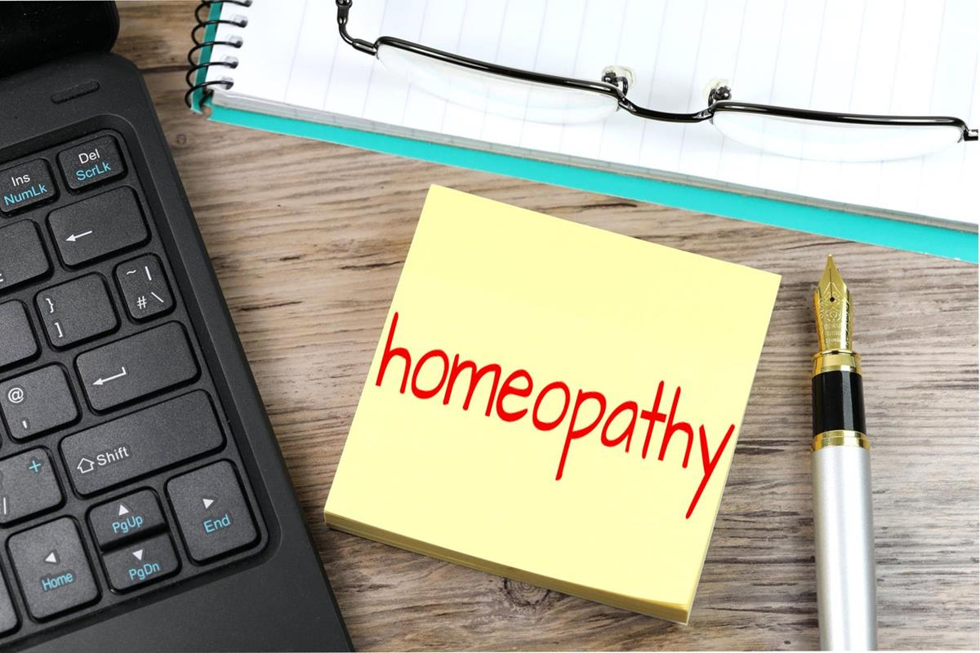
Olibia Chaffatt 1908130
Mark-Gallager Read

CONTENT PAGE

Page 1……………..Cover page
Page 2…………….Content page
Page 3……………..Introduction
Page 4…………….Effectiveness and Efficiency
Page 5………………cont.
Page 6……………...conclusion
Page 7……………...Reference

Introduction

Homeopathy is a type of 'treatment' that uses very weak substances by practitioners which they suggest can be used by the body to heal itself, however, a report on homeopathy from the 2010 House of Commons Science and Technology states that homeopathic remedies work no better than placebos also known as dummy treatments (NHS,2018).

Homeopathy is known as a complementary or alternative medicine or CAM. This means that unlike conventional western medicine treatments used in homeopathy are different. A main part of the treatment suggests that "like cures like", this means that any substance that causes a particular symptom can also be used to help remove that particular symptom. A second part looks at succession which is a process of shaking and dilation, the belief of practitioners is the more diluted the substance is the more it will be able to treat the symptom (NHS,2018).

A common but implausible form of medicine is homoeopathy. Contrary to certain homoeopathic arguments, there is no definitive proof that placebo is distinct from heavily diluted homoeopathic remedies. Therefore, the advantages encountered by many patients during homoeopathic care are most likely due to non-specific treatment results. Homeopathy is not completely free of danger, contrary to common belief. Therefore, beyond the beneficial effects of placebo, the proven benefits of highly diluted homoeopathic remedies do not outweigh the potential for harm that this approach - cause. The use of the drug is tailored to the patient by the sick person due to the concept of individualization, according to which the homoeopath analyses all the symptoms of the person and not just those associated with the illness (Ernst, E., 2005).

Efficacy and Effectiveness of homeopathy treatment

Care effectiveness usually implies the positive outcome of the treatment, which is the result of a combination of factors such as an intervention's effectiveness, the patient's approach, the patient's response, and the environment in which care is given. Effectiveness also reflects the placebo or expectation effect aspects. The demonstrated efficacy relied heavily on a single tool for measuring a biological therapeutic effect because of the costs, safety problems and the dominance of pharmaceutical interventions/randomised controlled trials (RCT). The RCT approach is usually important in determining all the clinical merits of the alternative invention. Typically, because of the highly individualised and multifaceted treatment protocols used. The RCT research method usually tests a well-defined and standardised treatment, delivered uniformly to specified subjects in a standard setting, designed for those who ideally have only the target condition being treated, and also includes agreements with subjects to comply with and usually comply with the protocol for a reward. The efficacy of homoeopathy has been thoroughly investigated. There is no proof of good quality that homoeopathy is effective for any health condition as a treatment.

There are several healing philosophies that play an important role in evaluating the effectiveness of alternative medicines and treatments for complementary medicines such as self-healing, system approach, equilibrium and holism; the effect of clinician-patient relationship; the set of therapeutic methods used to improve the healing process.
Homeopathy usually offers the healing philosophy of evaluating the results. In some cases, the scientific conclusions of the efficacy of homoeopathy therapy are strongly rejected by clinicians because the non-material nature of homoeopathic remedies is outside the conventional scientific paradigm and is rejected as placebo. CAM, which means strong patient enforcement, is an extremely valuable device. Alternative medicine thus serves as important treatments when looking at different diseases and raises the level of patient acceptance, which is stated to be an issue for certain traditional therapies and serves within some or all of its values to a greater degree.
While looking at the placebo effect some people have noticed an improvement in their medical condition while using homeopathy.
You can lose out on other treatments that have been shown to be more successful if you select health treatments that provide only a placebo effect.
They are few therapies that have attracted more debate and discussion than homoeopathy. Throughout its 200-year history, analysts point out that its very ideals fly in the face of science, although supporters have maintained that denying an openly beneficial approach to healing is limited only because it can not be demonstrated how it could work. Similarly, supporters have cited seemingly rigorous studies indicating efficiency, although opponents have had no difficulty finding similarly extensive research claiming the contrary
(Ernst, 2002).
Dr. Hahneman used all natural sources to make the treatments, he used the idea that by using very diluted substances then that substance can be used to relieve the symptoms, he also suggested the more diluted the substance the more effective the remedy. But that's where homoeopathy is part of the business of traditional science. Scientists believe that the usage of homoeopathic dilutions is so bad that not even a single molecule of the original drug remains, i.e. homoeopathic medication is no better than a placebo.
Edzard Ernst, professor of complementary medicine at the Peninsula Medical School in Exeter, one of the strongest opponents of homoeopathy, has indicated that the decline in prescribing homoeopathy reflects a move towards evidence-based medicine. The proof that homoeopathic treatments are nothing but placebos is growing.
On the NHS, homoeopathy isn't commonly available. In 2017, NHS England advised that it should avoid being given by GPs and other prescribers.
This is because "no clear or robust evidence to support the use of homoeopathy on the NHS (PDF, 607kb)"
Homeopathy is typically privately practised, and pharmacies sell homoeopathic remedies.
The price will range from about £ 30 to £ 125 for a consultation with a homoeopath. Usually, homoeopathic tablets or other items cost from £ 4 to £ 10.

CONCLUSION

Homeopathy is used with confidence by millions of patients around the world who prefer this mode of care, despite being sometimes questioned for its scientific validity and mechanism of action. Contrary to the views of sceptics, homeopathy studies using modern methods continue to support its effectiveness and promote new concepts for understanding its mechanism of action. There is a need to strengthen self-regulation and standards for the alternative medicine industry and also for its health professionals. The public has received reliable information on alternative medicines on the internet and on the websites of alternative medicines, where information on safety and effectiveness is clearly described.

Reference

Aversa, R., Petrescu, R.V., Apicella, A. and Petrescu, F.I., 2016. About homeopathy or≪ Similia similibus curentur≫. American Journal of Engineering and Applied Sciences, 9(4).

Ernst, E., 2002. A systematic review of systematic reviews of homeopathy. British journal of clinical pharmacology, 54(6), pp.577-582.

Ernst, E., 2005. Is homeopathy a clinically valuable approach?. Trends in Pharmacological Sciences, 26(11), pp.547-548.

Fisher, P., 2012. What is homeopathy? An introduction. Frontiers in Bioscience (elite edition), 4, pp.1669-1682.

Khuda-Bukhsh, A.R., 2006. Laboratory research in homeopathy: pro. Integrative Cancer Therapies, 5(4), pp.320-332.

NHS (2018). Homeopathy. “https://www.nhs.uk/conditions/homeopathy/

RAO, M.T., YAMINI, M., PHANINDRA, C. and RAO, Y.S., 2021. Alternative Medicine: New Ways to Treat Diseases and Therapies. Indian Journal of Pharmaceutical Sciences, 83(1), pp.7-12.

(2008), "Homeopathy", Nutrition & Food Science, Vol. 38 No. 6.
https://doi.org/10.1108/nfs.2008.01738fab.042

