University of Wales Trinity Saint David

Swansea


Assignment
BEng / HND Electrical & Electronic Engineering
BEng Embedded Electronic Systems

Electronics II

Written by: Adam Mark Newman
Employer: Expleo
Submission date: 17/04/2025
Contents
1. Introduction 5
2. Background Research 5
2.1 Wallace Tree Research 5
2.2 Brauns Research 5
3. Application and Advantages of these multipliers 6
3.1 Wallace Tree Applications & Advantages 6
3.2 Brauns Multiplier Applications & Advantages 8
4. Flowchart/Pseudocode & Block Diagram Showing the System Operation 9
4.1 Wallace Tree Block Diagram 9
4.2 Brauns Block Diagram 10
4.3 Brauns Flowchart 11
4.4 Wallace Flowchart 12
4.5 Wallace Tree Algorithm 13
4.6 Braun Multiplier Algorithm 13
5. Methodology 14
5.1 General Methodology for designing multipliers 14
5.2 Wallace Tree Methodology 14
5.3 Brauns Methodology 16
6. VHDL Codes 17
6.1 Wallace Tree Codes 17
6.2 Brauns Multiplier Codes 20
7.1 Wallace Tree Simulation 24
7.1 Wallace Tree RTL Design 26
7.2 Wallace Schematic 26
7.3 Wallace Tree Device 27
7.4 Wallace Tree I/O Planning 27
7.5 Wallace Tree Timing Constraints 28
7.6 Report Utilization 32
7.7 Project Summary 33
7.8 Power Report 35
7.9 Wallace I/O Port 35
7. Brauns Multiplier Simulation Screenshots through VIVADO 36
8.1 Brauns Multiplier Simulation 36
8.2 Brauns Multiplier RTL 38
8.3 Brauns Multiplier Schematic 38
8.4 Brauns Multiplier Device 39
8.5 Brauns Multiplier I/O Planning 39
8.6 Brauns Multiplier Timing Constraints 40
8.7 Brauns Multiplier Report Utilization 44
8.8 Brauns Multiplier Report Summary 44
8.9 Power Report 45
8.10 Braun Multiplier I/O 46
8. Conclusion 47
9. References 48

Table of Tables
Table 1 - Wallace Tree Applications 6
Table 2 - Wallace Tree Advantages 6
Table 3 - Brauns Multiplier Application 8
Table 4 - Brauns Multiplier Advantages 8
Table 5 - Report Utilization Summary 32

Table of Figures
Figure 1 - Wallace Tree Architecture 9
Figure 2 - Brauns Multiplier Architecture 10
Figure 3 - Brauns Flow Chart 11
Figure 4 - Wallace Tree Flow Chart 12
Figure 5 - Wallace Tree Algorithm 13
Figure 6 - Brauns Multiplier Algorithm 13
Figure 7 - Wallace Tree Dot Diagram 15
Figure 8 - Wallace Tree Code 1 18
Figure 9 - Wallace Tree Code 2 19
Figure 10 - Brauns Multiplier Code 1 21
Figure 11 - Brauns Multiplier Code 2 22
Figure 12 - Brauns Multiplier Code 3 23
Figure 13 - Wallace Tree Behavioural systems (1BxD2) 24
Figure 14 - Wallace Tree Behavioural systems (FFxFF) 24
Figure 15 - Wallace Tree Behavioural systems (A4xFF) 25
Figure 16 - Wallace Tree Behavioural systems (B7xE4) 25
Figure 17 - Wallace Tree RTL Design 26
Figure 18 - Wallace Tree Implementation Schematic 26
Figure 19 - Wallace Tree Device 27
Figure 20 - Wallace Tree I/O Planning 27
Figure 21 - Wallace Tree Timing Constraints 28
Figure 22 - Wallace Critical Diagram 29
Figure 23 - Port Delay 1 30
Figure 24 - Port Delay 2 30
Figure 25 - Port Delay 3 30
Figure 26 - Port Delay 4 30
Figure 27 - Port Delay 5 30
Figure 28 - Port Delay 6 30
Figure 29 - Port Delay 7 31
Figure 30 - Report Utilization 32
Figure 31 - Project Summary 33
Figure 32 - Utilization (Synth & Place Design), Power, Timing 34
Figure 33 - Power Report 35
Figure 34 - Wallace I/O Port 35
Figure 35 - Brauns Multiplier Behavioural systems (ABx1D) 36
Figure 36 - Brauns Multiplier Behavioural systems (BBxA3) 36
Figure 37 - Brauns Multiplier Behavioural systems (5CxEA) 37
Figure 38 - Brauns Multiplier Behavioural systems (FFxC2) 37
Figure 39 - Brauns Multiplier RTL 38
Figure 40 - Brauns Multiplier Schematic 38
Figure 41 - Brauns Multiplier Device 39
Figure 42 - Brauns Multiplier I/O Planning 39
Figure 43 - Brauns Multiplier Timing Constraints 40
Figure 44 - Brauns Critical Path 41
Figure 45 - Brauns Port Delay 1 42
Figure 46 - Brauns Port Delay 2 42
Figure 47 - Brauns Port Delay 3 42
Figure 48 - Brauns Port Delay 4 42
Figure 49 - Brauns Port Delay 5 42
Figure 50 - Brauns Port Delay 6 42
Figure 51 - Brauns Port Delay 7 43
Figure 52 - Brauns Multiplier Report Utilization 44
Figure 53 - Brauns Multiplier Report Summary 44
Figure 54 - Brauns Utilization (Synth & Place Design), Power, Timing 45
Figure 55 - Brauns Multiplier Power Report 45
Figure 56 - Brauns Multiplier I/O Port 46

Introduction
This report covers the two methods of multiplication such as the Brauns 8x8 and the Wallace tree 8x8 [1]. To design and write the multiplication code and structure, VIVADO software was used that allows you to synthesise and analyse descriptive language designs. The report will include a background research, applications and advantages of multipliers - 8-bit Brauns multiplier, 8x8 Wallace tree multiplier, design, critical evaluation of both multipliers and conclusion.

Background Research
Binary multiplication is fundamental in Arithmetic Logic Units (ALUs), Signal Processing (DSP), Graphics Processing Units and Machine Learning Hardware such as matrix operations [2]. The purpose of introducing techniques is to optimize the multiplication process to improve overall system performance. Multiplication methods can be found in many day-to-day applications, those which are found in real-time systems, rely on time-critical operations. Unlike addition, multiplication scales non-linearly, generating and summing multiple partial products. Multiplication process can limit the clock frequency due to the critical path through the circuit which provides the required clock speed. A slow multiplier can delay the entire path. Producing a design which uses a minimum number of required gates and switches to achieve low power consumption, less required chip area and less energy waste. Choosing a multiplier design is dependant on the application and its set requirements.

Wallace Tree Research
Introduced by Chris Wallace in 1964, the Wallace tree is a hardware-optimized technique that is used to perform fast binary multiplication [3]. The purpose of the design was to significantly reduce the delay of multiplying binary numbers. To mitigate the issue of cumulative carry delays, thus, leading to slow performance. The Wallace Tree a tree like design of CSAs made up of full and half adders. Allowing for multiple bits to be combined at the significance level simultaneously. It works by delaying resolution until the final stage as appose to producing carries instantly. In each level of the tree, a full adder is used to combine three bits in two or a half adder to combine two bits into two. The reduction process is carried out until left with two rows. These are summed by using a fast adder to generate a final sum.

Brauns Research
The Brauns multiplier is a array multiplier which is found in digital hardware to multiply unsigned binary numbers [4]. The Brauns, like the Wallace Tree, uses a simple design making it suitable for implementation in hardware platforms such as FPGAs and ASICs. Within the Brauns design, an array of AND gates are implemented to generate all partial products simultaneously. These products are then summed through a further grid carry-saved adders in a rectangular matrix of rows that corresponds to a bit multiplier and columns that each corresponds to a bit of the multiplication. This produces a simple structure with minimum connections and predictable timing behaviour. Due to its advantages, the Brauns multiplier is commonly used for applications that have area and power constraints. These systems being things such as signal processors. This is due to its simplicity and user-friendly layout. The Brauns multiplier is less efficient for applications requiring high-performance tasks.

Application and Advantages of these multipliers

Wallace Tree Applications & Advantages
Table 1 - Wallace Tree Applications
Wallace Tree Multiplier Applications
Application | Why it’s used
Cryptography | The Wallace tree is commonly found in cryptographic algorithms. As the Wallace is more efficient at handling large operations. This is useful as the cryptographic algo usually requires large integers or multiplications.
Digital Signal Processing (DSP) | The Wallace true can produce fast multiplications and achieving real-time signal manipulation. This is perfect for a DSP as it requires fast Multiply-Accumulate (MAC) operations.
High-Speed Arithmetic Units (CPUs/GPUs) | With its capabilities of parallel reduction of partial products. The Wallace tree is very common in this application as processors require high clock frequencies and fast execution I order to achieve real-time signal execution.
Table 2 - Wallace Tree Advantages
Wallace Tree Multiplier Advantages
Advantages | Explanation
Efficient for Large Bit-Widths | The number of the partial products is dependant on the operation size. Wallace tree can handle large multipliers such as 32, 64-bits or higher. Handling multiplications without significant increase of delay.
High Speed Operations | By handling partial products in parallel the Wallace is can reduce the delay. Providing a fast multiplication process. Also suitable for large operations.
Low Computation Depth | The few steps required to execute multiplication. Minimizes the number of logics levels and reduces overall delay.
Well suited for Pipelining | A pipeline register is a storage element that is used to separate in a pipelines Datapath found in computer architecture. The Wallace tree allows for simple implementation of pipeline registers. Thus, providing high clock rates in digital systems such as the DSP.

With the information provided, the Wallace Tree Multiplier is a high performance multiplication technique that is well suited for application where speed is a critical function [5]. Used for supporting advanced computer systems, due to its fast and efficient execution with minimum time delay and support in real-time systems with high resolution processing. It is key to note that it’s suited for applications where performance is required more than area as well as simplicity.

Brauns Multiplier Applications & Advantages
Table 3 - Brauns Multiplier Application
Braun Multiplier Applications
Application | Why it’s used
Area-Constrained ASICs and low speed embedded systems | The Brauns is more suited for applications that require a compact and powerful technique of multiplication - as appose to speed. Making it suitable for wearable and sensor interfaces. This is also true for microcontrollers as the Brauns Multiplier has a simple design which makes it easy to implement with minimal resources.
Fixed-Point Arithmetic Units | The Brauns is far simpler in design and a better solution when considering cost. Due to this, it is suitable for low precision calculation where embedded systems use fixed-point arithmetic for a balance of performance and efficiency with cost.
FPGA-Based Projects | Braun multipliers have a regular and simple layout that maps well to the configuration of logic blocks of FPGAs. making place-and-route and timing analysis simpler and more predictable.

Table 4 - Brauns Multiplier Advantages
Braun Multiplier Advantages
Advantages | Explanation
Area Efficient | As the Braun Multiplier uses fewer resources, it is suitable for applications where space is constrained. Especially for the Brauns 4x4 and 8x8.
Easy to scale for small sizes | The Brauns is suitable for designs where mid operations are required. This is because the design allows larger multipliers can be built by replication.
Hardware Layout | With simple design and layout, it is easier to utilize for physical design tools such as I FPGAs and ASICs.
Simple and Regular Design | With a simple layout of AND gates and adders, it is easy to work with and scalable for various operation sizes.

The Brauns multiplier being one of the simpler designs and ability to be compact in size for straight forward and efficient execution [6]. Thus, making it a suitable candidate for embedded systems and FPGA-based projects. The Brauns multiplier is less efficient when required to perform high speed or large-bit-width in other applications. This is due to carry delays.

Flowchart/Pseudocode & Block Diagram Showing the System Operation

Wallace Tree Block Diagram
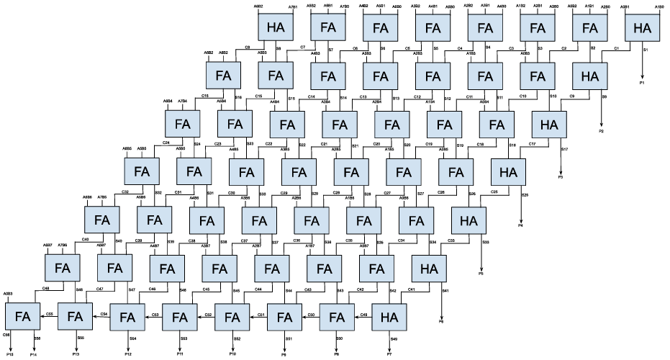
Figure 1 - Wallace Tree Architecture

Brauns Block Diagram
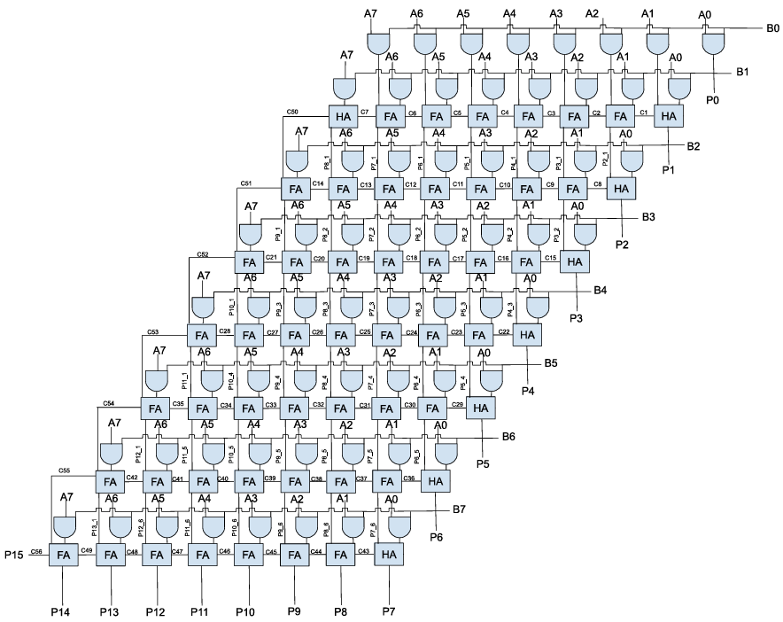
Figure 2 - Brauns Multiplier Architecture

Brauns Flowchart
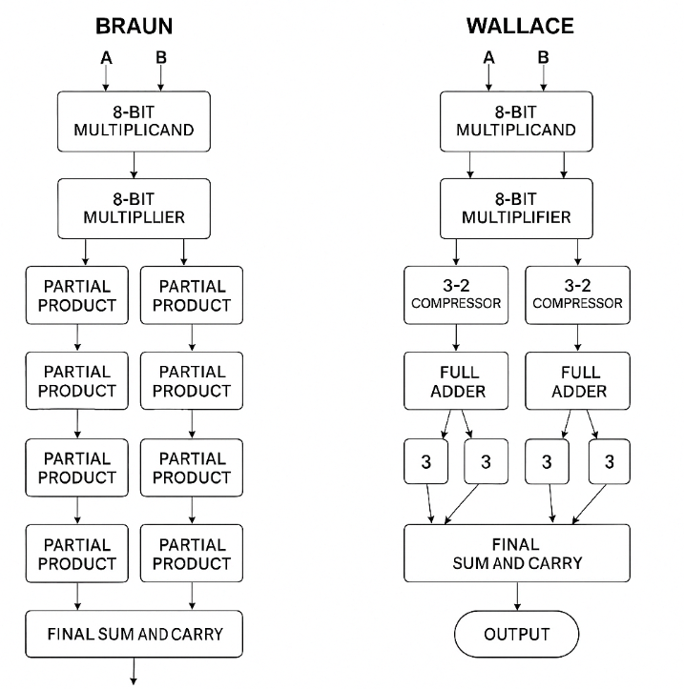
Figure 3 - Brauns Flow Chart

Wallace Flowchart
Figure 4 - Wallace Tree Flow Chart

Wallace Tree Algorithm
Figure 5 - Wallace Tree Algorithm

Braun Multiplier Algorithm

Figure 6 - Brauns Multiplier Algorithm

Methodology

General Methodology for designing multipliers
The design of an 8x8 multiplier – as seen within this report [7]. Involves computing a product that provides two 8-bit binary numbers. Each product can have up to a 16-bit result. The process differs depending on the use of multiplication technique such as, the Brauns and Wallace Tree. Selection between the two is dependent on the requirements of the system – referring to the applications and advantages tables. With this, designers can choose between an array or tree based architecture. These multipliers are then implemented using hardware descriptive languages, for the design within this report, VHDL was used, allowing to simulate and synthesize into gate-level logic. This also allows the design to be optimized for constraints such as layout, timing and power consumption – all captured within the report.

Wallace Tree Methodology
The 8x8 wallace tree multiplier begins with partial product generation [8]. Where each bit of one factor is then multiplied by the other 8 bit. This results in 64 partial product bits that are arranged into 8 rows. Each partial product has weight that is equal to the product of its factor. These are then aligned based on their binary weight. Each row represents the intermediate terms that must be summed to get the final product.
Multi-level reduction strategy is used within the Wallace Tree which is done by full-adders and half-adders, combining three bits in the same gate into two (sum and carry) [9]. Then passed on to the next reduction layer where carries are moved to the next higher column. This is repeated until only two rows remain where a full adder sums them to produce a 16-bit. The design improves timing and routing during the synthesis. This provides the advantages of a Wallace Tree such as high performance, time reduction due to the critical path minimization and efficiency.
A Wallace Tree Dot Diagram [Fig 3] provides the visual representation of the partial products being reduced [10]. This is provided by showing the stages of full adders (1 column x 3 rows – blocks shown in red circled green) and the half adders (1 column x 2 rows – blocks shown in Blue circled Black) and how the partial products are reduced through each of the 5 stages. This is a schematic tool which is used to track the bits at each weight. It also shows how they are compressed over time.
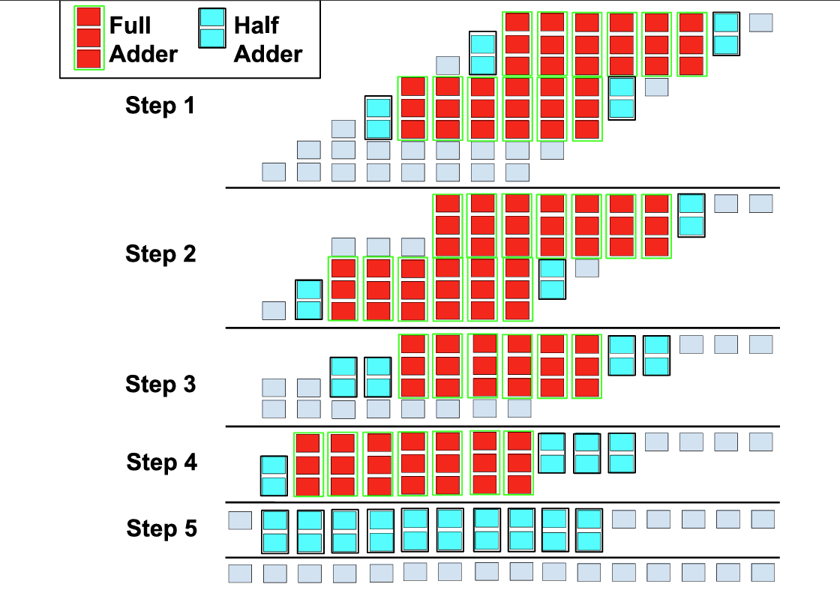
Figure 7 - Wallace Tree Dot Diagram

Brauns Methodology
The Brauns multiplier is an array-based architecture – known as a pretty straight forward and regular design [11]. This follows the classic Brauns structure where partial products are firstly generated through a grid of AND gates. Each 8-bit of the multiplication passes through the AND gate with each of the 8-bit multiplier. This then produces 64 partial bits which are arranged similarly to the wallace tree – in rows that correspond to one bit of the multiplier and where each column corresponds to the weight of the bit.
From this, the partial products they are summed by using the grid of Half-adders and Full-adders [12]. Carries from each adder is passed diagonally down and into the next stage. The sums are then passed vertically downward . This continues row by row until the final row includes a ripple-carry adder, completing the remaining bits to form the 16-bit output.
While not as fast as Wallace Tree designs, the Braun multiplier is efficient in terms of area and layout and works well for applications where moderate speed, regular structure, and ease of implementation are more important than raw performance.

VHDL Codes

Wallace Tree Codes

Please refer to pages 12 & 13.
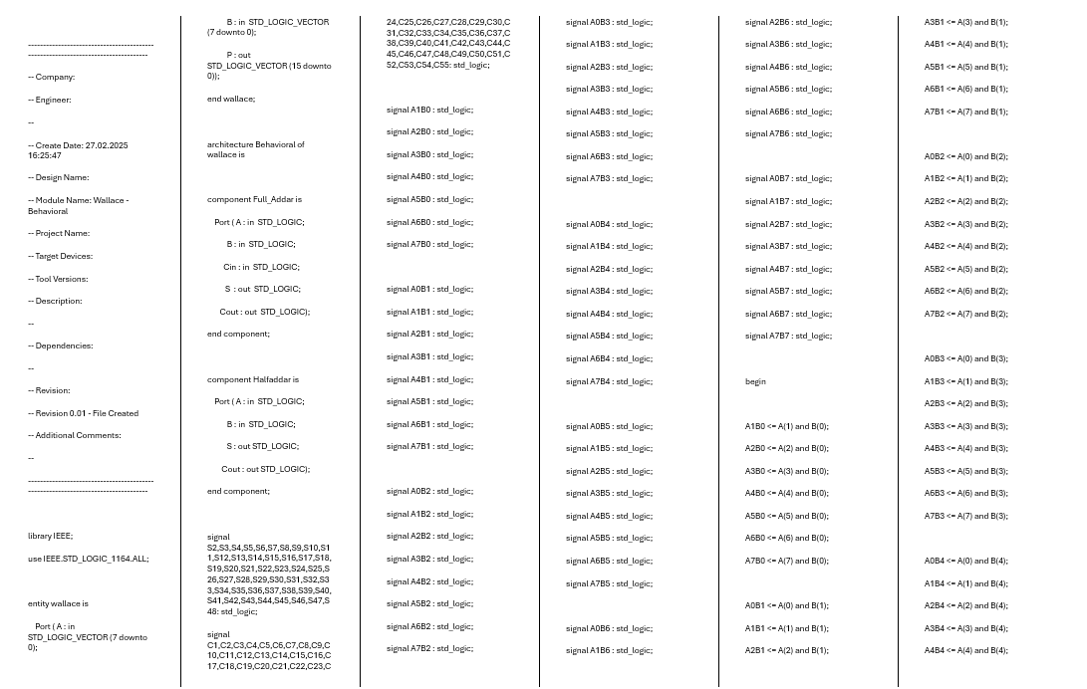
Figure 8 - Wallace Tree Code 1

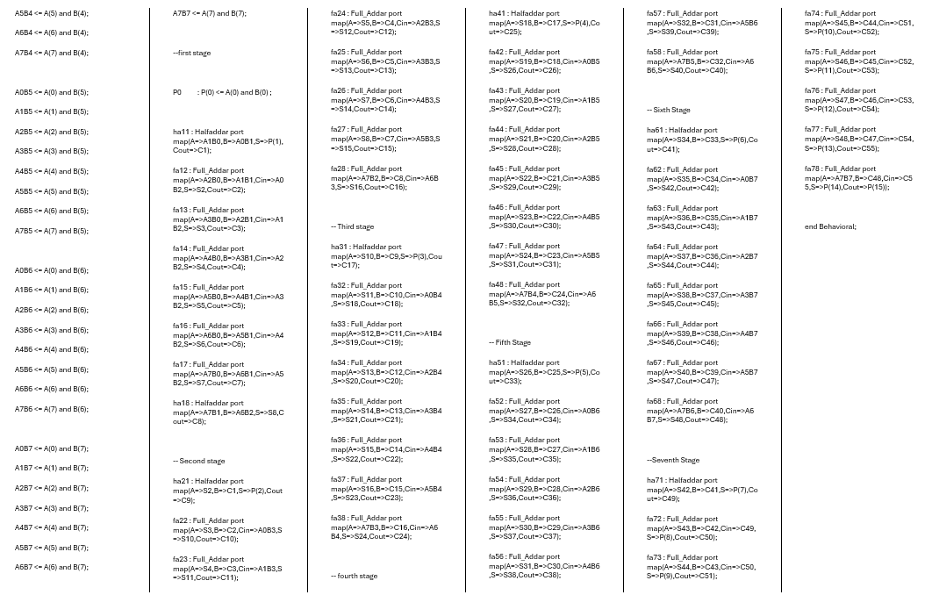
Figure 9 - Wallace Tree Code 2

Brauns Multiplier Codes
Please refer to pages 15-17.
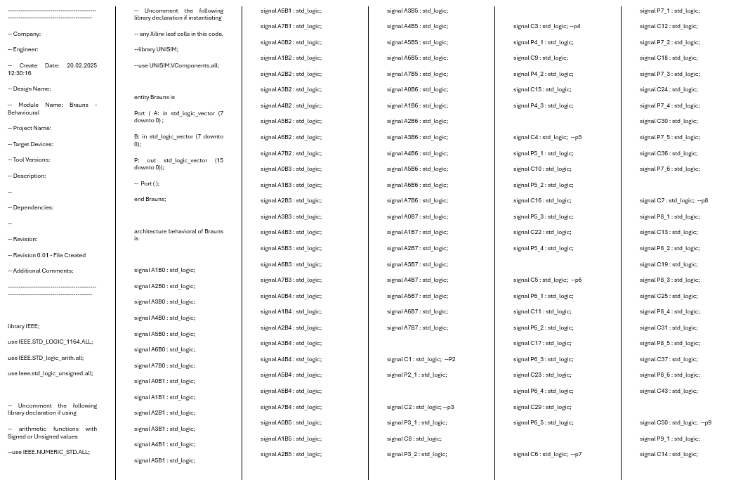
Figure 10 - Brauns Multiplier Code 1
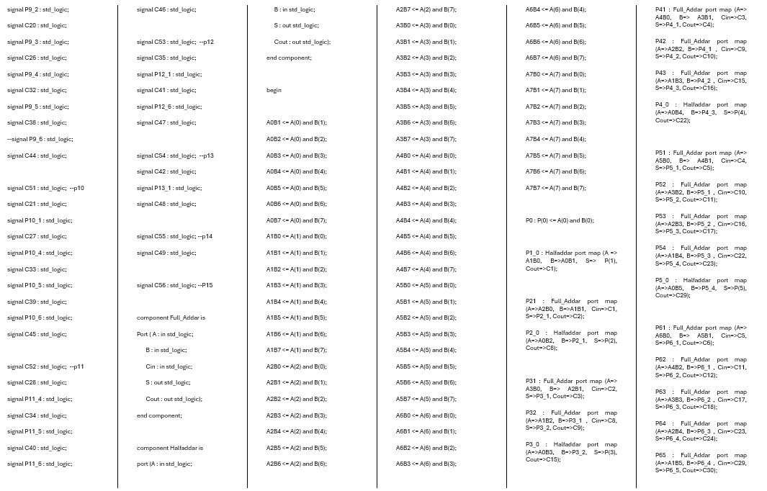
Figure 11 - Brauns Multiplier Code 2

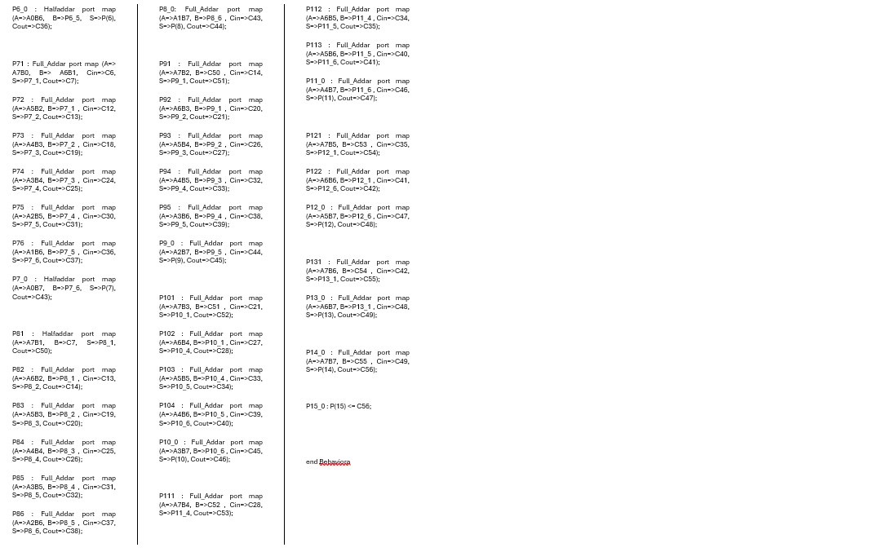
Figure 12 - Brauns Multiplier Code 3

Wallace Tree Simulation
Figures 4-7 shows the behavioural system within the VIVADO Software [13]. This is used to prove that the written code carries out multiplication for hexadecimal values. Four separate calculations were carried out to provide evidence of the system executing.
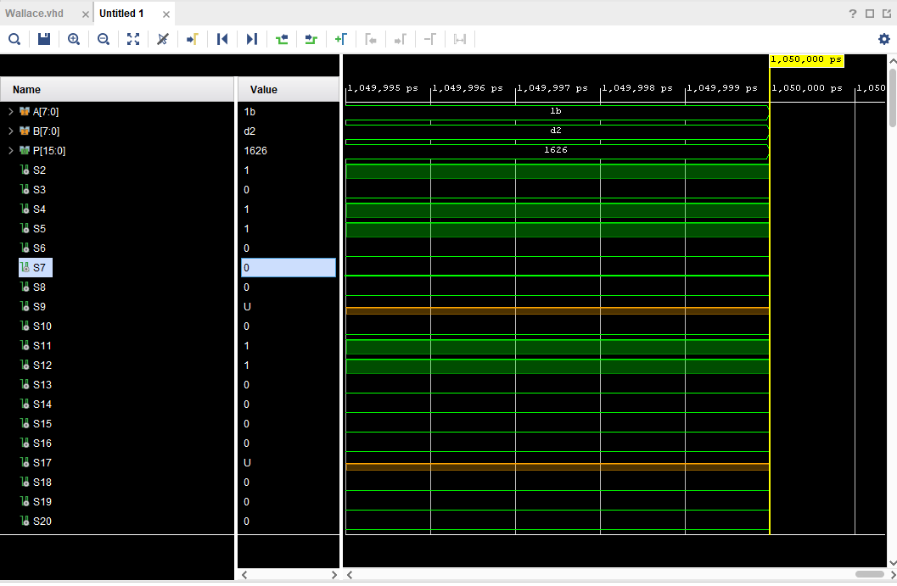
Figure 13 - Wallace Tree Behavioural systems (1BxD2)
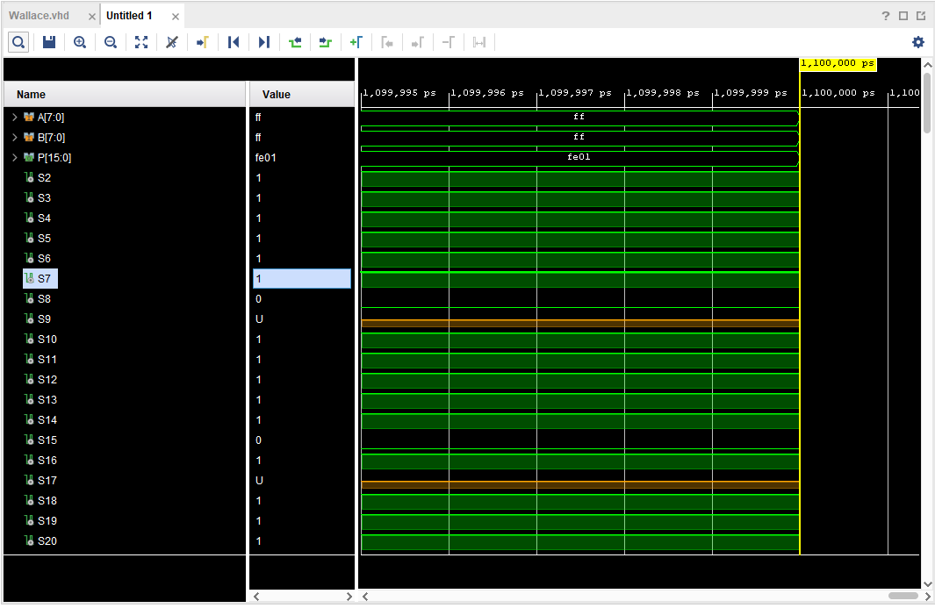
Figure 14 - Wallace Tree Behavioural systems (FFxFF)
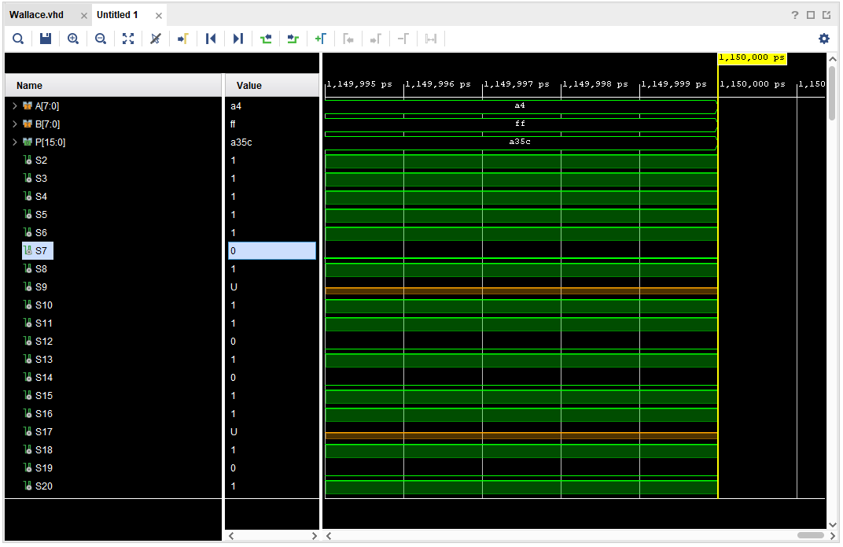
Figure 15 - Wallace Tree Behavioural systems (A4xFF)
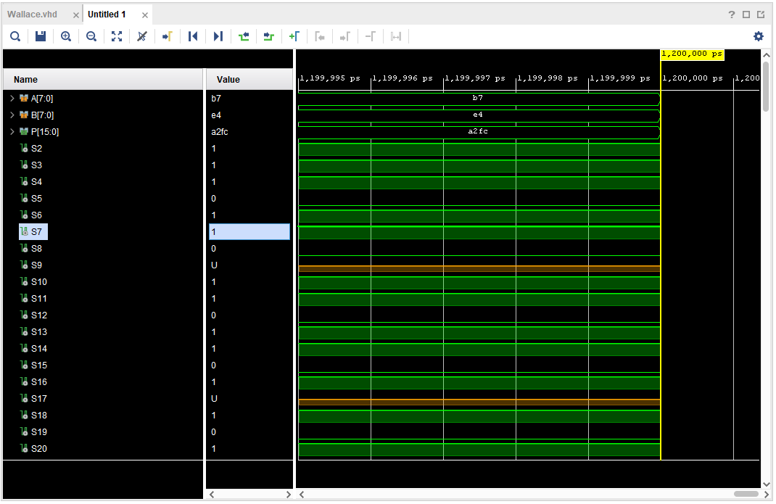
Figure 16 - Wallace Tree Behavioural systems (B7xE4)

Wallace Tree RTL Design
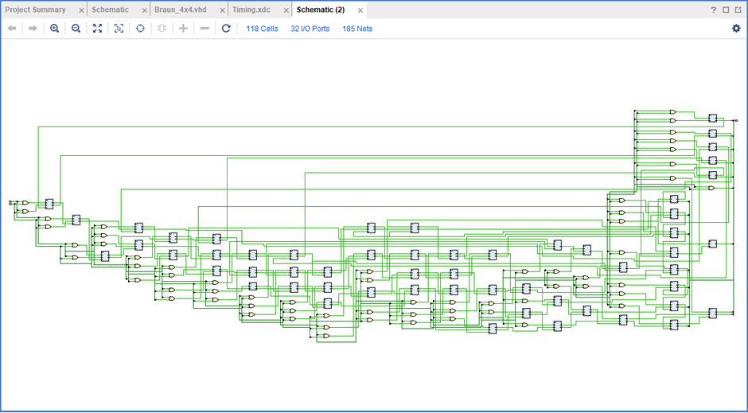
Figure 17 - Wallace Tree RTL Design

Wallace Schematic
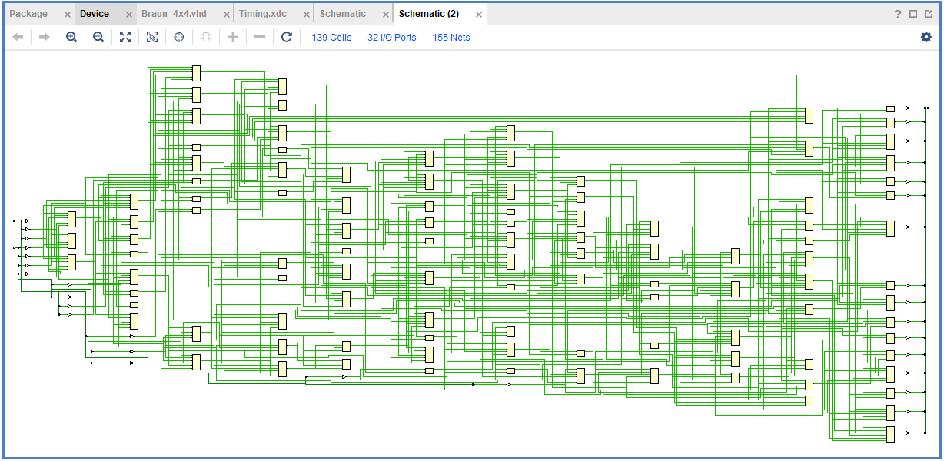
Figure 18 - Wallace Tree Implementation Schematic

Wallace Tree Device
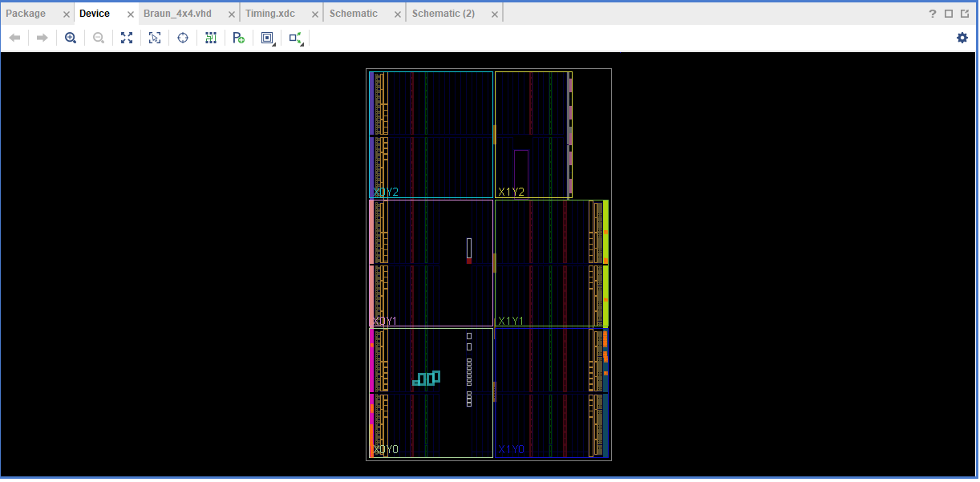
Figure 19 - Wallace Tree Device

Wallace Tree I/O Planning
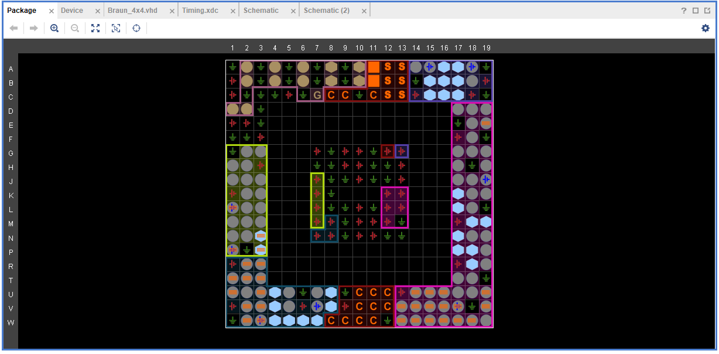
Figure 20 - Wallace Tree I/O Planning

Wallace Tree Timing Constraints
This provides the timing report of the Wallace Tree [Fig 12 & Page 23].
This shows that the worst negative slack is 12.040ns. This shows that there is no timing violation indicating that the shortest path still has 12.04 ns of margin.
The total negative Slack is equal to 0 ns. This is the sum of all negative slack within the design which because it is 0 ns, there are no timing violation in any path of the design.
This shows that the Wallace Tree design meets all setup timing constraints.
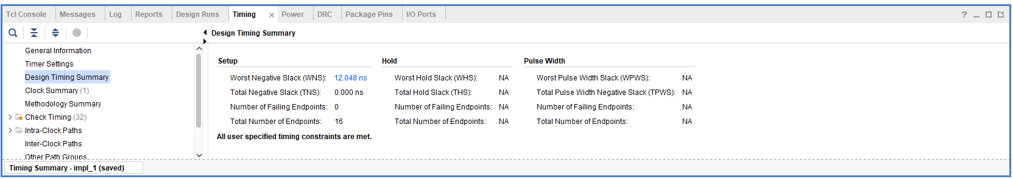
Figure 21 - Wallace Tree Timing Constraints

To work out the critical path of the Wallace 8x8. It is assumed that AND gate delay is $t_{g}=1ns$ and the $n$ adder delay (full adder and half adder) is $t_{ad}=2ns [14]$.
Critical Path = $1ns$ + 7($2ns$)+7($2ns$)
Critical Path = 29ns
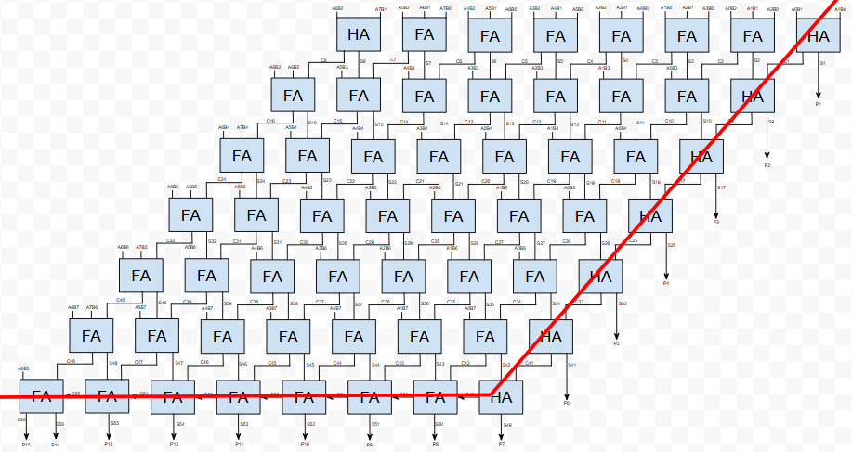
Figure 22 - Wallace Critical Diagram
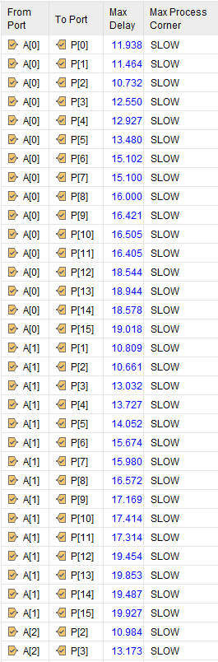
Figure 23 - Port Delay 1
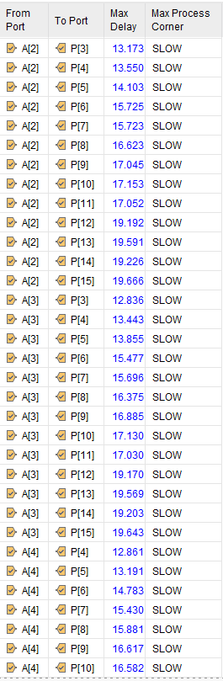
Figure 24 - Port Delay 2
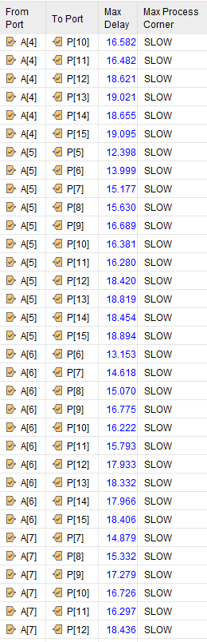
Figure 25 - Port Delay 3
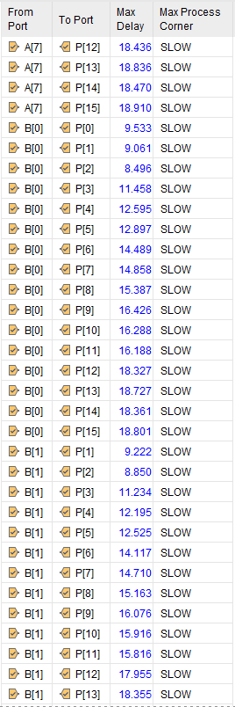
Figure 26 - Port Delay 4
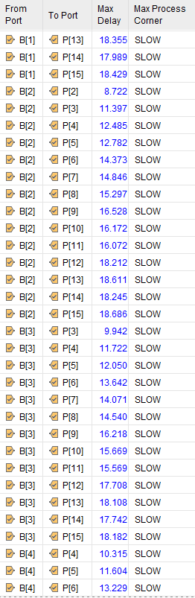
Figure 27 - Port Delay 5
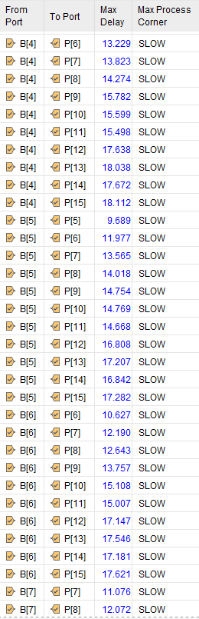
Figure 28 - Port Delay 6
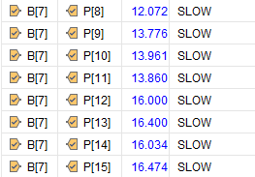
Figure 29 - Port Delay 7

Report Utilization
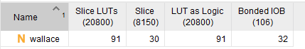
Figure 30 - Report Utilization
Table 5 - Report Utilization Summary
Report Utilization Summary
Section | Value | Explanation
Slice LUTs | 91 | Uses 91 LUTs. Basic building blocks within the FPGA which are used to implement the logic. This compares the LUTs used to those available
Slice | 30 | The number of slices used each slice contains LUTs and flip-flops. This is extremely low as there is 30 out of 8150.
LUT as Logic | 91 | Confirmation that all 91 LUTs are used for combinational logic
Bonded IOBs | 32 | Input/Output blocks that are used for interfacing the design with external pins.

This shows that the Wallace tree is resource efficient and consistent. The 32 I/O’s shows that it is perfectly aligned with the input/output size of an 8x8 binary multiplier.

Project Summary
This section [Fig 14 & 15] summarizes the Wallace Tree 8x8 design, showing the efficient resource usage, which is 1% LUTs, 30% I/Os. That the design meets all timing constraints with 12.04 ns whilst consuming 0.081 W power. This shows a well efficient and low power design which is capable of support high speed applications.
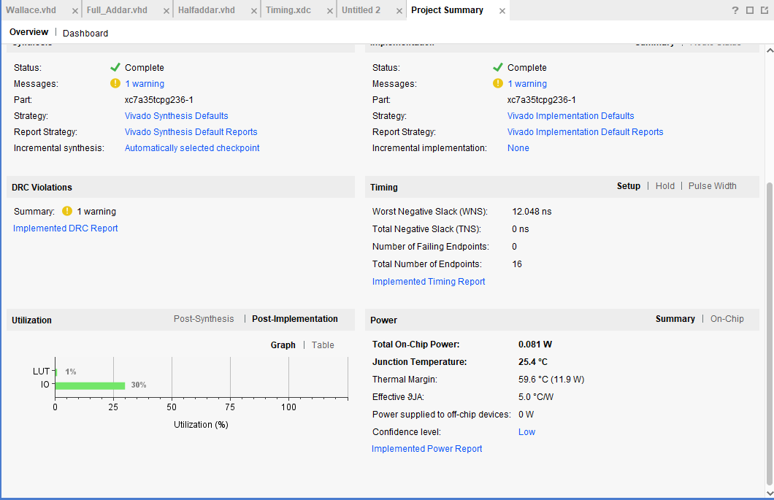
Figure 31 - Project Summary

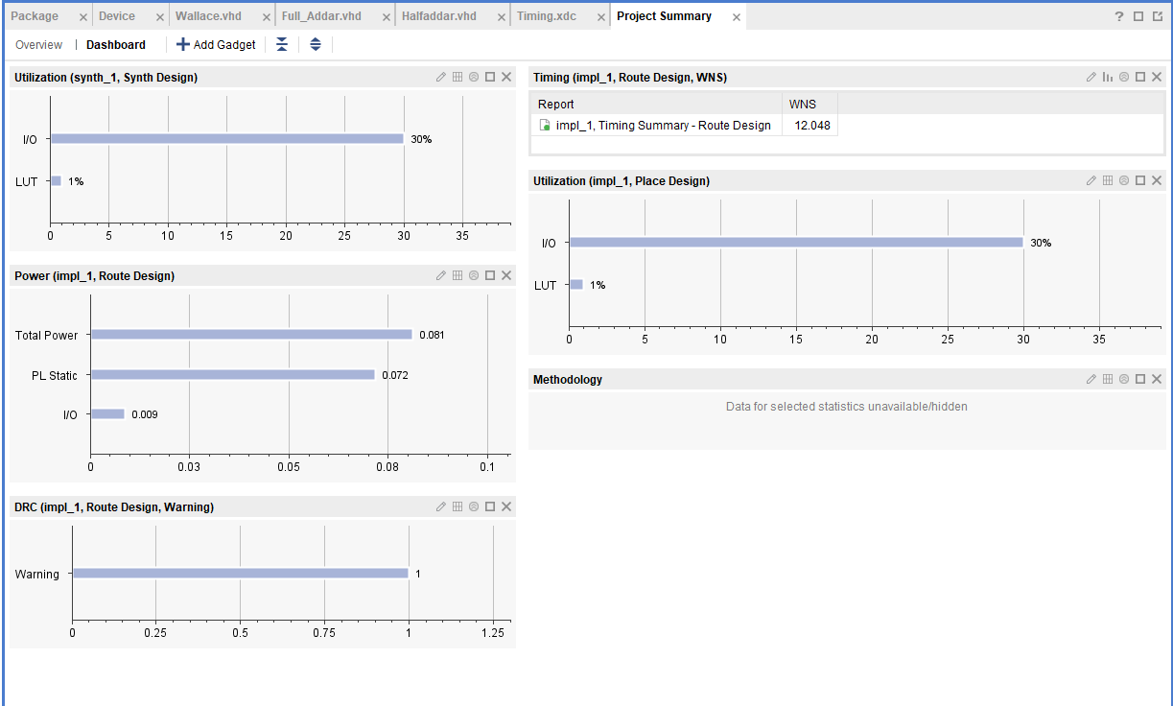
Figure 32 - Utilization (Synth & Place Design), Power, Timing

Power Report
The power report [Fig 16] shows that the wallace tree is well below its 2W budget by only consuming 0.081W. 88% of power being static and the I/O accounting for 93% of the dynamic power at 0.002W. Providing an efficient and low power design.
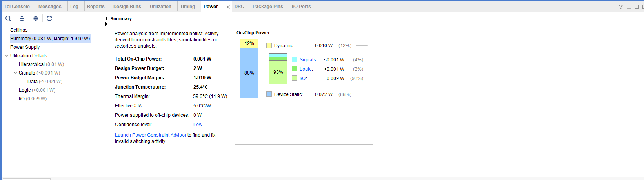
Figure 33 - Power Report

Wallace I/O Port
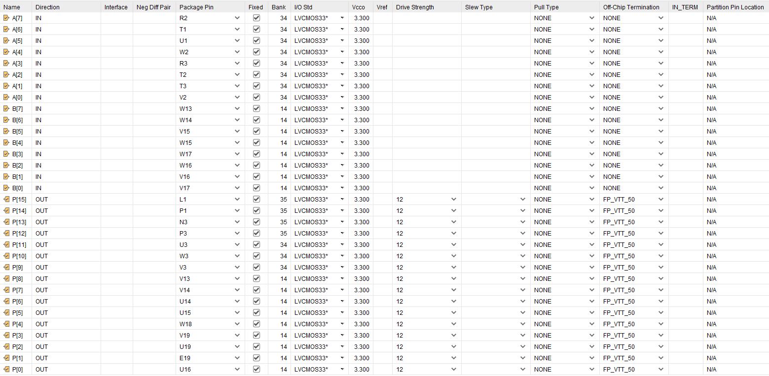
Figure 34 - Wallace I/O Port

Brauns Multiplier Simulation Screenshots through VIVADO

Brauns Multiplier Simulation
Explanation provided in section 7.1.
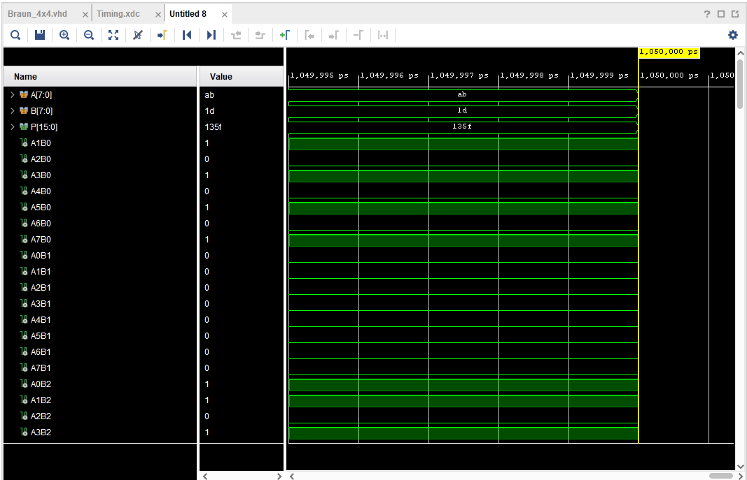
Figure 35 - Brauns Multiplier Behavioural systems (ABx1D)
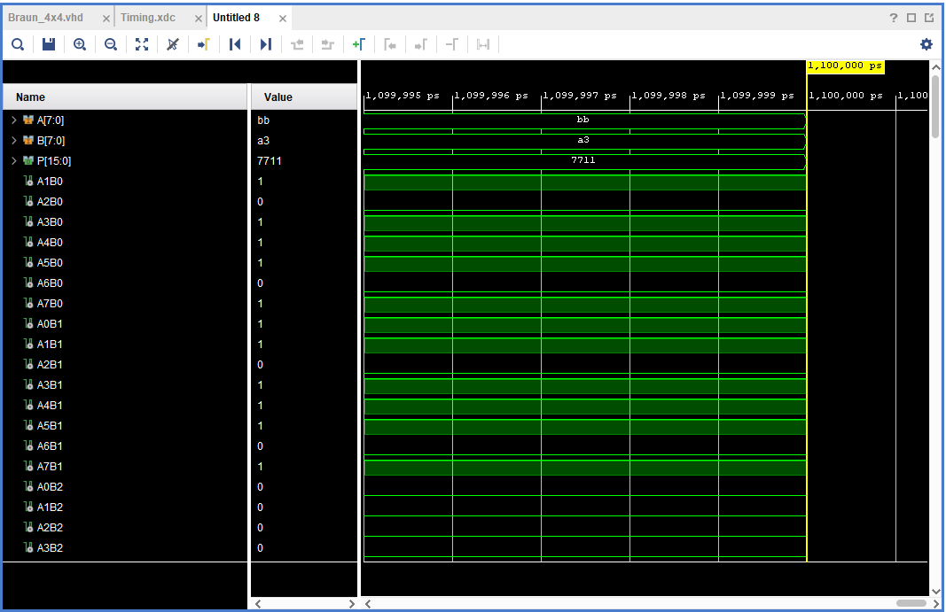
Figure 36 - Brauns Multiplier Behavioural systems (BBxA3)
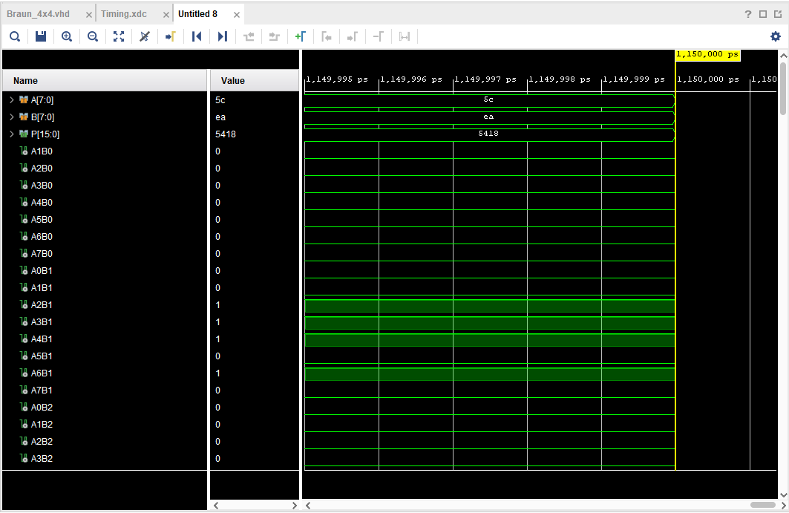
Figure 37 - Brauns Multiplier Behavioural systems (5CxEA)
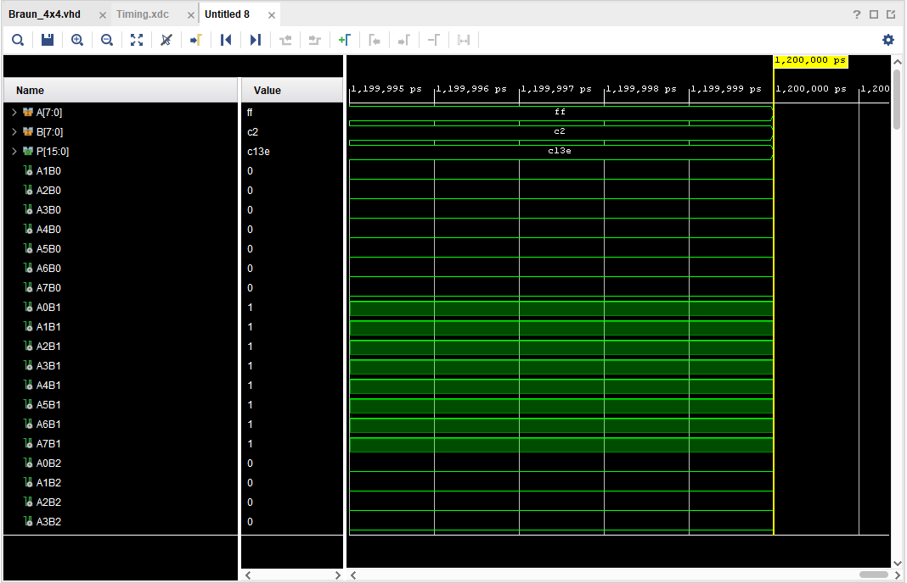
Figure 38 - Brauns Multiplier Behavioural systems (FFxC2)

Brauns Multiplier RTL
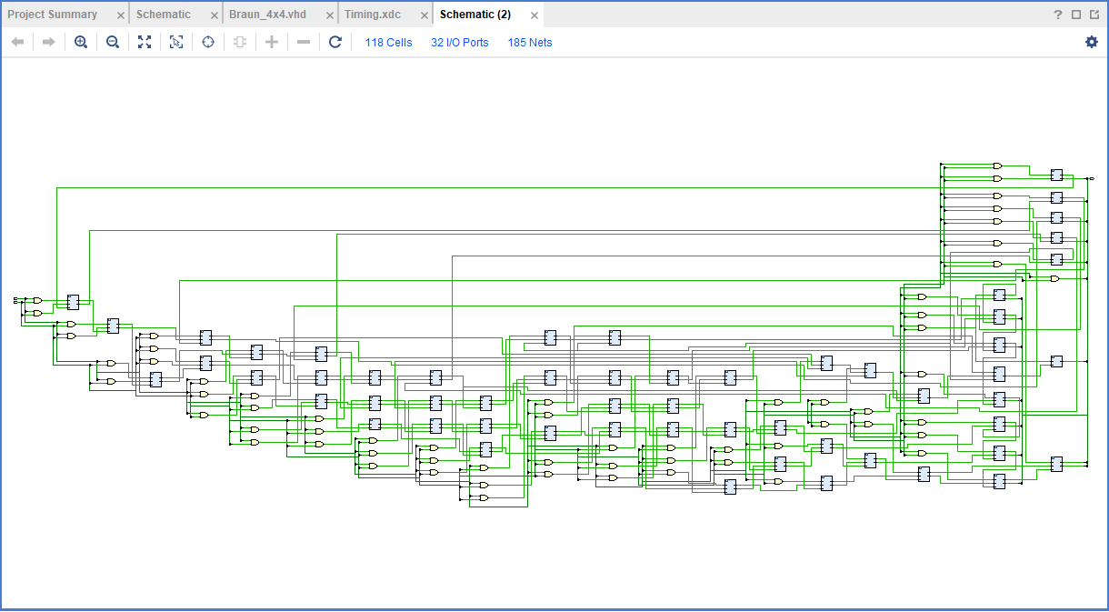
Figure 39 - Brauns Multiplier RTL

Brauns Multiplier Schematic
Figure 40 - Brauns Multiplier Schematic

Brauns Multiplier Device
Figure 41 - Brauns Multiplier Device

Brauns Multiplier I/O Planning
Figure 42 - Brauns Multiplier I/O Planning

Brauns Multiplier Timing Constraints
- Worst Negative Slack (WNS): 14.713 ns – Excellent timing margin.
- Total Negative Slack (TNS): 0.000 ns – No timing violations.
- Failing Endpoints: 0 of 16 – All timing paths meet constraints
The Brauns 8x8 meets all timing constraints with no pulse width or hold violations reported – showing a well timed design which is suitable for low-end speed digital applications.
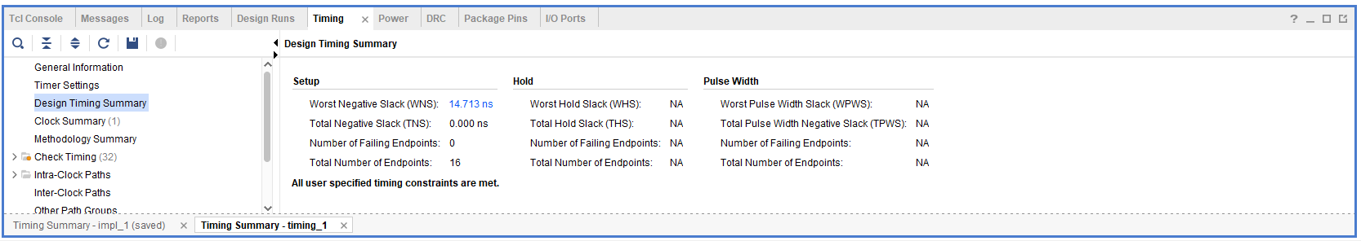
Figure 43 - Brauns Multiplier Timing Constraints

Using the same equation as the Wallace tree (Section 7.5) the below shows the Brauns Critical Path.
Critical Path = $1ns$ + 7($2ns$)+13($2ns$)
Critical Path = 41ns

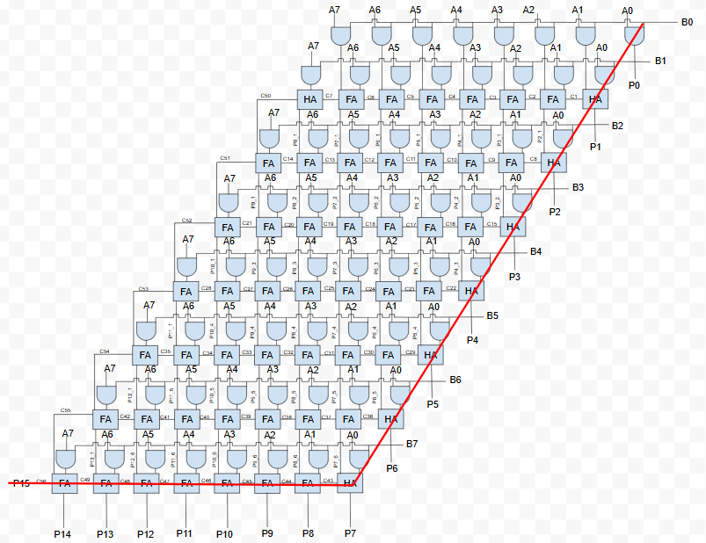
Figure 44 - Brauns Critical Path
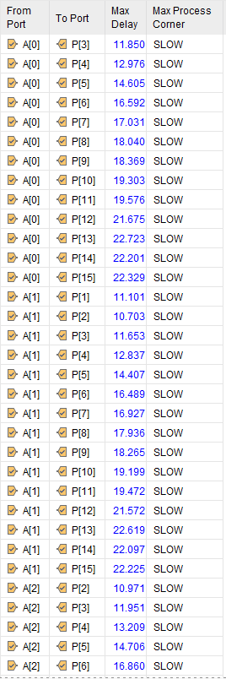
Figure 45 - Brauns Port Delay 1
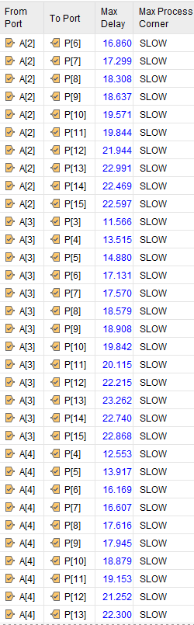
Figure 46 - Brauns Port Delay 2
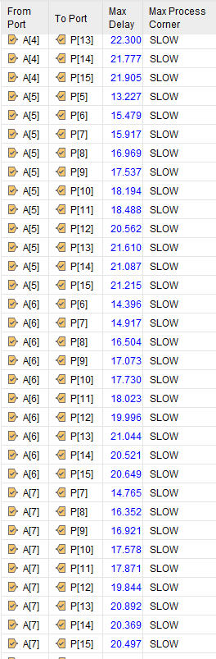
Figure 47 - Brauns Port Delay 3
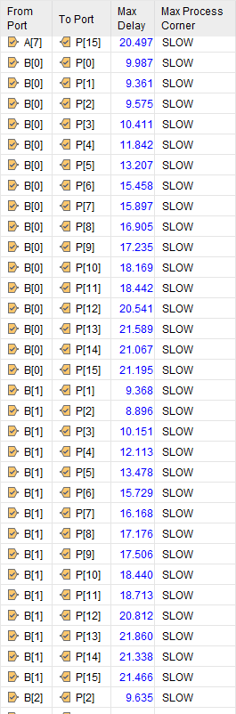
Figure 48 - Brauns Port Delay 4
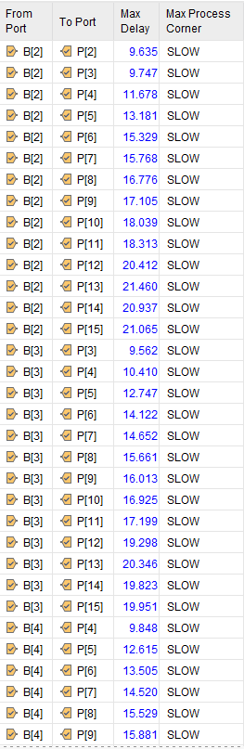
Figure 49 - Brauns Port Delay 5
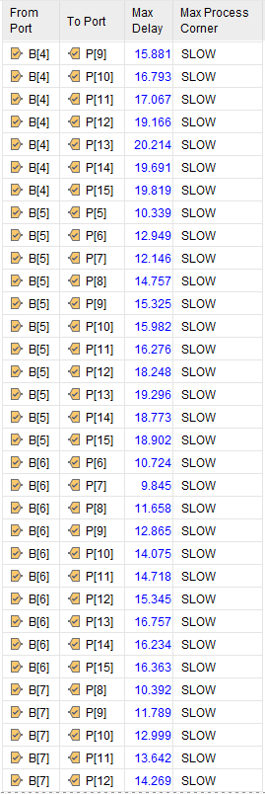
Figure 50 - Brauns Port Delay 6
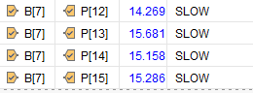
Figure 51 - Brauns Port Delay 7

Brauns Multiplier Report Utilization
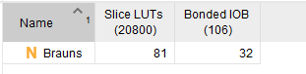
Figure 52 - Brauns Multiplier Report Utilization
The Brauns Multiplier is using 81 out of 20,800 LUTs. Equating to 0.39% of the available LUTs. 32 Ios are used in the 8x8 which is 30.2% of its capacity (106). Meaning that it is lightweight in logic but I/O-intensive.

Brauns Multiplier Report Summary
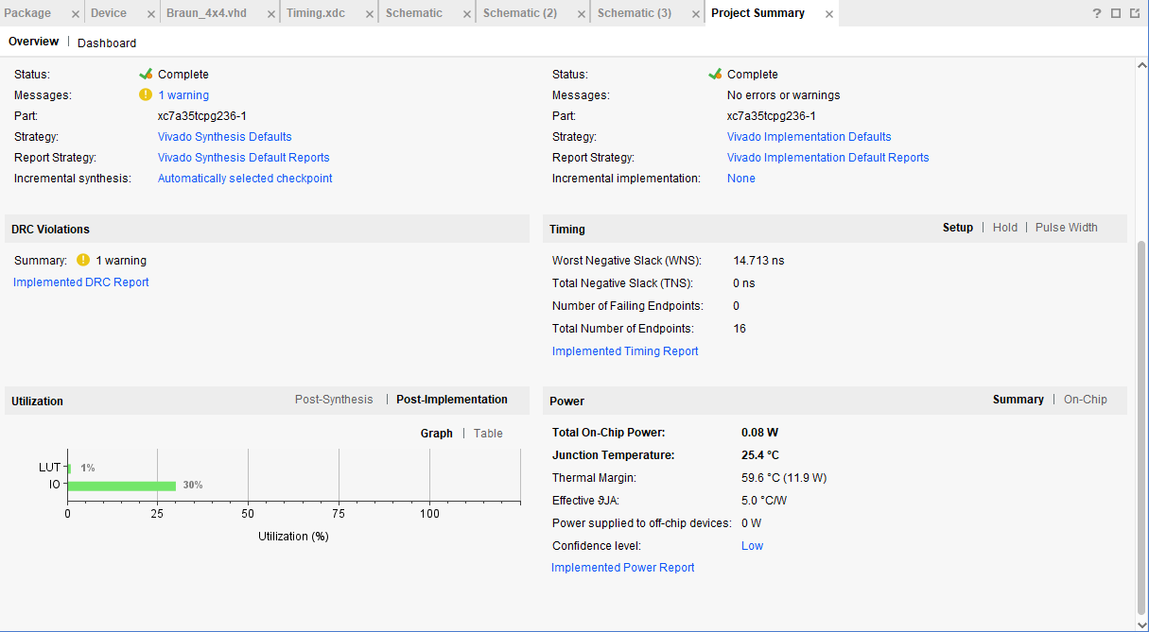
Figure 53 - Brauns Multiplier Report Summary
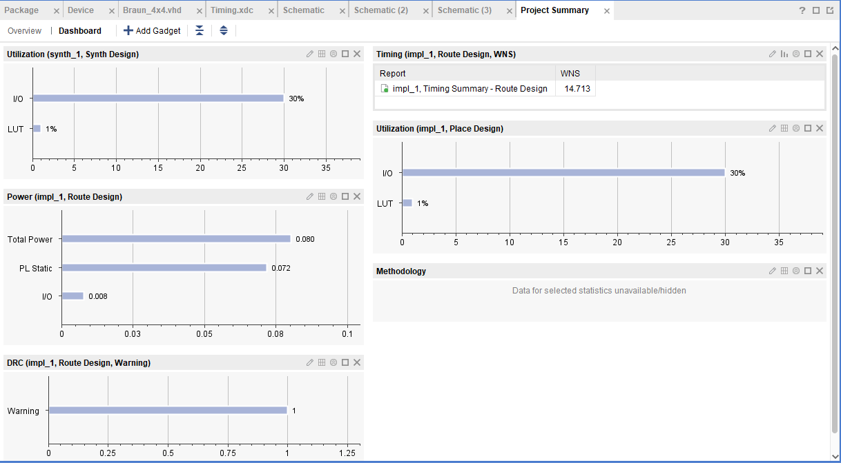
Figure 54 - Brauns Utilization (Synth & Place Design), Power, Timing
The report shows a successful synthesized and implementation of the 8x8 Brauns with no critical errors. The logic utilization is minimal due to using just 1% of slice LUTs , I/O usage is higher at 30%, indicating significant external connectivity. The WNS shows to be 14.713 ns meeting the timing comfortably. The power consumption is low at 0.08W and a safe thermal margin. No timing violation or failed endpoints were reported. It shows that the design is efficient in logic, meets timing and operates well within thermal and power limits.

Power Report
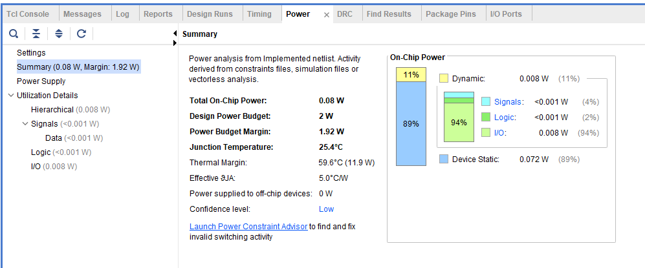
Figure 55 - Brauns Multiplier Power Report
The report shows that the design leaves a 1.92W margin. Most of the power is 89% static and 11% dynamic which is split between logic signal and I/O ports. Overall, this provides a very power efficient and thermal safe device.

Braun Multiplier I/O
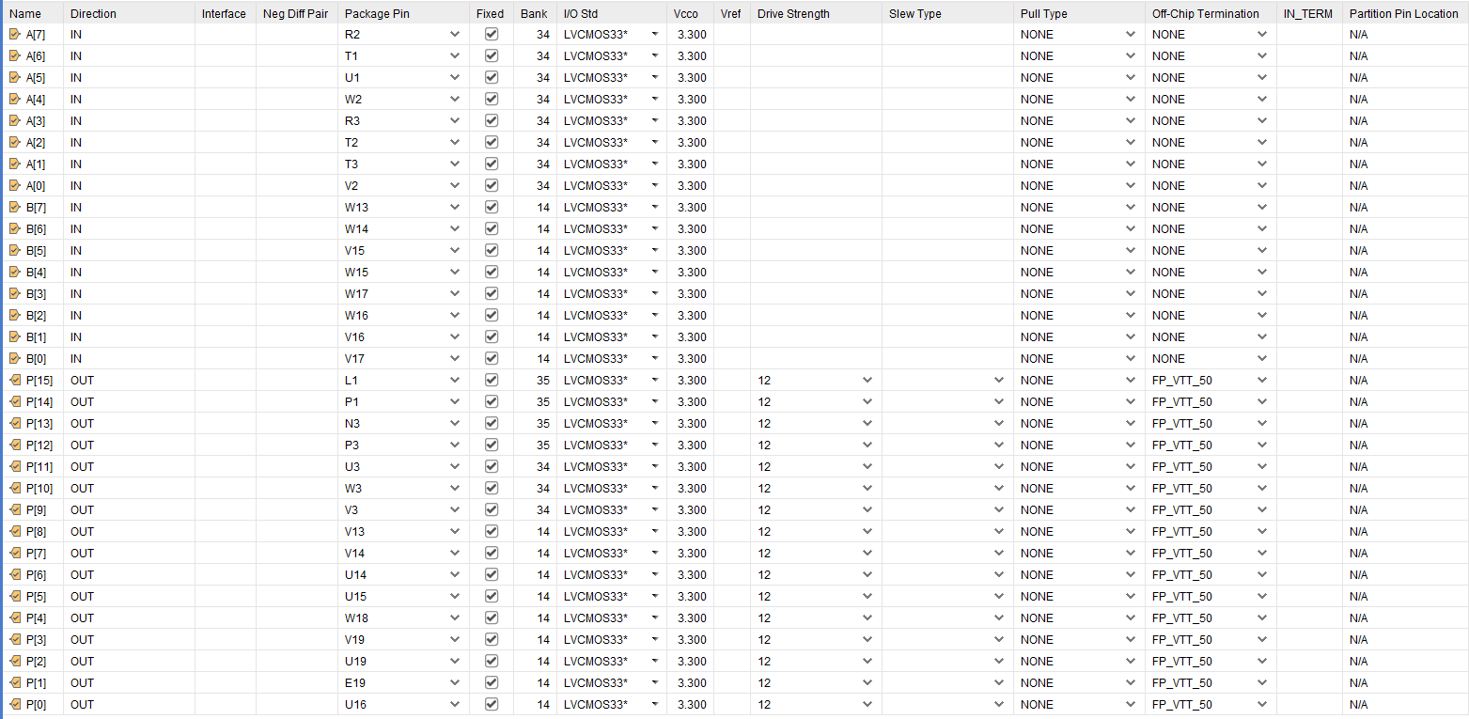
Figure 56 - Brauns Multiplier I/O Port

Conclusion
After designing, implementing and analysing both the Brauns 8x8 and Wallace Tree 8x8 multipliers using VHDL and Vivado, it’s clear that each design has its strengths depending on the system requirements.
The Brauns multiplier uses a regular and simple array structure. It relies on AND gates for generating partial products and a structured grid of adders to sum them row by row. This gives it a very predictable layout, which is reflected in its low logic utilisation – using just 81 LUTs, or 0.39% of available resources. Although it's slower than Wallace, with a critical path delay of 41 ns, it meets all timing constraints with a WNS of 14.713 ns and TNS of 0 ns, meaning it operates reliably. It also has a very low power draw of 0.08W, with 89% static and 11% dynamic power, making it ideal for area-constrained and power-sensitive applications like embedded systems or fixed-point arithmetic units.
On the other hand, the Wallace Tree multiplier was designed for speed and performance. By using a carry-save adder tree to reduce partial products in parallel, it avoids the carry propagation delay seen in Brauns. This design shows a critical path of just 29 ns, with a WNS of 12.04 ns, it also passes all timing checks with 0 TNS and no failing endpoints. The design still only uses 1% of logic resources (91 LUTs) and maintains low power consumption (0.081W). Most of the dynamic power comes from the I/O (93%), suggesting it supports high data throughput, which is expected in high-speed applications. With its faster execution, it’s more suited for DSP, cryptography, or high-speed processors.
In conclusion, Brauns is more efficient in layout, area and power, while Wallace is optimised for speed and high-performance tasks. The right choice depends on the system you're designing for. If timing and speed are critical, then the Wallace Tree is clearly the better option. If power, simplicity and resource usage are more important, then Brauns is the more appropriate solution.

References
[1] D. Harris and S. Harris, *Digital Design and Computer Architecture*, 2nd ed. Morgan Kaufmann, 2012.
[2] S. Palnitkar, *Verilog HDL*, 2nd ed. Pearson, 2003.
[3] A. Kumar and R. Raj, 'Low Power Multiplier Designs in VLSI: A Review', *IJCA*, vol. 96, no. 17, 2014.
[4] B. Parhami, *Computer Arithmetic: Algorithms and Hardware Designs*, 2nd ed. Oxford University Press, 2010.
[5] C. S. Wallace, 'A Suggestion for a Fast Multiplier', *IEEE Trans. Comput.*, vol. C-13, no. 1, pp. 14–17, 1964.
[6] N. Weste and D. Harris, *CMOS VLSI Design*, 4th ed. Addison-Wesley, 2010.
[7] Xilinx, 'Vivado Design Suite User Guide: Power Analysis and Optimization', UG907, v2020.1.
[8] P. Ashenden, *The Designer’s Guide to VHDL*, 3rd ed. Morgan Kaufmann, 2008.
[9] A. M. Shams and M. Bayoumi, 'A novel high-performance CMOS 1-bit full-adder cell', *IEEE Trans. VLSI Syst.*, vol. 10, no. 1, pp. 20–29, 2002.
[10] R. Zimmermann and W. Fichtner, 'Low-power logic styles: CMOS versus pass-transistor logic', *IEEE JSSC*, vol. 32, no. 7, pp. 1079–1090, 1997.
[11] K. K. Parhi, *VLSI Digital Signal Processing Systems: Design and Implementation*, Wiley, 1999.
[12] M. D. Ercegovac and T. Lang, *Digital Arithmetic*, Morgan Kaufmann, 2003.
[13] Y. Kim et al., 'An energy-efficient VLSI architecture for real-time motion estimation', *IEEE Trans. Circuits Syst. Video Technol.*, vol. 19, no. 2, 2009.
[14] M. Bhunia and A. Raychowdhury, 'A high-speed Wallace-tree multiplier using modified Booth encoding', *Proc. IEEE VLSI Design*, pp. 112–117, 2005.

