

Assessment 1
Supporting Paper

Student name: Harriet Erhere Akpojotor
Student ID: 2020979
Module name: Mental Disorders and Psychopathology
Chosen disease: Dementia in Alzheimer's Disease
Module code: BMHP6006
Lecturer name: Bianca Sanfilippo
Date: 27/04/2023

TABLE OF CONTENT
Introduction/Definition........................................................................................3 Causes...............................................................................................4 Symptoms/Signs................................................................................4 Diagnosis.............................................................................................5
Historical View and Treatment.............................................................5
Current Treatments (NHS)…................................................................6
Principles when working with people with Alzheimer's Disease……………6
Conclusion/Recommendation................................................................6 and 7 References..............................................................................................8
Appendix..............

Introduction
The subject of this report is Alzheimer's disease. Alzheimer's disease is described along with its definition, ICD-10 classification, causes, symptoms, diagnosis, and past and present therapies. Additionally, guidelines for treating patients with Alzheimer's disease with respect and suggestions for enhancing this condition.

Definition
The hallmark neuropathological features of Alzheimer's disease are the accumulation of extracellular amyloid beta (Aβ) plaques and intracellular neurofibrillary tangles (NFTs) in the brain, which lead to the death of neurons and synapses (Soria Lopez, González and Léger 2019). Aβ is derived from the cleavage of the amyloid precursor protein (APP), while NFTs are composed of hyperphosphorylated tau protein.
The precise aetiology of Alzheimer's disease remains unclear, although it is believed to result from a complex interplay between genetic, environmental, and lifestyle factors (Soria Lopez, González and Léger 2019). There is also evidence to suggest that neuroinflammation, oxidative stress, and mitochondrial dysfunction contribute to disease pathogenesis.
Alzheimer's disease is the most common cause of dementia, accounting for 60-80% of all cases. In Alzheimer's disease, dementia is characterized by progressive cognitive decline, particularly in memory, language, and visuospatial function (Breijyeh and Karaman 2020). Behavioral changes, such as depression and anxiety, are also common.

Alzheimer's disease is classified as an organic, including symptomatic, mental condition (F00-F09 and in F00) in the ICD-10 manual.

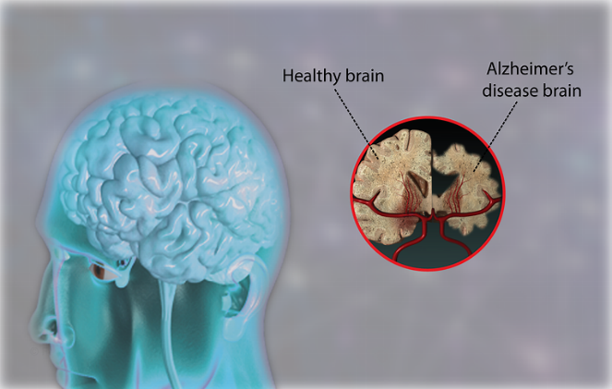

Causes
Alzheimer’s disease is caused by the abnormal build-up of proteins in and around the brain cell (NHS)
According to Breijyeh and Karaman (2020) It is the alteration in amyloid β-protein production and processing.
The posterior region of the brain atrophys (shrines) because of Alzheimer's disease. Amyloid plaques, aberrant protein deposits that harm and kill brain cells, are present in the affected brain tissue.
Neurofibrillary tangles: Tau, a protein, is necessary for the healthy structure and operation of brain cells. In brain cells with Alzheimer's disease, tau protein threads coil abnormally, killing the brain cells.
The following elements are known to raise the likelihood of developing the condition:
advancing age
genealogy and genetics
Dwarf Syndrome
head trauma
past head injuries
minimal brain impairment (Abhimanyu Chandak, 2023)

Symptoms/signs
Alzheimer's disease signs develop gradually over several years. These symptoms can occasionally be mistaken for those of other illnesses and first attributed to getting older.
Alzheimer's disease symptoms are typically broken down into three distinct stages.
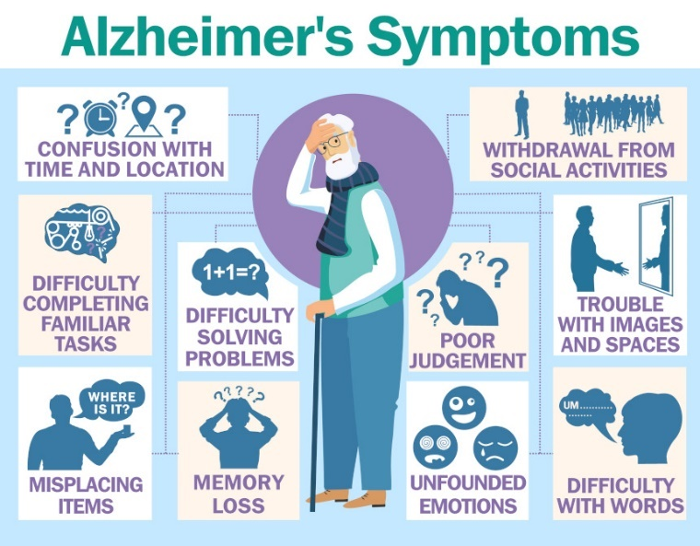 (NHS)
Diagnosis
An in-depth examination of the patient's medical history is necessary for the diagnosis of Alzheimer's disease.
inspection of the body
examining the patients' reflexes, their strength and muscle tone, their ability to stand up from a chair and walk across the room.
neurological testing
Check your balance, coordination, and senses of hearing and sight.
CBC, or a complete blood count
To examine liver capabilities, Electrolyte (sodium, potassium, creatinine, glucose, and calcium) and blood glucose levels, thyroid function tests, and an HIV test (ELISA) are among the other tests that can be performed.
an MRI
To assess the degree of brain ageing, a CT scan of the head is done.
(MRI) Magnetic resonance imaging
A brain MRI scan can provide more specific information about the brain, such as the existence of a tumour or damaged nerves, etc.
EEGs are used to detect aberrant brain wave activity.
Amyloid proteins linked to Alzheimer's disease are found using positron emission tomography (PET). (Abhimanyu Chandak, 2023)

Historical view and treatments
Historically, the care and support for individuals with dementia in Alzheimer's disease were inadequate, and there was a lack of understanding of the disease (Ballenger 2017).
In the 1970s and 1980s, there was growing recognition of the importance of community-based care for individuals with dementia (Ballenger 2017). This led to the development of programs aimed at providing support and assistance to individuals with dementia in their homes and communities.
In the mid-20th century, there was a shift towards more humane treatment of individuals with dementia, with the development of specialized dementia care facilities (Ballenger 2017). However, these facilities were often overcrowded and lacked the resources to provide adequate care for their residents. Furthermore, the stigma associated with dementia persisted, and many families continued to feel ashamed of having a family member with the disease.

Current treatments (NHS)
There’s currently no cure for Alzheimer’s disease. But there is medicine available that temporarily reduce the symptoms. Acetylcholinesterase (AChE) inhibitors and Memantine (Not AChE inhibitor) Memantine is used for moderate or severe Alzheimer's disease. It's suitable for those who cannot take or are unable to tolerate AChE inhibitors. (NHS)
Another important contemporary support option for individuals with dementia in Alzheimer's disease is residential care (Carrarini et al. 2021). This includes care provided in assisted living facilities and nursing homes. Residential care can be especially helpful for individuals with more advanced dementia, who require more specialized care and support. In addition, residential care can provide respite for family members who are caring for a loved one with the disease.
Principles when working with people with Alzheimer’s Disease.
support must be considerate of the individual receiving it. We refer to this as person-centred care. Additionally, assistance should emphasise enhancing their wellness and addressing what they need. It's critical to keep your attention on the person's assets rather than potential losses. Instead of focusing on what they recall, pay attention to how they feel.

The reality that the person with dementia is experiencing could be very different from the one that those around them are experiencing. Try to see things from the person's perspective and pay attention to their coping mechanisms to understand and help the person. (Alzheimers.org.uk)

Conclusion/Recommendations
Early diagnosis and intervention: Early detection of dementia can lead to earlier interventions, which can slow the progression of the disease and improve quality of life (Cognitive, and Sensory Sciences Board on Behavioral et al. 2021). Primary care physicians can play a key role in the early detection of dementia.
Person-centered care: Person-centered care is a holistic approach that considers the individual's preferences, needs, and values when developing a care plan. This approach can improve the quality of care and the quality of life for individuals with dementia.
Caregiver support: Caregivers play a crucial role in the management of dementia, and providing support and resources for caregivers can improve the quality of care and reduce caregiver burden.
Non-pharmacological interventions: non-pharmacological interventions, such as exercise, cognitive stimulation, and social activities, can improve cognitive function and quality of life for individuals with dementia (Cognitive, and Sensory Sciences Board on Behavioral et al. 2021).
Pharmacological interventions: Pharmacological interventions, such as cholinesterase inhibitors and memantine, can be effective in managing symptoms of dementia in Alzheimer's disease.
Research: Continued research is essential for improving the understanding and management of dementia in Alzheimer's disease, including the development of new treatments and interventions

Reference
- Ballenger, J. F., (2017). Framing confusion: dementia, society, and history. AMA Journal of Ethics [online]. 19(7), 713–719. [Viewed 27 March 2023]. Available from: doi: 10.1001/journalofethics.2017.19.7.mhst1-1707
- Breijyeh, Z. and Karaman, R., (2020). Comprehensive review on alzheimer’s disease: causes and treatment. Molecules [online]. 25(24), 5789. [Viewed 27 March 2023]. Available from: doi: 10.3390/molecules25245789
- Carrarini, C., Russo, M., Dono, F., Barbone, F., Rispoli, M. G., Ferri, L., Di Pietro, M., Digiovanni, A., Ajdinaj, P., Speranza, R., Granzotto, A., Frazzini, V., Thomas, A., Pilotto, A., Padovani, A., Onofrj, M., Sensi, S. L. and Bonanni, L., (2021). Agitation and dementia: prevention and treatment strategies in acute and chronic conditions. Frontiers in Neurology [online]. 12. [Viewed 27 March 2023]. Available from: doi: 10.3389/fneur.2021.644317
- Cognitive, and Sensory Sciences Board on Behavioral, Division of Behavioral and Social Sciences and Education, National Academies of Sciences, Engineering, and Medicine and Committee on the Decadal Survey of Behavioral and Social Science Research on Alzheimer's Disease and Alzheimer's Disease-Related Dementias, (2021). Reducing the impact of dementia in america: a decadal survey of the behavioral and social sciences. National Academies Press.
- Soria Lopez, J. A., González, H. M. and Léger, G. C., (2019). Alzheimer's disease. In: Handbook of clinical neurology [online]. Elsevier. pp. 231–255. [Viewed 27 March 2023]. Available from: doi:10.1016/b978-0-12-804766-8.00013-3
- NSH. https://www.nhs.uk/conditions/alzheimers-disease/symptoms
- Molecules, 2020. https://doi.org/10.3390/molecules25245789, Zeinab Breijyeh and Rafik Karaman
- Abhimanyu Chandak. (2023) www.linkedin.com
- Alzheimers.org.uk. www.alzheimers.org.uk

APPENDIX POWER POINT PRESENTATIO

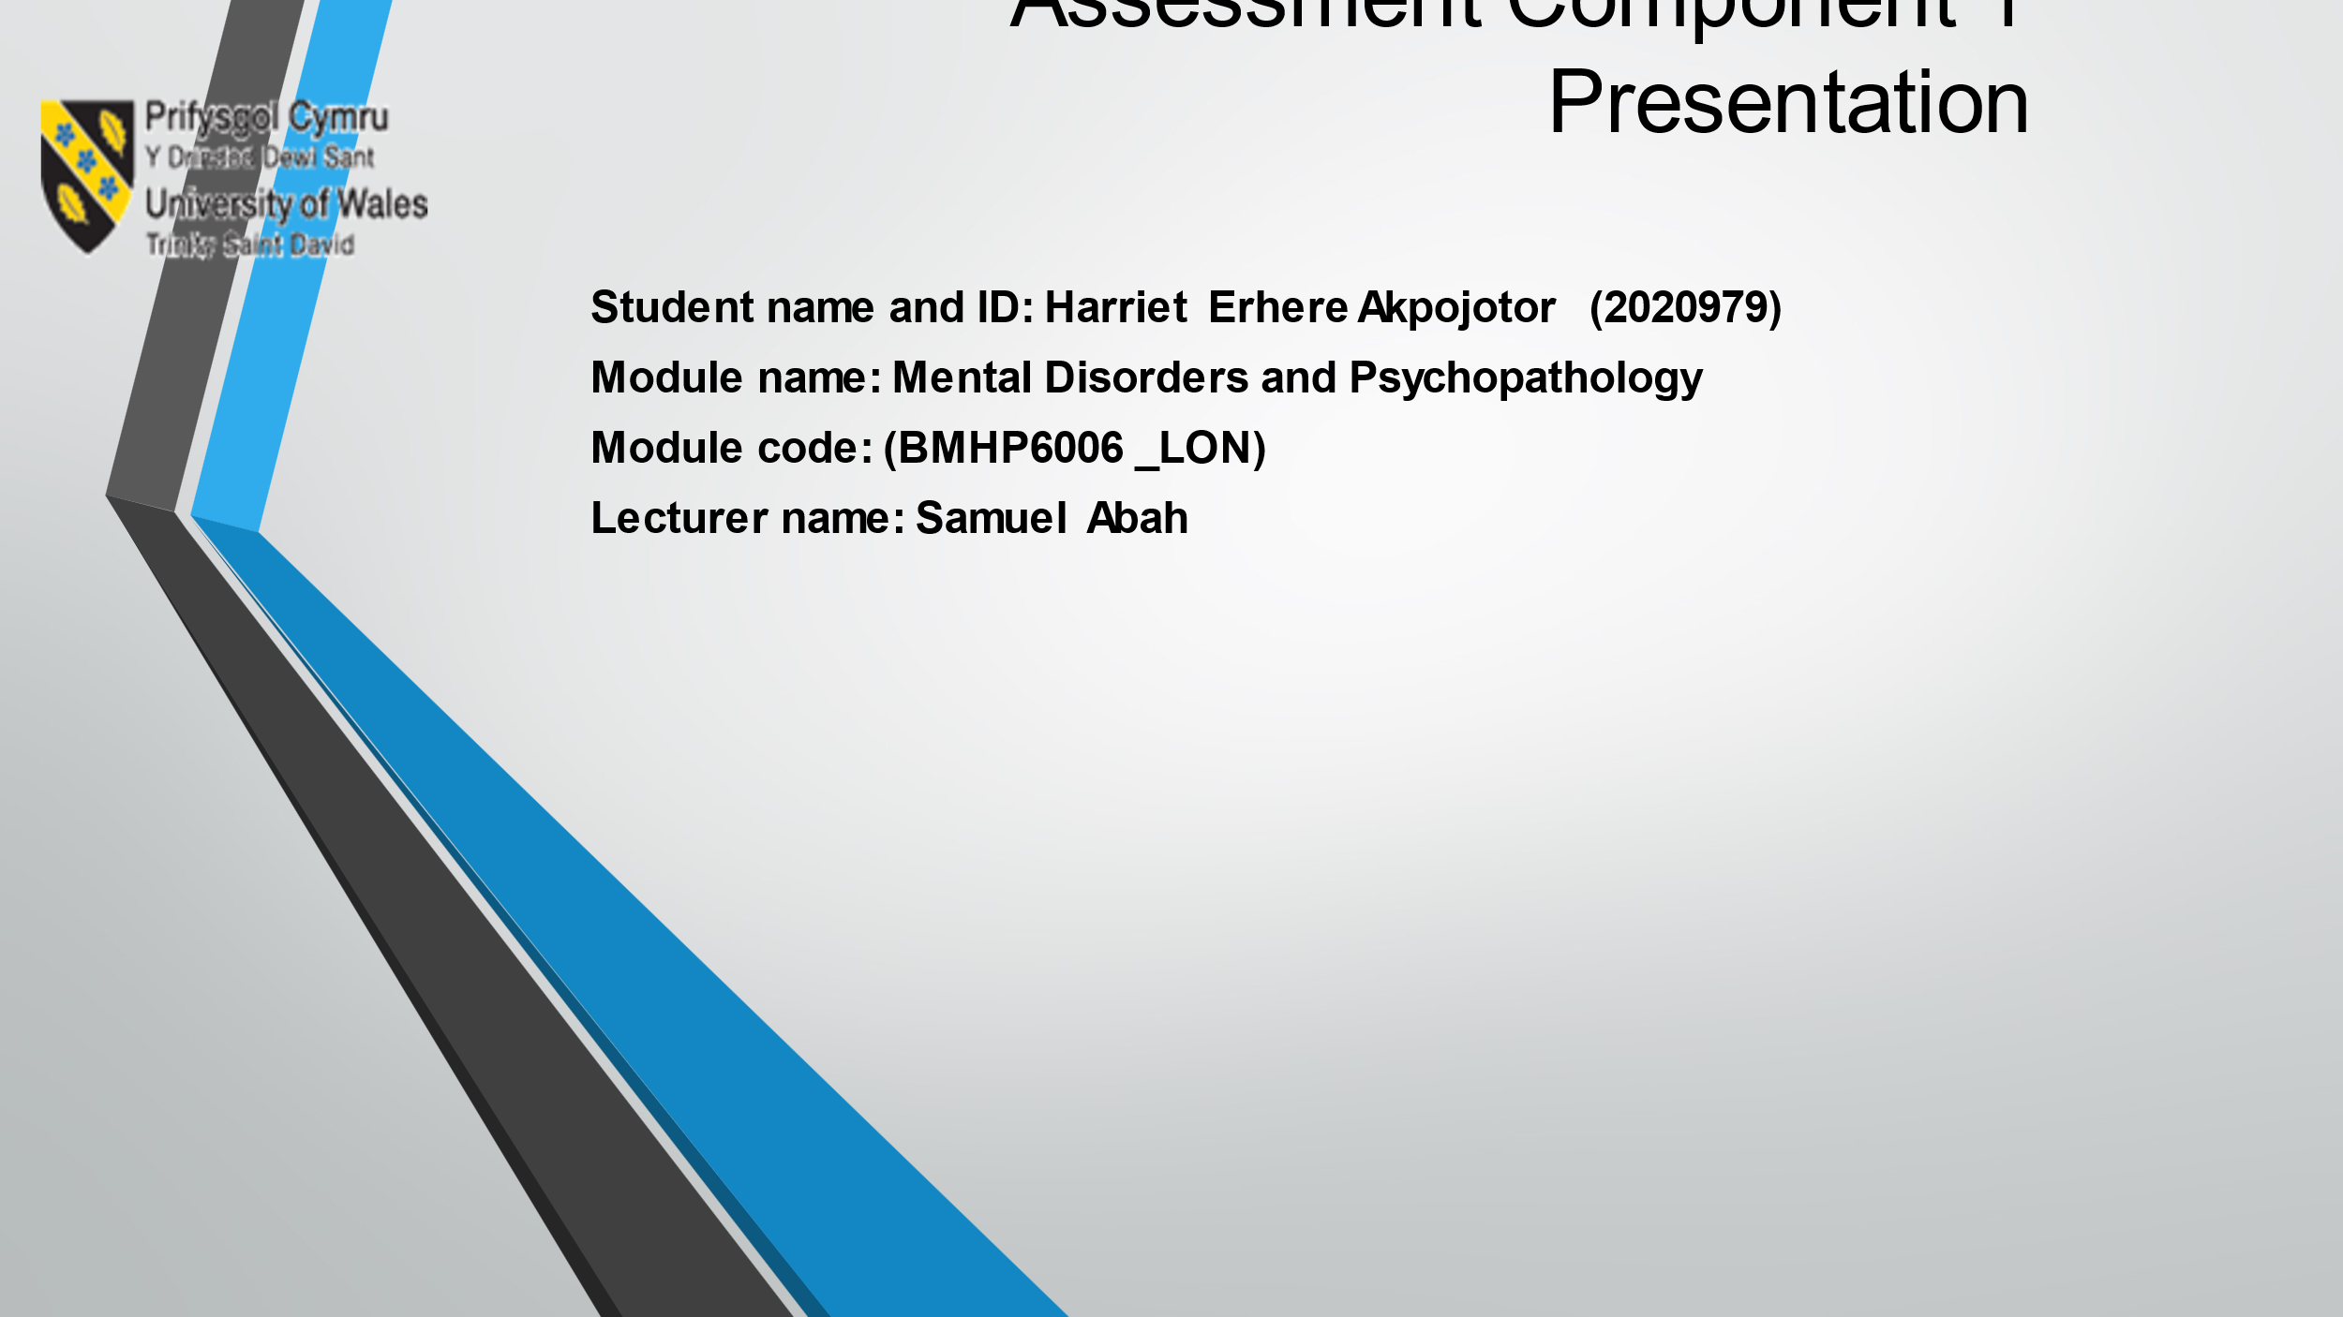

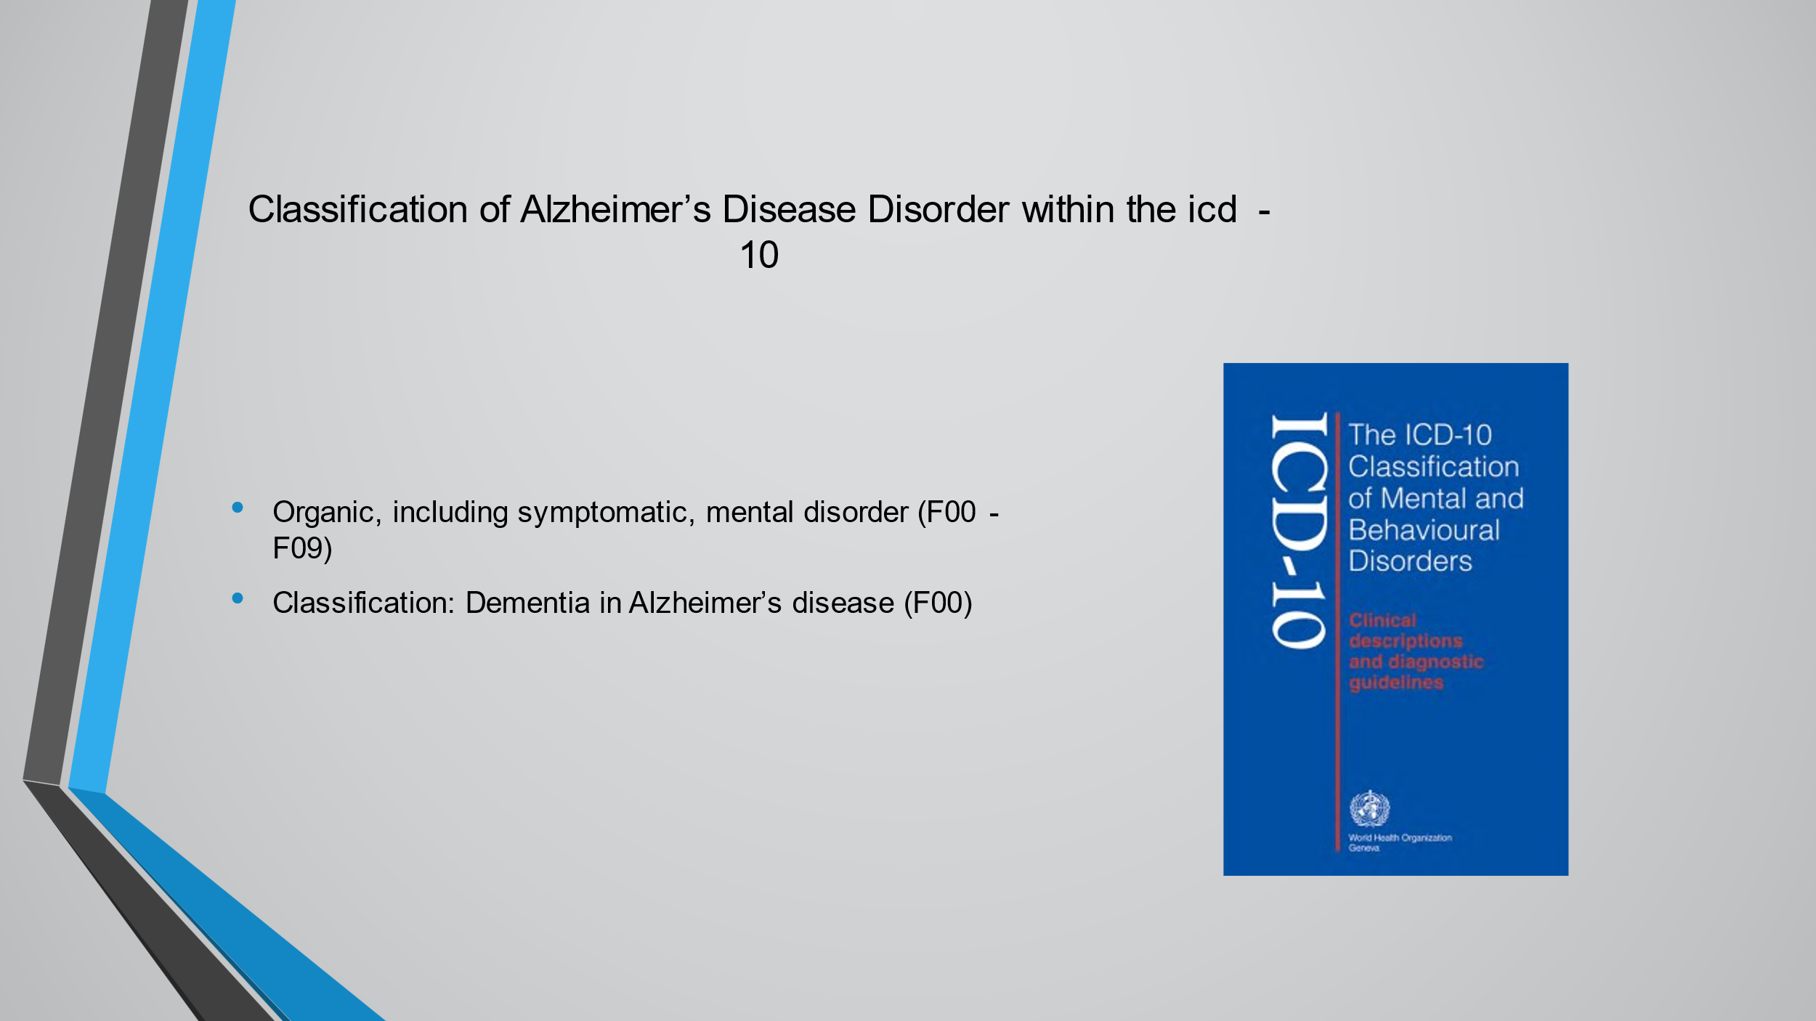
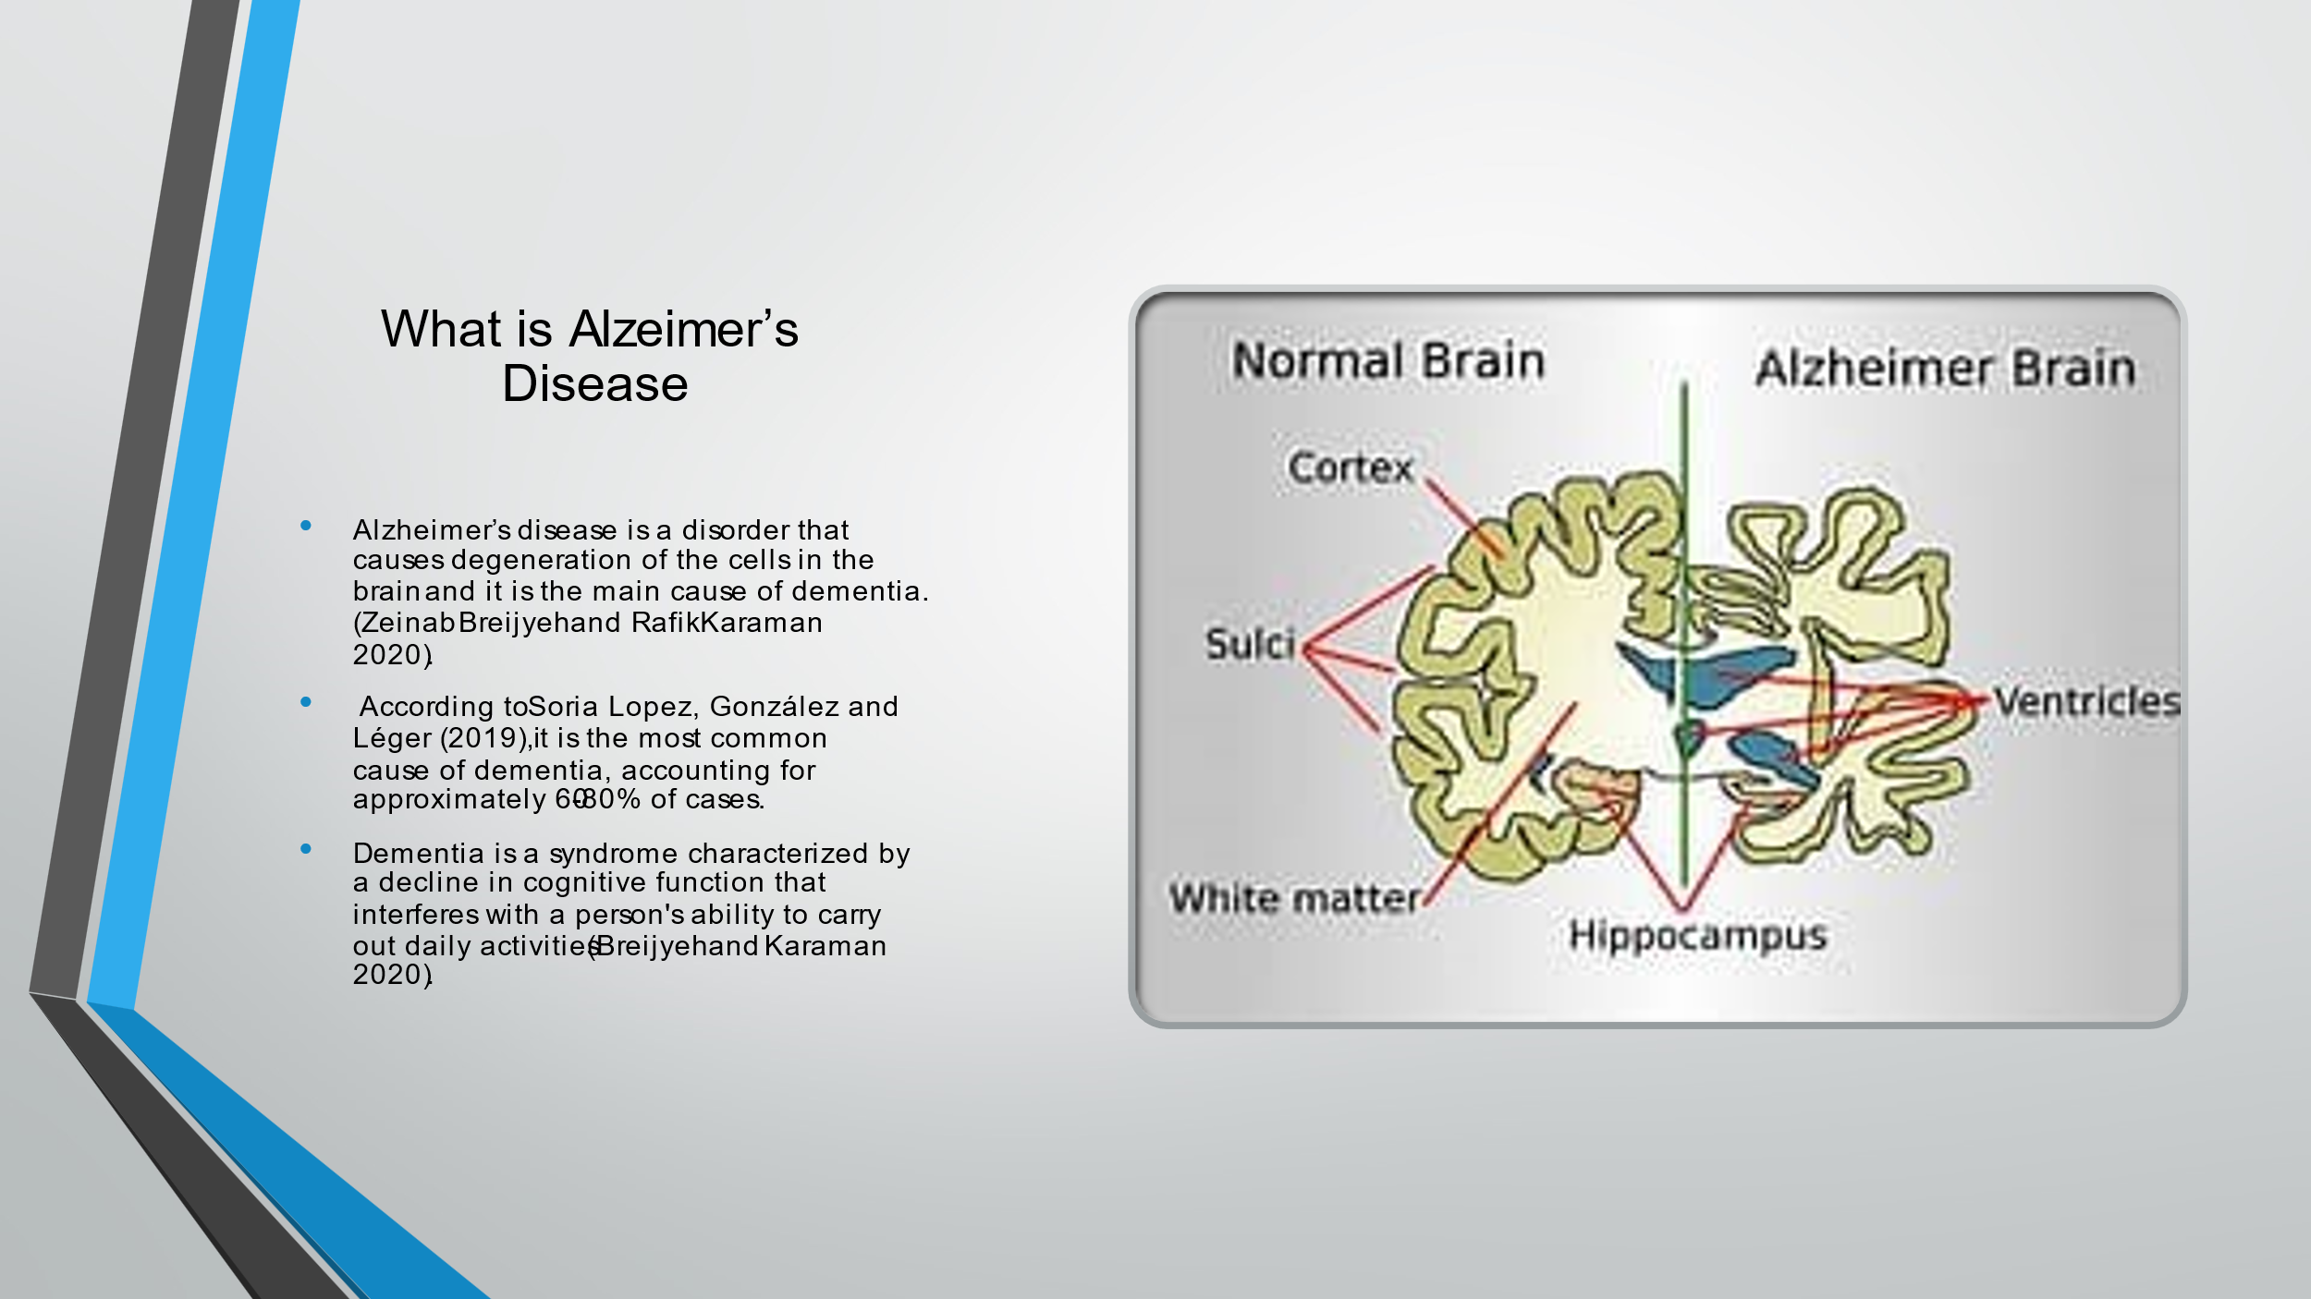

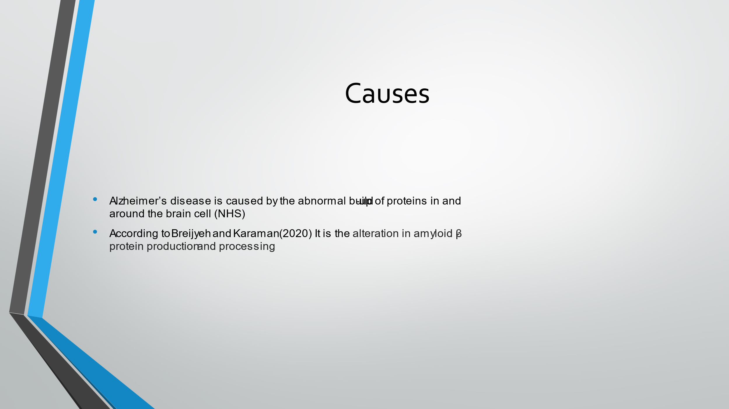

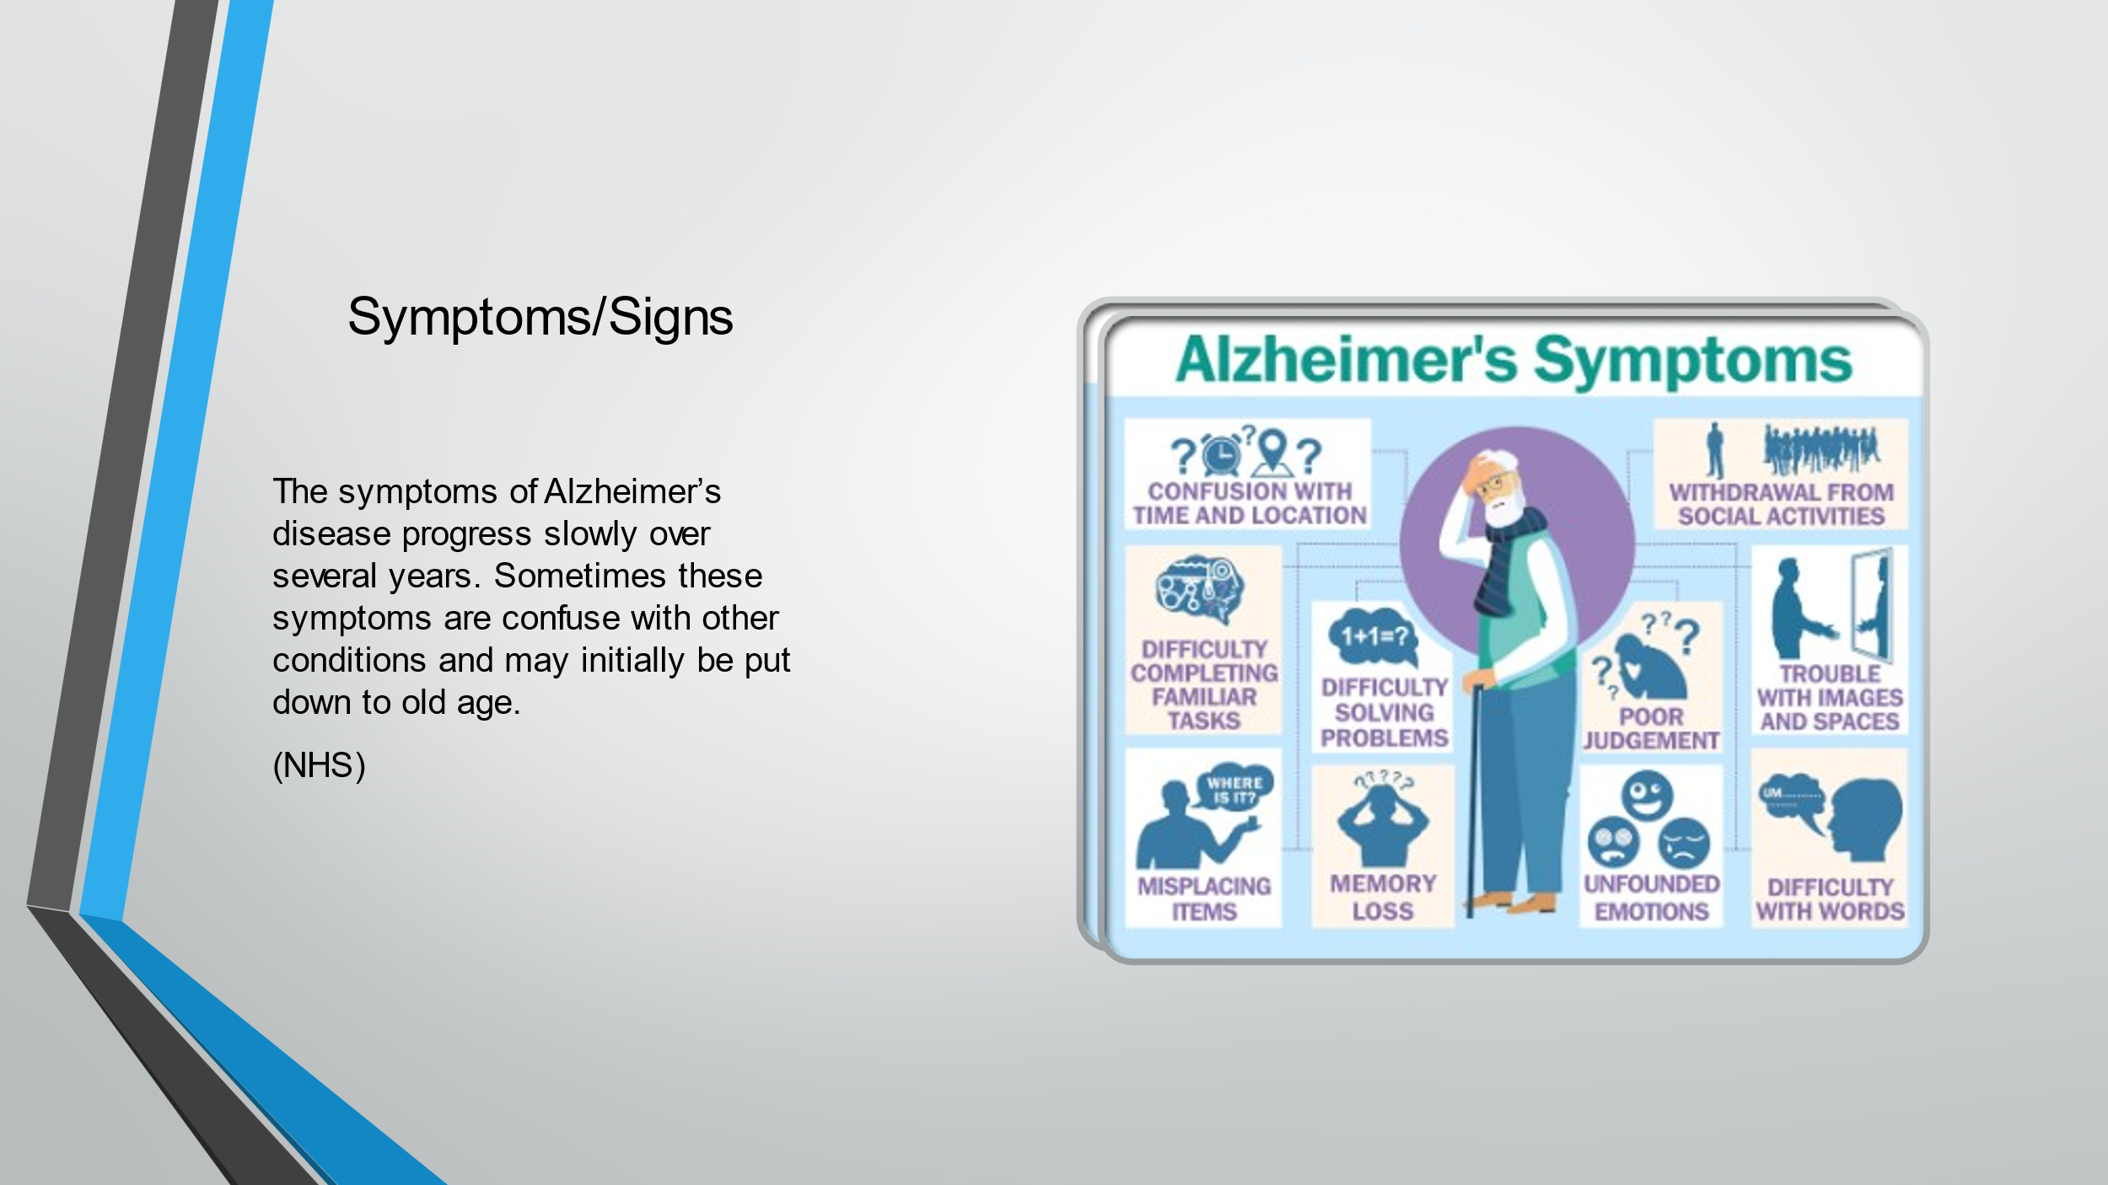

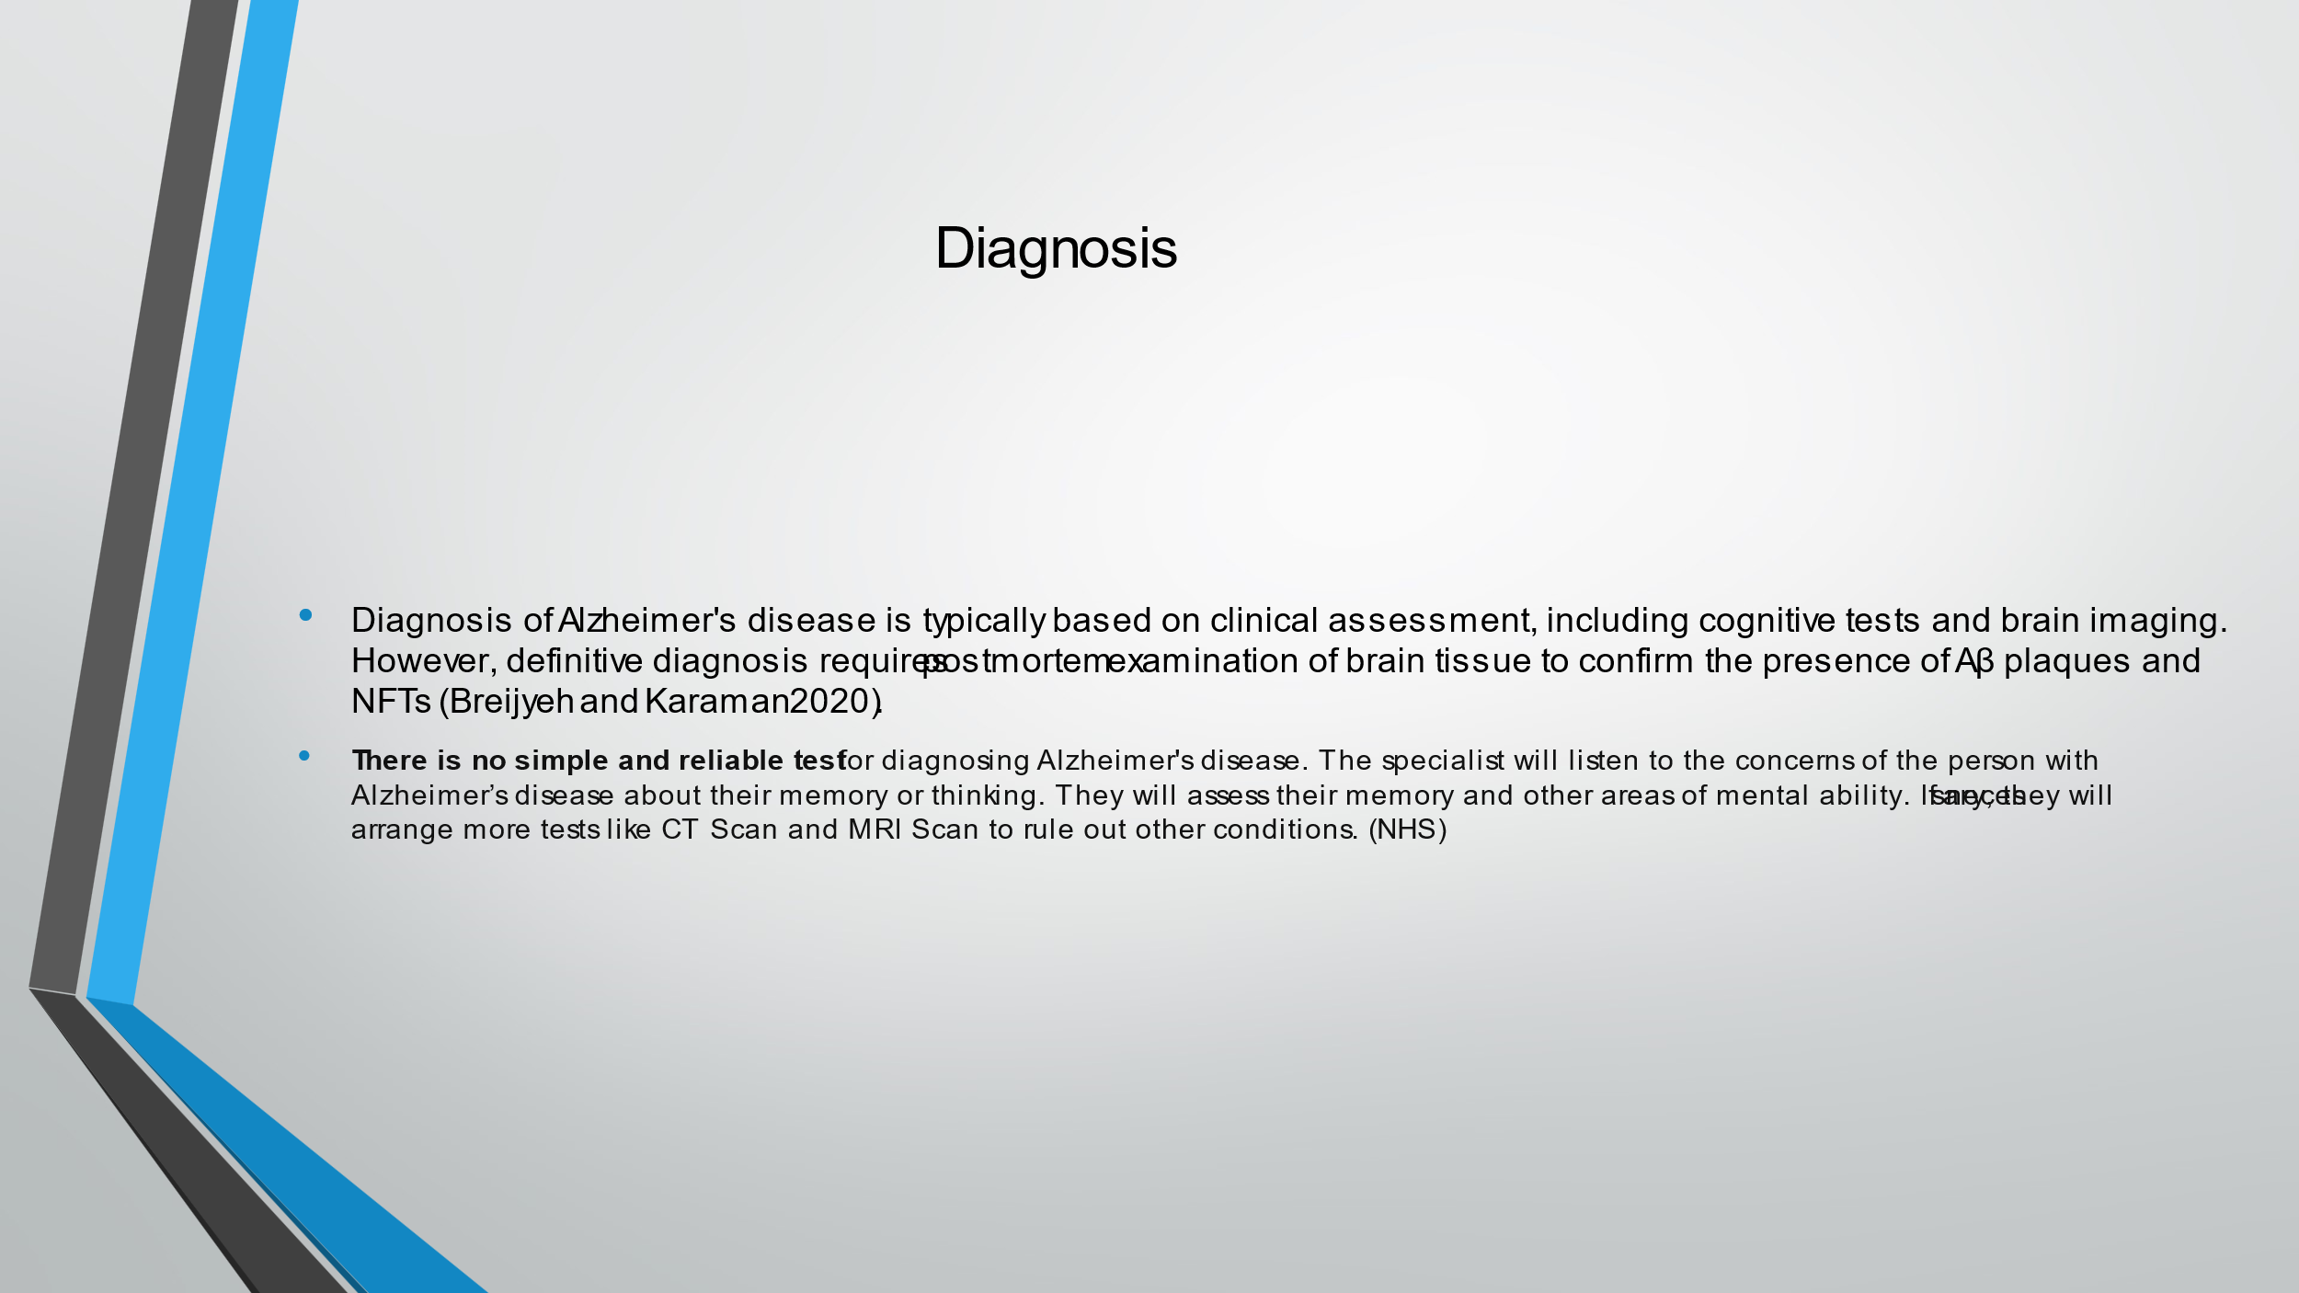

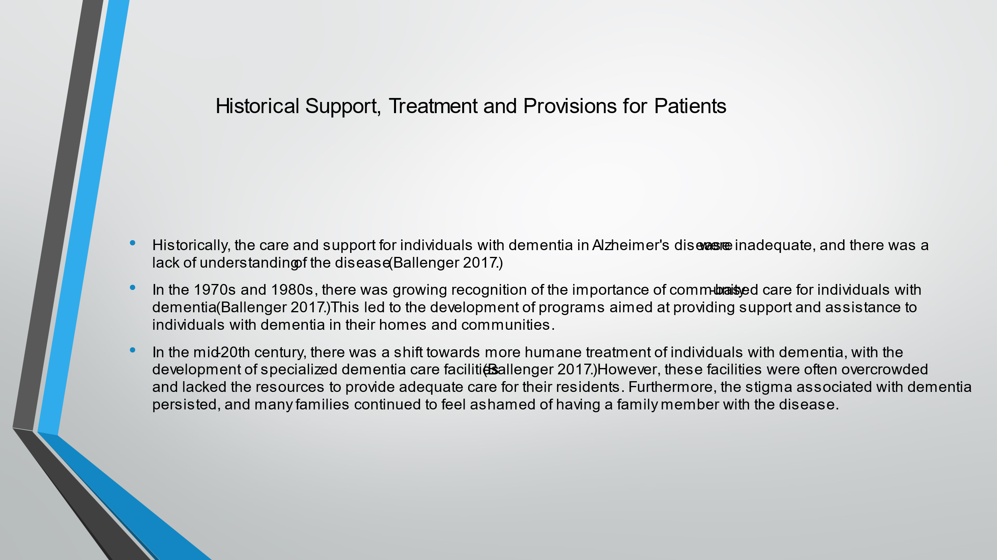

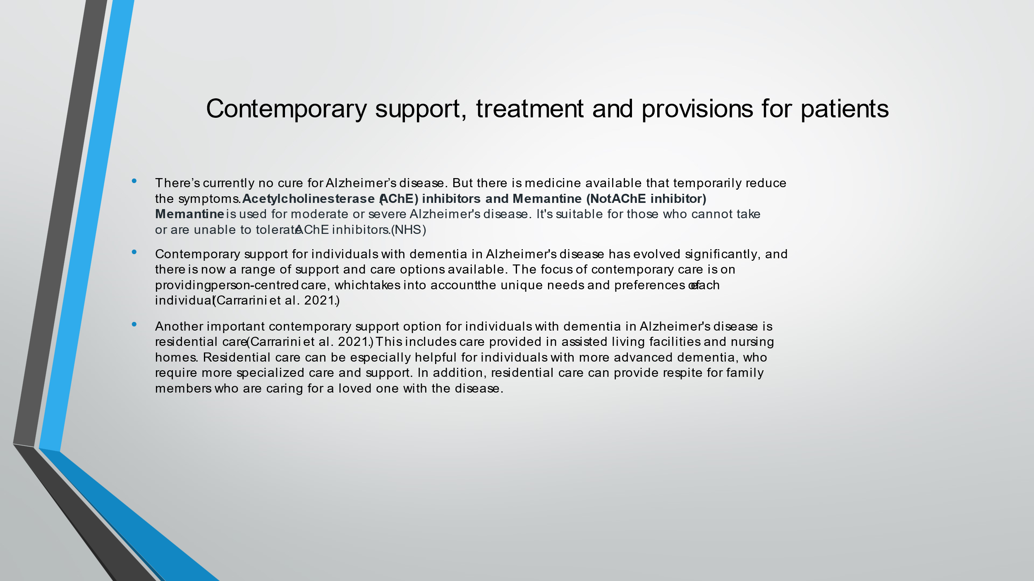

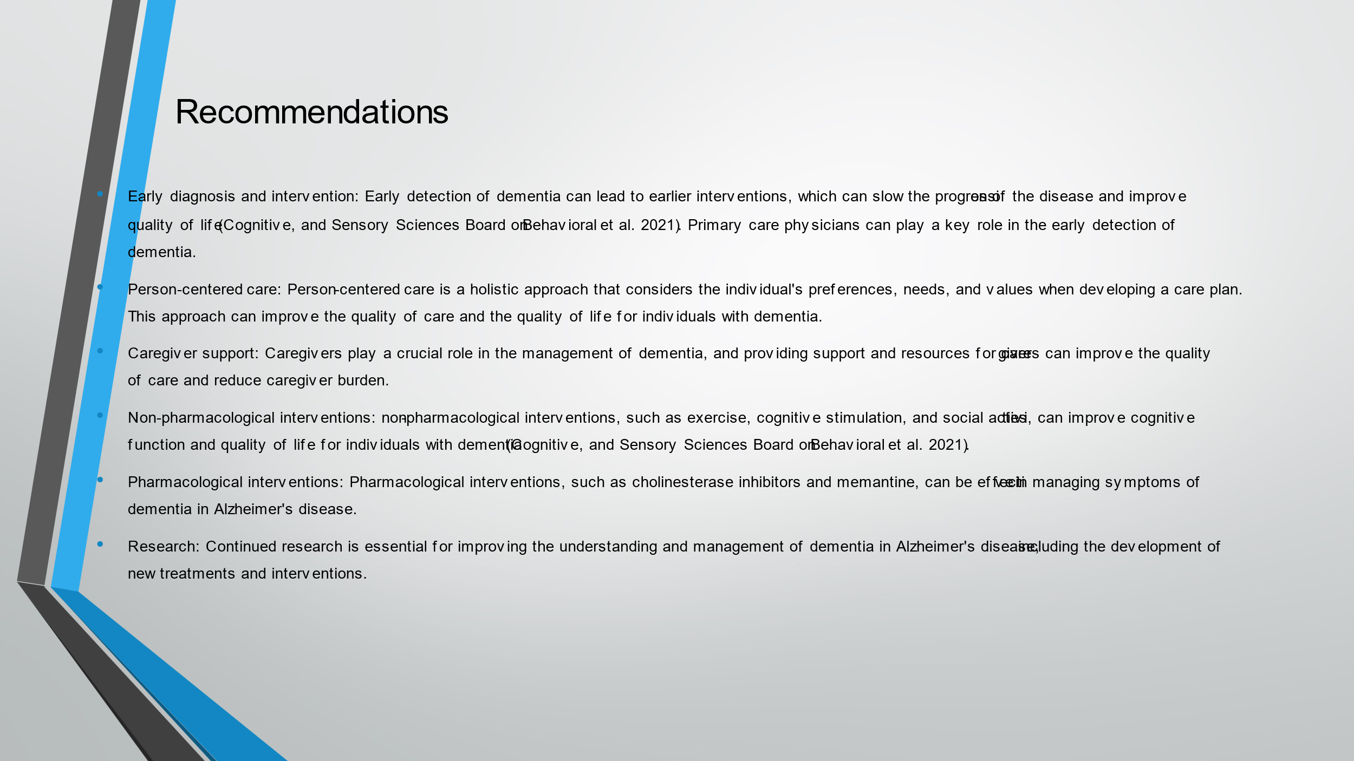

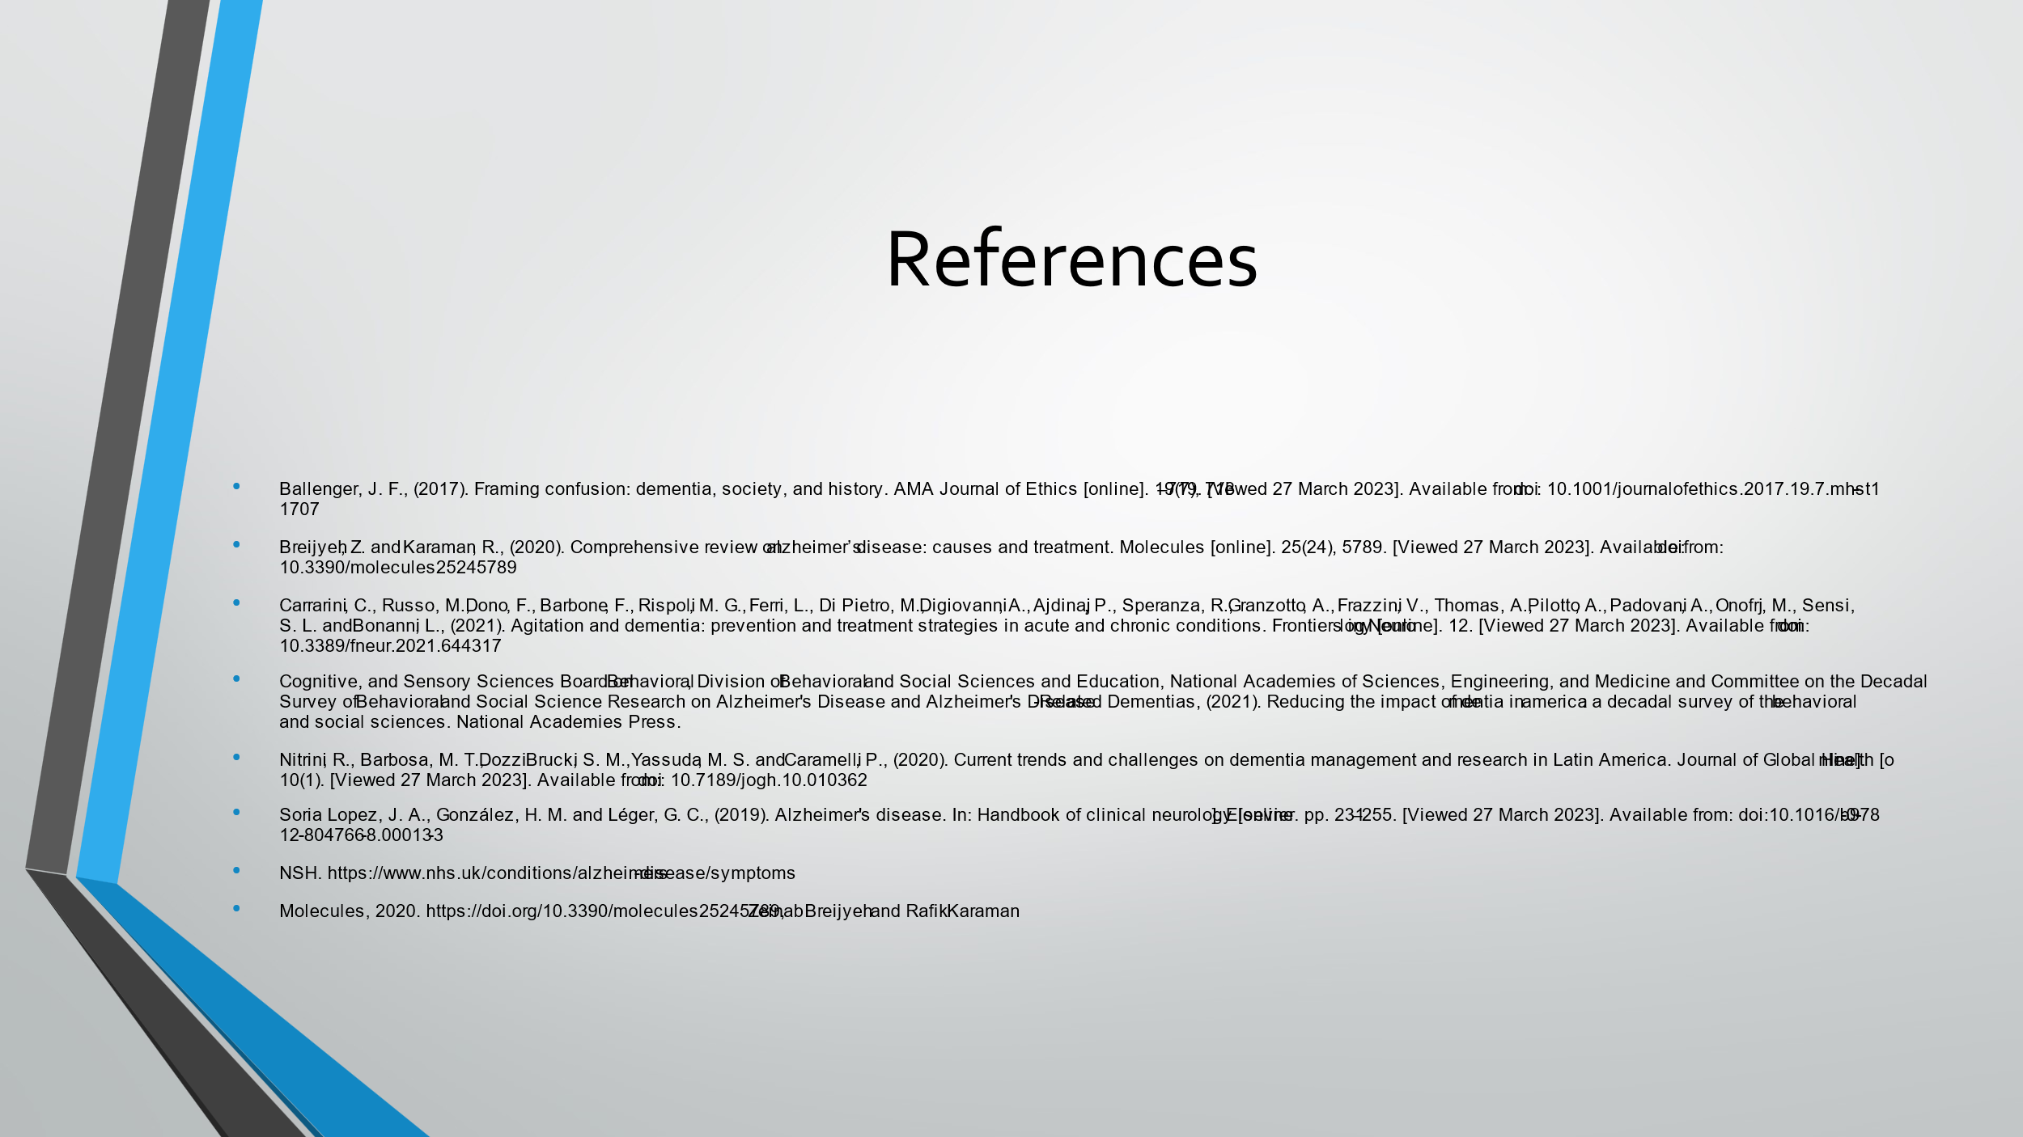

Appendix: Power Point Presentation



