Islamic Finance
Brent Jones
International Financial Management
SBUS6113
Anthony Burns
14/12/2018

Executive Summary:
This report aims to measure the success of Islamic Finance from how it has fared from its origin in 1975 to its current activity in the marketplace today. Islamic banking has shown to have grown rapidly in the past three decades but is also now slowly regressing in 2017. It will also share its evaluation and finding on its inability to avoid the peaks and troughs of the economy. The results of these findings will show that like any other bank, it is affected by the economy and factors such as real estate that have a dominating effect in the marketplace. Finally, this report will make three recommendations as to why Islamic finance is the way forward for international banks as it will help stimulate the economy, provide healthy competition, and pave new areas of growth and opportunity for the financial market.
Contents
Introduction: 4
Peaks and Troughs 4
The Way Forward 6
Conclusion: 7
REFERENCES: 8

Introduction:
Islamic finance is an alternate form of financing from traditional conventional banking. Derived from Islamic economics, which shares its roots in the Quran around 1,400BC. (IMF, 2009) Islamic finance began to really take shape in 1975 where one of the first Islamic banks were established in Dubai. It has skyrocketed from this to now having more than 300 in more than 75 countries, appearing not only in the Middle East, but also in the United States as well as Europe. Growth is estimated at 15% per year and estimates exceed $250 billion with the net value of Islamic investments more than doubling from 1995 to 2004 (Qorchi, 2005).
25% of the world’s population is Muslim, these figures stand between 1.5 and 1.8 billion people. With such high figures, there can be no perplexity as to why Islamic finance is on the rise. In 2010, growth was increasing between 15% to 20% and it was predicted that Islamic finance assets would reach $1 trillion (CIMA, 2015). This figure is now at $2.4 trillion in 2017, but according to the Global Islamic Finance Report, this is the “fifth consecutive year of declining growth.” (Sardana, 2018).
Although there is a declining growth, Islamic Finance is a business model where countries that have a small to high Muslim population, are interested in undertaking. This is because the Muslim population are highly religious and will not do anything to offend their faith. Conventional banks make interest to create money, making money out of money (interest or “Riba”) is against Islamic law (CIMA, 2015). Muslims can refuse the interest earned on a savings account and that allows them to use the conventional banks, however, what has been brought to light is that these conventional banks will take money for a saving account and will invest that money in another company to help stimulate the economy. This has always been the way for conventional banks, unfortunately, it does not work for Muslims. Placing their money into other business that do not support Shari’ah law, such as casinos, pubs, or any entertainment, is against Islamic law. Islamic finance protects Muslims from this action. (Alrayanbank, 2018). Islamic finance is sharing this knowledge with Muslims and they are now taking towards Islamic finance. Countries with a population of Muslims are introducing Islamic Finance to tender to Muslim needs.
Although the primary function of Islamic finance is to cater to Muslim needs, governments and businesses are keen to invest in them for another reason as well; It is believed that Islamic Finance can avoid the peaks and troughs of the financial markets, the research discussed below will show that is simply not the case.

Peaks and Troughs
According to Encyclopaedia Britannica, there have been many forms of financial crises in our history: The Credit Crunch Crisis of 1772, The Great Depression that happened from 1929 to 1939, The OPEC oil crisis in 1973, to name a few, but more recently we had the Asian Crisis in 1997, and the house market crash in 2008. (Bondarenko, 2018) Unfortunately, although Islamic Finance, which is based on Islamic economics, has been around since 1400BC, the first Islamic finance bank only came to be in 1975, effectively removing it from many of the world’s financial crises that took place. This report will investigate the remaining two crises that took place and show why Islamic Finance does not avoid the peaks and troughs of the marketplace.
The house market crash, at first glance, does not seem to impact Islamic banking. As shown in the graph below, when the crash first commences, Islamic banking seems to be completely unaffected, in fact, efficiencies of the banks are rising.
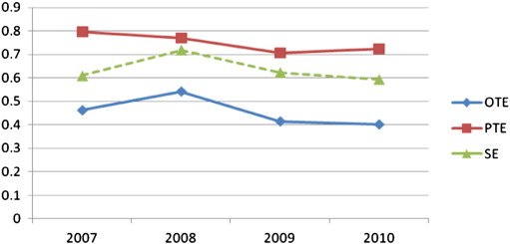
(Roseman et al, 2014)
(Graph representing Overall, Pure, and Technical efficiency)
What really peaks the interest is why Islamic banks are falling in efficiency when conventional banks are rising. The table below (Dridi and Hasan. 2010) displays a comparison of Conventional and Islamic banks in 2008 and how they were affected during the crisis.

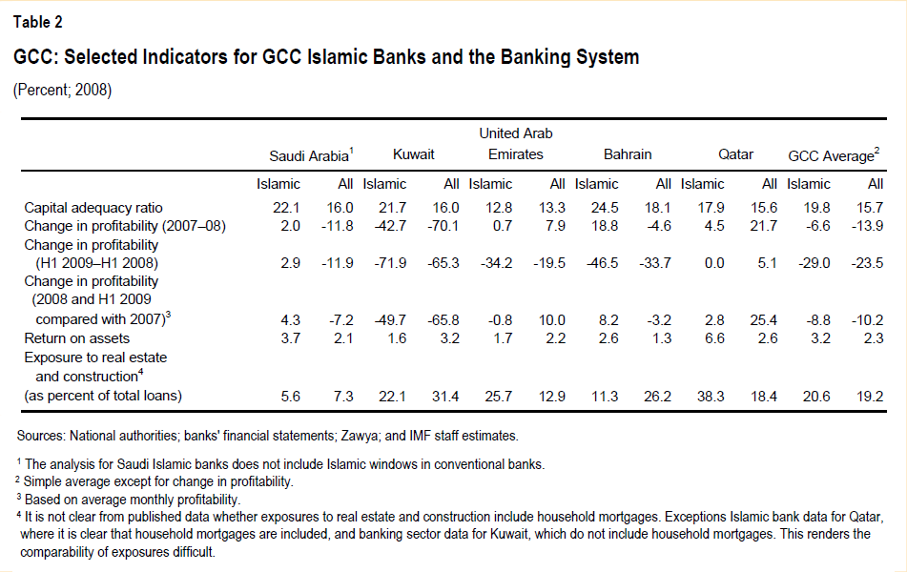
As shown, nearly all the conventional banks were affected by the crisis, but Islamic banks located in Kuwait, United Arab Emirates, and Bahrain show signs of struggling in 2007 and leading into 2009. The reason these three particular countries were more affected than the other Islamic banks is due to them having a “considerably higher exposure to the real estate and construction sectors.” (IMF, 2009)
Smaller Islamic banks were performing better than larger Islamic banks, larger Islamic banks were investing more in real estate and were more devastated by the real economy. Smaller banks had the advantages of “smaller investment portfolio and lower leverage explain(ing) in part their better performance in 2008.” (Dridi and Hasan. 2010)
Trad et al. discovered that conventional banks were more successful than Islamic banks through profitability, assets, and liquidity. His findings indicated small Islamic banks were better at resisting the financial crisis, whereas the larger Islamic banks were less stable than the larger conventional banks (Trad et al. 2017). This is further backed by (Cihak and Hesse, 2010) who also shares that “small Islamic banks tend to be financially stronger than large Islamic banks” this effects the credit risk management for larger banks.
Opposing the view that Islamic banks do avoid the peaks and troughs, (Said, 2012) shares that “the efficiency of Islamic banks operat(ing) in Middle Eastern and non-Middle Eastern Counties have increased during an economic crisis.” However, most Islamic banks are small and a small increase in revenue will result in a greater than average performance (Gul et al, 2015). Said does admit in his study that larger Islamic banks began to falter in 2009.
Islamic banks do not avoid the peaks and troughs of a financial crisis. As shown above, Islamic banks are smaller in size and the largest banks that are invested in the real economy get influenced by the crisis, but at a later time. Similar results showed in the 1997 crisis where Islamic banks were experiencing technical inefficiencies during the global crisis. (Roseman et al, 2014).
Islamic Finance hosts smaller, less profitable banks that are more liquid and less risky in comparison to a conventional bank (Gul et al). But it is a way forward for international banks.

The Way Forward
Islamic Finance will help stimulate the economy. With the Islamic market valued over $2 trillion, an estimated growth rate of 20% and a need of human capital of 50,000 professionals, Islamic finance will help to bring in revenue for an international country that houses a small to large percentage of Muslims. (CIMA, 2018). Economic growth is strong in countries with a large Muslim population, and out of 25 countries identified for rapid growth by 2020, ten will have a high Muslim population. (Yueh, 2014)
Islamic finance will help create jobs, will appeal to a niche market that want and need to tend to their religious beliefs, and will help create new business ventures with the services rendered.
Islamic finance will bring healthy competition to conventional banks. Conventional banks strive for profit, whereas Islamic banks strive for a stimulating economy. Islamic banks want to help people by “preventing injustice in the acquisition and disposal of material resources” this can be done by removing interest on loans and providing a fair system that doesn’t embellish on the issuer taking out a loan. Instead they pay a premium for services rendered. With Islamic banks involved in the current economy and bringing in competition to conventional banks. This may result in a decrease in mortgage rates for conventional banks and better saving accounts that allow the individual to make a small profit.
Islamic finance does not hold the potential to take over the current banking system, it has already reached its plateau as it is currently on its fifth year of declining growth. This leaves a great opportunity in areas where Muslims are a minority and to hit the remaining 75% of the population. There is a great potential for growth as non-Muslims can also participate in Shariah compliant investments. (Marketline, 2018). This leaves a great opportunity for Islamic finance as currently their opportunities comes from Malaysia where it concentrates on real estate, in order to attract more diversity in investors, they will need to do more such as lowering the cost of Sukuks for smaller businesses to access the marketplace. (Marketline, 2018)

Conclusion:
Islamic banking is a successful form of financing that has taken the Muslim population by storm. Although it is not impervious to financial disasters as it is affected by the real economy, it holds a place in the future of the banking system. A bank with the mix of the properties of conventional banking and Islamic banking would surely do well as it would take the benefits of both by removing interest charges and provide all of its customers satisfactory investments that can appeal to religious and non-religious customers.

REFERENCES:
Alrayanbank. (2018). Islamic Banking. Retrieved from: https://www.alrayanbank.co.uk/useful-info-tools/islamic-finance/frequently-asked-questions/
Bondarenko, Peter. (2018). 5 of the World’s Most Devastating Financial Crises. Retrieved from https://www.britannica.com/list/5-of-the-worlds-most-devastating-financial-crises.
Cihák, M., & Hesse, H. (2010). Islamic Banks and Financial Stability: An Empirical Analysis. Journal of Financial Services Research, 38(2-3), 95-113.
CIMA. (2015). An Introduction to Islamic Finance. [PDF File]. Retrieved from https://www.cimaglobal.com/Documents/Islamic%20finance/Rebrand%20Brochures/Islamic%20Introduction%20brochure_Mar2015.pdf
CIMA. (2018). Why Islamic Finance? Retrieved from: https://www.cimaglobal.com/Qualifications/Islamic-finance-qualifications/Why-Islamic-finance/
Dridi, J, Hasan, Maher. (2010). The Effects of the Global Crisis on Islamic and Conventional Banks: A Comparative Study. Retrieved from https://www.imf.org/en/Publications/WP/Issues/2016/12/31/The-Effects-of-the-Global-Crisison-Islamic-and-Conventional-Banks-A-Comparative-Study-24183
Gul, F., Awan, M., & Ahmad, I. (2015). Do Islamic Banks Financially Perform Better Than Conventional Banks? A Comparative Study of Pakistani Banks. NUML International Journal of Business & Management, 10(2), 27-50.
(Islamic banking and finance) below
IMF. (2009). Regional Economical Outlook Middle East and Central Asia. World Economic and Financial Surveys. [PDF File]. Retrieved from: https://www.imf.org/en/News/Articles/2015/09/28/04/53/sores100410a
Marifa. (2018). Islamic Banking and Finance: Principles and Practises. [PDF File]. Retrieved from: https://islamicbankers.files.wordpress.com/2014/09/marifas-practical-guide-to-islamic-banking-and-finance.pdf
Rosman, Wahab, & Zainol. (2014). Efficiency of Islamic banks during the financial crisis: An analysis of Middle Eastern and Asian countries. Pacific-Basin Finance Journal,28, 76-90.
Said, A. (2012). Efficiency in Islamic Banking during a Financial Crisis-an Empirical Analysis of Forty-Seven Banks. Journal of Applied Finance and Banking, 2(3), 163-197.
Sardana, S. (2018). What is Islamic finance and why anybody can use it. Retrieved from https://www.verdict.co.uk/private-banker-international/news/what-is-islamic-finance/
Trad, N., Rachdi, H., Hakimi, A., & Guesmi, K. (2017). Banking stability in the MENA region during the global financial crisis and the European sovereign debt debacle. The Journal of Risk Finance, 18(4), 381-397
Yudistira, Donsyah. (2004). Efficiency of Islamic Banks: An Empirical Analysis of 18 Banks. 1.
Yueh, L. (2014). Islamic banking: growing fast but can it be more than a niche market? Retrieved from https://www.bbc.co.uk/news/business-28365639
Marketline. (2018). How Islamic finance can develop its appeal to wealth managers. Retrieved from: http://advantage.marketline.com.ezproxy.uwtsd.ac.uk/Product?ptype=Analyst+Comment&pid=8E0F5520-BC0C-4E8A-BA84-C4D30590A687
Marketline. (2018). What is Islamic finance and why anybody can use it. Retrieved from: http://advantage.marketline.com.ezproxy.uwtsd.ac.uk/Product?ptype=Company+News&pid=7CEB8716-3A53-4F77-B722-87163D796E12
Qorchi, M. (2005). Islamic Finance Gears up. Retrieved from https://www.imf.org/external/pubs/ft/fandd/2005/12/qorchi.htm

