

BMSW4005 Professional Career Development

Skill, Knowledge, and Experience: The Everlasting Keys to Success in the Workplace.

Module: PROFESSIONAL CAREER DEVELOPMENT
Module code: BMSW4005
Lecture Name: AFZAL MUNNA
Assignment Title: PROFESSIONAL CAREER DEVELOPMENT Task 2 – Report (2,000 words)
Student Number: 2023024
Student Name: MARIA VITOROI
TABLE OF CONTENTS

INTRODUCTION 2
GIBBS REFLECTIVE CYCLE 3
PESONAL DEVELOPMENT PLAN 5
ROLE- PLAYING 6
CONCLUSION 7
REFERENCES 8
APPENDIX 9

INTRODUCTION
The requirements of the twenty-first century differ from those of the past. People must be ready for the quick changes that are occurring because of technology, and they must revise to new conditions, develop new skills, and be more accommodating to achieve the objectives they set.
In a progressively dynamic and competitive socioeconomic, cultural, and work environment, providing students with theoretical and practical knowledge is insufficient. Pollit (2001) points out that there is a need to develop more flexible workforce capable of adapting to changing conditions, being accountable, and thinking for itself. According to Mckenna et al. (2009), reflexive learning is a method that leads to thinking on all sources of knowledge that can provide to understanding a situation, including personal sources and experiences. According to Colomera et al. (2013), reflective learning methodology encourages critical thinking and analysis of students' potential, proposing both development strategies and new approaches for overcoming problems that arise during the learning process. According to their findings, this appears to assist students in identifying their own learning needs as well as better understanding how they may value future learning.
The goal of reflection is to comprehend what is already known and to incorporate new information, resulting in knowledge, new meaning, and a higher level of comprehension (Moon, 2004). Reflection, according to Boud et al. (1985), is a conscious gaze and thought about experiences, actions, emotions, feelings, and reactions, followed by interpretation to learn from them. On reflection, both authors' descriptions are similar. It is a deliberate and systematic approach to reflecting on experiences with the goal of learning and changing behaviour.

GIBBS REFLECTIVE CYCLE
One of the best well-established cyclical models of reflection, it guides you through six steps of delving into an experience: description, feelings, evaluation, analysis, conclusion, and action plan.

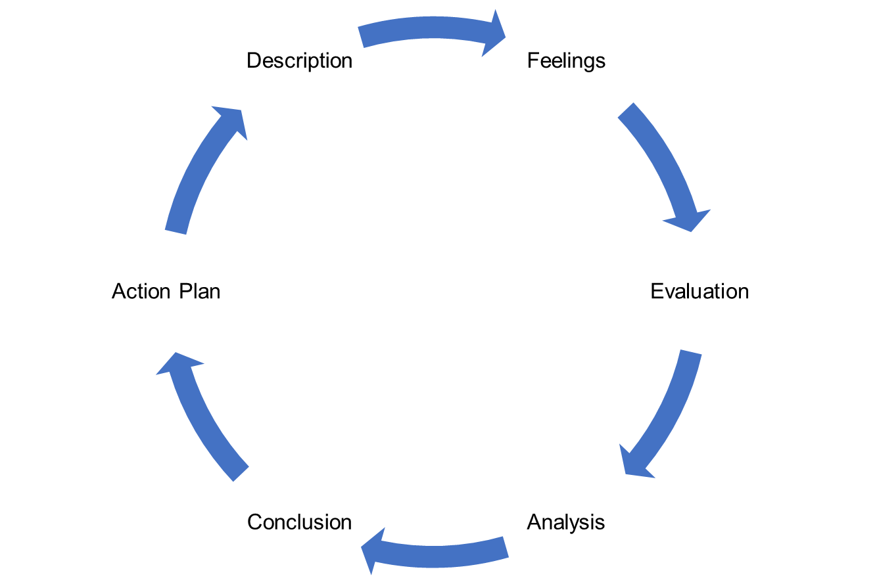

Figure 1: Gibb’s Reflective Cycle

- Describe. The therapist describes what occurred.
- Emotions. Thoughts and feelings that occurred at the time and were later explored
- Evaluation. An analysis is carried out in the form of identifying what was positive and challenging about the experience.
- Examine. This analysis entails attempting to make sense of the situation and recognising the impact it had on the therapist's professional practise.
- Conclusion. At this point the person should understand better the position and determine what else could have been done.
- Action plan. A future action plan is developed, outlining alternative approaches if this or a similar situation arises in the future.
In 1988, Graham Gibbs developed the Gibbs Reflex Circle to structure experience-based learning. It provides a framework for learning, and because it is cyclical, it is especially suited for repetitive experiences, allowing you to learn and plan based on what went well or bad.
This model is a good way to get out of a predicament. This could be a single event or a recurring situation, such as meeting with a team that you need to work with. Gibbs initially advocated its use in repetitive situations, but these steps and principles also apply to individual experience. When launched as a stand-alone activity, the action plan can be broadened, and you can see how to implement your findings in the future.
These phases can be used to analyse and suggest on a situation, habit, practice, or method of service. Models can be used at different times for convenience or deeper reflection. Both emphasize the importance of reading the literature and discussing the situation with other people, who may be collaborators, service users, managers, or family and friends.

PESONAL DEVELOPMENT PLAN
A personal development plan (PDP) is defined by Lejeune et al. (2018) as an evaluation tool that is integrated into a larger development evaluation cycle and is used to collect and handle data about the skills and knowledge that the employee has worked on and prepares to develop in the future. According to Lam (2014), a personal development plan (PDP) is a special evaluation tool that promotes self-directedness as a procedure.
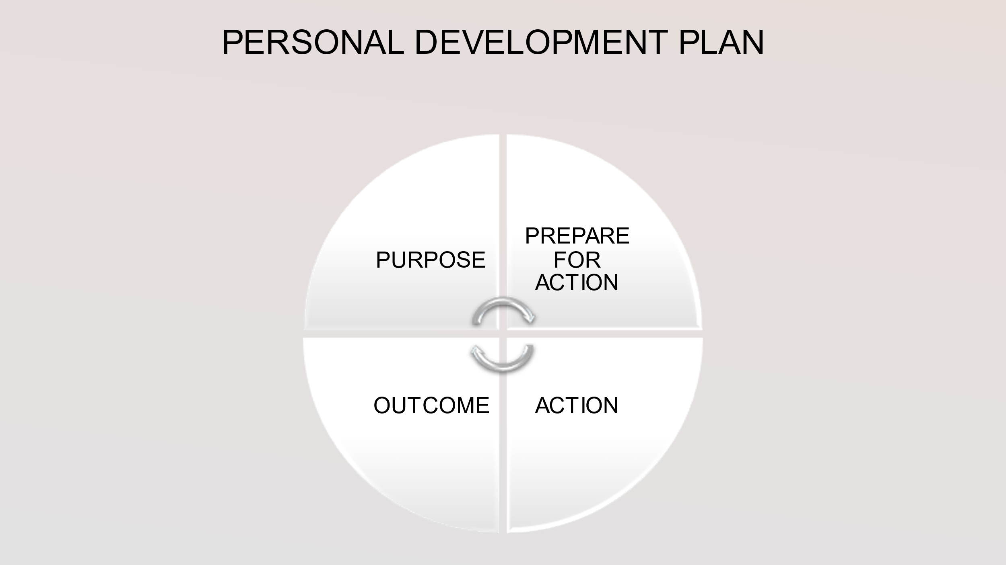
Figure 2: My Personal Development Plan.
For example, my personal development plan (PDP) starts with the purpose, which means the goals that I set, and then continues with my preparation. In addition, follows what actions did I take to complete these goals and finally the outcome.
My personal development plan (PDP) assisted me in identifying my learning needs as well as my personal aspirations and outlining ways to achieve them. Firstly, I assessed my learning requirements and established SMART goals (specific, measurable, achievable, relevant, and time-bound). When I was deciding on my goals, I tried to choose areas that interest me, as I would be more likely to devote myself to and enjoy the tasks.
My personal goal was to advance professionally. I wanted to obtain the CHE for the Workplace for this purpose. Through this process I wanted to gain new skills, enrich my knowledge, gain more experience, and continue my studies in Finance and Accounting. To achieve my goal, I enrolled in courses at UWTSD to obtain the CHE in workplace. Through this course I had to write assignments and reports, to create Power Point presentations, to take part in Role Plays, to communicate and collaborate with new people, and to read books to improve my English language and to enrich my vocabulary.
As an outcome of these procedure, I received an excellent study environment and learning outcome. I have acquired new skills, such as being more patient and properly organising and managing my time. I have improved in technology, and by that, I mean that I now know how to use my computer, as well as to find reliable sources, and I have learned the process of online learning. After all these steps, I consider how effective my PDP has been and whether there are any areas that haven't been addressed or haven't worked. Generally, my PDP in my opinion was very effective for me but there are areas I should work more such as my English language.

ROLE- PLAYING
Gaete-Quezada (2011) describes role-playing as a process in which participants interpret a set of cases and actions based on reality within the structure of a similar simulation. This enables them to comprehend the processes, cases, problems, requires, demands, and involvement of multiple people in real work settings, assisting them in developing the skills required for their future career.
According to Rao and Stupans (2012) role-playing has been shown to be effective in achieving learning outcomes in the domains of affective, cognitive, and behavioural learning. Jones (2018) supports those the workforce market’s demands are related to aspects such as decision making, negotiation, and innovative thinking. On the other hand, Tomkins and Ulus (2016) point out that role-playing can also provoke feelings of anxiety, rejection, and personal failure, when the students dive into role-playing without adequate preparation and knowledge, they can quickly become tossed around in the waves of emotional reactions.
In my opinion role play simulation contributes to the development of confidence or conviction in individuals that they can practise their professions, as well as to the development of professional identity. Through the role play that I had to prepare for my course, I had to think as a consultant manager, and I tried to find a possible solution that had to benefit both the company as well as my colleague. These situations are not easily managed and not every person is capable to handle such a situation.
The practise of effective communication skills and concepts through role play simulations help the integration of their newly acquired skills and approaches into a variety of settings, including the workplace. For my role-play I required courage and determination, because for me it was something new and I didn't how to handle it. It was a very stressful procedure that I couldn’t handle it. During role play or after several times of practise I acquired new skills and greater self-confidence.
Although after the procedure of the role - play I see different the things. I understand now that there are many advantages through this procedure. All these years I saw only my perspective when I was confronted with different problems in my work. Now as a consultant manager for a few minutes I understood and the other side. Imitating another human being is not easy. You need to understand the other person's feelings, needs and responsibilities and try to think like him. Through the experience of the role – play, the participants are likely to find that they do not deal properly with some situations or do not fully understand the point of views of others, thus leading to a re-examination of their perceptions and behaviour.
A role – play can prepare you for a real situation that you maybe be confronted in the market. Improves communication and language skills and develops thinking, learning and problem-solving skills. The role-play experience is varied and powerful in its possibilities. Its strengths are found in its diverse capabilities, but also in what is probably the most crucial aspect of any educational experience: feedback.

CONCLUSION
When I looked back on myself before starting these courses, I noticed that I had met several of the goals I had set for myself. Some skills existed, such as respect, listening, and honesty. However, because of the programme, I developed myself, learning new skills such as patience, time management and becoming more familiar with technology. The most difficult challenge I faced was changing to online learning, understanding the fundamentals of computers, and being faced with so many new things that I acknowledge I was scared at first. Another challenge I faced was a lack of social relationships, as I am a social person who is unfamiliar with these new circumstances.
Challenges, pain, distress, and uncertainty characterise work. There are many things to learn and many mistakes to make, so becoming a skilled and experienced worker cannot exist without challenges and disappointments. However, we must never stop extending our horizons, remaining open-minded, evolving, and enriching our knowledges. The world around us is changing rapidly, and people must constantly evolve and adapt; after all, as Charles Darwin stated, "it is not the strongest species, nor the most intelligent, but the most adaptable to change that survive."

REFERENCES
Boud, D., Keogh, R. and Walker, D., 1985. Reflection Turning Experience into Learning. Kegan Page. London.
Colomera, J., Pallisera, M., Fullana, J., Burriel, M. P. and Fernández, R., 2013. Reflective Learning in Higher Education: A Comparative Analysis. Procedia - Social and Behavioral Sciences. October, vol. 93, pp. 364-370.
Gaete-Quezada, R., 2011. El juego de roles como estrategia de evaluación de aprendizajes universitarios [Role play as a strategy for evaluating university learning]. Educación y educadores. Vol.14, No 2, 289–307.
Gibbs, G., 1988. Learning by Doing: A guide to teaching and learning methods. Further Education Unit. Oxford Polytechnic: Oxford. Published (11 Nov 2020)
Jones, A., 2018. The role of team leadership on critical thinking skills A case of business major students using a role-play simulation at the American University in The Emirates (AUE). International Journal of Development Research. Vol. 9, No 7, pp. 29097–29100.
Lam, R., 2014. Promoting self-regulated learning through portfolio assessment: Testimony and recommendations. Assessment & Evaluation in Higher Education. Vol. 39, No 6, pp. 699–714.
Lejeune, C., Beausaert, S. and Raemdonck, I., 2018. The impact on employees’ job performance of exercising self-directed learning within personal development plan practice. The International Journal of Human Resource Management, pp.1–27.
Mckenna, A.F., Yalvac, B. and Light, G.J., 2009. The role of collaborative reflection on shaping engineering faculty teaching approaches. Journal of Engineering Education. Vol. 98, pp. 17-26.
Moon, J. A., 2004. A Handbook of Reflective and Experiential Learning: Theory and Practice. London: Routledge Falmer.
Paterson, C. and Chapman, J., 2013. Enhancing skills of critical reflection to evidence learning in professional practice. Physical Therapy in Sport. Vol. 14, No 3, pp. 133–138.
Pollit, D., 2001. A flexible workforce for the modern economy; the role of education and training. Education and Training. Vol. 43, No. 7, pp. 345‐376.
Rimmer, A., 2018. How do I prepare a personal development plan?. BMJ.

APPENDIX




