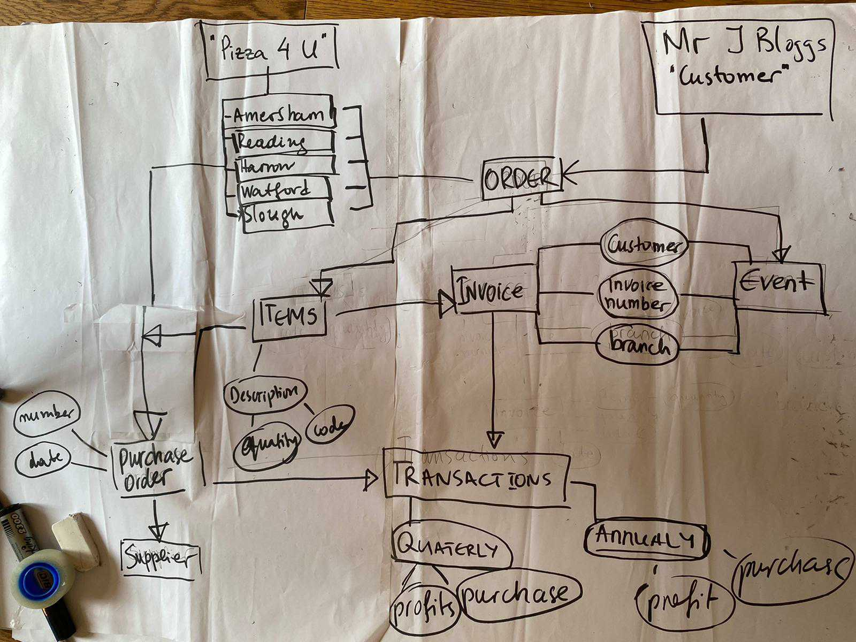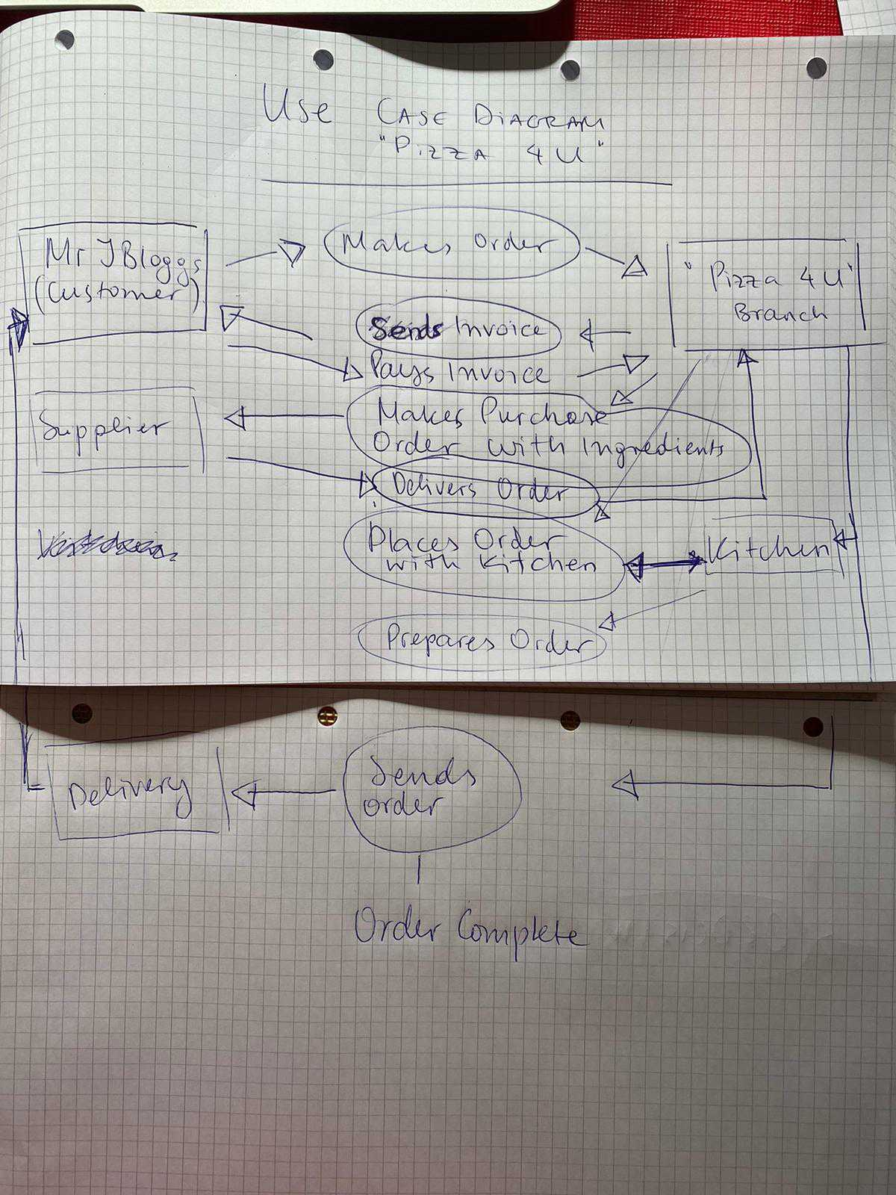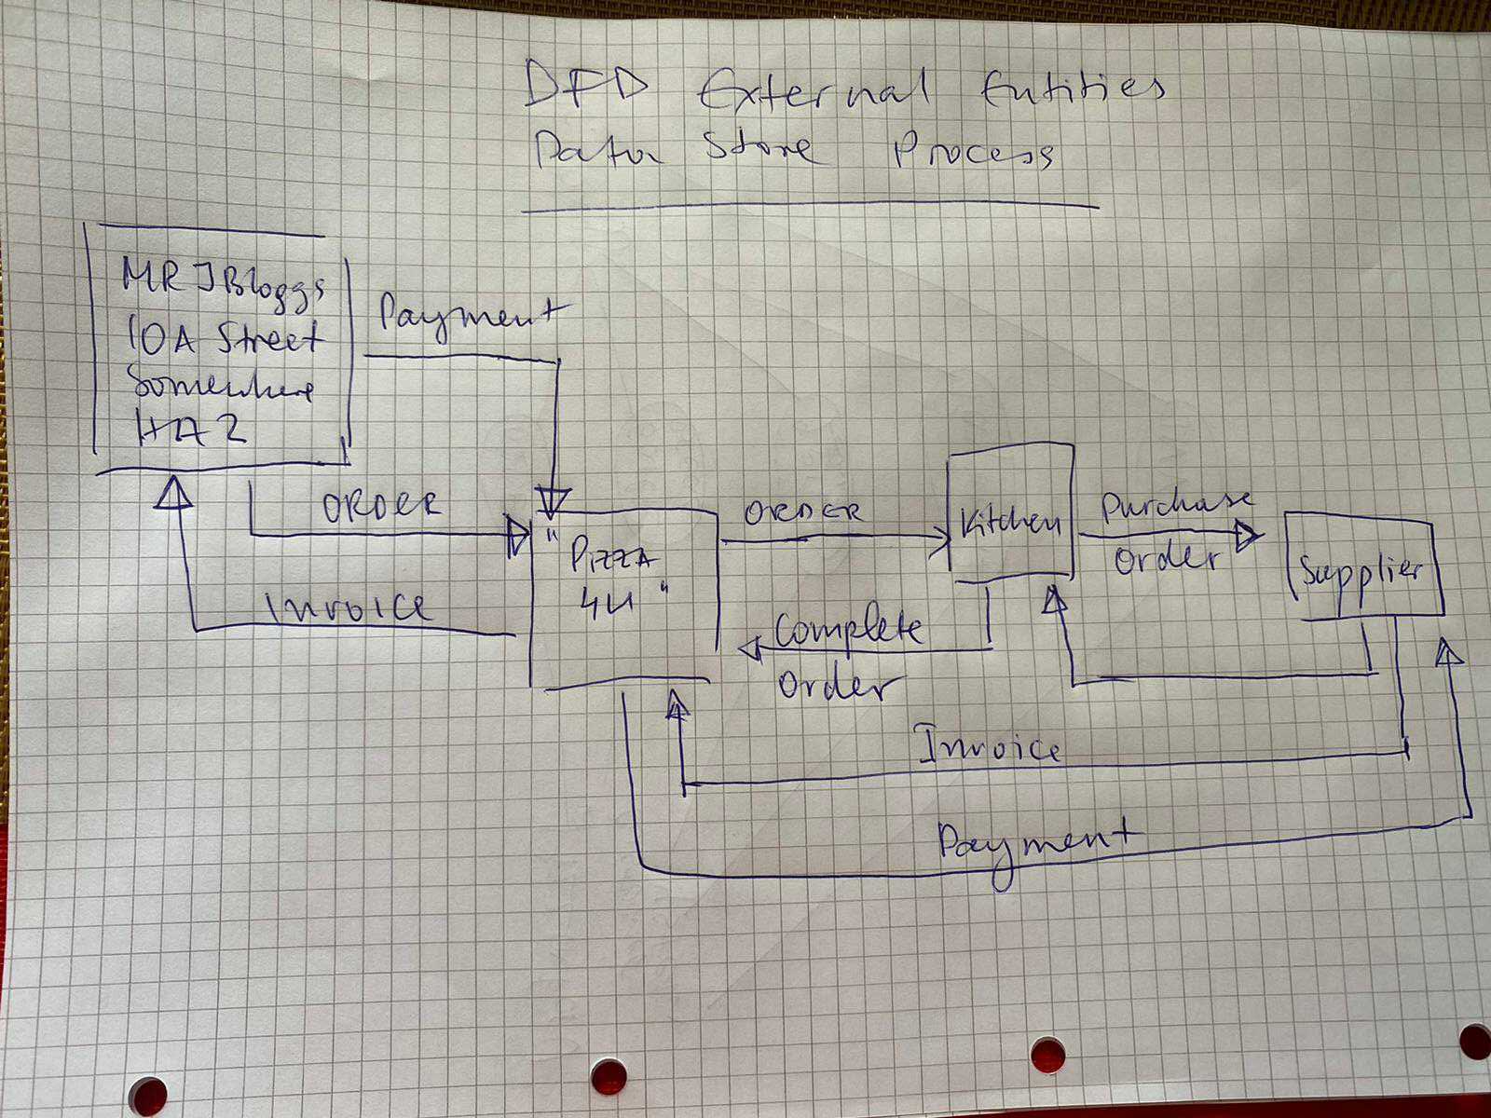
INE Exam – 7 May 2020
By Teodora Zdravkova
INE Exam – 7 May 2020
By Teodora Zdravkova

INE Exam – 7 May 2020
By Teodora Zdravkova
INE Exam – 7 May 2020
By Teodora Zdravkova

