REFLECTION ON REFLECTION MODELS, TRANSFERRABLE SKILLS AND ACADEMIC THEORIES

Name Adelina-Victoria Dumitru
Student ID 2015292
Module : Community Engagement
Module Code: LCBB4002
Lecturer: Dale Clarke

Table of Contents
Introduction……………………………………………………………………….3
Reflection: Gibb’s Model…………………………………………………………3
Gibb’s Model and transferrable skills ……………………………………………6
Academic theories ………………………………………………………………..8
Conclusion ……………………………………………………………………….10
References ……………………………….………………………………………11

Introduction
Reflection is guided by different models, including Gibb’s, John’ and Driscoll model. The best model is Gibb’s model, which is applied in every aspect of life; it is also a model that can be applied when handling small children; to teach them how to focus on growing. This paper describes Gibb’s model, reflecting on how the model has been applied in personal experiences and learning through the model. There is also a reflection on the academic theories and how they are applied in a person’s life.
Reflection: Gibbs Model
Different reflection models were discussed which includes Gibb’s ,Jhon’s ,Driscoll’s They are applied in different sectors of life, including in class. One of the most significant models is Gibb’s reflective cycle which was created to enhance experiential learning. It was a model that was designed as a continuous cycle aiming at improving the repeated experience. It also works with stand-alone experiences. This model is good because it is directly relevant for most people as they go through school and education, requiring continued learning experience. It is an important model as it recognizes the aspect of feeling in reflection. It also focuses on the evaluation to understand what happened and how it occurred. There are extra stages, including Description, Feelings, Action Plan, Evaluation, Analysis, and Conclusion (Wain, 2017).
Description
Through description, aspects that are focused on include what occurred and give a clear description of the things that occurred. According to Gibbs, it is important to stay relevant and precise. Hence the description should also be about the outcome, and the issue identified (Wain, 2017).
Feelings
This section speaks about the person’s thoughts and feelings about the learning experience. Does it aim at answering “questions such as how did you feel? What did you think at that time? What impact did your emotions, beliefs, and values have? What do you think other people were feeling? What did you think about the incident” afterward? This is an academic section that should be brought out honestly (Wain, 2017).
Evaluation
Evaluation allows the learner to understand the positive and negative aspects of the learning process. Some of the areas to focus on include the good and bad things about the experiences, the contributions, and how the issue was resolved (Wain, 2017).
Analysis
Through analysis makes sense of the occurrences. Gibb’s model allows for a wider opportunity to understand. Through analysis, it is possible to have a particular aspect that gives the specific aspect of learning. Therefore, it allows one to bring theory and experience into one thing (Wain, 2017).
Conclusion
Gibbs suggested two aspects of conclusion, which include a general conclusion that can be transferred and a specific one that focuses on one’s situation. The conclusion aims to analyse what one has learned, how they can improve, what they would have done differently, and what one needs to handle the issue better (Wain, 2017).

Action Plan
The action plan helps in understanding the areas one can improve in the next time. It also aims to understand where one can apply the learned knowledge, adapt their actions, and improve their skills. One should also describe what they could have done differently (Wain, 2017).

The six stages include:

Gibb's model can be applied in different sectors of life since life is a continuous learning process. As one is in school, it can be directly applied after every lesson or course. It can also be applied in one's personal experiences, which are not necessarily part of school learning. In areas such as parenting, one will always be required to learn how to be a better parent and perform better; hence, through Gibb's, it is possible to understand areas to improve and continually grow into a better or greater person. It is also a lesson that can be taught directly to young children who will keep evaluating themselves and improving their lives. Moreover, the Gibb's model can be applied during the recruitment and training sectors when people join the work industry. Therefore, Gibb's model is applicable in different sectors of life. Additionally, it can be merged with the school learning activities and made part of the education system to enhance students' performance in both personal and academic lives.
Gibb’s model and transferrable skills
Some of the organization skills I learned have been linked to Gibb's model, which focuses on one's growth in an organization. Some of the skills required for an individual's success are soft skills, including communication, and people's targeted skills. Some of the skills that need a regular application of the Gibbs model include problem-solving. Problem-solving is a skill that one learns over time and gets better. Through the problem-solving process, it is possible to identify the issues causing the problems and find a way to implement a solution. Therefore, to become better, one has to apply the evaluation aspect continually and analysing borrowed from Gibb's model (Canelas et al., 2017).
Like in Gibb's model, critical thinking should be incorporated to increase the analytical reasoning process. The analytical process requires one to break down a problem to identify a solution. As one becomes better through a constant reflection of how they apply and use their analytical skills.
Leadership is a sector of life where employers are expected to bring out their best skills and offer their best services. When working with different people, it is also important to embrace becoming better because one works with diverse people, which exposes one to possible mistakes as a leader. Just like everyone else, leaders are also expected to grow through their mistakes. At this point, it becomes relevant to directly apply Gibb's model, which expects the leader to reflect on their actions constantly conclude on which areas to improve (Faber et al., 2021).
I have also learned about teamwork which practically applies the skills taught by Gibbs. A team is a group of people that work towards a common goal; thus, being part of a team means working towards accomplishing its goals. Hence, it is crucial to assess the achievements while applying the Gibbs model continually as a team leader or player and an entire team. The Gibbs model helps ensure continuous growth and assessment of the skills of a team (Nägele and Stalder, 2017).
Project management goes hand in hand with teamwork, which expects the projects to be handled and managed from the start to the end. There is the need to ensure everything is done in time and issues go as planned. This is a skill that expects the deadlines are effectively met and completed effectively as well efficiently. Through the continuous application of Gibb's model, one can learn how to work under pressure (Nägele and Stalder, 2017).
Relationship building is also crucial for me because it is inclusive of an individual's feelings. Relationship building is also dependent on how well one can relate with other people around them. It is also a way of creating positive networks for one's career growth and desired outcome. It is also in need of regular evaluation and analysis of how well one's relationships benefit or add value. As one grows in their career, one should constantly evaluate their relationships and enhance the appropriate relationships (Nägele and Stalder,2017).
At some point, I hope to become an employer that will require me to constantly apply Gibbs of experiential learning, which will expect me to handle my employees effectively and ensure they are corrected in the best way ever. As employees get into a career, they desire to grow and get better; they will grow and get better through regular training and assessment. This is the sector within which I have learned that leaders also require leadership skills (Weber et al., 2018).
Academic theories
There are different academic theories learned in class which include behaviourism, cognitivism, and constructivism. Behaviourism is a theory that focuses on behaviours that are learned through interaction with the environment. Through the behaviourism learning theory, there is learning of behaviours. Behaviourism theory is similar to socialization, allowing people to learn how to behave according to the people within the same area. Behaviourism theory focuses on understanding how to motivate and help students perform better. There is the transformation of information from the teachers to the students. According to behavioural theory, students act as passive subjects in the process of learning behaviours. Through teachers, students learn how to react to situations and stimuli. It is important to maintain the performance of the behaviours repetitively. One of the ways to continuously emphasize positive behaviours is through reinforcement. Through repetition and positive reinforcement, there is positive behavioural learning. Behavioural learning theory is directly applicable in the workplace. As employees join an organization, they often find an existing organizational culture to which they adapt. Besides, when employees are regularly rewarded for their good job, they are likely to perform better and maintain the same standards. This is also directly applicable in life because when one achieves something worthwhile, they are motivated to perform better or keep up the same good lifestyle (Muhajirah, 2020).
Cognitivism learning theory focuses on how information is picked, organized, reserved, and retrieved in mind. The mind serves in processing information just like a computer. When applying this approach, there is a focus on looking past the behaviours one can adopt or learn. Cognitivism believes that learning is an internal process other than a product. Therefore, as they get the information, they slowly synthesize and make the most out of it. Hence some of the areas for development include knowledge, memory, problem solving, and thinking. Hence there are different aspects of learning which cannot be ignored. Cognitivism is identified through the understanding of mathematical and scientific concepts which cannot be proved through behaviours. I have learned the transferrable skill of problem solving and analysis which cannot be clearly defined through action but conceptualization. Besides, aspect learning has been continuous, such as the statistical skills that I learned over the period I was in school (Clark, 2018).
Constructivists, the theory is based on both social and cognitive psychology. Therefore, it combines the ideas of behaviourism theory and cognitivism theory as the learner gathers knowledge and skills, and the information remains with the constructs of the individual instead of the external environment. Constructivists hold that the person can process the stimuli from the environment, leading to adaptive behaviours. It also claims that it creates an environment that supports learning. Hence every learner has a unique way of building their knowledge. Hence people construct their approaches in expanding and growing their knowledge. Constructivists are experienced in every day, especially during discussion groups. When engaging in the group discussion, people are assigned different things that they need to handle for them to grow their knowledge continually. Also, everybody has a role which means that they have a different way of conceptualizing the information presented. For instance, I realize that I do better in English when I read content; however, I have friends who prefer listening and writing to expand their knowledge in English. Therefore, people develop different ways of internalizing information (Suhendi, 2018).

Conclusion
This paper has reflected different reflective models, including Gibb's model, John's model, and Driscoll's model. It recommends that Gibb's model is the most appropriate approach in reflecting on different aspects of life such as personal, academic, and career life. Through Gibb's model, people constantly grow. Some of the concepts of the Gibb’s model include description, feelings, evaluation, analysis, conclusion, and action. When applying Gibb's model, transferrable skills such as leadership, teamwork, project management, and relationship-building skills are applied. Different academic theories have been describing and reflected upon to show how they are applied in regular academic life. The behaviourism theory mentions that knowledge is earned through interacting with an environment. Cognitivism mention that knowledge is learned through the conceptualization of ideas, and it cannot be depicted through behaviours. Lastly, constructivists mention that knowledge is earned through both attainments of behaviours and learning of concepts. Therefore, people have different ways of conceptualizing and internalizing knowledge.

References
Canelas, D.A., Hill, J.L. and Novicki, A., 2017. Cooperative learning in organic chemistry increases student assessment of learning gains in key transferable skills. Chemistry Education Research and Practice, 18(3), pp.441-456.
Clark, K.R., 2018. Learning theories: cognitivism.
Faber, H.C.L., Grote, M. and Seland, E.H., 2021, June. Transferable skills?. In Septentrio Conference Series (No. 2).
Muhajirah, M., 2020. Basic of Learning Theory:(Behaviorism, Cognitivism, Constructivism, and Humanism). International Journal of Asian Education, 1(1), pp.37-42.
Nägele, C. and Stalder, B.E., 2017. Competence and the need for transferable skills. In Competence-based vocational and professional education (pp. 739-753). Springer, Cham.
Suhendi, A., 2018. Constructivist learning theory: The contribution to foreign language learning and teaching. KnE Social Sciences, pp.87-95.
Wain, A., 2017. Learning through reflection. British Journal of Midwifery, 25(10), pp.662-666.
Weber, C.T., Borit, M., Canolle, F., Hnatkova, E., O'Neill, G., Pacitti, D. and Parada, F., 2018. Identifying transferable skills and competences to enhance early career researchers employability and competitiveness (Doctoral dissertation, EURODOC).

a
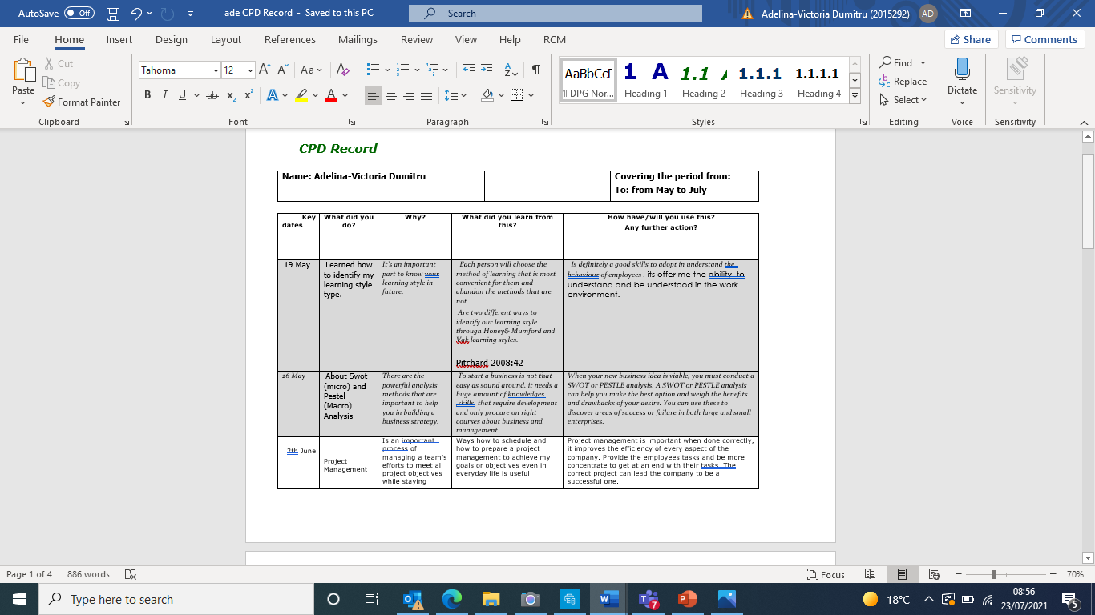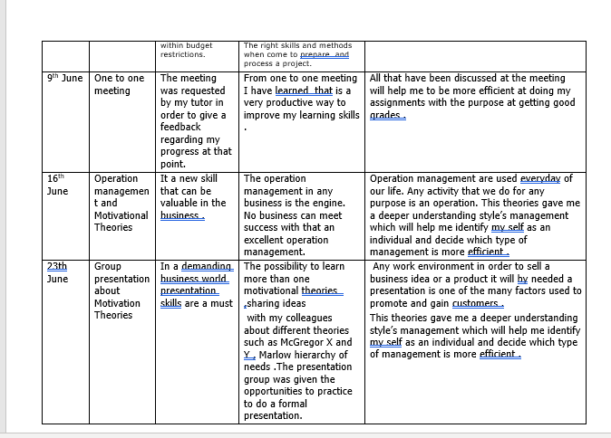

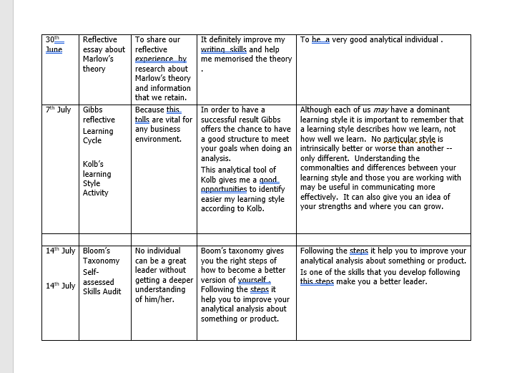
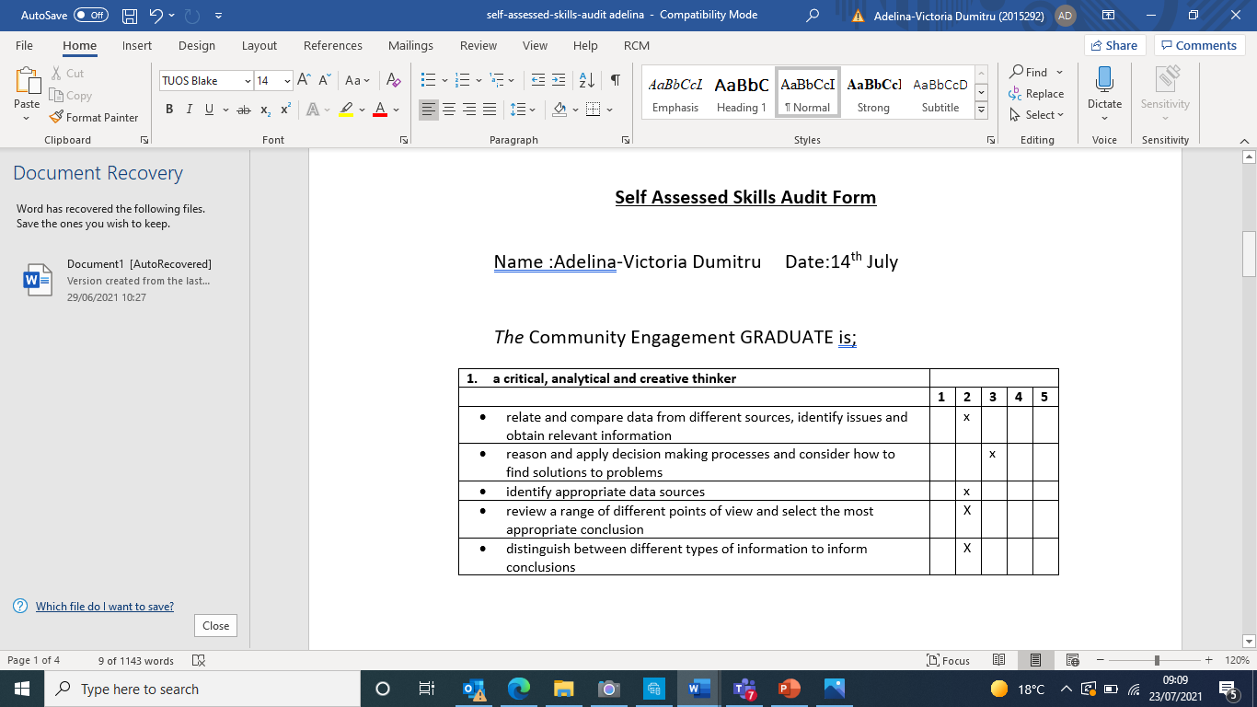
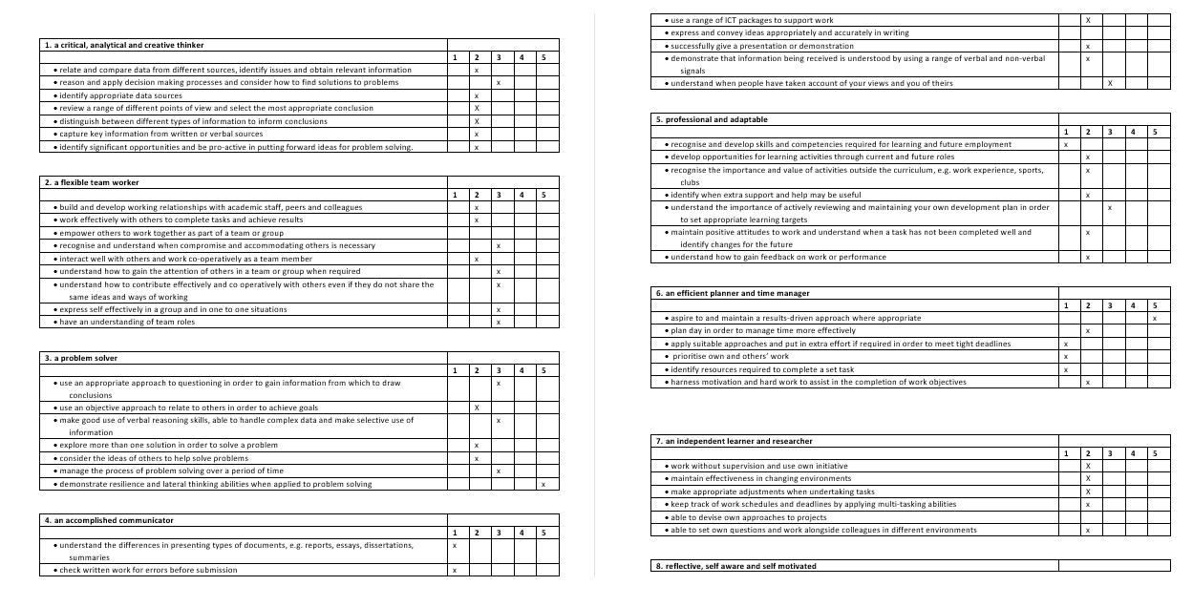

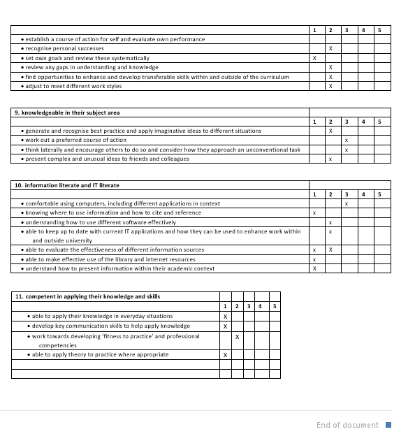

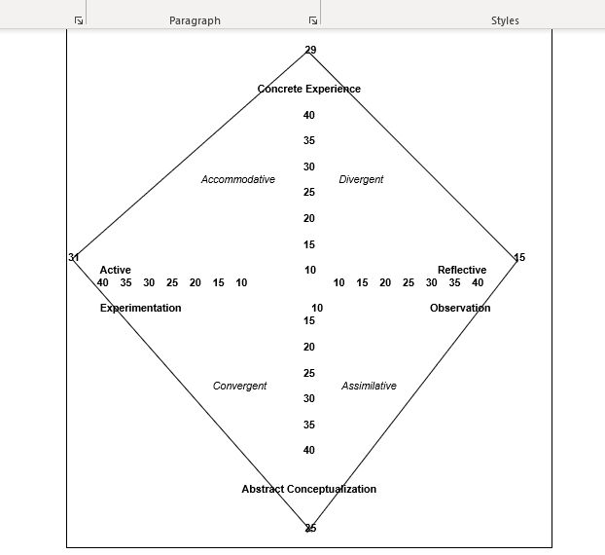Kolb’s learning style inventory

