The title of the report – Intercultural competence report
Student name: Galen Atanasov
The module title and module code: BMIH5003 Foreign Languages and Cultural Awareness
Lecturer’s name: Lisa Bassler
Wordcount: 982
Date: 10/10/2023

Diversity Hotel & Spa
Assistant General Manager's Report

Executive Summary
This comprehensive report aims to provide a detailed understanding of intercultural competence and leadership, focusing on the General Manager's upcoming visit to the new overseas hotel located in Japan. Begins by outlining the cultural customs and practices of Japan. Subsequently, using insights from the GLOBE Project, we analyze the cultural dimensions and leadership practices relevant to the scenario. The report emphasizes the significance of cultural intelligence and sensitivity within the hotel business context, highlighting potential pitfalls and challenges for the General Manager. Finally, a comprehensive list of recommendations is presented to ensure the successful integration of the new hotel into the Diversity Hotel & Spa chain.

Table of Contents
Executive Summary 2
Introduction 4
Culture Overview: Japan 4
GLOBE Project and Country Analysis: Japan 5
The Importance of Cultural Intelligence and Sensitivity 7
Conclusion 7
Recommendations 7
References: 9

Introduction
In the globalized hospitality industry, intercultural competence and effective leadership are essential for success. As Diversity Hotel & Spa expands overseas, the need for cultural understanding and effective leadership becomes paramount. The General Manager's visit to the new hotel in Japan represents an excellent opportunity to foster cultural understanding and align operations with the chain's global standards. This report provides insights into Japanese culture, analyzes it through the lens of the GLOBE Project, underscores the importance of cultural intelligence, and concludes with detailed recommendations for a successful transition.

Culture Overview: Japan
Japan, an island nation in East Asia, boasts a rich and distinct culture influenced by centuries of tradition and modernization (Abbo, 2023). Key aspects of Japanese culture and customs include:
- Collectivism: Japanese society places a strong emphasis on group harmony and consensus. Hierarchical structures are common, and loyalty to one's group or company is highly valued.
- Politeness: Respect and courtesy are integral to Japanese interactions. Bowing is a common form of greeting, and addressing people by their titles is customary.
- High Context Communication: Japanese communication tends to be implicit, relying on context, non-verbal cues, and shared understanding. This can pose challenges in cross-cultural interactions.
- Ceremonial Rituals: Rituals and ceremonies, such as tea ceremonies and festivals like Hanami (cherry blossom viewing), hold significant cultural importance (Acar, 2020).
- Work Ethic: The Japanese work ethic is renowned for its dedication and diligence, often resulting in long working hours.
Japan's culture is deeply rooted in Confucianism and Shintoism, which influence social norms, rituals, and etiquette. Understanding and respecting these cultural are critical for successful in Japan.

GLOBE Project and Country Analysis: Japan
The GLOBE Project identifies cultural dimensions and leadership practices. For Japan, key findings include:
- Uncertainty Avoidance: Japan scores high on this dimension, indicating a preference for structured and predictable environments. The General Manager should ensure clear guidelines and protocols are in place to reduce uncertainty and ambiguity (Japanese Culture, 2018).
- Power Distance: Japan exhibits a relatively high-power distance, implying that hierarchical structures are expected and respected (Binti, Binti, Nur Atiqah; Hamid, Abdul; Nor, Zainiyah; Chung, Ji-Hye Jaime, 2017). The General Manager should adapt their leadership style, accordingly, emphasizing respect for authority.
- In-Group Collectivism: Japanese culture is strongly collectivist, with loyalty to in-groups like family and company. The General Manager should foster a sense of belonging among staff, encourage teamwork, and consider the well-being of the group.
- Assertiveness: Japan ranks low on assertiveness, emphasizing harmony and consensus (Wagner, 2015). The General Manager should encourage open communication but avoid confrontational approaches, focusing on building consensus and resolving conflicts harmoniously.
- Performance Orientation: Japanese culture values achievement and excellence, aligning with the chain's quality standards. The General Manager should promote performance-based recognition, setting clear expectations for staff performance and celebrating achievements.
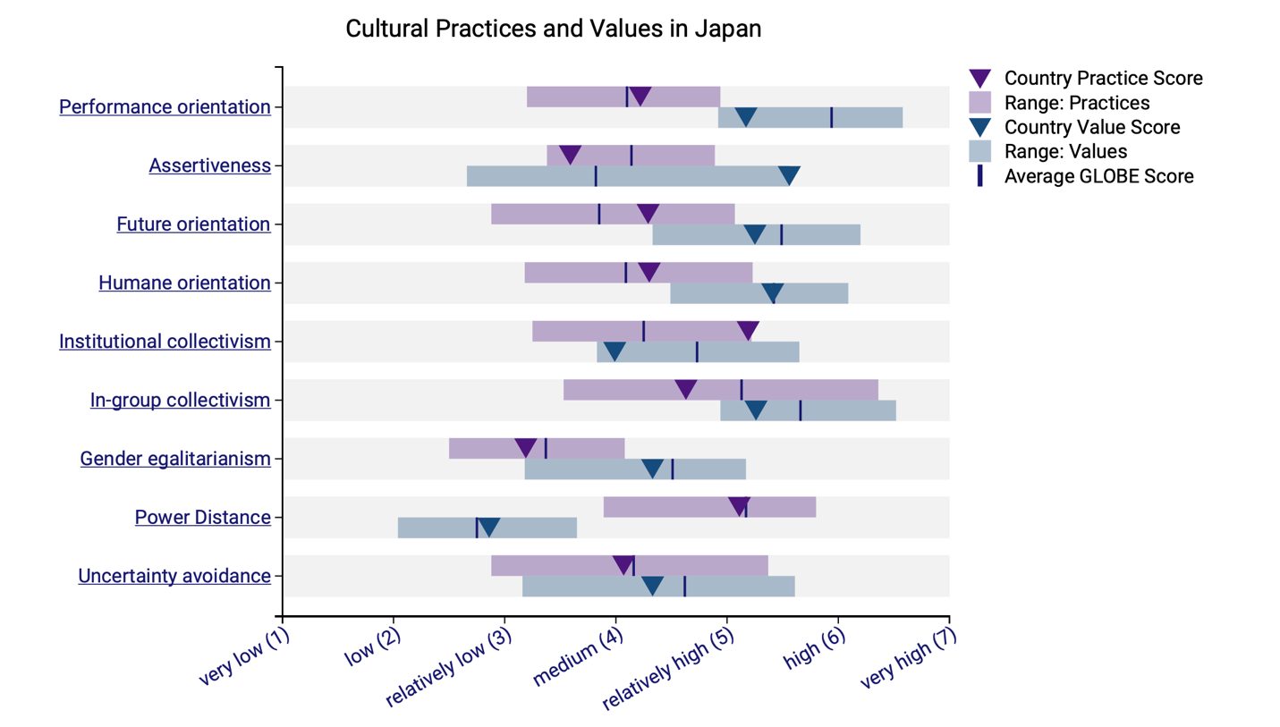
Cultural Practices and Values in Japan
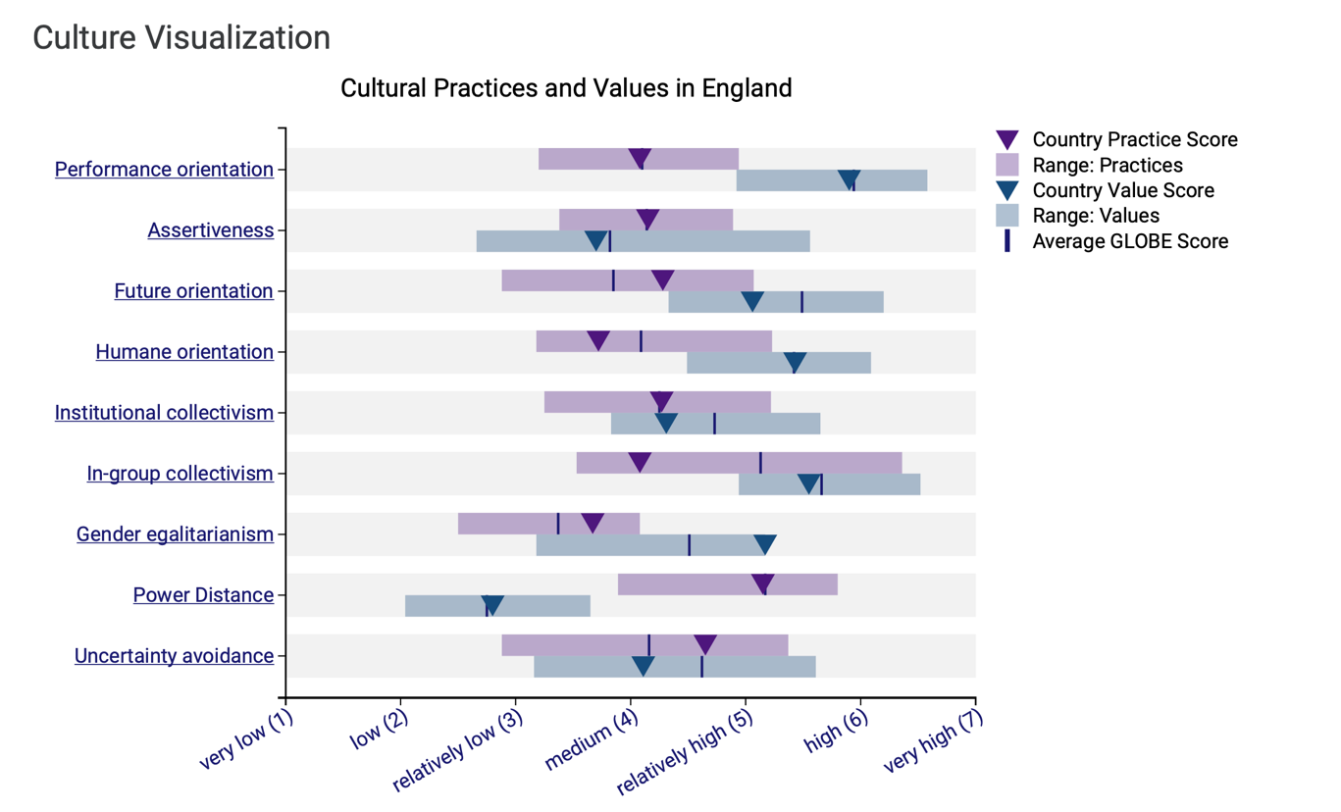
(Picture from Globe Project)
Cultural Practices and Values in England
(Picture from Globe Project)

The Importance of Cultural Intelligence and Sensitivity
Cultural intelligence and sensitivity are imperative for hotel personnel in a global business context. They play a pivotal role in the following ways:
1. Enhance Guest Experiences: Understanding and respecting diverse guest needs and expectations fosters positive experiences and customer loyalty. When international guests feel welcomed and understood, they are more likely to return and recommend the hotel to others.
2. Facilitate Team Cohesion: Culturally intelligent teams work more harmoniously, improving efficiency and morale. When employees from diverse backgrounds feel valued and respected, they are more likely to collaborate effectively, resulting in a smoother workflow.
3. Mitigate Misunderstandings: Awareness of cultural nuances minimizes the risk of misunderstandings and conflicts. Misinterpretations or insensitive behavior can harm relationships and tarnish the hotel's reputation.
4. Improve Reputation: A culturally sensitive hotel is more likely to be perceived positively by international guests. This positive image can lead to increased bookings and customer loyalty.
In the context of Diversity Hotel & Spa's expansion into Japan, cultural intelligence and sensitivity are not merely optional but essential for the successful integration of the new hotel into the chain.

Conclusion
Successfully integrating the new hotel into the Diversity Hotel & Spa chain in Japan requires a deep understanding of Japanese culture and effective leadership practices. Cultural intelligence and sensitivity are not optional but fundamental to ensuring smooth operations, satisfied guests, and a strong brand reputation. By implementing the recommendations outlined in this report, the General Manager can navigate the challenges of cross-cultural management effectively and create a hotel environment that respects and celebrates Japanese culture while maintaining the chain's global standards.

Recommendations
1. Cultural Training: Implement a comprehensive cultural training program for all staff members, including front-line employees, managers, and executives. This training should cover various aspects of Japanese culture, including language lessons, cross-cultural communication workshops, and cultural awareness sessions. Training should be ongoing to ensure continuous improvement.
2. Feedback Mechanisms: Establish regular feedback mechanisms that allow staff to express concerns, share cultural insights, and offer suggestions related to cultural integration. An open and transparent feedback system will encourage employees to contribute to the hotel's success.
3. Continuous Monitoring and Adaptation: Cultural dynamics can evolve over time, so it is essential to continuously monitor and adapt to changes. Regularly assess the effectiveness of cultural initiatives and make adjustments as needed.
4. Celebrating Japanese Festivals and Traditions: Embrace and celebrate Japanese festivals and traditions within the hotel. This can include hosting special events, decorating the hotel to reflect local customs during festivals, and offering traditional Japanese cuisine to guests.
5. Language Support: Ensure that there are staff members proficient in both English and Japanese who can assist with translations and communication, particularly for non-Japanese-speaking guests.
6. Cross-Cultural Teams: Consider creating cross-cultural teams within the hotel, where employees from diverse backgrounds collaborate on projects and initiatives. This promotes cultural understanding and creativity.
7. Recognition of Achievements: Develop a system for recognizing and celebrating staff achievements that align with Japanese values. This can include awards, certificates, or other forms of recognition.

References:
Abbo, V. E. (2023) Japanese Hospitality: Omotenashi, Linkedin.com. Available at: https://www.linkedin.com/pulse/japanese-hospitality-omotenashi-von-eric-abbo (Accessed: October 14, 2023).
Acar, A. (2020) Japanese culture and traditions, Tea Ceremony Japan Experiences MAIKOYA. Maikoya. Available at: https://mai-ko.com/travel/culture-in-japan/japanese-culture-1/ (Accessed: October 14, 2023).
Binti, Binti, Nur Atiqah; Hamid, Abdul; Nor, Zainiyah; Chung, Ji-Hye Jaime (2017) Power distance among leaders in tourism, Worldresearchlibrary.org. Available at: https://www.worldresearchlibrary.org/up_proc/pdf/999-150486359421-24.pdf (Accessed: October 14, 2023).
GLOBE Project (Global Leadership and Organizational Behavior Effectiveness). Retrieved from: https://globeproject.com/
House, R. J., Hanges, P. J., Javidan, M., Dorfman, P. W., & Gupta, V. (2004). Culture, leadership, and organizations: The GLOBE study of 62 societies. Sage Publications.
Japanese Culture (2018) Cultural Atlas. Available at: https://culturalatlas.sbs.com.au/japanese-culture/japanese-culture-core-concepts (Accessed: October 14, 2023).
Results - England GLOBE project (no date) Globeproject.com. Available at: https://globeproject.com/results/countries/GBR?menu=country (Accessed: October 14, 2023).
Results - Japan GLOBE project (no date) Globeproject.com. Available at: https://globeproject.com/results/countries/JPN?menu=country (Accessed: October 14, 2023).
Takaoka B. Y. (2022) “Japanese work culture: How to succeed working in Japan,” EJable. Employment Japan, 28 November. Available at: https://www.ejable.com/japan-corner/working-in-japan/japanese-work-culture/ (Accessed: October 14, 2023).
Tennant, A. (2021) Japanese Culture, FamilySearch. Available at: https://www.familysearch.org/en/blog/japanese-culture (Accessed: October 14, 2023).
Trompenaars, F., & Hampden-Turner, C. (2017). Riding the Waves of Culture: Understanding Diversity in Global Business. Nicholas Brealey Publishing.
Wagner, D. (2015) Talk to anyone in business in Japan these days and “Abenomics” comes in to the conversation. Structural and financial reform seems to the topic of the day, Linkedin.com. Available at: https://www.linkedin.com/pulse/being-assertive-missing-action-japan-david-wagner (Accessed: October 14, 2023).

