

Student name: Mohammed Azharuddin
Student ID: 2105239
Module name: Entrepreneurship
Module code: LCMB7004
Lecturer name: Gladius Kulothungan

Table of Contents
Introduction 3
Discussion 4
Concepts of enterprise and entrepreneurship from entrepreneur’s perspective 4
Concept of enterprise 4
Concept of entrepreneurship 5
Evaluation of aspects related to entrepreneurs 6
Critical evaluation of entrepreneur’s traits 6
Critical evaluation of entrepreneur’s characteristics 7
Critical evaluation of entrepreneur’s attributes 8
Critical evaluation of motivation of the entrepreneurs 9
Difference between profit and non-profit organisation 11
Impact on entrepreneur’s values and beliefs 11
Conclusion 12
References 13

Introduction
The importance of understanding concepts such as enterprise and entrepreneurship is increasing on a daily basis in the modern business environment. Understanding the mechanism behind the functioning of an enterprise and and on entrepreneurial business is becoming very much necessary. This is very much important for any entrepreneur to understand the difference between the two models of business operations. Understanding such concepts in depth will help an entrepreneur to understand the necessary innovation that is required for the business that the entrepreneur is going to initiate in this modern business environment (Tittel and Terzidis, 2020). Apart from that with the implementation of such ideas and having a knowledge regarding these concepts entrepreneurs will have a less chance of facing risk and loss in business operations (Ratten, 2020). This will also help the entrepreneurs to understand the application of the necessary business model that is beneficial for the growth and development of the business that the entrepreneur is trying to set up, focusing on the success in the particular field of business in which the entrepreneur has set up its operations. The particular report is mainly going to focus on the application of various knowledge and concepts related to enterprise and entrepreneurship that an entrepreneur has in order to initiate a business operation. The report will also focus on the traits characteristics attributes and also the motivational drivers for an entrepreneur. The particular report will also be helpful in terms of highlighting the difference between profit and non profit organisation and the impact that it places upon the values and the beliefs of an entrepreneur in the modern business world.

Discussion

Concepts of enterprise and entrepreneurship from entrepreneur’s perspective

Concept of enterprise
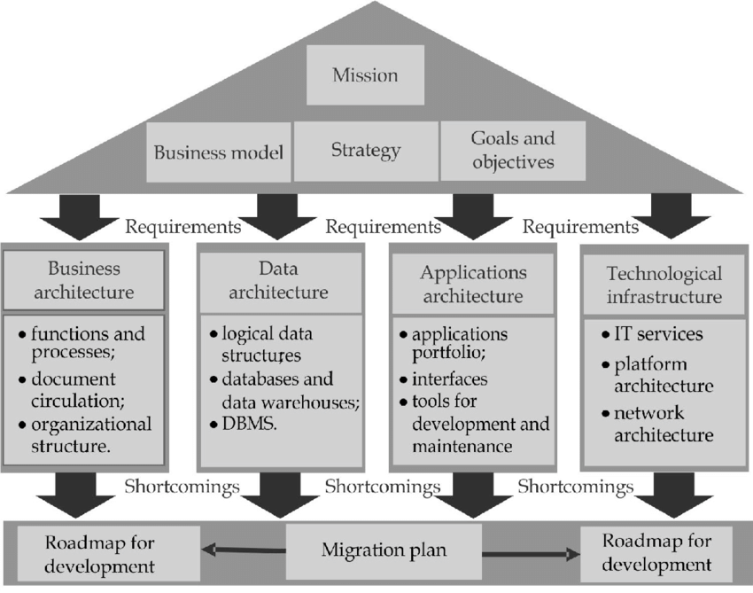
Figure 1: Enterprise design in the modern business environment
(Source: Costin et al., 2018)
Enterprises are mainly business operations that focus on business opportunities for setting up businesses in the modern business environment. Enterprises are set up in the modern business world whenever there is a difference seen in between a demand that is not made from the existing products or service line in the business environment. As a result of which business operations are set up to create an innovative product or service line that can mitigate such differences in customer needs. Enterprises always focus on fulfilling the gap that is present in the market (Costin et al., 2018). With that in mind enterprises tend to create a product or a service line to fill up that gap and mitigate the demand of the goods and the services that are required in the market. With the help of such idea enterprises tend to create profits and also increase business operations (Sharma, 2018). Enterprises that are set up in this modern business environment can provide a huge range of products such as food transportation, electronic devices as well as services such as internet connection, personal care etc.

Concept of entrepreneurship
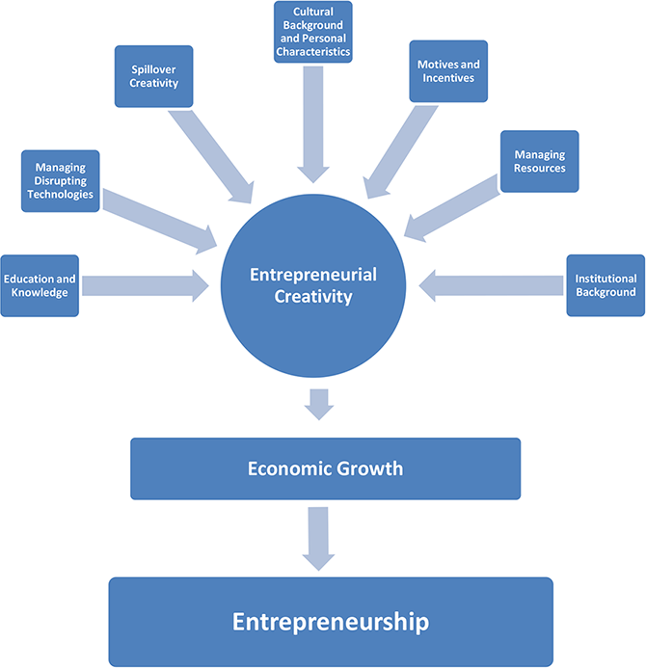
Figure 2: Core focuses on Entrepreneurship
(Source: Hägg and Gabrielsson, 2019)
Entrepreneurship is directly linked to the concepts of enterprising. Entrepreneurship mainly focuses on an individual's action of formulating a new business by taking on various risks related to the new business idea in terms of providing effective services and product range that is not present in the modern business environment. Entrepreneurship always focuses on the implementation of such new products with a high risk in the market so that greater rewards can be achieved by the business if the product gets success (Hägg and Gabrielsson, 2019). Entrepreneurs are highly important in the modern business market as entrepreneurs tend to bring in new innovative technology ideas and also products and services. Entrepreneurs tend to play a key role in the modern economy as they are the ignitor of bringing in necessary disruptive technology into the production process of the economy (Hakala et al., 2020). Apart from those entrepreneurial activities are a major force behind upskilling and innovating a society. Both enterprising and entrepreneurship are intertwined with each other in the modern business environment.

Evaluation of aspects related to entrepreneurs

Critical evaluation of entrepreneur’s traits
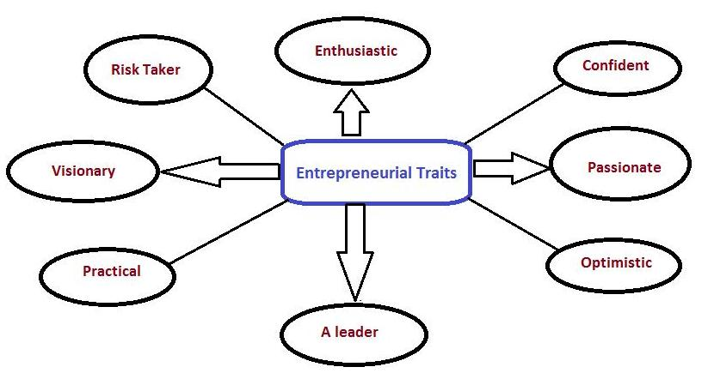
Figure 3: Traits of entrepreneurs
(Source: Gilmore et al., 2020)
According to the study of Muo and Azeez, (2019) it has been seen that Entrepreneurs tend to showcase various traits in terms of increasing their business operations and also incorporating their ideas into the modern business environment. With the help of particular traits entrepreneurs tend to implement and formulate strategic ideas for increasing businesses and also the product and the service line of the company. The first trait that is being showcased by modern entrepreneurs is that of having a robust work ethics. This mainly showcases the amount of time that they invest in terms of developing a new product or service line in the modern business environment (Gilmore et al., 2020). The particular trade that is shown by the entrepreneurs also helps in terms of increasing quality management of the product and the product or the service valuation to the customers. For example companies such as Charged Up, have created on the go charging stations that can be used in terms of charging electronics equipment. This is one of the most influential entrepreneur ideas that has been made possible with the help of robust work culture that the entrepreneurs have presented in terms of developing such an idea in the modern business environment.
Entrepreneurs also tend to showcase a deep passion in terms of developing their business ideas strongly and also incorporating various new strategies in terms of reaching out to the customs. With the help of such traits entrepreneurial companies have the ability to raise business operations and also attract more customer base towards their operations. Entrepreneurs also show the trait of creativity in terms of developing new ideas (Macke et al., 2018). As the example has been previously mentioned in regards to the portable charging units developed by the Charged Up company that are present in various places are mainly produced keeping in mind the convenience level of the customers. Another important trait that is shown by the entrepreneurs is that of the eagerness to learn new aspects that would help to raise their business operations. This is beneficial for increasing product development skills.

Critical evaluation of entrepreneur’s characteristics
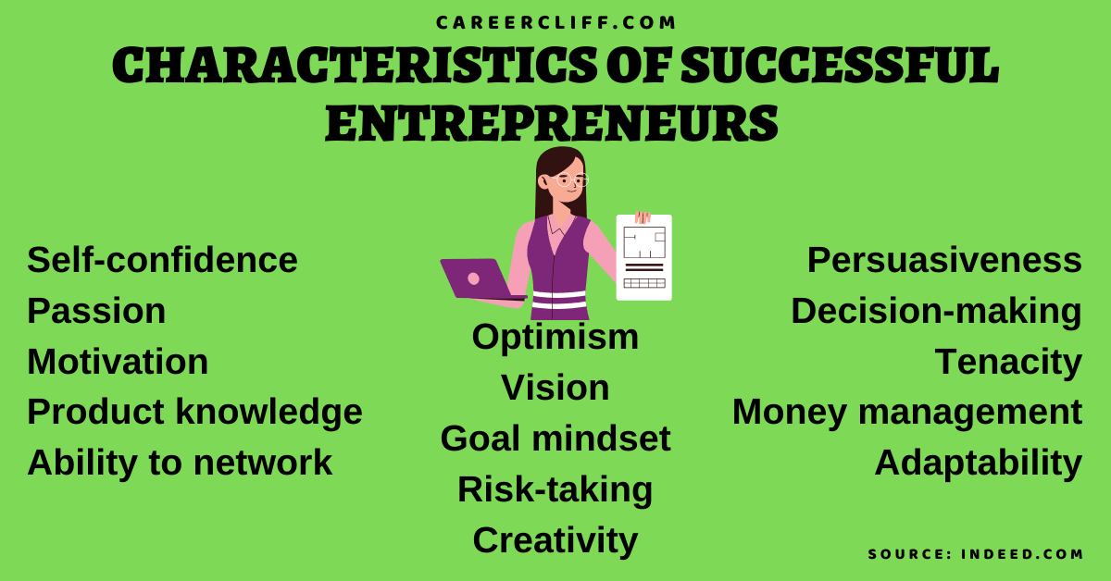
Figure 4: Characteristics of entrepreneurs
(Source: Bauman and Lucy, 2021)
In the modern business environment entrepreneurs tend to showcase various characteristics that are beneficial for them to raise the operation capability of the businesses that they are running and also incorporate various innovations that are necessary for the business. As per the study of Bauman and Lucy, (2021) it has been seen that the 10 most shown characteristics of entrepreneurs are curiosity, structured experimentation of the products and services, adaptability , decisiveness , team building capability, risk tolerance, being comfortable with failures, persistence , innovation and lastly focus on long term development. With all these characteristics entrepreneurs tend to develop their businesses and also increase their profit margin.
Curiosity: this is one of the characteristics that is shown by modern entrepreneurs. This mainly implements the area of learning new technologies and also to see new opportunities in terms of increasing businesses (Julien, 2018).
Structured experimentation: this is another characteristic that is shown by entrepreneurs in terms of trying out new opportunities. This is also beneficial for them to develop new ideas for product and service lines.
Adaptability: one of the most important characteristics that is shown by entrepreneurs is that of adaptability. This helps the entrepreneurs to adapt and be prepared for the changes that are seen in the modern business environment (Olanrewaju et al., 2020).
Decisiveness: these characteristics help entrepreneurs to take strategies and also implement them correctly. This is beneficial for increasing their profit margin.
Team building: another characteristic that is shown by entrepreneurs is that of team building. Creating effective teams helps in terms of developing new products and also increasing the operational capability of the company.
Risk tolerance: in the modern business environment risk tolerance is one of the most important characteristics that is needed to be showcased by entrepreneurs. This helps them to implement new ideas into business operations and raise the operational capabilities.
Being comfortable with failures: it is also important for entrepreneurs to be comfortable with failures. Being comfortable with failures helps them to analyse and understand the risk that is associated with the new ideas.
Persistence: analysing failure and developing new products based on those weaknesses helps entrepreneurs to have growth in their operations.
Innovation: entrepreneurs also showcase the ability of implementing various innovative ideas such as the inclusion of disruptive technology in the production process (Kier and McMullen, 2018).
Long term focus: entrepreneurs also tend to showcase characteristics that focus on long term growth and development of their company by pointing out critical success factors in that process.

Critical evaluation of entrepreneur’s attributes
Entrepreneurs also tend to show various attributes in terms of increasing their ability to raise scales of business operations. The five most common attributes that are shown by entrepreneurs are innovation, taking chances working hard, people management and capital Management and lastly being passionate of developing the services for the product line (Cao and Shi, 2021). With the help of these attributes entrepreneurs tend to perfect their business operations and also raise their ability for implementing their business model in the modern business environment.
Being innovative: Being innovative in the modern business environment helps entrepreneurs to develop new product lines and create variations in existing products with the incorporation of various disruptive technologies such as AI blockchain and IoT. These measures are also beneficial for the entrepreneurs to maintain the requirements of the customers and also increase customer service.
Taking chances in increasing business operations: this is another attribute that is showcased by entrepreneurs. This helps entrepreneurs to analyse the market condition and also take risk in terms of developing new products, growing their businesses and expanding into new markets with the investment of capital and hiring workforce. This also portrays the ability of entrepreneurs to take risks in this modern business environment (Drobyazko et al., 2019).
Willingness to work hard: this is also an attribute that is presented by entrepreneurs in showcasing their ability to work hard and develop new products. This is also a way of showing how passionate the entrepreneur is in regards to the business that the entrepreneur has formed.
People management and capital Management: Entrepreneurs also need to have the effective skill of managing people in terms of performing various jobs and running the business effectively. Apart from that capital Management and investment of capital funds are also necessary for an entrepreneur to grow its business operations.
Passionate about work: another important attribute that is shown by entrepreneurs is that of being passionate in regards to the job that they perform (Henry and Lewis, 2018). This helps them to understand modern business prospects and also the various necessary measures that can be implemented to increase business operations.

Critical evaluation of motivation of the entrepreneurs
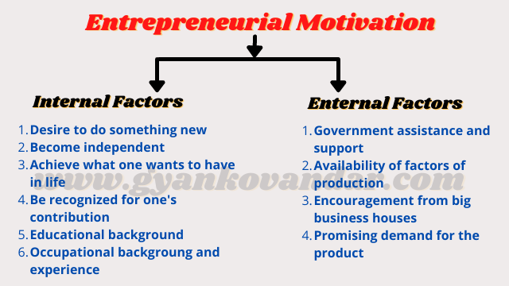
Figure 5: Motivation of the entrepreneurs
(Source: Javed, Yasir and Majid, 2019)
In the modern business environment there are various motivational factors that can help entrepreneurs to raise their operation capability. The motivational factors also act as positive measures for various entrepreneurships in terms of implementing various ideas and also tracking the modern business environment effectively. The major motivational factors that might help in terms of increasing productivity of an entrepreneur are divided into two sets of factors. Factor is an internal factor that depends upon the desire of the entrepreneur to achieve something new (Javed, Yasir and Majid, 2019). Apart from that, being recognised in accordance with the work that is being performed by the entrepreneur also helps the entrepreneur to get motivated and increase the operational capability. Entrepreneurial motivation also depends on the aspects of the implementation of the plan that has been produced by the entrepreneur and also the ability to convey the idea to the modern business world.
In terms of the external factors monetary and capital assistance from the government and also the availability of good grades of raw materials as well as an educated workforce is one of the most important motivating factors for entrepreneurs to grow and develop in the modern business environment. With the help of these external factors entrepreneurs can raise effectiveness in terms of business operations and also obtain promising results from the end of the action processes (Jones, Penaluna and Penaluna, 2019). This is also very much beneficial for the business operation that the entrepreneur is focusing on as well as the returns that the entrepreneur is getting in terms of increasing the organisation and capability and also raising the profit margin in the modern business environment.

Difference between profit and non-profit organisation
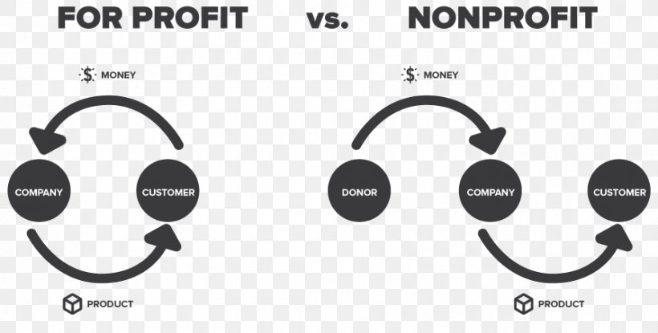
Figure 6: Difference between Profit and non profit organisation
(Source: Islam, 2020)
In the modern business environment, they are two types of organisations that are seen in terms of carrying out business operations. The first organisation is mainly the profit organisation. Profit organisation focuses on increasing profit margin with the help of increasing business operations by direct sales of products and services that are considered disruptive in the modern business environment (Islam, 2020). Various enterprises follow this sort of prospect in terms of rising business operations and also gaining profit. Non profit organisations mainly focus on providing services to the society without any cost. The main Source of revenue for the non profit organisations are donation subscription as well as membership fee. Whereas a profit organisation always focuses on making profit and providing results to its shareholders. Non profit organisations are mainly accountable to the public and must provide information in a detailed way that the organisation obtained from the government. Where a profit organisation must always provide market data and also the various risks that are associated with the effective functioning of the shareholders of the company.

Impact on entrepreneur’s values and beliefs
Entrepreneurs always tend to formulate products that are highly beneficial for the society as well as disruptive in nature. The products that are produced are mainly to provide convenience to the customers that are present in the society. Entrepreneurs tend to produce such disruptive products using modern digital technology to increase service provision to the customers. Implementation of such aspects are mainly seen for increasing the profit margin of the entrepreneurs (France and Regmi, 2019). But there rises a dilemma in regards to the sales operations that are carried on by the entrepreneurs. Providing services to the society but extracting profit from the society is the major cause for this dilemma. Entrepreneurs tend to focus upon such aspects and justify the generation of profit from the customers with statements such as the inclusion of disruptive technology and innovative ideas and also the requirements of funds to carry out the usage and implementation of such technology. The particular statement is also true as entrepreneurs need capital and financial assistance to carry out the incorporation of modern technology into their business systems and also increase the profit margin with the implementation of such disruptive measures (Heikkinen, Kujala and Inha, 2019). This also helps entrepreneurs in terms of growth operations in the modern business environment.

Conclusion
The particular report has been very much beneficial to present the importance of the knowledge and the concepts regarding enterprise and entrepreneurship for an entrepreneur. With the help of these concepts an entrepreneur can implement new technology innovation and also understand the necessity of increasing the product line for its business. This also helps them to understand the difference between profit and non profit organisations and the necessity of obtaining funds from the society. This also helps an entrepreneur to increase the profit margin and also innovate in a better way by the inclusion of various modern disruptive technologies. Understanding the role of enterprise and entrepreneurship and the relation between them health and entrepreneur to understand the various requirements that are necessary to grow business operations.

References
Bauman, A. and Lucy, C., 2021. Enhancing entrepreneurial education: Developing competencies for success. The International Journal of Management Education, 19(1), p.100293.
Cao, Z. and Shi, X., 2021. A systematic literature review of entrepreneurial ecosystems in advanced and emerging economies. Small Business Economics, 57(1), pp.75-110.
Costin, Y., O'Brien, M.P. and Slattery, D.M., 2018. Using simulation to develop entrepreneurial skills and mind-set: An exploratory case study.
Drobyazko, S., Barwińska-Małajowicz, A., Ślusarczyk, B., Zavidna, L. and Danylovych-Kropyvnytska, M., 2019. Innovative entrepreneurship models in the management system of enterprise competitiveness. Journal of Entrepreneurship Education, 22(4), pp.1-6.
France, A. and Regmi, P., 2019. Information Accountability in a Non-profit Organisation. Journal of New Business Ideas & Trends, 17(1).
Gilmore, A., McAuley, A., Miles, M.P. and Pattinson, H., 2020. Four questions of entrepreneurial marketing education: Perspectives of university educators. Journal of Business Research, 113, pp.189-197.
Hägg, G. and Gabrielsson, J., 2019. A systematic literature review of the evolution of pedagogy in entrepreneurial education research. International Journal of Entrepreneurial Behavior & Research.
Hakala, H., O'Shea, G., Farny, S. and Luoto, S., 2020. Re‐storying the business, innovation and entrepreneurial ecosystem concepts: The model‐narrative review method. International Journal of Management Reviews, 22(1), pp.10-32.
Heikkinen, A., Kujala, J. and Inha, M., 2019. Stakeholder engagement in a non-profit organisation: an issue-based perspective. International Journal of Human Resources Development and Management, 19(1), pp.5-20.
Henry, C. and Lewis, K., 2018. A review of entrepreneurship education research: Exploring the contribution of the Education+ Training special issues. Education+ Training.
Islam, S.M., 2020. Unintended consequences of scaling social impact through ecosystem growth strategy in social enterprise and social entrepreneurship. Journal of Business Venturing Insights, 13, p.e00159.
Javed, A., Yasir, M. and Majid, A., 2019. Is social entrepreneurship a panacea for sustainable enterprise development?. Pakistan Journal of Commerce and Social Sciences (PJCSS), 13(1), pp.1-29.
Jones, C., Penaluna, K. and Penaluna, A., 2019. The promise of andragogy, heutagogy and academagogy to enterprise and entrepreneurship education pedagogy. Education+ Training.
Julien, P.A., 2018. The state of the art in small business and entrepreneurship. Routledge.
Kier, A.S. and McMullen, J.S., 2018. Entrepreneurial imaginativeness in new venture ideation. Academy of Management Journal, 61(6), pp.2265-2295.
Kuratko, D.F., Fisher, G. and Audretsch, D.B., 2021. Unraveling the entrepreneurial mindset. Small Business Economics, 57(4), pp.1681-1691.
Macke, J., Sarate, J.A.R., Domeneghini, J. and da Silva, K.A., 2018. Where do we go from now? Research framework for social entrepreneurship. Journal of cleaner production, 183, pp.677-685.
Muo, I. and Azeez, A.A., 2019. GREEN ENTREPRENEURSHIP: LITERATURE REVIEW AND AGENDA FOR FUTURE RESEARCH: Muo, I., Azeez, A..(2019). Green Entrepreneurship: Literature Review and Agenda for Future Research. International Journal of Entrepreneurial Knowledge, 7 (2), 17-29. doi: 10.12345-0007. International Journal of Entrepreneurial Knowledge, 7(2).
Olanrewaju, A.S.T., Hossain, M.A., Whiteside, N. and Mercieca, P., 2020. Social media and entrepreneurship research: A literature review. International Journal of Information Management, 50, pp.90-110.
Ratten, V., 2020. Coronavirus and international business: An entrepreneurial ecosystem perspective. Thunderbird International Business Review, 62(5), pp.629-634.
Sharma, L., 2018. A systematic review of the concept of entrepreneurial alertness. Journal of Entrepreneurship in Emerging Economies.
Tittel, A. and Terzidis, O., 2020. Entrepreneurial competences revised: developing a consolidated and categorized list of entrepreneurial competences. Entrepreneurship Education, 3(1), pp.1-35.

