LCBB4004
Marketing Fundamentals
Assessment 1
Student Name: Martina Martinova Karadzhova
Student ID: 2021296
University of Wales

Contents
Introduction 4
Marketing 5
Marketing processes 5
Marketing process steps 5
Understanding the customers need 5
Developing a marketing strategy according to the customers' satisfaction 6
Making necessary decision 6
Plan execution 6
Providing result 7
Stages of marketing 7
Development stage 7
• Customer value 8
• Cost 8
• Communication 8
• Convenience 8
Start-up 8
Survival 8
Expansion or growth 9
Maturity 9
Marketing mix 9
Product 9
Price 10
Place 10
Promotion 11
Conclusion 12
References 13

Introduction
Every business organisation must have a proper marketing plan to survive in today’s world of competition. Marketing is the only way for any business organisation to know their customers need and their level of interest in the products that they sell. There are many stages and processes that a business marketing should go through (Baines, Fill and Rosengren, 2017). The marketing mix is the most appropriate way to understand the business condition of any business. Though while entering a global market the business organisation should set up the models of marketing by acknowledging the market environment to cope up with the competition. Siemens is a technology-based top company in Europe (Siemens, 2021). Examples of them can be taken while providing a marketing strategy. This report will analyse the fundamentals of marketing for any business organisation.

Marketing
Marketing includes a set of activities that are performed by any organisation or business industry for promotional purposes (Bowman and Gatignon, 2010). It is to promote their products and increase their buying and selling rate. Marketing can indicate advertising of the product, selling them to the target customers, and transport it to the buyers or other organisations. Marketing can be done by third parties as tv shows. As like the business company Siemen who is a technology-based company working to make the world intelligent and more efficient using better technology. They have their sales and marketing team to spread their innovation all around the world (Carpenter, Gebhardt and Sherry, 2014).

Marketing processes
The marketing process is the process to satisfy the target customers need in terms of price. It is a process to serve and satisfy their customers by providing enough and satisfying price. It helps to create a healthy relationship with the customers.

Marketing process steps
The marketing process starts by understanding the customer's needs and build up a strategy accordingly. Marketing processes have some major steps which are stated below.

Understanding the customers need
The marketing process highly depends on the customers so understanding them well is the first step toward success. Understanding the customers may have some requirements as well.
The local customers and their needs should be understood. Then the country that the business organisation is targeting should be focused and understand their needs (Cateora, Gilly and Graham, 2016). They should let their customers know about their products and have an outlook about their interest. The economic situation of the customers should be acknowledged. While launching a product understanding their economy and situation will help a lot in the pricing. As a company, Siemens understand their customers and want to be innovative in a way to help their customers, so they put up a reasonable price for their products to reach their customers and satisfy them. They believe that their customers play a vital role in their development (Elliott et al., 2018).

Developing a marketing strategy according to the customers' satisfaction
While starting a business the business organisation must acknowledge the local customers need, recent trends, their target customer, and the level of their products need. The goal is not to satisfy every single person in the area which is not even possible. Though the maximum amount of people should be satisfied through the product, who have a good outlook about the product (Šalgovičová and Štefančiková, 2015). A survey should be done to find this customer. After targeting necessary budget should be provided and a strategy should be established. The first step should be taken at a minimal level with one single product. Then the competitors and their strategies should be acknowledged. The Company Siemen is all about their customers and their needs and development. They have built a strategy that satisfies every customer need.

Making necessary decision
After targeting and developing a strategic structure the company must make important decisions (Kerin and Hartley, 2021).
- The budget of each product
- The specifications of the products
- Future development of several products
- Promote their products and procedures.
- The launch date of the products.
After taking the necessary decisions the company must understand their next step. This is the most important part of marketing as these decisions control the business’s success. This will help to develop the company in the future. The organisation should provide premium products to stay put with their customers (Laurens, 2005).

Plan execution
After building up the strategy and making necessary decisions the company must execute their plan and while doing so, they must focus on some important things which are competence should be created while sharping their interest and lighting up the company’s passion. The plan that is provided should be simple and easily executing. Execution is the process to develop the company so one should know about their work (Baines, Fill and Rosengren, 2017). The company should explore the market situation and their competitors and improve them accordingly. Providing the best items will outnumber the competitors and help them grow. Then they can launch their products.

Providing result
After the following processes, the product is launched. The products can be delivered in the market and the organisation should ask for feedback from the customers (Kerin and Hartley, 2021). The products will not satisfy all the customers. The haters will provide feedback which will help the company to improve themselves accordingly. Siemens innovates themselves regularly according to their customer's feedback and this is what made them one of the top business organisations in Europe.

Stages of marketing
A successful business organisation follows some stages of marketing. Which are stated below. Every business will change according to the change in the world market. Every company grows through some stages it does not happen in one day. The organisation must face development at every single stage of it (Šalgovičová and Štefančiková, 2015). Change in the world market will change customers needs and their satisfaction level and the business should develop accordingly. The marketing stages are stated below.

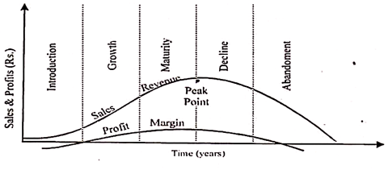

Figure 1: product life cycle (Bowman and Gatignon, 2010)

Development stage
This is the first step of any business organisations marketing process. This is the stage to develop the ideas and assess them. To test any idea surveys can be conducted. And this survey will help to understand the business whether it will run normally or if it needs further development. Some business organisation depends on the online media or search engine optimisation for promotion (Elliott et al., 2018). Though marketing channels nowadays is the most helpful process. It is hard to decide the best marketing process for a specific product. The survey is to help you to create the best plan of marketing considering customers satisfaction. The model of 4C gives a clear vision to it (Kerin and Hartley, 2021).

Customer value
It is the value that is provided to determine the position of the organisation in the market.

Cost
Thinking about what the customers must pay should be considered.

Communication
Communication is the best way to the success of any business organisation while marketing (Carpenter, Gebhardt and Sherry, 2014).

Convenience
The customers should have reasons to choose the products of the specific organisation.

Start-up
This is the stage after the proper planning and development of the products that will be provided in the market. This step will start by acquiring the feedbacks from the first customers and by analysing the demand of the served product in the market. The business structure should be adjusted according to customers expectations to increase profitability which will help to direct the business perfectly (Baines, Fill and Rosengren, 2017). Having a small market serving goods can be expensive at this stage which will improve shortly.

Survival
After surviving these crucial stages, the business will start receiving profits from the market and their customers will increase day by day. This profit will be used in paying the expenses while starting the business. Any business can face loss or great success at this period but to successfully run the business the organisation should use the methods like Sales model, the model of Marketing and the model of operations to keep this flow (Laurens, 2005).

Expansion or growth
At this stage, the business will start to expand and enter the market with more competitors. To keep up the expansion the business must seize some big shares in the market and earn profit through them, which will help the organisation to adapt a massive profit (Cateora, Gilly and Graham, 2016). At this stage, the marketing model should be set to develop the growth rate of the business.

Maturity
At this stage, the company has already reached the top and now it is to decide whether to keep up the growth or to exit from the market. This stage involves maintaining the share in the market. This stage faces the most competitive in the market (Carpenter, Gebhardt and Sherry, 2014).

Marketing mix
A marketing mix is the set of activities that a business organisation follows to reach the goal as a business organisation. The 4p’s Marketing mix includes the following items.
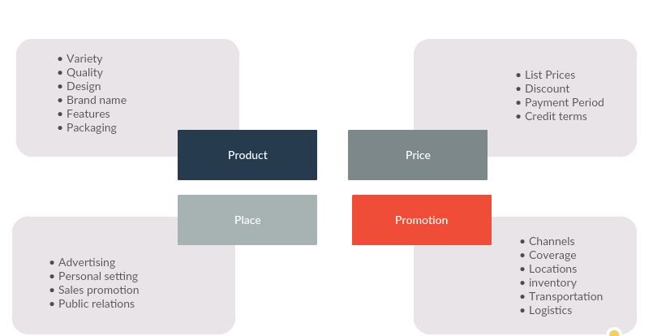

Figure 2: 4p’s marketing mix (Bowman and Gatignon, 2010)

Product
Product is the item as well as the service that is provided to the customers according to their satisfaction level. The product development process should involve consideration of the products life and challenges that the product might face. As an example, the company Siemens provides products related to an electric field, Automation and digitalizing the world. They offer low voltage systems and automation of energy solutions (Cateora, Gilly and Graham, 2016). They also have power and gas sectors.

Price
It the price which is put in any product according to the customers will, which helps to generate revenue and lets the organisation know how much they will profit from each product. The costing of production should be considered while pricing a product and the organisation must acknowledge its competitor’s strategy. The company Siemens is expanded in many sectors and they have its pricing policy. They earn 10 to 15 per cent of their profit from the power and gas sectors. 5 to 8 per cent from their wind power section. By managing the energy, they gain 7to 10 per cent profit. From their digital factories, they gain 14 to 20 per cent revenue. They have spent 4.7 B Euro in their R&D sector (Siemens, 2021).
.
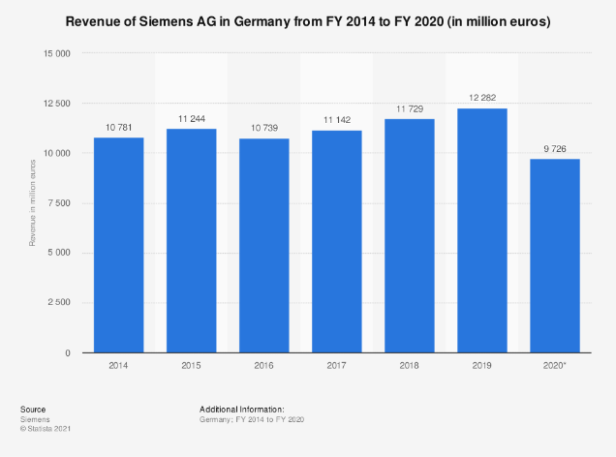
Figure 3: Siemens revenue in Germany from 2014 to 2020 (Siemens, 2021)

Place
The place indicates where the organisation will distribute their products to reach its target customers. The physical stores should be placed in a place that allows the customers to locate them. Siemens have more than 280 manufacturers worldwide (Kerin and Hartley, 2021). They have expanded their business to 200 countries along with 350 thousand employees (Armstrong, 2020).

Promotion
This the strategy of the business organisation to promote their business and attract their target customers to increase their sales. The promotional strategy should be adopted by analysing the competitors. Siemen promotes their products through tv shows, posting videos online, and providing ads and offers from time to time (Laurens, 2005). They also arrange campaigns.

Conclusion
To build up an organisation every business company should have their marketing strategy. They can use the marketing mix to understand their situation and develop them accordingly. They should analyse and provide the necessary processes to run their organisation.

References
Armstrong, P. T. (2020) Principles Of Marketing, Global Edtion. S.L.: Pearson Education Limited.
Baines, P., Fill, C. and Rosengren, S. (2017) Marketing. Oxford University Press.
Bowman, D. and Gatignon, H. (2010) Market response and marketing mix models : trends and research opportunities. Boston: Now.
Carpenter, G. S., Gebhardt, G. F. and Sherry, J. F. (2014) Resurgence : the four stages of market-focused reinvention. New York, Ny: Palgrave Macmillan.
Cateora, P. R., Gilly, M. C. and Graham, J. L. (2016) International marketing. New York, Ny Mcgrawhill Education.
Elliott, G. et al. (2018) Marketing. Milton, Qld.: John Wiley & Sons.
Kerin, R. A. and Hartley, S. W. (2021) Marketing. New York, Ny: Mcgraw-Hill Education.
Laurens, B. J. (2005) Monetary policy implementation at different stages of market development. Washington, D.C.: International Monetary Fund.
ŠalgovičováJ. and ŠtefančikováA. (2015) Marketing Processes. Łódź: Księży Młyn Dom Wydawniczy Michał Koliński.
Siemens (2021) www.siemens.com. Available at: https://www.siemens.com/global/en.html.

