

Marketing Management
(HKBM 7012)

Visionary Elegance:
A 3-Year Strategic Marketing Plan for
LensCrafters Hong Kong - Fashion and Luxury Eyewear

Student Name | ： | Shuk Man, Chau (Kathy)
Student ID Number | ： | 2322640
Date of Submission | ： | 15 July 2024
Lecturer | ： | Dr Arion Wong

Executive Summary
Table of Contents

- Introduction
  - Industry Overview
  - Company Background – LensCrafters Hong Kong

- Segmentation, Targeting and Positioning Strategies of LCHK’s Fashion and Luxury Eyewear
  - Segmentation and Targeting
  - Positioning

- Situation Analysis of LCHK’s Fashion and Luxury Eyewear
  - External Environment Analysis by PEST
  - Internal Environment Analysis by Marketing Mix 4Ps
  - Competitive Landscape
  - SWOT Analysis

- Conclusion and Recommendations for the Coming 3 Years
  - Conclusion
  - Recommendations

References
- Academic References
- Other References

Executive Summary
This report provides an in-depth analysis of LensCrafters Hong Kong’s (hereafter LCHK means LensCrafters Hong Kong business and operations only while LensCrafters refer to its parent company unless specified) fashion and luxury business line within the competitive Hong Kong eyewear market. It outlines strategic initiatives and actionable steps tailored to LCHK’s fashion and luxury eyewear business in Hong Kong, including market overview, company background, STP analysis, PEST analysis, Marketing Mix 4Ps, SWOT analysis, and strategic recommendations.
The Hong Kong eyewear market is highly competitive, with a growing demand for premium and luxury eyewear. Consumers seek high-quality, fashionable products integrated with advanced technologies, presenting opportunities for LCHK to stand out through innovation and superior service. LensCrafters, a global leader in eyewear retail, is known for high-quality products and advanced eye care services. In Hong Kong, LCHK aims to be the top destination for fashion and luxury eyewear, leveraging its strong brand and technological advancements.
LCHK targets high-end consumers and fashion enthusiasts, positioning itself as a luxury brand with premium products and personalized services. This is supported by strategic brand partnerships and a pricing strategy that reflects the exclusivity and quality of its offerings. The PEST analysis highlights key external factors: a stable political environment, rising disposable income, increasing awareness of eye health, and technological advancements in digital eye exams, virtual try-ons, and augmented reality.
LCHK’s marketing strategy focuses on high-quality, fashionable products, premium pricing, a robust online and physical presence, and targeted promotions through digital marketing and influencer partnerships. The SWOT analysis identifies strengths such as advanced technology integration and a strong brand reputation, while weaknesses include limited market penetration in the luxury segment. Opportunities lie in the demand for personalized, tech-enhanced shopping experiences, while threats include intense competition and economic fluctuations.
In conclusion, LCHK should enhance product customization, strengthen its online presence, implement tiered pricing, optimize customer service, and improve the in-store experience. By leveraging opportunities and mitigating threats, LCHK can achieve sustained growth and solidify its market leadership in Hong Kong’s eyewear sector.

- Introduction
In this section, we will delve into the industry overview of eyewear in Hong Kong and explore the company background of LensCrafters Hong Kong. This will provide essential context for our marketing analysis.

  - Industry Overview
The eyewear industry is a vital segment of the healthcare and fashion markets, encompassing prescription glasses, contact lenses, and non-prescription sunglasses. In Hong Kong, this industry is dynamic and rapidly evolving. Referring to Graph 1 (Statista, 2024), the market is projected to generate US$627 million in revenue in 2024, with a compound annual growth rate (CAGR) of 3.13% from 2024 to 2029 as shown in Graph 2 (Statista, 2024). Hong Kong’s eyewear market growth is driven by global trends such as an aging population, increased screen time leading to digital eye strain, and heightened awareness of eye health. Technological advancements in lens and frame materials, along with evolving fashion trends, significantly influence consumer preferences and demand (Kaiser & Miller, 2023). As a major international hub with a high density of retail establishments and a population that values both fashion and eye health (Euromonitor International, 2024a), Hong Kong offers unique opportunities and challenges for eyewear retailers. The market caters to a diverse range of consumers, from high-income professionals seeking luxury eyewear (Statista, 2024) to price-sensitive customers looking for functional yet affordable options (InvestHK, 2024). The eyewear market in Hong Kong is highly competitive, with numerous local and international brands vying for market share (Euromonitor International, 2024b). LensCrafters is one of the key players in this market.

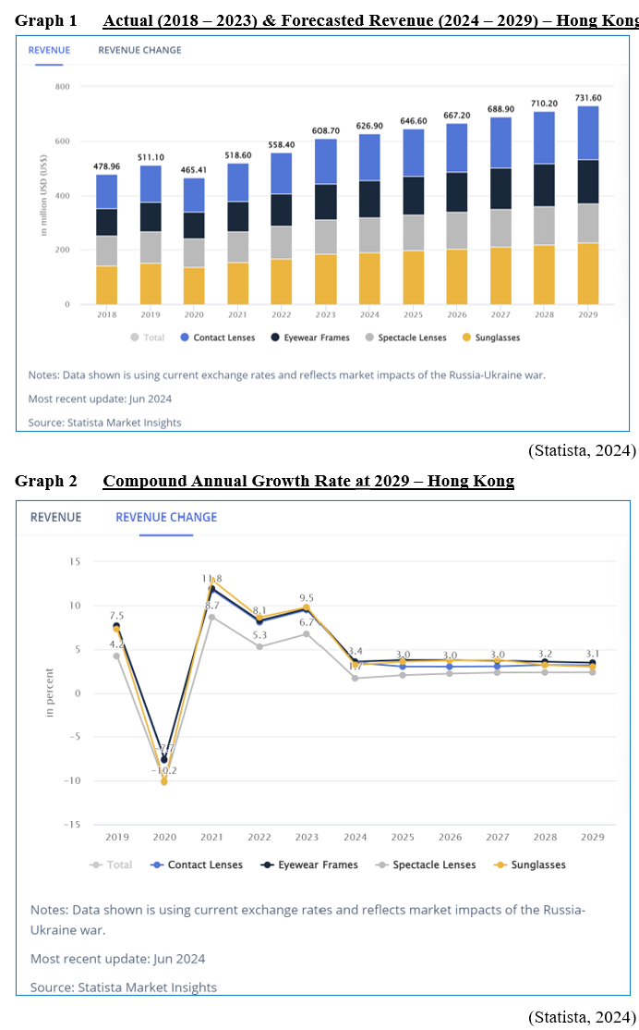
  - Company Background - LensCrafters Hong Kong
LensCrafters, a subsidiary of EssilorLuxottica, is a prominent international retailer of prescription eyewear and sunglasses. Since entering the Hong Kong market in 2003, LCHK now operates more than 20 chain stores in Hong Kong (LensCrafters HK, 2024). The brand aims to differentiate itself through a combination of quality products, state-of-the-art optical technology, and personalized customer experiences. With the aim of assisting customers in both looking and seeing their best, LCHK is committed to offering an extensive selection of eyewear and eyecare solutions (LensCrafters, 2024). However, this report and the marketing plan will only focus on its business line of fashion and luxury eyewear.

- Segmentation, Targeting and Positioning Strategies of LCHK’s Fashion and Luxury Eyewear
Segmentation, Targeting and Positioning (STP) is a strategic framework (Kumar, 2023). In this section, STP is used to identify LCHK’s current customer groups, focus efforts, and how LCHK creates a unique brand identity for marketing of fashion and luxury eyewear.

  - Segmentation and Targeting
LCHK targets two main customer groups based on demographic and psychographic factors for the fashion and luxury eyewear business.

- Demographic - Age
LCHK focuses on young to middle-aged adults who are more inclined towards fashionable eyewear. This group is likely to be interested in the latest trends and styles in eyewear, seeking products that not only improve their vision but also complement their personal style.

- Demographic - Income
LCHK targets high-income individuals willing to spend on premium, stylish eyewear that combines luxury, advanced technology, and personalized service, ensuring both exceptional vision and a sophisticated look.

- Psychographic - Lifestyle
The target audience includes individuals with an active lifestyle who are fashion-conscious and tech-savvy. These customers prefer designer eyewear brands that seamlessly integrate advanced technology into everyday fashion. They value eyewear that not only meets their functional needs but also enhances their overall look and fits into their dynamic, modern lifestyle (GoHub, 2024).

  - Positioning
LCHK positions itself as a premium eyewear brand that offers high-quality products, innovative technology, and exceptional customer service. The brand's positioning statement includes the following elements:

- Value Proposition
Positioning itself as a reliable, quality-focused eyewear provider.

- Product Differentiation
Focusing on offering high-quality lenses with advanced technology and emphasizing the trendiest frames from top designer brands and comfort of frames made from premium materials.

- Service Excellence
Highlighting the comprehensive eye care services, including thorough eye exams by experienced optometrists and showcasing the personalized fitting and styling services provided by trained staff.

- Situation Analysis of LCHK’s Fashion and Luxury Eyewear
The upcoming section will conduct a comprehensive analysis of LCHK’s external environment as well as an evaluation of its internal strengths and weaknesses. This assessment will provide valuable insights for LCHK’s current marketing strategy.

  - External Environment Analysis by PEST
PEST is a strategic tool used to help to understand LCHK’s external macro-environmental factors, which refer to Political, Economic, Social and Technological, impacting strategic decisions (Citilci & Akbalik, 2020).

    - Political
Hong Kong’s political landscape has witnessed tensions and protests recently, impacting business operations, customer traffic, and overall market confidence. Hong Kong’s unique status as a Special Administrative Region of China exposes it to regulatory shifts that can affect businesses. Ongoing tensions and government intervention raise concerns about political stability, potentially influencing consumer confidence and retail activities. While the eyecare sector remains relatively stable due to its necessity, political changes do pose a risk to the fashion eyewear market, which is more susceptible to fluctuations in consumer spending and sentiment (Wright, 2023).

    - Economic
In the first quarter of 2024, Hong Kong’s gross domestic product (GDP) expanded by 2.7%, as reported by the Census and Statistics Department, HKSAR (2024). Despite the pandemic’s initial impact, eyewear sales in Hong Kong have rebounded to pre-pandemic levels in the first quarter of 2024 as well, driven by increased mobility and the resumption of various activities (Global Information, 2024). For LCHK, disposable income levels and consumer spending behavior are critical factors, especially for fashion and luxury eyewear.

    - Social
Despite challenges from an aging population, LCHK’s target group for fashion and luxury eyewear remains dominant over the next two decades (Graphs 3 & 4). Social media influencers and celebrities significantly drive trends in this segment. Cultural shifts towards personal style and self-expression have increased demand for unique and high-end eyewear. Additionally, fashion trends influence the eyewear market, emphasizing the need for LCHK to stay attuned to consumer preferences and industry trends (Impactful Insights, 2024). Moreover, Hong Kong’s eyewear market is experiencing robust growth, driven by increased digital device usage and rising awareness of eye health. Prolonged screen exposure has led to higher incidences of eye strain and Computer Vision Syndrome (CVS), boosting demand for eyewear designed to mitigate these issues (Future Market Insights, 2023).

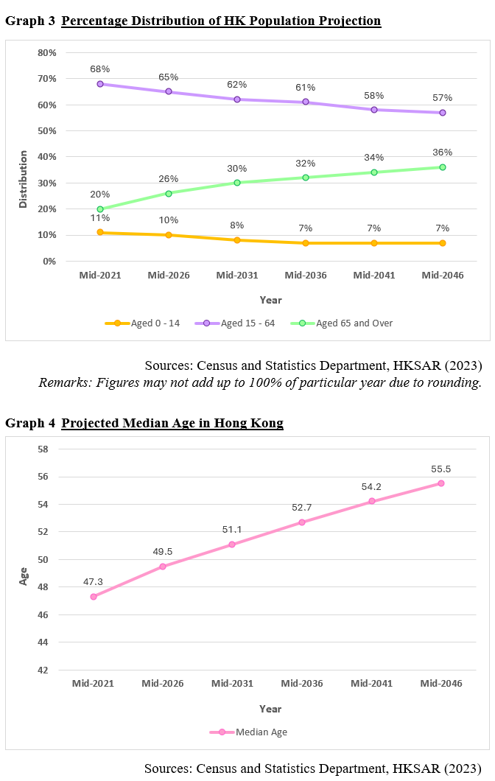
    - Technological
Technological advancements are transforming the eyewear industry. Innovations like digital eye exams, virtual try-ons, and augmented reality (AR) enhance customer experiences and streamline operations. These technologies enable precise fittings and personalized recommendations, catering to tech-savvy consumers who value convenience and customization (Pires, 2024). The growth of online shopping necessitates a strong digital presence. Leveraging e-commerce can expand reach and convenience for customers (Piarna, Fathurohman and Purnawan, 2020).

  - Internal Environment Analysis by Marketing Mix 4Ps
The marketing mix, 4Ps, refers to product, price, place and promotion which form a foundational framework for successful marketing strategies The primary purpose is to encompass essential strategies that enhance brand awareness, foster customer loyalty, boost sales growth and drive revenue (Goi, 2009). Evaluating LCHK’s current marketing mix for fashion and luxury eyewear provides insights into its strengths and areas for improvement.

- Product
- Wide Range of Products
LCHK offers a variety of eyewear products, including prescription glasses, sunglasses, and contact lenses. This diversity caters to different customer needs and preferences. LCHK also carries the latest designer eyewear collections in prescription glasses and sunglasses.

- High Quality and Technology
LCHK is known for high-quality service, products and innovative technologies, such as digital eye examination, advanced lens options and customizable frames. The customization options available ensure that the customers can tailor their choice to perfectly match their vision and lifestyle requirements.

- Brands and Partnerships
LCHK carries popular brands like Ray-Ban, Oakley, Burberry, Prada, Versace, enhancing its appeal to fashion-conscious consumers. Their collaboration with top brands to provide the trendiest frames is a significant selling point.

- Price
      - Premium Pricing Strategy
This strategy aligns with LCHK’s high-quality products and brand partnerships, positioning the company as a luxury brand in the eyewear market. The premium pricing strategy underscores the quality and exclusivity of their offerings, reinforcing LCHK’s image as a provider of high-quality and fashionable eyewear.

      - Discounts and Offers
LCHK usually has in-store promotions, including discounts on frames and lenses, seasonal sales, and bundled offers.

- Place
- Strategic Locations
LCHK stores are often located in high-traffic areas such as shopping malls (LensCrafters HK, 2024), making them easily accessible to customers. Strategic store locations increase foot traffic and brand visibility.

- Online Presence
LCHK’s website provides a comprehensive overview of products and services, including the ability to book eye exams online, browse frames, and find store locations but without e-commerce functionality.

- Promotion
- Brand Advertising
LCHK’s marketing campaigns highlight their commitment to quality and innovation, emphasizing quality, fashion and innovation helps attract a premium customer base.

- Digital Marketing
The presence of LCHK can be found on social media platforms, Facebook and Instagram, to enhance engagement with tech-savvy consumers. Their content often includes product showcases, educational posts about eye health and promotional content.

- Loyalty Program
To encourage repeat purchases, a loyalty program has been already introduced to help build a loyal customer base. Members can accumulate reward points with every purchase, which can then be redeemed as cash (LensCrafters, 2024)

  - Competitive Landscape
LCHK faces stiff competition in the Hong Kong eyewear market, with renowned local brands like Puyi Optical and Optical 88. The former is LCHK’s competitor which offers luxury brands with prestige customer experience while the latter is the competitor which also offers high-end brands with more competitive prices (Graph 5).
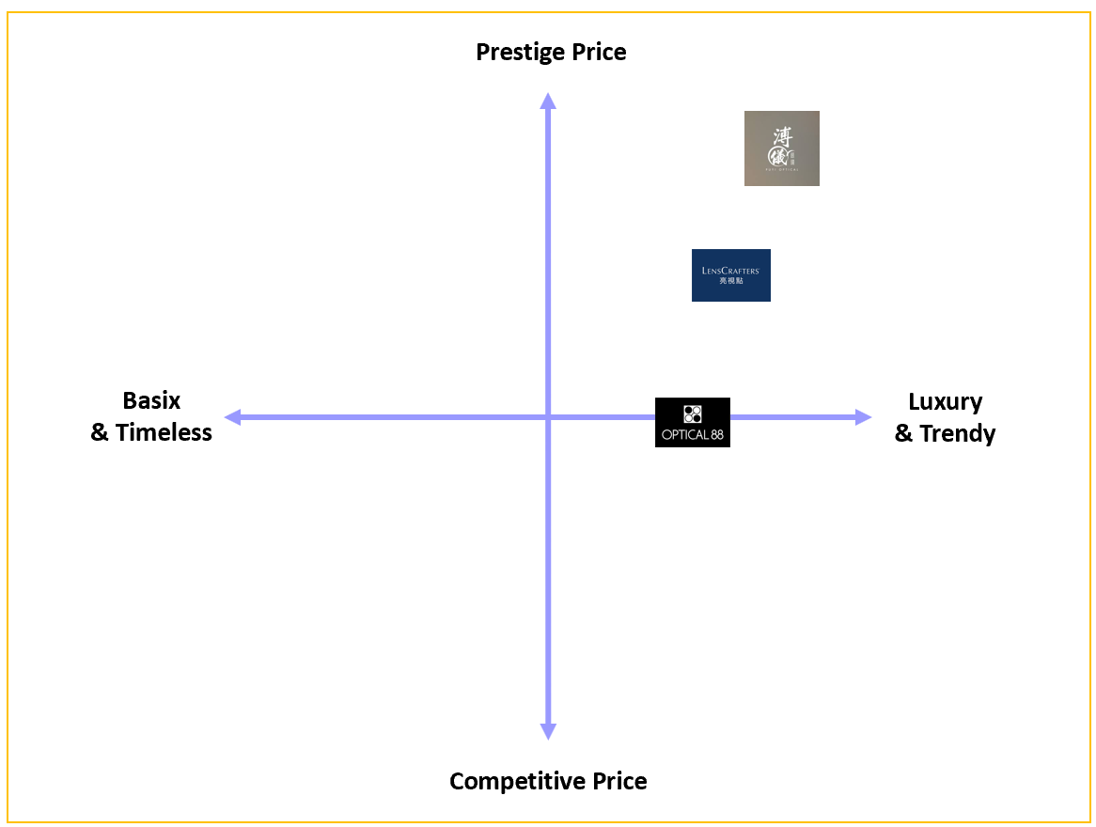

- Puyi Optical
Puyi Optical, a luxury eyewear retailer based in Hong Kong, is renowned for its high-end and designer eyewear collections. Synonymous with luxury and sophistication, Puyi Optical curates a selection of eyewear from top-tier brands, attracting customers who seek unique, high-quality products and prioritize style and exclusivity. Their stores are strategically located in upscale areas and luxury malls, enhancing visibility and accessibility to high-income consumers. The brand emphasizes creating a prestigious shopping experience with luxurious store decor and a high level of personalized service, including bespoke fittings and consultations. To stay relevant in the digital era, Puyi Optical operates an online shop and maintains an active presence on social media platforms such as Facebook, Instagram, and LinkedIn. These platforms are used to showcase their latest collections, share fashion trends, and engage with their audience through visually appealing content (Puyi Optical, 2024).

- Optical 88
Optical 88 is a prominent optical retail chain in Hong Kong, recognized for its extensive network of stores, ensuring convenience and accessibility for local customers. While primarily targeting the mass market, Optical 88 also offers a diverse range of high-end, trendy, and fashionable brands such as Chloé, Ferragamo, and Tom Ford (Optical 88, 2024). The brand’s competitive pricing strategy positions Optical 88 as a strong contender for customers seeking high-end brands without the premium price tag of luxury. Optical 88 maintains an active presence on social media platforms, including Facebook, Instagram, and YouTube, to engage with customers, showcase new products, and share promotional offers. . This approach enhances customer interaction and brand visibility, balancing quality and affordability to appeal to a broad customer base.

  - SWOT Analysis
This section uses a SWOT analysis to assesses LCHK’s internal Strengths and Weaknesses, as well as external Opportunities and Threats. It not only helps to evaluate LCHK’s competitive position, but also to inform strategic decisions and improve its performance (Palazzo & Micozzi, 2024).

- Conclusion and Recommendations for the Coming 3 Years
This section summarizes the key findings and provides strategic recommendations to enhance LCHK’s market position in the fashion and luxury eyewear segment. These insights aim to guide future marketing efforts and drive sustainable growth.

  - Conclusion
LCHK is well-positioned to capitalize on the growing demand for premium eyewear and eye care services. By enhancing product customization, strengthening online presence, implementing tiered pricing, optimizing customer service, and enhancing the in-store experience, LCHK aims to solidify its position as a market leader in Hong Kong's competitive luxury and fashion eyewear market. The strategic recommendations provided address current challenges, leverage opportunities such as the demand for personalized and tech-enhanced shopping experiences and mitigate threats like intense competition and economic fluctuations. Leveraging its strengths in advanced technology integration and a strong brand reputation, LCHK can achieve sustained growth and strengthen its market presence in the fashion and luxury eyewear sector over the next three years.

  - Recommendations
LCHK aims to establish itself as the premier destination for fashion and luxury eyewear. Aiming at high-end consumers and fashion enthusiasts, this comprehensive marketing plan details the steps LCHK will undertake over the next three years to solidify its position in the fashion and luxury eyewear market. The focus will be on brand positioning, customer engagement, product expansion, leveraging advanced technologies to enhance customer experiences, and strategic celebrity endorsements.

- Year 1: Foundation Building and Brand Awareness
Both are essential to create a solid brand identity, differentiate from competitors, and establish trust and recognition among consumers. This groundwork is crucial for driving long-term growth and customer loyalty in subsequent years (Jusuf, 2024).

- Brand Positioning and Messaging
In the first year, the primary objective is to refine LCHK’s brand positioning to emphasize its fashion and luxury eyewear offerings. This involves developing a compelling brand message that highlights the unique value propositions, such as exclusive designer collaborations, superior craftsmanship, and personalized customer service (Kostelijk and Alsem, 2020). The brand message will be consistently communicated across all marketing channels.

- Digital Marketing Enhancement
To increase brand awareness and reach a broader audience, a robust digital marketing strategy will be implemented (Olson, E.M. et al., 2021). This includes optimizing the LCHK’s website for a seamless user experience, with a focus on showcasing luxury eyewear collections. SEO (Search Engine Optimization) and PPC (Pay-Per-Click) campaigns will be launched to drive traffic to the website, complemented by targeted social media advertising on platforms like Instagram and Facebook, which are popular among fashion-conscious consumers.

- Social Media Engagement
An active presence on social media is crucial (Cao et al. 2021). Except enhancing the informative content such as detailed posts about LCHK’s products, promotions, and events, engaging content, such as behind-the-scenes looks at new collections, interviews with designers, and fashion tips, should be regularly posted too. Collaborations with local fashion influencers will help amplify the brand message and reach a wider audience.

- In-Store Experience Enhancement
Improving the in-store experience is essential for attracting and retaining customers (Balconi, M. et al. 2021). Staff training programs will be conducted to ensure that all employees provide exceptional service, emphasizing product knowledge and personalized recommendations. Stores will be redesigned to create a luxurious and welcoming environment with advanced technology such as digital eye examinations and the most updated augmented reality (AR) technology (Konarzewski and Reiner, 2023) that reflects the brand’s premium positioning.

- Expansion of E-Commerce Capabilities
To cater to the growing demand for online shopping and reclaim the market share of it from Puyi Optical and Optical 88, the e-commerce platform will be launched with advanced online shopping experience with features such as virtual try-ons (Konarzewski and Reiner, 2023), comprehensive product descriptions, and customer reviews. Partnerships with local logistics providers will ensure fast and reliable delivery.

- Loyalty Program Revamp
To further encourage repeat purchases, enhance the customer loyalty base and increase customer lifetime value, the existing loyalty program will be revamped (Alshurideh et al. 2020). Except continuously offering the reward points at every purchase, this revamp will include introducing new tiers with additional benefits, such as exclusive access to new collections, higher discounts, invitations to VIP events, and personalized styling services. The revamped program will be promoted through email marketing, in-store signage, and social media campaigns, ensuring customers are aware of the new benefits and how they can make the most of the program.

- Year 2: Expansion and Customer Engagement
These are placed in the second year to leverage the established brand foundation from Year 1, allowing for effective outreach and deeper customer relationships to drive sustained growth and market presence.

- Celebrity Endorsement
Year 2 will see the strategic use of celebrity endorsement to further enhance brand visibility and credibility (Jun et al. 2023). A red-hot celebrity who aligns with LCHK’s luxury and fashionable brand values and appeals to the target audience will be selected. The endorsement will kick off with a high-profile launch event, exclusive collections, and a comprehensive advertising campaign across digital and traditional media. The celebrity will also engage in social media takeovers and in-store appearances, creating a buzz and drawing attention to the brand.

- Expansion of Product Range
LCHK will expand its product range by introducing new and exclusive designer collections. Partnerships with renowned international designers and luxury brands will be established to offer unique and limited-edition eyewear. These collections will be heavily promoted through both online and offline channels to create excitement and anticipation among customers.

- Content Marketing and Storytelling
Both will play a significant role in deepening customer engagement (Nicoli et al. 2022). A dedicated blog section on the website will feature articles on the latest eyewear trends, designer interviews, and eye care tips. High-quality video content, including product showcases and customer testimonials, will be produced and shared across social media and the website.

- Enhanced Customer Relationship Management
Investing in a robust CRM system will enable LCHK to better understand and engage with its customers (Khan et al. 2022). Personalized email marketing campaigns will be launched to keep customers informed about new arrivals, special offers, and upcoming events. The CRM system will also help in tracking customer preferences and purchase history, allowing for more targeted and relevant communications.

- Exclusive Events and Collaborations
Hosting exclusive events, such as private trunk shows, styling sessions, and collaborations with eminent fashion designers, will create a sense of exclusivity and strengthen the brand’s association with luxury. These events will be promoted through social media, email marketing, and partnerships with fashion magazines and blogs.

- Year 3: Consolidation and Market Leadership
Both are positioned in year 3 to allow sufficient time for initial brand establishment, customer base growth, and product range expansion, ensuring a solid foundation before pursuing extensive market penetration and leadership efforts.

- Market Penetration and Expansion
In the third year, the focus will shift towards consolidating LCHK’s market position and expanding its presence. This includes opening new flagship stores in upscale areas and luxury malls locations. A comprehensive market analysis will be conducted to identify potential growth areas and tailor marketing strategies accordingly.

- Advanced Data Analytics
Leveraging advanced data analytics will provide deeper insights into customer behavior and preferences. This data will inform decision-making across all marketing activities, from product development to promotional campaigns. Predictive analytics will help anticipate market trends and customer needs, allowing LCHK to stay ahead of the competition.

- Technology Integration Review
Technology is advancing at an unprecedented pace, with innovations emerging every second. This rapid evolution continuously reshapes industries and enhances daily life. While technology integration begins in Year 1, LCHK should continuously review and invest in cutting-edge technologies to further enhance the shopping experience and attract tech-savvy consumers.

- Evaluation and Continuous Improvement
Regular evaluation of marketing strategies and performance metrics will ensure continuous improvement. Customer feedback will be actively sought and incorporated into future plans. Bi-annual reviews of the marketing plan will be conducted to assess progress, identify challenges, and make necessary adjustments to stay aligned with the brand’s goals.

By implementing this comprehensive marketing plan, LCHK will be strategically positioned to secure a substantial share of the fashion and luxury eyewear market. This approach will deliver exceptional value to customers and ensure sustained growth over the next three years.
Academic References
Alshurideh, M. et al. (2020) Loyalty program effectiveness: Theoretical reviews and practical proofs, Uncertain Supply Chain Management, 8(3), pp.599-612.

Balconi, M. et al. (2021) Touching to feel: brain activity during in-store consumer experience. Frontiers in psychology, 12, p.653011.

Cao, D. et al. (2021) Understanding consumers’ social media engagement behaviour: An examination of the moderation effect of social media context, Journal of Business Research, 122, pp.835-846.

Citilci, T. and Akbalik, M. (2020) The Importance of PESTEL Analysis for Environmental Scanning Process, Handbook of research on decision-making techniques in financial marketing, IGI Global (pp. 336-357).

Fernando, Y., Zainul Abideen, A., & Shaharudin, M. S. (2020) The nexus of information sharing, technology capability and inventory efficiency, Journal of Global Operations and Strategic Sourcing, 13(4), 327-351.

Goi, C. L. (2009) A review of marketing mix: 4Ps or more, International journal of marketing studies, 1(1), 2-15.

Jun, M. et al. (2023) When is celebrity endorsement effective? Exploring the role of celebrity endorsers in enhancing key brand associations, Journal of Business Research, 164, p.113951.

Jusuf, D.I. (2024) Integrated Marketing: A Powerful Strategy for Increasing Brand Awareness, Best Journal of Administration and Management, 2(3), pp.104-109.

Khan, R.U. et al. (2022) The impact of customer relationship management and company reputation on customer loyalty: The mediating role of customer satisfaction, Journal of Relationship Marketing, 21(1), pp.1-26.

Konarzewski, B. and Reiner, M. (2023) Augmented Shopping: Virtual Try-On Applications in Eyewear E-retail, In European Conference on Software Process Improvement, Springer Nature Switzerland, (pp. 289-299).

Kostelijk, E. and Alsem, K.J. (2020) Brand positioning: Connecting marketing strategy and communications, Routledge.

Kumar, P. (2023) Principles of Marketing, Sultan Chand & Sons.

Nicoli, N. et al. (2022) Investigating digital storytelling for the creation of positively engaging digital content, EuroMed Journal of Business, 17(2), pp.157-173.

Olson, E.M. et al. (2021) Business strategy and the management of digital marketing, Business horizons, 64(2), pp.285-293.

Palazzo, M., & Micozzi, A. (2024) Rethinking Decision-Making Strategies and Tools: Emerging Research and Opportunities (pp. 53-70), Emerald Publishing Limited.

Piarna, R., Fathurohman, F. and Purnawan, N. N. (2020) Understanding online shopping adoption: The unified theory of acceptance and the use of technology with perceived risk in millennial consumers context, JEMA: Jurnal Ilmiah Bidang Akuntansi dan Manajemen, 17(1), pp. 51–66. doi: 10.31106/jema.v17i1.5050.

References
Census and Statistics Department, HKSAR (2023) Hong Kong Population Projections for 2022 to 2046, October 2023
Available at:
https://www.censtatd.gov.hk/en/data/stat_report/product/B1120015/att/B1120015092023XXXXB01.pdf
(Assessed: 21 June 2024)

Census and Statistics Department, HKSAR (2024) Chain volume measures of Gross Domestic Product by economic activity for the first quarter of 2024, 20 Jun 2024
Available at:
https://www.censtatd.gov.hk/en/press_release_detail.html?id=5431
(Assessed: 21 June 2024)

Emergen Research (2024) The Future of Eyewear: Exploring New Innovations and Trends, 13 March
Available at: https://www.emergenresearch.com/blog/the-future-of-eyewear-exploring-new-innovations-and-trends
(Assessed: 18 June 2024)

Ewen, L. (2024) EssilorLuxottica posts steady revenue growth for third consecutive year, Dive Brief, 15 February
Available at: https://www.fashiondive.com/news/EssilorLuxottica-Rayban-revenue-increase-fiscal-2023/707593/
(Assessed: 18 June 2024)

Euromonitor (2024a) Sunglasses in Hong Kong, China, June
Available at: https://www.euromonitor.com/sunglasses-in-hong-kong-china/report#
(Assessed: 18 June 2024)

Euromonitor (2024b) Spectacles in Hong Kong, China, June
Available at: https://www.euromonitor.com/spectacles-in-hong-kong-china/report#
(Assessed: 18 June 2024)

Future Market Insights (2023) Eyewear Market, November
Available at: https://www.futuremarketinsights.com/reports/eyewear-market
(Assessed: 18 June 2024)

Global Information (2024) Eyewear in Hong Kong, China, Euromonitor International, 5 June

Available at: https://www.giiresearch.com/report/eo1493870-eyewear-hong-kong-china.html

(Assessed: 18 June 2024)

GoHub (2024) The Evolution of Eyewear Fashion: From Necessity to Style Statement, 26 February

Available at: https://www.goptichub.com/blog/the-evolution-of-eyewear-fashion-from-necessity-to-style-statement

(Assessed: 18 June 2024)

Impactful Insights (2024) Eyewear Market Report by Product (Spectacles, Sunglasses, Contact Lenses), Gender (Men, Women, Unisex), Distribution Channel (Optical Stores, Independent Brand Showrooms, Online Stores, Retail Stores), and Region 2024-2032

Available at: https://www.imarcgroup.com/eyewear-market

(Assessed: 18 June 2024)

InvestHK (2024) Hong Kong Plays Key Role in Eyewear Brand’s Vision for Global Expansion, 12 January
Available at: https://www.investhk.gov.hk/en/case-studies/hong-kong-plays-key-role-in-eyewear-brand-s-vision-for-global-expansion/
(Assessed: 18 June 2024)

Kaiser, E & Miller, M (2023) Report predicts global eyewear boom: Estimated 76 billion USD growth by 2027, Optometry Times, 27 December
Available at: https://www.optometrytimes.com/view/report-predicts-global-eyewear-boom-estimated-76-billion-usd-growth-by-2027
(Assessed: 18 June 2024)

LensCrafters HK (2024) Discover our flagship store
Available at: https://lenscrafters.hk.cn/store
(Assessed: 18 June 2024)

Medium (2024) The History of Eyewear: How Glasses Became a Fashion Statement, 26 February
Available at: https://medium.com/@glassessize/the-history-of-eyewear-how-glasses-became-a-fashion-statement-f27022c944cf
(Assessed: 18 June 2024)

Neele, J. Ernst, D. and Speetjens, R. (2024) Consumer trends in 2024: The resilient shopper, Robeco, 17 January
Available at: https://www.robeco.com/en-hk/insights/2024/01/consumer-trends-in-2024-the-resilient-shopper
(Assessed: 18 June 2024)

Optical 88 (2024) All Brands
Available at: https://eshop.optical88.com.hk/hk_en/brands
(Assessed: 18 June 2024)

Pires, C. (2024), How Technology Leads Eyewear Industry New Vision, Visualmodo, 9 February
Available at: https://visualmodo.com/how-technology-leads-eyewear-industry-new-vision/
(Assessed: 18 June 2024)

Puyi Optical (2024)
Available at: https://www.puyi.com/hk_en
(Assessed: 18 June 2024)

Statista (2024) Eyewear - Hong Kong, March
Available at: https://www.statista.com/outlook/cmo/eyewear/hong-kong
(Assessed: 18 June 2024)

Statrys (2024) Hong Kong E-commerce Statistics and Trends for 2024, 9 February
Available at: https://statrys.com/blog/hk-ecommerce-trends
(Assessed: 18 June 2024)

Woo, G (2024) Hong Kong must not take its eyes off primary health care, South China Morning Post, 7 April
Available at:
https://www.scmp.com/opinion/letters/article/3257946/hong-kong-must-not-take-its-eyes-primary-health-care
(Assessed: 18 June 2024)

Wright, L. (2023) Fractured foundations: Assessing risks to Hong Kong’s business environment, Atlantic Council, 7 March
Available at:
https://www.atlanticcouncil.org/in-depth-research-reports/report/fractured-foundations-assessing-risks-to-hong-kongs-business-environment/
(Assessed: 18 June 2024)

