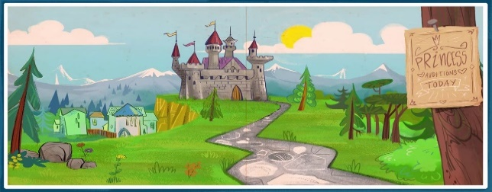
WALT: How to write feelings towards characters and why in welsh.
This Photo by Unknown Author is licensed under CC BY
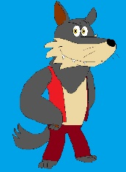
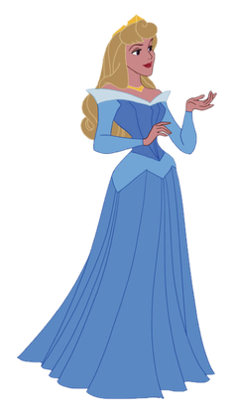
This Photo by Unknown Author is licensed under CC BY-SA

Brawddegau Cymraeg am y cymeriadau storiau

Dw i'n hoffi________________________________________

Achos mae e’n/hi’n _________________________________

Dw i ddim yn hoffi _________________________________

Achos mae e’n/hi’n _________________________________

Please write your own sentence using the word bank provided.

