

DESIGN AND EVALUATION OF AN ADAPTIVE DIRECTOR SYSTEM WITHIN AN IMMERSIVE SIMULATION FRAMEWORK USING THE SOURCE ENGINE
by
Jacob James-Machin

Supervisor:
Nathan Morgan

Project given as part of the requirements for the award of
BSc (Hons) Computing (Game Development)

February 2026

ABSTRACT
To summarise this project. It is to investigate how the design and implementation of a system that can change and adapt depending on how you play. Utilizing the Source Engine this project will have Immersive Sim elements that prioritise player agency, emergent gameplay, and systemic interaction. Allowing players to approach multiple strategies using the systems provided with the game. E.g. Source Engine Physics.
The most important angle to this project is to support a balanced gameplay loop which can sustain engagement, and this can be done through interesting gameplay scenarios or using multiple routes that encourages player experimentation.
These routes include Stealth, Combat and Technical. With the use of these routes these can encourage a system that can dynamically be approached by the player.
This gameplay structure alongside the use of the director mode can have an experience that will always feel different every time the user plays the game.
To summarise the aim of this project is to evaluate whether adaptive systems can enhance player engagement and allow for replay ability without undermining the core idea behind immersive sims. Including in this framework is the testing of the system and to see how these gameplay elements would function in this system to see if they work as intended. Alongside this would include a consistent playtesting schedule where it compares static linear gameplay and adaptive gameplay configurations. This can help to the understanding on how procedural balancing systems can work and be implemented within an immersive sim design using the source engine.

Contents
ABSTRACT 2
Glossary 5
CHAPTER 1 - INTRODUCTION 6
CHAPTER 2 - RESEARCH & REVIEW OF LITERATURE 7
Defining the immersive sim genre and the design philosophy 7
The main philosophy behind Immersive Simulation Games 7
The Immersive Sim Definition issue. 8
The idea behind procedural generated game design 9
The Algorithms behind procedural generation 9
The Source Engine 10
History of the Source Engine 11
Games that use the Source Engine 12
CHAPTER 3 - RESEARCH AND/OR DEVELOPMENT METHODOLOGY 13
Questionnaire/Survey 14
Playtesting 14
Tools and Methods used for this methodology SMART 14
CHAPTER 4 - DESIGN & IMPLEMENTATION 15
The Development process 15
25
25
Conclusion 36
CHAPTER 5 – ANALYSIS AND EVALUATION 37
Questionnaire Results and Discussion 37
Literature Review 48
CHAPTER 5 – EVALUATION AND POTENTIAL IMPROVEMENTS FOR THE FUTURE 50
Analysis 50
What conclusions can be drawn from the data 50
Is the data backed up by the literature review or did the data disagree with the literature. 50
Were the objectives met? 50
Were the aims met? 50
Are there any answers that would’ve been expected? 50
The Future of a project this scale? 51
What can be improved upon if revisited 51
CHAPTER 6 - CONCLUSIONS AND RECOMMENDATIONS 52
CHAPTER 7 – REFLECTION 53
CHAPTER 8 – REFERENCES 55
CHAPTER 9 – BIBLOGRAPHY 56
APPENDICES 60

Glossary
NPC means Non-Playable Character
Sim short for simulation
FPS means First Person Shooter
RNG means Random Number Generator
QOL means Quality of Life
SDK means Software Development Kit
Goldsrc is the shorthand version of “Gold Source” or the Half-Life Engine
RPG means Role Playing Game
Minimap is the overlay of the game level.

CHAPTER 1 - INTRODUCTION

This chapter should start off by setting the context for the work:

- Design a multi-route level using immersive sim design elements that support stealth, combat, and system interaction,
- Implement an adaptive director system inspired by the director from Left 4 Dead [1]
- This system would track player behaviour metrics like health, aggression, resource usage, and route choice.
- This system would dynamically alter NPC (Non-Player Characters) encounters through intensity and resource placement all dependant on player state.
- This would evaluate whether adaptive systems would increase through perceived player agency and replayability.
- Compare player behaviour between static and adaptive gameplay configurations.
- Critical evaluate the result and assess limitations of procedural adaptive design within the source engine.
- Document and evaluate the outcome and feedback from players.

The general aim of this project is to design a robust immersive sim demo that accommodates both the immersive sim design philosophy and player agency. In hopes to understand how that could translate well as a demo to highlight how gameplay can respond to the player’s actions.

CHAPTER 2 - RESEARCH & REVIEW OF LITERATURE

Defining the immersive sim genre and the design philosophy
To define an Immersive Sim or Immersive Simulations there should be a clear understanding of what it means to design emergent gameplay for example immersive sims are based on the idea on how to prioritize simulation over scripting. The solve problems using the game systems presented to them rather than have it scripted. [2]
Another important aspect is that immersive sims are defined by the rules that were defined by the developer about how the game world works without the use of scripting and through this aspect those rules would interact with each other.
It relies solely on player freedom allowing for players to solve multiple solutions using the systems presented to the player. Encouraging a free form design for both the player and developer. [3]
Theres also the Systemic gameplay. With the game world relying in interacting systems like physics, AI [4], sound, lighting and etc and these systems would combine in ways allowing for emergent gameplay. Allowing players to solve these problems that is not relied on scripting.
The game world must also rely on a consistent rule-based system [5]. For example, logically sound should attract enemies or objects obey the rules of physics. Consistence helps players learn and experiment with finding creative solutions.
As the nature of this project player agency plays a huge role especially on playstyle as this project accommodates three major playstyles that players would use. [6]
The biggest issues with an Immersive Sim that meany game designers come across is that they are exceedingly difficult to nail down definition wise. This project will also aim to address that with this demo.

The main philosophy behind Immersive Simulation Games
The core philosophy behind immersive sims is that looking at games like Deus Ex and System Shock is that the player is part of the world and not the world itself.
This means that the player should be able to interact with this world as if they were part of the world and have the world respond to the player’s interactivity in a meaningful way. As Jean-Paul Satre’s existentialism states “You define your path through your actions” This is the philosophy that immersive sims stand behind.
Immersive Sims must prioritize simulation over scripted events. [7]

The Immersive Sim Definition issue.
Theres a problem that video game developers come across when designing games is that how would you define an immersive sim game. Is it a genre or philosophy? Unlike genres like First Person Shooters or Real Time Strategy games. Another thing that makes immersive sims difficult to truly define is that immersive sim can be seen in a lot of games that fall under different genres.
Games like Deus Ex, System Shock 2, Dishonoured, Gloomworld, Shadows of Doubt, Vampire the Masquerade Bloodlines, Cruelty Squad, Deathloop and Prey all are considered immersive sims but have vastly different genres. All these games considered elements of stealth, action, and horror. [8] As a result, players and developers may classify the same game differently depending on what kind of aspects these games would focus on.
Because of this. It is a difficult term to truly nail down, and it is something some developers avoid associating with because of how loose the term is.
To truly define an Immersive Sim as mentioned above:
- Player Agency-Must allow players to approach the game goal in multiple ways.
- Systemic gameplay-Mechanics that would be interconnected and would interact with each other consistently.
- Emergent Gameplay- Unscripted situations that are the result of system interaction.
- Reactive Worlds-The Environment must react to the player and respond in ways that feel real and responsive.
- Environmental storytelling-Narrative delivered through how the world is designed and exploration rather than through cutscenes or text prompts (See Half-Life 2 as an example in effective way to show off environmental storytelling)
[9]
The most common idea mong developers and critics alike is that immersive sims is a type of game where the world feels believable with consistent rules and a system where the player is free to experiment within the rules the game has set up. Its not just realism but the idea of how the world would react to the player that feels logical. [10]
Historically Immersive Sims are developed and connected to studios like Looking Glass and Arkane Studios with influential developers with Warren Spector himself describing the philosophy behind immersive sims as with a set of principles that defines immersive sims as saying yes to the player which means the player should be allowed to experiment and fine alternative ways to solve a problem. [11] [12]

The idea behind procedural generated game design
Procedural generated design is usually less about how random everything is and more about how a gameplay system. It is defined through creating meaningful variation allowing for free form gameplay design.

The Algorithms behind procedural generation
When it comes to procedural generation. The algorithm relies on a mix of rules and randomness using both Mathematics and algorithms. These are used to create content whatever that would be terrain, levels, textures, stories, etc. Instead of designing everything with hand.
Developers would still decide the rules and systems that would allow for content to be generated with procedural generation.
Here are the key aspects of procedural generation.

Random Number Generation aka RNG
This is based on using a pseudo random function to create a sense of variability. It uses a seed and this seed generates what kind of elements you would see in that world. An example of this would be “Minecraft” [13]

Noise Functions (Natural randomness)
Noise functions are used for clouds, terrain, and textures. The common types of Noise functions are Perlin, Simplex and Value and what they do is that they generate smooth continuous randomness without being pure RNG. It is why its perfect for making stuff that should appear random like clouds. [14]

Fractals and Midpoint Displacement
These are used to create more natural structures like Mountains or coastlines or basic terrain. First, it will start with a line or a surface then it would constantly divide and add random offsets to create terrain that would feel unique. [15]

L-Systems (Lindenmayer Systems)
When it comes to generating trees or plants it would use an L System method and how it would work is that it would rewrite strings using rules. [16]

Cellular Automata
Like fractals these are used to generate things like caves or terrain smoothing. And it changes its state based on neighbours. [17]

Voronoi Diagrams
Voronoi Diagrams splits regions apart based on distance and with this each point owns the space closest to it. It is used for biomes like deserts, forests and etc, map regions and natural patterns. [18]

Graph Based Algorithms
This is used for structured generation for stuff like levels or dungeons and it relies on algorithms like A* pathfinding or BFS (Breadth First Search) or DFS (Depth First Search). Its especially useful if a developer wants to create randomly generated dungeons for a player to clear out. [19]

Binary Space Partitioning (BSP)
Like Graph Based Algorithms it is also used for creating levels and it works by splitting an area into smaller regions. (Note this is a quite common method to develop maps or games in the source engine or in DOOM or Quake 2) [20] [21]

Wave Function Collapse
This would involve collapsing tiles into valid patterns based on constraints. It is like solving a puzzle with rules. This algorithm is used for Tile Based maps and various patterns that make sense visually. [22]

Grammer Based Generation
This is a rule-based content creation. It is used for story generation or quests. How it works is that it defines rules for valid structures. [23]

Marching Cubs and Voxels
Popular for 3D terrain or voxel-based structures. These can also create complex and randomized structures for things like mountains or terrain. [24]

The key idea behind procedural generation
Procedural Generation [24] is not just randomness as it relies on rules. The randomness comes through as Variation rather than pure random. For example, creating a rule would consist of picking a number between 1-10 and the randomness algorithm would pick a number based on that rule e.g.

The Source Engine
The Source Engine is a modifiable and versatile game engine which was developed by Valve Corporation and next to Unreal its one of the most influential game engines within modern game development especially about first person shooters. It is known for its physics engine, modular design, and an extremely long-life span (The engine is still being built upon today with modern games like Black Mesa or Titanfall using Source or a modified version of it) [25] [26]

History of the Source Engine
In 1996 Valve Corporation was founded by two former Microsoft employees Gabe Newell and Mike Harrington. They also licenced the Quake Engine and hired a bunch of Quake modders and using the Quake Engine they rewrote it into the Goldsrc engine. [28] [29]
Written in C++ the Goldsrc’s engine’s biggest selling points was that it had.
-Added Skeletal animations creating models that can move naturally
-A heavily advanced AI system
-Enhanced Level Scripting
The biggest breakthrough game that showed this engine off was Half-Life released in 1998. Half-Life pushed the boundaries for what is possible in technological innovations and storytelling in first person shooters (because before Half-Life shooters had little story and was focused on the action. [30]
Half-Life was a shooter that focused on telling its story with its level scripting and skeletal animations and because of this it influenced a whole generation of shooters afterwards. While also spawning revolutionary mods such as Counter Strike, Team Fortress Classic, Day of Defeat, Gunman Chronicles etc.
Goldsrc left behind a legacy that proved Valve as an influential developer within the fps genre. However, as time went on Goldsrc’s limitations became apparent with its rendering pipeline not being up to scratch compared to other games, limited shader support, physics being very basic and relying on baked or predetermined animations rather than real time calculations and it doesn’t help that the FPS is dependent on the physics. [31]

Valve knew this and they set out to develop an engine that would be future proof (able to properly run on modern hardware) realistic physics, advanced shaders and improved animation and realism. Valve built source from scratch mostly, but some Goldsrc frameworks was carried over.
Beginning development around 2000 Valve wanted to create something that feels real and would be able to push storytelling capabilities beyond what was possible at the time especially when it comes to physics-based gameplay simulations. Alongside real time lighting and shader-based rendering.
The Source Engine debuted with Counter-Strike Source in 2004 but the game that truly showed this engine off was Half-Life 2.
The biggest innovations that came with Half-Life 2 was advanced real time physics gameplay with its Gravity Gun (The Game world responds to the player in ways that feel real and interactive), Facial Animation system where characters would feel like real people with Valve utilizing its facial animation system from Professor Paul Eckman’s Facial Action Coding Systems.
Like the Goldsrc engine the Source Engine left behind a giant legacy that is seen through its games and mods that it spawned. Especially with how overtime the source engine grew and evolved through its engine branches with valve adding in improvements like HDR lighting, better particle systems and for this project the AI Director.
Overtime Valve took what they developed with the source engine to develop an even more technologically advanced game engine like the Source 2 engine which had Vulkan API support, better tools for developers and a robust modern rendering pipeline.
Like Goldsrc it paved the way for future developers to expand and iterate on the engine.
[32] [33] [34]

Games that use the Source Engine
The Games that use the Source Engine includes:
Half-Life 2
Half-Life 2: Lost Coast
Half-Life 2: Episode One
Half-Life 2: Episode Two
Half-Life: Source
Counter-Strike: Source
Team Fortress 2
Day of Defeat Source
Portal 1
Portal 2
Left 4 Dead
Left 4 Dead 2
Alien Swarm
Dota 2 (which was later ported to Source 2)
Garry’s Mod
The Stanley Parable
Dear Esther
Insurgency
Zeno Clash
Vampire: The Masquerade Bloodlines (also an immersive sim)
Black Mesa
Fistful of Frags
CSGO (Counter Strike: Global Offensive)
Zombie Panic Source
INFRA
[35]

CHAPTER 3 - RESEARCH AND/OR DEVELOPMENT METHODOLOGY

Research Methodology
To conduct good proper research, it is important to consider using proper evidence and data. Its especially important because some researchers would use secondary data to analyse data there’s also primary data to use with stuff like observations, interviews, experiments and in this case this project will use a questionnaire and a play testing session.
The strategy to consider with this project is the type of research method. And because this project involves an interactive experience so to conduct the necessary data like performance or game design there needs to be sessions that allows users to play it and conduct a questionnaire.

Questionnaire/Survey
The purpose of a questionnaire of this nature is to gauge the responses of how players would approach a certain problem and what kind of playstyle they would use to play a game of this nature. The type of questions in this would evolve how players would approach a certain goal with the question involving a scenario and what type of things players would look for in game design.
An example of a question would be:
“You are given a goal to complete. Theres a large building with multiple entry points with enemies surrounding the area what would be your approach to said objective and what kind of tools would you use?”
The exact purpose of these questions is to analyse what kind of playstyle players would use, and another question would be dependant on how players would react to a procedural generated system with questions like:
“Do you prefer dynamic difficulty scaling in games? Where the game makes itself harder or easier dependant on how you play?”
After conducting this questionnaire, the results would be collected in a chart that measures the type of playstyle a player would use and how they would react to procedurally generated gameplay elements.

Playtesting
After the research has been made and the demo has been completed there would be conducted play testing sessions which is merely for bug testing purposes, feedback on where to go from here and how they would respond to an immersive sim/procedural generated environment.

Tools and Methods used for this method SMART.
Using the SMART method, I discovered that it could help set up a realistic goal that turns a vague intention into structured goals. Within this project it can help show the goals and intent of this project and within a reasonable period.
To summarise using the SMART acronym
- Specific- Create a playable source engine demo prototype.
- Measurable- Measure progress through level design and implemented features.
- Achievable- How realistic is the scope for a source engine mod?
- Relevant- Learning game development, scripting and implement immersive sim systems.
- Time Bound- Set a realistic deadline of 12 weeks.
Depending on how things go it is important to adapt and react. [36]

CHAPTER 4 - DESIGN & IMPLEMENTATION
To create this source engine mod, it is important to consider the implementation of VScripts. [36] It is a system used in later versions of the Source Engine that allows modders to add custom gameplay elements without changing the engine source code. Letting developers create dynamic events and manage game rules within a game or mod.
At its core it uses the programming language “Squirrel” which is a high-level scripting language with it being used as developers to implement custom languages. [37] Instead of recompiling the entire game Squirrel lets developers write script files that the engine would interpret during runtime. Making development faster and efficient especially when there’s time to prototype and playtest.
Furthermore, the main functions of VScript which were considered and used in this project were:
- Event Triggers
- Adjusting NPC Behaviour
- Creating Puzzles alongside scripted sequences
- Spawning objects during gameplay
- Creating custom aims and win conditions.
- Modifying the game logic without changing engine binaries

The Development process
The Development process was a more of a learning process as using Hammer++ requires some prior knowledge as it has a ton of dedicated tools and learning resources for it.
Considering it is a third-party toolset created by valve and curated by Valve’s community. And because of its Hammer has a better version known as Hammer++ which was used in the development process of this demo. See above for the hammer++ improvements.
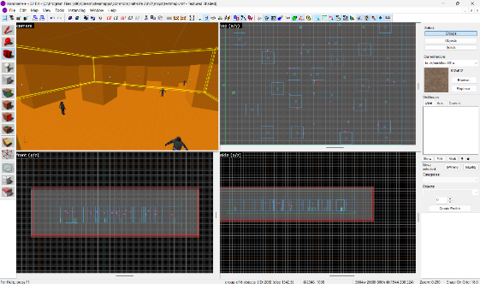

Figure 1 Hammer++
This is hammer++. Its still based on the original version of hammer but features modern QOL improvements. However, since it is based on the original version of hammer all the fundamentals are still there. Part of this is the 4-screen interface. These 4 screens include the camera (showing the user what the map looks like) The Top view, Front view, and the side view.
The last 3 screens show the map in a grid-based format. Ideally this helps the user plant entities or build brushes (within this context brushes are the cubes or blocks that the user can draw)

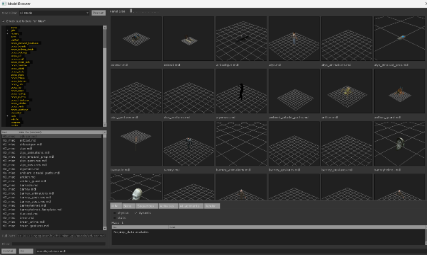
Figure 2 Model Viewer
This is the model viewer this lets the user select which model can be viewed and implemented within the map. To use something like this simply select the entity tool, select which entity you would like to use which the prop_physics and then simply in the properties window select which model would that physics prop would use.
The reasoning behind using these models is to let the players use them as a weapon using the gravity gun. This adds to the immersive sim design which is the intent of the demo letting plays using the systems such as the source physics engine to their advantage.

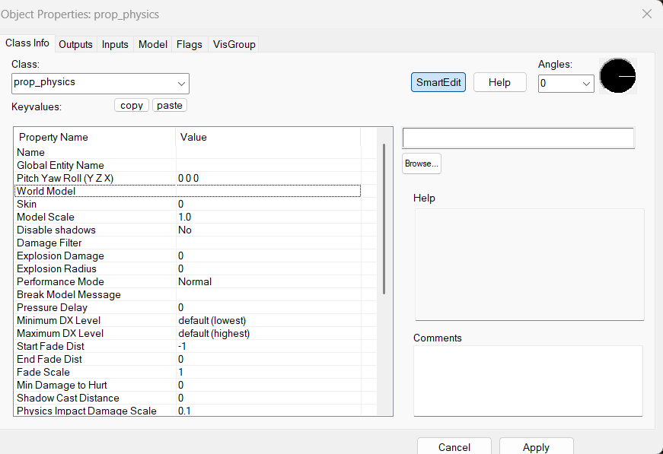
Figure 3 Prop Physics properties.
As mentioned, this is the property window from the prop physics function. This is important to figure out the type of behaviour a specific type of entity would have. Through this you can change the world model of the physics prop. Which would lead into the model viewer popup window which would let the user select the model.

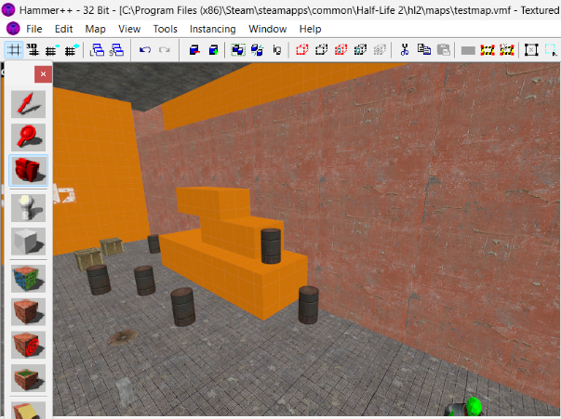
Figure 4 Alternate route design.
While building this map the idea of multiple routes. Whereas that would be a combat only run, stealth run on what this screenshot shows is the alternate run. If players are smart enough to understand the physics engine, they can build an alternate route using the physics props. Added into the map.

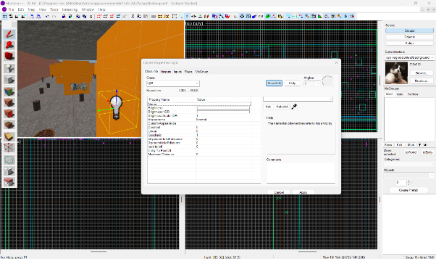
Figure 5 Lighting.
To add some character to a map that can guide the player or add ambience lighting is the most important aspect of level design. In this case the entity tool was used to create the lighting entity. These creates light spots within the map which was used to light the important parts of a level like enemy placement or where the player needs to go.

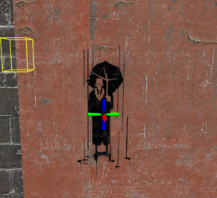
Figure 6 Decals.
Hammer allows the user to place in decals which adds some detail to any given level, and they can be used as a guide to let players know where to go and what to do. The decals used here acts more as decoration as the layout is already easy to follow for any player.

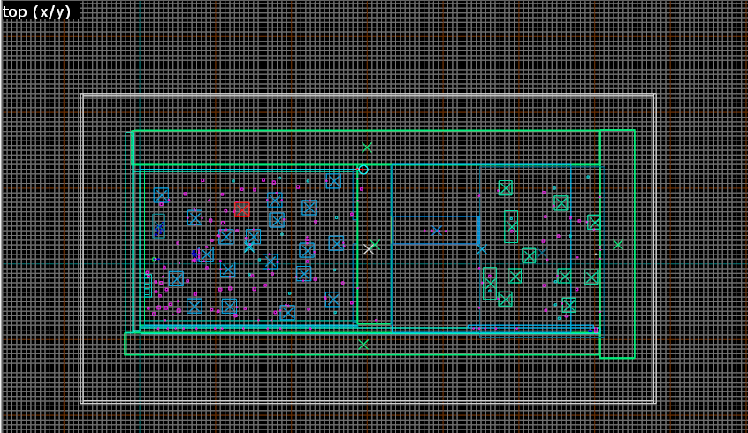
Figure 7 Technical map view.
This is the overhead view of the map from one of hammer’s screens. This gives the user an overhead view of the map. This helps to properly place the entities, brushes, and other various aspects of a source engine map. It also acts as a minimap for the game area letting the developer know where the player starts and where they would end up.

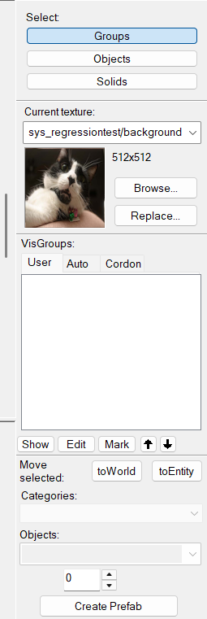
Figure 8 Side Menu
This is the Side Menu for Hammer. It lets the user select what kind of entity they want to use what in this case what texture they would want to use. For instance, if the player clicks on the “Browse” a pop-up window would show which would act like a menu to select the various textures to use.
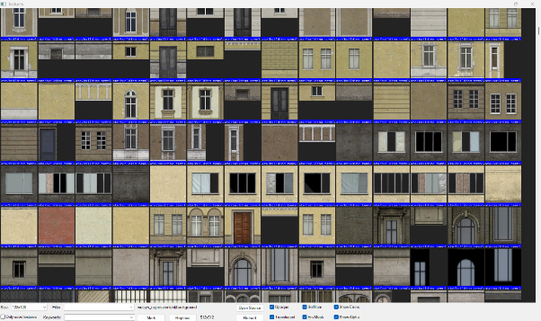
Figure 9 Texture Menu
From clicking the “browse” button this menu would show which acts like a giant depository of all the various textures used in the video game Half-Life 2. This can also be used to select what decals to use in a level as a decal functions the same was as a texture expect that it is an overlay.

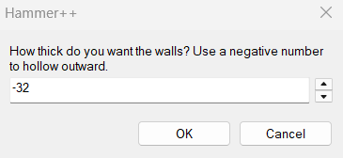
Figure 10 Making a Skybox
Making a Skybox on hammer is an effortless process. This is part of the process as this makes the skybox acts like a hollow cube. Most skyboxes are giant cubes with a texture overlay.

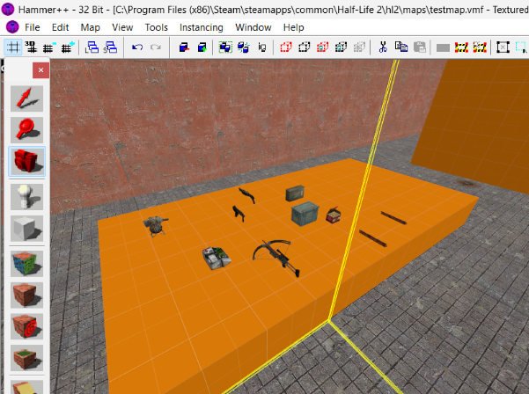
Figure 11 Weapon Selection
These are the weapons/tools for the player to use. Initially I wanted to have a prop for the table to add for extra gameplay options for physics-based combat, but the weapons were not getting put in place, so a brush block is now acting as a placeholder for the table. This is placed for the player to easily find it but not be too intrusive so the player can explore other avenues for gameplay other than guns.

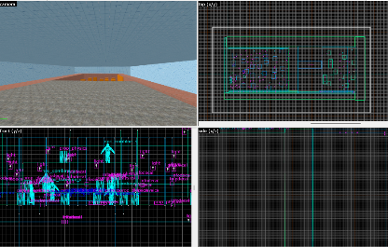

Figure 12 Screen Layout
This is the screen layout. As mentioned above this is how Hammer is organised by default using the worldcraft program from 1996. [39] These screen views show every view that would be useful while editing via hammer. This was useful for any user to map out and plan the level layout.

Figure 13 Hammer Toolbox
This is the toolbox it comes with every version of Hammer even the goldsrc versions. Let us you select which tool what you want to use at a specific moment. For example, if the user wants to insert a new brush model. Simply select the white cube and it can let you draw said brush model. Or if the user wants to implement textures on the model select the brown cube and finally if the user wants to implement a certain type of entity, they can simply select the pawn shaped icon.

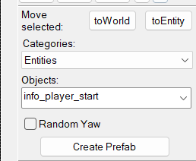
Figure 14 Player spawn point.
This is the most important function of creating a Hammer map within the source engine as you cannot really do anything with a map in a game engine if you do not have an entity dedicated to figuring out where the player would spawn. This is where “Info_player_start” comes in as decides where the player would spawn within the game world. Another important aspect to consider is where you place this entity as it finds how the player would view the level. What they would see as they start the game.

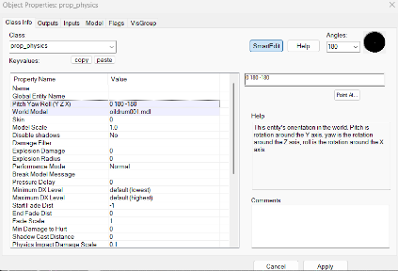
Figure 15 Prop Physics Properties
This is the properties for the objects and in this case, it is the physical props. As mentioned above this is used to adjust the visgroup (note: visgroups helps manage the number of entities or items placed within a hammer level) [40] properties or the physics properties of an object. With this you can edit what kind of model physics props would use and in this case this demo uses props that can be used by the physics gun in the game.

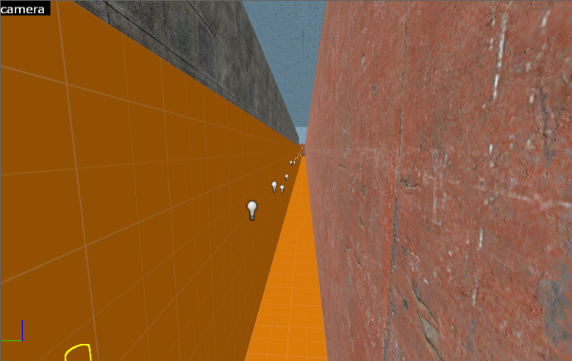
Figure 16 Secret Path
The most interesting and important aspects of an immersive sim is having players be encouraged to be creative and find alternate paths to the aim. In this case there is as a secret path that the player can only find by using the physics prop laying around the level to build and stack behind the spawn point with a light entity and brushes writing down where the player can be creative. The key aspect of an immersive sim is players using the game system provided by the game to come up with creative solutions and being able to find a path not accounted by the developer (even though in this case this was built as an example of a type of path the player can use if they are clever enough)

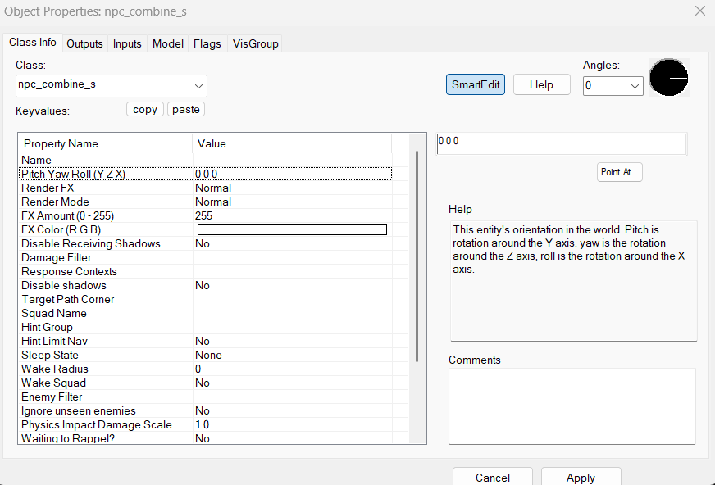
Figure 17 NPC properties.
To create dynamic gameplay scenarios then one must implement NPCs. These NPCs are used to create obstacles for the player to overcome or outsmart. In this property window for the npc’s the developer can change what weapons the enemy NPC spawns with, their goal/pathfinding, squad management etc. However, for the purpose of this demonstration the AI uses the basic mode. They would awake when the player approaches them or attacks them. This can allow for a stealth walkthrough because of layout of the brush’s geometry.
Figure 18 Texture Repository
The game this hammer version is working from is Half-Life 2 and Half-Life 2 uses a lot of textures to add to the art style of the game. They can be used to create a diverse environment in the game while also show where the player needs to go. For this demonstration only basic textures were used however the diverse the look of the level other textures was also used to create a sense of visual cohesion for the player.

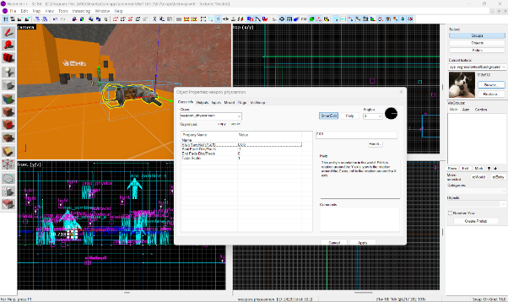
Figure 19 Gravity Gun
This is the gravity gun. The idea behind the gravity gun in this specific context is to allow for more gameplay diversity. Because of the use of physics props the gravity gun can use those props as weapons as opposed to the player strictly using guns. Which again diversifies the gameplay, and it encourages the player to experiment using the physics engine provided by the source engine.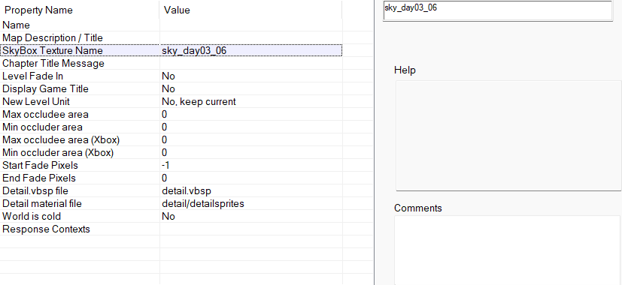
Figure 20 Skybox.
Adding a skybox into a level adds to the lighting, mood and atmosphere and it creates a sense of cohesion for the player. Especially within this case where the demo has an outdoor section with a bridge. If the level does not have a skybox, then the lighting in the level would break. A broken level within the source engine would affect the lighting especially when the shadows are missing and everything looks fully lit up. To support the lighting and create an interesting level for players to interact with like an outdoor section one must create a skybox. To create a skybox within hammer, create a hollow out block over the level. Assign the interval -32 then also in the map properties add the texture that would fit for the level. In this case the sky texture was “sky_day03_06”

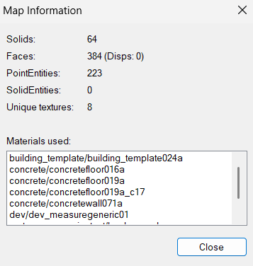
Figure 21 Map Information
This is information about the properties of a created map. It tells the developer all the materials used when it comes to entities, decals, brushes, and textures. This is useful information especially for debugging and finding elements that might be breaking the map or would not fit properly. Particularly useful tool for hammer developers.

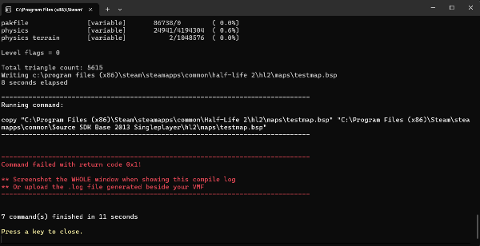
Figure 22 The Compiler
When finishing a Hammer Source Engine map, the next important thing the developer should do is compile what they have into a map that can be booted up and played within a game. For this demonstration, the map was saved then compiled then the game was booted up to run with the command “map testmap” (testmap is the name of the hammer project) then the map will boot in the game Half-Life 2.

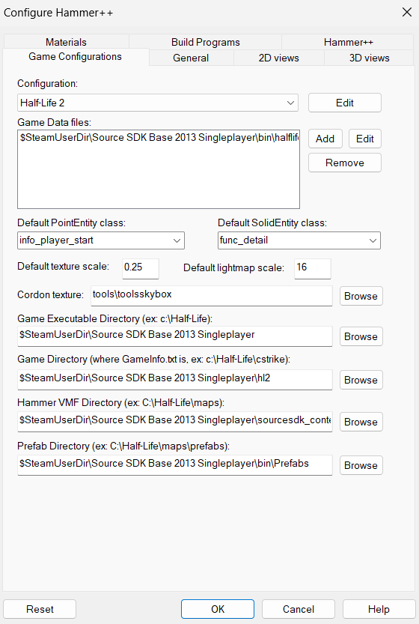
Figure 23 Hammer configurations.
To develop a map for Half-Life 2 or for any game that runs on the source engine it is important to consider the configurations you want to set before building a hammer++ map. For example, since this project uses Hammer++ the default configurations that were set was 2013 version of Source SDK using Half-Life 2 as a base alongside this it also configures it to be a singleplayer experience because Hammer++ can be used to develop multiplayer maps for Source also whereas the default entity class was “info_player_start”

Figure 24 Hammer Ribbon
This is the ribbon at the top of the Hammer++ page. It gives the developers everything they would need to build a map using Hammer or in this demonstration’s case Hammer++. It can let you set what kind of view that is wanted for any kind of project. For example, if the developer wants to set the type of grid that the hammer layout is used in or they make a mistake they can undo it from this section. Or as would be discussed below how the developer would be able to run or export the map they created.

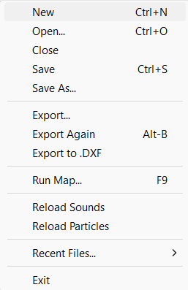
Figure 25 The File function.
In Hammer or Hammer++ in order to play the map you created you must press “run map” which would compile the map through a command prompt and through the “file” button on Hammer the developer can also export the map into a .DXF(Drawing Exchange Format) file which be used for scripted sequenced or can be exported elsewhere. By default, however Hammer maps are saved as a VMF (Valve Map Format) which is a plain text file that stores precompiled map data compiled by the hammer editor and it would have all the information on the map from brushes to entities. The source code of the map file for Hammer.
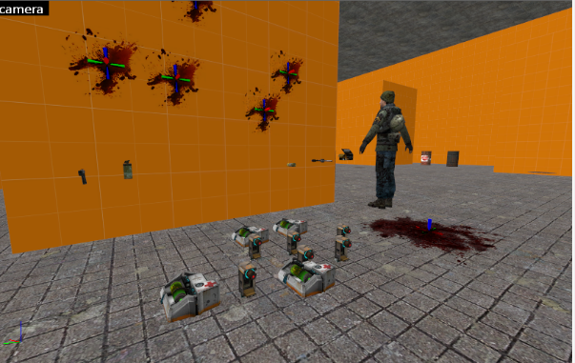
Figure 26 Health pickups and defining where the player starts.
This is what the player would see when they spawn in. The intended ideas here where the player would be able to know where the health packs. Initially the idea was to have med stations and dynamically spawning health packs however instead of that system all the health packs the player would need would be at spawn. This would create a sense of challenge for the player as there is limited health packs. Limiting the resources for the player allows them to think of solutions and be more clever approaching problems as per the design pillar of an immersive sim.

Conclusion
To conclude this section developing a complex gameplay focused map within the Hammer mapping tools is an interesting challenge especially for someone who is new to the process but getting the basics right building an immersive sim using the source engine is not only possible but necessary.
So where does procedural generation come into play in this regard? As proven in an earlier section the source engine provides a basic framework for it to be possible. With Left 4 Dead 2’s Director Mode it is very possible to create something within the source engine using the Director Mode’s scripting and algorithm to combine the immersive sim design philosophy and the complex intricacies of the procedural generated output. While not implemented within the demo the goal is to figure out if the player would respond positively to such an idea if proposed in an actual full-on game. As clear by the questionnaire that was conducted.

CHAPTER 5 – ANALYSIS AND EVALUATION
To Evaluate while the demonstration does not have a procedurally generated system in place however the goal was to see if a procedurally generated system would help an immersive sim design using the source engine.

Questionnaire Results and Discussion
To decide the nature of this project and how the average player would react to a project that combines immersive sim elements while also implement a procedural generated gameplay scenario.
One of the biggest hurdles in this project was trying to decide the b clear definition on what an immersive sim truly is. To a pleasant surprise it looks like players had a decent idea on what an immersive sim is or at least the type of games that fall under the immersive sim umbrella.
Out of several participants here are the various answers they gave to my questionnaire.

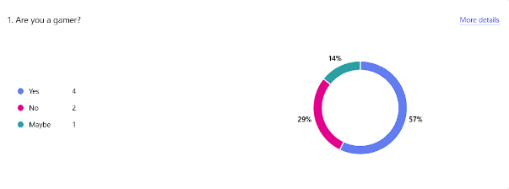
Figure 27 Are you a Gamer?
The first question that was asked is whatever if the participant was a “gamer.” It is important to set the foundation of what this survey would entail. In this case this is a gaming centric survey.

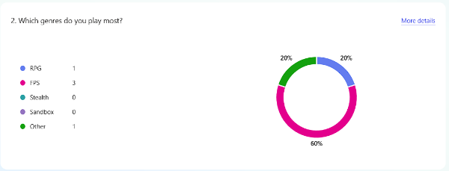
Figure 28 Which games do you play the most?
The next question in this survey is which games the player plays the most. To quantify this the survey has a list of various genres that folks usually play in games, and these genres also cover most if not all immersive sims especially with how dynamic those scenarios could be. As the results show most people play FPS games. Which is useful information as this immersive sim demo is built upon a foundation of an FPS title.
Not to mention the other categories can also be used in an immersive sim foundation. RPG’s and Stealth games. In fact, there are stealth games like Thief that is also considered an immersive sim. [41]
In short, these results are useful to know what folks can expect in a demo like this and as such it is an FPS type of game.
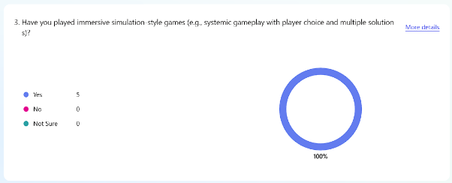
Figure 29 Have you played Immersive sims or Immersive sim type games?
This question is the most important in this survey as for the nature of this project. Knowing if players are familiar with what immersive sims are. Considering how ambiguous the term is being mostly seen as a design philosophy rather than a traditional game genre. So, to know that the participants of this survey know what an immersive sim is or at least have played them helps bypass the definition.

Figure 30 If yes, which ones have you played?
Naturally the follow up question to “if you played an immersive sim” is to know what immersive sim games they would play. Because how can they know what an immersive sim is if they do not know what the games are. Fortunately, the results were varied and interesting. Some folks do have some idea what an immersive sim is and one of the results was interesting. One participant who wishes to be anonymous said that Half-Life 2 is what they considered to be an immersive sim.
While the game was never designed to be one in mind the parallels are they as it can fall under the definition of what an immersive sim can be. About systemic gameplay mechanics and with Half-Life 2’s physics engine being used in gameplay.

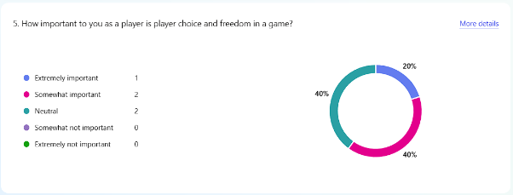
Figure 31 How Important is player choice and freedom in a game.
The next question is a simple one but provides interesting data to use. As player choices is defined through immersive sims with player choices being a typical characteristic. As the results show players do prefer player choices in games considering it important.
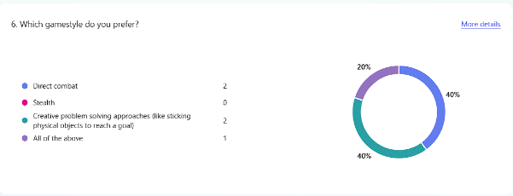
Figure 32 Which game style do you prefer?
The next question in this survey is the game style these players would prefer. It is not surprising that many players would prefer direct combat or finding a creative solution. Whereas direct combat can create fun gameplay scenarios that allows players to just go in and have fun engaging with the combat mechanics in a game.
Finding creative solutions is also not surprising as players would like to feel smart and feel like they achieved something without following what the game has asked. Players find it more rewarding and interesting beating a game outside of the intended purpose of the developers. It also a defining aspect of an immersive sim.
However, the surprise of this result is that no one picked stealth as a preferred choice. As Stealth is also another aspect seen in Immersive sims.
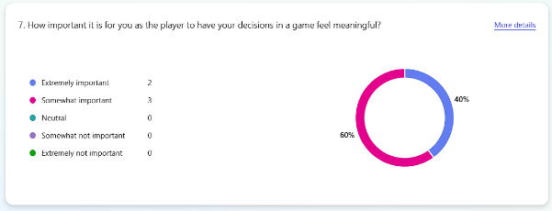
Figure 33 How important it is for you as the player to have your decisions in a game feel meaningful.
The next question in this survey is the importance of player choices in video games. It is not surprising that players would prefer having choices in a game that would feel meaningful as players would like to feel that they are part of the game world in a way that feels natural and fulfilling from a gameplay and design perspective.

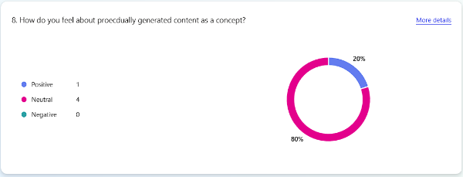
Figure 34 How do you feel about procedurally generated content as a concept.
The next part of this survey is to understand how players would feel about procedurally generated content as it is a complicated subject within game design. The result of this question shows that folks are both positive and neutral about it which shows that depending on how its used players would respond positively to it.

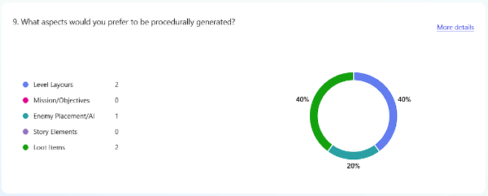
Figure 35 What aspects would you prefer to be procedurally generated?
The next question from the survey is asking what kind of procedural generation players would like to see in a game. This question is important as this hypothetical game that combines the immersive sim design to procedural generation. Asking these questions helps find what a player would look for in a game like this and it is a useful considering the nature of this project.
As the results show players prefer seeing Level layouts to be procedurally generated. As a procedurally generated level can lead to interesting design outcomes for the players as this level would be completely randomize potentially changing routes or NPC pathing each time a player would replay a game. It adds to replayability in so many ways.
Enemy placement and AI are also an understandable response. Because a randomized enemy placement would change the way the player would approach a problem. It also adds to the dynamic difficulty design element. As per the Left 4 Dead director mode it is a dynamic difficulty setting depending on how they player would play the game.
The third answer is also not surprising. Loot items are also common in immersive sims like Deus Ex as finding certain types of items would either let you be lucky enough to find the right tool for the job or finding something useless for your run forcing the player to rethink the strategy. In this scenario loot items in this scenario would be completely randomized each time a player does a new run leading to potential surprises allowing the player to think about what they are picking up.


Figure 36 What concerns do you have about procedural generation?
This question is intended for players to understand the potential concerns that procedural generation could have. As it can be used to create bad or uninteresting games. Being used in the right context can make a game that feels infinitely replayable. Asking what potential concerns players would have with procedural generation would help the developer avoid these shortcomings.
Figure 37 What do you prefer Mostly?
This question was asked in the intent to see what players would prefer when it comes to the approach of procedural generation. As suspected players would mostly prefer a hand-crafted experience so this is something that will be considered when developing this project.
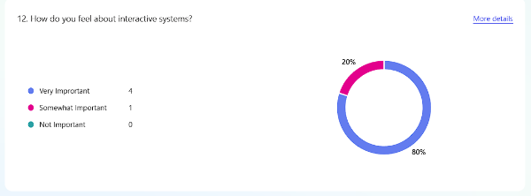
Figure 38How do you feel about interactive systems?
The purpose of this question is to gather data on how players would feel about how they interact with the game world as one of the key aspects of immersive sims. As the results show most players prefer interactive systems in games. Interactive systems allow player to complete in game aims using the rules and mechanics that the game provides.

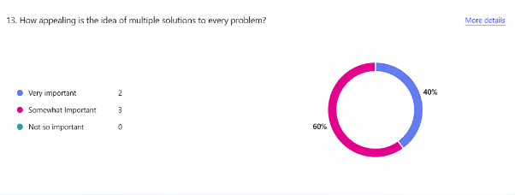
Figure 39 How appealing is the idea of multiple solutions to every problem?
This question is intended to prove that players would prefer to have multiple solutions to solve a problem. As it adds to the replayability of the game and allows players to be expressive within gameplay and experiment with the game mechanics to solve any given problem on hand.

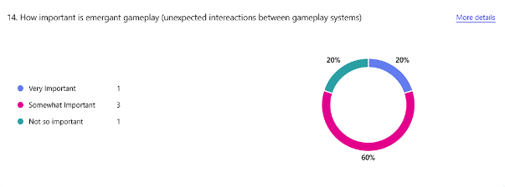
Figure 40 How important is emergent gameplay(Unexpected interactions between gameplay systems)
The purpose of this question is to see how players feel about emergent gameplay. Emergent gameplay is when something occurs within the game that the developer did not foresaw like players finding a new path or a way to play the game. Judging from the results of this question players are indifferent to emergent gameplay as a concept, so this is something to consider when building the game.
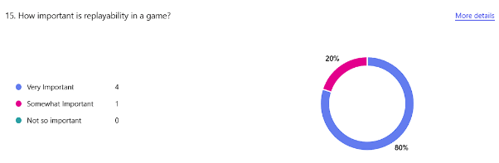
Figure 41 How important is replayability in a game.
The results here are not surprising. Gamers like to replay their favourite games and making a game feel fresh every time it gets replayed is something of a goal for most developers. As it stands a game that is replayable lets them see their favourite game in a new light when it comes to interesting or fulfilling game mechanics. Plus, it allows players to do unique runs that can assess their abilities. As per the nature of the project Immersive Sims in nature are designed to be replayed [42] Just as much as RPGs in a game. And the very nature of procedural generation can provide thousands or even millions of new ways or unique gameplay moments that can be experienced. An infinitely replayable game.

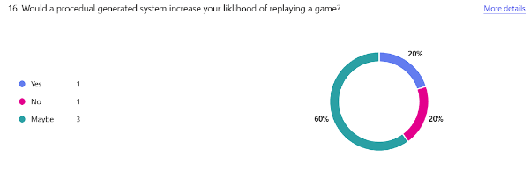
Figure 42 Would a procedural generated system increase your likelihood of replaying a game?
Building off from the last question the answers here provide valuable data as it says that players have not thought about it as much. Which shows that there has not been a proper implementation of a procedurally generated system that offers a meaningful way to replay a game. So, looking at Left 4 Dead 2’s system it can be used to allow for more replayability if the levels were to feel more natural and if the game can provide a new meaningful experience for the player without it being too intrusive or “artificial”.
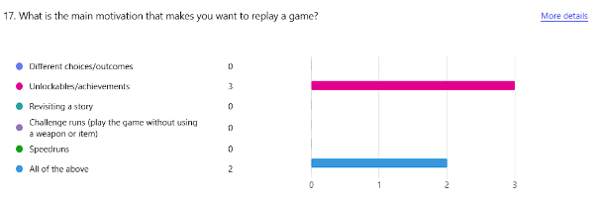
Figure 43 What is the main motivation that makes you want to replay a game?
Asking this question helps understand what players tend to look for when they do a new playthrough of a game. Not entirely surprising the choices where either all the Above or achievement hunting. Achievement hunting can offer a meaningful reward that feels earned. It is easy to understand why achievement hunting can offer a lot for a player looking to replay their favourite game. Also, all the above is also not a surprise consider there is a lot that can bring a player back to replay a game.
See new choices or outcomes if it is a multiple choice like game.
Revisit the story if the story was told in a meaningful way.
Challenge runs like trying to beat a game under a certain condition.
Or simply to speed run and try to beat the game as fast as possible.
There are so many reasons for players to replay a game. It does not have to be a one and done type of deal.


Figure 44 What would make an immersive sim stand out to you?
The purpose of this question is to see what the target audience or gamers are looking for when it comes to immersive sims. The design allows for all types of games to be playable from all kinds of genres. Asking this helps better understand what the player tends to look for in an Immersive sim which overall is usually having players feel like they are achieving something in the game world.

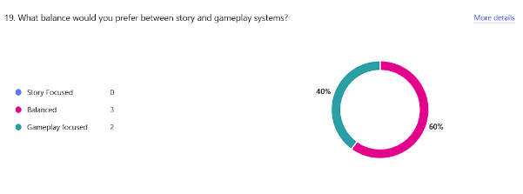
Figure 45 What balance would you prefer between story and gameplay systems?
The purpose behind this question was to see the type of balance players would prefer between gameplay and story. Unsurprisingly players tend to prefer a bit of both because a game would have to feel meaningful in both story and gameplay. A balanced approach is the right approach because it helps developers define the gameplay and still deliver a meaningful story. However, finding the right approach to go develop this is also key.

Figure 46 What is your biggest frustration with modern games?
The purpose behind this question is to see what the biggest frustrations for players within the modern games industry. The data is valuable because it tells me that players would receive help from a game that respects their decisions and would offer a meaningful and fun experience.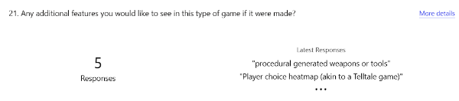
Figure 47 Any added features you would like to see in this type of game if it were made?
The purpose behind a question like this is that if a game like this were to be made what kind of features a player would like to see to enhance the experience. This serves to allow for development to start off with a clear goal for what players would want and how it would tie into a coherent and most importantly fun experience.

Figure 48 What is your all-time favourite game?
An added bonus question to see what the target audience is playing. It does serve one purpose to see the type of game they would enjoy and how those elements from their favourite games can be implemented in a project on this scale.

Literature Review
To analyse what has been discussed her so far. Immersive Sims and Procedural Generation and how a procedurally generated system can help the immersive sim design philosophy. It could increase player freedom by offering a lot of replayability and systemic unpredictability which are the core pillars of Immersive sim design.
They are built around the idea that players can solve problems in multiple ways by interacting with the built-in systems that the game provides. Furthermore, depending on how a procedurally generated system is implemented it could offer dynamic difficulty or randomized level layout or change the loot items every time a player revisits the game. The goal would be to offer infinite replayability.
This is the kind of concept that would force the player to react and adapt whenever they play the game as there would be something new around the corner creating infinite possibilities for special runs. For example, if this system was implemented for NPCs. The AI would react in random and unexpected ways forcing the player to adapt to their surroundings.
A system like this can indeed help the core philosophy of immersive sims because it would encourage the player to truly interact with the systems that are presented by the game.
More examples would include the level changing its lighting and NPC placement if they opted to go stealth or combat this system can change and adapt depending on how someone would play the game.
Furthermore, if this were implemented into a larger more detailed game like intricate RPG like Cyberpunk 2077 or Fallout New Vegas it could add more emergent storytelling with story NPC dynamically interacting with the world that the player is affecting. While Cyberpunk 2077 and Fallout New Vegas are not considered immersive sims the idea of a world that reacts in a dynamic way like what those games provide would create an interesting immersive sim experience for the player.
For replayability. There are games like Dwarf Fortress, Noita, Cruelty Squad and Robocop. Games with the immersive sim design philosophy proves how unpredictable a systemic Gameworld can affect how a player would approach challenges. Let us say that there is an aim that a player must complete in a game. Depending on the type of algorithmic method used this specific system can create a dynamically altering system that can change depending how a player approaches an aim. Creating a fully systemic interaction between the player and the Gameworld
About the adaptive difficulty gameplay systems there are algorithms such as the AI Directors. In games like Left 4 Dead this AI Director would check and track on how a player would play or interact with the game and depending on how they play it would generate items or NPCs. However in an immersive sim type environment AI directors can monitor or track player behaviour in regards to stealth this combat which is the nature of this project like if the player is approaching the game using stealth it would generate surveillance or stealth like mechanics or NPC behaviour that would encourage the player to think and come up with creative solutions whilst in stealth or if the stealth failed and they are forced into a situation that becomes dangerous.
However as said through the questionnaire results there can be limitations. Immersive Sims are defined by tightly handcrafted level design which are created in a way that heavily supports player interaction. And at the same time level designs must make that world feel believable and fun to play in. It is a tight careful balance and if done badly the game would be unfun.
So, the limitations would be that if there is excessive procedural generation it would negatively affect the important balance that immersive sims rely upon which could come down to several aspects that makes a meaningful immersive sim experience such as environmental storytelling, pacing, logical world design etc. If not implemented carefully, with great precision and a clear understanding of proficient level design it would feel less believably and most importantly fun.
So how does level designer or developer would approach this problem? One must approach the design with a handcrafted approach, with an unobstructed vision of what you want to create for the player and how fun it shall be for them with a logical consistent design that stays true to the immersive sim design philosophy. Level design benefits from a handcrafted approach while a procedural generated system would change the details of the level, encounters, lighting, NPC pathfinding, or the dynamics of the world state.
The balance is the right approach for any developer.
Overall procedural generation can benefit or compliment the immersive design philosophy because procedural generation as a concept can increate systems-driven gameplay and increase player agency and emergent outcomes. When its balanced correctly so the level designer can handcraft the level design making sure the design is consistent and logically sound. When both elements are blended well, they can complement the main philosophy behind immersive sims and create a fun and meaningful experience making the game feel real, reactive, offer infinite replay value while also keeping the depth and environmental coherence that defines immersive sims.

CHAPTER 5 – EVALUATION AND POTENTIAL IMPROVEMENTS FOR THE FUTURE

Analysis
Looking back on what had been built I can say that the data was a success in proving that immersive sims can receive help from procedurally generated gameplay elements. However, there can be improvements:

What conclusions can be drawn from the data?
To start out the conclusions I gathered from the data. From building the map then conducting the questionnaire. On top of all the research I have made into this topic, and I learned that there must be a balance between how the developer would implement this feature. There must be a balance that does not upset the delicate and intricate design of how Immersive Sim levels are made.

Is the data backed up by the literature review or did the data disagree with the literature.
Reviewing the literature on this subject immersive sim is defined by their levels so if a procedurally generated system were to be implemented it must take shape for gameplay mechanics akin to the Left 4 Dead AI system rather than a randomizing level layout.

Were the aims met?
I believe the goals to build an immersive sim in the source engine was met. However, to implement a procedurally generated system would’ve taken time to perfect.

Were the aims met?
The aim to build a functional demo that can be played and evaluated were met. Unfortunately, a play testing session was not conducted so I could not gather any concrete data.

Are there any answers that would have been expected?
I expected that people would not know what an Immersive Sim was. Considering how loose the term was but to my surprise a pleasant one folks had a decent idea on what they are working with. And they know the fundamentals of what an immersive sim so. So, this made the data easier to gather.

The Future of a project this scale?
The future of this project when or if it gets revisited would be a full-scale mod that uses the Left 4 Dead AI director and implemented in an open-ended level design. This director mode would only affect with how the NPCs would react to the player’s actions while also change the difficulty depending on how the player would interact with the game.
If the balance is supported and that the core principle of hand-crafted immersive sims is met, then it can lead to an incredibly fun and meaningful experience for the player. [43]

What can be improved upon if revisited?
To revisit this idea properly one must see how this concept was realized in Left 4 Dead 2. A game on the source engine that uses this algorithmic system in a remarkably effective way having the game be dynamically altered depending on how you play. Left 4 Dead offers a good framework to build from.
However, it is difficult to define Left 4 Dead as an Immersive Sim so one must take in account on how its implemented there as opposed to this hypothetical game. So, in this game this system would be implemented in a way that affect how NPC would react and adapt to player feedback.
Like if a player drops too many NPCs in an area the game world reacts and account for the said player act leading to a game world that feels responsive, believable, and staying true to the original groundwork that developers have defined for immersive sims.
Look at a game like Deus Ex while the world already feels very responsive to how the player would act this system would account for everything that the player does. So, depending on what the player does for example if they dropped many enemy NPCs this system can increase Enemy NPC patrols or squads to hunt the player down for revenge.

CHAPTER 6 - CONCLUSIONS AND RECOMMENDATIONS

To conclude these findings there needs to be a revaluation of everything that has been done so far so the findings can be as clear and concise as possible.
To summarise this project so far
- Understand and define what immersive sims are.
- The Design philosophy behind immersive sims
- Discuss procedural generation as a concept.
- Design and implement a demo that integrates the immersive sim design philosophy.
- Conduct a questionnaire with a select group of gamers.
- Evaluate and assess.

So where to go from here? The biggest finding that has been discussed already is the creation of a game that uses the said balanced between procedural generation and immersive sim design philosophy.
To implement this game that has a solid framework, and a sound design the developer must preserve what makes immersive sims work which is the handcrafted level design.
As proven procedural generation does not have to be making a system that would generate a level. It can be gameplay mechanics dependant that would change itself depending on how the player would approach the game. Which is a far better approach, and it balances the game out with a design that feels uniquely different every time someone replays the game.
Immersive Sim strives to offer a new unique experience for the player. Its part of the core philosophy and it is why games like Deus Ex is considered the standard because of how replay able it is.

CHAPTER 7 – REFLECTION

To reflect on this endeavour, I have learnt many things. Game design specifically mostly and how development works.
The biggest things I have learnt was using Hammer. For a long time, I really wanted to make something using hammer. There have been attempts in the past however I never made anything beyond a simple place where the player can walk around. However, thanks to developing this project I have finally used to opportunity to build something.
The first thing I did with hammer was download the right version. Which is the Source SDK 2013 Singleplayer version which would allow me to tailor this demo for a singleplayer game. Because this is using Half-Life 2 as a base it can also allow me to use Half-Life 2’s assets and entities.
Another thing I ended up using was the Hammer++ version. Looking back at the original base version of Hammer it is very out of date in regards of QOL features not to mention it supports stability and it feels better to use. Plus, it allows me as the developer to analyse lighting through its improved lighting display. It also features modern controls, and it is much faster to build a map here compared to the original version of hammer.
The quality-of-life features includes undo improvements, better object management, advanced visgroups, improved texture browser, easier entity management, cleaner grid snapping and a better complier (Will not need to compile to assess if things like lighting and entities were implemented properly)
Alongside this is enhanced vertex editing. While not implemented in this demo it makes making complex terrain feel much less of a hassle compared to the original iteration of hammer alongside making terrain.
So, this is why I chose to use Hammer++ because all it does it making maps feel much easier and more convenient.
So, after learning hammer I also intend to understand the fundamentals of game design. It is one thing to know how to make a level within hammer editor but to make it fun is an entirely different matter.
To make a level feel fun I implemented enemy NPCs for the player to interact with and fight against. Giving the player something to do is important to make the game feel fun.
Also considering since I am building from what Half-Life 2 set up, I wanted to add physics-based gameplay allowing the players to use the props around them to use as weapons or objects. Half-Life 2’s main selling point was its physics-based gameplay. Allowing the players to use the physics objects in the world as weapons or objects to solve puzzles.
So, with this thought in mind, I wanted to use this physics engine to build upon the immersive sim design philosophy. I figured the source engine is a perfect benchmark for an immersive sim design.
However, my biggest drawback was my failure to implement the procedurally generated system. My original intent was to use the director system from Left 4 Dead 2 to create a demo that would feel dynamic in its difficulty. However, I did not have the time to implement the feature to make it work considering it was on the Left 4 Dead branch.
Furthermore, it was a good opportunity to prove that it can still work from a design standpoint through my questionnaire. So, it was not all in vain.
I do hope in the future that I am able to properly implement this feature in a fully playable mod. Using Half-Life 2’s assets while using the system that was implemented in Left 4 Dead 2. In fact, I could experiment on this creating a demo using the Left 4 Dead branch of the engine to experiment how an AI Director could adjust game mechanics and NPC behaviour.
I could also use this opportunity to improve my time management also.
To conclude I would say that this project was a moderate success in the fact that I learnt a lot in terms of basic game design and how to build something using the source engine which is something I always wanted to do.

CHAPTER 8 – REFERENCES
Timothy Cain - What is an Immersive Sim?
Game Maker’s Toolkit – The Comeback of the Immersive Sim
Game Maker’s Toolkit – Deus Ex: Mankind Divided’s Amazing Open World
Accursed Farms – Ross’s Game Dungeon: Deus Ex
Warren Spector - Lectures
Valve – Half-Life: 25th Anniversary Documentary
Valve – Half-Life 2: 20th Anniversary Documentary
Tyler McVicker - Half-Life 3 - The Rise, Fall and Rebirth
qyuetx – Source Evolution and Branches Explained
LamWrap - The History of Goldsrc Games
LamWrap – The History of Source Games
DigiDigger - How does procedural generation work? | Bitwise
IGoByLotsOfNames - Game terrain generation is simple, actually

CHAPTER 9 – BIBLOGRAPHY

[1] | M. Booth, “The AI Systems of Left 4 Dead,” in Valve, Bellevue WA, 2009.
[2] | C. C. M. K. a. D. S. Myles Blasonato, Immersive Sims: A New Paradigm or a New, Sydney Australia: AIE Institute, Macquarie University, 2022.
[3] | L. Kullas, The Design Philosophy of, Tampere, Finland: Tietojenkäsittelyn tutkinto-ohjelma Games Production, 2025.
[4] | N/A, “AI in Video Game Development: From Smarter NPCs to Procedural Worlds,” CAPITOL Technology University, 23 October 2025. [Online]. Available: https://www.captechu.edu/blog/ai-in-video-game-development. [Accessed 14 05 2026].
[5] | J. T. Clark, “What is an 'Immersive Simulation?',” The Player is the Thing, 23 02 2023. [Online]. Available: https://www.theplayeristhething.com/p/what-is-an-immersive-simulation. [Accessed 14 05 2026].
[6] | N/A, “The Role of Player Agency in Dynamic Game Experiences,” MODELCLINICS, 12 02 2025. [Online]. Available: https://modelclinics.com/blog/the-role-of-player-agency-in-dynamic-game-experiences/. [Accessed 14 05 2026].
[7] | A. Sergeev, “Five Pillars of Immersive Sims,” 80 Level, 27 05 2018. [Online]. Available: https://80.lv/articles/five-pillars-of-immersive-sims. [Accessed 14 05 2026].
[8] | B. Caldwell, “The 10 best immersive sims on PC,” Rock Paper Shotgun, 25 07 2024. [Online]. Available: https://www.rockpapershotgun.com/the-10-best-immersive-sims-on-pc. [Accessed 14 05 2026].
[9] | E. Stonham, “What is an immersive sim? Game genre, explained,” Adventure Gamers, 26 09 2025. [Online]. Available: https://adventuregamers.com/article/what-is-an-immersive-sim-explained. [Accessed 14 05 2026].
[10] | T. Biery, “What makes an Immersive Sim, and why are they staging a comeback?,” Polygon, 18 08 2016. [Online]. Available: https://www.polygon.com/2016/8/18/12539476/what-makes-an-immersive-sim-and-why-are-they-staging-a-comeback/. [Accessed 14 95 2026].
[11] | W. Spector, Interviewee, RPS Exclusive: Warren Spector Interview. [Interview]. 13 02 2008.
[12] | W. Spector, “Warren Spector's Commandments of Game Design,” GameIndustry.biz, 04 09 2013. [Online]. Available: https://www.gamesindustry.biz/warren-spectors-commandments-of-game-design. [Accessed 14 05 2026].
[13] | A. Elise, “RNG Meaning: Simple Guide for Beginners (2026),” Manywys, 14 04 2026. [Online]. Available: https://manywys.com/rng-meaning-simple-guide-for-beginners-2026/. [Accessed 14 05 2026].
[14] | P. G. V. &. J. L. Lowe, “The Book of Shaders,” 2015. [Online]. Available: https://thebookofshaders.com/11/. [Accessed 14 05 2026].
[15] | P. Martz, “Generating Random Fractal Terrain,” Game Programmer, 28 04 1999. [Online]. Available: https://web.archive.org/web/20060420054134/http://www.gameprogrammer.com/fractal.html#diamond. [Accessed 14 05 2026].
[16] | E. W. Weisstein, “Lindenmayer System,” MathWorld--A Wolfram Resource, [Online]. Available: https://mathworld.wolfram.com/LindenmayerSystem.html. [Accessed 14 05 2026].
[17] | E. W. Weisstein, “Cellular Automaton,” MathWorld--A Wolfram Resource., [Online]. Available: https://mathworld.wolfram.com/CellularAutomaton.html. [Accessed 14 05 2026].
[18] | E. W. Weisstein, “Voronoi Diagram,” MathWorld--A Wolfram Resource, [Online]. Available: https://mathworld.wolfram.com/VoronoiDiagram.html. [Accessed 14 05 2026].
[19] | Various, “Graph Algorithms,” Geeks for Geeks, 26 01 2026. [Online]. Available: https://www.geeksforgeeks.org/dsa/graph-data-structure-and-algorithms/. [Accessed 14 05 2026].
[20] | N. Bruce, “A tutorial on Binary Space Partioning Trees,” 2005. [Online]. Available: https://www.researchgate.net/publication/238348725_A_Tutorial_on_Binary_Space_Partitioning_Trees. [Accessed 15 05 2026].
[21] | M. McGuire, “Quake 2 BSP File Format,” Flipcode, 07 06 2000. [Online]. Available: https://www.flipcode.com/archives/Quake_2_BSP_File_Format.shtml. [Accessed 15 05 2026].
[22] | L. Voisard, “Procedural Generation: Wave Function Collapse,” Ptidej Team Blog, 10 07 2024. [Online]. Available: https://blog.ptidej.net/procedural-generation-using-wave-function-collapse/. [Accessed 15 05 2026].
[23] | J. McCollum, “Generative grammars as a form of procedural content generation,” The Shaggy Dev, 16 03 2022. [Online]. Available: https://shaggydev.com/2022/03/16/generative-grammars/. [Accessed 15 05 2026].
[24] | F. B. M. Bothen´, Using marching cubes with noise to generate complex surfaces, Sweden: Lund University, 2026.
[25] | Boris, “What Is Procedural Generation,” BorisTheBrave.Com, 25 05 2024. [Online]. Available: https://www.boristhebrave.com/2024/05/25/what-is-procedural-generation/. [Accessed 15 05 026].
[26] | D. Crespo, “The Evolution of Valve's Source Engine,” Deus In Machina, 28 12 2023. [Online]. Available: https://www.deusinmachina.net/p/the-evolution-of-valves-source-engine. [Accessed 15 05 2026].
[27] | R. O'Donnell, “Counter-Strike: Source -- Full-Screen E3 2004 Presentation,” GameSpy, 19 07 2004. [Online]. Available: http://pc.gamespy.com/pc/counter-strike-remake-source-engine-powered/531716p1.html. [Accessed 15 05 2026].
[28] | C. Bokitch, “Half-Life's Code Basis,” VERC Collective, 01 08 2002. [Online]. Available: https://web.archive.org/web/20070204012725/http://collective.valve-erc.com/index.php?doc=1028244478-62628500. [Accessed 15 05 2026].
[29] | G. Newell, Interviewee, GameSpot UK Half Life: Interview With Gabe Newell. [Interview]. 1999.
[30] | M. Byrd, “Half-Life: The Many Ways the Classic Sci-fi Shooter Changed PC Gaming,” Den of Geek, 20 11 2024. [Online]. Available: https://www.denofgeek.com/games/half-life-changed-pc-gaming/. [Accessed 15 05 2026].
[31] | R. Liptak, “Source vs GoldSrc Movement: Downward Slopes,” ryanliptak, 03 04 2023. [Online]. Available: https://www.ryanliptak.com/blog/source-vs-goldsrc-movement-slopes/. [Accessed 15 05 2026].
[32] | S. Pastis, “How Valve founder Gabe Newell turned ‘Half-Life’ into a nearly $10 billion fortune,” Forbes, 06 12 2024. [Online]. Available: https://www.forbes.com.au/covers/magazine/how-valve-founder-gabe-newell-turned-half-life-into-a-nearly-10-billion-fortune/. [Accessed 15 05 2026].
[33] | R. Cobbett, “The legacy of Half-Life 2,” PC Gamer, 16 11 2014. [Online]. Available: https://www.pcgamer.com/the-legacy-of-half-life-2/. [Accessed 15 05 2026].
[34] | Various, “The History of Source,” Source Modding, 2020. [Online]. Available: https://www.sourcemodding.com/history/source/. [Accessed 15 05 2026].
[35] | Various, “List of Source games,” Valve Developer Community, 27 08 2024. [Online]. Available: https://developer.valvesoftware.com/wiki/List_of_Source_games. [Accessed 15 05 2026].
[36] | R. R. May Britt Bjerke, Being smart about writing SMART objectives,, Grand Forks: University of North Dakota, 2017,.
[37] | M. Booth, “The AI Systems of Left 4 Dead,” in Valve, Bellevue, 2009.
[38] | Interneted, “VScript - Introduction to Squirrel,” steamcommunity, 01 14 2025. [Online]. Available: https://steamcommunity.com/sharedfiles/filedetails/?id=3406867526. [Accessed 15 05 2026].
[39] | Various, “Worldcraft,” Valve Developer Union, 05 12 2017. [Online]. Available: https://valvedev.info/tools/worldcraft/. [Accessed 15 05 2026].
[40] | Various, “Grouping and VisGrouping,” Valve Developer Community, 12 07 2024. [Online]. Available: https://developer.valvesoftware.com/wiki/Grouping_and_VisGrouping. [Accessed 15 05 2026].
[41] | Various, “Thief : The Dark Project,” [Online]. Available: http://immersivesim.wikidot.com/game:thief. [Accessed 15 05 2026].
[42] | HitmanX, “Deus Ex – Review,” GameFAQ, 03 03 2002. [Online]. Available: https://gamefaqs.gamespot.com/dreamcast/364511-deus-ex/reviews/31316. [Accessed 15 05 2026].
[43] | E. Adams, Fundamentals of Game Design, Thousand Oaks: New Riders, 2014.

APPENDICES
Other engines were considered for this project and the reason the source engine was chosen is because of the physics integration.
Valve has experimented with immersive sim elements in Source 2
I could have expanded the questionnaire to a wider range of users, but I feel like I got plenty of data to work from.
Initially there was supposed to be 2 demos one for the Immersive Sim and the other for the AI Director from Left 4 Dead 2, but I went with one demo instead.

