L4 - Introduction to Web and Database Concepts

Written By James Taylor
Computer Networks and Cybersecurity BS-Hons
0152272@student.uwtsd.ac.uk

Revision 0.0
May 2022

Contents
2 introduction 3
3 Requirements 3
4 Implementation 3
4.1 Wire Frame Implementation 4
4.2 Website Page Implementation 8
4.2.1 Home Page 8
4.2.2 About Me 8
4.2.3 Contact Me 9
4.2.4 Portfolio 9
5 Validation 9
6 Evaluation 11
6.1 Website Usability & Accessibility 11
7 Search Engine Optimisation (SEO) 17
8 Conclusion and Recommendation 19
9 Bibliography 20
10 Appendices 22
10.1 Appendix 22
10.2 Appendix 27
10.3 Appendix 29
10.4 Appendix 32
10.5 Appendix 34
10.6 Appendix 36
10.7 Appendix 38
10.8 Appendix 40

introduction
This website is solely based on a Photographer’s Portfolio. It has been requested that the code must be in HTML / CSS format.
As a keen hobbyist I chose to implement this website based around my photography so if in the event someone wanted to see the work this could be made available.
The code has been tested and validated using various online checker tools to validate the HTML Home & Website main CSS.
Within this report you shall find the wire diagram of the design and combined with various screenshots of the website.

Requirements
The soul purpose for this website is to demonstrate my understanding of how HTML / CSS code works and furthermore how to implement it into a functional website with an ease of access. the website is intended for an audience that are looking to hire a Photographer.

Implementation & Validation

Implementation
Snipping tool has been used to take screen grabs of each page, also included is the Wireframe diagram of each page to show its functionality and furthermore how it will be implemented.

Wire Frame Implementation

What is a wireframe?
A wireframe's primary purpose is to explain the structure and functionality of a user's flow, with functionality referring to anything the user interacts with, such as buttons, menus, and dropdowns. This is accomplished by the creation of a visual representation of the product's structure, information hierarchy, functionality, navigation, and content placement. A wireframe depicts the product's broad layout and specifies which elements must be included on each page without going into visual specifics or UI design. [1]

A storyboard is a useful tool that allows designers, graphic artists, and eLearning content developers to arrange images or graphics in a logical order to visualise the final product. [2] This shows the End User how the navigation, Links and button layout will look like.

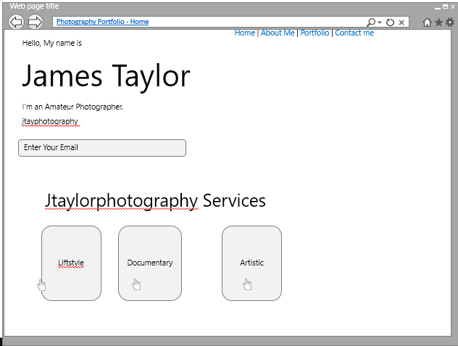

In order to map out the fundamental components of an interface, a wireframe is necessary. It aids everyone participating in the process in gaining complete knowledge of the brand early on. Below you can see the text boxes and the “ let’s Talk “ button that will take you to an email form. [3]

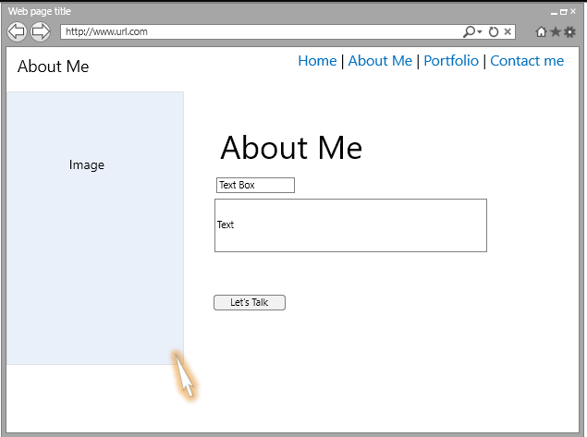

Wireframes are also much more approachable than abstract written concepts. Showing a wireframe to developers or clients will help them grasp your objectives more clearly, allowing you to get valuable feedback and implement it into your design. This portfolio page shows you the library collection of images. [4]
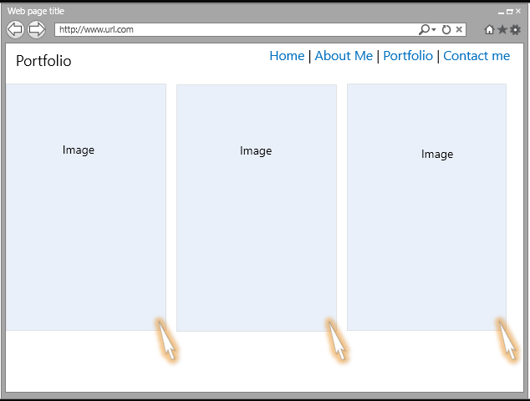

The Developer chose to have an “ Get in Touch “ link whereby this auto generates an email that gets sent to the webmaster. It’s also important to stress to the customer that this is not the final product but more of it’s structure and how we would like the functionality to work. [1]
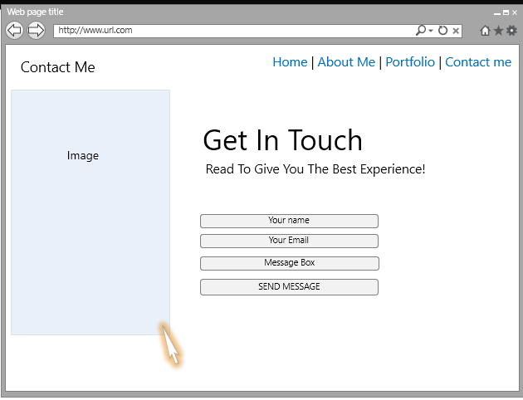

Website Page Implementation

Home Page
The developer chose this Home page layout as the functionality and usability is very basic which gives ease of use to the end user.
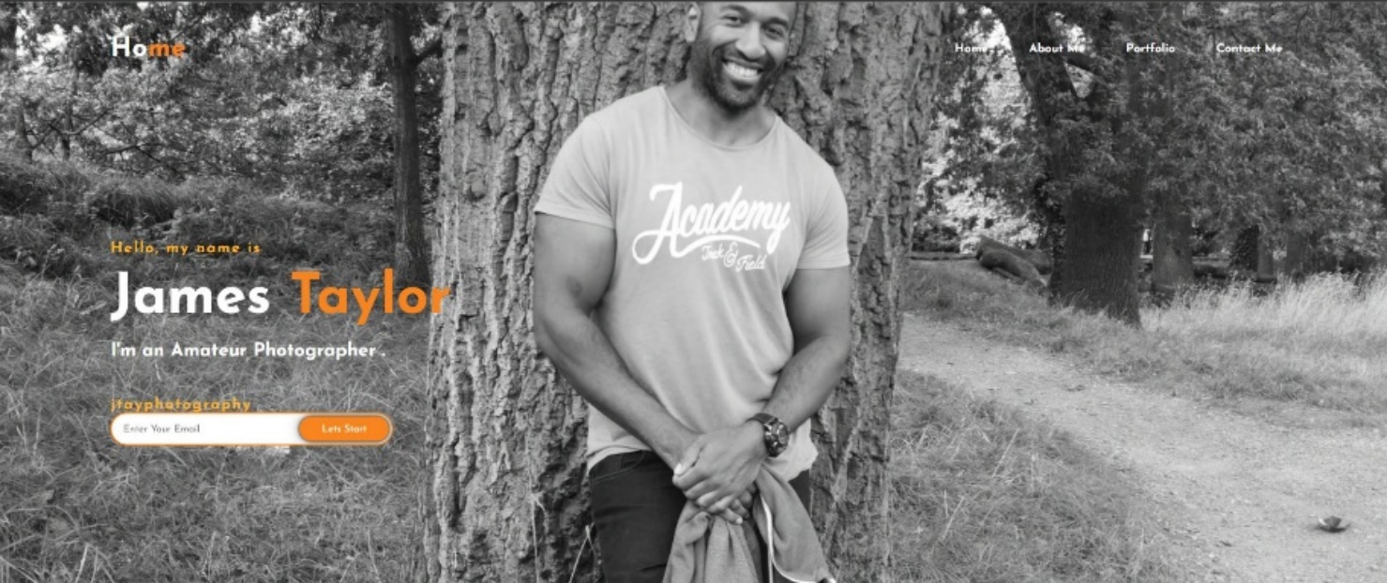

About Me
Consistency has been kept the same throughout most of the page layout design. This page displays further information “ About Me “ also and lets talk button has been added which brings you to the Contact me page which you shall see below.
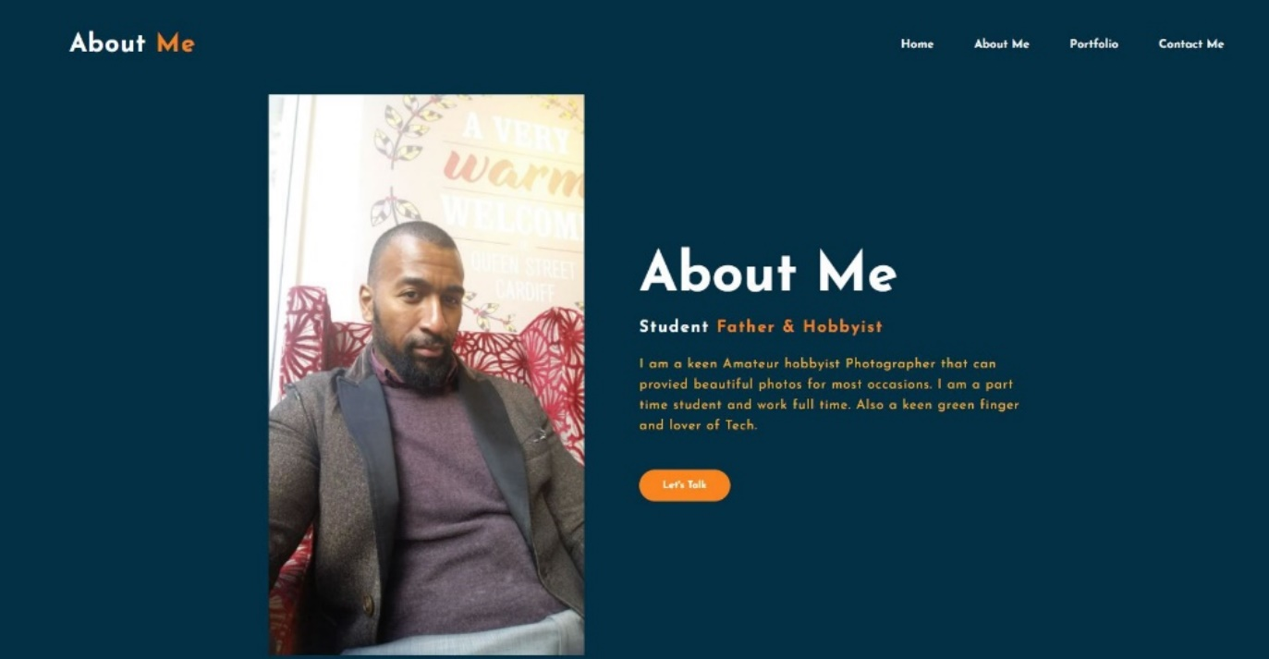

Contact Me

The Developer chose a simplistic Get-in-Touch form with decent size text boxes for ease of flow. When the customer fills in the text fields this will automate an email which will then go to the owner of the website.
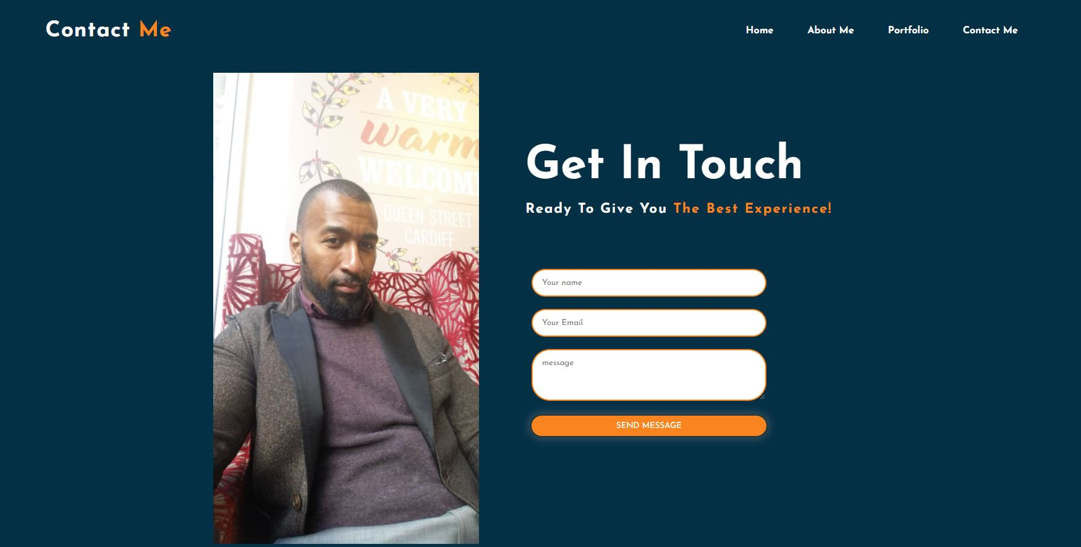

Portfolio

Below are a few photos that the client has asked the Developer to add so the customers can see the quality of the photography.

Validation

Website code has been checked and validated by HTTP://validator.w3.org this is site is used to find any errors withing the backend code. This is also used for CSS. Below you will find screen shots.

HTML Checker

Below is the Html code checker, and no errors came back for the Home Page Validation. [5]

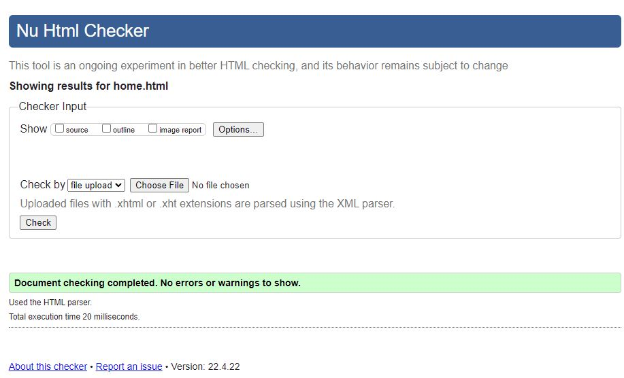

CSS Validation
Below the code was checked for any errors for the CSS. Results came back with no issues. [5]
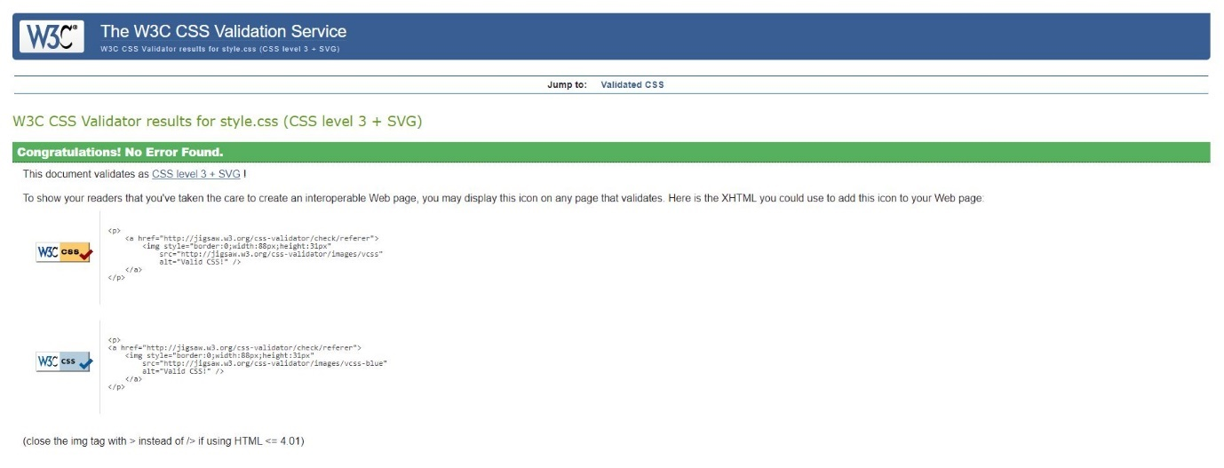

Evaluation

Website usability, accessibility, and search engine optimisation

Website Usability & Accessibility
From a fundamental perspective, site ease of use resolves the topic of how "easy to use" a site is. Convenience is an issue applied to practically any innovation, yet especially to those frameworks that work with the utilization of new media like the Internet. Great destinations should have an easy-to-use plan and be available by individuals who are utilizing it.
One major part of site ease of use is responsive plan. Responsive plan tends to be making sites usable by various gadgets, by bigger presentation gadgets like workstations and more modest showcase gadgets like Mobile phones. Across the Internet, site administrators are utilizing responsive plan to assist with making their locales more open and easier to understand to a more extensive scope of guests. [6]

“ Ben Shneiderman is an American computer scientist and professor at the University of Maryland's Human-Computer Interaction Lab. He was born on August 21, 1947.” [6]
Strive for consistency
When designing similar scenarios and sequences of activities, aim for consistency by using recognisable icons, colours, menu hierarchy, call-to-actions, and user flows. Users can apply knowledge from one click to the next by standardising the way information is delivered, eliminating the need to learn new representations for the same tasks. Consistency is vital because it helps consumers grow accustomed to your product's digital landscape, making it easier for them to achieve their goals. [7]

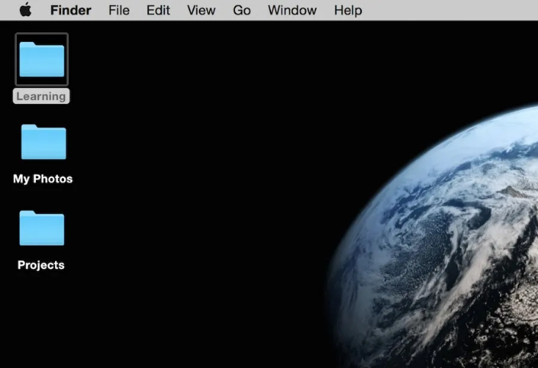
” Author/Copyright holder: Euphemia Wong. Copyright terms and licence: Fair Use”

Allow frequent users to use keyboard shortcuts.
As the number of individuals who use the internet increases, so does the desire for quicker ways to do tasks. For example, keyboard shortcuts for copying and pasting are available on both Windows and Mac, letting users to browse and use the user interface more quickly and easily as they gain experience. [8]


“ Author/Copyright holder: StockSnap.io. Copyright terms and licence: CC0 “

Provide useful input.
At all times, the user should know where they are and what is going on. Within a fair amount of time, meaningful, human-readable feedback should be provided for each activity. When working through a multi-page questionnaire, a nice example of this would be to show the user where they are in the process. When an error message displays an error-code rather than a human-readable and meaningful message. [9]

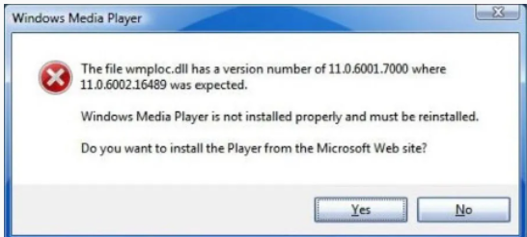
“Author/Copyright holder: Google, Inc. Copyright terms and licence: Fair Use”
The designers of Windows Media Player should have followed Ben Shneiderman's third golden rule: provide useful feedback. Poorly constructed error messages frequently display an error code that is meaningless to the user. As a good designer, you should constantly strive to provide feedback that is both human-readable and meaningful. [10]
Design dialogue
Don’t keep your customers guessing. Inform them of the consequences of their actions. When consumers complete an online purchase, for example, they would welcome a "Thank You" message and a proof of purchase receipt. [11]
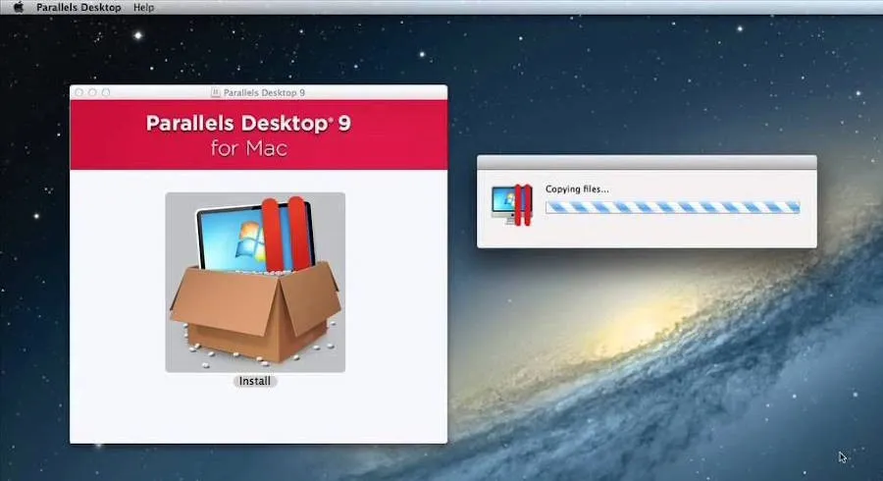
“Author/Copyright holder: Google, Inc. Copyright terms and licence: Fair Use”

Provide straightforward error handling.
Nobody enjoys being corrected, especially your users. Systems should be built to be as error-free as possible, but if faults are unavoidable [12] to resolve the issue as quickly and painlessly as feasible. For example, in an online form, highlight the text fields where consumers failed to give input. [12]
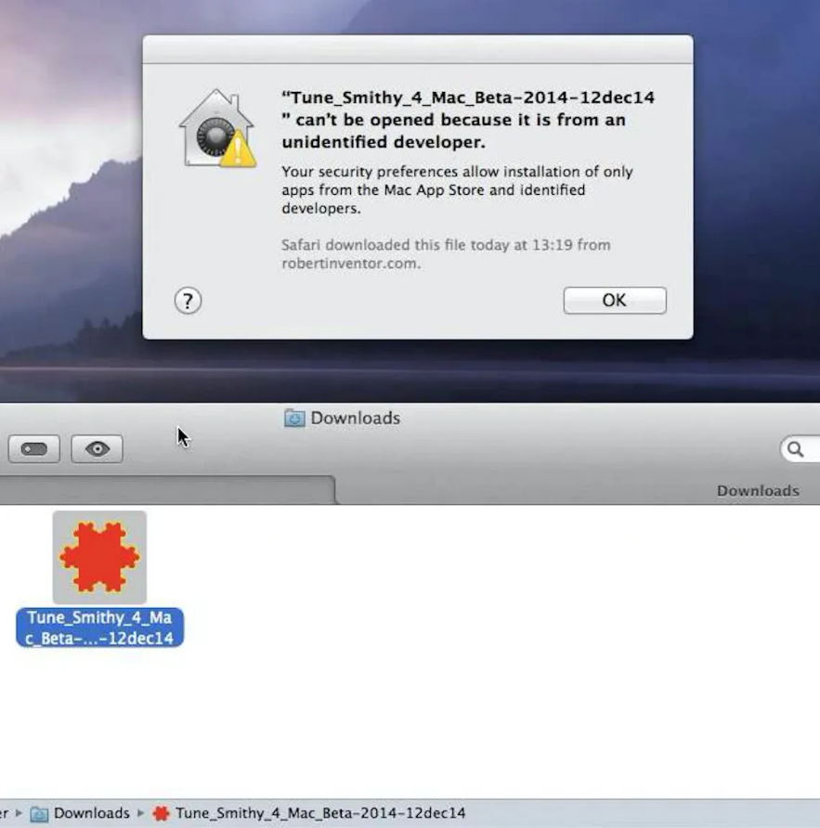
“Author/Copyright holder: Google, Inc. Copyright terms and licence: Fair Use”
Allow for quick reversal of actions.
User will be able to easily undo their actions, according to designers. These reversals should be permitted at various times, such after a single action, a data entry, or a sequence of events. Shneiderman writes in his book:
“This feature relieves anxiety, since the user knows that errors can be undone; it thus encourages exploration of unfamiliar options.” [10]
Structure your site appropriately for Disabilities
When designing Websites, you need to be mindful for people accessing your website with learning or physical mobility issues.
“The British Dyslexia Association recommends following a few basic criteria when structuring your message to make sure people with dyslexia have the easiest time understanding it” [13]
- Use sans-serif textual styles. This implies textual styles without the projections — the 'flicks' that you see on letters — in Times New Roman and Georgia. Sans-serif text styles like Arial, Calibri, and Veranda are a lot simpler for individuals with dyslexia to peruse.
- Text dimension ought to be kept on the bigger side — somewhere around 12-14pt, albeit certain individuals require greater sizes.
- Separating is significant. sizeable character separating, word dividing, and line dispersing all further develop the perusing experience for individuals with dyslexia
- For headings and titles, utilize a textual style that is no less than 20% bigger than the remainder of your text. You can make this strong for more accentuation, yet don't emphasize or underline it. These can cause letters to seem swarmed or confounded.
below you can see how I chose to use two different styles of Text, This was chosen due to the fact that I have Dyslexia so this was implemented.
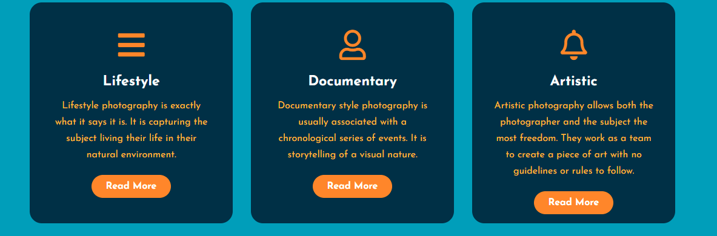
- Utilize single variety foundations, albeit unadulterated white foundations to be kept away from. Dim text on a pastel background is best for the vast majority.
- Multiple columns have been left out also kept characters up to and around 70 per column box.

Overview of WCAG 2.1 guidelines

The Web Content Accessibility Guidelines (known as WCAG 2.1) are a globally perceived set of suggestions for further developing web openness. This gives information on how to make digital services accessible to anyone with impairments or learning disabilities. [14]

To Summarise “ what is Web Accessibility “ [15]
It basically means Websites, tools, and technology are created and developed in such a way that individuals with disabilities may use them. Individuals can, for example:
Web perception, comprehension, navigation, and interaction.
Web accessibility includes all limitations that affect Web access, such as:
- auditory
- cognitive
- neurological
- physical
- speech
- visual
People without disabilities, for example, benefit from web accessibility:
- People using smartphones, smart watches, smart TVs, and other small-screen gadgets with various input modes, etc.
- people with "temporary disabilities" such as a broken arm or misplaced glasses older adults with fluctuating skills due to ageing
- those having "situational restrictions," such as being in direct sunlight or being unable to listen to audio
- folks with a sluggish Internet connection or limited or pricey bandwidth
“ The power of the web is in its universality. Access by everyone regardless of disability is an essential aspect. “ Tim Berners-Lee, W3C Director, and inventor of the World Wide Web [15]

Search Engine Optimisation (SEO)

SEO (Search Engine Optimization) is the process of optimising your website so that it ranks higher in Google and other search engines. While SEO does have some complex parts, there are several fundamentals that even SEO beginners should use to increase their Google and other search engine rankings. [16]
To bring more visitors to the web site the Developer has taken advantage of two types of SEO
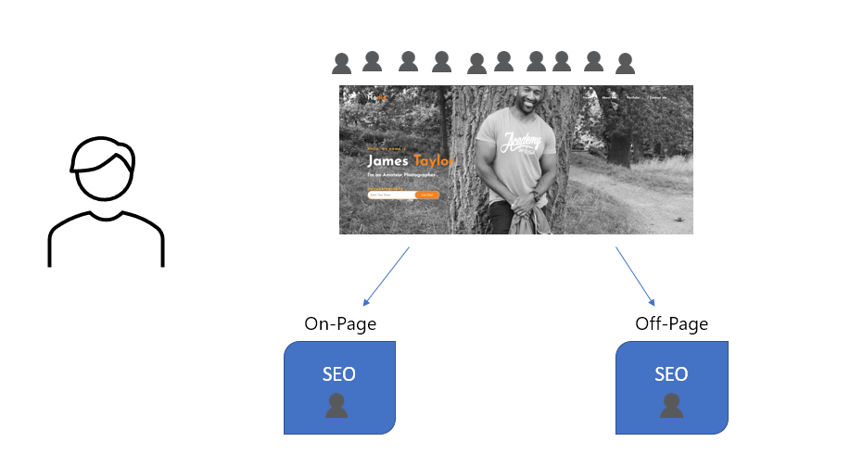
Next stage would be to optimise content IE, Page layout design, Media links as such.
For the technical terms the developer looked into:
- HTML source code
- Meta Tags
- Schema

To get the Accessibility to work the developer had to enter in this code which was received from www.w3schools.com [17]
Some meta tags used on the website
- <title> Title tags are usually used by search engines to determine the subject of a particular page and display it in SERPs ( Search Engine Result Pages )
- <meta> Meta description tag is a short paragraph of tags in the HTML section, it’s usually displayed in a SERP snippet after a website’s title and URL.
- <robots> Robots tag is an element in the HTML of a page that informs SEO’s which pages on your site should be indexed and which should not.
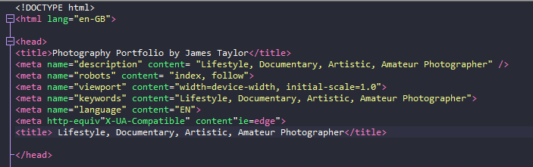

As above, Meta tags are text snippets that describe the content of a website and are found in the source code rather than on the page itself. Meta tags are short content descriptors that assist search engines in determining the purpose of a page.
The primary distinction between tags that can be seen (on a blogpost, for example) and tags that can't be seen is their location: meta tags are only visible to search engines because they only exist in HTML, and are normally found at the "head" of the page (and people who know where to look). The term "metadata" is used in these tags to refer to information about the information on your page. [18]
Matt Cutts, who was head of Google's online spam team, has commented on the popular webmaster YouTube series, claiming that Meta Tags are no longer used by Google. That is what he says in this video. [19] https://youtu.be/jK7IPbnmvVU “

Conclusion and Recommendation

In conclusion, the Developer aimed to investigate and develop a website that can deliver and have ease of access. The three key areas are Usability, Accessibility, and functionality. It is argued that it is an important consideration to make sure that the website can have interaction across all levels. The developer has aimed to set these standards with requirements to WCAG 2.1 guidelines

Recommendations
If the developer had more time to build this website, they would have suggested the following recommendations.

- Call to Action - A call to action can be anything from a free trial to registering for an account to linking them to a purchase or asking them to subscribe.
- Have a Blog - Blog pages will drive more visitors to your company's website, which will result in more sales. It can also assist you in establishing yourself as an authority in your subject, hence increasing customer confidence in your services.
- Testimonial Pages - Pass or current feedback testimonial pages could have been added.
- Thank you pages - You may utilise thank you pages to have users sign up for your newsletter, download an eBook, offer them a coupon code, include a video, have them follow you on social media, and so on.

Bibliography
References
[1] Anonymous (-04-02T17:11:26.000Z). What is a Wireframe and How to Create Wireframes. Available: https://www.wix.com/blog/creative/2019/04/what-is-a-wireframe-and-how-to-create-one/.
[2] Anonymous (-05-11T11:00:04+00:00). 6 Reasons To Create Storyboards With PowerPoint. Available: https://elearningindustry.com/create-storyboards-with-powerpoint-6-reasons.
[3] Anonymous Anonymous User interface elements every designer should know. User interface elements every designer should know. 2020. Available: https://www.uxpin.com/studio/blog/user-interface-elements-every-designer-should-know/.
[4] S. Lauria. (-06-18T14:24:02.538Z). How to Present Wireframes to Clients. Available: https://uxdesign.cc/how-to-present-wireframes-to-clients-a5c2824d577b.
[5] w3c. (). The W3C Markup Validation Service, 2022. Available: http://www.validator.w3.org.
[6] (). What is Website Usability? - Definition from Techopedia. Available: http://www.techopedia.com/definition/23903/website-usability.
[7] N. Babich. (-06-24T21:49:21.946Z). Golden Rules of User Interface Design. Available: https://uxplanet.org/golden-rules-of-user-interface-design-19282aeb06b.
[8] M. Klein. (). How to Remap Your Windows Cut/Copy/Paste to OS X-like Controls and Vice-Versa. Available: https://www.howtogeek.com/219156/how-to-remap-your-windows-cutcopypaste-to-os-x-like-controls-and-vice-versa/.
[9] B. Metangmo. (-10-30T10:01:01.418Z). Why writing Human readable errors would be more and more important ?. Available: https://medium.com/@BillMetangmo/why-writing-human-readable-errors-would-be-more-and-more-important-97b95b96709b.
[10] E. Wong. (). Shneiderman’s Eight Golden Rules Will Help You Design Better Interfaces. Available: https://www.interaction-design.org/literature/article/shneiderman-s-eight-golden-rules-will-help-you-design-better-interfaces.
[11] N. Babich. (-05-12T13:01:53.393Z). 5 Essential UX Rules for Dialog Design. Available: https://uxplanet.org/5-essential-ux-rules-for-dialog-design-4de258c22116.
[12] J. Honig. (). What Makes Software User-Friendly?. Available: https://start.docuware.com/blog/document-management/what-makes-software-user-friendly.
[13] Anonymous Anonymous How can I create A more dyslexia friendly website experience? | succeed with dyslexia. How can I create A more dyslexia friendly website experience? | succeed with dyslexia. Available: https://www.succeedwithdyslexia.org/blog/creating-a-dyslexia-friendly-website-experience/.
[14] Anonymous (). Understanding WCAG 2.1. Available: https://www.gov.uk/service-manual/helping-people-to-use-your-service/understanding-wcag.
[15] (WAI), W3C Web Accessibility Initiative. (). Introduction to Web Accessibility. Available: https://www.w3.org/WAI/fundamentals/accessibility-intro/.
[16] Anonymous (-01-23T12:38:29+00:00). SEO Tips for Beginners - 5 Easy Wins for 2022. Available: https://www.bowlerhat.co.uk/seo-tips-beginners/.
[17] Anonymous (). HTML meta tag. Available: https://www.w3schools.com/tags/tag_meta.asp.
[18] Anonymous Anonymous Meta tags - how google meta tags impact SEO. Meta tags - how google meta tags impact SEO. Available: https://www.wordstream.com/meta-tags.
[19] C. Crum. C. Crum. Google: Actually, meta tags do matter. Google: Actually, meta tags do matter. 2012. Available: https://www.webpronews.com/google-actually-meta-tags-do-matter/.

Appendices

Appendix

Home.html
<!DOCTYPE html>
<html lang="en-GB">

<head>
<title>Photography Portfolio by James Taylor</title>
<meta name="description" content= "Lifestyle, Documentary, Artistic, Amateur Photographer" />
<meta name="robots" content= "index, follow">
<meta name="viewport" content="width=device-width, initial-scale=1.0">
<meta name="keywords" content="Lifestyle, Documentary, Artistic, Amateur Photographer">
<meta name="language" content="EN">
<meta name="http-equiv="set-Cookie">
<meta http-equiv"X-UA-Compatible" content"ie=edge,chrome=1">
<title> Lifestyle, Documentary, Artistic, Amateur Photographer</title>

</head>

<head>
<meta charset="utf-8"/>
<title> Photography Portfolio - Home</title>
<link rel="stylesheet" type="text/css" href="css/style.css">
<link rel="preconnect" href="https://fonts.gstatic.com">
<link href="https://fonts.googleapis.com/css2?family=Josefin+Sans:ital,wght@0,100;0,200;0,300;0,400;0,500;0,600;0,700;1,100;1,200;1,300;1,400;1,500;1,600;1,700&display=swap" rel="stylesheet">
<link rel="stylesheet" href="https://cdnjs.cloudflare.com/ajax/libs/font-awesome/5.15.3/css/all.min.css" integrity="sha512-iBBXm8fW90+nuLcSKlbmrPcLa0OT92xO1BIsZ+ywDWZCvqsWgccV3gFoRBv0z+8dLJgyAHIhR35VZc2oM/gI1w==" crossorigin="anonymous" referrerpolicy="no-referrer" />
</head>
<body>

<!--Pain starts here-->

<div class="hero">
<nav>
<h2 class="logo">Ho<span>me</span></h2>
<ul>
<li><a href="home.html">Home</a></li>
<li><a href="about.html">About Me</a></li>
<li><a href="portfolio.html">Portfolio</a></li>
<li><a href="contact.html">Contact Me</a></li>
</ul>
</nav>

<div class="content">
<h4>Hello, my name is</h4>
<h1>James <span>Taylor</span></h1>
<h3>I'm an Amateur Photographer .</h3>
<h4> jtayphotography </h4>
<div class="newslatter">
<form>
<input type="email" name="email" id="mail" placeholder="Enter Your Email">
<input type="submit" name="submit" value="Lets Start">
</form>
</div>
</div>
</div>

<!--service section start-->
<div class="service">
<div class="title">
<h2>Jtayphotography Services</h2>
</div>

<div class="box">
<div class="card">
<i class="fas fa-bars"></i>
<h5>Lifestyle</h5>
<div class="pra">
<p>Lifestyle photography is exactly what it says it is. It is capturing the subject living their life in their natural environment.</p>

<p style="text-align: center;">
<a class="button" href="lifestyle.html">Read More</a>
</p>
</div>
</div>

<div class="card">
<i class="far fa-user"></i>
<h5>Documentary</h5>
<div class="pra">
<p>Documentary style photography is usually associated with a chronological series of events. It is storytelling of a visual nature.</p>

<p style="text-align: center;">
<a class="button" href="documentary.html">Read More</a>
</p>
</div>
</div>

<div class="card">
<i class="far fa-bell"></i>
<h5>Artistic</h5>
<div class="pra">
<p>Artistic photography allows both the photographer and the subject the most freedom. They work as a team to create a piece of art with no guidelines or rules to follow.</p>

<p style="text-align: center;">
<a class="button" href="artistic.html">Read More</a>
</p>
</div>
</div>
</div>
</div>

<!--Contact Me-->
<div class="contact-me">
<p>Let me make your beautiful moments last forever.</p>
<a class="button-two" href="contact.html">Hire Me</a>
</div>

<!--footer start-->
<footer>
<p>James Taylor</p>
<p>For more information please click on the links below:</p>
<div class="social">
<a href="https://en-gb.facebook.com/"><i class="fab fa-facebook-f"></i></a>
<a href="https://www.instagram.com/"><i class="fab fa-instagram"></i></a>

</div>
<p class="end">CopyRight By James A Taylor</p>
</footer>
</body>
</html>

Appendix

About.html

<!DOCTYPE html>

<html lang="en-GB">
<head>
<meta charset="utf-8"/>
<title> Photography Portfolio - About Me</title>
<link rel="stylesheet" type="text/css" href="css/style.css">
<link rel="preconnect" href="https://fonts.gstatic.com">
<link href="https://fonts.googleapis.com/css2?family=Josefin+Sans:ital,wght@0,100;0,200;0,300;0,400;0,500;0,600;0,700;1,100;1,200;1,300;1,400;1,500;1,600;1,700&display=swap" rel="stylesheet">
<link rel="stylesheet" href="https://cdnjs.cloudflare.com/ajax/libs/font-awesome/5.15.3/css/all.min.css" integrity="sha512-iBBXm8fW90+nuLcSKlbmrPcLa0OT92xO1BIsZ+ywDWZCvqsWgccV3gFoRBv0z+8dLJgyAHIhR35VZc2oM/gI1w==" crossorigin="anonymous" referrerpolicy="no-referrer" />
</head>
<body>
<div class="altmenu">
<nav>
<h2 class="logo">About <span>Me</span></h2>
<ul>
<li><a href="home.html">Home</a></li>
<li><a href="about.html">About Me</a></li>
<li><a href="portfolio.html">Portfolio</a></li>
<li><a href="contact.html">Contact Me</a></li>
</ul>
</nav>
</div>
<!----About section start---->
<section class="about">
<div class="main">
<img src="img/main.jpeg">
<div class="about-text">
<h2>About Me</h2>
<h5> Student <span> Father & Hobbyist</span></h5>
<p> I am a keen Amateur hobbyist Photographer that can provied beautiful photos for most occasions. I am a part time student and work full time. Also a keen green finger and lover of Tech. </p>
<button onclick="location.href='contact.html'">Let's Talk</button>
</div>
</div>
</section>
</body>
</html>

Appendix

Portfolio.html
<!DOCTYPE html>
<html lang="en-GB">
<head>
<meta charset="utf-8"/>
<title> Photography Portfolio - Portfolio</title>
<link rel="stylesheet" type="text/css" href="css/style.css">
<link rel="preconnect" href="https://fonts.gstatic.com">
<link href="https://fonts.googleapis.com/css2?family=Josefin+Sans:ital,wght@0,100;0,200;0,300;0,400;0,500;0,600;0,700;1,100;1,200;1,300;1,400;1,500;1,600;1,700&display=swap" rel="stylesheet">
<link rel="stylesheet" href="https://cdnjs.cloudflare.com/ajax/libs/font-awesome/5.15.3/css/all.min.css" integrity="sha512-iBBXm8fW90+nuLcSKlbmrPcLa0OT92xO1BIsZ+ywDWZCvqsWgccV3gFoRBv0z+8dLJgyAHIhR35VZc2oM/gI1w==" crossorigin="anonymous" referrerpolicy="no-referrer" />
</head>
<body>
<div class="altmenu">
<nav>
<h2 class="logo">Portfo<span>lio</span></h2>
<ul>
<li><a href="home.html">Home</a></li>
<li><a href="about.html">About Me</a></li>
<li><a href="portfolio.html">Portfolio</a></li>
<li><a href="contact.html">Contact Me</a></li>
</ul>
</nav>
</div>
<section class="portfolio-prev">
<!-- The grid: four columns -->
<div class="row">
<div class="column">
<img src="img/linux2.jpg" alt="linux2" style="width:100%" ocnclick="expandImage(this);">
</div>
<div class="column">
<img src="img/artistic1.jpg" alt="artistic1" style="width:100%" onclick="expandImage(this);">
</div>
<div class="column">
<img src="img/podge.jpg" alt="podge" style="width:100%" onclick="expandImage(this);">
</div>
<div class="column">
<img src="img/python.jpg" alt="Python" style="width:100%" onclick="expandImage(this);">
</div>
</div>
</section>
<!-- The expanding image container -->
<div class="container portfolio-exp">
<!-- Close the image -->
<span onclick="this.parentElement.style.display='none'" class="closebtn">&times;</span>

<!-- Expanded image -->
<img id="expandedImg" style="width:100%" src="img/python.jpg" alt="picture of python">

<!-- Image text -->
<div id="imgtext"></div>
</div>

<script>
window.onload = expandDefImage();

function expandDefImage() {
var expandImg = document.getElementById("expandedImg");
var imgText = document.getElementById("imgtext");
expandImg.src = "img/classroom.jpg";
imgText.innerHTML = "Default";
expandImg.parentElement.style.display = "block";
}

function expandImage(imgs) {
var expandImg = document.getElementById("expandedImg");
var imgText = document.getElementById("imgtext");
expandImg.src = imgs.src;
imgText.innerHTML = imgs.alt;
expandImg.parentElement.style.display = "block";
}
</script>
</body>
</html>

Appendix

Contact.html
<!DOCTYPE html>

<html lang="en-GB">
<head>
<meta charset="utf-8"/>
<title> Photography Portfolio - Contact Me</title>
<link rel="stylesheet" type="text/css" href="css/style.css">
<link rel="preconnect" href="https://fonts.gstatic.com">
<link href="https://fonts.googleapis.com/css2?family=Josefin+Sans:ital,wght@0,100;0,200;0,300;0,400;0,500;0,600;0,700;1,100;1,200;1,300;1,400;1,500;1,600;1,700&display=swap" rel="stylesheet">
<link rel="stylesheet" href="https://cdnjs.cloudflare.com/ajax/libs/font-awesome/5.15.3/css/all.min.css" integrity="sha512-iBBXm8fW90+nuLcSKlbmrPcLa0OT92xO1BIsZ+ywDWZCvqsWgccV3gFoRBv0z+8dLJgyAHIhR35VZc2oM/gI1w==" crossorigin="anonymous" referrerpolicy="no-referrer" />
</head>
<body>
<div class="altmenu">
<nav>
<h2 class="logo">Contact <span>Me</span></h2>
<ul>
<li><a href="home.html">Home</a></li>
<li><a href="about.html">About Me</a></li>
<li><a href="portfolio.html">Portfolio</a></li>
<li><a href="contact.html">Contact Me</a></li>
</ul>
</nav>
</div>

<!----Contact Me section start---->
<section class="contact">
<div class="main">
<img src="img/main.jpeg">
<div class="contact-text">
<h2>Get in touch</h2>
<h5> Ready to give you <span>the best experience!</span></h5>
<div class="contact">
<form id="contact-form" method="post" action="">
<input name="name" type="text" class="form-control" placeholder="Your name" required><br>
<input name="email" type="email" class="form-control" placeholder="Your Email" required><br>

<textarea name="message" class="form-control" placeholder="message" rows="4" required></textarea><br>

<input type="submit" class="form-control submit" value="SEND MESSAGE">
</form>
</div>
</div>
</div>
</section>
</body>
</html>

Appendix

Documentary.html

!DOCTYPE html>

<html lang="en-GB">
<head>
<meta charset="utf-8"/>
<title> Photography Portfolio - Documentary</title>
<link rel="stylesheet" type="text/css" href="css/style.css">
<link rel="preconnect" href="https://fonts.gstatic.com">
<link href="https://fonts.googleapis.com/css2?family=Josefin+Sans:ital,wght@0,100;0,200;0,300;0,400;0,500;0,600;0,700;1,100;1,200;1,300;1,400;1,500;1,600;1,700&display=swap" rel="stylesheet">
<link rel="stylesheet" href="https://cdnjs.cloudflare.com/ajax/libs/font-awesome/5.15.3/css/all.min.css" integrity="sha512-iBBXm8fW90+nuLcSKlbmrPcLa0OT92xO1BIsZ+ywDWZCvqsWgccV3gFoRBv0z+8dLJgyAHIhR35VZc2oM/gI1w==" crossorigin="anonymous" referrerpolicy="no-referrer" />
</head>
<body>

<!-- Documentary section start-->
<div class="altmenu">
<nav>
<h2 class="logo">Documentary<span></span></h2>
<ul>
<li><a href="home.html">Home</a></li>
<li><a href="about.html">About Me</a></li>
<li><a href="portfolio.html">Portfolio</a></li>
<li><a href="contact.html">Contact Me</a></li>
</ul>
</nav>
</div>

<!-- artistic section start-->
<section class="artistic">
<div class="main">
<img src="img/documentary.jpg"/>
<div class="artistic-text">
<h2>Get in touch</h2>
<h5> Ready to give you <span>the best experience!</span></h5>
</div>
</div>
</section>

</body>
</html>

Appendix

Lifestyle.html
<!DOCTYPE html>

<html lang="en-GB">
<head>
<meta charset="utf-8"/>
<title> Photography Portfolio - lifestyle </title>
<link rel="stylesheet" type="text/css" href="css/style.css">
<link rel="preconnect" href="https://fonts.gstatic.com">
<link href="https://fonts.googleapis.com/css2?family=Josefin+Sans:ital,wght@0,100;0,200;0,300;0,400;0,500;0,600;0,700;1,100;1,200;1,300;1,400;1,500;1,600;1,700&display=swap" rel="stylesheet">
<link rel="stylesheet" href="https://cdnjs.cloudflare.com/ajax/libs/font-awesome/5.15.3/css/all.min.css" integrity="sha512-iBBXm8fW90+nuLcSKlbmrPcLa0OT92xO1BIsZ+ywDWZCvqsWgccV3gFoRBv0z+8dLJgyAHIhR35VZc2oM/gI1w==" crossorigin="anonymous" referrerpolicy="no-referrer" />
</head>
<body>
<div class="altmenu">
<nav>
<h2 class="logo">Life <span>Style</span></h2>
<ul>
<li><a href="home.html">Home</a></li>
<li><a href="about.html">About Me</a></li>
<li><a href="portfolio.html">Portfolio</a></li>
<li><a href="contact.html">Contact Me</a></li>
</ul>
</nav>
</div>

<!-- Life Style section start-->
<section class="lifestyle">
<div class="main">
<img src="img/main.jpeg"/>
<div class="lifestyle-text">
<h2>Get in touch</h2>
<h5> Ready to give you <span>the best experience!</span></h5>
</div>
</div>
</section>

</body>
</html>

<!-- <li><a href="lifestyle.html">link to page 1</a></li>

Appendix

Artistic.html

<!DOCTYPE html>

<html lang="en-GB">
<head>
<meta charset="utf-8"/>
<title> Photography Portfolio - Artistic</title>
<link rel="stylesheet" type="text/css" href="css/style.css">
<link rel="preconnect" href="https://fonts.gstatic.com">
<link href="https://fonts.googleapis.com/css2?family=Josefin+Sans:ital,wght@0,100;0,200;0,300;0,400;0,500;0,600;0,700;1,100;1,200;1,300;1,400;1,500;1,600;1,700&display=swap" rel="stylesheet">
<link rel="stylesheet" href="https://cdnjs.cloudflare.com/ajax/libs/font-awesome/5.15.3/css/all.min.css" integrity="sha512-iBBXm8fW90+nuLcSKlbmrPcLa0OT92xO1BIsZ+ywDWZCvqsWgccV3gFoRBv0z+8dLJgyAHIhR35VZc2oM/gI1w==" crossorigin="anonymous" referrerpolicy="no-referrer" />
</head>
<body>

<div class="altmenu">
<nav>
<h2 class="logo">Artistic<span></span></h2>
<ul>
<li><a href="home.html">Home</a></li>
<li><a href="about.html">About Me</a></li>
<li><a href="portfolio.html">Portfolio</a></li>
<li><a href="contact.html">Contact Me</a></li>
</ul>
</nav>
</div>

<!-- artistic section start-->
<section class="artistic">
<div class="main">
<img src="img/artistic.jpg"/>
<div class="artistic-text">
<h2>Get in touch</h2>
<h5> Ready to give you <span>the best experience!</span></h5>
</div>
</div>
</section>

</body>
</html>

Appendix

Style.css
*{

padding: 0;
margin: 0;
font-family: 'Josefin Sans', sans-serif;
box-sizing: border-box;
}
.hero{
height: 100vh;
width: 100%;
background-image: url(../img/background.jpg);
background-size: cover;
background-position: center;
}

.altmenu{
background-color:#023047
}

nav{
display: flex;
align-items: center;
justify-content: space-between;
padding-top: 45px;
padding-left: 8%;
padding-right: 8%;
}
.logo{
color: white;
font-size: 35px;
letter-spacing: 1px;
cursor: pointer;
}
span{
color: #fb8500;
}
nav ul li{
list-style-type: none;
display: inline-block;
padding: 10px 25px;
}
nav ul li a{
color: white;
text-decoration: none;
font-weight: bold;
text-transform: capitalize;
}
nav ul li a:hover{
color: #fb8500;
transition: .4s;
}
.btn{
background-color:#fb8500;
color: white;
text-decoration: none;
border: 2px solid transparent;
font-weight: bold;
padding: 10px 25px;
border-radius: 30px;
transition: transform .4s;
}
.btn:hover{
transform: scale(1.2);
}
.content{
position: absolute;
top: 50%;
left:8%;
transform: translateY(-50%);
}
h1{
color: white;
margin: 20px 0px 20px;
font-size: 75px;
}
h3{
color: white;
font-size: 25px;
margin-bottom: 50px;
}
h4{
color: #ffb703;
letter-spacing: 2px;
font-size: 20px;
}
.newslatter form{
width: 380px;
max-width: 100%;
position: relative;
}
.newslatter form input:first-child{
display: inline-block;
width: 100%;
padding: 14px 130px 14px 15px;
border: 2px solid #fb8500;
outline: none;
border-radius: 30px;
}
.newslatter form input:last-child{
position: absolute;
display: inline-block;
outline: none;
border: none;
padding: 10px 30px;
border-radius: 30px;
background-color:#fb8500;
color: white;
box-shadow: 0px 0px 5px #000, 0px 0px 15px #858585;
top: 6px;
right: 6px;
}

.contact form{
width: 380px;
max-width: 100%;
position: relative;
}
.contact form .form-control{
display: inline-block;
width: 100%;
padding: 14px 130px 14px 15px;
border: 2px solid #fb8500;
outline: none;
border-radius: 30px;
margin: 10px;
}
.contact form input:last-child{
/* position: absolute; */
display: inline-block;
outline: none;
border: none;
padding: 10px 30px;
border-radius: 30px;
background-color:#fb8500;
color: white;
box-shadow: 0px 0px 5px #000, 0px 0px 15px #858585;
top: 6px;
right: 6px;
}

.about{
width: 100%;
padding: 50px 0px;
background-color: #023047;
}
.about img{
height: auto;
width: 430px;
}
.about-text{
width: 550px;
}

.contact{
width: 100%;
padding: 50px 0px;
background-color: #023047
}
.contact img{
height: auto;
width: 430px;
}
.contact-text{
width: 550px;
}
.contact-text h2{
color: white;
font-size: 75px;
text-transform: capitalize;
margin-bottom: 20px;
}
.contact-text h5{
color: white;
letter-spacing: 2px;
font-size: 22px;
margin-bottom: 25px;
text-transform: capitalize;
}
.contact-text p{
color: #ffb703;
letter-spacing: 1px;
line-height: 28px;
font-size: 18px;
margin-bottom: 45px;
}

.lifestyle{
width: 100%;
padding: 50px 0px;
background-color: #023047;
}
.lifestyle img{
height: auto;
width: 430px;
}
.lifestyle-text{
width: 550px;
}
.lifestyle-text h2{
color: white;
font-size: 75px;
text-transform: capitalize;
margin-bottom: 20px;
}
.lifestyle-text h5{
color: white;
letter-spacing: 2px;
font-size: 22px;
margin-bottom: 25px;
text-transform: capitalize;
}
.lifestyle-text p{
color: #ffb703;
letter-spacing: 1px;
line-height: 28px;
font-size: 18px;
margin-bottom: 45px;
}

.artistic{
width: 100%;
padding: 50px 0px;
background-color: #023047;
}

.portfolio-prev{
width: 100%;
background-color: #219ebc;
}

.portfolio-exp{
width: 100%;
background-color: #023047;
}

.main{
width: 1130px;
max-width: 95%;
margin: 0 auto;
display: flex;
align-items: center;
justify-content: space-around;
}
.about-text h2{
color: white;
font-size: 75px;
text-transform: capitalize;
margin-bottom: 20px;
}
.about-text h5{
color: white;
letter-spacing: 2px;
font-size: 22px;
margin-bottom: 25px;
text-transform: capitalize;
}
.about-text p{
color: #ffb703;
letter-spacing: 1px;
line-height: 28px;
font-size: 18px;
margin-bottom: 45px;
}

.artistic-text h2{
color: white;
font-size: 75px;
text-transform: capitalize;
margin-bottom: 20px;
}
.artistic-text h5{
color: white;
letter-spacing: 2px;
font-size: 22px;
margin-bottom: 25px;
text-transform: capitalize;
}
button{
background-color:#fb8500;
color: white;
text-decoration: none;
border: 2px solid transparent;
font-weight: bold;
padding: 13px 30px;
border-radius: 30px;
transition: .4s;
}
button:hover{
background-color: transparent;
border: 2px solid #fb8500;
cursor: pointer;
}

.service{
background: #219ebc;
width: 100%;
padding: 100px 0px;
}
.title h2{
color: white;
font-size: 75px;
width: 1130px;
margin: 30px auto;
text-align: center;
}
.box{
display: flex;
justify-content: center;
align-items: center;
min-height: 400px;
}
.card{
height: 365px;
width: 335px;
padding: 20px 35px;
background: #023047;
border-radius: 20px;
margin: 15px;
position: relative;
overflow: hidden;
text-align: center;
}
.card i{
font-size: 50px;
display: block;
text-align: center;
margin: 25px 0px;
color: #fb8500;

}
h5{
color: white;
font-size: 23px;
margin-bottom: 15px;
}
.pra p{
color: #ffb703;
font-size: 16px;
line-height: 27px;
margin-bottom: 25px;
}
.card .button{
background-color:#fb8500;
color: white;
text-decoration: none;
border: 2px solid transparent;
font-weight: bold;
padding: 9px 22px;
border-radius: 30px;
transition: .4s;
}
.card .button:hover{
background-color: transparent;
border: 2px solid #fb8500;
cursor: pointer;
}
.contact-me{
width: 100%;
height: 290px;
background: #023047;
display: flex;
align-items: center;
flex-direction: column;
justify-content: center;
}
.contact-me p{
color: white;
font-size: 30px;
font-weight: bold;
margin-bottom: 25px;
}
.contact-me .button-two{
background-color:#fb8500;
color: white;
text-decoration: none;
border: 2px solid transparent;
font-weight: bold;
padding: 13px 30px;
border-radius: 30px;
transition: .4s;
}
.contact-me .button-two:hover{
background-color: transparent;
border: 2px solid #fb8500;
cursor: pointer;
}
footer{
position: relative;
width: 100%;
height: 400px;
background: #219ebc;
display: flex;
flex-direction: column;
align-items: center;
justify-content: center;
}
footer p:nth-child(1){
font-size: 30px;
color: white;
margin-bottom: 20px;
font-weight: bold;
}
footer p:nth-child(2){
color: white;
font-size: 17px;
width: 500px;
text-align: center;
line-height: 26px;
}
.social{
display: flex;
}
.social a{
width: 45px;
height: 45px;
display: flex;
align-items: center;
justify-content: center;
background: #fb8500;
border-radius: 50%;
margin: 22px 10px;
color: white;
text-decoration: none;
font-size: 20px;
}
.social a:hover{
transform: scale(1.3);
transition: .3s;
}
.end{
position: absolute;
color:#fb8500;
bottom: 35px;
font-size: 14px;
}

/* The grid: Four equal columns that floats next to each other */
.column {
float: left;
width: 25%;
padding: 1px;
}

/* Style the images inside the grid */
.column img {
opacity: 0.8;
cursor: pointer;
}

.column img:hover {
opacity: 1;
}

/* Clear floats after the columns */
.row:after {
content: "";
display: table;
clear: both;
}

/* The expanding image container (positioning is needed to position the close button and the text) */
.container {
position: relative;
display: none;
}

/* Expanding image text */
#imgtext {
position: absolute;
bottom: 15px;
left: 15px;
color: white;
font-size: 20px;
}

/* Closable button inside the image */
.closebtn {
position: absolute;
top: 10px;
right: 15px;
color: white;
font-size: 35px;
cursor: pointer;
}

