

Applied Computing

Wales Institute of Science and Art (WISA)

Advanced Cybersecurity (ACCB6000)

Lab 4: Let’s go F(ph)ishing
Always know:
Trusting is bursting in security




1

Nitheesh Murugan Kaliyamurthy – n.kaliyamurthy@uwtsd.ac.uk

What we do?
Part 1
- Set up your Lab
- Go Phishing
- Record your reflections to mitigate these types of vulnerabilities

Part 2
- Observe the demonstration by your Instructor (Using Telnet and SSH)
- Identify the vulnerability and record your reflections to mitigate it

Part 3
- Use Packet Tracer Exercise and investigate the FTP Traffic and record your reflections to mitigate the vulnerability.

What you need?
• Host computer with a minimum of 8 GB of RAM and 40GB of free disk space • Internet access
Part 1:
Set up your Lab
Download Kali Linux 2020.3 version from https://www.kali.org/downloads/. (Based on your Operating System, Select the version and install) Start Kali Linux and login.
(Based on your previous lab exercises, if you come across any issues in starting kali Linux, troubleshoot it on your own. Recommendations: You should have created a “Lab Manual/Reference Document” to record all your previous errors/ issues and its troubleshooting steps. Refer the document to troubleshoot. If not done, please start now.)
You should now know the username and password to login into Kali Linux 2020.3. If you don’t know, search and find as a warm up activity to go Phishing!!!



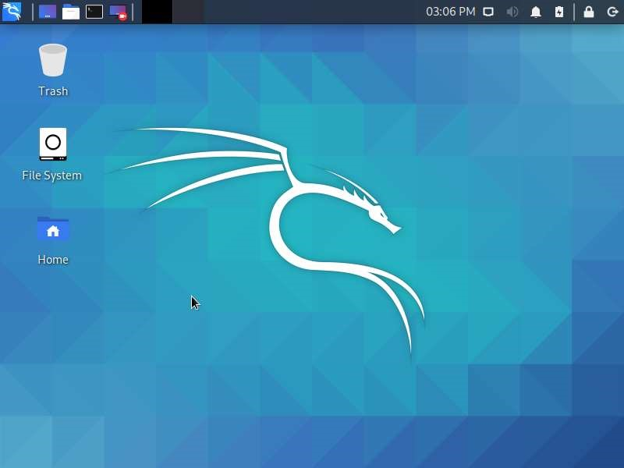
Login and record your screen:

Paste your screenshot here!!!
Is it similar to the other screenshot?
Should be a YES or Try again!!!

Go to https://github.com/trustedsec/social-engineer-toolkit or any other websites, which you find better. List out the other website links here (Add additional lines)
_______________________________________________________________ Record your reflections/ understanding about SE Toolkit

SET Package Description
The Social-Engineer Toolkit is an open-source penetration testing framework designed for Social-Engineering. SET has a number of custom attack vectors that allow you to make a believable attack in a fraction of the time.

Now, let’s go Phishing. The idea is to clone a social media website and use the template to harvest the user credentials. It could be done in many ways. This lab is to help you understand the use of Social Engineering Toolkit. Warning: Be Ethical. After learning the functions of SE Toolkit, you could try other options and record them in your manual for further learning.

Let’s get into a scenario:
Scene 1: You are receiving a link from your friend asking to look at his post in linkedin. You click on the link and it takes you to the official login page. You enter your credentials and login. It loads and asks for the login credentials again. No doubts for you, (maybe thinking of some internet/ application issue) and logging in again. It takes into your account. But you could not see your friends post. You think it is not working and focus on other interesting posts.
Behind the scene: Your friend actually sets you a trap by sending the link. It is to harvest your credentials. Your user name and password is now with your friend. (No worries ahh!!! Its your friend. He/She will not do any harm to you)
Just deeper behind the scene: Your friend’s account has been compromised and actually it was some real time criminal (hacker) who sent you a link in the name of your friend setting you a trap through the link. Now your user name and password is with some criminal.
Imagine the next day morning. You wake up andddddd…..
It is a nice story. But, is it really possible? How?
Let’s go phishing….
Click on Programs→ Social Engineering Tools → social engineering toolkit
It prompts for your password. Give your password
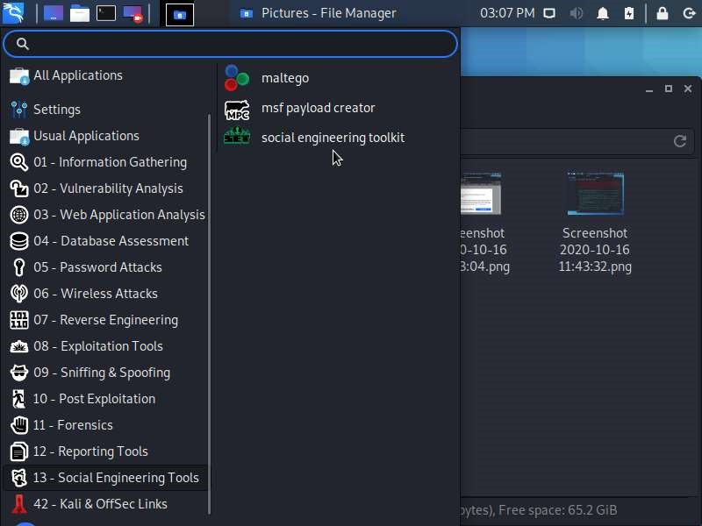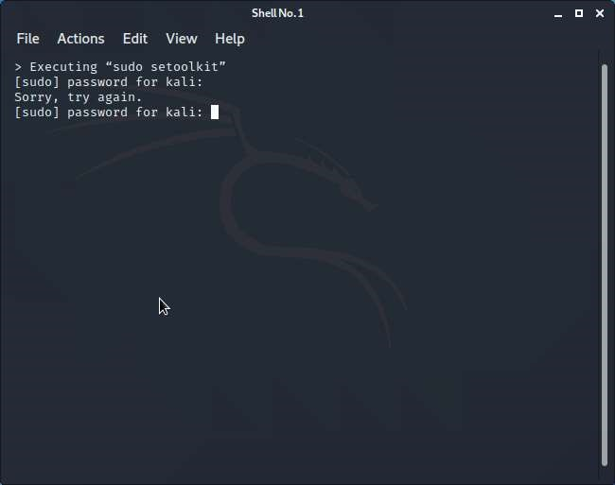

Select Social Engineering Attacks → 1
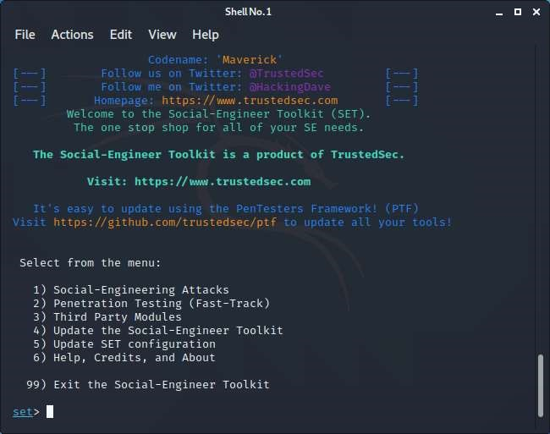
Select Website Attack Vectors → 2
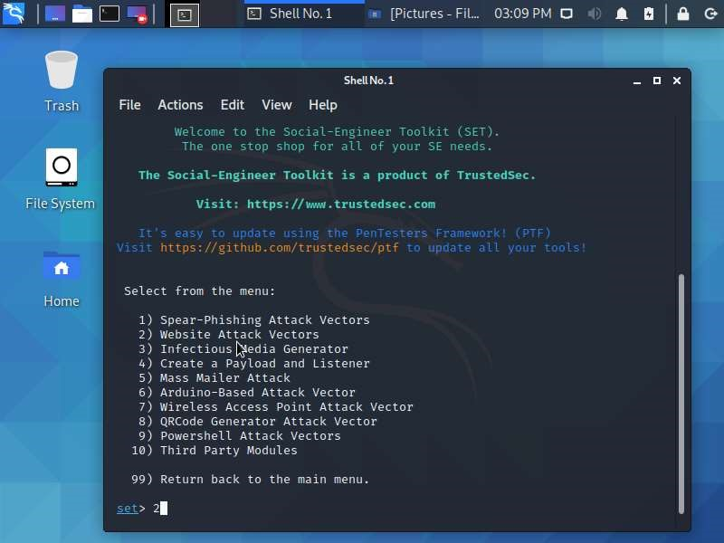

Select Credential Harvester Attack Method → 3
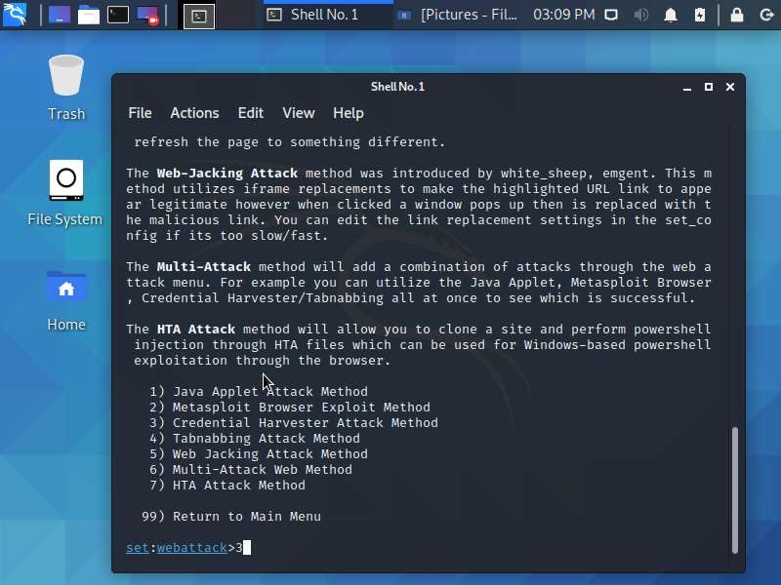
Select Web Templates → 1
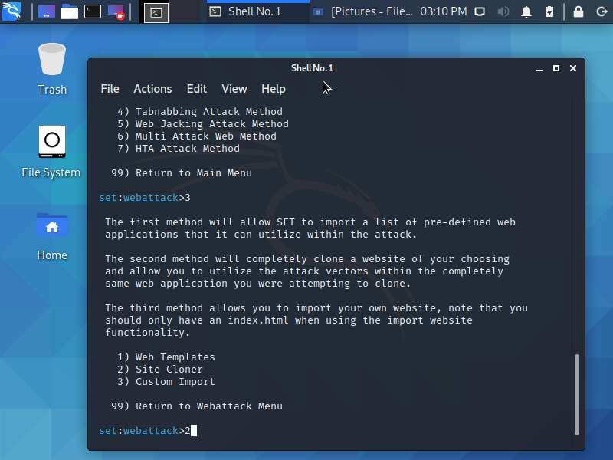
It will ask for an IP Address → Give your Local IP Address. (In cases, if you are phishing outside the network, you might need a Public IP Address)
It will ask for the website to clone/ use: Give, https://www.twitter.com
Open the Web Browser and click the Local IP Address, which you had set. It should take you to the twitter login page.
Give dummy credentials to check. After login, it will take you to the original twitter login page.
Go back to the SETools Editor and check for the harvest. You should find out the credentials listed.
You could also try to set this link (Local IP Address) and send via emails/ Embed it with some image and send it to get a professional look. But, remember, this lab is just to practice and identify the vulnerabilities as a Cybersecurity Analyst.
You could also embed this into a pdf or other applications (.jpg., .png etc). Try them out within the Virtual Machine !!!

Record your reflections/ understanding about using the SE Toolkit
There are a range of powerful tools that can be used to aid in a social engineering attack.

What is the security vulnerability you identified when using the link to login the social media page?

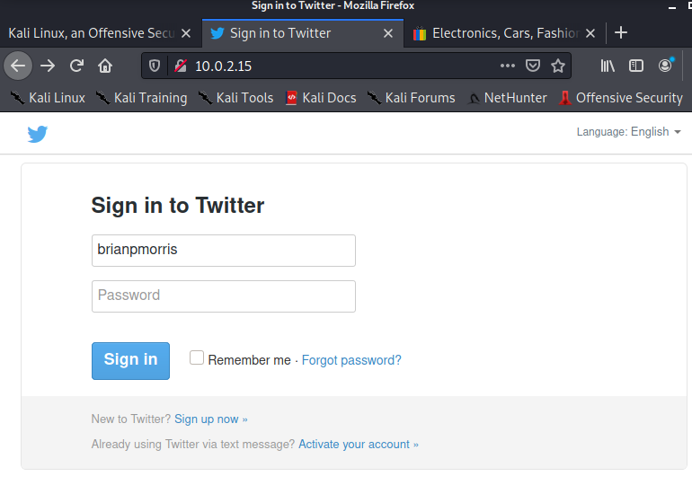

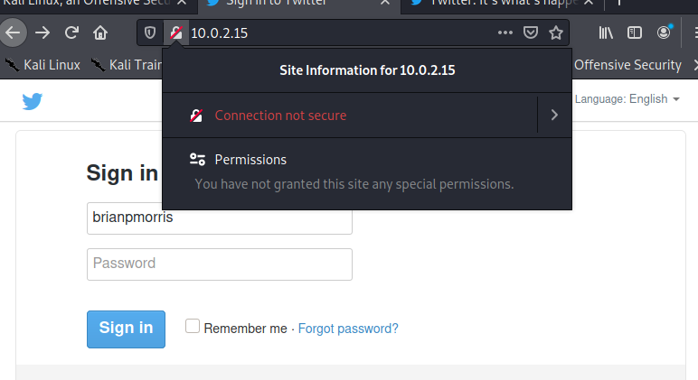
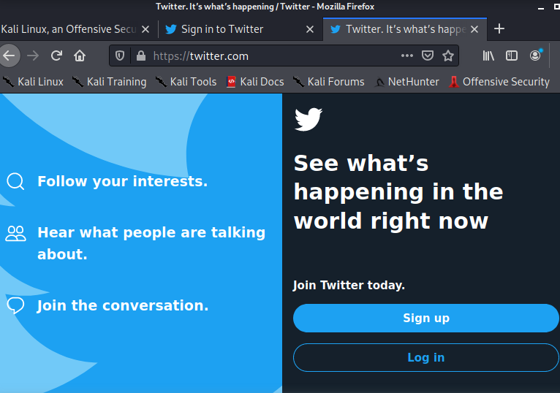

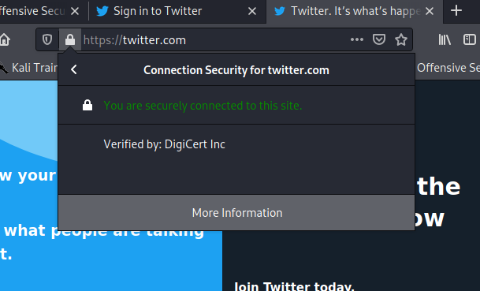

The padlock was not green indicating that the certificate is not valid for the HTTPS site . The local 10 range IP address was listed as the website certificate which is a non-internet routable address. The page was very plain compared to the official twitter site

What is your recommendations to mitigate the above identified vulnerability? (Like, when you click on a link, what should you check for?)
Don’t click on the link, verify with the friend if they sent you a link first. Check the certificate presented to the site. Type in the site address manually to the host domain and navigate from there

Part 2:
Observe and identify
The Lecturer has demonstrated about the Telnet and SSH configuration. How it works? Its advantages and disadvantages.

(Link is available in Moodle)
Record your reflections/ understanding about the vulnerabilities you identified when using Telnet.

Record your reflections/ understanding about any vulnerabilities you identified when using SSH.
Telnet is in clear text and is easily sniffed where as SSH uses encryption to communicate between client and server also it can be used exchange more than text information

What is your recommendations to mitigate the above identified vulnerabilities?
Avoid the use of clear text protocols when configuring services

Part 3:
Use Packet Tracer to investigate the FTP Traffic
Packet Tracer is available in Moodle and Teams File Channel
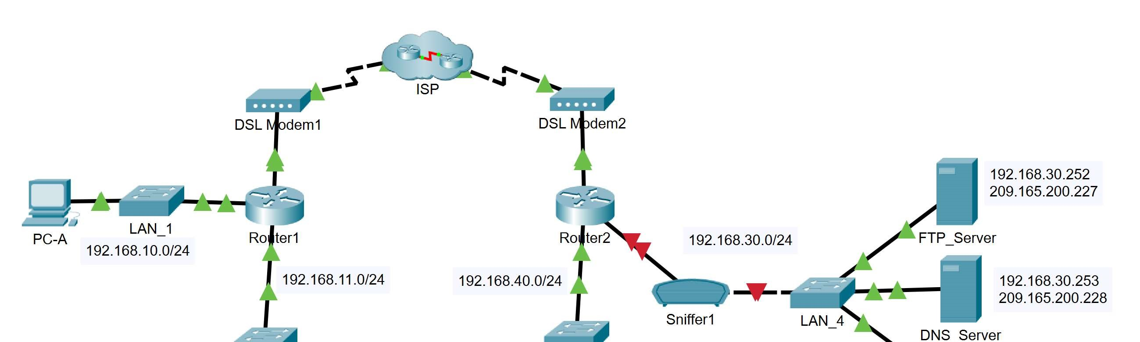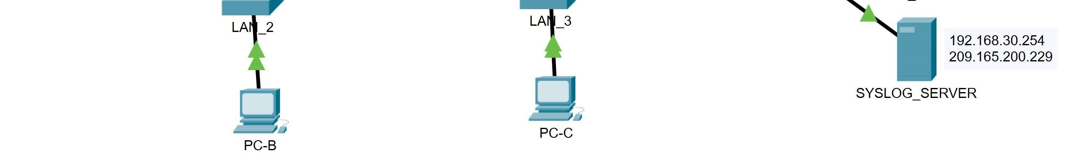
Addressing Table
Device | Private IP Address | Public IP Address
FTP_Server | 192.168.30.253 | 209.165.200.227
SYSLOG_SERVER | 192.168.11.254 | 209.165.200.229
Router2 | N/A | 209.165.200.226

➔ Create FTP traffic.
➔ Activate the sniffing device.
- Click on sniffer device Sniffer1.
- Go to the Physical tab and turn on the power to the sniffer.
- Go to the GUI tab and turn the sniffer service on. o Select the appropriate port to sniff.
Note that the FTP and syslog packets entering the sniffer from Router2 are being monitored.
➔ Remotely connect to the FTP server.
➔ Click on PC-B and go to the desktop.
➔ Click Command Prompt. From the command prompt, open an FTP session with FTP_SERVER using its public IP address.

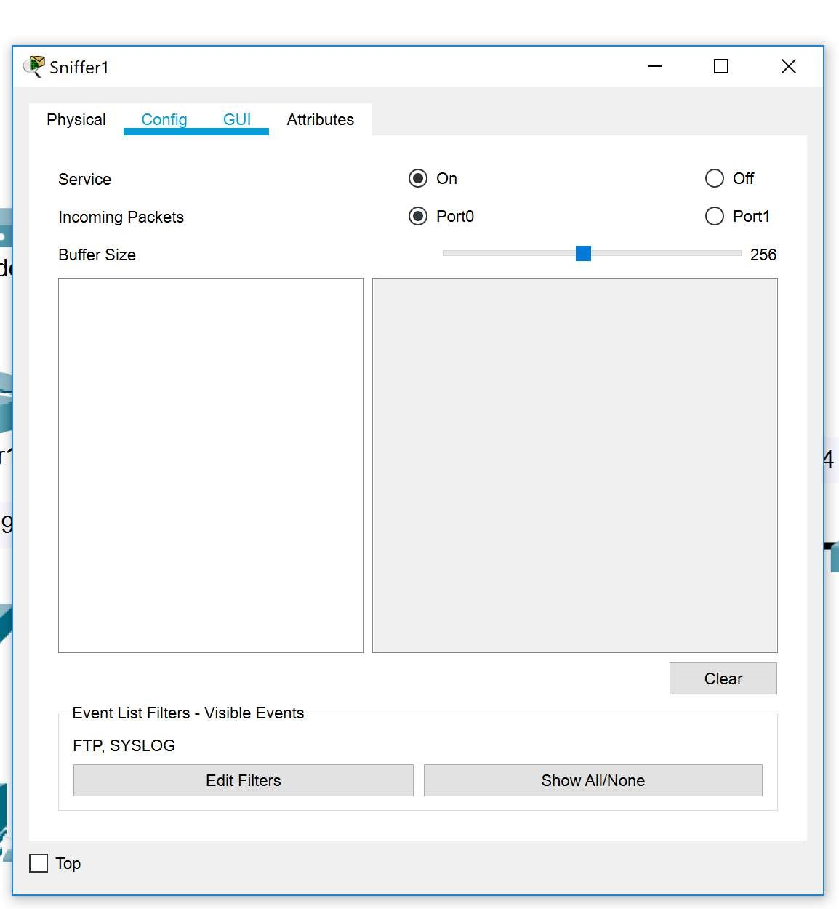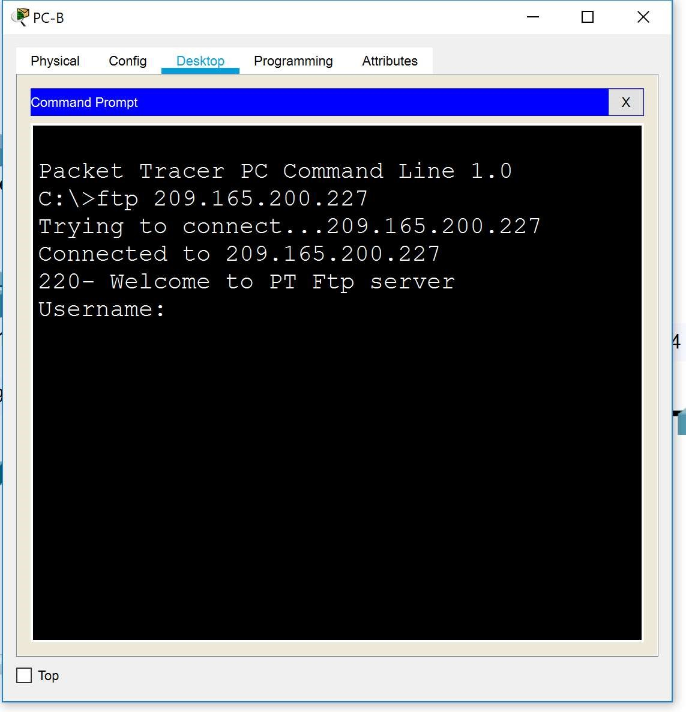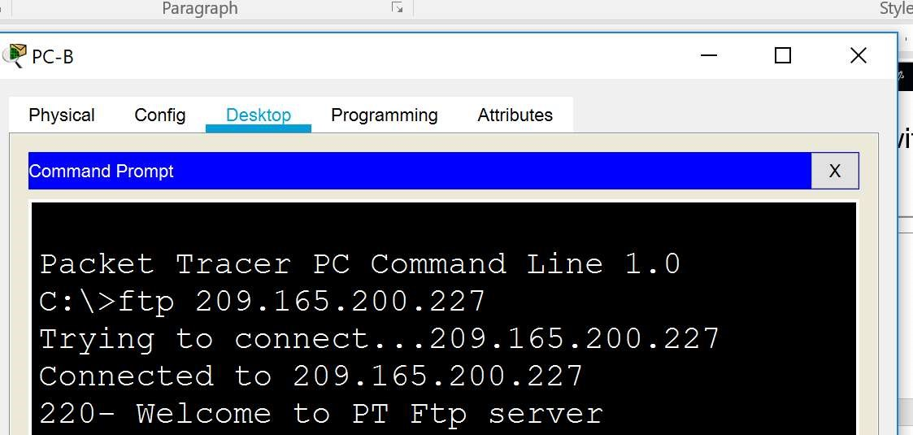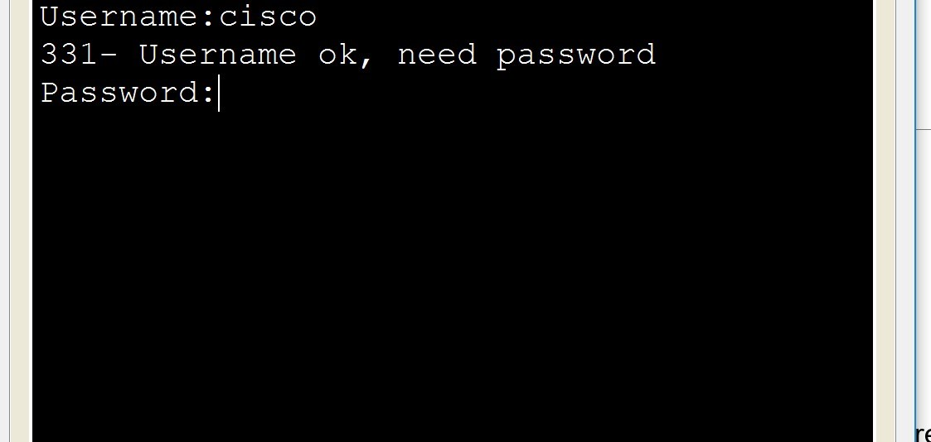

➔ Enter the username of cisco and password of cisco to authenticate with the FTP_Server.
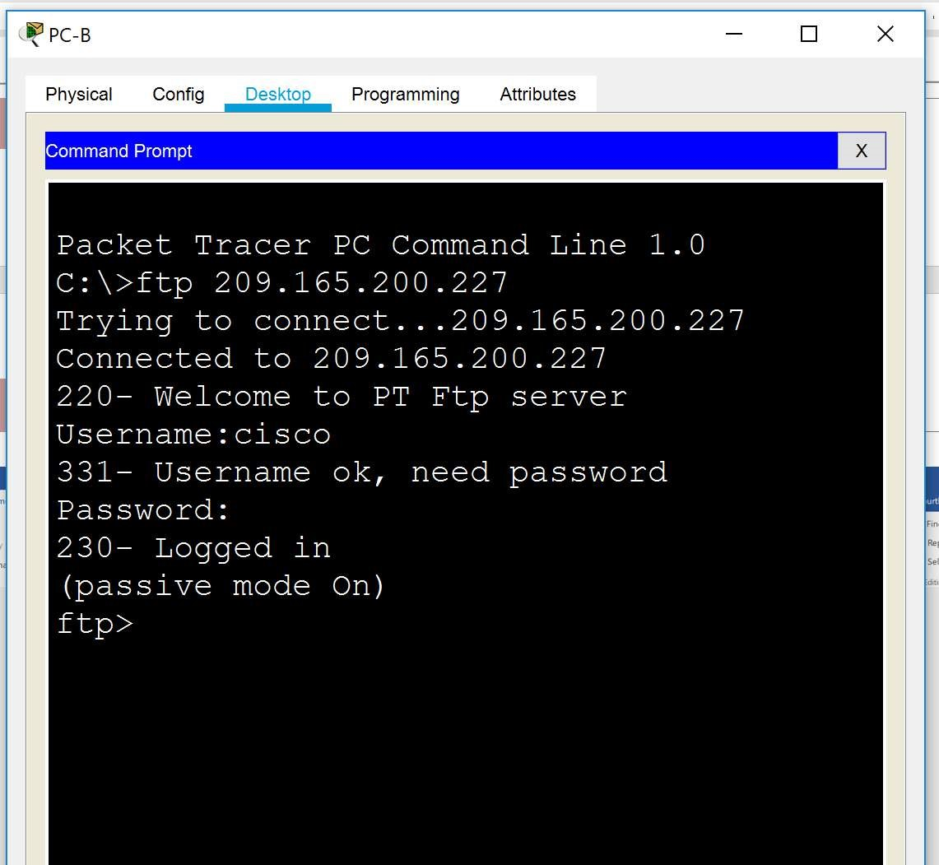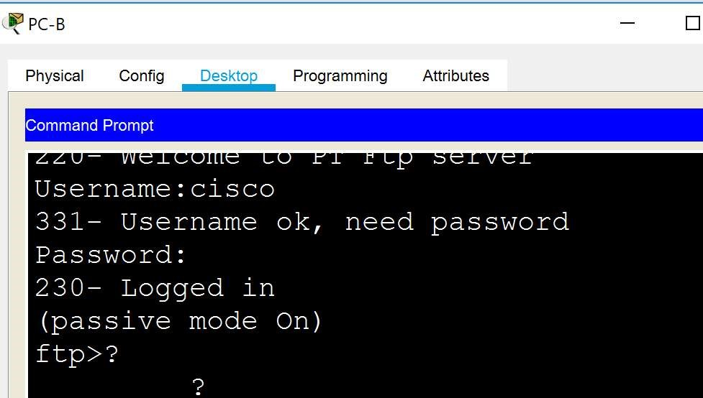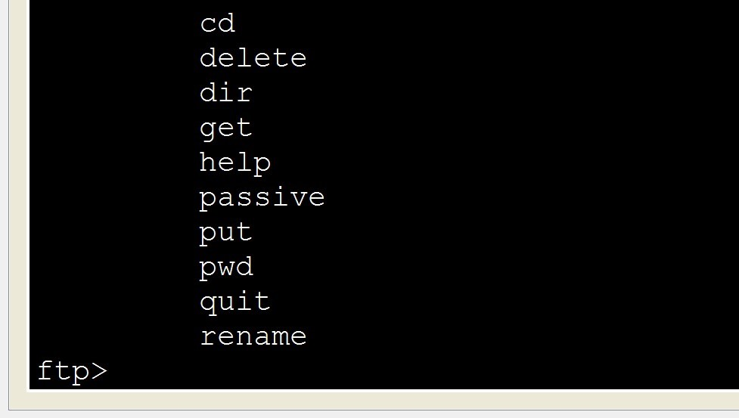

➔ Upload a file to the FTP server.
- At the ftp> prompt, enter the command dir to view the current files stored on the remote FTP server.
- Upload the clientinfo.txt file to the FTP server by entering the command put clientinfo.txt.
- At the ftp> prompt, enter the command dir and verify that the clientinfo.txt file is now on the FTP server.
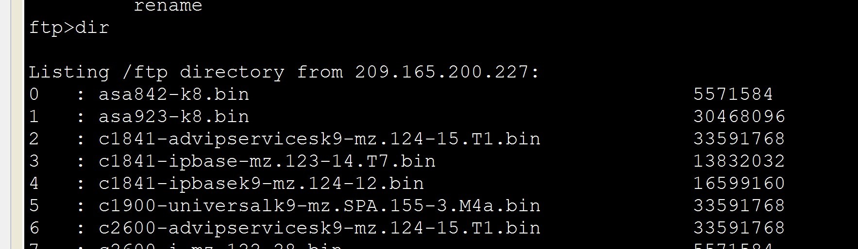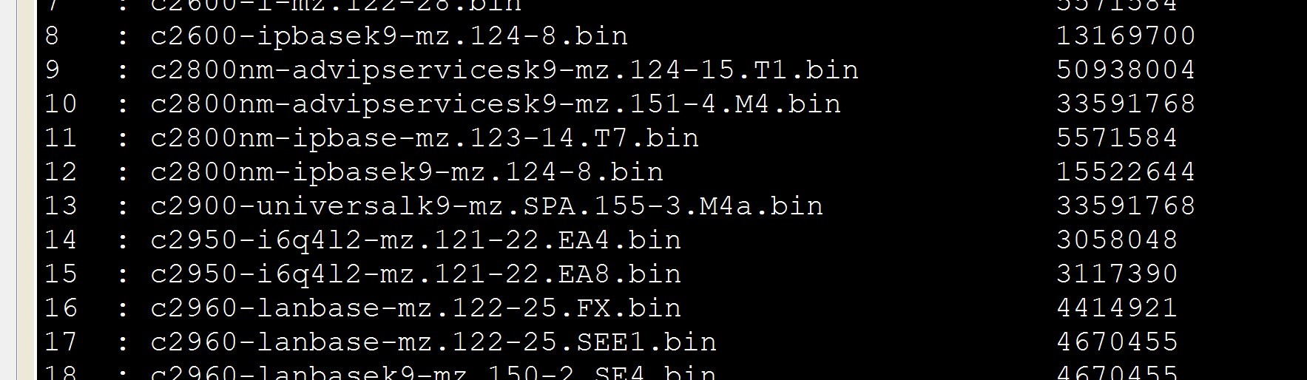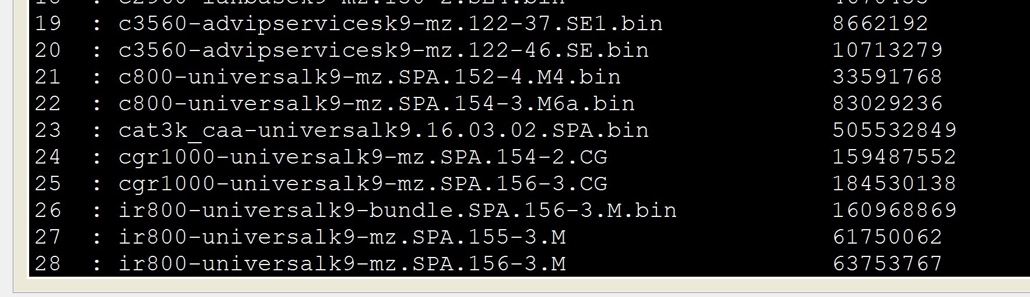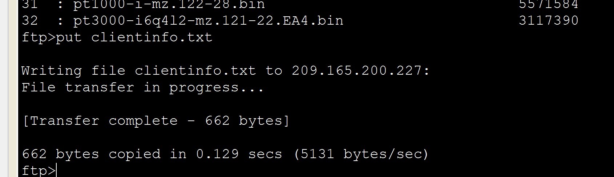

➔ Enter quit at the FTP prompt to close the session.
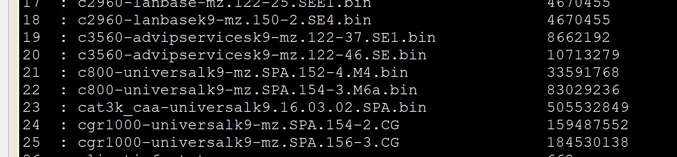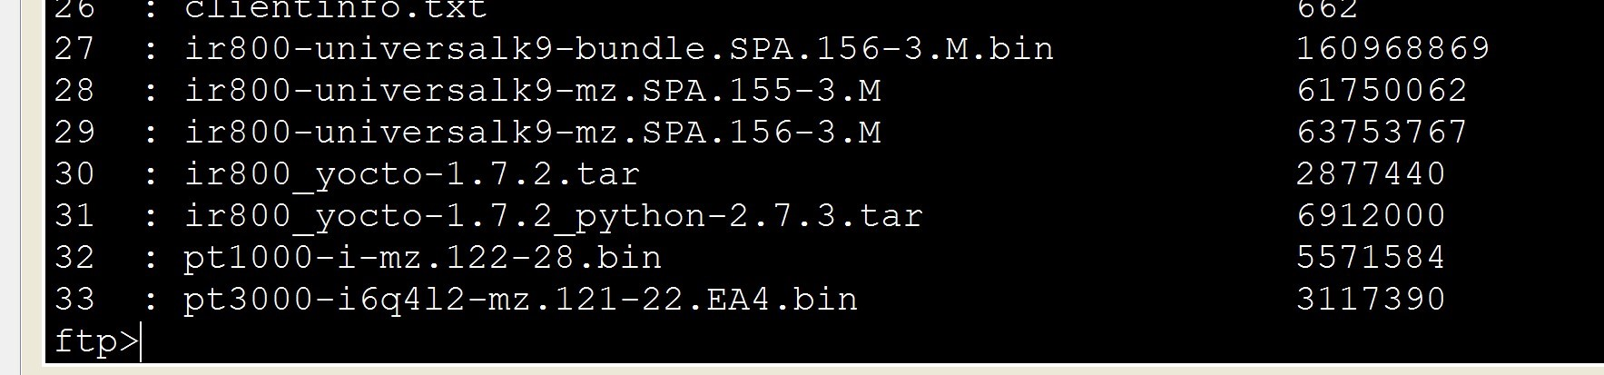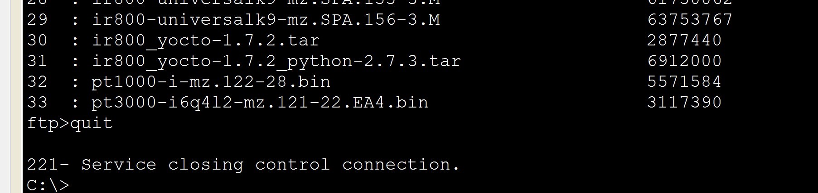

Investigate the FTP Traffic
➔ Click the Sniffer1 device and then click the GUI tab.
➔ Click through some of the first FTP packets in the session.
- Be sure to scroll down to view the application layer protocol information in the packet details for each.
- (This assumes this is your first FTP session. If you have opened other sessions, clear the window and repeat the login and file transfer process.)
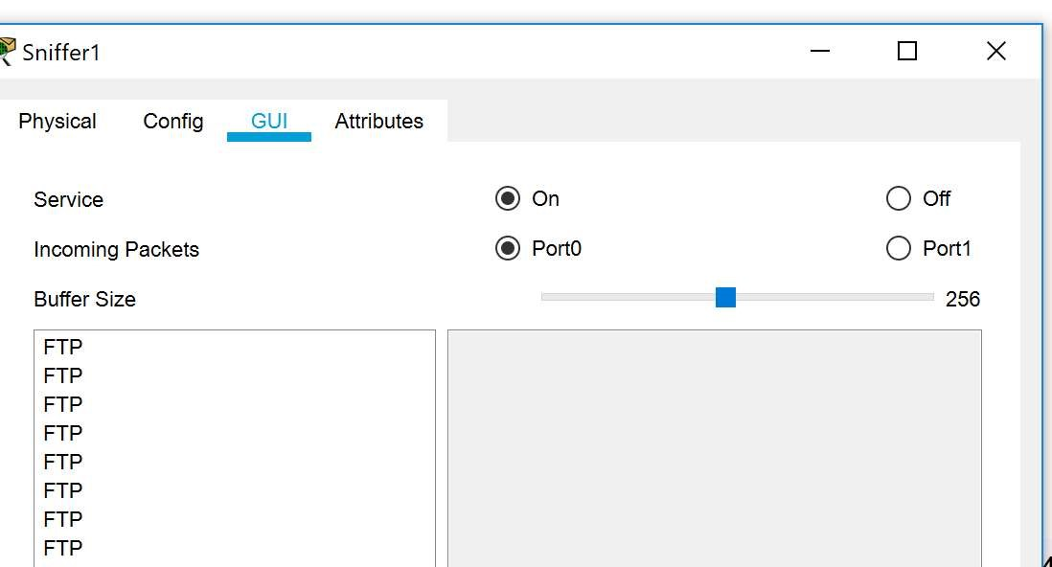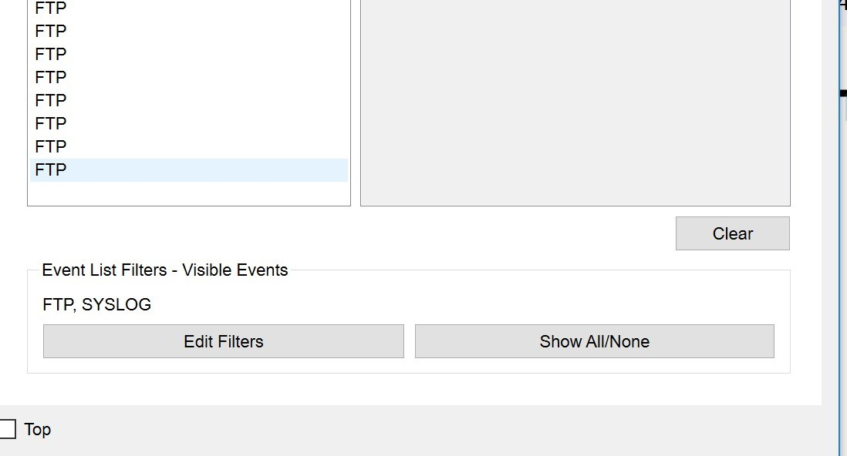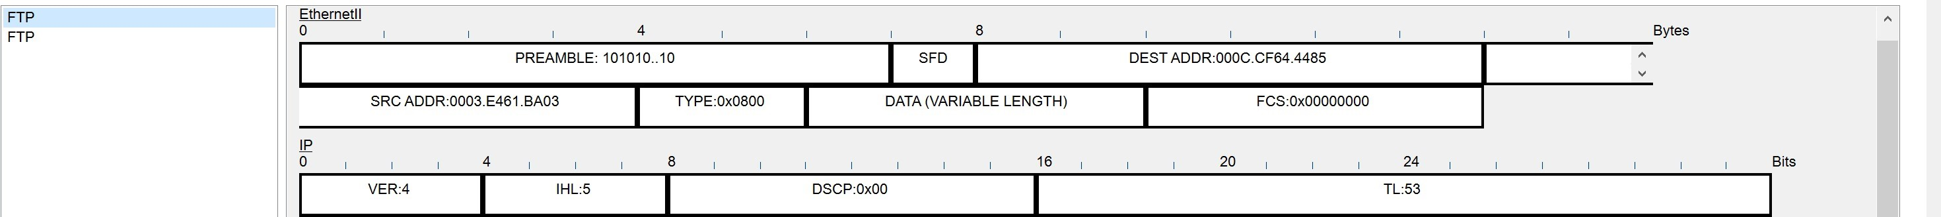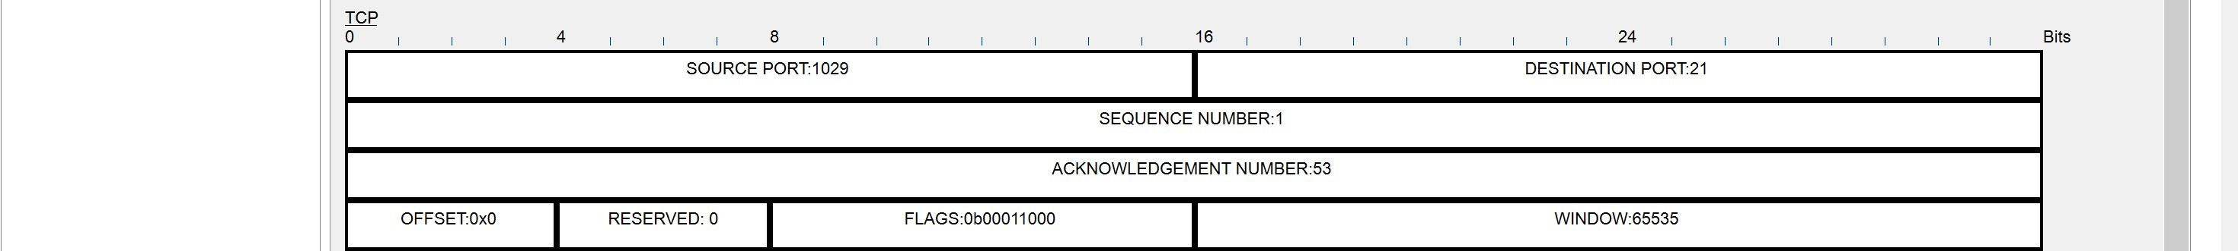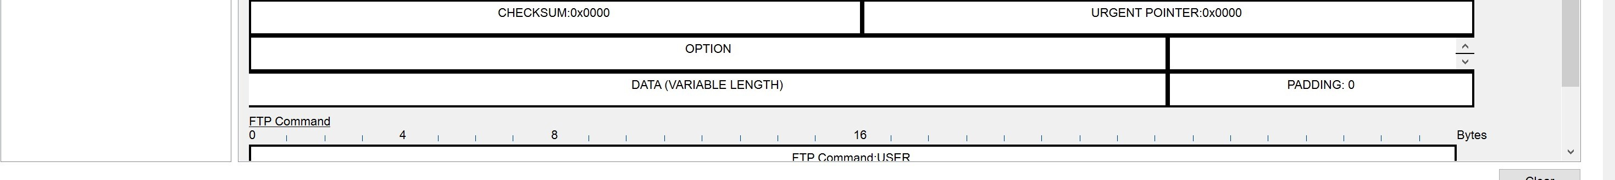

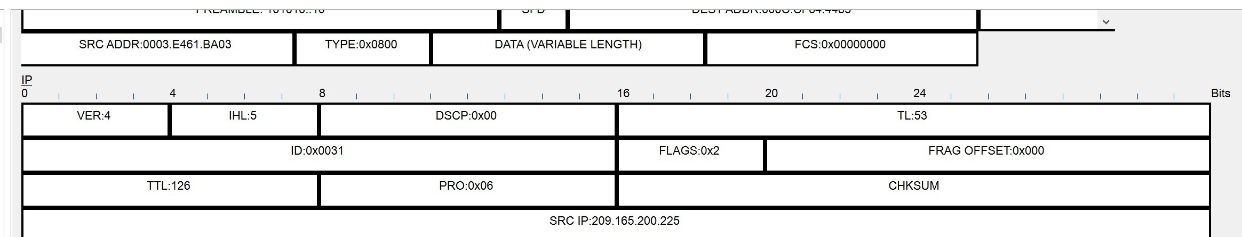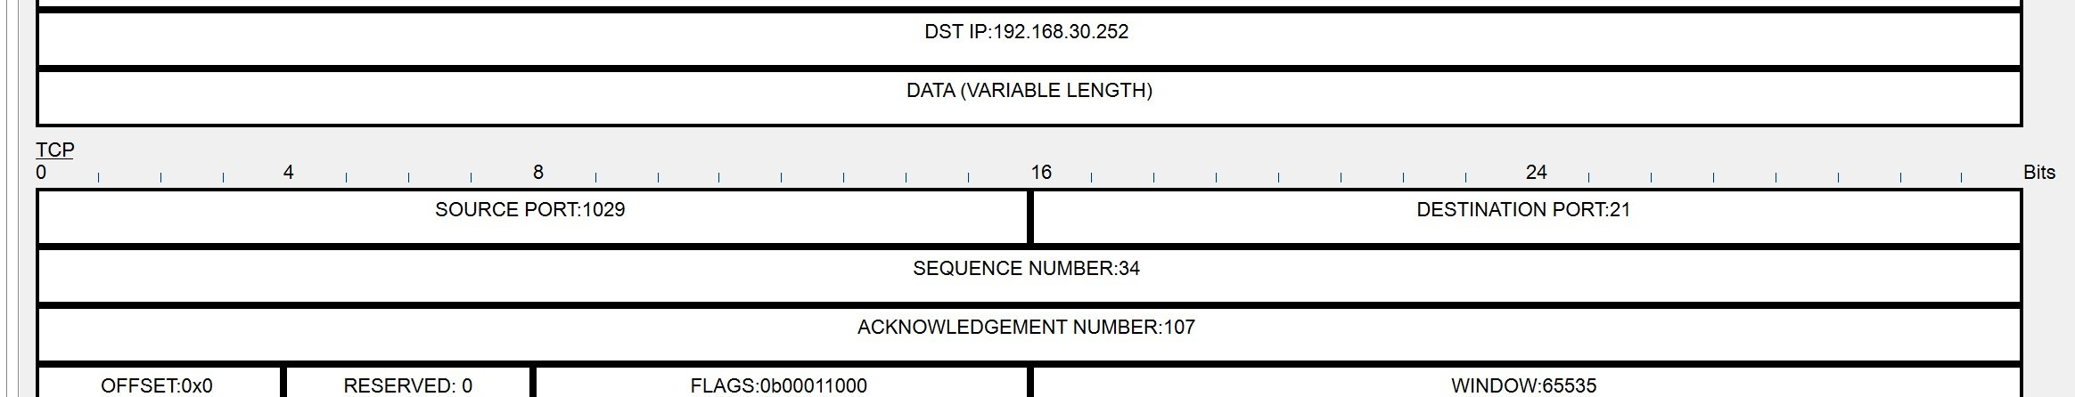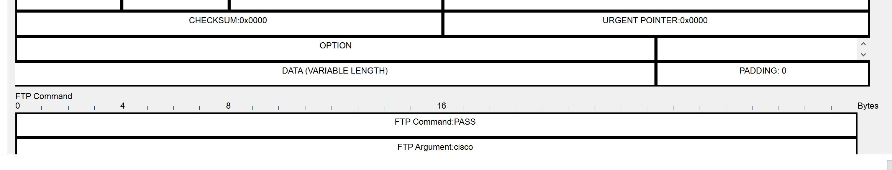
Record your reflections/ understanding about the vulnerabilities you identified when using FTP.
FTP uses un un-encrypted communication protocol- Usernames and passwords are sent in clear text along with all the data

What is your recommendations to mitigate the above identified vulnerabilities?
Either use SSH to transfer the data or move to SFTP . Avoid storing sensitive information on the FTP server and if the information is freely available allow anonymous access so usernames and passwords are irrelevant

Learnings from this lab:
- Understand Cyberattacks, Updates about recent attacks.
- Analyse the Cyberattacks to find out the target, outcome, vulnerabilities and exploits.
- Available Certifications and Job Opportunities in Cybersecurity domain.
- Setup various lab environments (Virtual Machines with Cyberops, Kali Linux etc), modify settings and troubleshoot compatibility issues with Operating Systems.
- Use MiniNet, trace the routes and examine the packets using Wireshark.
- Contributing and working as a part of a Team (Blue Team) and to share responsibilities of a demonstrated SOC.
- Analyse various Malwares and Social Engineering methods to gain access.
- Using tools like TCPView to identify the process running in the machine to establish a connection.
- Use Social Engineering Toolkit to harvest credentials of users.
- Using a sniffer and sniff the packets and analyse its vulnerabilities.

