Proposal

Student Number: 1803264

Student Name: Kelly Rees

Course: Surface Pattern and Design

Word Count: 2309

Tutor: Julia Lockheart

As research for my Independent Enquiry I will be looking at three keywords that reflect my interests within my own practice. I will be researching Embroidery, Symbol and Cloth all of which I use within my practice. I will look at the history of embroidery and the uses of symbols within its history, the choice of cloth used depends on the country or era it was embroidered. I will then discuss the purpose of embroidery today and what impact it has had on today’s fashion industry and is there still a place for embroidery today.

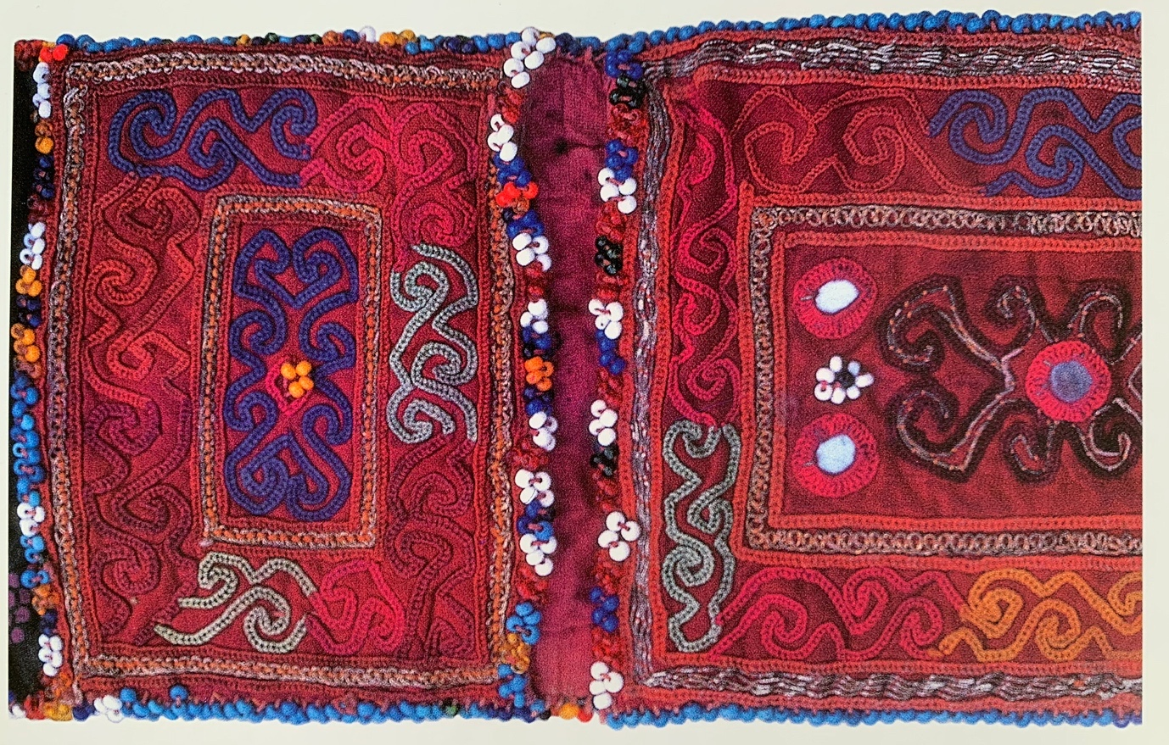

Figure 1. Purse, Pashtun, Ghazni, Afghanistan.

Embroidery according to Paine:

Embroidery is the embellishment of an existing fabric with accessory threads and sometimes with other materials such as decorative elements such as fish skin, teeth, bone, feathers, horn, shells, beetle wings, tassels, beads, coins, buttons, metal and mirror have all at some time or place been used in this way. Most embroidery however is straightforward stitchery. The designs are freely drawn or worked by counting threads and I replied with a needle but occasionally with a hook. The thread used is silk, cotton, linen, gold and silver, but also whatever comes to hand including sometimes even human hair, moose hair, sinew and quills. A separate technique exists for metal or other precious thread, for non-pliable material such as quills, and for narrow decorative trims, usually cords and braids. These are laid on fabric and couched down by stitching with another thread, so that none of the decorative material is hidden underneath the cloth.
(Paine,1990, pp.5)

The main function of embroidery is to decorate or to embellish cloth that has already been made. The main purpose for the decoration was from the belief that it warded off spirits and were rooted deeply in ancient superstitions. Later such decorations and adornments were placed on garments as symbolic messages, such as if a woman was single, married or widowed. In some countries is a means of knowing what village a person was from. Different countries have different uses for embroidery. It can be used to celebrate a marriage, and when one or both of the married couple die the same embroidery is used as a shroud.

Paine explains that “Almost everywhere the event at which embroidery plays its major part is marriage” (Paine, 1990, p.218). Although designs vary depending on the country embroidery has a significant part to play. These are used as forms of ceremonies where both families of the bride and groom would exchange embroidered cloths. The embroidered symbols on a females clothing would demonstrate the skills that the new bride is bringing to the marriage. Linens are also embroidered by the bride to adorn the marriage bed. When the girl married, they would be carried through the streets to the bridegroom’s home.

Embroideries from 1070’s are still in existence today. The Bayeux Tapestry is over 70m long and depicts the Battle of Hastings. Although it is called a ‘tapestry’ it is in fact a piece of embroidery. It is housed at the cathedral at Bayeux.

Embroidery in England flourished during the 13th – 15th century. Opus Anglicanum which were used as wall hangings. This is a dual stitch style of embroidery, split stitch and couching from the underside. These were often given as diplomatic gifts.

Haute Couture was developed in the 19th century and was a discovery by Charles Fredrick Worth. ‘High Sewing’ is what we recognise on fashion today. The house of worth was established in the 1858. Today haute couture fashion is represented by the likes of Chanel. “Chanel, one of the few fashion houses still operating in the haute couture business.” (Pile, 2018, p.17).

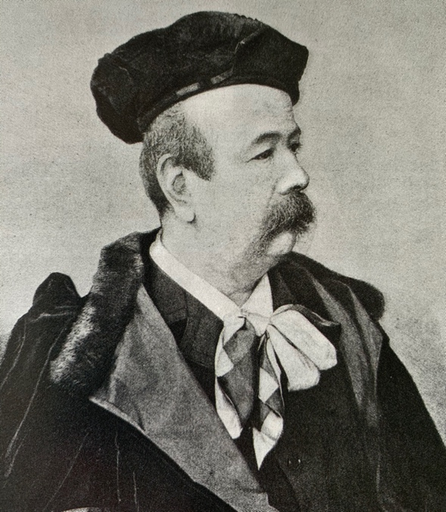
Figure 2. Fredrick Worth

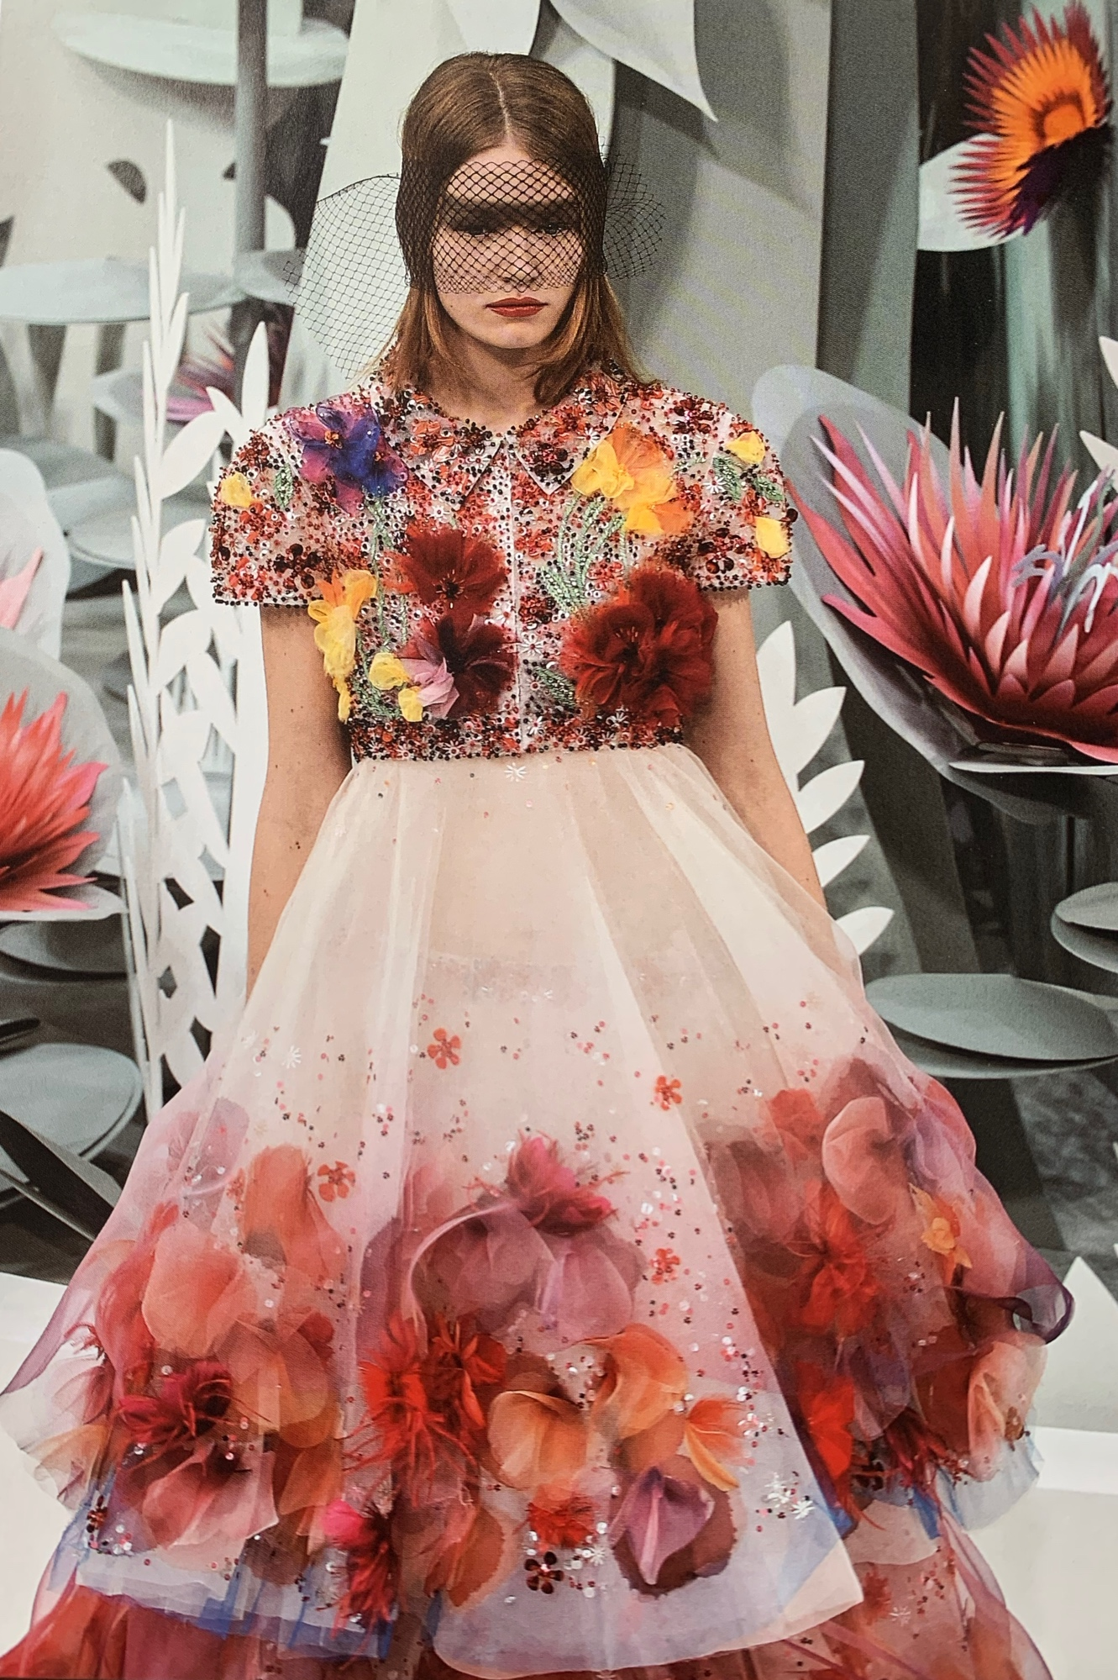
Figure 3. Chanel (Spring/Summer 2015)

Hunter perfectly describes embroidery perfectly:

You cut a length of thread, knot one end and pull the other end through the eye of a needle. You take a piece of fabric and you think about what you were going to make, what do you are going to say, who it will be for and what others will be able to read from it. And you consider what patterns and symbols you might use in this embroidery. Will it have a story or will it message be told in symbols readable to future generations? Will it hold sewn promise of protection, blessings from the heart, warnings to spirit who might wish as harm, you choose colours with care to convey specific emotions. You look through your collection of adornments, the tiny glitter and sequins the box of beads the breed of jig jigging pom poms and select all or some to add when the embroidery is complete. Then you push it round a needle in one side of the cloth and pull it out to the other, on and on in rhythmic sewing, until you have made something that matters: I think of beauty and meaning, and embroidery that holds your spirit fast within its threads.

(Hunter, 2019, p. 299)

This brings me to my second keyword, Symbol. Symbols have been used in embroidery since it began. I am going to look at different countries and what symbols are used to signify chapters in people’s lives. “Seeing comes before words” (Berger, 1972, p. 7). Children often recognise symbols without really understanding the words associated with them as explained by Winter (2017):

As young children begin keying into symbols, they are making a huge conceptual leap; they’re learning that a “picture” can convey a message. They can decipher it on their own and put to use. With this dawning realization (I know what that says!), their interest grows. They begin the process of decoding.

So, from birth we are learning a language of symbols, these can vary depending on where you are born. Embroideries have been used for centuries to communicate using symbols. Religious symbols and motifs were embroidered onto typically white household linen. The cross is a recognised universal symbol and is not just a Christian symbol, its meaning is quite clear. The cross is nearly always central and other symbols are used to frame it. Depending what country and religion is being followed will depend on what and where the cross is placed, however, the majority of us have a personal understanding what it means to them.

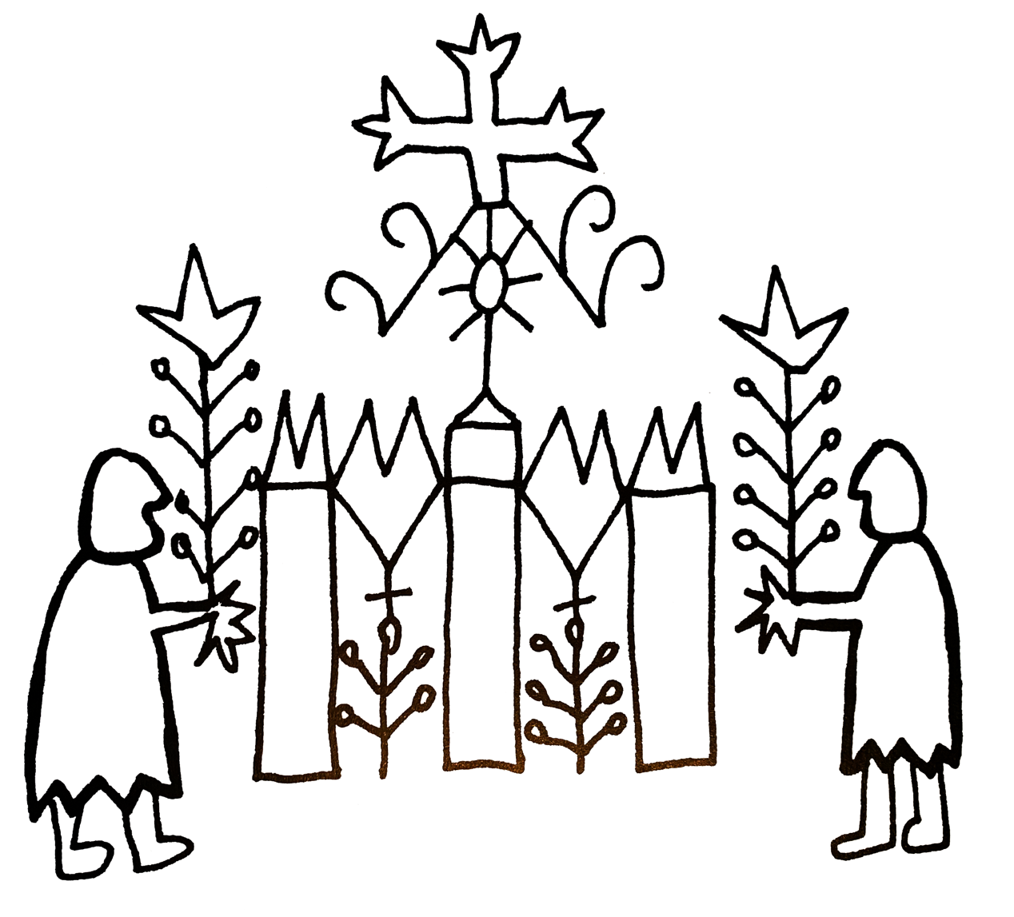
Figure 4. Festive shawl of the women of Qaracoche

In Islamic faith interlacing geometric patterns and calligraphy are recognised symbols. The embroidery is often not quite finished or has a few errors, this is to show that that only Allah is perfection. In some parts of north-western India, where different religions live side by side, the only way to distinguish between them is the style of embroidery, which can take years to complete. Some amulets are appliqued onto garments, as it is believed that these can ward off evil spirits. These symbols can include crescents, fish, triangles and squares.

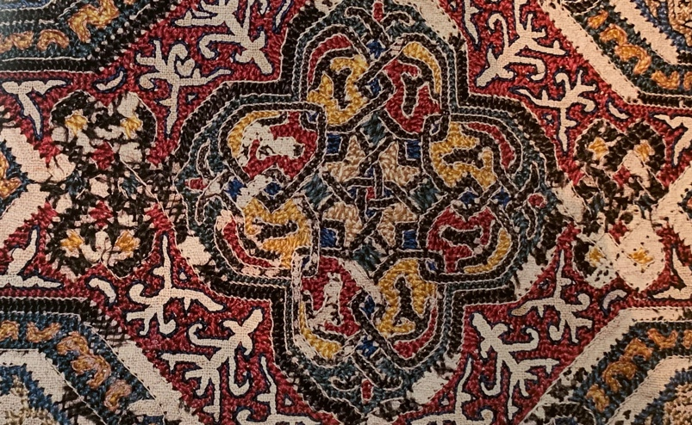
Figure 5. Islamic pattern fragment

Buddhism most significant symbol is the lotus flower. As the roots are in mud, the stem in water and the flower are in the air and sun, it is believed to bring creative force. The petals open in the sun and close at night signifying immortality. This idea migrated to central Asia through the travels along the silk road. The half-opened lotus pattern is not always instantly recognisable. The full open lotus flower is often illustrated onto the ceilings of Buddhist temples. The lotus flower is embroidered onto the cloth that is used to wrap the dowry of a bride. On embroideries of the Bengal is always the central motif. The lotus flower is recognisable for its significance in modern day design, it is often used for beauty salons and spa’s, to signify peace and tranquillity.

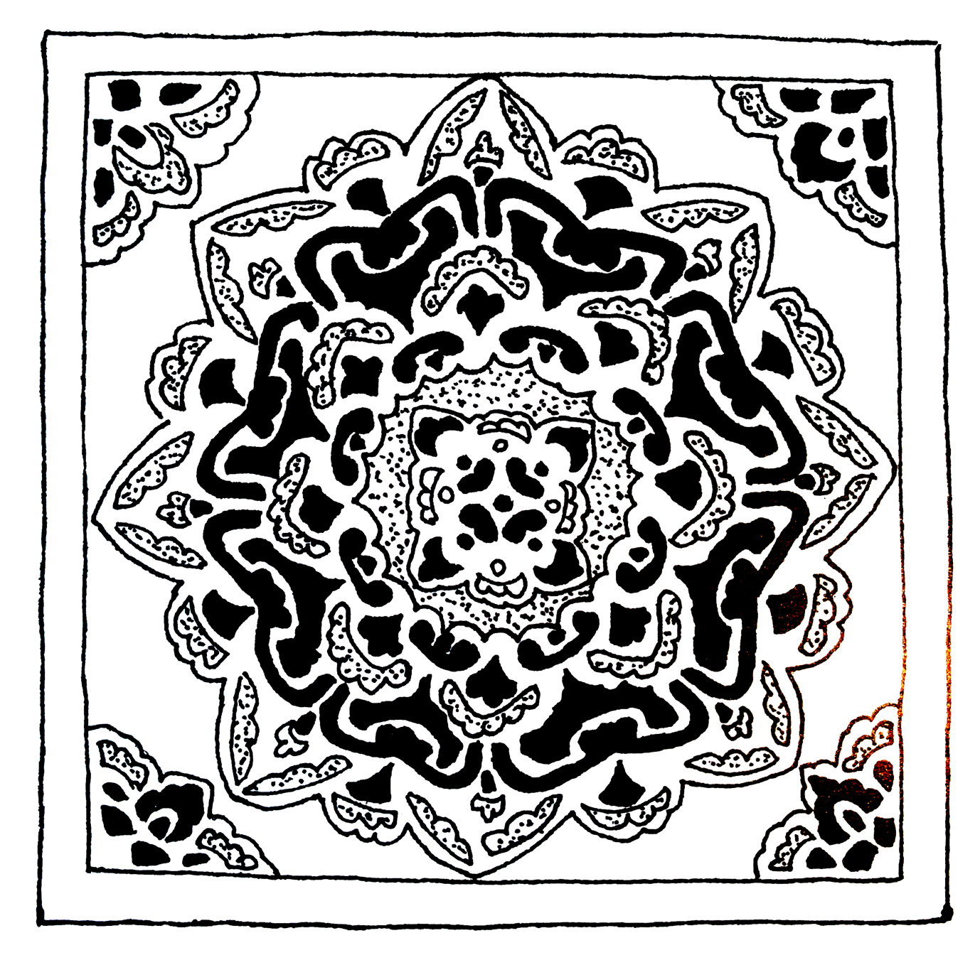
Figure 6. Lotus pattern

The sun is a symbol that is also used by many different cultures. It is recognised all over the world. Depending on how the symbol is drawn shows the era, religion and when its embroidered it often shows what part of the world its from. Concentric circles were originally a lunar symbol. Combined with a cross the symbol then becomes a solar one. In Celtic and Viking traditions, the spiral not only signified a creative force, it also symbolises the moon and the sun. In Egypt when siwan girls are married family of the bride are responsible for embroidering the clothing. The bride wears seven layers under her dress. The top dress is embroidered completely with a sunburst pattern. Rows of stitching around the neck opening. From the neck opening rows of stitches branching out, which is accompanied by small embroidered symbols, crosses, stars, spinning circles, pearl buttons along the front opening, stitched in small groups are also used to signify the sun.

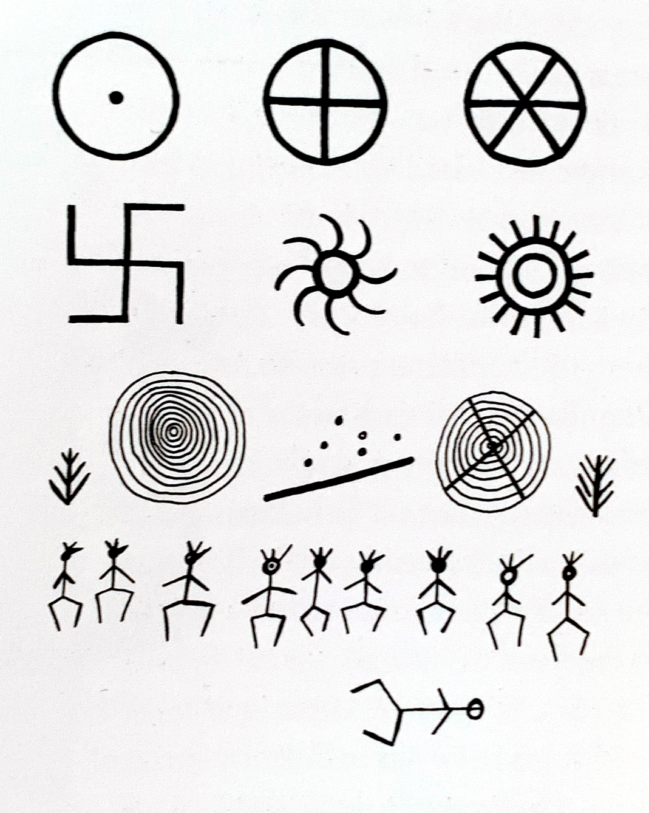
Figure 7. Pictographs for the sun

Symbols are a worldwide language, still used today to represent so many interlaced messages of religion, status and rites of passage. We instantly recognise a symbol even if we do not speak the language of the country of origin.

It is my own belief that embroidery is language stitched onto cloth, which is my final keyword. Cloth relates hugely to my practice as a textile maker and embroiderer. Without cloth I have nothing to make no story to tell. According to Hunter “Cloth holds onto its material memory” (Hunter, 2019, p.86) This relates to cloth that has folds and creases, that cloth needs to be touched and manipulated back into shape, even ironed to remove the creases from linen for example. Even when embroidering multiple versions of the same design on different pieces of the same cloth I have noticed subtle differences, almost little quirks, the way the stitches rise and fall through the cloth differ so greatly. Almost poetic.

When I am considering cloth for embroidery there is a thought process that is personal to the embroiderer. Choices that have to be made, is the cloth suitable? Does it stretch? How does the cloth feel to the touch? All of these questions and many more are asked and answered subconsciously before the embroidery can begin.

According to kettle “Textiles are deeply and uniquely entangled with place across time and throughout the globe” (Kettle, 2019, p.334). Cloth holds a story for everyone who touches it. For the mothers of some eastern countries who embroider their young daughter’s wedding clothes, it is a matter of pride and to present a worthy wife to the bridegroom’s family.

Hunter states “In many cultures, the persistence of old cloth, stitched by others, endows it with greater value” (Hunter, 2019, p.87). I believe that Hunter is relating her comment to the sentimental value of cloth that has been passed down through families for years. A shawl that a great grandmother had made when her first grandchild was born. The quilt that an aunt had lovingly sewn as a wedding gift for nieces and nephews. When these pieces are touched the love can be felt.

Staines explains:

Most often, the hand makes the initial contact with clothes. This interaction offers the wearer formative impressions of the tactility, sensation, or feel of the garment and its fibre: whether it is silky, rough, soft, crisp. This first vignette illustrates how the potentialities of clothes use come alive through touch.
(Staines, 2019, p.232)
The link to an emotional response through touch is a recognised action. The ‘feel’ of the cloth in our hands informs us of all the information we need to make a decision regarding the suitability of the cloth. We can make a rational choice using our touch.
Conclusion
Concluding my findings, I have explored the many uses of symbols from around the world, all of which have been used for decades. Symbols are prevalent everywhere. These create a link to all of us in one way or another. All human beings are taught to read symbols. They are used to signify marital status – the wearing of a wedding ring for example, is a symbol of marriage. The use of embroidery to tell a story using the language of symbols also used for thousands of years. These stories have been preserved in achieves for hundreds of years also. They are there for us to study and understand not only our own heritage but that of other countries far and wide. I explored the emotions of embroidered heirlooms have, what they evoke in us. The pride we have for these well used, old, often falling apart and in need of repair. Cloth plays such an important part of our daily routine. Deciding what clothing we are going to purchase will often times come down to the cloth. Makers will also make the decision of the quality of cloth used depending what the final outcome will be. This has led to the question ‘Does hand embroidery have a place in the modern technological future?’

Bibliography

Paine, S (1990) Embroidered Textiles. London: Thames & Hudson

Hunter, C (2019) Threads of Life. Stirlingshire: Sceptre

Berger, J (1972) Ways of Seeing. London: BBC

Alice Kettle (2019) Textile and Place, TEXTILE Cloth and Culture, 17:4, 332-339, DOI: 10.1080/14759756.2019.1639413 https://doi.org/10.1080/14759756.2019.1639413 (Accessed: 8 June 2020)
Dr Elyse Stanes (2019) Clothes-in-Process: Touch, Texture, Time, TEXTILE Cloth and Culture, 17:3, 224-245, DOI: 10.1080/14759756.2018.1548553 https://doi.org/10.1080/14759756.2018.1548553 (Accessed: 8 June 2020)
Winter, K (2017) Pre-Reading Activities: Signs and Symbols. Available at: https://www.scholastic.com/teachers/blog-posts/elaine-winter/2017/Pre-Reading-Activities-Signs-and-Symbols/#:~:text=As%20young%20children%20begin%20keying,begin%20the%20process%20of%20decoding. (Accessed: 31 May 2020)

Images

Figure 1: Paine, S. (1990) ‘Embroidered Textiles’ p. 15
Figure 2: Pile, JJ. (2018) ‘Fashion Embroidery’ p. 17
Figure 3: Pile, JJ. (2018) ‘Fashion Embroidery’ p. 16
Figure 4. Paine, S (1990) ‘Embroidered Textiles’ p.185
Figure 5. Paine, S (1990) ‘Embroidered Textiles’ p.181
Figure 5. Paine, S (1990) ‘Embroidered Textiles’ p.175
Figure 5. Paine, S (1990) ‘Embroidered Textiles’ p.160

