Name: Ash Toner

Student Number: 2514500
__________________________________________________________

WORKSHEET 3 – TESTING (Lap Times)

- Original code:
lapTimes = []

def check_valid_number(num):
time_error = "ERROR: Please enter a valid lap time, time is"
if num <= 1:
print(f"{time_error} too short.")
return False
elif num >= 999:
print(f"{time_error} too long.")
return False
return True

print("Please enter the latest lap times (in seconds)")
try:
for lap in range(0, 5):
singleLapTime = float(input(f"Lap {lap + 1}: "))
if not check_valid_number(singleLapTime):
exit()
lapTimes.append(singleLapTime)

while True:
targetTime = float(input("What is your target lap time? "))
if check_valid_number(targetTime):
break

print("Statistics...")

totalTime = 0 # Overall time

for oneLapTime in lapTimes: # for each
totalTime = totalTime + oneLapTime

# Overall time
print(f"1. Overall time for 5 laps was: {totalTime} seconds")

# Average time
print(f"2. Average lap time was: {totalTime / 5} seconds")

fastestLapTime = 9999 # Fastest lap time
fastestLapNum = 9999 # Fastest lap number
slowestLapTime = -1 # Slowest lap time
slowestLapNum = -1 # Slowest lap number
targetLapsHit = 0 # Target laps hit

for count in range(0, len(lapTimes)): # for (counter needed)
lapTime = lapTimes[count]

if lapTime < fastestLapTime: # Fastest
fastestLapTime = lapTime
fastestLapNum = count + 1

if lapTime > slowestLapTime: # Slowest
slowestLapTime = lapTime
slowestLapNum = count + 1

if lapTime <= targetTime: # Target
targetLapsHit += 1

# Fastest lap
print(f"3. The fastest lap was lap {fastestLapNum} in {fastestLapTime} seconds")

# Slowest lap
print(f"4. The slowest lap was lap {slowestLapNum} in {slowestLapTime} seconds")

# Target lap
print(f"5. {targetLapsHit} of your target laps were better than or equal to your target")

# Lap evaluations
print("6.")
print(f"Lap 1 was {lapTimes[0]}")

faster = " which was faster than the previous lap"
slower = " which was slower than the previous lap"
equal = " which was equal than the previous lap"

for count in range(1, len(lapTimes)):
lapTime = lapTimes[count]
previousLapTime = lapTimes[count - 1]
print(f"Lap {count + 1} was", lapTime, end="")
if lapTime == previousLapTime:
print(equal)
elif lapTime < previousLapTime:
print(faster)
else:
print(slower)

except ValueError:
print("ERROR: PLease enter a valid lap time, lap time must be a number")

- Code Testing
For each test below, run your code and show the results of the scenarios below. Present a screenshot of what happened when the programme ran. Did the programme behave correctly or did it do something unexpected, and if so, why?

- Test a lap time for your programme:
- 42 seconds
- 2 seconds
- -4 seconds
- 53444 seconds
- Test the target lap time – show that the values entered are reasonable

- Using the same five lap times as the sample output ie

Lap 1: 42.3
Lap 2: 42.1
Lap 3: 44
Lap 4: 44
Lap 5: 39.4

Examine each statistic (1-6) and comment on whether the correct answer(s) are displayed or not. (If any statistics were incomplete after Phase 1 (code completed in class) simply write “Unfinished”)

- Test two further sets of lap times of your own choice.

A: Lap Times

Test: i. 42 seconds
Screenshot(s) of output:
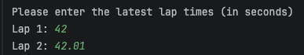
Result: Did the programme behave as expected ie syntactically and logically correct?
YES
The program was made to accept floating point integers between 1 and 1000, 42 is a valid input along with 42.01 and any floating-point integer between 1 and 1000 so 1.01, 4.001, 999 are all valid inputs. The system passes the test.

Test: ii. 2 seconds
Screenshot(s) of output:
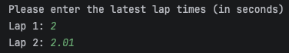
Result: Did the programme behave as expected ie syntactically and logically correct?
YES
The system has to “compare lap times around a circuit for a practice drive”, the length of the circuit is unspecified so it’s not fair to assume a minimum value; therefore, the system is accepting 2 a valid input. 2 is still a floating-point number above 0 so despite being low I think the system should accept it, for this reason the system passes this test.

Test: iii. -4 seconds
Screenshot(s) of output:
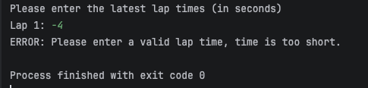

Result: Did the programme behave as expected ie syntactically and logically correct?
YES
The task can’t be completed in negative time and so the system shouldn’t accept negative floating-point integers, which it doesn’t. Validation was already added for this case and so the system passes this test.

Test: iv. 53444 seconds
Screenshot(s) of output:
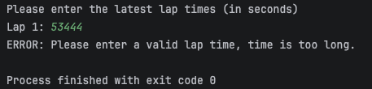

Result: Did the programme behave as expected ie syntactically and logically correct?
YES
As said previously, the system has validation to accept floating point numbers between 1 and 1000 so 53444 exceeds this range and outputs an error message. The system passes this test

Test: v. Target lap times
Screenshot(s) of output:
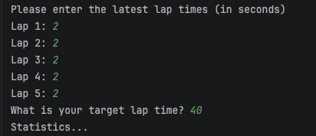

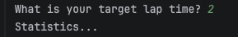

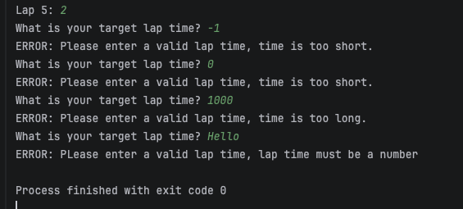

Result: Did the programme behave as expected ie syntactically and logically correct?
YES
Target lap time goes through the same validation the individual lap times do. So, only floating-point integers between 1 and 1000 pass validation. A while loop was implemented to keep checking for a valid target lap time until one gets entered; you can see invalid attempts above. The program will end if a number doesn’t get entered though as this is caught in a try except block. The system passed this test.
B: Sample Laps

Test: i. Set Values
Screenshot(s) of output:
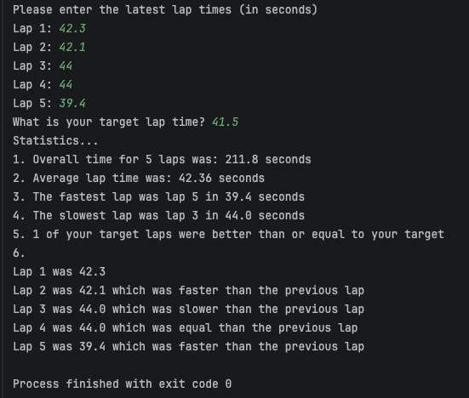

Result: Did the programme behave as expected ie syntactically and logically correct?
YES
The system outputs identical values to the example given in the worksheet. The only minor difference is a grammatical error “was equal than the” should be “was equal to”, but logically it’s identical. The system passes this test.

C: More Tests

Test: Full Test - 1
Screenshot(s) of output:
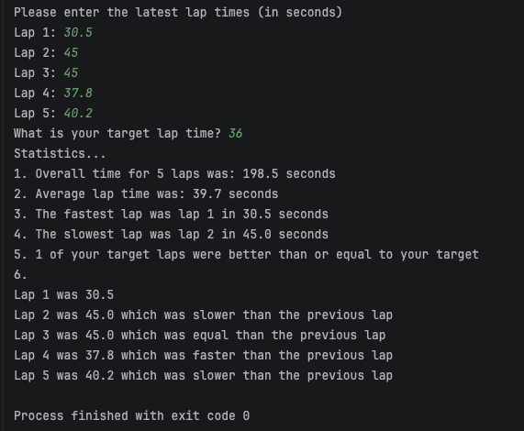
Result: Did the programme behave as expected ie syntactically and logically correct?
YES
These statistics are correct and so the system passes this test.

Test: Full Test - 2
Screenshot(s) of output:
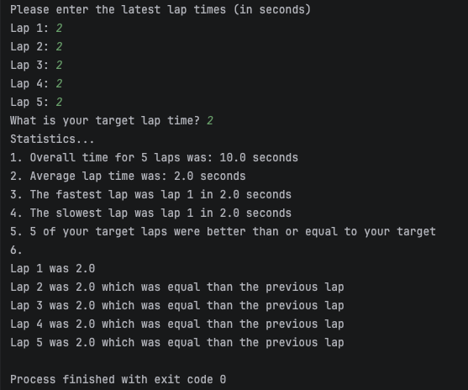
Result: Did the programme behave as expected ie syntactically and logically correct?
YES
A few obscure lap times were used but all these statistics are correct and so the system passes this test.
- Consider the results of the above tests and revisit your original code in order to address any tests that failed and/or improve code efficiency.

What was done:
- Fixed / Implemented while loops so incorrect inputs can be retried / re-entered without ending the program
Before this, only the target time worked on a loop and that was only when you entered an invalid number. Now all inputs continue waiting for a correct input. Invalid inputs were tested then a valid input to demonstrate below:
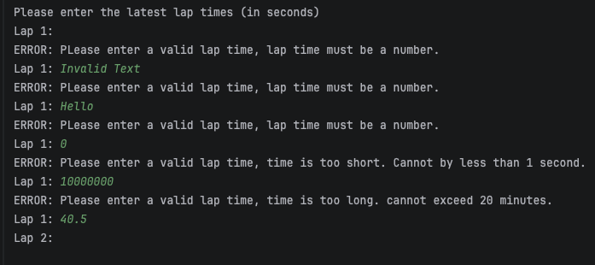

- Changed the boundaries for min and max value for lap time.
Before, 1 was an invalid lap time so the program was changed it to accept 1 as a minimum value. 1 was chosen as a valid input because again, the size of the course is unknown and it could have a lap time of 1 second. If the user enters a valid number that is not the number they meant to enter, then that is the user’s faut and the program shouldn’t account for that. Also, the program was changed to and changed the maximum value from 999 to 1800. This needed changing because 999 seconds in minutes is 16.65 minutes which is a weird time to cap out on, so this was changed to 1800 which is 30 minutes, which is a much fairer value for lap times. You can see this here:
def check_valid_number(num):
try:
valid_num = float(num)
except ValueError:
print("ERROR: PLease enter a valid lap time, lap time must be a number.")
return False
time_error = "ERROR: Please enter a valid lap time, time is"
if valid_num < 1:
print(f"{time_error} too short. Cannot by less than 1 second.")
return False
elif valid_num >= 1800: # 30 minutes
print(f"{time_error} too long. cannot exceed 30 minutes.")
return False
return True

- Changed grammar mistake ( equal )

Paste your full revised code here :

def check_valid_number(num):
try:
valid_num = float(num)
except ValueError:
print("ERROR: PLease enter a valid lap time, lap time must be a number.")
return False
time_error = "ERROR: Please enter a valid lap time, time is"
if valid_num < 1:
print(f"{time_error} too short. Cannot by less than 1 second.")
return False
elif valid_num >= 1800: # 30 minutes
print(f"{time_error} too long. cannot exceed 30 minutes.")
return False
return True
lapTimes = [] # Lap time array
print("Please enter the latest lap times (in seconds)")
for lap in range(0, 5):
singleLapTime = input(f"Lap {lap + 1}: ")
while not check_valid_number(singleLapTime):
singleLapTime = input(f"Lap {lap + 1}: ")
cleanLap = singleLapTime.strip()
lapTimes.append(float(cleanLap))
targetTime = input("What is your target lap time? ")
while not check_valid_number(targetTime):
targetTime = input("What is your target lap time? ")
cleanTarget = targetTime.strip()
targetTimeNum = float(cleanTarget)
print()
print("Statistics...")
totalTime = 0 # Overall time
for oneLapTime in lapTimes: # for each
totalTime = totalTime + oneLapTime
# Overall time
print(f"1. Overall time for 5 laps was: {totalTime} seconds")
# Average time
print(f"2. Average lap time was: {totalTime / 5} seconds")
# Initialising variables
fastestLapTime = 1201 # Fastest lap time
fastestLapNum = 99 # Fastest lap number
slowestLapTime = -1 # Slowest lap time
slowestLapNum = -1 # Slowest lap number
targetLapsHit = 0 # Target laps hit
for count in range(0, len(lapTimes)): # for (counter needed)
lapTime = lapTimes[count]
if lapTime < fastestLapTime: # Fastest
fastestLapTime = lapTime
fastestLapNum = count + 1
if lapTime > slowestLapTime: # Slowest
slowestLapTime = lapTime
slowestLapNum = count + 1
if lapTime <= targetTimeNum: # Target
targetLapsHit += 1
# Fastest lap
print(f"3. The fastest lap was lap {fastestLapNum} in {fastestLapTime} seconds")
# Slowest lap
print(f"4. The slowest lap was lap {slowestLapNum} in {slowestLapTime} seconds")
# Target lap
print(f"5. {targetLapsHit} of your target laps were better than or equal to your target")
# Lap evaluations
print("6.")
print(f"Lap 1 was {lapTimes[0]}")
faster = " which was faster than the previous lap"
slower = " which was slower than the previous lap"
equal = " which was equal to the previous lap"
for count in range(1, len(lapTimes)):
lapTime = lapTimes[count]
previousLapTime = lapTimes[count - 1]
print(f"Lap {count + 1} was", lapTime, end="")
if lapTime == previousLapTime:
print(equal)
elif lapTime < previousLapTime:
print(faster)
else:
print(slower)

