Blaenavon

I have recently been on a field trip to Blaenavon to visit the Ironworks and Big Pit. I will be talking about the history of it and how it became a historical landmark. We had a tour guide on the day who really helped me put this field report together. The tour guide was Ruth Taylor-Davies. I saw many interesting things on this field trip.
The Big Pits and Ironworks created many jobs in Blaenavon. The created so many jobs in fact in 1921 Blaenavon population increased to 13,000 (T-Davies, 2018). This is more than double the population it has now. I took many photos and spoke to some ex minors and the strange thng was the majority of them enjoy working in the mines but not because they like the job, but because it brought the communit together. They said they would often share everything with everyone in the community. I found it moving how back then if people had nothing they would share with them even if they didn’t have much themsleves, it sad to think that they were willing to do it back then when times were a lot harder and in these days most people are greedy and are not part of a community.

As I was working around Blaenavon I could see that many building are closed down. They looked like they been closed down for some time too. The doesn’t seem to be much of a community there anymore. As soon as I got off the bus I that it had an abandoned vibe to the place. During the trip I only saw to people in Blaenavon, who were not working in the museum or Big Pits. There is not much bring people to Blaenavon because in my opinion the Ironworks and Big Pigs are a forgotten part of history for many people. They are definitely trying to hold on to the past and unfortunately not many people are interested.
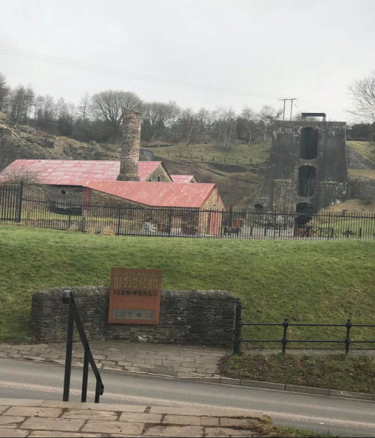
Although the Ironworks is a world heritage site because it revolutionised the mining industry there is not much else to bring tourist in to visit the place. Personal I never heard of Blaenavon before this assignment. The people of Blaenavon are definitely holding on to the past and don’t want or know how to move forward with the rest of the world, I’m not saying for them to forget about the big pits and ironworks but to find other alternatives to bring the community back together.
This is an image of the Iron Works. It’s a former industry site which is now a museum. The Ironworks revolutionised the mining industry and put Blaenavon on the map.

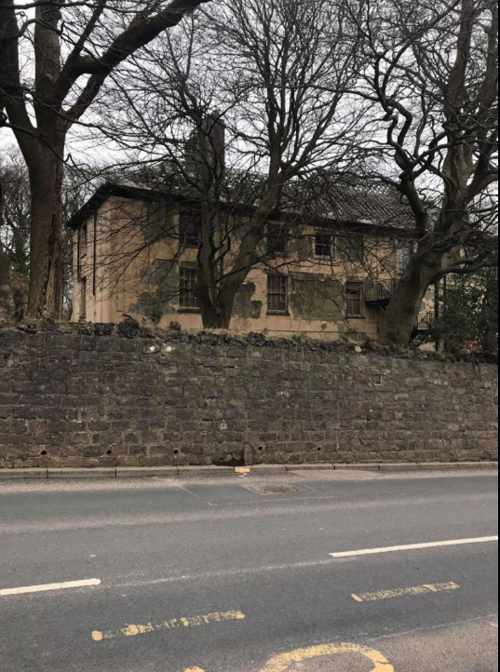
This is one of many places the workmen lived in. It very rundown now however, it wasn’t a very safe place to live back then either because of all the chemicals in the air.
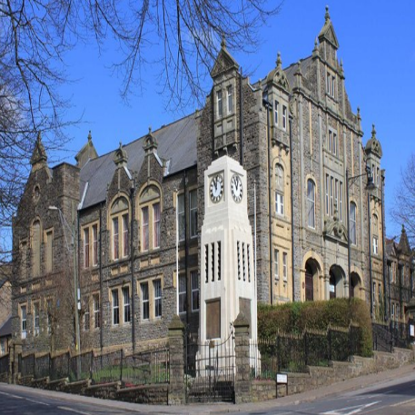
This is the workmen’s hall
I didn’t know that they used the workmen’s hall to recruit people to join the war. However, after the great world war there was a big decline, and Blaenavon Company had to close. This started a big decrease in the population and people moved away in search for new jobs. This had a negative effect on the community.

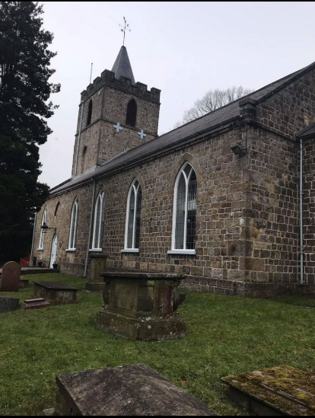

The Ironmaster built the church back in 1862. Other religious were shortly set up and hey built s chapel.
Religious meeting were held in 1905 during the great Revivalthe Hall, it was filled with people who met in the Hereb Chapel. The chapel and church brought people together and brought the community closer together.

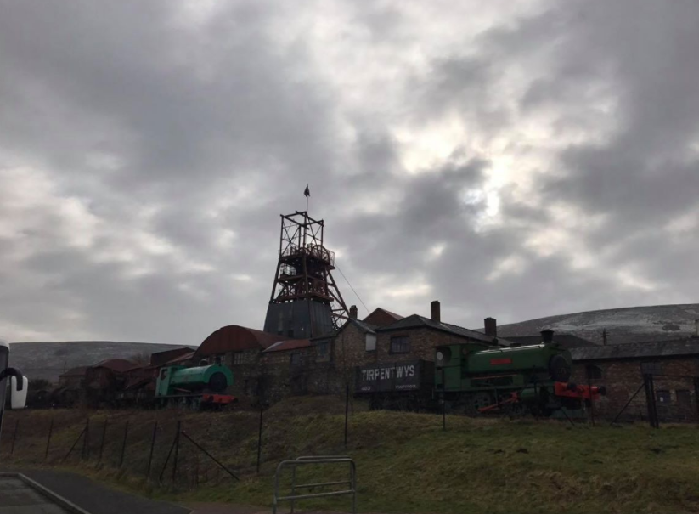
After seeing the Ironworks, we visited the Big Pits which was originally an iron mine however, it was turned into a coal mine because it was no long profitable to produce pig iron. The Big Pit was closed in 1980 which was then made into a museum in 1983.

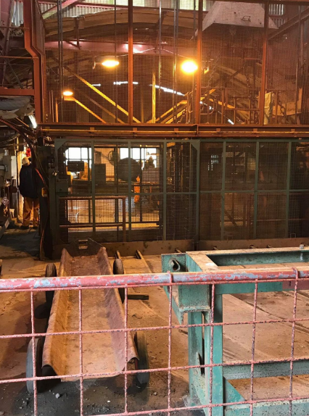

This is the lift the minors would use to get up and down the mines. Unfortunately we were unable to go down because the person that usually gives us the tour was unable to make it in on that day. This was a little bit disappointing however after talking to some of the minors, you get a feel of what it must have been like.

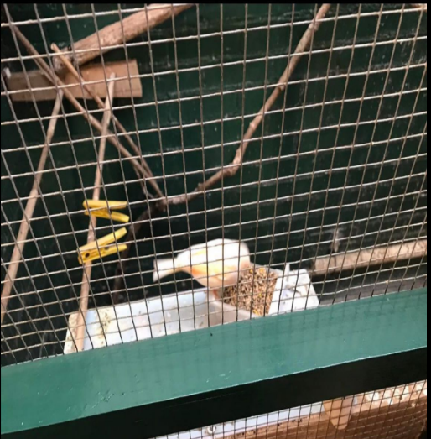
When we visited the pig pit, I noticed they had canaries locked up in cages, I read that they used to bring them down into the mines with them because the canaries would often sing but if the stop the minors would know that there’s gas in the mines.
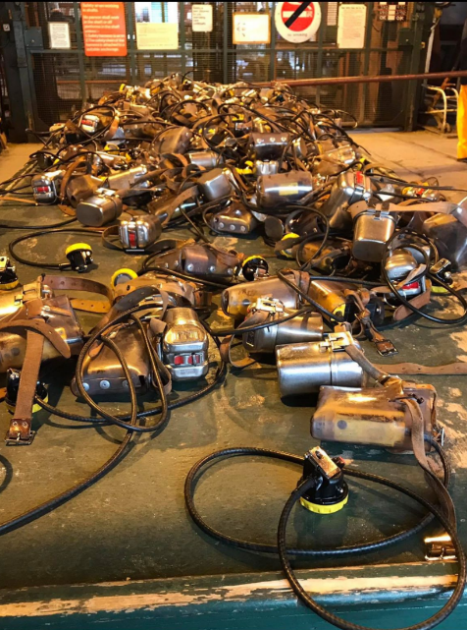

Every minor had to take one of these down the mines, in case of a gas leak. These allowed the minors to a few things, it also was a torch. These allowed the minors to work more safely and efficiently



This guy is Sydney Gylchrist Thomas and Percy Gylchrist. Without realising he almost bankrupt Blaenavon mining industry. In 1875 they were determined to eliminate the phosphorus from iron. The Bessemer converter was the first inexpensive way to mass steel from molten pig iron. Other countries began to copy this method which was terrible form them because they could not keep other with other countries who could produce more for a better price.

To conclude, I had a great time and learnt a lot from this field trip. My favourite part if the field trip was definitely talking to the ex-minors, it was very interesting to hear how they lived back then. I definitely feel they need to do a lot more to attract tourist and people there to visit the place. I don’t think they have thought it through in the long term because they said they are struggle to find people to work there and what most people go there for is to hear the minors personal experience. However 30 years from now most of the people that actually work in the mines would have past away.

References

Taylor-Davies, R. (2018), A Specialist in Industrial Heritage and Regeneration Wales
(Personal communication), 6th February 2018.

