The Principality Stadium

Sustainability Plan
  - Lisa Lewis 1809121

Sustainability within Organisations – BMSP7003 Photograph: (Lewis, 2018)

TABLE OF CONTENTS
1. Summary 3
2. Overview 5
3. Our Focus and Market Trends 6
4. Marketing and Sales Plan 9
5. Resourses 10
6. Monitoring and Reporting 11
References 13
Bibliography 14

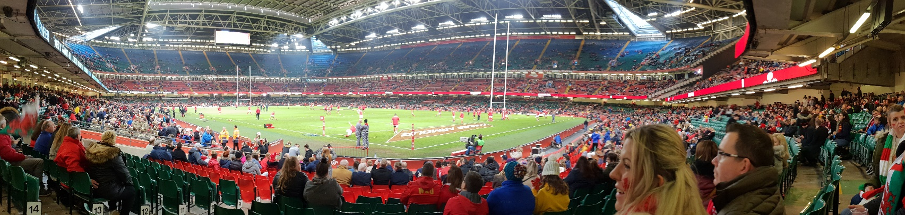

Picture: (Lewis, 2018)

Summary
The following outlined plan will aim to provide a focus on sustainability for the Principality management team in alliance with the purpose of the Principality Stadium. The organisation will require to work closely with stakeholders, other businesses and also its own employees and customers to help plan, implement and assess changes going forward. They will also aim to improve customer service and experience as a whole.
The Principality Management team will need to: -
- Commit: They will need to commit to looking at food and beverages being sold within the Principality Stadium and provided during conferencing and hospitality events to ensure that they are sustainable. Provide ownership for tasks to ensure progress is made.
- Assess: The management team will need to assess all of its current bars, food outlets and catering contracts focusing on supply chain, local produce, seasonal produce and Fairtrade etc. They will also need to look at sales data and current market trends to help identify new opportunities and identify all impacts.
- Define: The management team will need to put together a plan of implementation, providing clear set goals to help implement proposed changes going forward.
- Implement: Agree a clear way of implementing the changes for its customers. Looking at lessons learnt from previous changes to the food and beverage area(s) within the stadium to ensure a smooth transition.
- Measure: Measure sales, employee and customer satisfaction feedback against other food and beverages on offer within the stadium to be able to see current performance as well as gain a better understanding of future demands. The management will also need to measure and record changes to environmental impacts.
- Communicate: The management team will need to look at how to communicate changes with all relevant parties involved as well as how to communicate its commitment and progress against the agreed goals.

Overview
Background of the Principality Stadium
The Principality Stadium, previously known as the Wales Millennium Stadium was primarily built to replace the previous stadium, increasing seating capacity and facilities for rugby matches. Since the stadium was completed in 1999 it has also gone on to host a variety of sporting events and music concerts.
Our Purpose
“The purpose of the Principality Stadium is to provide a flexible multipurpose events venue for sporting and other types of event in a sustainable manner. Concern for the environment and promoting a broader sustainability agenda are integral to Principality Stadium’s professional activities and the management of the organisation. We aim to follow and to promote good sustainability practice, to reduce the environmental impacts of all our activities and to help our clients and partners to do the same”. (Stadiwm Prinipality Stadium, 2020)
Our Sustainable Journey
Since 2010 the Principality Stadium made advances in becoming more sustainable and set a goal of being a certified sustainable stadium and in 2011, they had achieved BSI – British Standard 8901 Certification. As well as this the Principality team have also been working with their suppliers to look at reducing waste going to landfill by separating waste, reducing the amount of packaging from their goods and switching products to more environmentally friendly ones. The stadium is also signed up to the Welsh Government’s Sustainability Charter, the WRAP (Waste and Resource Action Programme) Cymru Agreement and is also a member of the BASIS group (British Association for Sustainable Sport).

Our focus and market Trends
The previous sustainability report (Sustainability within Organisations – BMSP7003 Assignment 1, November 2018) looked at a wider spectrum of what the stadium has done, what the stadium has achieved, some impacts on the local environment and community and lastly some new opportunities to further embed sustainability into the everyday working practices of the stadium.
To begin with the stadium will focus on one main area which is food, beverages and hospitality packages. This does not mean that sustainability in other areas will not move forward, but part of the Principality team can focus on this area as it has a direct link and impact on the customers and stakeholders and can be monitored and reported on through customer and stakeholder feedback, supplier cost, sales figures and volumes of food waste. With changes that are implemented the management team will also need to look generally across the board at portion sizes of food against cost not only to make the product value for money for the customer but also to assess whether portions sizes are contributing to food waste within the stadium.
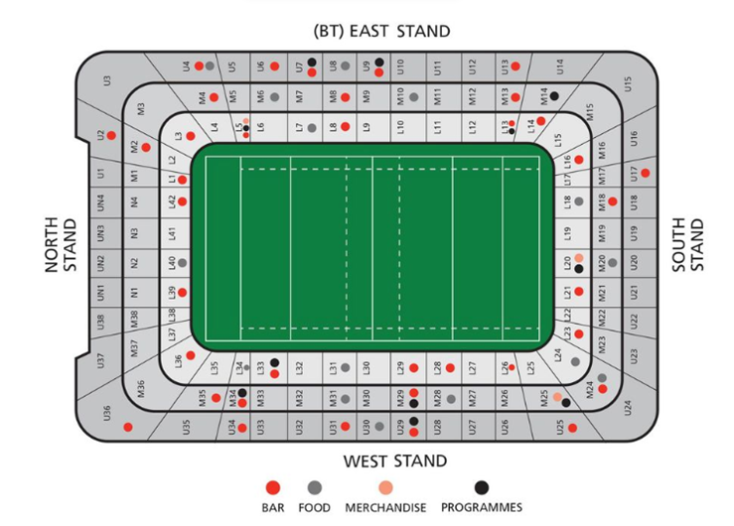
Over the last year sales in plant-based alternatives and vegetarian, vegan, gluten-free and flexitarian eating choices have all increased. “More than 3.5 million Britons switched to a plant-based diet in 2018, compared with 540,000 people in 2016 – an astonishing growth of 548 per cent.” (Daly, 2019). Alongside this many supermarkets and food outlets have already started to expand their menu choices to provide more choice and also tap into this market. Greggs’ introduced a vegan sausage roll to their stores in 2018 and after a surge in popularity the outlet at times struggled to keep up with demand. “Sales at Greggs have topped £1bn for the first time….The bakery chain posted a 15 per cent rise in pre-tax profits to £82.6m in 2018, with sales rising 7.2 per cent to just over £1bn”. (Sembhy, 2019) Following on from this Tesco also brought out a cheaper vegan sausage roll to rival Greggs. There has also been an increase in promotions such Veganuary alongside increase in social media. Many more street food stalls are now popping up in food events such the Eisteddfod and the Royal Welsh Show and also in regular markets, towns and cities. Going into 2020 many more fast food chains such KFC, McDonald’s, Nando’s, Subway, Pizza Hut and Frankie & Benny’s to name a few, have all added a Vegan or plant-based options onto the menu. They are also all showing that these foods do sell in the current time. This is definitely an area that the Principality team need to move quickly into as to not get too left behind the current trend with customers having to spend money before they enter the stadium if the choice is limiting. This will need to be achieved by expanding the current types of foods that are available within the stadium, working with the current food outlets and suppliers. Initially, this could be something that is trialed in one food stand in the stadium across the four stands.
Picture: Principality (2020)

Another area of food industry that the management team can do much more with would be to look at sourcing ingredients/foods locally and building up a good partnership within the local community. This not only help with the stadium being able to have fresh produce from its own doorstep but also help the local economy to prosper and grow. There has been a lot more marketing being done within Wales itself to promote shop local ethos as well as highlighting the need for traceability and transparency. This is also a theme that was picked up in 2012, having a ‘whole food chain approach’ and notions of ‘earth to table’ (Post, A. and Mikkola, M. 2012).
As well as bringing in local suppliers the stadium could also look at how they can incorporate seasonal goods into their foods especially with hospitality and conference events which can sometime be easier to plan than fast foods environment at sport events and concerts. In 2018 the Ryder Cup also signed up to the French Sustainable Event Charter, which meant that they had to agree to meet fifteen different points, one of which being that they had to have at 50% of food from sustainable sources available during the event.
From 2020 the stadium has already put in place free water re-fill stations. They can also need to look at eco-friendly tea bags and what solutions can be put in place to re-use coffee grounds. Another emerging change is also some more sustainable alcohol choices coming available. In June 2019 Kellogg’s collaborated with Salford Brewery to produce a line of beers using waste grains from cereal production. There are also other spirits such as gin and vodka which are being produced from other wasted products which other companies are putting on the market.

Marketing and Sales Plan
To help to promote the additional choices signage will need to be created. Clear menu boards which will need to include nutritional and sustainability information will need to be placed around the food outlets. Any advertising or key messaging will need to make sure that these additional choices are clear to not only promote healthier lifestyles but sustainable lifestyles. Advertising can also be added to back of tickets and advertised on large screens prior to the games. This will also help link sport with sustainable lifestyles, building on brand reputation and customer loyalty. Advertising could be made jointly with suppliers in lead up to events and also use digital marketing by using social media and email marketing to stakeholders etc.
WRU players can also help to champion brands and become brand ambassadors which can be marketed digitally or through television, radio or printed in magazines, newspapers etc.

REsourses
Staff will need to be trained and upskilled on what produce they are selling and will need to understand and know the background of the product e.g. where it was bought, transported, cooked etc. They will also need to ensure that the customer is able to make their own choices and are not influenced in any way.
The management team will need to be assigned different tasks within the plan so that progress can be made. This can be contacting current supplier, finding new suppliers, working on information of the menu boards, and also advertising.
The principality stadium itself will also need to be able to supply the food needed in order to offer the choice to its customers. They will either need to be able to work with current suppliers or find new suppliers to meet the additional menu choices. There may also be an increase of costs involved as the purchase of the foods will be on a smaller scale and may cost more per unit until a better understanding of demand has been acquired. The stadium will also have the unknow challenges of Brexit to deal with during 2020, however this will be something that is not specific to the sporting/hospitality area but to the country and a whole.

MOnitoring and Reporting
Monitoring of the changes will need to be captured by the number of sales that the different foods have had during events. The management team can also look into whether there is an increase in food waste during the same time period although this will be harder to pinpoint whether the food wastage is from which type of food.
The team can also review the outgoing costs to also see what the changes are and how these can be offset in they are seeing a decrease.
It would also be good to capture customer feedback to not only see what they like and dislike but to also capture suggestions going forward. This will help the team gain a better understanding in what is driving customer decisions when it comes to food and beverages.
Future Achievements – Measuring Success?
Paris has already pledged to use “100% sustainable and certified food sources” (Olympics, 2020) as well as plan to work to the Paris Agreement and the UN’s Sustainable Development Goals during the Paris 2024 Olympics. They also have said that they would like to share their model with other sporting venues in the future. This is an area of collaboration that the Principality Stadium can look into. This will also be important of the stadium would want to host future major events. In Wales the management team could also look at aligning changes to the One Planet Cardiff or the Wales Well-being of Future Generations Act by 1) helping to make Wales more prosperous by keeping money supporting local, 2) being more resilient by keeping the demand for local goods and helping to build the market, 3) helping to not only promote a healthier diet but also a more sustainable one and 4) being more globally responsible by decreasing food waste that they produce and making sure that the food sources are more sustainable than what they currently are.
They can also look at how they work towards Sustainability Awards that the Principality Stadium can proudly have these awards on display through the stadium. This will also show that the stadium is making strides in not only walking the walk but also talking the talk and being independently verified. This could be a Green Tourism Business Scheme Award, a Sustainable Food Cities Award or a Corporate Social Responsibility Award (CSR Award). They could also look at setting up a scheme where food that cannot be used for other events due to use by dates, that these are donated to a food scheme in the area.
Next Steps
Looking forward as well as food and beverages, the management team will also need to look at waste in general. Most of the waste at the grounds are produced through food and beverage packaging or directly by food.

References
- Lewis, L (2018) ‘The Principality Stadium’ [Taken 17 November 2018]
- Stadiwm Prinipality Stadium, 2020. Stadiwm Prinipality Stadium. [Online]
Available at: https://www.principalitystadium.wales/information/sustainability/
[Accessed 31 January 2020].
- UN Global Compact, 2020. United Nations Global Compact; Uniting business for a better world. [Online] Available at: https://www.unglobalcompact.org/library/231 [Accessed 31 January 2020].
- Daly, H (2019), The Telegraph, How vegan, vegetarian and gluten-free foods are changing search in 2019 [Online]. Available at: https://www.telegraph.co.uk/branded-content/marketing-guides/vegan-foods-changing-search/#source=refresh [Accessed 31 January 2020]
- Sembhy, R (07 March 2019), Independent, Greggs’ sales top £1bn as vegan sausage roll helps boost customer numbers [Online]. Available at: https://www.independent.co.uk/news/business/news/greggs-sales-profits-vegan-sausage-roll-annual-results-a8812416.html [Accessed on 31 January 2020]
- Stadiwm Prinipality Stadium, 2020. Stadiwm Prinipality Stadium. [Online]
Available at: https://www.principalitystadium.wales/information/fanzones/ [Accessed 30 January 2020].
- Post, A. and Mikkola, M., 2012. Nordic stakeholders in catering for sustainability. British Food Journal, 114(5), pp. 743-761
- Paris 2024; A Responsible Project [Online]. Available at: https://www.paris2024.org/en/responsible-project/ [Accessed 02 February 2020].

Bibliography
- E.A.T Report (2019) Healthy Diets start from Sustainable Systems - Food, Planet, Health [Online]. Available at: https://eatforum.org/content/uploads/2019/01/EAT-Lancet_Commission_Summary_Report.pdf [Accessed on 31 January 2020]
- Visit Wales (2019) Catering for Sustainability [Online]. Available at: https://businesswales.gov.wales/dmwales/catering-for-sustainability [Accessed on 28 January 2020]
- Solar Impulse Foundation (2019, May 29) Climate Nugget - Faster, Higher, Stronger... Greener? How sports events are joining the sustainability challenge [Online]. Available at: https://solarimpulse.com/news/view/faster-higher-stronger-greener-how-sports-events-are-joining-the-sustainability-challenge [Accessed on 28 January 2020]
- Verberne, J (2017, March 08). WWF International - Sustainability through Sport [Online]. Available at: https://ec.europa.eu/sport/sites/sport/files/docs/docs/eusf-greening-4_en.pdf [Accessed on 28 January 2020]
- Campelli, M (2018, 25 July) Sports Sustainability Journal; Ryder Cup 2018 commits to French sustainable events charter, [Online] Available at: https://sportsustainabilityjournal.com/news/ryder-cup-2018-commits-to-french-sustainable-events-charter/ [Accessed on 28 January 2020]

