

Student Name: Peri Hiteshkumar Patel
Student ID: 2504928

Programme: Master of Business Administration
Module Name: International Marketing: Principles and Practices
Module code: LCMB7026

Lecturer’s Name: Tushara Balendran

Term: 2

Table of Contents
Section 1: 3
Introduction 3
Overview of the brand 3
Company Introduction and Financial Performance: 3
Vision, mission, and value: 4
Employees, suppliers, and key competitors: 4
Focused markets: 5
A. Comparative analysis of the market in India and UK: 5
PESTLE analysis for IKEA 5
Compare and contrast 7
Comparison of Socio-cultural aspects by using Hofstede Model 8
B. A comparative analysis of STP and International Marketing Mix strategies in both countries 10
STP Framework for UK furniture market 10
STP Framework: India furniture market 14
Compare and contrast: 15
Marketing Mix 16
Compare and contrast 22
C. Directional development strategy of IKEA. 23
D. Ethical issues 23
E. Recommendations 24
Conclusion 24
Section 2: 26
Reflection: 26
References: 29

Section 1:

Introduction
In the emerging and changing global environment, strategic brand positioning helps a brand to critically and strategically build a position in the market (Onalaja and Otokiti, 2021). Focusing on the global brand positioning and international marketing strategies, this report will analyse IKEA’s operational state and process in the UK and India. In the UK, customers’ demand for the eco conscious market is increasing, making the annual growth rate of sustainable furniture by 10.7% (Grand new horizon, 2026). Similarly, IKEA is seeing growth in the Indian market too, and adapting a strong strategic plan to expand the business in India as the company’s sales in India improved by 6% in 2025 (Paramasivam, 2026). Therefore, Ikea’s operational comparison between these two countries will be discussed in this report as both of the countries are helping the business to grow and have future prospects. Following these, market environment analysis will be done Hofstede with a comparative analysis using a marketing mix framework. Directional development strategies, ethical issues, key challenges and opportunities will be explored with further recommendations to improve Ikea’s marketing and strategic position in the UK and Indian market. A reflective account of the report using Gibbs Reflective Cycle will be provided.

Overview of the brand

Company Introduction and Financial Performance:
IKEA has been operating globally with 504 stores in 63 markets with its approach towards affordable decoration (IKEA, 2026c). In 2025, the company’s group sales have decreased by -1.0% compared to 2024. Although IKEA increased its in-store visitors by 915 million with an improvement of 1.9% in 2025 (Ikea, 2026a).

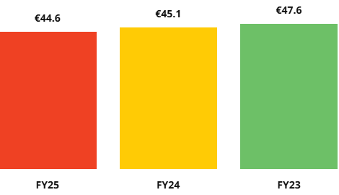
Figure.1: Ikea group sales
(Source: Ikea, 2026)
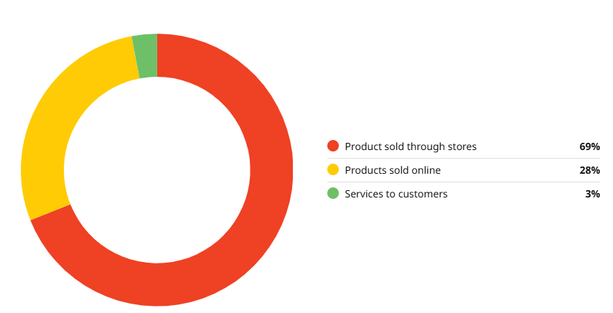
Figure.2: Share of Ikea retail sales
(Source: Ikea, 2026)

Vision, mission, and value:
The brand’s vision was to offer products at low prices and good quality. The company’s mission is driven by its focus on people and planet and doing an ethical business (Ikea, 2026d).

Employees, suppliers, and key competitors:
IKEA’s seamless operational process worldwide operated by 231,000 employees (Ikea, 2026e). The company operates and collaborates with 2100 suppliers (Ikea, 2026b). However, apart from its strong internal collaboration, IKEA also has very strong competitors in the UK, namely, Amazon, Argos, B&Q, M&S (Statista, 2025).

Focused markets:
IKEA has also been strongly operating in the UK, planning on expanding the business more with its £2.25bn retail sales in the UK market for the financial year 2025. Similarly, in India, IKEA is also taking an expansion plan following the robust business growth and with a focus on opening more stores around the country (Paramasivam, 2026).

A. Comparative analysis of the market in India and UK:
The Macro Environment analysis consists of a few different variables that help to align the organisation with the marketing strategy in improving or shifting the business environment.

PESTLE analysis for IKEA
Political
The UK government's timber usage and procurement regulations need furniture companies ensuring the ethical timber harvesting and sourcing (GOV.UK, 2025). IKEA has faced legal issues and acquisition of sourcing illegal woods from Europe (Greenpeace, 2024). Thus, not maintaining regulations can harm the operational process of IKEA harming their reputation in the UK.
On the other hand, In India under the single brand retail trading category brands are required to acquire 30% resources from India (Acharya, 2025). Ikea in India sourcing 30% of resources for its business operation (PTI, 2025). Therefore, maintaining political regulations will bring political security to IKEA.
Economic
In 2024, the UK’s furniture market growth and revenue valued at USD 21.89 Billion (Yahoo Finance, 2025). IKEA created 150 jobs for their exceptional positions in the UK’s retail industry, contributing to the UK’s economy by creating job opportunities (Ingka Group, 2025). Thus, the growing furniture market will help IKEA to grow its business. However, the Indian furniture industry market size is increasing further by USD 31.51 billion within 2026 (Mordor Intelligence, 2026) In India, IKEA is increasing its sales growth with an improvement of 6% in 2025 (Ranipeta, 2025). Hence, if the company fails to maintain its competitive advantage it might fail in the operating process reducing its position among competitors.
Social
The UK’s demographic and cultural trends, lifestyles, consumer preferences focused on home and living room furniture (Global Data, 2024). In the UK, IKEA is offering customers with home decor and room decor furniture (IKEA, 2026e). However, the company has decreased its sales by 2.1% in 2025 compared to 2024 (IKEA, 2025b). Therefore, this can pose a threat for IKEA if they do not perfectly align with customers' demand and market trends in future.
However, Indian customers prefer modular furniture, mostly focused on highly functional and stylish and technologically advanced furniture (Sharma, 2026). They offer modular and furniture designs for the Indian customers. Thus, IKEA can gain opportunities by aligning the business with the market and customers trends.
Technological
The UK government helps the furniture companies with R&D fundings, and sustainable energy technology (GOV.UK, 2024). IKEA is investing in renewable cooling and heating technology (IKEA, 2024). Using government funds can bring opportunities for IKEA in betterment of its technological transformation from fossil fuel to renewable sources.
While, the furniture retail sector in India is transforming adapting digital technologies aligning with AI in their supply chain (FDT Bureau, 2026). IKEA started investing in AI powered logistics systems in their operation and supply chain in India (IKEA, 2026f). Therefore, aligning with the market trend will be beneficial for IKEA to improve its competitive advantage in the Indian market.
Legal
UK’s product safety regulations come under the furniture and furnishing fire safety regulations 2025 (SafeGuardS, 2025). By integrating fire safety IKEA ensures its commitment towards the regulations and its customers (IKEA, 2026f). Therefore, the furniture and furnishing fire safety regulations aligns with the company’s operational process in the UK, thus, providing opportunity.
However, according to the Indian standard for furniture sellers, manufacturers, to ensure the safety and security aspects under the Bureau of Indian Standards Regulations, 2018 (Aleph, 2026). By maintaining the legal compliance of the Indian government, IKEA has gained the BIS safety and security certificate (Benerjee, 2025). Hence, this provides the regulatory security and improves the business reputation of the company in India.
Environmental
Building on the UK's rejection of persistent organic pollutants (POPs) in business and household materials, waste management is necessary (GOV.UK, 2024). IKEA designs products by discarding chemical flame retardants, and incorporating circular capabilities in the products (IKEA, 2026F). Hence, maintaining environmental regulations will be favourable for the business protecting it from regulatory disruptions in the UK.
However, The ESG regulations in India provides a regulatory framework for retail companies to ensure reduction in carbon emission, prevention, and control pf pollutions (Law Asia, 2024) In India, IKEA reduced carbon emission by 51% in 2023 (IKEA, 2026g). Therefore, the company can be beneficial in their operation process by maintaining environmental regulations in India.

Compare and contrast
The political context in the UK emphasised on maintaining legal timber sourcing, which IKEA has been accused of not maintaining by Greenpeace in 2024. In comparison with the UK market, IKEA is significantly growing in India by maintaining the country's political aspects, driven by 30% sourcing from the country itself. Thus, maintaining political aspects of a country significantly improves operational risk management of IKEA in India (Simmons, 2022). Social aspects are well maintained by the company, both markets focusing on the customers’ preferred furniture type and trend but in the UK IKEA's sales are decreasing. The UK market can be a soft position for IKEA as the decreasing sales can be led by the customers’ dissatisfaction with the product, as dissatisfaction can decline sales growth (Dekamini et al., 2024). Although in the UK the company focuses on its own R&D approaches, while in India, based on the market trend IKEA adapted AI in logistics, improving their supply chain. The legal and environmental aspects are also being maintained without any risk by IKEA. Therefore, with the growing opportunities and sales growth in the Indian market while some critical issues in the UK market suggest that India can be the right fit for IKEA to grow with the trend and operate seamlessly.

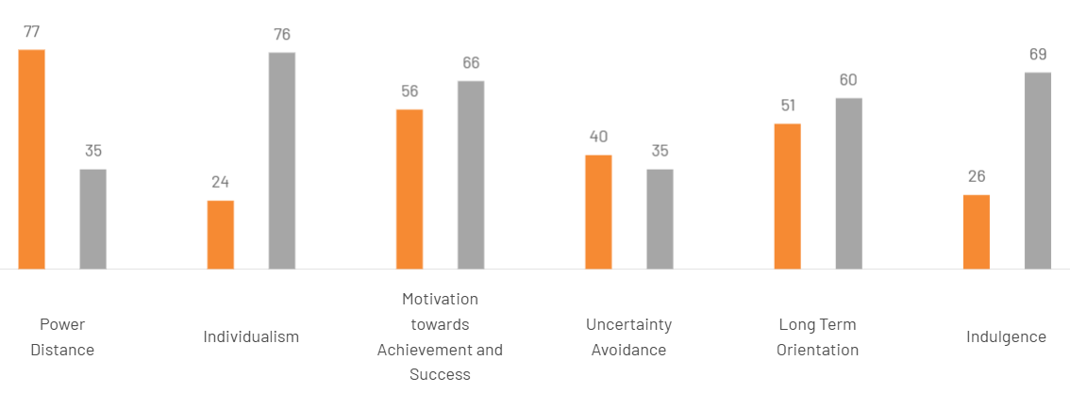
Comparison of Socio-cultural aspects by using Hofstede Model
Figure 3: Country comparison of UK and India
(Source: The culture factor group, 2026)
Power Distance:
In the power distance dimension, the UK has a fair play in the society (The culture factor, 2026). In the UK, IKEA has robust policies to close the gender gap while being a member of Equal Pay International Coalition to promote equal gender pay (IKEA, 2026m).
While, India has a high preference for hierarchical structure. However, IKEA is operating with a non-hierarchical approach in India with a focus on women empowerment, despite the society being hierarchical (IKEA, 2026n).
Individualism:
The UK is a highly individualistic society where personal fulfilment is a key to happiness (The cultural factor, 2026). In the UK, customers are preferring multifunctional sustainable design with eco-friendly furniture (Research and Markets, 2025). Focusing on customer preference IKEA is providing renewable, recycled furniture along with using sustainable materials in the UK (IKEA, 2026o).
While in India, focuses on collectivist and individualist traits (The cultural factor, 2026). The demand for modular furniture in India is growing, with a strong preference for sustainable solutions (Times of India, 2024). Depending on the customer's need and lifestyle in India the company has introduced modular, sustainable smart furniture’s in the Indian market (Biswas, 2022).

Motivation towards achievement and success:
Society in the UK is driven by a highly success oriented and decisiveness (The cultural factor, 2026). To motivate employees, IKEA invested for the financial wellbeing of the workers, focusing on pay increase (IKEA, 2023).
Similarly, India is also a decisive society, values the visual display of success and power (The cultural factor, 2026). In India, to show gratitude to employees for their effort and motivate them towards success, IKEA invested 150,120 each for its employees’ pension fund (IKEA, 2022).
Uncertainty Avoidance:
The UK’s societal trait is not being bothered with uncertainty, and consumers are attracted towards new innovations (The cultural factor, 2026). IKEA is consistent in introducing new innovative products in the UK market, focusing on the customers sustainable choices (IKEA, 2025a).
Whereas, in India, a medium low preference for avoidance of uncertainty is present (The cultural factor, 2026). In India, IKEA is also bringing new ideas and designs for furniture to help the Indian family live with durable furniture and modern designs (Biswas, 2022).
Long Term Orientation:
In this dimension, the UK has adaptation capability to new traditions in a changing context and time (The cultural factor, 2026). In the UK, demand for contemporary furniture design is growing, customers are significantly investing in new innovative ideas that are different from traditional furnishing (Mordor Intelligence, 2026).
Whereas, India has an intermediate dimension with a dominant preference on traditional approach with a balanced view (The cultural factor, 2026). In India customers are shifting towards durability, flexibility within their traditional furniture design focusing on circular living (Chaturvedi, 2025).

Indulgence:
In this dimension, the UK describes a high stance for indulging behaviour (The cultural factor, 2026). Focusing on providing customers seamless shopping experience, IKEA is providing accessibility, visibility in their website and increasing page speed (Salmon, 2025).
India is a pessimistic society that does not enjoy indulgence (The cultural factor, 2026). Although IKEA, to align with the market trend of digital shopping experience, has launched live streaming shopping experience in India (IKEA, 2022).
Overall, The Cultural Dimensions Theory developed by Hofstede assists in comparing the cultural differences between the UK and India by making the simplification of such values as individualism and power distance, which will aid in the market placement of IKEA. But it generalises national cultures, fails to account internal diversity and uses old data (Chaturvedi, 2025). The model might not be a complete reflection of the current consumer behaviour as culture changes; therefore, it needs to be applied cautiously with other analysis instruments.

B. A comparative analysis of STP and International Marketing Mix strategies in both countries

STP Framework for UK furniture market
STP Framework gives a blueprint for companies, providing positioning strategies, insight on market segmentation by providing robust marketing approaches (Agustian et al., 2025).
Segmentation:
Demographic-
In the UK, 89% of people between the age group of 55-64 and 93% of individuals between the ages 65 have shown interest in purchasing furniture (Opia, 2021). Additionally, in the furniture shopping process 50.9% female shoppers showed interest rather than 49.1% male shoppers have shown interest in furniture shopping in the UK (Talk, 2025).

Psychographic-
In the UK, the demand for eco-friendly and sustainable furniture is growing as customers are shifting towards more eco-friendly shopping driven by environmentally conscious choices (UK WEB GEEKZ, 2024). Furthermore, individuals in the UK are also preferring quality furniture while 93.9% of consumers stated that quality is an important factor (GlobalData, 2025). These behaviours align with VALS framework personality types such as “Thinkers” and “Experiencers,” who emphasise sustainability and informed purchasing decisions (Mallik, 2024).
Geographic-
In the context of purchasing furniture in the UK, people in the north east England spend almost £884 yearly. However, London is almost in the last spot in the furniture purchasing trend in the UK (Englanderline, 2023).
Behavioural-
In the UK market, customers are spending 20.6 billion for furnishing their home (Statista, 2026). Customers are purchasing more frequently as 30.5% of individuals showed stability in purchasing furniture in the last 12 months in the UK (RESEARCH AND MARKETS, 2026).
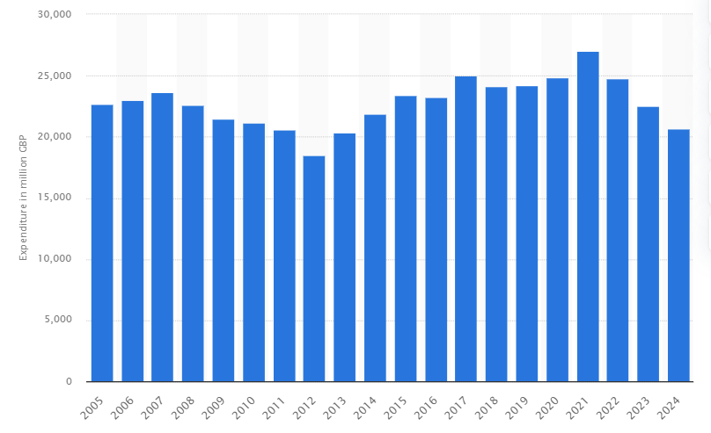
Figure.4: Furniture purchasing expenditure in the UK
(Source: Statista, 2026)

Targeting-
In the UK, IKEA focuses on cost conscious customers, young families, and middle-aged consumers who are looking for affordable and stylish home accessories and furniture (Perira, 2025). IKEA targets multiple market segments and gives distinct offers, which helps to attract customers (Alonso, 2022). This indicates that the company is adopting differentiated marketing to attract its customers.
Positioning:
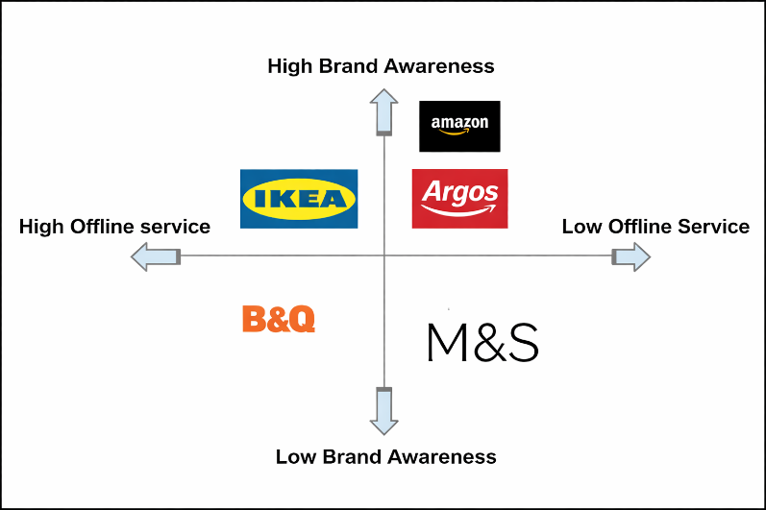
Figure.5: Positioning of Ikea’s competitors in UK Market
(Source: Statista, 2025)
IKEA’s strong competitors in the UK are Amazon, Argos, B&Q, M&S. The brand awareness of Amazon is 96%, and Argos is 95%, followed by IKEA with 92% (Statista, 2025). Moreover, it is found that IKEA ranks high selling products through stores or offline processes compared to the competitor (Statista, 2025).
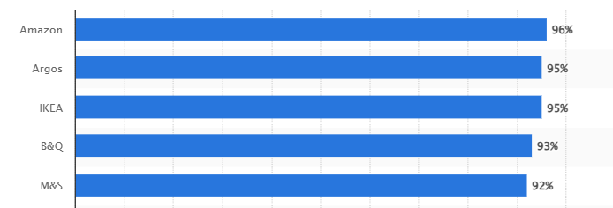
Figure.6: Leading furniture online shops ranked by brand awareness in UK.
(Source: Statista, 2025)
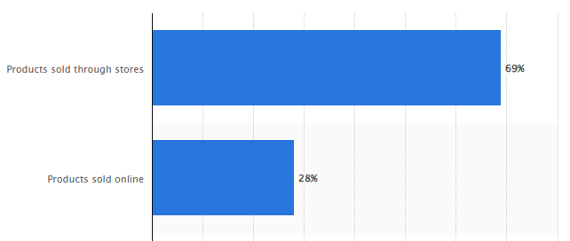
Figure.7: retail sales share of Ikea worldwide in 2025
(Source: Statista, 2025)

STP Framework: India furniture market
Segmentation:
Demographic-
In India, 62% of males and 37.7% of females responded to buy furniture products. Furthermore, it is also found that 35.6% of people in the age group of 31 to 40 years responded more in buying furniture products, followed by the age group under 41 to 50 years (Priyanka, 2023).
Psychographic-
In India, the majority of furniture consumers are preferring to buy multifunction, spacious modular design furniture because of the rapid growth of urbanisation, rising disposable incomes, and real estate sectors (Rebecca, 2025).
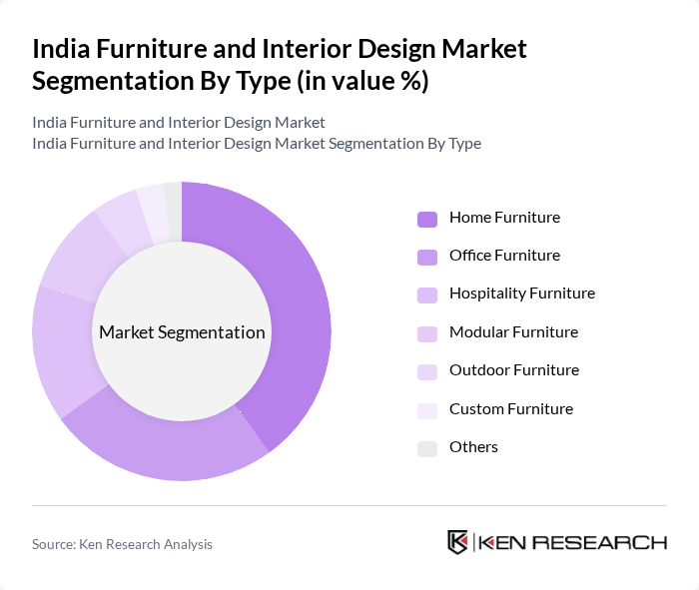
Figure.8: India Furniture and Interior Design Market Segmentation by Type
(Source: Rebecca, 2025)
Geographic-
Indian north regions are the growing hub for furniture purchasing trends with rapid urbanisation and disposal income (Research and Markets, 2026). Furthermore, Delhi, Ahmedabad are also quite engaging areas for customers to purchase furniture in India (FDT Bureau, 2026).
Behavioural-
In India, the furniture market size is increasing to USD 27.27 billion in 2026 with a growth rate of 8.24% CAGR (Mordor Intelligence, 2026). Growing urbanisation and disposal income has shifted customers’ preference on purchasing modern furniture very frequently, which stated the market growth 2.67% annually (Statista, 2025b).
Targeting:
The differentiated marketing approach focuses on knowing the characteristics of the market and then segmentise their strategies with unique techniques to differ from competitors (Xiao et al., 2022). Based on the differentiated marketing approach, IKEA offered space saving ideas with modular designs for the Indian customers (IKEA, 2026J).
Positioning:
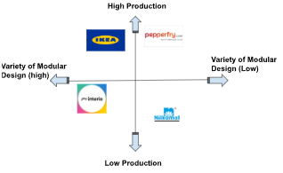
Figure.9: Positioning of Ikea’s competitor in the Indian Market
(Source: Modor Intelligence, 2025)
In India, IKEA faces strong competition with local brands, namely, Godrej Interior, Nilkamal, Pepperfry and more (Mordor Intelligence, 2025). IKEA India competes via affordability of products, modular designs, and online personalization services.

Compare and contrast:
Through the STP framework, IKEA’s positioning and attracting strategies in two different markets namely, India and UK, has been gathered. The demographic consists mostly of female customers from the mid-age group (Talk, 2025). Their preference and demand towards sustainable, eco-friendly shopping make them frequent furniture shoppers. In contrast, the Indian customers are creating the difference as the furniture purchasing trend is driven by male dominance (Priyanka, 2023). While in India, the customers are mostly purchasing modular and spacious furniture (Rebecca, 2025). Depending on the different market demand, customer preference, age and gender of the customers in the UK furniture market and Indian furniture market, IKEA has significantly taken the standardization strategy taking by differentiated marketing style in both of the markets.

Marketing Mix
Product:
Within UK
Core - In the UK, the demand for eco-friendly and sustainable furniture among UK consumers is increasing (UK WEB GEEKZ, 2024). The consumer's preferences shifted to natural, durable, affordable, and sustainable furniture for every space (Yahoo Finance, 2025).
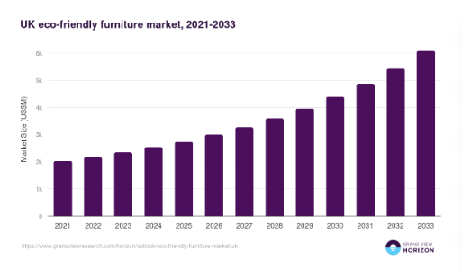
Figure.10: UK eco-friendly furniture market, 2021-2033
(Source: Grand View Research, 2026)
Actual- According to the demand, the company is adapting the trend and providing furniture with cushioning for the earth and sustainable design with FSC (Forest Stewardship Council)- certified wood and renewable natural fibres (IKEA, 2026b).
Augmented- In the UK Ikea offers rewards and points along with discounts and just-for-members food offers (IKEA, 2026). It also offers instant benefits and replacement offers along with planning tools, interior design, and financial services to its customers (IKEA, 2026).
Within India
Core- In India, customers are mostly preferring smart furniture with modular features and also preferred space-saving features in it (Trang Bricks India, 2026).
Actual- by focusing on adaptation, IKEA is providing smart design for furniture along with modular furniture design which are also appropriate for any kind of space ratio (IKEA, 2026p).
Augmented- IKEA also provides significant offers on its products. Similarly, different offers in different types of furniture are also provided by IKEA in India (IKEA, 2026p).
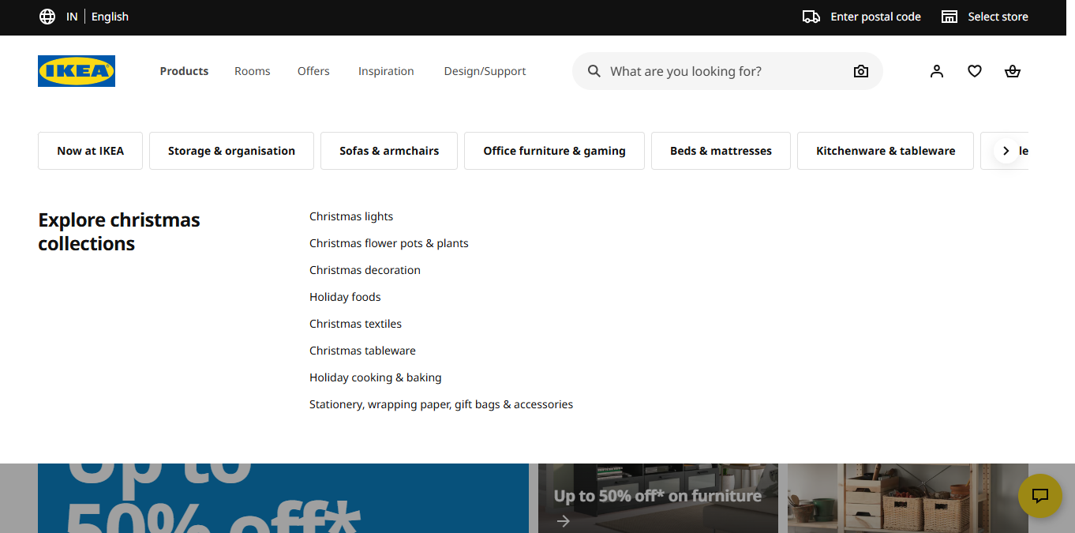
Figure.11: Products of IKEA India
(Source: IKEA, 2026)
Price:
Customers in the UK are demanding sustainable and affordable furniture due to the cost-of-living pressure (Research and Markets, 2026). Building on a robust pricing strategy, IKEA’s operation in the UK market is based on providing customers with sustainable furniture at affordable pricing (IKEA, 2024). Thus, IKEA is adapting to the customers' demand and has invested £117 million to lower the price of its products in the UK (IKEA, 2024).
Whereas the Indian furniture market size is scattered into multiple segments and highly competitive with key competitors (Research and Markets, 2025). Therefore, IKEA also uses competitive pricing by leveraging its flat-pack furniture, which decreases the shipping and storage costs to match the prices of the competitors by taking an adaptation approach (IKEA, 2026).
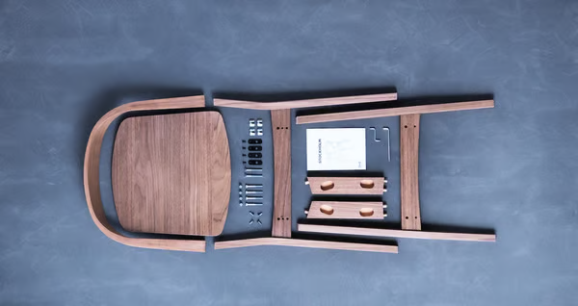
Figure.12: IKEA delivered flat-packed to save customers’ money
(Source: IKEA, 2026)
Place:
In the UK, shoppers prefer a multichannel approach while shopping for furniture consisting of both in-store and online purchasing (Furniture News, 2024). That’s why IKEA is currently operating with 22 stores in the UK with in-store customer service (IKEA, 2026r). Similarly, the company is engaging customers in campaigns on their websites as well (IKEA, 2026k).
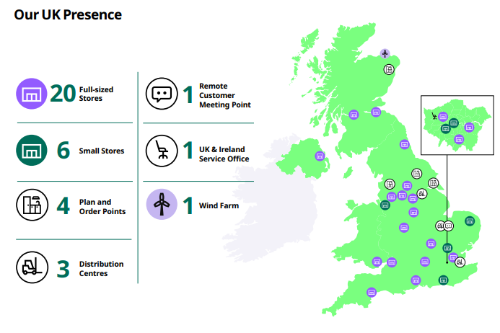
Figure.13: UK Presence of IKEA
(Source: IKEA, 2026)
Whereas, in India, 45% of customers prefer hybrid channels for shopping (Fibre2Fashion, 2025).
Therefore, taking the adaptation strategy, IKEA seamlessly operates in both online and in-store shopping processes across India and provides a user-friendly website for customers (IKEA, 2026).
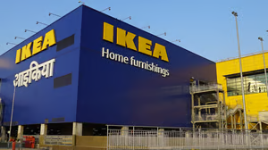
Figure.14: IKEA store- Navi Mumbai
(Source: IKEA, 2026)
Promotion:
In the UK 76% adults have a habit of watching television (YouGov, 2024). By adapting these cultural aspects, IKEA uses TV advertisements to promote its brands along with online video and BVOD, cinemas, PR, meta, and in-store (IKEA, 2025).
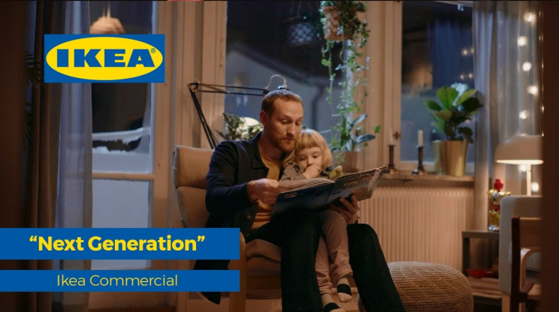
Figure.15: IKEA Next Generation Emotive Commercial
(Source: Larena, 2020)

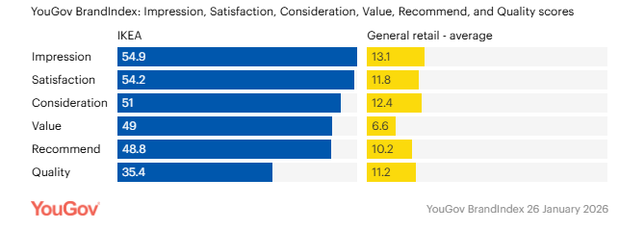
Figure.16: IKEA’s brand measures in the UK compared to other retailers
(Source: YouGov, 2026)
In India, there are currently 985 million active social media users consisting from urban area to rural area (The Hindu Bureau, 2026). IKEA India partnered with Mallika Dua, Danish Sait, and Jahnavi Dasetty to enhance its social media advertisement, which indicates that the company is adopting an integrated marketing strategy (IKEA, 2022).
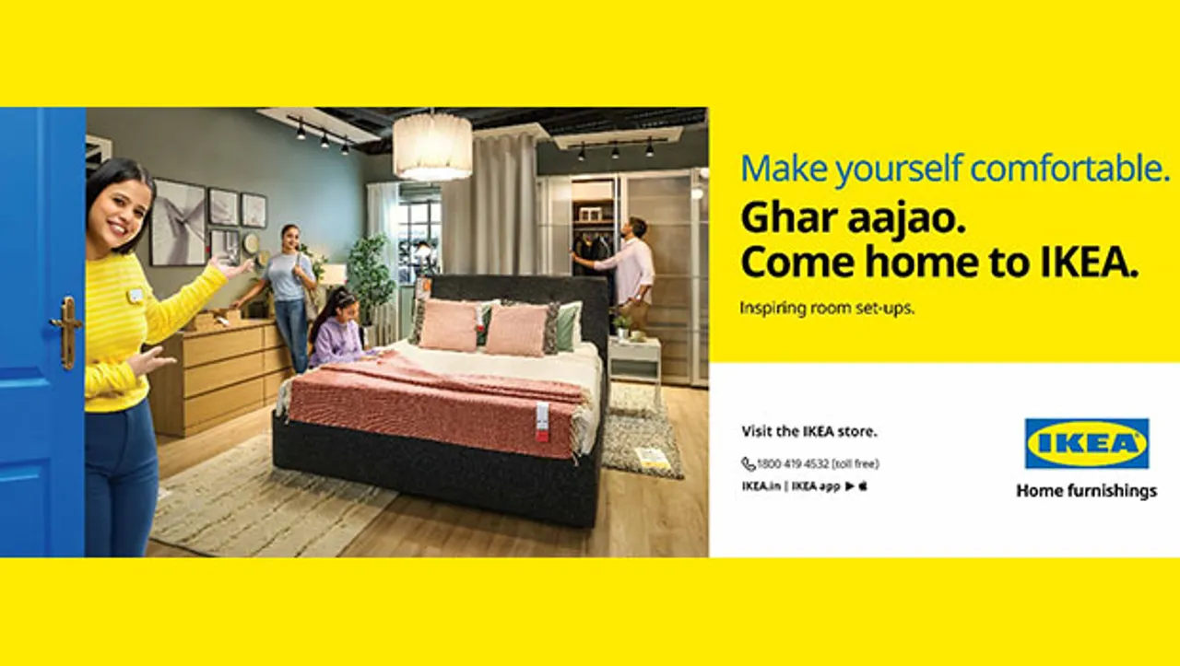
Figure.17: IKEA Ghar Aa Jao campaign
(Source: ET Brand Equity, 2022)
People:
In the UK, almost 86% workers are demanding flexible working hours focusing on work life balance (Businesswire, 2025). IKEA is adapting this culture and providing working flexibility to the workers along with assisting in employee well-being (Boyle, 2024). In the UK, IKEA has approximately 11,728 employees across its operations.
In contrast, IKEA India employs around 3,000 employees, reflecting its relatively newer market presence (IKEA, 2026). In India, the new labour code is focused on creating a gender equal workforce, wage equality, and women empowerment policies in the workforce (Tewari, 2025). By adapting India’s labour code, IKEA is maintaining a gender balanced workplace with 46% of women employees (Mitra, 2023). However, in spite of suppliers' code of conduct, IKEA India faced challenges due to children working at Indian rug suppliers violating child labor rules and regulations (IKEA MUSEUM, 2026).
Process:
IKEA is operating in the UK with 2100 suppliers who are responsible for the company’s raw material sourcing (IKEA, 2026). Additionally, by supporting customers' online purchasing intentions, IKEA also improved its delivery options and provided online delivery to the customer by following adaptation strategy (IKEA, 2026m). However, IKEA has been accused of illegal timber sourcing by destroying European ancient forest (Greenpeace, 2024).
However, the company sources its raw material from 48 suppliers in India while working with 400000 coworkers in the operational process using modern manufacturing technologies (IKEA, 2026r). IKEA operates in India in both offline and online mode where the customers connect in the purchasing process (IKEA, 2026q). Thus, IKEA standardised its operational approach in India.
Physical evidence:
IKEA stores are designed as room-by-room showrooms, which aim to create appealing stores for UK customers (Peacock, 2025). The warehouse stores in the UK are designed in a circular design and one-way systems to encourage window shopping (BBC, 2018). Therefore, the company adopted an adaptation strategy in the UK market.
The official website of IKEA in the UK is one of the most effective physical evidence.
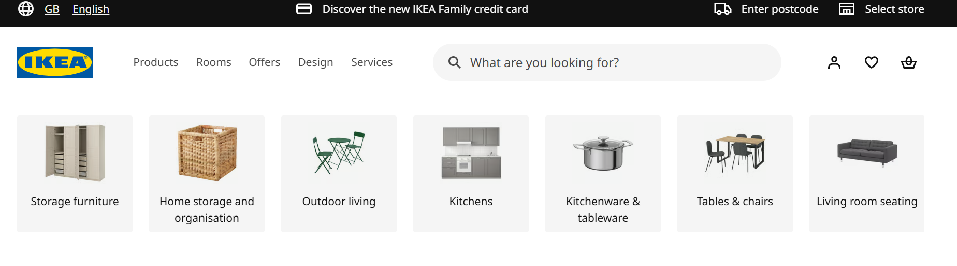
Figure.18: IKEA UK website
(Source: IKEA, 2026)
Across India, IKEA stores have separate sections according to customer preference, such as showroom, market hall, self-serve area, and circular hub to simplify customer experience (IKEA, 2026). By adapting the need for Indian customers, IKEA offers Hindi and English on their website including other languages based on region (IKEA, 2026). Their official website for Indian market is also physical evidence.
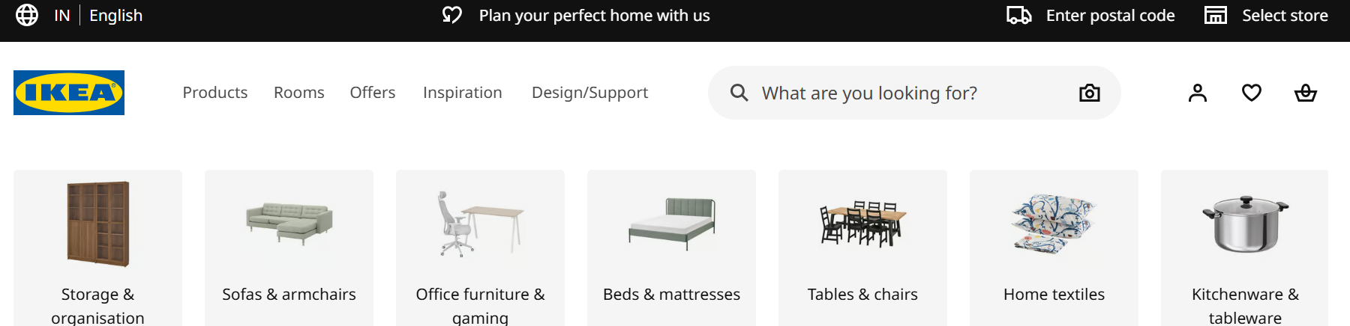
Figure.19: IKEA India website
(Source: IKEA, 2026)

Compare and contrast
With the growing demand for sustainable products, durable furniture in the UK market, IKEA is providing sustainable value and durable furniture in the UK. While in India with a growing trend for modular furniture, smart design, the company aligns its product accordingly. In the rapidly evolving business trend, adapting new strategies in markets is important to improve operational processes (Siswati and Rapitasari, 2024). Thus, IKEA is taking adaptation strategies in the UK and Indian market according to the customer demand. Similarly, IKEA used adaptation strategy in the UK, the company used a value-based pricing strategy to gain customers' willingness to purchase despite economic turmoil. While in India, IKEA's approach is based on competitive pricing to give customers better service than competitors. In the UK, companies operate in offline and online mode similarly in India, to provide customers with an omnichannel experience. Hence in this context, to achieve operational efficiency in the standardisation strategy helps in practicing consistency in service of IKEA in both markets (Kong et al., 2022). IKEA using mutichannel promotion consisting of in-store video, email marketing in the UK. While, the marketing approach in India IKEA focuses on localising campaigns, influencer marketing. Thus, IKEA has taken an adaptation approach in two different markets.

C. Directional development strategy of IKEA.
To introduce new service in India, IKEA has planned towards achieving long-term growth in the Indian market with the motivation for reaching double customers than before (Adgully Bureau, 2026). In this context, the Ansoff Matrix gives a strategic direction to brands’ fundamental growth options like market development, to guide towards development strategies. Market development emphasises on modifying existing products to attract new customers (Ferreira and de Sá, 2024). In north India, IKEA started its expansion with 7000+ products and solutions (IKEA, 2026t). Therefore, building on the market development factor in the Ansoff Matrix, IKEA is taking a directional development strategy in India by expanding its stores throughout the country.

D. Ethical issues
In the UK, IKEA faced challenges and accusations due to illegal timber sourcing by not maintaining the regulations and destroying the European ancient forest (Greenpeace, 2024). This has impacted the reputation of IKEA in the UK. In addition, in spite of IWAY suppliers’ code of conduct IKEA faced major challenges due to child labour ethical issues, working at Indian rug suppliers violating Indian child labour legal regulations (IKEA MUSEUM, 2026). Due to this accusation, IKEA faced supply chain issues by ending contracts with many suppliers and reputational damage (Rao, 2023). IKEA, along with its suppliers, built a partnership with UNICEF and collaborated with the Save The Children campaign to again build its reputation and make a safe working environment (IKEA, 2026)

E. Recommendations
Inclusion of B2B operation along with B2C - According to the STP analysis, it is found that IKEA faces production challenges with the local competitors in India (Girdhar, 2013). To rank among competitors based on production, IKEA should strengthen its manufacturing and production process in every operating country by increasing its supply chain network and launching B2B operations with target clients to mitigate the production challenges. This strategy of strengthening B2B customers and supply chain networks will reduce production downtimes and enhance efficiency by collaborating with trustworthy businesses.
Adoption of trendy “Phygital” (Physical and Digital) marketing - IKEA traditionally used integrated marketing strategy coordinating all promotional tools. However, it is seen that the company rarely promotes through TV advertisements in international markets, where middle aged people favour TV advertisements (Liu, 2022). To improve its international marketing, and spread awareness among every age group, IKEA should focus more on phygital marketing to merge physical and digital platforms (Mishra, 2023).
Encouraging transparency to mitigate greenwashing issues- IKEA claims FSC certified and recycled sources of wood in their publicity campaign (IKEA, 2026). In spite of its claim, the company faced accusation due to illegal timber sourcing, triggering greenwashing issues (Greenpeace, 2024). To mitigate greenwashing, IKEA should adopt a multi-layered strategy with interconnected pillars of transparency, stakeholder engagement, third party verification, internal controls, and technologies (Sneideriene, 2026).

Conclusion
From the above discussion, it can be concluded that in the case of the macro environment of the UK and Indian market, IKEA is well fit for the Indian market with a growing trend, seamless operation, and maintained reputation. However, through STP analysis, it is found that IKEA is taking the approach of differentiating marketing strategy in both markets by depending on market demand. Moreover, in spite of some ethical issues of illegal raw material sourcing in the UK and challenges of child labor issues working the Indian rug suppliers in India, IKEA is taking steps to control and regain its reputation in both markets.

Section 2:

Reflection:
Description:
In the process of conducting this report, I have done an in-depth exploration of the chosen company, namely, IKEA. Throughout the exploration process, I have chosen two countries, namely, UK and India, where the company is currently operating, focusing on the company's approach towards its business process. Similarly, to analyse the macro environment of IKEA in the UK and India I have initiated PESTLE analysis. Through the analysis, I have gained knowledge about which has given me an insight into comparing both markets’ regulatory, societal economical regulations and factors impacting IKEA’s business and can impose possible threats in the company’s operation. To gain the cultural perspective of both markets, I have utilised Hofstede's cultural dimension framework and gained a comparative overview. I have further conducted STP, to get an insight into IKEA’s present marketing approach and strategies in the UK and Indian market, comparing the success rate. Initiation of 7Ps in the Marketing mix has also been used by me to evaluate the current situation of the company’s strategic approach regarding adaptation and standardization in two different countries and comparing the state of the operational success. In the way of analysing the performance level I have also evaluated the company’s financial performance in the UK and India and gained secondary data from several new articles, company press releases and academic journals.
Feeling:
Searching for the information while analysing for the timely data built a sense of time rush into me, I have faced a certain level of distraction in my planning process and data sourcing process. Chu et al (2021) have highlighted that distraction has an influence on reducing focus, which can impact on the attraction in the nearest surroundings. Furthermore, I faced a time management issue in the process of evaluating the performance and operating situation of IKEA in the UK and India. I have continuously faced challenges in controlling my stress over multitasking. High stress levels and anxiety directly disrupt the time management aspects creating emotional and mental disbalance, which in fact affected me in some way (Kordzanganeh et al., 2021). I have faced a problem to focus on my research due to extreme stress and anxiety. Although, my tendency to maintain perfection and excitement on searching for information relating them to the existing business context have significantly improved my stress level making the evaluation process effective.
Evaluation:
Throughout the process of doing the comparative analysis of IKEA’s market performance in India and the UK, I have gained comprehensive knowledge on customers' changing preferences in both countries. I have gained a positive view on the relation between customer demand and aligning company’s product according to it. I observed the difference in the product IKEA offers in two different countries, which nonetheless aligned significantly with customer demand. I have explored the concept of adaptation and standardisation to analyse IKEA’s marketing approach in two different countries; while gaining a positive insight, it has also helped my evaluation process in comparing the dynamics of UK and Indian market. However, in the process of using Hofstede’s cultural dimension tool, I have faced difficulties in doing the comparison between IKEA’s performance and initiatives between two countries. While collecting secondary data for this research, I have explored multiple academic articles which has given me in-depth support gaining structured information about international marketing strategies.
Analysis:
By gaining knowledge on the concept of intentional marketing, I have been fulfilled with the insight of marketing strategies with external and internal environments in different markets (Donthu et al., 2021). Furthermore, during this research I have recognised that the international marketing mix framework has been implemented to analyse the controlled marketing strategies of IKEA in its business process in two different countries (Agusta and Yusnidar, 2024). Additionally, the cultural dimension model has been used to identify and compare the business strategies of IKEA between UK and Indian where the cultural perspective differs along with the societal aspects (Andersson et al., 2022).
Furthermore, by following the accurate steps from gathering information about the company and gaining its background, collecting secondary data about the company’s operational process in the UK and Indian market, I have recognised. Analytical skill has a significant impact on improving information evaluation, critical thinking and problem solving (Martodiryo et al., 2024). Therefore, improving analytical skill has sometimes effectively helped me to improve my research and mitigate the negative feelings and hurdles using problem-solving aspects.
Conclusion:
The comparative analysis of IKEA’s market position, STP, and international marketing mix strategies has reflected my data analysis skills. Throughout the process of analysing the directional development strategy of IKEA in India, I have done in-depth synthesis of IKEA’s previous process and development strategies taken to introduce their brand position in India. Similarly, in the process of finding information, collecting secondary data, analysing data from two different countries, I could have used task planning to improve time management and reduce multi-tasking. Although I have also learned the significance of the comparative analysis process to know about IKEA’s performance and possible challenges the company can face by comparing its operational approach in two different countries.
Action Plan:
For improving my research capability further, I will firstly focus on my time management skills by focusing on task prioritising and setting a clear schedule of tasks (Lund and Wiese, 2021). With the intention of controlling my stress and anxiety, I will practice self-control and mindfulness practice to control my nervous system during rush (Mitsea et al., 2022). In this context, to further improve my comparative analysis skill I would be significantly involved with the data analysis process, which will sharpen my analytical skills further.

References:
Acharya, M. (2025) Single Brand Retail Trading. Available at: https://cleartax.in/s/single-brand-retail-trading (Accessed: 13 February 2026)
Adgully Bureau (2026) As homes turn into hustle spaces, IKEA India reinforces its brand position: It All Starts at Home. Available at: https://www.adgully.com/post/12031/as-homes-turn-into-hustle-spaces-ikea-india-reinforces-its-brand-position-it-all-starts-at-home (Accessed: 16 February 2026).
Agusta, M.A. and Yusnidar, Y. (2024) ‘Revisiting the Future of International Marketing Strategy in the Digital Age’ Journal of Applied Business and Technology, 5(3), pp.164-192. Available at: https://www.e-jabt.org/index.php/JABT/article/view/185
Agustian, A.M., Bakhri, S. and Faozi, M.M. (2025) ‘STP Analysis (Segmenting, Targeting, Positioning) and SWOT Analysis in Digital Marketing Strategies Infacing Business Competition at BT Batik Trusmi Cirebon’ Journal on Islamic Economics, Finance & Banking [Z-CONOMICS], 1(2). Available at: https://az-zahra.or.id/jiefb/article/view/157
Aleph (2026) BIS QCO for the Furniture (Tables and desks). Available at: https://alephindia.in/bis-qco-for-the-furniture-tables-and-desks.php (Accessed: 13February 2026).
Alonso (2022) How IKEA became a household name with digitalization, consistency, and experience Available at: https://www.cascade.app/studies/how-ikea-became-a-household-name (Accessed: 13 February 2026).
Andersson, S., Svensson, G., Molina‐Castillo, F.J., Otero‐Neira, C., Lindgren, J., Karlsson, N.P. and Laurell, H. (2022) ‘Sustainable development—Direct and indirect effects between economic, social, and environmental dimensions in business practices’ Corporate Social Responsibility and Environmental Management, 29(5), pp.1158-1172. Available at: https://onlinelibrary.wiley.com/doi/abs/10.1002/csr.2261
BangkokPost, (2025), Ikea launches series of price cuts as demand shrivels, Available at: https://www.bangkokpost.com/business/general/3104586/ikea-launches-series-of-price-cuts-as-demand-shrivels
Bennerjee, N. (2025) IKEA’s Big North India Launch: 10 Cities, Online Shopping & Faster Deliveries! Available at: https://www.indianretailer.com/article/retail-business/retail/ikeas-big-north-india-launch-10-cities-online-shopping-faster (Accessed: 13February 2026).
Biswas, S. (2022) How Ikea tweaked its products to woo India's shoppers. Available at: https://www.bbc.com/news/world-asia-india-60256867 (Accessed: 16 February 2026).
Boyd, J, C, (2018), How Ikea's shop layout influences what you buy, BBC,Available at: https://www.bbc.com/worklife/article/20180201-how-ikea-has-changed-the-way-weshop
Boyle, M, (2024), IKEA did what others only talk of doing & it was a game changer for India staff, The Economic Times, Available at: https://economictimes.indiatimes.com/news/company/corporate-trends/ikea-did-what-others-only-talk-of-doing-it-was-a-gamechanger-for-india-staff/articleshow/110901748.cms?from=mdr
Boyle, M. (2024) IKEA did what others only talk of doing & it was a gamechanger for India staff. Available at: https://economictimes.indiatimes.com/news/company/corporate-trends/ikea-did-what-others-only-talk-of-doing-it-was-a-gamechanger-for-india-staff/articleshow/110901748.cms?from=mdr (Accessed: 13February 2026).
Businesswire (2025) The Great Flexpectation: 86% of UK workers demand flexible hours as four-day week and “work-to-rule” go mainstream, Owl Labs report reveals. Available at: https://www.businesswire.com/news/home/20250924468170/en/The-Great-Flexpectation-86-of-UK-workers-demand-flexible-hours-as-four-day-week-and-work-to-rule-go-mainstream-Owl-Labs-report-reveals (Accessed: 13 February 2026).
Butler, S. (2024) Ikea says cutting prices ‘remains a priority’ after UK sales slide. Available at: https://www.theguardian.com/business/2024/oct/10/ikea-price-cutting-priority-uk-sales-slide (Accessed: 13February 2026). (Accessed: 13February 2026).
Carbon Trust, (2024), How to counter greenwashing with transparent communications, Available at: https://www.carbontrust.com/our-work-and-impact/guides-reports-and-tools/how-to-counter-greenwashing-with-transparent-communications
Chaturvedi, S. (2025) Flexible, Conscious, Unique: The New Face of Indian Living Spaces. Available at: https://www.news18.com/lifestyle/flexible-conscious-unique-the-new-face-of-indian-living-spaces-9369209.html (Accessed: 16 February 2026).
Chu, J., Qaisar, S., Shah, Z. and Jalil, A. (2021) ‘Attention or distraction? The impact of mobile phone on users' psychological well-being’ Frontiers in psychology, 12, p.612127. Available at: https://www.frontiersin.org/journals/psychology/articles/10.3389/fpsyg.2021.612127/full
Dekamini, F., Razvani, A., Ramona, B., Wanke, P. and Tan, Y. (2024) ‘Factors affecting customer dissatisfaction in chain stores’ Annals-Economy Series, 1, pp.45-56. Available at: https://www.researchgate.net/profile/Ramona-Birau/publication/379899209_FACTORS_AFFECTING_CUSTOMER_DISSATISFACTION_IN_CHAIN_STORES/links/6621053943f8df018d172bc0/FACTORS-AFFECTING-CUSTOMER-DISSATISFACTION-IN-CHAIN-STORES.pdf
Donthu, N., Kumar, S., Pandey, N. and Lim, W.M. (2021) ‘Research constituents, intellectual structure, and collaboration patterns in Journal of International Marketing: An analytical retrospective’ Journal of International Marketing, 29(2), pp.1-25. Available at: https://doi.org/10.1177/1069031X211004234
ET BrandEquity, (2022), Ikea India invites people home in new campaign, Available at: https://brandequity.economictimes.indiatimes.com/news/research/advertising/ikea-india-invites-people-home-in-new-campaign/94069313
FDT Bureau (2026) Business of Furniture in India 2023-2027-The Infusion of Technology in the Indian Furniture Industry. Available at: https://furnituredesignindia.com/articles/70660/business-of-furniture-in-india-2023-2027-the-infusion-of-technology-in-the-indian-furniture-industry (Accessed: 13February 2026)
FDT Bureau (2026) Know About India's Largest and Favourite Furniture Market. Available at: https://furnituredesignindia.com/articles/257/know-about-india-s-largest-and-favourite-furniture-market (Accessed: 13February 2026).
FDT Bureau (2026) The Rise of Sustainable Furniture Available at: https://furnituredesignindia.com/articles/10433/-the-rise-of-sustainable-furniture
Ferreira, A.P.P.F.S. and de Sá, M.M.B.P. (2024) ‘The importance of the Ansoff matrix for the study of the information services market’ The Canadian Journal of Information and Library Science, 47(2), pp.78-84. Available at: https://ojs.lib.uwo.ca/index.php/cjils/article/view/17432
Franchiseindia, (2026), IKEA to accelerate india expansion, double store count in next 18 months, Available at: https://www.instagram.com/p/DNmtIKuOCo8/
Furniture News (2024) Comparing the in-store and online shopping experiences. Available at: https://furniturenews.net/resources/comparing-the-in-store-and-online-shopping-experiences (Accessed: 13 February 2026).
Furniture News, (2025), J Sainsbury outlines Argos' H1 progress, Available at: https://furniturenews.net/news/j-sainsbury-outlines-argos-h1-progress#:~:text=Argos'%20sales%20were%20up%20%2B4.4%25,its%20highest%20market%20share%20since%E2%80%A6
Girdhar, (2013), How IKEA adapted its strategies to expand and become profitable in China, Business Today, Available at: https://www.businesstoday.in/magazine/lbs-case-study/story/how-ikea-adapted-its-strategies-to-expand-in-china-132642-2013-07-06
Global Data. (2024) United Kingdom (UK) Home Living Room Furniture Market Trends, Analysis, Consumer Dynamics and Spending Habits. Available at: https://www.globaldata.com/store/report/uk-home-living-room-furniture-market-analysis/ (Accessed: 13 February 2026).
GlobalData (2025) Customers prioritize quality furniture as confidence begins to rise, says GlobalData. Available at: https://www.globaldata.com/media/retail/customers-prioritize-quality-furniture-confidence-begins-rise-says-globaldata/ (Accessed: 13 February 2026).
GOV.UK (2024) From import to innovation: how Grown in Britain and ercol are transforming UK furniture manufacturing. Available at: https://www.gov.uk/government/case-studies/from-import-to-innovation-how-grown-in-britain-and-ercol-are-transforming-uk-furniture-manufacturing (Accessed: 13 February 2026).
GOV.UK (2024) Manage waste upholstered domestic seating containing POPs. Available at: https://www.gov.uk/guidance/manage-waste-upholstered-domestic-seating-containing-pops (Accessed: 13 February 2026).
GOV.UK (2025) Furniture and Furnishings (Fire) (Safety) (Amendment) Regulations 2025: UK. Available at: https://www.gov.uk/government/publications/furniture-and-furnishings-fire-safety-regulations/furniture-and-furnishings-fire-safety-amendment-regulations-2025-uk (Accessed: 13 February 2026).
GOV.UK (2025) Regulations: timber and FLEGT licences. Available at: https://www.gov.uk/guidance/regulations-timber-and-flegt-licences (Accessed: 13February 2026).
Grand view Horizon (2026) UK Eco-friendly Furniture Market Size & Outlook, 2026-2033. Available at: https://www.grandviewresearch.com/horizon/outlook/eco-friendly-furniture-market/uk (Accessed: 13 February 2026).
GrandViewResearch, (2026), UK Eco-friendly Furniture Market Size & Outlook, 2026-2033, Available at: https://www.grandviewresearch.com/horizon/outlook/eco-friendly-furniture-market/uk
Greenpeace (2024) IKEA furniture destroys some of Europe’s last remaining ancient forests. Available at: https://www.greenpeace.org/international/press-release/66349/ikea-furniture-destroys-some-of-europes-last-remaining-ancient-forests/ (Accessed: 13February 2026).
Hills (2022) Waste Industry Regulation for upholstered furniture. Available at: https://www.hills-waste.co.uk/news/legislation-for-upholstered-furniture-disposal (Accessed: 13 February 2026).
IKEA (2022) IKEA Group rewards loyalty with €96 million extra to co-workers pension fundings. Available at: https://www.ikea.com/in/en/newsroom/corporate-news/ikea-group-rewards-loyalty-with-eur96-million-extra-to-co-workers-pension-fundings-pube69e3530/ (Accessed: 16 February 2026).
IKEA (2022) IKEA India launches live streaming shopping experience ‘Live From IKEA’. Available at: https://www.ikea.com/in/en/newsroom/corporate-news/ikea-india-launches-live-streaming-shopping-experience-pubc8fd6370/ (Accessed: 16 February 2026).
IKEA (2025) Home is where the smart is: IKEA invites people to ‘show off your savvy’ Available at:https://www.ikea.com/gb/en/newsroom/corporate-news/ikea-invites-people-to-show-off-your-savvy-pub64ca3880/ (Accessed: 13February 2026).
Ikea (2025a) In FY25 IKEA UK continued long-term accessibility journey, and returned to growth in final quarter. Available at: https://www.ikea.com/gb/en/newsroom/corporate-news/ikea-continued-long-term-accessibility-journey-pub773f0040/ (Accessed: 13 February 2026).
IKEA (2025c) Ingka, IKEA’s parent company, makes its first renewable energy investment in India. Available at: https://www.ikea.com/in/en/newsroom/corporate-news/ingka-ikeas-parent-company-makes-its-first-renewable-energy-investment-in-india-pubf4411f90/ (Accessed: 13February 2026).
IKEA (2025o) We’re all in this together. Available at: https://www.ikea.com/gb/en/this-is-ikea/about-us/were-all-in-this-together-pubc8331c51/#:~:text=Leading%20the%20way%20by%20being,letting%20down%20quality%20and%20comfort. (Accessed: 16 February 2026).
IKEA (2025r) How many stores does IKEA have in the UK?. Available at: https://www.ikea.com/gb/en/customer-service/knowledge/articles/16b2503g-fe2f-4f1e-809e-0b5531gc438d.html (Accessed: 16 February 2026).
Ikea (2026) About IKEA. Available at: https://www.ikea.com/in/en/this-is-ikea/about-us/ (Accessed: 13 February 2026).
IKEA (2026) IKEA Food Tasty, affordable food for every occasion, Available at: https://www.ikea.com/gb/en/food/ (Accessed: 13February 2026).
Ikea (2026) IKEA year in review. Available at: https://www.inter.ikea.com/en/performance/ikea-year-in-review (Accessed: 13 February 2026).
IKEA (2026) Our services, Available at: https://www.ikea.com/gb/en/customer-service/services/ (Accessed: 13February 2026).
IKEA (2026) Products Available at: https://www.ikea.com/gb/en/ (Accessed: 13February 2026).
IKEA (2026) Sustainable living starts at home, Available at: https://www.ikea.com/in/en/this-is-ikea/sustainable-everyday/ (Accessed: 13February 2026).
Ikea (2026c) How we work. Available at: https://www.ikea.com/global/en/our-business/how-we work/#:~:text=Spread%20all%20over%20the%20world%2C,life%20for%20the%20many%20people (Accessed: 13 February 2026).
Ikea (2026d) The IKEA vision and values. Available at: https://www.ikea.com/us/en/this-is-ikea/about-us/the-ikea-vision-and-values-pub9aa779d0/ (Accessed: 13 February 2026).
IKEA (2026e) Decoration. Available at: https://www.ikea.com/gb/en/cat/decoration-de001/ (Accessed: 13 February 2026).
IKEA (2026F) Ingka Group acquires Locus, an AI-powered logistics software company to transform the IKEA home delivery experience. Available at: https://www.ikea.com/in/en/newsroom/corporate-news/ingka-group-acquires-locus-an-ai-powered-logistics-software-company-to-transform-the-ikea-home-delivery-experience-pub3d38b980/ (Accessed: 13February 2026).
IKEA (2026f) Our view on flammability. Available at: https://www.ikea.com/global/en/our-business/our-view-on/flammability/ (Accessed: 13 February 2026).
IKEA (2026g) Zero emission IKEA deliveries. Available at: https://www.ikea.com/in/en/this-is-ikea/climate-environment/zero-emission-ikea-deliveries-pub07b1dc70/ (Accessed: 13February 2026).
IKEA (2026k) IKEA Campaigns. Available at: https://www.ikea.com/gb/en/campaigns/ (Accessed: 13February 2026).
IKEA (2026m) Reports & Downloads. Available at: https://www.ikea.com/gb/en/newsroom/media-resources/reports-and-downloads-pub1c260b90/ (Accessed: 13February 2026).
IKEA (2026n) IKEA opens in India with opportunities for all. Available at: https://www.ikea.com/jo/en/ideas/ikea-opens-in-india-with-opportunities-for-all-pub51242f51/#:~:text=IKEA%20India's%20service%20office%20is,IKEA%20share%2C'%20says%20%C3%85sa. (Accessed: 16 February 2026).
IKEA (2026p) IKEA India-Affordable home furniture, designs & ideas - IKEA. Available at: https://www.ikea.com/in/en/ (Accessed: 16 February 2026).
IKEA (2026q) Is my location eligible for IKEA delivery, and what are the nearby delivery options?. Available at: https://www.ikea.com/in/en/customer-service/knowledge/articles/fe2f3117-f73d-4d46-84e4-c7gc14g1c4fd.html#:~:text=IKEA-,Is%20my%20location%20eligible%20for%20IKEA%20delivery%2C%20and%20what%20are,please%20Call%20us%20on%2018004194532 (Accessed: 16 February 2026).
IKEA (2026r) Expansion in India. Available at: https://www.ikea.com/in/en/newsroom/expansion-in-india-pub800130d7/ (Accessed: 16 February 2026).
IKEA (2026r) IKEA in India. Available at: https://www.ikea.com/in/en/this-is-ikea/ikea-india-pubb0de1ef1/#:~:text=IKEA%20in%20India,-IKEA%20India%20has&text=Today%20we%20source%20products%20for,in%20our%20extended%20supply%20chain (Accessed: 16 February 2026).
IKEA (2026s) IKEA answers the call to “When is IKEA coming to North India” with the launch of online deliveries. Available at: https://www.ikea.com/in/en/newsroom/corporate-news/ikea-answers-the-call-to-when-is-ikea-coming-to-north-india-with-the-launch-of-online-deliveries-pub889756b0/ (Accessed: 16 February 2026).
IKEA MUSEUM, (2026), Sceptical reception, Available at: https://ikeamuseum.com/en/explore/the-story-of-ikea/a-new-compass/#:~:text=On%20the%20advice%20of%20Save,in%20a%20studio%20in%20Germany.
IKEA Retail (2025) IKEA serves more customers and increases volumes in a challenging year. Available at: https://www.ingka.com/newsroom/ikea-serves-more-customers-and-increases-volumes-in-a-challenging-year/ (Accessed: 13 February 2026).
IKEA Retail (2025) IKEA serves more customers and increases volumes in a challenging year. Available at: https://www.ingka.com/newsroom/ikea-serves-more-customers-and-increases-volumes-in-a-challenging-year/ (Accessed: 16 February 2026).
IKEA(2024) IKEA UK stands with customers as it invests more than £117 million in lowering prices throughout financial year 2024. Available at: https://www.ikea.com/gb/en/newsroom/corporate-news/ikea-uk-it-invests-more-than-117-million-pounds-in-lowering-prices-pub20b45e30/ (Accessed: 13February 2026).
IKEA(2026m) Equal everyday commitment. Available at: https://www.ikea.com/gb/en/this-is-ikea/work-with-us/diversity-and-inclusion-pub86a2cb59/ (Accessed: 16 February 2026).
IKEA, (2026), Assembly Service for Online and Instore Shopping, Available at: https://www.ikea.com/in/en/customer-service/services/assembly/
IKEA, (2026), Explore our furniture & home furnishing range, Available at: https://www.ikea.com/in/en/#:~:text=Since%20most%20IKEA%20furniture%20is,%7C%20Tv%20units%20%7C%20Mattresses
IKEA, (2026), From co-worker uniforms to fresh, recycled designs, Available at: https://www.ikea.com/global/en/stories/design/vaxelbruk-collection-recycled-coworker-uniforms-240118/
IKEA, (2026), IKEA in India, Available at: https://www.ikea.com/in/en/this-is-ikea/ikea-india-pubb0de1ef1/
IKEA, (2026), IKEA Stores, Available at: https://www.ikea.com/in/en/stores/
IKEA, (2026), IKEA UK Annual Summary FINANCIAL YEAR 2025, Available at: https://www.ikea.com/gb/en/files/pdf/c1/ed/c1ed761a/ikea-2025-uk-report-final-2.pdf#:~:text=IKEA,IKEA%20UK%20Management%20Team%20lead
IKEA, (2026), Language, Available at: https://www.ikea.com/gb/en/
IKEA, (2026), Opening doors to diversity in India, Available at: https://www.ikea.com/global/en/stories/sustainability/opening-doors-to-diversity-in-india-230101/
IKEA, (2026), products,Available at: https://www.ikea.com/in/en/
IKEA, (2026), The wood we use, Available at: https://www.ikea.com/global/en/our-business/sustainability/wood-we-use/
IKEA, (2026), What is the layout of an IKEA store?, Available at: https://www.ikea.com/in/en/customer-service/knowledge/articles/39c45915-b3e0-424f-9950-97d6ed4bge2b.html
IKEA, (2026), What languages can I use for assistance other than English?, Available at: https://www.ikea.com/in/en/customer-service/knowledge/articles/4e129026-c850-49ce-811c-36c425017bg6.html
IKEA, (2026), Where are IKEA stores located in India?, Available at: https://www.ikea.com/in/en/customer-service/knowledge/articles/99c4002b-64gd-48c9-8282-2890862064fd.html
INGKA (2024) IKEA Retail unleashes AI revolution: empowering thousands to master the future of tech. Available at: https://www.ingka.com/newsroom/ikea-retail-unleashes-ai-revolution-empowering-thousands-to-master-the-future-of-tech/ (Accessed: 16 February 2026).
Ingka Group. (2025) IKEA UK breaks all records as 3,730 job seekers apply for Oxford Street store. Available at: https://www.ingka.com/newsroom/ikea-uk-breaks-all-records-as-3730-job-seekers-apply-for-oxford-street-store/ (Accessed: 13 February 2026).
Jain, R., Jain, S. and Jain, S. (2022) ‘Analyzing and exploring the effectiveness of each element of 7Ps of marketing mix’ International Journal of All Research Education and Scientific Methods (IJARESM), 10(1), pp.2455-6211. Available at: https://www.researchgate.net/profile/RiddhishaJain/publication/357657009_Analyzing_and_Exploring_the_Effectiveness_of_Each_Element_of_7Ps_of_Marketing_Mix/links/61d84cdfb6b5667157d148c7/Analyzing-and-Exploring-the-Effectiveness-of-Each-Element-of-7Ps-of-Marketing-Mix.pdf
Jang, H., Loh, J. and Chatrath, S.K., 2025. Navigating Kkondae bullying and power distance: generational perspectives and workplace dynamics in South Korean higher education. Human Resource Development International, pp.1-28. Available at: https://www.tandfonline.com/action/showCitFormats?doi=10.1080/13678868.2025.2535293
Kong, L., Hu, K. and Verma, R. (2022) ‘Service chains’ operational strategies: Standardization or customization? Evidence from the nursing home industry’ Manufacturing & Service Operations Management, 24(6), pp.3099-3116. Available at: https://pubsonline.informs.org/doi/abs/10.1287/msom.2022.1111
Kordzanganeh, Z., Bakhtiarpour, S., Hafezi, F. and Dashtbozorgi, Z. (2021) ‘The relationship between time management and academic burnout with the mediating role of test anxiety and self-efficacy beliefs among university students’ Available at: https://www.sid.ir/en/VEWSSID/J_pdf/ng101420210103.pdf
Larena, D, (2020), The emotional Ikea’s commercial after 80 years: “Next Generation”, Marketing Magazine Eslogan, Available at: https://en.esloganmagazine.com/ikea-commercial-next-generation/
Lau, S, (2025), IKEA’s Pricing Strategy: Leveraging Vertical Integration for Cost Efficiency, Newswirejet, Available at: https://newswirejet.com/ikea-pricing-strategy/#:~:text=IKEA%20employs%20psychological%20pricing%20to,customers%20to%20perceive%20greater%20affordability.
Law Asia (2024) Overview of the ESG framework in India. Available at: https://law.asia/esg-compliance-overview/ (Accessed: 13February 2026).
Lehren, W, A, (2021), kea likely to have sold furniture linked to illegal logging in forests crucial to Earth's climate, report says, NBC NEWS, Available at: https://www.nbcnews.com/science/environment/ikea-likely-sold-furniture-linked-illegal-logging-forests-crucial-earth-n1273745
Liu, (2023), “Standardized” Marketing Strategies of IKEA? The Challenges of China, BCP Business & Management, volume- 38,Available at: https://bcpublication.org/index.php/BM/article/download/3821/3728/3697
Lund, J.R. and Wiese, J. (2021) ‘Less is more: exploring support for time management planning’ In Proceedings of the 2021 ACM Designing Interactive Systems Conference (pp. 392-405). Available at: https://dl.acm.org/doi/abs/10.1145/3461778.3462133
Mahavir, A. (2025) Ikea UK (&IE) Win/Win Reciprocal Mentorship Programme – An Equitable Breakthrough Action. Available at: https://brc.org.uk/news-and-events/news/hr/2025/ungated/ikea-uk-ie-winwin-reciprocal-mentorship-programme-an-equitable-breakthrough-action/ (Accessed: 16 February 2026).
Mallik, D.A., (2024). Consumer preferences for plant-based herbal tea: post-Pandemic study on aeca tea using VALS framework through psychographic segmentation. In AI Impacts in Digital Consumer Behavior (pp. 291-321). IGI Global Scientific Publishing.
Marquis, C. (2025) IKEA’s Circular Economy: Redefining Sustainability In The Furniture Industry. Forbes. Available at: https://www.forbes.com/sites/christophermarquis/2025/01/14/ikeas-circular-economy-redefining-sustainability-in-the-furniture-industry/ (Accessed: 13 February 2026).
Martodiryo, S., Hadiyanto, M., Ratumbuysang, M.F. and Hasanah, M. (2024) ‘The Relationship of Analytical Skills and Information Literacy on Student Learning Outcomes of Economic Education Study Program at the Faculty of Teacher Training and Education, Lambung Mangkurat University’ Journal of Media & Management. SRC/JMM-253. DOI: doi. org/10.47363/JMM/2024 (6), 171, pp.2-4. Available at: https://www.academia.edu/download/115337972/The_relationship_of_analytical_skills_and_information_literacy.pdf
Mishra, A.B., Satarkar, M. and Joshi, S., (2023) IKEA-Phygital Transformation in Furniture Manufacturing Industry. International Journal of Emerging Research in Engineering, Science, and Management, 2(3), pp.06-09. Available at: https://doi.org/10.58482/ijeresm.v2i3.2
Mishra, B, A, (2023), IKEA - Phygital Transformation in Furniture Manufacturing Industry, International Journal of Emerging Research in Engineering, Science, and Management, volume- 2, pp- 06-09, Available at: https://ijeresm.com/wp-content/uploads/2023/10/2.-2303-6-9.pdf
Mitra, T, (2023), Gender equality has a positive impact on talent recruitment and retention, says IKEA’s Parineeta Cecil Lakra, ET Edge Insights, Available at: https://etedge-insights.com/industry/hr/gender-equality-has-a-positive-impact-on-talent-recruitment-and-retention-says-ikeas-parineeta-cecil-lakra/
Mitsea, E., Drigas, A. and Skianis, C. (2022) ‘Mindfulness for anxiety management and happiness: the role of VR, metacognition, and hormones’ Technium BioChemMed, 3(3), pp.37-52. Available at: https://www.researchgate.net/profile/Eleni-Mitsea/publication/363799817_Mindfulness_for_Anxiety_Management_and_Happiness_The_Role_of_VR_Metacognition_and_Hormones/links/64b6c8a395bbbe0c6e466cf4/Mindfulness-for-Anxiety-Management-and-Happiness-The-Role-of-VR-Metacognition-and-Hormones.pdf
Mordor Intelligence (2026) India Furniture Market Size & Share Analysis - Growth Trends and Forecast (2026 - 2031). Available at: https://www.mordorintelligence.com/industry-reports/india-furniture-market (Accessed: 13 February 2026).
MordorIntelligence (2026) India Wood Furniture Companies: Leaders, Top & Emerging Players and Strategic Moves Available at: https://www.mordorintelligence.com/industry-reports/wood-furniture-market-in-india/companies#:~:text=The%20India%20wood%20furniture%20category%20features%20Godrej,focus%20on%20supply%20chain%20differentiation%20and%20consumer%2D
Onalaja, A.E. and Otokiti, B.O. (2021) ‘The role of strategic brand positioning in driving business growth and competitive advantage’ International Journal of Multidisciplinary Research and Growth Evaluation. 2(1), pp.1-835. Available at: DOI: https://doi. org/10.54660/.
Opia (2021) UNCOVERING MARKET SENTIMENT IN THE UK FURNITURE SECTOR. Available at: https://f.hubspotusercontent00.net/hubfs/5153250/Opia-Retail-Confidence-Survey-furniture.pdf (Accessed: 13 February 2026).
Paramasivam, P., (2026) IKEA plans to double India investment to more than $2.20 billion over five years. Available at: https://www.reuters.com/world/india/swedens-ikea-plans-double-india-investment-22-billion-over-five-years-2026-01-20/ (Accessed: 13 February 2026).
Peacock, A, (2025), IKEA Oxford Street design for London “living in super small spaces”, denzeen, Available at: https://www.dezeen.com/2025/04/30/ikea-oxford-street-london-renovation-bdp/
Pereira (2025) Ikea Target Market Analysis Available at: https://businessmodelanalyst.com/ikea-target-market-analysis/?srsltid=AfmBOoqQ0BeEVuaMvWC7gayZBpThTE19J7OxXx_C3wPdIzHlo1CKG6p3 (Accessed: 13 February 2026).
Priyanka, S, Govindraj, V, (2023), FACTORS INFLUENCING THE CONSUMERS TO PURCHASE HOUSEHOLD FURNITURE IN DHARMAPURI DISTRICT, INTERNATIONAL JOURNAL FOR INNOVATIVE RESEARCH IN MULTIDISCIPLINARY FIELD, volume- 9, issue- 1, Available at: https://www.ijirmf.com/wp-content/uploads/IJIRMF202301016.pdf
PTI (2025) IKEA to amplify sourcing from India for global operations, to increase local sourcing to 50%. Available at: https://economictimes.indiatimes.com/industry/services/retail/ikea-to-amplify-sourcing-from-india-for-global-operations-to-increase-local-sourcing-to-50/articleshow/121548805.cms?from=mdr (Accessed: 13February 2026).
Ranipeta, S. (2025) IKEA India reports 6% sales growth in FY25, targets profitability within two years. Available at: https://www.cnbctv18.com/business/ikea-india-6-pc-sales-growth-fy25-targets-profitability-19754672.htm (Accessed: 13February 2026).
Rao, Y, (2023), IKEA Case: One Company’s Fight to End Child Labor, Santa Clara Markkula Center, Available at: https://www.scu.edu/ethics/focus-areas/business-ethics/resources/ikea-case-one-companys-fight-to-end-child-labor/
Rebecca, (2025), India Furniture and Interior Design Market Ken Research, pp- 88 Available at: https://www.kenresearch.com/india-furniture-and-interior-design-market
Renascence.(2024) How IKEA Uses Technology to Improve Customer Experience (CX) in Retail. Available at: https://www.renascence.io/journal/how-ikea-uses-technology-to-improve-customer-experience-cx-in-retail
Research and Market (2025) India Furniture Market, By Region, Competition, Forecast & Opportunities, 2020-2030F. Available at: https://www.researchandmarkets.com/reports/4769687/india-furniture-market-by-region-competition?srsltid=AfmBOop4EmtpOFBE3S7RIejK-pV7QSkES-kwJmO8Q9b1vZxJ04jaYTCT (Accessed: 13 February 2026).
Research and Markets (2026) India Furniture Market, By Region, Competition, Forecast & Opportunities, 2020-2030F. Available at: https://www.researchandmarkets.com/reports/4769687/india-furniture-market-by-region-competition?srsltid=AfmBOorJWZm7bdDy1BYPWl5PZLmBqC76mW5PHMAz5M4Bp1VOmFrSpsxU (Accessed: 13February 2026).
SafeGuardS (2025) UK Updates Furniture and Furnishings Fire Safety Regulations. Available at: https://www.sgs.com/en-in/news/2025/06/safeguards-08525-uk-updates-furniture-and-furnishings-fire-safety-regulations (Accessed: 13 February 2026).
Salmon, K. (2025) IKEA tops ecommerce for best customer experience in 2025. Available at: https://ecommercenews.uk/story/ikea-tops-ecommerce-for-best-customer-experience-in-2025 (Accessed: 16 February 2026).
Schrotenboer, D., Constantinides, E., Herrando, C. and de Vries, S. (2022) ‘The effects of omni-channel retailing on promotional strategy’ Journal of theoretical and applied electronic commerce research, 17(2), pp.360-374. Available at: https://www.mdpi.com/0718-1876/17/2/19
Sharma, A. (2026) Furniture industry players see double-digit growth; demand momentum continues with real estate boost. Available at: https://retail.economictimes.indiatimes.com/news/home-and-decor/furniture-and-decor/furniture-industry-players-see-double-digit-growth-demand-momentum-continues-with-real-estate-boost/126317108?utm_source=latest_news&utm_medium=homepage (Accessed: 13 February 2026).
Simmons, O.S. (2022) ‘Political risk management’ Wm. & Mary L. Rev., 64, p.707. Available at: https://heinonline.org/hol-cgi-bin/get_pdf.cgi?handle=hein.journals/wmlr64&section=21
Siswati, E. and Rapitasari, D. (2024) ‘Optimization of Foreign Market Entry Through Adaptation to Changing Market Trends in The Destination Country’ International Journal of Science, Technology & Management, 5(4), pp.743-748. Available at: https://ijstm.inarah.co.id/index.php/ijstm/article/view/1121
Sneideriene, A, (2026), A Framework for Mitigating Greenwashing in Sustainability Reporting, MDPI,
Statista (2025) Leading furniture online shops ranked by brand awareness in the United Kingdom in 2024 Available at: https://www.statista.com/statistics/1342541/most-well-known-furniture-online-shops-in-the-uk/#:~:text=With%2096%20percent%20brand%20awareness,%E2%9C%95 (Accessed: 13 February 2026)
Statista (2025) Leading furniture online shops ranked by brand awareness in the United Kingdom in 2024 Available at: https://www.statista.com/statistics/1342541/most-well-known-furniture-online-shops-in-the-uk/#:~:text=With%2096%20percent%20brand%20awareness,%E2%9C%95
Statista (2025) Retail sales share of IKEA worldwide in fiscal year 2025, by sales channel Available at: https://www.statista.com/statistics/946210/ikea-sales-share-by-sales-channel-worldwide/?srsltid=AfmBOor_pPUxMceoPjsjqxT821HCs0Ms3w4cEiZotCzXGnm-38qqEYwl (Accessed: 13February 2026)
Statista (2025a) Furniture - India. Available at: https://www.statista.com/outlook/cmo/furniture/india?srsltid=AfmBOopyhlk6uQkElRjZOalkZH-tUPr4uFK71j6T1RmRjBT52_1nF_zl#revenue (Accessed: 13 February 2026).
Statista (2026) Annual expenditure on furniture and furnishings in the United Kingdom (UK) from 2005 to 2024, based on volume. Available at: https://www.statista.com/statistics/301022/annual-expenditure-on-furniture-and-furnishings-in-the-united-kingdom-uk/?srsltid=AfmBOopjjtHnq6CZK6iiRvYUDnVQmBEDj5ociodbw9DeaZcWXtY443-0 (Accessed: 13 February 2026).
Steinbrenner, F. and Turčínková, J. (2021) ‘The value-based pricing determination matrix for pricing method selection’ Central European business review, 10(4), p.99. Available at: https://www.ceeol.com/search/article-detail?id=1001656
Talk (2025) Furniture Shopping in Focus. Available at: https://talk-group.com/furniture-shopping-in-focus/ (Accessed: 13 February 2026).
Tewari, T. (2025) Can India’s new labour code finally bridge the gender divide at work? Available at: https://timesofindia.indiatimes.com/education/news/can-indias-new-labour-codes-finally-bridge-the-gender-divide-at-work/articleshow/125540539.cms (Accessed: 13 February 2026).
The culture factor (2026) Country Comparison tool. Available at: https://www.theculturefactor.com/country-comparison-tool?countries=india%2Cunited+kingdom (Accessed: 16 February 2026).
Times of India (2024) Growing demand for furniture manufacturing. Available at: https://timesofindia.indiatimes.com/city/mumbai/growing-demand-for-furniture-manufacturing-technologies-drives-focus-at-event-in-mumbai/articleshow/113189339.cms (Accessed: 13February 2026).
Times Of India, (2024), India to cut prices, widen online presence in India, Available at : https://timesofindia.indiatimes.com/business/india-business/ikea-to-cut-prices-widen-online-presence-in-india/articleshow/107273183.cms
Times of India, (2026), IKEA to roll out 10,000 sq ft compact stores for smaller cities across India in major retail strategy shift, Available at: https://timesofindia.indiatimes.com/business/india-business/ikea-to-roll-out-10000-sq-ft-compact-stores-for-smaller-cities-across-india-in-major-retail-strategy-shift/articleshow/120766165.cms
Trang Bricks India (2026) What furniture is in high demand in India right now? Available at: https://trangbricks.co.in/what-furniture-is-in-high-demand-in-india-right-now (Accessed: 16 February 2026).
UK WEB GEEKZ (2024) Surging Demand for Eco-Friendly Furniture Drives Market Growth in the UK. Available at: https://www.einpresswire.com/article/739003983/surging-demand-for-eco-friendly-furniture-drives-market-growth-in-the-uk (Accessed: 13 February 2026).
UK WEB GEEKZ (2024) Surging Demand for Eco-Friendly Furniture Drives Market Growth in the UK. Available at: https://www.einpresswire.com/article/739003983/surging-demand-for-eco-friendly-furniture-drives-market-growth-in-the-uk (Accessed: 13February 2026).
Xiao, X., Fang, C., Lin, H. and Chen, J. (2022) ‘A framework for quantitative analysis and differentiated marketing of tourism destination image based on visual content of photos’ Tourism Management, 93, p.104585. Available at: https://doi.org/10.1016/j.tourman.2022.104585
YahooFinance (2025) UK Bedroom Furniture Consumer Trends Report 2025 | IKEA Leads Market, Range is Key Buying Driver Available at: https://uk.finance.yahoo.com/news/uk-bedroom-furniture-consumer-trends-144100973.html?guccounter=1&guce_referrer=aHR0cHM6Ly93d3cuZ29vZ2xlLmNvbS8&guce_referrer_sig=AQAAAMYapzTSLYsELW3J0CVjB7v7Qu7r9M3risXKij5QDEvo326QsbPcN8JNdCVEdw_XkjQeYu_7twMbJ3LhBvgV5cdjCxfVMJSGiDpwuMtWhruCDfWhLm-DbArBRU2tTPUi9-CKL5I6F0hyVXW-R6xLlKQZIrMQngCQdK7fKSyypa4s (Accessed: 13 February 2026).
YouGov, (2026), IKEA’s new campaign puts the spotlight on quality – but what do consumers think?, Available at: https://yougov.com/en-gb/articles/53971-ikeas-new-campaign-puts-the-spotlight-on-quality-but-what-do-consumers-think

