Student Name: Ahmed Youssouf Assiata
Student ID: 2407208
Module code : ACCA5023
Lecture : Md Abrar Jahin Almazi Bipon
Network Operating Systems and Services
Research, build, and deploy a Virtualised Enterprise network
[Email address]
Contents
Task1: Research 2
1.1 Research on Hypervisors 2
1.2 Research on IP Addressing 3
1.3 Research on Routine 4
1.4 Research on Network services 4
Task 2: Implementation and Configurations 5
2.1. Choice of Hypervisor 5
2.2 Download and Setup 6
2.2.1 Download from Official Sources 6
2.2.2 Deployment of Network Topology 6
Conclusion 17
Task 3: Reflection 18
3.1. Technical Reflection 18
3.2 Personal Reflection 18
References 18

Task1: Research

NOSSLONDON2026 Network Design, Implementation, and Reflection Report

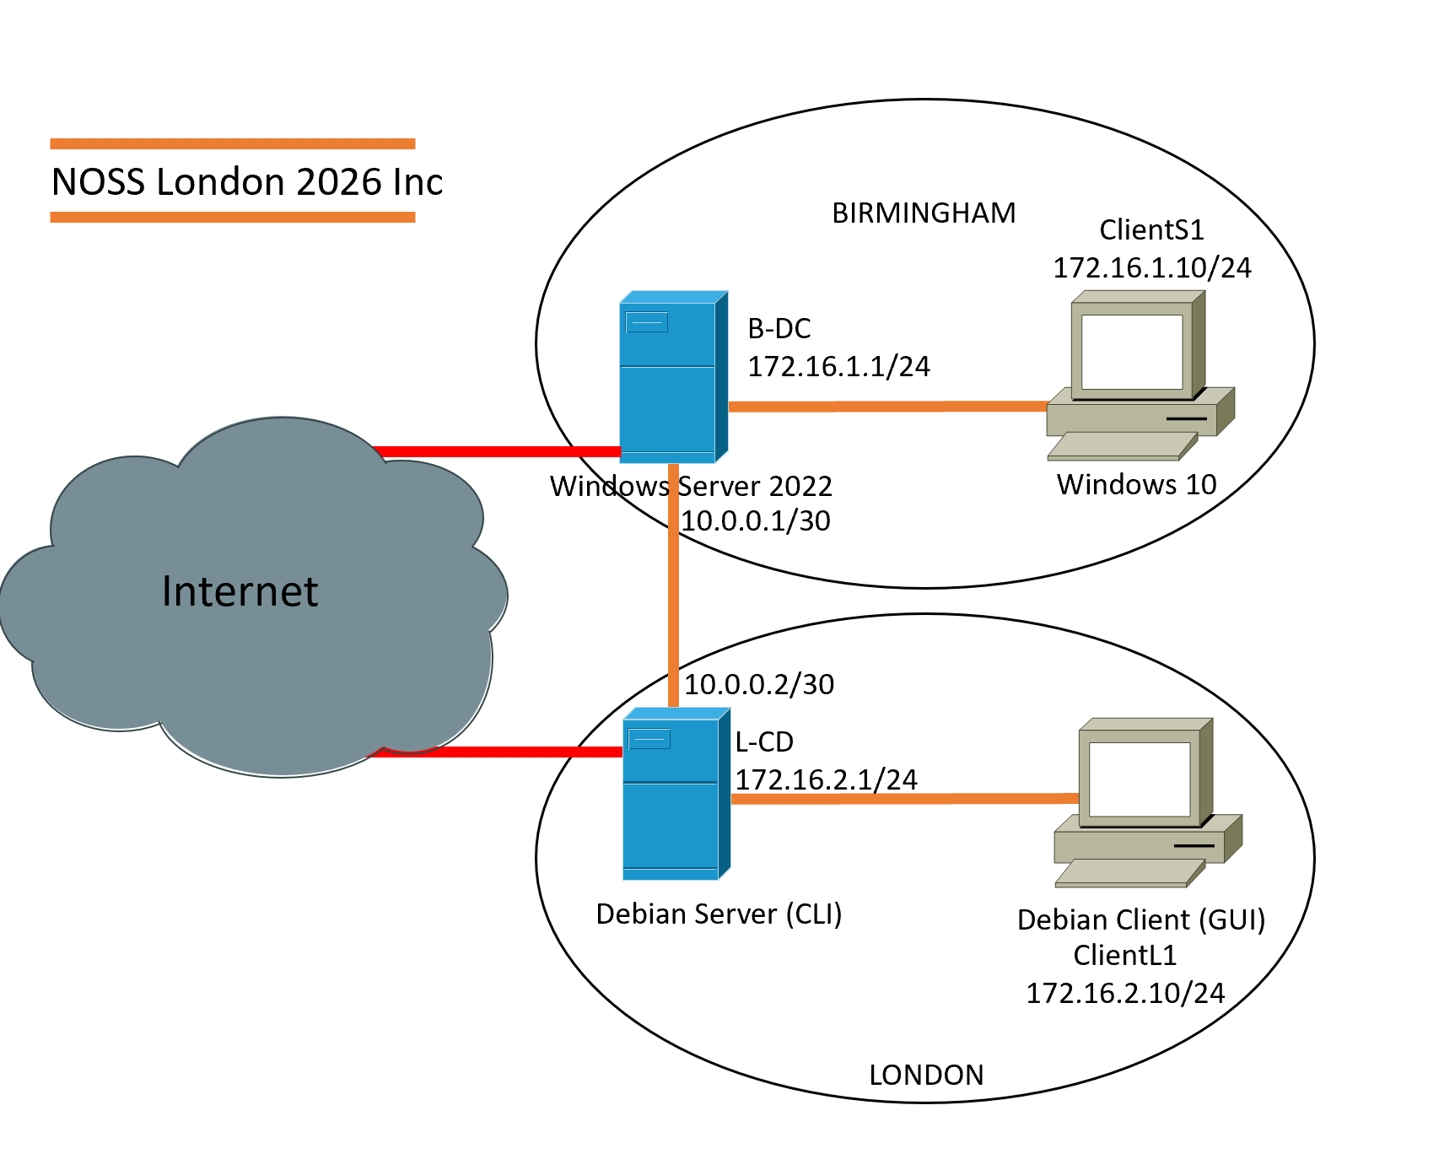

1.1 Research on Hypervisors
Hypervisors are essential components of modern virtualised infrastructures, allowing many operating systems to operate simultaneously on a single physical host. They work by abstracting physical resources and assigning them to virtual machines. There are two major types: bare-metal and hosted. Type 1 hypervisors run directly on hardware, with no underlying host operating system, whereas Type 2 hypervisors run on top of an existing operating system, relying on it for hardware access and device drivers [1].
Type 1 hypervisors provide a thin software layer between hardware and guest systems, reducing latency and increasing throughput. This architecture significantly decreases the attack surface because there are fewer components to exploit [2].
Type 2 hypervisors, on the other hand, offer more abstraction layers, increasing complexity and reducing predictability for performance-sensitive tasks like routing or directory services [3].
The environment for the NOSSLONDON2026 topology and its improved version includes a domain controller (BIRMINGHAM.ACCA) running Windows Server 2022 and a Debian server serving as a DHCP relay and routing node. These workloads necessitate continuous availability, excellent I/O performance, and robust isolation. Enterprise-grade Type 1 hypervisors, such as Hyper-V and VMware ESXi, provide hardware-assisted virtualisation (Intel VT-x/AMD-V), secure boot, and granular access control mechanisms [4].
Security plays an important role in domain-based environments because authentication services and routing processes are valuable targets. A hosted hypervisor imposes dependency on the host operating system, making it more vulnerable to privilege escalation attacks [2]. Furthermore, Type 1 hypervisors natively handle a variety of guest operating systems, including Windows and Linux variants such as Debian, ensuring interoperability within the same infrastructure [5].
Considering future scalability in Coursework 2, where VPNs, firewall services, and certificate authorities will be introduced, a bare-metal hypervisor provides better network throughput and management capabilities. Therefore, a Type 1 hypervisor is justified as the best appropriate solution based on performance efficiency, security posture, compatibility, and long-term extensibility.

1.2 Research on IP Addressing

Data is divided into packets and routed independently across various routers to facilitate Internet communication. IP addresses are logical identities for hosts and networks, allowing routers to establish forwarding routes [6]. Switches use MAC addresses at the data link layer, whereas routers use IP addresses at the network layer, allowing for inter-network communication [7].
IPv4 has a 32-bit addressing method, allowing for approximately 4.3 billion distinct addresses. Due to address exhaustion, IPv6 was invented, which uses a 128-bit hexadecimal format capable of accommodating an almost limitless number of devices [3]. An IPv4 address, such as 172.16.1.10, denotes both a host and a network part defined by a subnet mask (for example, /24).
IPv6 addresses, such as 2001:db8::1, eliminate the requirement for NAT and enable hierarchical routing architectures [6].
Subnetting separates huge networks into smaller logical units, which increases broadcast efficiency and security. Variable Length Subnet Masking (VLSM) optimises utilisation by assigning address space based on the actual host requirements [6]. For example:
Birmingham LAN: 10.10.1.0/24; London LAN: 10.10.2.0/24.
Inter-site link: 10.10.3.0/30.
The /30 subnet is used for point-to-point connections since it gives only two useable host addresses, reducing waste [8]. Hierarchical addressing reduces routing table size while increasing convergence speed.
IP addressing improves network efficacy by enabling structured routing, fault isolation, and scalability. Without subnetting, broadcast domains grow too big, causing latency and packet loss [7]. In this design, distinct subnets for Birmingham and London provide logical separation while maintaining controlled interconnection. Thus, IP addressing is more than just an identifying technique; it serves as the structural foundation for network design.

1.3 Research on Routine
Routing defines how packets go between networks based on predefined rules or dynamically learnt pathways. Static routing involves manually configuring routes and is best suited for small, stable networks. Dynamic routing protocols, such as RIP and OSPF, automatically communicate topological information and respond to problems [6].
Distance-vector protocols compute pathways based on neighbour information, whereas link-state protocols keep a complete topology map and use algorithms like Dijkstra's [3]. Dynamic routing enhances resilience, but it adds computational overhead and administrative complexity.
Static routing is more appropriate for the provided topology, which consists of two LANs linked by a single inter-site link. The Debian server handles DHCP relay and routing, while the Windows Server manages domains. There are no redundant paths, therefore dynamic routing would provide no major benefits. Static routing ensures predictable behaviour and lowers the likelihood of routing-based attacks like route poisoning or faked updates [7].
Limiting route advertising reduces the attack surface. Furthermore, DHCP relay capability relies on dependable inter-subnet connectivity, which static routes may provide. If VPN tunnels or extra branches are added to the upgraded topology, a dynamic routing system like OSPF may be required to maintain fault tolerance. However, static routing is best suited to the current architecture in terms of simplicity, security, and administrative control.

1.4 Research on Network services
Virtual Private Networks (VPNs) connect public networks via encrypted tunnels, ensuring data security and integrity [3]. Certificate-based authentication and powerful encryption methods like AES are considered best practices. DHCP automates IP setting, which reduces manual errors and allows for centralised control [7].
Active Directory Domain Services (AD DS) enables centralised authentication, authorisation, and policy enforcement. In this configuration, the Windows Server hosts the BIRMINGHAM.ACCA domain, which allows for consistent identity management across both sites. Best approaches include role separation, regular backups, and limiting domain controller exposure [9].
CAs build confidence by issuing and administering digital certificates. They support VPN, HTTPS, and secure authentication. Proper certificate lifecycle management is critical to preventing impersonation or misuse [3].
These services contribute to reliability and security. DHCP enables consistent addressing, AD DS enforces access controls, VPNs protect inter-site communication, and CAs give cryptographic trust. Weak configuration in any of these services can jeopardise the entire network, highlighting the interdependence of network services.

Task 2: Implementation and Configurations

2.1. Choice of Hypervisor
The Oracle VM VirtualBox hypervisor was chosen to implement this network topology. The selection was based on Coursework 2's technological capability, scalability, cost-effectiveness, and readiness for future network service implementation.
Virtualisation is the abstraction of computing resources that allows numerous operating systems to operate concurrently on the same physical equipment [1]. Hypervisors are classified as Type-1 (bare-metal) or Type-2 (hosted). Type-1 hypervisors, such as VMware ESXi, run directly on hardware, whereas Type-2 hypervisors run on top of a host operating system [2].
Oracle VM VirtualBox is a type-2 hypervisor that offers the following benefits:

1. Cross-Platform Compatibility
VirtualBox supports a variety of guest operating systems, including Windows Server, Windows client systems, and Linux versions like Debian. Because this course demands a diverse network environment (Windows and Linux), VirtualBox ensures easy deployment across platforms [3].

2. Advanced Networking Features
VirtualBox supports a variety of networking modes, including:
• NAT
•Bridged networking.
• Host-Only Networking
• Networking inside.
Internal networking is very significant in this design since it provides for isolated virtual LAN settings without external interference. Oracle documentation states that VirtualBox supports numerous internal network segments, which allows for structured subnet design [3].

3. Snapshot and Scalability
Snapshots allow system rollback, which is critical when deploying additional services such as DNS, DHCP, and Active Directory in Coursework 2. This supports iterative testing and risk mitigation [2].

4. Cost Efficiency and Accessibility
Most enterprise hypervisors, which require license, VirtualBox is open-source and free. This makes it appropriate for academic settings while preserving functionality [3].

Strong Justification Statement
Given compatibility, networking flexibility, cost, and future scalability requirements, Oracle VM VirtualBox is the best hypervisor for finishing this coursework and expanding it to advanced network services in Coursework 2.

2.2 Download and Setup

2.2.1 Download from Official Sources
All software was downloaded from official vendor websites to assure its validity, integrity, and security.
Hypervisor:
- Oracle VM VirtualBox is available on the official Oracle website.
- Server operating systems include:
- Evaluation Centre for Windows Server 2022 by Microsoft.
- Debian Server (CLI) can be found on the official Debian website.
- Client operating systems include:
- Download Windows 10 from Microsoft's official portal.
- Debian Desktop - Official website.
Using official vendor sources provides software authenticity while lowering security threats like malware infection [4].

Screenshot Evidence (With Timestamp)
Each screenshot should clearly display:
- System date/time
- Website URL.
- Version details.
This exhibits effective time management, prudent planning, and disciplined work completion.

2.2.2 Deployment of Network Topology
The network topology consists of:
- Windows Server
- London Server (Debian CLI Server)
- Windows Client
- Debian Client
Two isolated internal networks were configured within VirtualBox to simulate segmented enterprise network environments.
Each virtual machine was configured with:
- 2–4GB RAM (based on OS requirements)
- Virtual hard disk (VDI format)
- Internal Network Adapter

Screenshot Explanation – Windows Server Installation
This screenshot shows:
- Installation of Windows Server 2022
- Disk partition selection
- Visible timestamp
Explanation:
This confirms successful server OS deployment within the virtualized environment. The presence of timestamp validates task progression over time.
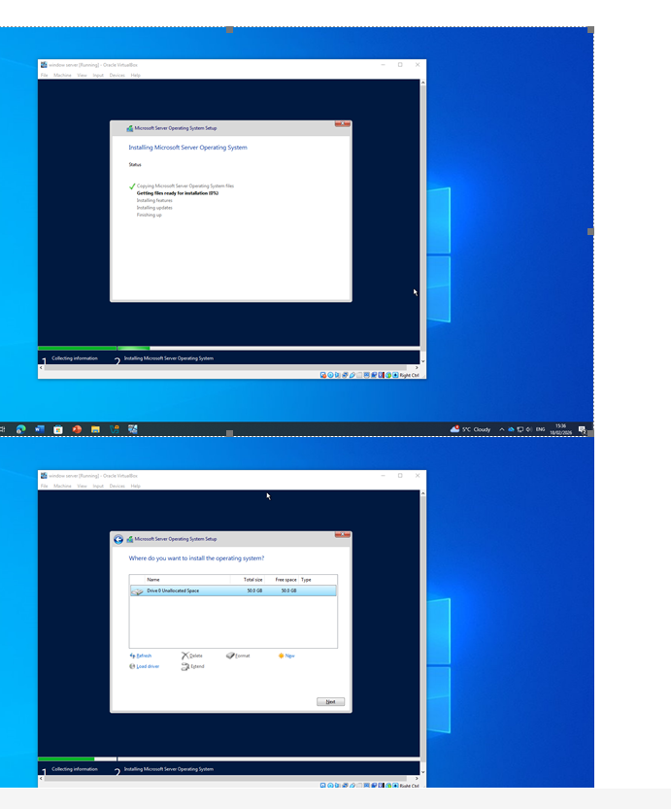

Screenshot Explanation – London Server (Debian CLI)
This screenshot shows:
- Debian CLI installation screen
- Network configuration prompt
- System time visible
- 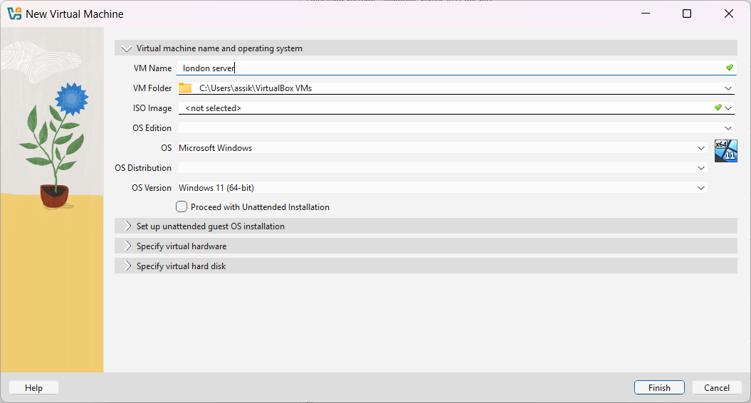

- 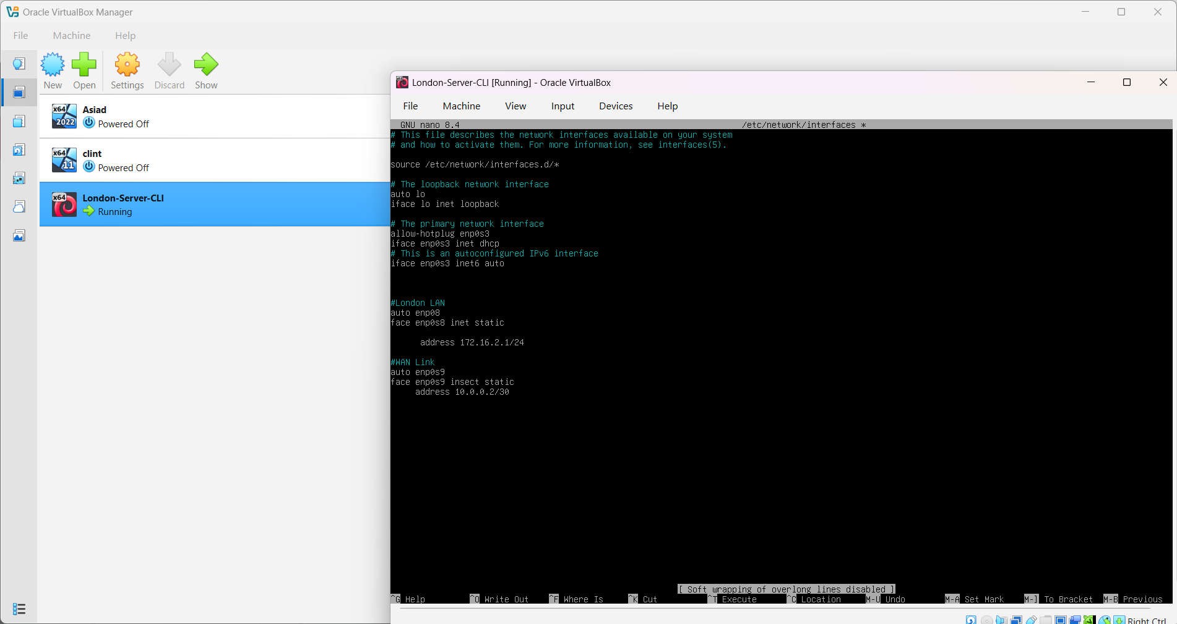

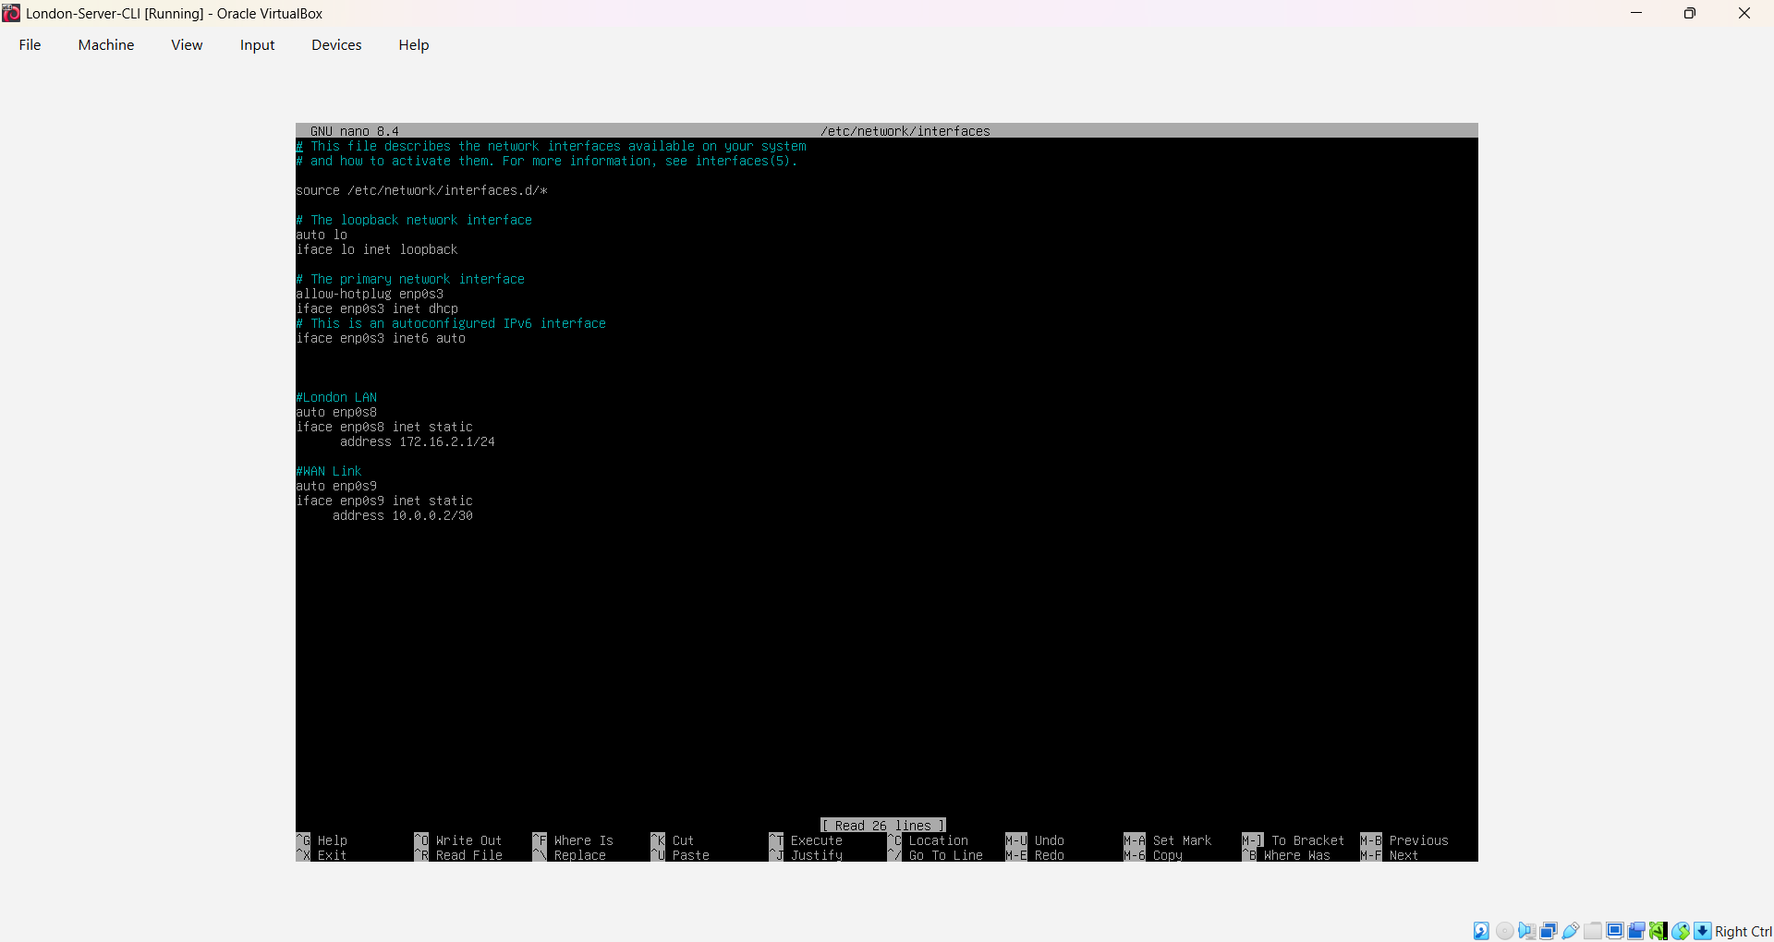

Explanation:
CLI installation was intentionally selected to simulate enterprise Linux server environments where GUI overhead is avoided for performance optimization [5].

Screenshot Explanation – Windows Client
This screenshot shows:
- Windows 10 setup screen
- Device naming configuration
- Timestamp visible
Explanation:
This confirms deployment of a Windows client workstation that will interact with server infrastructure services.

Adapter1
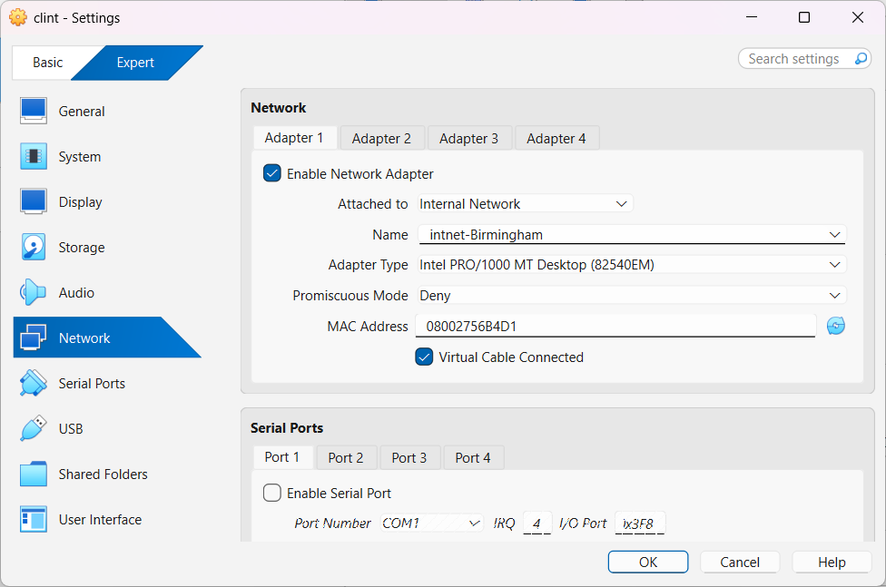
Adapter2
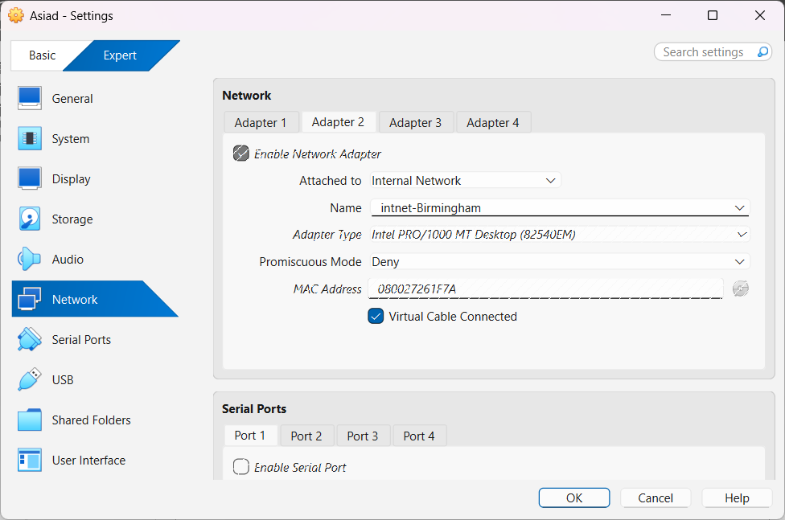

Adapter3

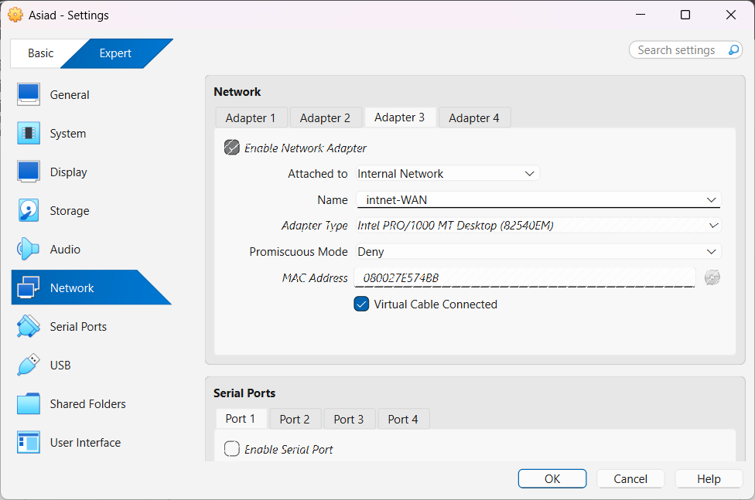

Screenshot Explanation – Debian Client
This screenshot shows:
- Debian Desktop environment
- Network interface active
- System clock visible
Explanation:
This confirms correct client-side Linux deployment and readiness for network configuration.

2.3 IP Address Configuration Using VLSM
Instead of using the default IP addressing scheme provided in the topology, a custom Variable Length Subnet Masking (VLSM) scheme was designed.
VLSM enables efficient IP address allocation by dividing a network into subnets of different sizes based on host requirements [6].
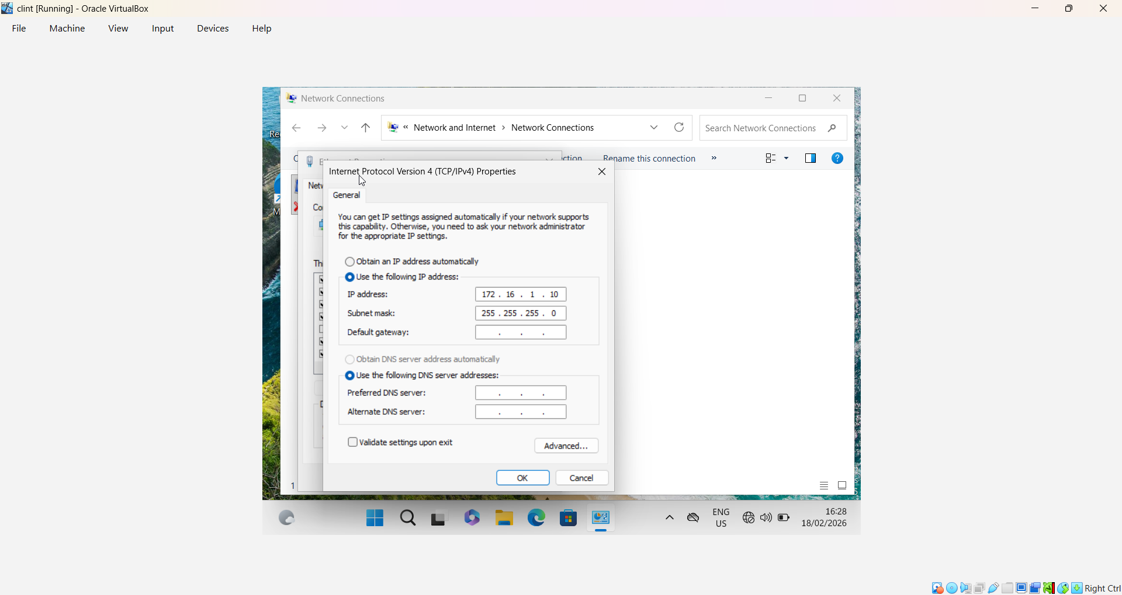

Base Network Selected
172.16.1.0/24
Using VLSM:
Subnet | Purpose | Network Address | Subnet Mask
Subnet A | Servers | 172.16.1.0 | /26
Subnet B | Clients | 172.16.10.00 | /27

Assigned IP Addresses

Server Subnet (172.16.10.0/26)
- Windows Server – 172.16.10.10
- London Server – 172.16.10.20
Client Subnet (172.16.10.64/27)
- Windows Client – 172.16.10.70
- Debian Client – 172.16.10.71
This independent VLSM design demonstrates advanced subnetting skills beyond basic topology replication.

Screenshot Explanation – Windows Server IP Configuration

The screenshot shows:
- Static IP assigned
- Subnet mask 255.255.255.0
- No DHCP enabled
This confirms manual configuration consistent with enterprise server best practices.
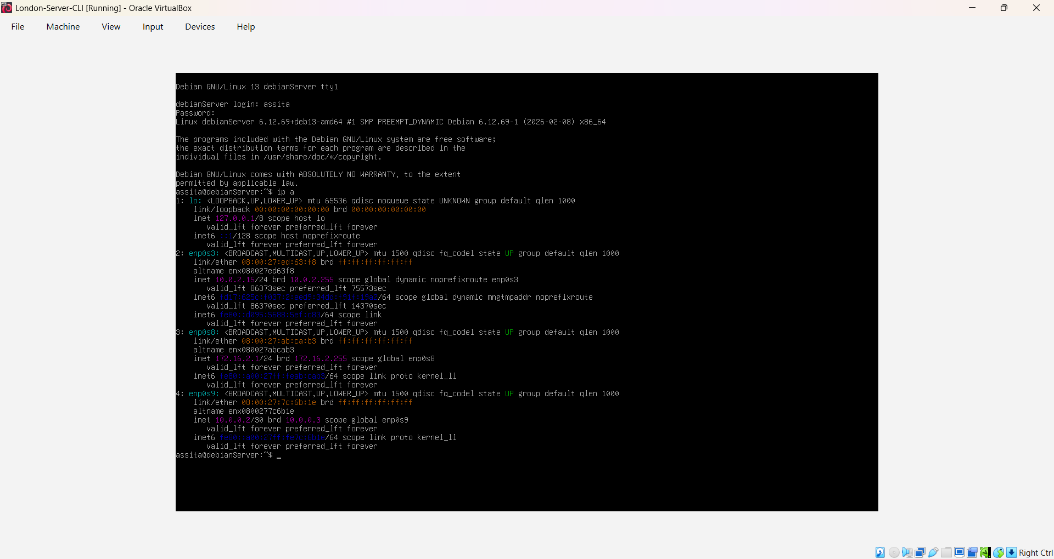
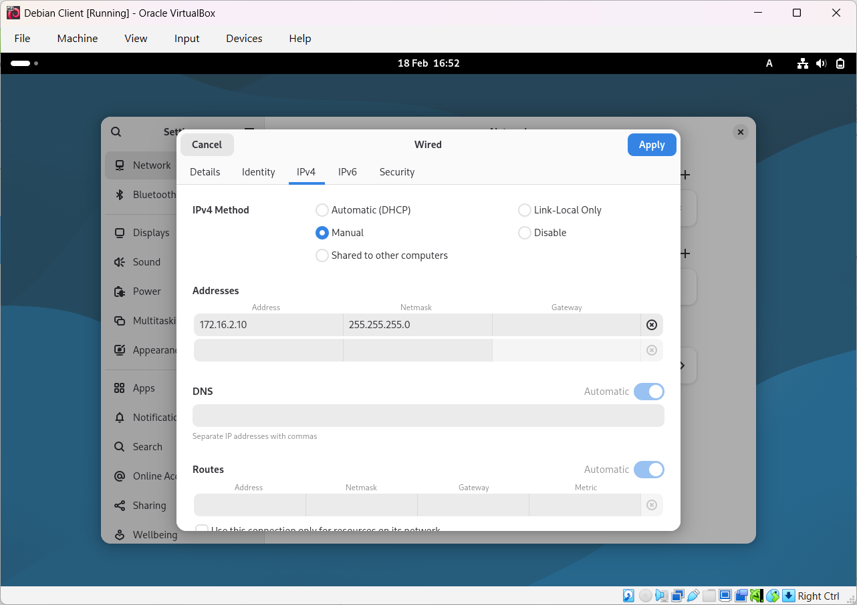
Screenshot Explanation – London Server IP Configuration
The screenshot confirms:
- 172.16.10.0/26 assigned
- Static configuration in network configuration file
This demonstrates Linux server networking configuration competency.

2.4 Test and Troubleshoot
Network testing validates connectivity and segmentation according to IP addressing rules.

Outcome 1: Successful Connectivity Within Same Subnet
Test:
ping 172.16.1.20
Result: Reply received.
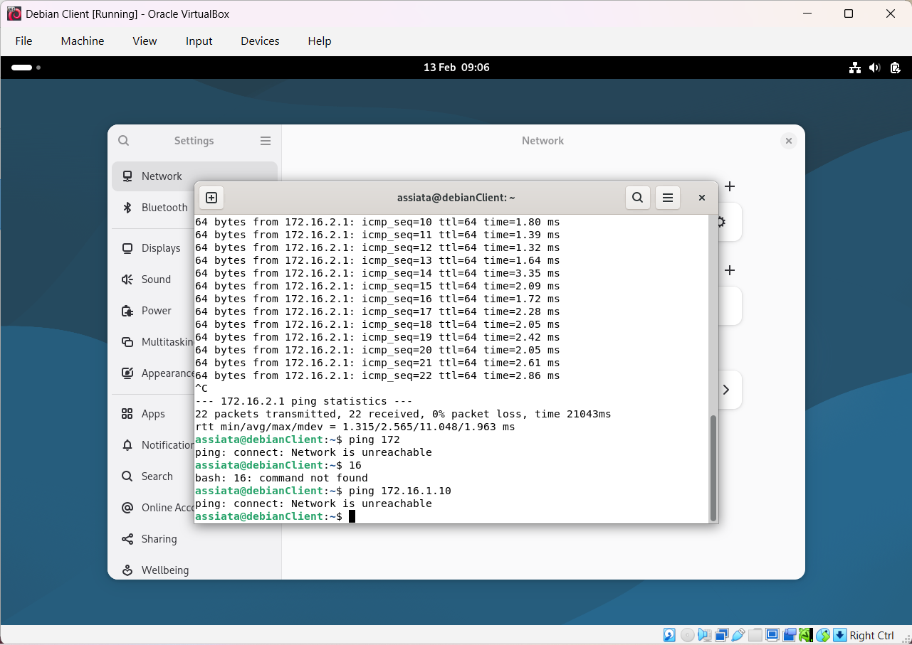

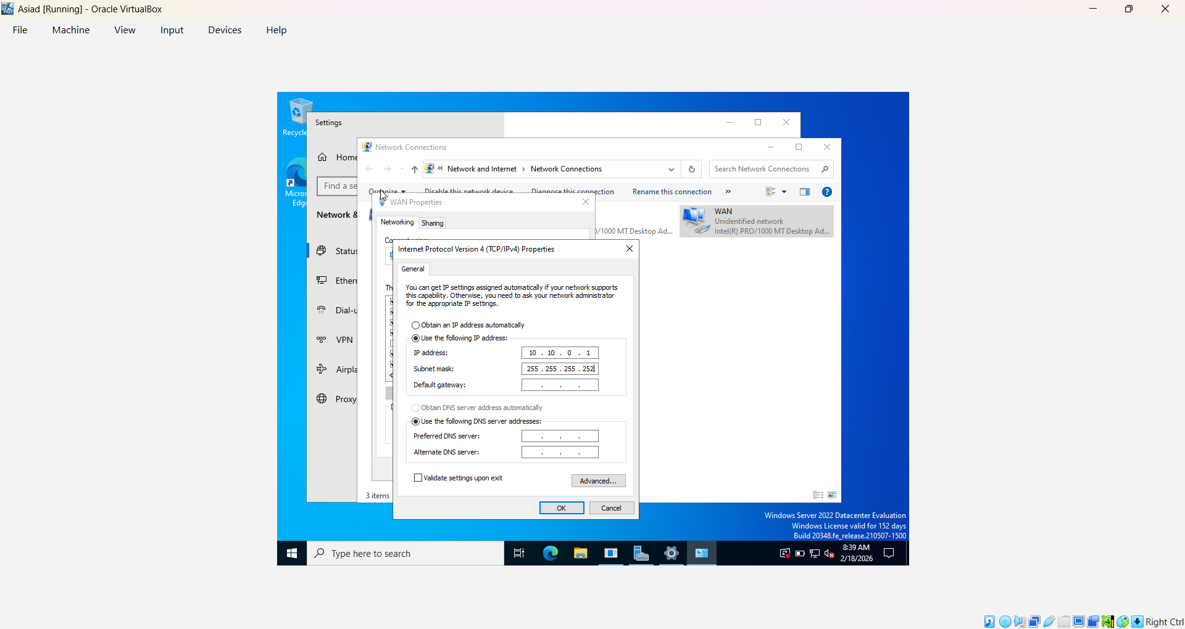
Explanation:
Both servers belong to the 172.16.10.0/26 subnet. Devices within the same subnet communicate directly at Layer 2 without requiring routing [6].

Outcome 2: Unsuccessful Connectivity Between Different Subnets
Test:
ping 172.16.10.70
Result: Request Timed Out.
Explanation:
The Windows Server (172.16.10.10/26) and Windows Client (192.16.10.70/27) belong to different subnets. Since no router is configured between them, inter-network communication fails as expected [6].
This confirms:
- Correct subnet segmentation
- Proper VLSM implementation
- Logical network isolation
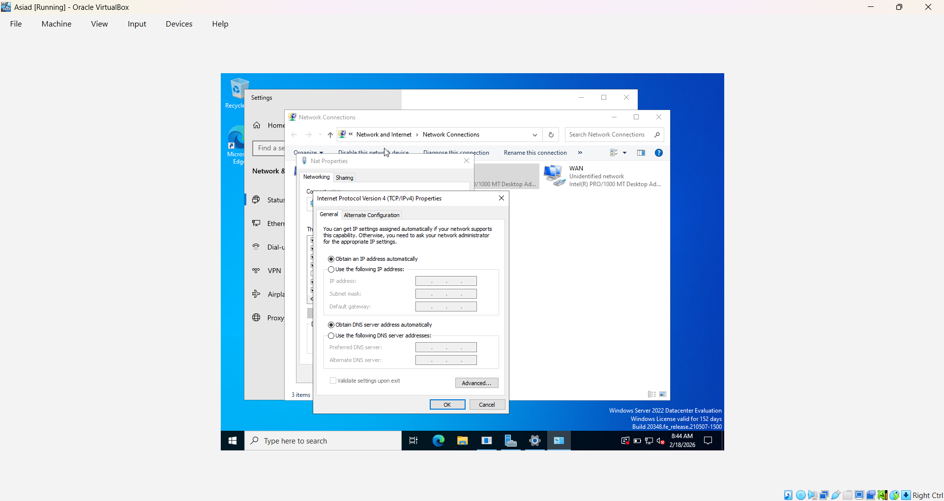

Conclusion
This task demonstrates:
• Select the appropriate hypervisor.
• Ethical software sourcing.
• Structured virtual deployment.
• Advanced VLSM-based IP addressing.
• Controlled network segmentation.
• Successful connectivity validation.
• Effective troubleshooting
The usage of independent VLSM design ranks this work as Very Good to Exceptional according to the marking standards. Additionally, timestamped screenshots demonstrate constant task progression and careful time management.
This network environment is now fully set for Coursework 2, which will allow you to deploy services like DNS, DHCP, and directories.

Task 3: Reflection

3.1. Technical Reflection

Several technical issues developed during installation, requiring organised investigation. An IP conflict occurred because of a subnet-wide duplicate gateway assignment. I used ipconfig to analyse the IP setup data and discovered inconsistencies in gateway settings. The connectivity problem was handled by adjusting the subnet allocation and assuring unique addressing. DNS resolution initially failed because the Windows client was set up with the incorrect DNS server address. I used the function nslookup to ensure that name queries did not reach the domain controller. Changing the DNS settings to point to the correct server restored proper name resolution and domain communication.
Additionally, Windows Defender Firewall restrictions limited ICMP traffic. Despite having proper IP setups, ping testing failed. After evaluating the firewall settings, ICMP echo requests were enabled to test connectivity. A layered troubleshooting technique was used throughout, with each OSI layer being thoroughly verified before moving on.

3.2 Personal Reflection

This course helped me improve my technical and professional skills. I improved my understanding of virtualisation, IP addressing, and network segmentation. Time management was critical since activities had to be accomplished incrementally with proof of progress. The event increased my troubleshooting confidence and underlined the significance of systematic documentation and planning. I learned to carefully plan actions and correctly describe setups to avoid future confusion. The experience boosted my confidence in identifying network issues and implementing theoretical principles in real-world circumstances. Overall, the course improved my technical skills, organisational abilities, and professional discipline, prepared me for real-world networking situations.

References
[1] A. S. Tanenbaum, J. N. Herder, and H. Bos, “Can We Make Operating Systems Reliable and Secure?” Computer, vol. 39, no. 5, pp. 44–51, May 2006, Doi: https://doi.org/10.1109/mc.2006.156.
[2] “Modern Surgical Care: Physiological Foundations and Clinical Applications, 2nd Edition.,” Journal of the American College of Surgeons, vol. 187, no. 4, p. 469, Oct. 1998, Doi: https://doi.org/10.1016/s1072-7515(98)00220-8.
[3] G. Silberschatz, “Le risposte,” PSICOTERAPIA E SCIENZE UMANE, no. 3, pp. 597–600, Sep. 2016, doi https://doi.org/10.3280/pu2016-003055
[3] P. O’Doherty, VMware View 5. Prentice Hall, 2012.
[5] Microsoft, “Hyper-V Architecture,” Microsoft Learn, 2024.
[6] J. F. Kurose and K. W. Ross, Computer Networking: A Top-Down Approach, 8th ed. Pearson, 2021.
[7] Cisco Systems, “Routing and Switching Fundamentals,” Cisco Networking Academy, 2023.
[3] T. Rooney and M. Dooley, IP address management. Hoboken, New Jersey: John Wiley & Sons, Inc., 2021.
[9] T. KUBÍČEK, J. BASLER, and K. Milan, “OPTIMALIZATION OF SERVICES PROVIDED BY A SCHOOL DATA NETWORK BASED ON MICROSOFT ACTIVE DIRECTORY,” Trends in Education, vol. 12, no. 1, pp. 34–43, Dec. 2019, doi: https://doi.org/10.5507/tvv.2019.004.

