Programme: MSc Cybersecurity and Digital Forensics
Module: Data Security, Governance and Compliance
Module code: ACCA7028
Title: Information Security Governance Framework for AeroLink Logistics (ALL)
Lecturer: Dr Ayman El Hajjar
Student Name: Dharmikkumar Dabgar
Student ID: 2536691
Abstract
This report evaluates the problems associated with the information security governance in AeroLink Logistics (ALL), a multinational logistics company, because the firm is increasingly becoming exposed to cyber-attacks owing to cloud computing, artificial intelligence, Internet of Things (IoT), and outsourcing. The report evaluates some of the most prevalent information security models such as NIST CSF 2.0, ISO/IEC 27001:2022, COBIT 2019, and ITIL 4, and examines how these models can help resolve the security problems in the organisation. The proposed governance model will create value for the security of the organisation through improving its governance, risk management, regulatory compliance, incident response management, business continuity, and vendor security management. The proposed governance model that integrates the use of COBIT 2019, ISO/IEC 27001:2022, NIST Cybersecurity Framework (CSF) 2.0, and ITIL 4 provides an effective model that will help improve the resilience, regulatory compliance, service delivery, and threat response of ALL.
Table of Contents
1. Introduction 4
1.1 Background 4
1.2 Case Study Overview 4
1.3 Aim 5
1.4 Objectives 5
2. Assumptions 5
3. Literature Review: Information Security Frameworks 7
3.1 Information Security Governance 7
3.2 NIST Cybersecurity Framework (CSF) 2.0 9
3.3 ISO/IEC 27001:2022 10
3.4 COBIT 2019 11
3.5 ITIL 4 12
3.6 Comparative Analysis 13
4. Security Gap Analysis 15
5. Proposed Integrated Security Governance Framework 17
5. Proposed Integrated Security Governance Framework 17
5.1 Framework Overview 17
5.2 Governance Structure 18
5.3 Risk Management 19
5.4 Security Policies 20
5.5 Identity and Access Management 21
5.6 Protection Mechanisms 22
5.7 Vendor and SLA Management 23
5.8 Incident Response 24
5.9 Business Continuity 25
5.10 Compliance Strategy 26
6. Critical Discussion: Importance of Continuous Updates to Regulations and Standards 26
7. Conclusion and Recommendations 28
Reference 29
Appendices 36
Appendix A: RACI Matrix 36
Appendix B: Security Policy Matrix for AeroLink Logistics (ALL) 38
Appendix C: Vendor Risk Matrix for AeroLink Logistics (ALL) 39

1. Introduction

1.1 Background
Organisations have been transformed by digital transformation due to the use of cloud computing, AI, IoT, and outsourcing of digital services, thereby improving efficiency, scalability, and decision-making processes in organisations. Consequently, cybersecurity has become an important consideration for organisations due to the fact that the above-mentioned digital technologies expand the attack surfaces in organisations, thus leaving them prone to advanced cyber-attacks [1]. Over 72% of firms in the world experienced the impacts of ransomware attacks in 2023, a record [2]. Furthermore, cloud computing and AI have created issues of governance because organisations have embraced new technologies faster than it is possible to create governance mechanisms [3]. Thus, the growing use of external providers of IT services has added new risks which need to be governed continuously during the entire service lifecycle.

1.2 Case Study Overview
AeroLink Logistics (ALL) is an international logistics company that delivers complete logistics solutions with a global reach, reliability, and customer satisfaction [4]. It heavily depends on the use of cloud infrastructure, Internet of Things (IoT)-based tracking systems, advanced analytics using AI, and outsourced Infrastructure-as-a-Service (IaaS) and Software-as-a-Service (SaaS). Nevertheless, the company has been experiencing several data breaches due to the unauthorized access of confidential and personal information regarding its customers by unknown individuals, indicating poor cybersecurity practices in the company.

Figure 1: Current Security Challenges of AeroLink Logistics

1.3 Aim
This report analyses the top information security governance frameworks and constructs a framework for information security governance and compliance that fits the unique operational and regulatory needs of AeroLink Logistics.

1.4 Objectives
- To critically evaluate leading information security frameworks and standards.
- To compare security governance models to determine their suitability for addressing security.
- To determine the risks relating to cybersecurity, governance, and regulatory compliance associated with AeroLink Logistics from the case study.
- To propose an information security governance framework for improving governance, risk management, and compliance.

2. Assumptions
First, AeroLink Logistics (ALL) is expected to be a multinational logistics company working in the UK, EU, and Asia, dealing with high amounts of sensitive data that should not be disclosed. Second, it is supposed to have a budget for cybersecurity that would allow it to introduce governance, security technologies, and compliance gradually [5]. The third assumption is that ALL is perceived as an organisation that has a low maturity level of information security governance due to the absence of a security framework, the risk management process, and a compliance program. Moreover, ALL is perceived as an organisation that uses a hybrid cloud computing model involving Microsoft Azure and AWS, while using a lot of external IaaS and SaaS providers [6]. Lastly, it can be assumed that ALL is subject to the UK GDPR, the Data Protection Act 2018, and ISO/IEC 27001 requirements.
Assumption Area | Assumption
Organisation Size | Large multinational logistics company
Cybersecurity Budget | Moderate budget for security improvements
Security Maturity | Low maturity in governance and security
Technology | Cloud Hybrid (Azure & AWS), AI, IoT, IaaS/SaaS
Regulatory Scope | GDPR UK and EU, ISO/IEC 27001
Risk Appetite | Low risk tolerance for cyber and compliance
Business Operations | Global logistics and shipment tracking in real time
Table 1: Key Assumptions

Figure 2: Security Investment

3. Literature Review: Information Security Frameworks

3.1 Information Security Governance
Information security governance enables control and accountability to ensure that the organisation’s objectives are aligned with cybersecurity [7].
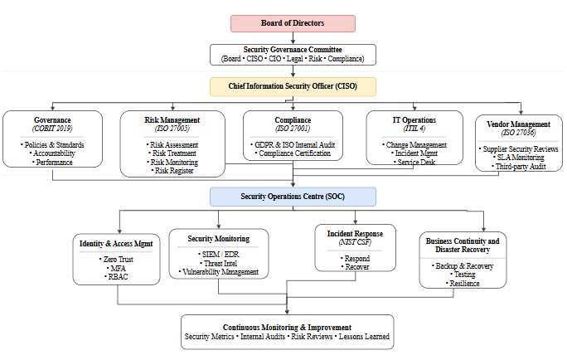
Figure 3: Information Security Frameworks

With the inclusion of ISO/IEC 27014, the information security governance consists of objective-setting, objective steering, responsibility assignment, performance evaluation, and continuous improvement [8]. Information security governance implies accountability and assurance that the cybersecurity strategies are aligned with other organisational goals.
Similar to this, the CSF 2.0 framework incorporation emphasizes cybersecurity governance as a governance activity of an organisation rather than an IT activity [9]. It should be noted that governance contributes to decision-making in terms of risks and security policy formulation.
COBIT 2019 provides for improved governance of the organisation through differentiation of governance and management [10]. In essence, governance involves identifying the needs of the stakeholders, providing direction, and monitoring the performance of the organisation, whereas management involves planning, implementing, and operating security processes [11].
AeroLink Logistics (ALL) faces issues related to having no governance structure, risk management, and clearly defined security obligations. Hence, implementation of the governance concepts according to the standards of ISO 27014, NIST CSF 2.0, and COBIT 2019 will ensure better accountability of the executives, risk management skills, and a security-based culture.

3.2 NIST Cybersecurity Framework (CSF) 2.0
The NIST Cybersecurity Framework (CSF) 2.0 is a voluntary and risk-based framework that assists organisations of all sizes and sectors in managing their cybersecurity risks [9]. As opposed to previous versions of the CSF, the CSF 2.0 covers not only the critical infrastructure but also has a new component named Govern [12]. The structure of the framework is based on six major functions such as Govern, Identify, Protect, Detect, Respond, and Recover. These six major functions make it possible to create a cycle of cyber risk management within the organisation. The framework can be incorporated into other internationally accepted standards such as ISO/IEC 27001. However, there are numerous disadvantages related to the use of this framework [13]. First, it is a governance framework that does not include any specific technical measures and certifications.
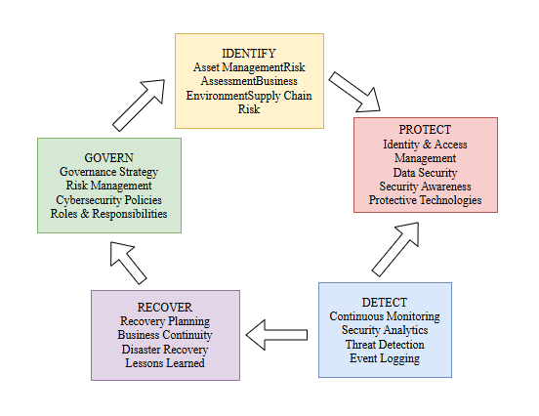
Figure 4: NIST Framework

In the case of AeroLink Logistics, CSF 2.0 presents a great framework that would assist in enhancing governance and cyber risk assessment for cloud computing, artificial intelligence, Internet of Things devices, and vendors. However, CSF 2.0 is not sufficient to cover all the aspects of compliance and information security management for ALL, and thus CSF 2.0 should be integrated with ISO/IEC 27001, COBIT 2019, and ITIL 4.

3.3 ISO/IEC 27001:2022
ISO/IEC 27001:2022 is the internationally accepted standard that outlines the requirements for the establishment, implementation, maintenance, and continuous improvement of an ISMS. It uses a risk management approach whereby information security risks can be identified and controlled and where there is continuous improvement through the PDCA process [14]. The standard is also supported by Annex A, which includes organisational, physical, and technical controls for information management purposes.
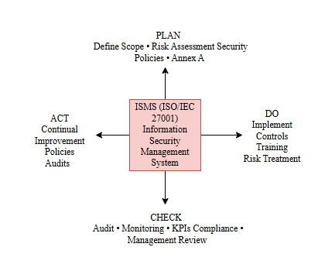
Figure 5: PDCA Model of ISO/IEC 27001 Mapping

ISO/IEC 27001 one of its most important advantages is related to the process of certification, which ensures that the security will be certified independently by clients, governments, and any other stakeholders [15]. However, ISO/IEC 27001 might be expensive because of the documentation and audit that will be required [16]. In the case of AeroLink Logistics Company, ISO/IEC 27001 will ensure ISMS implementation, GDPR compliance, and risk management.

3.4 COBIT 2019
The COBIT 2019 framework is designed to be used as a means of linking IT processes within an enterprise with the goals of the enterprise, and at the same time making sure that there is proper governance, risk management, and creation of value [10]. It emphasises governance principles, enterprise objectives, performance measures, and decision-making responsibilities based on technical security standards.
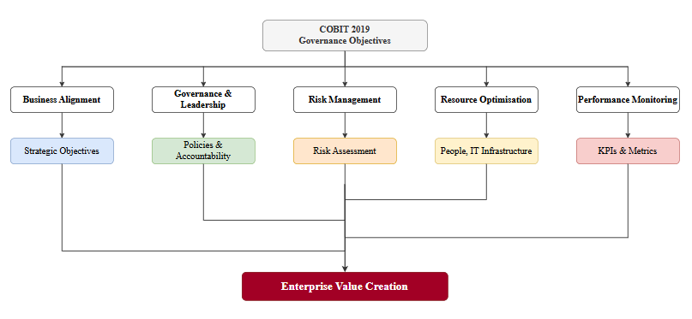
Figure 6: COBIT 2019 Governance Objectives

COBIT has the following strength in that cybersecurity becomes an issue of strategic importance due to its strong business orientation. Nonetheless, COBIT lacks guidance on technical implementations, which means that COBIT needs other frameworks like ISO/IEC 27001 and NIST CSF [17]. In relation to ALL, COBIT will add value in terms of executive oversight and strategic decision-making.

3.5 ITIL 4
The best practices offered by ITIL 4 framework in IT service management come as a result of the implementation of the process of services delivery and organisation value creation by making use of the Service Value System [18]. Information security is obtained by management of incidents, change enablement, problem management and ITIL continuous improvement. It also builds resilience by managing security incidents effectively.
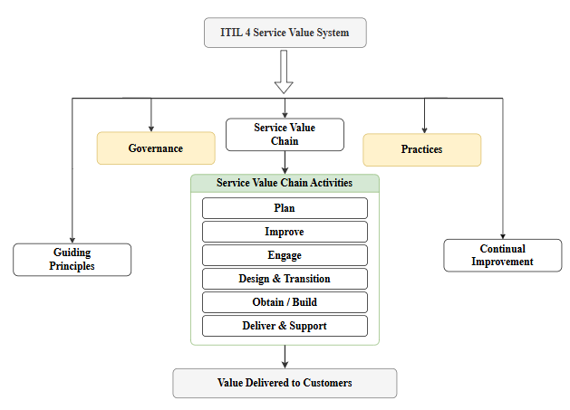
Figure 7: The ITIL Value System

As per [19], though ITIL provides for increased efficiency and high-quality services, it does not form an integrated framework for cybersecurity governance and needs to be complemented with cybersecurity standards such as ISO/IEC 27001 and NIST CSF. In the case of AeroLink Logistics, ITIL will improve incident management, change management, and service continuity along with secure IT operations.

3.6 Comparative Analysis
Criteria | NIST CSF 2.0 | ISO/IEC 27001:2022 | COBIT 2019 | ITIL 4
Governance | High | High | Very High | Moderate
Risk Management | Excellent | Excellent | High | Moderate
Regulatory Compliance | Moderate | Excellent | High | Low
Certification | No | Yes | No | No
Incident Response | Excellent | Moderate | Moderate | High
Cloud Security | High | High | Moderate | Moderate
Business Alignment | High | High | Excellent | High
Best Use | Cybersecurity Risk Management | ISMS & Compliance | Enterprise Governance | IT Service Management
Table 2: Comparison of Information Security Frameworks

From the comparative study of the frameworks, it highlights that no single framework covers all aspects such as governance, risk management, compliance, technical security, and IT service management together. The NIST CSF 2.0 has been found to have a good lifecycle for risk management in cybersecurity, while ISO/IEC 27001 has a standard for ISMS and security controls. Also, COBIT 2019 has strengths in terms of enterprise governance and strategic alignment, whereas ITIL 4 has strengths in terms of operational service management. Therefore, the most suitable framework for AeroLink Logistics will be one where all these frameworks work together.

4. Security Gap Analysis
AeroLink Logistics (ALL) has high exposure to cyber threats as a result of bad information security and governance. This organisation has a lack of risk management and incident response, and also has no comprehensive security governance, which implies lower maturity levels.
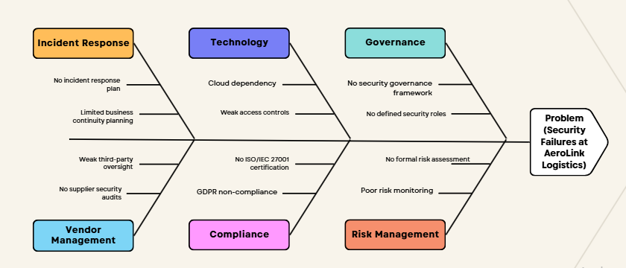
Figure 8: Root Causes of Security Failures (Fishbone Diagram)

In terms of governance, the lack of security roles and governance means that it would be impossible to guarantee accountability and link cybersecurity to organisational goals. This problem is solved by the COBIT 2019 framework of governance, which defines roles of the stakeholders, thus making sure that the decision-making process becomes strategic [20]. The lack of a risk management framework makes it difficult to identify and address cybersecurity-related risks. ISO/IEC 27005 offers a framework for security risk assessment and treatment. However, NIST Cybersecurity Framework 2.0 enhances organisational resilience through the Detect, Respond, and Recover capabilities [9]. Weak vendor management and a lack of compliance audits are some other factors that create vulnerability in the organisation, leading to possible violations of GDPR [21].
Thus, developing an integrated framework that will incorporate COBIT 2019, NIST CSF 2.0, ISO/IEC 27001, ISO/IEC 27005, ISO/IEC 27036, and ITIL 4 will help solve the organisational problems related to governance, risk management, compliance, and security.
Current Problem | Business Impact | Recommended Framework/Standard
No unified security governance | Poor accountability and weak strategic oversight | COBIT 2019
Poor risk management | Increased likelihood of data breaches | ISO/IEC 27005
No formal incident response | Operational disruption and delayed recovery | NIST CSF 2.0
Poor third-party/vendor management | Supply chain vulnerabilities | ISO/IEC 27036
Lack of GDPR and ISO compliance | Regulatory penalties and reputational damage | ISO/IEC 27001:2022
No business continuity planning | Extended service interruption | ITIL 4 and ISO 22301
Table 3: Security Gap Analysis

5. Proposed Integrated Security Governance Framework

5. Proposed Integrated Security Governance Framework

5.1 Framework Overview
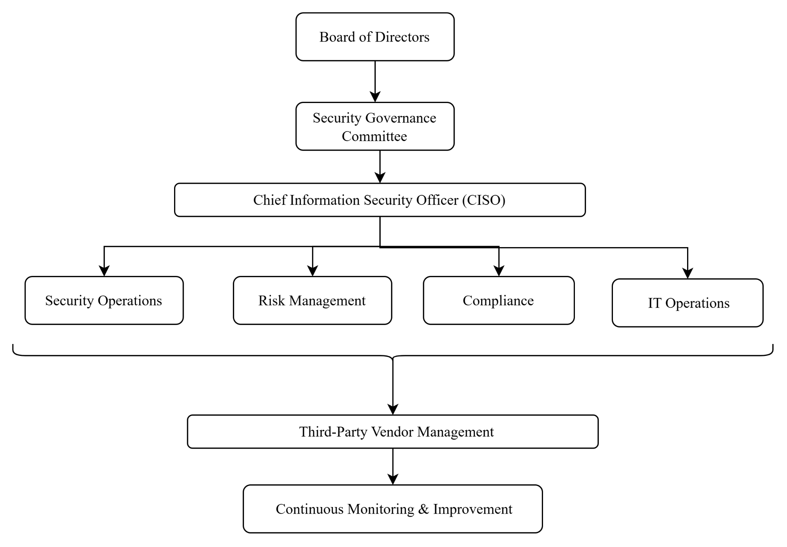
Figure 9: Governance Framework

The integrated governance framework in figure 3 shows that the Board of Directors is the oversight for the Security Governance Committee, which is directing CISO under it. The CISO manages security, risk, compliance, IT, third party, and continuous security functions [22]. The layered structure merges COBIT 2019 for governance, ISO/IEC 27001:2022 for Information Security Management Systems (ISMS), the NIST Cybersecurity Framework (CSF) 2.0 for operational cybersecurity, and ITIL 4 for secure service management [23]. Corporate strategies of Microsoft and HSBC towards integrated governance to align cybersecurity with business goals is an effective adoption of pandemic response as well as crisis and resilience management.

5.2 Governance Structure
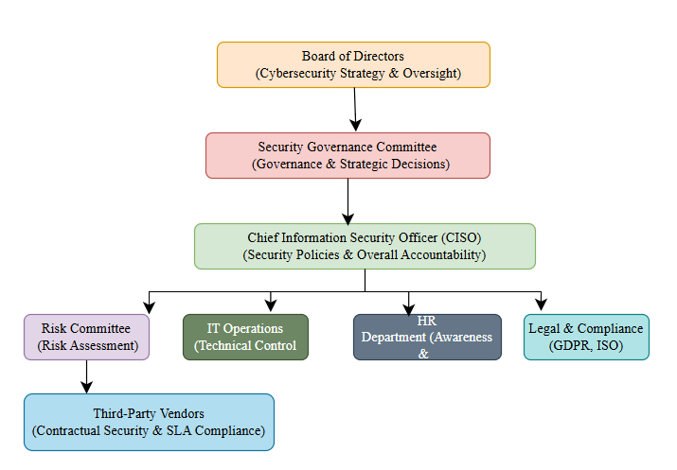
Figure 10: Cybersecurity Governance Structure for AeroLink Logistics (ALL)

A RACI matrix that defines cybersecurity responsibilities among organisational stakeholders [Refer to Appendix A]. For the execution of cybersecurity policies, the CISO is responsible and for the oversight of cybersecurity strategies, the Board of Directors is responsible [24]. The Risk Committee evaluates enterprise risks. The IT teams deploy technical control such as firewalls, access rights. Security awareness and insider risks are managed by the HR department [25]. The suppliers must satisfy their contractual security obligations. The governance model incorporates the governance principles of COBIT 2019, which is an accountability across business functions [26]. Similar governance structures are used by large organisations in the UK such as the NHS and large banking institutions to achieve better decision-making, strengthen ownership and reduce other security gaps within the organisation.

5.3 Risk Management
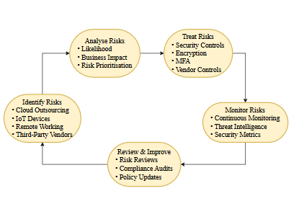
Figure 11: Enterprise Risk Management Cycle for AeroLink Logistics (ALL)

As shown in Figure 4, a continuous risk management cycle has risk identification, risk analysis, risk treatment, risk monitoring and review, and risk management and support. ISO/IEC 27005 risk management guidelines with NIST Risk Management Framework (RMF) help to broaden the enterprise-wide security process [27]. The risks of cloud outsourcing, IoT devices, remote working and third-party vendors should be prioritised for the business assessments.

5.4 Security Policies
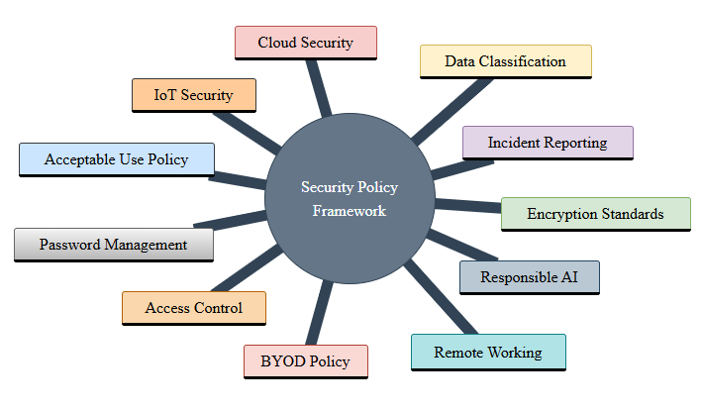
Figure 12: Security Policy Framework

The core security policies needed to ensure effective governance at ALL are listed [Refer to Appendix B]. The essential policies include acceptable use policy, password management, remote working, data classification, access control, bring your own device (BYOD), responsible AI, cloud security, IoT security, encryption standards, and incident reporting [28]. The above policies, as required by law, shall include controls from ISO/ IEC 27001:2022 Annex A [29]. Moreover, they shall be reviewed on an annual basis in order to cover any emerging risk. Firms like BP and Shell have policies in place that streamline employee behaviour, enhance regulatory conformity, and lower operational risk in widely located settings.

5.5 Identity and Access Management
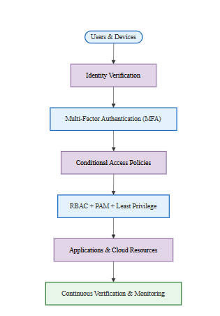
Figure 13: Zero Trust Identity and Access Management (IAM) Architecture for AeroLink Logistics (ALL)

Essentially, a Zero Trust Architecture is a system whereby a user, device, or application must constantly be verified before access is granted to an organisation’s resources. Figure 5 is an illustration of this architecture. AeroLink Logistics (ALL) should implement Multi-Factor Authentication (MFA), Role-Based Access Control (RBAC), Privileged Access Management (PAM) along with conditional access policies and the principle of least privilege for securing remote operations and unmanaged devices [30]. This approach reduces risks of unauthorized access related to stolen logins. To help in remote working and cloud digital transformation, companies such as through the BeyondCorp model of Google highlights the improvements in security of Zero Trust architecture [31].

5.6 Protection Mechanisms
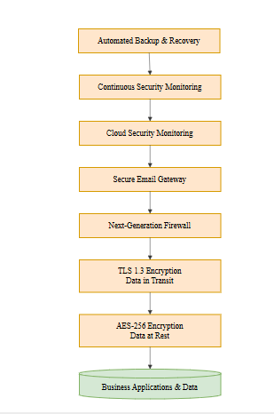
Figure 14: Defence-in-Depth Protection Mechanisms for AeroLink Logistics (ALL)

To secure assets, Defence-in-Depth involves multiple layers for organisational defence. There is a need for AES 256 encryption of stored data, TLS 1.3 for data-in-transit, next-gen firewall through constant security monitoring to secure email gateway, cloud security monitoring, automated backup [32]. Microsoft Azure and Amazon Web Services promote similar defence-in-depth strategies to secure enterprise cloud environments against evolving cyber threats [33].

5.7 Vendor and SLA Management
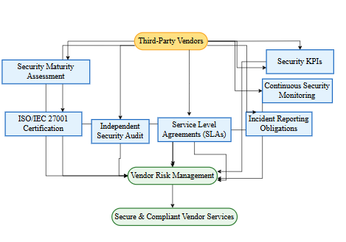
Figure 15. Vendor Governance and SLA Management Framework

The Vendor Risk Matrix is shown which helps score the vendors on the basis of security maturity, compliance status [refer to Appendix-C]. Vendor governance is critical since nearly 88% of AeroLink Logistics' infrastructure is outsourced [34]. ISO/IEC27001 certification and independent security audit, Service Level Agreements (SLAs), incident reporting obligations, Key Performance Indicators (KPIs) and continuous security monitoring should be included in the security contracts [35]. IBM and Unilever are among the organizations that have adopted similar programs of supplier assurance, where third-parties’ risks are continually assessed to limit vulnerabilities in the supply chain and enhance regulatory compliance across the vendor ecosystem [36].

5.8 Incident Response
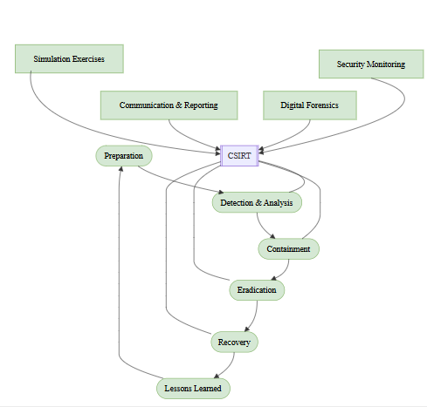
Figure 16: NIST Incident Response Lifecycle for AeroLink Logistics (ALL)

The NIST Incident Response Lifecycle is depicted in figure 7 starting with preparation and continuing with detection, containment, eradication, recovery and lessons learned. A CSIRT must be formally established for AeroLink Logistics (ALL) alongside documentation. Security monitoring, forensic investigations and simulation exercises will support the CSIRT [37]. By employing coordinated communication and rapid containment, it can reduce operational disruption and regulatory fallout after cyber incidents. The main incident response activity that Maersk and other organisations strengthened post-NotPetya ransomware attack was incident response planning for recovery purposes through repeatable activity and improving upon it [38]. So, it’s important to have a structure.

5.9 Business Continuity

Figure 17: Business Continuity Framework for AeroLink Logistics (ALL)

The diagram in figure 8 shows that a business impact analysis (BIA) is the first phase of the business continuity framework. It is followed by disaster recovery planning, cloud backup, set recovery time objective (RTO) and recovery point objective (RPO), and tests regularly [39]. AeroLink Logistics (ALL) needs to maintain essential operation of logistics systems during cyber incidents or infrastructural failure. Through business continuity planning, FedEx and DHL want to ensure that there is no interruption in services [40]. Whether there is a cyberattack or natural disaster, the logistics operations would be unaffected. Moreover, it applies to their global operations and not only the local ones.

5.10 Compliance Strategy
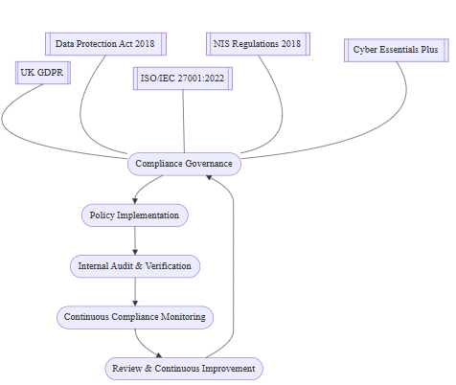
Figure 18: Compliance Strategy Lifecycle

The compliance lifecycle involves governance, implementation, audit, monitor and improvement as illustrated in figure 9. AeroLink Logistics (ALL) should align its security programme with the UK GDPR, Data Protection Act 2018, ISO/IEC 27001:2022, Network and Information Systems (NIS) Regulations 2018, Cyber Essentials Plus certification [41]. The audits help to keep the compliance ongoing. The verification is done by internal audit on a regular basis.

6. Critical Discussion: Importance of Continuous Updates to Regulations and Standards
Marinating good practice may lead to highlight the evolving cyber threat landscape which ensure emerging threats such as ransomware, AI-powered attacks, phishing. Also, different rules and regulations including UK GDPR, NIS Regulations, ISO/IEC 27001:2022, and NIST CSF 2.0 helps to strength the organisation to maintain their regular review as improving their security system.
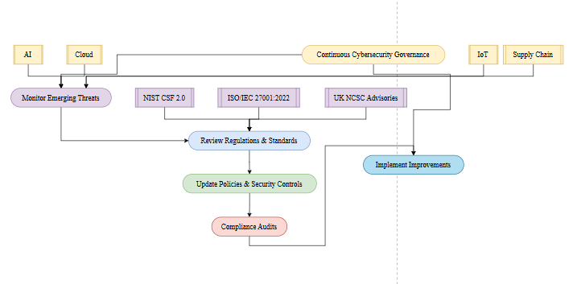
Figure 19: Continuous Improvement Cycle for Cybersecurity Governance

The Continuous Improvement Cycle illustrated in Figure 10 monitors threats and reviews security performance, promotes updates of policies, controls and audits and implements improvements which is followed by repetition. Cybersecurity governance will not be static but rather dynamic, evolving through a cycle of governance.
The automated cyberattacks help in data poisoning through the new artificial intelligence (AI) systems model [42]. To adopt more IoT devices, Cloud Services increased the number of interconnected supply chains, and the organisational attack surfaces became stretched [43]. Managing risk by strengthening governance led to highlighting the Framework of CSF 2.0 of NIST Cybersecurity which can increase the ability of supply-chain security which has helped ISO/IEC 27001:2022. The National Cyber Security Centre (NCSC) in the UK highlighted the threat advisories which needed continuous updates to highlight the confirmation system [44].

7. Conclusion and Recommendations
The report analyzed the information security challenges being faced by AeroLink Logistics (ALL). It further assessed various leading security frameworks such as COBIT 2019, ISO/IEC 27001:2022, NIST Cybersecurity Framework (CSF) 2.0, and ITIL 4. It was found that ALL’s incident of no harmonized governance structure, the absence of formal risk management, regulatory compliance, and vendor oversight has raised its vulnerability towards cyber threats, data breaches, and operational disruptions. To bridge these issues, it designed an integrated security governance framework on strategic governance, risk-based security management, operational controls and continual service improvement.
The framework helps businesses achieve significant benefits through increased governance accountability and regulatory compliance, enhanced access controls, strengthened security capabilities for cloud and IoT, and improved incident response and business continuity.
In order to sustain these enhancements, ALL must make efforts towards obtaining ISO/IEC 27001 certification, set up a Security Governance Committee headed by a Chief Information Security Officer (CISO), implement continuous risk assessments and security audits, strengthen third-party vendor governance through robust Service Level Agreements (SLAs), and invest in employee cybersecurity awareness programmes.

Reference
1. IBM, (2025), Cost of a Data Breach Report 2026. Available from https://www.ibm.com/reports/data-breach?cq_net=g&cq_src=google_ads&gad_campaignid=22644626335. Accessed on 03.08.2026.
2. IBM, (2025), Cybersecurity dominates concerns among the C-suite, small businesses, and the nation. Available from https://www.ibm.com/think/insights/cybersecurity-dominates-concerns-c-suite-small-businesses-nation. Accessed on 03.08.2026.
3. Mahmood, H.S., Abdulqader, D.M., Abdullah, R.M., Rasheed, H., Ismael, Z.N.R. and Sami, T.M.G., 2024. Conducting in-depth analysis of AI, IoT, web technology, cloud computing, and enterprise systems integration for enhancing data security and governance to promote sustainable business practices. Journal of Information Technology and Informatics, 3(2), pp.297-332. https://www.researchgate.net/profile/Dildar-Abdulqadir/publication/383087255_Conducting_In-Depth_Analysis_of_AI_IoT_Web_Technology_Cloud_Computing_and_Enterprise_Systems_Integration_for_Enhancing_Data_Security_and_Governance_to_Promote_Sustainable_Business_Practices/links/66bdb090311cbb094939611f/Conducting-In-Depth-Analysis-of-AI-IoT-Web-Technology-Cloud-Computing-and-Enterprise-Systems-Integration-for-Enhancing-Data-Security-and-Governance-to-Promote-Sustainable-Business-Practices.pdf
4. Aerolink Logistics, (2025), About Company, Digital & Trusted Transport Logistic Company. Available from https://aerolink-logistics.com/about/ Accessed on 03.08.2026.
5. Melaku, H.M., 2023. A dynamic and adaptive cybersecurity governance framework. Journal of Cybersecurity and Privacy, 3(3), pp.327-350. https://www.mdpi.com/2624-800X/3/3/17
6. RIZVI, D.Q.M., Ansari, T. and Siddiqui, O., 2024. Comparative Analysis of SaaS, IaaS, and PaaS: Exploring the Cloud Computing Paradigm. International Journal of Innovative Research in Computer Science and Technology (IJIRCST), pp.89-93. https://www.academia.edu/download/124278096/csistw.2024.12.1.pdf
7. Herath, T.C., Herath, H.S. and Cullum, D., 2023. An information security performance measurement tool for senior managers: Balanced scorecard integration for security governance and control frameworks. Information Systems Frontiers, 25(2), pp.681-721. https://www.researchgate.net/profile/Hemantha-Herath/publication/358909388_An_Information_Security_Performance_Measurement_Tool_for_Senior_Managers_Balanced_Scorecard_Integration_for_Security_Governance_and_Control_Frameworks/links/6390a7aa484e65005bee951c/An-Information-Security-Performance-Measurement-Tool-for-Senior-Managers-Balanced-Scorecard-Integration-for-Security-Governance-and-Control-Frameworks.pdf
8. Magnusson, L., Iqbal, S., Elm, P. and Dalipi, F., 2025. Information security governance in the public sector: investigations, approaches, measures, and trends. International Journal of Information Security, 24(4), p.177. https://link.springer.com/content/pdf/10.1007/s10207-025-01097-x.pdf
9. NIST, (2024), CThe NIST Cybersecurity Framework (CSF) 2.0. Available from https://tsapps.nist.gov/publication/get_pdf.cfm?pub_id=957258 Accessed on 03.08.2026.
10. ISACA, (2023), Seven Key Features Lessons and Tips from a COBIT Journey of 27 Years. Available from https://www.isaca.org/resources/news-and-trends/newsletters/atisaca/2023/volume-46/seven-key-features-lessons-and-tips-from-a-cobit-journey-of-27-years Accessed on 03.08.2026.
https://www.researchgate.net/profile/Kumrashan-Indranil-Iyer/publication/390597579_Poisoning_AI_Models_New_Frontiers_in_Data_Manipulation_Attacks/links/67f59a9d9b1c6c487784c1a6/Poisoning-AI-Models-New-Frontiers-in-Data-Manipulation-Attacks.pdf
11. Wattimury, G. and Faza, A., 2023. COBIT 2019 implementation for enhancing IT governance in educational institutions. JISKA (Jurnal Informatika Sunan Kalijaga), 8(3), pp.210-221. https://ejournal.uin-suka.ac.id/saintek/JISKA/article/download/4186/2709
12. Kate, A., 2026. Operationalizing the NIST CSF 2.0 “Govern” Function for AI-Augmented Critical Infrastructure Protection: Policy, Accountability, and Risk Ownership Models. https://www.researchgate.net/profile/Austin-Kate-2/publication/403508974_Operationalizing_the_NIST_CSF_20_Govern_Function_for_AI-_Augmented_Critical_Infrastructure_Protection_Policy_Accountability_and_Risk_Ownership_Models/links/69d10fb49f53d47411c46806/Operationalizing-the-NIST-CSF-20-Govern-Function-for-AI-Augmented-Critical-Infrastructure-Protection-Policy-Accountability-and-Risk-Ownership-Models.pdf
13. Kitsios, F., Chatzidimitriou, E. and Kamariotou, M., 2023. The ISO/IEC 27001 information security management standard: how to extract value from data in the IT sector. Sustainability, 15(7), p.5828. https://www.mdpi.com/2071-1050/15/7/5828
14. ISO, (2022), ISO/IEC 27001:2022. Available from https://www.iso.org/standard/27001 Accessed on 03.08.2026.
15. Calder, A., 2023. Cyber Essentials: A guide to the Cyber Essentials and Cyber Essentials Plus certifications. https://www.torrossa.com/en/resources/an/5751016
16. Agustina, M., Syahputri, A., Natasya, R. and Wardhani, N.S., 2025, December. Information System Audit Based on ISO/IEC 27001: A Case Study of a Culinary Small and Medium Enterprise. In Proceedings of The International Conference on Computer Science, Engineering, Social Science, and Multi-Disciplinary Studies (Vol. 1, pp. 458-461). https://proceeding.raskhamedia.or.id/index.php/cessmuds/article/download/93/105
17. Rambau, T.M., Munyoka, W., Phahlamohlaka, L.J. and Kadyamatimba, A., 2026. Evaluating cyber resilience frameworks for e-government: applicability of NIST CSF, ISO/IEC 27001 and COBIT 2019 in developing country contexts. Information & Computer Security, pp.1-22. https://www.emerald.com/ics/article-pdf/doi/10.1108/ICS-09-2025-0376/11493712/ics-09-2025-0376en.pdf
18. ISTM, (2025), ITIL 4 Explained: Framework, Practices, and Key Changes. Available from https://itsm.tools/itil-4-explained/ Accessed on 03.08.2026.
19. Noor, M. and Novelan, M.S., 2026, March. Evaluation of Information Technology Service Governance in Higher Education Using the ITIL 4 Framework. In International Conference Epicentrum of Economic Global Framework (pp. 681-689). https://proceeding.pancabudi.ac.id/index.php/ICEEGLOF/article/download/1646/1606
20. Mambu, J.Y., Lumingkewas, C. and Tangka, G.M.W., 2025. IT Governance Maturity Assessment Using COBIT 2019 for System Enhancement and Strategic Decision Support. CogITo Smart Journal, 11(1), pp.193-206. https://cogito.unklab.ac.id/index.php/cogito/article/download/998/397
21. Afrifah, W., Epiphaniou, D.G., Ersotelos, N. and Maple, C., 2022. Barriers and opportunities in cyber risk and compliance management for data-driven supply chains. https://scholarspace.manoa.hawaii.edu/bitstreams/187dd8f3-05f3-402e-a304-7cef9d7f8e69/download
22. Baker, D., 2024. A CISO Guide to Cyber Resilience: A how-to guide for every CISO to build a resilient security program. Packt Publishing Ltd. https://books.google.com/books?hl=en&lr=&id=CTQAEQAAQBAJ&oi=fnd&pg=PP1&dq=The+CISO+manages+security,+risk,+compliance,+IT,+third+party,+and+continuous+security+functions&ots=wJOYgjzv1s&sig=Vgg0xGWaFZ8C58CZ2rUGm7YbQ9g
23. Reuben-Owoh, B. and Haig, E., 2025. A systematic review of voluntary cybersecurity standards and frameworks: B. reuben-owoh, e. haig. International Journal of Information Security, 24(5), p.206. https://link.springer.com/content/pdf/10.1007/s10207-025-01121-0.pdf
24. Mehmood, K.T., Ashraf, Z., Iqbal, R., Rafique, A.A., Gul, H. and Ali, M., 2025. Cyber security Governance as a Pillar of Enterprise Risk Management: Designing a Compliance-Driven Framework for Operational Resilience, Policy Enforcement, and Regulatory Alignment. Annual Methodological Archive Research Review, 3(5), pp.59-77. https://www.researchgate.net/profile/Raza-Iqbal-3/publication/391448694_Cyber_security_Governance_as_a_Pillar_of_Enterprise_Risk_Management_Designing_a_Compliance-Driven_Framework_for_Operational_Resilience_Policy_Enforcement_and_Regulatory_Alignment/links/6818595bbfbe974b23c2f725/Cyber-security-Governance-as-a-Pillar-of-Enterprise-Risk-Management-Designing-a-Compliance-Driven-Framework-for-Operational-Resilience-Policy-Enforcement-and-Regulatory-Alignment.pdf
25. Narayan, S.B., 2025. What is one effective way organizations can reduce the risk of insider threats without disrupting productivity. Journal of Engineering and Artificial Intelligence, 1(2), pp.1-3. https://engineering-ai.academicsquare-pub.com/index.php/1/article/download/25/9
26. Stefani, E., 2025. Assessment of the relationship between information technology governance and artificial intelligence governance in organizations: expansion of the COBIT 2019 framework. https://bibliotecatede.uninove.br/bitstream/tede/3833/2/Eduardo%20Corr%C3%AAa%20Stefani.pdf
27. Efe, A., 2023. A comparison of key risk management frameworks: coso-erm, nist rmf, iso 31.000, cobit. Denetim ve Güvence Hizmetleri Dergisi, 3(2), pp.185-205. https://dergipark.org.tr/en/download/article-file/3120080
28. AlShalaan, M.R. and Fati, S.M., 2023. Enhancing organizational data security on employee-connected devices using BYOD policy. Information, 14(5), p.275. https://www.mdpi.com/2078-2489/14/5/275
29. Malatji, M., 2023, January. Management of enterprise cyber security: A review of ISO/IEC 27001: 2022. In 2023 International conference on cyber management and engineering (CyMaEn) (pp. 117-122). IEEE. https://www.johanolausson.com/management.pdf
30. Arumugam, K.J., 2024. Behind the cloud: Uncovering critical security threats. Available at SSRN 5160686. https://papers.ssrn.com/sol3/Delivery.cfm?abstractid=5160686
31. Sunkara, G., 2025. Implementing zero trust architecture in modern enterprise networks. SAMRIDDHI: A Journal of Physical Sciences, Engineering and Technology, 17(03), pp.1-11. https://smsjournals.com/index.php/SAMRIDDHI/article/download/3350/1701
32. Sekhar, K., (2026). What Is IT Security? A Practical Guide for IT and Security Teams. Available from https://www.manageengine.com/products/desktop-central/articles/what-is-itsecurity.html Accessed on 3.8.2026
33. Alam, M.M., Khan, M.I. and Sayem, S.M., 2026. Hybrid Cybersecurity: AI Models for Predicting Threats Across Multi-Cloud for US Business Environment. Frontiers in Computer Science and Artificial Intelligence, 5(9), pp.59-66. https://alkindipublisher.com/index.php/fcsai/article/download/12959/11628
34. Wto (2026). AIR TRANSPORT AND THE GATS. Available from https://www.wto.org/english/res_e/booksp_e/airtransport_2000_e.pdf Accessed on 3.8.2026
35. Yli-Karro, V., 2025. ENSURING NIS 2 COMPLIANCE IN AN ISO/IEC 27001 CERTIFIED ORGANIZATION. Tampere, Pirkanmaa, Finska. KAZALO SLIK Slika, 3. https://trepo.tuni.fi/bitstream/handle/10024/205043/Yli-KarroValtteri.pdf
36. Mandal, S., 2025. Strategic Business Responses to Shifts in Promoting Sustainable Supply Chain Management (SSCM) in Business Practices. https://osuva.uwasa.fi/bitstreams/308d2886-a5bf-4071-b4cc-e616d9750b17/download
37. Potapovs, M., Teters, K., Frīdmanis, J. and Blumbergs, B., 2025. Evaluating National CSIRT Maturity: The Case of CERT. LV. In Cybersecurity in Latvia (pp. 52-73). Routledge. https://library.oapen.org/bitstream/handle/20.500.12657/104373/1/9781040422359.pdf#page=73
38. Lewis, L., (2018). Ransomware recovery: How can enterprises operate post-attack? Available from https://www.techtarget.com/searchsecurity/answer/Ransomware-recovery-How-can-enterprises-operate-post-attack Accessed on 3.8.2026
39. Tatineni, S., 2023. Cloud-based business continuity and disaster recovery strategies. International Research Journal of Modernization in Engineering, Technology, and Science, 5(11), pp.1389-1397. https://www.academia.edu/download/109038414/fin_irjmets1700193452.pdf
40. Al-Abri, A.I.S., 2023. The Impact of Risk Management Strategies Used by Parcel Delivery Companies to Cope With Customs Uncertainties on Clearance Time in Cross-Border Supply Chain. Sultan Qaboos University (Oman). https://search.proquest.com/openview/11b5bbf99421d95d36b679c97b187781/1?pq-origsite=gscholar&cbl=2026366&diss=y
41. Qusef, A. and Alkilani, H., 2022. The effect of ISO/IEC 27001 standard over open-source intelligence. PeerJ Computer Science, 8, p.e810. https://peerj.com/articles/cs-810.pdf
42. Iyer, K.I., 2023. Poisoning AI models: New frontiers in data manipulation attacks. International Journal of Innovative Research in Computer and Communication Engineering, 11(11).
43. Syed, A., 2024. Supply chain software security: AI, IoT, and application security. Springer Nature. https://books.google.com/books?hl=en&lr=&id=b-wwEQAAQBAJ&oi=fnd&pg=PR5&dq=+As+companies+began+to+adopt+more+IoT+devices,+Cloud+Services+and+an+increasing+number+of+interconnected+supply+chains,+the+organisational+attack+surfaces+became+further+stretched&ots=kPJT4HxXpG&sig=97GmDJ1_lRD5NTrNQ_aDH2Md2YQ
44. Shelby, J., 2026. The UK Cyber Security and Resilience Bill: A Practitioner's Guide to Legislative Reform, Compliance, and Organisational Readiness. arXiv preprint arXiv:2603.07861. https://arxiv.org/pdf/2603.07861

