Module Name: Learning In the Digital Era
Module Code: ACCA 4025
Lecturer’s Name: Anees Baqir
Student Name: Ruben Fabio Paquete Pires Sa Dabo
Student ID: 2540497
Group 3
Date 27.07.2026

LDE Assignment 1
E-Portfolio
E-Portfolio link: https://rubendabo80.wixsite.com/my-site-3
University of Wales Trinity Saint David
LONDON CAMPUS

Introduction 2
Main Body 2
Task 1: Essential Academic and Employment Skills for the future career Path 2
Task 1 (a): Report on Essential Academic and Employment Skills 2
Task 1 (b): Evaluation of Task 1 (a) based on Similarity report 2
Task 2: Collaborative Mind Map and Individual Poster 2
Mind Map (Collaborative) 2
Poster (Individual) 2
Task 3: Virtual Collaboration and RefWorks 2
Report on Virtual Collaboration 2
Step-by-step process of using RefWorks with visuals 2
Task 4: E-Portfolio Creation and Evaluation 2
Task 4 (a): E-Portfolio Creation 2
Task 4 (b): Illustrative Review of E-Portfolio tool Selection 2
Conclusion 2
References 2
Task 1 References: 2
Task 3 References: 2

Task 1
1a)
Introduction
The computer industry is always changing, and businesses need qualified to create maintain and enhance digital technologies as technological expertise is crucial whilst exhibiting transferable skills such as problem-solving, teamwork, communication, and management. Gaining these skills whilst in university will enable need to adapt to the ever-changing needs of the technology sector.[1]
For most computing professionals using communication helps the team minimise misunderstandings and ensure projects are finished successfully. Group projects, written assessments, and presentations will improve my communication abilities for my future profession [2]
Recognising that computer tasks are really finished by one person teamwork, is crucial software engineers collaborate with diverse teams to accomplish shared objectives. University group projects will help me build the teamwork skills necessary to successfully contribute to professional computer settings. [3]
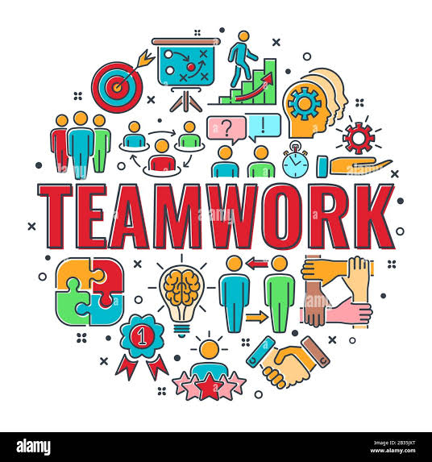
When creating software, fixing networks, or enhancing cybersecurity, professionals must recognise technical problems assess solutions and make decisions by building these abilities through coursework and rule projects I will be better equipped to handle obstacles at work.[4]
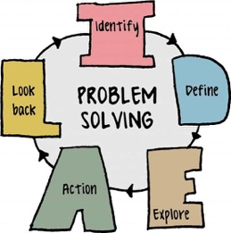
Professionals and individuals who use computers may prioritise activities, fulfil deadlines, and adjust to new technology with the help of time management. I will be more equipped for work and continue to grow professionally in the computer business if I successfully manage my education to maintain an open mind.[5]
In conclusion efficient communication, teamwork, problem-solving skills, and time management are critical for success in both higher education and computing sector. I will be more equipped to collaborate with others and overcome technical obstacles and create a successful career [1-5]

Task 1b
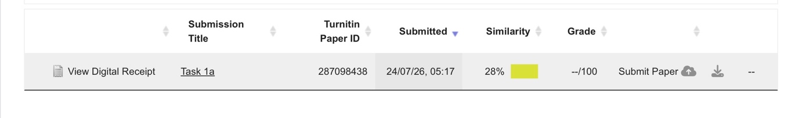

My Turnitin report said that. I had a 28% similarity score. This demonstrated that some of my assignments content match scholarly terms or publish sources. I acknowledge that some passages may have been better paraphrased, even though all sources were cited. I will read and comprehend material before writing it in my own words rather than precisely adhering to the original text to get better. In addition, I’ll use more scholar sources, sharpen my citing techniques, and use a similarity checker before submitting my work. I will be able to write more original academic work in the future.

Task 2A) Mind Map

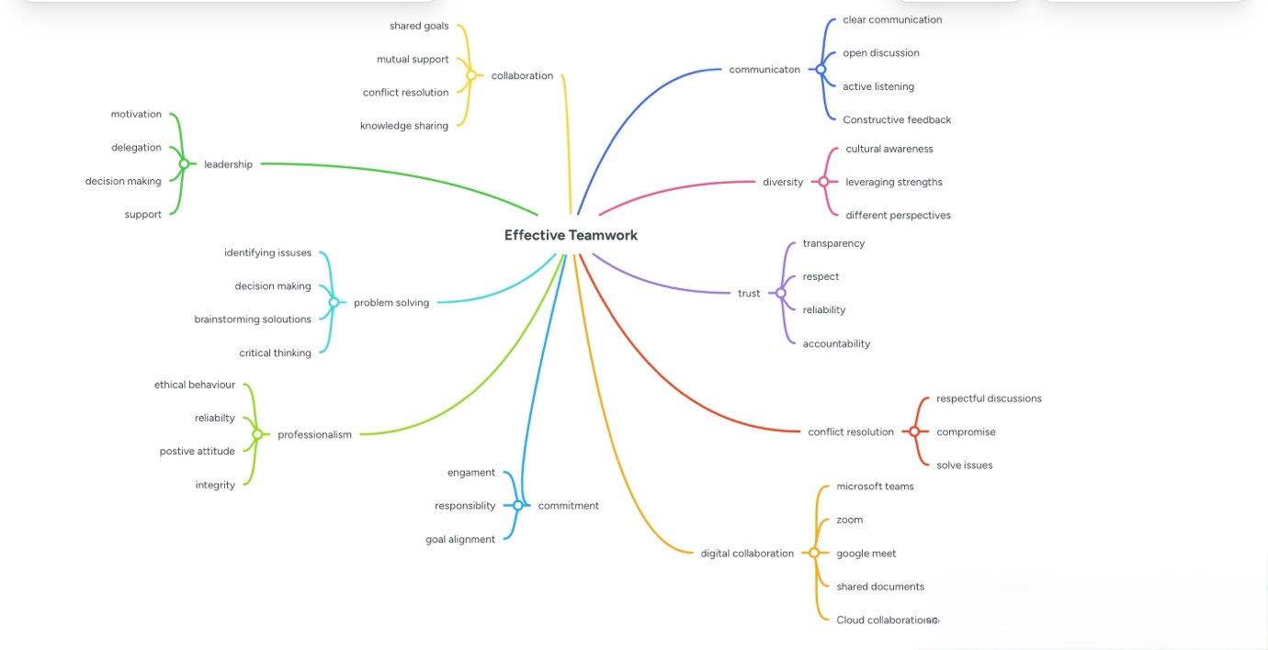
Team members: Rasheeda Richards, Ruben Dabo. Collaboration
Tool: Mind Meister

https://mm.tt/map/4055184847?t=brpnn8OSZj

2B) Academic Poster.
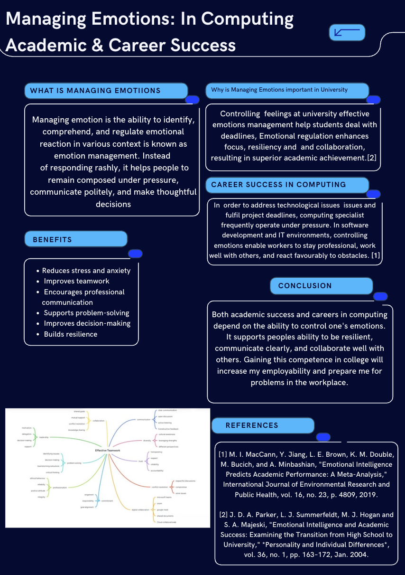

https://canva.link/b6ewdyltt40ydwv

3A)

In both academic and professional settings, reaching common objectives require effective teamwork. Teams can still encounter difficulties that lower the output. Groupthink and a lack of focus on outcomes are two prevalent problems that can hinder teams from reaching successful decisions.

When team members refrain from voicing divergent viewpoints in an effort to preserve unity within the group, this is known as groupthink. New ideas could therefore be disregarded resulting in poor decision-making. Members who see disagreement as a threat rather than a chance to advance ideas are more likely to experience this. By aggressively seeking and out of perspectives and comment, accepting constructive criticism, and carefully weighing various points of views before making decisions, teams can lessen groupthink. every team member will feel comfortable offering their views if open communication is encouraged. [6]

Teams go through five stages of development, according to the Tman and Jensen team development model: forming, storming, norming, performing, and adjourning.
Disagreements are normal during the s storming period and can enhance decision-making by promoting dialogue and problem-solving. As the team moves into the norming I’m performing phases, individuals gain confidence communication becomes more transparent, skills continue to advance, and the teamwork more effectively towards a common objective.[7]

One of Lencioni’s five dysfunctions of a team is inattention to result, which presents another difficulty. This happens with people prioritise their own objectives over the team’s overreaching aim. It is frequently associated with other issues, such as a lack of commitment, fear of conflict, a lack of trust, and then avoidance of accountability. Team should set clear goals, make practical strategies and divide work into quantifiable milestones so that progress can be effectively tracked in order to overcome these obstacles. To stay focused on accomplishing the teams comment objective, team members should also refrain from putting things off, seek assistance when necessary, and evaluate the progress on a regular basis. [8]

These ideas are especially crucial in the computing sector, where IT specialist and software engineers collaborate on projects. Teams meet enhanced problem-solving skills, generate better work, and successfully finish projects on schedule by avoiding groupthink promoting open communication, and keeping an eye on set outcomes.

3B)

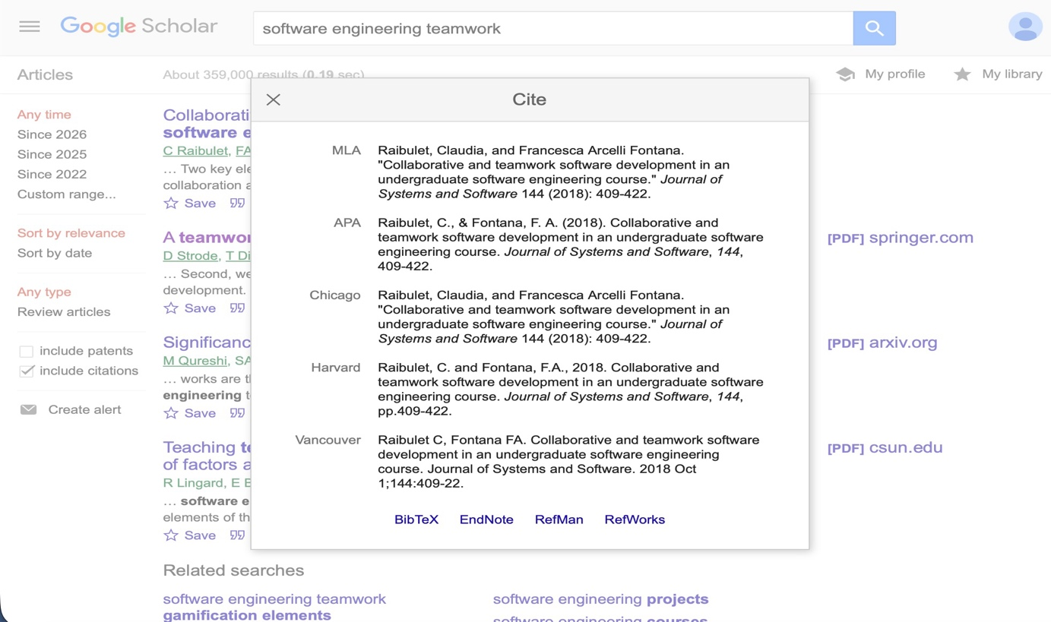

Exporting a reference from Google Scholar to RefWorks.

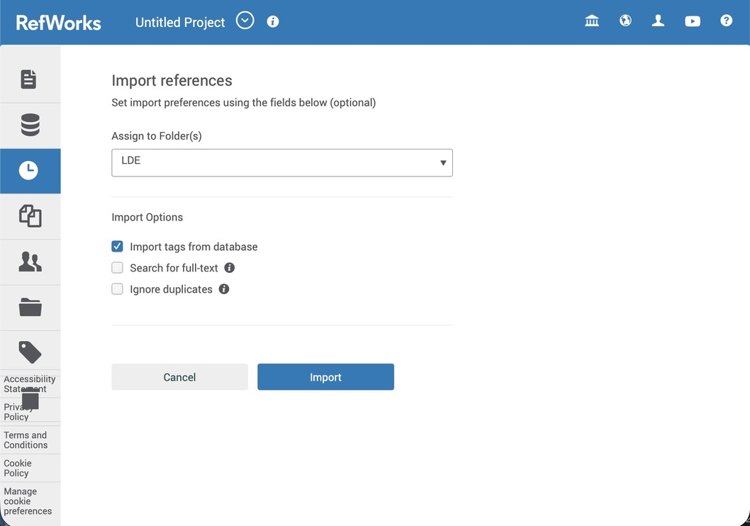

Importing the reference into RefWorks library.

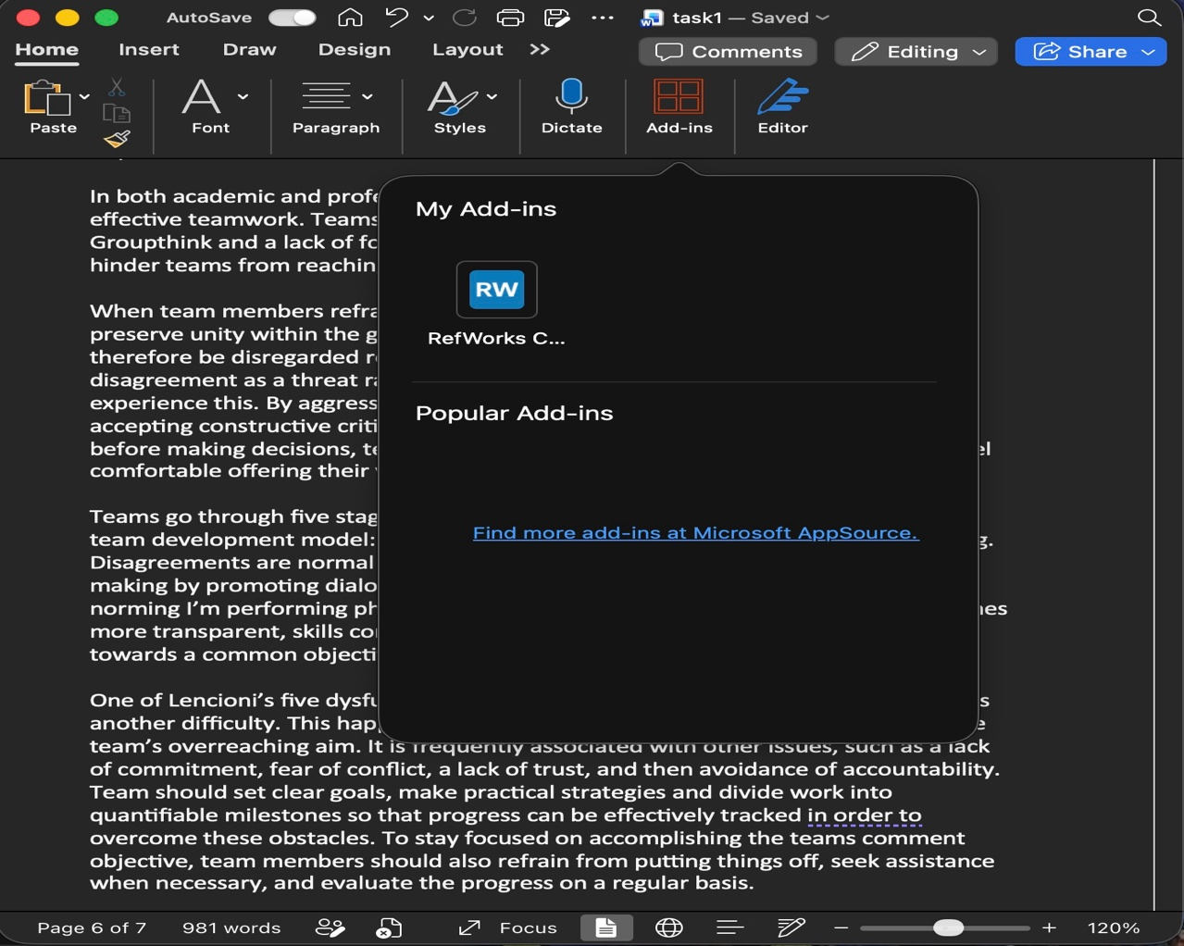

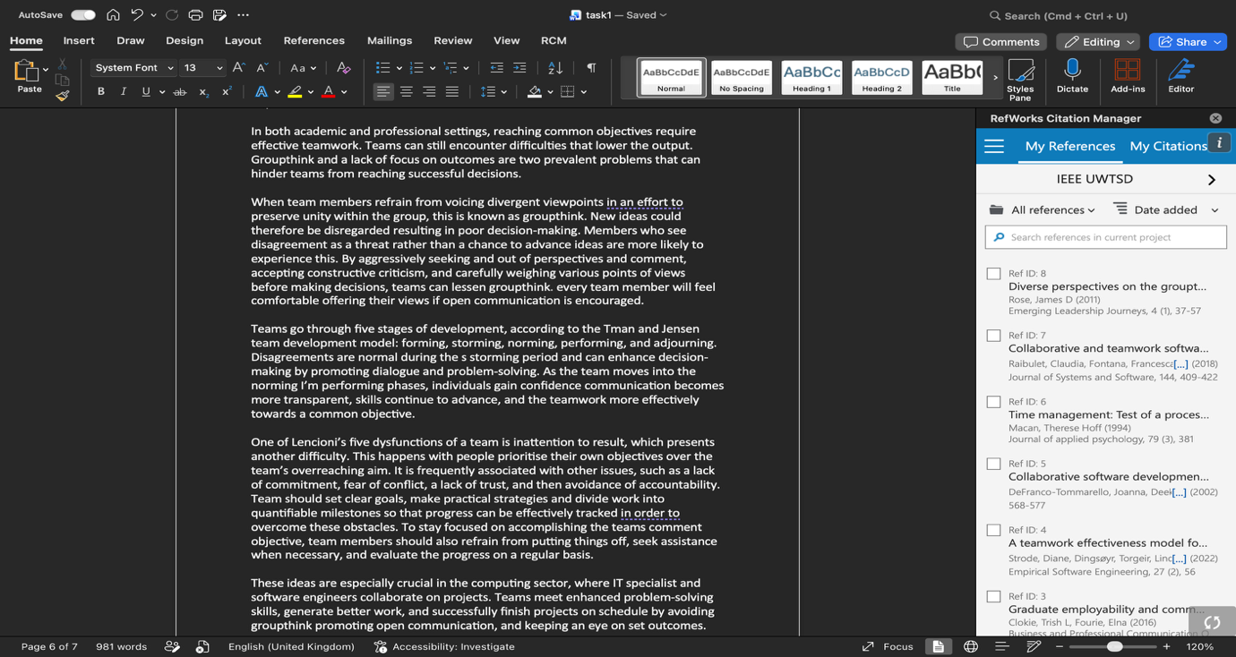

Using RefWorks Citation Manger in Microsoft Word to insert IEEE citations.

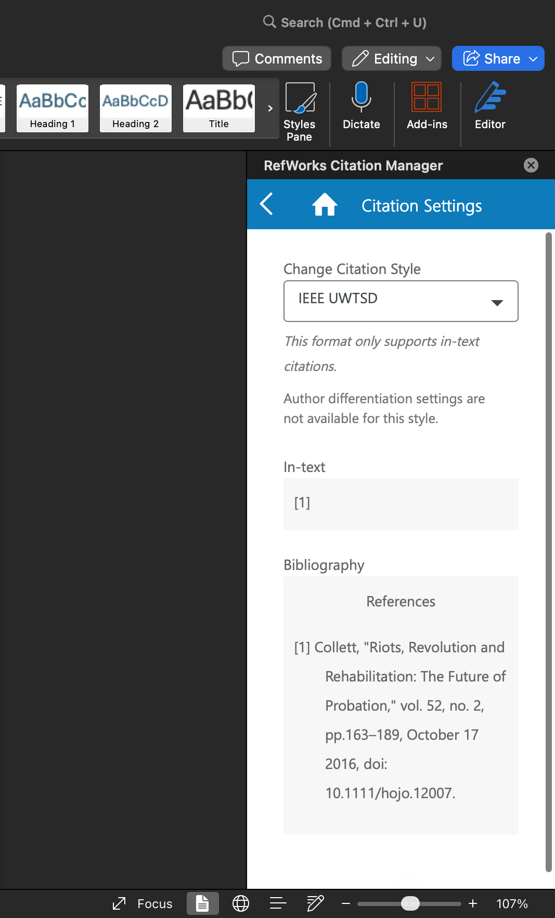
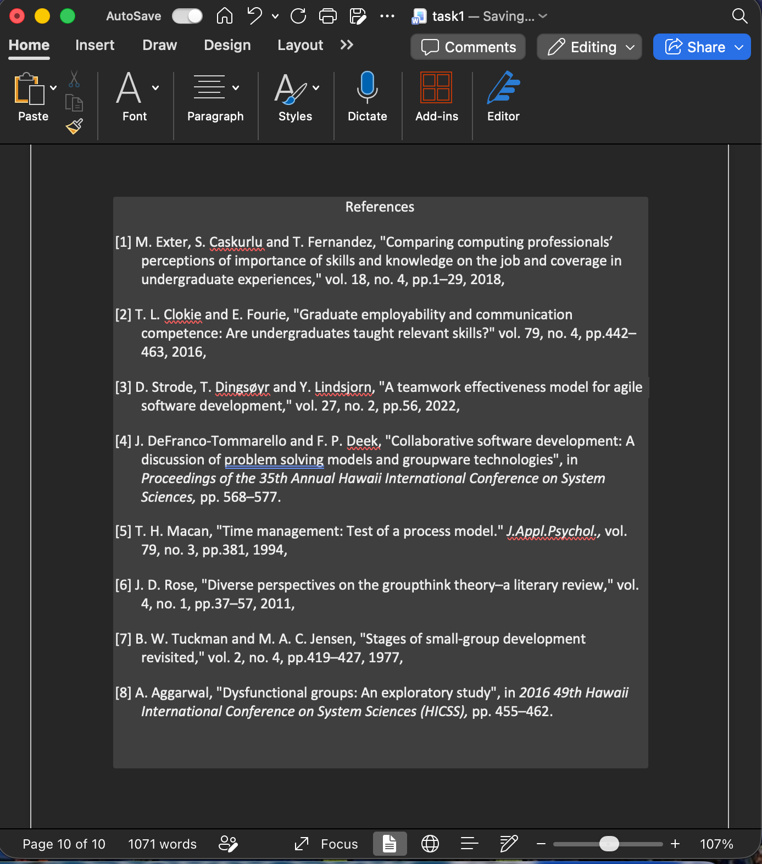
Use RefWorks to add relevant IEEE style citations and a reference list.

RefWorks are used to organise and manage the references included in task 3a. The sources were imported into RefWorks using Google Scholar and online journal databases. Once the references had been added to the library, the IEEE referencing style was selected. RefWorks automatically generated in-text citations and a reference list, which were inserted into the word document using the RefWorks Citation Manager add-in. This process improved the accuracy and consistency of my referencing while reducing the risk of formatting errors. Using RefWorks also saved time and made it easier to manage multiple academic sources throughout the assignment.

Task 4



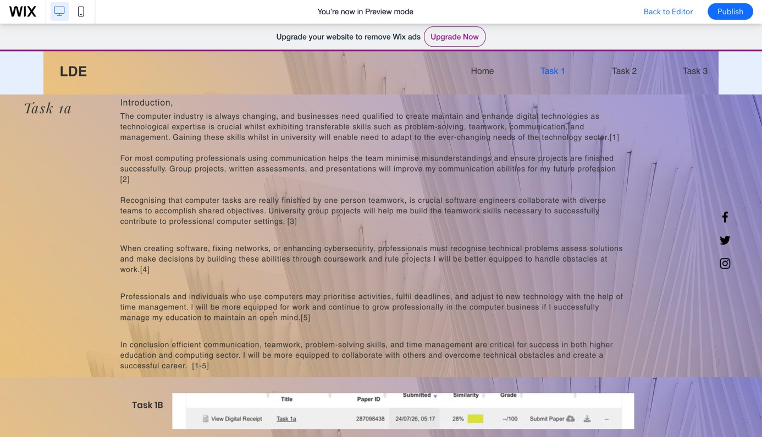
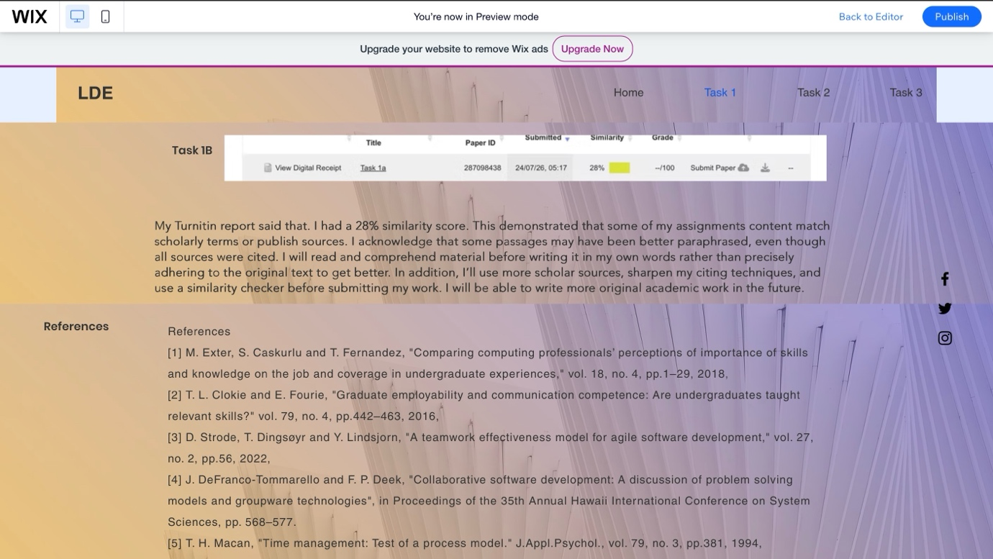

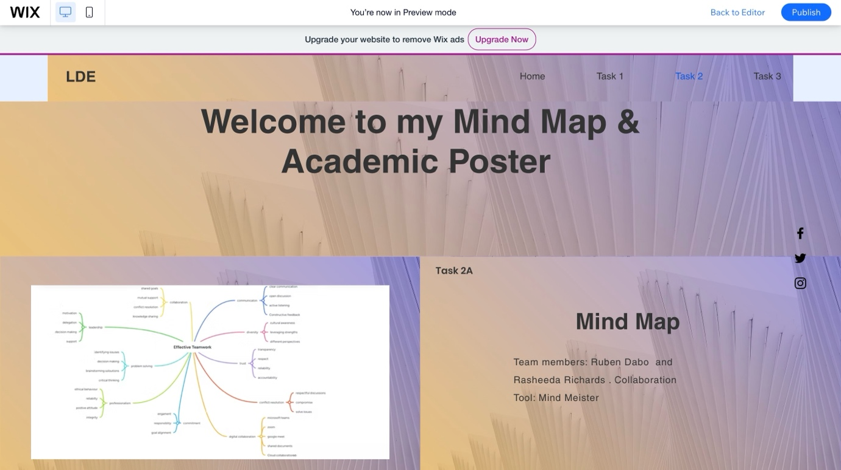

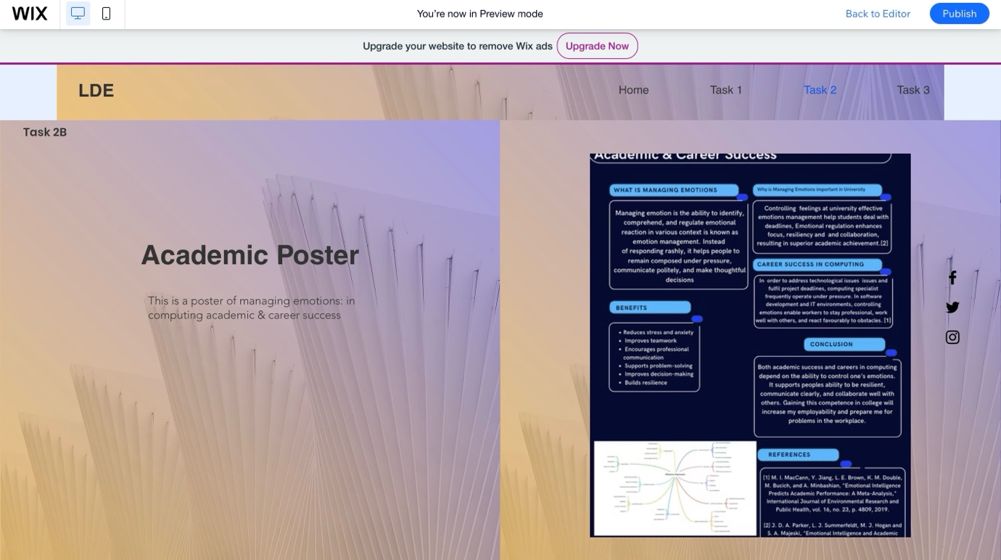

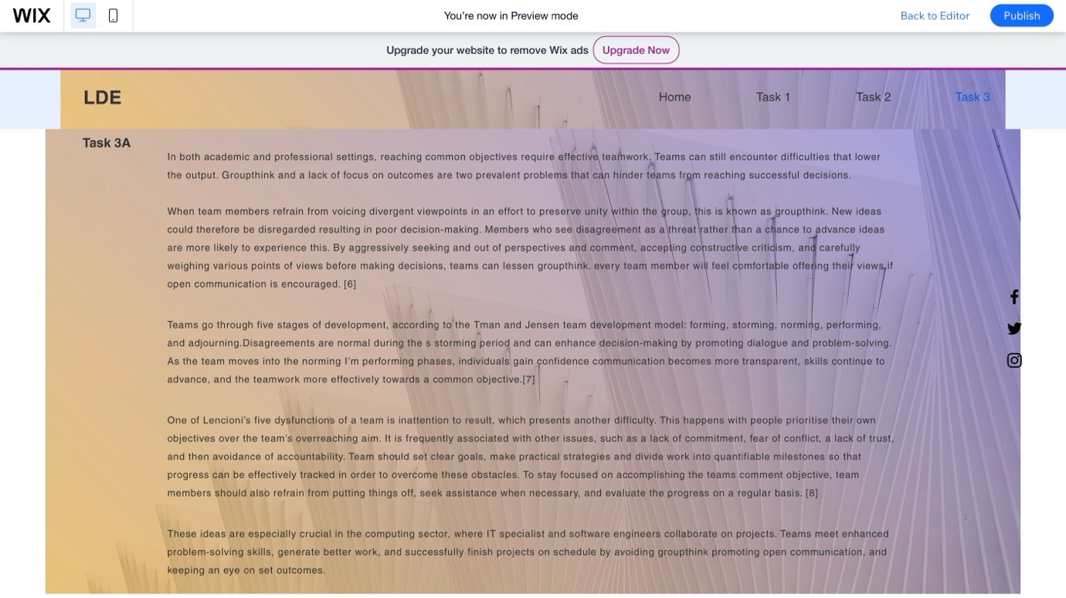

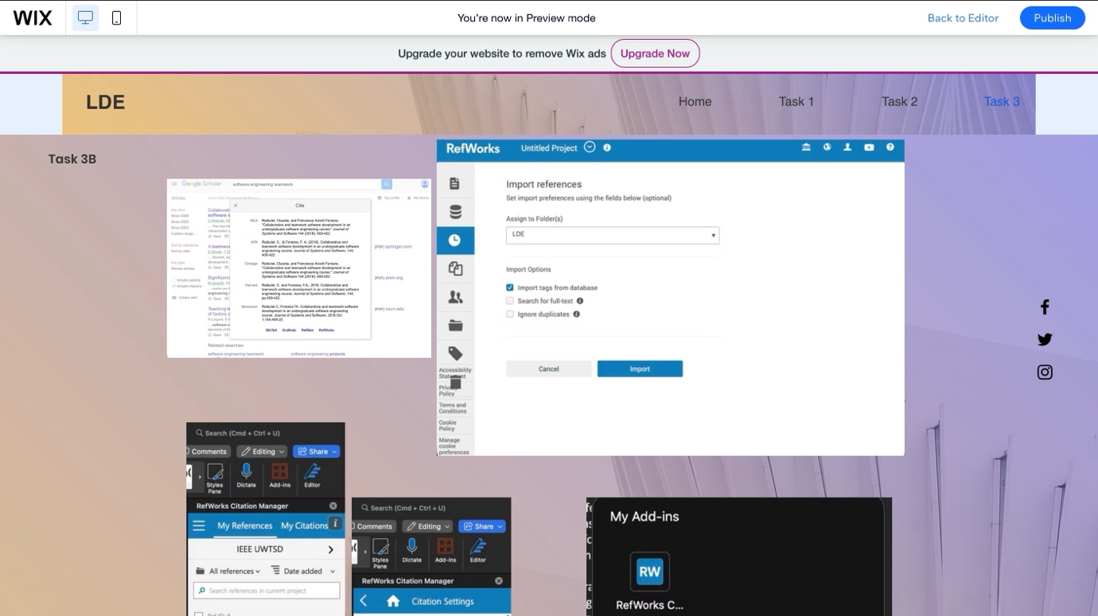

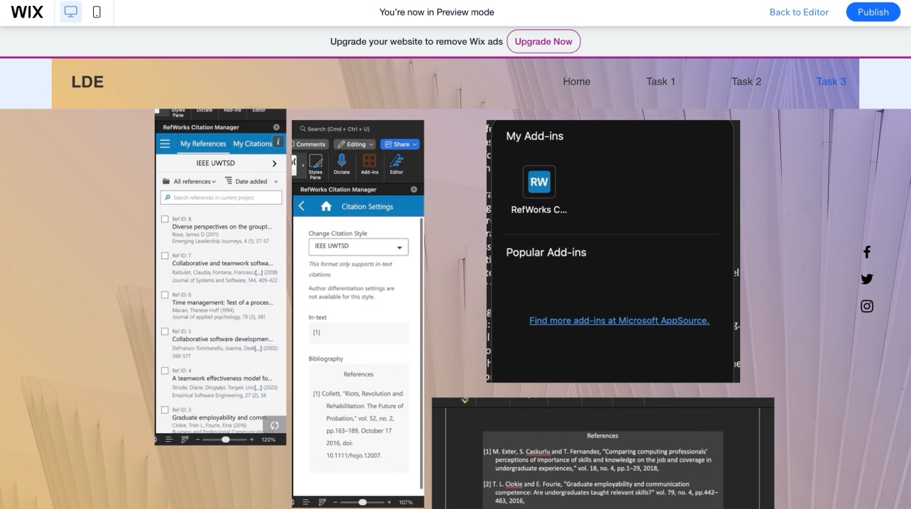

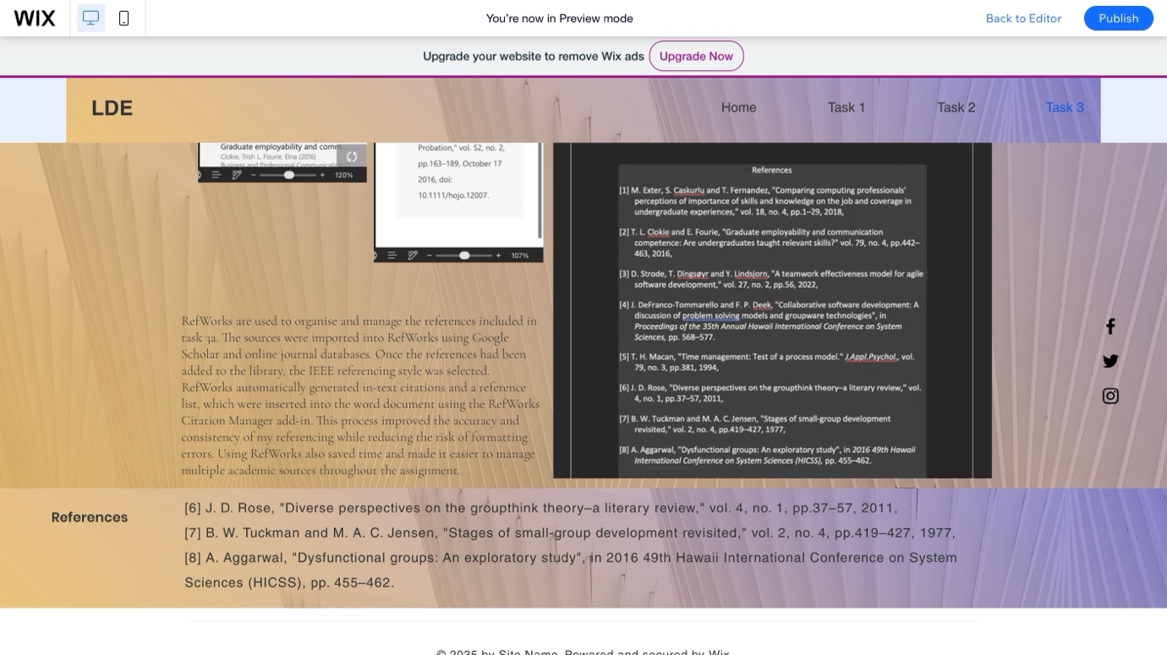

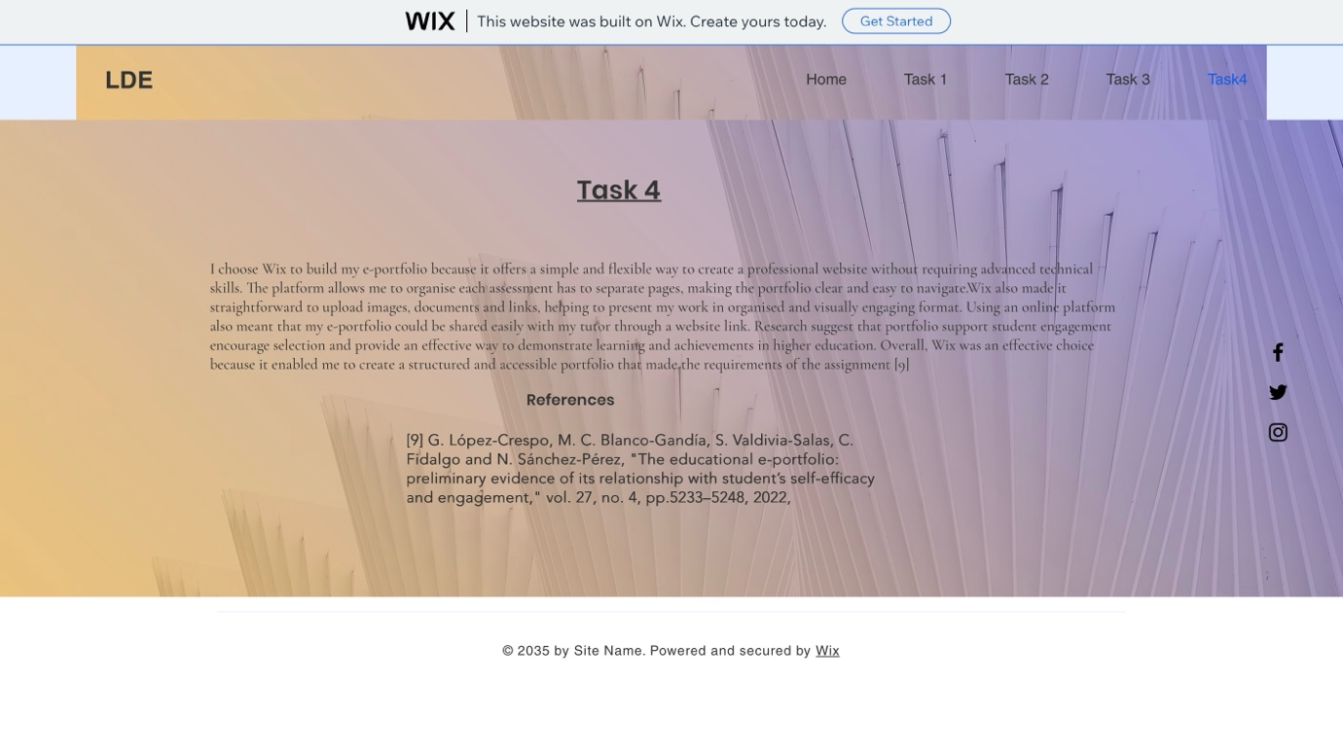

References
[1] M. Exter, S. Caskurlu and T. Fernandez, "Comparing computing professionals’ perceptions of importance of skills and knowledge on the job and coverage in undergraduate experiences," vol. 18, no. 4, pp.1–29, 2018,
[2] T. L. Clokie and E. Fourie, "Graduate employability and communication competence: Are undergraduates taught relevant skills?" vol. 79, no. 4, pp.442–463, 2016,
[3] D. Strode, T. Dingsøyr and Y. Lindsjorn, "A teamwork effectiveness model for agile software development," vol. 27, no. 2, pp.56, 2022,
[4] J. DeFranco-Tommarello and F. P. Deek, "Collaborative software development: A discussion of problem solving models and groupware technologies", in Proceedings of the 35th Annual Hawaii International Conference on System Sciences, pp. 568–577.
[5] T. H. Macan, "Time management: Test of a process model." J.Appl.Psychol., vol. 79, no. 3, pp.381, 1994,
[6] J. D. Rose, "Diverse perspectives on the groupthink theory–a literary review," vol. 4, no. 1, pp.37–57, 2011,
[7] B. W. Tuckman and M. A. C. Jensen, "Stages of small-group development revisited," vol. 2, no. 4, pp.419–427, 1977,
[8] A. Aggarwal, "Dysfunctional groups: An exploratory study", in 2016 49th Hawaii International Conference on System Sciences (HICSS), pp. 455–462.
[9] G. López-Crespo, M. C. Blanco-Gandía, S. Valdivia-Salas, C. Fidalgo and N. Sánchez-Pérez, "The educational e-portfolio: preliminary evidence of its relationship with student’s self-efficacy and engagement," vol. 27, no. 4, pp.5233–5248, 2022,

