

Student name: Sonia Maria Mendes Da Cruz Furtado
Student ID: 2412237
Module name: Changemakers: Building your Personal Brand for Sustainable Employment
Module code: (BMHP5015_ LON)
Lecturer name: Brian Mashumba

Changemakers: Building your Personal Brand for Sustainable Employment - Portfolio

Component 1

Introduction :

This portfolio is a reflection on my learning across the module Changemakers: Building your Personal Brand for Sustainable Employment. The module contained four units: Unit 1 explored ambition, goal setting, emotional intelligence and personal branding, Unit 2 examined networking, diversity and digital communication influence; Unit 3 focused on perception, opportunity, recruitment and professional online presence; Unit 4 focused on limiting beliefs, resilience, grit, and the pursuit of happiness in career roles. These topics lead me to reflect on my strengths, values and future career and develop the knowledge and skills needed. I will use Gibbs’ reflective Cycle (Gibbs, 1988), to help me structure my reflection because it provides a framework to describe my experiences, my feelings, evaluate concepts learned and analyse their importance and in addition to identify how what I learned will help me in my future career as a Designated Safeguarding Lead in a school setting and in identifying actions for future development McLeod. Throughout this portfolio I will discuss how the concepts explored during the module had an impact on my personal and professional growth and reflect on how the knowledge I acquired strengthened my ambition to become a Designated Safeguarding Lead working in a school setting and how it will help in the future safeguarding children, working with their families and also when working together with professionals to deliver positive outcomes.

Reflection on Unit 1: Brand You

Unit 1 initiate with the concept of personal branding which encouraged me to reflect on my ambition, values and professional identity. Before studying this unit, I did not have the clear understanding of personal branding, I thought that personal branding was only about how I present myself professionally. However, through the lectures, the class discussions and completing the Moodle activities, I understood that my personal brand is built on self-awareness, values, behaviours and continuous learning to help me with my personal and professional development.
One of the first key topics explored during the forum activity was ambition, I was asked what I wanted to become after completing my BSc (Hons) in Health and Social Care. I initially found this question difficult because I had not clearly defined my future career until that moment, however, reflecting on my passion for safeguarding children and vulnerable people helped me recognise that I want to become a Designated Safeguarding Lead. Fraser (2019) explains that ambition motivates individuals to pursue meaningful goals despite challenges. This activity gave me a clearer sense of direction and helped me understand that my personal brand should reflect commitment, integrity and a pure desire to protect children and support families.
Another concept that influenced my learning was autonomy. Researching what means autonomy for the Moodle activity helped me understand that autonomy is the ability to make informed decisions while respecting rights, dignity and preferences of others (British Medical Association, 2024). Before completing this activity, I associated autonomy mainly with I being independent, however now I understood that, in health and social care, it also involves empowering individuals and making ethical decisions. As a future DSL, this understanding will help me build a professional brand based on respect, accountability and person-centred practice (NSPCC, 2020).
The concept that had also an impact on me was emotional intelligence. Before researching Emotional intelligence and complete a Quiz from the National Career Service website in class, I did not had the knowledge that Emotional Intelligence is the ability to manage and understand my own and others emotion; after researching I understood that with the development of healthcare industry, it is an important skill for me to master because it will enable me to have effective communication with parents and children’s, stakeholders and colleagues, help me manage stress efficiently and also to adapt to challenging situations easily (Gupta, 2023). After completing the National Careers Service Emotional Intelligence quiz, I made a reflection on the importance of self-awareness, empathy and emotional regulation. Raisani et al. (2026) argues that emotional intelligence is essential for effective leadership and professional relationships. The quiz results encouraged me to identify areas for further development, such as self-control and empathy because these qualities will be essential for me to communicate with children, families and colleagues, especially when responding to safeguarding concerns.
Overall, Unit 1 strengthened my understanding that personal branding goes beyond having a qualifications or experience. It is about demonstrating ambition, ethical values and emotional intelligence constantly. This reflection motivated me to continue developing the personal and professional qualities required for my future career as a Safeguarding Leader.

Screenshot of the activity posted on Forum week 1 of autonomy meaning:
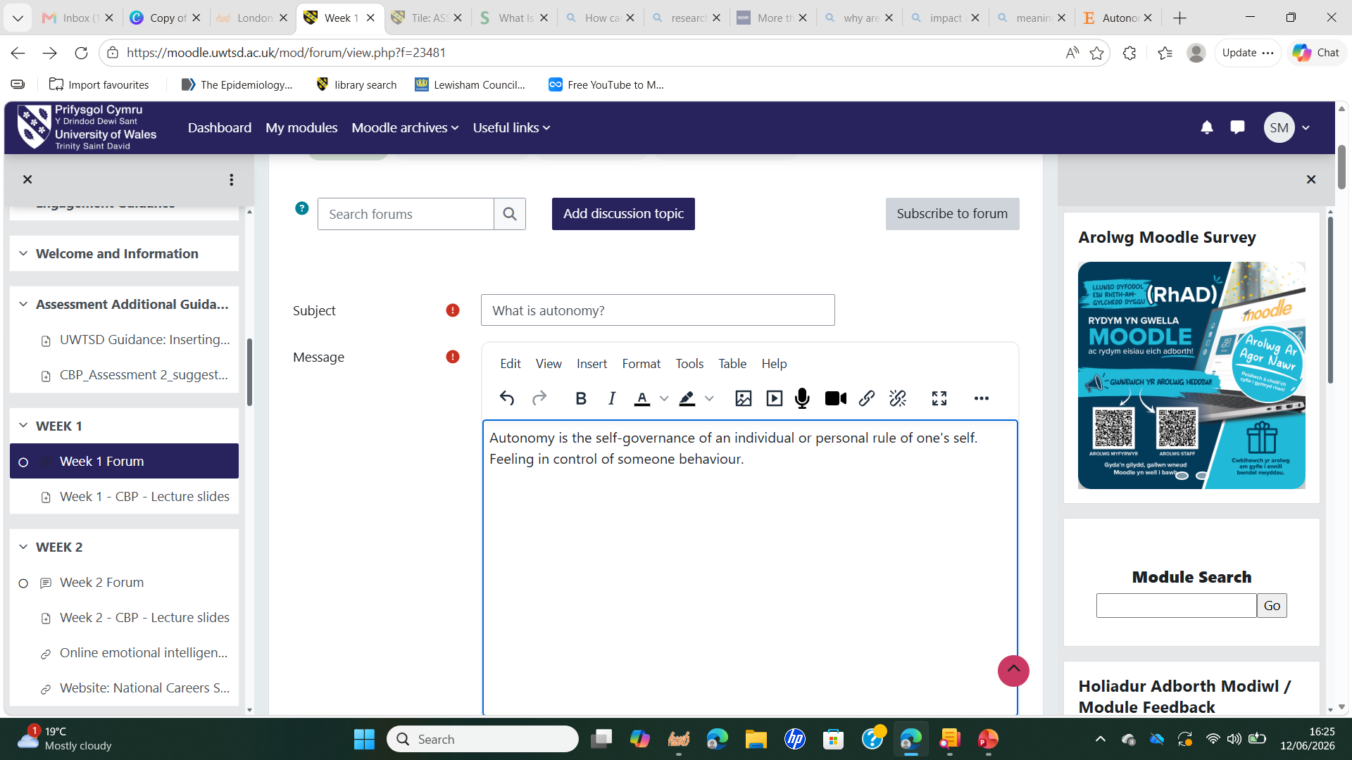

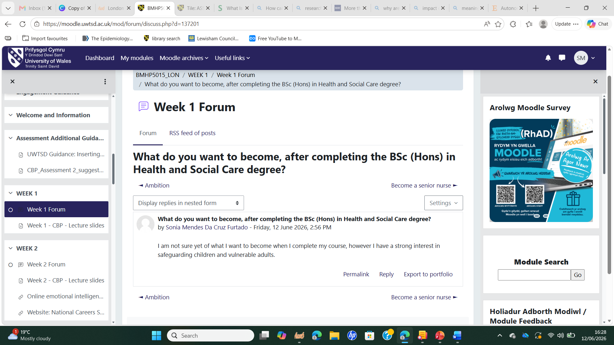

Screenshot of my results of the Emotional Intelligence National Career Quiz done in class:
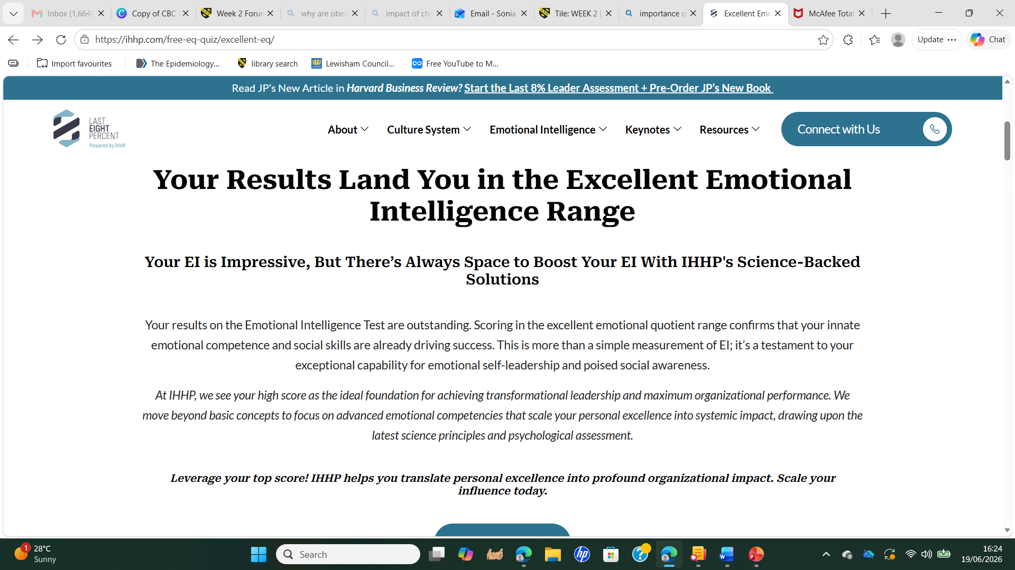

Reflection on Unit 2: It’s a Small World
One of the main concepts explored in unit 2 was networking. Hamlin (2024) explains that networking enables professionals to exchange the knowledge they have, share experiences, create innovative solutions and to access opportunities for professional development. Reflecting on this concept made me value that, as a future Designated Safeguarding Lead, I will need to work closely with teachers, social workers, health professionals, police and multi-agencies to safeguard children effectively which provided me with the knowledge that networking is not only about receiving support but it is a reciprocal process where knowledge is exchanged from the experiences of others, in health and social care this is important because it supports reflective practice and continuous improvement (NSPCC,2020). This reflection has opened my vision of the importance in building professional relationships through volunteering, university activities and professional platforms such as LinkedIn.
Before exploring diversity in networking for the forum activity, I had not considered how engaging with people from different cultural, professional and social backgrounds could improve decision-making. According to NHS England (2026) diverse teamwork promotes innovation, reduces inequalities and improves the quality of care. This activity gave me the understanding that understanding different perspectives is essential when working with children and families from diverse communities. As a future DSL, I want to ensure that my decisions are fair, inclusive and culturally sensitive instead of influenced by my own assumptions (NSPCC, 2020).
With the concept of network society and the influence of digital communication I learned that technology will enable me to communicate, share information and collaborate beyond geographical boundaries which will strengthen my professional networks and my access to diverse knowledge (Belkacem and Senouci, 2026). This helped me understand that building a professional online presence and using digital communication responsibly are important aspects of modern health and social care practice because it will help me come out of my comfort zone and engage with confidence with other professionals.
Overall, Unit 2 gave me the awareness that safeguarding cannot be achieved without collaboration, effective networking, diversity and digital collaboration are essential for protecting children and supporting families (Jahans‐Baynton and Grealish, 2021). This reflection has encouraged me to develop stronger professional relationships and value partnership working as crucial for my future career.

Screenshot of the activity about networking posted on Moodle/ Forum
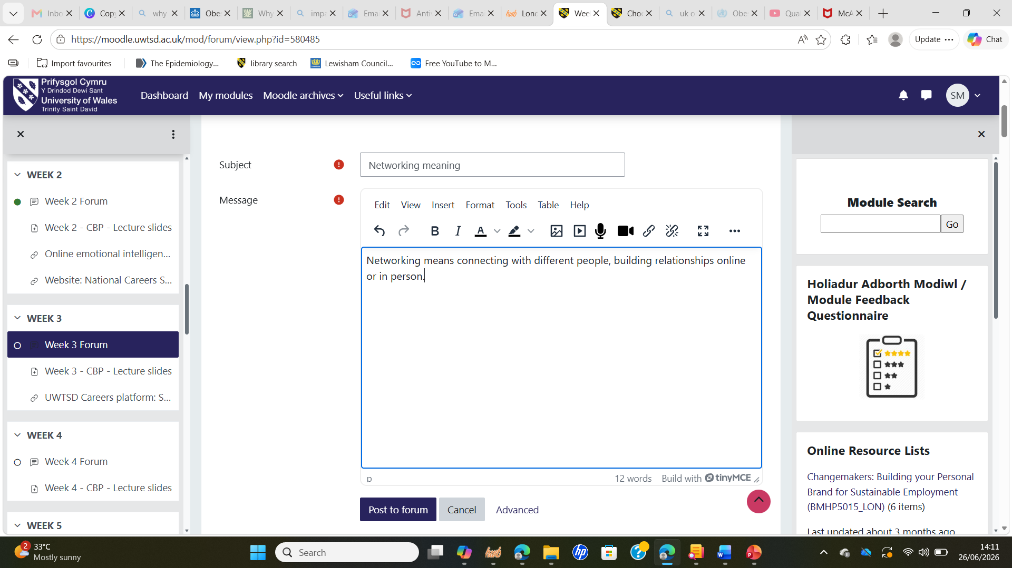
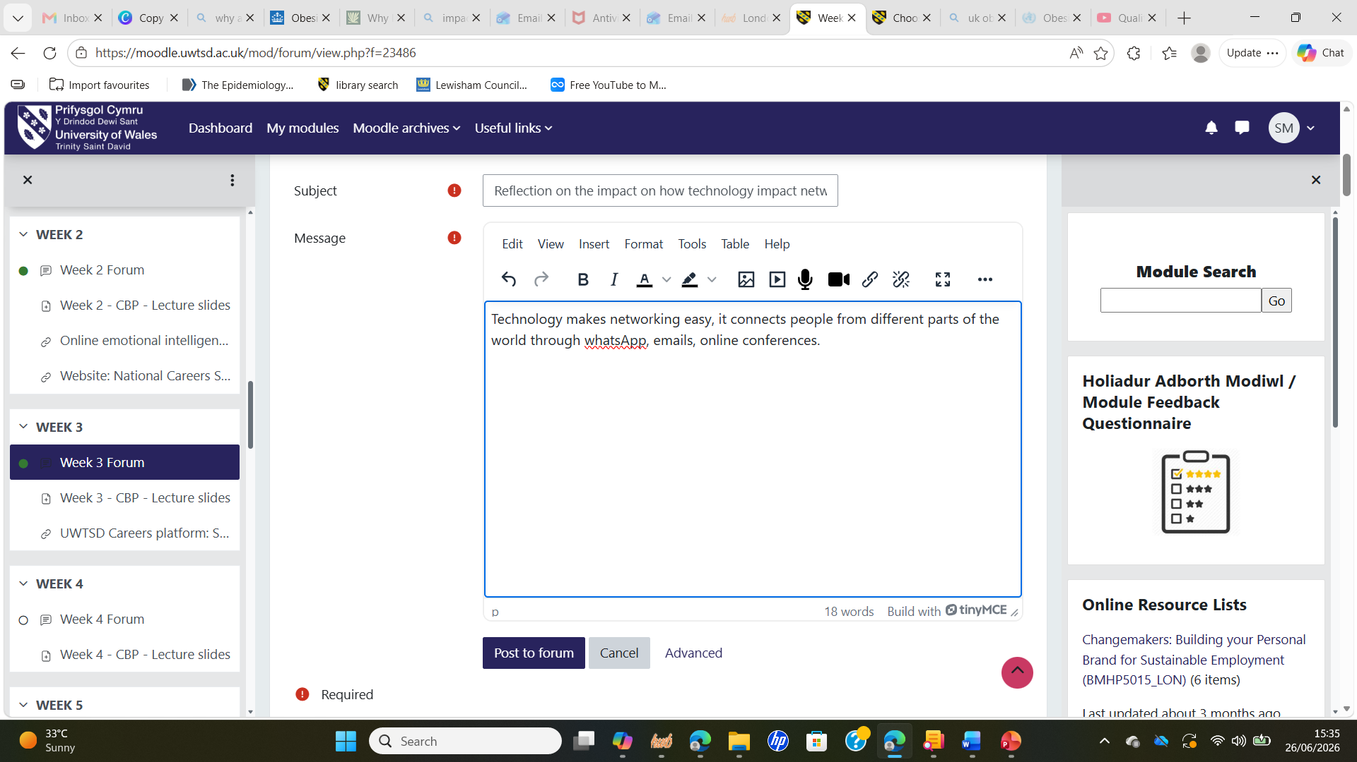

Reflection on Unit 3: Opportunity Knocks

Unit 3 focused on perception, recognising opportunities, the Serendipity Mindset, SMART and stretch goals, traditional and modern recruitment, professional online presence, influencing tools and blog writing. These topics helped me to reflect on how opportunities can be recognised and used to support personal and professional development. Before studying this unit, I believed that career success depended on qualifications and luck. However, the lectures and Moodle activities changed my perspective by showing me that opportunities are often created through the way I think, respond to challenges and act.
One of the most valuable concepts I explored was changing perspective. During the class activity posted on Forum, I reflected on the importance of looking beyond my own assumptions and considering the experiences of people from different cultural and social backgrounds. Ekezie et al. (2023) highlights that understanding different perspectives can reduce inequalities and improve the quality of health and social care. This activity helped me realise that, as a future Safeguarding Lead, I must avoid making assumptions and instead listen carefully to children, families and professionals before making safeguarding decisions. Developing this mindset will enable me to provide fair, inclusive and person-centred support (Fraser, Stewart and Jones, 2019).
Another concept that had a significant impact on me was the Serendipity Mindset. I had never heard of serendipity before, I believed that opportunities occurred mainly through having luck, however, after learning about it, I changed my thinking, now I understand that opportunities can be created through curiosity, networking and being open to new experiences (Busch, 2024). I reflected on my volunteer work at church and realised that it has provided valuable opportunities to develop communication, leadership and safeguarding awareness. This experience encouraged me to recognise that every opportunity can contribute to my professional growth if I am willing to learn from it.
Finally, learning about stretch goals encouraged me to challenge myself beyond my comfort zone. Although SMART goals helped me understand the importance of setting realistic objectives, stretch goals inspired me to pursue continuous personal and professional development. My ambition to become a Designated Safeguarding Lead motivates me to complete my Health and Social Care degree, undertake additional safeguarding training and gain practical experience working with children. Overall, Unit 3 helped me understand that recognising opportunities requires an open mindset, while making use of them requires continuous learning and the confidence to challenge myself. These lessons will continue to guide my professional development and prepare me for a future career in safeguarding.

Screenshot of the activity posted on Forum Serendipity meaning
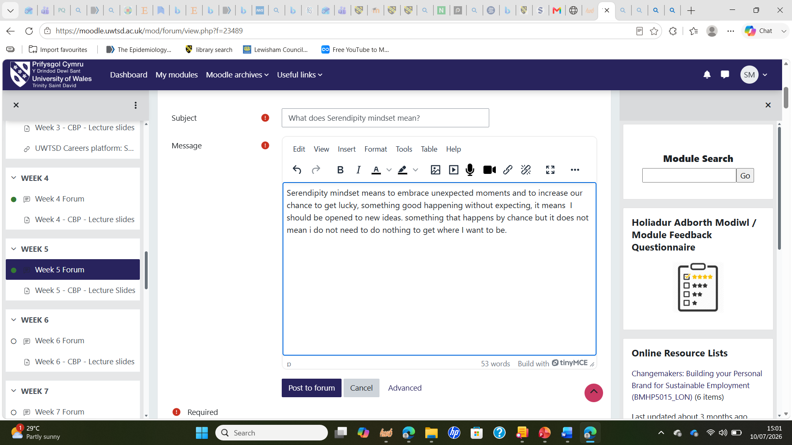
Screenshot of the activity posted on Forum: Importance of changing perspective in healthcare
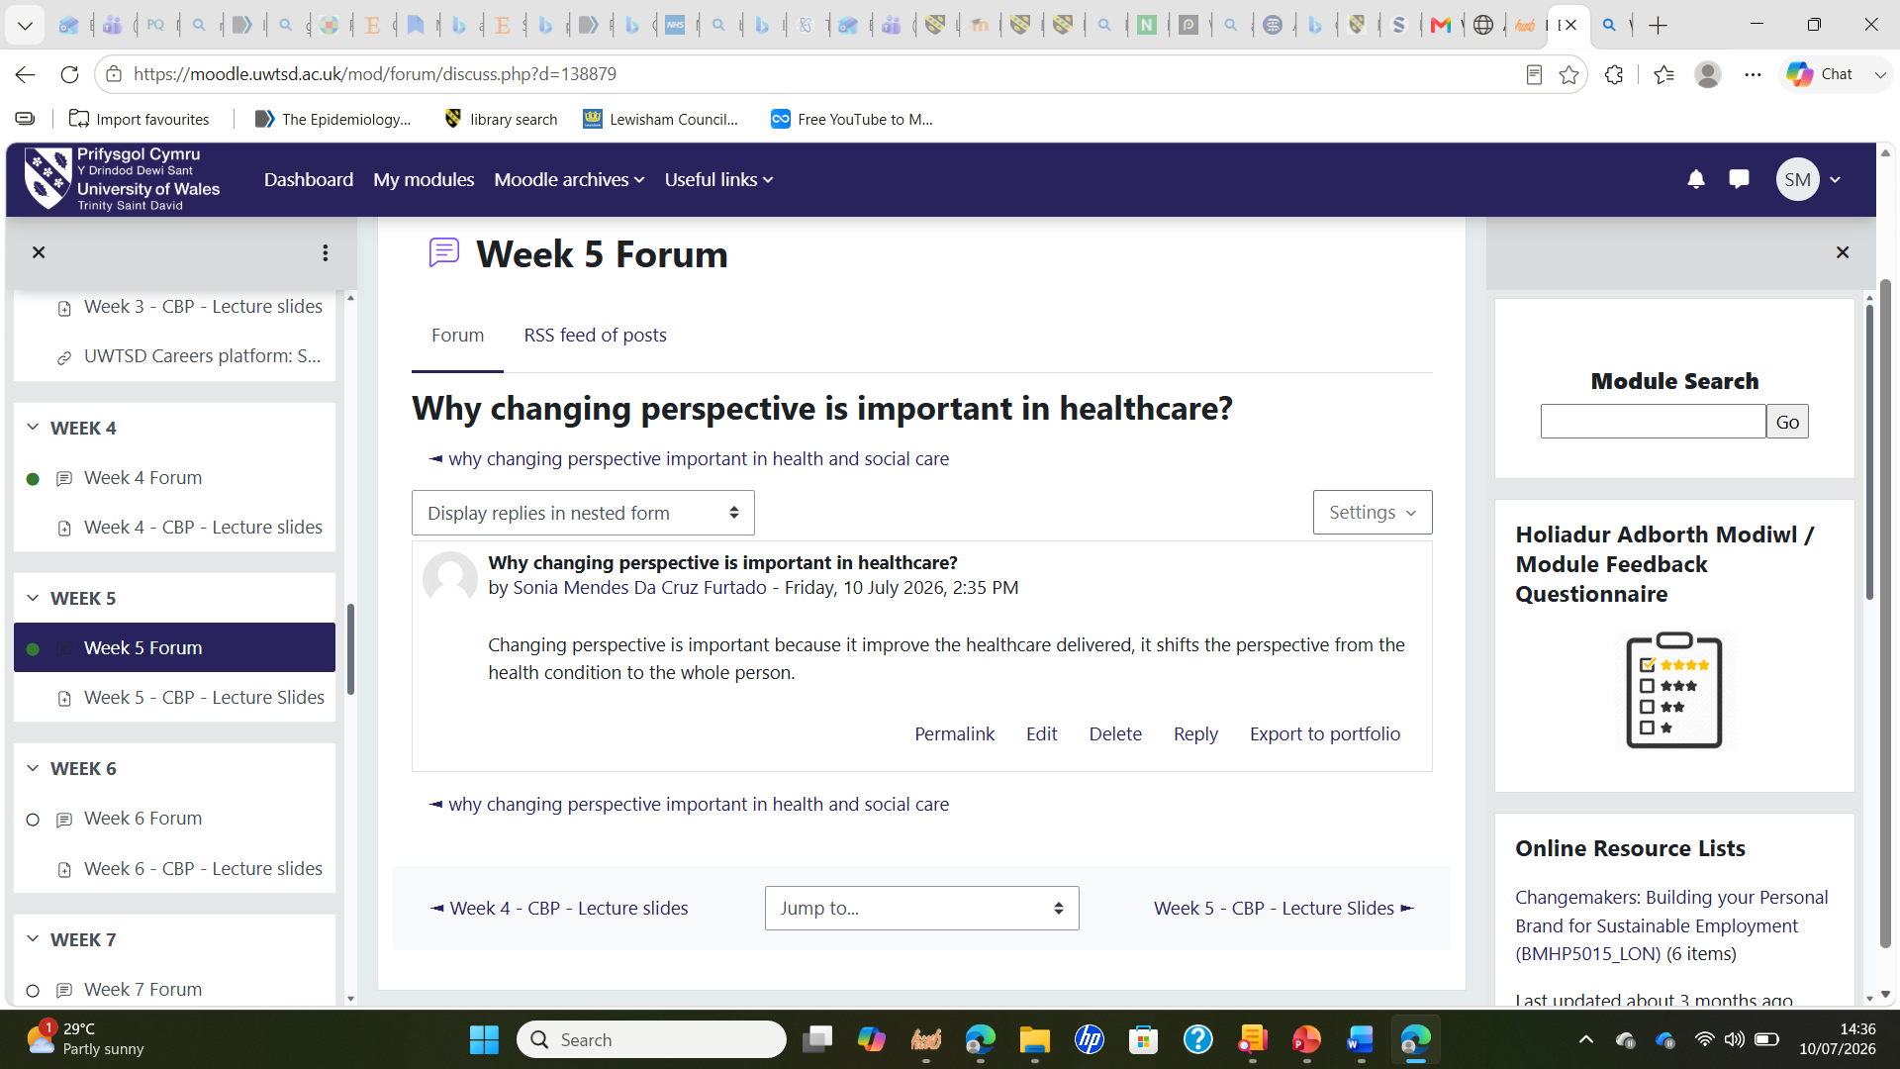

Screenshot of the activity posted on Forum: Stretch goals meaning
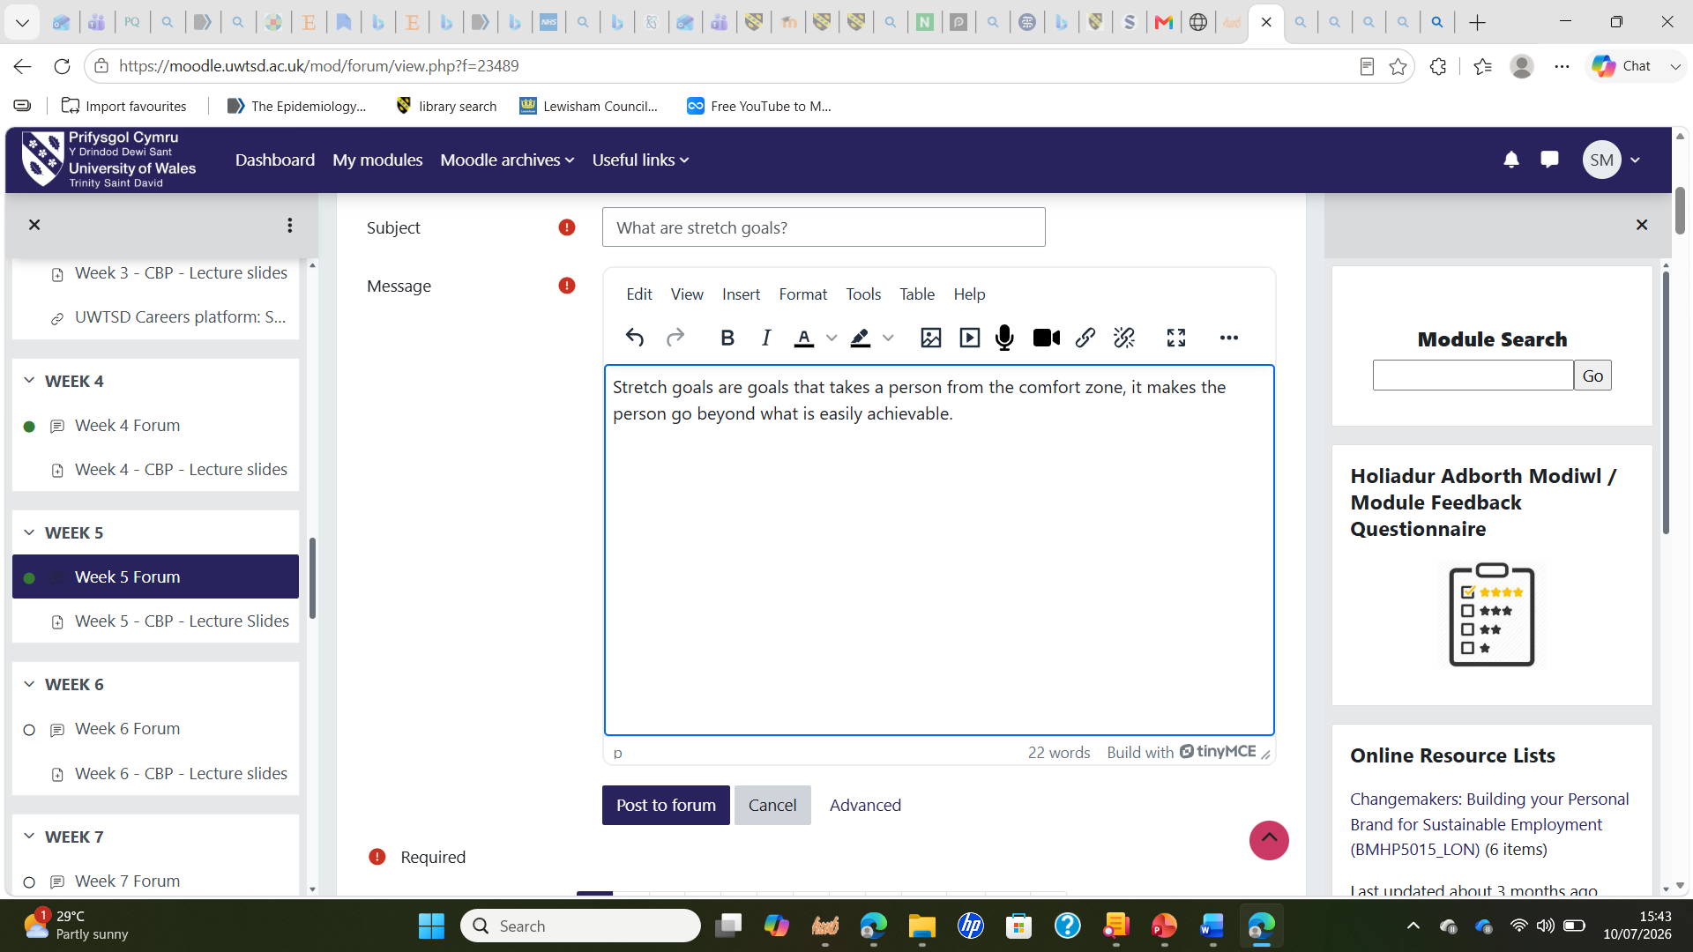

Reflection on Unit 4: The Pursuit of Happiness

Unit 4 explored why people choose to study, limiting beliefs, grit, resilience, dealing with failure, career change, the impact of technology on future employment, anti-fragile thinking, Social Learning Theory and the importance of mentors. These topics strengthened my reflection on the personal qualities I needed to build a successful and sustainable career in health and social care. Before studying this unit, I focused mainly on achieving my academic goals. However, I now understand that developing the right mindset and resilience is important for long-term professional success.
One of the concepts that had great impact on me was limiting beliefs. Reflecting on this topic equipped me with the awareness that self-doubt can prevent me from achieving my full potential, to recognise these thoughts that could hold me back from achieving my goals is important that I make a pause, have a reflection, and admit my emotions without letting them overwhell me. Recognising and challenging limiting beliefs will lead me to personal growth and success (Moore, Parsons and Jessup, 2018).
A key concept explored in class was grit and resilience, I learned that setbacks and challenges are part of personal and professional growth and that I should not see it as a sign of failure. Stoffel and Cain (2018) describe grit as perseverance and passion for achieving long-term goals despite obstacles. Reflecting on my own journey, including balancing university with personal responsibilities and health challenges, helped me conclude that resilience has enabled me to continue even when circumstances have been difficult. I now understand that these qualities will be essential when dealing with emotionally demanding safeguarding situations and supporting children and families through difficult experiences.
Dealing with failure was another key lesson that taught me that I should not see failure as something personally or through what others think or opinions, but rather see failure as an opportunity to learn and grow (Stoffel and Cain, 2018). This helped me to reflect on how I have been responding to setbacks and how I can improve my emotional resilience in the future when challenges or emotional demands arise.
Sources of resilience were explored in this unit such as mindset, self-belief, support systems and reflective practice, resilience comes from internal sources such as self esteem, ability to manage emotions, positive mindset and from external sources such as support system as support from friends, family, community and access to opportunities in life (Van Breda 2018).
Overall, Unit 4 strengthened my confidence, resilience and commitment to lifelong learning. It reminded me that professional success depends not only on knowledge and qualifications but also on perseverance, self-belief and a willingness to learn from others. These qualities will support my future career as a Designated Safeguarding Lead and help me respond positively to future challenges.

Screenshot of the activity posted on Forum: How to overcome limiting beliefs
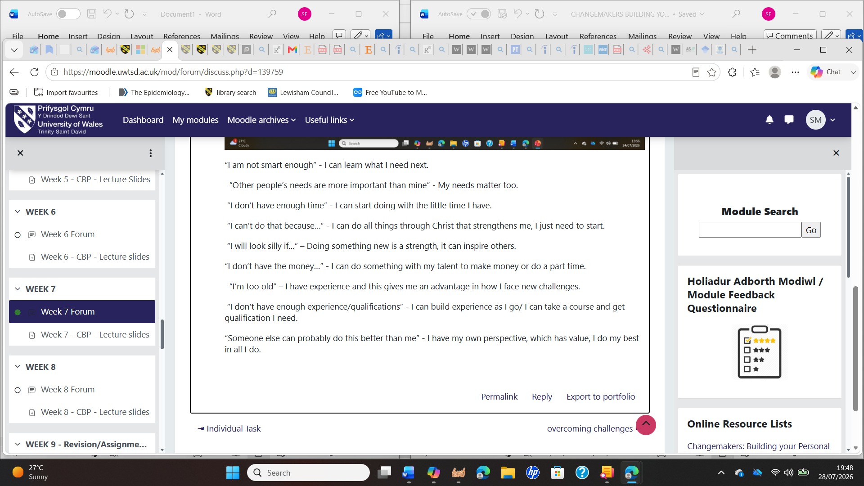

Screenshot from the activity posted on Forum: Resilience approach
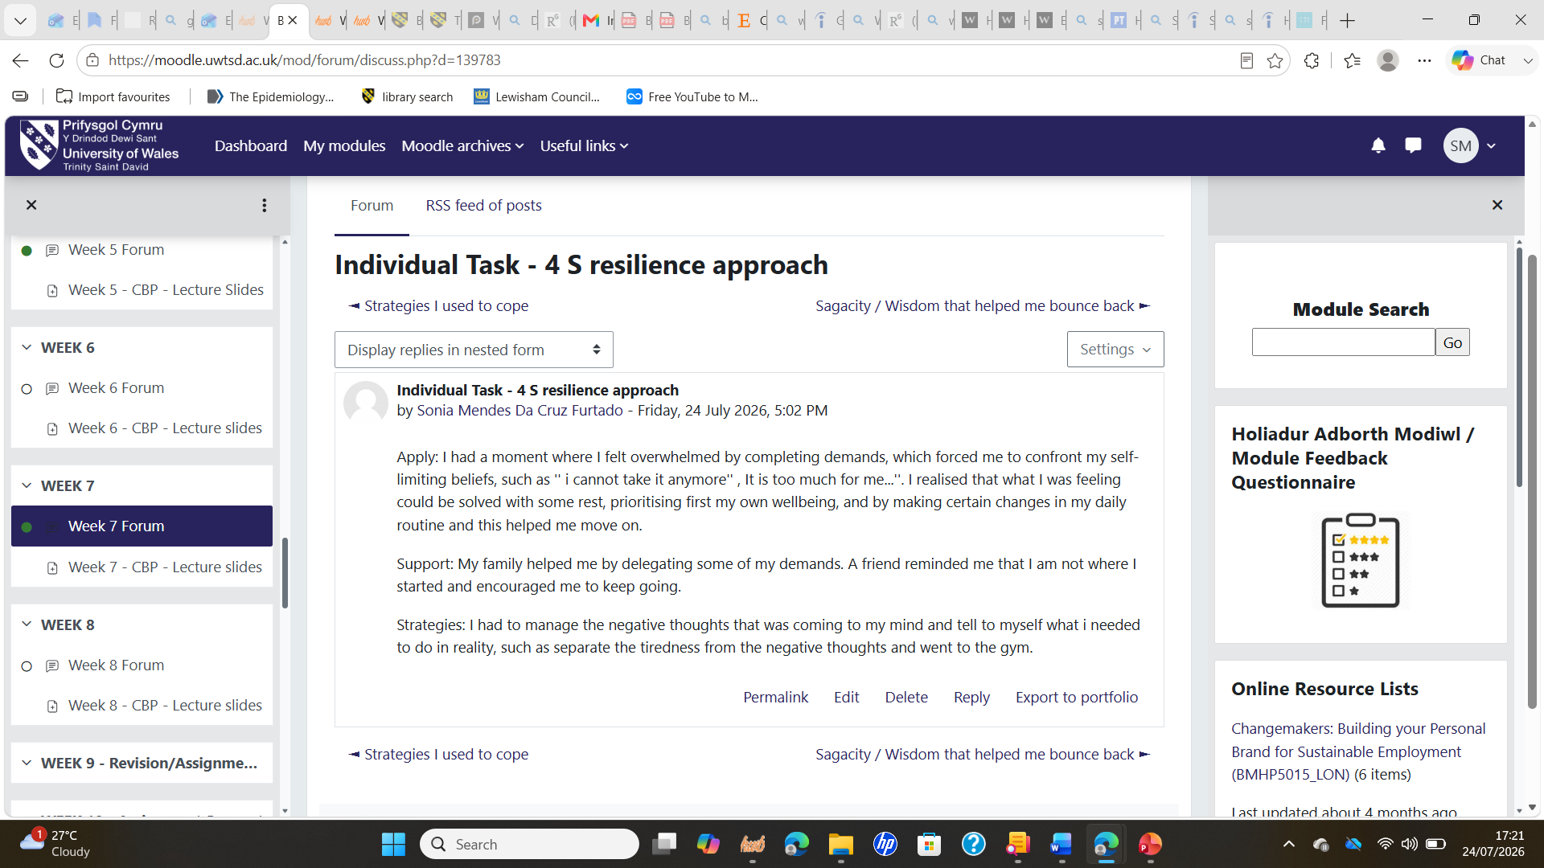

Conclusion:

In conclusion, this portfolio has enabled me to reflect on my learning throughout the Changemakers: Building Your Personal Brand for Sustainable Employment module and recognise how each unit has added to my personal and professional development. Using Gibbs’ Reflective Cycle (Gibbs, 1988) helped me critically evaluate my experiences and identify how my knowledge, skills and professional identity developed. I have gained understanding of the importance of ambition, emotional intelligence, networking, recognising opportunities, resilience and lifelong learning to build a sustainable career in health and social care.
Reflecting on the module has also strengthened my confidence and clarified my future career aspiration of becoming a Designated Safeguarding Lead in a school. Now I understand that developing a strong professional identity involves more than gaining academic qualifications; it also requires ethical practice, effective communication, collaboration, continuous professional development and the ability to adapt to change. Overall, this module has equipped me with valuable knowledge and transferable skills that will support me in safeguarding children, working effectively with multidisciplinary professionals and continuing to develop as a compassionate, reflective and competent health and social care professional.

References:

Belkacem, A. and Senouci, H. (2026). The networked society and social disintegration: A study on the impact of Digital transformation on social structure. Revue de recherches et etudes scientifiques, [online] 20(1), pp.421–435. Available at: https://asjp.cerist.dz/en/article/287485 [Accessed 28 July 2026].
British Medical Association (2024). Autonomy or self-determination as a Medical Student. [online] The British Medical Association. Available at: https://www.bma.org.uk/advice-and-support/ethics/medical-students/ethics-toolkit-for-medical-students/autonomy-or-self-determination [Accessed 6 July 2026].
Christian Busch Ph.D (2024). Creating our own good luck. [online] Psychology today. Available at: https://www.psychologytoday.com/us/blog/connect-the-dots/202410/harnessing-chance-the-science-of-serendipity?msockid=0958ddd8a94268973029c8faa8a26954 [Accessed 24 July 2026].
Ekezie, W., Cassambai, S., Czyznikowska, B., Curtis, F., O’Mahoney, L.L., Willis, A., Chudasama, Y., Kamlesh Khunti and Farooqi, A. (2023). Health and social care experience and research perception of different ethnic minority populations in the east midlands, United Kingdom (represent study). Health expectations, 27(1). doi:10.1111/hex.13944.
Fraser, A., Stewart, E. and Jones, L. (2019). Editorial: The importance of sociological approaches to the study of service change in health care. Sociology of Health & illness, [online] 41(7), pp.1215–1220. doi:10.1111/1467-9566.12942.
Gupta, R. (2023). Emotional intelligence for health professionals. Journal of internal medicine and health affairs, 2(3). doi:10.58489/2836-2411/024.
Hamlin, K. (2024). Professional Networking in Nursing. [online] NurseJournal. Available at: https://nursejournal.org/resources/networking-in-nursing/ [Accessed 6 July 2026].
Jahans‐Baynton, K. and Grealish, A. (2021). Safeguarding communications between multiagency professionals when working with children and young people: A qualitative study. Journal of Child and adolescent psychiatric nursing, [online] 35(2). Available at: https://onlinelibrary.wiley.com/doi/full/10.1111/jcap.12363 [Accessed 28 July 2026].
McLeod, S. (2025). Gibbs Reflective Cycle. [online] Simply Psychology. Available at: https://www.simplypsychology.org/gibbs-reflective-cycle.html [Accessed 23 July 2026].
Moore, M., Parsons, B. and Jessup, P. (2018). How evaluators can use a complex systems lens to get “untrapped” from Limiting beliefs and assumptions. American journal of Evaluation, 40(1), pp.75–91. doi:10.1177/1098214018756578.
NHS England (2026). Working in Partnership with people and communities: Statutory guidance. [online] NHS England. Available at: https://www.england.nhs.uk/long-read/working-in-partnership-with-people-and-communities-statutory-guidance/ [Accessed 25 July 2026].
NSPCC Learning (2020). Named Child Protection or Safeguarding Lead. [online] NSPCC Learning. Available at: https://learning.nspcc.org.uk/research-resources/templates/nominated-child-protection-lead-role [Accessed 6 July 2026].
Raisani, I.H., Ahmad, S., Umer, K., Rahim, A., John, W., Tafakhar, S., Khan, K. and Afridi, B.K. (2026). The role of emotional intelligence during stressed and demoralized environments inside organizations. Inverge journal of Social sciences, [online] 5(3), pp.327–340. doi:10.63544/ijss.v5i3.304.
Stoffel, J.M. and Cain, J. (2018). Review of Grit and resilience literature within health professions education. American journal of pharmaceutical education, [online] 82(2), p.6150. doi:10.5688/ajpe6150.
Van Breda, A. (2018). A critical review of resilience theory and its relevance for social work. Social work, [online] 54(1), pp.1–18. doi:10.15270/54-1-611.

