uNIVERSITY OF WALES TRINITY ST. DAVID
Management Economics
LCBB5003
BORISLAVA ZLATANOVA
ID 2013043
Lecturer: Dr. Konstantina Mari

Table of Contents
LCBB5003 3
References 14

LCBB5003

- The chosen firm for this assignment is Samsung, which is currently the largest producer of smartphone handsets and android smartphone phones in the global market (Statista 2022). The firm is in a oligopoly market structure and commands the market being the first in position. It has competitors like Apple, Huawei, Xiaomi, Oppo, which gives tough competition to the each other mainly due to the technology which is free to be used in smartphone manufacturing but needs to be licensed only from the Google. The market share of Samsung has about 24% of the market share internationally, with about 75 million units of shipments annually. Samsung was a conglomerate when it first established in 1938, later they entered the digital phone market in 2007. Below figure shows that the revenues of Samsung globally have increased in the last 15 years. Currently in 2021 the annual revenue earned was about 244.39 billion USD.
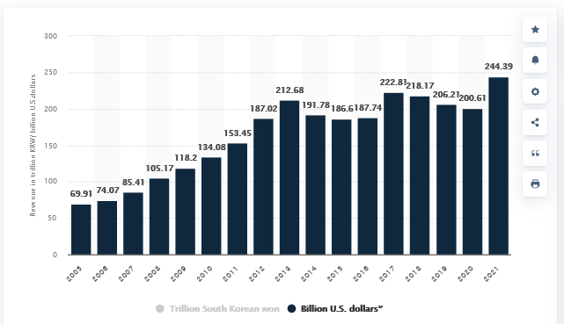
Figure 1 Revenues earned by Samsung on smartphones
Source: (Statista 2021)
Although currently Samsung is a leading producer of not only smartphone handsets but also products like tablet phones, appliances, digital media services, integrated systems and semi-conductors.
- The chosen product is android smartphone phones produced by Samsung, which is sort to be a necessary gadget needed in daily lives of numerous customers. Android smartphone phones are available with high-speed internet connection and modern technology through which the customers can use for various purposes. A Smartphone phone serves the purpose of communication, entertainment and connection. Customers buy smartphone phones for easy communication, fast connection and also to be present in the social media platforms for various entertainment, information and knowledge (Sreejith and Menon 2019).
- The smartphone handset is chosen as the main product because of its importance in daily lives. With the availability of modern technology in smartphone handsets customers, can replace using laptops and computers to some extent. More or less smartphone phones available with modern technology can do all such works which computers can do in general. Customers can not only place a call or message, but with the availability of smartphone applications, various utility work can also be done. Smartphones are necessary items in general as they cater to various needs of the consumers like connectivity, access to information, news and entertainment along with being available in social media sites which are considered as important aspect of modern livelihood (Savitha Nair and Karthika 2016).
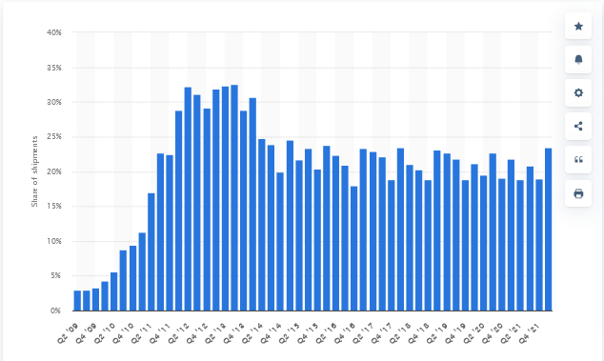
Figure 2 Samsung smartphones Global share of shipments from 2019 to 2022.
Source: (Statista 2022)
- The demand and market equilibrium has been identified by the following points.
- The substitute good is a good which gives the similar kind of utility to the consumers. Hence the consumers are indifferent in choosing a substitute good. The substitute good for Samsung handset would be another smartphone handset, produced by its competitors like Apple. In reality although no good has perfect substitutes hence the smartphone phones produced by Apple would not be a perfect substitute giving the consumers the same of utility. But the utility would be similar. The price of the substitute is negatively related to the demand for Samsung smartphone handsets (Goh et al. 2016). This is because the consumers always want to maximize their utility at the lowest possible expenditure. Hence when the price of the substitute is increasing it would boost the demand for Samsung smartphones which is comparatively cheaper than the Apple smartphone. Currently the price of Apple smartphones is increasing mainly due to the cost of raw materials like semiconductors. Since there is a negative relationship between the price of the substitute and the good in hand the Samsung smartphones would be cheaper than Apple smartphones hence the consumers will be willing to buy Samsung smartphones. Hence the price of Apple is always higher than Samsung because of its brand value. For Samsung this price rise would increase the demand for their products and hence their revenues (Mankiw 2021). Cheaper substitutes on the other hand reduce the market demand for Samsung as the consumers do not buy the Samsung phones but other cheaper products.
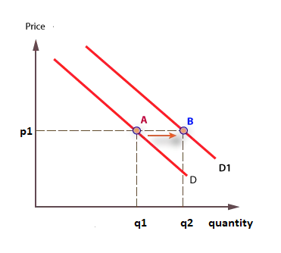
Figure 3 Shift in the Demand curve of Samsung smartphones
- Complementary goods are those goods which are consumed together, for example tea and cookies are consumed together. Using a complementary goods with another increases the utility gained by the consumers. The complementary goods in relation to Samsung would be Galaxy Buds produced by Samsung. This is a complementary good because Galaxy Buds and smartphone phones are bought together. Galaxy Buds are smartphone accessories which are consumed together. The prices of complementary goods are negatively related to the demand for another complementary good (Seshadri et al. 2019). Thus when price of Samsung Galaxy Buds raise the demand for Galaxy Buds would fall and hence the demand for Samsung smartphones would also fall due to the fact that they are complementary goods. Since both are used together, when the price of the Galaxy Buds rise, the demand for Samsung smartphones would fall. Currently the prices of the Samsung Galaxy Buds are falling due to economies of scale, the technology being available to all other earphone manufacturers. The falling price of Galaxy Buds would raise the demand of Galaxy Buds by law of demand and due to the relationship between the Galaxy Buds and Samsung smartphones would also increase because consumers would want to buy new smartphone handsets to use it with Galaxy Buds. This would increase the demand for Samsung smartphones and boost the sales of Samsung (Perloff 2017).
- The consumers’ income is another determinant of demand for any product. Since the consumers maximize their utility remaining within their budget constraint, so when their budget increases they have the added chance to increase their consumption for the goods they consume. The consumers income is positively related to the demand for the goods. The higher the income of the consumers the higher they would demand for the goods. In the case of Samsung, the same thing happens. When the consumers’ income would raise on an average the demand for Samsung smartphones too would rise, because the smartphone phones would become affordable to all when their budget increases. Currently the incomes of the consumers are rising because the pandemic is over and the economy is growing. This would increase the demand for Samsung smartphone phone as people have more money in hand to expend for. The Samsung would find that more number of consumers are demanding all types of smartphones they are manufacturing and hence with increase in income there would be a increase in the increase for all Samsung smartphones (Cowell 2018).
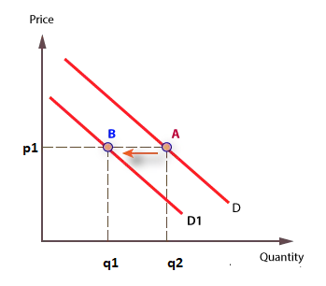
Figure 4 Reduction of Demand and shift
- Costumers’ preferences for any good are source of their demand, hence when they prefer a product they buy it with their available budget. But they reduce the consumption of the product when their preferences change. Hence with changing preferences the market demand could be lost or gained according to the choices of the consumers. While when their preferences for a good reduce they demand less of that product. For example when smartphones came into the market, consumers' affinity for the new technology increased and hence their preferences too (Friedman 2017). The consumer's preferences are changing with more consumers wanting to buy smartphone phones with advanced features. Hence their affinities for Samsung’s high quality smartphone phones with advanced features are rising. Seemingly the consumers prefer to buy smartphone phones not only because smartphone phones are necessary but also to increase their image in their social surroundings. When the affinities for the smartphone phones are rising among the consumers they would increase their demand for the same. The demand for Samsung smartphones hence would increase and thus the sales of Samsung smartphones, the market for Samsung smartphones would rise with more consumers preferring such android devices.
- Consumers’ expectations’ regarding the price of the product is another determinant of demand for the product. When the consumers expect that the price would rise in the near future, this would raise the demand of the product in the present times. Now holding the supply of the product at a constant position because, supply of goods generally does not change in the short run period. Thus in the present the demand rise, would not be met by the rising demand (McEachern 2016). Eventually there would be shortage of the product in the present times, and in order to reach the market equilibrium the consumers compete among themselves to get the product and this would raise the prices of the product in the near future. Hence the anticipations made by the consumers about the demand realise and thus a positive relationship exists. Currently, as the news availability and era of information technology, the consumers are aware that there is a shortage of semi – conductors which are essential for the manufacturing of the smartphones are other electrical devices. Hence they expect that the prices would increase in near future, due to other market uncertainties. They would hence react according to this anticipation, and demand the smartphones in the present because in near future they anticipate the price of Samsung smartphones would increase. Thus in the present they would demand more of the Samsung smartphones because they feel that the current market prices are actually lower increasing the demand for the Samsung smartphones (Shapiro and Greenlaw 2018).
- Demography impacts the demand in a positive manner, meaning when the demography of the market increase, there are more consumers who would demand Samsung smartphones, thus with increase in the number of consumers the Samsung smartphones would increase. Currently in the UK economy, the growth rate of population is lowering with a reduction in the adult population. This would negatively impact the demand for Samsung smartphones. Hence there is a less population to demand for these devices.
- The price elasticity is the responsiveness of the demand with respect to the price of the product. The elasticity of the product depends upon the needs of the consumers and the other factors like availability substitutes.
- Substitution effect is the change in the demand of the product due to the change in the prices of the product. The Samsung smartphones are an absolute necessity when viewed from the fact that the usages of mobile devices are essential in the current lifestyle of the consumers. Hence the Samsung smartphones are not a luxury, they are necessity and consumers would buy them even if the price increases. The Samsung smartphones are thus not luxury goods and can be deemed as normal good for which the substitution effect would be negative. For Samsung this means that the consumers would switch to cheaper products when Samsung tries to increase the price of the smartphones. Thus with increase in price of the Samsung smartphones the demand for the smartphones would fall because the consumers are substituting it for other substitute products. Although since the consumers find this product as a necessary they would not quickly switch to other cheaper products when the price increases to a great extent. This factor indicates that the Samsung smartphones are inelastic products because with smartphones being a necessary good in a consumer’s life, they would buy the good even if the prices rises. Inelastic demand means that demand would not rise or fall to great extent when the price changes. For example, if the price of Samsung smartphones rises by 15%, the demand for the smartphones would fall to a lesser degree, much less than 15% say, 5%. For necessary goods, the elastic demand stands less than 1 (Dahunsi 2019).
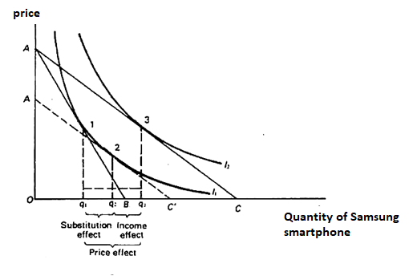
Figure 5 Income and Substitution Effect
Income effect is the change in the demand of the product, with respect to the change in the consumers’ purchasing power because there is a real change in the income of the consumer. The income effect can come through both a increase or decrease in the prices, or increases in the income of the consumers. Generally for normal goods the income of the consumers, income effect is positive, while for inferior goods the income effect is negative. On the other hand, for normal goods, the substitution effect generally dominates; in case of inferior goods the income effect dominates (Curtis and Irvine 2017). Thus in case of the Samsung smartphones, which are deemed as necessary normal goods, the income effect be positive but the substitution effect would dominate. The direction of the income and substitution effect in normal goods case are same, meaning a decrease in the price of Samsung smartphones would lead to a higher demand for the product both because, the consumers would substitute towards Samsung smartphones, and also because there is an increase in the real income of the consumers and they have a higher affordability for the Samsung smartphones. Consumers spend a moderate amount of their income for the Samsung smartphones since they deem it to be a necessary in current times of technological advancement. With this aspect, the income of the Samsung smartphones would be positive, because when the incomes of the consumers are increasing their demand for the smartphones too would increase to a greater extent. Hence the income elasticity would be positive but less than unitary because, the consumers would increase their demand to be lesser proportion than the proportion their income might increase. For example, if the consumer’s income rises by say 30%, the demand for the Samsung smartphones would increase by say 10%. Thus Samsung Smartphones have positive income elasticity but less than unity. (Roberson 2016)
- The Samsung smartphones are viewed as necessary but they are treated as those products for which higher prices also indicate higher quality and premium products by the consumers. The generally pricing strategy to be followed under this aspect is the skimming price strategy (Tien, Long and Chi 2019). The skimming price strategy is also followed when the company has to recover sunk costs. Samsung being a technology giant always tries to keep its consumers attracted to its products through new technology and new features within their smartphones. The consumers are always attracted to new technology but not technology is long time available. The Samsung takes initiatives to continue its research and development in products ranges and hence there are sunk costs for its technology which are always not successful. Furthermore, the company also is an MNC which also wants to maximize its revenues because it is a capitalist enterprise (Liu, Zhai and Chen 2019). This is also when the skimming price strategy is taken up. The skimming price strategy is the pricing strategy when the company sets a very high price when it first launches the product in the market. The term skim in management or business is the procedure where the company skims or scoops out the profit from the consumers at the first launch of the product. Later on after some time has passed, the price is reduced and the company takes up the strategy where price sensitive consumers could buy the product, this is when they make it available for all type of consumers in the middle or low band income (Mehra, Rajput and Paul 2022).
This strategy is then taken up to attract more consumers later who lie in the lower slab of income. The reason the Samsung should continue following the skimming pricing strategy is that the company needs to pull for both the market share and also have a dominant strategy to recover the sunk costs and as well recover the cost of production. The importance of the skimming strategy is also to hold on the most loyal customers for who the brand value and product value matters, and also those customers who are willingness pay high price for newly launched smartphones with new features and technology that are taken as a mark of luxury to these customers (Zhang and Chiang 2020). Thus through the skimming pricing strategy the customers of all income slabs become the loyal customers of brand. The Samsung thus takes the initiative that they have special segment of the customers who value price as the status of luxury and higher product value; also catering to the customers who regard the product as a necessary. It thus shows that for maximum customers, the Samsung smartphones is a necessary product as well as they are a symbol of luxury when the prices are higher at newly launched time. Thus the skimming pricing strategy ensures the company is able to maintain to all of its benefits as well as cater to its customers and hence build up both a profitable business as well as a customer centric business (Li et al. 2016).

References

Cowell, F., 2018. Microeconomics: principles and analysis. Oxford University Press.
Curtis, D. and Irvine, I., 2017. Principles of Microeconomics (Lyryx). Lyryx.
Dahunsi, O.J., 2019. Commodities' Preferences and Determinants of Demand Among University Students in Nigeria. Advanced Journal of Social Science, 5(1), pp.101-107.
Dubé, J.P., Fang, Z., Fong, N. and Luo, X., 2017. Competitive price targeting with smartphone coupons. Marketing Science, 36(6), pp.944-975.
Friedman, L.S., 2017. The microeconomics of public policy analysis. Princeton University Press.
Goh, S.K., Jiang, N., Hak, M.F.A. and Tee, P.L., 2016. Determinants of smartphone repeat purchase intention among Malaysians: A moderation role of social influence and a mediating effect of consumer satisfaction. International Review of Management and Marketing, 6(4), pp.993-1004.
Li, I., Simonson, R., Babajanova, G. and Tuomala, M., 2016. Smartphone diffusion and consumer price comparison shopping behavior: Implications for the marketplace fairness act. Econ. Bull, 36(3), pp.1337-1353.
Liu, J., Zhai, X. and Chen, L., 2019 . Optimal pricing strategy under trade-in program in the presence of strategic consumers. Omega, 84, pp.1-17.
Mankiw, N.G., 2021. Principles of Microeconomics 9e. Cengage Learning Asia Pte Limited.
McEachern, W.A., 2016. Economics: A contemporary introduction. Cengage Learning.
Mehra, A., Rajput, S. and Paul, J., 2022. Determinants of adoption of latest version smartphones: Theory and evidence. Technological Forecasting and Social Change, 175, p.121410.
Perloff, J.M., 2017. Microeconomics: Theory and applications with calculus.
Roberson, M., 2016. Price Elasticity for Smartphones in the United States: Results from Three Methodological Approaches (Doctoral dissertation).
Savitha Nair, N.N.N. and Karthika, R., 2016. Consumer preference towards smartphone phones: An empirical analysis. IJAR, 2(12), pp.343-347.
Seshadri, R., Kumarga, L., Atasoy, B., Danaf, M., Xie, Y., Azevedo, C.M.L., Zhao, F., Zegras, C. and Ben-Akiva, M., 2019. Understanding preferences for automated mobility on demand using a smartphone-based stated preference survey: a case study of Singapore. In 98th Annual Meeting at the Transportation Research Board (TRB).
Shapiro, S.A. and Greenlaw, D., 2018. Principles of Microeconomics 2e. Texas: Openstax Publishing.
Sreejith, G. and Menon, V., 2019. Smartphone phones as a medium of mental health care service delivery: perspectives and barriers among patients with severe mental il
Statista, 2022. Samsung smartphone market share worldwide 2009-2022 | Statista. [online] Statista. Available at: <https://www.statista.com/statistics/276477/global-market-share-held-by-samsung-smartphones/> [Accessed 3 August 2022].
Tien, N.H., Long, N.T. and Chi, D.T.P., 2019. Price Policy in International Marketing. Comparative Analysis between Samsung and Apple.“. International Journal of Research in Marketing Management and Sales, 1(2), pp.144-147.
Zhang, J. and Chiang, W.Y.K., 2020. Durable goods pricing with reference price effects. Omega, 91, p.102018.
Statista, 2021. Samsung Electronics' global revenue 2021 | Statista. [online] Statista. Available at: <https://www.statista.com/statistics/236607/global-revenue-of-samsung-electronics-since-2005/> [Accessed 19 August 2022]

