Effective Team Work and communication Task 2

Student name: Mirela Filipova
Student number: 2114282
LECTURER: - Joy Botu
Table of Contents:

1.Introduction……………………………………………………………….2
2.Model of communication………………………………………………..3
3.Communication skills……………………………………………………7
4.Advantages and disadvantages of communication………………….8
5.Conclusion………………………………………………………………..9
6.References……………………………………………………………..10

1. Introduction
In this report we will look at the different types of communication. Why it is important to have good communication skills and how this will help us, in our professional development and personally. We will focus on several types of communication and different methods of connection. Is an action that involves of communicating information from one location, person, or organisation to another which is known as communication. A sender, a message, and a recipient are all part of any communication. Communication is a difficult issue, despite the fact that it appears to be a simple concept. A number of factors can influence the path a communication takes from sender to destination. Aspects to consider include emotions, cultural context, communication medium, and even geographical location. The issue is why firms all over the world appreciate outstanding communication skills: accurate, effective, and clear communication is incredibly difficult. (SKILLS YOU NEED, 2011)
2.Model of communications.
In class we learn three different models of communication.
The first model is: Shannon and Weaver Model
According to the Shannon and Weaver Communication Model, human communication can be separated into six basic concepts: sender, encoder, channel, noise, decoder, and receiver. It is known as the "mother of all models" because of its enormous popularity. The concept that is currently known as 'information theory' or 'Shannon theory' was invented by Claude Shannon.' (Drew, 2019)
2.1 On Figure one is Shannon-Weaver Model
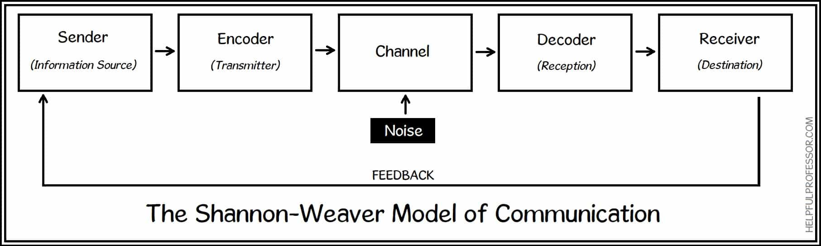

Example:
Mr V works in a bank office. Before work time is finished, He received an unexpected invitation from his colleague, who will be having a party at his home. Colleague’s Mr V invited him and his family. Mr V called his wife, and tried to explain to her about the situation. Mr and Mrs V had three children. It is usually quite noisy in their house. This day is no exception.
Mr V: Hello my dear, how are you?
Mrs V: Hello darling, I am fine, how are you? Are you come home soon?
Mr V: Actually, I am calling you exactly for that. John (his colleague) invited us to his home for a garden party this afternoon. Do you want us to go? Children will have a fun time with their kids and lovely dogs. Take the children with your car and we will meet in his house.
Because of the terrible noise, Mrs V misunderstood half of the explanation. She hears only this part of the conversation, when her husband says -Party in my colleague's house. Go by car and have fun.
Mrs V was really disappointed and angry with her husband. She wished a long time ago to go to a party like that, but her husband is unexpectable selfish.
This misunderstanding should be avoided if another type of communication is involved. Example - email, SMS or feedback.

The Second model is: Schramm’s Model of communication.
Wilbur Schramm, a well-known communication theorist, suggested a simple communications model in his book "The Process and Effects of Mass Communications." Schramm, like Aristotle, demonstrated that communication always has three components: source, message, and destination. In a perfect world, the source encrypts a message and sends it across certain channels to its intended recipient, who receives and decodes it. The Schramm Model of Communication was suggested by Wilbur Schramm in 1954, proposing that communication is a two-way process in which the sender and receiver alternate sending and receiving signals. (Juneja, 2015)
The following are some of the similarities and contrasts between Aristotle's model and the Shannon–Weaver model: 1. According to Aristotle's concept, the speaker has increased in prominence. This approach provides greater direction to someone who wants to become a better public speaker. Both the sender and the receiver are equally significant in Shannon – Weaver's.
Example:
John sends message to Lisa:
Would you like to come to my house for dinner?
Lisa didn't answer. John made sure nothing was missing for dinner. Everything was ready, just waiting for an answer from Lisa. At 7.30 pm, very disappointed, John sat down to dinner alone. At the time, Lisa was thinking about how much she wanted to go out with John. She had forgotten her cell phone at home in the morning, and she couldn't wait to go home and call him.
That situation can be avoided, if John were to call Lisa in her office, or send her email. Also, when Lisa gives feedback- John can know with sure, she will accept his invitation.

Personal experience:
My colleague called me before work and asked me to take her special food - specifying that her stomach hurts. Since the connection is not very good, I realised - that she wants to bring her special shoes because her foot hurts. She had told me a few days ago that her new shoes were not comfortable. We could have avoided this mistake, if my colleague had sent me a message, and waited for my answer.
2.2 On figure two is Schramm’s Model
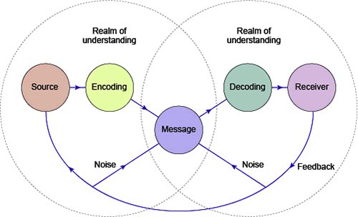
The third method of communication, which we learn in this module is Berlo’s SMCR model of communication.
The SMCR Model of Communication (1960) by Berlo illustrates the several components that make up the basic communication process. Because it emphasises message coding and decoding, this communication tool can be used for more efficient communication. In ancient Greece, Aristotle wrote on communication systems. All methods of communication have three essential characteristics: the speaker, the subject, and the person who hears the message. According to him, the listener is ultimately responsible for determining the meaning of each message. Berlo's SMCR Model of Communication, which is similar to contemporary communication theories, defines four components of communication. (Janse, 2019)
2.3 On figure three is Berlo's model.


Example:
The professor, known for his scientific work, lived alone in a small section near the city. He was not very social, and few people knew him well. He did not go to the village market very often, but almost never talked to the locals. One night, it rained a lot. On his way home from work, the professor saw that the roof of his house was leaking and almost everything was flooded. He went to the village to seek help.
-Please help me. A great calamity befell me. There is an inundation in my house ...
People didn't pay attention to him. He tried to get their attention again and said in a louder tone.
-Please help me. A great calamity befell me. there is an inundation in my house ...
People ignored him.
The professor, very unhappy that no one had helped him, went back to his house and waited until morning. The next day, he was back in the village to seek specialized help for his problem. People asked him-
-Professor, what happened? Why didn't you tell us your roof was leaking? We would help.
In this case we observe other types of communication. Differences between sender and recipient, as a function of language, make it harder for the receiver to grasp. Because village people don’t understand the professor, we see another attitude -they are not listening to him. Language barrier.
Personal experience:
There is a new doctor on a morning visit. He has no idea how handover works between night and day shifts. When the nurses finish handing over the shift, the doctor gathers the day's staff and explains to them what needs to be done during the day. He speaks only in medical terminology, without realising that not everyone has a clue about it. When he's done, he goes to his office. The daily thinker looks puzzled after him, trying to figure out what the tasks for the day are. Realising what problems may arise, the head nurse goes to talk to the doctor. After their conversation, she gathers her colleagues and explains their tasks for the day in clearer words.

3.Communication skills: We can comprehend and be understood by others if we have strong communication abilities. Effectively communicating ideas to others, carefully listening in conversations, giving and receiving constructive feedback, and public speaking are just a few examples. To communicate, new ideas, thoughts, or even a project update can all be employed. Listening, speaking, seeing, and empathising are all communication abilities. It's also useful to understand the differences between face-to-face conversations, phone calls, and digital communications such as email and social media. We understand that four basic communication skills are required for our success
3.1. Verbal -when is our talent to use oral/speaking communication.
3.2 Non-verbal- body language, gestures, mood, emotions. Really important for both position- Manager and employee.
3.3 Active listening - we listen intently to our interlocutor, showing the necessary respect.
3.4 Empathetic listening.
We show empathy, understanding of the situation, and sympathy for our interlocutor's feelings.
We have a better understanding of people and situations when we communicate effectively. It aids in the overcoming of differences, the development of trust and respect, and the promotion of the exchange of innovative ideas and problem-solving opportunities. Communication skills are in handy in a variety of situations, from the workplace to personal life and all in between. Communication is the foundation of all economic transactions. To help others and oneself absorb knowledge more efficiently and rapidly, good communication skills are required.
On the other hand, poor communication skills result in a lot of misunderstandings and frustration. According to a LinkedIn poll from 2016, the most sought-after talent was excellent communication. (Corporate Finance Institute, 2018)
In the workplace we couldn’t work properly without communication. Most important things, of everything. If we don't communicate properly, our day would be meaningless. In the Health Care sector, it is really important to have good communication skills. Cause, we help illness patients, and every mistake- because of miscommunication, can be fatal.
3.1 Figure four is example of Effective Communication.
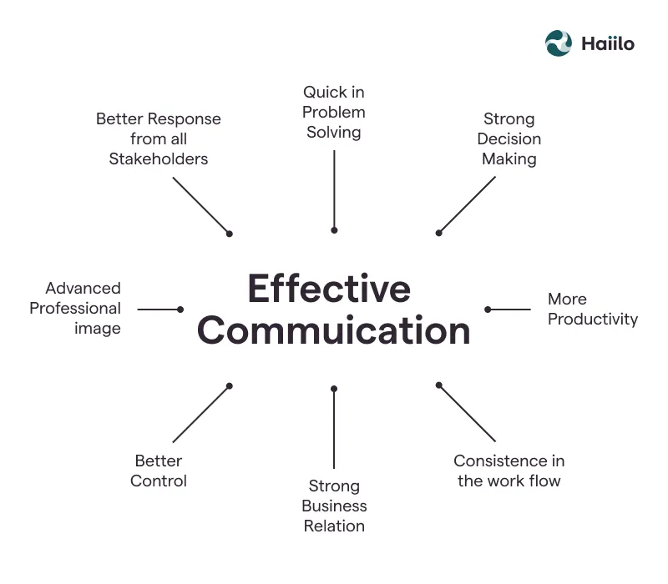

4. Advantages and disadvantages of communication
4.1 Advantages
Positive human engagement is built on effective communication. It evaluates the message's emotional effect as well as the actual facts and factual content. Good communicators strive for clarity in their communications so that concepts aren't misunderstood or muddled. Even when the message is presented in an effective and clear manner, communication has advantages and downsides. (Leonard, 2019). Everything in our lives is communication. Technologies, modern means of communication. Even when we meet someone on the street, we communicate. With a smile, with a look with a touch. Computers are an important part of our daily lives - we receive emails, phone - we have important business conversations, we talk to our families. Especially important communication in this difficult and stressful life. Many of us who have chosen to live and work in another country have the opportunity to see our families thousands of miles away. Thanks to technology we have the opportunity to be with our families no matter the distance.
4.2 Disadvantages of communication
Reading emotional clues isn't always a good thing. Others will be able to interpret these indications if you can. When you don't have control of your emotions, this might work against you. In any form of negotiation, losing your temper puts you at a disadvantage. (Leonard, 2019). The disadvantages of this technology are many. We are so used to all of them that it is difficult for us to imagine life without them. Mobile phones, computers, tablets. We lost the human in ourselves, busy watching the screen. The ability to talk to an interlocutor is already disappearing. Many people cannot have a normal conversation in a cafe because they have lost this ability. Parents do not raise their children in games and activities together, but prefer to put a tablet or phone in their hands to keep them busy. Without guessing how much technology has taken from their childhood. Doctors does know they patient. They just look in computers, see the patient's diagnosis, and prescribe some medications, but don't speak with the patient, to ask how you are, what you feel about your illness, or just to show them empathy and support.

5.Conclusion
Everything I learned in this module will be very useful to me. Both -professionally and personally. Types of communication, their importance and specificity enriched me with new knowledge and skills. I believe that in my future it is very important to have excellent communication skills so that I can do my job conscientiously.

Reference list
Corporate Finance Institute (2018). Communication - Importance of Good Communication Skills. [online] Corporate Finance Institute. Available at: https://corporatefinanceinstitute.com/resources/careers/soft-skills/communication/.
Drew, C. (2019). 7 Key Concepts | The Shannon-Weaver Model of Communication. [online] The Helpful Professor. Available at: https://helpfulprofessor.com/shannon-weaver-model/.
Janse, B. (2019). Berlo’s SMCR Model of Communication, a classic model | ToolsHero. [online] ToolsHero. Available at: https://www.toolshero.com/communication-skills/berlos-smcr-model-of-communication/.
Juneja, P. (2015). Schramm’s Model of Communication. [online] Managementstudyguide.com. Available at: https://www.managementstudyguide.com/schramm-model-of-communication.htm.
Leonard, K. (2019). Advantages & Disadvantages of Effective Communication. [online] Bizfluent. Available at: https://bizfluent.com/list-6714762-advantages-disadvantages-effective-communication.html.
SKILLS YOU NEED (2011). What is Communication? Verbal, Non-Verbal & Written | SkillsYouNeed. [online] Skillsyouneed.com. Available at: https://www.skillsyouneed.com/ips/what-is-communication.html.
toppr (2019). Toppr-guides. [online] Toppr-guides. Available at: https://www.toppr.com/guides/business-correspondence-and-reporting/communication/barriers-in-communication/.

