Student Name: Huzaira Shafqat
Student ID: 2128180
Module Name: Hotel Placement Research Project
Module Code: BMIH6008
Lecturer: Dr. Ernest Wavei
Submission Deadline: 3rd March 2025, 23:59

Declaration:
The information which I have provided is correct and complete to the best of my knowledge. I have attempted to identify any risks and issues related to the research activity and acknowledge my obligations and the rights of the participants. I acknowledge that I have not used any AI for this assignment.

Theme: Staff Shortages and Retention Strategies in the Hotel Industry: a case study is Novotel Cardiff Centre

Executive Summary:
This study aims to examine the staffing issues and staff turnover interventions in a 4-star hotel known as Novotel Cardiff Centre located in Cardiff, Wales. The hotel sector’s major challenge is staff shortage as organisations continually experience high rates of staff turnover, mainly due to the nature of work and the new post-Brexit environment. It is evident that Novotel Cardiff Centre faces such challenges, which are most likely to occur during busy events like conferences and marathons as this affects service delivery, employee motivation, and therefore customer satisfaction. This work aims to determine the main factors that lead to staff deficiency, wage rates, no promotion, and seasonality. It assesses how these shortages impact the operations of the hotel business, resulting in poor service provision and stress among the remaining staff members. The research has also recommended several ways through which the organisation could retain its employees and they include; improving the remuneration package, developing the career development programs and supporting the work-life balance. It also suggests the use of technology in customer service through the utilisation of artificial intelligence as well as the automation of appointments. It is recommended that Novotel Cardiff Centre needs to apply both the short-term and long-term solutions in order to solve the staffing problem and increase the staff retention rate, they are the flexible working hours, staff training, and development, and mentorship.

Table of Contents
Executive Summary: 3
1. Introduction: 6
1.2. Key Theme: Staff Shortages and How to Retain Staff: 7
1.3 Research Objectives: 8
1.4 Research Questions: 8
1.5. Significance of the Research: 8
2. Literature Review: 9
2.1. Causes of Staff Shortages: 9
2.2. Impact on Service Quality, Operations, and Employee Well-being: 9
2.3. Successful Retention Strategies: 10
2.4. Research Gaps: 11
3. Methods 12
3.1. Methodological Approach: 12
3.2. Data Collection: 12
3.3. Relevance and Limitations: 13
4. Case Study Hotel Overview and Findings: Novotel Cardiff Centre 13
4.1. Brand and Location” 14
4.2. Descriptive Information 14
4.3. Key Analyses: 16
4.3.1. SWOT Analysis: 16
4.3.2. PESTLE Analysis: 18
4.4. Competitor Analysis (Price vs Quality): 20
4.5. Netnography: 21
4.6. Reflective Account: 23
5. Discussion 23
5.1 Critical Analysis 23
5.2 Impact on Operations 24
5.3 Retention Strategies 25
5.4 Limitations and Implications 25
5.5 Valuable Areas Critical to the Placement Hotel Operation 26
5.6. Competitive Compensation and Work Conditions: 27
5.7. Employee Engagement and Recognition Programs: 27
5.8. Recognition and Reward Programs: 27
5.9. Team Building and Work Culture: 28
5.10. Technology Integration in Hotel Operations: 28
5.11. Data-Driven Workforce Management: 29
5.12. Operational Contingency Planning: 29
5.13. Crisis Management and Business Continuity Plans 30
6. Conclusion and Recommendations: 30
6.1 Conclusion: 30
6.2 Recommendations 30
References 34

1. Introduction:
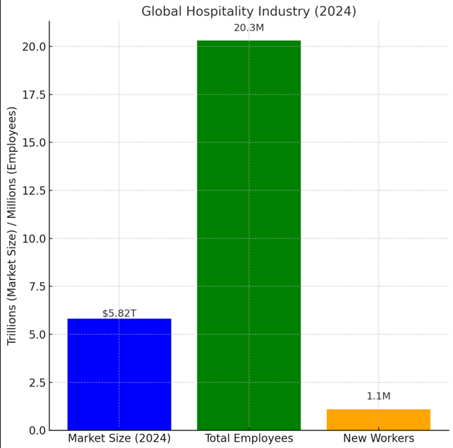
Figure 1: Global hotel Industry in 2024, (Ghani et al., 2022)
The hotel industry is expected to generate a market size of almost $5.82 trillion by 2024, growing at a CAGR of 5.5% from previous years (Aksoy et al., 2022). However, the industry has not been able to overcome these staffing challenges even as it grows (Ghani et al., 2022). According to the data, the hotel industry provides work to 20.3 million people worldwide, with 1.1 million new employees, which proves the ability of the sector to adapt and to create new workplaces. Particularly in the United Kingdom, the hotel industry generates £93 billion of revenue per year and provides work for about 3.5 million, which is equivalent to 7.5% of the country’s population.
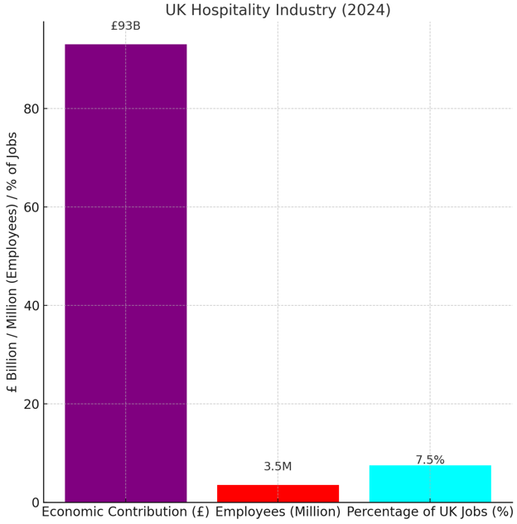
Figure 2: The UK hotel Industry in 2024, (Forde et al., 2024)
Some issues that concern the UK hotel sector include; labour issues, cost issues, and regulatory issues after Brexit. December 2024 saw job listings reduced to 1.41 million, down from November by 5.5% and hotel jobs decreasing (Forde et al., 2024). However, like a dynamic society and a key world economy, staffing shortages are still a concern. This research focuses on Novotel Cardiff Centre, a 4-star hotel in Cardiff that offers various services and is located near various tourist attractions to analyse the effects of staffing difficulties and possible remedies (Calinaud et al., 2021). This report identifies some reasons for staff turnover, low wages, lack of opportunities for career progression, and fluctuating demands for services as some of the reasons for staff shortages at Novotel Cardiff Centre. These lead to poor service delivery, high levels of stress among employees, and low satisfaction among the guests. The measures that were suggested as a way of increasing retention are better remuneration, promotion of career advancement, employee’s quality of life, as well as the use of technology such as artificial intelligence and automated scheduling to enhance efficiency. For the short-term measures to be addressed by the hotel include flexibility in the employees’ working schedules while the long-term measures include coming up with policies that support staff development and training.

1.2. Key Theme: Staff Shortages and How to Retain Staff:
The topic of focus of this study is concerned with the issue of staffing deficits and strategies for staff retention in the hotel industry. In Novotel Cardiff Centre, marathons and major conferences expose the pressure resulting from inadequate staffing, which contributes to organisational inconvenience and guest dissatisfaction (Cantrell et al., 2024). This research examines how these challenges occur, the effects on the hotel’s operations, and possible ways of addressing the problem (Ollor & Adiele, 2022).

1.3 Research Objectives:
The primary objectives of this research are:
- To analyse the factors contributing to staff shortages, such as high turnover rates, demanding work conditions, and seasonal fluctuations.
- To evaluate the impact of staffing challenges on service quality, employee morale, and overall guest experiences.
- To propose practical retention strategies that can enhance workforce stability and operational efficiency at Novotel Cardiff Centre.

1.4 Research Questions:
To address the objectives, this study seeks to answer the following questions:
- What are the root causes of staff shortages at Novotel Cardiff Centre?
- How do these shortages impact service delivery and employee satisfaction?
- What strategies can be implemented to improve staff retention and reduce turnover?

1.5. Significance of the Research:
The following are the research objectives of the study; To offer practical recommendations to Novotel Cardiff Centre as well as other hotel businesses. In addressing specific operational issues related to staff turnover, the study also goes beyond the identification of practical solutions and helps to develop a long-term model for the well-functioning and human management of employees (Umrani et al., 2022).

2. Literature Review:

2.1. Causes of Staff Shortages:
Economic Factors: Staff shortages in the hotel industry are often driven by broader economic conditions. Edirisinghe & Manuel (2019) identify high turnover rates and economic volatility as primary drivers of staff shortages in the hotel industry. Economic downturns, such as the COVID-19 pandemic, lead to workforce instability as many employees opt for more stable employment opportunities outside the hotel sector. The increased competition from other industries with better working conditions exacerbates the situation​.
According to Oliinyk et al., (2021) Economic entry barriers also contribute to the dynamics of the labour market, with businesses in South Africa increasingly struggling to acquire and maintain skilled workers, even if they pay competitive wages (Ndiuini & Baum, 2021)​. Moreover, highly skilled migrant workers particularly in areas such as the Gulf Cooperation Council (GCC) remain largely underused and undergo lower-level employment although having qualifications that might satisfy senior level requirements (Ndiuini & Baum, 2021)​ which is an added complexity to the labour market.
Social and Industry-Specific Factors: As previously explained, social factors related to the appearance of hotel industry play a crucial role in the issue of the staff shortage. Innerhofer et al. (2024) cite poor industry image as a barrier to attracting potential workers, including low wages, irregular working hours, and excessive job demands. They argue that the hotel industry is largely seen as unattractive, particularly in rural areas, where attracting those with the required skills proves particularly problematic​. In addition, the industry faces high turnover rates and struggles to have a steady workforce due to seasonal demand fluctuations (Choy & Kamoche, 2021)​. The high turnover rate is often linked to a lack of career advancement opportunities and professional development within the industry. Workers may perceive limited career growth, which leads to dissatisfaction and eventually to higher attrition rates (Douglas et al., 2020).

2.2. Impact on Service Quality, Operations, and Employee Well-being:
Service Quality and Operational Efficiency: The consequences of staff shortages are profound, affecting both service quality and operational efficiency. When understaffed, hotels and other hotel businesses experience service delays, reduced guest satisfaction, and a decline in operational efficiency (Ali et al., 2021). According to Salem et al. (2024), service automation and strategic downsizing, if poorly executed, may reduce operational costs in the short term, but they also risk diminishing the quality of guest experiences by limiting human interaction​.
Choy and Kamoche (2021) highlight that in industries like travel agencies, where high customer contact and emotional labour are crucial, staff shortages lead to burnout and stress among the remaining employees, ultimately affecting service delivery. This can be especially damaging in customer-centric sectors like hospitality, where employee interactions directly impact customer satisfaction​.
Employee Well-being: The well-being of employees in the hotel sector is directly affected by high turnover and poor working conditions (Benitez & Medina, 2022). Stress, burnout, and job dissatisfaction are common outcomes when employees are overburdened by excessive workloads or when they lack support from management (Davern., 2021)​. Additionally, inadequate compensation and long working hours can lead to mental and physical exhaustion, further contributing to high turnover rates and decreasing employee retention​.

2.3. Successful Retention Strategies:
Competitive Pay and Benefits: It is a retention strategy to offer market pay alongside the staff shortages. Adeyefa et al. (2023) demonstrate that while wages are important, implementing green human resource management (GHRM) activities like sustainability initiatives can also enhance retention by appealing to employees' environmental values​ ​. Additionally, it is highlighted by Edirisinghe & Manuel (2019), competitive compensation packages comprising health benefits and performance-based incentives are critical in minimising turnover and increasing overall job satisfaction ​.
Career Development and Training: According to Hosen et al., (2024) Career Development and Training Another way to retain staff is to invest in career development. Providing training programs, mentorship opportunities and clear career progression all lead to greater job satisfaction and loyalty​ (Innerhofer et al., 2024)​ Additionally, in order to create a more motivated workforce, hotels and other hospitality businesses can provide employees with opportunities to learn new skills and advance in their careers. Salem et al. (2024) observe that not only did training in areas such as digital skills and health and safety facilitate employee retention during the COVID-19 pandemic, but it also equipped employees for the emerging demands of the industry. ​
Work-Life Balance: The study of Budhiraja et al., (2022) shows that having a solid work-life balance is very important for better employee retention in the hotel industry. Literature indicates that flexible work arrangements as well as the freedom to manage personal and work commitments have strong positive effects on job satisfaction and burnout (Douglas et al., 2020) notes​ that hotels with a great employer brand including flexible working​,​ retain more employees and have lower turnover​.
Employer Branding: With the competitive nature of the hotel sector, employer branding has become an important strategy to attract and retain talent (Douglas et al., 2020) which viewed a strong employer brand, tied to an organisation commitment to employee well-being and career development​, as a means to build loyalty and decrease turnover​. Employees are also more likely to remain with a company that fosters a positive work culture and values that reflect their own (Azhar et al., 2024).

2.4. Research Gaps:
Despite the substantial body of research on staff shortages and retention strategies, several gaps remain. One of the main drawbacks is the lack of concentration on the regional issues, for example, regarding the situation in Cardiff or any other particular place where the labor market conditions might vary. The literature tends to extrapolate results from global studies, which does not consider the specific problems that specific hotels experience (Edirisinghe & Manuel, 2019). However, there is a research gap that addresses the retention strategies in relation to operations issues such as changes in demand due to seasonal or economic conditions.

3. Methods

3.1. Methodological Approach:
This research is a case study approach, and the main case for this study is the Novotel Cardiff Centre. Hence, the case study approach can be applied to analyse multifaceted challenges like staff shortage and retention in the hotel sector (Cantrell et al., 2024). Thus, the focus on the case study of Novotel Cardiff Centre enables the research to identify all the issues that the hotel experiences and gain a detailed understanding of how different retention strategies work. It also allows the researcher to investigate how the large issues in the field of hotel are reflected at the level of the particular hotel.
A case study approach allows for a greater amount of data collection and analysis since it focuses on both the quantitative and qualitative data. In this way, the research focuses not only on the existing staff turnover problems but also on the organisational climate, policies, and practices that define the staff satisfaction and productivity (Cantrell et al., 2024). Hence, the method makes it easy to determine patterns, causes, and effects of staffing problems, and thus suitable for answering the research questions.

3.2. Data Collection:
1. Employee’s Testimonies: The employees will be required to give testimonies regarding their working experience at the hotel with an emphasis on reasons for staying or leaving the hotel. These accounts will provide qualitative information about the nature of workplace environment, job satisfaction, and the issues that are experienced at the workplace (Valk & Yousif, 2023).
2. Employee Feedback: From the study, it will be important to seek feedback from the employees to determine their perception on their working conditions, career growth, remuneration, and satisfaction (Akhtar et al. 2022). This will be achieved by conducting questionnaires that will be anonymous in order to allow the employees to express themselves freely. Cue from the employees will help in establishing trends on the key issues that affect retention and the efficiency of the current retention measures (Narayan et al., 2022).
3. Review of internal reports and performance indicators: The quantitative data of staffing levels, turnover rates, and employee performance indicators from internal reports of Novotel Cardiff Centre will help in determining staff shortages and turnover rates (Awwad & Heyari, 2022). These documents will be used to measure the hotel operating performance and establish trends regarding the turnovers of employees and the previous retention measures (Hassanein & Özgit, 2022).

3.3. Relevance and Limitations:
The use of qualitative analysis ensures that the study has a vast understanding of the challenges pertained to staff shortages and staff retention at Novotel Cardiff Centre (Maslakçı et al., 2022). Hence, research about the staff and reflective accounts, as well as employees feedback will reveal the reasons for staff shortages, identify the emotions and psychological factors that contribute to staff turnover, and capture the staff and managerial perceptions (Thwaites et al., 2023). It is very useful to comprehend these dynamics and potential in order to design proper retention strategies.

4. Case Study Hotel Overview and Findings: Novotel Cardiff Centre
Novotel Cardiff Centre is a modern hotel of 4star ranking located in the middle of Cardiff, Wales. The location of the hotel is quite strategic since it is situated overlooking the Bute East Dock; however, guests are within easy access to some of the popular attractions such as Cardiff Castle, Cardiff Bay, and St David’s Shopping Centre. It boasts of 138 en-suite bedrooms, a dining room, a bar, leisure amenities such as a heated swimming pool, a fitness centre and a steam room.

4.1. Brand and Location”
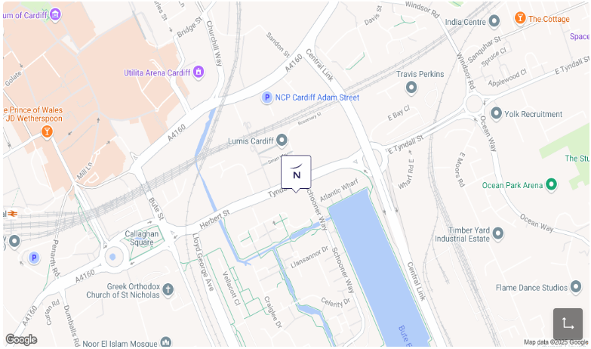
Figure 3: Novotel Hotel location, (Accor, n.d.)
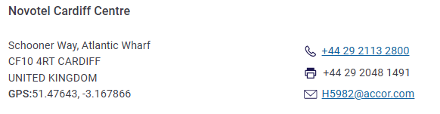
Novotel is a global hotel brand under the Accor Group, known for its family-friendly accommodations and modern amenities (Accor Group, n.d.). The Cardiff Centre location exemplifies the brand's commitment to providing comfortable and convenient stays for both business and leisure travelers. Cardiff, the capital city of Wales, is renowned for its rich history, cultural landmarks, and vibrant entertainment scene, making it a prime destination for tourists.

4.2. Descriptive Information
Turnover and Staffing: Novotel Hotels has a global workforce of 9,530 employees. The leadership team at Novotel includes key figures such as Shubham Bafna (Owner), Pullman Recruitment (Talent Manager) and Sandra Esteva (Head of Sales and Marketing) (RocketReach, n.d.).
The overall revenue generated by Novotel across its global operations is $173.3 million. The Cardiff Centre location is managed by a skilled team that consists of front-of-house staff, housekeeping, and management professionals who ensure efficient operations and provide excellent service to guests (RocketReach, n.d.).
Number of Branches and Locations: Novotel operates more than 500 hotels and 115,649 rooms across 60 countries, with a significant presence in Europe, Asia, and the Middle East. In the UK, Novotel has several locations, including London, Manchester, and Edinburgh.
Geographical and Cultural Context: Cardiff is a dynamic city known for its cultural diversity, historic sites, and modern amenities. The city's economy is bolstered by sectors such as tourism, media, and education. The proximity of Novotel Cardiff Centre to attractions like Cardiff Bay and the Millennium Stadium positions it as a convenient choice for visitors (Song & Wei, 2025).

4.3. Key Analyses:

4.3.1. SWOT Analysis:
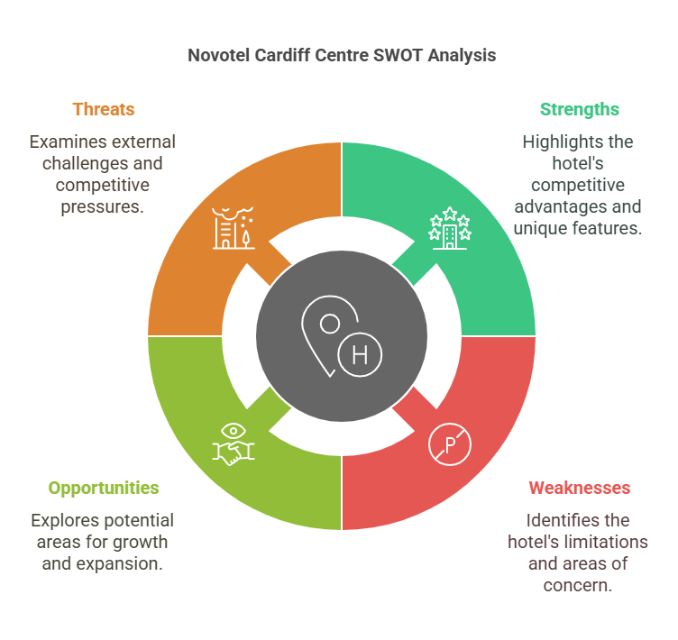
Figure 4: Novotel Cardiff centre SWOT analysis, (Maté-Sánchez-Val & Teruel-Gutierrez, 2022)
Strengths: One of the key strengths of Novotel Cardiff Centre lies in its strategic location. The hotel is positioned near major attractions such as Cardiff Castle, Cardiff Bay, and St David's Shopping Centre. This central location significantly enhances its appeal to both business and leisure travellers who wish to explore the city's cultural landmarks and vibrant social scene. Proximity to these high-traffic areas ensures that Novotel Cardiff Centre remains a convenient option for tourists and visitors attending events in the city, contributing to the hotel's consistent demand (Maté-Sánchez-Val & Teruel-Gutierrez, 2022).
Novotel Cardiff Centre has the advantage of the strong brand image that is associated with the Accor Group, which is a worldwide hotel chain. The Accor Group has a good reputation in providing quality services to its guests and this has influenced guests’ perception and confidence. This has given Novotel Cardiff Centre a competitive advantage because many guests are aware of the quality that is offered by the Accor Group.
In addition, it has leisure amenities such as a heated swimming pool, a fitness center, and steam bath. These facilities meet the needs of clients who are in need of a quiet and healthy environment which in turn makes the hotel have a wider market. : Such amenities are especially important in the context of the growing competition in the accommodation industry where the guests require more than just a place to lay their heads but also an environment that meets all their needs (Rančić Demir et al., 2021).
Weakness: However, there are some strengths that Novotel Cardiff Centre possess. The most apparent drawback of this concept is that it has a small area for parking. The hotel is situated in a commercial zone of the city, and the problem of car access is critical for the guests, especially during the high tourist season. This may cause inconvenience to the guests who bring their own cars depending on the trip origin, and this may be outsiders (Kazis et al., 2021).
Novotel Cardiff Centre has a slightly higher price range than some of the other hotels within the region. Although the hotel has every reason for the prices, this may affect the low budget clients who are in search of cheap accommodation. While some hotels like the Premier Inn or Ibis Cardiff are relatively cheaper for those who do not want to spend much money for the luxurious and fully equipped hotels. This is a major issue that may limit the target market of Novotel Cardiff Centre since the hotel may not attract both the low-end and high-end consumers in the market.
Opportunities: Novotel Cardiff Centre has several opportunities to further enhance its market position. One key opportunity is the expansion of services to cater to business travellers. Cardiff is an important hub for conferences, exhibitions, and business meetings, and the hotel could leverage this by enhancing its business offerings. Adding dedicated business facilities, such as meeting rooms, conference spaces, and business services like high-speed internet, could attract corporate clients who require both accommodation and professional amenities during their stay (Morrison, 2022).
Another opportunity lies in forming partnerships with local attractions. Cardiff is home to numerous tourist attractions, including Cardiff Bay, the Wales Millennium Centre, and Cardiff Castle (Bharwani & Mathews, 2021). By collaborating with these attractions, Novotel Cardiff Centre could offer package deals that include admission to local sites along with accommodation. These could not only improve the overall guest experience but also generate extra revenues which would place the hotel in a good standing in the competitive market of Cardiff.
Threats: The external environment presents some threats that may affect the performance of Novotel Cardiff Centre. This is one of the biggest challenges since there are numerous hotels in the region that may pose a great threat to the operations of the hotel business. The hotel industry in Cardiff is quite saturated that it has big chains, small and unique hotels, and even small independent properties. Both Radisson Blu and Clayton Hotel are competitors in the same market and are offering similar services to the same clients. This could exert a pressure on Novotel Cardiff Centre to reduce its prices and to find ways of distinguishing itself by the quality of the services it offers (Ollor & Adiele, 2022).
The other threat is mainly caused by fluctuations in the economic cycles that may have a negative impact on tourism. Market factors for example a recession or a decline in the numbers of tourists visiting Cardiff for international or domestic tourism. It is evident from the COVID-19 outbreak that the hotel industry is sensitive to external conditions, and any future economic problems could result in low occupancy and bookings (Manrique-de-Lara-Peñate et al., 2022).

4.3.2. PESTLE Analysis:
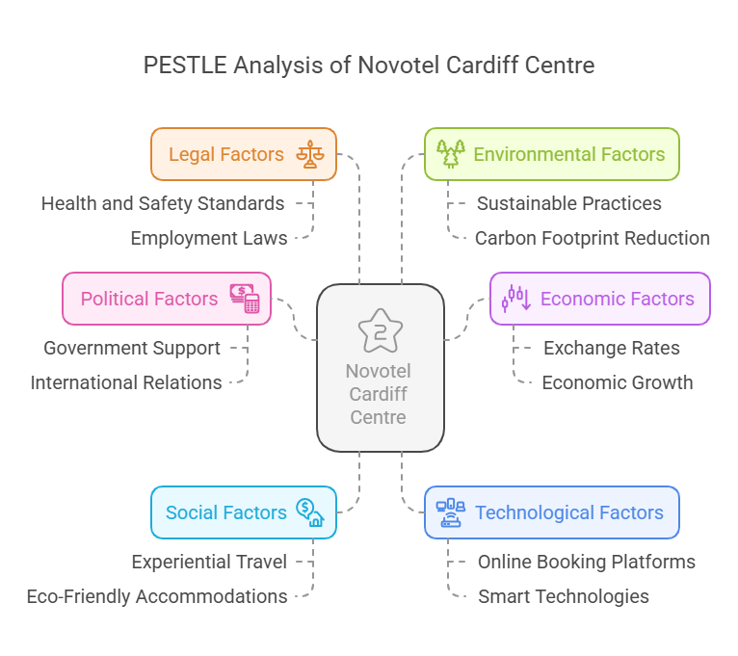
Figure 5: PESTLE Analysis of Novotel Cardiff Centre, (Ntounis et al., 2022)
Political: At the political level, the environment in UK is comparatively stable for the hotel industry to thrive. Government funding for cultural events and other programs will promote the growth of the tourism industry, which will increase its revenue (Ntounis et al., 2022). The local government in Cardiff has over the years supported the marketing of the city as a suitable location for conferences and festivals, which has been advantageous to hotels such as the Novotel Cardiff Centre in that it brings in visitors. In addition, the relations between the UK and the global members such as the European Union before British exit as well as relations between trade partners also contributed to the advancement of international tourism.
Economic: The economy of the United Kingdom has gone through some changes over the recent past and the effects have been realised in the areas of tourism and travel. Another aspect of the business environment that may influence Novotel Cardiff Centre is the changes in exchange rates, especially in relation to the British Pound. The fact that the Pound has depreciated may have a negative impact on the number of foreign visitors coming to the UK and therefore fewer visitors to Cardiff and fewer bookings at the hotel. On the other hand, an appreciation of the Pound could increase the number of tourists, and this would increase hotel sales (Rafiei & Abbaspoor, 2022).
Another factor is economic growth as it has an impact on the performance of the hotel industry. This is because there is an increase in disposable income especially among the domestic travellers hence more people are staying in hotels for leisure and vacations. This is a positive factor that could be of benefit to Novotel Cardiff Centre since the increasing number of people consider mid-range or luxury accommodation such as that provided by Novotel.
Social: Morrison, (2022) has established that social trends are becoming popular in the hotel industry with a shift towards experiential travel. It is no longer a question of where to sleep but what to do during their stay to make their trip memorable. Being a cultural city, Cardiff presents Novotel Cardiff Centre with the chance of promoting such additional services as a historical tour of Cardiff or buying tickets to the show at the Wales Millennium Centre.
First of all, there is a tendency to increase the demand for accommodations that are environmentally friendly. The young people are becoming more conscious of the consequences they have on the environment when making their travel decisions. This is an opportunity for Novotel Cardiff Centre to take some environmental elements like energy saving, provision of environmentally friendly products, and exercising environmental friendly policies within the hotel. These would not only be in harmony with the social expectations but would also go a long way in meeting the ecological sensitivity of the travellers.
Technological: This is an important factor that cuts across most organisations, and it is quite evident in the operations of Novotel Cardiff Centre. With the establishment of online booking platforms, customers’ engagement with the hotel industry has changed tremendously (Monica & Soju, 2024). Novotel Cardiff Centre enjoys the benefits of being affiliated with Accor since its mobile app and website makes it easy for the guests to book the available rooms. However, the adoption of smart technologies, for instance, check-in and check-out, room controls through portable devices could also improve the guests’ experience and efficiency in the hotel operations.
Legal: The legal system in the UK requires Novotel Cardiff Centre to adhere to various health and safety measures especially in this period of the pandemic. In relation to hygiene standards, it is necessary to note that hotels should ensure that the environment is safe for guests. Also, employment laws for employees are well formulated and demanding that Novotel provides its employees with reasonable wages, amenities and conditions of work. It is crucial to adhere to these legal standards to ensure that the hotel has a good standing legally as well as to minimise on any legal repercussions (Giousmpasoglou, 2024).
Environmental: Environmental issues are today considered as very crucial in the hotel industry. Novotel Cardiff Centre experiences pressure to act more significantly in order to decrease the impact of carbon footprint, waste, and use environmentally friendly products. This is especially the case in light of the recent awareness of climate change and the need for sustainable lodging (Tanveer et al., 2024). The hotel may introduce energy-efficient systems, recycle water and support the environment which is likely to be an advantage to those guests who are environment wise.

4.4. Competitor Analysis (Price vs Quality):
Aspect | Novotel Cardiff Centre | Radisson Blu Hotel Cardiff | Clayton Hotel Cardiff
Room Rates (Starting) | £79 per night | £212 per night | £188 per night
Key Amenities | Indoor swimming pool, fitness center, restaurant, bar/lounge | Fitness center, restaurant, bar | Fitness center, restaurant, bar/lounge
Guest Reviews | Positive feedback, appreciated for central location and amenities | Rated favorably, modern facilities, convenient location | Positive reviews, noted for comfortable accommodations and proximity to attractions
Booking Sources | KAYAK | BASKARUHOTELS | GUESTRESERVATIONS
Website/Reviews Sources | GUESTRESERVATIONS | HOTELS.COM | GUESTRESERVATIONS
Overall Price Position | Mid-range (Affordable luxury) | Premium (Higher pricing) | Mid-range (Comparable to Novotel)

4.5. Netnography:
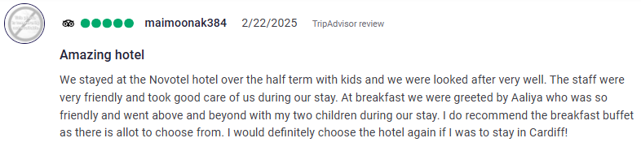
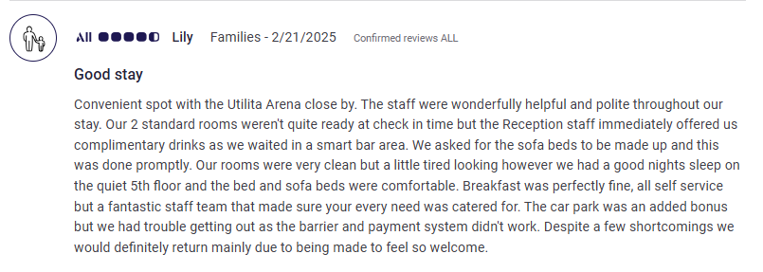
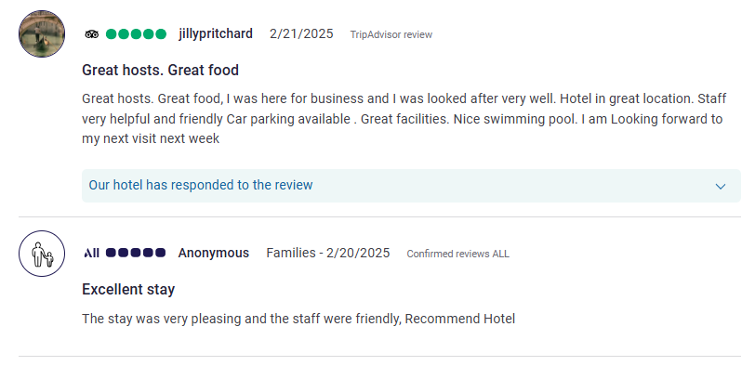

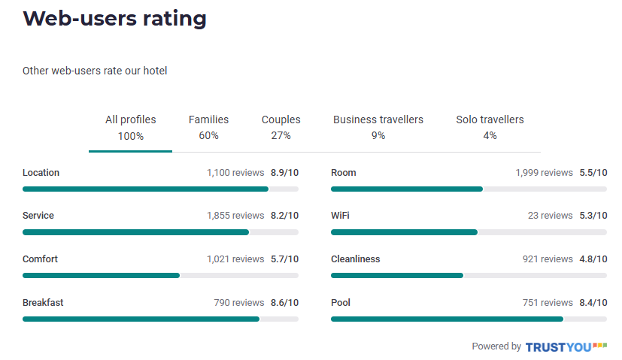
Figure 6: Novotel Web-users rating rating, (Accor, n.d.)
A review of the guests’ reviews on Novotel Cardiff Centre reveals the areas that the hotel excels in as well as the areas that require improvement (Zarezadeh et al., 2022). A common trend that is evident with customers is that they agree with the hotel’s location, employees, and breakfast menu. Positive feedback includes good service, and certain individuals such as Aaliya for her good customer service. However, some of the guests complain of the conditions in the rooms, the WiFi, and parking.
Service ratings average 8.2/10, indicating a strong emphasis on customer satisfaction. However, room comfort scores remain low (5.7/10), suggesting that enhancements in room quality are necessary. The reviews also reveal discrepancies in expectations versus reality, emphasising the need for clear communication about amenities (Accor, n.d.).

4.6. Reflective Account:
During my placement at Novotel Cardiff Centre as a front desk officer, I observed a strong commitment to customer satisfaction and operational excellence. The staff demonstrated professionalism and a genuine desire to enhance the guest experience. However, challenges such as the challenges of managing the demand during the peak season as well as the ability to maintain service standards in all departments were observed (Cheng & Tung, 2021).
In my work experience in F&B Operation department, I faced the challenge of serving large events with few people on the team. This brought out the need to have contingency staffing and proper organisation of shifts. In the same way, when I was working for Guest Services, I understood the importance of pre-event planning and avoiding confusion, especially when it comes to the services that are to be provided (Gámez et al., 2023). Furthermore, in Hotel Administration I faced some challenges in the allocation of rooms especially during the festive seasons, which confirmed the need to enhance on the forecasting and booking systems.

5. Discussion

5.1 Critical Analysis
A major research question that was sought in this study was to establish the causes of staff shortage and the effects on Novotel Cardiff Centre. When the results are compared with the literature, there are several similarities that can be noted. According to onyango (2023), high turnover rates and economic instability are some of the factors that have led to shortage of staff in the hotel industry, this can be confirmed by the current situation of Novotel Cardiff Centre. The research shows that high employee turnover, challenging working conditions, and Brexit-related labor scarcity negatively affect the operations.
Another interesting issue to be discussed at Novotel Cardiff Centre is the fluctuation of the staffing requirement throughout the year. Actually, in contrast to many hotels that are situated in cities, Novotel Cardiff Centre may face stable occupancy quite often, but it has a high dependence on such events as conferences, sports events, etc. According to Traskevich & Fontanari (2024), it is not easy to retain employees as a result of the fluctuations in demand within the sector which is evident with Novotel Cardiff Centre.
Furthermore, while the literature points out low wages as the key factor behind staff shortage (Douglas et al., 2020), the research reveals that besides low wages, Novotel Cardiff Centre faces staff shortage due to lack of career advancement and job satisfaction. There is a lack of internal promotion opportunities that employees note as a key factor that increases turnover.

5.2 Impact on Operations
There are several effects of staff shortages in Novotel Cardiff Centre for the operations of the hotel and its customers. Lack of human resource results in poor service delivery hence more complains from guests and bad reviews. Other research by Poór et al. (2023) also supports this notion of how while service automation and strategic downsising, if done unsustainably, may decrease operating expenses in the short run, they at the same time can negatively impact the guests’ experiences by limiting their direct interaction with employees.
That is why the results also show that staffing shortage has a strong negative effect on the morale of the employees. Stressed employees are dissatisfied with their work and more likely to resign from their position, which is a cycle in itself. Demirović Bajrami (2022) also proves that workplace stress and increased absenteeism arise from heavy workloads and lack of managerial support in the hotel industry. This is in accordance with the evidence at the Novotel Cardiff Centre, whereby the employees complained of high stress levels and inadequate staffing.
However, there are other operational performance challenges that are occasioned by shortages of labour. Some of the examples include; late check-ins and long waiting time for meals that are offered in the hotel affect the reputation of the hotel. According to Koc (2019), it is evident that any interruption in the delivery of services affects customer loyalty, especially in the highly competitive Cardiff hotel industry.

5.3 Retention Strategies
To address the problem of staff turnover, Novotel Cardiff Centre has tried to implement several measures such as offering better salaries, staff development, and promotion from within the organisation (Galang et al., 2023). However, the effectiveness of these strategies has been and still continues to be an issue of debate.
Increased Remunerations: As for the aspect of wages, there has been an introduction of casual wage increases to ensure that the organisation retains its human resource. However, as the research has shown, wages alone are not enough to retain the human resource. According to the research done by Carr (2024), the main factors that should be offered in order to retain the staff include wages, job security, and career advancement. This is in support of this claim, given that employees at Novotel Cardiff Centre have expressed discontent with few promotion opportunities even with moderate salary increase.
Training and Career Development: The hotel ensures that its new employees are trained on the job; however, the hotel does not have a proper system of career development. According to Innerhofer et al. (2024), it was evident that turnover rates are low in the hotels that have structured and career path programs. Employees at Novotel Cardiff Centre also complained that there is no clear career progression, which can be considered as an area that needs to be addressed.
Work-Life Balance: This is an area where employees are not very happy with their work schedule especially at peak periods. According to Douglas et al. (2020), it is also essential to consider the use of flexible work arrangements in decreasing burnout as well as improving job satisfaction. It is possible to reduce some of these concerns by adopting rotational shifts and ensuring that adequate breaks are taken.

5.4 Limitations and Implications
However, some limitations of the study need to be noted. Some of the limitations include the data being self-generated from the employees hence it may be influenced by bias. This is because employees may have different perceptions of certain issues, which may see them exaggerate or understate such challenges (Gordon & Adler, 2022). Future work should use more quantitative measures, including reviewing turnover rates in the past and customer satisfaction ratings, where possible.
One of the limitations of the study is that it focuses on the hotel industry only, thus slightly limiting its generalization. However, it is possible that the findings presented in Novotel Cardiff Centre may not represent the problems that other hotels encounter in other locations or under other ownership systems (Choi et al., 2022). Further work should be aimed at conducting comparative research across different hotel brands to have a wider view on the staffing problems in the hotel industry.
In terms of implications, this research has indicated that there is a need for policy and operational reforms in the Novotel Cardiff Centre. The management should consider the following measures for the employees: establish regular training and development sessions, foster interdepartmental cooperation, and focus on retention efforts. Furthermore, adapting to the existing system to reduce on the use of technology during the delivery of services during rush hours can also help in overcoming some of the challenges posed by shortage of employees.

5.5 Valuable Areas Critical to the Placement Hotel Operation
The following are areas of focus that should be implemented in order to improve the operation efficiency and staff turnover rate of Novotel Cardiff Centre. These areas include recruitment and retention strategies, staff motivation and appreciation, use of technology, and business continuity management. To address these critical areas, it will be possible to achieve long-term sustainability in an industry that is constantly experiencing fluctuations in labor market and ever-demanding guests.
1. Enhanced Recruitment and Retention Policies: Staffing and staffing retention are two critical challenges that continue to hold a lot of importance in the hotel industry. Due to the challenges of engaging and retaining talented employees, Novotel Cardiff Centre should consider other sources through which it can recruit its employees to reduce high turnover rates. Another strategy is to cooperate with local hotel schools and universities as they can offer a constant supply of qualified staff willing to work in the industry (Hassanein & Özgit, 2022).
2. Industry Partnerships and Apprenticeships: Manzoor et al. (2023) noted that effective cooperation between the hotels and universities help in enhancing recruitment since it offers practical training to the learners before joining the job market. Such partnerships have the following advantages:
Closing the skill gaps: Apprenticeship enables the trainee to learn from practical experience in the actual hotel environment and be in a position to meet the market demands when employed.
Promoting employee retention: The nature of structured apprenticeship is such that the skills acquired as well as the familiarity with the expectations of the employer make the employees more committed to the employer.
Also, it is crucial to provide comprehensive information on the prospects for career advancement, as it can help increase the employees’ retention levels. Lack of promotion opportunities is one of the biggest sources of employee discontent in hospitality, according to Innerhofer et al. (2024). The management of Novotel Cardiff Centre should ensure that it establishes clear career progression paths, sponsorship programs, and promotions to help employees for career development.

5.6. Competitive Compensation and Work Conditions:
Although employees’ remuneration is an essential factor, literature shows that money is not the only motivator that can help to retain hotel employees (Douglas et al., 2020). Offering a range of employee benefits—like flextime, health insurance and wellness programs has been shown to increase employee satisfaction and decrease turnover.
Salem et al. (2024) pointed out that organisations in the hotel industry that focus on employees’ health and welfare receive more engagement at the workplace. Hence, the management of Novotel Cardiff Centre needs to enhance the staff welfare measures such as reasonable staff scheduling, mental health considerations, and paid courses.

5.7. Employee Engagement and Recognition Programs:
It is worth noticing that employees’ engagement is one of the most effective factors in ensuring high levels of service delivery and low turnover. Organisations that show appreciation to their workers are likely to enjoy the loyalty of those workers in the organisation.

5.8. Recognition and Reward Programs:
According to Montani et al. (2020), effective employee recognition programs are effective in minimising turnover and enhancing morale among employees. In order to motivate the employees, Novotel Cardiff Centre can offer reward-based programs for the excellent performance. Some of the strategies of recognition include:
- Employee of the Month programs with monetary bonuses.
- Public acknowledgment and appreciation during team meetings.
- Career advancement incentives, such as sponsoring external training courses for high-performing staff members.
Other forms of encouragement, which are not necessarily tied to monetary rewards, include; promotions, extra paid holidays, and an opportunity to be mentored within the company. Choy and Kamoche (2021) showed that when the employees believe that their contributions are valuable, they are more satisfied with the jobs and have more organisational commitment.

5.9. Team Building and Work Culture:
There is a need to ensure that work culture in Novotel Cardiff Centre specifically means that there should be cohesiveness, communication and employee provisions. The opportunity to conduct surveys and focus groups is effective for encouraging the employees to share the issues they face in the workplace, so that the management can address them before they become a problem.
It has been established that creating a positive work environment ensures enhanced performance and decreased employee stress in pressured sectors such as the hotel industry (Umrani et al., 2022). The promotion of employee participation in the decision-making process and providing the workers with constant professional training will foster employee commitment.

5.10. Technology Integration in Hotel Operations:
The use of technology in some of the key operational areas is crucial to tackle the problem of shortage of labour and to enhance efficiency. The management of Novotel Cardiff Centre should consider automation, AI-based customer care, and data-driven staff management to enhance its functioning.
Self-Service and AI Integration: Choy and Kamoche (2021) establish that self-service check-in systems and AI customer service solutions make the work of the employees easier and simultaneously improve the guest experience. Possible technological incorporations for Novotel Cardiff Centre include:
- Self-check-in kiosks to reduce front desk congestion and allow employees to focus on more complex guest interactions.
- AI chatbots and virtual assistants to handle routine inquiries such as room availability, booking modifications, and hotel policies.
- Automated housekeeping scheduling systems to optimise staff allocation and minimise downtime between guest check-ins.
These technologies can significantly improve operational efficiency, allowing the hotel to function smoothly even during peak seasons.

5.11. Data-Driven Workforce Management:
The adoption of smart workforce management software can assist in the process of scheduling that will ensure that the employees are not overworked while at the same time ensuring that they have adequate workforce. According to Innerhofer et al. (2024) predictive scheduling which entails the use of occupancy history and demand forecasting enhances labor distribution hence enabling employees to be happier and less stressed.
Thus, automating some tasks in Novotel Cardiff Centre will minimise human labor, and it will be easier to manage staff, as they can focus on delivering high-quality services to customers.

5.12. Operational Contingency Planning:
Contingency planning is crucial for business as it helps to stay afloat during the lack of workforce, increased demand or any kind of disruptions.
Temporary Staffing Models: Due to the fact that the staffing requirements may vary from time to time, it is highly advisable for Novotel Cardiff Centre to develop a pool of casual workers who can be hired during peak months. According to Samaninia, S. (2016), the use of flexible staffing structures including hiring employees for specific seasons or having a pool of employees to be called in when the need arises can be of great improvement to the operations.
Temporary staffing can also be arranged through:
- Collaboration with hotel staffing agencies to ensure access to trained personnel on short notice.
- Maintaining an on-call list of part-time workers to address sudden demand surges.
- Cross-training employees so that they can perform multiple roles when needed.

5.13. Crisis Management and Business Continuity Plans
Other unpredictable challenges, including system breakdown and epidemics disrupt the workflow of the hotels. Thus, creating a contingency plan will help Novotel Cardiff Centre to be ready for various operational issues (Yacoub & ElHajjar, 2021). Some of the considerations that should be made when developing an effective contingency plan are:
- Crisis response training for employees to handle service disruptions efficiently (Arikawe et al., 2024).
- Backup operational protocols for managing customer complaints and service failures.
- Investment in cloud-based hotel management systems to enable remote access to critical operational data (Ghosh & Sen, 2023).

6. Conclusion and Recommendations:

6.1 Conclusion:
This paper has sought to establish the staffing issues at Novotel Cardiff Centre with specific regard to turnover, working conditions, and promotional opportunities. This paper uncovers the following challenges which affects operational effectiveness, staff motivation, customers’ satisfaction and hence the quality-of-service delivery and revenue generation.
It is therefore important for the hotel industry to work towards addressing these challenges so as to enhance sustainability. A better recruitment procedure, staff motivation and the use of technology in the improvement of operations will help Novotel Cardiff Centre to have a steady workforce. In the long run, training people at the workplace and adopting effective policies will help to enhance service delivery, customer satisfaction, and organisational performance.

6.2 Recommendations
Short-Term Strategies:
Flexible Schedules: One of the most effective short-term solutions to improve employee well-being and reduce burnout is implementing flexible work schedules. The hotel industry is known for demanding working hours, often leading to job dissatisfaction and high turnover (Xu et al., 2022). Rotational shifts and alternative work schedules provide employees with a better work-life balance, increasing their job satisfaction and motivation. Flexible scheduling can be implemented through shift rotations to ensure employees do not consistently work late-night or early-morning shifts, split shifts that divide work hours into two separate time blocks in a single day, and employee choice scheduling, allowing staff to express preferred shift timings while maintaining business efficiency. By offering flexibility, Novotel Cardiff Centre can create a more engaged workforce, reducing absenteeism and turnover while maintaining high service quality (Jung & Yoon, 2021).
Hiring Temporary Staff: During peak seasons, labor shortages significantly impact hotel operations. One practical approach is developing partnerships with hotel staffing agencies to provide temporary staff during high-demand periods (Manolopoulos et al., 2022). These partnerships can ensure that the hotel always has access to trained professionals when needed. Strategies for managing temporary staffing include maintaining an on-call staff database of experienced part-time or contract workers who can be called upon during peak times, collaborating with staffing agencies to provide immediate support when necessary, and cross-training employees so they can perform multiple roles, enhancing workforce flexibility. By having a contingency plan for temporary staffing, Novotel Cardiff Centre can avoid operational disruptions during busy periods while ensuring consistent service delivery.
Long-Term Strategies:
Invest in Training Programs and Career Development: A major factor contributing to staff turnover in the hotel sector is the lack of career advancement opportunities. Employees who feel stuck in entry-level positions without prospects for growth are more likely to leave. To encourage retention, Novotel Cardiff Centre should focus on structured training programs and career development initiatives (Preko & Anyigba, 2024). Key actions include structured training modules consisting of regular workshops and hands-on training sessions to improve employee skills in guest service, operations, and management, career pathways that establish clear career progression plans with promotions based on performance and skill development, and internal mobility programs that allow employees to transition into different roles within the hotel, keeping their work engaging. Investing in employee growth and learning fosters a loyal workforce that is motivated to stay with the company long-term.
Enhance Workplace Culture and Engagement: A positive and supportive workplace culture significantly impacts employee retention (Bhardwaj & Kalia, 2021). When employees feel valued and respected, they are more likely to remain committed to the organization. Novotel Cardiff Centre should focus on employee feedback mechanisms such as conducting open forums where employees can share concerns and suggestions, team-building activities like organising staff outings, social events, and team challenges to build camaraderie among employees, and recognition and rewards programs, implementing Employee of the Month initiatives, performance bonuses, and appreciation events to recognize outstanding contributions (Ampofo & Karatepe, 2022). By fostering a collaborative and engaging workplace culture, Novotel Cardiff Centre can improve job satisfaction and encourage long-term commitment from employees.
Implement Competitive Salary and Benefits Packages: This is an extremely critical area where much effort has been placed in an organisation as the key determinant of employee turnover. Though the remedy cannot be as simple as monetary compensation, ensuring that employees are paid competitive salaries in the industry, providing bonuses based on performance, and offering employees’ attractive benefits packages can go a long way in increasing their satisfaction (Gomathy et al., 2022). Some of the recommendations for improving employees’ satisfaction are the implementation of the performance-based increase in salaries where the employees who offer excellent services are rewarded, health benefits such as offering medical care options, mental health programs, and paid sick leave, and some privileges like free meals, hotel discounts, or free transportation for the night shift (Bardukova, 2023). The presence of a good benefits package strategy is an advantage for Novotel Cardiff Centre as it helps to minimise the turnover rate and also boosts the chances of recruitment.
Innovative Solutions:
Leverage Technology for Operational Efficiency: Technology plays a critical role in enhancing efficiency and reducing employee workload. By integrating AI-driven customer support, automated scheduling, and self-service kiosks, Novotel Cardiff Centre can minimise manual labor requirements while maintaining service quality (Das, 2023). Key technological innovations include AI chatbots and virtual assistants that handle common guest inquiries, such as booking details, check-in/check-out procedures, and hotel services, automated workforce scheduling that uses AI-based scheduling software to predict labor demand and optimise shift planning, and self-service kiosks at reception to facilitate automated check-ins and check-outs, reducing front-desk workload (Golja & Paulišić, 2021). By embracing technology-driven solutions, Novotel Cardiff Centre can reduce employee burnout, streamline operations, and enhance the overall guest experience.
Establish Mentorship Programs: Mentorship programs play an essential role in employee development and job satisfaction (Goh & Richardson, 2024). Pairing new employees with experienced mentors can ease their transition into the hotel industry, improve training effectiveness, and create a sense of belonging. Benefits of mentorship programs include knowledge transfer, where senior employees share expertise with new hires, reducing onboarding time, career development support by providing mentees with guidance on growth opportunities within the hotel, and increased employee retention as employees who feel supported and guided are more likely to stay with the organisation (Lan et al., 2022). A well-structured mentorship program can create a strong support system within the hotel, improving employee engagement and reducing turnover.

References
Accor Group. (n.d.). Accor Group. Retrieved February 28, 2025, from https://group.accor.com/en.
Accor. (n.d.). Novotel Cardiff Centre. Retrieved February 28, 2025, from https://all.accor.com/hotel/5982/index.en.shtml#section-location.
Adeyefa, A., Adedipe, A., Adebayo, I., & Adesuyan, A. (2023). Influence of green human resource management practices on employee retention in the hotel industry. African Journal of Hospitality, Tourism and Leisure, 12(1), 114-130.
Akhtar, M. W., Karatepe, O. M., Syed, F., & Husnain, M. (2022). Leader knowledge hiding, feedback avoidance and hotel employee outcomes: a moderated mediation model. International Journal of Contemporary hotel Management, 34(2), 578-600.
Aksoy, L., Choi, S., Dogru, T., Keiningham, T., Lorenz, M., Rubin, D., and Tracey, J. B. (2022). Global trends in hospitality. Journal of Business Research, 142, 957-973.
Aksoy, L., Choi, S., Dogru, T., Keiningham, T., Lorenz, M., Rubin, D., and Tracey, J. B. (2022). Global trends in hospitality. Journal of Business Research, 142, 957-973.
Ali, B. J., Gardi, B., Othman, B. J., Ahmed, S. A., Ismael, N. B., Hamza, P. A., ... & Anwar, G. (2021). Hotel service quality: The impact of service quality on customer satisfaction in hospitality. International Journal of Engineering, Business and Management, 5(3), 14-28.
Ampofo, E. T., & Karatepe, O. M. (2022). The effects of on-the-job embeddedness and its sub-dimensions on small-sized hotel employees’ organizational commitment, work engagement and turnover intentions. International Journal of Contemporary hotel Management, 34(2), 509-533.
Arikawe, O., Edwards-Fapohunda, M. O., & Waite, P. (2024). Strategies for Student Related Crisis Management in The Learning Environment in Further Education Colleges in UK. Iconic Research And Engineering Journals, 8(2), 576-586.
Awwad, M. S., & Heyari, H. I. (2022). Predicting employee turnover using financial indicators in the pharmaceutical industry. Industrial and Commercial Training, 54(3), 476-496.
Azhar, A., Rehman, N., Majeed, N., & Bano, S. (2024). Employer branding: A strategy to enhance organizational performance. International Journal of hotel Management, 116, 103618.
Bardukova, L. (2023). Navigating the hotel horizon: current trends and strategies for customer attraction and retention in the hotel industry. Economics and computer science, 2, 88-103.
Benitez, M., & Medina, F. J. (2022). A work-unit level analysis of employees’ well-being and service performance in hotel industry. Current Psychology, 41(2), 1043-1056.
Bhardwaj, B., & Kalia, N. (2021). Contextual and task performance: role of employee engagement and organizational culture in hotel industry. Vilakshan-XIMB Journal of Management, 18(2), 187-201.
Bharwani, S., & Mathews, D. (2021). Techno-business strategies for enhancing guest experience in luxury hotels: a managerial perspective. Worldwide hotel and Tourism Themes, 13(2), 168-185.
Budhiraja, S., Varkkey, B., & McKenna, S. (2022). Work–life balance indicators and talent management approach: a qualitative investigation of Indian luxury hotels. Employee Relations: The International Journal, 44(6), 1241-1258.
Calinaud, V., Kokkranikal, J., and Gebbels, M. (2021). Career advancement for women in the British hotel industry: The enabling factors. Work, Employment and Society, 35(4), 677-695.
Cantrell, A., Chambers, D., & Booth, A. (2024). Interventions to minimise hospital winter pressures related to discharge planning and integrated care: a rapid mapping review of UK evidence. Health and Social Care Delivery Research, 12(31), 1-116.
Carr, S. M. (2024). Safety, Security and Emergency Management Strategy Training in hotel Industry: Report of Preparedness for Active Threats, Traumatic and Epidemic Events (Doctoral dissertation, Capitol Technology University).
Cheng, T. Y., & Tung, V. W. S. (2021). Dropping out of the hotel industry after frontline work experience: An investigation into the personal changes of hotel employees. International Journal of hotel & Tourism Administration, 22(2), 213-233.
Choi, J. G., Zhang, Y. W., Nadzri, N. I. B. M., Baymuminova, N., & Xu, S. N. (2022). A Review of Forecasting Studies for the Hotel Industry: Focusing on results, contributions and limitations. Global Business & Finance Review (GBFR), 27(5), 65-82.
Choy, M. W., & Kamoche, K. (2021). Identifying stabilizing and destabilizing factors of job change: A qualitative study of employee retention in the Hong Kong travel agency industry. Current Issues in Tourism, 24(10), 1375-1388.
Das, M. P. (2023). Technology and Guest experience: innovations reshaping hotel management. International Journal for Multidimensional Research Perspectives, 1(3), 76-95.
Davern, D. (2021). Talent management, the employer brand, and employee retention: Evidence from the Irish hotel sector. In Talent management innovations in the international hotel industry (pp. 79-98). Emerald Publishing Limited.
Demirović Bajrami, D., Petrović, M. D., Sekulić, D., Radovanović, M. M., Blešić, I., Vuksanović, N., ... & Tretiakova, T. N. (2022). Significance of the work environment and personal resources for employees’ well-being at work in the hotel sector. International Journal of Environmental Research and Public Health, 19(23), 16165.
Edirisinghe, S. D., & Manuel, S. (2019). Factors affecting sales employee turnover in hotel & travel industry: A literature review. Journal of Humanities and Social Science, 24(5), 35-54.
Forde, C., Bessa, I., Alberti, G., Dolezalova, M., Ciupijus, Z., and Cutter, J. (2024). Employers' post-Brexit workforce strategies and their use of migrant workers.
Galang, J. P., Pablo, J. J., Melad, Q., Tamaray, G. A., Velasco, R., & Catacutan, K. J. (2023). Employee Retention Strategies of Hotel Industries in the Philippines Amidst the Pandemic. Asian Journal of Applied Business and Management (AJABM), 2(1), 79-98.
Gámez, S. R., León, M. A. B., & Gonzalez, M. F. O. S. (2023). Behind the scenes of hospitality: Crafting memorable experiences as an intern in Hilton Cartagena.
Ghani, B., Zada, M., Memon, K. R., Ullah, R., Khattak, A., Han, H., ... and Araya-Castillo, L. (2022). Challenges and strategies for employee retention in the hotel industry: A review. Sustainability, 14(5), 2885.
Ghosh, M., & Sen, S. (2023). CLOUD-BASED DATA ANALYTICS PLATFORM IN THE hotel INDUSTRY: A COMPREHENSIVE ANALYSIS AND FUTURE PROSPECTS.
Giousmpasoglou, C. (2024). Working Conditions in the hotel Industry: The Case for a Fair and Decent Work Agenda. Sustainability, 16(19), 8428.
Goh, E., & Richardson, S. (2024). Developing effective mentoring programs in hotel higher education: a practical perspective using the mentoring framework. Journal of Teaching in Travel & Tourism, 24(2), 179-188.
Golja, T., & Paulišić, M. (2021). Managing-technology enhanced tourist experience: The case of scattered hotels in Istria. Management: Journal of Contemporary Management Issues, 26(1), 63-95.
Gomathy, C., Reddy, M. V. K., Meghana, M. V., & Reddy, M. M. V. (2022). The Human Resource Management Service In Hotel And Catering Industry. International Journal of Scientific Research in Engineering and Management (IJSREM) Volume, 6.
Gordon, S., & Adler, H. (2022). Challenging or hindering? Understanding the daily effects of work stressors on hotel employees’ work engagement and job satisfaction. International Journal of hotel Management, 103, 103211.
Hassanein, F., & Özgit, H. (2022). Sustaining human resources through talent management strategies and employee engagement in the Middle East hotel industry. Sustainability, 14(22), 15365.
Hosen, S., Hamzah, S. R. A., Ismail, I. A., Alias, S. N., Abd Aziz, M. F., & Rahman, M. M. (2024). Training & development, career development, and organizational commitment as the predictor of work performance. Heliyon, 10(1).
Innerhofer, J., Nasta, L., & Zehrer, A. (2024). Antecedents of labor shortage in the rural hotel industry: A comparative study of employees and employers. Journal of hotel and Tourism Insights, 7(1), 28-55.
Jung, H. S., & Yoon, H. H. (2021). Generational effects of workplace flexibility on work engagement, satisfaction, and commitment in South Korean deluxe hotels. Sustainability, 13(16), 9143.
Kazis, N., Appel, E., & Murphy, M. (2021). Challenges and opportunities for hotel-to-housing conversions in NYC.
Koc, E. (2019). Service failures and recovery in hotel and tourism: A review of literature and recommendations for future research. Journal of hotel Marketing & Management, 28(5), 513-537.
Lan, J., Wong, C. S., & Wong, I. A. (2022). The role of knowledge sharing in hotel newcomer socialization: a formal intervention program. International Journal of Contemporary hotel Management, 34(6), 2250-2271.
Manolopoulos, D., Peitzika, E., Mamakou, X. J., & Myloni, B. (2022). Psychological and formal employment contracts, workplace attitudes and employees’ turnover intentions: Causal and boundary inferences in the hotel industry. Journal of hotel and Tourism Management, 51, 289-302.
Manrique-de-Lara-Peñate, C., Gallego, M. S., & Valle, E. V. (2022). The economic impact of global uncertainty and security threats on international tourism. Economic Modelling, 113, 105892.
Manzoor, S. R., Ullah, A., Ullah, R., Khattak, A., Han, H., & Yoo, S. (2023). Micro CSR intervention towards employee behavioral and attitudinal outcomes: a parallel mediation model. Humanities and Social Sciences Communications, 10(1), 1-14.
Maslakçı, A., Sürücü, L., & Sesen, H. (2022). Moderator role of subjective well-being in the impact of COVID-19 fear on hotel employees’ intention to leave. Journal of Human Resources in hotel & Tourism, 21(1), 57-81.
Maté-Sánchez-Val, M., & Teruel-Gutierrez, R. (2022). Evaluating the effects of hotel location on the adoption of green management strategies and hotel performance. Journal of Sustainable Tourism, 30(8), 2029-2052.
Michael, N., & Fotiadis, A. (2022). Employee turnover: The hotel industry perspective. Journal of Tourism, Heritage & Services Marketing, 8(1), 38-47.
Monica, R., & Soju, A. V. (2024). Artificial intelligence and service marketing innovation. In AI Innovation in Services Marketing (pp. 150-172). IGI Global.
Montani, F., Boudrias, J. S., & Pigeon, M. (2020). Employee recognition, meaningfulness and behavioural involvement: Test of a moderated mediation model. The International Journal of Human Resource Management, 31(3), 356-384.
Morrison, A. M. (2022). hotel and travel marketing. Routledge.
Morrison, A. M. (2022). hotel and travel marketing. Routledge.
Narayan, R., Gehlot, A., Singh, R., Akram, S. V., Priyadarshi, N., & Twala, B. (2022). hotel feedback system 4.0: Digitalization of feedback system with integration of industry 4.0 enabling technologies. Sustainability, 14(19), 12158.
Ndiuini, A., & Baum, T. (2021). Underemployment and lived experiences of migrant workers in the hotel industry: policy and industry implications. Journal of Policy Research in Tourism, Leisure and Events, 13(1), 36-58.
Ntounis, N., Parker, C., Skinner, H., Steadman, C., & Warnaby, G. (2022). Tourism and hotel industry resilience during the Covid-19 pandemic: Evidence from England. Current Issues in Tourism, 25(1), 46-59.
Oliinyk, O., Bilan, Y., Mishchuk, H., Akimov, O., & Vasa, L. (2021). The impact of migration of highly skilled workers on the country's competitiveness and economic growth. Montenegrin Journal of Economics.
Ollor, H. Y., & Adiele, S. D. (2022). Food Service Delivery and Consumer Preference of Fast-Food Restaurants in Port Harcourt. African Journal of Management and Business Research, 3(1), 01-17.
onyango, J., Williamson, D., & Harris, C. (2020). Dirty deeds, done dirt cheap: Creating'hospitable wages' through the Living Wage Movement. hotel & Society, 10(1), 3-22.
Poór, J., Szabó-Szentgróti, G., Veresné Valentinyi, K., Varga, E., Hollósy-Vadász, G., & Kőmüves, Z. (2023). Labour Shortage, Labour Retention and Robotisation: Problems and Solutions–Agricultural Organisations.
Preko, A., & Anyigba, H. (2024). The tourism and hotel career progression pathway. International hotel Review, 38(1), 54-80.
Putra, F. K. K., & Law, R. (2024). Critical success factors for virtual hotel operator partnership with small-and medium-sized hotels: perspectives of owners and operators. Journal of hotel and Tourism Insights, 7(3), 1391-1411.
Rafiei, F., & Abbaspoor, N. (2022). The impact of exchange rate on domestic tourism demand of Iran. Anatolia, 33(3), 451-462.
Rančić Demir, M., Petrović, M. D., & Blešić, I. (2021). Leisure industry and hotels: The Importance of wellness services for guests’ well-being. Handbook of sustainable development and leisure services, 127-140.
RocketReach. (n.d.). Novotel Hotels profile. Retrieved February 28, 2025, from https://rocketreach.co/novotel-hotels-profile_b556eda8f68e3cc4.
Salem, I. E., Aideed, H., Alkathiri, N. A., & Ghazi, K. M. (2024). Retaining talented employees during COVID-19 pandemic: The leverage of hotel pandemic response strategies. Tourism and hotel Research, 24(2), 187-202.
Samaninia, S. (2016). The Impact of Job Stress on Employee Creative Performance in the hotel Industry: The Moderating Effect of Psychological Capital A Study of Frontline Hotel Employees in North Cyprus (Master's thesis, Eastern Mediterranean University (EMU)-Doğu Akdeniz Üniversitesi (DAÜ)).
Song, H. J., & Wei, W. (2025). Environmental practices and firm performance in the hotel industry: Does national culture matter?. Journal of hotel & Tourism Research, 49(3), 529-547.
Tanveer, M. I., Yusliza, M. Y., & Fawehinmi, O. (2024). Green HRM and hotel industry: challenges and barriers in adopting environmentally friendly practices. Journal of hotel and Tourism Insights, 7(1), 121-141.
Thwaites, C., McKercher, J. P., Fetherstonhaugh, D., Blackberry, I., Gilmartin-Thomas, J. F., Taylor, N. F., ... & Morris, M. E. (2023, November). Factors impacting Retention of aged care workers: a systematic review. In Healthcare (Vol. 11, No. 23, p. 3008). MDPI.
Traskevich, A., & Fontanari, M. (2024). The Concept of Destination Resilience to Prevent Overtourism. From Overtourism to Sustainability Governance, 266.
Traskevich, B. (2023). Effects of organizational characteristics on employee turnover among star-rated hotels in Nairobi County, Kenya (Doctoral dissertation, Maseno University).
Umrani, W. A., Channa, N. A., Ahmed, U., Syed, J., Pahi, M. H., and Ramayah, T. (2022). The laws of attraction: Role of green human resources, culture and environmental performance in the hotel sector. International Journal of hotel Management, 103, 103222.
Valk, R., & Yousif, L. (2023). “Going beyond to deliver hip hospitality”: exploring motivation and job satisfaction of hotel workers in Dubai. International Journal of Organizational Analysis, 31(2), 293-316.
Xu, Y., Jie, D., Wu, H., Shi, X., Badulescu, D., Akbar, S., & Badulescu, A. (2022). Reducing employee turnover intentions in tourism and hotel sector: The mediating effect of quality of work life and intrinsic motivation. International journal of environmental research and public health, 19(18), 11222.
Yacoub, L., & ElHajjar, S. (2021). How do hotels in developing countries manage the impact of COVID-19? The case of Lebanese hotels. International Journal of Contemporary hotel Management, 33(3), 929-948.
Zarezadeh, Z. Z., Rastegar, R., & Xiang, Z. (2022). Big data analytics and hotel guest experience: a critical analysis of the literature. International Journal of Contemporary hotel Management, 34(6), 2320-2336.
Zhou, J., Yang, J., & Zhou, X. (2021). Customer cooperation and employee innovation behavior: the roles of creative role identity and innovation climates. Frontiers in psychology, 12, 639531.

