Ben Sillman (P142991)
BA Business Management
Supervisor: Caroline Jawad
RESEARCH PROPOSAL
A Critical Analysis of Animal Welfare and its Threat to the Sustainability of McDonalds
Table of Contents
1.0 Introduction 3
1.1 Rationale 3
1.2 Background 3
1.3 Aims and Objectives 4
1.4 Literary Review 4
2.0 Research Design 6
2.1 Methodology 6
2.2 Philosophy 6
2.3 Research Approaches 7
2.4 Research Strategy 7
2.5 Time Horizon 7
2.6 Research Choices 7
2.7 Data Analysis 8
2.8 Limitations and Ethical Considerations 8
2.8.1 Time Management and Sample 8
2.8.2 Ethical Considerations 8
2.9 Reliability and Validity 8
3.0 Resources and Planning 9
3.1 Resources 9
3.2 Gantt Chart 9
4.0 References 11

1.0 Introduction

This dissertation will be a critical analysis concerning animal welfare and its threat to the long-term sustainability of the fast-food industry, using McDonalds as a case study. Footage was captured in May, 2016, showing McDonalds’ suppliers brutally torturing chickens. This was the fifth instance since 2015, that seen animal abuse secretly recorded at ‘Tyson farms’, a chicken supplier to McDonalds (Polansek, 2016).

1.1 Rationale

After choosing to partake in a third year of higher education, there is a requirement to undergo the writing of a research project, resulting in a 10,000-word dissertation, based around an appropriate topic of the writer’s choice. The love of animals and repetitive use of fast food restaurants are the driving forces behind the motive of this report. The link between fast food and animal welfare is beyond the extent of many individual’s knowledge, and there is a potential awareness on the subject that needs to be raised.

Therefore, this report will take an in depth insight into McDonalds’ animal welfare regime, and assess the sustainability of McDonalds if this regime continues into the future. The likely difficulty for McDonalds’ sustainability of their current standard comes from the multiple negative press stories that have found the production process to have inhumane conditions for the animals used in their production. Not just are the living conditions poor for the animals, but also they are heavily mistreated and abused by the production process and the production workers.

While the press tends to shine a light on these concerns, McDonalds continue to use the same methods that create an increasingly poor reputation for the company. Society will largely frown upon the animal welfare stories associated with McDonalds, and this might be the foundation for activist groups to enhance the impact of their campaigns. Furthermore, McDonalds will begin to experience negative impacts on the long-term performance of their company if their animal welfare position isn’t amended significantly.

1.2 Background

Animals have become growingly involved in the production of fast food and, as the market becomes greater, the production also increases, enlarging the impact again on animals. Generally, companies tend to attempt to keep their costs as low as possible, including in the fast food market, so as a result animals could experience their welfare being sacrificed in order for the costs to be at a minimum. This has resulted in poor animal welfare becoming an infamous formality in the fast-food industry.

There are many individuals that inhibit great emotional attachment toward animals, having pets of all different kinds. Many of these people also eat great quantities of fast-food with the fast-food market generating $911.5 billion in 2016, equating to 25.1 percent of the global food industries overall value (Marketline, 2017, p.8). This could be potentially due to a lack of research in to the perceived hypocritical nature of a personal interest in both animals and fast food.

McDonalds are an example of a fast-food company that prioritise profit over animal welfare, which has resulted in many negative stories and videos about the company that have hurt their reputation and could potentially impact their future existence.

1.3 Aims and Objectives

The overall aim of this dissertation is to conduct an in-depth evaluation as to how consumer purchasing habits at McDonalds are impacted by their animal welfare practises, and how this will impact McDonalds’ long term sustainability.

This aim will be achieved firstly by the use of primary research. Surveys and interviews will provide insight into the perception of consumers regarding animal welfare at McDonalds, that will then be analysed thoroughly.

Secondly, this dissertation will evaluate the sustainability of McDonalds with concern to its poor animal welfare. This evaluation will be based on the findings collected in the report, exhibiting the perception of McDonalds and how impactful this perception could be on their future performance.

Lastly, this report will provide recommendations to McDonalds, as to what additional ethical animal welfare opportunities are available to them, in order to better their public image and as a result, increase their long-term sustainability in the process.

1.4 Literary Review

This dissertation will focus on the responsibility affiliated with fast-food restaurants and specifically how this impacts McDonalds. The Corporate Social Responsibility (CSR) of the fast-food market can be visualised oppositely by different individuals, as it is largely based on interpretation. Interpretation varies due to a there being a lack of a definite definition for Corporate Social Responsibility (CSR), as according to Göbbels (2002) CSR “Means something, but not always the same thing to everybody” (Marrewijk, 2003, p. 96).

There are two main interpretations of CSR, the first being Edward Freeman’s theory (Stakeholder theory), and secondly Milton Friedman’s theory (Stockholder theory). Freeman’s theory is formed loosely around that of stakeholder theory, mainly due to the fact he believes ‘the interests of the stockholders, shouldn’t outweigh the importance of other stakeholders’ (Bowie and Werhane, 2004, p. 25). Freeman’s theory considers all stakeholders equally important, so as a result all stakeholders must be kept as content as is possible, even if it means certain stakeholders won’t be happy with some of the outcomes of decisions (Matteson and Metivier, 2017).

Oppositely, Milton Friedman has a differing view if CSR in comparison to Freeman’s theory. Friedman’s theory argues the case of stockholder theory in his thesis, as he believes the only responsibility of a business is to ‘increase its profits, whilst also staying within the guidelines set, meaning ‘conducting their business in an open/free market, without deception or fraud’ (Bowie and Werhane, 2004, p. 21). Friedman’s theory is based on three underlying factors including ‘only human being have a moral responsibility for their actions’, the second factor is ‘it is managers’ responsibility to act solely in the interests of shareholders’ and lastly, the final criteria for Friedman’s theory is ‘social issues and problems are the power province of the state rather than corporate managers’ (Crane and Matten, 2010, p. 48).

McDonalds will fall into the Friedman based CSR theory, as opposed to Freeman’s as a result of their continued insistence on aiming toward profit maximisation (ChinaAbout.net, 2017). McDonalds attempts to profit maximise have resulted in them minimalizing costs and therefore they have endorsed practises that have been beneficial to their profit margins, but have caused a litany of issues for other stakeholders along the way.

Sustainability is a separate factor that is linked significantly with CPR, when looking at the future of business organisations, including McDonalds. There are many possible definitions of sustainability that have been drawn up over the years, and many people view sustainability as a purely ecological issue in terms of the environment, but sustainability does in facts include social, economic and environmental dimensions (Blowfield, 2012, p. 28).

Economic sustainability is the relevant context of the term ‘sustainability’ that will be used in this report to assess McDonalds’ future. The goal of economic sustainability is to use resources in the most efficient and responsible way, that will produce the best long-term benefits (Anand and Sen, 2000).

A survey in 2015 collected the opinions of a portion of the North American population as to what fast-food companies were the most socially responsible and the least. The survey found McDonalds to be considered the least socially responsible fast food company. This relates to sustainability because many believe “good corporate citizenship is also good business”, as it gives companies an ability to differentiate from other due to a good socially responsible reputation. Thus, meaning other companies have a competitive advantage over McDonalds, having being viewed as more socially responsible, potentially resulting in diminishing long-term sustainability (Morgan et al, 2016, p. 705).

Currently, consumers are demanding more from fast-food, and as a result fast-food organisations have made a move to meet the growing demand for social responsibility, as a way to separate themselves from competitors, as price differentiation becomes over saturated (Morgan et al, 2016, p. 19). With McDonalds considered by many ideologues as a ‘Demon’ that “sells unhealthy food to children, is cruel to animals and sells harmful products”, other companies might distance themselves from McDonalds in the future, meaning their future sustainability is currently at risk (Lee and Lambert, 2016, p. 3).

2.0 Research Design

2.1 Methodology

Research is defined as “something that people undertake in order to find out things in a systematic way, therefore increasing their knowledge.” (Saunders et al, 2012, p. 5). Saunders et al, also created the concept of the ‘research onion’ (See figure 2.1) in 2007. The research onion outlines the details an individual must cover in order to develop a successful research strategy. The great benefit of the research onion is how it can be adapted to fit a majority of research methodologies. The research onion suggests that choosing a research methodology is a process that consists of many layers. The layers included in the research onion include philosophy, approach, methodological choice, strategy, time horizon, and techniques and procedures (UKEssays, 2017).

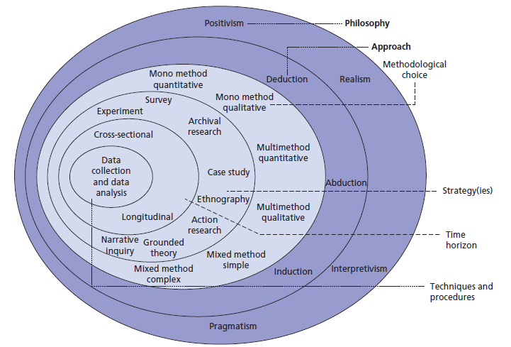

Figure 2.1: Saunders’ Research Onion (Research-methodology.net, 2017)

2.2 Philosophy

Based on the methods of research that will be utilised in this dissertation, the philosophy of the research will be both positivism and interpretivism. Interpretivism “is concerned with understanding human behaviour and…focuses on the meaning, rather than the measurement of social Phenomena.” (Collis and Hussey, R. 2003, p. 53). Alternatively, positivism is famously the ‘scientific’ method and is an idealised model that attempts to extract the truth through objective observation, measurement, careful and accurate analysis of data, minimising pre-conceptions about how the world works (Webster, 2017).

2.3 Research Approaches

This report will also use two research approaches, as there are mixed methods of strategy that endorse the use of multiple approaches. The two approaches used in this report are ‘inductive’ and ‘deductive’. The deductive approach is necessary for the questionnaire, because this method will test an existing theory as to its accuracy. The inductive approach on the other hand will associate with the interview process, as it will look into generating a new theory based on the data collected (Fereday, J. and Muir-Cochrane, 2006, pp. 80-92).

2.4 Research Strategy

This report will contain two methods of research including questionnaires and interviews but overall this will result in the use of one strategy as they are both a form of survey. The reasoning behind Survey taking a prominent role in the research of this project are a result of the benefactors. Surveys are ideal for this report as they are time-effective and convenient, as you can send them via email or stand in a densely populated area and wait for participants, so you can get the research completed swiftly. Also, with the speed of the collection through survey, there is the added benefit that the user can collect high amounts of data in this short period of time (Sincero, 2017).

2.5 Time Horizon

The time horizon method from the research onion associated in this report is the cross sectional process. Cross-sectional allows users to use both qualitative and quantitative research and they can also make it possible to measure an aspect or behaviour of groups of people or individuals at a single point of time (Onion.derby.ac.uk, 2017). Therefore, this increases the convenience of research and the time consumption, which is a useful tool when trying to collect research by a certain deadline, as is the case with this report.

2.6 Research Choices

There will be two types of data collection used in this dissertation, but they are both a method of survey. The two survey methods are questionnaires and interviews, and they are useful in different ways.

Questionnaires have many advantages when utilised correctly, including how they enable users to collect large amounts of data in a short period of time, whilst being cost-effective. Questionnaires can also be easily quantified by the researcher or software, and when quantified, it can be used to compare and contrast other research (Libweb.surrey.ac.uk, 2017). This will give the report a large amount of research data to analyse, giving a bigger sample size and therefore a larger perspective.

Interviews also garner multiple advantages for users including mainly how an individual can chose the person they wish to interview, so the best information can be gathered by selecting the most appropriate candidate. Also, interviews enable users to ask specific questions, that get detailed and more valuable research (Thebusinesscommunication.com, 2017). Interviews will make sure the report gains perception from people with a firm knowledge and opinion, also collecting specific research.

As this report will be using two qualitative methods research, this outlines that the data collection sector used will be the multi-method approach. Mixed methods essentially mean “collecting, analysing and interpreting quantitative and qualitative data in a single study or in a series of studies that all investigate the same underlying assumption” (Cameron, 2015).

2.7 Data Analysis

The research collected in this dissertation will be analysed and presented using various tools including spreadsheets, graphs, tables and figures. This will make the data easier to read and therefore, an easier task to interpret the overall consensus.

2.8 Limitations and Ethical Considerations

2.8.1 Time Management and Sample

Due to this being a report being a graded university project, there is inevitably a time constraint, as a result of the deadline set. The time constraint then confines the sample size, with there being a limited time to collect research and formulate a report.

2.8.2 Ethical Considerations

The research collected in this dissertation will only include persons over the age of 18, and every participant will forgo the reading and signing of an ethics form beforehand. The topic of this report isn’t one of controversy and will not cause any physiological harm to those taking part.

2.9 Reliability and Validity

The Oxford dictionary defines reliability as “The degree to which the result of a measurement, calculation, or specification can be depended on to be accurate”, and validity as “The state of being legally or officially binding or acceptable” (Oxford Dictionaries | English, 2017).

Ensuring the research collected in this dissertation is both reliable and valid will have a huge role in the accuracy of the conclusion drawn from this report. The research collected will fundamentally outline the conclusion of the report, and so to come to an accurate outcome, there will be extra emphasis on ensuring the variables and external factors are limited, to gain the most appropriate research and conclusion possible.

3.0 Resources and Planning

3.1 Resources

There will be a multitude of academic resources used in the entirety of this dissertation that will include books, journals, articles, reports, and academic websites. These resources will be accessed by the use of libraries, online libraries, University resources, online databases, and the internet. The information gathered on behalf of this dissertation will be relevant to the overall topic, aims and objectives of the report, in order for it to be analysed and build the foundation of a well-informed and accurate dissertation.

3.2 Gantt Chart

A ‘Gantt chart’ is effectively a time keeping tool that helps its user remain on track with the exercises in a particular project. Gantt charts must contain a list of activities on the left side of the chart, and a chosen timescale along the top of the chart. This will then be a representation to the user as to when each task needs to be completed, in order to move on to the next and resultantly, the project should be completed within the set time period, if the chart metrics are maintained (Gantt.com, 2017). A Gantt chart used in the context of this dissertation is situated below in figure 3.1.

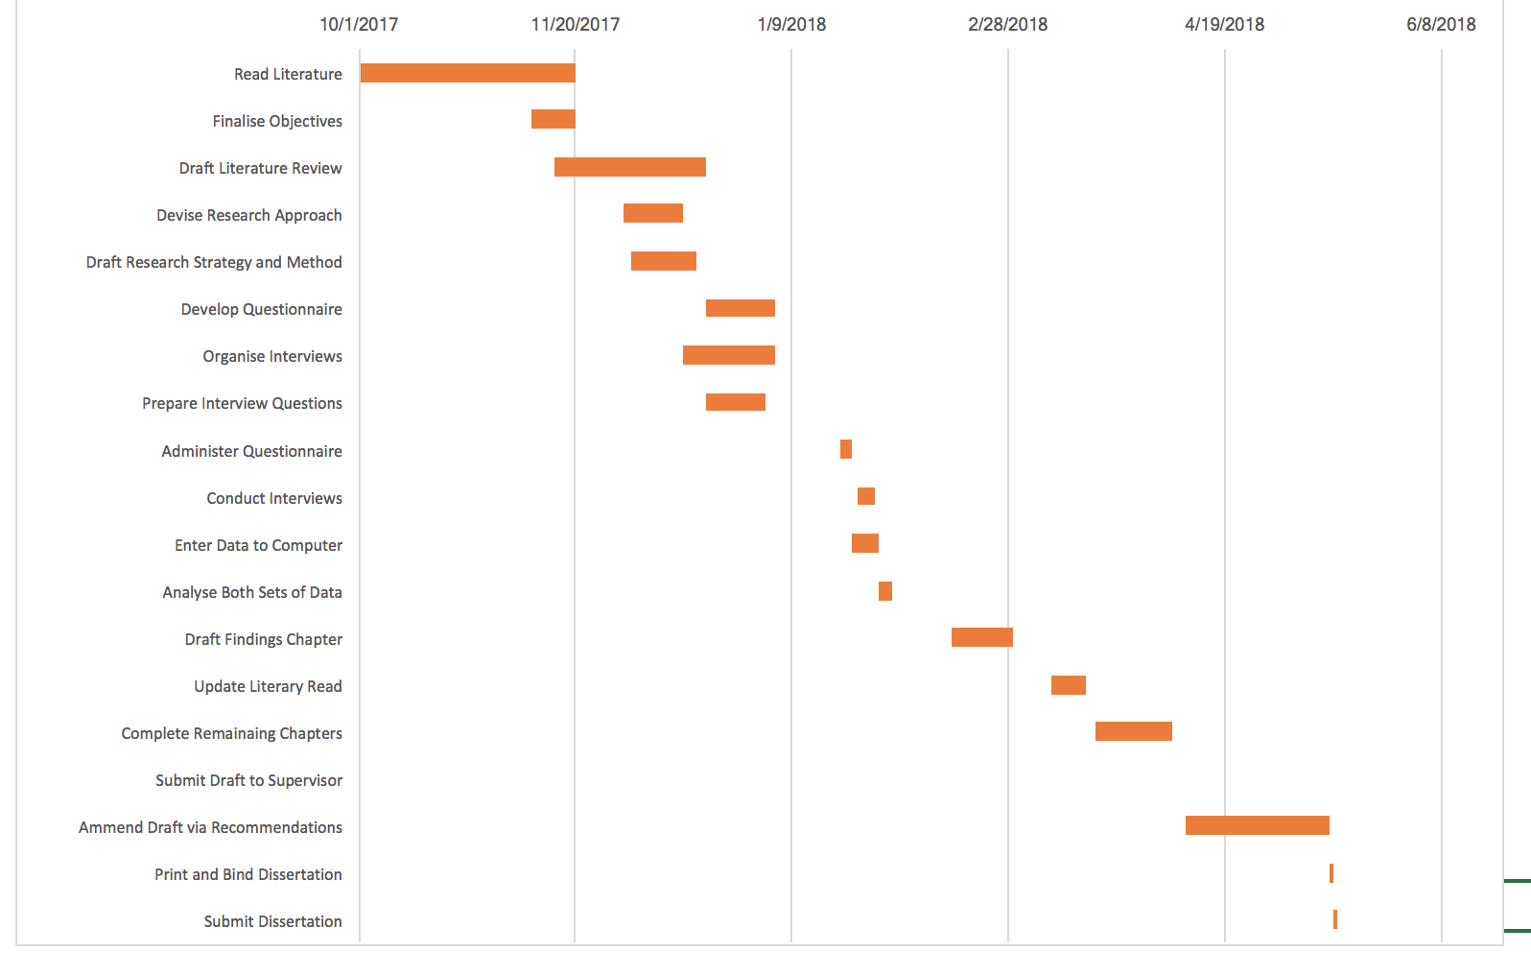
Figure 3.1 Gantt Chart

4.0 References

Anand, S. and Sen, A. (2000) ‘Human development and economic sustainability’, World Development, 28(12), pp. 2029–2049. Doi: 10.1016/s0305-750x (00)00071-1.
Baker, S.C. (2005) Environment and sustainable development. New York, NY: Taylor & Francis.

Blowfield, M. (2012) Business and sustainability. Oxford: Oxford University Press, p. 28).

Bowie, N.E. and Werhane, P.H. (2004) Management ethics (foundations of business ethics). 3rd edn. Malden, MA: Blackwell Publishing, p. 21-25).

Cameron, R. (2015). Mixed Method Research. [online] Deakin.edu.au. Available at: https://www.deakin.edu.au/__data/assets/pdf_file/0020/681023/Dr-r-cameron_mixed-methodology.pdf [Accessed 20 Nov. 2017].

ChinaAbout.net. (2017). The economy side of McDonald's - ChinaAbout.net. [online] Available at: https://www.chinaabout.net/economy-side-mcdonalds/ [Accessed 19 Nov. 2017].

Collis, J. and Hussey, R. (2003). Business research. 3rd ed. p.53.

Crane, A. and Matten, D. (2010) Business ethics: Managing corporate citizenship and sustainability in the age of globalization. 3rd edn. New York: Oxford University Press, USA.

Fereday, J. and Muir-Cochrane, E. (2006). Demonstrating Rigor Using Thematic Analysis: A Hybrid Approach of Inductive and Deductive Coding and Theme Development. International Journal of Qualitative Methods, 5(1), pp.80-92.

Gantt.com. (2017). What is a Gantt Chart? Gantt Chart Software, Information, and History. [online] Available at: http://www.gantt.com [Accessed 19 Nov. 2017].

Lee, A. and Lambert, C. (2016). Special Sauce in Sesame Seed Buns: Legal Strategy and Public Policy in the Fast-food Industry. Sage Publications Ltd, p.3.

Libweb.surrey.ac.uk. (2017). The advantages and disadvantages of questionnaires. [online] Available at: http://libweb.surrey.ac.uk/library/skills/Introduction%20to%20Research%20and%20Managing%20Information%20Leicester/page_51.htm [Accessed 20 Nov. 2017].

Marketline (2017). Global Foodservice. Marketline Industry Profile. London: Marketline, p.8.

Marrewijk, M. (2003). Concepts and Definitions of CSR and Corporate Sustainability: Between Agency and Communion. Journal of Business Ethics, 44(2-3), p.96.

Matteson, M. and Metivier, C. (2017) Business ethics. Available at: https://philosophia.uncg.edu/phi361-metivier/module-2-why-does-business-need-ethics/freemans-stakeholder-theory/ [Accessed 17 Nov. 2017].

Morgan, C., Widmar, N., Yeager, E., Downey, W. and Croney, C. (2016). Perceptions of Social Responsibility of Prominent Fast Food Restaurants. Modern Economy, 07(06), p.705.

Morgan, C., Widmar, N., Yeager, E., Downey, W. and Croney, C. (2016). Perceptions of Social Responsibility of Prominent Fast Food Restaurants. Modern Economy, 47(3), p.19.
Onion.derby.ac.uk. (2017). Research Onion Saunders. [online] Available at: https://onion.derby.ac.uk/onion.pdf [Accessed 20 Nov. 2017].

Oxford Dictionaries | English. (2017). reliability | Definition of reliability in English by Oxford Dictionaries. [online] Available at: https://en.oxforddictionaries.com/definition/reliability [Accessed 19 Nov. 2017].

Polansek, T. (2016). KFC and McDonald's supplier staff filmed torturing live chickens. [online] mirror. Available at: http://www.mirror.co.uk/news/world-news/kfc-mcdonalds-chicken-supplier-workers-8620791 [Accessed 17 Nov. 2017].

Research-methodology.net. (2017). [online] Available at: https://research-methodology.net/wp-content/uploads/2012/06/Research-philosophy.png [Accessed 19 Nov. 2017].

Saunders, M., Lewis, P. and Thornhill, A. (2012). Research methods for business students. 5th ed. Harlow: Financial Times Prentice Hall, p.5.
Sincero, S. (2017). Advantages and Disadvantages of Surveys. [online] Explorable.com. Available at: https://explorable.com/advantages-and-disadvantages-of-surveys [Accessed 20 Nov. 2017].

Thebusinesscommunication.com. (2017). Advantage and disadvantage of interview. [online] Available at: https://thebusinesscommunication.com/advantage-and-disadvantage-of-interview/ [Accessed 20 Nov. 2017].

UKEssays. (2017). Research Onion - Explanation of the Concept. [online] Available at: https://www.ukessays.com/essays/psychology/explanation-of-the-concept-of-research-onion-psychology-essay.php [Accessed 19 Nov. 2017].

Webster, M. (2017). Definition of POSITIVISM. [online] Merriam-webster.com. Available at: https://www.merriam-webster.com/dictionary/positivism [Accessed 20 Nov. 2017].

