POSKITT Kjartan
Murderous Maths: The perfect sausage and other fundamental formulas
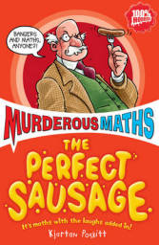Scholastic, 2008, £5.99, Pbk, 10+
ISBN: 9781407107165
A fun look at the principles of mathematics.

Desperate measures
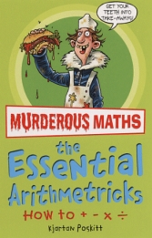ISBN: 9781707105864
Do you feel lucky
ISBN: 9781407107127
Easy questions, evil answers
ISBN: 9781407114514
The essential arithmetricks
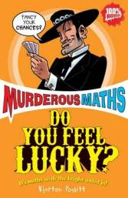ISBN: 9781407105857
The fiendish angletron
ISBN: 9781407107141
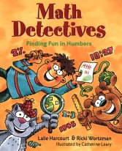Guaranteed to bend your brain
ISBN: 9781407105888
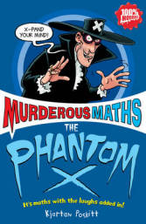Guaranteed to mash your mind
ISBN: 9781407105871
The key to the universe
ISBN: 9781407107110
The mean and vulgar bits
ISBN: 9781407107097
The phantom X
ISBN: 9781407107134
The secret life of codes
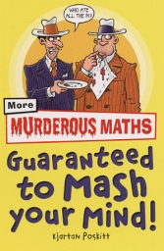ISBN: 9781407107158
Savage shapes
ISBN: 9781407107103

Schools Library and Museum Service
Hammonds Drive
Eastbourne BN23 6PW
Tel: 01323 416324/417030
Email: slams@eastsussex.gov.uk January 2011
Images of books from peters-books.co.uk


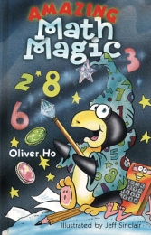and
Maths Books
for Key Stage 2
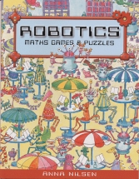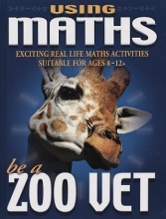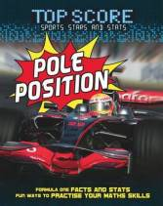

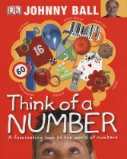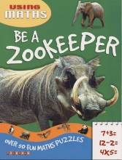
BALL Johnny
Think of a Number
Dorling Kindersley, 2010, £8.99, Pbk, 7+
ISBN: 9781405358026
Looking at the development and use of numbers and shapes.

CLEMSON David and CLEMSON Wendy
Using Maths: Be a Zoo Vet
TickTock, 2004, £5.99, Pbk, 8+
ISBN: 9781860075476
Exciting real life maths activities.

Solve a Crime Extreme Sports Challenge
ISBN: 9781860075483 ISBN: 9781860075490
Fly a Jumbo Jet Win a Grand Prix
ISBN: 9781860075452 ISBN: 9781860075445

CLEMSON Wendy
Using Maths: Be a Zookeeper
TickTock, 2007, £5.99, Pbk, 6+
ISBN: 9781846960635
Spend a day as a zookeeper caring for wild animals and find out how zookeepers use maths every day.

Dinosaur Dig Firefighters to the Rescue
ISBN; 9781846960604 ISBN: 9781846960611
Journey to the Moon Ocean Giants
ISBN: 9781846960598 ISBN: 9781846960581
Treasure in the Jungle
ISBN: 9781846960628

HARCOURT Lalie
Math Detectives: finding fun in numbers
Sterling, 2003, £9.99, Hbk, 7+
ISBN: 9780806978932
A collection of maths games, projects and activities.

HO Oliver
Amazing Math Magic
Sterling, 2001, £9.99, Hbk, 7+
ISBN: 9780806960173
Math puzzles and magic tricks.

NILSEN Anna
Robotics: maths games and puzzles
Little Hare, 2004, £4.99, Pbk, 8+
ISBN: 9781877003615
Presents a range of puzzles requiring simple maths skills.

NOBLE Jonathan and OWEN Ruth
Top Score: Pole Position!
Evans, 2010, £7.99, Pbk, 7+
ISBN: 9780237542832
Features mathematical exercises and quizzes based on facts and statistics about Formula One racing. An engaging way to put maths into context.
WOODS Mark and OWEN Ruth
Ace! Goal!
ISBN: 9780237542801 ISBN: 9780237542795
Scrum! Slam Dunk!
ISBN: 9780237542818 ISBN: 9780237542788
Xtreme!
ISBN: 9780237542825

OXLADE Chris
Real World Data: Graphing Weather and Climate
Heinemann, 2008, £6.99, Pbk, 9+
ISBN: 9780431029641
Showing the presentation of information through charts and graphs. How to organize data in different visual forms, and how to interpret and create line graphs, bar graph, and pie charts.
RAND Casey UNDERWOOD Deborah
Graphing Sports Graphing Transport
Heinemann, 2009, £12.99, Hbk, 9+ Heinemann, 2008, £6.99, Pbk, 9+
ISBN: 9780431033471 ISBN: 9780431029634

