Introduction
Business Intelligence is a combination of approaches, procedures, architectures, and technologies that transform raw data into meaningful and practical information. BI empowers business users to use real-time data to make data-driven decisions that can put a company ahead of its competition (Huang et al, 2021). A variety of sectors including business, security, finance, marketing, law, education, science, engineering, medicine, health, retailing, and telecommunications, etc., occasionally use business intelligence technologies. Although BI is frequently employed in businesses (private or public) for both conventional business and e-business, BI applications are expanding across a wide range of sectors (Obeidat et al, 2015).
Examples of BI trends
- Data governance
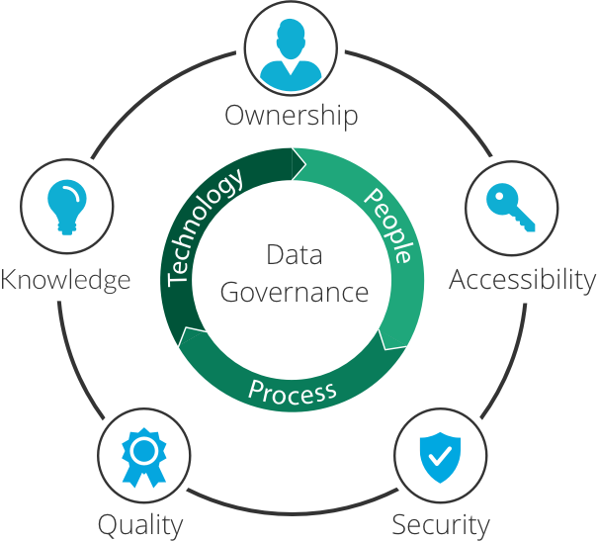

Data governance is a process that establishes the guidelines for managing processes, operational infrastructure, and architectural components of corporate data assets. Simply said, it creates the solid foundation for organization-wide data management. It ensures that corporate data is typically accurate, comprehensive, reliable and safe (Financesonline.com, 2019). Additionally, it is now more crucial than ever for organisations to develop appropriate data governance processes due to the GDPR's passage in 2018. To avoid paying penalties for non-compliance, businesses are expected on devote a larger portion of their budgets to data security (Ramsoy, 2022).
Data governance is a requirement for many jobs or initiatives and offers a number of
advantages:
• Minimize risks;
• Establish internal guidelines for data use;
• Implement compliance standards;
• Improve internal and external communication;
• Security for internal and external data by monitoring and reviewing privacy policies;
• Raise the value of data;
• Central control mechanisms offer potential to optimise the cost of data management; (Janoschek, 2018).
- Embeddable Data
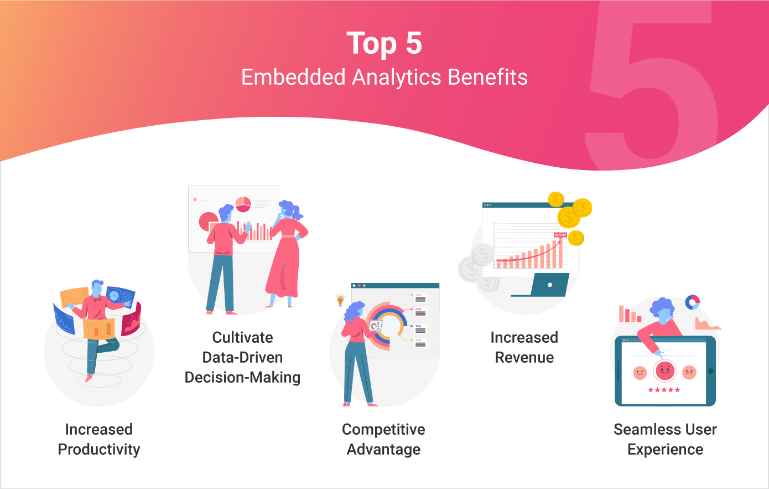
One of the most common trends in BI is data storytelling, as organisations want to use visual analytics to communicate with stakeholders. Traditional reporting that takes a lot of time can be eliminated by integrating data stories into client systems and web apps. Instead of having to tap on buttons or menus, scrolling actions, GIFs, and animated 3D charts can be used. It has a more human feel and makes it simpler to comprehend what it is being showed (Tseng, 2021).
Businesses have realised the possibility of integrating different BI elements, such as reports or dashboards, into their own applications to enhance productivity and decision-making. Companies have learned how using embedded dashboards enables them to give better value within their own application. (Datapine, 2018). Businesses are looking for professional methods of data presentation that don't require them to create their own software. By simply white labelling the application, businesses may produce a clear presentation and reporting that they can give to consumers. Analytics embedded in an application allow for collaboration by involving all stakeholders, going beyond simply by adding a dashboard or BI functionality. Giving customers and staff the option to alter the data in a recognisable environment makes it easier to get insights from every aspect of the business (Trends, 2022).
- Data Quality Master (DQM)
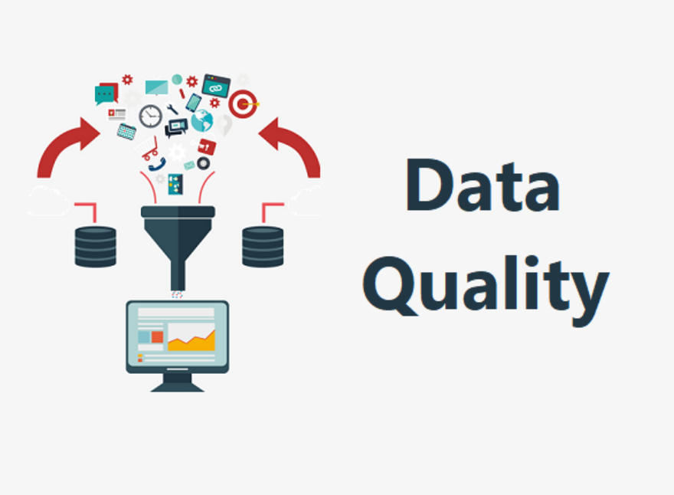
To produce data that is not only correct but also relevant, data quality management is a crucial process that integrates technology, methodology, the appropriate people, and organisational culture. More importantly, data quality encompasses a variety of criteria that assess the state of data utilised for analysis, not just whether it is good or bad (Financesonline.com, 2019).
The objective of master data management in the context of business intelligence is to combine and exchange master data from various applications or data silos, such as customer, supplier, or product master data. It offers information about the flow of data within an organisation. It strengthens the foundation for data governance and upholds data uniformity, guaranteeing that the analysis of the data can paint a clear picture of regular company operations. Business executives can thus make informed choices that advance their companies.
Data quality has consistently been ranked as one of the top three issues for users of BI software since The BI Survey's inception in 2002, despite the fact that it is crucial to many modern enterprises (Janoschek, 2017).
- Collective BI

Business intelligence that is shared collaboratively is not a brand-new trend. However, this tendency has continued to gain momentum due to the constantly changing corporate environment, which is characterised by managers and employees who must connect in new ways. In order to speed up data-driven decision-making, collaborative BI combines BI tools with the greatest collaboration software, including web 2.0 and social technologies. The phrase "self-service BI" frequently appears when discussing collaborative BI in the sense that these self-service solutions do not require an IT team to access, interpret, and comprehend all the data.
The demand for greater collaboration in the business environment has led to the appearance of this trend. The exchange of analytics and reporting is made simpler with collaborative BI, which supports effective decision-making (Financesonline.com, 2019).
By generating automatic reports that may be scheduled to be delivered at particular times and to particular recipients, these BI solutions facilitate sharing. For instance, they enable the creation of business information alerts and the sharing of interactive dashboards that can be shared publicly or integrated. These options enhance the decision-making and problem-solving processes that are so crucial in today's continuously changing world because they are all available across all platforms. This is particularly important now that businesses adopt an hybrid working policy where cooperation requires the proper tools more than ever (Datapine, 2018).
- Artificial Intelligence (AI)

The goal of artificial intelligence (AI) is to enable machines to perform tasks that are typically performed by human intelligence. The way we interact with analytics and data management is revolutionised by AI and machine learning, but increasing security precautions are also necessary (Financesonline.com, 2019).
It is projected that AI will soon grow into a more responsible and scalable technology given the increased demands that businesses will place on AI-based systems. There are currently so many AI-based applications available that IT specialists aren't even sure how to use or evaluate them. This opens the door for security flaws and financial losses that could have a serious negative effect on both businesses and customers. In response, words like explainable AI (XAI) has been the topic of discussion during 2022. The goal of XAI, an emerging area, is to use particular techniques and procedures to make it possible for humans to comprehend the outcomes and outputs produced by machine learning and AI algorithms. In order to offer humans authority over these technologies, this field's ultimate goal is to ensure trust and transparency with them (Datapine, 2018).
- Data discovery/Visualisation
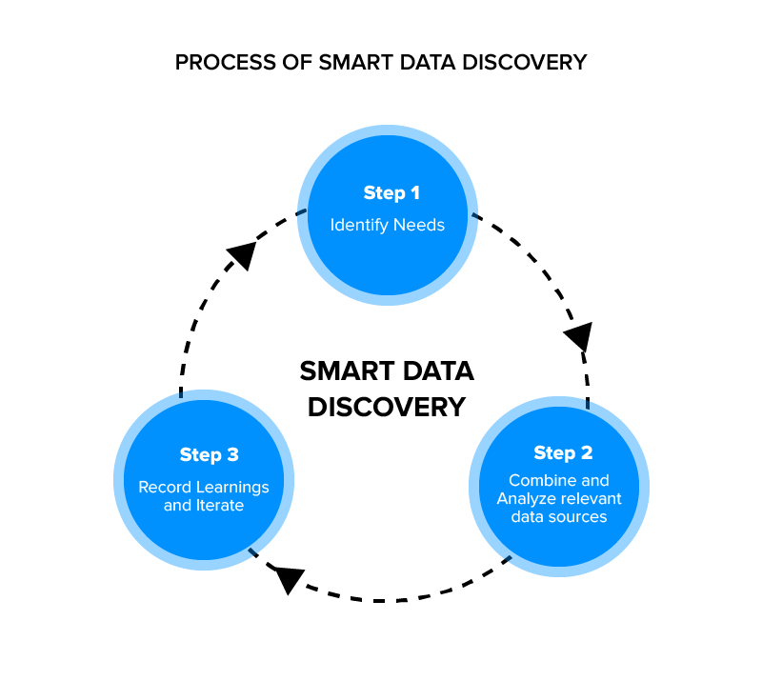
It is anticipated that data discovery via visuals will continue to expand in the years to come. Data discovery has already ranked among the top 4 BI trends by importance hierarchy for 2022 and is anticipated to continue expanding in 2023.
Data discovery is essentially the act of gathering data from numerous internal and external sources, then combining it all utilising complex analytics and visualisations. By giving people the tools to examine, alter, and collect useful insights from the information, organisations can maintain the interest of all pertinent stakeholders in the information. People without IT expertise can easily access data and dig deeper into it to find the information they need thanks to data discovery.
Data visualisation has become a cutting-edge method to present and interact with numerous graphics on a single screen, whether it is concentrated on producing sales charts or fully interactive reports. The idea is that data discovery is a process that gives decision-makers the ability to reveal insights, and teams have the chance to quickly spot trends and notable outliers by utilising visualisations.
Conclusion
Data is the lifeblood of any business today. A corporation can use data to forecast client expectations, learn about competitors, carry out efficient product management, and take well-informed decisions. A recent study from DataProt found that 97% of the data that enterprises acquire goes wasted. The absence of integration with the companies’ usual software is a big contributing factor (Kaur, 2022).
Data now plays a crucial role in achieving corporate success. Companies are continuously gathering increasingly intricate data from many sources, and this data needs to be carefully managed with the appropriate tools and procedures. As compliance regulations become more stringent on a daily basis, it is more crucial than ever to make sure everything is in order and the data is available (Datapine, 2018).

Reference list
- Financesonline.com. (2019). 11 Business Intelligence Trends for 2020/2021: Latest Predictions You Should Be Thinking About. [online] Available at: https://financesonline.com/business-intelligence-trends/ [Accessed 10 Dec. 2022].
- Huang, Z., Savita, K.S. and Zhong-jie, J. (2021). The Business Intelligence impact on the financial performance of start-ups. Information Processing & Management, 59(1), p.102761. doi:10.1016/j.ipm.2021.102761.
- Kaur, H. (2022). Top 5 Business Intelligence Trends You Can’t Ignore | Zyxware. [online] Zyxware Technologies. Available at: https://www.zyxware.com/article/top-5-business-intelligence-trends-you-cant-ignore#footnote7_pltny8w [Accessed 13 Dec. 2022].
- Janoschek, N. (2017). BI Survey. [online] BI Survey. Available at: https://bi-survey.com/data-quality-master-data-management [Accessed 10 Dec. 2022].
- BI Survey. [online] BI Survey. Available at: https://bi-survey.com/data-governance [Accessed 10 Dec. 2022].
- Obeidat, M. (2015). Business Intelligence Technology, Applications, and Trends. International Management Review, Vol 11(2).
- Ramsoy, C. (2022). Top 10 business intelligence trends in 2022. [online] Visma International Blog – technology, business & life at Visma. Available at: https://www.visma.com/blog/business-intelligence-trends-2022/ [Accessed 11 Dec. 2022].
- Top 10 Analytics And Business Intelligence Trends for 2019 (2018). BI Blog | Data Visualization & Analytics Blog [online] BI Blog | Data Visualization & Analytics Blog. Available at: https://www.datapine.com/blog/business-intelligence-trends/ [Accessed 12 Dec. 2022].
- Trends, M. (2022). 7 Business Intelligence Trends to Watch Out For in 2022. [online] www.analyticsinsight.net. Available at: https://www.analyticsinsight.net/7-business-intelligence-trends-to-watch-out-for-in-2022/ [Accessed 13 Dec. 2022].
- Tseng, H. (2021). Business Intelligence Trends in 2021 | Latest Trends In BI. [online] SelectHub. Available at: https://www.selecthub.com/business-intelligence/business-intelligence-trends/ [Accessed 11 Dec. 2022].

