

Housing Young People: A Review of the Literature and Implications for Youth Work.

Ruth James.

BA Youth and Social Education.
ECYW6001.
Yr Athrofa: Education and Humanities.

Declaration Form


Dissertation Declaration Form.

1. This work has not previously been accepted in substance for any degree and is not being concurrently submitted in candidature for any degree.
Signed: R James………………………………………………………………………...
Date: 15/05/2022………………………………………………………………………...

2. This dissertation is being submitted in partial fulfilment of the requirements for the degree of ……………………………………………………………….................
Signed: R James…………………………………………………………………….
Date: 15/05/2022…………………………………………………………..…………...

3. This dissertation is the result of my own independent work/investigation, except where otherwise stated.
Other sources are acknowledged by footnotes giving explicit references.
A reference list is appended.
Signed candidate: R James………………………………………….……………….
Date: 15/05/2022………………………………………………….……………………….

4. I hereby give consent for my dissertation, if accepted, to be available for photocopying, inter- library loan, and for deposit in the University’s digital repository
Signed (candidate)……R James………………………………….………….…………...
Date 15/05/2022……………………………………………….…………….……………..
Supervisor’s Declaration.
I am satisfied that this work is the result of the student’s own efforts.
Signed: …………………………………………………………………………..
Date: ……………………………………………………………………………...

CONTENTS
DECLARATION FORM…………………………………………..P 2-3
CONTENTS………………………………………………………..P 4-5
ACKNOWLEDGEMENTS………………………………………..P 6
1. INTRODUCTION……………………………………………….P 8-11
2.1 LITERATURE REVIEW INTRODUCTION………………..P 11-12
2.2 Effects of Austerity on Public Services and Housing..P 12-20
2.3 Potential Impacts of Lockdown and Self-Isolation Rules on Young People………………………………………………………………P 20-28
2.4 How Austerity has Affected Youth Provisions…………P 28-33
3. DISCUSSIONS…………………………………………………P 34-36
4. CONCLUSION AND RECOMMENDATIONS……………..P 36-39
5. REFERENCES…………………………………………………P 40-46
6 APPENDICES…………………………………………………..P 47
6.1 Appendix 1:……………………………………………... P 48-48
6.2 Appendix 2:……………………………………………… P 49
6.3 Appendix 3: ………………………………………………P 49
6.4 Appendix 4:……………………………………………… P 50
6.5 Appendix 5: ………………………………………………P 50
6.6 Appendix 6: ………………………………………………P 51
6.7 Appendix 7: ………………………………………………P 51
6.8 Appendix 8:……………………………………………....P 52
6.9 Appendix 9:……………………………………………… P 52
6.10 Appendix 10: …………………………………………...P 53
6.11 Appendix 11:……………………………………………P 53
6.12 Appendix 12: ………………………………………….P 54
6.13 Appendix 13: ………………………………………….P 54
6.14 Appendix 14: ………………………………………….P 55
6.15 Appendix 15:…………………………………………..P 55
6.16 Appendix 16:…………………………………………..P 56
6.17 Appendix 17:…………………………………………. P 57
6.18 Appendix 18: ………………………………………….P 57
6.19 Appendix 19: ………………………………………….P 57
6.20 Appendix 20:…………………………………………..P 58

ACKNOWLEDGEMENTS:

I would like to thank firstly my tutors at the University of Wales Trinity St David for seeing my passion early on for youth work and giving me the opportunity to study for the BA in Youth and Social Education.
Angharad Lewis- course director, Alana Enoch- course lecturer, Dr Darrel Williams- course lecturer, Katie Gardner- student lecturer, Cindy Hunt- Visiting Field work Mentor, Lisa Hagley- Field Work Supervisor, and Dr Nichola Welton, from the offset have shown me nothing but support and advice. This is especially so after I suffered the sudden loss of my partner, Ricky, towards the end of my level 5 studies. If it was not for their dedication to my studies and personal wellbeing, I would have not completed my level 6 studies. For this reason alone, you will be remembered fondly for the rest of my life.
All lecturers have passed their passion for youth work onto their students during their studies, this has made the course one of the most rewarding courses to study at the university. Thank you.
Many friendships have been formed during my studies, but I would like to give a special mention to Dana Jones who has been a constant source of support for both myself and my family. I have a friend for life in Dana, she picked me up during my lowest points during the duration of the degree and for this I am truly blessed to have someone like her in my life.
I would like to say thank you to my long-suffering sons Jack and Adam who have had to put up with a very stressful mum at times. Their resilience over the last year after losing their dad has made me incredibly proud of them. You both are my reason to live, and I love you dearly.
Finally, to my partner of twenty years Ricky, you started this journey with me and supported me throughout my level four and level five studies. You were the first person I rang when I had my results and you always used to tease me ‘you could have done better’. Sadly, this is a bittersweet ending to the degree. You are not here to see me graduate but I know you will be watching me walk across the stage in July, cheering me on from wherever you may be.

Dedicated to, and In Loving Memory
of
Ricky John Jones
1972-2021
And
Nancy James
1947-2012

1: INTRODUCTION:
For the purpose of this dissertation, a literature review, the author is going explore a specific group of young people, specifically those in supported accommodation during the COVID 19 pandemic.
The author is a 43 year old female who lives in a small village in the Carmarthenshire area of South Wales. Previous to embarking on the BA Youth and Social Education degree the author was an Operating Department Practitioner and a Senior Laboratory Technician at their local hospital. Duties included working in the histology and mortuary departments and multiagency working was prevalent throughout their career.
Having a neurodiverse child, the author seen herself learning more about difficulties young people face both within the school setting and in society in general. Having to act as an advocate within the school setting for her son brought about many challenges and this is where the passion for Youth Work started to flourish. The decision to embark on a career change was also supported by the school’s youth worker who saw my passion and encouraged me to apply for the degree.
As part of the BA in Youth and Social Education degree the author was required to complete 800 hours of face to face and non-face to face work with young people. She was fortunate enough to be placed at a young people’s accommodation project in a local town in Carmarthenshire, where most of her experience was gained.
On completion of level four, the author was offered a post as a relief support worker and then eventually a senior support worker role within the project.
Homelessness is described by Public Health England as where someone that has nowhere to live or a place to call home. This does not simply mean sleeping rough, it can refer to people who have insecure tenancies or are staying with family (Public Health England. 2019. Pp2).
It has been difficult for the author to gain a real snapshot of homeless people in the UK as most government websites are stating homelessness statistics in England and not the UK as a whole. The Office for National Statistics does however give a breakdown of each individual country and its UK homelessness figures between 2005 to 2018. It notes that England, in the year ending 2018, saw figures of homelessness applications at 109.47 thousand, Wales 13.8 thousand, Scotland 34.95 thousand and finally Northern Ireland 18.18 thousand (Office of National Statistics. 2018). Graphs of the statistics can be seen in appendix A.
There is a distinct downward trajectory in the housing applications between 2005 and 2018 however, the author is only too aware that although these figures look promising, housing stock within the Carmarthenshire area is at crisis point.
Current homelessness figures in the Carmarthenshire area are difficult to source but one Welsh Government paper suggests the number of rough sleepers in the Carmarthenshire are zero (Welsh Government, 2021). Please see appendix B.
It is also incredibly difficult to get a true figure on those people who are classed as the hidden homeless, Shelter Cymru (No Date).
Hidden homelessness comes in different guises such as sofa surfing, rough sleeping, suffering domestic violence, family breakdowns, sleeping in their vehicles, tents, hostels, and those who are living in poverty, Geraghty (2018).
A damning report by Nick Bennett, Public Services Ombudsman for Wales initiated his own independent investigation into the homelessness review process in Wales, finding evidence of “systemic maladministration” by local authorities (Public Services Ombudsman for Wales, No date). Bennett also goes on to detail why he initiated this report by stating ‘despite “beacons of good practice”, too many people at risk of homelessness are victims of “injustice” due to unacceptable delays, inadequate processes, poor communication, and placement in unsuitable accommodation’ (Bennett, No date).
The investigation focused on three local authorities namely Carmarthenshire, Cardiff, and Wrexham, it highlighted each authority has a different approach on how it deals with homeless people. Bennett also makes a strong case for all local authorities need to follow a similar process of evaluating and dealing with homelessness and with a regulatory role. This role will provide clear guidance to aid authorities so consistency can be achieved for all (Bennett, 2021).
Interestingly, leading charities that focus on supporting those who are homeless do seem to be more proactive in providing up to date and current demographics with regards the statistics within the UK and its sub nations.
The Wallich is a homelessness charity and is based solely in Wales, and has many projects situated all over the nation. Its ethos is to:
We believe that everyone deserves the right to a home, but more than that, that everyone deserves the right to feel safe, to feel valued and to feel positive about their future. The Wallich operates under three core objectives: getting people off the streets; keeping people off the streets; and creating opportunities for people.
(The Wallich, No Date).
Many of the services The Wallich offer are based on an identified need within a specific area and such facilities can provide:
• Shelter for those people with drug misuse issues.
• Dry houses for those who have left rehabilitation and require more support before they return to their property.
• Wet houses for those who wish to embark on harm reduction schemes.
• Accommodation for young homeless people.
At the authors placement setting is defined as supported accommodation, supported accommodation can be defined as:
A housing service where housing, support and/or care services are provided to help people to live as independently as possible. Supported housing provides homes for a wide range of people including older people, people with a learning disability and autistic people, people with mental health related needs, vulnerable young people and people who have experienced homelessness.
(Local Government Association, 2020).

Within the UK there are young people who are homeless, and each have different entitlements based on which country they live in, England, Wales, Scotland and Northern Ireland.
The Homelessness Act (2002) notes that every local housing authority has a strategy based on a review of their area. This strategy needs to be reviewed at least every five years, so such issues are addressed and acted on (Department for Levelling Up, Housing and Communities, 2018). Additionally, the Homelessness Act (2002) highlights those local authorities should strengthen their duties owed to people who are homeless and allocating suitable accommodation to those in need (The Homelessness Act 2002, 2002).
At the project in Carmarthenshire, we have 11 self-contained flats where young homeless people can reside. The young people receive 24/7 support that they need in order to learn through in-formal and non-formal learning to become self-sufficient and move on into properties and become confident and independent.

2: LITERATURE REVIEW INTRODUCTION:
This introduction will provide a review of the existing literature, which will include sources taken from research journals, books, articles from well regarded institutions, newspapers, and online sources in relation to the following themes.
- Fiscal Austerity and its impact on public services.
- Potential impacts of lockdown and self-isolation rules on young people.
- How austerity has affected youth provisions.
The literature reviewed will include a mix of qualitative and quantitative data.
Theme one will look at how fiscal austerity has had an impact on public services but focuses on the provisions that support young people. In the 2010 a hung parliament was announced which resulted in a drastic change on how the United Kingdom budget was managed. This ultimately impacted on how the UK’s money was invested, savings were needed to reduce the debt owed from the financial crisis it inherited.
Theme two will examine how young people managed the impacts of lockdown and self-isolation. The UK government wasted time in preparing for the Corona Virus and when the pandemic hit the UK, many were not equipped to deal with the threat the virus imposed on the nation. The sudden lockdown measures affected businesses and public services like never before, but more so it affected those who were from poor socio-economic backgrounds and those living in environments that were detrimental to their wellbeing.
Many young people were schooled from home and often those from poorer backgrounds had limited access to internet and digital devices. Families who reached out to public service provisions were also faced with the brunt of the closures resulting in some young people seeking refuge away from the family home.
Finally theme three, the author will seek to explore how disinvestment due to the social policy of austerity, has affected youth services, and how young people were affected due to the retraction of services during this increasingly stressful and uncertain time. Furthermore, the author will look at youth work and its position within the local community. Non-formal and informal education will be explored and its benefits for those young people who struggle in mainstream education. Literature will be critically evaluated to discuss the disinvestment in the youth service field and its impact on the youth who seek to use the provision in Carmarthenshire. There will also be an evaluation of the youth service and its provision in helping young people who present themselves as homeless.

2.2: THE EFFECTS OF AUSTERITY ON PUBLIC SERVICES AND HOUSING:
This section of the dissertation will critically explore the policy of fiscal austerity undertaken by the Conservative led government and the many implications this austerity had on public services and specifically focusing on how it has affected the services that support young people.
The general election in May 2010 resulted in the first hung parliament in United Kingdom in thirty-six years (UK Parliament, n.d). Ultimately as a result of this hung parliament it meant there was a need for talks and negotiations between the political parties to establish a viable government. These negotiations resulted in the second coalition government between the Conservatives and the Liberal Democrats since the Second World War (Britannica, 2019, n.p).
It has been said that austerity has a complicated history and derives from the multidimensional catastrophe of the financial system in 2007-2008 (Clarke & Newman, 2012, p 300). However, it has also been claimed that austerity has been driven by political ideology, this notion has been supported by Harrison (2020) where she stated that:
Firstly, the government chose to talk about the cuts in a way that made them seem both necessary and unavoidable. They made arguments such as ‘we are not doing this because we want to, driven by theory or ideology. We are doing this because we have to’. Despite some arguing that austerity is, in fact, an ideological choice and not the only solution, the British public largely accepted the narrative that there is no alternative.
(Harrison, 2020, n.p)
During this time the government set about to drastically change the shape of its establishment, resulting in a transformation from a ‘financial crisis to a fiscal crisis’ (Clarke & Newman, 2012, p 300). A fiscal crisis can be defined as:
A fiscal crisis is a situation where a government cannot finance its regular activities, including providing social services, paying for defence, and managing other government functions. There are a number of ways nations can attempt to address a fiscal crisis and they often involve hardship for many citizens.
(McMahon, 2022, n.p).
This process of trimming the government finances has been described as Fiscal tidying which was largely initiated as a means of minimising public spending (Emmerson, 2017, n.p).
This moved the narrative from how to rescue the banking crisis, to identifying who’s to blame for the crisis (Clarke & Newman, 2012, p 300). The aim of turning disaster into triumph resulted in a new neo-liberal settlement in an attempt to find some sort of alchemy (Clarke & Newman, 2012, p 300).
Gordon Brown was accused of being overly optimistic about the UK's growth prospects when he was in office. On the other hand, he was also too willing to spend money on improving services. This combination of spending and reforms resulted in public money being wasted (Sowels, 2014, n.p).
Although the United Kingdom’s growth has developed between 2010 and 2018 this growth has not followed historical standards as seen in appendix 5 (Cribb and Johnson, 2018, p1). The study for the Institute for Fiscal Studies notes that the public debt owed is almost double the pre-crisis level (Cribb & Johnson 2018, p1) and this has had an impact on the tough choices the people in the United Kingdom face today.
The austerity policies set in place focused on the expressed need to drastically reduce the public spending that was allegedly caused by the irresponsibility of the New Labour Government between 1997 & 2010 (Hernandez, 2021, p1).
According to Drakeford (2012), the public expenditure restraint was already in place in the New Labour era and by the time Labour left the office the Chancellor of the Exchequer, Alistair Darling had already imposed budget cuts in revenue and spending (National Assembly Research Service, 2010).
Between 2012 and 2022 the Government has slashed its funding in public services, on a superficial level to balance its books, but unfortunately it has been to the detriment to public services and those who rely on them. For example, according to a new analysis by the Labour Party, spending on youth services in England has been cut by over £700 million since 2010 (Labour, 2019, n.p). This figure is equivalent to a 70% reduction since the Conservative Party took power in 2010. Similarly, in Wales, an ITV News report (2016) states that the union UNISON, claims that the funding cuts have led to the closure of over a hundred youth centres. These closures have resulted in the loss of 360 jobs, with most of them being part-time positions. In addition, seven of these centres have closed due to the pressures on Welsh local authorities (ITV News, 2016, n.p).
Funding cuts to public sectors services has hit Britain hard and this has filtered down to the local authorities within the UK. The public service union- UNISON, please see appendix 6, under the series of freedom of information requests, requested information from the UK administration to assess the human costs of the financial cutbacks. It is important to highlight that UNISON has perfectly described the effects of the budget cuts as the ‘human cost’ because ultimately, it’s those who rely on these vital services who suffer the brunt of the cuts. Unfortunately, in the report, UNISON does not state clearly which administrations were affected the most, and what service group users were questioned. However, there is evidence that suggests that those with families and young children, who used youth and health centres, saw such provisions lost with nothing set in place to substitute it.

By 2019 the COVID 19 Pandemic hit China and eventually the United Kingdom, it threw the world into an unprecedented health crisis (Chatuvedi, Vishwakarma & Singh, 2021, p1).
The retrenchment of government spending saw the already struggling public services fighting to maintain its commitment to its community. The negative impacts of lockdown exacerbated those who were already disadvantaged and living in poverty and the lockdown measures and self-isolating rules meant that many professionals had to work from home.
A Guardian article notes that ‘spending on youth services in England and Wales has been cut by 70% in real terms in less than a decade, with the loss of £1bn of investment resulting in zero funding in some areas’ (Weale, 2020, n.p). Similarly, the Chief Executive of the YMCA in England & Wales reiterates that the purpose of youth services is to provide young people with a sense of belonging and to enjoy being young. However, with over 760 youth centres and closing due to nearly over a billion worth of real time cuts and over 4,500 youth workers, young people are being pushed aside and seen by the decision makers as unworthy of support. (Haton cited in the YMCA, p22, n.p).
Literature relating to sector shutdowns notes that for the virus to stop spreading, it was vital that entire sections of the economy were to shut down (Blundell, Dias, Joyce and Xu, 2020, p8). On the contrary to non-essential workers, key workers were openly encouraged to continue working regardless of the dangers posed by the Coronavirus (Blundell. et al. 2020, p11).
The complexity of the pandemic's effects can be traced back to the underlying policies and inequalities that emerged during the last major economic crisis. This crisis is also highlighting the need to address these issues and implement effective policies to protect those most at risk (Blundell. et.al, 2020 p2).
The Welsh Service Audit released in 2021, provides information about the activities of the statutory youth work sector in the country of Wales prior to the outbreak of the coronavirus. The youth work sector in Wales is managed by the local authorities and the voluntary sector. The release, details the information gathered by all 22 local authorities (Welsh Government, 2021, p1).
The main points highlighted by the audit can be seen in appendix 7, here it notes that in March 2020, there were approximately 719 full-time equivalent youth worker staff delivering work in the local authorities, and this has increased by 10% from the previous year (Welsh Government, 2021, p1). Secondly, youth work provision funding for Wales had increased by 16% compared to the core budget decreasing by down by 11%, and thirdly, spending for youth work provisions across Wales during the period of 2019 to 2020 had increased by 22% compared to the previous years (Welsh Government, 2021, p1).
In the Welsh Service Audit Report, it notes that there were 82,766 young people registered with a youth provision service, for graphical data of this please see appendix 8 (Welsh Government, 2021, p2).
It is interesting to note from the figures in appendix 7, that only approximately five to six thousand young people aged seventeen to nineteen are involved in youth work provisions and the numbers are even smaller for those aged twenty to twenty-five at approximately two to three thousand. This begs the question as to why young people in this age group are not accessing essential services that are available to them. A government paper called the Building Engagement, Building Futures: Our Strategy to Maximise the Participation of 16–24-Year-Olds in Education, Training and Work (2011) reiterates that we know that young people from disadvantaged backgrounds are at risk of long-term disengagement. Therefore, it is important that we develop a new approach to help them realise their full potential (HM Government, 2011, p3). The strategic priorities set out in this paper can be found in appendix 10. Unfortunately, this plan does not meet the aspirations it set to achieve, and this is evident in the figures in appendix 8.
In 2014, the National Youth Work Strategy in Wales was updated and set out a four-year plan for the future of Youth Work in Wales. It included a requirement for Youth Work organisations to be more integrated with other support services (Rose, 2020, p8). The strategy also highlighted the various benefits of open-access provision for young people, such as being able to access services that are not only accessible to them, but also provide an environment where they can feel safe and secure. It also stated that Youth Work can help identify young people who may be at risk of experiencing adverse hardship or disengagement.
The Welsh Service Audit also provides statistical information regarding to the type of youth service that has been provided within the administrational areas, please see appendix 11. The types of projects that were recorded included those related to health and wellbeing, sports and physical activity, and arts and drama. Projects were also recorded multiple times if they were relevant to different categories (Welsh Government, 2021, p6). Unfortunately, there is no recorded provisions included for those young people who seek housing support, supported living, and those who are at risk of homelessness.
The Carmarthenshire’s Policy for Allocating Social Housing (2016) sets out to describe its commitment to providing social housing for those people living in the Carmarthenshire area of Southwest Wales. Very little is documented about young people who are at risk of homelessness, with the exception to:
Anyone over the age of 16 can apply to join the register. Prospective tenants will be assessed in terms of their ability to manage a home. This may include a referral to our Social Services team or other organisations who work with young and vulnerable people, who may make a recommendation regarding an applicant’s suitability. Any tenancy for a person under 18 will be held in trust (after which they can legally hold a tenancy in their own right). This means that another suitable person parent, legal guardian, carer, social worker or relative) will be responsible for the property in the meantime. 5 parent, legal guardian, carer, social worker or relative) will be responsible for the property in the meantime.
(Carmarthenshire County Council, 2016, p4).
The Welsh Government’s Take Wales Forward strategy (2016) aims to make Wales a country where everyone wants to live and work. It includes a commitment to giving every child in the country the best possible start in life (Welsh Government, 2017, p6).
Although the data in appendix 11 shows no actual homelessness provisions in the 22 administrations, there are a number of policies and programs which support young homeless people in Wales, for example, Families first is a programme set up for families who need support either from the local authority or external services. The programme has a strengths-based approach that supports families to develop and manage their own development. This approach aims to prevent them from requiring expensive remedial care in the future (Welsh Government, 2017, p8).
Families First also support that multidisciplinary agency work is key to working with families to ensure interventions, and care packages are in place to prevent a crisis from escalating. Information sharing is also underpinned by effective sharing protocols to ensure that vital information is handed over in a fluid manner so all members working with the families are informed and up to date with the relevant information. Please see appendix 13 for the continuum of support structure (Welsh Government, 2017, p11). An evaluation of Families First Year 3 Report highlights its successes by stating the Family Support programme has been able to prompt systems redesign at local levels. This has resulted in improved quality and range of services being provided for families. The programme's managers have also developed a culture of learning, which is evidenced using data and feedback to improve the program's delivery (Welsh Government, 2015, p97).
When a young person becomes homeless or threatened with homelessness there seems to be very little in place to advertise the services offered within the area unless you have access to the internet. For those young people who have left school or have access to no youth work support this can be quite a daunting prospect.
The author found it quite difficult to source statistical data stating how many local homeless accommodation provisions that are available, specifically for young people, in the Carmarthenshire area. Council ‘Hwbs’ based in the three largest towns (Carmarthen, Llanelli and Ammanford) offer housing support to anyone within the local area, and can refer them to Housing Options for access to the four local housing associations:
• Wales and West Housing Association.
• Bro Myrddin Housing Association.
• Pobl Housing Association.
• Family Housing Association.
(Carmarthenshire Council, 2016, p5).

Appendix 14 shows statistical data that contradicts Carmarthenshire County Council’s commitment to housing people in Carmarthenshire area. Shelter Cymru reports that according to the data they collected, Carmarthenshire is one of the least successful areas in preventing homelessness compared to other local authorities in Wales (Cross, Gaen, England & Dua, 2021, n.p).
During the 2020-21 financial year, there was an increased demand for services and Carmarthenshire Council were forced to address a new group of individuals who presented themselves to us as rough sleepers and couch surfers (Carmarthenshire County Council, No Date, n.p).
Literature relating to the number of young people’s accommodation has been difficult to source in the Carmarthenshire area. However, from the authors knowledge and experience in this area of practice she can recall three projects that provide such a service to young people who seek refuge for whatever reason.
Having sat on the Carmarthenshire Youth Accommodation Panel the author is all to aware that the housing availability within the area is at crisis point. Young people are having to be housed in short term accommodation’s such as bed and breakfasts, hotels, shared houses, and short-term temporary accommodation properties. The pressures the council face within the county has been highlighted in a Wales Online post where it is stated ‘There were 26 people in four bed and breakfasts venues in Carmarthenshire at the time the Freedom of Information request was submitted last autumn’ (Youle, 2022, n.p). In Carmarthenshire, the cost of providing bed and breakfast accommodations for the homeless increased significantly during the Covid pandemic and this is due to the lack of social housing available to those in need in the county (Youle, 2022, n.p).
In England and Wales, HM Inspectorate of Probation and Care and Social Services have made recommendations to the Directors of Children's Social Care Services regarding the placement of homeless 16- and 17-year-olds in appropriate accommodation and the protection of their vulnerabilities (Her Majesty’s Inspectorate of Probation, n.d, n.p). However, the author is aware that this is not the case in Carmarthenshire and some under 18-year-olds have been placed in bed and breakfasts alongside prison leavers and low class offenders.
For those young people who were fortunate enough to receive a placement in a supported accommodation provision, whether it be council run or third sector funded, the retraction of professional services had a detrimental impact on the young people who needed to use such commodities. The Child and Adolescent Mental Health Service (CAMHS), the Youth Support Service, and other professional bodies that protect children and young adults were impacted by the stay-at-home orders that were enforced on upon them (Cohen and Bosk, 2020, p1).
A recent publication by End Youth Homelessness Cymru, recommendation 9, highlights that young people told them that consistency of support through this key transitional period is very important to them. Given the trauma that has been experienced by many young people, they should be a high priority for mental health support, whether via CAMHS or adult mental health services (End Youth Homelessness Cymru, 2020, p11). Unfortunately, this is not always the case as reported in an article by Wales Online (2021), where they draw attention to that there were 432 hundred out of 720 young people and children that had to wait at least four weeks for their first appointment. In 2020 there were only 95 out of 372 patients meaning that the figures had more than quadrupled in a year (Smith, 2021, n.p).
Sadly, young people who required homeless shelter within Carmarthenshire during the Covid 19 pandemic faced negative consequences due to the lack of suitable accommodations, reduced young people’s services and extended waiting times to access professional provisions. Similarly, this also extended to families who lived in poverty or in detrimental environments within the county.

2.3: POTENTIAL IMPACTS OF LOCKDOWN AND SELF ISOLATION RULES ON YOUNG PEOPLE:
Public Health experts at The University of Bristol, together with the chief editor of the British Medical Journal, slam the UK Governments response to the Covid 19 pandemic by stating “say the UK was “forewarned but not forearmed” (BMJ, 2020, N.P). Furthermore, the author expresses its distain at the time it took for the government to respond to the emerging crisis by saying “by the time the UK formally announced a lockdown with a huge package of economic support measures, almost two months of potential preparation and prevention time were squandered” (BMJ, 2020, n.p).
It is interesting to note that they also point out that the lack of scientific input from Public Health Scientists was largely due to the shortfall of investment in services due to austerity cuts (BMJ, 2020, n.p).
Sudden changes in routines and resources brought on by the Covid 19 pandemic had a significant impact on families, children and young people. It threw our generation into unprecedented times. Due to the nature of COVID19, individuals and families were dealing with various threats to their health. One of these is the loss of a loved one (Weingarten & Worthen, 2018, n.p) . For families this is especially in an era where the distance between them is becoming more pronounced.
A typical family set up in today’s society can be seen as a group of individuals who are related by blood or ancestry. They are also linked by their love, trust, bonding, and support they show one another. A person's personality and character can be shaped by his or her relatives. There are various forms of the family today such as same sex parents, step parenting, single parenting, and the nuclear family (Blessing, n.d, n.p).
Robson (2020) states in an article that while many families will have to stare at the same four walls, celebrities and wealthy families were able to escape the stresses of isolation by taking advantage of sunshine destinations with low Covid 19 rates (Robson, 2020, n.p). However, it is likely to have a disproportionately negative effect on those who are from poorer socioeconomic backgrounds, larger families, and those with poor educational attainment (Blundell. et.al 2020).
The well-known and respected charity MIND complied a report with regards to the mental health and wellbeing of adults and young people during the pandemic. The report highlighted that although one in eight adults and young people stated their mental health improved over lockdown there is strong evidence that many were adversely affected (MIND, 2020, p4). For a qualitive snapshot of their findings please see appendix 15. Loneliness, strict restrictions, and the confidence to seek support have all been cited as the driving factors to poor mental health and wellbeing (MIND, 2020, p4). The statistical information of the respondents to the report in Wales are shown in appendix 16. Although the numbers are relatively low compared to the population of Wales, the figures cannot be bypassed as insignificant. The low figures may suggest that some people did not feel they could reach out to such mental health charities such as MIND or the Samaritans. A study by the National Institute of Health and Care Research (2021) highlighted that
It could be that many people self-managed their mental health problems during the pandemic. They may also have sought help from sources other than the NHS (...) Some people may not have sought help for fear of contracting the virus. Public health messaging may also have played an important role in discouraging people from seeking help.
(National Institute for Health and Care Research, 2021, n.p).

With the sudden closure of schools and parents having to adapt from working at home, resulted in some families being enclosed in the same home environment for extended periods of time. During this period the vulnerable young people who were placed with foster carers where the supportive relationship had not been built, felt the true burden of the isolation rules (Pisani-Jacques, 2020 ,p2).
With schools and education institutes closing at short notice, this meant that many young children and adolescents were forced to stay at home with little opportunity to leave the house due to strict restrictions placed by the National Government. It has been suggested that this ultimately increased parental stress levels, especially if they are under increased pressure to work from home. According to some studies, the stress levels of parents during the pandemic increased. This could be due to the added responsibilities of working from home while raising their children, as well as worries about catching Covid 19 and suffering the adverse effects of the virus (Almeida, Challa, Riberiro, Harrison and Castro, 2021, p1.).
Having fewer resources can also affect the well-being of children from poorer families. They may be less likely to have access to adequate space for learning, and they may be less likely to have the necessary resources to support their physical and mental well-being (Crawley, Loades , Feder , Logan , Redwood, & Macleod. 2020, n.p). Similarly, the same study highlights that young people with disabilities or have additional learning needs are not having their needs met appropriately. The requirements of an Education, Health and Care Plan (EHCP for young people with special educational needs or learning difficulties) are not suitable for home learning as the provision of support is usually provided in specialist settings (Crawley, et.al. 2020). Literature from the British Psychological Society (2021) reiterates that young people with special educational needs are likely to receive support from services such as occupational therapy, speech and language therapy, and mental health support. During the first lockdown in the UK, the support networks were disrupted, which led to several unmet needs in the families (Toseeb, Asbury, Code, Fox & Deniz, 2020, n.p).
Schools had to adapt to the new norm of delivering classes through digital media, and this still risked isolating young people from poorer backgrounds. To enter the world of virtual classrooms young people needed to have access to laptops, Ipad’s or PC’s.
The lack of digital resources can sometimes be defined as digital poverty, this is “a term used to refer to those who live without, or with very minimal, access to the internet and digital technologies capable of connecting to it” (Learning Hive. n.d, n.p). The report by Learning Hive highlighted that 40 % of young people from middle class backgrounds had no issues accessing online learning from home, and typically would spend an extra five hours online learning compared to the 26% who came from pooper backgrounds (Learning Hive. n.d, n.p). Worryingly, UNICEF’s report on Averting a Lost COVID Generation notes that:
More than 90 per cent of governments adopted some form of remote learning, reaching almost 70 per cent of schoolchildren – more than 1 billion of children worldwide. However, about 30 per cent of schoolchildren globally either do not have necessary technology for remote learning available at home or were not reached by the remote learning policies.
(UNICEF, 2020, p14).
Some parents who had more than one child, but only one device, found that the young people would have to share that single device which further digitally excluded their subsequent children from learning.
The Digital inclusion forward look: Towards a Digitally Confident Wales, recognises that bridging the gap between accessing digital access has been a lot slower than anticipated, compounded by Covid 19, it has furthermore digitally excluded priority groups in Wales (Welsh Government. 2020, n.p.).
Whilst many schools within Wales closed to prevent the spread of the coronavirus, it soon became apparent that those identified as key workers had to make the difficult choice of either staying home with their children or go to work. With the Coronavirus posing a threat to the older generation, families with children were apprehensive to send their children to their grandparents as it posed a significant risk to their existing health. The Institute for Fiscal Studies (2020) also points out an important consideration, parents that were key workers also faced pressures to work well over their hours to cover the demands of the increasing pressures that the Covid-19 placed on health care provisions (The Institute of Fiscal Studies, 2020, n.p).
Childminders and those who worked in childcare provisions were also placed under immense pressure to provide high quality childcare whilst still having to adhere to social distancing measures and covering staff sickness. The Minister for Education in Wales made a cabinet statement where she outlines that:
We have strengthened the duties for local authorities providing for the children of critical workers and vulnerable learners with provisions included in The Health Protection (Coronavirus Restrictions) (No.5) (Wales) Regulations 2020.
(Welsh Government, 2021, n.p).
The Family Information Service Carmarthenshire, issued a statement on their council website, that they would provide childcare for the continuation for frontline key service workers (Carmarthenshire County Council, 2021, n.p). However, availability is limited, and parents would have to apply in advance for spaces, leaving some key workers making the choice of leaving their over fourteen year olds at home alone.
School day care provisions were offered to key workers by utilising some of the staff they already had access to such as National Nursery Examination Board (NNEB’s), Youth Workers and school-based breakfast and after school clubs. It is important to note however that the author had difficulty sourcing information with regards to staffing for the young people in schools, and the information is solely based on the author’s experience of conversing with the Youth Service teams in Carmarthenshire.
As mentioned earlier in this section many young people who were isolated at home were also vulnerable to pre-existing conditions that were detrimental to their overall wellbeing. The pressure to live in a family that is too close together can also lead to the development of a culture of neglect and abuse. It can also create an environment where children and young people are more vulnerable. It has been acknowledged that another factor that contributes to the rise of child abuse and neglect is the lack of outside supervision from professionals such as teachers, social workers, health visitors and Youth Workers (The BMJ, 2020, n.p).
For most young people the school environment offers a safe place where they can relax, have a hot meal, and socialise with friends. With this provision shut, many young people remain at home and can be exposed to the daily fear of witnessing domestic abuse, drug taking, neglect, and other negative patterns of behaviour.
There is an abundance of literature relating to women isolated with abusive partners but very little is focused on the young people who are abused by their parents. However, the literature does highlight that a child who witness domestic violence in the home are equally adversely affected. One research paper notes that “the regional or global nature and associated fear and uncertainty of pandemics provide an enabling environment that may exacerbate or spark an unsafe environment (Organisation, 2020, n.p). According to a refuge worker who also responded to the report stated, “We believe that children who lived with violence before the pandemic are now even more exposed (…) and that the exposed parent is now even less able to protect the child”. (Øverlien, 2020, n.p).
The National Society for the Prevention of Cruelty to Children (NSPCC), received over 1,500 calls following the implementation of the lockdown in schools in 2020. This represents a 32% increase from the number of calls before the restrictions were implemented. The main concerned young people presented with were parental behaviour, abuse and neglect (NSPCC, 2020, n.p).
The UK charity Centrepoint alarmingly notes that during the Covid 19 pandemic they received an increased number of calls from young people who were sleeping rough and had nowhere to stay (Centrepoint, 2021, n.p.). The main cause for their homelessness is noted as family breakdown and needing help to break away from their homelife (Centrepoint, 2021, n.p.). Violence is also cited by Quilgars, Johnsen and Pleace (2008) as the main reason to leave the family home. Of course, there also other varied underlying causes in which a family can breakdown such as strict parental rules or suffering the effects of poverty.
During the Covid 19 pandemic in Wales, the Welsh Government launched an emergency response to address the issue of homelessness during the pandemic. This included additional funding and guidance to ensure that no one was left without accommodation (Welsh Government. 2021, n.p). In Carmarthenshire, the South Wales Guardian states that “over 280 homeless people have been supported by Carmarthenshire County Council since the Covid-19 pandemic hit the UK” (Snowdon. 2020, n.p). However, since this release, the author feels the numbers could have risen significantly since 2020 and there is very little statistical information relating to homeless young people in Carmarthenshire.
The author’s experience within the youth homelessness and supported temporary accommodation field of work has highlighted that those young people referred by the local council, suffer with Adverse Childhood Experiences or (ACES). Many of the referral forms give an ACES score in order to identify certain traumas that may have impacted the young person’s overall wellbeing.
ACES can be described as “stressful events occurring during childhood that directly affect a child (e.g. child maltreatment) or affect the environment in which they live (e.g. growing up in a house where there is domestic violence)” (The British Psychological Society, 2019, n.p). For more information on ACES please see appendix 17.
It is interesting to note that literature relating to ACES does not cover homelessness, and the author feels that becoming homeless is one of the most stressful experiences a young person can face during such an important and influential time of their lives. This is furthermore backed up by Grey and Woofine (2018) who cite (Braubach et al., 2011; Marmot et al., 2010) as saying
Inadequate housing, including homelessness, is known to adversely affect the health of occupiers (Braubach et al., 2011; Marmot et al., 2010). Housing comprises of four dimensions: physical structure, the home environment, the neighbourhood infrastructure, and the community. All of which can have a direct or indirect effect on physical, social, and mental health, and two or more dimensions combined may have a greater impact (Braubach et al., 2011).
(Grey and Woodfine, 2018, p7).
Young people who were offered supported accommodation provisions were fortunate enough to be allocated key workers who could carry out comprehensive risk assessments and support plans to assist them. Sadly, many of the young people who were suffering the effects of ACES were left high and dry, meaning that that their overall well-being was left untreated by support workers not trained highly enough to deal with such adversities. Support workers who brokered to such mental health and support services were faced with closed offices and people working from home.
Dickrell (2016) notes that failure to address the ACES that someone can present with can have lifelong consequences on a young person’s life and especially so during such a critical time in their development.
It has been identified by McCrystal, Percy and Higgins (2008) that substance misuse amongst young people who reside in residential care is high. According to Jackson and Simon (2008), those in state care are seven times more likely to abuse drugs and alcohol. Young people are constituted as a vulnerable sub-group of the population especially when mental health and drug use co-exist (Holmes, O’Connor & Perry, 2020).
A review of the literature available to the author states that although switching to digital support was beneficial for many it did have its drawbacks, especially so for those who were struggling with harm reduction programs (Brandon. John. Maurizio. & Evins, 2021, n.p.). According to The National Library of Medicine (2013), nurses have the unique ability to interact with patients in a variety of settings, nurses are able to provide effective and positive services to people with substance abuse disorders (Bartlett, Brown, Shattell, Wright & Lewallen, 2013).
Similarly, the link between mental health and homelessness can be a self-fulfilling prophecy. Having a mental health issue can make a person more prone to depression and it can also contribute to an existing condition such as misusing drugs to numb whatever trauma they are experiencing (Mental Health Foundation, 2015, n.p). A statistical graph can be found in appendix 18 of the most significant worries young people faced during the pandemic. Such concerns affecting their mental health were: education, family relationships, and limitation of individual freedom.
With such services provisions stopping face to face contact with young people, and minimal support offered online, this only compounded the effects of the pandemic on young people who were classed as homeless or living in temporary/supported accommodation facilities (OECD, 2020, n.p).
The Youth Service within Carmarthenshire, from the authors experience, disappeared overnight. Although many services, such as youth clubs, went online and offered group activity sessions, uptake was fragmented and based on a young person’s access to a digital device as described above. Staff sickness also influenced the activities being delivered by the Youth Service, especially so due to sickness and having to care for family. Since lockdown measures have been relaxed, Carmarthenshire County Council appear to have been very slow in releasing its youth workers back into the community. This only further exacerbated the young people’s needs as they wait for support from such services. Unfortunately, very little literature is available to the author from the council to critically assess its workforce output during this period, therefore this needs to addressed to enable them to evaluate and reflect on their performance.

2.4: HOW AUSTERITY HAS AFFECTED YOUTH PROVISIONS.
This theme will discuss how youth work has been affected by the disinvestment of public services when the social policy of austerity came into play. Also, the author will look at how a young person who is homeless may present to them and what they can do to enable them to be valued members of their community.
The Department of Education (2011), defines perfectly what youth work represents by stating:
Youth work is a distinctive practice sitting alongside formal education, parenting, family and the wider community, in providing the teaching, learning and development young people need to make successful transitions to adulthood.
(Department of Education, 2011, n.p).
The youth work approach is centred on the idea that young people are capable of fully participating in and transferring themselves into different contexts. It is inspired by a set of values that includes respect, creativity, diversity, independence, and equity (Department of Education, 2011, n.p).
The Council for Wales of Voluntary Youth Services (CWVYS) (2018), highlights that the purpose of youth work is:
Enable Young people to develop holistically, working with them to facilitate their personal, social and educational development, to enable them to develop their voice, influence and place in society and to reach their full potential.
(CWVYS,2018.p.2).
The transition from childhood to adolescence is a thorny path compared to the relatively smooth journey some young people experience during their childhood. With biological and cognitive changes at their peak, many young people enter a world full of questions, decisions, risky behaviour and navigating to find their personal identity and independence (Youth First, 2018, n.d, n.p).
Formal education in the United Kingdom is compulsory for those aged between five and sixteen, however, unlike formal education, non-formal education is taught by individuals who have no authority over the young person and the worker is simply interested in helping others learn. This type of education gives the young person the freedom to explore what they are learning and interpret it to enhance their life (Laas, 2022, n.p).
Sercombe (2010) asserts that:
The power of youth work is in the quality of the relationship between the youth worker and the young person…[where]…unlike many other professional relationships, youth work operationalises friendship-type relating styles, overtly pursuing a more equal style of relationship.
(Sercombe, 2010).
Given this type of relationship, the youth worker is not to perpetuate the limitations of formal education, but rather to facilitate an alternative analysis (Coburn & Gromally, 2015). The Council for Europe (2000) asserts that despite the various advantages of formal education, it cannot address the needs of modern society. Therefore, non-traditional methods of learning are needed to be part of the solution (Council for Europe, 2000, p2).
Youth Work can be carried out in a plethora of settings ranging from the typical youth club setting to schools, residential settings, street based, youth cafes, youth action and participation groups and, basically, anywhere young people are at (Youth Work Essentials, n,d).
While Youth Workers have the opportunity to engage with young people within the community, very little is focused on youth homelessness residential settings within the literature. This gap within the research may be down to the fact that such provisions do not employ suitably qualified youth workers within that environment. A recent search on google shows the author a plethora of support worker roles within the homelessness arena in Carmarthenshire, however there is a very limited numbers of roles requiring a formal youth work qualification.
BMC Public Health (2018) notes that youth experiencing homelessness is defined as those between the ages of 11 and 24 who live independently and do not have the means to secure a stable, safe, and consistent home with those they trust such as parents and guardians. Family dysfunction can also reinforce the negative effects of homelessness on young people. It can cause them to desire separation from their unsupportive environments and develop substance use and mental health issues (BMC Public Health. 2018, n.p).
To understand and support the young people within these settings, it appears that the Youth Work qualification is vital, the young people need to be supported in a manner that maintains the ethos that youth work demonstrates.
The Youth Work in Wales: Principles and Purposes (CWVYS, 2018), states that youth work is delivered by voluntary and statutory sectors, both sectors aim to work closely with each other to offer young people the best outcomes for them. Ultimately, both areas respond to the young persons needs and enable them to become resilient members of the community they live in. However, the Chief Executive of YMCA England & Wales, said that
As the longest provider of youth services in England and Wales, YMCA has tracked the real-terms decline in youth services funding over the past several years. However, these latest figures from 2020/21 are especially significant in not only highlighting the localised fallout of a new global crisis, but also the harsh reality of a generation and sector repeatedly devalued by devastating cuts.
(YMCA, 2022, n.p).
According to the report Cardiff has the lowest spending in Wales of £18.80 per head for young people within the area (YMCA, 2022, n,p). It is important to note however that the author visited a youth club within the Ely area of Cardiff in April 2022, the service is funded by the local authority and the facilities available for the young people far outweigh what is available to those in Carmarthenshire. In the Carmarthenshire area there are 2 youth clubs, one is situated in Carmarthen town centre and the other is in Ammanford. None of the youth clubs within this area are funded by the local authority and are solely funded by grant applications, fund raising and donations. It is clear to see by the author that the provisions provided in Cardiff offer more to the young people in terms of the variety of activities available and opportunities.
Additionally, aside from a decade of funding failures, the pandemic also caused young people to experience unprecedented levels of anxiety and stress. As a result, youth services faced increasing pressure to support them. The shift in how the sector operates also led to a shift in how young people were served (YMCA, 2022, n.p).
UK YOUTH, a registered charity, focusses on the lack of investment in the youth sector and the lack of understanding of how youth work is contributing to the achievement of goals and opportunities are some of the factors that contribute to the mass inequality that affects young people's access to services (UK YOUTH, n.d). The charity has also pushed that the £500 million Youth Investment Fund, that was announced by the UK government in 2019, to be released immediately so it can enable the youth service to re-establish and expand the safe places for young people to access (UK YOUTH, n.d).
Focussing back to youth homelessness, evidence sourced from the Local Government Association (2020) Working strategically with Local Authorities to End Homelessness, highlights that through the partnership between local authorities, charities, and public sector agencies they can identify individuals who are at risk of experiencing homelessness or experiencing financial insecurity. By working quickly, it brings together their resources to ensure that those who are at risk of experiencing homelessness are provided with the support they need (Local Government Association, 2020, n.p). Carmarthenshire is fortunate it can rely on such youth homelessness provisions such as The Wallich, Llamae, Llety (POBL) and Dewis Cymru to house the most vulnerable young people within the county. Sadly, due to Carmarthenshire County Councils regeneration of they Tyisha area of Llanelli, two of the young people’s accommodation projects are due to be knocked down before Christmas 2022. This now leaves the vulnerable young people at the two projects bidding for limited social properties on their bidding site. As part of the regeneration initiative Housing First are working closely with the young people at the said projects to ensure that they have first priority when bidding on available accommodation.
According to Wales Online (2021) a study by property buyers Goodmove, note that:
There is a staggering 288,539 empty homes across Wales, England and Scotland - with more than 25,000 of those in Wales (…) Carmarthenshire has been revealed as the Welsh county with the highest number of empty houses, according to new research”.
(Harries, 2021, n.p).
A statistical breakdown of the empty house numbers can be found in appendix 19.
In the same article, Councillor Campell has been noted to say that a motion calling for a ban on holiday homes and second homes in the county was passed by a majority of the council. However, around a quarter of the members did not vote after expressing an interest in the issue. Secondly, the local councilman in Carmarthenshire has also raised concerns about the rising house values. He said that communities and especially young people in the area were left defenceless and forced to move elsewhere due to the lack of properties in the area (Harries, 2021, n.p).
Whilst the Tyisha regeneration is set to rejuvenate the area with the demolition of the outdated housing, and investment is focused on building brand new properties for first time buyers and those requiring social housing, they failed to meet the needs of the young people who are still homeless in the area. Within the same article Carmarthenshire County Council boast that they have ‘spoken to their community’ and their views helped them shaped how they develop the area (Carmarthenshite County Council, n.d, n.p). This statement however is untrue to the authors knowledge, no representatives have been and spoken to the young people within the young people’s accommodation project to seek their opinions or give them the relevant information so they can make informed decisions about their next move. This has had a detrimental effect on the young people within the area and will no doubt increase the demands placed on the already stretch youth service within Carmarthenshire.

3: DISCUSSIONS:
The aim of this literature review was to explore how the fiscal tidying of the government’s budget has had an impact on youth services, especially so for the young people who sought refuge and support from homelessness provisions. Not only has it impacted the youth service provisions but also families from poorer socio-economic backgrounds.
There were three themes explored which the author wished to research as she felt there were contributing implications to how the youth services have managed homelessness. The COVID 19 pandemic also had a significant impact on the overwhelming demand that was placed on young people, their families, and public services.
Evidence suggests that homelessness within the United Kingdom has been an issue way before the government’s austerity plans came into force. Yet the radical approach the government initiated, resulted in the poor becoming poorer and detrimental cuts to the youth services saw many youth clubs and provisions shutting leaving young people vulnerable and isolated.
As seen in appendix 7, The Welsh Service Audit (2021) notes what activities were available in Wales prior to the pandemic, yet there is distinct drop in those aged between seventeen and nineteen accessing such provisions. This suggests that this maybe due to the lack of youth clubs available for young people within this age range. Interestingly, this also correlates to those who have become not in education, employment, and training (NEET). This evidence highlights a gap in Wales, regardless of the Building Engagement: Building Futures Strategy (2011) which aims to target those who have left school or any form of education.
The closing of youth provisions has only not only alienated young people, but also prevents youth practitioners from identifying young people who are at risk from harm and neglect. In the same audit, it highlights the types of provisions that were available to young people in the Carmarthenshire area, and although many young people accessed those relating to health and wellbeing, and sports there were no provisions relating to a drop-in service or specified youth worker specialising in homelessness. Whilst these provisions have their value in youth work, it would have been beneficial for service managers to assess a young person based on their initial need. Maslow’s Hierarchy of Needs (Maslow, 1943) notes that people have five levels of needs- these are physiological, safety, social, and personal security needs. The lower levels are composed of food, shelter, and water, while the higher levels are filled with love and belonging (Raffaele, Mendez and Randle, 2021, n.p). Additionally, it is important to highlight that “It is only when needs at the bottom of the pyramid are met that increasingly higher levels of need on the pyramid become salient for an individual” (Raffaele, Mendez and Randle, 2021, n.p). As the lower needs of Maslow’s Hierarchy note that shelter is a fundamental building block of the pyramid, it recognises that homeless young people need to find safe and accessible housing before they can start to work towards the higher goals in the pyramid.
Although the Carmarthenshire’s Policy for Allocating Social Housing (2016) notes its commitment to provide more adequate social housing for those who need it, it seems too little too late. The demand for supported living or single occupancy flats surged and this was only further exacerbated by the arrival of the Covid 19 Pandemic in the United Kingdom.
The Welsh Service Audit (2021) also states the types of youth services that were available to young people (Appendix 11) were namely focused on health and wellbeing and physical activity. Similarly, in the authors workplace they co-worked with emotional wellbeing youth workers, yet no youth worker was assigned to deal with young people who were homeless, as no such position even existed.
During the compilation of this dissertation, Carmarthenshire County Council funded by Families First, recognised that there was a need for homelessness youth worker within the county. This is very promising that this area of Youth Work has been addressed within the county.
The sheer lack of housing for homelessness people in the Carmarthenshire area also meant that they were placed in unsuitable accommodations such as hotels and bed and breakfast. Sadly, those placed in such provisions had to deal with the negative consequences of their situation which could have only compounded the trauma of being homeless.
The lockdown and self-isolation rules also amplified the stress on the family and especially those who had to work from home/lost their jobs/schooling their children from home. During these unprecedented times the UK faced, those from poorer backgrounds seemed to have suffered significantly. The already struggling public services fell back into the shadows leaving vulnerable children and young people isolated and impuissant.
While learning from home seemed like a perfect opportunity to fill the gap of educational learning, those who had no access to digital provisions were likely to fall through the net. This risked their educational attainments, but also having the lack of a trusted person to turn to left them pray to disengagement, neglect, and physical abuse.
Many young people who did suffer family breakdowns and seek support from housing professionals, presented themselves to workers with ACES. Unfortunately, brokering to mental health services was a fruitless exercise, as many services closed or worked within a limited capacity.
Youth Workers by their very nature are renowned for adapting their practices to suit the environment they work with yet faced with the demands of lockdown, reaching out to young people seemed an almost impossible task. Detached youth work similarly faced the same barriers, and this meant that digital media was the only option to deliver face to face support.
The literature available to the author also highlighted that those who were already residing in supported accommodations still fell foul to the social distancing measures, meaning that face to face support was bounded by such requirements.
The lack of support Carmarthenshire youth clubs receive via funding from the council was also an area which dumbfounded the author. A visit to a large youth club in the Ely area of Cardiff only confirmed how investment in such youth clubs can provide the young people with a much more fruitful experience compared to those who have to fundraise for their facilities.
It is disappointing to see that Carmarthenshire County Council have failed to address the issue of social housing for those young people who are having to relocate due to the closing down of two supported accommodation provisions in the Llanelli area of the county. Whilst hindsight is a wonderful thing, The council were fully aware that that they did not have sufficient stock to rehome the young people, which has left them having to scroll the housing bidding sites for non-existent or unsuitable tenures.
Reinvestment and refurbishment into the many derelict houses around Llanelli would have dramatically reduced the pressure the council now face of having to rehome young people from two young people accommodation projects.
By researching the literature available, the author was able to see how the disinvestment in the youth service has impacted those who seek to use such a valuable and much needed service. Youth Workers are expected to deliver a high standard of care regardless of the disinvestment they face, and still do so in a manner that allows them to exercise the National Occupational Standards (2019) code of conduct to deliver an indefectible service to the young people they encounter.

4: CONCLUSION AND RECOMMENDATIONS:
To conclude, homelessness within the United Kingdom has been an issue for many years and no more so in the recent decade (Crisis, n.d, n.p) it places vulnerable people in dire situations and locates them in situations that can prove dangerous and harmful. Poverty and the stresses of homelife have certainly seen young people having to seek support from the local council and housing agencies. The already struggling provisions have found themselves at breaking point in terms of trying to rehouse not only young people but those who come from a variety of backgrounds and ages (Ploeg and Scholte, 1997.p.1).
By reviewing the literature, the author was able to understand the deeper issues relating to fiscal austerity and the impact it has on public services in general. The youth service and provisions that serve young people have been hit the hardest leaving many isolated and vulnerable.
Having worked in a young person’s accommodation project during the last three years, the author was already familiar to the pressures councils faced when trying to support young people who are homeless. However, when the COVID 19 pandemic arrived in the United Kingdom, the council was hit with unprecedented demands from people from all walks of life. The pandemic highlighted how unprepared the country was for such a medical crisis and this was filtered down to all the administrations within the United Kingdom. The already damning affects of austerity were exacerbated by the pandemic and this was witnessed first-hand by the author.
It begs the question that does the government and local authorities truly understand the complexities of youth homelessness and the multifaceted issues that young people present with during such a crisis. Bearing this in mind, those who present with multiple adverse childhood experiences need more specialised provisions to enable a multidisciplinary approach to be adopted to their care in one setting.
The closure of youth clubs within the counties of Wales has left young people with no definitive safe place to go should they seek to, yet it seems apparent that more are provisions available the further east of Wales and with better facilities and opportunities.
The dissertation has highlighted some recommendations which the author will now discuss.
A one size fits all approach to youth homelessness may not suit every town or city within the United Kingdom, however the author feels there should be a set protocol that is followed to ensure that very young person is treated fairly and equally. The Barnardo’s Care Leavers Accommodation and Support Framework for Wales (2016) in partnership with Shelter Cymru highlights key pathways need to be set in place to enable young people transition easily from homelessness into suitable accommodations, please see appendix 20. The key pathways should be viewed as gold standard for any young person who finds themselves homeless and could be adapted to suit each local authority on a demand basis.
Secondly, the author noted that while many adverse childhood experiences (ACE) are noted within the literature, homelessness has not been identified as an ACE. From experience the author can identify that while significant ACES may contribute to a young person becoming homeless, being homeless does have an impact on a young person's overall wellbeing. Subsequent to the authors findings she will now seek to discuss this with the local ACES hub in Wales to report her findings of this dissertation.
Thirdly, it appears evident that in order for the Welsh Government to invest in youth clubs and youth provisions an evidence-based business plan needs to be put forward in order for them to see what youth work can achieve within society. Relating this back to homelessness, the charity Crisis supports that if the root causes of homelessness are not addressed, or prevention services are not supported this could ultimately end up very costly for the government in the long run (Crisis, n.d).
And finally, the author will discuss her findings with the local authority to put forward that investment into the local youth clubs, such as the one visited in Cardiff could ultimately provide more fruitful opportunities and experiences for the young people in Carmarthenshire.

5: REFERENCES:
Almeida, M., Challa, M., Ribeiro, M., Harrison, A.M. and Castro, M.C. (2022), Editorial Perspective: The mental health impact of school closures during the COVID-19 pandemic. J Child Psychol Psychiatr. https://doi.org/10.1111/jcpp.13535
Attanasio, O., Blundell, R., & Conti, G. (in press). (2020). Inequality in socio-emotional skills: a cross-cohort comparison. Journal of Public Economics. https://doi.org/10.1016/j.jpubeco.2020.104171
Available at: https://www.nspcc.org.uk/about-us/news-opinion/2020/2020-10-07--helpline-recovery-plan/ (Accessed on 24th April 2022).
Blessing. M (No Date). Types of Family Structures. Available at: https://family.lovetoknow.com/about-family-values/types-family-structures (Accessed on 27th April 2022).
Blundell, Costa Dias, M., Joyce, R., & Xu, X. (2020). COVID‐19 and Inequalities. Fiscal Studies, 41(2), 291–319. https://doi.org/10.1111/1475-5890.12232
BMJ. (2020). UK’s response to covid-19 “too little, too late, too flawed” Available at: https://www.bmj.com/company/newsroom/uks-response-to-covid-19-too-little-too-late-too-flawed/ (Accessed on 19th April 2020).
Brandon G. Bergman, John F. Kelly, Maurizio Fava, A. Eden Evins, (2021). Online recovery support meetings can help mitigate the public health consequences of COVID-19 for individuals with substance use disorder. Addictive Behaviors, Available at: https://doi.org/10.1016/j.addbeh.2020.106661 (Accessed on 24th April 2022).
Britannica, The Editors of Encyclopaedia. (2019) "British general election of 2010". Encyclopedia Britannica, 2. Available at: https://www.britannica.com/topic/British-general-election-of-2010 (Accessed on 12th April 2022).
C.L.D. Standards Council Scotland, (2019) Youth Work National Occupational Standards. Available at: https://cldstandardscouncil.org.uk/wp-content/uploads/NOSFunctionalMap.pdf (Accessed on 15th May 2022).
Carmarthenshire County Council (2016). Carmarthenshire’s Policy for Allocating Social Housing. Available at: https://www.carmarthenshire.gov.wales/media/4625/allocations-policy-corp-templete-eng.pdf (Accessed on: 15th April 2022).
Carmarthenshire County Council. (2021) Family Information Service Carmarthenshire. Providing care for children of key workers. Available at: https://fis.carmarthenshire.gov.wales/providing-care-for-children-of-key-workers/ (Accessed on 20th April 2022).
Carmarthenshire County Council. (No Date). Well-being Objective 5 Start Well/Live Well - Tackle poverty by doing all we can to prevent it, help people into work & improve the lives of those living in poverty. Available at: https://www.carmarthenshire.gov.wales/media/1226778/well-being-objective-5-progress-report.pdf (Accessed on 15th April 2022).
Chung, G., Chan, X., Lanier, P., Ju, P. W. Y. (2020a). Associations between work-family balance, parenting stress, and marital conflicts during COVID-19 pandemic in Singapore. OSF Preprints. doi:10.31219/osf.io/nz9s8
Coburn. A & Gormally. S. (2015). Youth Work in Schools. Available at: https://hull-repository.worktribe.com/preview/1094731/2018-09-30%2013734%20Gormally.pdf (Accessed on 28th April 2022).
Cohen. R. I. & Bosk. E.I (2020). In Paediatric Perspectives. Vulnerable Youth and the COVID-19 Pandemic. Available at: https://www.publications.aap.org/pediatrics/article-split/146/1/e20201306/37081/Vulnerable-Youth-and-the-COVID-19-Pandemic (Accessed on 18th April 2022).
Council of Europe. (2000). Recommendation 1437. (2000). Nonformal education. Assembly debate on 24 January 2000 (1st Sitting). Text adopted by the Assembly on 24 January 2000 (1st Sitting). Available at: http://oasis.col.org/bitstream/handle/11599/854/Latchem%20_%20Journal%20of%20Learning%20for%20Development%20-%20JL4D.pdf?sequence=1&isAllowed=y (Accessed on 28th April 2022).
Crawley E, Loades M, Feder G, Logan S, Redwood S, Macleod J. Wider collateral damage to children in the UK because of the social distancing measures designed to reduce the impact of COVID-19 in adults. BMJ Paediatr Open. 2020 May 4;4(1):e000701. doi:10.1136/bmjpo-2020-000701 PMID: 32420459; PMCID: PMC7223269.
Cribb. J & Johnson. P (2018) in Institute for Fiscal Studies. 10 years on - have we recovered from the financial crisis?. Available at: https://ifs.org.uk/publications/13302 (Accessed on 12th April 2022).
Crisis (No Date). The Plan to End Homelessness: Chapter 6 Preventing Homelessness. Available at: https://www.crisis.org.uk/ending-homelessness/the-plan-to-end-homelessness-full-version/solutions/chapter-6-preventing-homelessness/ (Accessed on 15th May 2022).
Cross. S, Gaen. M, England. A & Dua. S (2021) One in three people in Wales will be affected by the housing crisis and homelessness. Available at: https://cardiffjournalism.co.uk/altcardiff/2021/12/13/one-in-three-people-in-wales-will-be-affected-by-the-housing-crisis-and-homelessness/ (Available at: 15th April 2022).
CWVYS (2018) Youth Work In Wales: Principles and Purposes. Available at: https://www.cwvys.org.uk/youth-work-in-wales-principles-and-purposes/ (Accessed on 25th April 2022).
Department for Education. (2011). An education for the 21st century:A narrative for youth work today. Available at: https://assets.publishing.service.gov.uk/government/uploads/system/uploads/attachment_data/file/210380/a-narrative-for-youth-work-today.pdf (Accessed on 25th April 2022).
Dickrell.S. (2016) Child homelessness can have long-term consequences. Available at: https://eu.sctimes.com/story/news/local/homelesskids/2016/06/04/child-homelessness-can-have-long-term-consequences/84902750/ (Accessed on 21st April 2022).
Dr Patrick McCrystal, Andrew Percy & Kathryn Higgins (2008) Substance Use among Young People Living in Residential State Care, Child Care in Practice, 14:2, 181-192, DOI: 10.1080/13575270701868819
Dr. Rose. J. (2020). Summary of national policy for the provision of services to young
Emmerson. C. (2017). In Institute for Fiscal Studies. Two parliaments of pain: the UK public finances 2010 to 2017. Available at: https://ifs.org.uk/publications/9180 (Accessed on: 13th April 2022).
Fontanesi, L., Marchetti, D., Mazza, C., Di Giandomenico, S., Roma, P., Verrocchio, M. C. (2020). The effect of the COVID-19 lockdown on parents: A call to adopt urgent measures. Psychological Trauma: Theory, Research, Practice and Policy, 12(S1), S79-S81. doi:10.1037/tra0000672
Geraghty. L. (2018). The Big Issue. Hidden homelessness: The cold hard facts. Available at: https://www.bigissue.com/news/housing/hidden-homelessness-cold-hard-facts/ (Accessed on 4th April. 2022).
Green P. (2020) in The BMJ Risks to children and young people during covid-19 pandemic; 369. doi:10.1136/bmj.m1669.
Grey. C & Woodfine. L (2018). Adverse Childhood Experiences (ACEs) and Housing Vulnerability – Report and Evaluation of ACE-informed Training for Housing. Available at: http://www.wales.nhs.uk/sitesplus/documents/888/5%20ACE%20Informed%20Training%20for%20Housing.pdf (Accessed on 21st April 2022).
Harries. R. (2021). In Wales Online. The part of Wales with the highest number of empty houses - and where second home ownership has been on the rise. Available at: https://www.walesonline.co.uk/news/homes-property/part-wales-highest-number-empty-21360295 (Accessed on 1st May 2022).
Harrison. K. (2020). LSE. Can’t, won’t and what’s the point? Explaining the UK public’s muted response to austerity. Available at: https://blogs.lse.ac.uk/politicsandpolicy/uk-muted-response-to-austerity/ (Accessed on 13th April 2022).
Hatton. D (2020) cited in Weale. S (2020). THE GUARDIAN. Youth services suffer 70% funding cut in less than a decade. Available at: https://www.theguardian.com/society/2020/jan/20/youth-services-suffer-70-funding-cut-in-less-than-a-decade (Accessed on 12th April 2022).
Hawke LD, Szatmari P, Cleverley K, et al. Youth in a pandemic: a longitudinal examination of youth mental health and substance use concerns during COVID-19. BMJ Open 2021;11:e049209. doi:10.1136/ bmjopen-2021-049209
Her Majesty’s Inspectorate of Probation. (No Date). A third of homeless 16 and 17 year olds who offend placed in unsuitable accommodation, say inspectors. Available at: https://www.justiceinspectorates.gov.uk/hmiprobation/media/press-releases/2016/09/youthaccommodationthematic/ (Accessed on 18th April 2022).
Hernandez. T.A. (2021). Studies in Social Justice. The Consequences of the Austerity Policies for Public Services in the UK. DOI: https://doi.org/10.26522/ssj.v15i3.2568
Holmes EA, O'Connor RC, Perry VH, et al. (2020). Multidisciplinary research priorities for the COVID-19 pandemic: a call for action for mental health science. Lancet Psychiatry 2020;7:547–60
Hussong, A. M. et al. (2022) ‘COVID-19 Life Events Spill-Over on Family Functioning and Adolescent Adjustment’, The Journal of Early Adolescence, 42(3), pp. 359–388. DOI: 10.1177/02724316211036744
ITV News. (2016). Welsh youth services 'in crisis' after funding cuts. Available at: https://www.itv.com/news/wales/2016-11-18/welsh-youth-services-in-crisis-as-funding-cuts-total-6-1-million (Accessed on 14th April 2022).
Jackson, S. and Simon, A. 2005. “The costs and benefits of educating children in care”. In In care and after: A positive perspective, Edited by: Chase, E., Simon, A. and Jackson, S. 44–62. London: Routledge.
Kunal Chaturvedi, Dinesh Kumar Vishwakarma, Nidhi Singh, (2021) COVID-19 and its impact on education, social life and mental health of students: A survey, Children and Youth Services Review, Volume 121,105866, ISSN 0190-7409, https://doi.org/10.1016/j.childyouth.2020.105866
Laas. M. (2022). Explore the UK education system and learn about the levels of schooling, parental involvement, graduating, and educational support. Available at: https://www.expatica.com/uk/education/children-education/the-uk-education-system-106601/ (Accessed on 27th April 2022).
Labour. (2019). Youth services cut by 70% since 2010: £880m cut from services for young people since Tories. Available at: https://labour.org.uk/press/youth-services-cut-70-since-2010-880m-cut-services-young-people-since-tories-came-power/ (Accessed on 14th April 2022).
Learning Hive. (No Date). Digital Poverty and its Impact on Education Inequality. Available at: https://www.learninghive.co.uk/blog/digital-poverty-and-education-inequality (Accessed on 20th April 2022).
Local Government Association. (2020) Specialised supported housing: guidance for local government and NHS commissioners. Available at: https://www.local.gov.uk/publications/specialised-supported-housing-guidance-local-government-and-nhs-commissioners (Accessed on: 1st April 2022).
Mcmahon. M. (2022) WISEGEEK. What is a Fiscal Crisis. Available at: https://www.wise-geek.com/what-is-a-fiscal-crisis.htm (Accessed on 12th April 2022).
Mental Health Foundation. (2015). Homelessness and Mental Health. Available at: https://www.mentalhealth.org.uk/blog/homelessness-and-mental-health. (Accessed on 24th April 2022).
Mind Cymru (2020). Cardiff: Mind Cymru. The mental health emergency: how has the coronavirus pandemic impacted our mental health? Wales summary report.. Available at: https://www.mind.org.uk/media-a/6176/the-mental-health-emergency-wales-summary-report-english-1.pdf (Accessed on 19th April 2022).
National Assembly Research Service (2010) ‘Chancellor’s Budget 2010’. Cardiff: National Assembly for Wales. Available at: https://journals.sagepub.com/doi/full/10.1177/0261018312444421?casa_token=0k7dBwRoXX0AAAAA%3ANlT_OvkpoDvVuOgW1bL5vn9WxfiGirN0drMcvLwtU379K3B1nv3UO3h-PY1cZar6aQRB6HAlXw (Accessed on 12th April 2022).
National Institute for Health and Care Research. (2021). Many people with mental illness did not seek help during the first lockdown; research highlights unmet need. Available at: https://evidence.nihr.ac.uk/alert/people-mental-illness-did-not-seek-help-during-first-lockdown-unmet-need-increased/ doi: 10.3310/alert_48292 (Accessed on 27th April 2022).
NSPCC. (2020). Calls about domestic abuse highest on record following lockdown increase. Available at: https://www.nspcc.org.uk/about-us/news-opinion/2020/Calls-about-domestic-abuse-highest-on-record-following-lockdown-increase/ (Accessed on 21st April 2022).
NSPCC. (2020). Record numbers contact the NSPCC with concerns during lockdown.
Office of National Statistics, (2018). UK homelessness: 2005 to 2018 Assessment of the comparability and coherence of existing UK government data sources on homelessness. Available at: https://www.ons.gov.uk/peoplepopulationandcommunity/housing/articles/ukhomelessness/2005to2018 (Accessed on 3rd April 2022).
Øverlien, C. (2020). “The COVID-19 Pandemic and Its Impact on Children in Domestic Violence Refuges.” Child abuse review (Chichester, England : 1992), 10.1002/car.2650. 18 Aug. 2020, doi:10.1002/car.2650
Pawson. H & Davidson. E (No Date). Fit for Purpose? Official Measures of Homelessness in the Era of the Activist State. Available at: https://www.radstats.org.uk/no093/PawsonDavidson93.pdf (Accessed on: 10th April 2022).
people in Wales 1844-2020. Available at: http://www.youthworkwales.org.uk/wp-content/uploads/2020/10/Youth-Policy-in-Wales-2020-1.pdf (Accessed on: 14th April 2022).
Pisani-Jacques. K. (2020). A CRISIS FOR A SYSTEM IN CRISIS: FORECASTING FROM THE SHORT- AND LONG-TERM IMPACTS OF COVID-19 ON THE CHILD WELFARE SYSTEM. Available at: https://onlinelibrary-wiley-com.ezproxy.uwtsd.ac.uk/doi/pdfdirect/10.1111/fcre.12528 (Accessed on 19th April 2022).
Ploeg. J.V.D and Scholte. E. (1997) Homeless Youth. London: SAGE Publications.
Quilgars.D, Johnsen.S and Pleace.N. (2008) Youth homelessness in the UK. Available at: https://www.jrf.org.uk/sites/default/files/jrf/migrated/files/2220-homelessness-young-people.pdf (Accessed on 21st May 2022).
RAFFAELE MENDEZ, L.M. and RANDLE, C.A., 2021. Lifted: A thematic analysis of homeless adolescents’ reflections on their lives since beginning a multifaceted, community-based intervention. Children and Youth Services Review, 121, pp. 105891
Robson. M. (2020) FORBES. How the Rich and Famous Escape the Pandemic. Available at: https://www.forbes.com/sites/michelerobson/2021/12/27/how-the-rich--famous-escape-the-pandemic/?sh=27fb96605521 (Accessed on 27th April 2022).
Rosenthal. D.M, Ucci. M. Heys. M. Hayward. A. & Lakhanpau. M. in The Lancet. (2020). Impacts of COVID-19 on vulnerable children in temporary accommodation in the UK. DOI: https://doi.org/10.1016/S2468-2667(20)30080-3 (Accessed on 20th April 2022).
Sercombe, H. (2010). Youth Work Ethics. London: Sage.
Shelter Cymru. (No Date) There are many paths to homelessness. Available at: https://sheltercymru.org.uk/nevertooearly/?gclid=CjwKCAjwrqqSBhBbEiwAlQeqGiEDQnTwMEw_8CID1MF5rWVVxzAXFVaAWAQs9CUdhsasqmk4_TSd9xoCVS4QAvD_BwE (Accessed on 4th April 2022).
Smith. M. (2021) Wales Online. Children in Wales are waiting as long as nine months for professional mental health support. Available at: https://www.walesonline.co.uk/news/health/children-wales-waiting-long-nine-21342122 (Accessed on 18th April 2022).
Sowels, Nicholas. (2014) The Coalition’s Economic Policy of Fiscal Austerity and Monetary Experimentation by the Bank of England. Observatoire de la société britannique. DOI: 10.4000/osb.1641
The Wallich. (No Date). About Us. Available at: https://thewallich.com/innovation/ (Accessed on: 1st April 2022).
Toseeb, U., Asbury, K., Code, A., Fox, L., & Deniz, E. (2020). Supporting families with children with special educational needs and disabilities during COVID-19. PsyArXiv Preprints. https://doi.org/10.31234/osf.io/tm69k
UK Government. (2002) Homelessness Act 2002. Available at: https://www.legislation.gov.uk/ukpga/2002/7/notes (Accessed on: 1st April 2022).
UK YOUTH. (2021) What We Do. Available at: https://www.ukyouth.org/what-we-do/ (Accessed on 1st May 2022).
UNICEF (1989). A summary of the UN Convention on the Rights of the Child. Available at: https://www.unicef.org.uk/wp-content/uploads/2019/10/UNCRC_summary-1_1.pdf (Accessed on 10th April 2022).
Watts, EE, Johnsen, S & Sosenko, F 2015, Youth Homelessness in the UK: A Review for The OVO Foundation. Heriot-Watt University, Edinburgh.
Weale. S (2020). THE GUARDIAN. Youth services suffer 70% funding cut in less than a decade. Available at: https://www.theguardian.com/society/2020/jan/20/youth-services-suffer-70-funding-cut-in-less-than-a-decade (Accessed on 12th April 2022).
Weingarten, K. , & Worthen, M. (2018). The solace of an uncertain future: Acute illness, the self, and self‐care. Family Process, 57(2), 572–586. 10.1111/famp.12347.
Welsh Government (2021). Statistical First Release. Homelessness in Wales, 2020-21. Available at: https://gov.wales/sites/default/files/statistics-and-research/2021-12/homelessness-april-2020-to-march-2021-605.pdf (Accessed on 21st April 2022).
Welsh Government (2021). Statistics for Wales. Statistical First Release: Youth Work in Wales 2019-2020. Available at: https://gov.wales/sites/default/files/statistics-and-research/2021-06/youth-work-april-2019-march-2020-957.pdf (Accessed on 14th April 2022).
Welsh Government. (2015). Evaluation of Families First Year 3 Report. Available at: https://gov.wales/sites/default/files/statistics-and-research/2018-12/150930-evaluation-families-first-year-3-en.pdf (Accessed on 15th April 2022).
Welsh Government. (2016). Taking Wales Forward Welsh Government’s Well-being Objectives (2016). Available at: https://ruralhealthandcare.wales/wp-content/uploads/2017/07/WalesGovtWellBeingObjectives2016.pdf (Accessed on 15th April 2022).
Welsh Government. (2021). Digital inclusion forward look: towards a digitally confident Wales Available at: https://gov.wales/digital-inclusion-forward-look-towards-digitally-confident-wales (Accessed on 20th April 2022).
Welsh Government. (2021). Rough Sleepers by local authority. Available at: https://statswales.gov.wales/Catalogue/Housing/Homelessness/Rough-Sleepers/roughsleepers-by-localauthority (Accessed on: 3rd April 2022).
World Health Organization. (2020). Covid‐19 strategy update. Available: https://www.who.int/publications/i/item/covid-19-strategy-update---14-april-2020 (Accessed on 21st April 2022).
YMCA (2022). Devalued by a decade of cuts, dramatic fall in spend per head and a debilitating postcode lottery: the latest picture of youth service funding. `Available at: https://www.ymca.org.uk/latest-news/devalued-by-a-decade-of-cuts-dramatic-fall-in-spend-per-head-and-a-debilitating-postcode-lottery-the-latest-picture-of-youth-service-funding (Accessed on 1st May 2022).
Youle. R (2022). Wales Online. The huge but necessary cost of helping homeless people off the streets during the Covid pandemic. Available at: https://www.walesonline.co.uk/news/wales-news/carmarthenshire-houses-homelessness-money-council-23414895 (Accessed on 18th April 2022).
Youth First. (2018). Navigating the Journey From Childhood to Adolescence. Available at: https://youthfirstinc.org/navigating-the-journey-from-childhood-to-adolescence/ (Accessed on 25th April 2022).

6: APPENDICES:
Appendix 1.

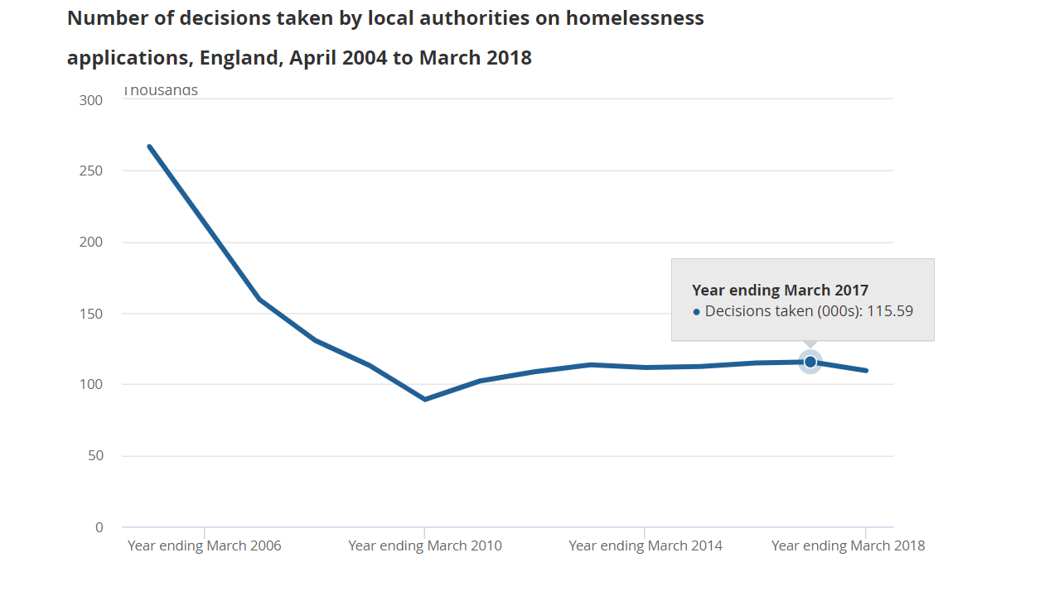
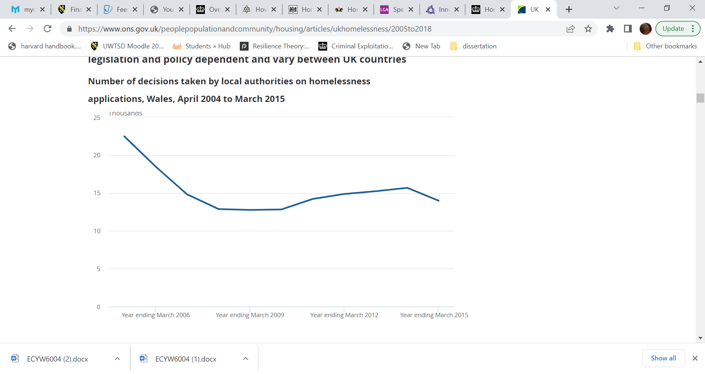

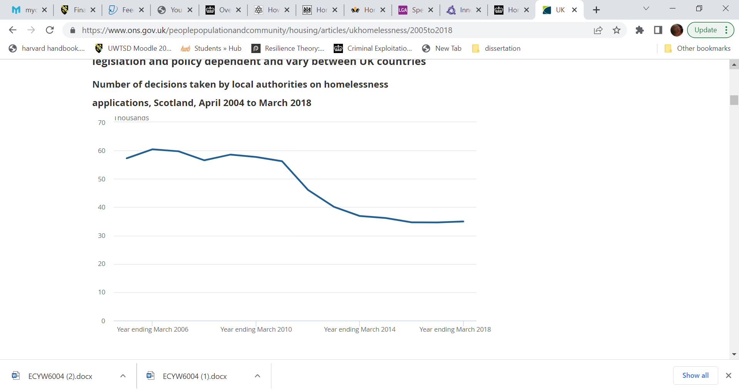

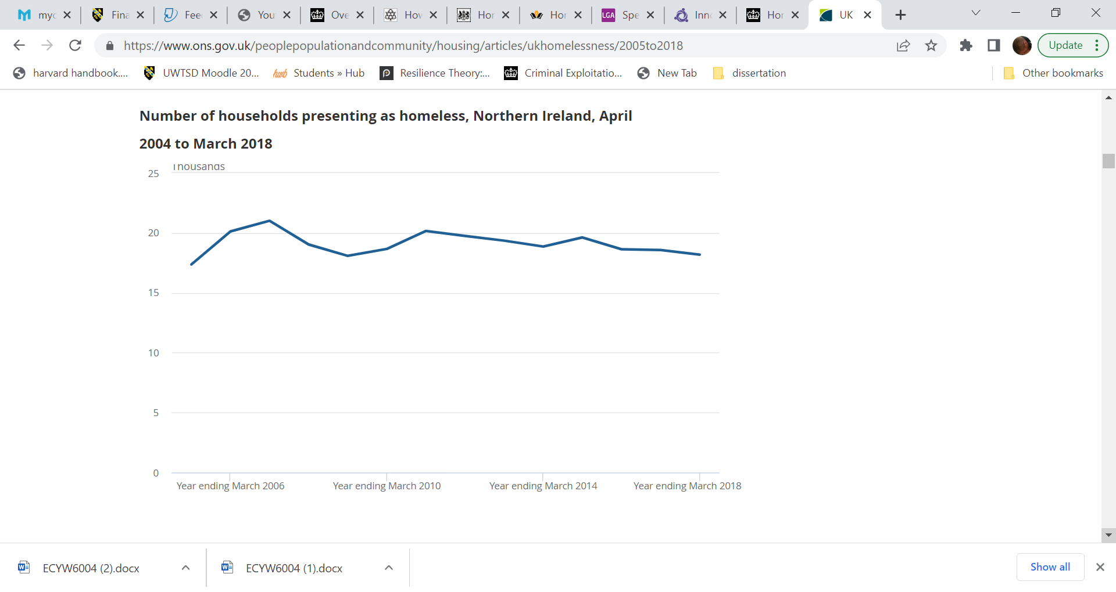

(Office of National Statistics, 2018)
Appendix 2.
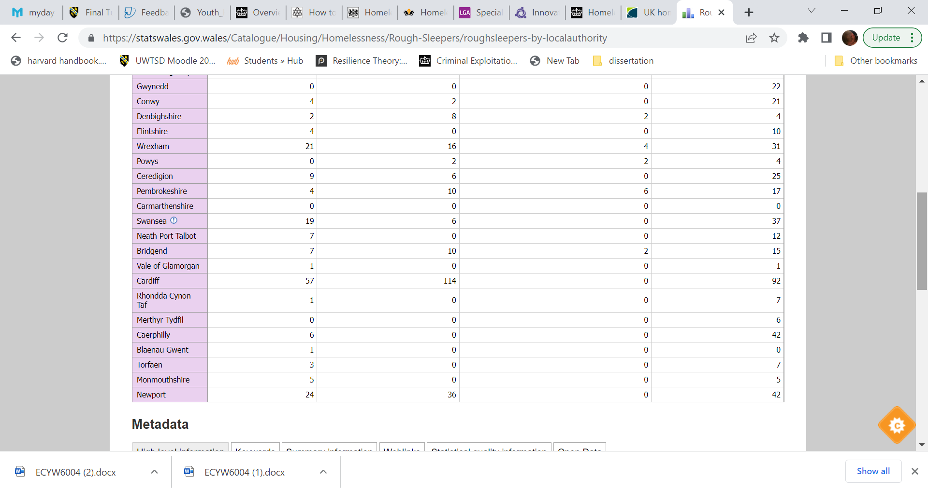
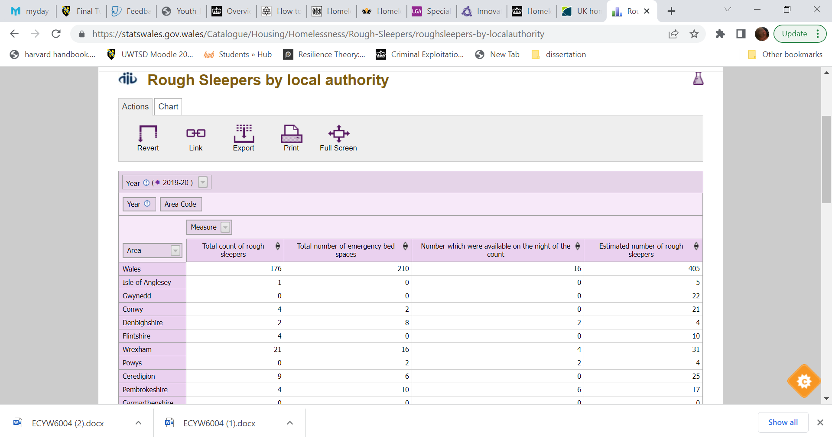
(Welsh Government, 2021).
Appendix 3.
Services The Wallich offer to people in need:
• Shelter for those people with drug misuse issues.
• Dry houses for those who have left rehabilitation and require more support before they return to their property.
• Wet houses for those who wish to embark on harm reduction schemes.
• Accommodation for young homeless people.
(The Wallich, n.d)

Appendix 4.
Family Stress Model
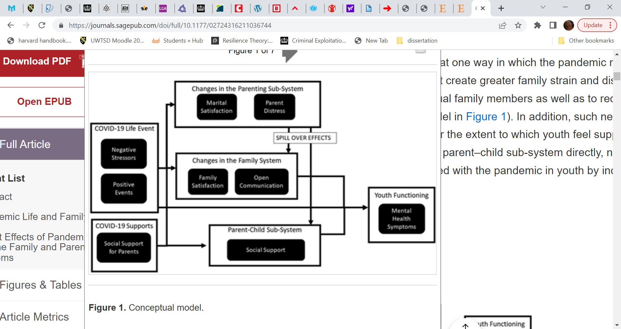
(Price et al., 2016)
Appendix 5.
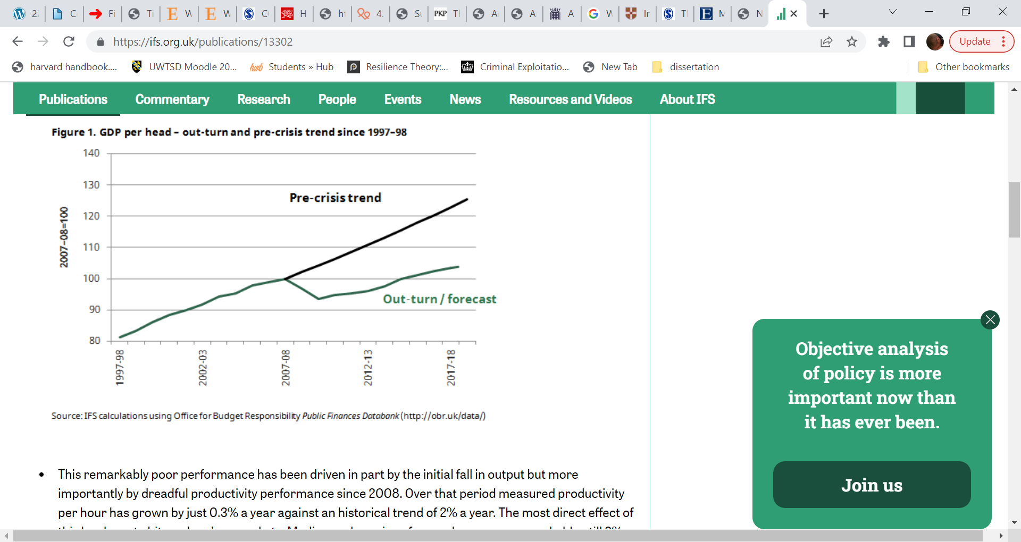
(Institute for Fiscal Studies, 2018, p1).
Appendix 6
UNISONS Findings from the FoI requested using data for 330 local authorities show the human cost of the cutbacks:
- A total of 859 children’s centres and family hubs (which provide support services for babies, young people and families) have been closed, while 940 youth centres have been lost.
- More than a fifth (21%) of public toilets have closed, with more than 835 public highlightconveniences disappearing since the Conservatives came to power.
- The number of council-subsidised bus routes has decreased by almost a third (32%), a reduction of more than 1,224 services, increasing the isolation of many living in rural communities.
- More than one in five (22%) libraries have either closed, been privatised or are now staffed by volunteers. This is a decrease of 738 council-run libraries. Over the past decade there’s been a ten-fold rise in the number run by volunteers, up from 21 to 227.
(UNISON, 2019, n.p).
Appendix 7
The main points highlighted by the Welsh Youth Service Audit.
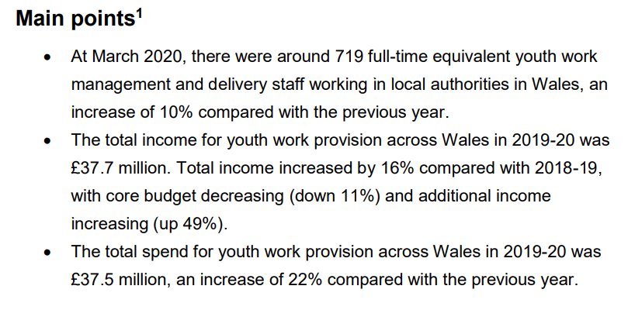
(Welsh Government, 2021, p2).

Appendix 8.
Graphical data relating to young people using the youth provisions in Wales.

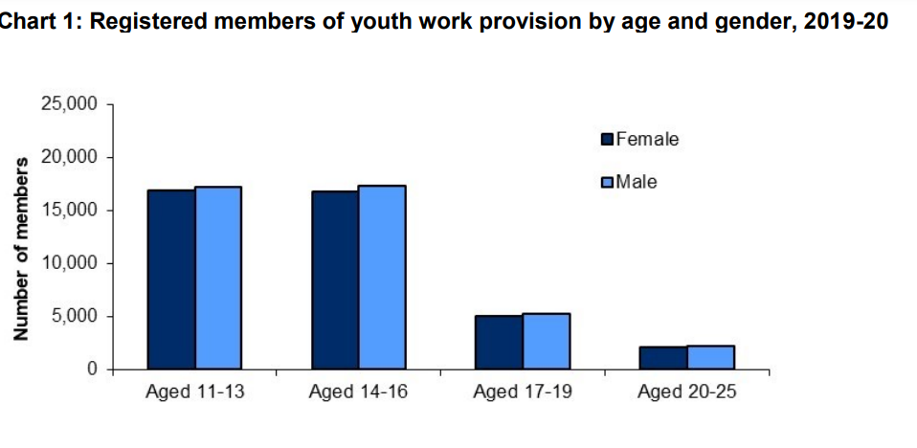
(Welsh Government, 2021).
Appendix 9.
Population of young people by counties in Wales.

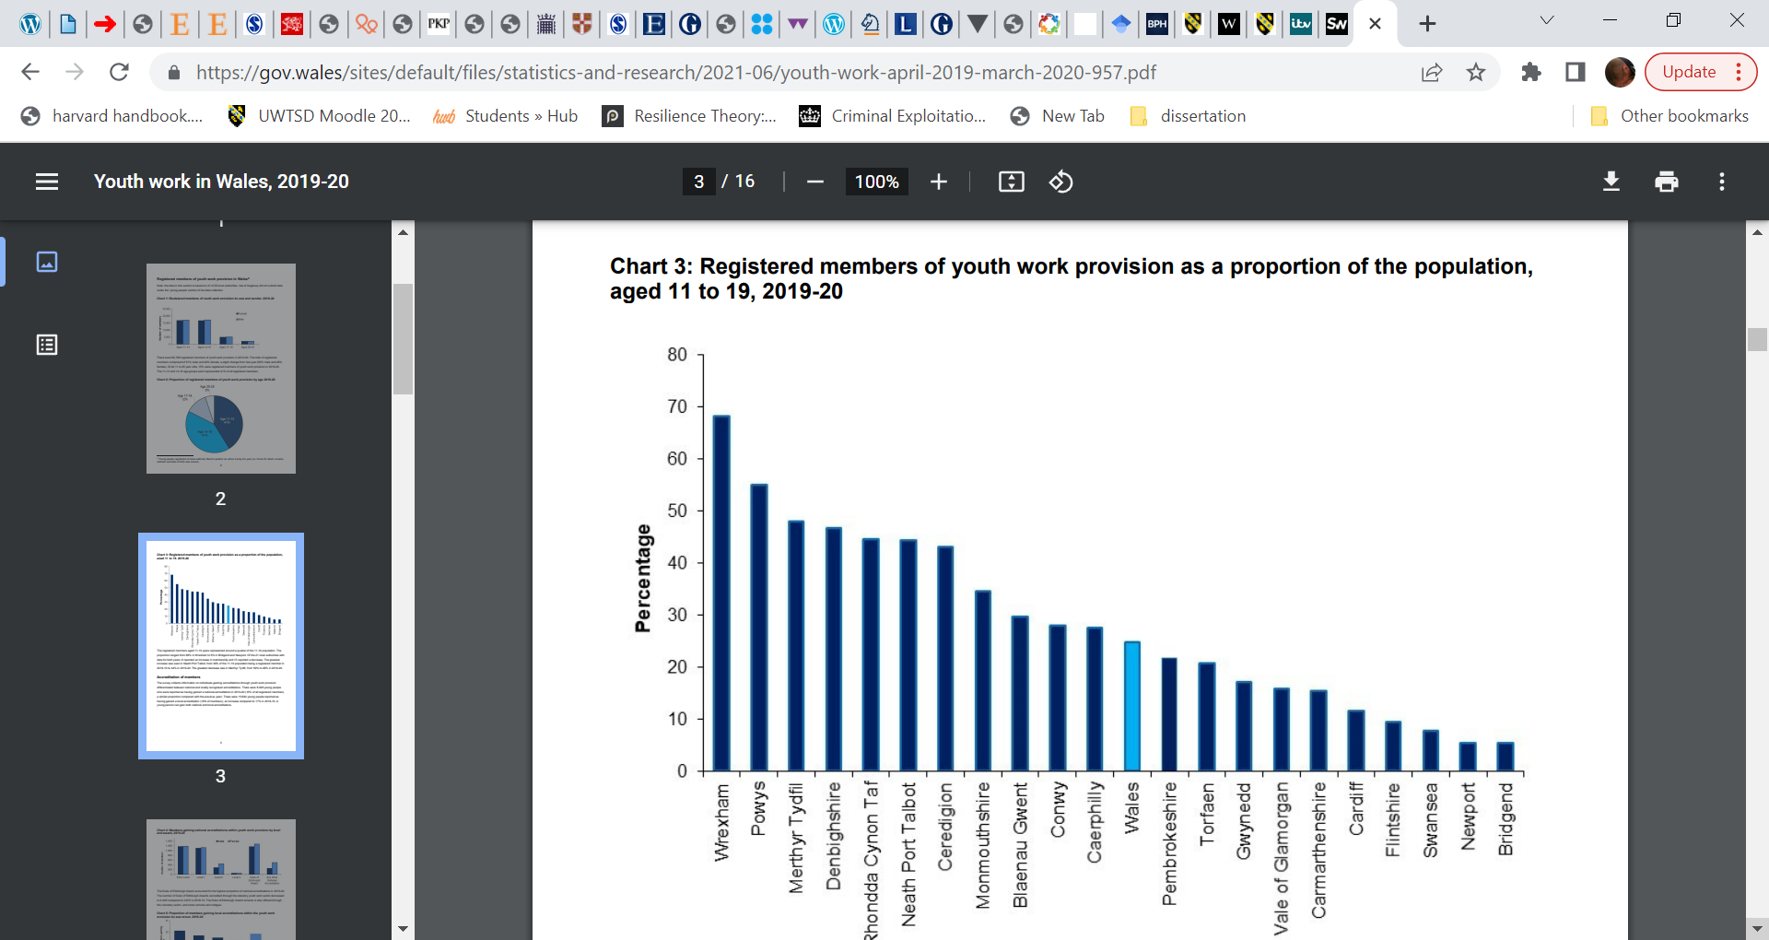

(Welsh Government, 2021).
Appendix 10.
The strategic priorities set out by the HM Government (2011) to improve engagement of those aged 16-25.

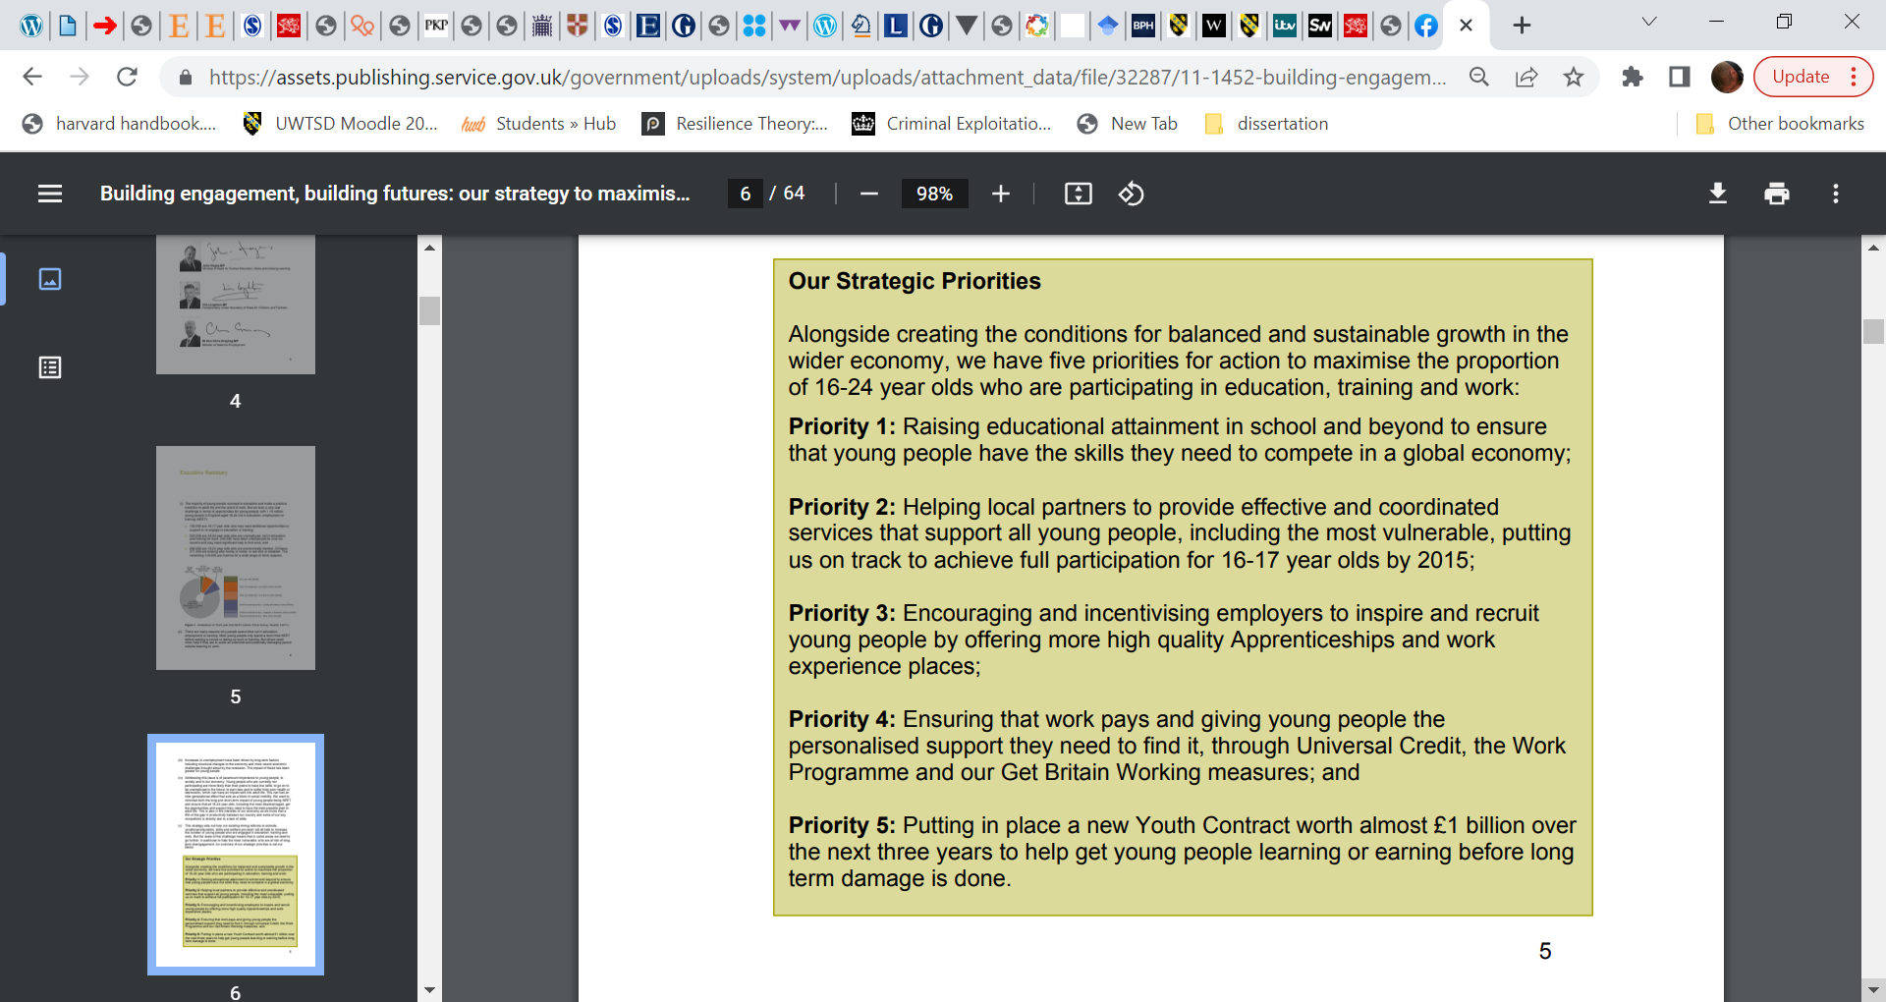
(HM Government, 2011, p3).
Appendix 11.

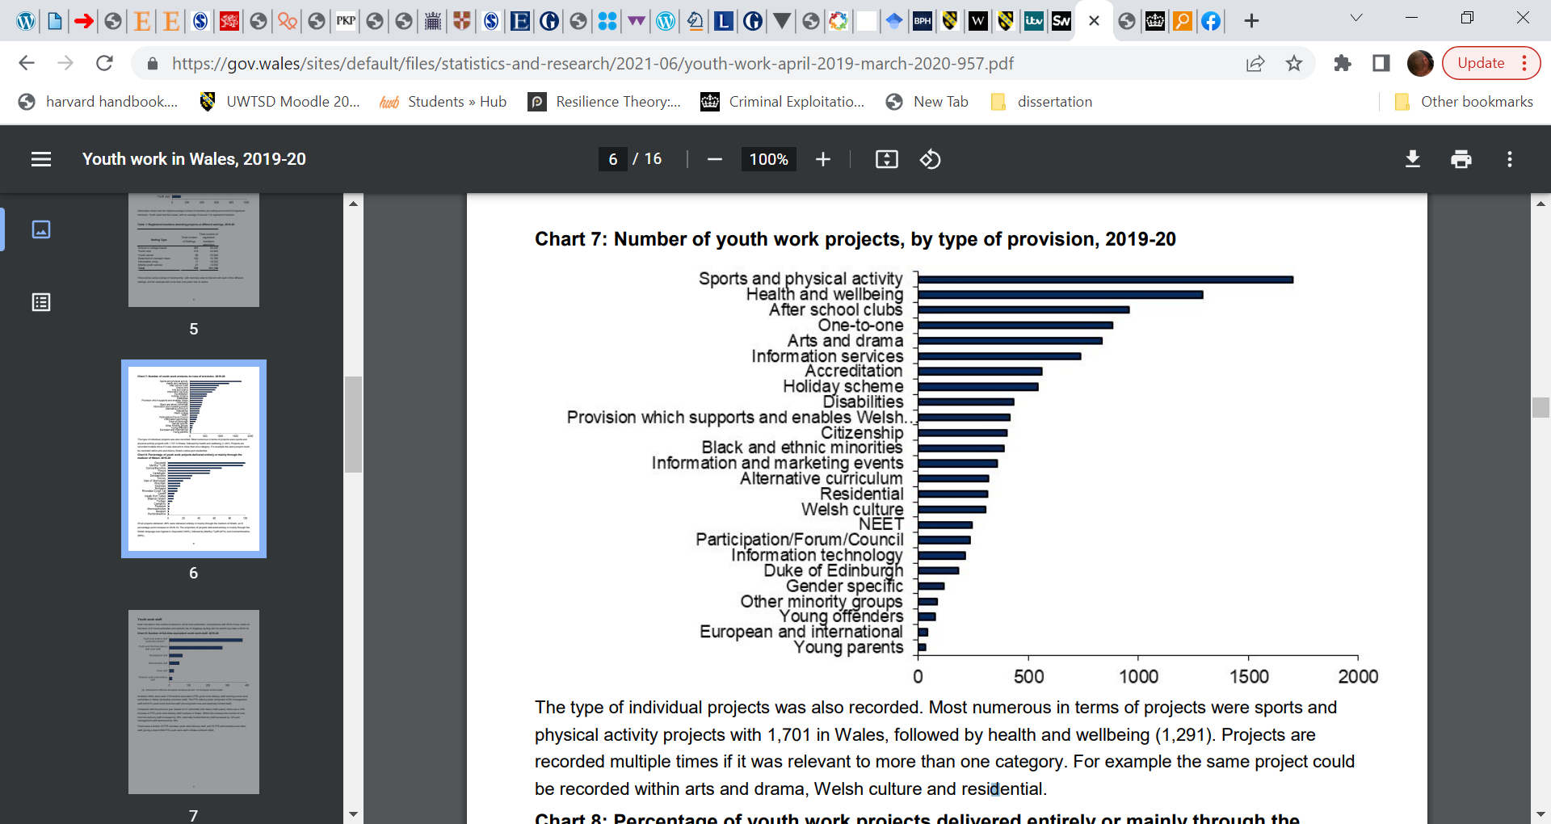

(Welsh Government, 2021).

Appendix 12.
Families First basic objectives.

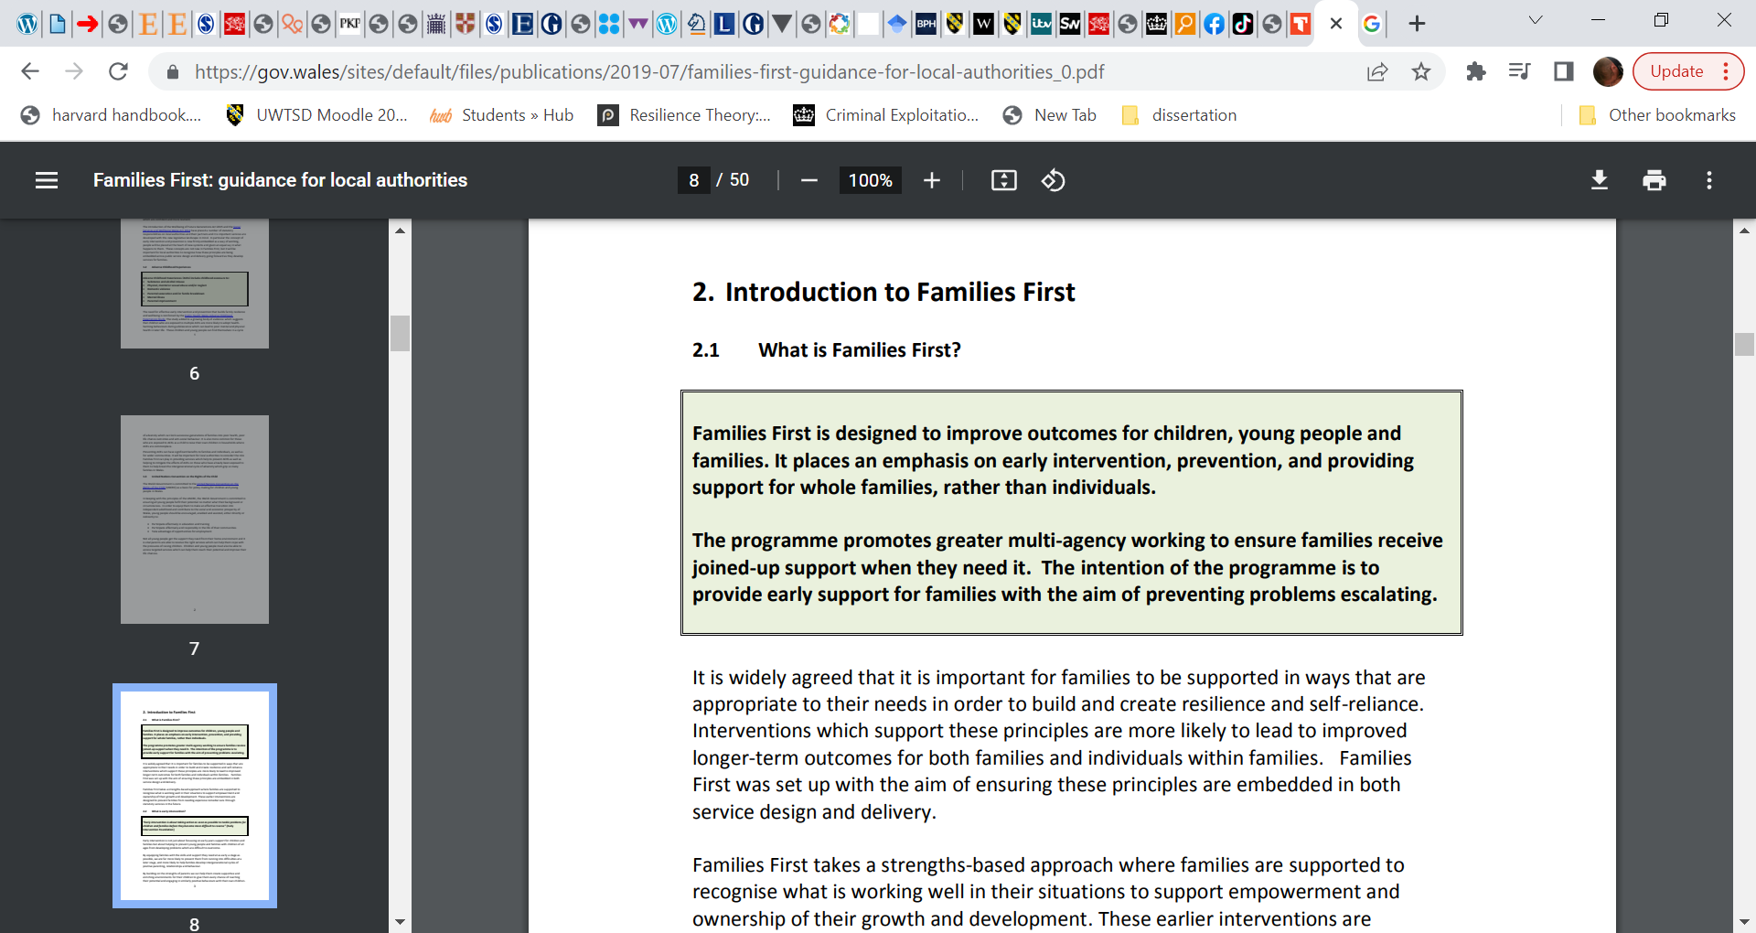(Welsh Government, 2017, p8).
Appendix 13.
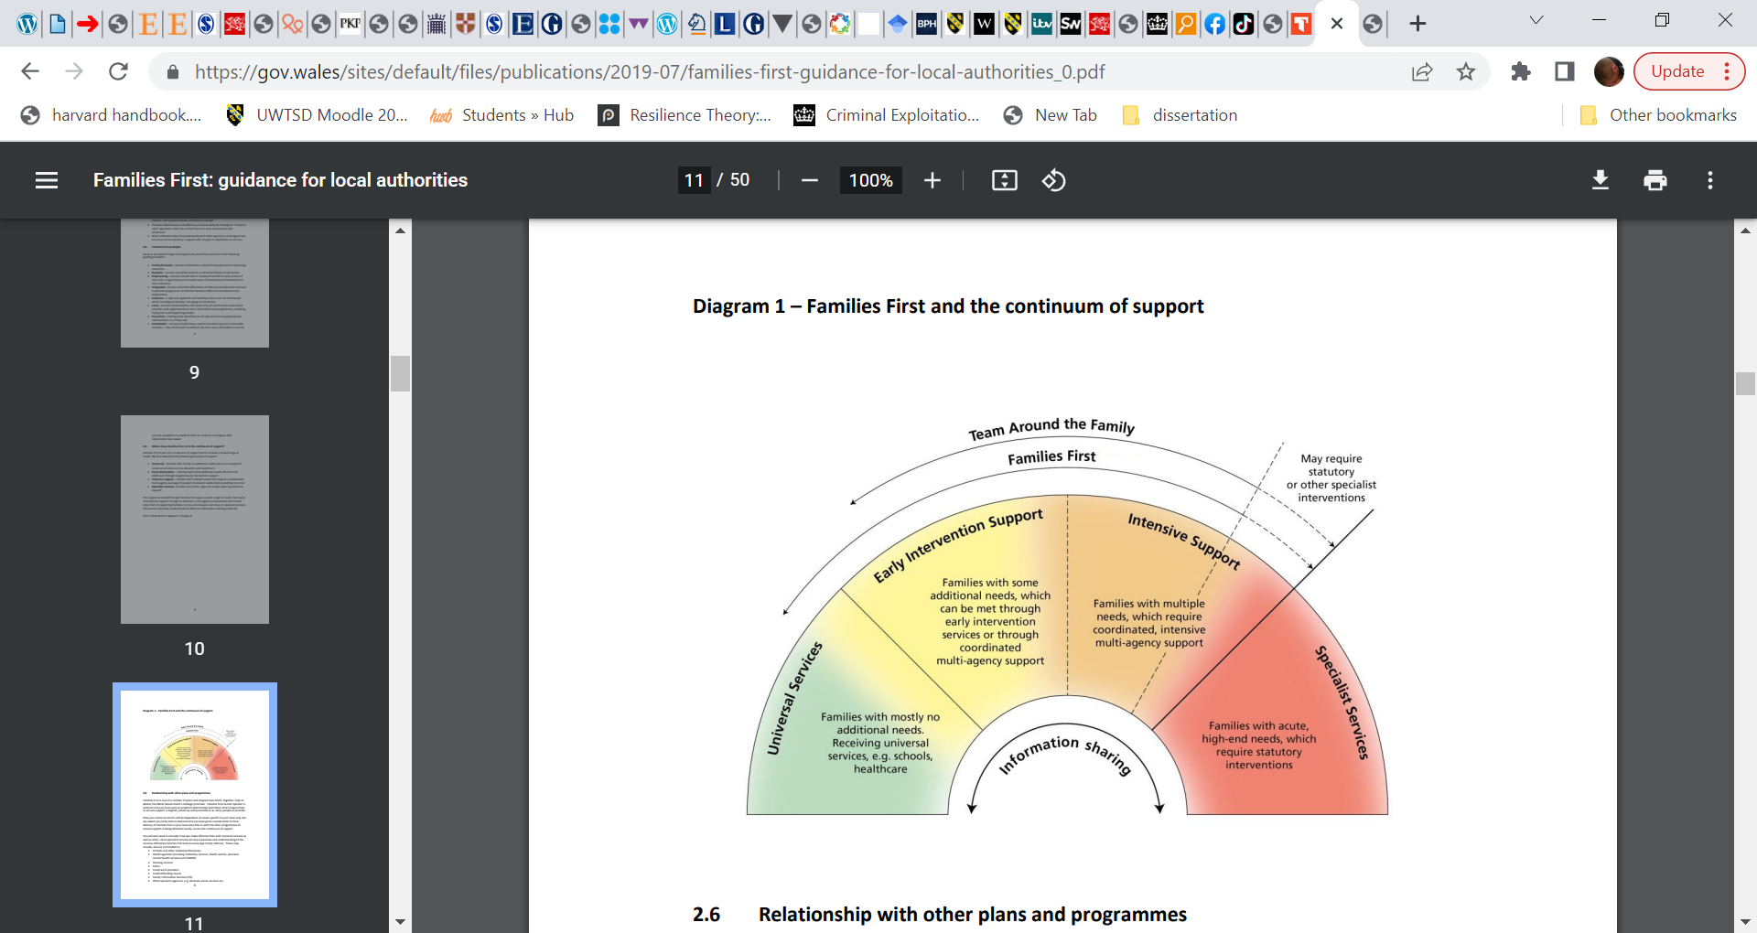
Families First support that all disciplines who work with a family share information to ensure the best outcome for the people they support.

(Welsh Government, 2016, p11).

Appendix 14.
Shelter Cymru data relating to threatened homelessness. Reds show the least successful authorities in Wales.
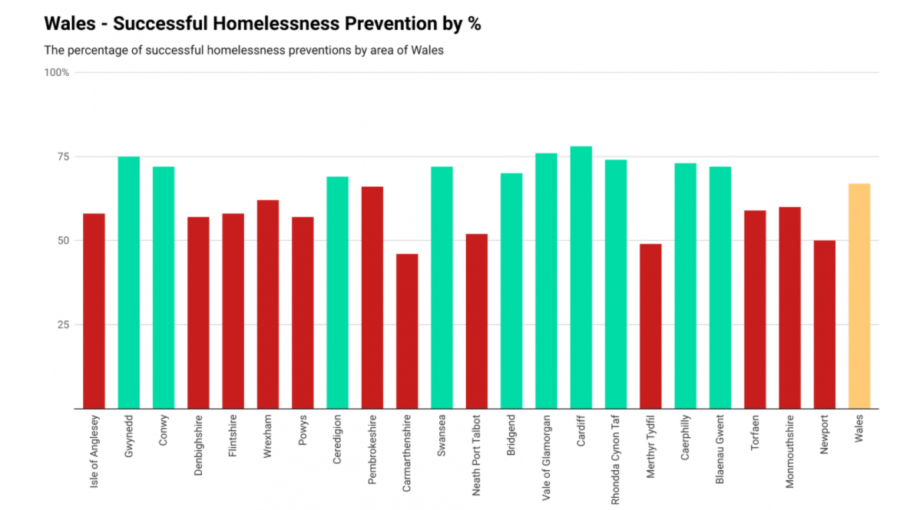
(alt.cardiff, 2021. n.p).
Appendix 15.
Key points highlighted in the MIND’s report on how the Coronavirus impacted the mental health of adults and young people.
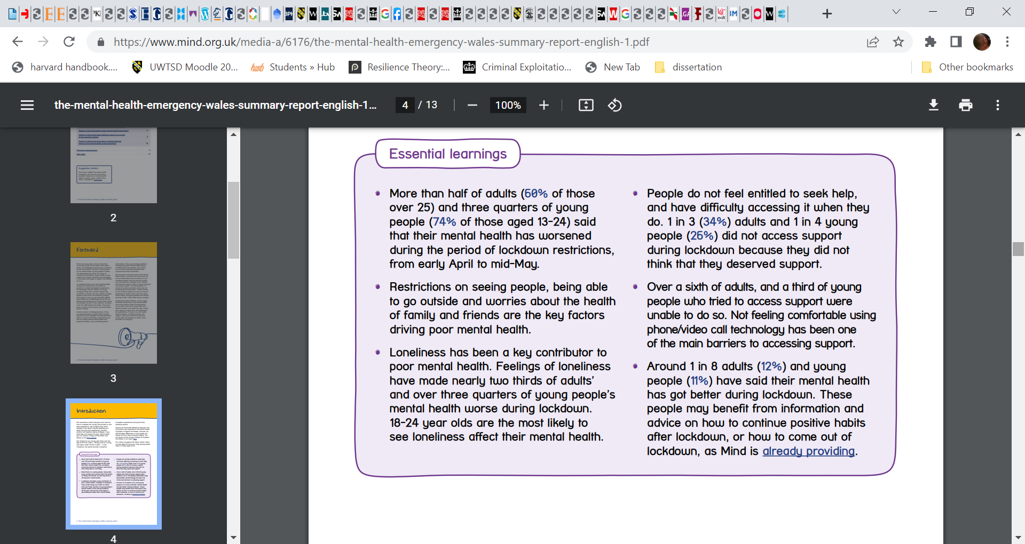
(MIND, 2020, p4).
Appendix 16.
Statistical information of the respondents of the report in Wales.
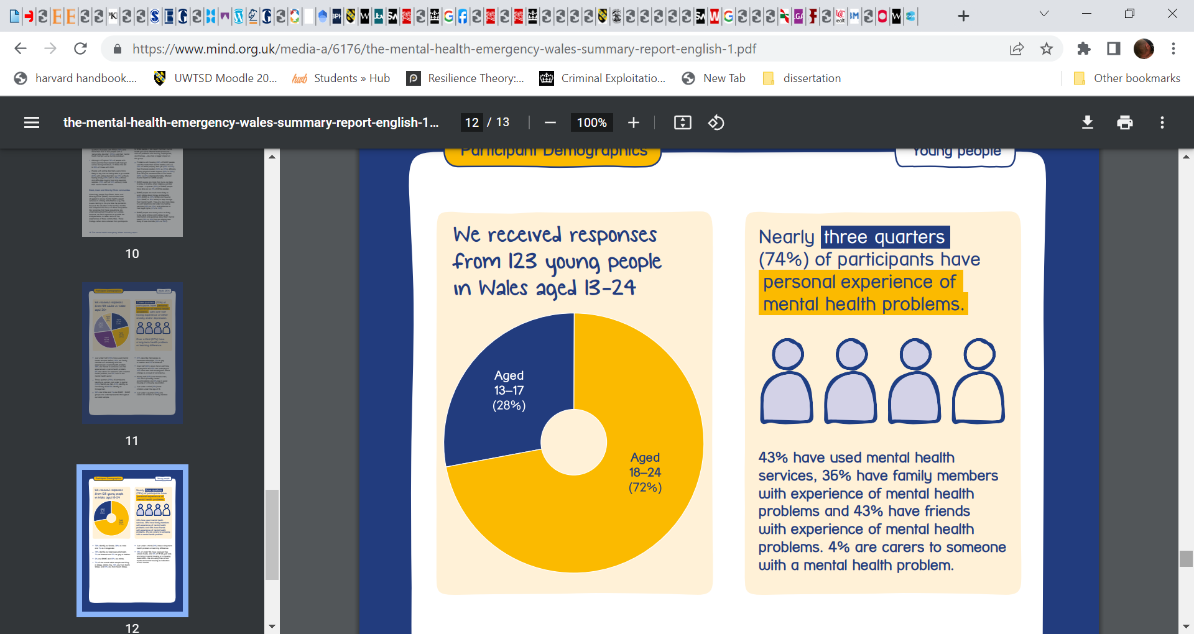
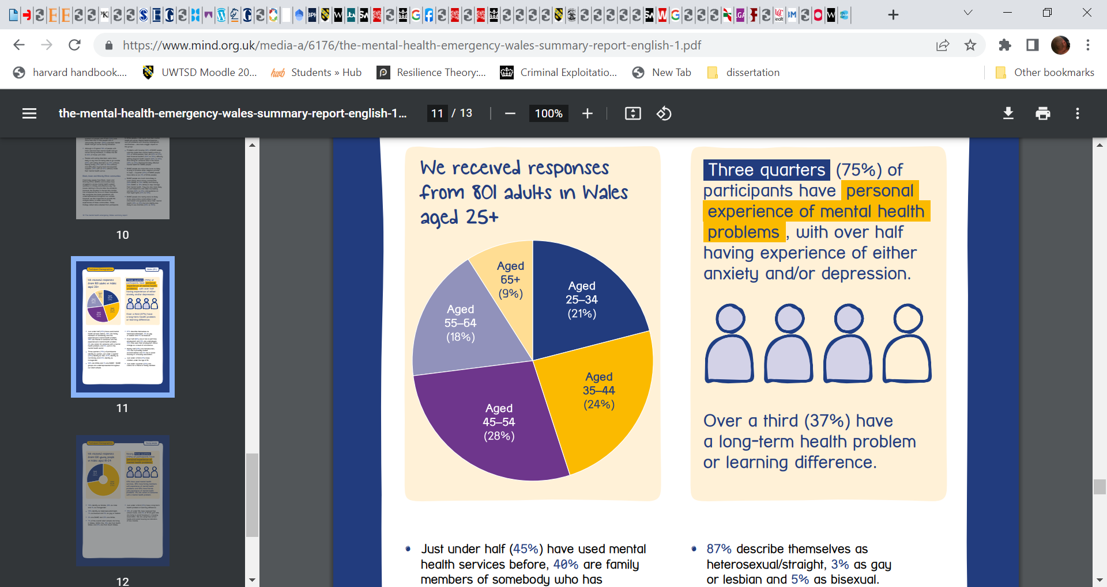
(MIND, 2020, pp10-11).

Appendix 17.
What ACES are and what it can involve.
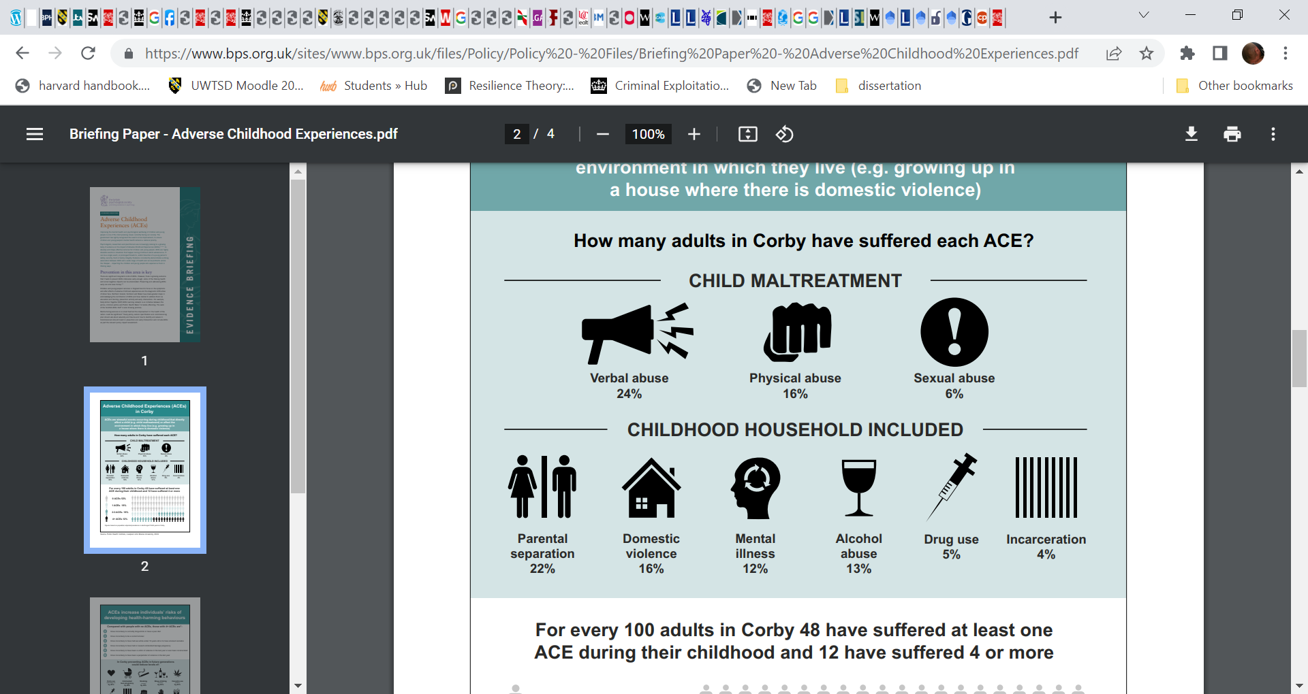
(The British Psychological Society, 2019, n.p).

Appendix 18.
Statistical information regarding the young people’s worries during the Covid 19 pandemic.
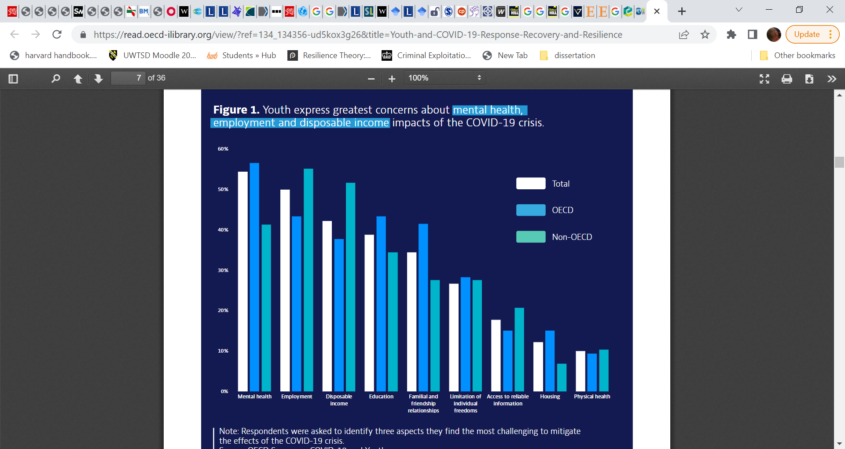
(OECD, 2021, p.7).
Appendix 19.
Statistical breakdown of empty house numbers within Wales.
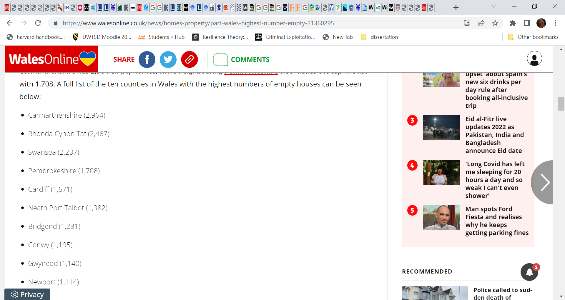
(Harries, 2021, n.p).
Appendix 20.
Link to the The Barnardo’s Care Leavers Accommodation and Support Framework for Wales (2016).

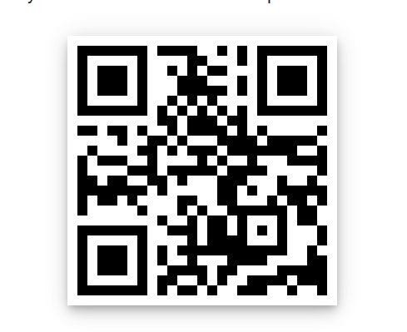
(Barnardo’s, 2016, n.p)

