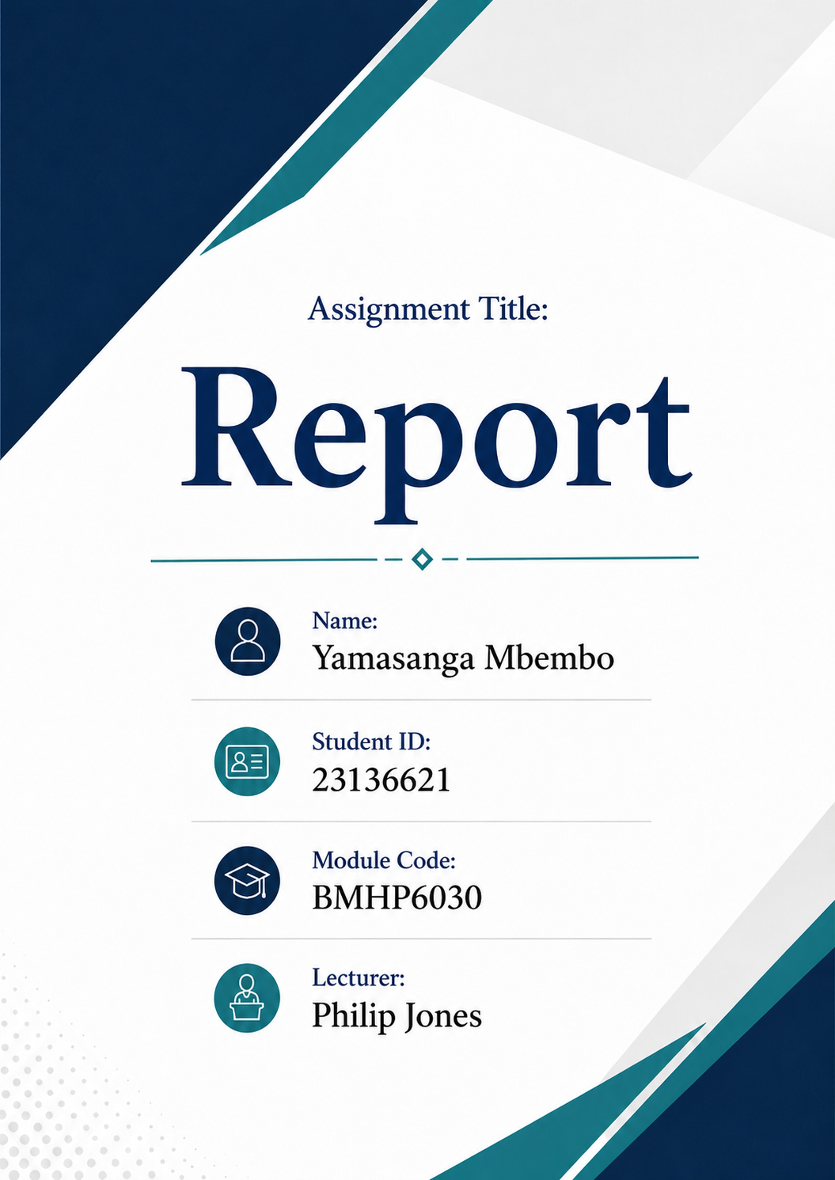
A Critical Analysis of Sustainable Development Goals 3 and 10: Evaluating Health, Wellbeing, and Inequality Initiatives in the United Kingdom

Table of Contents
Introduction 3
2. Sustainable Development Goal 3: Advancing Good Health and Wellbeing 3
2.1 Conceptual Overview and Strategic Objectives of Sustainable Development Goal 3 3
2.2 The Contribution of Sustainable Development Goal 3 to Population Health and Wellbeing 3
2.3 Contemporary Challenges to Achieving Sustainable Development Goal 3 4
3. Sustainable Development Goal 10: Reducing Inequalities to Improve Health Outcomes 5
3.1 Conceptual Overview and Purpose of Sustainable Development Goal 10 5
3.2 The Impact of Social and Economic Inequalities on Health and Wellbeing 5
3.3 The Interrelationship Between Sustainable Development Goals 3 and 10 6
4. Critical Evaluation of National Health, Wellbeing, and Sustainable Development Initiatives 7
4.1 The NHS Long Term Plan 7
4.2 The UK Major Conditions Strategy 7
4.3 Public Health Campaigns 7
5. Critical Evaluation of Local Health and Wellbeing Initiatives 8
6. Recommendations for Strengthening Health, Wellbeing, and Sustainable Development Initiatives 9
7. Conclusion 10
Reference list 11

Introduction
Sustainable development is defined as the development that satisfies the needs of the current generation without endangering the needs of future generations. The United Nations have adopted 17 Sustainable Development Goals (SDGs) in 2015, which aim to solve global social, economic and environmental problems. Of these, SDG 3: Good Health and Wellbeing aims to ensure healthy lives for all and SDG 10: Reduced Inequalities aims to ensure equitable access to opportunities and services (United Nations, 2015). These goals are closely linked, and social inequality has a significant impact on health outcomes. This report explores the role of SDGs 3 and 10 in relation to health and wellbeing and assesses some national and local measures to achieve fair health outcomes.

2. Sustainable Development Goal 3: Advancing Good Health and Wellbeing

2.1 Conceptual Overview and Strategic Objectives of Sustainable Development Goal 3
Sustainable Development Goal (SDG) 3 aims to ensure healthy lives and promote wellbeing at all ages (United Nations, 2015). The goal has been adopted by the United Nations as one of the Sustainable Development Goals, under the 2030 Agenda, acknowledging health as a human right and a precondition for sustainable social and economic development. SDG 3 includes thirteen targets that relate to major global health concerns: reduce maternal and child mortality, end communicable and non-communicable diseases, build resilient health systems, achieve universal health coverage, ensure access to quality essential health services, ensure access to safe, effective, and affordable medicines and vaccines, strengthen health systems against adverse shock and stress, improve mental health, build resilience against non-communicable diseases, end the transmission of HIV, tuberculosis, and malaria, support rehabilitation of health workers, enhance access to health information, and ensure the prevention, detection, and treatment of non-communicable diseases. SDG 3 is the world's most crucial and highly prioritized goal for health equity and prevention of avoidable disease, which requires integration and partnership at the national and international levels (WHO, 2024).

2.2 The Contribution of Sustainable Development Goal 3 to Population Health and Wellbeing
According to the WHO (2024), Sustainable Development Goal 3 aims for improved public health by delivering quality, equitable health care and enhanced primary prevention strategies. Immunisation programmes, early diagnosis and primary healthcare, which provide access to improved services, help to lower death rates and improve life expectancy through the improvement of physical health. It is encouraging that mental health has been incorporated into SDG 3 as mental wellbeing is a key component of health and is increasingly being recognized as a priority for investment in health services and support. Also, the goal focuses on maternal and child health and ensures access to reproductive health services and a decrease in preventable maternal and infant mortality. The burden of communicable and non-communicable diseases can be controlled through preventive healthcare measures such as vaccination programmes, disease screening, and public health campaigns. NHS England (2024) outlined these goals in the United Kingdom, which are supported by the NHS and government health policies through the promotion of healthier living and increased access to health services. Together, these actions enhance the quality of life, decrease health disparities, and help build healthier, more productive communities.

2.3 Contemporary Challenges to Achieving Sustainable Development Goal 3
While there has been significant progress, SDG 3's goals are difficult to reach because of ongoing structural and demographic factors. There are still major disparities in life expectancy and health outcomes between socioeconomically advantaged and disadvantaged communities, fuelled by health inequalities (Marmot, 2020). In the UK, there has been a growing demand for healthcare services, putting significant strain on the health system (the N.H.S), with longer wait times for services. The increasing incidence of mental illness has also heightened the need for specialist services to be able to meet population needs, and these services frequently fail to meet the needs of the population.
The ageing population poses further challenges because older people are at increased risk of having several long-term health conditions that need complex and ongoing health care (ONS, 2023). Labor shortages are also causing a lack of capacity in other healthcare professions, which impacts the ability of health systems to provide timely and high-quality services. Additionally, lifestyle-related diseases like cardiovascular disease, diabetes and obesity are on the rise and require more robust preventive health measures. Long-term funding, implementation of good policy and inter-sector working is needed to tackle these interlinked issues.

3. Sustainable Development Goal 10: Reducing Inequalities to Improve Health Outcomes

3.1 Conceptual Overview and Purpose of Sustainable Development Goal 10
The Sustainable Development Goal (SDG) 10, Reduced Inequalities, aims at reducing inequalities within and among countries by implementing social, economic and political inclusion for all people (Dugarova, 2015). The overall aim is to achieve equality of opportunity irrespective of income, age, gender, disability, ethnic origin or other factors which might be associated with disadvantage. Access to resources and opportunities is closely linked to health outcomes, as seen in SDG 10. There are close linkages between health and SDG 10, as inequalities in access to resources and opportunities can lead to unequal health outcomes. Increasing inequity is thus a prerequisite to meeting the goals of fair, inclusive, and sustainable health systems.
Table 1: Key Objectives of Sustainable Development Goals 3 and 10
Sustainable Development Goal | Primary Objective | Relevance to Health and Wellbeing
SDG 3: Good Health and Wellbeing | Ensure healthy lives and promote wellbeing for all at all ages | Improves healthcare access, disease prevention, mental health, and life expectancy
SDG 10: Reduced Inequalities | Reduce inequalities within and among countries | Promotes equitable access to healthcare, education, employment, and social services, improving overall health outcomes

3.2 The Impact of Social and Economic Inequalities on Health and Wellbeing
Social determinants of health, including many of those determined by inequality, have a major impact on health outcomes (WHO, 2024). People who are poor are more likely to not have healthy eating habits, to lack financial security, to lack access to health care, and so to suffer poor health, chronic illness, and a diminished life expectancy. Educational inequality also plays a part in poorer health, as it reduces health literacy, employment options and understanding of health promotion services (Kickbusch, 2001). Poor housing, such as overcrowding and inadequate housing conditions, is linked to higher rates of infectious illnesses, mental health issues and respiratory disease.
Job status is another important determinant of health. Financial and work insecurity can cause financial strain, stress and poor mental health. In addition, ethnic minority groups and persons with disabilities are frequently subject to unequal treatment, discrimination and barriers to access to health services, which exacerbates existing health disparities (Krahn, Walker and Correa-De-Araujo, 2015). Accessibility of healthcare is an issue, whether because of geographical location, financial or service availability, that prevents many people from timely diagnosis and treatment. The links between these inequalities have been consistently shown in academic research to lead to avoidable variations in health outcomes, thus perpetuating cycles of disadvantage from generation to generation (Marmot, 2020).

3.3 The Interrelationship Between Sustainable Development Goals 3 and 10
SDG 3 and SDG 10 are closely linked as greater equality leads to better health, while better health ensures better participation in education, employment and society. Lowering inequalities in health, quality of education, housing and income contributes to the reduction of inequalities in life expectancy and prevalence of disease among population groups (Di Cesare et al., 2013). In contrast, ill health can exacerbate social and economic disadvantage, through education, employment and financial pressures. Coordinated efforts in a variety of sectors are recognised as a key ingredient to promoting equitable health outcomes by the World Health Organization and UK health policies. Progress on SDG 10 benefits SDG 3 and advances in health and wellbeing benefit the reduction of inequality and sustainable development.

4. Critical Evaluation of National Health, Wellbeing, and Sustainable Development Initiatives

4.1 The NHS Long Term Plan
The NHS Long Term Plan (2019) is a strategic plan for the NHS in England that aims to enhance health care services, focusing on the importance of preventive health, increasing mental health support, improving health and social care integration, and making digital access easier (NHS England, 2024). The plan will contribute to Sustainable Development Goal (SDG) 3 through building universal access to quality healthcare and reducing preventable illness. Improvements have been achieved in the quality of community care, cancer diagnosis and digital healthcare services. But rising patient demand, labour shortages, cost constraints and waiting lists pose a constraint on its effectiveness, especially after the COVID-19 pandemic.

4.2 The UK Major Conditions Strategy
The UK Major Conditions Strategy takes a preventative approach to addressing the major conditions such as cancer, cardiovascular disease, respiratory disease, dementia and mental health. The strategy seeks to optimize long-term health outcomes through earlier intervention and healthy lifestyles, which will minimize burden on health care services (Bauer et al., 2014). It is a holistic strategy that supports SDG 3 goals, though the outcomes will be dependent on ongoing investments, adequate staffing of health workers and coordination among health and social sectors. Failure to address these challenges could result in uneven improvements around the community.

4.3 Public Health Campaigns
National campaigns, including the Better Health Campaign and Smoke Free programmes, are able to encourage weight management, physical activity, healthy eating and smoking cessation to promote healthier lifestyles. All these campaigns have helped raise awareness to reduce smoking rates and thus prevent non-communicable diseases. However, these are not equally effective, as social and economic inequalities can have an impact on people's capacity to engage in healthier behaviours (Marmot, 2020). Lack of financial resources, community resources, and health literacy are still major issues in poorer communities. As such, these efforts can help meet SDG 3 and assist in closing health inequities, but they must be complemented by policies that take a holistic approach to health determinants, including policies that incorporate public health education, if they are to be effective in the long term.
Table 2: Evaluation of National Health Initiatives
Initiative | Main Objective | Key Successes | Key Limitations
NHS Long Term Plan | Improve healthcare quality and preventive care | Expanded mental health services, greater digital healthcare, integrated care | Workforce shortages, waiting lists, funding pressures
UK Major Conditions Strategy | Prevent and manage major chronic diseases | Focus on prevention and early intervention | Implementation depends on funding and workforce capacity
Better Health and Smokefree Campaigns | Encourage healthier lifestyles | Increased public awareness and reduced smoking rates | Unequal impact across deprived communities

5. Critical Evaluation of Local Health and Wellbeing Initiatives
Local health and wellbeing initiatives are an important component of tackling community health needs and helping to achieve the SDGs 3 and 10 (Sacks et al., 2019) objectives. Local Health and Wellbeing Boards bring together local authorities, NHS organisations and public health services to plan and act on the local health priorities and to address health inequalities in the area. Likewise, social prescribing can help health care practitioners to provide community resources, such as exercise programs, community support groups, and volunteering opportunities, for people to help them improve their mental health and mitigate social determinants of health.
These programs have contributed to enhancing the quality and delivery of integrated care, engaging communities and enhancing support for people with complex health and social needs. They are, however, limited due to financial constraints, lack of personnel, growing demand and regional differences in service availability. These can affect equitable access to care, especially in disadvantaged communities. Despite these constraints, local campaigns are vital to the effort of supporting preventive health, enhancing wellbeing and closing the health inequalities (South, 2015). There is a need to increase investment and improve inter-agency working between local authorities and the NHS to ensure they are as effective as they can be in the long term.

6. Recommendations for Strengthening Health, Wellbeing, and Sustainable Development Initiatives
Table 3: Recommendations Linked to Identified Challenges
Identified Challenge | Recommended Action | Expected Outcome
Growing mental health demand | Increase investment in mental health services | Improved access and reduced waiting times
Health inequalities | Target resources towards deprived communities | More equitable health outcomes
Lifestyle related diseases | Strengthen preventive healthcare programmes | Reduced burden of chronic diseases
Limited community support | Expand social prescribing services | Improved wellbeing and reduced pressure on NHS services
Fragmented service delivery | Strengthen collaboration between NHS and local authorities | Better integrated and coordinated care

Increased funding should be allocated to the development of the mental health workforce and services to meet demand and staffing shortages, to ensure National and local initiatives are effective. The preventive healthcare programmes should be promoted to promote a healthier lifestyle and to minimize the long-term burden of chronic diseases. Ensure more targeted funding and greater service availability for healthcare within deprived communities (Atun et al., 2015). Greater integration of social prescribing into primary care to help tackle the social determinants of health. Finally, increased NHS-community organisation and local authority working is needed to address inequalities in health and health outcomes.

7. Conclusion
SDG3 and SDG10 are two of the pillars for enhancing the health of populations and reducing inequalities. Progress towards improving health outcomes through national and local initiatives has been made, but there remain a number of challenges that can hinder their effectiveness. The sustainable and equitable improvements in the health and wellbeing of school-aged children and young people will require continued investment, collaborative working and targeted policies.

Reference list
Atun, R., de Andrade, L.O.M., Almeida, G., Cotlear, D., Dmytraczenko, T., Frenz, P., Garcia, P., Gómez-Dantés, O., Knaul, F.M., Muntaner, C., de Paula, J.B., Rígoli, F., Serrate, P.C.-F. and Wagstaff, A. (2015). Health-system reform and universal health coverage in Latin America. The Lancet, [online] 385(9974), pp.1230–1247. doi:https://doi.org/10.1016/s0140-6736(14)61646-9.
Bauer, U.E., Briss, P.A., Goodman, R.A. and Bowman, B.A. (2014). Prevention of chronic disease in the 21st century: elimination of the leading preventable causes of premature death and disability in the USA. The Lancet, [online] 384(9937), pp.45–52. doi:https://doi.org/10.1016/s0140-6736(14)60648-6.
Di Cesare, M., Khang, Y.-H., Asaria, P., Blakely, T., Cowan, M.J., Farzadfar, F., Guerrero, R., Ikeda, N., Kyobutungi, C., Msyamboza, K.P., Oum, S., Lynch, J.W., Marmot, M.G. and Ezzati, M. (2013). Inequalities in non-communicable diseases and effective responses. The Lancet, [online] 381(9866), pp.585–597. doi:https://doi.org/10.1016/s0140-6736(12)61851-0.
Dugarova, E. (2015). Social inclusion, poverty eradication and the 2030 agenda for sustainable development. [online] www.econstor.eu. Available at: https://www.econstor.eu/handle/10419/148736 [Accessed 30 Jun. 2026].
Kickbusch, I.S. (2001). Health literacy: addressing the health and education divide. Health Promotion International, [online] 16(3), pp.289–297. doi:https://doi.org/10.1093/heapro/16.3.289.
Krahn, G.L., Walker, D.K. and Correa-De-Araujo, R. (2015). Persons with disabilities as an unrecognized health disparity population. American Journal of Public Health, [online] 105(S2), pp.S198–S206. doi:https://doi.org/10.2105/ajph.2014.302182.
Marmot, M. (2020). Health Equity in England: the Marmot Review 10 Years on. British Medical Journal, [online] 368(1). doi:https://doi.org/10.1136/bmj.m693.
NHS England (2024). Social Prescribing. [online] NHS England. Available at: https://www.england.nhs.uk/personalisedcare/social-prescribing/ [Accessed 30 Jun. 2026].
ONS (2023). Office for National Statistics. [online] Ons.gov.uk. Available at: https://www.ons.gov.uk/ [Accessed 30 Jun. 2026].
Sacks, E., Morrow, M., Story, W.T., Shelley, K.D., Shanklin, D., Rahimtoola, M., Rosales, A., Ibe, O. and Sarriot, E. (2019). Beyond the building blocks: integrating community roles into health systems frameworks to achieve health for all. BMJ Global Health, [online] 3(Suppl 3), p.e001384. doi:https://doi.org/10.1136/bmjgh-2018-001384.
South, J. (2015). A guide to community-centred approaches for health and wellbeing. [online] www.gov.uk. Available at: https://eprints.leedsbeckett.ac.uk/id/eprint/1229/ [Accessed 30 Jun. 2026].
United Nations (2015). Transforming our world: The 2030 Agenda for Sustainable Development. [online] United Nations. Available at: https://sdgs.un.org/2030agenda [Accessed 30 Jun. 2026].
WHO (2024). World Health Statistics. [online] www.who.int. Available at: https://www.who.int/data/gho/publications/world-health-statistics [Accessed 30 Jun. 2026].

