
SBMA7123D MBA Dissertation

The Internationalisation of Green Businesses

By Frank Bruce Student No. 1602754
Supervisor Dr Muhammad Mushtaq

14/08/2019

Declaration
This work has not previously been accepted in substance for any degree and is not being concurrently submitted in candidature for any degree.
Signed: Frank G Bruce (candidate) Date: 14/08/2019

Statement 1
This work is the result of my own investigations, except where otherwise stated. Where correction services have been used, the extent and nature of the correction is clearly marked in a footnote(s). Other sources are acknowledged by footnotes giving explicit references. A bibliography is appended.
Signed: Frank G Bruce (candidate) Date: 14/08/2019

Statement 2
I hereby give consent for my work, if accepted, to be available for photocopying and for inter-library loan, and for the title and summary to be made available to outside organisations.
Signed: Frank G Bruce (candidate) Date: 14/08/2019
Acknowledgements
I would like to thank my supervisor, Dr Muhammad Mushtaq, for all the help and support he has given to me, and the department at UWTSD for the most helpful online materials.
I would also like to thank all of the businesses involved for their time and for being most helpful in answering my questions, and not least my mother for her proof reading!

Abstract
The aim of this study was to investigate the key factors for the internationalisation of aspiring businesses with an ethical/ organic/ green focus. With this is mind objectives were set to explore the nature of internationalisation and green businesses to arrive at definitions.

This was an area of personal interest for the researcher, who has experience in a green business, and shares a commitment to environmental and ethical causes. In a rapidly changing business world of global opportunity, ethical and green issues are rapidly come to the fore. This created a new opportunity for research bringing together different disciplines.

In a review of the literature, economic and process models of internationalisation were considered as well as increasingly important broader factors, the role of networks and entrepreneurial qualities. Research specifically in green businesses was found to be in its infancy, so an exploratory approach was taken.

The research was undertaken using the methodology of semi-structured interviews. A sample of 10 different businesses was taken, consisting of different sizes and types of enterprise, at different stages of internationalisation, all with some form of green/ ethical focus. An interpretivist rationale was applied.

The results consider the factors which most influenced green businesses to internationalise and consider whether green businesses are distinct in their approach to internationalisation. Entrepreneurial drive twinned with eco-commitment; strong network links with similar ethical values; gain green certifications to differentiate and add value to a product; targeted forms of publicity to discerning customers and strong financial backing are identified as key factors.

Finally, issues are flagged for as a focus for further research, such as testing these conclusions with a larger sample and against a control group to validate results.

List of Figures
Figure 1: Vernon’s Product Life Cycle 22
Figure 2: Dunning’s Eclectic Paradigm 24
Figure 3: The Uppsala-Model 26
Figure 4: The revised Uppsala-Model 26
Figure 5: Uppsala, further revised to take into account modern developments 28
Figure 6: The Role of Networks in the Internationalization Process 30
Figure 7: Firm and Market internationalising degrees 30
Figure 8: The internationalisation process in the international entrepreneurship 32
Figure 9: International New Ventures (INVs) market focus 35
Figure 10: Influences on the Green Entrepreneur 39
Figure 11: Table to show range of businesses covered in this research 54
Figure 12 Business size, years exporting and relative importance of exports 55
Figure 13: International operations of companies in this research 56
Figure 14: High income countries based on nominal GDP per person 56
Figure 15: Application of Dunning’s eclectic paradigm 60
Figure 16: Businesses rated according to Uppsala stages 62
Figure 17 Networking links used by the green businesses in this research 70
Figure 18: Internationalisation through networks, adapted 74
Figure 19: Entrepreneurship qualities mentioned in interviews 77
Figure 20: Summary of the green mission of each business 79
Figure 21: Comparison of this sample with GEM data for 2018 82
Figure 22: Regulations, certifications and Memberships 86
Figure 23: Quotations about perceptions of differences in internationalisation 89

List of Abbreviations
BREXIT - Britain’s exit from the European Union (EU)
CAGE - Cultural, Administrative, Geographic and Economic differences
CEBR - Centre for Economics and Business Research
CEO - Chief Executive Officer
CSR - Corporate Social Responsibility
EI - Environmental Innovation
EC - European Commission
EXPO - Exposition, large-scale public exhibition
FDI - Foreign Direct Investment
GDP - Gross Domestic Product
GEM - Global Entrepreneurship Monitor
INVs - International New Ventures
IPO - Initial Public Offering of shares
KIC - Knowledge and Innovation Community
LGBT - Lesbian, gay, bisexual and transgender
MNEs - Multi National Enterprises
NCCSI - Network-Centric, Complex-Systems Internationalization models
NTB - Non-tariff barrier
OECD - Organisation for Economic Co-operation and Development
OLI - Ownership, Location and Internalisation advantages
SMEs - Small and Medium sized Enterprises
TEA - Early stage entrepreneurial activity
UK - United Kingdom
UKTI - United Kingdom Trade and Investment government department
UN - United Nations
USA - United States of America
WFTO - World Fair Trade Organisation
Contents
Abstract 4
List of Figures 6
List of Abbreviations 7
- Introduction 12
1.1 Background to subject area 12
1.2 Research question aims and objectives 12
- Literature review 16
2.1 Definitions: Internationalisation 16
2.2 Definitions: Green businesses 18
2.3 Vernon’s product lifecycle 21
2.4 Dunning’s eclectic paradigm 24
2.5 Uppsala Internationalisation model 25
2.6 Internationalisation through networks 29
2.7 Entrepreneurial and managerial motivation 31
2.8 Born Globals 34
2.9 Green businesses 36
2.10 Conclusion 40
- Research approach and methodology 42
3.1 Research rationale: Interpretivist 42
3.2 Primary research question 43
3.3 Exploratory approach 44
3.4 Qualitative methodology 45
3.5 Sampling framework selection and size 48
3.6 Data analysis and technique 49
3.7 Ethics, reliability, validity and limitations 50
- Analysis of results 53
4.1 Range of businesses covered 53
4.2 Inconsistency with Vernon 57
4.3 Application of Dunning’s eclectic paradigm 58
4.4 Uppsala and Psychic distance 61
4.5 Financial Considerations 64
4.6 Networks and green internationalisation 67
4.6.1 Networks: Opportunity Creation 67
4.6.2 Networks: Commitment decisions 67
4.6.3 Opportunity Development 69
4.6.4 Distribution Networks 71
4.6.5 Cooperative Networks 73
4.6.6 Networks and the degree of Internationalisation 73
4.7 Entrepreneurship Qualities 77
4.7.1 Business opportunity 77
4.7.2 Necessity entrepreneurship 78
4.7.3 Green opportunity 79
4.7.4 Green motivations 80
4.8 Born Globals 81
4.9 Green business approaches 83
4.9.1 Types of green businesses 83
4.9.2 Green certifications 85
4.10 Extent of difference 89

- Conclusions and recommendations 91
5.1 The nature of internationalisation 91
5.2 Defining green businesses 92
5.3 Factors which most influence internationalisation 93
5.4 Are green businesses distinct? 94
5.5 Flagging factors for further research 95

References 97
Appendixes 104

Appendix 1. Interview questions 104
Appendix 2: Interview transcripts 105

- Introduction
1.1 Background to subject area
Internationalisation is increasingly important for businesses, to take advantage of the opportunities of globalisation, and to gain customers in new markets. It has the potential to boost balance sheets and reward investors; drive economic growth and promote innovation. However, according to an analysis by the Centre for Economics and Business Research (CEBR), the UK lags behind the European average in exporting. Only 5% of Small and Medium sized Enterprises (SMEs), key drivers of growth, have even considered exporting (CEBR, 2016).

As the world moves to address climate change, interest grows amongst governments and consumers, and the potential for businesses with a particular green focus is expanding (Kidwai, 2017). The EC set up a project, Greeneconet, to improve knowledge of the issues. This recognised that business and innovation are essential in finding solutions (Revilla, 2015). Internationalisation is rejuvenating Europe’s industrial base, increasing competitiveness and addressing global environmental concerns by taking action to reducing emissions.

In the context of the UK’s relationship with Europe, the UK government launched an export strategy which set ambitious targets and promoted a green taskforce to meet international climate obligations (UK Government, 2018). The Welsh Assembly convened an International Green Growth Forum in Cardiff in 2016, to promote business growth with both a green and an international emphasis (International Green Growth Forum, 2016). It called for businesses to achieve “green competitiveness.”

Historically, academic research into internationalisation began with the assumption that large companies mastered their home market first, then went through stages of internationalisation. Models were developed by studying Multi National Enterprises (MNEs) based in developed, western countries, in the second half of the twentieth century. Some models focused on economic factors, such as Dunning’s eclectic paradigm. Others viewed internationalisation as a staged process, such as the Uppsala model.

By the turn of the millennium, some businesses simply exported; others set up production overseas; and other companies entered partnerships or contracted agents, making the field of research increasingly complex. Technology enabled entrepreneurs to quickly expand their businesses into overseas markets, using risk-taking skill to manage uncertainty. Some made their start-ups into international ventures within their first two years. Recent research highlights the importance of market knowledge. Johanson and Mattsson (1988) emphasised building up networks providing the knowledge needed to find the right partners and choose a form of market entry.

This research brings together interest in two domains often seen from very different perspectives: business management and environmental sustainability. It seeks to address a gap in knowledge about factors for internationalisation specifically for green businesses in the UK. Better understanding will help inform decision making, encourage wider take up of internationalisation and facilitate successful entry into new markets. It also provides an inspiration to creating a cleaner, more prosperous world. In the words of Ban Ki Moon, United Nations (UN) Secretary General (UN, 2013): "We cannot achieve a more equitable, prosperous and sustainable future without business engagement and solutions."

1.2 Research question aims and objectives
The purpose of this study is to gain a better understanding of the internationalisation process for green businesses. Consideration will be given to existing models and factors for internationalisation and how far these validate the experience of businesses with a green focus at different stages of expansion into foreign markets. The research title is designed to be open to encourage an exploratory approach and the objectives are similarly broad.

Research question: What are the key factors for the internationalisation of aspiring businesses with an ethical/ organic/ green focus?

Objectives
- Explore the nature of internationalisation, including theories about processes which may take place, and significant considerations for businesses
- Define green businesses according to their ethical/ green/ organic features and the extent to which they have internationalised
- Determine the factors which most influence businesses with an organic/ ethical/green product focus to internationalise
- Suggest whether green businesses are distinct in their approach to internationalisation
- Flag factors for the success of green businesses when internationalising, as well as those which may be especially problematic, as a focus for further research

The strategy for addressing these begins with a literature review of relevant research in chapter 2. The rationale and procedure for exploratory research will be set out in chapter 3. The results of the interviews conducted will be processed, presented and analysed in chapter 4, before arriving at conclusions and recommendations in chapter 5. This final section will inform the reader how far the objectives have been fulfilled, what patterns can be positively identified in the internationalisation of green businesses and which priorities should be raised for future research.

- Literature review
In the first two sections, the range and scope of the terms ‘internationalisation’ and ‘green businesses’ is considered. Various definitions are explored in the current context.

2.1 Definitions: Internationalisation
A business which has some form of presence in more than one country may be called international. Rialp and Rialp (2001) define internationalisation as: “the growing involvement of a firm in a variety of operations of international character” (Rialp & Rialp, 2001, p. 50). Nowadays different businesses produce a diverse range of products and services, sold in a variety of different markets, spread across more than one country. The organisation of businesses includes multiple aspects: from strategic planning to marketing to logistical cross border operations.

Researchers used to view internationalisation as the preserve of larger companies. Only larger companies were thought to have the capacity to set up operations in foreign markets, whereas smaller concerns were thought naturally to find a place in their local, home market. Various theories and models were developed, many of which viewed internationalisation as a step by step process in which a company would follow through one stage to the next in linear fashion (Johanson & Wiedersheim-Paul, 1975).

Internationalisation may be seen as a type of strategy, planned and integrated with the central aims of a business (Karami, 2007). If general business strategy includes organisational targets, product development, functional management and making decisions about product specialisation or diversification, then internationalisation has an effect on all of these aspects. An internationalisation strategy may follow a staged plan or process model; or may follow perceived economic advantages. These two different approaches have formed the basis of research into internationalisation (Anderson, 2000).

Modern technology, the internet, improvements in transport and increasing change in the world of business have put internationalisation within reach of even the smallest and newest firms today (OECD, 2009). “Globalisation both compels and facilitates companies to pursue cross border activities and international expansion” (Cavusgil et al., 2015 p. 5). SMEs are now significant players in both local and foreign markets, with some new companies being set up as international enterprises from the beginning, referred to as ‘born-globals’.

Dereksy introduces proactive and reactive motivations within her definition of internationalisation:
“The process by which a firm gradually changes in response to the imperatives of international competition, domestic market saturation, desire for expansion, new markets, and diversification” (Deresky, 2017, p.487).
Bartlett and Beamish (2018) identify personal desires of an entrepreneur or Chief Executive Officer (CEO), opportunism, and planned and structured approaches. A firm may positively desire economies of scale, better manage trade barriers and regulations, secure access to key supplies and achieve lower costs of production (such as by paying workers less) by internationalising. If a firm has a unique product or expertise, such as in marketing, they may use this competitive advantage in a new foreign market, effectively keeping out the competition (Albaum, Strandskov and Duerr, 1998).

Internationalisation may be viewed as a process of acquiring knowledge and managing the risks of operating internationally. Knowledge underlies the practical logistics of setting up across borders; language, laws and business custom. Knowledge is crucial to making the right strategic decisions to gain competitive advantage in a specific foreign market (Eriksson et al., 1997). Individuals in decision making positions also need to manage the risks and uncertainties of expanding internationally (OECD, 2009). Taking risks to enter new markets and managing new situations are crucial factors in the process of internationalisation.

2.2 Definitions: Green businesses
What are ‘green’ businesses? A narrow definition is businesses which produce products such as organic food or renewable energy generators, which are directly supporting environmental issues. According to Tom Delay, Chief Executive of The Carbon Trust:
“Cutting carbon in the supply chain is the next critical stage in the business contribution to reduce carbon emissions to tackle climate change and, represents a significant commercial opportunity” (The Carbon Trust, 2006).
A broader definition is any business which has committed to corporate responsibility regarding green issues: “a green business requires a balanced commitment to profitability, sustainability and humanity” (Makower and Pyke, 2009). A business with an environmentally friendly ethos might source components which are not the cheapest, but are compatible with a green ethos. Additional cost is recouped through the value gained to the brand image by being green (Sommer, 2012).

Green businesses are efficient users of resources: power, fuel and transport, to cut carbon emissions. Green interests and general good business practices overlap, as efficiency may create competitive advantage. Indeed, green businesses are some of the best financial performers (Park and Ahn, 2012). However, the interaction between traditional business models and green focused business models is complex and sometimes conflicts (Sommer, 2012). Efficiency should not come at the expense of the environment.

Green businesses could be green in one or more aspect, or run according to a broadly encompassing green model. Henriksen et al arrived at the following definition:
“Green business model innovation is when a business changes part(s) of its business model and thereby both captures economic value and reduces the ecological footprint in a life-cycle perspective.” (Henriksen et al., 2012)
Green business involves the meeting of two different academic areas of consideration: business modelling, usually the concern of schools of business; and environmental studies, usually the consideration of scientific researchers.

Green businesses are ‘sustainable’. This was defined in the Brundtland report:
“Humanity has the ability to make development sustainable – to ensure that it meets the needs of the present without compromising the ability of future generations to meet their own needs” (WCED, 1987).
Another definition of sustainable development is “ensuring better quality of life for everyone, now and for generations to come” (DEFRA, 2005). Businesses usually report on their financial bottom line, their profits. The ‘triple bottom line’ was developed for businesses and organisations to give equal weight to reporting environment and social concerns too (Sommer, 2012). However, whilst businesses now liberally use language of sustainability, it is not always easy to judge how far a company really is green in its operations.

Some suggest that all businesses ought to be green. There is increasing awareness of climate change and the importance of finding solutions to this. Inter-governmental conferences search for solutions and propose targets and regulations for reducing emissions. The UK’s environment minister at the time, David Miliband commented:
“In the future, every industry should be an environmental industry. In a world where energy and carbon emissions are constrained, every business must take resource productivity seriously.” (Miliband, 2006)

What used to be seen as a burden, regulation is increasingly seen as an opportunity (Esty and Winston, 2009). New green products provide solutions to environmental problems. Regulators look to businesses as partners. Companies increasingly advertise their green and sustainable credentials. Consumers purchase green products not simply for the value they receive in their hands but also for the value gained to their moral conscience. Businesses which enthuse green and ethical values may attract like-minded staff and retain talented millennial employees. They may voluntarily adopt standards or guidelines proposed by green groups, working in collaboration with green organisations, governments and regulators. Corporate Social Responsibility (CSR) may adopt a green tinge.

2.3 Vernon’s product lifecycle
Consideration will now be given to research into models of internationalisation and to what extent, they might be relevant to green businesses.

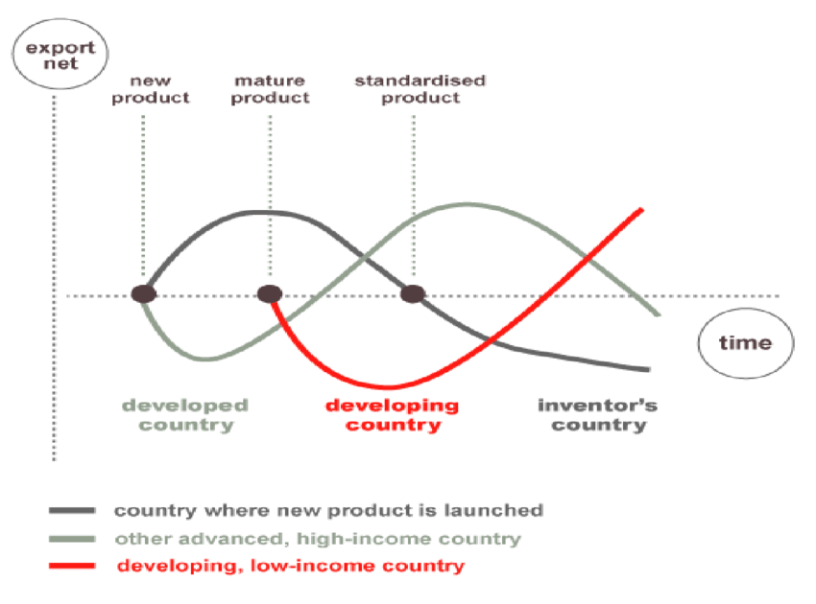
Figure 1: Vernon’s Product Life Cycle (Source: Vernon, 1966)

Vernon developed a model in response to his research into patterns of international trade (Vernon, 1966). A product begins life in the home market, requiring much advertising to raise awareness amongst potential customers. Due to its newness, sales and profits will be low, but there will be an absence of competitors. As sales grow, production increases, efficiencies are gained and profits increase. The product becomes mature, sells well but sales increases level off and profits begin to decrease as competitors grow. Eventually sales reach saturation and decline, facing stiff competition, to a point where eventually the product becomes uneconomic to manufacture. When sales reach maturity in the home market, a company can begin to export to similar markets. Overseas production may be considered. As the product life cycle progresses overseas production may increase to supply new and different markets in developing countries and exporting products back to the home country where it has become less economic to produce. This is a popular theory but is less useful as the world has become more complex since the 1980s. Different products may not follow through the stages smoothly or at all.

There is very little research about specific products which might be labelled ‘green’, green businesses and Vernon’s product lifecycle. Vernon prioritises national markets above global environmental challenges, but environmental policies by governments through regulation or subsidy may create lead markets for certain products (Jacob et al, 2006). China’s fast rise in production of environmental technology products challenges the idea in Vernon’s cycle that similar high-income markets are second to adopt a product (Gallagher, 2014).

Some research has been carried out in the solar industry, considering Vernon. Quitzow found a complex picture, in which government encouragement and collaboration led to atypical market. “Developments in Germany and China were not only inter-dependent but also highly complementary in enabling the development of the sector” (Quitzow, 2015). Initial developments came from firms in Germany, which were then complemented with improvements from firms in China, at a time when demand in China was not yet significant. Chinese state authorities gave priority to developing expertise in solar innovations in preparedness to enter the global market as a lead player and to prioritise the environmental agenda.

2.4 Dunning’s eclectic paradigm
Dunning attempted to flexibly draw together several factors, so his model became known as the eclectic paradigm. A company might invest overseas directly, form a licensed partnership, or simply export– whatever route, the eclectic paradigm could be applied. It focuses on weighing Ownership, Location and Internalisation advantages (OLI) as critical for success (Dunning, 1988).

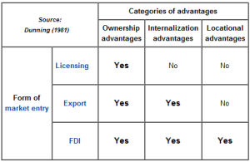
Figure 2: Dunning’s Eclectic Paradigm. (Source: Dunning 1981)

Opportunities and risks for each factor influences a company’s internationalisation strategy. Larger companies might use their reserves to benefit from direct ownership and make FDIs. Locating production in an overseas market may give transport efficiencies, gain government incentives for relocation and benefit from cheap labour. Fear of intellectual property theft by foreign partners might favour using internal efficiencies instead. The workings of the model are financial and economic, country and market specific for each particular product or service (Rugman and Brewer, 2001).

Dunning’s model retains influence particularly for larger firms in a globalising, knowledge rich marketplace (Bartlett and Beamish, 2018), but may have less influence for smaller companies. It may favour the way of doing business of the home country (Ferner, 2000) and emphasises profit, sometimes to the detriment of working conditions in developing countries. This suggests it has limited relevance to ethical, green businesses, although little specific research has been completed.

Ostaszewska analysed Swedish based MNE IKEA’s construction of a chipboard plant in Poland (Ostaszewska, 2016) with regards to Dunning. IKEA chose FDI using their successful expertise in manufacturing. The location supplied low cost local timber chippings, cheap land and relatively low-cost labour. The internal efficiencies of mass production and control over the technology of chipboard production combined to influence the choice of location. IKEA installed a biomass generator for power in line with their sustainability policy fuelled by cheap, local woodchip. The forest location of the plant was controversial with environmentalists. To mitigate opposition IKEA publicised their high environmental standards. OLI factors therefore needed adjustment to take into account green issues.

2.5 Uppsala Internationalisation model
Uppsala is a process model of four stages of market penetration. Market knowledge and market commitment form a cycle with change factors, which depend upon current activities and commitment decisions (Johanson and Vahlne, 1977, figure 3). The more exposure to dealing with a new, foreign market a management team develops, the better they understand it, which informs decisions about future investments.

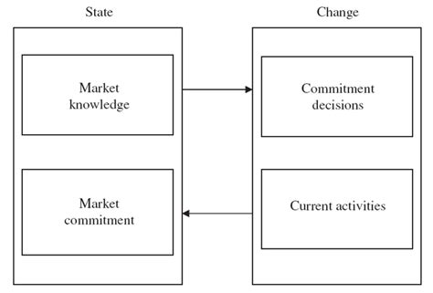
Figure 3: The Uppsala-Model (Source: Johanson and Vahlne, 1977).

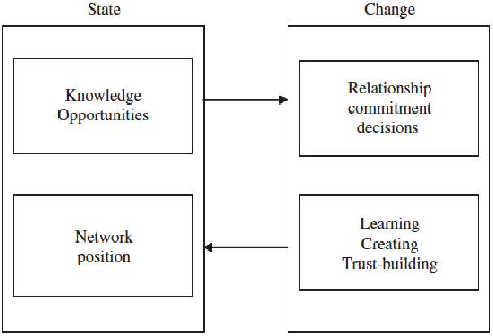
Figure 4: The revised Uppsala-Model (Source: Johanson & Vahlne, 2009)

To begin with, firms’ master their home market, refine their operations and establish their product lines. They then make decisions about where to commit their energies in foreign markets. “Psychic distance” is considered: “factors that make it difficult to understand foreign environments” (Johanson & Vahlne, 2009, p. 1412). This may include differences of language, political systems, regulation, market structures and so on. It is a psychological perception in the minds of decision makers. The less the psychic distance, the better a market is as an export destination.

Uppsala predicts that firms will begin exporting through independent agents, then go on to establish overseas subsidiaries, before eventually establishing their own manufacturing units abroad. These stages have been criticised because not all companies and product lines follow such a process. Uppsala addresses a country as an individual country whereas today a market could be a group of countries; furthermore, different markets might be interdependent on each other (Hollensen, 2001). In response to criticisms, a revision to the model was made. “The business environment is viewed as a web of relationships, a network, rather than as a neoclassical market with many independent suppliers and customers” (Johanson & Vahlne, 2009, p. 1411, figure 4). Coviello, Kano and Liesch (2017) further framed the influence of the internet and technology as a macro level factor, and the influence of individuals’ decisions, as shown in Figure 5.

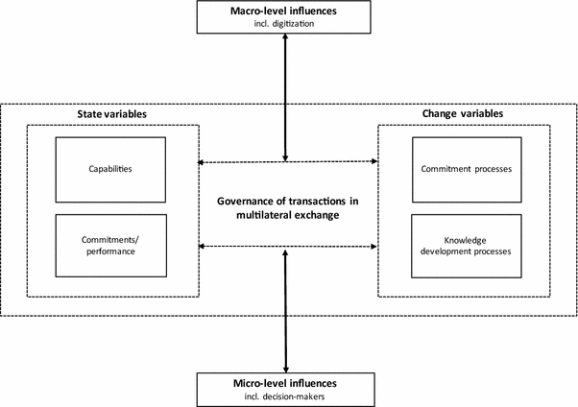
Figure 5: Uppsala, further revised to take into account modern developments
(Source: Coviello, Kano and Liesch, 2017)

Little has been written about Uppsala and green businesses. Johansson and Sabel (2016) researched fashion companies which were committed to environmental sustainability. Internationalisation was: “not strategically nor systematically implemented in any of the case companies, instead it was based on a feeling, interest and informal networks” (Johansson and Sabel, 2016). Most entered foreign markets using agents for practical reasons, including lack of knowledge and cost, in agreement with Uppsala. Problems occurred when companies expanded too quickly or failed to gain sufficient knowledge of partners in new markets, who did not always understand their commitment to sustainability. Environmental concerns and geographical nearness were important factors in establishing psychic distance.

2.6 Internationalisation through networks
Internationalisation may be considered the development of relationships (Cavusgil and Knight, 2009). Networks can spark a desire to internationalise; facilitate gaining knowledge and access local channels to enter a market, saving FDI. Chandra and Wilkinson (2017) argued that the role of networks was not adequately represented in traditional models of internationalisation, and proposed Network-Centric, Complex-Systems Internationalisation models (NCCSI) as in figure 6. Johanson and Mattsson (1988, p. 212) found that internationalising firms can be categorised into four stages, shown in figure 7, with the internationalisation of the firm linked to the strength of its networks.

The better the network relationships, the more opportunities a business might gain for new markets, develop greater efficiencies and collaborate for research and development. Mitgwe (2006) argues that networks are a faster way to internationalise than following a process model. Where a business has no links to a new market overseas, networks enable them to quickly find agents, sales contacts and understand laws and regulations. The strength of local networks influences how well a business is prepared to launch an overseas market penetration. Sometimes a broader range of weaker ties can be beneficial in opening up new knowledge and opportunities (Granovetter, 1973).
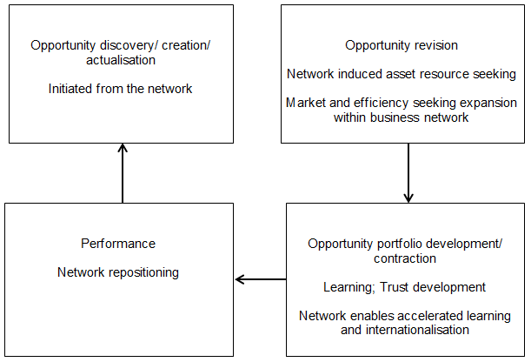
Figure 6: The Role of Networks in the Internationalisation Process.
(Source: Chandra and Wilkinson, 2017)

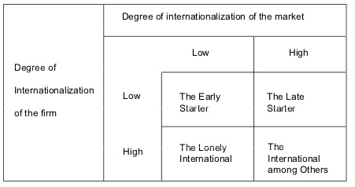
Figure 7: Firm and Market internationalising degrees
(Source: Johanson and Mattsson, 1988)

The view of networks from green businesses has changed from “exploiting competitive advantage to developing competitive advantage that requires closer relations with the environment” (Forsgren, Holm, & Johansson, 2005, p. 1). Davies (2013) found that meta-clustering of Greentech companies across national borders was a means to internationalise. Clusters help firms to gain advice by sharing experiences to form internationalisation strategies. Davies found that in order to further sustainability in business, the market and private actors are insufficient. Networks should also include green partners with skills in environmental governance and green transitioning. Without that, there is a risk that businesses might simply internationalise for profit.

Cainelli, Mazzanti and Montresor (2011) researched local networks in north-east Italy and their importance in bringing together expertise for Environmental Innovation (EI). Local companies benefitted from the expertise of academics and MNEs through networking. Some adopted international environmental standards and retained those standards when they expanded into other countries even where not required. This suggests green businesses are more influenced by networks than economic models of internationalisation.

2.7 Entrepreneurial and managerial motivation
Experience and motivation in assessing the challenges and uncertainties of internationalisation can be crucial. Some have concluded the entrepreneur is the critical factor, more so than the certainties or uncertainties of the situations they face (Freel, 2005). This is particularly true for SMEs. “SME internationalization is an entrepreneurial activity” (O’Cass and Weerawardena, 2009). A business with a cosmopolitan, diverse management may have greater propensity to identify international opportunities; an entrepreneur with greater innovative capacities may have greater skill to manage and tolerate risk (Leonidou et al, 1998). Entrepreneurs are individuals who have the vision and drive to start an enterprise, and in so doing have the confidence to take risks and manage uncertainty (Burns, 2010). The entrepreneur may be motivated by making profit, or desire to make their product famous, or a desire to change and influence people. Oyson and Whittaker view the process of internationalisation in terms of how entrepreneurs perceive opportunities (figure 8). These qualities are particularly important when planning to take the step into new, international markets.

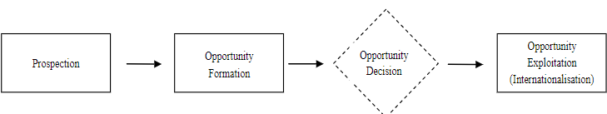
Figure 8: The internationalisation process in the international entrepreneurship. (Source: Oyson & Whittaker, 2010, p. 9).

International entrepreneurship may be defined as: “a combination of innovative, proactive, and risk-seeking behaviour that crosses national borders and is intended to create value in organisations” (McDougall and Oviatt, 2000 p. 903). An entrepreneur’s experience, language skills, interpersonal skills and experience of working with business people from different cultural backgrounds are important factors in success (Leonidou et al., 1998).

Failures are likely to be due to entrepreneurs underestimating the risks and complexities of the process (Anderson, 2000). Uncertainties may include reliability of foreign suppliers; chasing payments; product and brand perception by customers of a different cultural background and dealing with government officials and regulatory processes. The importance of the entrepreneur is amplified in smaller firms where their decision-making voice is all the greater.

Research into green entrepreneurs and internationalisation is less developed. Global Entrepreneurship Monitor (GEM) (Bosma and Kelley, 2018) provides detailed national indices about entrepreneurship but does not provide data for sectors or green businesses. Tools such as CAGE (Cultural, Administrative, Geographic and Economic differences) give more detail but again organise data by national market (Ghemawat, 2007). Green entrepreneurs may champion ethical and environmental concerns and might accept more cautious internationalisation to ensure these are not compromised. A famous example which has been studied is the Body Shop.

Founder entrepreneur Anita Roddick passionately sold her products with ethical, environmentally sustainable branding (Wycherley, 1999). Founded in 1976, Anita defied expectations and expanded rapidly using franchising. Her first overseas store opened in Belgium in 1978. High environmental standards were demanded of suppliers due to Anita’s uncompromising stance, which some feared was risky. The company further expanded rapidly across many international markets, focusing on its ethical niche. For many years the company was profitable although latterly experienced problems with strategic planning. The Body Shop shows how a green business entrepreneur can internationalise motivated by an ethical drive to change the world, not just profit.

Entrepreneurs can be central to both business internationalisation and solving environmental issues. According to Cohen and Winn (2007 p.30):
“Real gains will only be made by harnessing the innovative potential of entrepreneurs who will develop the innovative business solutions to deal with the environmental challenges”.
On the other hand, Omri (2018) found that opportunity entrepreneurs based in high income countries often caused more damage than they removed, particularly in the early stages during their pursuit of profit. There is a danger environmentally damaging business practices may be exported to low income countries where local entrepreneurs could run more sustainable, local enterprises themselves, more out of necessity than opportunity.

2.8 Born Globals
McDougall and Oviatt (2000) identified some business as International New Ventures (INVs) (figure 9). Improving technologies and communications, especially the internet, facilitate global network building and awareness amongst managers and entrepreneurs sufficient to enable them to start a business in more than one country as a ‘born-global’. SMEs with innovative or niche products benefit from going global before competitors erode their advantage. These companies may ‘sprinkle’ their products across many countries rather than cascade from one market to the next (Hashai and Almor, 2004). Often deals are done quickly and flexibly by a manager or entrepreneur, unrestrained by slower procedures in larger organisations. Sound knowledge and experience of decision makers is a pre-requisite.

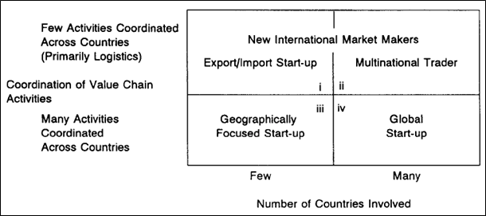
Figure 9: International New Ventures (INVs) market focus
(Source: McDougall and Oviatt, 2000)

Born globals enter international markets within around two years of start up, and sell 25% or more of their produce overseas by their third year (Cavusgil & Knight, 2015). Often born globals target a narrow group of consumers within several countries, rather than establishing a major outlet in one country. In order to achieve this, partnerships with local agents are used. Born globals do not fit well the traditional theories of industrialisation and may not yet be comprehensively researched, yet are an increasing phenomenon amongst new businesses. SMEs may find it not only attractive but essential to quickly internationalise, to keep up with the competition.

One of the few cases of green born globals which has been researched is Ki-An Eco, an organic sustainable food and niche product enterprise from Mexico (Zubirán and Nafula, 2012). Founding entrepreneurs had degrees in international business and put their expertise to work building a global company within two years. They expanding quickly from Mexico to the USA then Spain and Portugal and other Latin American countries. They focused limited funds available for marketing at consumers interested in quality, organic, sustainable foods. The founding entrepreneurs attended international conferences about environmental and business issues to build networks. Distributors and agents were used although there were some issues of understanding in dealing with other partners. Nevertheless, how far Ki-An Eco is representative of green businesses as born globals is difficult to determine without the further research.

2.9 Green businesses
Green movements favour local enterprises, reducing transportation and carbon emissions, which seems at odds with globalisation. Yet international trade can promote transition to a greener economy by spreading innovation and sustainable practices.
“Growing environmental concerns are generating considerable challenges for international firms because environmental regulations and priorities remain significantly different in the international arena” (Aguilera-Caracuel, Hurtado-Torres and Arago´n-Correa, 2012).

Internationalising green businesses need to navigate a complexity of regulations. Companies need to decide whether to produce differentiated products based on minimum requirements in each market, or produce the same product to benefit from mass production, knowing that product could be more cheaply produced in some countries to lower standards. MNEs sometimes took advantage of weaker environmental regulations (Vernon, 1992) but sometimes choose higher standards even where not required to enhance reputation (Rugman & Verbeke, 1998). Additional value and product differentiation based on communicating a brand’s ethical and environmental credentials may achieve competitive advantage above that gained by price (Collins, 2008).

The more complex a firm’s international experience, the better it is able to proactively engage in environmental strategies, due to the complexity involved (Aguilera-Caracuel, Hurtado-Torres and Arago´n-Correa, 2012). Knowledge is key: not only of business strategies, but also of national regulations and customer perceptions of ‘green’ which varies by country (Čekanavičius et al, 2014). Nielson (2015) suggests that consumers in the USA and Europe are more likely to be influenced by substantiated claims about the worth of a product in sustainability and ethical terms. However, such consumers were also more likely to produce more pollution than consumers in developing countries, who pay less attention to eco-friendly marketing.

Schaper defines ‘ecopreneurs’ as a new class of entrepreneurs with a passion for environmental concerns (Schaper, 2010). Schaper argues that people who take risks are essential for internationalisation; holding together a commitment to sustainable innovation and profit-making commerce. There is currently only a small body of literature about ecopreneurs but the term is being increasingly used and recognised. Kirkwood and Walton, based on their research in New Zealand, argue that green entrepreneurs consider international markets differently because of their commitment to ethical issues (Kirkwood and Walton, 2010).

The nature of green businesses means they do not necessarily fit easily within traditional business models. Walley, Taylor and Greig (2010) researched the influences on green businesses, shown in Figure 10, and proposed that green enterprises may vary: from those primarily focused on sustainability issues; to those orientated mostly in an economic direction. The visionary and ethical maverick tend towards the former; the innovative opportunist entrepreneur/ ecopreneur the latter. Schaltegger (2010) proposes that companies vary in their degree of attention to green issues. Some relegate the issue to a trustee duty. In the middle are companies who give environmental issues supplementary importance to core business goals. The eco-friendliest put environmental goals at the core of the business. Account must also be taken of the extent to which a business targets the mass market, an eco-niche or is an alternative scene enterprise.

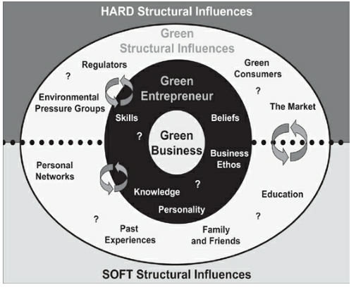
Figure 10: Influences on the Green Entrepreneur Walley, Taylor and Greig (2010)

According to Sommers (2012), initially businesses were wary of environmental restrictions, but now many see green products and a green corporate image as an opportunity to add value. Nevertheless, Sommers argues that an environmental focus is still bound by traditional business models which target competitive advantage gained financially. It is proposed by some that green enterprises will result in fundamental changes in the business world, changing existing patterns of competitiveness (Fankhauser et al., 2013), requiring new models of interpretation (Esty and Winston, 2009). If this is the case, then the approach taken by green businesses to internationalisation will be distinct.

2.10 Conclusion
The literature review has identified that there is a need for further research internationalisation from the perspective of green businesses. Models of internationalisation may still carry some truth but do not factor in specific green issues. There has been limited research from the point of view of Vernon, Dunning and Uppsala into how factors such as sustainability and global eco-consciousness may affect a product sold to new markets, and the research found and cited above has tended to focus on a limited number of case studies which may be atypical. There are questions about how far these models hold true today in an increasingly complex world. At the same time, the importance of economic factors and strategic staging cannot be written off. More flexible interpretations of Uppsala, and the concept of ‘psychic distance’ in considering new markets, provide fascinating avenues to consider with regard to the mindset of the green business leader and consumer. Therefore, internationalisation models will be explored with an open mind with regards to green businesses in this research.

The role of networks and entrepreneurs have been identified as two increasingly important factors in internationalisation. Some businesses are now able to internationalise in a different way by starting up as a born-global. It has been proposed in some research that green networking and ecopreneurship are specific and of heightened importance for the green firm. Specific networking and entrepreneurial factors in internationalisation will therefore be given detailed consideration in this research to explore their importance for green businesses, and what difference being green might make.

Some exciting research is emerging but still in its infancy (Schaper, 2010). “The literature on Green Growth is mostly quite recent and dominated by global and industrialised country applications or context” (Scott et al, 2013). This piece of research aims to explore the issues and contribute to the growing interest in the internationalisation of green businesses. A problem in identifying relevant research is that focus tends to be either about green enterprises from an environmental perspective, or about internationalisation from a business perspective; not green businesses from an internationalisation perspective. Whilst some examples of green businesses were found to illustrate each theoretical approach above, research leaves a gap for determining patterns in green, ethically orientated businesses overall. This research aims to explore the issues of internationalisation for green business to better inform decision makers and pinpoint areas for further research.

- Research approach and methodology
3.1 Research rationale: interpretivist
It is necessary to first outline the research paradigm which will be taken; that is, the approach to understanding knowledge. The aim is to understand reality from the point of view of how it is experienced by a selection of professionals working in businesses. Truth is as they perceive it, described according to the frame of reference of their own experiences in business and internationalisation. This will be interpreted and analysed by the researcher who also has some experience in this area, so is not a dispassionate observer. Interpretations will be made, therefore, which are to some extent subjective because of the nature of the research in an attempt to analyse and interpret the nature of the phenomenon studied.

The research position therefore is interpretivist. Three of the main research philosophies are positivism, phenomenology or interpretivist and realism. Positivism uses quantitative surveys and methods to develop general laws of nature which may be positively proved to be true (Symon and Cassell, 2012). Realism suggests that objects exist outside of human imagination and can therefore be scientifically studied and analysed without necessarily considering different individual and social perspectives (Saunders, Lewis and Thornhill, 2016). However, to understand the experiences of internationalisation of green businesses, the researcher felt that as a result of the literature review, hypotheses to test have not yet been clearly identified. The journey of different businesses may be considerably affected by context and the individuality and social position of entrepreneurs. Therefore, the interpretivist position provides the most suitable standpoint.

A positivist approach might be considered more scientifically accurate. If it was felt that general laws of process might be proven through this research then a numerical, positivist survey would be of advantage. But in the literature review it was found that if anything, there has been a trend away from process models of internationalisation, which did not always hold true. Interpretivism might be criticised for the potential for individual bias, but this is guarded against by openly identifying the position of the researcher. If the phenomenon observed is too diverse to hold to general scientific law, it would be wrong to approach it from that standpoint, as positivist results would not be held reliable in different situations (Saunders, Lewis and Thornhill, 2016).

The interpretivist position allows more flexibility to explore the field as it is. Indeed, it is of advantage that individuals interviewed in this research are able to give their personal perspectives about what drives them; their view of business and society; and therefore, their inspiration for decisions. The empathetic stance of the researcher helps assist the analysis (King, Horrocks and Brooks, 2018). A smaller sample size is used, which could be criticised, but this enables a more detailed study to draw out fuller understanding than a quantitative, positivist survey might yield.

3.2 Primary Research question
The main question is: what are the key factors for the internationalisation of aspiring businesses with an ethical/ organic/ green focus?
This will be considered broadly and not restricted to answering any particular hypothesis. There will be particular consideration of following three areas given that they are evident in the literary background:
1. The significance of networking and for internationalisation of green businesses;
2. The importance of ecopreneurial green entrepreneurs as drivers of internationalisation for green businesses; and
3. Whether the process of internationalisation for green businesses is distinct in comparison to traditional businesses.

3.3 Exploratory design
The design of this research is intended to facilitate answering the main research question and fulfilling the objectives. This is by nature exploratory: “a question which seeks to identify themes when little is currently known about the subject” (Gray, 2014). The intersection between internationalisation and green businesses appears a new focus according to the literature review, and as such an exploratory approach enables a researcher to find out ‘what is happening; to seek new insights; to ask questions and to assess phenomena in a new light’ (Robson 2002).

Exploratory research is flexible and allows the research to make adaptations if new data or new thought lines arise. It enables the researcher to begin with a broad approach which can then become more focused as the research progresses (Robson, 2002). Exploratory research has the advantage of setting the scene and defining the field, ready for further research. It is not necessary to define hypotheses or make definitive conclusions at this stage. Exploratory research might be criticised for potential researcher bias, small sample sizes from which it might be difficult to use to infer patterns or make decisions. Care will be taken here to ensure as wide a range of different green businesses as possible are chosen to be part of the research, as far as practicalities allow. Whilst making analysis, care will be taken to avoid bias and over-generalisation.

A different research design, explanatory, seeks to explain the patterns related to the phenomenon of interest and to answer the research questions (Yin, 2003). It was felt that the research literature did not produce enough clarity on the position of green businesses as yet to favour an explanatory approach. A third research design, descriptive, might result in a diverse set of experiences being described without any general pattern of predictive behaviour being concluded, since the nature of green internationalisation is diverse. Therefore, it was concluded that exploratory design to make sense of the phenomenon would be most practical and useful.

3.4 Qualitative methodology: semi-structured interviews
A qualitative approach will be taken, which is well suited to the interpretivist paradigm. Qualitative approaches often use interviews and observations to build up a detailed picture of businesses and changes without formally measuring or quantifying them. It helps to understand and describe a trend of phenomenon (Quinn, 2002). This suits the study of internationalising green business at this stage in the development of studies in this area. There is a risk of bias from the researcher given the lack of numeric data, so care will be taken in the analysis to consider different possible interpretations and avoid generalisation.

Researchers may collect primary or secondary data (Saunders et al, 2016). Secondary or second-hand data from other researches is mentioned as appropriate in the literature review. But due to the lack of focused research into specifically green businesses and internationalisation, it was felt more appropriate to explore this research from primary data in the form of interviews of professionals in the field: decision makers in businesses who had experienced, or were considering, internationalisation.

Semi-structured interviews were chosen as the main method of data collection. Interviews may be structured, semi-structured or unstructured; each has different advantages (Gray, 2014). Structured interviews lend themselves to formal, sequenced, specific questions which give quantitative results. Unstructured interviews provide in depth conversations which allow broad discussion of issues. Semi-structured interviews have the advantage of more guidance and direction than unstructured: the researcher may open up discussions with questions derived from understandings gained from the literature review. At the same time there is flexibility to explore one theme or other in more detail and for the interviewee to include information relevant to their experience as appropriate.

Semi-structured interviews can be time consuming. There is a risk that an interviewee might feel they have to omit sensitive information, such as failures, which they might more readily admit in anonymous online surveys (Symon and Cassell, 2012). However, the researcher may overcome this through a relaxed style and through reassurance. The personal interaction may be of benefit to sense human reaction and thereby understand more of the personal journey the business has gone through. The risk of researcher bias will be guarded against and the researcher standpoint made clear.

Other methods of data collection include questionnaires, surveys, diaries, telling the events, critical incident technique and observational approach. Questionnaires are better for handling a larger amount of data but give less detail about any one case. Surveys are better for providing quantitative information for a deductive approach (Saunders et al, 2016). Both are less useful than semi-structured interviews in giving the flexibility to explore in more depth individual accounts. Diaries and telling the story require a longitudinal time frame which is more difficult to find for comparison given the newness of the area of research. Critical incidents would help to explain barriers to internationalisation but are more difficult to find and miss identifying the main positive trends in the phenomenon.

Focus questions for the interviews are shown in appendix 1. The structure is practical to allow for development of themes within a practical time frame, but also flexible to allow interviewer and interviewee to follow up any particular factors in more detail or alternative ideas which might not have been anticipated. The interview questions in appendix 1 are designed to be open ended and to avoid the possibility of the researcher prompting for a particular response. The background of the researcher will be made clear and the interviewees asked about their background in the company so as to contextualise their data.

Interviews will take place by telephone for practical reasons, to allow interviewees to be drawn from a wide geographical area. They will be recorded with the specific consent of the interviewee, so they can be accurately transcribed afterwards. Interviewees will be sent a copy of their interview transcript for checking. After any corrections are completed, any names or identifiable products will be redacted and the original recordings will be deleted, prior to data analysis being made.

3.5 Sampling framework selection and size
Saunders identifies quota, convenience, snowball, self-selecting and purposive sampling methods. For exploratory research, self-selecting is particularly useful (Saunders et al, 2016). It is enacted by first publicising the need for interviewees and then taking a sample from amongst those who respond. In this research, a general email inviting response was sent to a wide variety of green businesses. Of those responding, the researcher chose a sample of 10 with an effort to include a variety of sizes of business at different stages of internationalisation. These range from those aspiring but yet to undertake moves into other markets, to those advanced in their operations in many different parts of the world. The aim was not to choose a representative sample as this is not possible using this type of sampling. Rather, it was desired explore the diversity of experience. A small sample size of ten is manageable and advantageous in that it permits some depth of conversation within the time frame allowed.

A quota sample might provide a more representative sample but with higher cost. However, there is no guarantee that the correct categories for the quotas would be allocated before an initial exploration of the field. Purposive sampling leads to judgements; snowball sampling would restrict the sample to the networked contacts of the first two businesses contacted and so be restrictive in that different sorts of networks and businesses might be excluded.

3.6 Data analysis
A thematic analysis of the data will be undertaken. This involves defining and organising broad themes and is widely used in qualitative research (King and Brooks, 2017). Other kinds of analysis such as discourse and conversation analysis focus on language used and are less common. Whilst a thematic analysis may make it more difficult to judge individual accounts, it is more useful to identify and explain themes overall. Thematic analysis may be conducted by organising data into a matrix or table; or by applying a template. Template analysis involves six stages: familiarisation; coding; clustering; drafting a template; developing it; revising and finalising the template (King and Brooks, 2017). Initial codes are defined, known as a priori codes, and applied to units of text, which can then be sorted and clustered. The codes identify themes which become important when they capture an important aspect in relation to the key question (Braun and Clarke, 2006). The coding can be altered along the way to suit the data found. The results may identify some form of hierarchy of factors, of two levels or more, which may be visualised on a conceptual diagram.

Inductive reasoning will be applied to analyse the data. Inductive reasoning is used to formulate theories, to facilitate the building of hypotheses for further research (Saunders et al, 2016). In the inductive approach, the researcher observes the environment, looks for patterns then provides an analysis of the general patterns found. By contrast, deductive reasoning occurs when a researcher puts a hypothesis to the test. Inductive reasoning is more suitable for the exploratory research undertaken here.

Applying thematic analysis to this project, initial coding was based on the areas highlighted from the literature review, such as process models, economic factors, networks, entrepreneurship, and green issues. The framework of the interviews was based on this. Colour coding marked the different topic areas from the first two interviews sampled. As further interviews were added this coding was reviewed and added to. The information was used to draft paragraphs analysing each theme in turn.

3.7 Ethics, reliability, validity and limitations
Maxwell (2012) argues that it is important to include a diverse range for interview: different businesspeople, those of different ethnic and cultural backgrounds for instance, those representing different sizes and types of business. Whilst self-sampling for exploratory research is not going to be truly representative it does allow the research choices to ensure a degree of diversity is included.

Results may be considered reliable if they are repeatable, or other researchers reach similar findings (Saunders et al, 2016). If interview responses begin to be repeated then the range of diversity may have been met (Merriam and Tisdall, 2016). This research has been produced through a rigorous process which should add to its credibility. The phenomenon is described with generalisations as true as the data suggests, from the sample of ten. Given the wide range of experiences of internationalisation of green businesses possible, a breadth is reflected in this research, but there is always a possibility that another researcher might find further diversity, and so the research might not be exactly repeatable. This is a common finding in qualitative research, but it should still be considered truthful as long acceptable standards of ethics are applied in the data collection process (Maxwell, 2012) and therefore useful in accurately reflecting people’s perceptions.

Validity concerns the accurate measurement of what is intended and the extent to which the results really validate that finding (Saunders et al, 2016). For practical purposes, a mock discussion was held with a businessperson in an enterprise not considered in the formal research, to check that the interview went well and the questions prepared for guiding the discussion has the intended effect. During the interviews, the researcher ensured these were conducted during normal working time and from a comfortable location whilst the interviewee was not distracted by other matters.

Anonymity was assured to ensure that interviewees did not feel they had to restrict any part of their account. If anonymity was not guaranteed, interviewees might have felt that they ought to omit a business failure as it might become more widely known and damage reputation; but a failed internationalisation project would be equally as important to understand for the purposes of this research as a successful one.

This research was limited in time frame. The political climate at the time of conducting the research was during the BREXIT crisis (Britain’s exit from the European Union) which caused business anxiety due to uncertainty ahead. This may have negatively affected results, with businesses less keen on exporting until political matters are resolved. The use of a semi-structured interview was practical within constraints of time but obviously if further methods could be added then this would further improve the research. Inevitably businesses were chosen from a geographical range which was realistic to cover, but this did not include all parts of the UK, for example it did not include Northern Ireland, with its obvious proximity to the Republic of Ireland and issues for internationalisation there.

- Analysis of results
4.1 Range of businesses covered
The range of businesses selected for this research covered the very small, classified as micro, run by a single person with a small business turnover, up to large, with multi-million pound turnover and several hundred employees. The sizes are taken from the standard UK definitions of business size as used in reporting, such as in the briefing paper by Rhodes (2018), based on size of trade and number of employees. Figure 11 shows a summary of the businesses covered, which include a cooperative, a sole trader who converted into a limited company, and several limited companies of both private and public share listings. The businesses range from 4 years old to 30; the establishment of their international operations from 3 to 14 years except for two companies which are yet to internationalise. The contrasting range is exemplified by Company A which manufactures compostable packaging in a mass production facility; compared to Company F which makes furniture by hand and largely to order.

Figure 12 shows the relationship between business size, years internationalised and relative importance of internationalised trade as a percentage of total trade. The size of circles visually represents the size of company turnover. Smaller Businesses F, J and C internationalised faster than the larger Firms G, A and H as a percentage of their trade, although the total trade volume carried out by the larger firms is much greater, possibly explaining the extra time taken. Using the definition of born globals provided by Cavusgil and Knight (2015), Businesses J and C may be categorised as such having internationalised within their first two years; A falls just outside this category.
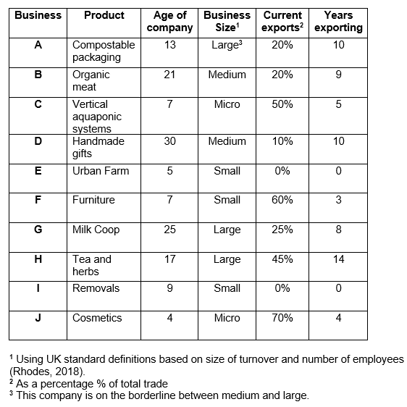
Figure 11: Table to show range of businesses covered in this research.

The geographical spread of exporting and international operations, excluding the supply of raw materials, is shown on the world map (Figure 13). Countries included are the USA and Canada; most of Europe; Kenya and South Africa; Austrailia and New Zealand; Qatar, the United Arab Emirates and Bahrain in the Middle East (difficult to view on the map due to their small size) as well as Hong Kong, Singapore, Macau, South Korea and China in the Far East. This correlates to a great extent with countries defined as high income economies (World Bank, 2019) shown in Figure 14, with the exception of China which is a destination and a few other high income countries which are not.

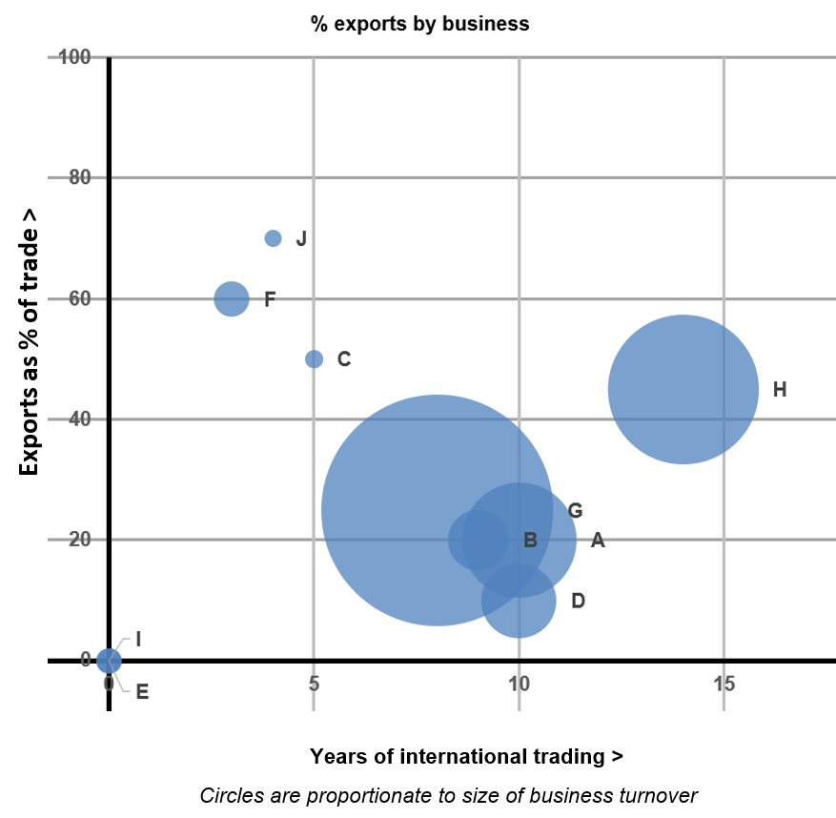
Figure 12 Business size, years exporting and relative importance of exports

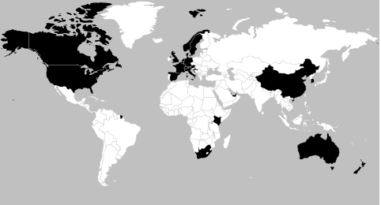
Figure 13: International operations of companies in this research.

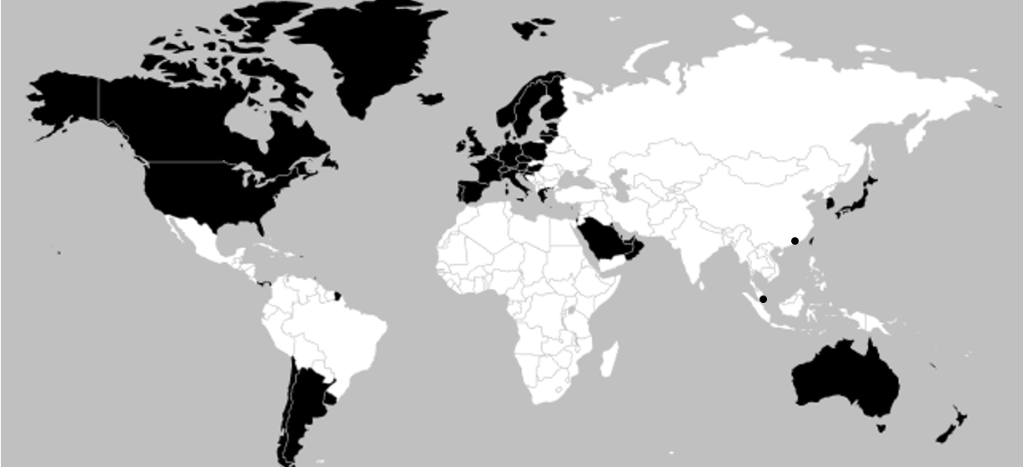
Figure 14: High income countries based on nominal GDP per person.
(Source: World Bank, 2019)

4.2 Inconsisency with Vernon
Aspects of Vernon’s product lifestyle are evident within this sample but the theory does not fit well overall. Company A commented:
“The market in the UK is growing but we have a good share of it now and we are facing stiff competition from new rivals on price. There is much more opportunity to increase sales abroad, especially in the USA.”
With maturity reached in the domestic market; expansion is occuring in a similar, developed market. Vernon suggests that at this stage production might move overseas, but Company A has chosen not to, because of the need to ensure green supply lines. This was an essential part of the brand, seen as too risky to move overseas. Instead, the company diversified by producing new products and customising existing ones.

Company H, producers of organic tea and herbs, commented:
“We are well established in the UK now so most of our growth comes from new, overseas markets. This enables us to keep on expanding our range.”
Nevertheless, their main income is still derived from their original three product lines in the domestic market. Company H retained production within the UK where technical testing facilities were available to ensure quality and organic standards were met.

Company J began internationally in a niche market of vegan cosmetics amongst 15 competitors; aquaponic equipment maker C focuses on solutions tailored to local situations. This points to the importance of international collaboration as suggested by Quitzow (2015), rather than a national, staged model.

4.3 Application of Dunning’s eclectic paradigm
Considering ownership, internalisation and locational advantages (OLI), none of the green businesses in this research chose FDI, not even those long established. Licensing, particularly for distribution and marketing, is by far the most popular, with some companies choosing direct export. Figure 15 summaries the advantages stated by each business.

Dunning’s model predicts some businesses would have shifted production overseas. However, green credentials are cited by several, including Company A, as a factor for not doing so. This suggests cost benefit in terms of brand reputation for upholding green principles outweighs the potential savings of transport efficiency and the lower labour costs of production overseas.

For those companies choosing licensing, this was for distribution rather than manufacture. Green expertise tended to be kept in house for concetration on the production process, whereas knowledge of foreign markets was less advanced internally. Even so, distributors were often required to adhere to green principles. Business A commented: “We have licensed companies in the USA and Australia who use our brand and sign up to our environmental principles.” Business B also commented: “Our distributors also share our concern for the environment.”

Business H followed Dunning’s rationale more closely, reasoning that distributors had practical advantages over directly ownership of distribution:
“The business is quite complex to manage. … we’ve recently used a consultancy firm to rationalise our supply arrangements and make them more efficient…Marketing is expensive, especially in huge new markets like the USA. …We appointed a sales rep in the USA to broker deals with established distributors over there.”

Some businesses internationalised through partnerships, which did not fit easily into the categories set by Dunning (see Figure 15). Cooperative partnerships were formed for mutual benefit by Company G and partnerships based on finding technical solutions by Company C, which commented:
“The business basically works to find solutions to help farmers and businesses so we see it as a partnership in business not just a seller-purchaser relationship.”
Some green businesses, then, do not see economic transactions as the main basis of their operations for internationalisation.

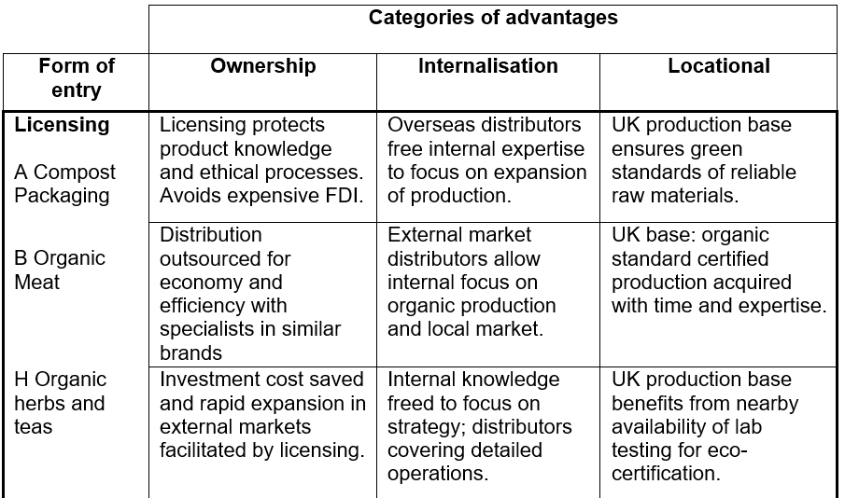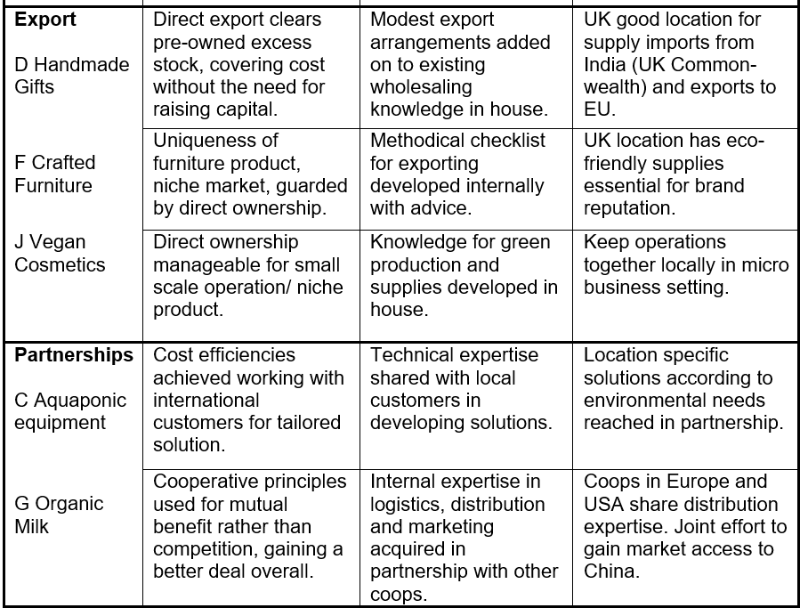

Figure 15: Application of Dunning’s eclcectic paradigm
4.4 Uppsala and Psychic distance
The Uppsala staged model does not work for Businesses J, C and F, which have internationalised quickly. A closer look at the method of market commitment is shown in Figure 16. This shows a bunching of green businesses who use independent representatives and an absence of foreign sales and production subsiduaries. It is possible that this is because the model itelf is outdated, or that it simply doesn’t fit green businesses. For those in the first column, it is not accurate to say that they are making sparodic or no regular exports, neither do they meet the criteria for independent representatives. Many export using the internet to organise sales. Some do not employ what they regard as costly representatives but use other means of gaining ambassadors for their products, such as exposure in trade fairs and magazines articles. Company A uses indepndent licensed distributors who nevertheless use the company branding and sign up to the company’s ethical ethos. Thus the distributor appears indistinguishable from a foreign sales subsiduary in all but ownership.

Are green businesses differently affected differently by psychic distance? There is a broad degree of similarity between high income countries and export markets for these green businesses shown on the world maps (Figures 13 and 14). This fits the World Business Council for Sustainable Development (2008) finding that consumers in high income countries are more concerned about the environment but also create more environmental pollution through their lifestyles. Green awareness in high-income countries may make these advantageous markets for green businesses to internationalise to.
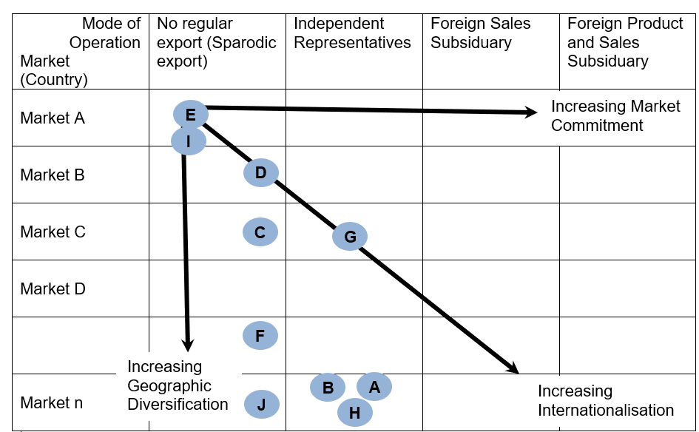
Figure 16: Businesses rated according to Uppsala stages of increasing internationalisation. Adapted from Forsgren & Johanson (1975) in Alon et al (2017)

Company A targeted similar markets:
“Most of our sales growth is in Australia and USA … where customers share interest in concern for plastic in the oceans and want to do something about it, just like here in the UK. We are working flat out to supply and expand the market in these markets so we are not looking at expanding into other countries ourselves at the moment.”
Company G applied what they called the French wine test to target markets with similar consumer tastes:
“When deciding where to target we apply the French wine test. If customers choose to drink French wine then they are going to buy organic cheese.”

Psychic nearness was not the only consideration. Company B targeted markets lacking domestic competitors, which were also high income countries:
“Some parts of the world do not have domestic supply, such as the in the Middle East and Hong Kong. Everything is imported here so we had a good chance to gain a share of the market. We tend to target parts of the world which are affluent and customers are looking for a high-quality product like ours.”
By contrast, Company D avoided similar markets:
“We do not ship to the USA or Canada as they already have a competitive fair-trade market supplying the same products.”

None of the companies interviewed mentioned using CAGE country comparison tools to determine similar marketplaces, as defined by Ghemawat (2007). Company J suggests that their niche product was of interest to a particular kind of consumer, so perhaps the concept of a country as a market is becoming less important for green products:
“The market is growing strongly as people are more interested in veganism and the environment. They do not want products tested on animals and they are aware of global warming so they do not want petroleum-based cosmetics.”
Company H targets magazines in different countries whose readership is discerning and may purchase quality, eco-friendly products. The readership is a small sector in more than one country, which forms a target market. Company A commented: “We just kind of think of business as being global these days and we have an international culture in the city we are based in.”

Regulation and environmental standards was of particular concern to green companies, which in the case of Company G, delayed their entry into the USA:
“First, we sold to Europe. It took longer to sell to the USA because we needed approval and we only got it when the EU agreed equivalence standards. Then we partnered with a USA cooperative to get approval to sell to China.”
Of note is Company G’s entry into China. China as a whole does not average a high income level, but contains such a huge population that within it there is a middle class population of aspirational consumers with reasonably high income which is a larger market than many other countries as a whole. This sub-section of the national market may be showing psychic nearness to green consumers in the west in their apetite for organic milk.

4.5 Financial Considerations
An emerging theme not anticipated in the original research plan is the importance of finance. Small Business F was able to raise sufficient funds through selling the concept of the business in a kickstarter campaign. But there are some suggestions from the sample that businesses conform more to traditional patterns when they require finance for growth. Company A, which is verging on the size of a large business, focused on rapid internationalisation.
“Finance was important and we got the backing of venture capitalists in return for a stake in the business. It is important to convince financial investors and their backing and encouraging was a boost to our business which meant we could rebuild and expand our processing facilities.”

Large Company H also required investment but rejected venture capital funding. H suggests that joining an MNC portfolio would be mutually beneficial, enabling their green practices to be shared rather than diluted.
“From start to finish it takes up to 8 months to produce and distribute our products. This meant that as we grew, we developed cashflow problems. Our founders recently sold the business to an MNC to add to their food and drink portfolio. This had many advantages for us. We got the investment we needed to expand, and the MNC was also looking to develop its image for sustainability, so it was a good match. We could not have got such a good deal from private equity finance as the conditions would have squeezed our ethical principles. Now we can benefit from the distribution and marketing resources of the MNC and make efficiency savings.”

Smaller Company C notes possible difficulties in finding the right kind of investor who shares green values.
“Now we are better known we are considering a first IPO. That means a public share offer. We need investors who can fund our business so that it can grow, but also understand that we are here to provide a green solution, not just for profit.”

The method of finance, style of internationalisation and interaction with green and ethical principles held by green businesses are a complex dynamic to be further investigated. Company D guranteed orders and fair prices to their suppliers in India, then faced a loss when the 2009 downturn hit their UK sales. This necessitated the restructuring of the company. Company G guaranteed organic farmers a fair price for their supplies and maintained prices by gaining, in effect, a monopoly with 65% of the domestic market. Suppliers responded by producing a surplas of milk. This nudged the company into finding new markets overseas and diversifying its products. Suppliers gained a fair price and security for their sustainable materials but passed financial risks up to the ethical, green businesses.

.
4.6 Networks and green internationalisation
4.6.1 Networks: Opportunity Creation
The green and ethical nature of personal network links as an inspiration for business came through strongly. Company C commented of the founder:
“He previously worked in IT and engineering, and visited dry, desert like locations in the Middle East and Australia. This gave him the idea to think of Scientific solutions to overcome the problems of drought for farmers.”

The founder of Company A gained knowledge whilst living abroad where he was inspired by recycled composting material, forming the basis of his product. Company J commented:
“We are a member of an enterprise support group in which we discuss and share ideas, which is really useful for inspiration and networking.”
Networking inspired one of the founders of Company H:
“One had passion for organic herbs, experience of travelling to India, doing yoga, and working for an organic farm – now one of our suppliers.”

4.6.2 Networks: Commitment decisions
The importance of green standards in commitment decisions is underlined by insistence on organic/ sustainable/ recycled supplies by Companies A, D, F, G, H and J. and membership of fair trade bodies, especially the World Fair Trade Organisation (WFTO) by Companises D, H and J.

In addition to inspiration and design, many businesses found networks important for finding supplies. D relies on ethical producers in India and F on local suppliers of sustainable timber. Company H relies on organic producers to supply materials and outsources manufacture as well. For A, the raw materials themselves are waste foods supplied by a local network which collects food waste for recycling:
“We needed to set up supply lines and make sure they were compostable. We built up a relationship of trust with suppliers so we knew they were reliable and checked they could supply more materials so we could expand.”

Company C used dynamic network links to develop their product then refined it in collaboration with customers:
“We are part of a local Agri tech cluster of small businesses. That has been really helpful in making links with Scientists at local universities to help us develop technical solutions and test our product.”
A summary of the green and general business links found is given in Firgure 17.

4.6.3 Opportunity Development
Getting green products known was a challenge which green businesses turned to network links and targeted outlets to find eco-inclined consumers. Company A worked with partners to develop their products further and thereby increase exposure and gain new customers for those new applications:
“We worked with a university catering facility to provide special bins at key places for compostable waste to stop most of our trays ending up in general waste. We used technical testing services to develop our products…We are currently working with an independent coffee shop group, to provide customised coffee cups with their logos as well as promoting our brand in store as a partnership. This is a win-win for both us and them.”

Company B mentions links with organic outlets and Michelin star restaurants as helpful for opportunity development. They drew on local connections to develop lean meat protein boxes advertised by an athlete, advertising this on social media. Most companies referred to internet exposure as important, with some exporting directly in response to orders received online. The effect of internet presence may mean that smaller Businesses D, F and J are actually less reliant on marketing networks.

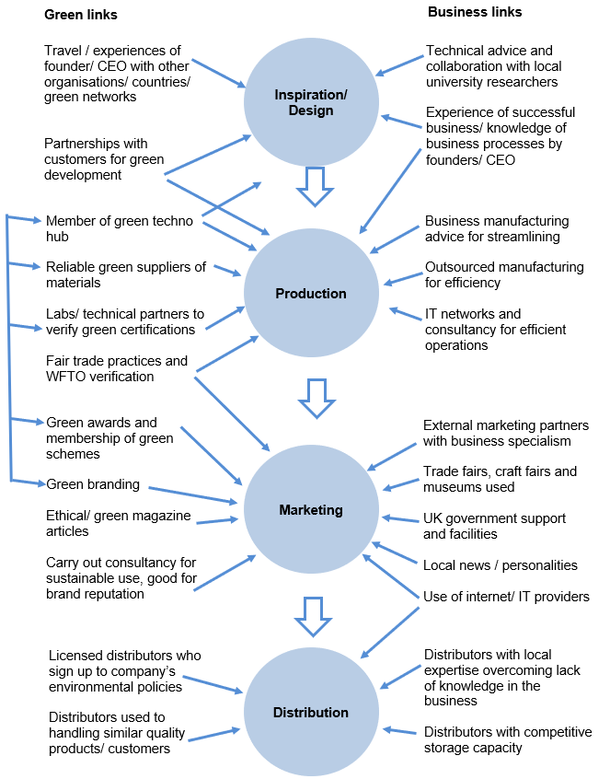

Figure 17 Networking links used by the green businesses in this research.

The UK government helped find distributors, making available meeting spaces in overseas locations and providing advice. Company C commented:
“The trip to Canada was funded by a grant which the cluster applied for. Local universities have been really helpful in testing nutrients and water volumes needed and calculating how the products would work in hotter climates. The UKTI helped with EXPO and that helped gain lots more contacts.”
Trade fairs were used for making links and finding customers: people interested in the same green niche market, more difficult to pick out by general advertising.

F and H mention marketing as expensive, but which can be effectively carried out by networks instead of paying for costly advertisements. F commented:
“We target the media to give them articles about how we grow our furniture… We actively look for stories to tailor to the magazines readership and those stories help give us a market.”

4.6.4 Distribution Networks
Many of the companies use partner organisations for efficiency. For H, distributors and marketers helped them manage a complex, fast expanding export process. This agrees with Mitgwe (2006) who argued that businesses find networking faster and more practical to expand internationally than process models.

Company A requires distributors to sign up to their environmental standards. For Company B, distributors are partners who they work with on food standards and marketeing:
“We use distributors in every country. Distributors now deliver to Hong Kong weekly. In 2013 we contracted a distributor with established presence in the Middle East and Far East, specialising in quality food exports. Our distributors also share our concern for the environment. The founder joined a sales mission to Hong Kong organised by the distributors which helped increase our brand exposure.”

However, Company H, which has been taken over by an MNC, regards distribution and warehousing as a general business need and hopes to gain efficiencies from their new owners, whilst influencing them to adopt sustainable practices. J criticises the way some green businesses don’t always insist on the same values from all of their partners or at every stage in their operations:
“Some green companies might seem green but don’t have certification or don’t insist on the same standards for their distributors or partners. We are a business based on belief and a desire to change the way business works, so we are totally different from your average big business.”

4.6.5 Cooperative Networks
Businesses D and E use cooperatives and G is a cooperative with links to others. Cooperatives commit to forming partnerships, ethical values and paying a fair price, which is creates stability for organic farmers. G commented:
“We don’t have shareholders like other companies, but we do share profits between members, who form the board of directors. The cooperative pays us a fair price guaranteed.”

Company G partnered with other cooperatives in Europe and the USA to gain access to distribution facilities in those markets. They joined a USA cooperative to pool their resources, overcome technical and legal hurdles and insodoing gain entry to the Chinese market. G commented:
“I would recommend the coop because they give us advice and support and put us in touch with other coops for help and advice about exporting. It’s complex and you need a bigger group to do it; farmers cannot do it as small businesses.”

4.6.6 Networks and the degree of Internationalisation
An attempt has been made to apply the matrix suggested by Johanson and Mattsson (1988) in Figure 18. The degree of internationalisation of the firm suggests that those able to export alone, rather than through assistance, are more experienced and more internationalised. But Companies F and J are not: they are relatively inexperienced, able to manage exports through the use of technology. They take orders directly through the internet, managing exports themselves due to their small size.

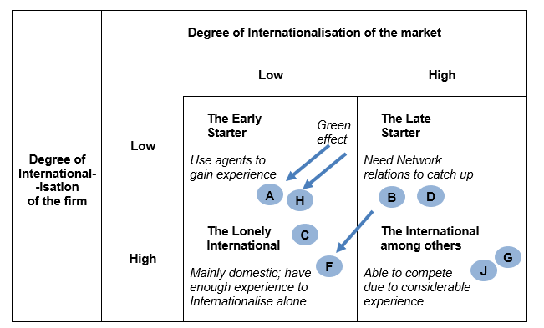
Figure 18: Internationalisation through networks,
adapted from Johanson and Mattsson (1988, p. 212)

The definition of ‘market’ depends on how products are placed. Company A’s product, in the packaging sector, should be placed within a highly internationalised market box. Redefining Company A’s compostable packaging as specifically green, the business moves left to a market which has a low degree of internationalisation. The green effect is shown by the arrows on the matrix. The same is true for large-sized Company H: one among many herb and tea exporters, but an early leader amongst organic herbs and teas. Similarly, SME F benefits from making sustainable, quality furniture for a niche market. The effect of internationalising a green product therefore appears to add competitive advantage for a business, by placing it in a less crowded international market.

The lack of effective partners held back Companies E and I from internationalisation. Company I commented:
“If we could partner with other removal firms in Europe then we might be able to link up for contracts, but that is some way off at the moment.”
Company E eyed the potential benefits of networking with companies in Europe to facilitate business expansion, but has not internationalised yet: E is moving towards the suggestion by Davies that meta-clustering of Greentech companies across national borders is a means to help internationalise green businesses (Davies, 2013).

Company D’s suppliers are not just considered contractually but as part of a mission to preserve sustainable practices:
“By taking contracts with them we are guaranteeing people work and helping them to improve their lives. Some are cooperatives and most don’t have any export experience so by partnering with us they get a good deal. We feel a responsibility towards them to honour our orders and not to cancel or change them at the last minute when sales vary.”
This became a financial risk. When the 2009 downturn in sales came, the company upheld its fair-trade commitments and paid its suppliers, but was left with excess stock. It then faced financial problems and had to restructure. Thus, Granovetter’s (1973) theory that network ties which are too close can be a disadvantage is shown by Company D’s experience.

It is a matter for further research to separate out the extent to which networks are a driver of internationalisation, from the role they play as facilitators for green businesses. Commitment decisions sometimes came from the founder finding network solutions to answer practical questions of business operation, rather than forming those decisions in the first place.

4.7 Entrepreneurship Qualities
4.7.1 Business opportunity
All of the businesses interviewed referred to common entrepreneurship qualities which might be expected of business founders in any particular sector, not just green businesses, shown in Figure 19. Inspiration and risk taking, identified in research as particularly important when internationalising (Leonidou et al, 1998), are reflected here.
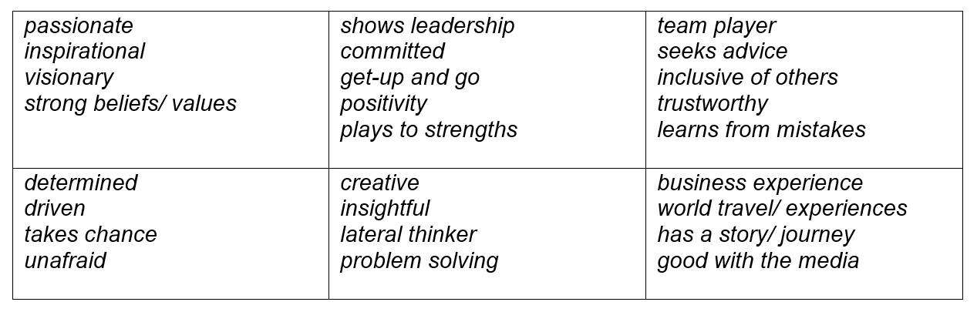
Figure 19: Entrepreneurship qualities mentioned in interviews (roughly grouped).

The founder of Company A had ambition and a business orientated goal: to be a global leader:
“Our CEO is very determined and it is his personal vision that drives us forward. He sets demanding targets for fast expansion and is driven to make an impact in the world. He wants the business to be a global leader.”
Company B referred to entrepreneurial advice from the CEO and founder:
“It’s also essential to learn from others outside of the business: seek advice and learn from other people's mistakes. Play to your strengths. Develop a strong brand. You have to make it highly visible wherever you can…. Don’t be afraid to do something totally new.”
Company F also described similar entrepreurial qualities in their founder:
“He is very passionate about being creative as well as being eco-friendly and using natural materials. He inspires everyone in the company.... When he started the business, he launched a Kickstarter campaign and managed to get over 200 backers who gave 260% of what he asked for.”

Business expereince was important for some of the leaders interviewed, including founders of A and F. However, no company particularly singled out prior expereince of internationalisation in business as being important for success.

4.7.2 Necessity entrepreneurship
Three businesses identified internationalisation as a means to survival. B commented: “At times when there is a UK downturn, international sales really help keep the business going.” G addressed oversupply by diversifying and increasing sales overseas. The effect of the 2009 downturn necessitated a restructuring of Company D:
“After 2009 we set up franchises like us and a wholesale business for sales, including sales to European businesses…For exporting, it was a necessity because our UK sales were declining after the recession.”

4.7.3 Green opportunity
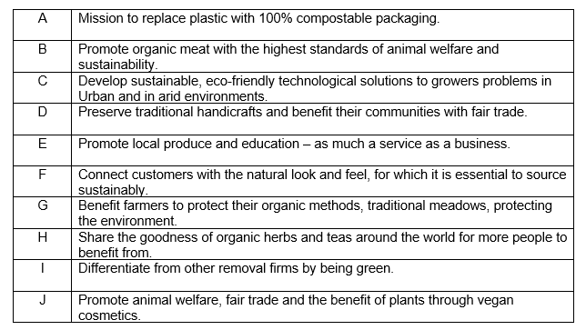
Figure 20: Summary of the green mission of each business under consideration.

Each business had a green basis to their entrepreneurship, summarised in Figure 20. This ranged from ethical principles being at the core of the enterprise, as in C and J, to being a differentiator against rivals, as in I. Company C commented:
“We are here to solve climate problems and work in partnership with others in the developing and developed world, not just maximise profit.
Nevertheless, partnership does not mean charity, as Company D commented:
“[The founder] believed in helping people out of poverty and doing something wonderful to support their traditions and crafts... His vision was to do it not by charity but by trade.”

A green product may not look physically different, but it it important for customers feel part of a green movement, a point made by Company B:
“Basically, it's selling a product that you believe in, and it's selling a product with a story, that's produced perhaps using local ingredients and telling the customer about the environment the product is coming from.”

4.7.4 Green motivations
Whilst some leaders mentioned business experience, more referred to green motivating factors for their entrepreneurship. Furniture making Business F, commented: “The founder was inspired as a child to use trees to make things and began making furniture as a hobby.” Similarly, the founder of J said: “He grew up learning about the value of plants as medicine with his mother. He also benefitted from organic creams when he had skin problems himself.”

For organic farmers Company B, the was a means of preserving family heritage and way of life. Company A’s founder experienced a recycled product whilst abroad, inspiring him, and Company H commented:
“One [founder] had passion for organic herbs, experience of travelling to India, doing yoga, and working for an organic farm – now one of our suppliers.”
The founder of Company D visited India in a gap year and wanted to help people and the founder of C was inspired during travel to desert like locations to find solutions for drought problems.

Green entrepreneurs from this sample were found to be particularly open to different experiences, different cultures and forming good relations using their interpersonal skills. Given that these are key to entrepreneurship (Leonidou et al., 1998), this suggests that green entrepreneurs are exceptionally well placed for success.

4.8 Born Globals
Company J exported from its beginning and C did so after 2 years, selling over 25% overseas by the third year. Their export destinations are sprinkled across Europe, southern Africa and North America. Companies A and H internationalised over a decade before and took more time to reach the 25% born global threshold for export sales. They might have reached born global status if founded more recently, given the development of communications, especially the internet. As this is a relatively recent phenomenon and the sample size is limited, it is difficult to draw general conclusions.

GEM (Bosma and Kelley, 2018) contains indexes of data about entrepreneurship, comparing countries. The tabular format provided does not differentiate green businesses from others. Relevant data for the UK is given below in Figure 21, compared to companies C and J. In this limited sample, the green businesses achieved a greater percentage of exports with focus on improvement opportunities. This could be due to the global dimension of environmental concern, increasing the propensity for green businesses to go global quickly.

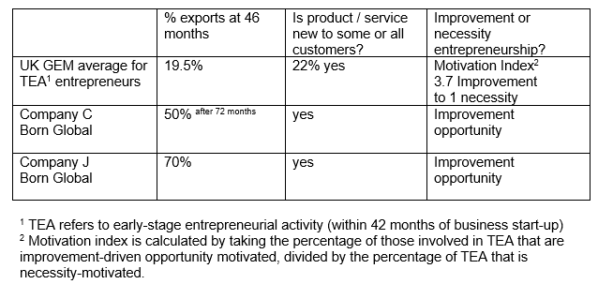
Figure 21: Comparison of this sample with GEM data for 2018.

4.9 Green business approaches
4.9.1 Types of green businesses
The types suggested by Walley, Taylor and Greig (2010) are partly evident, although the categorisation does not apply neatly. In many ways Company A is an innovator opportunist, focused on economic matters, aiming to be competitive with non-eco brands and establish global leadership. Yet despite this economic focus, green matters are calculated and reported on and at the core of the business, making it as amongst the most sustainability focused according to the criteria provided by Schaltegger (2010).

Environmental and ethical practice is checked and monitored at every stage in born global Business J, despite its micro business size. The importance of campaigns and ethos to J suggests this business fits the ethical maverick category.
“We support campaigns to change things. We support Stonewall’s campaign for LGBT [Lesbian, gay bisexual and transgender] equality. We support moves away from using pesticides. We believe it’s important to get certificates to show your standards. We ask suppliers questions, like do you sell to China, even though they insist on testing on animals? By doing this we can change the industry at every level.”

Some businesses emphasised ethical credentials more than green ones, without viewing them as opposed. A priority for Business G was to stabilise and expand sales with exports, putting economic focus first, in so doing helping to preserve livelihoods of organic fair-trade farmers. Standards of animal welfare are also cited as important. D emphasises fair trade, as does H, and this goes hand in hand with sustainability:
“We make sure that our suppliers always take from sustainable sources. The business has signed up to a fair-trade scheme which guarantees producers a fair price for what we buy. We also donate 1% of turnover to environmental charities each year. We are also part of the B company movement. B companies sign up and are certified to balance profit with making sure all decisions have positive impact.”

Company I tracks sustainability and advertises this to differentiate their service:
“We use biodiesel in our vans, which is made from recycled chip shop oil. We only use recycled packaging and wrapping paper. Our website is run on a solar powered server. In every way we could think of, we’ve gone green…The removals business is very competitive and it didn’t cost much to go green. We are able to differentiate ourselves from other removal companies by being green.”

B is a champion of sustainability across the business, including organic for quality, animal welfare and with a story to tell:
“We are one of the few farming businesses left where everything is field to plate; traceable, sustainable… We have started doing a lot of alternative energy projects, from wind turbines to solar and hydro and geothermal energy to power the farm.”

The common factor in all, regardless of extent, is the distinguishing added value of greenness. This is couched in terms universally appreciable: fair trade world-wide; sustainability for the good of the global environment. This supports Collins’ suggestion (2008) that green and ethical factors are creating competitive advantage.

4.9.2 Green certifications
The importance of green credentials which can be trusted is an emerging theme from this research. Figure 22 shows the certifications referred to in the interviews. Customers are paying a premium for green products and certification helps prove their worth. Other methods of exposure included presence at fairs, in magazine articles and at awards, such as the entry by the founder of Company F to a climate action award by Knowledge and Innovation Community (KIC).

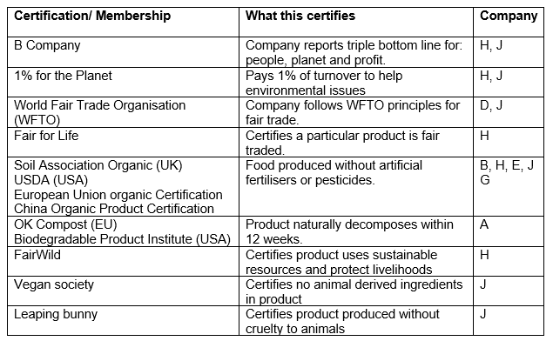
Figure 22: Regulations, certifications and Memberships

Certifications refer to global matters such as sustainability and fair-trade. This appears important in the internationalisation of green businesses and may make it easier to export globally. Company A commented:
“We can trace the origins of our containers from our suppliers to show we are using green waste and organic materials. We can prove that our products decompose within 12 weeks of being put in waste facilities where they can decompose… Our products are certified by the main USA and European compostable standards and are traceable. This is important to us to show our green credentials. We also send out eco-order receipts to our customers telling them how many kg of landfill waste they’ve saved and how much carbon our orders use compared to plastic equivalent.”

Nielson’s (2015) claims about the importance of green certification for consumers in developed countries is borne out here. As shown by Figure 13, the business operations of these companies are mostly in high income countries. Where they are not, Company G exports to China, as its growing middle class of consumers increasingly adopt western interests. An exception is Company C which works in partnership with purchasers in developing nations. The challenge of becoming truly global green exporters, and market to the developing world, is something that requires further research.

Regulations were a barrier to be overcome for some of the businesses. Cooperative G needed partnerships to achieve organic certification in four different authorities. Two businesses mentioned BREXIT, Britain’s withdrawal from the European Union, as a particular worry. Company B commented:
“Most Welsh lamb exports go to the EU. NTBs, that is Non-Tariff Barriers, could be a bigger problem than tariffs because if we lose EU agreements with third countries that could stop exports. There has been a lot in the press from the organic movement about this. Irish beef production is already very competitive and we will be at a disadvantage.”
G also commented:
“Organic standards are set by the EU and by EU agreements about equivalent standards with other countries. We could lose these overnight. Also, farm subsidies might change so we would get less than EU farmers.”

For Company I, not yet internationalised, the availability of green resources to fulfil their advertised credentials brought more complexity when internationalising:
“We offer all customers green removals by using biodiesel in the UK but the supply is different in Europe and we have to refuel from normal filling stations with diesel to start with, until we can find partners in Europe.”

  - Extent of difference
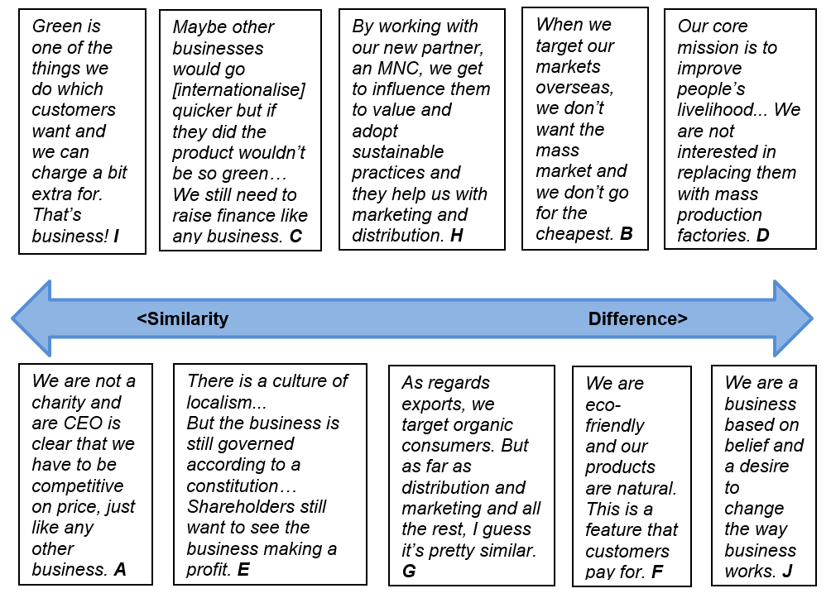

Figure 23: Quotations about perception of differences in internationalisation

Companies were asked to reflect on the overall extent to which the internationalisation of their green, ethical enterprise was different from that of a general business. A selection of quotations from their answers is shown in Figure 23. These range from those who said there was little difference on the left, to those who thought there was “light years of difference” (Company B) on the right. To some extent, larger businesses (A, H and G) saw more similarities; smaller, passionate, ethical concerns (B, D, F and J) saw differences in all aspects of their operations.

It might be concluded from this that the ideal way to better the planet is to stake universal ethical or green claims, gain certification and advertise this with passion. Businesses should ensure all aspects of their operations are environmentally sustainable, and give consumers attachment to environmental and ethical causes, thereby achieving competitive advantage. This method worked well for ethical champions J and B. But the realities of business are that they require financial discipline to survive, as was the experience of D, and investment to expand.

An alternative approach is to create a business goal of global leadership for a green product, raise venture capital for investment, and aim for competitive advantage by being most efficient. This was the path chosen by Company A, and partly by H, which chose MNC support to expand. The larger a green business becomes the more important economic concerns seem to be for internationalisation. If a company really wants to “change the way business works” (Company J), it may need to scale up and integrate with the operations of the mass market. Expanding green internationals therefore need to compromise, to integrate their green mission with economic business models, and in so doing bring greater influence on others to go green.

5. Conclusions and recommendations
The main question will now be assessed by drawing conclusions to the objectives defined in section 1.2. The main question is: what are the key factors for the internationalisation of aspiring businesses with an ethical/ organic/ green focus?

5.1 The nature of internationalisation
The literature review found several models, none of which fitted well the range of green businesses analysed in this research. Whereas Vernon suggests production of mature products move overseas, green businesses here retained it in their centres of expertise to ensure regulations and standards were met. Collaboration, partnerships, particularly the use of distributors with expertise in new markets, were used by green businesses provided they shared green credentials. This complexity diverged from expected economic advantages as predicted by Dunning. It has already been noted that a national, staged model of internationalisation is somewhat dated for business (Davies, 2013); this seems particularly so for green businesses.

Uppsala’s concept of psychic distance, suggesting businesses target similar markets, has some relevance. Several companies here targeted high-income countries in which a significant number of consumers shared a particular view of concerns about the environment, supporting Nielson (2015). This pattern may be loosening as larger pools of middle class, organic-preferring consumers arise in China and developing countries. There is evidence to suggest many of the company’s target a particular type of ethically conscious consumer across borders rather than a national market, as in the case of companies D, F and J.

5.2 Defining green businesses
Green businesses were very broadly defined from the literature review and as a result examples were taken here to reflect different sizes and those at different stages of internationalisation. All claimed to have some sort of inspiration to do good for the world, and displayed ethical and environmental credentials. Company A fits the innovator opportunist and Company J the ethical maverick, using the types defined by Taylor and Greig (2010).

All of the businesses offered products or services which differentiated with added value in some form of greenness or ethical value, such as sustainability for the good of the global environment. This supports Collins’ suggestion (2008) that green and ethical factors are creating competitive advantage and therefore crucial to internationalisation. On the other hand, some used distributors and partners with business expertise without necessarily sharing green values. It is proposed that this may affect the rate and style of internationalisation: businesses which demand green standards in all aspects may be prepared to internationalise more slowly, attracting a niche of committed, green consumers. Others might wish to change the world and become a global leader more quickly, such as Company A, using established general business know how, and further their mission to help environmental causes through the mass market. More research is needed to discover if this way of differentiating green businesses holds true for a greater number of examples.

5.3 Factors which most influence internationalisation
In common with general businesses, a range of factors influenced internationalisation, including taking opportunities to gain new markets as well as out of necessity to respond to events such as the 2009 downturn in domestic demand. All of the businesses commented on the green mission of their company or founder, a strong desire to change current practice and make the world more sustainable and eco-friendlier. This came across more strongly as motivation for internalisation.

The importance of entrepreneurial qualities was much in evidence, but the desire for profit and market dominance mentioned less frequently than the inspiration to share a cause. This appears to support the concept of ‘ecopreneurs’ (Schaper, 2010). Networking was also important, often for more practical reasons, in many cases to find distributors with knowledge of new markets. Networks included particular green clusters which enabled businesses to fulfil environmental credentials, identified as important or very important by nearly all of the businesses in this research. Cavusgil and Knight’s claim that internationalisation is the development of relationships seems especially true for green businesses (Cavusgil and Knight, 2009). Entrepreneurship and networking better explain aspects of internationalisation than models for businesses in this research.

5.4 Are green businesses distinct in their approach to internationalisation?
Perceptions of the degree of difference, shown in Figure 23, ranged from those who said there was little difference to those perceiving “light years of difference”. Areas of particular similarity included the need to appoint knowledgeable local agents. Significant differences were experienced by many in the need to fulfil regulations, such as organic certification, requiring technical expertise. Many saw certifications as an opportunity to promote and add value, rather than stifle export sales. Nielson’s (2015) claims about the importance of green certification for consumers in developed countries is borne out here. For most of the green businesses, markets consisted of particular groups of discerning consumers, not mass country markets. Expensive advertising campaigns were shunned for media stories, collaborative partnerships and even advertising business support for ethical campaigns. This suggests that the more importance a business places on ethical and green issues, the more distinct their approach to internationalisation might be.

The research literature identified born-globals as a new type of start-up. It was found there was a problem in the UK in that very few SMEs internationalise. This research positively identified green born-globals benefitting from the internet, communications and partnerships to become international more quickly. It may be that green businesses perceive environmental problems as global therefore are more inclined to go-global address them.

Financial concerns became a theme not specified in the original research plan. They suggest that green businesses might not be so different after all. Raising venture capital, a takeover by an MNC, and a restructuring for financial reasons were amongst the events experienced by green businesses suggesting that hard economics are always present in internationalisation. Some modified this to pay 1% of turnover to good causes and report according to the Triple Bottom line to give equal weight to reporting environment and social concerns as well as profit (Sommer, 2012), making their reporting distinct.

5.5 Flagging factors for success and problems for further research
Key factors for success frequently identified in the business interviews here are:
- Drive and enthusiasm of an entrepreneur committed to a green cause;
- Strong green networks to gain inspiration for internationalisation, and partners with target market experience to facilitate distribution;
- Certified green credentials/ satisfying regulations to add value to the product and capture a discerning market of ethically committed consumers;
- Targeted publicity to find those customers through alternative cost-effective means such as magazine articles and collaborative projects; and
- Good business acumen in organising financial backing for expansion, in common with general businesses.

Further research is needed to explore in more detail, and with a larger sample size, the initial findings of from this sample. That might enable generalisations to be validated. The selection of green businesses here was very broad: more research might take a narrower range of businesses and use a tighter definition of ‘green’, in order to pinpoint critical factors. The companies in this research internationalised at different times and internationalisation for businesses in general should not be assumed to stay constant, given the fast-changing nature of modern business practices and environmental concerns. Therefore, future research could consider more closely the effect of time. Comparisons with general businesses were made by referring to literature; this might be addressed in future research by comparing a selected control group of companies with green ones.

References
Aguilera-Caracuel, J., Hurtado-Torres, N., & Arago´n-Correa, J. (2012) Does international experience help firms to be green? a knowledge-based view of how international experience and organisational learning influence proactive environmental strategies. International Business Review 25(1) 10/2012:847-861
Albaum, G., Strandskov, J. & Duerr, E., (1998) International Marketing and Export Management. 3rd ed. Essex: Addison Wesley Longman Ltd.
Alon, I., Jaffe, E., Prange, C. & Vianelli, D. (2017) Global Marketing. Contemporary Theory, Practice and Cases. 2nd ed. Taylor and Francis.
Anderson, S. (2000) The Internationalization of the Firm from an Entrepreneurial Perspective, International Studies of Management & Organization, 30:1, 63-92
Bartlett, C. & Beamish, P. (2018) Transnational Management: Text and Cases in Cross Border Management. Cambridge.
Bhasin, H. (2017) Benefits and Limitations of Product Life Cycle. Marketing91 02/09/2018. Available online at: https://www.marketing91.com/benefits-and-limitations-of-product-life-cycle/ [Accessed 05/02/2019]
Bosma, N. & Kelley, E. (2018) Global Report 2017/8. Global Entrepreneurship Research Association.
Braun, V. & Clarke, V. (2006) Using thematic analysis in psychology. Qualitative Research in Psychology 3(2): 77–101
Burns, P. (2010). Entrepreneurship and small business: Start-up. Growth and maturity (3rd edition) Palgrave Macmillan.
Cainelli, G., Mazzanti, M. & Montresor, S. (2011) Environmental innovations, local networks and internationalisation. Ferrara University 01/2011. Available online at: http://docente.unife.it/paolo.pini/ricerca/pubblicazioni-1/innovazione-produttivita-sistemi-locali-regionali-strategie-di-innovazione-e-risultati-economici/2011-01.pdf [Accessed 26/02/2019]
Cavusgil, S. & Knight, G. (2009) Born Global Firms: A New International Enterprise. New York: Business Expert Press.
Cavusgil, S. & Knight, G. (2015). The born-global firm: An entrepreneurial and capabilities perspective on early and rapid internationalization. Journal of International Business Studies, 46(1), 3–16.
CEBR (2016) Thinking Global: The Route to UK exporting success. Worldfirst. Available online at: https://www.worldfirst.com/downloads/Think_Global_WorldFirst.pdf [Accessed 12/12/2018]
Čekanavičius, L., Bazytė, R. & Dičmonaitė, A. (2014) Green Business: Challenges And Practices. Ekonomika 2014 Vol. 93:1. Available online at: http://www.zurnalai.vu.lt/ekonomika/article/viewFile/3021/2162 [Accessed 9/12/2018]
Chandra, Y. & Wilkinson I. (2017) Firm internationalisation from a network-centric complex-systems perspective. Journal of World Business 52(5): 691-701. Available online at: https://www.sciencedirect.com/science/article/pii/S1090951617304674 [Accessed 18/04/2019]
Cohen, B. & Winn, M. (2007) Market imperfections, opportunity and sustainable entrepreneurship. Journal of Business Venturing 22: 29–49.
Collins, J. (2008). Why “Green” is good for business. Business and Economic Review, pp. 25–26.
Cooney, S. (2008). Build a Green Small Business: Profitable Ways to Become an Ecopreneur. New York, McGraw-Hill.
Coviello, N., Kano, L. & Liesch, P. (2017) Adapting the Uppsala model to a modern world: Macro-context and microfoundations. Journal of International Business Studies 48(9) 12/2017: 1151–1164.
Croston, G. (2009). Starting Green: An Ecopreneur’s Toolkit for Starting a Green Business from Business Plan to Profits. Entrepreneur Press.
Davies, A. (2013) Cleantech clusters: Transformational assemblages for a just, green economy or just business as usual? Global Environmental Change 23(5) 10/2013: 1285-1295
DEFRA (2005) Securing the future: delivering UK sustainable development strategy. UK government. Available online at: https://www.gov.uk/government/publications/securing-the-future-delivering-uk-sustainable-development-strategy [Accessed 11/02/2019]
Deresky, H. (2017) International Management Managing Across Borders and Cultures. 9th edition. Pearson.
Dunning, J. (1988). The eclectic paradigm of international production: A restatement and some possible extensions. Journal of International Business Studies, 19:1, 1–31.
Dunning, J. & Mcqueen, M. (1981) The Eclectic Theory of International Production: A Case Study of the International Hotel Industry. Managerial and Decision Economics 2(4) Multinational Business 12/1981 197-210.
Eriksson, K., Johanson, J., Majkgård, A. & Sharma, D. (1997). Experiential knowledge and cost in the internationalization process. Journal of International Business Studies, 28(2), 337–360.
Esty, D. & Winston, A. (2009) Green to gold: How smart companies use environmental strategy to innovate, create value, and build competitive advantage. John Wiley & Sons Inc.
European Commission (2007) Final Report of the Expert Group on Supporting the internationalisation of SMEs. Available online at: http://ec.europa.eu/growth/smes/access-to-markets/internationalisation/studies_en [Accessed 01/12/2018]
European Commission (2018) SME Internationalisation beyond the EU. Available online at: https://ec.europa.eu/growth/smes/access-to-markets/internationalisation_en [Accessed 01/12/2018]
Fankhauser, S., Bowen, A., Calel, R., Dechezleprêtre, A., Grover, D., Rydge, J. & Sato, M. (2013) Who will win the green race? In search of environmental competitiveness and innovation. Global Environmental Change. Available online at: http://www.sciencedirect.com/science/article/pii/S0959378013000812 [Accessed 12/12/2018]
Ferner, A. (2000) The Underpinnings of ‘Bureaucratic’ Control Systems: HRM in European Multinationals. Journal of Management Studies 37:4, 521–40.
Forsgren, M. & Johanson, J. (1975) International business economics. Stockholm: Norstedts.
Forsgren, M., Holm, U. & Johanson, J. (2005). Managing the embedded multinational, a business network view. Edward Elgar Publishing Limited, UK.
Freel, M. (2005). Perceived environmental uncertainty and innovation in small firms. Small Business Economics, 25(1), 49–64.
Gallagher, K. (2014) The Globalization of Clean Energy Technology: Lessons from China, Boston: MIT Press
Gast, J., Gundulf, K. & Cesinger, B. (2017) Doing business in a green way: A systematic review of the ecological sustainability entrepreneurship literature and future research directions. Journal of Cleaner Production 147, 01/2017: 44-56
Ghemawat, P. (2007) Redefining Global Strategy: Crossing Borders in A World Where Differences Still Matter. Harvard.
Granovetter, M. (1973) The Strength of Weak Ties. The American Journal of Sociology, 78(6):1360-1380. Available online at: https://www.cs.cmu.edu/~jure/pub/papers/granovetter73ties.pdf [Accessed 19/04/2019]
Gray. D. (2014) Doing Research in the Real World. 3rd ed. Sage.
Hashai, N., Almor, T (2004) Gradually internationalizing ‘born global’ firms: an oxymoron? International Business Review 13. 465–483.
Henriksen, K., Bjerre, M., Almasi, A. & Damgaard-Grann, E. (2012) Green Business Model Innovation: Conceptualization report. Nordic Innovation Publication Oslo, Norway.
Hill, C. W. L. (2007). International business: Competing in the global marketplace. Boston: McGraw-Hill/Irwin.
Hindle. T. (2008) Guide to Management Gurus and Ideas. The Economist.
Hollesen, S. (2001) Global Marketing: A Market-responsive Approach. 2nd ed. Europe: Prentice Hall.
International Green Growth Forum (2016) The business of becoming a sustainable nation. Available online at: https://gov.wales/docs/det/publications/160509-evaluation-en.pdf [Accesses 01/12/2018]
Jacob, K. et al (2006) Lead Markets for Environmental Innovations. Springer
Jansson, J., Marell, A. & Nordlund, A. (2010). Green consumer behaviour: determinants of curtailment and eco-innovation adoption. Journal of Consumer Marketing, 27(4) pp. 358–370.
Johanson, J. & Mattsson, L. (1988) Internationalisation in industrial systems: A network approach, In: Hood, N., Vahlne, J. (eds), Strategies in global competition. Croom Helm, London, pp. 194-213.
Johanson, J. & Vahlne, J. (1977). The internationalization process of the firm- A model of knowledge development and increasing foreign market commitments. Journal of International Business Studies, 8(1), 23-32.
Johanson, J. & Vahlne, J. (2009). The Uppsala internationalization process model revisited: From liability of foreignness to liability of outsidership. Journal of International BusinessStudies, 40(9), 1411-1431.
Johanson, J. & Wiedersheim-Paul, F. (1975). The internationalization of the firm. Four Swedish cases. Journal of Management Studies, 12(3), 305-323.
Johansson, U. & Sabel, J. (2016) Being Green and Global - A qualitative study of sustainable Swedish fashion companies and their environmental work connected to internationalization. Thesis submission Uppsala University. Available online at: https://www.diva-portal.org/smash/get/diva2:941045/FULLTEXT01.pdf [Accessed 25/02/2019]
Johnson, G., Whittington, R., Scholes, K., Angwin, D. & Regner, P. (2017) Exploring Strategy, text and cases. 11th edition. Pearson.
Karami, A. (2007). Strategy formulation in entrepreneurial firms. Great Britain: Ashgate Publishing Limited.
Kidwai, N. (2017) Going green is good for business. Financial Times 04/09/2018. Available online at: https://www.ft.com/content/b45860b2-917e-11e7-a9e6-11d2f0ebb7f0 [Accessed 09/12/2018]
King, N. & Brooks, J. (2017) Template Analysis for Business and Management Students. Sage.
King, N., Horrocks, C. & Brooks, J. (2018) Interviews in Qualitative Research. Sage.
Kirkwood, J. & Walton, S. (2010) How ecopreneurs’ green values affect their international engagement in supply chain management. Journal of International Entrepreneurship, June 2010, 8:2. Available online at: https://link.springer.com/journal/10843 [Accessed 01/12/2018]
Knight, G. (2015). Born global firms: Evolution of a contemporary phenomenon. Entrepreneurship in International Marketing. Advances in International Marketing, 25, 3 – 19. Emerald Group Publishing Limited.
Leonidou, L., Katsikeas, C. & Piercy, N. (1998). Identifying managerial influences on exporting: Past research and future directions. Journal of International Marketing, 6(2), 74-102.
Leonidou, L., Fotiadis, T., Christodoulide, P., Spyropoulou, S. & Katsikeas, C. (2015) Environmentally friendly export business strategy: Its determinants and effects on competitive advantage and performance. International Business Review 24 (2015):798–811.
Makower, J. (2018) The State of Green Business 2018. Trucost. Available online at: https://www.greenbiz.com/reports/ [Accessed 12/12/2018]
Makower, J.; Pike, C. (2009). Strategies for the Green Economy: Opportunities and Challenges in the New World of Business. New York, McGraw-Hill.
Maxwell, J. (2012) A realist approach to qualitative research. Sage.
McDougall, P. & Oviatt, B. (2000). International Entrepreneurship: The intersection of two research paths. The Academy of Management Journal, 43(5), 902–906.
Merriam, S. & Tisdall, E. (2016) Qualitative research: a guide to design and implementation. Wiley.
Miliband, D. (2006) Every industry should be an environmental one. Sustainable Business Magazine 09/02/2007. Available online at: https://www.edie.net/library/Every-industry-should-be-an-environmental-one/4012 [Accessed 21/02/2019]
Mitgwe, B. (2006) Theoretical Milestones in International Business: The Journey to International Entrepreneurship Theory. Journal of International Entrepreneurship 4: 5-25.
Nielson (2015) The sustainability Imperative: New insights on consumer expectations.
O’Cass, A. & Weerawardena, J. (2009). Examining the role of international entrepreneurship, innovation and international market performance in SME internationalisation. European Journal of Marketing, 43:11.
OECD (2009). Top barriers and drivers to SME internationalisation. Report by the OECD Working Party on SMEs and Entrepreneurship. OECD Publishing.
Omri, A. (2018) Entrepreneurship, sectoral outputs and environmental improvement: International evidence. Technological Forecasting & Social Change 128: 46–55
Ostaszewska, E. (2016) IKEA’s FDI in a Manufacturing Plant in Poland: Pursuing OLI Advantages – Case Study. Berlin Institute for International Business Studies (BIIBS) Paper No. 2, 03/2016. Available online at: http://www.biibs.org/uploads/6/8/7/2/68724203/biibs_wp_no2.pdf [Accessed 21/02/2019]
Oyson, M. & Whittaker, D. (2010). An Opportunity-Based Approach to International Entrepreneurship: Pursuing Opportunities Internationally through Prospection. Proceedings of the 18th Annual High Technology Small Firms Conference, May 27-28, 2010, The Netherlands.
Park, J. & Ahn, Y. (2012). Strategic environmental management of Korean construction industry in the context of typology models. Journal of Cleaner Production, 23(1), 158-166.
Quinn, M. (2002) Qualitative Research & Evaluation Methods. 3rd ed. USA: Sage.
Quitzow, R. (2015) A dynamic perspective on environmental innovation and national competitiveness - an assessment of policy and empirical evidence from the solar energy sector. Phd Thesis, University of Berlin. Available online at: https://d-nb.info/1073869091/34 [Accessed 04/03/2019]
Revilla, E. (2015) Internationalisation of green SMEs. European Commission. Available online at: https://www.ceps.eu/sites/default/files/Internationalisation%20of%20green%20SMEs%20Eva%20Maria%20Revilla.pdf [Accessed 20/11/2018]
Rhodes, C. (2018) Business statistics. House of Commons Library Briefing Paper Number 06152, 12/12/2018.
Rialp, A. & Rialp, J. (2001) Conceptual frameworks on SMEs’ internationalization: Past, present and future trends of research. Reassessing the Internationalization of the Firm. 11, 49-78.
Robson, C. (2002) Real World Research. 2nd ed. Blackwell.
Rugman A. & Brewer T. (2001) The Oxford Handbook of International Business. Oxford University Press. New York
Rugman, A. & Verbeke, A. (1998) Corporate strategy and international environmental policy. Journal of International Business Studies, 29(4): 819–833.
Saunders, M., Lewis, P. & Thornhill, A. (2016) Research Methods for Business Students. 7th ed. Pearson.
Schaltegger, S. (2010) A Framework and Typology of Ecopreneurship: Leading Pioneers and Environmental Managers to Ecopreneurship in Schaper, M. Making Ecopreneurs: Developing Sustainable Entrepreneurship. Routledge. Chapter 5.
Schaper, M. (2010) Making Ecopreneurs: Developing Sustainable Entrepreneurship. Routledge.
Scott, A., McFarland, W. & Seth, P. (2013) Research and Evidence on Green Growth. Research on demand. Available online at: https://assets.publishing.service.gov.uk/media/57a08a14ed915d622c000551/EoD_HD064_July2013_GreenGrowth_Final.pdf [Accessed 03/12/2018]
Sommer, A. (2012). Managing green business model transformations. Berlin: Springer.
Symon, G. & Cassell, C. (2012) Qualitative Organisational Research: Core Methods and Current Challenges. Sage.
The Carbon Trust (2006) Carbon footprints in the supply chain: the next step for business. Available online at: https://www.carbontrust.com/media/84932/ctc616-carbon-footprints-in-the-supply-chain.pdf [Accessed 14/02/2019]
UK Government (2018) Export Strategy. Available online at: https://assets.publishing.service.gov.uk/government/uploads/system/uploads/attachment_data/file/737201/HMG_Export_Strategy.pdf [Accessed 03/12/2018]
UN (2013). Global Corporate Sustainability Report. Available online at: https://www.unglobalcompact.org/library/371 [Accessed 21/02/2019]
Vernon, R. (1966) International investment and the international trade in the product cycle. Quarterly Journal of Economics, May 1966.
Vernon, R. (1992) Transnational corporations: Where are they coming from, where are they headed? Transnational Corporations, 24(1/2): 7–35.
Walley, E., Taylor, D. & Greig, K. (2010) Beyond the Visionary Champion: Testing a Typology of Green Entrepreneurs in Schaper, M. Making Ecopreneurs: Developing Sustainable Entrepreneurship. Routledge. Chapter 4.
WCED (1987) Report of the World Commission on Environment and Development: Our Common Future. UN. Available online at: http://www.un-documents.net/our-common-future.pdf [Accessed 04/02/2019]
World Bank (2019) World Bank Country and Lending Groups. Available online at: https://datahelpdesk.worldbank.org/knowledgebase/articles/906519#High_income (Accessed 18/04/2019]
World Business Council for Sustainable Development (2008) Sustainable Consumption Facts and Trends.
Wycherley, I. (1999) Greening Supply Chains: The Case of The Body Shop International. Business Strategy and the Environment 8: 120–127.
Yin, R. (2003) Case Study Research: Design & Methods. 3rd ed. Thousand Oaks: Sage
Zubirán, N. & Ritah Nafula, R. (2012) Born Global firms from emerging economies: Investigating their success factors in international markets. Masters Thesis, Halmstad University. Available online at: http://www.diva-portal.org/smash/get/diva2:538861/FULLTEXT01.pdf [Accessed 27/02/2019]

Appendixes

Appendix 1. Interview questions

1. What is the nature of your business?
2. In what ways could your business be regarded as a ‘green’ business?
3. How would you describe your company’s position in the domestic market?
4. What are your current international operations (if any)?
5. What are your future desired international operations (if any)?
6. What factors influenced your business (or would influence the business in future if not already international) to become international?
7. How far do the CEO/ Directors/ ‘Entrepreneurs’ driver forward decision making (with regard to internationalisation) in your business?
8. In what ways is your business involved in links with other businesses and organisations? How important are these when considering internationalisation?
9. How important would you consider internationalisation for your business?
10. Do you consider the way your business operates, particularly as a ‘green’ business, to be different from general businesses? Does this extend to the company’s approach to internationalisation?

Appendix 2: Interview transcripts
Transcript A

1. We make recycled food packaging using food waste and organic products. The food containers we make are compostable and recyclable.

2. Absolutely! Plastic packaging is of great concern because it pollutes the seas and ends up in landfill. Very little plastic packaging actually gets recycled. Our products are 100% compostable. We can trace the origins of our containers from our suppliers to show we are using green waste and organic materials. We can prove that our products decompose within 12 weeks of being put in waste facilities where they can decompose. This is at the heart of our company and what we are all about. We have an environmental policy which we follow. Our brand makes clear we are green and this is shown on our website. We provide leaflets about recycling. Our products are certified by the main USA and European compostable standards and are traceable. This is important to us to show our green credentials. We also send out eco-order receipts to our customers telling them how many kg of landfill waste they’ve saved and how much carbon our orders use compared to plastic equivalents. We encourage our customers to advertise this with our name in their businesses.

3. The food packaging market is huge in the UK, and we are a small but growing part of that. We estimate that we have about 3% of the disposable food packaging share. The vast majority of the market is traditional plastic, disposal packaging. We do not supply plastic: our company specifically targets replacing plastic packaging with compostable. If you want other sorts of packaging you can get pulp, from recycled cardboard and similar products, which is a growing market. But our product is different because it is made from compostable organic waste. We are the leader in this. In the past three years or so other start-ups have been competing on price in our market but the market overall is still growing because people want to ditch plastic.

4. Almost 20% of our sales volumes are now international exports which is a great success for us. We have been growing rapidly. We started trading in 2006 and started exporting in 2009. We have licensed companies in the USA and Australia who use our brand and sign up to our environmental principles. We export our products direct to them and they take care of the marketing and distribution over there. We also have a partnership with an established distributor in the USA. We have several partnerships in Europe, where we sell less than other markets at the moment. We advertise our products on our website as part of a global movement against plastic waste. We invite other companies who want to join this movement to sign up to be distributors of our products in their area. We have smaller partnership distributors in New Zealand, Hong Kong and South Africa.

5. Most of our sales growth is in Australia and USA at the moment, but our share there is still small. There is tremendous potential to gain market share in these countries where customers share interest in concern for plastic in the oceans and want to do something about it, just like here in the UK. We are working flat out to supply and expand the market in these markets so we are not looking at expanding into other countries ourselves at the moment. However, we invite others to join with us and become partners and we are interested in making links to expand sales into more countries. We are looking to introduce new products in the UK to meet demand and we can now bring these overseas quickly as we have set up distribution operations already.

6. Our CEO and founder was inspirational in setting the vision to be a global leader. He really believed in our product and wanted to make a difference to the world. He is always looking ahead of the game: he saw the chance to expand overseas and went about getting finance to expand. He does not take no for an answer. We see ourselves as providing a solution to the plastic problem which is polluting the seas. This is a world-wide problem. Therefore, we should be providing a solution to anyone who wants to buy. People were really passionate and committed to the business because they believed in the product.
Finance was important and we got the backing of venture capitalists in return for a stake in the business. It is important to convince financial investors and their backing and encouraging was a boost to our business which meant we could rebuild and expand our processing facilities.
Understanding the certification was important as it is different in the USA from Europe although it’s quite similar really. However, it was important to us to be able to market our products as complying with the highest standards and that meant getting approved. It would have been easier if there was an international agreement to make one set of standards.

7. Our CEO founder was the inspiration for the business. His vision is for us to be a leading global brand in compostable packaging. He had travelled and lived abroad and been inspired by recycled composting material. He also worked in IT and lead project management to solve problems to create new software, so he was experienced in business product development. Our CEO is very determined and it is his personal vision that drives us forward. He sets demanding targets for fast expansion and is driven to make an impact in the world. He wants the business to be a global leader.

8. Yes, I’ve already said about the distributor companies. Also, we work with customers who want solutions. Not only our products are green but we also do green consultancy to help other businesses who buy our products use them better. For example, it is less effective if you buy our trays but they end up being thrown in the normal waste. We worked with a university catering facility to provide special bins at key places for compostable waste to stop most of our trays ending up in general waste. We used technical testing services to develop our products. We needed to set up supply lines and make sure they were compostable. We built up a relationship of trust with suppliers so we knew they were reliable and checked they could supply more materials so we could expand.
We are currently working with an independent coffee shop group, to provide customised coffee cups with their logos as well as promoting our brand in store as a partnership. This is a win win for both us and them. We get sales and publicity and they get to fulfil customer demand for an eco-friendly product. We also bought management software to help monitor and predict demand which was important in our operations. That is because we need to receive delivery, process and dispatch pretty quickly in order to get the products overseas and we don’t have much storage space.

9. Essential. It is our aim to be a global brand leader in compostable packaging and we have been going all out to expand rapidly because it is a good time to do so. Although we were not the first, we are one of the first to make this kind of packaging. We internationalised very quickly because our product is ideal for helping people around the world address plastic. Also, the market in the UK is growing but we have a good share of it now and we are facing stiff competition from new rivals on price. There is much more opportunity to increase sales abroad, especially in the USA. Our employees are pretty mixed and have experience of different backgrounds from different countries. We just kind of think of business as being global these days and we have an international culture in the city we are based in.

10. Not really. Obviously, our product is green and we put a lot of emphasis on that. We market our green credentials and we check our supply lines. We keep to green standards of composting. But in a way those are just the standards that apply and there are always going to be some kind of standards and certification for any product, green or not. We are not a charity and our CEO is clear that we have to be competitive on price, just like any other business. If we offer a green product and people have to pay more for it then that’s not really efficient and it’s not going to work well for the business. We aim to be competitive. We are providing a solution to the problem of plastic waste by selling compostable products and good businesses find solutions to problems, whatever kind of business they are.
Transcript B

1. We are an organic farm business selling meat in our farm shop and supplying elsewhere. We are one of the few farming businesses left where everything is field to plate; traceable, sustainable. My father died in 1998, at that point it was a low input, low output farm. I always believed in sustainable organic farming and when I had a chance to do my own thing this is what I followed; a quantum leap to what my father was doing. In 2002 we began farm gate selling with takeaway burgers and fresh farm meat. In 2004 we began wholesaling to high end restaurants in London. A van now delivers to them three times a week. Since then we have expanded our farm shop and opened a restaurant section with a Bison grill.

2. We are an organic farming business. Organic farming guarantees the highest standards of animal welfare and sustainability. Basically, it's selling a product that you believe in, and it's selling a product with a story, that's produced perhaps using local ingredients and telling the customer about the environment the product is coming from. We have started doing a lot of alternative energy projects, from wind turbines to solar and hydro and geothermal energy to power the farm.

3. Our total business turnover was £8.5 million of which 80% was domestic last year. We supply high end restaurants in London; we sell locally through our farm shop and we are expanding our sales to some supermarkets. We are a quality product for the high-end market and discerning customer. British sales of meat are slightly down but we are holding our own and working hard to introduce new products. We have recently introduced Japanese deer and Bison. Quality products and trying something new helps to diversify our business and give customers something new and interesting to experience.

4. We export to Hong Kong, Macau, Singapore, Dubai, Abu Dhabi, Maldives, Qatar, Bahrain, Amsterdam, and Croatia. 20% of our sales are now exports, about £500,000. We began exporting to Singapore in 2010 when an organic outlet got in touch with us and asked us to supply. This led on to markets in Hong Kong, Dubai and Croatia as the brand has become renowned worldwide. We became known Michelin starred restaurants and that really helped our brand status. Distributors now send a delivery weekly to Hong Kong.

5. We hope to reach new markets for our wholesale business into the Maldives, Denmark and Sweden. We are competing with the southern hemisphere, and increasing share in markets like Singapore and the Middle East. We will also continue to expand our markets for organic chicken eggs where we already sell beef and lamb. I hope BREXIT never happens as it is a problem for us. Most Welsh lamb exports go to the EU. NTBs, that is Non-Tariff Barriers, could be a bigger problem than tariffs because if we lose EU agreements with third countries that could stop exports. There has been a lot in the press from the organic movement about this. Irish beef production is already very competitive and we will be at a disadvantage.

6. The UK meat market varies and has gone up and down, so by internationalising we are spreading risk. At times when there is a UK downturn, international sales really help keep the business going. Some parts of the world do not have domestic supply, such as the in the Middle East and Hong Kong. Everything is imported here so we had a good chance to gain a share of the market. We tend to target parts of the world which are affluent and customers are looking for a high-quality product like ours.

7. We are owner driven. The founder originally went out to high end restaurants to sell the product and generated sales himself. He had get up and go. Then, when he had the chance, he did the same thing by joining a sales mission to Hong Kong. Our business is totally leader driven and our founder has made it what it is today. Advice given from the business founder and CEO is: surround yourself with the right people: a strong team. It’s also essential to learn from others outside of the business: seek advice and learn from other people's mistakes. Play to your strengths. Develop a strong brand. You have to make it highly visible wherever you can. You have to have a story. You have to have a brand and a belief, and some sort of vision as to where you're going. Don’t be afraid to do something totally new. Be savvy to broader consumer trends and tastes. Give extra quality and be a little bit more special and unique.

8. We use distributors in every country. Distributors now deliver to Hong Kong weekly. In 2013 we contracted a distributor with established presence in the Middle East and Far East, specialising in quality food exports. Our distributors also share our concern for the environment. The founder joined a sales mission to Hong Kong organised by the distributors which helped increase our brand exposure. We have developed our internet presence and worked with a company to sort out our systems so we can organise our supplies better. We also promote ourselves through social media online. We also partnered with a local athlete to publicise lean protein meat and health boxes. We believe in employing local people and promoting links with the local community.

9. As I’ve said, it is important to spread risk as the UK market is fluctuating so we spread the risk by selling abroad. It also provides an opportunity to expand the business and provide more local jobs and opportunities.

10. Light years of difference. Organic is sustainable and average business's farming businesses aren't. We give quality and traceability all the way from field to plate. Higher quality comes from belief in organic. Our brand is a story we believe in. Our story is at the heart of our brand and our sales. When we target our markets overseas, we don’t want the mass market and we don’t go for the cheapest. We are a brand that you can trust and you pay for the higher quality. Our choices of market, customer base and distributors all reflect this. I think my ambition all along has been to create a secure business that I can pass over to the next generation and something that also is kind on the environment, as something that one believes in. At the end of the day, we're competing on the world stage and we prefer, much prefer to be a niche producer of sustainable products, rather than always selling on price. And I think here we've got something really special.

Transcript C

1. We make vertical growing systems for plants and small farms. The systems allow plants, vegetables, herbs and fruit to grow without needing soil. The system uses tanks containing fish that add nitrogen fertilisers to the water. The water is recycled, saving fresh water. The company is a micro business with one full time employee. Although we are small, we have links to many other organisations including technical developers and networks to those who may use our products around the world. We are increasingly making links and sending our product overseas to customers in Africa. The product is simple and easy to set up. It supports high value crops which are easier to maintain than normal farming because there are no weeds. The parts for our products are sourced from local manufacturers within 30 miles of our base.

2. We spent 4 years developing our product from the time we started the business in 2012. It was vital to make it green. It is much more efficient that conventional farming. We use vertical space for plants to grow and pools underneath to keep fish. The fish fertilise the water which is recycled for the plants. That means less fertiliser is needed and less water too. Rain water and solar power can also be used with our system. We have won awards for our contribution to adapting technology for the environment and for providing a green product. We are also now providing our system in Africa where arid conditions mean farming is really difficult. By growing more crops in one area it means that they don’t have to be transported in from further afield. There’s a fuel saving which helps the environment.

3. We’ve had a lot of interest from different organisations. We are developing our products further to suit their needs. We’ve had particular interest from farm shops where they like to have fresh, clean salads to display all year round. Our system provides for that. They basically supply a quality product. We’ve also had some local flower growers take interest. I’ve been working with a company in London apply our system in a place where space is limited. There’s growing interest in urban farming. Currently the UK only supplies 52% of its fresh food and all the rest is imported. We have to use the space we have better and Urban farming is one way to do it. The market trends for the sector suggest it may triple in the next decade. It’s always going to be a small section of the main food market but it is becoming more important. Our company is trying to tap into this growing trend.

4. We have started putting our system in with farmers in South Africa and Kenya. It is simple to put together and ideal for the climate difficulties they face. In Kenya the Chinese have bought up some of the rift valley farms for tea growing, so other farmers have to use drier areas. Our system helps them to use those areas better. We have set up two farm systems near Nairobi and these are a model for others to see. Hopefully our system will spread from there. We are working with Scientists from University to provide the best technical solution which we hope we can roll out across Africa.

5. I started getting international interest by attending trade fairs in 2014. I was successful in gaining a place at EXPO with help from the UKTI in 2015. This drummed up a lot of interest although not many orders to start with. I attended an Agri-tech consortium to Canada. Several companies were sponsored to make the trip to drum up business. There’s a huge area around Ontario where our system can be used and we have calculated could see 30% growth from higher yields. We are hoping for orders from there. Roughly half the work of our business is now international. I’ve had enquiries from Egypt, India, Pakistan, Sri Lanka, Australia and the Falkland Islands. I’d like to try Spain too because the climate in south Spain is now drier. I had a contact from Senegal where a farmer was losing half their crop due to transportation problems. We could fix this by setting up a farm nearby using our system.

6. We always aimed to go international and the product is pretty much ideal for that. Having seen the needs of growers and the problems with the environment, it is something that we always wanted to do. The contacts from our local group of Agri tech companies and local universities was also important because they helped make links and suggestions. We also won awards for our environmental contribution and that generated interest from others overseas too. We also needed to get funding. We were fortunate in achieving grants for the development of our products and for some of the sales missions, including the one to Canada. If we didn’t have that then I don’t think we could have made the international links which we did. Now we are better known we are considering a first IPO. That means a public share offer. We need investors who can fund our business so that it can grow, but also understand that we are here to provide a green solution, not just for profit.

7. The founder’s experiences led him to start the company. He previously worked in IT and engineering, and visited dry, desert like locations in the Middle East and Australia. This gave him the idea to think of Scientific solutions to overcome the problems of drought for farmers. The founder was very interested in developing technological solutions to problems. This led him to make links with different organisations to develop the business. He got involved in trade fairs which at first created interest but no orders. It is a mark of determination that he carried on. You have to think laterally – keep thinking of different ways to use the product to apply it to people’s needs. This is your market and this is the way to develop it, by working together. It doesn’t matter if new applications of the product are big or small. They all help.

8. We are part of a local Agri tech cluster of small businesses. That has been really helpful in making links with Scientists at local universities to help us develop technical solutions and test our product. The trip to Canada was funded by a grant which the cluster applied for. Local universities have been really helpful in testing nutrients and water volumes needed and calculating how the products would work in hotter climates. The UKTI helped with EXPO and that helped gain lots more contacts. The business basically works to find solutions to help farmers and businesses so we see it as a partnership in business not just a seller-purchaser relationship.

9. Very important because we offer a solution to farmers in dry climates so most of those are overseas. Helping them save energy is also helping the environment and that’s world-wide. We also have UK customers but the market is limited to specialist growers and urban farmers. It is important to be international as well as UK based.

10. Yes, because we are here to solve climate problems and work in partnership with others in the developing and developed world, not just maximise profit. Having said that, partnership can be the best way to run a successful business anyway. We have developed more slowly than many businesses because we focused on getting the technology right. We wanted to make sure we had maximum savings from the product, using less water and energy. Maybe other businesses would go quicker but if they did the product wouldn’t be so green. Having said that, we still need to raise finance like any business. We were lucky with grants but now we are considering a share offer. I suppose green businesses have to work in the real business world just like anyone else.

Transcript D

1. We are a franchise shop, part of a larger organisation which has several shops and a wholesale sales division. We sell fair-trade gifts, hand-made ornaments, fancy goods and cards. These are eco-friendly, made with high ethical principles and often from re-cycled products.

2. It’s at the core of everything we do. Our products are fair-trade: we import them from producers in the developing world such as India, and pay a fair price so that the producers can pay a living wage. We have an environment and ethics policy which is reviewed every 2 years. We make sure producers don’t exploit women and children. We use recycled paper for wrapping and even recycled tape and we are trying to get rid of as much excess packaging as possible. Some of our products are not fair trade but are produced by people who do good for the environment and follow similar ethical principles.

3. The original business started 30 years ago and sold items in one shop. It expanded to be the lead seller of fair-trade gifts in the UK. The organisation is now basically several businesses. We are a franchise. There’s the main business and wholesale business as well. It got organised like that after the recession in 2009 because the main business had to reorganise and put part into liquidation. After 2009 we set up franchises like us and a wholesale business for sales, including sales to European businesses. Since then UK sales have recovered and exports are rising. Overall in the UK market we are one of the largest fair traders, although fair trade is a small section of the market overall.

4. We are completely reliant on overseas fair-trade suppliers. The very basis of our company is to sell products from overseas, products made by communities where they need help because they have much lower living standards than us. Our founder has visited many and insists we build up ethical, long term partnerships from our suppliers. We do not have any overseas operations ourselves; our partners do all the production. As regards sales, the UK is one of the largest and the USA and Canada are also large fair-trade markets. Germany is growing as are some in Europe. We currently take individual orders via our website and wholesale orders, generally from small outlets. We ship direct to Europe and we have the occasional order outside Europe. International orders are about 10% of our business. We do not ship to the USA or Canada as they already have a competitive fair-trade market supplying the same products.

5. Global Sales of fair-trade products are rising, so there are more opportunities for sales. We would like to continue to expand our wholesale orders business.

6. Our founder had the idea from the business which was based on fair trade, so we imported from day one. He believed in helping people out of poverty and doing something wonderful to support their traditions and crafts. It was his vision that made it international. He visited India in a gap year and really wanted to help the people there. His vision was to do it not by charity but by trade, to give them what was due to them for work done, not handouts. Visiting the producers and making links was vital for importing. For exporting, it was a necessity because our UK sales were declining after the recession. In any case, we already have a good share of the UK market, which is a leader in fair-trade. Other European markets like Germany are growing. There’s more potential to grow exports. Splitting the operations enabled this, when a wholesale division was created, to manage this.

7. Already answered.

8. Our partnerships with suppliers are at the heart of the fair-trade business. We work closely with producers and the founder of the business visited many of them and reviews their fair-trade credentials every 2 years as part of our policy. Many are small producers, family firms and not for profit enterprises. By taking contracts with them we are guaranteeing people work and helping them to improve their lives. Some are cooperatives and most don’t have any export experience so by partnering with us they get a good deal. We feel a responsibility towards them to honour our orders and not to cancel or change them at the last minute when sales vary. The World Fair Trade Organisation (WFTO) has helped us because it has standards for fair trade and by becoming a member, we get good publicity. People trust our products. The WFTO monitor our ethical performance regularly. We have recently contracted a cooperative company to manage enquiries about the fair-trade business and promote our products. They have set up a new website for us. The wholesale department also takes part in trade fairs.

9. For the products, vital, as I’ve explained already. For export, it’s a growing opportunity and something we had to do after the recession because people spent less after the banking crash in 2009 and our luxury crafts were quite hard hit.

10. Yes, we are different. Society is materialistic but we think the biggest challenge is to be better people. There’s no point just running a business for profit – if you do that, then profit will always win over people. But in our business people are important – our suppliers as well as workers here. We aim to promote sustainable development in different parts of the world. It’s not about squeezing every last penny out of our suppliers like some national chains do. I think green businesses are very different in that way. Ethics and green issues go together and we keep watch to see that our suppliers don’t damage the environment in their region. Our core mission, set by the founder of the business, is to improve people’s livelihoods and their communities. We aim to preserve traditional skills and handmade crafts. We are not interested in replacing them with mass production factories.

Transcript E

1. I am a director of an Urban Farm business. This is a small-scale farm which supplies quality organic produce to local markets and high-end restaurants. It also provides some educational services and runs a café, as well as producing organic raw honey and running a store.

2. We are organic producers. We have links with other organic producers and cooperatives and not only promote food and drink, and products through the store, but also educational courses and facilities. People see us as a service as much as a business. Our openness to visitors and educational courses is one way in which we project our green image. We use biofuels for heating and we are currently investing in a solar power feasibility study. We also are against plastic packaging and use recycled materials. We try to limit our use of resources including water and are investing in a borehole which helps preserve local supplies as well as being cost efficient.

3. We are a niche market for local customers in food and for education. As we are located in a major urban area, we are a very small player compared to others around; there’s lots of choice. However, we supply unique products and some people actively search us out to choose our products because they believe in the environmental benefits which we give and our personal and friendly service. Since our foundation in 2014 we have developed a loyal following.

4. We do not really have any international operations as our business is locally based. One exception is that we provided an educational conference and paying delegates attended this course from several European countries, so I suppose we have provided this service internationally in a way.

5. We are not currently looking to export food because of the complexity in supply logistics. We have exported some educational materials and we could expand on these. Internationalisation is not a priority for sales at the moment.

6. Educational and services are opportunities for internationalisation. Sharing practice in our niche which is quite small. Business entrepreneurship looking for new opportunities.

7. This is an area which could be developed. There is a culture of consensus management amongst the board and that’s good for getting people on board and securing commitment to the business. But we could do more to promote new ideas and entrepreneurship. I think it came about because people wanted to promote a local concern and gain the approval of local customers, which is fair enough. Entrepreneurship is promoted through links with microbusinesses for whom we provide hub services. There are several projects going on which could develop into successful business lines. The openness to try out small scale new lines and new projects is entrepreneurial; we just need to get going on them more quickly. There was some reticence about one because it could have disrupted the local market and taken business away from a local garden centre, but sometimes you have to be disruptive to develop the business.

8. The business has good links with a wide range of other businesses, educational and community organisations. We have links with local microbusinesses, such as honey producers, and we are something of a hub for their sales. We work with educational researchers as their studies benefit us as well as their research, because they help us to adopt better and more efficient practices. We also work with other companies who recycle organic materials which we can take and are of benefit to us. We get a good press locally by sponsoring and supporting community organisations and events, which is a form of advertising for us. As a limited company we work with accountants and company’s house. We are keen to gain ideas from other businesses and have visited some to discuss ideas which we could learn from.

9. At the moment it is not important but potentially there are great benefits from sharing expertise and making links with other urban farms in Europe. There’s some great stuff going on in Denmark where they are developing the technology. We could pool resources and specialise in certain crops, things like that, which could mean we make inroads into international markets through cooperation.

10. As well as a director of this business, I am also a director of a media and entertainment business. My media business is larger and more business-like. We tend to take decisions more quickly. I think there is a culture of localism in the Urban farm business because of a belief that green is local, reduce transport costs and emissions, that sort of thing. But the business is still governed according to a constitution just like any other small business, and has the same financial constraints. Shareholders till want to see the business making a profit. I don’t see why being green should make any difference.

Transcript F

1. Our company was founded in 2012 to make carved and specialist furniture, mostly to order. Our range includes chairs, lamps, tables and sculptures. We are planning to expand our product range further. We are a small business start-up and our products are quality, handmade and personalised.

2. Natural materials are used in our furniture, mostly wood which is locally grown. The natural feel of our products would not work if we were not eco-friendly too. It’s part of a package. Customers like our products because they feel natural and we can tell them our wood is sustainable and locally grown. Our founder applied for a KIC award. KIC is an organisation which addresses climate change by promoting entrepreneurship. We didn’t win but we did well and as a result we signed up a KIC mentor to help guide the business in its planning.

3. We sell to individuals as well as art galleries and stylish venues who want special designs made to order. Our products are natural and emphasise the natural features of the wood. Each product is unique. That means we do not mass produce and all products are made by hand. That means we target a small section of the furniture market, at the luxury end. We have displayed our artistic pieces at craft centres and museums to drum up orders. We sell online and take orders for personalised designs.

4. We directly export to order. We first had orders for luxury, handmade furniture items from the USA and Hong Kong. The DIT helped us to start exporting. Since then we have had some orders from Germany, France and Norway. We started direct exports in 2016 and exports have grown steadily since then. In 2017 we attended our first exhibition in Europe at Rotterdam. Our CEO spoke at a design conference in Italy. We are taking more orders from Europe and exports are growing. About 60% of our work is now exported.

5. We are aiming to increase orders and have interest from Spain and some other European countries through our website. We target the media to give them articles about how we grow our furniture, our trees for our furniture that is, and the process of making it. It provides an interesting and eco-friendly article for the press which many magazines will carry, especially combined with high quality stylish products which fashion and home and garden magazines love. We actively look for stories to tailor to the magazines readership and those stories help give us a market.

6. To start with, it was quite frustrating. We were selling online from the time we started the business, and we started getting enquiries from overseas. However, working out the logistics of payment, delivery, tax and so on was difficult and we struggled as we are quite a small business. The DIT (Department for International Trade, UK government department) helped advise us on an exporting strategy. They supported us with advice from their regional advice team. They provided workshops, seminars and guides about everything you need to do to start exporting. Without them, we would have been stuck because we didn’t have the know how ourselves. You need to get the right forms and find out about what to do about taxes in particular. See exporting like a checklist and get everything in place – if we can do it, any business can.

7. The founder was inspired as a child to use trees to make things and began making furniture as a hobby. This developed into a side line from his main job. He is very passionate about being creative as well as being eco-friendly and using natural materials. He inspires everyone in the company. The founder has get-up and go. Other people aren’t confident about giving interviews but he’s a natural showman. He’s really good with the media. He is always looking for stories to help promote the business. When he started the business, he launched a Kickstarter campaign and managed to get over 200 backers who gave 260% of what he asked for. That shows you how inspirational he is and how determined he was to get the business up and running.

8. The DTI as I mentioned;
Museums and craft fares – they are important because they give us lots of publicity without much cost;
Magazine articles – again good publicity;
KIC Climate action organisation, which mentors and advises us.

9. It’s important to export because our base is small so there’s a limit to how much we can sell in the UK. That’s because our product is specialist. Besides, it doesn’t really matter now whether you sell to UK or anywhere round the world. We see business as global. It’s more important to get our product across to people interested in eco-friendly, designer furniture wherever they live.

10. We are eco-friendly and our products are natural. This is a feature that customers pay for. It’s important to our business. That’s very different from products you can buy in large stores. Our marketing is the same in the UK and overseas – that same green, sustainable product sells to customers who want quality and design.

Transcript G

1. We are an organic milk farm and part of the UK’s largest organic dairy cooperative. We produce fresh organic milk which goes into the milk pool of the cooperative, who also produce organic cheese and dried milk. As a cooperative we work in partnership with other coop organisations. We follow the principles of the coop. We don’t have shareholders like other companies, but we do share profits between members, who form the board of directors. The cooperative pays us a fair price guaranteed.

2. Yes, we are organic. We treat animals with kindness and look after them well. All our cows are grass fed and graze in the fields for most of the year, producing the best quality diary. It also means the fields are more like traditional meadows, protecting the environment.

3. We are one of over 200 farms who supply the organic diary coop. Organic diary is about 4% of the diary market. Our coop controls 65% of organic diary. We get a good price guaranteed because of this. Basically, milk used to be bought by the Milk Marketing Board but when this was got rid of, there was too much milk. A few organic farmers got together in 1994 to save themselves, otherwise we’d have all gone out of business. Sales went down in the UK market in 2009 but are slowly growing since. The Coop also signed up organic cheese and dried milk producers.

4. We sell to Europe, the USA and now we are starting to export to China. About 25% of our sales are now exports. Since 2009 the coop had a diversification strategy to sell to new markets. This was to make up for the UK recession. First, we sold to Europe. It took longer to sell to the USA because we needed approval and we only got it when the EU agreed equivalence standards. Then we partnered with a USA cooperative to get approval to sell to China.

5. We would like to aim for 50% or more of sales to be exports. We particularly want to aim for China. There is a lot of interest in China about organic, but sales are still low. In the UK and USA, the market is established and in Europe it’s still growing. When deciding where to target we apply the French wine test. If customers choose to drink French wine then they are going to buy organic cheese. It is these kinds of markets we aim for. BREXIT is a problem we need to overcome. Organic standards are set by the EU and by EU agreements about equivalent standards with other countries. We could lose these overnight. Also, farm subsidies might change so we would get less than EU farmers. We are trying to find new markets to make up for this.

6. Get together as a group like we have done with our Coop. I would recommend the coop because they give us advice and support and put us in touch with other coops for help and advice about exporting. It’s complex and you need a bigger group to do it; farmers cannot do it as small businesses. Suppliers want smooth deliveries and good quality, which the coop group organises. They also make sure we get a fair price and sell at a reasonable price too.

7. The farmers who got together to form the Coop had insight. If they weren’t bold enough to do it, we’d have gone out of business. They made a good judgement to go with the coop, because we get a fair price for our milk. Our ethical standards are protected. That has helped internationalisation as well. We’ve made partnerships with other coops aboard which help our distribution and deals. It has made it all much easier. We also get some technical support from the coop.

8. We have partnered with a coop in the USA to help get distribution and joined with them to get approval for export to China. We pool our resources. We have also partnered with an organic diary producer in the Netherlands. We work with a collection and delivery firm. We also have an IT provider who sorts out all the supplies and deliveries so that everything is traceable, which is important for organic. The government has trade offices around the world which we use. These are available for exporters to help organise meetings and get in touch with distributors to help set up exports.

9. It is increasingly important since the 2009 recession. The UK market is only growing very slowly now. We need new growth to come from abroad where people have not yet taken up organic so much. Surveys show people are more interested in buying it and are thinking about the health benefits. Since more farms joined the coop and went organic, there has been oversupply of organic milk. The coop has looked for new markets and new products to use it so we still get a fair price and don’t go out of business.

10. The coop operates differently because we get to share profits as producers. We get a fair price. Whereas the supermarkets squeeze mainstream milk producers for every penny. We farm ethically and organically, so that is differently. As regards exports, we target organic consumers. But as far as distribution and marketing and all the rest, I guess it’s pretty similar really. In fact, we use other firms to do most of that anyway.

Transcript H

1. We sell a range of organic teas and tea blends. We also have started to sell some supplements based on our herbs.

2. The products we sell are organically produced from sustainable sources. Some of the herbs are gathered and others farmed. We make sure that our suppliers always take from sustainable sources. The business has signed up to a fair-trade scheme which guarantees producers a fair price for what we buy. We also donate 1% of turnover to environmental charities each year. We are also part of the B company movement. B companies sign up and are certified to balance profit with making sure all decisions have positive impact. That means we take into account communities and the environment. It’s like your elite of companies who take CSR to a new level!

3. We are one of the leading brands of organic teas in the UK market. We were founded in 2002 and originally sold three different blends of tea. They are still our biggest sellers today! We rebranded the range in 2004 and expanded it with 20 other varieties. We grew slowly for the first four years. After that we grew more quickly and expanded. Since 2012, most of our growth has been international sales. About 55% of our sales are from the domestic market now.

4. We started as an international company by importing ingredients from India and Eastern Europe. We think international and global: whatever conditions we ask of our suppliers we should be prepared to accept ourselves. That’s why we signed up to fair trade and to organic production. Trade fairs helped us to start exporting to Germany and Scandinavia to start with. Germany is one of the biggest markets for organic teas and herbal teas. We began exporting in 2005. Sales were fairly slow to start with but have grown much faster since 2011. We began exporting to the USA in 2009 where growth has been steady.

5. We would like to continue growing by concentrating on the European and North American markets at this stage. Germany is one of the biggest tea markets where we are increasing share. The USA also has great potential where we are growing from a modest base.

6. We want to bring the goodness of our product to more people to enjoy. Our founders are inspirational speakers and global in their outlook. Our success in the UK market meant we got well known and we started to get enquiries from overseas. We also exhibited at trade fairs. One of our founders travelled to India and values cultures and traditions from around the world and has a passion to share them. The more we can share organic and fair trade, the more people will benefit. Governments have been slow to react to climate change, but we can be disrupters for sustainability through business.

7. Our two founders are inspirational in driving the business forward. One had passion for organic herbs, experience of travelling to India, doing yoga, and working for an organic farm – now one of our suppliers. The second founder had corporate business experience. Together, they formed a great team. They were really committed and didn’t take a salary for the first four years until the business was making a healthy profit. They didn’t let that make them compromise on paying Indian farmers – they believed in paying a fair price for what they bought.

8. We work with partners because its more practical. The business is quite complex to manage. We’ve got supplies to check, and we contract a laboratory here to make sure our products pass regulatory rules, which are slightly different in North America from Europe. We outsource manufacture and some distribution and keep some distribution in house. As we grew quickly, we used three different storage facilities but we’ve recently used a consultancy firm to rationalise our supply arrangements and make them more efficient. We also use consultancy services for recruitment. Marketing is expensive, especially in huge new markets like the USA. For that reason, we felt it was better to concentrate on a small number of countries and use trade fairs to promote our products as much as possible. We appointed a sales rep in the USA to broker deals with established distributors over there.
From start to finish it takes up to 8 months to produce and distribute our products. This meant that as we grew, we developed cashflow problems. Our founders recently sold the business to an MNC to add to their food and drink portfolio. This had many advantages for us. We got the investment we needed to expand, and the MNC was also looking to develop its image for sustainability, so it was a good match. We could not have got such a good deal from private equity finance as the conditions would have squeezed our ethical principles. Now we can benefit from the distribution and marketing resources of the MNC and make efficiency savings.

9. Internationalisation is really important because we want to bring the goodness of our product to help more people around the globe in their lives. Globalisation also helps the business smooth out variations in individual markets. We are well established in the UK now so most of our growth comes from new, overseas markets. This enables us to keep on expanding our range.

10. It’s different being a sustainable business because we believe in it, we put value on being sustainable. That’s very important to us, that’s what our customers pay for because they choose our brand knowing we up support fair trade and the environment. We won’t compromise on that. You could say in some ways we are the same because we need distributors, warehousing, recruitment services and so on. By working with our new partner, an MNC, we get the best of both worlds. We get to influence them to value and adopt sustainable practices and they help us with marketing and distribution, and provide investment for us to expand.

Transcript I

1. We are a removal company. We take contracts for people moving house, students moving to university and smaller, bulky items.

2. We advertise ourselves as a green business in several ways. We use biodiesel in our vans, which is made from recycled chip shop oil. We only use recycled packaging and wrapping paper. Our website is run on a solar powered server. In every way we could think of, we’ve gone green. The removals business is very competitive and it didn’t cost much to go green. We are able to differentiate ourselves from other removal companies by being green.

3. We mostly do local contracts, even if the removal destination is further away. We are open to customers from anywhere but at the moment we get mostly local contracts within a 100-mile radius. We are a small firm, established in 2010. There are many competitors out there: it’s difficult to get new business. Pricing is very competitive.

4. We don’t currently have any international operations although we are able to accept removal contracts to and from Europe if we are successful in getting any.

5. We are advertising removals for students as we thought there might be more students moving to and from Europe for university studies. We hope to get contracts in European countries with people moving to and from. If business expands significantly, we could schedule moves so we take a load, deliver on the continent, then return with another load from another contract. That would be very efficient use of time, man hours and would save fuel costs.

6. The competition locally means we need to find new markets elsewhere, so international is a good idea. People are increasingly moving around for work and study, so makes sense to offer international removals. There’s some complexity too. We reckon that we offer all customers green removals by using biodiesel in the UK but the supply is different in Europe and we have to refuel from normal filling stations with diesel to start with, until we can find partners in Europe. We are having problems getting known. As the business sector is really competitive, it is difficult to make enough money to spend on advertising in new markets to get known.

7. It was the founder’s idea to go green, which has helped our business. I think we get and keep customers loyal because we offer something special: our green eco-friendly brand. They are looking for new business and they keep trying new ideas.

8. In the UK we have a network of biodiesel suppliers. We have IT services for our website. We have linked with the National Union if Students to offer discounted removals for students because that gave us free advertising with them, which is a target market for us. If we could partner with other removal firms in Europe then we might be able to link up for contracts, but that is some way off at the moment.

9. Although we don’t have any international customers yet we would like to expand abroad. The local UK market is very competitive. There’s no reason why someone moving to the UK shouldn’t choose us as well as those moving within the UK. Hopefully we will be able to expand overseas when we get better known.

10. We are a normal business and operate that way. Green is one of the things we do which customers want and we can charge a bit extra for that, so customers can choose it, but if they don’t care about that then they can choose another firm. That’s business!

Transcript J

1. We make vegan, organic skincare products. Skin creams and beauty products. All are hand made in small batches. We use pure, all natural, plant-based materials which are organically grown. Instead of additives and chemicals we used essential oils and herbal extracts. Our products are particularly for vegans are for those with sensitive skin. We do not have a shop front so we sell direct over the internet and to other shops who agree to stock our range.

2. We are green and ethical in every way. We have organic certification and trace all our ingredients to make sure we can offer 100% organic. We are fair trade. We are a member of 1% for the Planet: a scheme in which we pay 1% of our takings to help environmental issues. We strongly oppose all animal testing. We are a member of the vegan society. We use recycled packaging and cotton bags, not plastic. We choose suppliers carefully and benchmark them to make sure they share our values on no animal testing, fair trade and so on. We are a member of B Corporation. This is based on a triple bottom line for reporting: people, planet and profit. We support campaigns to change things. We support Stonewall’s campaign for LGBT equality. We support moves away from using pesticides. We believe it’s important to get certificates to show your standards. We ask suppliers questions, like do you sell to China, even though they insist on testing on animals? By doing this we can change the industry at every level.

3. The cosmetics industry is huge but vegan cosmetics is only a small part of it. Even so, there are about 15 players and we are one of them. It’s a small sector but highly competitive. The market is growing strongly as people are more interested in veganism and the environment. They do not want products tested on animals and they are aware of global warming so they do not want petroleum-based cosmetics. There has been growing interest in organic food and the health benefits of plants. This has helped the vegan cosmetics sector too. We sell direct to customers in the UK and we stock independent retailers.

4. We sell direct to customers in many EU countries. Austria and Germany are our biggest markets. Exports account for 70% of our sales. We have always exported direct through our website as we don’t have a shop front. More recently we’ve had larger orders from wholesalers. We have built up relations with stockists in several European countries as well as Hong Kong and South Korea.

5. The US and European markets are growing and we hope to double our sales in the next few years, mostly through exports. We have simplified our ordering process and hope to increase sales through the stockists who have taken our range. We are expanding the number of products we make so that should also help sales. We are looking for advice from the Manufacturing Advisory Service to help suggest how we can produce our range more efficiently so we can increase productivity to produce more.

6. Do what you believe and you’ll attract customers who share your values from around the world fairly quickly. Having said that, don’t be pushy in your advertising: it is better to develop your brand for the long term to be a brand that people know they can trust. You’re not just in it for a quick buck. You’ve got to work hard but also take advice: work smarter not harder. To do that it’s important to network and listen to others to find out the best ways to get known abroad.

7. The business is very much based on the values of the founder and CEO. He grew up learning about the value of plants as medicine with his mother. He also benefitted from organic creams when he had skin problems himself. The business started using the founder’s own creams which he developed then shared with his friends. The founder is inspirational in wanting to change the world and supporting change for good causes. He is full of positivity. He is actively inclusive of others and supports LGBT issues. He never compromises on his values in business so you can trust him and know that what he stands for is reflected in his business. The founder built the business from small beginnings at home and as a sole trader before converting to become a limited company in 2015 and expanding. Even when the business was very small and did not make a living profit, he stuck with it and was determined to make it a success.

8. Obviously skin care products need testing so we employ a local lab. We’ve developed partnership with a network of local, independent retailers who stock our cosmetics, as we don’t have a shop ourselves. We employed a design company to give us a simple and natural brand identity. We source packaging from several different suppliers who we’ve worked with to ensure it is 100% plastic free. We are a member of an enterprise support group in which we discuss and share ideas, which is really useful for inspiration and networking.

9. 70% of our sales are exports, so very important. Most of our ingredients are grown in other parts of the world too. Veganism is followed by many people around the world as a lifestyle. Our ethical values are shared by others around the world. We may be a small part of the cosmetics market here in the UK, but we feel part of a global family supporting good causes.

10. We operate very differently and insist on certification and standards at every stage: from supply to packaging to certification for organic and insistence on animal welfare. Some green companies might seem green but don’t have certification or don’t insist on the same standards for their distributors or partners. We are a business based on belief and a desire to change the way business works, so we are totally different from your average big business.

