Student name: Luciana Maria Dobra
2019290@STUDENT.UWTSD.AC.UK Module code: BMIH6005
Teacher name: Jaliya De Silva
CHARTING THE COURSE
“A STRATEGIC CONSULTANCY REPORT FOR THE RITZ PARIS”

Table of Contents
Executive Summary 3
Introduction 6
Analysis 8
Identified Issues 9
Analysis and Discussion 11
Positive Aspects 13
SWOT Analysis( Internal Environment) 15
PESTLE (External Environment) 17
Recommendations and Change Management 20
Recommendations 20
Change Management Strategies: 23
Action Plan 30
Conclusion 32
Reference 34

Executive Summary
This report has been prepared by Baba Business Solutionist Consulting Firm. For the purpose of providing an explanation of the numerous opportunities and problems that the Ritz-Paris has faced. In order to provide the Ritz-Paris with a suggestion to enhance its performance and maintain its competitive edge in the high-end hotel sector, this report was prepared. To provide a full description of the various challenges and opportunities that the hotel experienced. This report looks at the issues that have been affecting The Ritz-Paris which include decreases in revenue, unsatisfied customers, inefficient business practices, and concern about the environment. Both internal and external aspects will be considered for understanding of the fundamental dynamics that influence the operation of the hotel. This report provides a different strategic recommendations which are suggest The Ritz Paris with a new strategies and position for sustained success in the competitive hotel industry. A wide variety of actions that can be taken are included in these concepts. Some of these actions include improving the quality of service, making processes work more smoothly, and protecting the environment.
To make activities run more smoothly, give guests a better experience, and boost the hotel's image, these changes are made. PESTEL and SWOT analyses were used to get a full picture of the hotel's chances, threats, flaws, and strengths. Using this knowledge to back up the suggestions. The study's main point is that change management strategies are very important for making sure that the recommend changes proceed without any issues. The consultancy report is like a strategy plan for The Ritz Paris. This provides them with helpful information and advice on how to deal with the challenges and opportunities that come along with being a high-end hotel management company. Through the adoption of innovative, operationally excellent, and environmentally responsible methods, the Ritz-Carlton Paris has the potential to reinforce its position as a leading destination for discriminating tourists. Another benefit of this is that it will assist the hotel in achieving long-term success and sustainability in an industry that is always evolving.
The Problem:
There are a number of difficulties that the Ritz Paris has to overcome, which pose a threat to the hotel's financial stability, operational efficiency, and brand reputation. Among the most important problems are falling revenue, low levels of customer satisfaction, inefficiencies in operating procedures, and inadequate environmental sustainability standards. Changes in customer preferences, higher levels of competition, and ever-evolving regulatory requirements are some of the internal and external causes that have contributed to these issues.
Findings:
Through careful research and analysis, we've come to a number of important results that show how serious the problems are that threaten The Ritz-Paris:
- Revenue at the hotel has dropped throughout the last year, which is attributed to changes in customer behaviour, recessions, and increased competition.
- Guest surveys showed a decline in general satisfaction levels; areas of concern include food quality, staff response, and room cleanliness.
- The guest experience is impacted and operating costs are raised by inefficiencies in operational processes like housekeeping and check-in/check-out procedures.
- The hotel is not meeting industry requirements for environmental sustainability, and there aren't many programmes in place to cut waste, lower energy use, and encourage environmentally friendly behaviour.
Analysis:
For the purpose of addressing these concerns, we conducted PESTEL and SWOT analyses. During these evaluations, the effects of external factors on the hotel industry as well as the strengths and weakness of The Ritz Paris were taken into consideration. The recommendations for future action that we made were made in order to solve difficulties and make the most of strategic possibilities.
Recommendations:
- Enhance the overall guest experience by offering personalised concierge services, new eating options, and staff training programmes.
- For better effectiveness, lower costs, and happier guests, streamline operational processes, use technology solutions, and start using environmentally friendly methods.
- Implement initiatives to reduce energy consumption, minimize waste, and promote eco-friendly practices, aligning with industry standards and meeting consumer expectations.
- Establish open communication channels, provide comprehensive training, and foster employee engagement to facilitate smooth implementation and mitigate resistance to change.
Conclusion:
This consulting research closes with an examination of The Ritz Paris' possibilities and risks and recommendations for improving operations. The Ritz-Paris may improve its competitiveness, guest satisfaction, and long-term viability in the premium hotel market by implementing the proposed changes and using change management. The Ritz Paris hopes to fulfil its strategic goals and remain the top luxury vacation destination by following this study's advice. I enjoy working with The Ritz Paris on this effort. We're committed to helping them succeed in the evolving hospitality sector.

Introduction
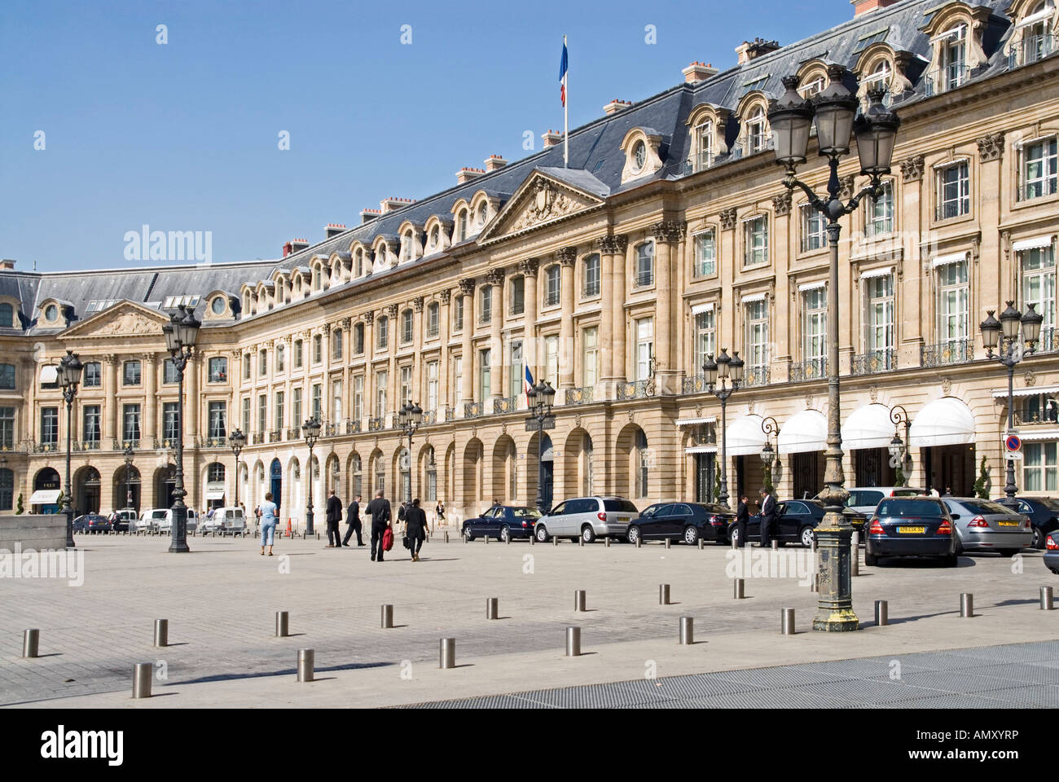
Source: https://ciasalesk.live/
The famous hotelier Condé Ritz opened it in 1898. This hotel's precarious placement on Paris' Place Vendôme is one of the world's most famous. The Ritz Paris is stylish from the outside with its large architecture to the inside with its luxury rooms. Its rich history and warmth draw visitors. The Ritz Paris has luxurious flats, rooms, and suites. These were designed to provide the best comfort and luxury for discerning vacationers. There are restaurants with Michelin stars, well-known bars, and other luxurious facilities at the hotel for the valuable guests (Meghan, 2023).
The Ritz Paris has hosted many famous people, making it a great setting for the world's most renowned guests. Coco Chanel, Ernest Hemingway, and others stayed at the hotel, adding to its aura. Despite its long history and outstanding reputation, the Ritz Paris is struggling in the modern hotel sector. The hotel has rethought its operations and services to keep up with rapid technology innovation, changing consumer tastes, and changing market conditions. Four years and $200 million were spent on Ritz Paris repairs. Reopened May 6, 2016. New York-based French designer and architect Thierry Despont directed the renovation. Price estimates range from €200 million to $400 million. A Chanel beauty sanctuary was included to the renovation (MICHELIN , 2024).
The Baba Business Solutionist Consulting Firm uses creative consulting to help organisations develop and expand. Creativity, teamwork, and excellent work are our business principles. Our team includes tech, marketing, financial, and hospitality experts. Baba Business Solutionist Consulting Firm seeks client happiness and quality. The Baba Business Solutionist Consulting Firm is the best choice to help The Ritz Paris resolve its issues and find a path to sustained success and profitability due to our industry expertise, openness to new ideas, and commitment to our customers. That’s why we have a case study in this famous Hotel The Ritz Paris (Nast, 2018).
The Ritz-Hôtel Paris in central Paris exudes class and money. It began over a century ago. The hotel opened in 1898 under Swiss inventor César Ritz. Rich and renowned individuals from throughout the world visit for its legendary generosity. Ritz Paris wanted to redefine perceptions of five-star hotels. The hotel's prominent location near the Place Vendôme offers stunning views of Paris. Royals, celebrities, and heads of state have visited Ritz-Paris. International celebrities like Ernest Hemingway and Coco Chanel have sought sanctuary there because to its privacy and convenience. The Ritz-Paris is known for more than its history. Beautiful classical design is another reason for its fame. Golden chandeliers and marble floors with intricate patterns make the interior feel royal. Our well-equipped rooms offer modern convenience and timeless elegance to escape Paris' noise and mayhem. The Ritz-Paris handpicks everything to make visitors' stays memorable. Styled apartments and rooms exude elegance and comfort. In the hotel's Michelin-starred restaurants, international chefs prepare excellent meals using the best ingredients. Enjoy tailored spa services to relax and feel better. The hotel provides excellent accommodations and will do everything possible to make a particular event run well. It's more than a five-star hotel. The location has served as the backdrop for many projects by renowned authors, performers, and artists. The city has transformed, but the Ritz-Carlton Paris still exudes refinement and grace, proving that luxury goods are always in trend. Hotel legacy and quality have moved generations of guests. Global fame will always surround this structure (Ritz Paris, 2024).
Baba Business Solutionist Consulting Firm uses PESTEL and SWOT analysis to address The Ritz Paris' challenges and prospects. Political, economic, social, technical, environmental, and legal aspects affecting the hotel business can be assessed using PESTEL. These variables help us comprehend industry trends, regulatory environments, and market dynamics, which is essential for evaluating The Ritz Paris's competitive landscape. SWOT analysis lets us assess the hotel's internal and external strengths, weaknesses, opportunities, and threats (Menet, 2016).

Analysis
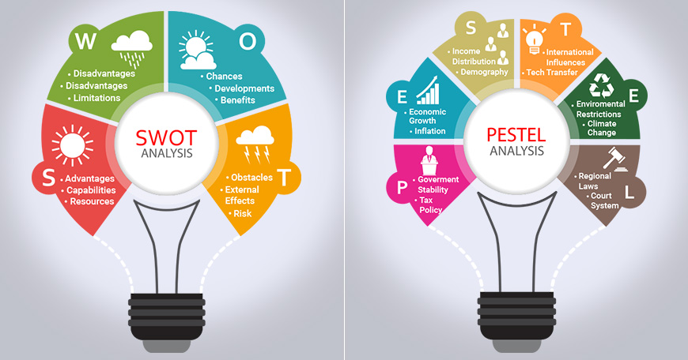
Source: https://www.researchoptimus.com/
The Ritz Paris' challenges needs in-depth internal and external analysis. The PESTEL framework assesses industry health by analysing political, economic, social, technical, environmental, and legal issues. Political instability, economic changes, new technology, social demographics, environmental protection measures, and laws affect The Ritz Paris' market trends and operational issues. SWOT analysis examine the hotel's internal and external strengths, weaknesses, opportunities, and threats. History, location, luxurious features, and excellent reputation which make the hotel stand out in the market. The hotel's longevity will be in risk if it unable to address its declining revenue, customer satisfaction, poor operations. The Ritz Paris uses the TOWS matrix, which combines PESTEL and SWOT.
Focusing on its strengths, improving its shortcomings to address future threats, and learning from outside the organisation may help the hotel become more competitive and expand. The Ritz Paris can manage the complex hospitality sector, remain on top of regulatory changes and market trends, and seize opportunities by evaluating all perspectives. The Ritz Paris uses the analytical department as a strategic north star to watch industry trends, appraise its position against rivals, and plan for success. The hotel may be able to continue expansion and provide top-notch luxury hospitality for years to come by looking forward and seizing chances (Çitilci & Akbalık, 2020).

Identified Issues
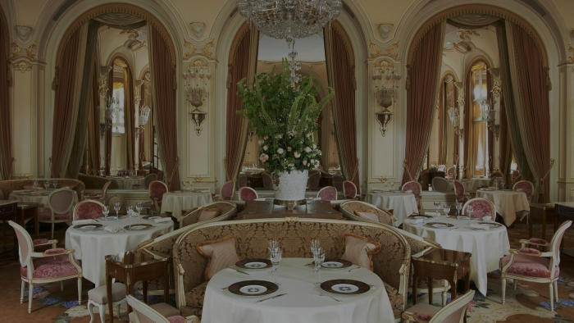
Source: https://www.ft.com/
Declining Revenue:
Revenue decline over the past year show a structural issue at the Ritz Paris. Travel trends and demography have changed consumer tastes, affecting demand and the hotel's revenue. Due to currency exchange rate changes and global economic uncertainties, people may have spent less on luxury hotels. Due to pricing competition from boutique hotels and internet vacation rental firms, the Ritz Paris may have lost money.
Customer Satisfaction:
Overall, guests are unhappy with room cleanliness, staff friendliness, and meal quality. When these concerns develop, guests' opinions of the hotel, especially their likelihood to return and recommend it, can suffer. Dissatisfied consumers might hurt the hotel's reputation and drive away future clients (Liat et al., 2017).
Operational Efficiency:
Inefficient operations like long check-in and check-out periods, inconsistent cleaning, and delayed repairs hurt the Ritz Paris visitor experience. Inefficiencies lead to unhappy customers, greater operating costs, and demoralised personnel. Smoother processes, happy guests, and maximum resource use result from optimised processes and technology.
Environmental Sustainability:
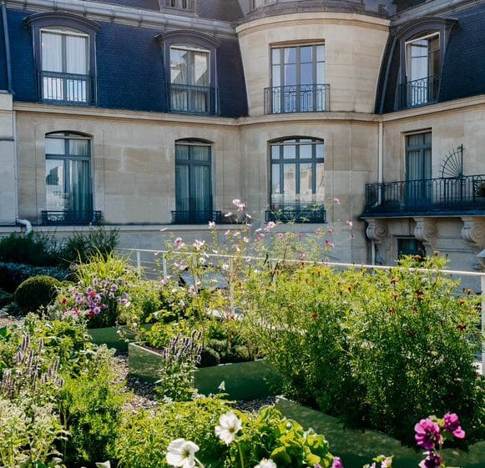
Source: https://luxus-plus.com/
This hotel isn't as eco-friendly as others. They should promote greener living and decrease energy and waste. Not using sustainable techniques may hurt your reputation and turn off environmentally conscious customers in today's market. Energy-efficient lighting, waste-reduction programmes, and eco-friendly facilities can help the hotel attract eco-conscious customers.
Market Positioning:
The hotel's market position may not match guest needs. Failure to react to new trends and client expectations might reduce market share and competitiveness. Market research and competition analysis are the greatest ways to track consumer preferences and trends. These strategic decisions can boost the hotel's market position and competitiveness (Diderich, 2022).

Analysis and Discussion
Declining Revenue:
Revenue patterns, market conditions, and rival performance can help explain The Ritz-sales Paris's downturn. Examining historical sales data and market indicators might help you understand client behaviour. Changes in GDP growth or foreign currency rates affect client demand and purchasing power, affecting the hotel's income streams. The Ritz Paris may struggle to set prices and maintain market share due to competitive pricing by competitor hotels, vacation rentals, and boutique hotels. In a competitive market, focused solutions to improve income involve customer-valued pricing, promotion, and services.
Customer Satisfaction:
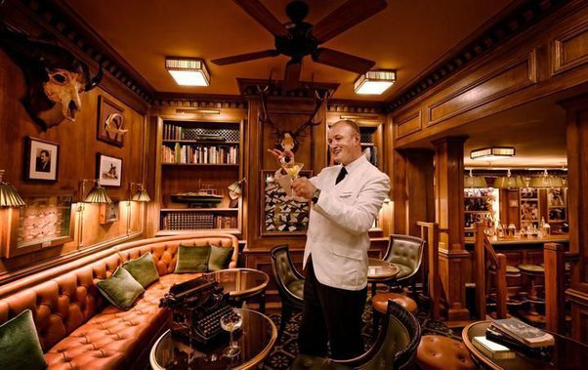
Source: https://www.quora.com/
Visitor feedback must be thoroughly examined to detect reoccurring concerns and customer satisfaction improvements. Mystery shopping, online reviews, and questionnaires can reveal guests' preferences. The hotel can prioritise and quickly fix frequent concerns regarding room cleanliness, staff attentiveness, and meal quality. Spending on staff training, services, and quality control can create a success culture, improve visitor experiences, and make customers happier and more loyal (Khajeh Nobar & Rostamzadeh, 2018).
Operational Efficiency:
The Ritz Paris must analyse all operating procedures and processes to uncover inefficiencies and improve workflows. Process mapping and time-motion studies can help businesses identify bottlenecks and improve cleaning, maintenance, and check-in/check-out. Property management systems and mobile apps can automate tedious processes, optimise workflow, and improve customer service. Training and performance incentives can boost morale and productivity by encouraging a growth mindset and worker agency.
Environmental Sustainability:
Comparing the hotel's sustainability policy to industry standards may help them become greener. Green sourcing, energy-efficient lighting, and waste-reduction programmes can help the hotel meet rising demand for eco-friendly rooms. Hotels can promote their green activities through advertising and eco-labels to attract eco-conscious customers (Radojevic et al., 2018).
Market Positioning:
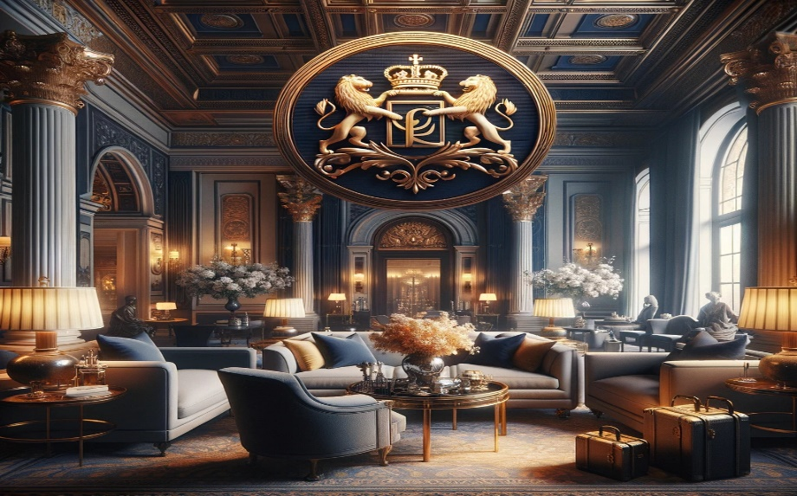
Source: https://hotelgrowers.com/
The Ritz Paris must analyse the market and its competitors. Customer trends, competitor offerings, and market gaps can assist the hotel position its brand, develop its products, and market to its target market. With its historic name and good location, the Ritz-Carlton, Paris may stand out from competitors. Health tourism and experiential travel are emerging areas the hotel may use to boost its market appeal and competitiveness (Diderich, 2022).

Positive Aspects
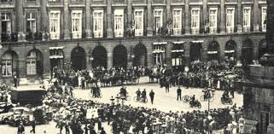
Source: https://www.luxurylink.com/
Brand Legacy:
Strong brand heritage gives the Ritz-Carlton its long-lasting attractiveness and competitive edge in high-end hotels. Swiss hotelier César Ritz founded the hotel in 1898. Its reputation for riches, style, and service is well-deserved. The Ritz Paris has hosted kings, celebrities, and international leaders for decades. Legendary hospitality and ageless appeal make it famous. This rich history provides the hotel a sense of custom and authenticity, as well as confidence and assurance that guests will have a Ritz-like experience (Ryu et al., 2019).
Location
The Ritz Paris lies on the Place Vendôme in Paris's 1st arrondissement, a wonderful location. You can quickly reach the city's most prominent landmarks, cultural attractions, and luxury shopping centres from here. The hotel's location among ancient buildings and high-end boutiques gives guests a true Parisian experience, with its bustling energy and timeless beauty. Hotel guests adore The Ritz Paris' convenient and magnificent location. They can stroll down the Champs-Élysées, see the Louvre, or dine at gourmet restaurants. Expert travellers looking for a memorable Parisian vacation would love it (Chang et al., 2020).
Luxurious Amenities
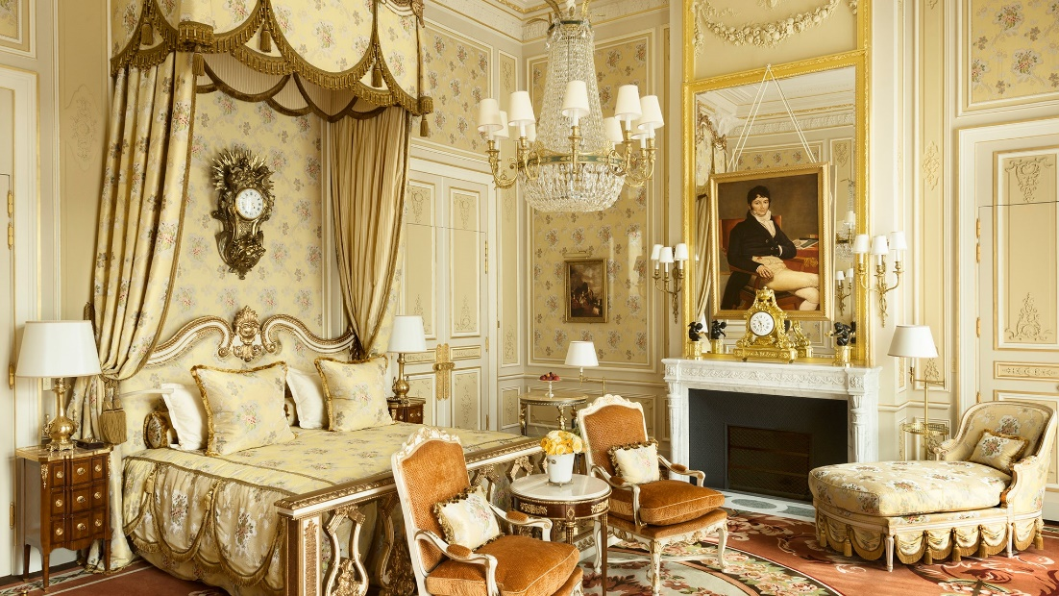
Source: https://www.cntraveler.com/
The Ritz Paris is noted for its luxury features. These facilities are luxurious and elegant. The hotel boasts beautiful rooms and suites, Michelin-starred restaurants, a spa, and distinctive boutiques. These are aimed to delight the senses and elevate the guest experience. Master chefs prepare delectable meals, and clients can unwind with tailored spa treatments or personalised services. Luxurious tourists choose the Ritz Paris for its comfort, elegance, and refinement. Our commitment to excellence and attention to detail ensures that every area of the visitor experience is the best in luxury hospitality (Lo & Yeung, 2019).

SWOT Analysis( Internal Environment)
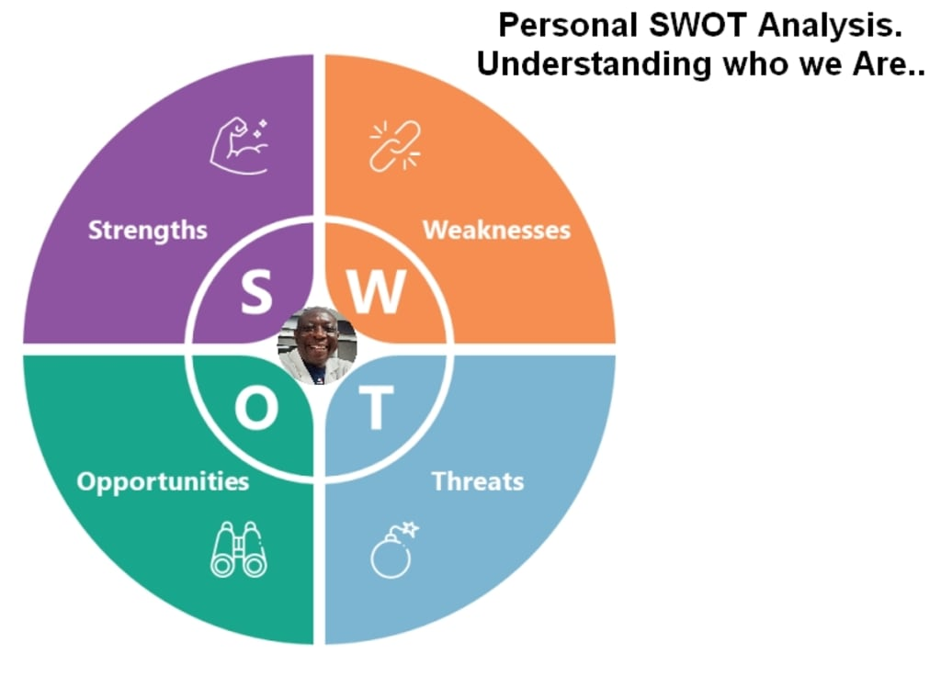
Source: https://vocal.media/
The Ritz Paris has been around for a long time, and thanks to its great service, it has become a household name, synonymous with opulence and refinement. Its prime central position in Paris adds to its allure by providing quick access to world-renowned attractions and luxurious services. The guest experience is elevated when they are offered opulent amenities, such as a Michelin-starred restaurant and plush rooms. However, there are issues with organisational inefficiency and the absence of sustainable practices. Potential threats include economic instability and fierce rivalry, while opportunities include expanding markets and green initiatives (Qiu & Wei, 2017).
SWOT analysis
Strengths:
- Ritz-Paris is known for its luxury and hospitality. Its heritage provides it an advantage and attracts high-end customers.
- The Ritz-Paris is near to many notable sights and important transportation hubs, making it perfect for business and leisure tourists.
- Due to its spa, fine dining restaurants, and personal concierges, the hotel is known for its luxury.
Weaknesses:
- Revenue has dropped due to customer behaviour, economic downturns, and increased competition, threatening the hotel's financial stability and growth.
- Despite its long history, The Ritz-Paris has struggled to maintain client satisfaction due to food quality, personnel attentiveness, and room cleanliness issues.
- Inefficient housekeeping and check-in/check-out have hurt guests and raised costs. It indicates better operational management.
- The hotel's insufficient environmental sustainability measures, including energy reduction, trash reduction, and eco-friendly behaviour, threaten its long-term business and reputation.
Opportunities:
- Ritz-Paris may increase its market share by contacting more customers, expanding its geographic footprint, and diversifying its products and services to match modern consumer and developing economy needs.
- The Ritz-Paris may stand out from competitors, increase customer engagement, and raise revenue via creative service delivery, technological integration, and guest experiences.
- The Ritz-Paris can meet industry and legislative requirements and attract environmentally conscious customers by following sustainability trends. These trends allow companies to be environmentally responsible, increase CSR, and attract customers.
Threats:
- The Ritz-Paris is threatened by economic downturns and financial uncertainties, which affect premium hotel demand, consumer spending, and travel habits.
- The hotel must innovate and differentiate itself to maintain market share and relevance in the face of strong competition from luxury brands and new high-end hospitality entrants.
- Negative press, service failures, and environmental issues can undermine a company's brand and lose customers' trust.
- Traditional hospitality models challenge with changing consumer preferences for experience travel, customised services, and sustainability. Adjustment is needed to suit these needs (Qiu & Wei, 2017).

PESTLE (External Environment)
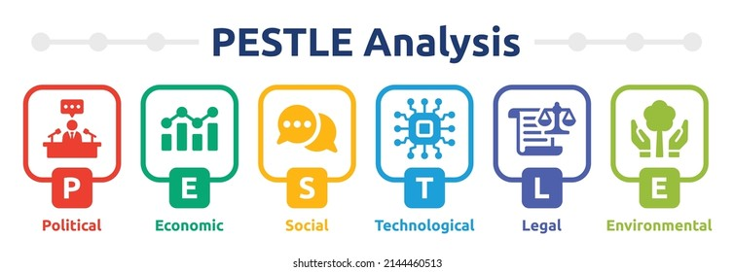
Source: https://www.shutterstock.com/
Factor | Description
Political | - Government policies on tourism promotion, taxation, and regulations
 | - Impact of political stability or instability on consumer confidence and travel decisions
Economic | - GDP growth, inflation rates, and exchange rates
 | - Economic downturns or recessions affecting consumer spending on luxury accommodations
Social | - Changing demographics and consumer preferences
 | - Social trends towards sustainability and immersive travel experiences
Technological | - Adoption of digital technologies such as online booking platforms and mobile applications
 | - Data analytics and CRM systems for guest personalization
Environmental | - Climate change, natural disasters, and sustainability initiatives
 | - Consumer demand for eco-friendly accommodations and responsible tourism practices
Legal | - Labor laws, employment regulations, and workplace safety standards
 | - Licensing requirements, zoning regulations, and building codes for property development
 | - Compliance with food safety regulations, alcohol licensing laws, and hygiene standards
 | - Data protection regulations such as GDPR for handling guest information

Political:
The Ritz Paris' business is affected by politics. Taxes, tourism promotion, and regulations affect the hotel industry's operations and profitability. Visa rules and travel warnings may affect foreign tourism, which affects occupancy rates and revenue. Political stability or turmoil in key supply markets may affect customer trust and travel plans. Immigration policy, health and safety standards, and labour laws can affect a hotel's compliance obligations, operational expenses, and staffing levels.
Economic:
The Ritz Paris' financial health and market performance depend on macroeconomic conditions. GDP growth, inflation, and currency exchange rates affect consumer spending, travel demand, and hotel rates. Luxury restaurant and hotel ADR and reservation rates can drop during recessions when consumers cut back on spending. Exchange rates affect foreign tourists' purchasing power and international tourism. For competitiveness, pricing and marketing methods may need to be adjusted due to regional or national economic inequalities affecting demand patterns.
Social:
Luxury accommodations and unique experiences are in demand because social and cultural changes affect people's tastes, lifestyles, and travel habits. The Ritz Paris may see increasing demand for wellness services, accessible amenities, and transport options for all ages due to demographic changes like an ageing population or more city dwellers. Consumer desires for sustainability, authenticity, and immersive travel may need changes to product, service, and marketing. Easy-to-use online review sites and social media influence hotel guests' impressions and purchases (Syromyatnikova & Lapina, 2022).
Technological:
Technology has changed how guests interact with hospitality organisations and use Ritz Paris services. Online booking platforms, mobile apps, and cashless payment methods have eased reservations, enhanced guest satisfaction, and enabled more personalised service. Data analytics and CRM technologies let hotels understand consumers' interests, customise marketing, and reward loyalty. In contrast, staying competitive in the digital age needs continual investment in infrastructure and staff training, which can be costly and pose data protection and cybersecurity risks.
Environmental:

Source: https://www.ritzparis.com/
Environmental concerns are increasingly affecting The Ritz Paris' eco-friendliness, company efficiency, and public image. Climate change, natural disasters, and environmental deterioration threaten hotel infrastructure and operations. This is why catastrophe preparedness and resilience plans are crucial. Due to the rise in eco-conscious travellers and ecologically concerned hotels, energy-saving equipment, waste-reduction plans, and green certifications are in demand. Eco-friendly methods save costs and resource use, improve business image, attract eco-conscious guests, and promote long-term environmental stewardship.
Legal:
The Ritz Paris must follow several regulatory rules, ordinances, and safety norms. The hotel follows labour laws, employment rules, and workplace safety standards for hiring, benefits, and health care. Zoning, licencing, and construction codes mandate property rehabilitation, enlargement, and growth. Food safety, alcohol licencing, and sanitation are essential to visitor safety, liability reduction, and business reputation. Privacy measures and guest consent before handling their data are also required by rules like the GDPR. Strong data management and cybersecurity procedures are needed to comply with rules and protect visitor privacy (Arif & Hossin , 2016).

Recommendations and Change Management

Recommendations
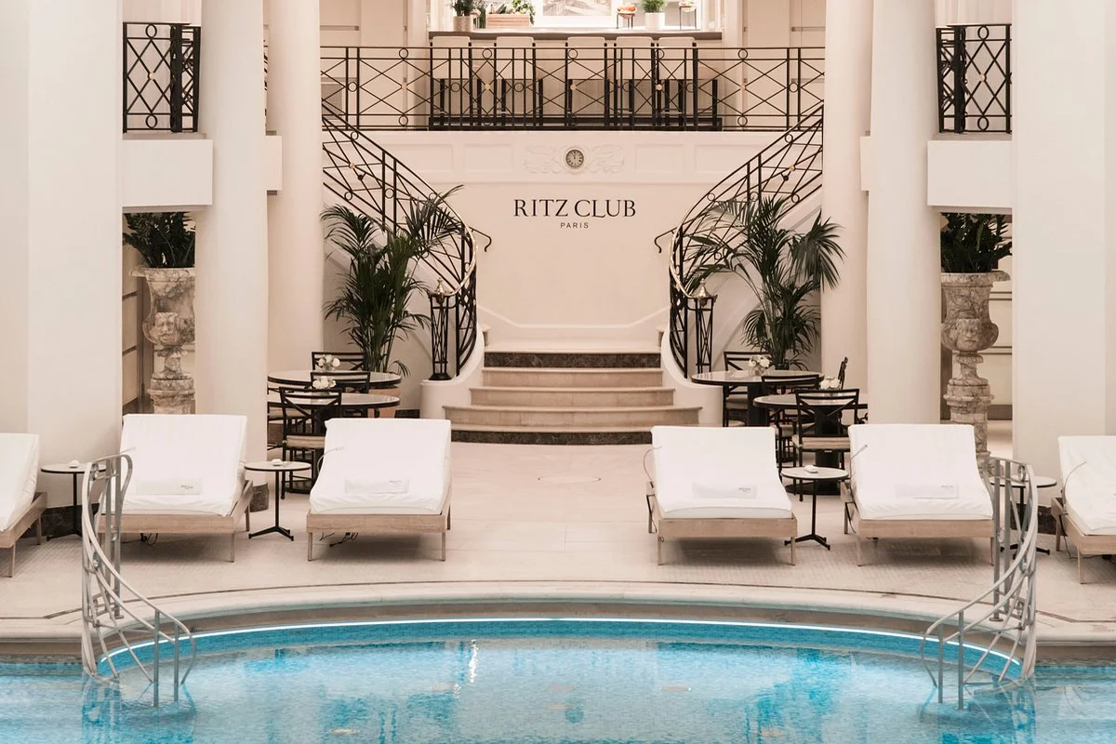
Source: https://globeinfinite.com/
The Ritz-Carlton Paris should address the identified issues and possibilities by improving guest satisfaction, operating efficiency, and environmental standards. Talent development programmes empower employees, digital marketing boosts business visibility, and tailored concierge services improve guests' stays. Along with eco-friendly methods, the hotel can reduce its environmental impact by encouraging clients to go green. Effective change management requires open communication, comprehensive training, and employee cooperation to implement these suggestions. Guest-centered service innovation, digital marketing trends, staff development, and environmental sustainability will help The Ritz Paris stay profitable and flexible in the ever-changing hospitality business. This will keep the hotel a luxury destination.
Personalized Concierge Services:
- Advanced guest profiling and CRM systems can help the Ritz-Carlton Paris understand guests' past stays, food preferences, special events, and fun activities (Mohammed et al., 2014).
- Staff can be educated to anticipate guest needs and recommend food, entertainment, cultural events, and local sights.
- A digital concierge platform or mobile app lets clients use their smartphones or tablets to make reservations, request services, and get tailored recommendations.
- Hotel partnerships with local businesses, attractions, and tour operators can provide customers personalised benefits (Liu et al., 2024).
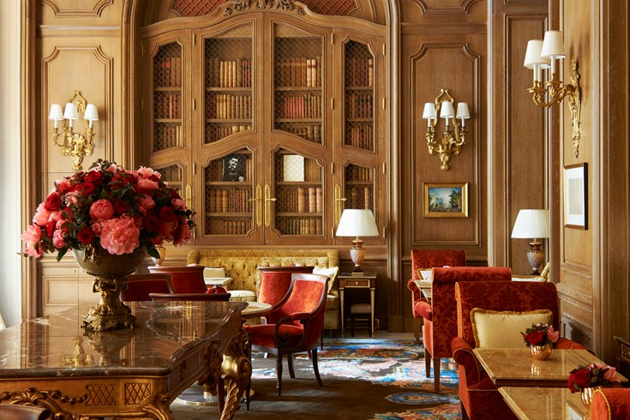
Source: https://www.lhw.com/
Innovative Dining Experiences:
- The Ritz Paris can organize themed pop-up restaurants with international cuisines, seasonal specialties, or partnerships with well-known chefs and culinary specialists.
- Organising culinary seminars and masterclasses can give visitors practical experiences including wine tastings, cocktail mixology workshops, and cooking classes.
- Promotion of special dining events like gourmet food festivals, themed afternoon teas, and culinary demonstrations can attract both locals and visitors.
- Dining establishments at the hotel can work with nearby farmers, producers, and craftspeople to highlight regional delicacies and encourage environmentally friendly, farm-to-table dining (Hallak et al., 2018).
Staff Training Programs:
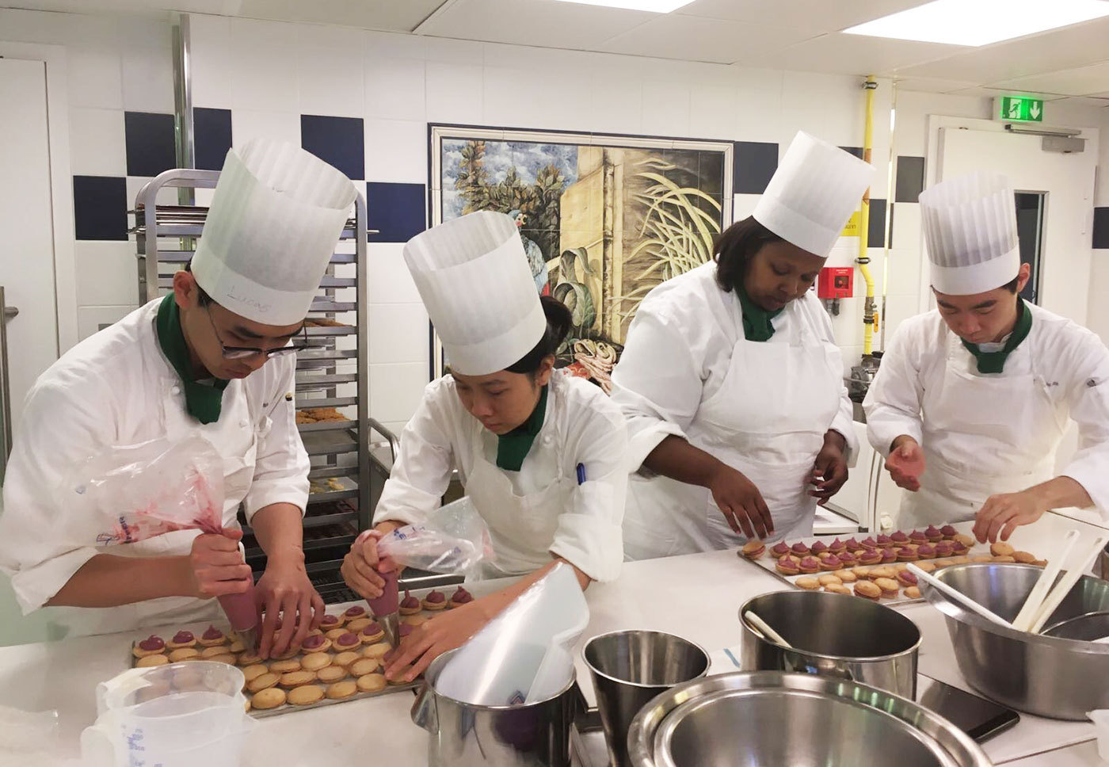
Source: https://www.culinaryartsswitzerland.com/
- The Ritz Paris can develop comprehensive training modules covering service standards, communication skills, problem-solving techniques, and cultural awareness to enhance staff competencies.
- Role-playing exercises, workshops, and simulations can be conducted to simulate real-life guest scenarios and prepare staff to handle diverse situations with professionalism and grace.
- Continuous feedback mechanisms, performance evaluations, and recognition programs can be implemented to incentivize staff performance and foster a culture of excellence and continuous improvement.
- Employees can get experience in different departments and roles through cross-training. This builds teamwork, collaboration, and mutual support throughout the organisation (Barreto & Mayya, 2023).

Change Management Strategies:
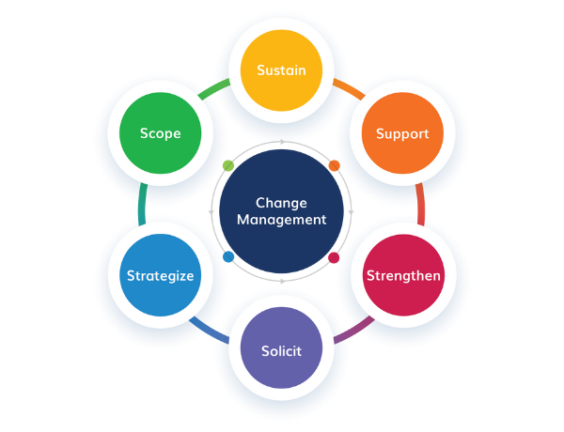
Source: https://insights.btoes.com/
Communication and Transparency:
- Set up transparent and open lines of communication, such newsletters, intranet updates, and frequent staff meetings, to spread knowledge about the suggested modifications and their justification.
- Engage staff members for their opinions, respond to their worries, and include them in focus groups and brainstorming sessions to come up with solutions.
- Make it clear and consistent what the goals, advantages, and anticipated results of the suggested adjustments are, stressing how they would improve employee roles, job happiness, and overall organisational success.
- Promote openness and trust by promoting two-way communication, attentively hearing employee input, and quickly and honestly resolving any misunderstandings or rumours (Kim & Kim, 2017).
Training and Development:
- Provide thorough training programmes catered to the particular requirements of the staff members impacted by the suggested changes so they have the tools, information, and abilities required to successfully adjust to new processes and service standards.
- To suit a range of learning preferences and types, combine classroom instruction with e-learning modules, on-the-job coaching, and mentorship.
- Offer chances for refresher courses, skill evaluations, and feedback sessions to reinforce learning and fill up any gaps or problems that may come up during the transition time.
- Encouraging self-directed learning, establishing specific performance targets, and offering chances for skill development and career progression will enable staff members to take charge of their own learning and development (Barreto & Mayya, 2023).
Employee Engagement:
- Actively including staff members in the implementation process, asking for their input, and acknowledging their accomplishments will help to create an environment of employee ownership and involvement.
- Encouraging cooperation and teamwork, set up cross-functional task forces, project teams, and working groups to tackle certain change initiative components.
- Give employees the chance to engage in decision-making, make recommendations for enhancements, and give creative and process-optimizing ideas.
- Reiterating the value of cooperation, teamwork, and a common dedication to organisational success, celebrate individual and team accomplishments along the road (Bafaneli & Setibi, 2015).
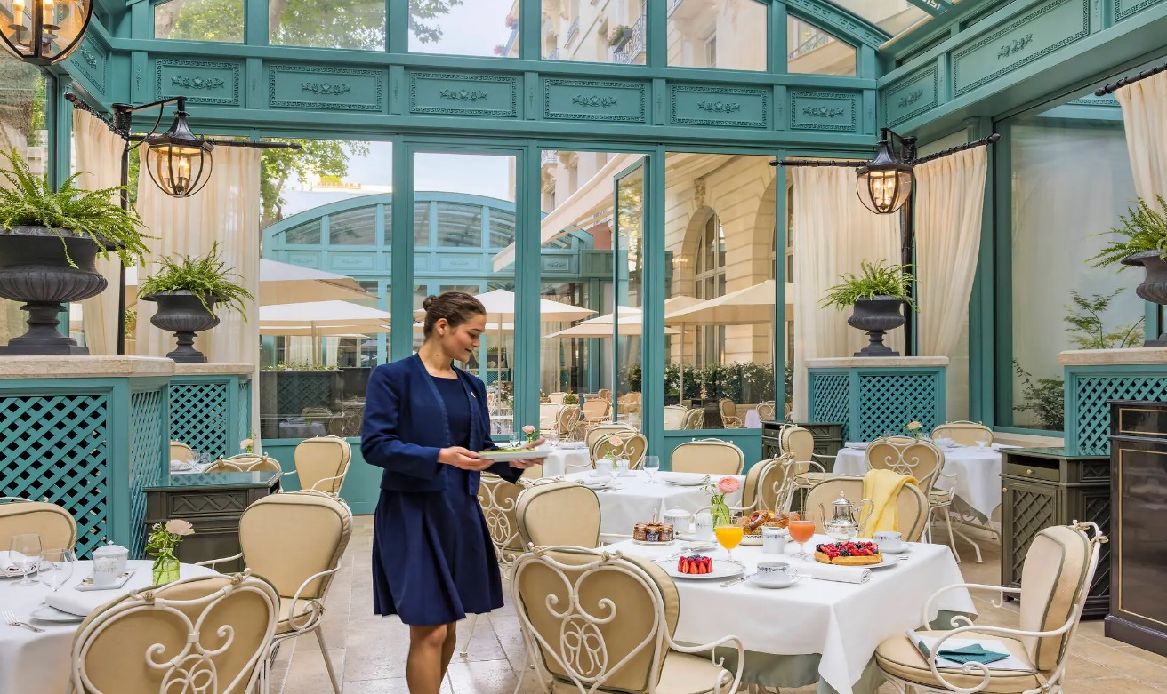
Source: https://www.ritzparis.com/
Monitoring and Evaluation:
- To evaluate the effectiveness of the recommended strategies and monitor advancement towards predetermined goals and objectives, put performance metrics and key performance indicators (KPIs) into use.
- In order to evaluate the success of the change efforts and pinpoint areas for development, routinely monitor and examine performance data and ask staff, customers, and other stakeholders for input.
- Use feedback and evaluation to adjust implementation plans, reallocate resources, refine techniques, and solve any obstacles.
- Share progress and performance results with stakeholders, celebrating achievements, addressing failures, and promoting continuous improvement and excellence (Ribeiro et al., 2019).
Cost Considerations:

Source: https://www.linkedin.com/
Implementation Costs:
- An investment in personalised concierge services may require a new visitor profiling system, personnel training, and technology upgrades.
- Costs include consultation, infrastructure upgrades, marketing, staff training, and technical expenses.
- A detailed cost analysis is needed to assess the initial investment and uncover ways to save money or find alternatives.
Cost-Benefit Analysis (CBA):
- CBA is important to calculate project return on invest (ROI). Comparing predicted expenses helps determine the financial issue.
- Cost-benefit analysis for personalised concierge services include revenue, cost savings, customer happiness and loyalty, competitive advantage, and long-term viability.
- When investments match with the hotel's strategic goals, it create financial returns and boost business growth (Dwyer et al., 2017).
Budget Allocation:
- The hotel's size, income, and budget should determine whether to spend more on concierge services, reinvest in less important areas, or seek external finance.
- Reasonable budget for each and make sure there are enough funds to cover both one-time costs of implementation.
- Monitor expenditures and implement cost-control measures to control waste cost and make sure that resources are utilized effectively.
Risk Management:
- Evaluate any potential risks which may be associated with suggestion which were not expected, constraints on resources, and cost overruns .
- Develop plans and risk-reduction strategies to deal with challenges and make sure that the process stays on schedule and within budget.
- Frequent monitoring of financial metrics and key performance indicators (KPIs) can help to assess the projects' financial success and spot any departures from the anticipated expenses and benefits (El Haddad, 2015).
Potential Benefits:
Enhanced Guest Satisfaction and Loyalty:
- Higher degrees of pleasure and loyalty will result from the enhancement of the entire visitor experience through the implementation of individualised concierge services and creative dining experiences.
- Increased repeat business and favourable word-of-mouth referrals are the outcomes of happy visitors' more probable return to The Ritz Paris for future stays and recommendation of the hotel to friends, family, and coworkers.
- Better ratings for guest satisfaction and good internet reviews can strengthen the hotel's standing and draw in discriminating tourists looking for outstanding hospitality experiences.
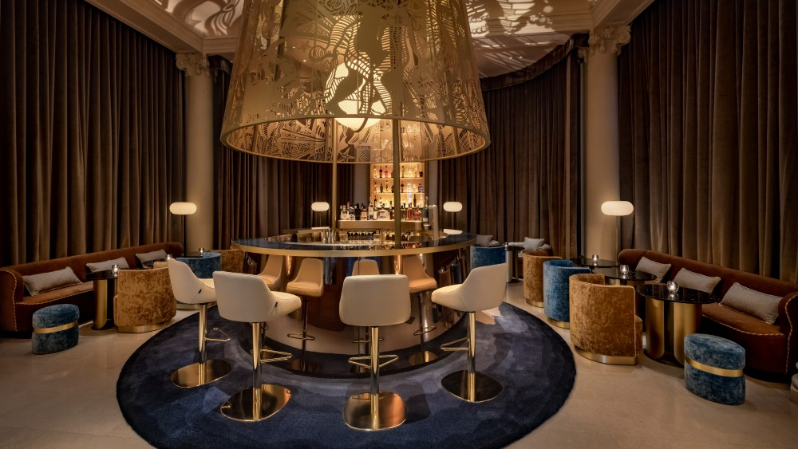
Source: https://wwd.com/
Improved Brand Reputation and Market Positioning:
- Adopting sustainable business methods and committing to environmental stewardship would improve The Ritz Paris's brand reputation and set it apart as a pioneer in premium hospitality and sustainability.
- Through alignment with changing customer preferences for environmentally friendly and socially conscious companies, the hotel could bring in an increasing number of environmentally concerned tourists and establish itself as a top option for morally and ethically sensitive tourists.
- The hotel's market positioning will be improved and its reputation as a distinguished and socially conscious hospitality destination will be reinforced by increased brand exposure and favourable media attention brought about by sustainability efforts (Akbari et al., 2020).
Greater Operational Efficiency and Cost Savings:
- Upgrades to technology, better staff training, and streamlined operations will boost productivity and save labour, material, and utility expenses.
- Routine chore automation, such housekeeping scheduling and check-in/check-out procedures, will maximise resource and personnel productivity, saving costs and enhancing service quality.
- Long-term cost reductions from waste reduction initiatives and energy-efficient technology investments will come from lower maintenance costs, cheaper electricity bills, and improved environmental performance (Singjai et al., 2018).
Increased Revenue and Profitability:
- Innovative services like personalised concierge and themed meals will increase income and attract new customers seeking unique and memorable experiences.
- Targeted marketing initiatives, leveraging digital channels and customer data analytics, will increase brand visibility, attract high-value customers, and drive revenue growth through strategic promotions and campaigns.
- Adoption of sustainable business practices, such as eco-friendly amenities and carbon offset programs, will appeal to environmentally conscious travelers and create opportunities for premium pricing and revenue enhancement (Neirotti et al., 2016).
The Ritz Paris can now address its difficulties and capitalise on development and innovation thanks to the preceding suggestions. Hoteliers can become top luxury destinations by prioritising visitor enjoyment, simplifying operations, and safeguarding the environment. Change management strategies including open communication, comprehensive training, and employee participation can assist implement these suggestions and smooth the transition. Prioritising investments based on cost-benefit assessments and monitoring performance measurements can boost revenue, brand recognition, and operations at the Ritz-Paris. The hotel's future is bright in the competitive hospitality industry (Neirotti et al., 2016).

Action Plan
The Ritz-Carlton Paris' action plan describes how it will solve difficulties and maximise possibilities. Every issue is discovered and solved to meet the hotel's needs. The hotel's quantifiable goals outline the changes and results they want from the proposed techniques. Every job has a carefully planned schedule. This ensures goals, deadlines, and progress are met. The budget is carefully set to cover the costs of implementing the initiatives and meeting the targets. To help everyone understand their role and participate to implementation, goals and obligations are outlined. This comprehensive method ensures that The Ritz Paris' plan guides all parties, assets, and schedules towards fixing the hotel's difficulties and transforming it. The Ritz-Carlton Paris may make proposed tactics more transparent, efficient, and competitive by carefully implementing the strategy. This will help it succeed, survive, and adapt to the changing hospitality industry (Sensen, 2018).
Number | Problem | Solution | Desired Outcome | Time Scale | Completion Date | Planned Budget
1 | Declining Revenue | Implement personalized concierge services, innovative dining experiences, and staff training programs to enhance guest satisfaction and revenue generation (Abrate & Viglia, 2016). | Increased revenue, improved guest satisfaction, and loyalty. | 6 months | 2024-11-12 | $100,000
2 | Customer Satisfaction | Introduce transparent communication channels, comprehensive training, and employee recognition programs to address guest feedback and improve service quality (Ali et al., 2021). | Enhanced guest satisfaction scores, positive online reviews, and increased repeat business. | 4 months | 2024-09-12 | $50,000
3 | Operational Efficiency | Streamline operational processes, invest in technology upgrades, and implement energy-efficient practices to optimize resource utilization and reduce costs (Semuel et al., 2017). | Improved operational efficiency, cost savings, and staff productivity. | 8 months | 2025-01-12 | $80,000
4 | Environmental Sustainability | Adopt sustainable business practices, such as eco-friendly amenities, waste reduction programs, and carbon offset initiatives, to minimize environmental impact and enhance brand reputation (Walsh & Dodds, 2017). | Enhanced environmental performance, positive media coverage, and appeal to eco-conscious travelers. | 12 months | 2025-05-12 | $120,00

Conclusion
The comprehensive study and strategic recommendations in this consultancy report led to its conclusion. It summarises the main findings and solutions. The Ritz Paris needs to take the initiative in order to succeed in the dynamic luxury hotel sector. Many aspects that affect hotel efficiency were found by this study. External market factors and internal operational dynamics are examples. PESTEL study can help one understand the industry's macro influence. This includes new technology, economic and political movements, and laws. SWOT analysis helped us comprehend the hotel's internal and external opportunities and threats, improving our strategic suggestions. One of the biggest concerns is the Ritz-Paris's deteriorating profitability. These falling numbers threaten the hotel's long-term and financial stability, thus fast action is needed. Changes in consumer choices, the economy, and new hotel chains have contributed to this fall.
The data also shows that customer satisfaction is going down, which makes buyers nervous. Room cleanliness, staff response time, and meal quality should be improved. This emphasises the importance of outstanding service. The Ritz-Carlton, Paris can improve guest experiences and cement its status as a luxury destination by investing in staff training and promoting excellent hospitality. Another area for improvement is operational effectiveness. Check-in/check-out inefficiency, cleanliness, and maintenance are regular complaints. Inefficiencies increase costs, impair staff happiness, and dissatisfy guests.
The hotel should focus operational process simplification and technology use to improve performance and efficiency. These steps will save the hotel money and boost production. Environmental sustainability has been a priority, yet the hotel is failing short. Few efforts have been made to decrease energy use, waste, and promote green practices, requiring a greater sustainability plan. The Ritz-Paris may attract environmentally conscious guests by reducing trash, using energy-efficient lighting, and buying from sustainable sources. Given these difficulties, we have produced a set of strategic recommendations to solve challenges and maximise strategic opportunities. New service ideas, digital marketing, staff development, and eco-friendly practises are included.
Good change management is needed to implement these suggestions. These are crucial for overcoming organisational change resistance and implementing changes. The report's change management strategies emphasise open communication, thorough training, and engaged workers to ensure a smooth process and continual progress. The Ritz-Carlton can win over employees by giving them a say in decision-making and offering ongoing support. The smooth implementation of modifications depends on this.
The Ritz-Paris could address these difficulties and capitalise on these opportunities. These recommendations when put into practice will enable this hotel to compete with other upscale hotels. It covers development of talent, environmental sustainability, and innovative digital marketing and services. Action calls for change management plan. A new business model can be successfully implemented by the Ritz-Carlton, Paris with open communication, thorough training, and employee engagement. Contributing our expertise and seeing the hotel prosper was satisfying.

Reference
Abrate, G. and Viglia, G. (2016) ‘Strategic and tactical price decisions in Hotel Revenue Management’, Tourism Management, 55, pp. 123–132. doi:10.1016/j.tourman.2016.02.006.
Akbari, M. et al. (2020) ‘How corporate social responsibility contributes to strengthening brand loyalty, hotel positioning and intention to revisit?’, Current Issues in Tourism, 24(13), pp. 1897–1917. doi:10.1080/13683500.2020.1800601.
Ali, B.J. et al. (2021a) ‘Hotel Service Quality: The impact of service quality on customer satisfaction in hospitality’, International Journal of Engineering, Business and Management, 5(3), pp. 14–28. doi:10.22161/ijebm.5.3.2.
Ali, B.J. et al. (2021b) ‘Hotel Service Quality: The impact of service quality on customer satisfaction in hospitality’, International Journal of Engineering, Business and Management, 5(3), pp. 14–28. doi:10.22161/ijebm.5.3.2.
Alonso-Almeida, M. del, Bremser, K. and Llach, J. (2015) ‘Proactive and reactive strategies deployed by restaurants in times of crisis’, International Journal of Contemporary Hospitality Management, 27(7), pp. 1641–1661. doi:10.1108/ijchm-03-2014-0117.
Alrawabdeh, W. (2021) ‘Seasonal balancing of revenue and demand in hotel industry: The case of dubai city’, Journal of Revenue and Pricing Management, 21(1), pp. 36–49. doi:10.1057/s41272-021-00290-6.
AMANDA (2024) Ritz Paris brand launch: Art Direction, Merchandising & Event, Brand & Creative Communications. Available at: https://www.amandalewkee.com/ritz-paris-art-marketing-direction (Accessed: 13 May 2024).
Arif, T. and Hossin , M. (2016) ‘A comparative analysis of internal and external environments between Hotel Hyatt, UK and Hotel The Cox Today, Cox’s Bazar, Bangladesh’, A comparative analysis of internal and external environments [Preprint]. doi:10.4324/9781315752532.
Ariffin, A.A. and Omar, N.B. (2016) ‘Surprise, hospitality, and customer delight in the context of Hotel Services’, Tourism and Hospitality Management, pp. 127–142. doi:10.1108/s1871-317320160000012010.
Bafaneli, S. and Setibi, G. (2015) ‘The impact of on-the-job training on employee performance: The case of riley’s hotel’, Journal of Business Theory and Practice, 3(2), p. 239. doi:10.22158/jbtp.v3n2p239.
Barreto, N. and Mayya, S. (2023) ‘A systematic review on training and development in the hotel industry’, International Journal of Management, Technology, and Social Sciences, pp. 22–52. doi:10.47992/ijmts.2581.6012.0268.
Bharwani, S. and Mathews, D. (2021) ‘Post-pandemic pressures to pivot: Tech transformations in Luxury Hotels’, Worldwide Hospitality and Tourism Themes, 13(5), pp. 569–583. doi:10.1108/whatt-05-2021-0072.
Chang, V. et al. (2020) ‘An improved model for sentiment analysis on Luxury Hotel Review’, Expert Systems, 40(2). doi:10.1111/exsy.12580.
Çitilci, T. and Akbalık, M. (2020) ‘The importance of Pestel Analysis for environmental scanning process’, Advances in Marketing, Customer Relationship Management, and E-Services, pp. 336–357. doi:10.4018/978-1-7998-2559-3.ch016.
Clauzel, A., Guichard, N. and Damay, C. (2020) ‘Exploring emotional traces in families’ recollection of experiences’, Qualitative Market Research: An International Journal, 23(1), pp. 21–45. doi:10.1108/qmr-07-2018-0076.
De Pelsmacker, P., van Tilburg, S. and Holthof, C. (2018) ‘Digital Marketing Strategies, online reviews and Hotel Performance’, International Journal of Hospitality Management, 72, pp. 47–55. doi:10.1016/j.ijhm.2018.01.003.
Diderich, J. (2022) How a branding expert is revving up the Ritz, WWD. Available at: https://wwd.com/business-news/marketing-promotion/how-a-luxury-brand-expert-is-helping-the-ritz-paris-to-develop-its-brand-1235415268/ (Accessed: 13 May 2024).
Dwyer, L., Jago, L. and Forsyth, P. (2017) ‘Economic evaluation of special events: Reconciling economic impact and cost–benefit analysis’, Event Impact, pp. 5–19. doi:10.4324/9781315181356-2.
El Haddad, R. (2015) ‘Exploration of revenue management practices – case of an upscale budget hotel chain’, International Journal of Contemporary Hospitality Management, 27(8), pp. 1791–1813. doi:10.1108/ijchm-08-2013-0390.
Elbanna, S. (2016) ‘Managers’ autonomy, strategic control, organizational politics and Strategic Planning Effectiveness: An empirical investigation into missing links in the hotel sector’, Tourism Management, 52, pp. 210–220. doi:10.1016/j.tourman.2015.06.025.
Ettinger, A., Grabner-Kräuter, S. and Terlutter, R. (2018) ‘Online CSR communication in the hotel industry: Evidence from small hotels’, International Journal of Hospitality Management, 68, pp. 94–104. doi:10.1016/j.ijhm.2017.09.002.
Fraj, E., Matute, J. and Melero, I. (2015) ‘Environmental strategies and organizational competitiveness in the hotel industry: The role of learning and innovation as determinants of environmental success’, Tourism Management, 46, pp. 30–42. doi:10.1016/j.tourman.2014.05.009.
Godinho, P., Phillips, P. and Moutinho, L. (2018) ‘Hotel location when competitors may react: A game-theoretic gravitational model’, Tourism Management, 69, pp. 384–396. doi:10.1016/j.tourman.2018.06.014.
GÜREL, E. (2017) ‘SWOT analysis: A theoretical review’, Journal of International Social Research, 10(51), pp. 994–1006. doi:10.17719/jisr.2017.1832.
Hallak, R. et al. (2018) ‘Firm performance in the upscale restaurant sector: The effects of resilience, creative self-efficacy, innovation and industry experience’, Journal of Retailing and Consumer Services, 40, pp. 229–240. doi:10.1016/j.jretconser.2017.10.014.
Heyes, A. and Lashley, C. (2017) ‘Price, exclusivity and luxury: Exploring London’s Luxury Hotels’, Research in Hospitality Management, 7(1), pp. 17–26. doi:10.1080/22243534.2017.1355470.
Heyes, A., Beard, C. and Gehrels, S. (2015) ‘Can a luxury hotel compete without a spa facility?—opinions from senior managers of London’s Luxury Hotels’, Research in Hospitality Management, 5(1), pp. 93–97. doi:10.1080/22243534.2015.11828332.
Hudson, B.T. (2017) ‘Approaches to corporate heritage brand management’, Foundations of Corporate Heritage, pp. 288–301. doi:10.4324/9781315735436-12.
Khajeh Nobar, H.B. and Rostamzadeh, R. (2018) ‘The impact of customer satisfaction, customer experience and customer loyalty on Brand Power: Empirical Evidence from Hotel Industry’, Journal of Business Economics and Management, 19(2), pp. 417–430. doi:10.3846/jbem.2018.5678.
Kim, J. et al. (2014) ‘Application of construal-level theory to promotional strategies in the Hotel Industry’, Journal of Travel Research, 55(3), pp. 340–352. doi:10.1177/0047287514550097.
Kim, S.-B. and Kim, D.-Y. (2017) ‘Antecedents of corporate reputation in the hotel industry: The moderating role of transparency’, Sustainability, 9(6), p. 951. doi:10.3390/su9060951.
Kolbina, O. (2015) ‘SWOT analysis as a strategic planning tool for companies in the Food Industry’, Problems of Economic Transition, 57(9), pp. 74–83. doi:10.1080/10611991.2014.1088367.
Kumar, J., Garg, A. and Sangaran, G. (2017) (PDF) consumer preferences for Hotel brand and brand sustainability: Luxury Hotels in Kuala Lumpur, Malaysia, Consumer preferences for Hotel brand and brand sustainability. Available at: https://www.researchgate.net/publication/321151477_CONSUMER_PREFERENCES_FOR_HOTEL_BRAND_AND_BRAND_SUSTAINABILITY_LUXURY_HOTELS_IN_KUALA_LUMPUR_MALAYSIA (Accessed: 13 May 2024).
Li, H. and Srinivasan, K. (2019) ‘Competitive Dynamics in the Sharing Economy: An Analysis in the context of Airbnb and hotels’, Marketing Science, 38(3), pp. 365–391. doi:10.1287/mksc.2018.1143.
Liat, C.B. et al. (2017) ‘Hotel Service Recovery and service quality: Influences of corporate image and generational differences in the relationship between customer satisfaction and Loyalty’, Journal of Global Marketing, 30(1), pp. 42–51. doi:10.1080/08911762.2016.1262932.
Liu, S.Q. et al. (2024) ‘AI concierge in the customer journey: What is it and how can it add value to the customer?’, Journal of Service Management, 35(6), pp. 136–158. doi:10.1108/josm-12-2023-0523.
Lo, A. and Yeung, M.A. (2019) ‘Brand Prestige and affordable luxury: The role of Hotel Guest experiences’, Journal of Vacation Marketing, 26(2), pp. 247–267. doi:10.1177/1356766719880251.
Marpaung, A., Pratomo, A. and Wicaksono, A. (2019) ‘Implementation of SWOT analysis in determining competitive strategy on catering and conference services in Hotels’, Proceedings of the Proceedings of the 1st International Conference on Economics, Management, Accounting and Business, ICEMAB 2018, 8-9 October 2018, Medan, North Sumatra, Indonesia [Preprint]. doi:10.4108/eai.8-10-2018.2288666.
Meghan (2023) Inside the Ritz Paris - Wit & Whimsy: Fashion. beauty, travel, & lifestyle, wit & whimsy. Available at: https://witwhimsy.com/inside-the-ritz-paris/ (Accessed: 13 May 2024).
Menet, G. (2016) The importance of Strategic Management in international business: Expansion of the Pestel method | semantic scholar, International Business and Global Economy. Available at: https://www.semanticscholar.org/paper/The-importance-of-strategic-management-in-business:-Menet/9f65eeb185f00dd51c4cace053837fa2e6a87738 (Accessed: 13 May 2024).
MICHELIN (2024) Ritz Paris - Paris - a Michelin Guide Hotel, MICHELIN Guide. Available at: https://guide.michelin.com/en/hotels-stays/paris/ritz-paris-6008?arr=2024-06-10&dep=2024-06-11 (Accessed: 13 May 2024).
Mohammed, A.A., Rashid, B.B. and Tahir, S.B. (2014) ‘Customer relationship management (CRM) technology and organization performance: Is marketing capability a missing link? an empirical study in the Malaysian Hotel Industry’, Asian Social Science, 10(9). doi:10.5539/ass.v10n9p197.
Nast, C. (2018) Reviewed by Sandra Ramani, Condé Nast Traveler. Available at: https://www.cntraveler.com/hotels/france/paris/hotel-ritz-paris (Accessed: 13 May 2024).
Neirotti, P., Raguseo, E. and Paolucci, E. (2016) ‘Are customers’ reviews creating value in the hospitality industry? exploring the moderating effects of market positioning’, International Journal of Information Management, 36(6), pp. 1133–1143. doi:10.1016/j.ijinfomgt.2016.02.010.
Nieves, J. and Segarra-Ciprés, M. (2015) ‘Management innovation in the Hotel Industry’, Tourism Management, 46, pp. 51–58. doi:10.1016/j.tourman.2014.06.002.
Piramanayagam, S. and Seal, P.P. (2022) ‘The language of luxury: Decoding the luxury hotel brand’s marketing communication’, The Emerald Handbook of Luxury Management for Hospitality and Tourism, pp. 221–242. doi:10.1108/978-1-83982-900-020211011.
Poldrugovac, K., Tekavcic, M. and Jankovic, S. (2016) ‘Efficiency in the hotel industry: An empirical examination of the most influential factors’, Economic Research-Ekonomska Istraživanja, 29(1), pp. 583–597. doi:10.1080/1331677x.2016.1177464.
Qiu, S. and Wei, L. (2017) ‘SWOT analysis and competition approaches of hotels in Guangzhou’, IOSR Journal of Business and Management, 19(01), pp. 19–25. doi:10.9790/487x-1901021925.
Radojevic, T. et al. (2018) ‘The effects of traveling for business on Customer Satisfaction With Hotel Services’, Tourism Management, 67, pp. 326–341. doi:10.1016/j.tourman.2018.02.007.
Radojevic, T., Stanisic, N. and Stanic, N. (2015) ‘Ensuring positive feedback: Factors that influence customer satisfaction in the contemporary hospitality industry’, Tourism Management, 51, pp. 13–21. doi:10.1016/j.tourman.2015.04.002.
Ren, H. et al. (2019) ‘Cost–benefit analysis of distributed energy systems considering multi-benefits and multi-stakeholders’, Energy, 189, p. 116382. doi:10.1016/j.energy.2019.116382.
Ribeiro, M.L., Vasconcelos, M.L. and Rocha, F. (2019) ‘Monitoring performance indicators in the Portuguese hospitality sector’, International Journal of Contemporary Hospitality Management, 31(2), pp. 790–811. doi:10.1108/ijchm-03-2017-0178.
Ritz Paris (2024) Home, A legendary hotel | Ritz Paris. Available at: https://www.ritzparis.com/hotel/paris/articles/legendary-hotel (Accessed: 13 May 2024).
Roy, M. and Chowdhury, S. (2021) ‘Ecotourism and hospitality in Bangladesh: The application of Pestel Analysis and determining the internal factors’, Tourism Products and Services in Bangladesh, pp. 181–215. doi:10.1007/978-981-33-4279-8_9.
Ryu, K. et al. (2018) ‘Compelling brand storytelling for Luxury Hotels’, International Journal of Hospitality Management, 74, pp. 22–29. doi:10.1016/j.ijhm.2018.02.002.
Ryu, K. et al. (2019) ‘Effect of a brand story structure on narrative transportation and perceived brand image of Luxury Hotels’, Tourism Management, 71, pp. 348–363. doi:10.1016/j.tourman.2018.10.021.
Semuel, H., Siagian, H. and Octavia, S. (2017) ‘The effect of leadership and innovation on differentiation strategy and Company Performance’, Procedia - Social and Behavioral Sciences, 237, pp. 1152–1159. doi:10.1016/j.sbspro.2017.02.171.
Sensen, B. (2018) Revenue management Im hotel [Preprint]. doi:10.1515/9783110582260.
Singjai, K., Winata, L. and Kummer, T.-F. (2018) ‘Green initiatives and their competitive advantage for the hotel industry in developing countries’, International Journal of Hospitality Management, 75, pp. 131–143. doi:10.1016/j.ijhm.2018.03.007.
Srivastava, N. and Maitra , R. (2016) ‘Key performance indicators (KPI) in hospitality industry: An emphasis on accommodation business of 5 Star Hotels of National Capital Region’, International Journal of Research in Tourism and Hospitality, 2(1). doi:10.20431/2455-0043.0201004.
Syromyatnikova, Yu.A. and Lapina, L.S. (2022) ‘Strategic Innovative Service Solutions in the hotel business on the example of activities of Scandic International Hotel Chain’, УСТОЙЧИВОЕ РАЗВИТИЕ ТЕХНОЛОГИИ СЕРВИСА: ТЕОРИЯ И ПРАКТИКА. МАТЕРИАЛЫ XI МЕЖДУНАРОДНОЙ СТУДЕНЧЕСКОЙ НАУЧНО-ПРАКТИЧЕСКОЙ КОНФЕРЕНЦИИ [Preprint]. doi:10.53980/9785907599086_8.
Tsiotsou, R.H. (2021) ‘Identifying value-creating aspects in luxury hotel services via third-Party Online Reviews: A cross-cultural study’, International Journal of Retail &amp; Distribution Management, 50(2), pp. 183–205. doi:10.1108/ijrdm-04-2021-0207.
Walsh, P.R. and Dodds, R. (2017) ‘Measuring the choice of environmental sustainability strategies in creating a competitive advantage’, Business Strategy and the Environment, 26(5), pp. 672–687. doi:10.1002/bse.1949.
Xu, X. and Li, Y. (2016) ‘The antecedents of customer satisfaction and dissatisfaction toward various types of hotels: A text mining approach’, International Journal of Hospitality Management, 55, pp. 57–69. doi:10.1016/j.ijhm.2016.03.003.
Yang, Y., Mao, Z. and Tang, J. (2017) ‘Understanding guest satisfaction with Urban Hotel Location’, Journal of Travel Research, 57(2), pp. 243–259. doi:10.1177/0047287517691153.
Yusoff, Y.M. et al. (2018) ‘Linking green human resource management practices to environmental performance in Hotel Industry’, Global Business Review, 21(3), pp. 663–680. doi:10.1177/0972150918779294.

