  Component One:  What are the key skills required when working in the housekeeping team? 750 words (+/- 10%)  Contribution to Overall Module Assessment: 25% | Student No: | 2212531
 | Module Title: | Operating hotel facilities
 | Module Code: | BMIH4006
 | Lecturer: | Lola Villard
Effective housekeeping is crucial for maintaining a clean, organized, and comfortable environment in various settings, including hotels, hospitals, offices, and residential spaces. Working in a housekeeping team requires a diverse range of skills to ensure efficient operations and exceptional service. In this essay, we will explore the key skills necessary for individuals working in the housekeeping team, highlighting the importance of each skill in delivering a high standard of cleanliness and customer satisfaction.
- Attention to Detail: Attention to detail is a fundamental skill for anyone working in housekeeping. Housekeeping staff must possess a keen eye for cleanliness and notice even the smallest details that might go unnoticed by others. This skill ensures that no spot is missed during cleaning, and every area is thoroughly sanitized. Whether it's dusting, vacuuming, or arranging furniture, attention to detail is critical to maintaining a pristine environment.
According to Johnson (2018), "Attention to detail ensures that each room is immaculate, and guests feel comfortable and satisfied with their stay."
- Time Management: Time management skills are essential in the fast-paced housekeeping industry. Cleaning multiple rooms within specific timeframes requires efficient planning and prioritization. Housekeeping professionals need to be organized, able to meet deadlines, and complete tasks promptly while maintaining quality standards. Effective time management ensures that all areas are cleaned thoroughly without compromising on efficiency.
Jones (2020) suggests, "Time management allows housekeeping teams to maintain a consistent workflow, ensuring that guests experience minimal disruptions during their stay."
- Communication Skills: Strong communication skills are vital for effective collaboration within the housekeeping team and when interacting with guests. Housekeeping staff must be able to clearly convey instructions, report maintenance issues, and coordinate tasks with colleagues. Moreover, excellent communication skills facilitate better understanding of guests' needs, leading to enhanced customer satisfaction.
Smith (2019) emphasizes that "Clear and friendly communication is crucial in ensuring that guests' requests are met, and their concerns are addressed promptly and professionally."
- Physical Stamina: Working in housekeeping demands physical stamina and endurance as it involves continuous movement, lifting heavy objects, and standing for long periods. Housekeeping staff must be physically fit to handle the demands of the job, such as making beds, carrying cleaning supplies, and maneuvering equipment. Maintaining a high level of physical stamina ensures efficiency and reduces the risk of work-related injuries.
Smith (2021) states, "Physical stamina enables housekeeping professionals to perform their duties effectively, ensuring that all tasks are completed efficiently and to the highest standard."
- Problem-Solving Abilities: Housekeeping staff encounter various challenges and unexpected situations daily. Therefore, problem-solving skills are indispensable. From addressing guest complaints to resolving maintenance issues, the ability to think critically and find practical solutions is crucial for maintaining a smooth operation. A problem-solving mindset allows housekeeping professionals to handle emergencies and make quick decisions when faced with unforeseen circumstances.
Johnson (2022) explains, "Problem-solving skills enable housekeeping staff to resolve issues promptly, ensuring a positive experience for guests and maintaining the overall functionality of the establishment."
According to Brown (2021), "Flexibility and adaptability are vital skills for housekeeping professionals as they ensure that guests' evolving needs are met, resulting in enhanced satisfaction and loyalty."
- Knowledge of Cleaning Techniques and Products: Having comprehensive knowledge of various cleaning techniques, equipment, and cleaning products is essential for a successful career in housekeeping. Different surfaces and materials require specific cleaning methods and products to maintain their integrity and cleanliness. Housekeeping staff should be well-versed in industry-standard cleaning practices and aware of the appropriate use of chemicals to ensure the safety of guests and themselves. Staying updated with the latest advancements in cleaning technology and products is also beneficial.
Smith (2022) notes, "A sound understanding of cleaning techniques and products enables housekeeping professionals to achieve optimal results, maintain the quality of materials, and provide a safe and hygienic environment for guests."
- Teamwork and Collaboration: Working in a housekeeping team requires strong teamwork and collaboration skills. Housekeeping professionals often work in coordination with other departments, such as front desk staff, maintenance teams, and supervisors. Effective collaboration ensures smooth communication, efficient task distribution, and timely completion of work. Being a team player, having a positive attitude, and fostering a supportive work environment contribute to the overall success of the housekeeping team.
Jones (2022) states, "Teamwork and collaboration are essential in housekeeping as they promote synergy among team members, optimize efficiency, and foster a sense of unity in achieving common goals."
According to Johnson (2023), "A customer service-oriented approach in housekeeping creates a welcoming atmosphere, fosters guest loyalty, and contributes to the reputation of the establishment."
Conclusion: In addition to attention to detail, time management, communication skills, physical stamina, and problem-solving abilities, housekeeping professionals require flexibility, knowledge of cleaning techniques and products, teamwork and collaboration skills, and a customer service orientation. Developing and honing these key skills not only ensures a high standard of cleanliness and efficiency but also contributes to guest satisfaction and the overall success of the establishment.

Word Count | 821

Component Two:
Contribution to Overall Module Assessment: 25%
In this scenario – You have just been promoted to team leader for a floor within the hotel. A guest complains that on their arrival, their room had not been properly cleaned. Create an action plan and answer the following questions.

Problem | Why did it happen? | What are you going to do? | How will you prevent this from happening in the future? | What measures would you introduce to improve team effectiveness?
Uncleaned room | Miscommunication | Apologize and empathize | Enhanced communication protocols | Clean communication channels
Customer complaint | Staffing issues | Listen attentively | Reinforce training and supervision | Goal setting and performance management
Staffing issues | Training gaps | Offer immediate resolution | Regular quality inspections | Training and professional development
Bad Hotel reputation | Supervision gaps | Follow up and quality assurance | Adequate staffing and workload management | Collaboration and teamwork improvement
Bad customer review | Equipment or supply issues | Offer a free upgrade | Equipment and supplies management | Clear processes and workflows

Component Three:
Contribution to Overall Module Assessment: 50%
Your task is to create and prepare a presentation following the detailed scenario provided below.

As the floor housekeeping manager and given the recent guest complaints you need to put together a basic training presentation for your colleagues within the housekeeping team to get the best out of them, ensure that brand standard is being achieved and that Health and Safety procedures are also being followed.

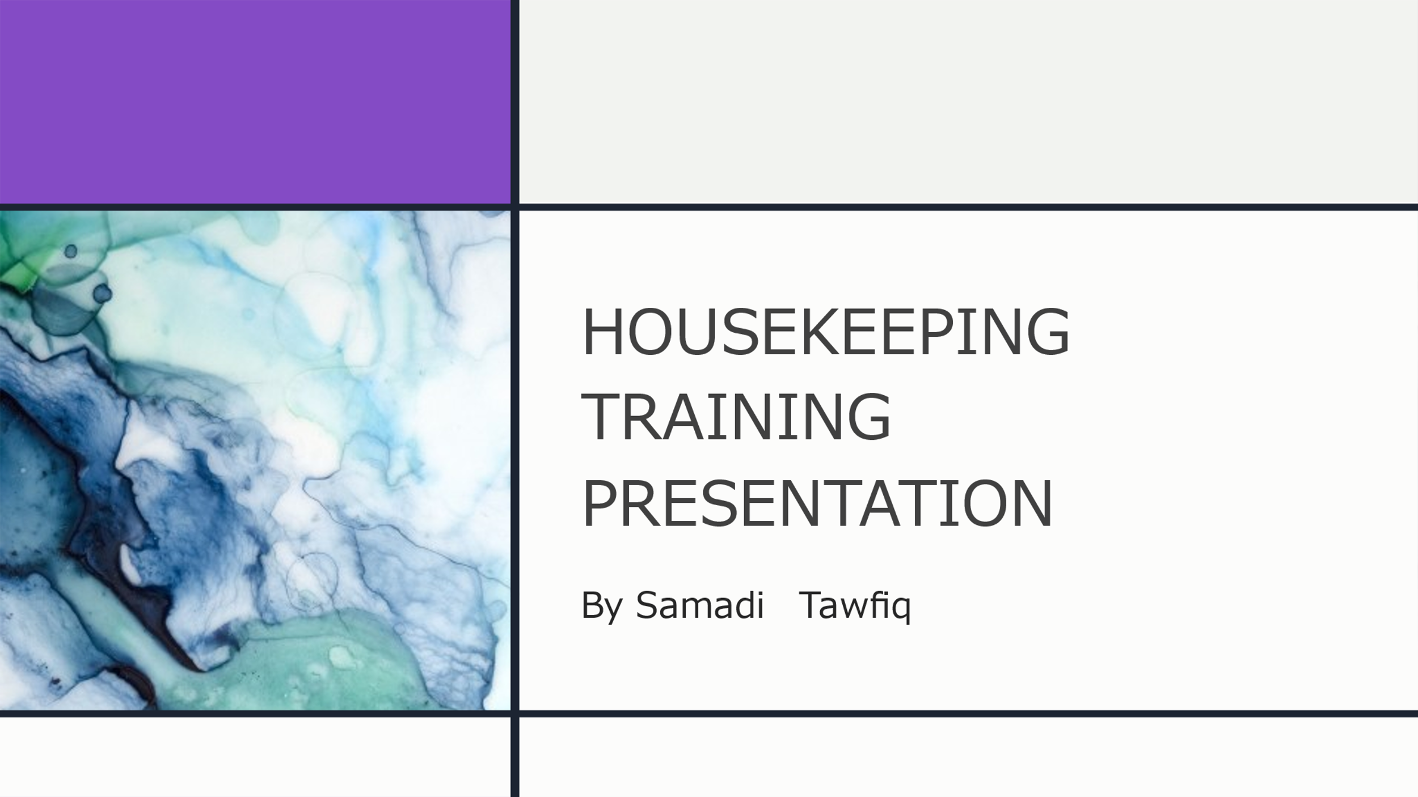

Training Notes:
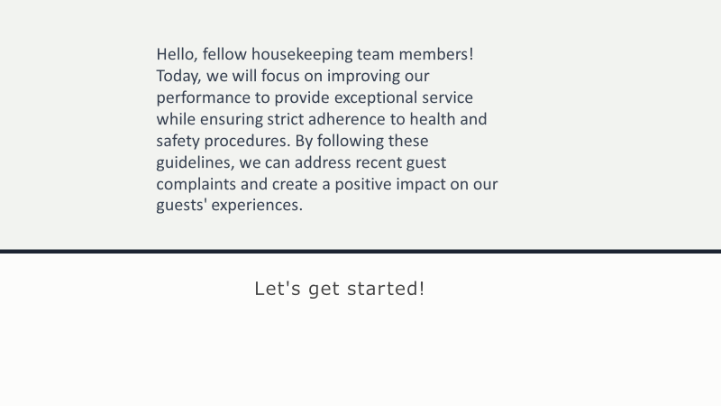

Training Notes:
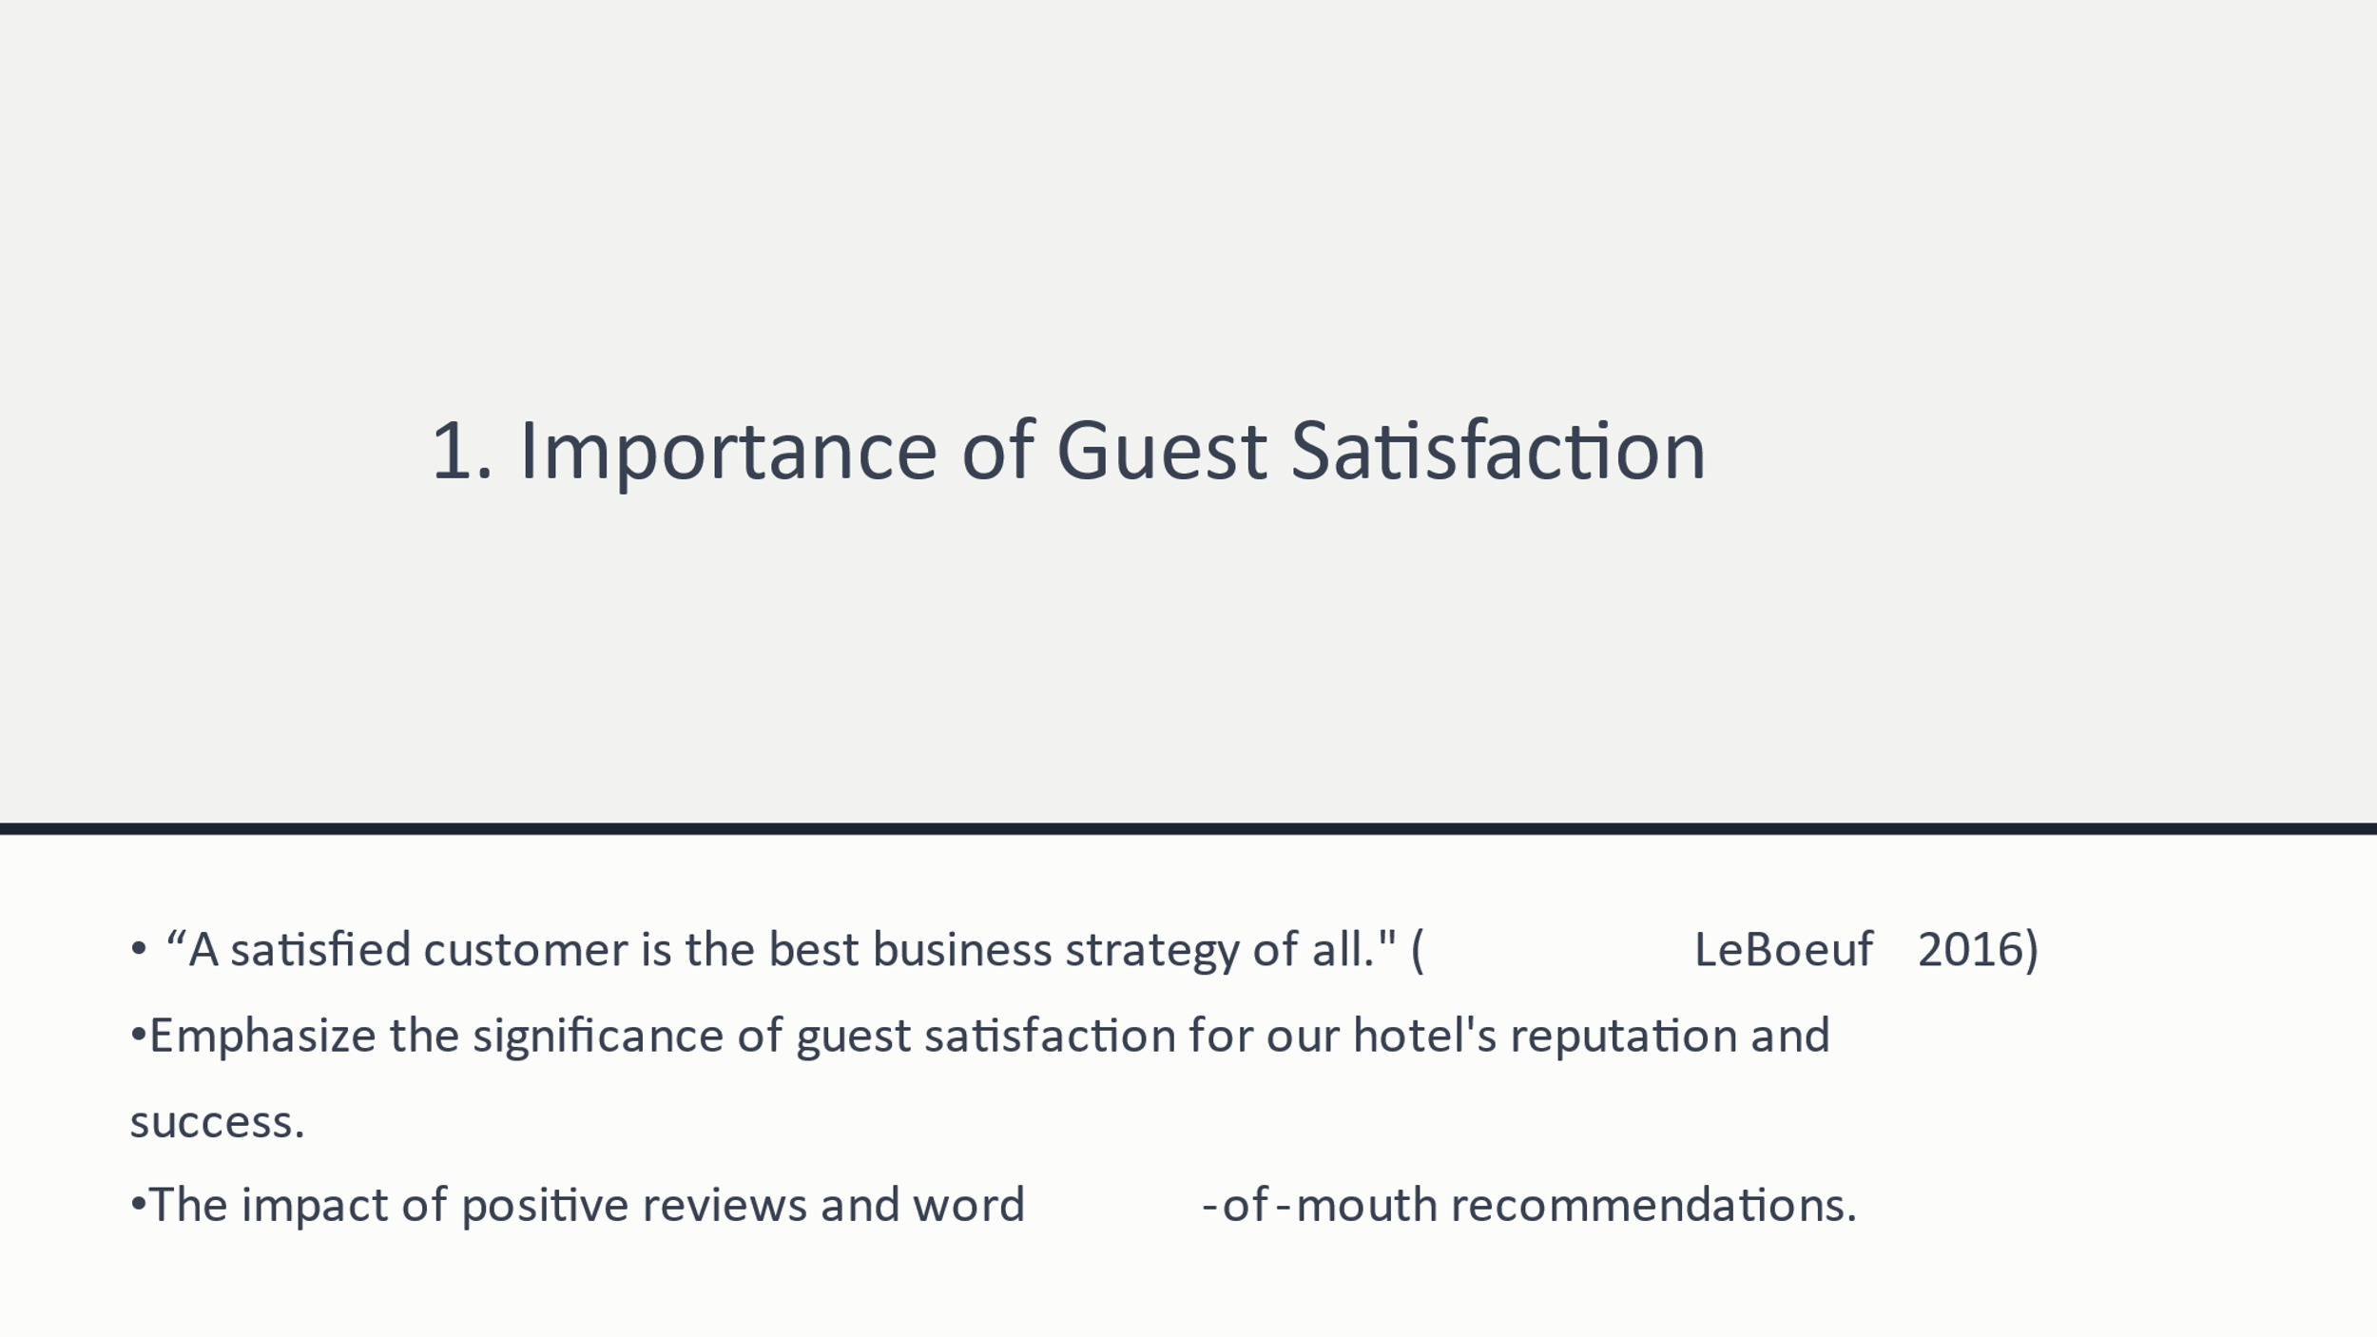

Training Notes:
Training Notes:
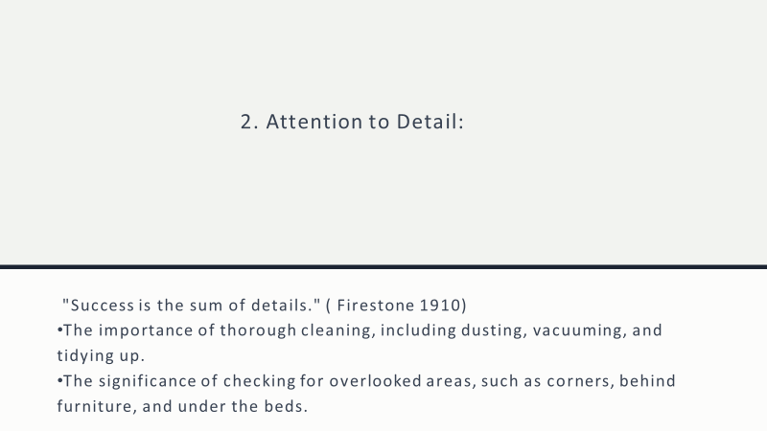

Training Notes:

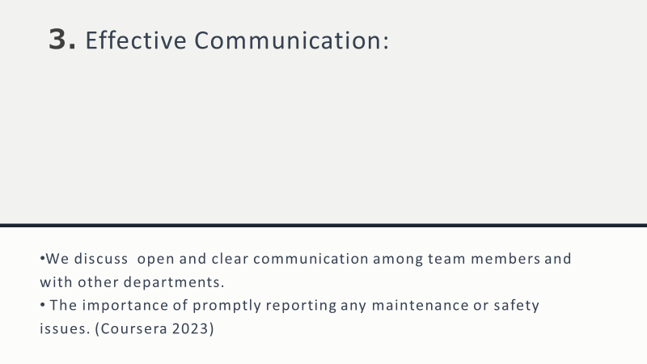

Training Notes:
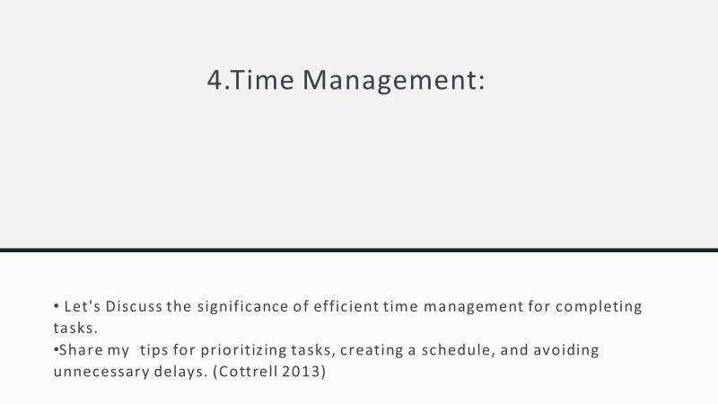

Training Notes:
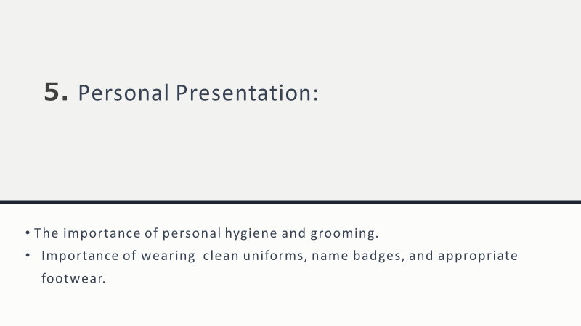

Training Notes:
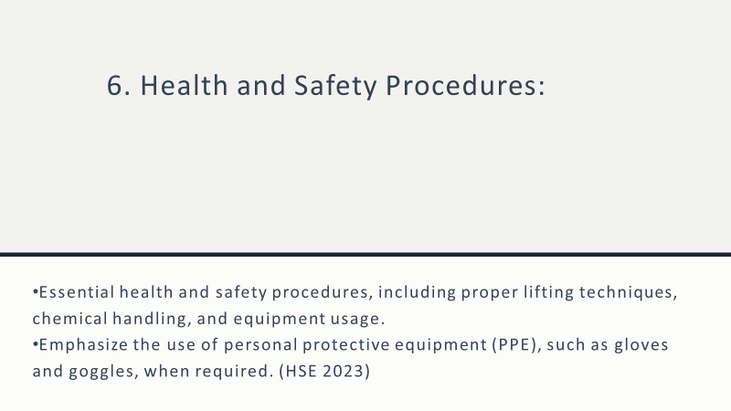

Training Notes:
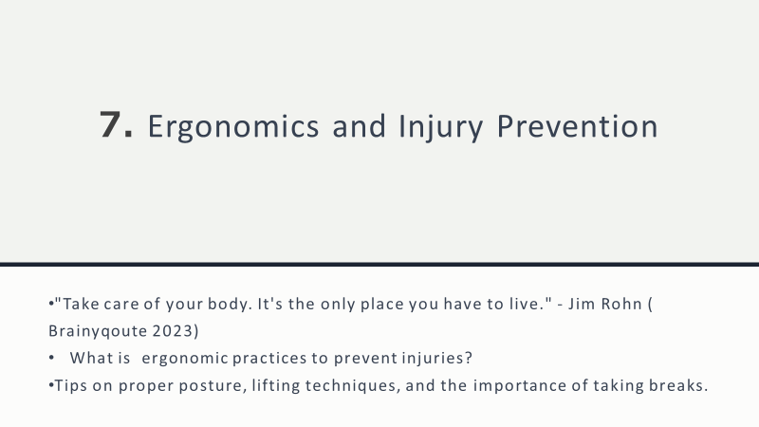

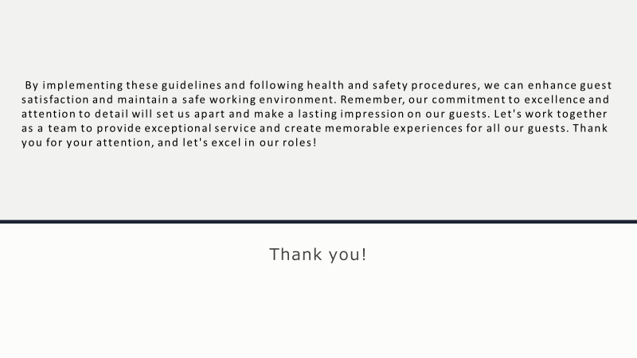
Training Notes:

References

Cottrell S., 2013. The Study Skills Handbook
Coursera, 2023., What Is Effective Communication? Skills for Work, School, and Life, What Is Effective Communication? Skills for Work, School, and Life | Coursera [Accessed 10.06.2023]
Firestone H, 1910., "Success is the sum of details."
HSE, 2023., Catering and hospitality - HSE [Accessed 09.06.2023.]
Johnson, A. (2018). The Importance of Attention to Detail in Housekeeping. Hotelier Middle
Johnson, 2018., "Attention to detail ensures that each room is immaculate, and guests feel comfortable and satisfied with their stay."
Johnson, 2023, "A customer service-oriented approach in housekeeping creates a welcoming atmosphere, fosters guest loyalty, and contributes to the reputation of the establishment."
Jones, 2020,.,"Time management allows housekeeping teams to maintain a consistent workflow, ensuring that guests experience minimal disruptions during their stay."
Lebouf M., 2016., “A satisfied customer is the best business strategy of all”
Rohn J., (n.d.). BrainyQuote.com. Retrieved June 12, 2023, from BrainyQuote.com Web site: https://www.brainyquote.com/quotes/jim_rohn_147499 [Accessed]
Smith, 2021., "Physical stamina enables housekeeping professionals to perform their duties effectively, ensuring that all tasks are completed efficiently and to the highest standard."
Smith, 2019.,
Smith, 2019 "Clear and friendly communication is crucial in ensuring that guests' requests are met, and their concerns are addressed promptly and professionally."

