Data Warehousing & Data Mining
Yasser El Ouafai Ouafa (2320925)
BSc Applied Computing

Contents
1.1 Purpose and Practice of Data Mining 2
1.2 Dataset Description and Exploration 2
1.3 Data Pre-processing 5
1.4 Sample Runs and Analysis Methods 7
1.5 Business Recommendations 10
1.6 Reflective Commentary 11

1.1 Purpose and Practice of Data Mining
Increasingly, organisations rely on data mining to analyse large volumes of customer data and convert it into meaningful information that supports business decision-making. In the telecommunications industry, companies continuously collect data relating to customer demographics, subscribed services, billing information, contract details and account activity. Analysing these data enables organisations to understand customer behaviour, identify hidden patterns and make informed strategic decisions that improve business performance.
In this project, data mining is applied to the IBM Telco Customer Churn dataset to predict whether a customer is likely to leave the company and to identify the key factors associated with customer churn. Customer churn represents a major challenge for telecommunication providers because attracting new customers generally costs more than retaining existing ones. By examining attributes such as contract type, monthly charges, tenure, payment method and additional subscribed services, organisations can recognise customers who are at greater risk of cancelling their contracts and implement appropriate retention strategies before customer loss occurs.
Classification techniques were selected because the dataset contains historical customer records with known churn outcomes. These techniques learn relationships between customer characteristics and previous behaviour, allowing the models to predict whether future customers are likely to churn. In addition, exploratory analysis helps identify behavioural trends and relationships within the data, providing valuable insights into customer retention and service usage.
The knowledge gained from data mining can support customer retention campaigns, improve marketing strategies, optimise resource allocation and enhance customer satisfaction. Consequently, data mining provides organisations with practical business intelligence that supports evidence-based decision-making, strengthens customer loyalty and contributes to improved long-term organisational performance.

1.2 Dataset Description and Exploration
The IBM Telco Customer Churn dataset was selected to analyse customer behaviour and identify the factors that influence customer churn. The dataset contains 7,043 customer records and 21 attributes, with Churn serving as the target variable for classification. The attributes describe customer demographics, account information, subscribed services and billing details. Numerical variables include MonthlyCharges, TotalCharges and Tenure, while categorical variables include Gender, Partner, Dependents, InternetService, Contract and PaymentMethod. The CustomerID attribute is a unique identifier assigned to each customer and does not contribute to predicting customer behaviour, making it unsuitable for predictive modelling. Initial inspection also showed that the dataset contained no missing values, indicating that the dataset was complete before preprocessing.
Before developing the classification models in Weka, the dataset was explored using Tableau Public to understand its overall structure and identify patterns associated with customer churn. Exploratory data analysis provides an opportunity to examine the distribution of variables, identify potential data quality issues and gain business insights before applying machine learning techniques.
The first visualisation illustrates the distribution of customers according to their churn status. As shown in Figure 1, 5,174 customers remained with the company, whereas 1,869 customers left the service. This indicates that the dataset is moderately imbalanced because the number of customers who stayed is considerably higher than the number who churned. Such imbalance is common in customer churn datasets and should be considered when evaluating classification models.

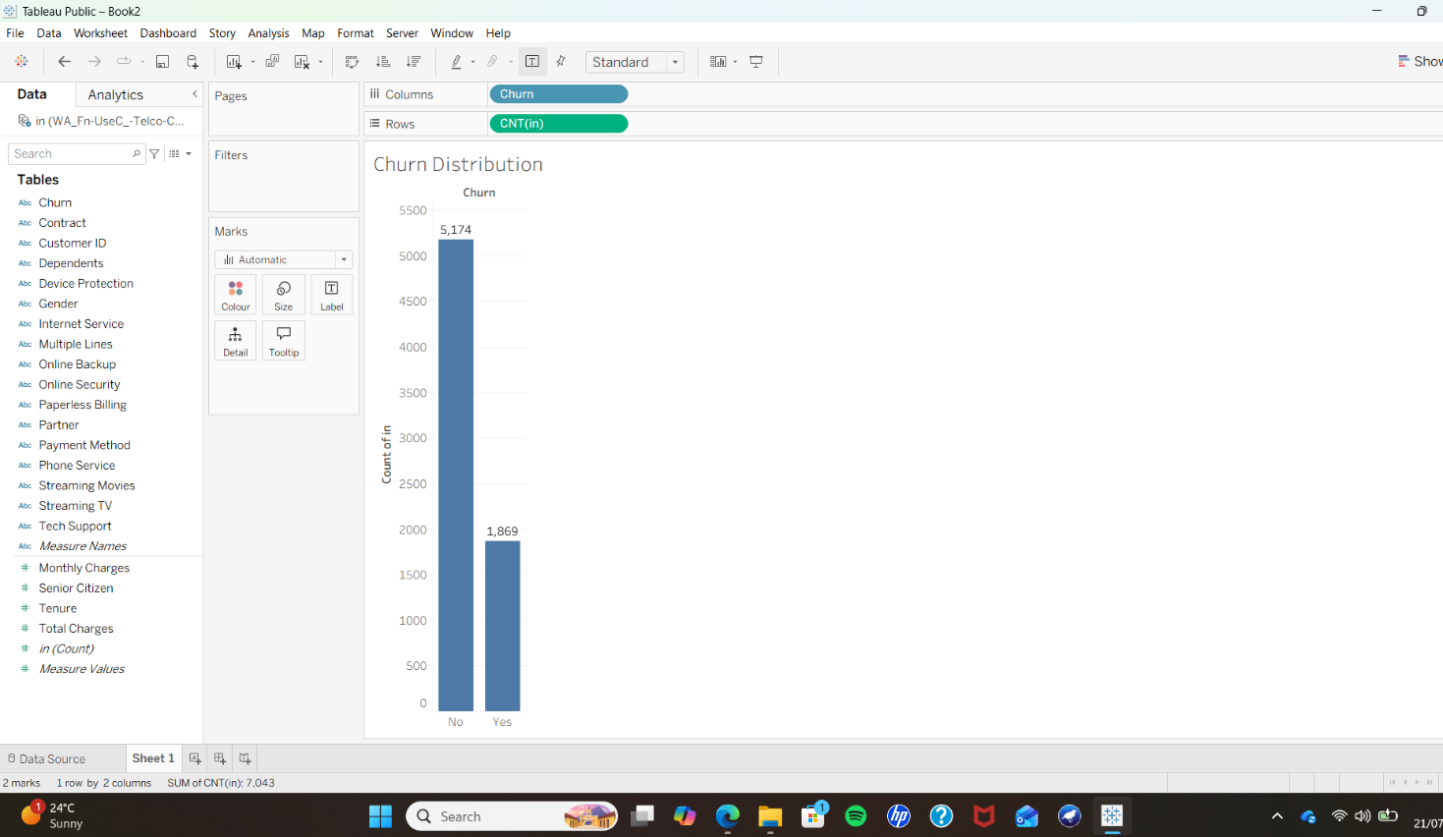

The second visualisation presents the distribution of customers according to their contract type. As shown in Figure 2, month-to-month contracts represent the largest customer group (3,875 customers), followed by two-year contracts (1,695 customers) and one-year contracts (1,473 customers). The dominance of month-to-month contracts suggests that many customers are not committed to long-term agreements, which may increase the likelihood of customer churn.
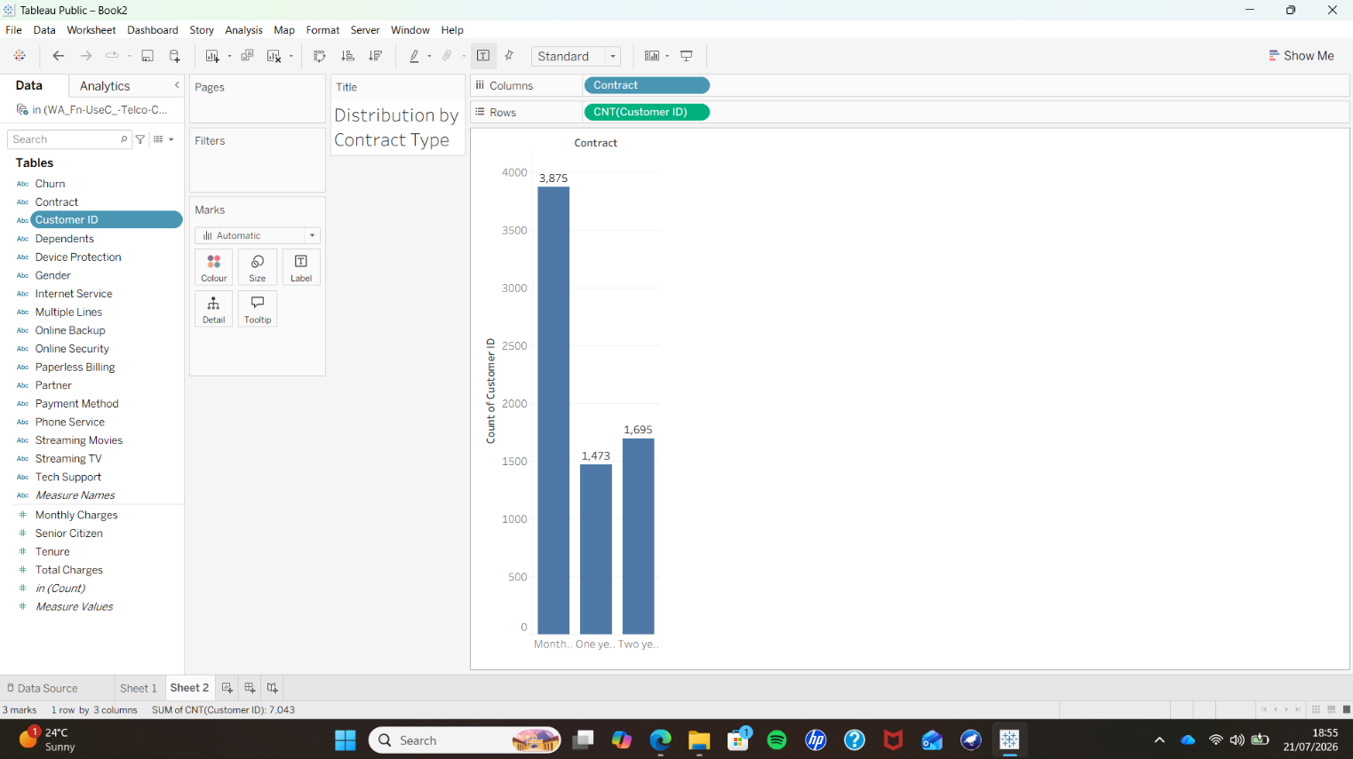

The final visualisation compares the average monthly charges of customers who remained with the company and those who churned. Figure 3 shows that customers who churned paid an average monthly charge of £74.44, compared with £61.27 for customers who remained. This suggests that higher monthly costs may be associated with an increased likelihood of customer churn and should therefore be considered during predictive modelling.
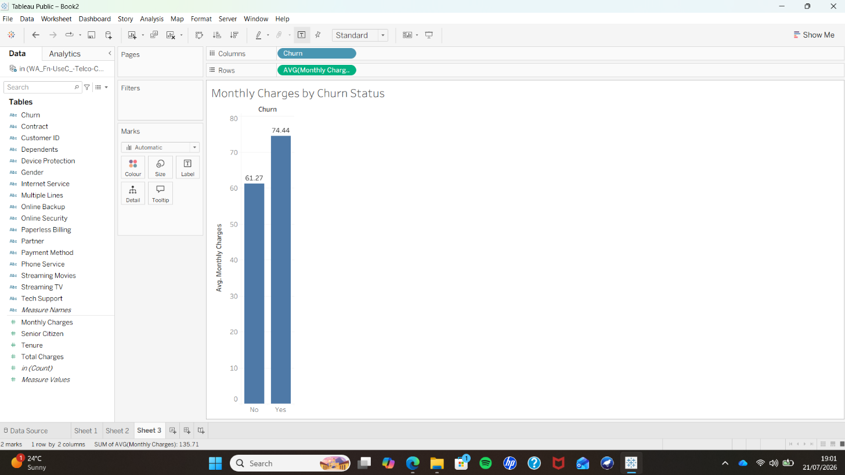

Overall, the exploratory analysis provided a clear understanding of the dataset before preprocessing and modelling. The visualisations highlighted important customer characteristics, confirmed the class distribution and identified variables that could influence churn prediction. These findings informed the preprocessing stage and supported the selection of suitable classification techniques for the subsequent analysis.

1.3 Data Pre-processing
Before developing the classification models, the IBM Telco Customer Churn dataset was pre-processed using Weka to ensure that it was suitable for predictive analysis. Data pre-processing is an essential stage in the data mining process because the quality of the input data directly influences the reliability and accuracy of the classification models. Well-prepared data enables machine learning algorithms to identify meaningful relationships while reducing the influence of irrelevant information or poor-quality records.
The original dataset was imported into Weka after being converted into a compatible format for analysis. During the initial inspection, the dataset contained 7,043 customer records and 20 predictive attributes, following the removal of the CustomerID field. This attribute was excluded because it acts solely as a unique identifier and contains no behavioural or business information that could contribute to predicting customer churn. Retaining identifier fields may introduce unnecessary complexity into the model without improving predictive performance. Removing CustomerID therefore ensured that the algorithms focused only on variables with potential predictive value.

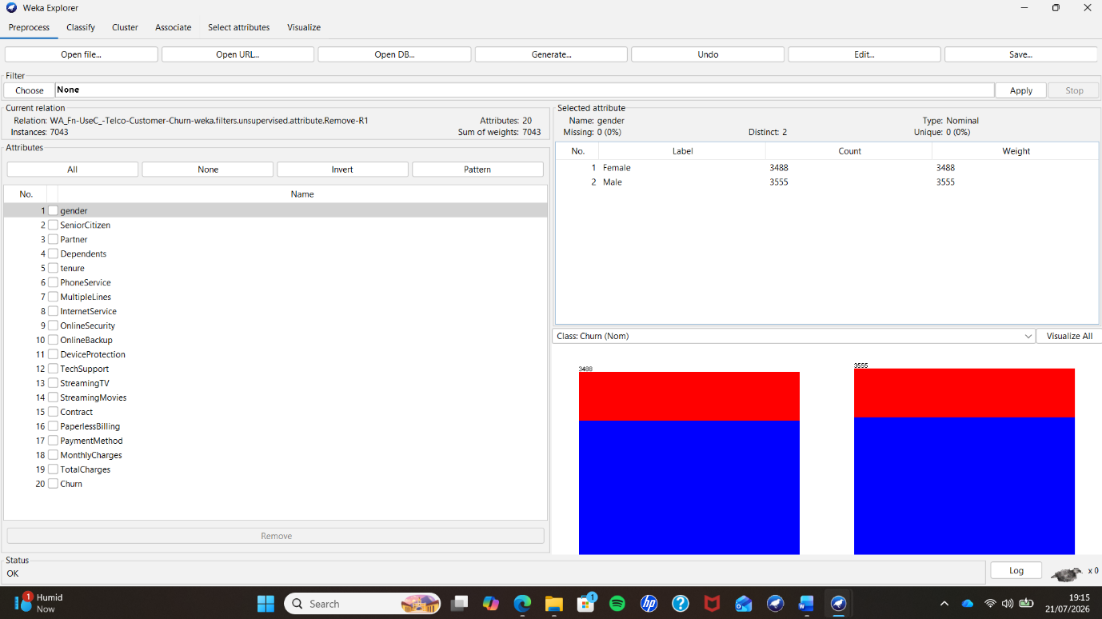

Following the removal of CustomerID, the dataset was examined for potential data quality issues. Weka confirmed that the dataset contained no missing values, meaning that no additional cleaning techniques such as data imputation or record deletion were required. Maintaining a complete dataset reduces the risk of introducing bias that may occur when missing values are estimated or observations are removed. As a result, the original integrity of the dataset was preserved throughout the analysis.
The imported attributes were also inspected to ensure that each variable had been recognised correctly. Numerical variables, including MonthlyCharges, TotalCharges and Tenure, were successfully imported as numeric attributes, while categorical variables such as Contract, InternetService, PaymentMethod, TechSupport and OnlineSecurity were correctly represented as nominal attributes. Correct attribute recognition is essential because classification algorithms process numerical and categorical variables differently. Confirming the attribute types before modelling helped prevent processing errors and ensured that the algorithms interpreted the data correctly.
The exploratory analysis performed in Tableau indicated that the dataset was moderately imbalanced, with substantially more customers remaining than leaving the company. Although techniques such as SMOTE can be applied to balance minority classes, no balancing method was used in this project. The classification models were deliberately trained using the original customer distribution to evaluate their performance under realistic business conditions. This approach reflects the data that telecommunication companies would normally encounter and therefore provides results that are representative of real-world customer behaviour. However, it is recognised that class imbalance may reduce the models' ability to identify all customers who are likely to churn.
Feature selection was intentionally limited to removing the CustomerID attribute because the remaining variables all represented meaningful aspects of customer behaviour, service usage and account information. Attributes relating to customer demographics, subscribed services, billing information and contract details were retained because each could potentially influence the likelihood of churn. Retaining these variables allowed the classification algorithms to learn relationships across multiple aspects of customer behaviour rather than relying on only a small subset of features.
For model evaluation, 10-fold cross-validation was selected within Weka. This validation technique divides the dataset into ten approximately equal subsets. During each iteration, nine subsets are used to train the model while the remaining subset is reserved for testing. The process is repeated ten times so that every customer record is used once for testing and nine times for training. Compared with a single train-test split, cross-validation provides a more reliable estimate of model performance because it reduces the influence of random sampling and makes efficient use of all available data.
After preprocessing, two supervised classification algorithms, J48 Decision Tree and Random Forest, were applied using the same validation procedure to ensure a fair comparison. The classification results were then interpreted using evaluation measures including accuracy, precision, recall, ROC Area (AUC) and the confusion matrix. These measures formed the basis for comparing the predictive performance of both models and supported the business recommendations presented later in this report.

1.4 Sample Runs and Analysis Methods
Following data preprocessing, two supervised machine learning algorithms were implemented in Weka to predict customer churn: J48 Decision Tree and Random Forest. Both algorithms are widely used classification techniques and were selected because they provide interpretable models while allowing their predictive performance to be compared. To ensure a fair evaluation, both algorithms were executed using Weka’s default parameters and assessed using 10-fold cross-validation, ensuring that each customer record was used for both training and testing during the evaluation process.
The performance of each classifier was evaluated using several standard classification metrics. Classification accuracy measures the proportion of correctly classified instances and provides an overall indication of model performance. Precision measures how many customers predicted to churn actually churned, while recall measures the model’s ability to correctly identify customers who left the company. The ROC Area (AUC) evaluates how effectively the classifier distinguishes between customers who churn and those who remain. Finally, the confusion matrix provides a detailed breakdown of correct and incorrect predictions for each class, allowing a more comprehensive evaluation than accuracy alone.
The first classification algorithm evaluated was the J48 Decision Tree. The model correctly classified 5,493 of the 7,043 customer records, producing an overall classification accuracy of 77.99%. The model achieved a Kappa statistic of 0.3988, indicating a moderate level of agreement between the predicted and actual classifications. In addition, the ROC Area was 0.758, suggesting that the model was capable of distinguishing between customers who churned and those who remained with a reasonable level of accuracy. The model required only 0.28 seconds to build, demonstrating that decision tree algorithms can produce classification models quickly while remaining relatively easy to interpret.

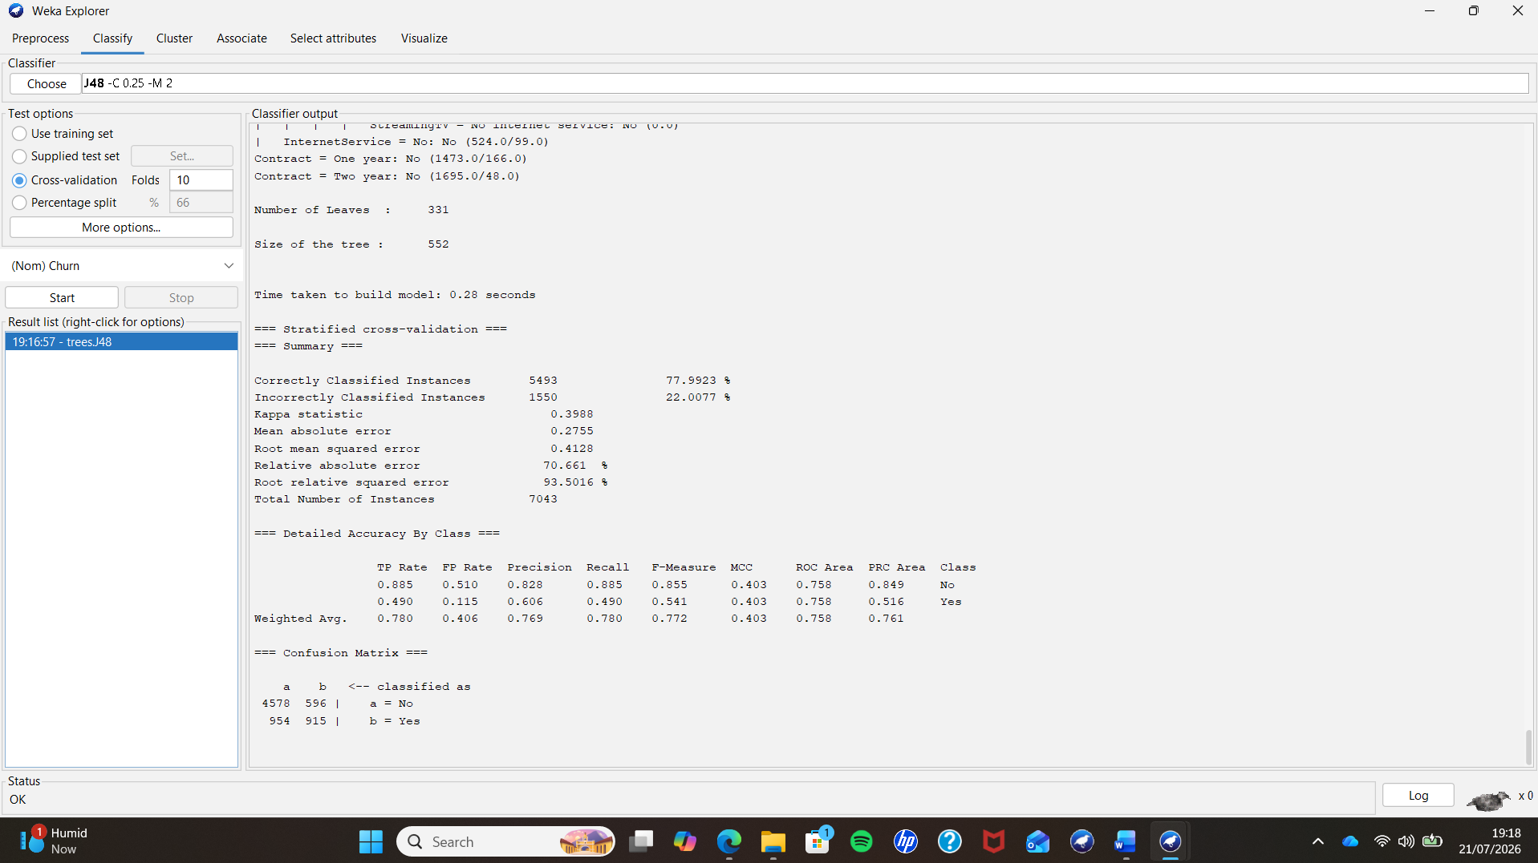
The confusion matrix for the J48 model showed that 4,578 customers who remained with the company were correctly classified, while 915 customers who churned were also correctly identified. However, 596 customers were incorrectly predicted to churn despite remaining with the company, and 954 customers who actually churned were classified incorrectly as non-churners. These false negatives are particularly important because they represent customers that the company could potentially lose without taking preventative action.
The second classification algorithm evaluated was Random Forest, an ensemble learning technique that combines multiple decision trees to improve predictive performance. The Random Forest model correctly classified 5,540 customer records, producing an overall accuracy of 78.66%, slightly higher than the J48 model. The Kappa statistic increased to 0.4118, while the ROC Area improved to 0.822, indicating a stronger ability to distinguish between churning and non-churning customers. The model required 0.99 seconds to build, which was longer than the J48 algorithm due to the construction of multiple decision trees.

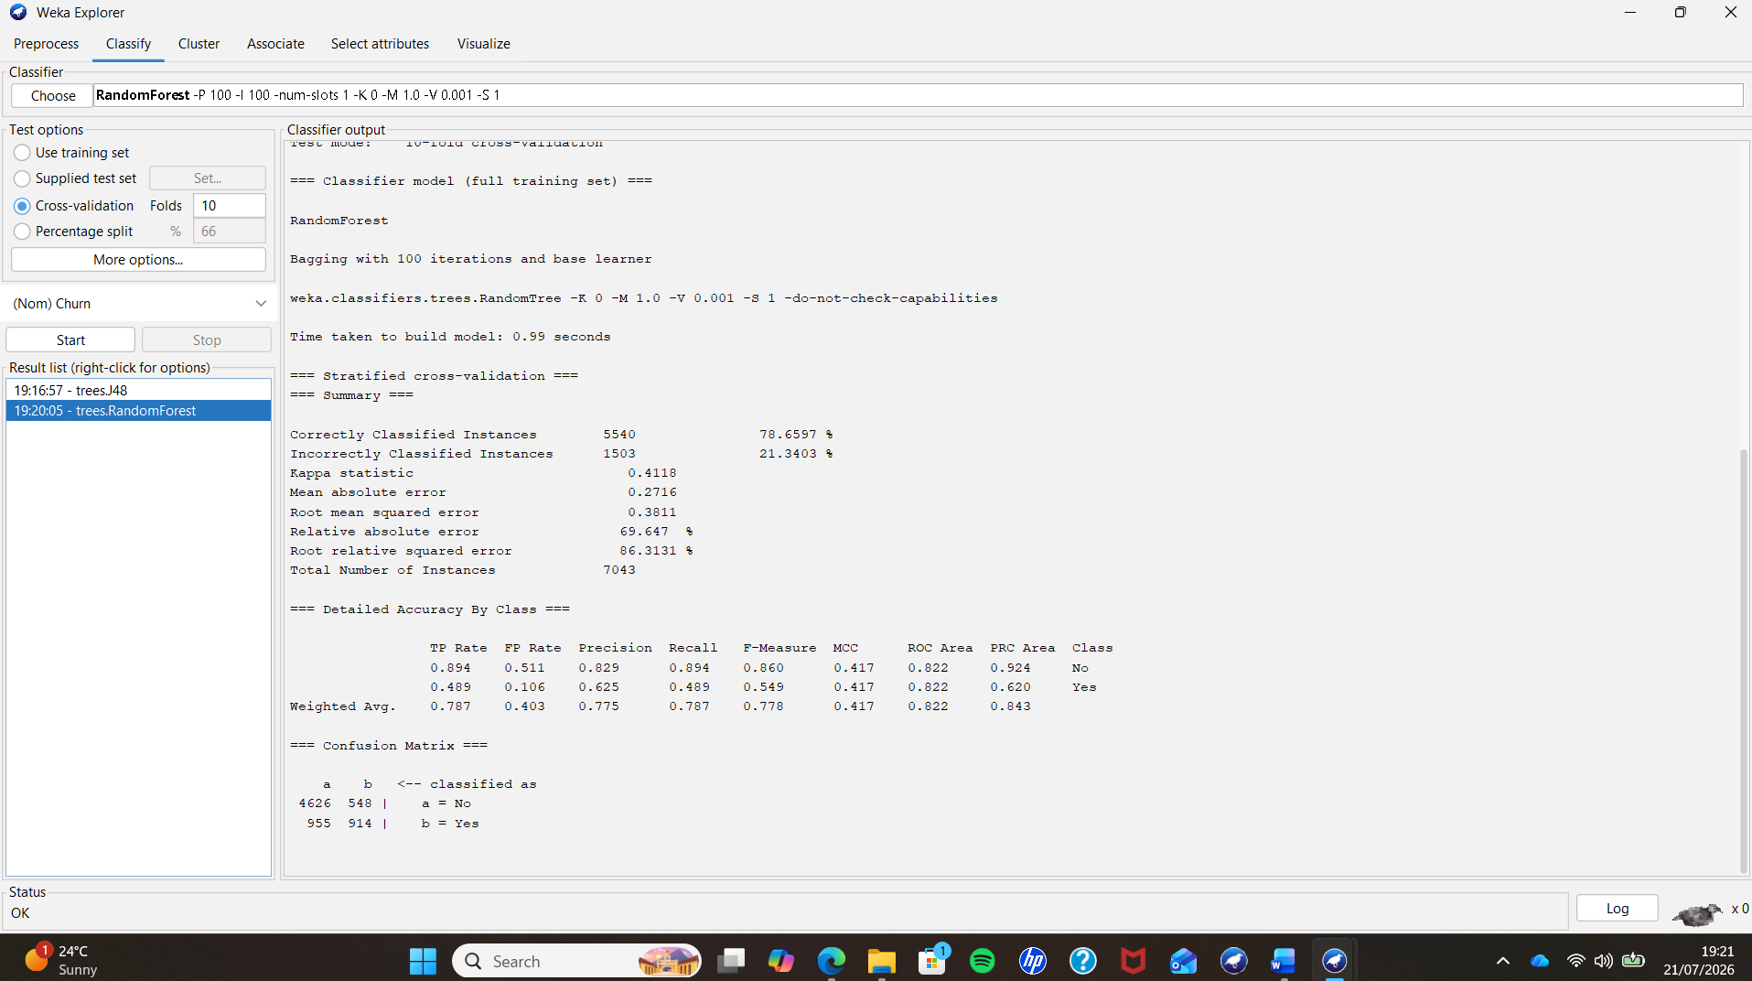
The Random Forest confusion matrix demonstrated a slight improvement over the J48 model. It correctly classified 4,626 customers who remained with the company and 914 customers who churned. The number of false positive predictions decreased to 548, although 955 churning customers were still incorrectly classified as remaining customers. Although the improvement in overall accuracy was relatively small, the higher ROC value suggests that Random Forest provides better discrimination between the two customer classes.
After evaluating both algorithms, their performance was compared using the principal evaluation metrics. The comparison showed that Random Forest outperformed J48 in overall accuracy, Kappa statistic and ROC Area, while both algorithms produced similar confusion matrices. The higher ROC Area achieved by Random Forest indicates that it provides a stronger balance between correctly identifying customers who churn and avoiding unnecessary false alarms. Although Random Forest required a longer model-building time, the difference was less than one second and is unlikely to affect practical business applications where predictive accuracy is more important than computational speed.

Table 1. Comparison of J48 and Random Forest classification models
Performance Metric | J48 Decision Tree | Random Forest
Correctly Classified Instances | 5,493 | 5,540
Accuracy | 77.99% | 78.66%
Incorrectly Classified Instances | 1,550 | 1,503
Kappa Statistic | 0.3988 | 0.4118
Mean Absolute Error (MAE) | 0.3032 | 0.2716
Root Mean Squared Error (RMSE) | 0.3885 | 0.3771
ROC Area (AUC) | 0.758 | 0.822
Time to Build Model | 0.28 s | 0.99 s

As shown in Table 1, both classification algorithms achieved satisfactory predictive performance, with classification accuracies above 77%. However, Random Forest consistently produced the strongest overall results, achieving the highest accuracy (78.66%), ROC Area (0.822) and Kappa statistic (0.4118). These findings indicate that Random Forest was better able to distinguish between customers who churned and those who remained with the company. Although the model required a longer build time than J48 (0.99 seconds compared with 0.28 seconds), the difference was negligible in practice. Therefore, Random Forest was selected as the preferred classification model for this study because it provided the best balance between predictive performance and computational efficiency.

1.5 Business Recommendations
The findings of this study suggest that predictive data mining can provide valuable support for customer retention strategies within the telecommunications industry. As the Random Forest model demonstrated the strongest predictive performance, it could be integrated into the company's customer relationship management (CRM) system to identify customers who are at a higher risk of churning. This would allow the organisation to take proactive action before customers decide to terminate their services.
One recommendation is to develop targeted retention campaigns for customers identified as being at risk. These campaigns could include personalised discounts, contract renewal incentives or service upgrades that are tailored to individual customer needs. Since the exploratory analysis showed that customers on month-to-month contracts formed the largest customer group, the company could encourage these customers to move to longer-term contracts by offering financial incentives or additional service benefits. Increasing customer commitment may help reduce the likelihood of churn.
The analysis also indicated that customers who churned had higher average monthly charges than those who remained with the company. Consequently, the organisation should review its pricing strategy to ensure that customers perceive the services as offering good value for money. Providing flexible pricing plans or customised packages may improve customer satisfaction while reducing the number of customers who leave because of cost concerns.
Finally, customer churn prediction should become part of a continuous decision-making process rather than a one-time analysis. Regularly updating the predictive model with new customer data would enable the company to monitor changing customer behaviour and adapt its retention strategies accordingly. By combining predictive analytics with proactive customer engagement, the organisation can improve customer loyalty, reduce churn rates and strengthen its long-term business performance.

1.6 Reflective Commentary
This project provided valuable practical experience in applying the data mining process to a real-world business problem. Throughout the assignment, I gained a better understanding of how raw customer data can be transformed into meaningful business information using data preprocessing, visualisation and machine learning techniques. Working with the IBM Telco Customer Churn dataset demonstrated the importance of preparing data carefully before building predictive models, as the quality of the input data directly affects the reliability of the results.
Using Tableau improved my ability to explore datasets visually and identify important trends before modelling. Creating charts to examine customer churn, contract types and monthly charges helped me understand the characteristics of the dataset and provided useful business insights that supported the later stages of the analysis. I also developed practical skills in presenting data clearly through appropriate visualisations.
Using Weka enhanced my understanding of supervised machine learning algorithms and model evaluation techniques. Comparing the performance of the J48 Decision Tree and Random Forest classifiers demonstrated that different algorithms can produce different predictive results even when applied to the same dataset. Interpreting evaluation measures such as classification accuracy, Kappa statistic, ROC Area and confusion matrices helped me understand that model performance should be assessed using multiple criteria rather than relying solely on accuracy.
One limitation of this project was that only two classification algorithms were evaluated. Future work could compare additional machine learning techniques or investigate methods for addressing the class imbalance within the dataset. Overall, this assignment strengthened both my technical and analytical skills while demonstrating how data mining can support evidence-based business decision-making. The knowledge and practical experience gained during this project will be valuable for future data analysis and business intelligence tasks.

References (IEEE)
[1] J. Han, M. Kamber and J. Pei, Data Mining: Concepts and Techniques, 3rd ed. Burlington, MA, USA: Morgan Kaufmann, 2012.
[2] P.-N. Tan, M. Steinbach, A. Karpatne and V. Kumar, Introduction to Data Mining, 2nd ed. Harlow, U.K.: Pearson, 2019.
[3] D. T. Larose and C. D. Larose, Data Mining and Predictive Analytics, 2nd ed. Hoboken, NJ, USA: Wiley, 2015.
[4] IBM, "Telco Customer Churn Dataset," IBM Sample Data Sets, 2019. [Online]. Available: https://www.ibm.com. [Accessed: Jul. 21, 2026].
[5] I. H. Witten, E. Frank, M. A. Hall and C. J. Pal, Data Mining: Practical Machine Learning Tools and Techniques, 4th ed. Cambridge, MA, USA: Morgan Kaufmann, 2017.
[6] V. Kotu and B. Deshpande, Data Science: Concepts and Practice, 2nd ed. Cambridge, MA, USA: Morgan Kaufmann, 2019.
[7] J. R. Quinlan, C4.5: Programs for Machine Learning. San Mateo, CA, USA: Morgan Kaufmann, 1993.
[8] L. Breiman, "Random Forests," Machine Learning, vol. 45, no. 1, pp. 5-32, 2001.
[9] T. Fawcett, "An Introduction to ROC Analysis," Pattern Recognition Letters, vol. 27, no. 8, pp. 861-874, 2006.
[10] F. Provost and T. Fawcett, Data Science for Business. Sebastopol, CA, USA: O'Reilly Media, 2013.
[11] M. J. A. Berry and G. S. Linoff, Data Mining Techniques: For Marketing, Sales, and Customer Relationship Management, 3rd ed. Indianapolis, IN, USA: Wiley, 2011.
[12] T. M. Mitchell, Machine Learning. New York, NY, USA: McGraw-Hill, 1997.
[13] Tableau Software, "Tableau Public," 2025. [Online]. Available: https://public.tableau.com/. [Accessed: Jul. 21, 2026].
[14] The University of Waikato, "WEKA 3: Data Mining Software in Java," 2025. [Online]. Available: https://www.cs.waikato.ac.nz/ml/weka/. [Accessed: Jul. 21, 2026].
[15] C. C. Aggarwal, Data Mining: The Textbook. Cham, Switzerland: Springer, 2015.

