TASK 1 – Book Dummy
Book dummy incorporating approx. 12 images of previous work
Due in session 2 – Thurs 12th Feb – bring to session.
Formatting: Please read Indesign & PDF Booklet Printing Guide and bring a physical book dummy to next weeks session. Focus on the layout of your imagery and the flow, pace, and communication of your work.

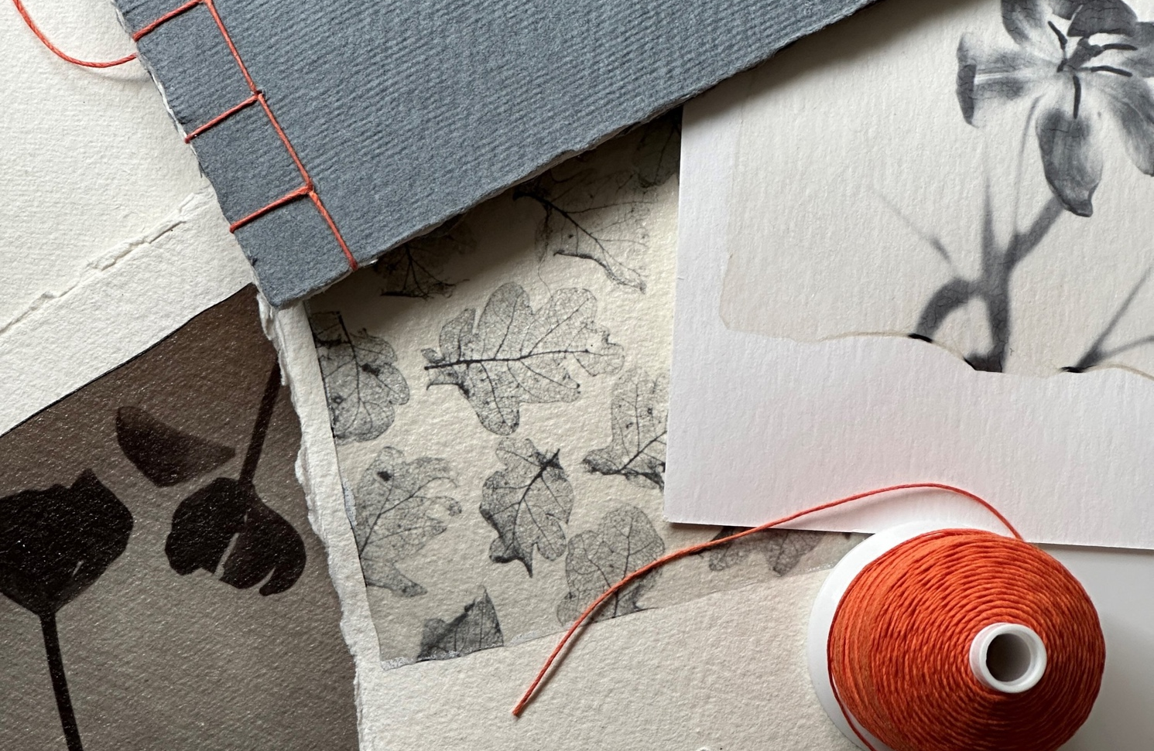
Content
Your book dummy should contain work from an existing project. Choose work from a project which was successful and resulted in a body of images which are succinct. The book format allows you to reconsider this work: The flow of pages, white space, cover, binding, typographic etc. are all key components of how the book works.
Format
This is a physical submission which requires you to plan and lay out a set of images then printing and binding it. Firstly, select, prepare and print your chosen imagery.
Research
We are expecting you to respond to works shared with you in sessions this week. Highlight a method, technique or quality of a book introduced to you and reflect that in your work. It could be an image flow or layout, a binding option, or a cover.

Skills
Practical skills – quality of finish, materials, techniques. These are key to a sense of quality – both in a traditional sense of a well-made art object and in the sense of quality reflecting the project sensibilities and your style.
Contextual/conceptual skills – the layout, flow and communication of your work. Often an extension of the practical/material quality of a book, consider how your work speaks.
Review
In next week’s session, we’ll look at your dummies discussing what you’ve learned and executed in your first practical submission.

