Introduction to Web Development
  - Lecture 6 Lab Tutorial Exercise

Creating a Registration Form and a Set of Social Media Links

Objectives
The aim of this lab exercise is to give you some experience of creating HTML Forms and using CSS Sprites.
To assist you in this exercise, please refer to the following references available on the W3Schools website (explanation of all CSS styles and selectors) – of course I am also here to assist :
- CSS Styling Properties: http://www.w3schools.com/cssref/default.asp
- CSS Selectors: http://www.w3schools.com/cssref/css_selectors.asp.

Exercise 1: Getting Started
- Note: This exercise requires you to have completed last week’s exercise.
- Open up the website project from last week in Visual Studio or your preferred development environment (e.g. NotePad++, Sublime).

Exercise 2: CSS Sprites
- In this exercise, you will create a set of social media menu links in the footer section of your web pages.

The HTML
- Open up your index.html page.
- Locate the <footer> element. Add another row spanning 12 columns as shown below.
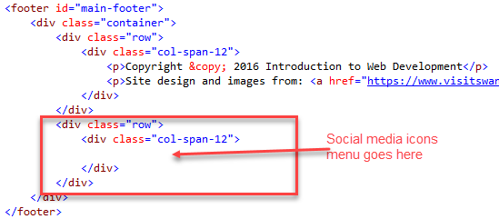
- Recall that a menu is simply a list of links and you use the <ul> element as the container element of all the links. Add a <ul> element into the space indicated and set the following attributes:
  - Id: social-menu
  - Class: menu
- Next you need to add the individual menu list items <li> containing the links <a> to the respective social media sites.
  - Recall that it is good practice to open links to an external site in a new window (you set the target attribute to blank).
  - Add the links for the social media sites listed below. An example is shown. There is no need to add any text to display because you are going to use sprite icons.
ID | URL
facebook | https://www.facebook.com/
twitter | https://twitter.com/
linkedin | https://www.linkedin.com/
youtube | http://www.youtube.com/visitswanseabayTV
pinterest | https://uk.pinterest.com/visitswanseabay/

- Save your changes and preview.
- You will probably notice that nothing appears, it’s time for CSS.

The CSS
- Download the mini-social-icons file from Moodle and copy it to the images folder of your website.
  - Each icon has a size of 42px by 42px.
  - The figure below shows you what it looks like (you are free to use an alternative)
84px
42px
0px
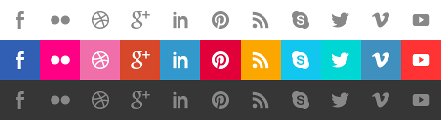
84px
42px

- Open up your styles.css file.
- Create a style selector to select all <a> elements that are a descendant of an element with id=social-menu (or whatever ID you have used in step 4). Add the following style definitions for the selector:
  - Background image: to the downloaded mini-social-icons.png file
  - Display – inline-block because the <a> element by default determines its size by its content. If it has no content, its size will be set to 0.
  - Width and height – 42px (you need to separate definitions)
- Next, you need to style the individual list icons. Each of the links for each of the social media links have been given IDs, so you can use these to select the individual items to style e.g. the Facebook link has the ID set to “facebook”.
- You will start with Facebook.
  - If you look at the image, you will notice that the Facebook icon is the first image sprite, so it does not need to be shifted on the x-axis (left position = 0)
  - You will use the images from the 3rd row as the default. This means you need to shift the image upward on the y-axis by 84px (top position = -84px, note the minus symbol)
  - Add a selector that selects the element with ID = facebook and add the following style definition:
- For the hover effect, you will use the icon images from the 2nd row, so this time you need to shift the image upward on the y-axis by 42px (top position = -42px). Create a selector for the hover state for the Facebook element and add the following style definition to it.
- Complete the styles for the other social media menu links. Use the image above to correctly work out the left position. The top position will be the same.
  - Twitter
  - Linked In
  - You Tube
  - Pinterest
- Save your changes and preview. Remember to try hovering over the icons.
- Hopefully, you got all the correct sprite images showing for each of the links, but you may notice a few problems.
  - When you hover over the image icon, you may notice an additional background colour. This is because of the styles that you have already defined for the menu class. You need to use more specific style selectors to override these general styles.
- Return to your CSS page and add the following two styles. Note: if you have used a different ID, modify accordingly.
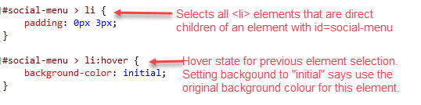
- Save your changes and preview. Has it fixed the problem?
- Now, return to your HTML document. Copy the HTML for the new social media menu list (everything you added today) and duplicate this across the other pages of your website, so they all have a consistent look and feel. Remember to save your changes.

Exercise 3: Creating a Registration Form
- In this exercise, you will create a registration form page. Note: the form you are creating is a bit over the top, and includes a few unrealistic fields. They have been chosen to demonstrate the concepts.
- In your website folder, duplicate the gallery.html page (use another page if you do not have this page).
- Rename the duplicated page to register.html.
- Open up the new register.html page and locate <section id=gallery> element.
  - Delete the id attribute from the <section> element
  - Delete all the <img> elements
  - Replace the <div class=”col-span-12 flex-container”> with a <form> element as shown below.
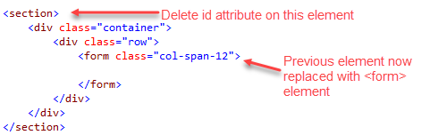
- As we are not writing any server-side code in this module, we will use the get method to submit the form input data to a page I have provided for you. Please note: in reality you will use the post method and not get because post is more secure and your form contains sensitive user data.
- Download the form-submission.html file provided on Moodle and add it to your website folder with all the other HTML pages.
- Add the following attributes to the <form> element.
  - Method = get
  - Action = form-submission.html
- The following elements will be added to the form.
- Note: all input elements (apart from the buttons) will be given:
  - An id attribute to identify the element for its corresponding <label> element.
  - A name attribute to identify the input data submitted for each field.

Name Field
- The name field is a text field and it is required field. Instead of using a separate <label> element, it is using a placeholder attribute to indicate to the user what the expected input for this element is.
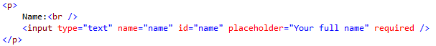

Email Field
- The email field will use the new HTML5 type, email, and this this will also be a required field.
  - This time around you will also use a separate <label> element for the field, as well as a placeholder.
  - The “for attribute” of the <label> element is set to the id of the element it is a label for.

DOB Field
- Add a <label> and <input> field for the Date of Birth and set the following attributes. You will also restrict the maximum value allowed for this field, so that people younger than 18 (or any age you wish) cannot register – you use the max attribute for this.
  - Type: date
  - Name and ID: dob
  - Max (maximum value allowed): 1998-11-24
    - That is today’s date minus 18 years
    - The date must be specified in the format: yyyy-mm-dd
  - Remember to set the “for attribute” for <label> to the id value of this input field.

Favourite Colour
- Add a <label> and <input> for the user to specify their favourite colour (why? It beats me , as I said some of these fields have been chosen to demonstrate what is available). Add the following attributes:
  - Type: color (note, American spelling)
  - Name and ID: favouriteColour

Gender
- The gender input field will have four options, but the user can only select one of the options. Therefore you use a radio button. For this to work, all options must have the same name, but they will have different IDs.
- The four options have been listed below and an example of the first one has been provided for you.
  - Male
  - Female
  - Other
  - Prefer not to say
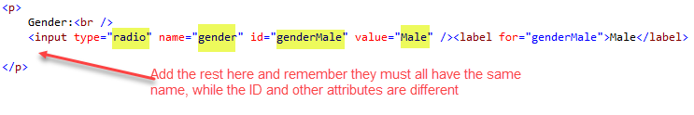

Preferred Method of Contact
- This field has two options: contact by email and contact by phone. The user is allowed to select none, both or just one of the options, so this time you will use a check box. Checkboxes have different names as well as different IDs.
- The first one for contact by phone is shown below. Add the option for contact by email.

Address
- The address will be made up of two input fields, so you will use a <fieldset> element to group them – just to demonstrate the behaviour of a fieldset element.
- Add the following <fieldset> element.
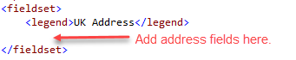
- Add a paragraph <p> element containing a <label> and <input> element for the address with the following attributes:
  - Type: text
  - Name and ID: ukAddress
  - Remember to set the “for attribute” for <label> to the id value of this input field.
- The second input field will be for the user to specify what region of the UK the address is in. You will use a <datalist> element in addition to a <label> and <input> field.
  - The <datalist> provides a list of pre-defined suggested options for an <input> element.
  - You give the <datalist> element an ID.
  - You link the <input> element to the corresponding <datalist> by setting its list attribute to the ID value of the <datalist> element.
- Add the following:
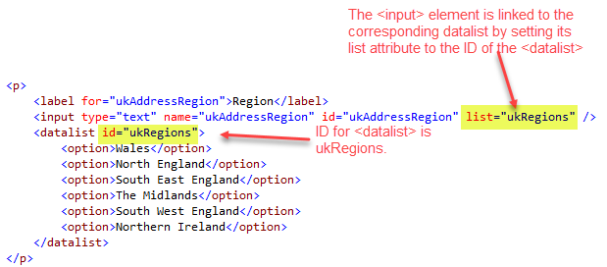

From
- Note, this field is added after the <fieldset> element.
- The from input field allows the user to select what part of the world they are from a drop-down list of fixed options.
  - You use a <select> element.
  - The <select> element contains a set of child <option> elements used to specify the options allowed.

- Add the following:
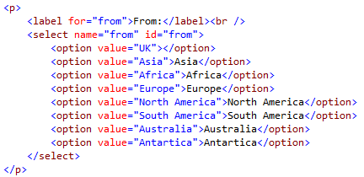

Additional Comments
- This field needs to be large enough for the user to specify all the comments they want. You will use a <textarea> field, which is a multi-line input text box.
  - You have to specify how many rows (i.e. how many input lines) and how many columns (i.e. how wide).
  - Add the following:

The Submit and Reset Buttons
- Finally you need to add two buttons. Add the following two buttons to a <p> element. They do not require labels.
  - Submit Button for submitting the filled in data when the user is done. This button has the following attributes:
    - Type: submit
    - Value: Register now (the display text on the button)
  - Reset Button for resetting the form to its initial blank state in the event that the user has made some errors. Add the following attributes:
    - Type: reset
    - Value: Reset
- Save your changes and preview.
  - Try testing your page with an invalid email address and/or not specifying a name.
  - You should see the submitted data displayed in the form-submission page.
- Add a menu link to the Register page on all your pages.
- That’s all for today!

