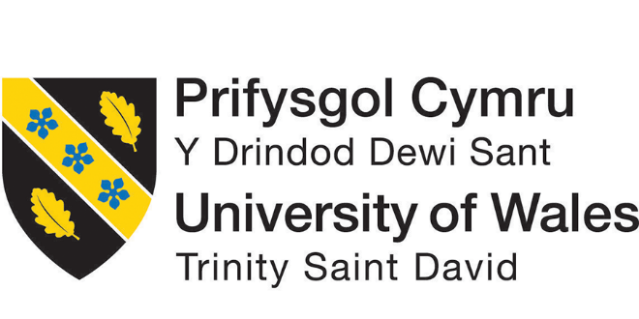

Module Title: Global Business Environment
Assessment 2

Name student: ANA BAICU
Student Number: 2012401
Module lecturer’s name: HOSSEIN SHOKRI
Module code: LCBB4005

Table of Contents
Introduction 1
1. The changes that the company has made in the last few years to their business models for self-regulating and adapting to some of the concerns raised by the different stakeholders above: 2
1.1 Product life cycle: 2
1.2 SWOT analysis: 4
2. Explaining if these changes will give some competitive advantages position and providing any relevant recommendations to the management of this organisation: 6
2.1 Porter’s five forces: 6
2.2 PESTEL analysis: 7
2.3 Recommendations: 8
Conclusion 9
References 10

List of Figures:
Figure 1: The product life cycle 3
Figure 2: SWOT analysis 4
Figure 3: Porter’s five forces 6
Figure 4: PESTEL analysis 7

Introduction
The global business environment is one of the major concerning issues for the researchers as different impacts are directly affected by the organisations. The management of a firm cannot make a similar business plan that they made in the domestic market. Different environmental analysis needs to be prepared by the management to successfully maintain the performance in the international market. For getting a sustainable advantage from the competition in the global market, firms have to make different strategic analyses to get a competitive advantage from the market. In this report, different strategies like SWOT, PESTEL, Porter’s five forces, value chain network, etc. strategies will be applied to the firm Primark which is a fashion retailer headquartered in Ireland. The firm is serving different countries all around the world where the management of the firm needs to use these strategic directions to get competitive advantages in the global market.

1. The changes that the company has made in the last few years to their business models for self-regulating and adapting to some of the concerns raised by the different stakeholders above:
Primark is a fashion retailer business firm that is providing its products and service to the people ensuring the best quality in it. The firm has started its production in 1969 in Ireland by in the last few years, the firm is starting to deliver its products all around the world. They have now 392 stores in 12 countries in different region of the world (Bishop, 2013). These firms have able to be NO1 low price retailers in the industry in the last few years using the different strategic directions in the management. In the last few years, the firm has understood that they need to do something different to get a different advantage from the market. As a result, the management of the firm made market research deeply in the international market and able to understand that, if the firm can use the production of different developing countries like Bangladesh, Pakistan, China, etc. where the labour cost is very cheap, the management can provide different products with lower price.
For this consideration, the management of Primark has started to contact the suppliers and factories from some countries including Bangladesh, Pakistan, China, Turkey, Ethiopia, etc., and able to decrease the cost of production from the firm (Burns, 2011). it helps to sell the products with less cost by the management but at the same time they can maintain the quality of their products as the garments industry of those countries are providing good quality products with low prices as the labour cost is low, the natural resources are huge and the economy of many of those countries mostly depends on it. So, they always try to make a good relationship with the global business retailer including Primark and provide the best possible quality of products at a reasonable price. This strategy has created a difference in the production of the firm and helps the firm to get advantages from the global market.

1.1 Product life cycle:
The firm has used different strategic models in the firm including product life cycle which helps the firm to understand whether the firm is going to make new quality products with new fashion or the firm will produce more trendy products that are being used currently. So, the products life cycle of Primark is showing below:
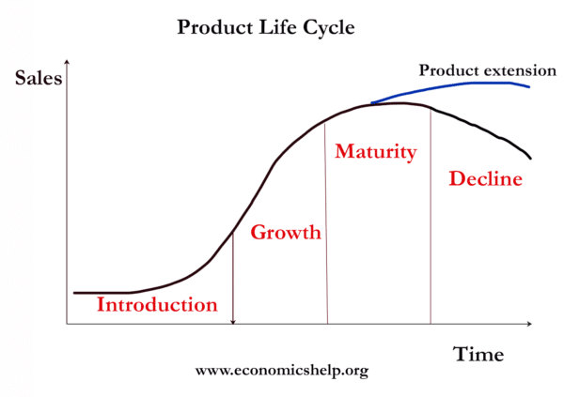
Figure 1: The product life cycle
Source: (Burns, 2011)
The product life cycle is considered as the measurement of time that takes a product to introduce in a market until it is taken off the shelves. This cycle has 4 stages including introduction, growth, maturity, and decline or extension. Primark uses this model for the growth of the firm. in the beginning, the firm introduces a product into the market (ChangsooLee, 2016). In this stage, Primark includes substantial costs regarding advertisement and making marketing campaigns. Primark uses different marketing strategies while launching new products into the market and organise different give-away ceremonies with social influences. Here the management of the firm uses social media greatly in introducing a new product in the market of a different country.
The second stage of the product life cycle is growth which is the next stage of introducing a new product. In this stage, the firm is getting orders from the consumers and the rate is increasing day by day. It is characterised by growing the demand for the products in Primark and increasing the production and availability of those products which is required by the firm if the products are successfully passed in the introduction part (Cuervo-Cazurra, 2011). The third stage of the growth cycle is maturity which is the most profitable stage in production at Primark. The cost is in the lowest range as no promotional cost is required here but the sales are at the top level here. If any products of Primark can reach this stage, the firm becomes profitable in its operations. The final stage is whether decline or product extension which is made based on the demand of the products to the consumer. If the demand for the products continues to increase, the products can extend by adding some new features or designs in Primark.

1.2 SWOT analysis:
Using SWOT analysis, Primark can understand where the firm should invest their money and where to avoid it. At the same time, the management can also understand the improvement factors available in the organisation (Dr. K. Madhava Rao, 2020). Applying this strategy successfully, Primark can make the market production successfully by gaining sustainable advantages from the market. So, the SWOT analysis of Primark is showing below:

Figure 2: SWOT analysis
Source: Author
Strengths: The company has over 50,000 employees that are providing their effort successfully in the organisation. They are providing their service in the firm from all around the world which is a big strength in the sustainability of the firm. Similarly creating a wide diversification in production, the firm has increased its strength in the market (Filippetti, 2011). It has the production of menswear, womenswear, childrenswear, footwear, accessories, lingerie, hosiery, and home wear. The profit of the firm is increasing at an increasing rate as the market expansion has increased a lot by the firm in the last decade. The advertising cost is minimal in the firm which helps to increase the profitability with the lowest price in the firm. though the last of 2020 has decreased in Primark by 9%, it is in the lowest number compared to the other brands in the UK.
Weaknesses: The economic growth of the EU is becoming slow which is creating problems to make large profits in that market. Again, the large number of competitions cannot make the firm dominate as they did in the other markets (FUJIKURA and NAKAMOTO, 2016). As the firm needs to outsource the manufacturing of apparel from different countries, different problems can slow down the production of the firm.
Opportunities: The management of Primark is going to continue its focus on different top cities in Europe including Madrid, Lisbon, Vienna, etc. So, these things can bring large opportunities for the firm to grab the customers of that market (Ganguli, 2019). Again, opening the shops of Primark in the countries like the Middle East, India, China, South Africa, can increase its fame and value of the stakeholders of the firm.
Threats: Different threats including the Potential post-pandemic period can create the problem of connecting with supplies in Primark (Katavić, 2013). The lack of resources and over manufacturing cost in this period can decrease the profitability of the firm.

2. Explaining if these changes will give some competitive advantages position and providing any relevant recommendations to the management of this organisation:

2.1 Porter’s five forces:
This is a strategic analysis of analysing the competitive market including how the company is getting a competitive advantage from the market. Analysing these facts, Primark can understand whether the company is going to sustain itself in the market or not. The five forces analysis of Primark is showing below:

Figure 3: Porter’s five forces
Source: Author
Threats of new entry (Low): The threats of new entry are low for Primark as the company is well developed and makes a good supply chain management as new companies need to struggle to survive in the market for the reason of high competition here.
Supplier’s power (Moderate): The supplier’s power is moderate in the organisation since there are no single suppliers available all around the world as Primark is a multinational firm and make a big supply chain management from all around the world (Mirwoba, 2010).
Buyer’s power (High): Buyers are the consumers in Primark which has high power in the market as there are lots of other companies are available in the market. So, consumers can easily choose any other companies if they can get better opportunities and service there.
Threats of substitutes (Moderate): There are some existing risks of low-price retailers available in the market (Satryo, 2018). So, Primark needs to concern about this facto for getting sustainable advantage from the market.
Competition Revelry (Moderate): Primark has to face some rivalry in the competitive market. Many organisations are providing almost similar quality products with good pricing in the market (Westney, 2011). So, analysing these factors, the management of Primark needs to make a good strategic campaign to sustain itself in the market.

2.2 PESTEL analysis:
PESTEL analysis can be another big strategic environmental analysis that can show whether the firm can gain sustainability in the industry or not. It is one of the most popular competitive and macroenvironmental analyses which is used by the management of Primark.

Figure 4: PESTEL analysis
Source: Author
Political factors: When it comes to the topic of political stability, the name China comes first which is impacting the business industry all around the world (Bishop, 2013). So, if the country can create a stable market, the firm can easily compete for its operations all around the world as a big part of Primark’s suppliers come from China.
Economic factors: The current economic condition is improving since the recession period occurred in the Pandemic period. But the Brexit event makes some concerning issues in the economic market in Europe which is also affecting Primark.
Social factors: Social influence is a big factor for sustaining the market in the industry where Primark has shine quite nicely (ChangsooLee, 2016). Behind the success of Primark, the influence of asocial media and people is huge.
Technological factors: As the firm is operating a business all around the world, the management has to use different technologies to deliver the products quickly to all the stores in time and direct the employees properly.
Environmental factors: Primark is producing clothes that require tons of water resources and other natural elements in the firm (Burns, 2011). so, the firm has to be concerned that, neither the environment nor any animals and planets and getting much harm by it.
Legal factors: Some legal factors are also arising while operating business in the global market (Cuervo-Cazurra, 2011). The company has to analyse the cultural difference and the laws and restrictions from different countries.

2.3 Recommendations:
So, the report recommends that the organisations that are delivering their service in the multinational market need to use different strategies appropriately. These models and strategic directions can show the proper direction to the firm which helps the management increase its productivity and efficiency. If the management can maintain the HR of the firm and guide the property, sustainable growth can be gained properly.
Moreover, organisations should arrange different training and development program for the employees which helps them to fuel up their skills and increase their ability to cope up with the advanced technologies. Understanding the demand of them, firms can offer proper career development options for them which can increase employee engagement. Moreover, before making any business plan, the management should understand the effect of different factors in the firm.

Conclusion
This report summarises that organisations have to make different strategic directions and models in the international market for the large competition here. The global business environment is one of the major concerning issues for the researchers as different impacts are directly affected by the organisations. The management of a firm cannot make a similar business plan that they made in the domestic market. Different environmental analysis needs to be prepared by the management to successfully maintain the performance in the international market. So, for achieving the goal of the firm, the management can get the advantages and information regarding sustainable business operations in the different markets.

References
Bishop, W., 2013. The Elements of Leadership in a Global Environment. Global Business and Organizational Excellence, 32(5), pp.78-85.
Burns, M., 2011. Competing In The Global Environment: What Does Business Want From Economics. International Business & Economics Research Journal (IBER), 1(4).
ChangsooLee, 2016. Impacts of Business Environment, Competitive Strategy and Logistics Management System on Logistics Performance. Global Business Administration Review, 6(4), pp.447-478.
Cuervo-Cazurra, A., 2011. Global strategy and global business environment: the direct and indirect influences of the home country on a firm's global strategy. Global Strategy Journal, 1(3-4), pp.382-386.
Dr. K.Madhava Rao, 2020. CHANGING GLOBAL ENVIRONMENT AND CHALLENGES OF INTERNATIONAL BUSINESS. EPRA International Journal of Economic and Business Review, pp.43-48.
Filippetti, A., 2011. The Global Environment of Business. Global Policy, 2(3), pp.354-354.
FUJIKURA, R. and NAKAMOTO, N., 2016. Study on Environmental Conservation Activities and Eco-Business by Japanese Business in Developing Countries. Proceedings of the Symposium on Global Environment, 7, pp.303-308.
Ganguli, S., 2019. Excessive Corporate Liquidity and Stock Return: Evidence from the Indian Business Environment. Global Business Review, 20(4), pp.946-961.
Katavić, I., 2013. International Business In Changing Global Environment. SSRN Electronic Journal,.
Mirwoba, S., 2010. Rethinking ethical issues in global business environment. KCA Journal of Business Management, 2(2).
Satryo, C., 2018. Free Trade Intervention: Political-Economic Intervention on Global Business Environment. Asia Pacific Management and Business Application, 007(01), pp.31-44.
Westney, D., 2011. Global strategy and global business environment: changing models of the global business environment. Global Strategy Journal, 1(3-4), pp.377-381.

