

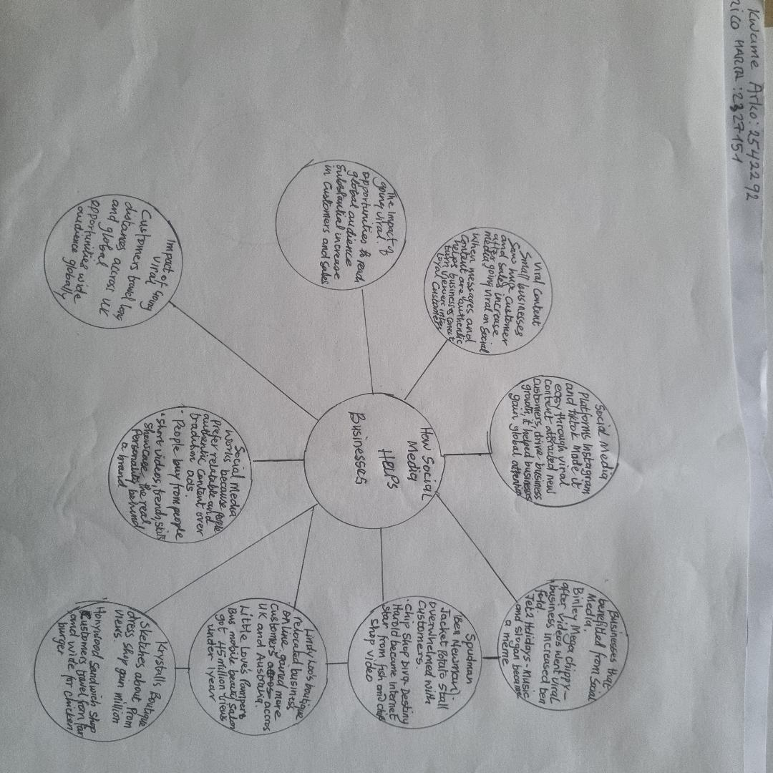

Instagram, Tik Tok have a very wide range of viewers, and when you use it, by posting viral videos it can help your business to become popular, attract more customer, increase sales and boost your revenue.
One key point is that when you produce entertaining videos and the messaging and content are authentic it helps businesses build trust, and people prefer to buy from people rather than traditional advertisement.
Businesses became popular, they attracted more customers and they increased sales.
From the text social media helped small businesses gain customers from all over the UK and from other countries.
Repeating made some parts a little confusing, but most of the text was clear.

We discussed the main ideas, we shared our opinions and it was a useful exercise.
On reflection, I understood clearly the importance of social media platforms as a digital tool can have a huge positive impact when their content becomes popular and viral online
It involved many different businesses and examples of social media success.

