

BA (Hons) Hospitality & Hotel Management

BMIH6001 CONTEMPORARY THEMES IN THE HOTEL AND
HOSPITALITY SECTOR

ASSESSMENT 1: CONFERENCE RESEARCH PAPER

OPTION TWO: SUSTAINABILITY IN TERMS OF FOOD WASTE AND ITS EFFICACY

Name: Bianca Negreanu
Student ID: 2244613
Level: 6
Module Leader: Dr Ernest Balutie Wavei
Abstract
Food waste is one of the sustained sustainability problems of hotel and hospitality. Characteristic of the continuous food service systems of hotels is the buffet-style food service, variable inflow of guests, consumer needs of amount, which preconditions the appearance of waste management in the working process. Increased regulatory demands, net-zero commitments, and responsible consumption by socially-responsible customers have led to a change in the mindsets that the issue of minimising food waste is an idealistic aspiration into a competitive need. Sustainable food waste management systems are not taxing in both the technological investment and behavioural change and supply chain reorganisation that leads to both the financial and operational cost to the half scale hotel operation.
This study is an enquiry of sustainable management of food waste in a hotel through the secondary qualitative thematic analysis of the available academic literature and industry. The study will evaluate the environmental, economic, social, technological, legal, and political factors affecting the practices of hotel food waste through the application of PESTEL-based analytical lenses. The industry responses and realities in the operations are reflected in a real practise of reflectiveness in terms of practises that can be observed within a middle-scale hotel as Novotel Ipswich stated as placement centre. A review reveals that although the waste-cutting programs are efficient regarding brand legitimacy and regulatory control, the operations and cost-related challenge is a setback to the uninterrupted application of the program. The conclusion in the study is that the harmonisation of employee behaviour and technical system and the forecasts that should be made using artificial forecasts would be necessary to achieve meaningful waste reduction in line with sustainability objectives and financial profitability.

Table of Contents
Introduction 4
Literature Review 4
Method 7
Theme Impact Analysis 7
Conclusions 11
Recommendations 11
Reference List 13

Introduction
Sustainability as an issue has taken a mainstream theme that is typical of the modern day as the trend of heightened environmental responsibility is accompanied by augmented competition and price drives on the hospitality establishments. One of the urgent questions of sustainability is the issue of food waste as the supply of food in the hotels necessarily leads to an overproduction of food resources in the form of buffets, to the instability of the occupancy rate, and the desire of the guests to receive everything. Among such significant sources of waste of about 1.3 billion tonnes of food annually, the hospitality sector has contributed to the money wasted by the hospitality sector, estimated at $940 billion every year in the global economy and attracting around 8-10% of global greenhouse gas emissions (Socaci, 2020). The hotel and restaurant food waste in the UK offers a figure of over 920,000 tonnes of food waste every year and expense of disposal of food waste is estimated to be over £100 million pounds annually (Gerassimidou et al., 2022). There has been a shift in the needs of customers and sustainability grew to be a key component of the hotel selection and brand imagery (Costa and Costa, 2022). Strategic pressure is applied on the hotels to ensure reduced wastage is taken to ensure guest satisfaction and profitability. One of the current themes of the hospitality industry, which is discussed in the study, is the problem of food waste management sustainability in the efficiency of waste minimization policies and the contradiction of the responsibility and cost-efficiency of operations. The qualitative mode of analysis is secondary and qualitative in the sense of the thematic evaluation of the current academic data, industry norms, and practical contextualisation of the operations of the mid-scale hotels, like Novotel Ipswich as placement (Novotel Ipswich, 2025).

Literature Review
In the hospitality sector, food waste has no longer been an outskirt of the business, but it is a sustainability measure of the business. In the eco-friendly markets, the present literature of the hospitality industry calls food waste resource waste and reputational risk (Batabyal and Das, 2019). Company areas sensitive to the generation of waste in the hotel industry involve the buffet service delivery format, demand unpredictability, and brand positioning strategy where the abundance is not considered as a predictor of the quality of the service offered (Kasavan et al., 2022). According to Dixit (2020), the past management of guest experience have endorsed over-providing in the name of avoiding a stock out and this has rendered a waste to service culture. However, this conservative model of services is proving problematic as the sustainability requirements and the expenses of augmented dumping of garbage.
Based on the empirical results, the food waste of the hotel industry is between 0.3 and 1.0 kilogrammes per guest per day with regards to the hotel category and service form (Amicarelli et al., 2022). The service with the largest waste generation is buffet breakfast services as it is pre-empted by the phenomenon of overproduction and strategies to replace aesthetics output to sustain the visual abundance until the service moment (Goh et al., 2022). It is a key indicator of a contradiction that exists between the guest satisfaction management and sustainable utilisation of resources. Cooper and Hall (2023) explained that the existing sustainability systems within tourism and hospitality organisations have compelled the hotels to reduce waste as a constituent of their general pledge to environmental responsibility.
It is becoming common in contemporary literature whereby a quantification of the amount of waste in this or that amount has been substituted by a behavioural, organisational, and technological insight into the determinants of the efficacy of waste reduction. Chawla et al., (2022) stated that the effects of employee pro-environmental behaviour can influence the food wastes, yet the hotel companies fail to create the systematic training that could assist them in introducing sustainability to their daily service practices. Goh et al., (2022) stated that they observe inconsistencies between frontline operational operationalization of managerial sustainability intentions and the deficiency of institutional misalignment between policy and practice.
Regarding the system, Ruiz Molina et al., (2022) introduced a list of the sustainable food management models like the procurement forecasting systems, portion optimization, donation associations, and the waste valorisation. It entails departmental coordination, data collection infrastructure, and communication of ideas with the suppliers, which are not found in most of the mid-scale hotels. The other barriers Lagioia et al., (2024) utilised include funding, insufficient technological capability, and insensitive measurement systems as a hindrance to the adoption of non-luxury hotel markets.
Such restrictions are enhanced by economic aspects. Danzer (2025) employed behavioural economics to explain the dynamic inconsistency in the food waste decision-making process given that short-term risks of service avoidance will offer incentives to overproduce at the long-term costs of long-term sustainability. This indicates the nature of failure of voluntary waste programs in performance when institutions cannot learn to motivate them or when they are not supported through regulation. According to Pearson (2025), best-practise waste management systems save money, in the long-term due to their cost-effective nature, but their initial high cost makes them unaffordable to smaller and mid-sized operators.
Technological innovation makes new solutions available. Omar et al., (2024) demonstrated the application of inventory monitoring through blockchain and that it allows reducing procurement error and spoilage. Chkoniya (2021) focused on the idea of AI-based demand forecast systems that may raise the accuracy of production by 30%. However, there is also a condition that such technologies require the investment and online maturity, which does not appear across all types of hotels.
It is linked to competitive positioning in the sustainability discourse of the sector because of the reduction of food waste. Costa and Costa (2022) denoted that the environmental credibility of a brand becomes a key driver of brand differentiation and customer loyalty within the hospitality markets. Sharma et al., (2024) stated that the tendencies toward regenerate tourism and net-zero promises raise the requirements towards the stakeholders to undertake open sustainability reporting, including waste indicators. As per Statista (2025), when identifying sustainability practices in the hotel business, 62% of the guests remain with the hotel businesses in the UK, meaning that they are committed to the performance of the businesses in the aspect of reputational level.
The notable tension cases in this environment are such international brands as Novotel that are of a middle size. Homogentisic brand service models encourage homogeneity of buffets, uniformity of menus in different stores, and limit flexibilities to responsiveness to wastes to localisation. However, models of sustainability adopted by the corporate Accor entail waste remedies, leading to implementation pressure at the property level (Novotel Ipswich, 2025). This reflects a sign of the gap in the literature as the systematic solutions to the lack of sustainability are provided by the sustainability frameworks, however, practical challenges to the workings of the mid-scale hotels do restrict the constant application. The existing literature is dedicated to luxury or flagship hotels, which does not give a lot of empirical information about the effectiveness of waste minimization in resource-starved hotel environments (Kasavan et al., 2022). To address this gap critical analysis of viability of implementation, sustainability aspirations is needed.

Method
The research design applied in this study involves secondary qualitative research design, which is based on thematic assessment of the most recent scholarly documents and industry reports on the same with reference to the sustainability documentation of the sector. No primary data is collected in it. The data sources will include peer-reviewed journal articles dedicated to the management of hotel food waste, hospitality sustainability, models, and behavioural research in waste management and industry benchmarking reports published in 2020-2025. It is to be used in developing repeated patterns, contradictions, and explanatory variables, which affect the extent of food waste management in the hotel management. Themes surf with the assistance of the iterative coding of literature extracts covering the drivers of the waste, technological intervention, organisational barriers, behavioural influences, and the trade-offs in economy.
To find the meaning of the effects a PESTEL analysis model is applied to integrate how the political, economic, social, technological, environmental, and legal forces affect the use of food waste management in the hospitality industry. Through this model, systematic consideration of the macro-level sustainability pressure and the micro-level operation pressures are involved. Reflective conformity provides contextualisation of applied industry, which can be seen through the publicly upheld service and sustainability policies of mid-scale hotel setups like Novotel Ipswich whose operational business policies reflect realistic practice examples of the real-world (Novotel Ipswich, 2025). This type of analysis is profound enough and it does not break the rules of secondary qualitative research.

Theme Impact Analysis
Increasing role of the politics and legal factors in the hotel food waste practices can be explained by the national waste reduction policies and the environmental regulations frameworks. The policy of landfill diversion and reporting on waste management compels hospitality firms in the UK to install garbage management monitoring systems by imposing expenses on hotels (Gerassimidou et al., 2022). Demands of regulators call the requirements of food waste higher than voluntary morality, which is a mandatory institution and non-adopters run a risk. However, enforcement is inconsistent and this indicates that a significant number of hotels choose to comply at bare minimum rather than embark on transformational waste reduction to reduce the progress of the industry.
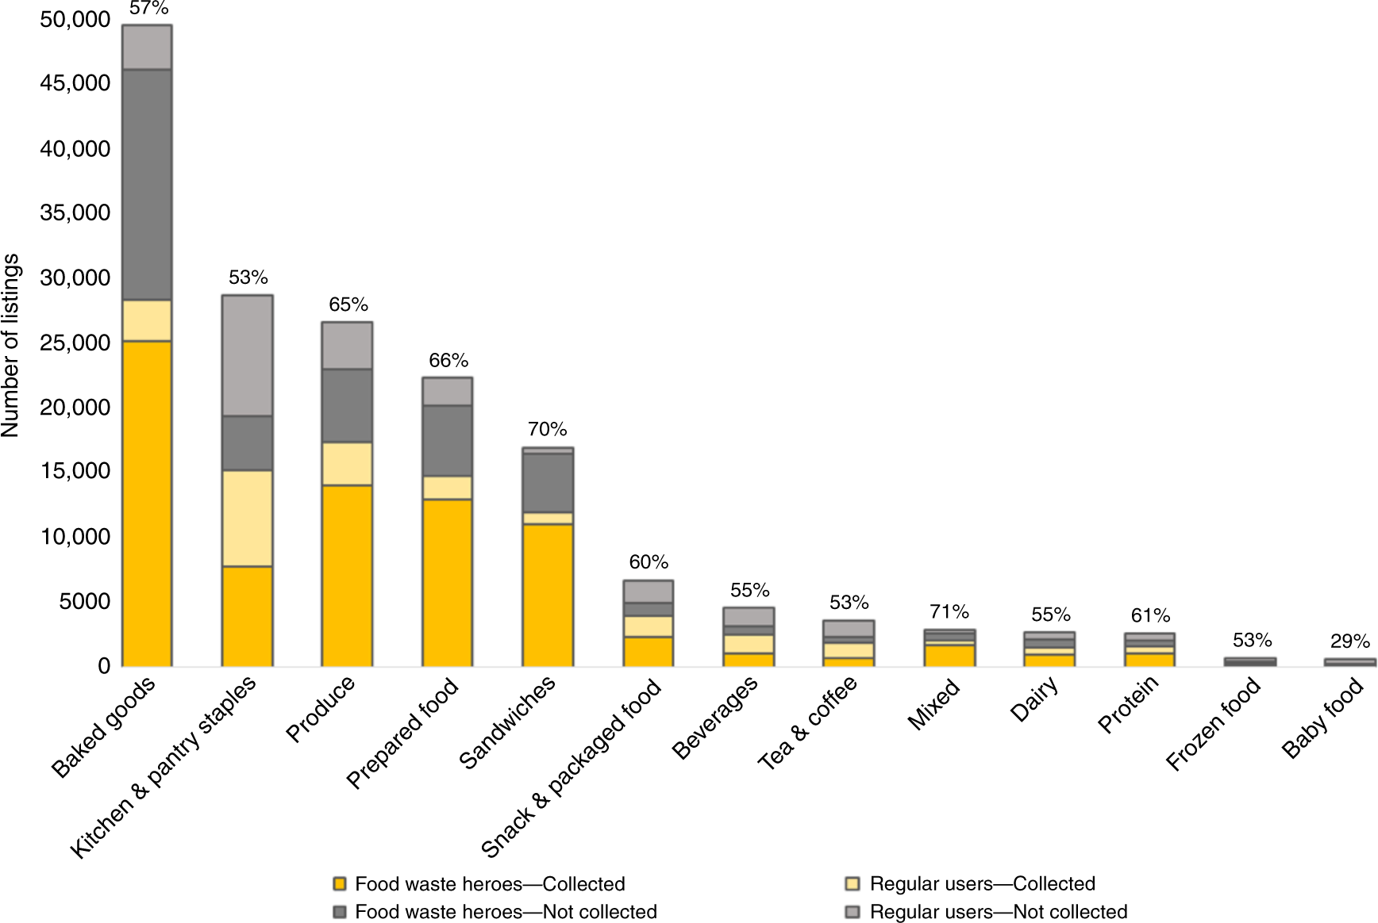
Figure 1: Economic Analysis of Food Waste Abetment through Sharing Economy
(Source: Statista, 2025)
Economic pressures are the urgent constraint to identify reduction efficacy of waste. Hotel restaurants acquisition expenses occupy 30 to 40% of hotel activities and the cost of garbage disposal raises expenditure (Amicarelli et al., 2022). Initial investment outlay of implementing sustainable solutions like AI predictive tools, intelligent inventory management or blockchain traceability might be difficult to support given the narrow margins in this case and considering business-in-the-middle hotels. The appearance of such financial burden is in consequence to international chains that create the same standardised lines of models of service where the cost efficiency becomes an antagonist to the objectives of sustainability investments. Analysis of behavioural economics that Danzer (2025) revealed that the predictive motive of only overproduction being resorted to about failure in performing the service pertains to having a lowered risk of guest dissatisfaction and recognising the management strategies as rather being conducive to efficiency of waste reduction in the long-term basis.
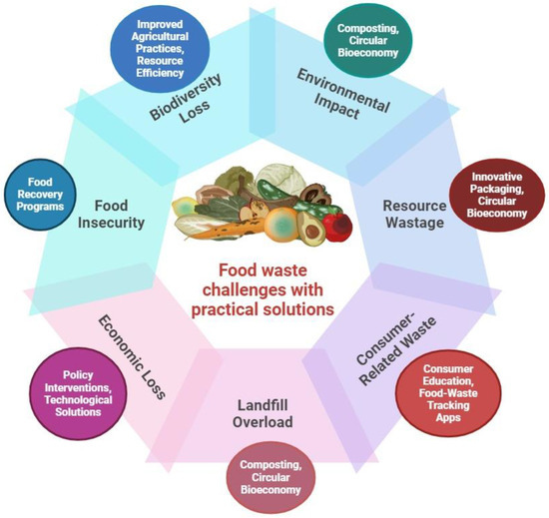
Figure 2: Food Waste and Security - Bioresources to Sustainability
(Source: Danzer, 2025)
There is an increase in sustainability accountability regarding the guest expectations on the premise of the social forces. Statista (2025) agreed that the degree of sustainability dictates the purchasing made to occur within the hospitality segments and convert waste reduction into a reputation resource. However, the anticipation of the abundance of the buffets on the side of the customers remains strong as it brings about contradicting social forces. The existence of working paradoxes makes food service managers deal with the pressure of sustainability and unstopping availability of products among the guests. Goh et al., (2022) underlined that the examples of situations when, in the name of sustainability pledges, managers respond to the needs of guests and resort to waste reduction efforts are numerous.
It is the actual mitigation of technological innovation. Predictive use of AI and computer-regulated inventories, and portion controllers reduce the possibility of excessive production and spoilage (Chkoniya, 2021). According to Omar et al., (2024), blockchain-based procurement systems improve its expiration and traceability. However, the determinants of technology uptake are digital competence at the staff, data integration infrastructure, and organisational readiness. With the example of mid-scale hotels like Novotel Ipswich who have adopted a centralised brand system, there is no property-level customisation aimed to generate customised digital waste tools and the boundaries of technology standardisation within a multinational hotel chain.
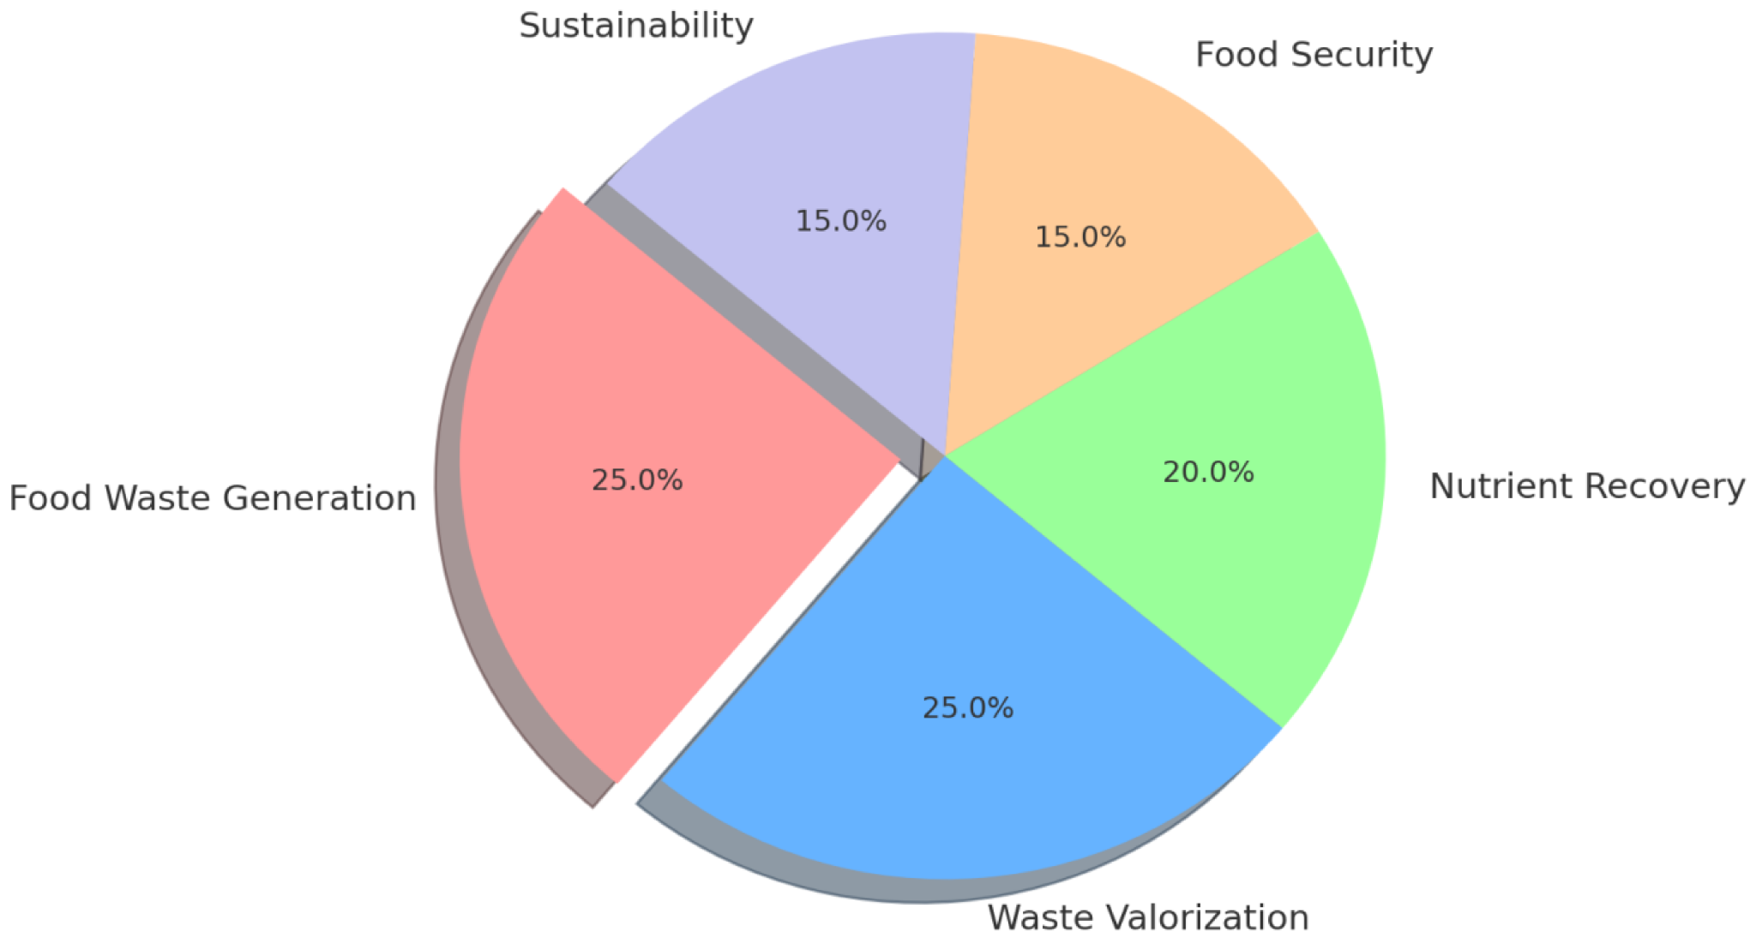
Figure 3: Food Waste to Food Security Landscape
(Source: Statista, 2025)
Environmental imperatives form the simplest of the justification of the waste reduction activities. The validity of hot hotel net-zero commitments directly disagrees with the fact that food waste causes the emission of methane gases and landfills influence (Costa and Costa, 2022). The waste diversion, donation partnerships, and compost structures, are required by the corporate sustainability models. Lagioia et al., (2024) illustrated that despite the coexistence of the environmental programs, not all efforts will run on a functional level and be functional opposed to when such programs are quantified and held accountable and liable.
The industry response is neither transformative response, but incremental response. Ruiz Molina et al., (2022) suggested that the procurement forecasting, menu engineering, and food donation alliances are exercises applied by the large hotel chains. The properties of the best-practise are recording over 40% cuts of waste on average compared to the average of less than 15% of performance in the industry implying a difference in adoption (Pearson, 2025).
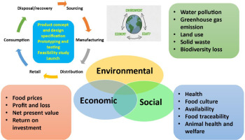
Figure 4: Sustainable Development Goals through reducing Food Loss and Waste
(Source: Kasavan et al., 2022)
The reflection applied to mid-size operations like Novotel Ipswich reflects these dynamics. At the brand level, sustainability measures promote policy that reduces amounts of waste, but the actualities of variable occupancy and unpredicted conference catering and the homogeneous buffet model constrain local autonomy to the scheme of waste reduction. The served patterns of services are publicly-recorded, which testifies to the reliance on the buffet-based event catering offers and breakfast deals that have been proven in the literature to be waste-intensive (Kasavan et al., 2022).

Conclusions
The management of food waste has become one of the key attributes of the sustainability issues in the contemporary hotel business dictated by the regulatory demands and the sustainability policy of environmental responsibility and dynamic needs of the guests. However, the reduction of waste has been constrained about financial constraints, discrepancies in behaviour and differences in technological preparedness in hotel functioning procedures. The sustainable management of food waste necessitates integrated forecasts technologies, alignment of behavioural, and expenditure model of the personnel in the process and balances the environmental responsibility and needs of the hospitality services.

Recommendations
Demand forecasting and systems based on data should concentrate on reducing overproduction vagueness in the hospitality sector and reduction of future food waste in the hospitality industry. The use of AI and its implementation in the forecasting of the outcomes of the booking processes and the availability of new events based on the outcomes of engineered predictive analytics will help reduce the level of inaccuracy of the procurement process, reduce the number of excesses of the buffet, and will not affect the level of satisfaction with the services among the guests. It is implied that hotels would have waste monitoring dashboards on the operational reports to ensure that the waste quantities that are operational at both the managerial levels and frontline positions will be visible. Such transparency on behaviour addresses the intention/action contradictions (Goh et al., 2022).
The consciousness of the staff, sustainability planning, and waste reduction should be institutionalised by providing lifelong sustainability training and integrating the monitoring of the waste reduction cost in line with the performance evaluation systems. The alignment of behaviour has been employed to ensure that sustainability policies are made to be the policies of operation practice despite being a symbol of commitment. The procurement policies will aim at contracting flexible suppliers who would be able to place less-frequent and smaller orders to reduce the risk of spoilage (Kasavan et al., 2022).
Circular waste includes food donation, composting organisations, and bioenergy transformation systems are the kind of investments that can have a quantified effect of diversion and increasing the level of corporate sustainability respectability. However, the cost-benefit evaluation models will be developed in a way that they will present long-term savings that will mitigate the short-termism aspect of management (Danzer, 2025).
The willingness to adopt technology of middle size hotel strategy must be brought into reality. A feasible entry-level digital solution is inventory-tracking software and expiry-alert software, which operates on a modular system despite company-wide solutions using blockchain technology. The hotel groups at the brand level should delegate the sustainability innovation control, giving the property level the right to test it depending on the local demand instability.
To make certain that the concept of sustainability will be re-defined as something shared, despite something sacrificed, the guest communication strategies will be crucial to re-design buffet service as smaller batch replenishment and customisation of the portions. This does not reduce the services and changes the surpluses expectation associated with guests that lead to wastages (Singh et al., 2024).

Reference List
Alexander M. Danzer (2025) Food Waste and Dynamic Inconsistency: A Behavioral Economics Perspective. IZA - Institute of Labor Economics.
Amicarelli, V., Aluculesei, A.C., Lagioia, G., Pamfilie, R. and Bux, C., (2022). How to manage and minimize food waste in the hotel industry: An exploratory research. International Journal of Culture, Tourism and Hospitality Research, 16(1), pp.152-167.
Batabyal, D. and Das, D.K. (eds) (2019) Global trends, practices, and challenges in contemporary tourism and hospitality management. Hershey, Pennsylvania: Business Science Reference, an imprint of IGI Global.
Chawla, G., Lugosi, P. and Hawkins, R., (2022). Factors influencing hospitality employees’ pro-environmental behaviours toward food waste. Sustainability, 14(15), p.9015.
Chkoniya, V. (ed.) (2021) Handbook of research on applied data science and artificial intelligence in business and industry. Hershey, Pennsylvania: IGI Global.
Cooper, C. and Hall, C.M. (2023) Contemporary tourism : an international approach. 5th ed. Oxford: Goodfellow Publishers Limited.
Costa, V. and Costa, C. (eds) (2022) Sustainability and competitiveness in the hospitality industry. Hershey, Pennsylvania: Business Science Reference.
Dixit, S.K. (2020) ‘Managing hospitality organizations: achieving excellence in the guest experience (second edition): by Robert C. Ford and Michael C. Sturman, Sage Publications Inc., 2019, 544
Gerassimidou, S., Dora, M. and Iacovidou, E., (2022). A tool for the selection of food waste management approaches for the hospitality and food service sector in the UK. Resources, 11(10), p.80.
Goh, E., Okumus, B., Jie, F., Djajadikerta, H.G. and Lemy, D.M., (2022). Managing food wastage in hotels: discrepancies between injunctive and descriptive norms amongst hotel food and beverage managers. British Food Journal, 124(12), pp.4666-4685.
Kasavan, S., Siron, R., Yusoff, S. and Fakri, M.F.R., (2022). Drivers of food waste generation and best practice towards sustainable food waste management in the hotel sector: A systematic review. Environmental science and pollution research, 29(32), pp.48152-48167.
Lagioia, G., Amicarelli, V., Strippoli, R., Bux, C. and Gallucci, T., (2024). Sustainable and circular practices in the hotel industry in Southern Italy: Opportunities, barriers and trends in food waste management. British Food Journal, 126(1), pp.428-452.
Novotel Ipswich, (2025), Home, [Online], Available at: https://novotel-ipswich.hotel-rez.com/ [Accessed on 25th January 2026]
Omar, I.A., Hasan, H.R., Jayaraman, R., Salah, K. and Omar, M., (2024). Using blockchain technology to achieve sustainability in the hospitality industry by reducing food waste. Computers & Industrial Engineering, 197, p.110586.
Pearson, N., (2025). Rethinking food waste: Lessons from best practice. Journal of Sustainable Tourism, 33(12), pp.2693-2714.
Ruiz Molina, M.E., Belda-Miquel, S., Hytti, A. and Gil-Saura, I., (2022). Addressing sustainable food management in hotels: proposing a framework and examining hotel groups. British Food Journal, 124(2), pp.462-492.
Sharma, M., Singh, A.K. and Tyagi, P. (2024) Proceedings of the International Conference on Innovation and Regenerative Trends in Tourism and Hospitality Industry (IRTTHI 2024). 1st ed. Dordrecht: Atlantis Press Zeger Karssen.
Singh, A., Tyagi, P.K. and Garg, A. eds., (2024). Sustainable disposal methods of food wastes in hospitality operations. IGI Global.
Socaci, S.A. (ed.) (2020) Food preservation and waste exploitation. London, England: IntechOpen.
Statista, (2025), Hotels - United Kingdom, [Online], Available at: https://www.statista.com/outlook/mmo/travel-tourism/hotels/united-kingdom [Accessed on 25th January 2026]

