

Programme: Master of Business Administration
Module: Dissertation (LCMB7035)
Lecturer: Masud Ibrahim
Supervisor: Mohamed Ben Farah
Dissertation Title: Evaluating the Impact of AI-Driven Predictive Analytics on Customer Engagement in Digital Marketing: A Systematic Review
Student Name: Hom Chandrakant Limbachiya
Student Number: 2420433
Word Count: 15990

DECLARATATION
I, Hom Chandrakant Limbachiya, declare that this dissertation has been composed by myself, that the work contained herein is entirely my own except where explicitly stated otherwise in the text, and that this work has not been submitted for any other degree or qualification, in whole or in part, except as specified.

Signature: .......... Hom Chandrakant Limbachiya ......
Date: …………20 December 2025……….........

Acknowledgement
It is my great pleasure to thank my supervisor, Mohamed Ben Farah, who has shown great assistance, constructive criticism and constant support in the process of completing this dissertation. I also owe my academic guidance and experiences to the module lecturer, Masud Ibrahim, in the Dissertation (LCMB7035) module. I want to appreciate the faculty and staff of the Master of Business Administration programme who have helped me to have a favourable learning environment. Lastly, I would like to say thank you to my family and peers who supported and understood me during this academic life.
Table of Contents
Acknowledgement 2
List of Figures 6
List of Tables 6
1 Chapter 1: Introduction 7
1.1 Background 7
1.2 Problem Statement 10
1.3 Research Aim, Objectives & Questions 11
1.3.1 Research Aim 11
1.3.2 Objectives 11
1.3.3 Research Questions 11
1.4 Rationale and Significance of the Study 11
1.5 Overview of the Chosen Methodology 12
1.6 Outline of the Dissertation 14
1.7 Chapter Summary 14
2 CHAPTER 2: LITERATURE REVIEW 15
2.1 Introduction 15
2.2 Definition of the Key Concepts 15
2.3 Theoretical Frameworks 16
2.4 Evolution of Artificial Intelligence in Digital Marketing 18
2.5 Implementation of Predictive Analytics in Digital Marketing 20
2.6 Scholarly Debates on the Influence of Predictive Analytics on Customer Engagement 23
2.7 Challenges in Implementing Predictive Analytics for Customer Engagement 24
2.8 Scholarly Debates on Strategies to Enhance Customer Engagement through AI-Driven Approaches 26
2.9 Research Gap 28
2.10 Conceptual Framework 28
2.11 Conclusion of Chapter 29
3 CHAPTER 3: RESEARCH METHODOLOGY 30
3.1 Introduction 30
3.2 Research Philosophies and Assumptions 30
3.3 Research Design 30
3.4 Research Approaches 31
3.5 Data Collection Methods 31
3.6 Ethical Considerations 33
3.7 Conclusion 34
4 CHAPTER 4: FINDINGS, ANALYSIS AND DISCUSSION 35
4.1 Introduction 35
4.2 Search Result and Inclusion of Articles 35
4.3 Summary of the Included Articles 1
4.4 Analysis of the Findings 1
4.4.1 Thematic Analysis of how organisations use predictive analytics within digital marketing strategies (RQ1) 1
4.4.2 Narrative Synthesis of Organisational Use of Predictive Analytics in Digital Marketing (RQ1) 3
4.4.3 Thematic Analysis of how does predictive analytics affect customer engagement, including loyalty, personalisation, and satisfaction (RQ2) 5
4.4.4 Narrative Synthesis: Effects of Predictive Analytics on Customer Engagement, Loyalty, Personalisation and Satisfaction (RQ2) 6
4.4.5 Thematic Analysis of the challenges organisations face when using predictive analytics to improve customer engagement (RQ3) 8
4.4.6 Narrative Synthesis of Challenges in Using Predictive Analytics to Enhance Customer Engagement (RQ3) 10
4.4.7 Thematic Analysis of Recommended Strategies for Enhancing Customer Engagement through AI-Driven Predictive Analytics (RQ4) 12
4.4.8 Narrative Synthesis of Recommended Strategies for Improving Customer Engagement through AI-driven Predictive Analytics (RQ4) 14
4.5 Discussion 15
4.5.1 Comparison to Previous Systematic Reviews 15
4.5.2 Comparison to Established Theoretical Frameworks 17
4.6 Chapter Summary 18
5 CHAPTER 5: CONCLUSION 20
5.1 Summary of Main Findings 20
5.2 Conclusions Based on the Research Questions 20
5.3 Recommendations 21
5.4 Limitations of the Research 21
5.5 Recommendations for Future Work 22
6 References 23
7 Appendices 31

List of Figures
Figure 1: AI in Digital Marketing (Ziakis and Vlachopoulou, 2023) 8
Figure 2: Market Value of AI Driven Marketing Market (Grand View Research, 2024) 9
Figure 3 Revenue Increase within Business Units from AI Use (McKinsey & Company, 2025) 10
Figure 4 The Steps involved in the Systematic Review (Author) 13
Figure 5: Technology Acceptance Model (TAM) (Davis, 1989) 17
Figure 6: The Behavioral Reasoning Theory (Westaby, 2005) 17
Figure 7: The Unified Theory of Acceptance and Use of Technology (Venkatesh et al., 2003) 18
Figure 8: Consumer Engagement Theory (Hollebeek, Glynn and Brodie, 2014) 19
Figure 9 Types of Predictive Modelling (Gooljar et al., 2024) 20
Figure 10: A Conceptual Framework for Enhancing Customer Engagement through AI-Driven Predictive Analytics in Digital Marketing (Adapted by the Author) 29
Figure 11 Identification and Inclusion of Articles via PRISMA Framework (Page et al., 2021) 36

List of Tables
Table 1 Inclusion and exclusion criteria 33
Table 2 Key Characteristics of the Included Articles (N = 50) 1
Table 3 Thematic Analysis of Organisational Use of Predictive Analytics in Digital Marketing Strategies (RQ1) 1
Table 4 Thematic Analysis of the Effects of Predictive Analytics on Customer Engagement, Loyalty, Personalisation, and Satisfaction (RQ2) 5
Table 5 Thematic Analysis of Organisational Challenges in Using Predictive Analytics to Enhance Customer Engagement (RQ3) 8
Table 6 Thematic Analysis of Recommended Strategies for Enhancing Customer Engagement through AI-Driven Predictive Analytics (RQ4) 12
Table 7 Critical Appraisal of Studies on AI in Digital Marketing Based on CASP Criteria 31

Chapter 1: Introduction

Background
Artificial intelligence (AI) has been one of the transformative technologies in retail and digital marketing in the past years, especially when it is applied to predictive analytics (Al Khaldy, Al-Obaydi and al Shari, 2023). Predictive merchandising enables organisations to use the consumer information to predict demand, and set production over the various seasons of the year. Mirza et al. (2025) note that AI-based business intelligence uses raw data to build engagement and make strategic decisions. On the same note, Ankam (2025) notes that predictive analytics makes inventory alignment easy and helps to know customer behaviour in a much better way. Maheta, Pandya and Patel (2024) also posit that with the competition in the market, particularly among the high-end customers, businesses that incorporate predictive tools have an edge as they provide highly personalised experiences creating deeper customer beliefs and involvement.
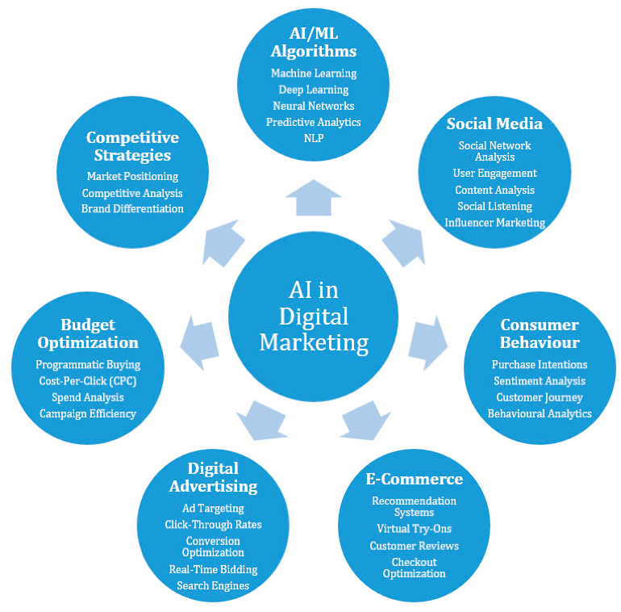
Figure 1: AI in Digital Marketing (Ziakis and Vlachopoulou, 2023)
The use of AI in marketing is increasing in pace all around the world. Projections of the industry mean that the global AI marketing revenue will grow substantially during this decade both in terms of prevalence among marketers and the considerable investment in AI technologies (McKinsey & Company, 2025). The U.S. market of AI alone reached USD 74 billion in 2025, with the projections suggesting that the growth rates (compound annual growth rate (CAGR) are going to be in the double-digit range, which implies the fast pace of growth in marketing analytics and automation spending (Statista, 2025). As a result, companies are investing more in predictive forecasting, data infrastructure and analytics, in order to gain a competitive advantage.
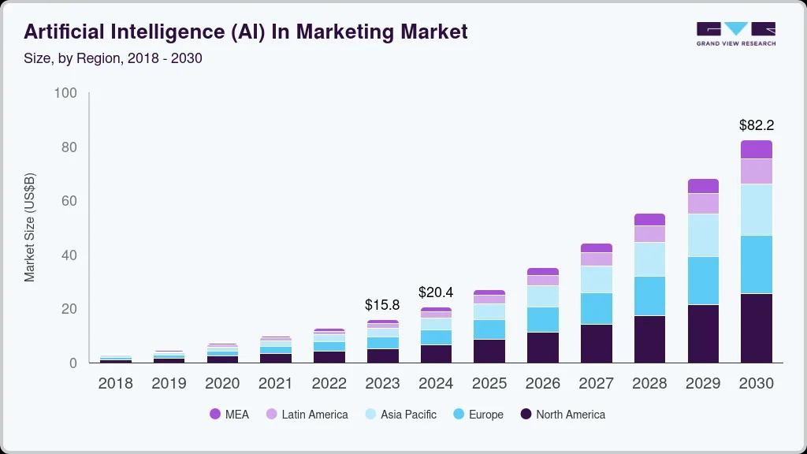
Figure 2: Market Value of AI Driven Marketing Market (Grand View Research, 2024)
Predictive models are already showing physical results in various fields at a functional level. As an illustration, Netflix has an AI-based recommendation engine which has made it earn more than USD 1 billion a year via enhanced user loyalty and retention (McAlone, 2016). Predictive systems are also used in telecommunications and finance to predict high-risk customers and enable firms to act proactively to retain them (Omari et al., 2025). Equally, predictive analytics can be used to streamline customer care in retail and banking by forecasting the possible problems and shortening the response time. In the omnichannel retail sector, the demand forecasting models help the companies match marketing promotions with the supply capacities and reduce stockouts and excessive production (Mckinsey, 2021).
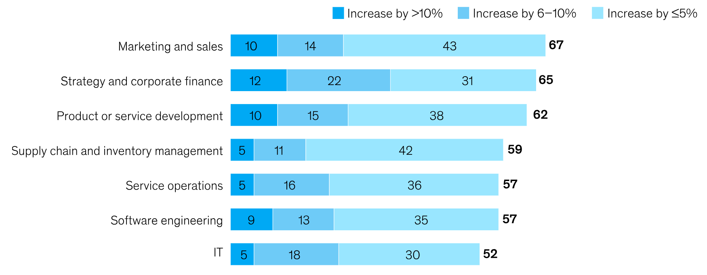
Figure 3 Revenue Increase within Business Units from AI Use (McKinsey & Company, 2025)
Mark Read, the Chief Executive of WPP, one of the largest marketing services groups in the world based in London, claimed that AI is the key to the business of WPP in the future (Sweney, 2023). This feeling is a nationwide trend of adopting AI by marketers. According to surveys that took place in 2023, one out of every three marketers in the UK had already used AI and almost a quarter were experimenting with it. Targeting optimisation, content personalisation and automated testing have become more common in the UK marketing practices. Nevertheless, in spite of the recent changes, including the move by Google in 2024 to keep third-party cookies, AI still remains a important contributor to improving marketing accuracy and consumer insights (Harvard, 2024).
Nonetheless, AI is not yet welcomed by the general audience. The proportion of the UK population which think the advantages of AI surpass the dangers are only 16 percent, whereas the significant portion informs about their doubts regarding the ethical aspects of AI (ONS, 2023). Almost three-quarters of the UK adult population want brands to share information on whether they are using AI generated content, with older consumers and females showing more worry on this issue (IPA, 2024). These findings highlight the increased significance of transparency, regulation, and implementation of marketing technologies in an ethical manner.
In general, predictive analytics through AI is transforming the marketing strategy by allowing companies to predict demand, optimise resources, and scale, or perform custom experiences. However, these advantages are directly linked to the trust of the people and the responsible data management both of which will be the key to the further sustainable development of AI marketing.

Problem Statement
Predictive systems are so aimed at predicting customer behaviour but this very feature gives birth to the concerns about the collection, interpretation and use of data (Wagh et al., 2023). Business intelligence infrastructures in organisations rely on the ability to discern behavioural patterns, and the lack of transparency in AI-driven models frequently hinders understanding of how it occurs (Balasubramaniam et al., 2023). Such lack of transparency may bring uncertainty to the firms as well as consumers especially when the marketing choices fall under the influence of automated inferences.
The existing studies note the role of AI in improving segmentation, loyalty and retention (Zulaikha et al., 2020) but a portion of the academic focus is concentrated on the technical efficiency and the operational benefits. Consequently, the literature provides very little information on the consumer reaction to predictive marketing activities. This is a critical gap since the application of predictive analytics intersects with sensitive matters that directly affect the engagement with the customers (Tanhaei et al., 2024). The issue of data privacy, surveillance, and algorithm bias still remain subjects of debate in the popular press, whereas the role of the regulatory frameworks like the General Data Protection Regulation (GDPR) exerts significant pressure on companies that must operate in a compliant, responsible, and transparent way in data operations.
The issues are not confined to the tensions on regulatory and ethics. The challenge of transforming predictive insights into meaningful or trustworthy experiences to the customers is a challenge that many organisations face in spite of the perception of data as strategic asset (Alserhan et al., 2025).
Considering these doubts, the urgent necessity to investigate the impact of AI-based predictive analytics on customer attitudes in digital marketing situations arises. It is especially true in the United Kingdom, where social attitudes to AI are still quite hesitant and where the issue of fairness, privacy, and accountability still defines consumer expectations. These issues are critical towards elucidating what predictive analytics means when it comes to customer engagement and solving the tensions that come along with the increasing application of the concept in modern marketing practice.

Research Aim, Objectives & Questions

Research Aim
This study aims to systematically evaluate the Impact of AI-Driven Predictive Analytics on Customer Engagement in Digital Marketing.

Objectives
- To examine how organisations implement predictive analytics within their marketing strategies.
- To evaluate the impact of predictive analytics on key customer engagement factors, including loyalty, personalisation, and satisfaction.
- To identify the primary challenges organisations encounter when using predictive analytics to enhance engagement.
- To propose strategies for improving AI-driven customer engagement initiatives.

Research Questions
- How do organisations use predictive analytics within their digital marketing strategies?
- How does predictive analytics affect customer engagement, including loyalty, personalisation, and satisfaction?
- What challenges do organisations face when using predictive analytics to improve customer engagement?
- What are the strategies, which can help to improve customer engagement through AI-driven predictive analytics?

Rationale and Significance of the Study
The assessment of the relevance of predictive analytics in the marketing strategies of organisations is of importance since it fills an apparent gap in the academic and practical literature. Despite the fact that the available literature recognizes AI as more effective in forecasting and aiding strategic planning (Muthukalyani, 2024; Oluwafemi et al., 2021), the literature does not shed much light on how the technologies impact customer engagement. In this research, the gap is addressed by refocusing on the customer experience and the role of predictive analytics in shaping perceptions of loyalty, personalisation and satisfaction.
The study has importance on two levels. On an academic level, it contributes to existing knowledge through an evidence-based analysis of the influence of predictive analytics on consumer engagement instead of organisational performance. In practice, the research is useful to the UK retail industry, as it demonstrates real-life applications. By way of illustration, brands in the UK that have used AI-based recommendation systems commonly claim to have increased engagement, although most of them have not successfully addressed customer concerns regarding the use of data and transparency. The study offers insights to organisations by examining such discrepancies on the ways that predictive analytics can be used to a greater advantage to enhance trust and retention and long-term competitiveness.

Overview of the Chosen Methodology
The study was systematic in terms of its review approach in that it was conducted in a series of steps.

Figure 4 The Steps involved in the Systematic Review (Author)
Step 1: Defining the Review Scope and Criteria
The research had inclusion criteria which included English-language, peer-reviewed article publications that were published between 2015 and 2025. To identify the studies that were eligible to be used, they had to study AI-based predictive analytics in digital marketing, specifically the customer engagement results of loyalty, personalisation, and satisfaction.
Step 2: Conducting the Search Process
Scopus and Google Scholar were used to identify the relevant literature. The first objective was to be comprehensive in terms of coverage of the topic by means of applying Boolean search terms that combine the terms in the domain of artificial intelligence, predictive analytics, and customer engagement.
Step 3: Screening and Selecting Studies
The screening process was based on the PRISMA framework. The titles, abstracts and full texts would be evaluated to establish their relevance and their adherence to the inclusion criteria. EndNote was used to complete the reference management and eliminate duplications.
Step 4: Extracting and Organising Data
Key data about each of the studies were collected using a standardised data extraction template that included research design, sample characteristics, analytical approach and results regarding the findings of engagement outcomes. This guaranteed uniformity and precision in the dataset.
Step 5: Assessing Study Quality
The quality of methodologies of the included studies was assessed with the help of the CASP checklist. Such an evaluation was necessary to determine the possible biases, enhance the validity of the review, and make sure that only studies that were rigorously conducted influenced the synthesis.
Step 6: Synthesising the Evidence
Qualitative narrative synthesis was used because of disparity in methodological approaches between studies. The results were grouped into three broad themes including how AI-based predictive analytics can be used in marketing, how it can impact engagement performance, and how the process can be challenged.
Step 7: Ensuring Ethical Integrity
To resolve ethical issues, the transparency in reporting, the correct reference to all sources, and the limitations of the review were taken into account. Other major constraints were the language bias, publication bias, and the quality of studies.
This step-by-step approach allowed having a solid and methodical approach to the review, as it became possible to obtain credible information concerning the role of predictive analytics in determining customer engagement and what areas need more empirical research.

Outline of the Dissertation
This dissertation is presented in five chapters to make the research coherent and systematic. Chapter Two is the literature review where the literature available on the topic is reviewed critically, including existing theoretical frameworks, empirical studies, and gaps in the area of predictive analytics, artificial intelligence, and customer engagement. Chapter Three gives the research methodology where systematic review design and inclusion and exclusion criteria, search strategy, data extraction methods and quality assessment procedures are detailed to warrant rigour and reliability. In Chapter Four, the findings and analysis is presented, which synthesised the results of the studied papers into thematic groups demonstrating the applications, effects and issues of AI-based predictive analytics in marketing. This is followed by Chapter Five, which concludes the study by summarising important findings, implications to theory and practice, limitations, as well as future research and organisational recommendations.

Chapter Summary
Chapter One summarized the background of the research, which was the increasing application of AI-predictive analytics in improving engagement with customers in digital marketing. It defined the research issue and the deficient consolidated evidence on the effectiveness of predictive analytics and said that it would critically evaluate its effects on engagement outcomes. The research questions and objectives covered the tools, effects, and the problems of implementation. The reason behind the relevance of the study to the contemporary marketing practices was presented, and a brief introduction to the systematic review methodology was made. The chapter ended by mentioning that the following chapter gives an in-depth literature review of AI, predictive analytics, and customer engagement.

CHAPTER 2: LITERATURE REVIEW

Introduction
Digital marketing with the introduction of artificial intelligence (AI) has changed the way organisations interact with customers, and AI-based predictive analytics has become one of the strong instruments to predict consumer behaviour and individually tailor marketing campaigns (Dwivedi et al., 2021; Behera et al., 2024; Acikgoz et al., 2023). In spite of its increasing use, there are still issues regarding successful implementation of these technologies, which confirm significance of critical perception of their role in digital marketing outcomes and customer interaction.

Definition of the Key Concepts
Artificial Intelligence: Artificial Intelligence (AI) is the simulation of human intelligence operations by machines, especially computer systems, to execute tasks that are normally carried out by the human cognitive system, including learning, reasoning, and problem solving (Dwivedi et al., 2021; Behera et al., 2024).
Predictive Analytics: Predictive analytics constitutes a type of data analytics, which involves making predictions based on past and current data, statistical algorithms, and other machine learning methods to predict future events or behaviour (Al Kurdi et al., 2024). Regarding digital marketing, predictive analytics enables organisations to forecast the customer requirements, streamline marketing efforts, and enhance interaction by forecasting purchasing behavior, the risk of churn, and content preferences (Acikgoz et al., 2023).
Customer Engagement: Customer engagement is the level of emotional, cognitive and behavioural commitment that a customer has to a brand (Dwivedi et al., 2021. The successful engagement methods frequently rely on AI-based insights to personalise the experiences, drive higher satisfaction, and establish better customer-brand relationships (Behera et al., 2024).
Digital Marketing: Digital marketing refers to marketing that uses digital platforms, such as social media, search engines, email, and websites, to communicate with target audiences and influence them (Acikgoz et al., 2023). As opposed to traditional marketing, digital marketing is based on data-driven methodology heavily, which makes it possible to target customers in real-time, measure their performance, and allow incorporating modern technologies, including artificial intelligence and predictive analytics, to achieve customer engagement and marketing efficiency.

Theoretical Frameworks
The application of predictive analytics, which is based on AI, is integrated into digital marketing using a few theoretical models that determine how users will be adopted, engaged, and accept the technology.
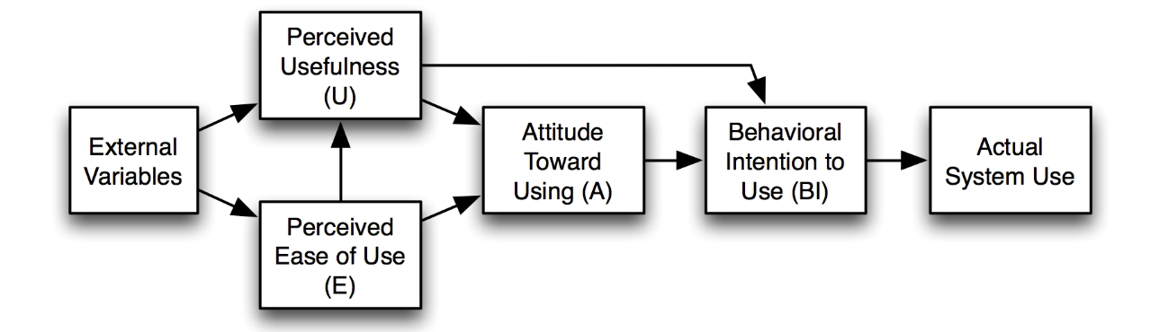
Figure 5: Technology Acceptance Model (TAM) (Davis, 1989)
The Technology Acceptance Model (TAM) is one of the most common models that assume that perceived ease of use and perceived usefulness represent the main factor influencing the intention of people to employ new technologies (Dai and Wang, 2021). TAM in digital marketing TAM has been widely applied to learn how consumers engage with AI-powered applications, such as chatbots, recommendation engines, and personalised content delivery systems. These systems are more likely to be used by consumers when they feel that they are helpful in enhancing their decision-making or other ways they intend to add value by saving time and being convenient (Kumar et al., 2023).
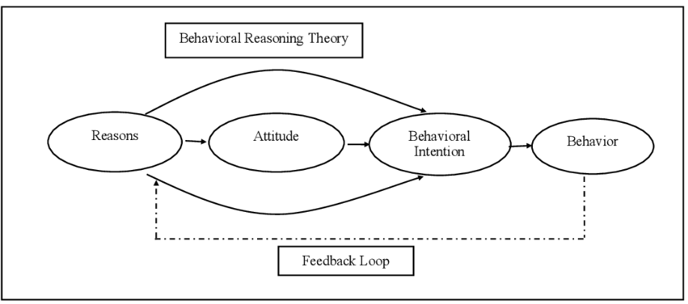
Figure 6: The Behavioral Reasoning Theory (Westaby, 2005)
The other theory is the Behavioral Reasoning Theory (BRT), the extension of classical models of adoption which focuses on the motives consumers give as the reasons behind their decision-making, both facilitating and inhibiting (Acikgoz et al., 2023). BRT can be applied especially in the field of digital marketing because it takes into account psychological and situational factors that influence the interaction with AI systems. As an example, the elements of perceived trustworthiness, transparency, and the precision of AI-based suggestions may play a major role in affecting the desire of the customer to engage in AI-driven platforms.
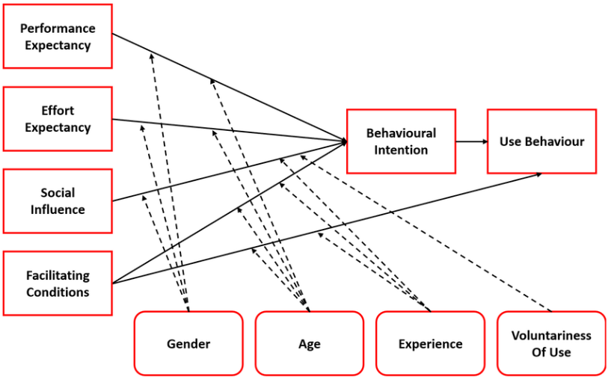
Figure 7: The Unified Theory of Acceptance and Use of Technology (Venkatesh et al., 2003)
Unified Theory of Acceptance and Use of Technology (UTAUT) is yet another inclusive theory that can offer an understanding of technology adoption. UTAUT incorporates several of the constructs of other technology acceptance models, such as performance expectancy, effort expectancy, social influence, and facilitating conditions, to describe the intentions and actual usage behaviour of users (Dwivedi et al., 2021). UTAUT is the mechanism that, in digital marketing, helps to test the idea of how the role of AI-powered predictive analytics can impact individual perceptions as well as the effects of a wider environment and organisational context on engagement.
Lastly, the Consumer Engagement Theory (CET) provides a marketing-oriented point of view, where engagement is a multidimensional variable that can be cognitive, emotional, and behavioural (Behera et al., 2024). CET emphasizes the need to create meaningful consumer involvement, loyalty and advocacy through the interactive, personalised, experiences. CET, combined with AI-based predictive analytics, can be used to demonstrate how data-driven insights may be used to optimise touchpoints through the customer journey to allow marketers to deliver personalised content, timely interventions and predictive suggestions that can build deeper customer engagements. The high tech AI tools enable the marketers to predict consumer preferences, customize interactions, and quantify engagement outcomes in real time, a feature that establishes a direct connection between the theoretical constructs and practical use.
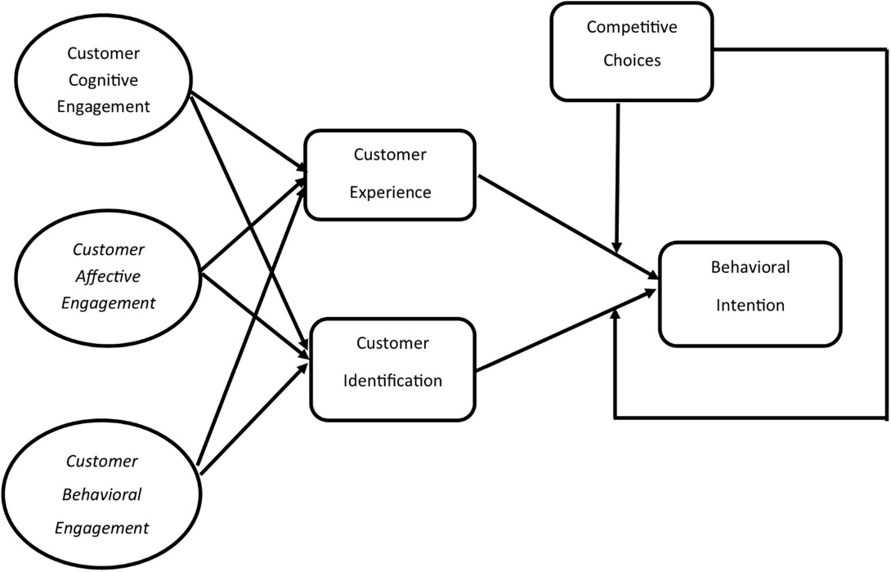
Figure 8: Consumer Engagement Theory (Hollebeek, Glynn and Brodie, 2014)
Together, these theories, TAM, BRT, UTAUT, and CET, offer a solid theoretical framework to the analysis of the relationship between AI technologies, predictive analytics, and customer engagement. They are complementary to each other as TAM and UTAUT deal with the behaviours of adoption and use, BRT deals with the reasoning and motivation, and CET deals with the experiential and relational nature of engagement. Collectively, they inform empirical studies and strategic practice in digital marketing, which helps organisations leverage AI-driven predictive analytics to their advantage in driving customer experiences, customer satisfaction, and customer loyalty.

Evolution of Artificial Intelligence in Digital Marketing
The use of artificial intelligence (AI) in digital marketing has developed significantly in the last twenty years both due to advancement in technologies and evolving customer demands. Towards the start of the 2000s, AIs were mostly used in primitive automation tools, including email marketing software, simple recommendation systems, and so on, which made marketers able to automate repetitive activities and go about targeting audiences in a more efficient manner (Subramani, 2019). The types of predictive modelling (Figure 9) may be considered as the ones that seem to be the most relevant within the framework of this research (Gooljar et al., 2024).
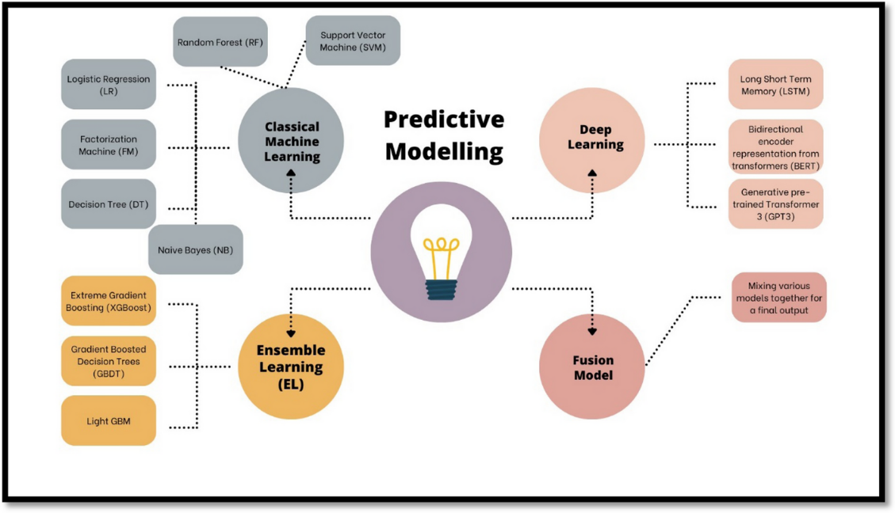
Figure 9 Types of Predictive Modelling (Gooljar et al., 2024)
With the growing access to big data and the enhancement of machine learning algorithms by the 2010s, digital marketers were able to create more advanced AI applications. Predictive analytics, natural language processing, and sentiment analysis were part of digital marketing mix since it allowed organisations to comprehend customer preferences, predict behaviour, and customise interactions on a scale (Kachamas, 2016; Takahashi, 2019). At this time marketers began realizing the potential of AI to not only streamline processes, but also improve customer experience through delivering timely, relevant and context-oriented messages.
More sophisticated AI methods, such as deep learning, cognitive computing, and generative models, were adopted into digital marketing systems in the late 2010s and early 2020s, and these methods greatly extended the possibilities of digital marketing systems (Gkikas and Theodoridis, 2019; Behera et al., 2024). These technologies made real-time analytics, real-time pricing, and hyper-personalisation of content possible, which meant that marketers could make predictions about customer requirements more effectively and develop highly personal engagement tactics.
During the latest stage, AI has infiltrated customer marketing practices, predictive analytics and generative AI are influencing the customer interaction on a new dimension (Wiputra et al., 2024; Sharma and Sharma, 2024). Robots like AI-driven recommendation engines, chatbots, and predictive content engines can today enable brands to predict consumer behaviour, provide personalised experiences, and be able to stay in touch at every touchpoint. Furthermore, ethics, transparency, and data privacy have become the key aspects of the AI adoption that affect regulatory frameworks and consumer belief (Oluwafemi et al., 2021). This continued development indicates a change in the approach towards the use of technology to being strategic, and AI can be considered a key force in driving innovation in digital marketing.
In the future, the trend of AI in digital marketing suggests continuing the convergence of predictive analytics, machine learning, and consumer engagement theories, thus allowing organisations to not only examine previous behaviour but also to shape future behaviour (Dwivedi et al., 2021; Mirza et al., 2025). With the further development of AI technologies, they are already set to become part of digital marketing, making them increasingly seamless, predictive and prescriptive analytics with proactive engagement, loyalty programs, and personalised communication should be increasingly made with scale. This development emphasizes the transformative power of AI, as it develops the idea of intelligent, data-driven marketing ecosystems with the primary focus on customer-centricity and long-term interaction.

Implementation of Predictive Analytics in Digital Marketing
Predictive models have found extensive application in retail and e-commerce to predict shopping behaviors, product recommendation and promotion. These systems take historical buy data, the activity of the browsing and interactions on social media to divide customers and provide specific campaigns that enhance conversions and loyalty (Behera et al., 2024; Long et al., 2024). The first popular method is the classification models, which make a decision on whether the customer can purchase or churn or not. This is commonly modeled in form of logistic regression (Equation 1).
$$P\left(Y=1 ∣ X\right)=\frac{1}{1+e^{-(β_{0}+β_{1}X_{1}+…+β_{n}X_{n})}}$$
with (Y) being a behavioural outcome i.e. purchase likelihood, and X₁, X₂, X₃…X_{n} being customer attributes or behavioural predictors.
Collaborative filtering is also employed by the major e-commerce websites in order to create individualized suggestions. One of the most popular formulations of item-based collaborative filtering is an approximation of the individual preference of a customer (u) to an item (i) (Equation 2):
$${\hat{r}}_{u,i}=\frac{\sum_{j∈N_{(i)}}{sim(i,j)r_{u,j}}}{\sum_{j∈N_{(i)}}{sim(i,j)}}$$
Its prediction is ${\hat{r}}_{u,i}$ defined as the prediction rating of item $\left(i\right), N_{(i)}$ denotes the similar items and $sim(i,j)$ denotes how similar the two items are based on previous user ratings or interaction. This enables retailers to generate customized advices that can be more relevant and entertaining.
Predictive analytics is a concept that social media marketers use to inform the optimisation of their content, as it analyses various metrics, including the engagement rate, sentiment intensity, click-through patterns, and shareability (Albiali and Hamdan, 2021; Panda et al., 2023). ARIMA and other time-series forecasting models assist marketers in estimating when the most successful moments are expected to be registered with regard to engagement (Equation 3):
$$Y_{t}={c+ϕ}_{1}Y_{t-1}+ϕ_{2}Y_{t-2}+…+θ_{1}ϵ_{t-1}+ϵ_{t}$$
This will help in planning the content releases, projecting the campaign performance and dynamically adjusting the advertising budgets.
Predictive analytics in the tourism and hospitality industry helps in forecasting demand, personalisation, and optimisation of prices (Cunha et al., 2024). Demand prediction models which are usually employed by hotels and travel businesses refer to their past booking history, seasonal changes, and competitor prices. A simple predictive pricing model is an equation in which the expected demand D t is related to the price elasticity (Equation 4):
$$D_{t}=α-{βP}_{t}+γX_{t}$$
where $P_{t}$ denotes the price at time (t) and $X_{t}$ incorporates additional factors, like seasonality, or promotion. These models allow companies to predict the changes in demand and adjust the marketing messages and offers to them.
Predictive analytics is used in the financial services and banking sector to segment customers, evaluate risk, and personalise suggestions on products (Gazala Masood et al., 2023; Islam et al., 2024). Supervised machine learning models are used in credit scoring and product targeting and usually include decision trees and gradient boosting. The logic that underlies these models could be represented in the form of recursive partitioning (Equation 5):
$$Prediction= \sum_{M-1}^{M}{γ_{m}I(x∈R_{m})}$$
where each $R_{m}$ represents a decision region, and 8m is the value of the decision that it is predicted to take. The methods help the firms to determine which of their customers are likely to take up marketing offers without breaching regulations.
Programmatic marketing and digital advertising are also extensively dependent on predictive algorithms that optimise the bidding technique and the positioning of advertisements (Guru et al., 2023; Sriram et al., 2023). Predicted click-through rate (pCTR) models help marketers to spend money efficiently. One of the most popular representations of pCTR is (Equation 6):
$$pCTR=f(X_{1},X_{2},……,X_{n})$$
In which (f) commonly assumes the form of a neural network or gradient boosting model. The ad platforms can use these predictions to make real-time adjustments on impressions and bidding to maximise the return on investment.
In every industry, predictive analytics implementation involves the introduction of analytics platforms with customer relationship management systems, marketing automation tools, and social media monitoring technologies (Dwivedi et al., 2021). With this integration, organisations can understand both the data of a variety of origins and transform them into a useful insight that can be used to personalise and engage customers. Nevertheless, there are still certain outstanding issues, such as the problem of data privacy, algorithmic bias, and the lack of qualified analysts who can design and explain predictive models (Oluwafemi et al., 2021).
In general, predictive analytics has turned into one of the cornerstones of the contemporary digital marketing, allowing organisations to shift to the strategies of proactive data-driven decision-making, rather than reactive. Through statistical modelling, machine learning, and unified data systems, companies are able to enhance customer experiences, engagement, and create long-term loyalty (Mirza et al., 2025; Behera et al., 2024).

Scholarly Debates on the Influence of Predictive Analytics on Customer Engagement
According to some researchers, predictive analytics is a significant and transformative factor that allows organisations to design a marketing strategy in a highly individualised way. As an example, predictive models can be used to predict consumer preferences, offer personalised content and make timely recommendations, all of which can increase satisfaction levels and loyalty (Acikgoz et al., 2023; Behera et al., 2024; Long et al., 2024).
On the other hand, other researchers warn that the effect of predictive analytics can be overestimated and point out poor quality of the data and predictable consumer behaviour. Dai and Wang (2021) observe that a predictive model can be as accurate as the data that it is based on; partial, inaccurate, or old data may result in incorrect predictions and this may not increase but decrease engagement. On the same note, Sriram et al. (2023) suggest that although perceived relevance can be enhanced through personalisation enabled by predictive analytics, excessive focus on algorithm-based suggestions may lead to loyalty and dissatisfaction by customers who may feel that the intermediary has violated their privacy.
The other area of controversy is the differences between the impact of predictive analytics on different aspects of engagement. According to some of the studies, though analytics increases cognitive engagement, e.g., the perception of relevance or usefulness of marketing content, the effect on emotional engagement, which depends on subjective experiences, brand trust, and relational aspects, is somewhat more modest (Dwivedi et al., 2021; Sharma and Sharma, 2024). Predictive analytics in this perspective can be used to maximise personalisation and satisfaction but cannot entirely replace the subtle emotional bonds that support the loyalty in the long run.
Moreover, researchers disagree on the effectiveness (sector-specific). Predictive analytics in the retail and e-commerce context usually correlates with quantifiable returns in brand loyalty and repeated purchases because of the large volume of transactional data (Behera et al., 2024; Deepak et al., 2024). Conversely, in industries such as tourism or financial services, the outcomes of engagement are less predictable and more contextual, and depend on external conditions, including regulatory standards, the quality of services and perceptions, experience (Cunha et al., 2024; Gazala Masood et al., 2023). This deviation shows that predictive analytics can be used to increase the level of engagement, but its effect is not similar and universal across the settings.
Overall, the academic discussion shows the potential and the shortcomings of predictive analytics in driving customer engagement. The advocates highlight its ability to boost loyalty, personalisation and satisfaction by means of data-driven interventions that are tailored, the opponents mention issues connected with data quality, ethical issues and the multidimensional and intricate nature of engagement. These views taken together imply that predictive analytics can be as effective as it is implemented, depending on the industry, and adhering to a more extensive set of human-centered marketing policies (Oluwafemi et al., 2021; Mirza et al., 2025).

Challenges in Implementing Predictive Analytics for Customer Engagement
Though predictive analytics presents great potential in terms of customer engagement, organisations have numerous challenges in ensuring that they put them into practice. Among the core impediments is the data-related issues such as the quality, completeness and integration of data. Predictive models are based on large and precise datasets, but most organisations are faced with disjointed, inaccurate, or old-fashioned information, which may undermine the quality of predictions and the efficiency of the engagement approach (Dai and Wang, 2021; Nivetha et al., 2024). In addition, uniting the information of various digital touchpoints, including social media, e-commerce platforms, and mobile applications, demands advanced infrastructure and analytics functionality, which not every organisation has (Behera et al., 2024).
The other important challenge is the issue of technological complexity and skills shortages. Application of predictive analytics is associated with the use of sophisticated tools of computation, knowledge of machine learning, and the skills of converting the findings of the analysis into effective marketing practices (Deepak et al., 2024; Iwendi et al., 2024). Such resources are not available to many organisations especially to the small and medium enterprises leading to poor usage or misuse of predictive models. Misalignment between the data scientists, marketing teams, and management even in large organisations can result in ineffective use of analytics as an engagement tool.
The implementation of predictive analytics is further complicated by privacy, ethical as well as regulatory concerns. Managing and gathering customer data is a sensitive subject, and risks associated with personal information disclosure, data insecurity, and regulation breach (such as the General Data Protection Regulation (GDPR)) violations are inevitable (Oluwafemi et al., 2021; Islam et al., 2024). Trust and engagement may be destroyed by perceptions of intrusive data gathering or manipulative targeting practices by customers, which restrict the application of predictive initiatives (Acikgoz et al., 2023). To ensure that consumers remain confident, organisations have to ensure they balance the advantages of predictive analytics with transparency and ethical issues.
Furthermore, difficulties in converting knowledge into practical processes are also mentioned in the literature. Predictive analytics produces advanced outputs and predictions that should be interpreted and incorporated into marketing processes (Gazala Masood et al., 2023; Sharma and Sharma, 2024). Absence of clear decision-making models or commitment to organisational objectives may result in lost opportunities or improper engagement strategies. Moreover, the fluctuating consumer behaviour implies that predictive models should be constantly updated and verified which presupposes constant monitoring, testing, and adjustment, which is challenging to maintain in some organisations.
Lastly, researchers point at industry-specific and situational issues. Regulated sectors like the finances and healthcare industry have high compliance requirements, which restrict the amount and capacity of the data that can be predicted, limiting the quality of predictions (Kaponis and Maragoudakis, 2022). Fast-moving industries such as e-commerce or social media, on the contrary, need their predictive models to be flexible and kept constantly in tune with changing consumer tastes and trends in technology (Sriram et al., 2023; Guru et al., 2023).
Finally, though predictive analytics have a great potential to improve customer engagement, their effective use depends on the capacity to overcome a variety of challenges. To counteract changing consumer patterns and industry-specific restraints, organisations need to invest in quality data, technological systems, competent human resources, and ethical systems and remain dynamic. Inability to address these issues may restrict the predictive ability of analytics and its effect on engagement, loyalty, and satisfaction (Mirza et al., 2025; Behera et al., 2024).

Scholarly Debates on Strategies to Enhance Customer Engagement through AI-Driven Approaches
The existing body of research on AI-based customer engagement has offered varying and even contradictory views on the approaches that should be employed by organisations. Other researchers believe that the most important method is personalisation, and AI technologies, including recommendation engines, predictive content systems, and chatbots, allow marketers to provide highly personalised experiences that result in a rise in satisfaction and loyalty (Acikgoz et al., 2023; Behera et al., 2024). These works imply that predictive algorithms, along with real-time behavioural data, enable companies to anticipate customer demands, optimise communications, and enhance the topicality of the interactions, building more profound engagement and brand support (Long et al., 2024).
On the other hand, some other researchers warn on excessive focus on personalisation, emphasizing the dangers of excessive automation and intrusiveness. According to Sriram et al. (2023) and Oluwafemi et al. (2021), although AI can make the experience personalised, overuse or inadequately handled interventions can push customers away, which can give them the impression of being watched or manipulated. In these scholars, AI-based strategies are suggested to be balanced by human control, emotional intelligence, and transparency to uphold trust and prevent adverse effects on engagement. This conflict entails a larger discussion regarding the question of whether AI must be used as a complement to or a substitute of human-centered approaches to marketing.
The other point of difference deals with the use of multi-channel integration and platform optimisation. Others speculate that the best engagement approaches are to utilize AI in the multi-touchpoints, social media, online stores, mobile applications and email platforms to create a unified, omnichannel experience (Dwivedi et al., 2021; Mirza et al., 2025). Conversely, some other researchers highlight that a focus on the high-impact channels in the context of AI could lead to more fruitful engagement results, especially in resource-restrained organisations, where overextension can weaken the predictive accuracy of the results and customer satisfaction levels (Gazala Masood et al., 2023; Sharma and Sharma, 2024).
The prioritisation of the reactive and proactive engagement approaches is also disputed. Advocates of AI proactive strategies state that predictive analytics and machine learning will allow companies to forecast customer needs before they happen, increase loyalty and perceived value (Deepak et al., 2024; Iwendi et al., 2024). Critics argue, though, that excessive dependence on predictive forecasting is likely to cause errors or mismatched advice, so that reactive strategies in terms of responding to articulated preference and feedback are necessary to achieve accurate and meaningful engagement (Dai and Wang, 2021; Guru et al., 2023).
Lastly, other people believe that AI-based interventions can be the most efficient when they are supported by transparency, explainability, and ethical use of data because consumers are becoming more concerned about responsible marketing practices (Oluwafemi et al., 2021; Islam et al., 2024). Other ones are more technologically advanced and think more in terms of predictive accuracy, automatisation, personalisation without exploring the ethical aspect in detail, creating a conflicting view on the optimal way engagement should be boosted.
Overall, it is important to note that the literature on using AI to boost customer interaction is multidimensional and situational. Although people agree on the significance of personalisation and data-driven insights, there are still contradictions about balancing between automation and human control, proactive and reactive measures, multi-channel integration versus narrow strategies and the use of ethics and trust. Such discussions indicate that successful interaction with the help of AI requires not only high-tech equipment but also thorough attention to the perception of consumers, organisational resources, and strategies (Behera et al., 2024; Mirza et al., 2025).

Research Gap
The way predictive analytics affects major engagement outcomes, including loyalty, personalisation, and satisfaction, attracts mixed opinions among scholars, but some researchers highlight its ability to transform (Acikgoz et al., 2023; Behera et al., 2024) and others highlight that excessive reliance on algorithms or poor data quality can have a negative effect (Dai and Wang, 2021; Sriram et al., 2023). Also, as the research focuses on methods of using AI to achieve engagement, there are no clear discussions on optimal practices as certain researchers debate the balance of personalisation and intrusiveness, proactive versus reactive interventions, and the incorporation of ethical considerations (Oluwafemi et al., 2021; Sharma and Sharma, 2024). Moreover, the literature is usually industry-focused, and there is a lack of comparative investigation across industries, not mentioning a number of studies that investigate the long-term impact of predictive analytics on customer behaviour.

Conceptual Framework
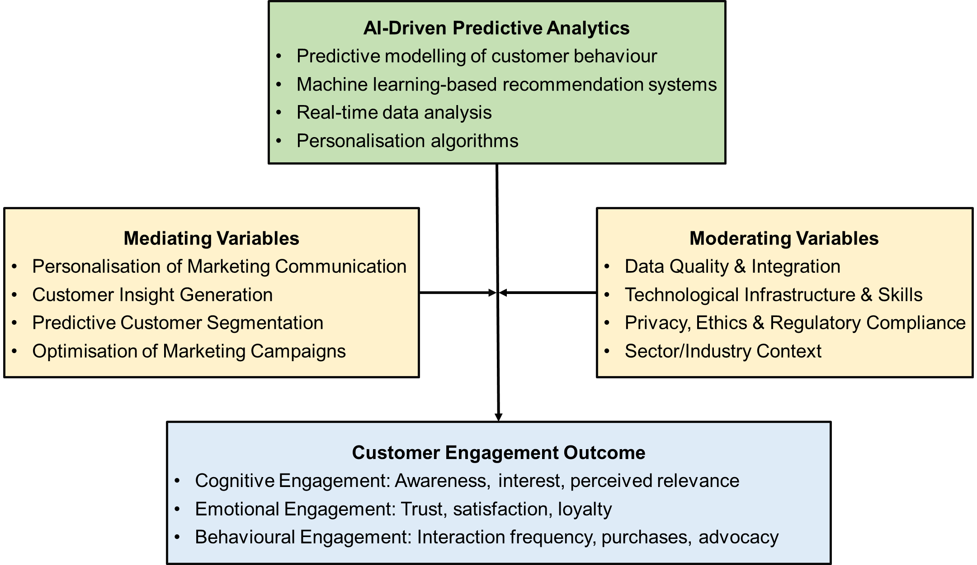
Figure 10: A Conceptual Framework for Enhancing Customer Engagement through AI-Driven Predictive Analytics in Digital Marketing (Adapted by the Author)
This theoretical framework (Fig. 9) explains how AI-based predictive analytics is related to customer engagement in digital marketing. The main driving force is AI technologies, such as predictive modelling, machine learning algorithms and real-time data analysis, which can allow organisations to create actionable customer insights, segment audiences, and personalise marketing communications. The effects of predictive analytics on engagement are mediated through these processes and they are cognitive (awareness and perceived relevance), emotional (trust, satisfaction, and loyalty), and behavioural (interaction frequency, purchases and advocacy). The framework also identifies moderating elements of the quality of data, technological infrastructure, the ethical aspect, and sector positioning, which may improve or limit the success of AI applications. Lastly, engagement is dynamic and a feedback loop captures this dynamic where the interactions with customers constantly inform and refine AI-driven strategies, enabling the creation of iterative improvements and relationships in the long term.

Conclusion of Chapter
This literature review has critically examined the literature on AI-based predictive analytics and its application in digital marketing with the theoretical basis, development, implementation plans, and challenges related to customer engagement improvement. The chapter determined that predictive analytics can help organisations forecast customer behaviour, tailor marketing communications, and maximise interactions through various channels, and theories like TAM, BRT, UTAUT, and Consumer Engagement Theory offer a solid framework in the interpretation of adoption and effectiveness. The academic discussion indicates the potential transformational nature of predictive analytics by enhancing loyalty, satisfaction, and personalisation, as well as challenges the quality of data, ethical issues, and industry-related restrictions. The chapter also consolidated the evidence on the practical application strategies, on how organisations can benefit by using predictive model to inform targeted campaigns, as well as to optimize customer experiences. On balance, this review highlights the fact that although AI-based predictive analytics proves to be a potent resource in improving engagement, it depends on how the business strategy embraces it, ethical controls, and an unceasing adjustment to changing consumer behaviour.

CHAPTER 3: RESEARCH METHODOLOGY

Introduction
The chapter presents the research methodology that was used to examine the effects of AI-based predictive analytics on customer interaction in online marketing. This chapter sets the grounds of validity, reliability, and credibility of the research outcomes by giving a systematic and transparent approach of the research process.

Research Philosophies and Assumptions
The research philosophy used in the study was a positivist research philosophy with an objectivist ontology and deductive epistemology (Su, 2018). This philosophy presupposes that the connections between AI-based predictive analytics and engagement with customers are measurably and objectively observable and measurable in various organisational settings. The use of positivist approach can be explained by the fact that the study synthesised the findings of several empirical sources in a systematic manner, which allowed making generalisable conclusions on the effectiveness, implementation, and challenges of predictive analytics in digital marketing. In addition, it coincides with the use of systematic review, which is based on reproducible and verifiable procedures in minimizing subjective bias (Petticrew and Roberts, 2006).

Research Design
Systematic review design was taken to critically review and synthesise the existing literature on AI-driven predictive analytics in digital marketing. This design is predetermined by the fact that it allows conducting a detailed and systematic evaluation of both empirical and theoretical research, and such evidence is assessed in a uniform and open way (Moher et al., 2009). The systematic review enabled the research to combine the results of various industries, predictive models, and engagement measures, which gave a high-level picture of the effectiveness of predictive analytics application, as well as challenges. Also, this design fits the situation because the research is secondary as it allows performing a rigorous collection of data, its quality evaluation, and synthesis of the narrative without direct data collection of the participants.

Research Approaches
A deductive research methodology was used in the study where the current theory and facts were taken as a starting point and the conclusions were synthesised. The deductive approach allowed the study to test theories by undertaking systematic tests of patterns found in other previous studies, thereby either confirming or refuting them in various organisational environments. Besides, the method facilitates designate comparison across studies, permitting the determination of tendencies, voids, and contradictions in the literature (Dwivedi et al., 2021). The deductive approach is appropriate because this method contributes to the increased reliability of the results and the conclusions made in the research should be supported by the theoretical and empirical data.

Data Collection Methods
The research applied the systematic review approach to gather information about the use and effectiveness of AI-based predictive analytics to engage customers in online marketing (Petticrew and Roberts, 2006). The search was carried out on peer-reviewed journal articles, conference papers, and review studies that were published in English during the period of 2015 to 2025. The publications published before or after this time span, non-English publications, opinion articles, or studies that are not related to predictive analytics and customer engagement were not considered to maintain relevancy and quality. Table 1 represents the eligibility criteria used:
Table 1 Inclusion and exclusion criteria
Criteria Type | Inclusion | Exclusion
Language | English publications | Non-English publications
Publication Period | Studies published between 2015 and 2025 | Studies published before 2015 or after 2025
Type of Source | Peer-reviewed journal articles, conference papers, and reviews | Opinion pieces and non-empirical grey literature
Research Focus | Studies on predictive analytics implementation in marketing and its impact on customer engagement or organisational performance | Studies outside business or marketing contexts
Specific Areas of Interest | Loyalty programmes, personalised marketing, customer satisfaction, and retention strategies using predictive analytics | Studies unrelated to predictive analytics or customer engagement
Empirical Basis | Studies with measurable, data-driven findings | Theoretical works without empirical evidence
The use of primary databases like Scopus and Google Scholar was based on the high coverage, multidisciplinary indexing, and high retrieval accuracy of the marketing and AI-related studies (Shea et al., 2017). The search strategies were a combination of AI-related words (artificial intelligence, predictive analytics, machine learning) and customer engagement words (digital marketing, customer engagement, personalisation, loyalty, and satisfaction) using Boolean operators. Title, abstract, and keyword search together with filters were used to restrict the search to English-language articles and reviews, and in order to obtain maximum results (Moher et al., 2009).
The studies that were retrieved were then imported into EndNote to manage the reference and the duplicates were filtered. The screening was done according to the PRISMA guideline and initially by title and abstract and then later by full-text review to ensure that the information was relevant to the research objectives (Higgins and Green, 2011). The necessary data were extracted with the help of a standardised data extraction template to capture such important information as publication details, research design, organisational context, AI tools, predictive analytics strategies, engagement variables measured, challenges identified, and key outcomes in terms of loyalty, personalisation, and satisfaction.
The quality assessment was performed with the help of the Critical Appraisal Skills Programme (CASP) checklists and assessed the quality of the methodology, validity, and relevance (Shea et al., 2017). Research was classified as high, medium and low quality and results of the low-quality studies were viewed with caution to reduce bias (Higgins and Green, 2011).
Due to the study designs, predictive analytics methods, engagement measures, and the organisational settings being heterogenous, a qualitative narrative synthesis approach was employed (Petticrew & Roberts, 2006). The findings were grouped into three thematic issues, namely (1) how AI-based predictive analytics are applied in digital marketing, (2) how AI-driven predictive analytics affects the results of engagement that include loyalty, customisation, and satisfaction, and (3) issues and obstacles to doing so. This method helped to compare the sphere, predictive models, and approaches that could be used to determine how AI-based predictive analytics can affect customer engagement (Booth, Sutton and Papaioannou, 2016).

Ethical Considerations
Since this research adopted a systematic review design, the research study did not entail direct contact with human subjects and hence did not necessitate any formal ethical permission. To begin with, the study selection was conducted transparently through the application of clear inclusion and exclusion criteria, documentation of search strategy in a systematic manner and adherence to PRISMA guidelines to screen and select the studies (Higgins and Green, 2011).
Secondly, there was the emphasis on accuracy and honesty in reporting. All data and results were measured and captured via a standardised template and the findings were subjectively interpreted without skewing the results of the original studies. This made sure that the synthesis was accurate in terms of evidence including reporting of positive and negative results of AI-powered predictive analytics and customer engagement (Petticrew and Roberts, 2006).
Thirdly, the issues of intellectual property and correct referencing were practiced through the proper citation of all sources and following the academic conventions (Shea et al., 2017). This prevented plagiarism and recognition of original authors.
Fourthly, there was mitigation against possible bias by evaluating the quality of studies based on the CASP checklist which reflected methodological rigour, validity and relevance (Higgins and Green, 2011). Results of studies with a lower quality were interpreted carefully and made sure that conclusions were not unequally determined by weak or untrustworthy results.
Lastly, constraints and disclosure of the study constraints were clearly stated, such as exclusion of non-English studies and grey literature, inconsistency in predictive analytics procedures, and discrepancies in engagement measures. The study fulfilled the role of ethical responsibility by reporting these restrictions and effectively communicating them, which included issues of honesty and reproducibility (Gough, Oliver and Thomas, 2017).

Conclusion
Finally, this chapter has provided an elaborate description of research methodology used in this study. The systematic review design enabled one to identify, select and synthesize empirical and theoretical studies in a rigorous manner hence guaranteeing reliability, transparency and replicability. Ethical issues were thoughtfully handled, such as transparency, correct reporting, and proper attribution, and quality assessment and the risk of bias measures made the findings relied on the credible evidence. On the whole, the methodology chapter provides a solid framework of the analysis and interpretation of findings to prove that the design of the study.

CHAPTER 4: FINDINGS, ANALYSIS AND DISCUSSION

Introduction
The chapter gives the results of the systematic review, in accordance with the PRISMA structure, to maintain the transparent and rigorous selection of studies. There were 50 articles containing different industries and methodologies and presenting empirical data about the implementation and effects of AI-based predictive analytics in digital marketing. The chapter outlines the main peculiarities of those works, compares their results concerning each of the research questions, and explains the consequences of these results to customer engagement, such as loyalty, personalisation, and satisfaction. Patterns and trends have been included in the discussion covering the literature, and these have combined practical insights and gaps in need of further research.

Search Result and Inclusion of Articles
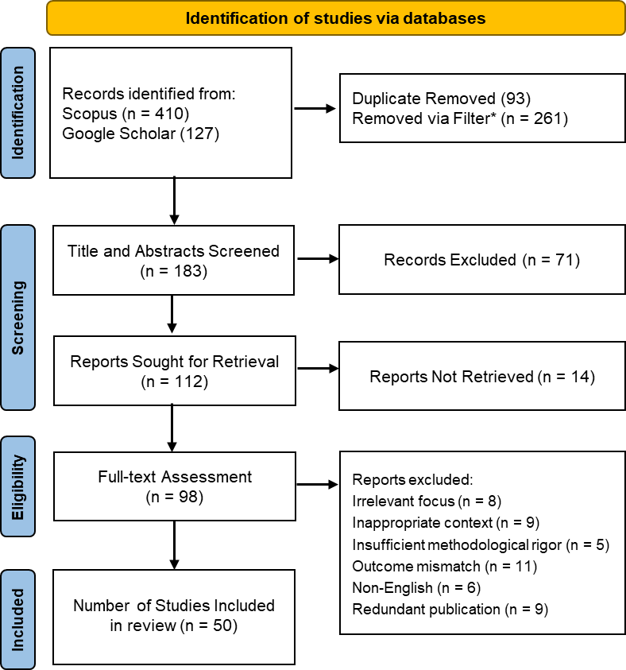
Figure 11 Identification and Inclusion of Articles via PRISMA Framework (Page et al., 2021)
Essentially, 537 records were first searched through Scopus (n = 410) and Google Scholar (n = 127). The 183 records that were left after 93 duplicates were eliminated and filters were used on the materials by year of publication, document type and language passed into title and abstract screening of which 71 records were eliminated. After that, 112 full-text reports were to be retrieved and 14 of them were not retrieved. Ninety-eight studies were assessed in full text and 48 studies were eliminated as irrelevant focus (n = 8), inappropriate focus (n = 9), insufficient methodological rigor (n = 5), outcome mismatch (n = 11), non-English language (n = 6), and redundancy (n = 9). As a result, 50 studies that fit the eligibility criteria were incorporated in the system review to give empirical basis on assessing the effects of AI-based predictive analytics to customer engagement in digital marketing. Among these, 28 articles are rated “high” and 22 articles are rated “medium” by the criteria of CASP checklists (Appendix, Table 7), indicating the reliability of these studies and robustness of the findings.

Summary of the Included Articles
Table 2 Key Characteristics of the Included Articles (N = 50)
Index | Authors (Year) | Title | Methodology | Key Themes
1 | Acikgoz et al (2023) | Consumer engagement with AI-powered voice assistants: A behavioral reasoning perspective | Quantitative survey (n=491) using mTurk; multimethod analysis (PLS and fsQCA) | Consumer engagement, AI-powered voice assistants, privacy, trust, TAM, behavioral reasoning theory (RQ1, RQ2)
2 | Al Kurdi et al (2024) | Machine Learning Applications in Social Media Marketing: Innovating Customer Engagement and Brand Building | Quantitative empirical research using structural equation modelling on data from 237 UAE retail professionals | Shows how machine learning enhances customer engagement and brand strength through content personalisation and platform diversity (RQ2, RQ4)
3 | Albinali and Hamdan (2021) | The Implementation of Artificial Intelligence in Social Media Marketing and Its Impact on Consumer Behavior: Evidence from Bahrain | Quantitative survey-based research examining AI’s effect on consumer behaviour in social media marketing | Investigates how AI tools analyse social media trends to understand and influence consumer preferences (RQ2)
4 | Bayoude et al. (2018) | How machine learning potentials are transforming the practice of digital marketing: State of the art | State-of-the-art review; analytical discussion of ML applications in marketing | Machine learning in digital marketing, consumer behaviour prediction, large-scale data analysis, marketing optimisation (RQ2, RQ3)
5 | Behera et al. (2024) | Transforming customer engagement with artificial intelligence E-marketing: an E-retailer perspective in the era of retail 4.0 | Quantitative analysis of 305 e-retailer customers, structural model validation | AI e-marketing (AIeMktg), customer engagement transformation, Retail 4.0, data-driven personalisation (RQ1, RQ2, RQ4)
6 | Benjelloun and Kabak (2024) | Ethical Challenges and Managerial Implications of Artificial Intelligence in Digital Marketing | Documentary research methodology; literature-based analysis | Ethical concerns in AI marketing (privacy, transparency, discrimination), managerial implications, responsible AI use (RQ3, RQ4)
7 | Cunha et al. (2024) | Revolutionising Luxury: The Role of AI and Machine Learning in Enhancing Marketing Strategies within the Tourism and Hospitality Luxury Sectors | Quantitative survey of 2,048 respondents; geographical data analysis | AI and ML in luxury marketing, predictive analytics for behaviour, personalisation, operational challenges (RQ2, RQ3)
8 | Cutler (2024) | The evolution of digital marketing in the era of AI | Conceptual paper examining technological, ethical and regulatory trends | Predictive analytics, personalisation, automation ethics, privacy-centric marketing (RQ3, RQ4)
9 | Dai & Wang (2021) | Prediction of customer engagement behaviour response to marketing posts based on machine learning | Machine learning approach using Stimulus-Organism-Response theory, BERT model for text analysis | Predictive analytics for customer engagement, social media behaviour modelling (RQ1, RQ2)
10 | Deepak et al (2024) | Paradigm Shift in E-Commerce by Applying Cognitive Multi-Agent System with Machine Learning and Deep Learning Techniques | Conceptual and applied research within e-commerce AI systems | Examines AI’s influence on automation, customer engagement, data privacy, and fraud detection within e-commerce ecosystems (RQ2, RQ3, RQ4)
11 | Dwivedi et al. (2021) | Setting the future of digital and social media marketing research: Perspectives and research propositions | Expert perspective synthesis and conceptual analysis | Emerging AI trends, research gaps, ethical and practical challenges in digital marketing (RQ3, RQ4)
12 | Gazala Masood et al. (2023) | Evaluating the Performance of Deep Learning Methods and Its Impact on Digital Marketing | Conceptual mapping of deep learning applications in digital marketing and framework proposal | Deep learning in marketing intelligence, model efficiency, automation potential (RQ1, RQ4)
13 | Geetha et al. (2024) | Advancement Improving the Acquisition of Customer Insights in Digital Marketing by Utilising Advanced Artificial Intelligence Algorithms | Conceptual paper supported by applied AI use cases | AI-based customer insight generation, predictive modelling, personalisation, data-driven marketing, automation (RQ1, RQ2, RQ4)
14 | Ghareeb et al (2024) | Using Data Analytics Techniques for Enhancing Social Media Marketing Processes | Analytical research employing machine learning and deep learning models (e.g., logistic regression, LSTM) | Focuses on predictive modelling, sentiment analysis, and personalisation to improve engagement and ethical social media marketing (RQ1, RQ2, RQ4)
15 | Gkikas & Theodoridis (2024) | Predicting Online Shopping Behaviour: Using Machine Learning and Google Analytics to Classify User Engagement | Quantitative analysis using machine learning classifiers (DT, NB, k-NN) with Google Analytics data | Predictive analytics for user engagement, personalisation, consumer behaviour modelling, e-commerce optimisation (RQ1, RQ2)
16 | Gkikas and Theodoridis (2019) | Artificial Intelligence (AI) Impact on Digital Marketing Research | Conceptual and mapping study examining intersections of AI and digital marketing through literature review and model proposal | Explores the integration of AI into digital marketing research and identifies gaps for predictive modelling applications (RQ1)
17 | Guru et al. (2023) | The Future Impact of Technological Developments on Digital Marketing Through Artificial Intelligence | Descriptive analysis of AI’s integration with SEO, PPC, chatbots and AR | AI-enabled marketing innovation, customer interaction, sales optimisation, technological advancement (RQ1, RQ2, RQ4)
18 | Hendrayati et al (2024) | The Impact of Artificial Intelligence on Digital Marketing: Leveraging Potential in a Competitive Business Landscape | Quantitative method using surveys and statistical analysis (SPSS) of 100 companies | Strategic integration of AI in marketing, customer engagement metrics, adaptability, and competitive advantage (RQ1, RQ2, RQ4)
19 | Islam et al (2024) | Artificial Intelligence in Digital Marketing Automation: Enhancing Personalization, Predictive Analytics, and Ethical Integration | Systematic literature review using PRISMA methodology, synthesising 150 studies and 25 reports | Highlights predictive analytics and automation for hyper-personalisation, efficiency, and ethical AI integration (RQ1, RQ2, RQ3, RQ4)
20 | Iwendi et al. (2024) | Empowering Marketing Management and Gaming Consumer Interaction Through AI and Citizen Science | Conceptual framework integrating AI, machine learning, NLP, and sentiment analysis | Predictive analytics, personalisation, consumer engagement, real-time interaction, dynamic pricing, NLP-driven marketing insights (RQ1, RQ2, RQ4)
21 | Kachamas (2016) | Shaping interactive marketing communication (IMC) through social media analytics and modelling | AI-driven classificatory modelling using Bayesian Classifiers within AISAS framework | Social media analytics, consumer behaviour modelling, AI for marketing communication, engagement triggers (RQ1, RQ2)
22 | Kanojia, Malhotra & Tiwari (2024) | Integration of Artificial Intelligence in Digital Marketing in the New Era | Quantitative study using SEM (SmartPLS) with 248 business respondents | AI-driven personalisation, customer experience, brand loyalty, engagement modelling (RQ2)
23 | Kaponis and Maragoudakis (2022) | Data Analysis in Digital Marketing using Machine Learning and Artificial Intelligence Techniques, Ethical and Legal Dimensions, State of the Art | Systematic review and conceptual discussion on AI’s role in digital marketing within legal and ethical frameworks | Reviews predictive analytics, ethical considerations, and challenges in AI-based marketing strategies (RQ1, RQ3)
24 | Khan et al. (2025) | AI-driven business intelligence in retail: Transforming customer data into strategic decision-making tools | Quantitative empirical analysis; case studies | AI in business intelligence, customer data analytics, operational efficiency, sales and loyalty enhancement (RQ2, RQ3)
25 | Kumar et al. (2023) | Maximizing the Potential of Artificial Intelligence in Digital Marketing | Literature review and empirical synthesis of AI applications in marketing | AI-driven personalisation, optimisation of campaigns, customer engagement, data privacy challenges, strategic recommendations (RQ1, RQ2, RQ3, RQ4)
26 | Lohchab, Chauhan & Kumar (2024) | Factors Affecting Brand Image in Social Media Marketing | Literature-based conceptual analysis | Social media marketing strategies, brand loyalty, AI ethics and consumer trust (RQ2, RQ4)
27 | Long et al (2024) | Factors Affecting Customer Engagement and Brand Loyalty in Vietnam FMCG: The Moderation of Artificial Intelligence | Quantitative study using multivariate regression analysis on 416 samples | Investigates how AI moderates the link between customer engagement and brand loyalty in FMCG social media marketing (RQ2, RQ4)
28 | Maheta, Pandya, Patel (2024) | Predictive intelligence in action: Evaluating the impact of AI-powered analytics on digital marketing performance in India | Mixed-methods (quantitative campaign analysis + qualitative interviews) | Predictive analytics, digital marketing performance, AI adoption, personalized targeting, regulatory compliance, SME challenges (RQ2, RQ3)
29 | Mary Chinthamani et al. (2024) | Influencing Consumer Behaviour on E-Commerce Platforms Through Social Media Marketing Using BiLSTM-KNN Models | Quantitative experimental study using hybrid BiLSTM-KNN model integrating social media sentiment and behavioural data | AI-based behavioural prediction, model accuracy, social media marketing impact (RQ2)
30 | Meepung & Kannikar (2022) | Artificial Intelligence for Digital Business Performance | Conceptual study integrating AI and ML applications in digital marketing tools | AI-enhanced customer journey, behaviour tracking, marketing efficiency (RQ1, RQ2)
31 | Nivetha et al (2024) | Enhancing Consumer Behavior Insights in Digital Marketing through Artificial Intelligence Integration | Experimental quantitative research using LSTM-SVM hybrid model on large digital datasets | Demonstrates AI’s role in predicting and understanding consumer behaviour for personalised marketing strategies (RQ1, RQ2)
32 | Oluwafemi et al. (2021) | A review of ethical considerations in AI-driven marketing analytics: Privacy, transparency, and consumer trust | Literature review; conceptual analysis | Ethical AI in marketing, privacy, transparency, consumer trust, regulatory considerations (RQ1, RQ3)
33 | Panda et al (2023) | Turning Data Into Insights: Leveraging Artificial Intelligence for Better Understanding of Social Media Consumer Behaviour | Conceptual and analytical paper exploring consumer behaviour stages through AI-based insights | Examines AI’s ability to analyse big data and influence consumer decisions, social media interactions, and influencer marketing effectiveness (RQ1, RQ2)
34 | Panda, Mishra & Sharma (2023) | Understanding the ripple effect: Exploring the influence of cyber crime on social media and its consumer behavior | Case study; analytical review | Social media impact on consumer behaviour, cybercrime influence, trust and reputation, risk mitigation strategies (RQ2, RQ4)
35 | Patil et al (2024) | Artificial Intelligence Powered Paradigm Shift: Revolutionizing Digital Marketing | Conceptual and analytical study reviewing AI’s integration into digital marketing | Analyses AI’s transformative influence on personalisation, efficiency, targeting, and data-driven decision-making (RQ1, RQ4)
36 | Shameem et al. (2023) | The Rising Importance of AI in Boosting the Efficiency of Online Advertising in Developing Countries | Quantitative study using regression and fsQCA on consumer behavioural data | Deep learning in advertising, consumer perception, predictive analytics, AI-enhanced targeting efficiency (RQ1, RQ2)
37 | Sharma & Sharma (2023) | The role of generative pretrained transformers (GPTs) in revolutionising digital marketing: A conceptual model | Conceptual analysis with literature review and case examples | Application of GPT in digital marketing, automated content creation, personalisation, social media engagement, and customer interaction (RQ1, RQ2, RQ4)
38 | Sharma and Sharma (2024) | How Artificial Intelligence is Transforming Social Media Marketing: Analysing its Potential and Addressing Concerns | Qualitative study exploring professional perspectives on AI-driven social media marketing | Examines AI’s role in enhancing personalisation and engagement, while identifying ethical risks such as bias and trust issues (RQ2, RQ3)
39 | Srinivas et al (2024) | AI and Machine Learning in Digital Marketing: Revolutionizing Customer Engagement and Decision Making | Analytical study using applied predictive modelling (logistic regression) to assess AI and ML in marketing decisions | Demonstrates how predictive analytics supports customer retention, decision-making, and marketing optimisation (RQ1, RQ2, RQ4)
40 | Sriram et al. (2023) | Consumer Behaviour on Digital Marketing Platforms—Specifically in Terms of Consumer Loyalty Using Machine Learning | Qualitative and correlational research using secondary data | Machine learning for loyalty prediction, consumer behaviour analysis, customer retention strategies (RQ1, RQ2)
41 | Subramani (2019) | Transforming the Enterprise with Applied Artificial Intelligence | Conceptual analysis and applied framework | AI-driven digital transformation, marketing efficiency, best practices for applied AI in marketing (RQ1, RQ4)
42 | Takahashi (2019) | Consumer behavior DNA for realizing flexible digital marketing | Applied AI model development (“consumer behaviour DNA”) | Predictive marketing automation, consumer engagement, data-driven decision making (RQ1, RQ3)
43 | Tawara et al. (2024) | A Systematic Review and Comprehensive Analysis of AI-Enabled Re-Skilling and Upskilling in Education: Transformative Strategies for the Future | Mixed-methods study combining systematic review and quantitative survey | AI for marketing engagement insights, customer engagement prediction, adoption challenges and strategies (RQ1, RQ3, RQ4)
44 | Tchelidze (2019) | Potential and skill requirements of artificial intelligence in digital marketing | Conceptual study; literature-based analysis | AI potential in marketing, skills required for AI-driven marketing (creativity, analytics, tech understanding, communication) (RQ1, RQ3)
45 | Vij et al (2024) | Evaluating the Effectiveness of AI-Integrated Digital Marketing on Consumer Behavior, Brand Perception, and Sales Performance | Mixed-methods approach combining quantitative consumer surveys and qualitative literature review | Assesses how AI-driven marketing affects consumer behaviour, brand image, and sales performance through personalisation and predictive analytics (RQ1, RQ2, RQ4)
46 | Wang & Wang (2022) | Reinventing the Wheel of Marketing: Assessing the Impact of Artificial Intelligence (AI) on Digital Marketing and Consumer Buying Behavior | Mixed-methods research using thematic and statistical analysis | AI’s impact on digital marketing and consumer behaviour, conversational interfaces, behavioural prediction (RQ2, RQ3)
47 | Wiputra et al (2024) | Exploring the Impact of Generative AI on Customer Engagement in Digital Marketing | Systematic literature review using PRISMA methodology | Analyses how Generative AI enhances customer engagement and loyalty through personalisation, affective commitment, and customer delight, while addressing ethical challenges (RQ2, RQ3, RQ4)
48 | Yaiprasert, Hidayanto (2023) | AI-driven ensemble three machine learning to enhance digital marketing strategies in the food delivery business | Empirical analysis using ensemble ML (decision trees, naïve Bayes, nearest neighbor) | Machine learning in digital marketing, customer data analysis, predictive accuracy, ensemble models (RQ2, RQ3)
49 | Ziakis and Vlachopoulou (2023) | Artificial Intelligence in Digital Marketing: Insights from a Comprehensive Review | Systematic literature review using PRISMA and bibliometric analysis | Provides an extensive synthesis of AI’s role in digital marketing, covering predictive analytics, social media, and strategic optimisation (RQ1, RQ3, RQ4)
50 | Zulaikha et al (2025) | Customer predictive analytics using artificial intelligence | Conceptual discussion; literature review | AI for customer targeting, customer lifecycle management, predictive analytics, behavioral insights (RQ2, RQ3)

Analysis of the Findings

Thematic Analysis of how organisations use predictive analytics within digital marketing strategies (RQ1)
The table below provides the thematic analysis of RQ1, which shows the application of predictive analytics by organisations in digital marketing strategies. It brings out the key themes, sub-themes and the analysis codes that have been found in the literature.
Table 3 Thematic Analysis of Organisational Use of Predictive Analytics in Digital Marketing Strategies (RQ1)
Theme | Sub-theme | Code
Predictive Analytics for Understanding Consumer Behaviour | Behavioural prediction | Forecasting engagement and behaviour patterns using predictive models (Dai and Wang 2021; Shameem et al 2023; Mary Chinthamani et al 2024)
Predictive Analytics for Understanding Consumer Behaviour | Social media behavioural modelling | Interpreting social media signals to understand preferences and attitudes (Albinali and Hamdan 2021; Panda et al 2023; Kachamas 2016)
Predictive Analytics for Understanding Consumer Behaviour | Customer lifecycle and loyalty modelling | Predicting retention, churn and loyalty trajectories (Sriram et al 2023; Srinivas et al 2024; Zulaikha et al 2025)
Personalisation and Targeted Marketing | Hyper-personalised experiences | Tailoring content and communications at individual level (Islam et al 2024; Iwendi et al 2024; Geetha et al 2024)
Personalisation and Targeted Marketing | Targeted advertising and recommendations | Optimising ad delivery and product recommendations (Behera et al 2024; Vij et al 2024; Patil et al 2024)
Personalisation and Targeted Marketing | Segmentation and micro-targeting | Enhanced segmentation and precise targeting using ML (Bayoude et al 2018; Yaiprasert and Hidayanto 2023; Maheta, Pandya and Patel 2024)
Marketing Performance Optimisation and Decision Support | Campaign optimisation | Improving campaign timing, content, and media allocation (Kumar et al 2023; Guru et al 2023; Subramani 2019)
Marketing Performance Optimisation and Decision Support | Sales and conversion forecasting | Predicting conversions and revenue outcomes (Khan et al 2025; Vij et al 2024; Sriram et al 2023)
Marketing Performance Optimisation and Decision Support | Operational and strategic decision making | Informing data-driven strategic and operational marketing decisions (Takahashi 2019; Ziakis and Vlachopoulou 2023; Wang and Wang 2022)
Sentiment, Social Media and Engagement Analytics | Sentiment analysis for engagement | Predicting audience response and refining messaging (Ghareeb et al 2024; Panda et al 2023; Wiputra et al 2024)
Sentiment, Social Media and Engagement Analytics | Engagement prediction models | Anticipating engagement levels to optimise content (Acikgoz et al 2023; Long et al 2024; Tawara et al 2024)
Sentiment, Social Media and Engagement Analytics | Influencer and community behaviour forecasting | Assessing influencer impact and community dynamics (Panda et al 2023; Albinali and Hamdan 2021; Sharma and Sharma 2023)
Ethical and Governance Considerations | Privacy, transparency and trust | Need for responsible data practices to maintain trust (Benjelloun and Kabak 2024; Islam et al 2024; Oluwafemi et al 2021)
Ethical and Governance Considerations | Bias and fairness risks | Managing algorithmic bias and discrimination in predictive use (Cutler 2024; Sharma and Sharma 2024; Kaponis and Maragoudakis 2022)
Ethical and Governance Considerations | Regulatory and responsible use | Ensuring compliance and ethical adoption (Maheta, Pandya and Patel 2024; Dwivedi et al 2021; Zulaikha et al 2025)

Narrative Synthesis of Organisational Use of Predictive Analytics in Digital Marketing (RQ1)
In the literature, predictive analytics is a key competency that is used by organisations to improve their knowledge about consumers and marketing effectiveness. There is a significant amount of literature that predictive modelling enables companies to predict behavioural patterns more accurately, which is beneficial in engagement management and strategic targeting (Dai and Wang 2021; Shameem et al 2023; Mary Chinthamani et al 2024). This power to model behaviour is particularly dominant in the social media context, where artificial intelligence systems analyze unstructured information of large amounts to derive preferences and attitudes (Albiali and Hamdan 2021; Panda et al 2023; Kachamas 2016). Moreover, predictive modelling can help forecast customer lifecycle behavior like churn and retention, so it is possible to be more proactive in retention (Sriram et al 2023; Srinivas et al 2024; Zulaikha et al 2025). Although it is evident that these applications are very beneficial in generating insight, they also rely on data quality and model transparency, which according to several authors can constrain interpretability and managerial trust.
The second defining role of predictive analytics is the personalisation and direct communication. Predictive systems are more extensively used by organisations to provide hyper-personalised content based on individual needs and behaviour (Islam et al 2024; Iwendi et al 2024; Geetha et al 2024). It also goes all the way to recommendational systems and target advertising that enhances relevance and efficacy of advertising considerably (Behera et al 2024; Vij et al 2024; Patil et al 2024). Predictive segmentation also allows even greater accuracy in the targeting process by identifying hidden clusters of consumers that cannot be included in traditional demographic segmentation (Bayoude et al 2018; Yaiprasert and Hidayanto 2023). The literature identifies these advantages, but notes that there are diminishing returns once personalisation is too intrusive to consumer discomfort and trust destruction.
There is also the input of predictive analytics in the optimisation of performance and decision support of marketing activities. Predictive methods are used to streamline campaign execution, such as message scheduling, creative differentiation and channel choice, among other factors, by organisations (Kumar et al 2023; Guru et al 2023; Subramani 2019). The types of forecasting models help make better predictions of sales and conversions, which have a direct impact on budgeting and resource allocation (Khan et al 2025; Vij et al 2024; Sriram et al 2023). At a larger scale, predictive systems can also influence strategic planning and operational decision making through more agile and evidence based marketing practice (Takahashi 2019; Ziakis and Vlachopoulou 2023; Wang and Wang 2022). Nonetheless, a number of authors observe that the managerial skill deficits and organisational preparedness remain limiting to successful adoption especially with regard to model output interpretation.
Sentiment and engagement analytics have become essential in the social media sphere in the determination of communication strategies. Predictive sentiment analysis enables companies to forecast audience responses and modify content based on it (Ghareeb et al 2024; Panda et al 2023; Wiputra et al 2024), engagement prediction models help in optimisation of posting behaviour and post content construction (Acikgoz et al 2023; Long et al 2024). They can also be used to evaluate the effectiveness of influencers and community dynamics that are becoming more dominant in digital persuasion (Panda et al 2023; Sharma and Sharma 2023). However, there are still ethical and governance issues. Researchers highlight privacy, transparency, algorithmic bias and compliance risks (Benjelloun and Kabak 2024; Cutler 2024; Oluwafemi et al 2021), and they are worried that unsupported ethical standards will undercut the benefits of predictive analytics, as consumers will resist and regulatory agencies will scrutinise them. Together, the literature shows that predictive analytics is a major tool in improving the digital marketing potential, although it depends on ethical governance and organisational competence.

Thematic Analysis of how does predictive analytics affect customer engagement, including loyalty, personalisation, and satisfaction (RQ2)
The table below is the thematic analysis on RQ2, which analyses the impact of predictive analytics on customer engagement, i.e. their loyalty, personalisation, and satisfaction. It summarizes the beneficial and adverse consequences of predictive analytics found in the literature, emphasizing the two-fold influence of predictive analytics on customer experience and relational outcomes.
Table 4 Thematic Analysis of the Effects of Predictive Analytics on Customer Engagement, Loyalty, Personalisation, and Satisfaction (RQ2)
Theme | Sub-theme | Code
Positive Effects on Customer Engagement | Enhancing personalisation | Predictive systems tailor content, recommendations and communication, increasing perceived relevance and satisfaction (Islam et al 2024; Geetha et al 2024; Iwendi et al 2024)
Positive Effects on Customer Engagement | Strengthening loyalty | Predictive modelling improves retention and fosters loyalty through personalised value and engagement (Long et al 2024; Sriram et al 2023; Zulaikha et al 2025)
Positive Effects on Customer Engagement | Increasing engagement intensity | Predictive engagement forecasting supports content optimisation and higher interaction rates (Acikgoz et al 2023; Tawara et al 2024; Behera et al 2024)
Positive Effects on Satisfaction | Improved service efficiency | Automation and targeted assistance enhance convenience and satisfaction (Deepak et al 2024; Meepung & Kannikar 2022)
Positive Effects on Satisfaction | Predictive insight value | Anticipating needs reduces friction and increases perceived service quality (Vij et al 2024; Kumar et al 2023)
Negative Effects on Engagement | Privacy and trust erosion | Heavy data dependence can reduce trust and create discomfort, lowering engagement (Benjelloun & Kabak 2024; Acikgoz et al 2023; Oluwafemi et al 2021)
Negative Effects on Engagement | Perceived manipulation | Personalisation may be interpreted as intrusive or controlling, reducing satisfaction and engagement (Sharma & Sharma 2024; Cutler 2024)
Negative Effects on Engagement | Bias and misprediction | Inaccurate predictions or biased models can produce irrelevant or harmful outputs, weakening engagement and satisfaction (Kaponis & Maragoudakis 2022; Islam et al 2024)
Negative Effects on Loyalty and Satisfaction | Reduced perceived autonomy | Excessive automation may diminish user agency and negatively affect satisfaction (Dwivedi et al 2021; Takahashi 2019)
Negative Effects on Loyalty and Satisfaction | Ethical and fairness concerns | Discrimination or opacity can damage brand image and loyalty (Benjelloun & Kabak 2024; Cutler 2024)

Narrative Synthesis: Effects of Predictive Analytics on Customer Engagement, Loyalty, Personalisation and Satisfaction (RQ2)
Within the literature reviewed, predictive analytics has significant impact on customer engagement that has generated both considerable benefits and significant threats to organisations and consumers. One of the regular positive results is the increase in personalisation. Research shows that predictive systems allow companies to make content, recommendations and communication highly-relevant, which enhances the perceived value and satisfaction of customers (Islam et al. 2024; Geetha et al. 2024; Iwendi et al. 2024). Personalisation is often cited as the key approach whereby the engagement can be more enhanced since the consumers will be more willing to interact with the marketing content that resonates with their interests and buying situation. Predictive modelling also helps to form loyalty, enabling organisations to guess needs, eliminate friction in the customer experience and have a more receptive relationship with the consumer (Long et al. 2024; Sriram et al. 2023; Zulaikha et al. 2025). The results are consistent with larger arguments in retail and digital marketing that perceived relevance and convenience are major motivation contributors of loyalty in the overcrowded digital landscape.
Predictive analytics is another way of contributing to engagement through the level of interaction. By predicting engagement behaviour, organisations are able to schedule posting schedules, creative aspects and channel selection optimally to enhance the response rates and participation (Acikgoz et al. 2023; Tawara et al. 2024; Behera et al. 2024). This, in turn, facilitates satisfaction, especially when automated assistants that are predictive are involved to streamline routine support and accelerate the process of service (Deepak et al. 2024; Meepung and Kannikar 2022). Some authors also make remarks on the goodness of predictive insight as such: when companies foresee demand or behaviour changes, customers will gain easier and more suitable services and become more satisfied and perceive a better service delivery (Vij et al. 2024; Kumar et al. 2023).
Nevertheless, there are also negative implications which are significant and should be critically noticed in the literature. The issue of trust is raised as a theme. Predictive systems rely on the usage of large amounts of personal data, which can be seen as an invasion by consumers, making them less trusting and less engaged (Benjelloun and Kabak 2024; Acikgoz et al. 2023; Oluwafemi et al. 2021). Personalisation may be perceived as manipulative or too intrusive even when it is technically successful and leads to discomfort instead of satisfaction (Sharma and Sharma 2024; Cutler 2024). This shows a natural contradiction: the very mechanisms that make it possible to be relevant can also jeopardize the autonomy and privacy.
The other quantifiable risk is model bias and misprediction. Inaccurate or systematically biased predictive outputs can lead to consumers getting inappropriate or unfair treatment, which might harm consumer satisfaction and worsen loyalty (Kaponis and Maragoudakis 2022; Islam et al. 2024). Lack of transparency or fairness in ethics may also be negative to organisational reputation, which will cause long-term loyalty damage that would be more than short-term gains of automation.
Lastly, a number of authors warn that too much automation can lessen perceived agency so that the consumers feel manipulated instead of nurtured (Dwivedi et al. 2021; Takahashi 2019). This implies that there is no engagement at the cost of relevance or convenience but also psychological comfort and perceived autonomy.
In sum, predictive analytics can contribute to meaningful engagement and loyalty and thus, can also harm these results when being used in a careless and unethical manner.

Thematic Analysis of the challenges organisations face when using predictive analytics to improve customer engagement (RQ3)
The table below is a summary of the thematic analysis of RQ3, with the critical issues that organisations encounter when using predictive analytics to enhance customer engagement. It divides these issues into technical and operational, ethical and governance, managerial and strategic, and consumer-related, demonstrating the multidimensionality and complexity of the implementation of predictive analytics in marketing situations.
Table 5 Thematic Analysis of Organisational Challenges in Using Predictive Analytics to Enhance Customer Engagement (RQ3)
Theme | Sub-theme | Code
Technical and Operational Challenges | Data quality and availability | Predictive performance depends on large, clean, representative datasets; poor data reduces accuracy and effectiveness (Bayoude et al 2018; Yaiprasert & Hidayanto 2023; Geetha et al 2024)
Technical and Operational Challenges | Model complexity and integration | Organisations face difficulty embedding advanced predictive systems into existing processes and workflows (Cunha et al 2024; Subramani 2019)
Technical and Operational Challenges | Skills and capability gaps | Effective use requires technical, analytical and communication skills often lacking in marketing teams (Tchelidze 2019; Takahashi 2019)
Ethical and Governance Challenges | Privacy and transparency | Predictive analytics relies on sensitive data, raising concerns about consent, transparency and consumer trust (Benjelloun & Kabak 2024; Oluwafemi et al 2021; Acikgoz et al 2023)
Ethical and Governance Challenges | Algorithmic bias and fairness | Predictive systems can reflect or amplify discriminatory patterns, harming consumers and firms (Cutler 2024; Sharma & Sharma 2024; Kaponis & Maragoudakis 2022)
Ethical and Governance Challenges | Regulatory compliance | Organisations must navigate evolving data protection and ethical regulations, which can restrict or complicate analytics use (Maheta et al 2024; Dwivedi et al 2021)
Managerial and Strategic Challenges | Adoption and change management | Integrating predictive analytics requires culture change, training and strategic alignment (Hendrayati et al 2024; Tawara et al 2024)
Managerial and Strategic Challenges | Cost and resource demands | Advanced analytics require substantial investment in infrastructure, expertise and data governance (Cunha et al 2024; Islam et al 2024)
Managerial and Strategic Challenges | Measuring impact | Demonstrating clear ROI on engagement outcomes remains challenging for many firms (Guru et al 2023; Ziakis & Vlachopoulou 2023)
Consumer-Related Challenges | Trust and acceptance | Consumers may resist predictive systems due to perceived surveillance or loss of control (Acikgoz et al 2023; Cutler 2024)
Consumer-Related Challenges | Satisfaction risks | Misaligned predictions or overly intrusive personalisation can reduce satisfaction and engagement (Sharma & Sharma 2024; Dwivedi et al 2021)

Narrative Synthesis of Challenges in Using Predictive Analytics to Enhance Customer Engagement (RQ3)
The literature indicates that organisations have been faced with a set of challenges, which are multi-layered in nature, during implementation of predictive analytics to improve customer engagement, on technical, ethical, managerial, and consumer-related levels. Predictive analytics requires the presence of big, clean and representative datasets at the technical level. A number of researchers point out that the low quality of data, incomplete consumer records, and noise in social media data considerably cause the downgrading of the model and, thus, the deterioration of engagement outcomes (Bayoude et al 2018; Yaiprasert and Hidayanto 2023; Geetha et al 2024). The incorporation of complicated machine learning systems in the current marketing systems is a problem even when data is adequate. In the case of luxury and high-touch industries, like high-end jewellery, it is stated that the operation becomes frictional when trying to make personalised predictions and non-standardised customer experiences (Cunha et al 2024). Moreover, efficient predictive utilization requires a set of technical literacy, analytical thinking, and communication competencies which the marketing departments usually lack (Tachelidze 2019; Takahashi 2019). The severe outcome is that organisations can implement sophisticated tools without yet realizing their constraints or proper interpretation of results, which generate implementation gaps and mismatched strategies.
The second critical cluster is ethical and governance issues. Predictive models need access to fine-grained behavioural data, which is why the issue of privacy, transparency, and informed consent remains persistent (Benjelloun and Kabak 2024; Oluwafemi et al 2021). As soon as consumers believe that their data is used or manipulate their attention, they quickly lose trust, which makes the engagement worse and not better (Acikgoz et al 2023). These problems are enhanced by the fact that algorithmic bias is a phenomenon that makes models trained on historical datasets go through discriminatory patterns or make inaccurate predictions about minority groups (Cutler 2024; Sharma and Sharma 2024). Besides damaging the consumers, such mistakes place the firms at a reputational and legal risk. Compliance also makes predictive deployment more complicated to use, especially in jurisdiction with robust data protection regimes where any constraints on data use would restrict the extent or the level of modelling (Maheta, Pandya and Patel 2024; Dwivedi et al 2021).
There are also managerial barriers that greatly influence the results of adoption. Predictive analytics necessitate organisational cultures that are based on experimentation, data literacy, and the ability to work across functional lines, and most companies are not able to change current workflows and incentive systems (Hendrayati et al 2024). Other barriers include high investment in infrastructure, talent, and governance which is especially a burden to SMEs that have few resources (Islam et al 2024). The direct impact on engagement is also hard to measure when implemented since engagement is a phenomenon that can be affected by a large number of interacting variables, and the return on investment is consequently hard to demonstrate (Guru et al 2023; Ziakis and Vlachopoulou 2023).
Lastly, consumer-related issues warningly do not presume that predictive sophistication can be transformed into more intense interaction. Predictive systems can be disliked or demotivated by the consumers when they feel that they are intrusive, over-automated, or strip them of their autonomy (Cutler 2024; Dwivedi et al 2021). Lack of alignment has the potential to generate irrelevant recommendations or messages that decrease satisfaction and undermine loyalty (Sharma and Sharma 2024).
Taken together, the literature suggests that even though predictive analytics has great promise in terms of improving customer engagement, its successful application depends on the ability to overcome the major technical, ethical, organisational, and consumer-based challenges.

Thematic Analysis of Recommended Strategies for Enhancing Customer Engagement through AI-Driven Predictive Analytics (RQ4)
The following table shows the thematic analysis of RQ4, which lists the recommendations based on the strategies that organisations can use to improve customer interaction through AI-based predictive analytics. It divides strategies into data and analytical, personalisation and experience design, ethical and governance, managerial and organisational actions, and communication-oriented human-centric steps, which represent a holistic model of effective and responsible adoption of predictive analytics.
Table 6 Thematic Analysis of Recommended Strategies for Enhancing Customer Engagement through AI-Driven Predictive Analytics (RQ4)
Theme | Sub-theme | Code
Data and Analytical Strategies | Improve data governance and quality | Organisations should invest in clean, representative and ethically sourced datasets to enhance predictive accuracy (Bayoude et al 2018; Geetha et al 2024; Yaiprasert & Hidayanto 2023)
Data and Analytical Strategies | Advanced modelling and optimisation | Use ensemble models, deep learning and continuous model evaluation to improve forecasting and engagement outcomes (Shameem et al 2023; Gazala Masood et al 2023; Mary Chinthamani et al 2024)
Data and Analytical Strategies | Real-time analytics | Adopt systems capable of dynamic prediction to support timely personalised responses (Iwendi et al 2024; Dai & Wang 2021)
Personalisation and Experience Design Strategies | Hyper-personalisation | Deliver tailored content, offers and communication to increase relevance and satisfaction (Islam et al 2024; Geetha et al 2024; Behera et al 2024)
Personalisation and Experience Design Strategies | Customer journey optimisation | Use predictive insights to remove friction and enhance service convenience (Meepung & Kannikar 2022; Deepak et al 2024)
Personalisation and Experience Design Strategies | Loyalty-enhancing interventions | Predict churn and intervene with personalised loyalty programmes and retention tactics (Sriram et al 2023; Long et al 2024; Zulaikha et al 2025)
Ethical and Governance Strategies | Responsible and transparent AI | Maintain transparency, fairness and explainability to build trust and safeguard engagement (Benjelloun & Kabak 2024; Cutler 2024; Oluwafemi et al 2021)
Ethical and Governance Strategies | Privacy-by-design | Integrate data minimisation, consent and security practices to mitigate trust erosion (Acikgoz et al 2023; Islam et al 2024)
Ethical and Governance Strategies | Compliance and auditing | Adopt regular ethical audits and align with data regulations (Maheta et al 2024; Dwivedi et al 2021)
Managerial and Organisational Strategies | Skills development | Equip marketing teams with data literacy, creativity and technical understanding (Tchelidze 2019; Subramani 2019)
Managerial and Organisational Strategies | Strategic integration | Align predictive analytics with organisational goals and customer engagement metrics (Hendrayati et al 2024; Guru et al 2023)
Managerial and Organisational Strategies | Cross-functional collaboration | Encourage cooperation between data scientists, marketers and IT to maximise impact (Cunha et al 2024; Ziakis & Vlachopoulou 2023)
Communication and Human-Centric Strategies | Maintain human oversight | Combine predictive outputs with human judgement to avoid misalignment and maintain satisfaction (Sharma & Sharma 2024; Takahashi 2019)
Communication and Human-Centric Strategies | Manage consumer perceptions | Communicate value and safeguards to reduce perceived intrusiveness (Cutler 2024; Acikgoz et al 2023)

Narrative Synthesis of Recommended Strategies for Improving Customer Engagement through AI-driven Predictive Analytics (RQ4)
The literature presents various approaches by which the organisations can deepen customer interactions with the help of AI-based predictive analytics: both potential opportunities and hidden tensions are identified. One of the underlying strategies deals with data and modelling capability. The quality, completeness and representativeness of the data is a key factor in predictive systems, and researchers always maintain that predictive accuracy is constrained by poor data governance and, consequently, engagement results (Bayoude et al 2018; Geetha et al 2024; Yaiprasert and Hidayanto 2023). To deal with this, authors suggest investing in more advanced modelling methods, such as ensemble and deep learning methods, that can enhance the accuracy of predictions and assist with finer-grained interventions of engagement (Shameem et al 2023; Gazala Masood et al 2023). The ability to predict in real-time is also stressed in more and more dynamic digital settings, where it allows responding in a timely manner and increasing relevance and interaction (Dai and Wang 2021; Iwendi et al 2024).
The most prevalent strategy of enhancing engagement is personalisation. When predictive systems are correctly targeted in the specifics of streamlining individual preferences and needs, companies can provide customers with content and recommendations that they see as highly relevant and, as a result, enhance both their satisfaction and interaction (Islam et al 2024; Geetha et al 2024; Behera et al 2024). Predictive insights facilitate loyalty as well because they can be used to proactively retain and create targeted values (Sriram et al 2023; Long et al 2024; Zulaikha et al 2025). However, the literature cautions unobtrusively that the personalisation must be well-tuned, since excessive or incorrect customisation may cause unease and lack of interest.
Ethical management is a second dire strategic area. Since predictive analytics itself involves the use of large amounts of customer data, the principle of transparency, fairness and ethical responsibility is said to be a necessity to preserve trust (Benjelloun and Kabak 2024; Cutler 2024; Oluwafemi et al 2021). Perceptions of being surveilled can be addressed by privacy-by-design and straightforward communication regarding the use of data, as well as increase willingness to cooperate (Acikgoz et al 2023; Islam et al 2024). Adherence to changing data regulation also predetermines the way predictive technology may be implemented (Maheta et al 2024; Dwivedi et al 2021), implying that the ethical strategy cannot be considered outside of the engagement strategy.
Effectiveness is also dependent on organisational strategies. To apply successfully, one has to possess skills in analytics, creativity and communication, but these competencies are not necessarily available in marketing teams (Tchelidze 2019; Subramani 2019). It is also advisable to have cross-functional cooperation and synchronisation of foresees activities with engagement metrics (Cunha et al 2024; Ziakis and Vlachopoulou 2023; Hendrayati et al 2024).
Lastly, the literature emphasizes the need to have a human presence and control the perception of the consumers to prevent misalignment and reduce risk to ethics (Sharma and Sharma 2024; Takahashi 2019). Combined, the strategies show that enhancing customer engagement with predictive analytics is not entirely an undertaking of technology but a socio-technical one that involves the simultaneous consideration of data, ethics, organisation and consumer experience.

Discussion

Comparison to Previous Systematic Reviews
The current systematic review validates, builds and in certain aspects complicates the findings generated by previous systematic reviews of the AI in marketing and customer engagement. In all of the reviews, predictive analytics and broader AI tools are depicted as revolutionary features that help companies learn more about their customers and also aid in more personalised and specific interaction. Nevertheless, the focus, explanation levels and limits of topics vary in aspects that are capable of presenting fresh insights as to how AI-enabled predictive analytics programs define customer interaction in modern online marketing.
One of the main points of convergence is associated with a personalisation and relevance as the main forces in which AI enhances involvement. Both Żyminkowska and Zachurzok-Srebrny (2025) and Ribeiro et al. (2025) state that relevance, convenience and enhanced user experience are the key avenues through which AI is associated with positive results of engagement. These mechanisms are confirmed in the current review, but it goes deeper and offers more granularity by demonstrating how predictive modelling can help companies to predict the lifecycle, anticipate sentiment, optimise content, and modify the timing of communication. This shifts the literature out of descriptive assertions as to the existence of better personalisation to a more functional conception of how predictive functions contribute to the structural improvement of the intensity of engagement, satisfaction as well as loyalty.
The other similar insight would be the centrality of trust. Unlike the previous reviews which consider trust as one among many effects brought by AI, the current synthesis demonstrates that trust is a structural precondition based on which the engagement is built, which demonstrates a dilemma between relevance and perceived intrusiveness. At the same time, personalisation may trigger increased engagement as well as create an uncomfortable feeling in cases where the consumers have been made to feel spied on or manipulated. The paradox is not fully acknowledged in previous reviews, which are more likely to introduce trust as a moderating element as opposed to a potentially weak one in determining engagement. This review introduces another dimension of criticism in the debate on ethical adoption and user acceptance by recording this ambivalence.
Compared to Ribeiro et al. (2025), which identifies autonomy and perceived security as factors of consumer responses to AI, the current review also focuses on perceived autonomy as a particular psychological pathway, according to which engagement may be worsened in situations when predictive systems over-automate choice. This subtlety explains anomalies in the empirical research in which the gains in relevance do not always correspond to the increased engagement and satisfaction. By so doing, the review contributes to knowledge of consumer agency in an algorithmic setting, which is currently immature in the literature of systematic research.
This review is echoed in the work of Lopez-Lopez and Iniesta (2025) who illustrate the growing role of data-driven analytics in determining marketing strategy and practices of engagement. Nevertheless, their interest in conversational agents generates thematic groups, which privileges communication interfaces and sentiment analysis, whereas the current review foreshadows predictive modelling as a cross-cutting ability, which operates under several AI applications. This change shows that predictive analytics is not a single technology but rather a logic behind segmentation, recommendation, churn prediction and content optimisation. Theoretically, this provides a more unified insight into the effect of various AI artefacts on engagement based on some common predictive processes.
Ledro et al. (2025) highlight organisational preparedness and implementation of AI by design as indicators of the successful implementation. The current review confirms these organisational issues but provides more insight to how the quality of data, modelling transparency and skill gaps directly relate to the outcomes of engagement as opposed to organisational performance itself. This extension carries weight since it demonstrates how engagement is not just a by-product of either consumer psychology or technological affordances but is heavy handed by upstream organisational competences.

Comparison to Established Theoretical Frameworks
As the current results are interpreted using the existing theoretical frameworks, additional comparative insights are generated. The Technology Acceptance Model (TAM) is still applicable when it comes to explaining the initial willingness of the users to interact with AI-based systems. Predictive analytics can be used to increase perceived usefulness by lessening the uncertainty and maximizing the relevance, whereas convenience can be used to at least partially improve the feeling of ease of use. Nevertheless, the review indicates that the TAM is insufficient to explain the instances of counterbalancing the effect of perceived usefulness by ethical discomfort or autonomy issues. It is these latter dynamics that are better explained by Behavioral Reasoning Theory (BRT) which explicitly takes into account inhibiting reasons. The repeated issues with surveillance, agency loss and manipulation are in line with the statement by BRT that adoption and engagement rely on motivating and disincentivizing cognitive reasons.
The Unified Theory of Acceptance and Use of Technology (UTAUT) also presents some extra explanatory force through the significance of the facilitating conditions and social influence. The review shows that organisational preparedness, data governance and skills in interpretation are also key enabling factors, without which predictive analytics can never achieve engagement benefits irrespective of consumer attitudes. Such an organisational aspect is less evident in previous reviews and forms a significant theoretical extension.
Lastly, the Consumer Engagement Theory (CET) is a construct that offers a convenient perspective of predictive analytics in enhancing cognitive, emotional and behavioural engagement via relevance and interactivity. However, the current synthesis implies that CET should consider negative responses to algorithmic mediation, too. Not only does engagement involve satisfied relevance but also psychological comfort and devoted respect to autonomy. This leads to the new theoretical discussions of the engagements in a way that might need to re-conceptualize the concept of engagement as both being facilitated and restricted by the data-driven systems.

Chapter Summary
To sum up, this systematic review contributes to the field by providing a more operational explanation of the role played by predictive modelling in engagement and finding a paradox where the same features that make it more relevant strongly affect trust and perceived autonomy when applied poorly. It also demonstrates that the measure of engagement is highly dependent on organisational capabilities, placing data governance and ethical control into a close context with consumer customer reactions, and making ethical and psychological limitations structural factors and not peripheral issues. Combining the perspectives of various theoretical models, the review will help to define in which areas the current theories are sufficient but where they need to be extended to understand the specifics of data-heavy predictive systems, thus approaching AI-powered predictive analytics as a socio-technical phenomenon and offering a more solid foundation to the future research and responsible practice.

CHAPTER 5: CONCLUSION

Summary of Main Findings
The review demonstrates that predictive analytics has become a key digital marketing capability that allows organisations to make predictions about behaviour, sentiment, communication and customer lifecycle performance. Simultaneously, the literature shows that there is a constant clash of interests where the relevancy-enhancing mechanisms might be used to the detriment of trust and perceived autonomy in cases where they are not implemented transparently or ethically. Another important determinant of effective use is identified as organisational readiness, and the degree to which the opportunities of engagement can be realised are determined by the data quality, modelling literacy, cross-functional coordination and governance practices. Other issues raised in the review include ethical, technical and consumer-related, such as privacy-related problems, algorithmic bias, misprediction and over-automation resistance that makes assumptions that more advanced analytics automatically create stronger engagement more complex.

Conclusions Based on the Research Questions
On the aspect of predictive analytics being used by organisations in their digital marketing approach, companies incorporate predictive modelling to enhance the generation of insights, aid in targeted communications and reinforce campaign execution.
Regarding the impact of predictive analytics on customer engagement, such as loyalty, personalisation and satisfaction, the review demonstrates that the goal is achieved in the first place due to relevance and convenience. Still, this does not necessarily lead to better engagement; in case personalisation is perceived to be intrusion or unclearly explained, trust decays and engagement may suffer. This proves that both the relevance of functionality and the psychological comfort determine engagement.
Predictive analytics present challenges to organisations in a multidimensional way when it comes to promoting engagement. In terms of technical issues, reliance on high-quality data and complexities with incorporating advanced modelling into the existing infrastructures are also issues. Ethical issues are privacy, transparency, fairness and regulatory compliance and consumer ones are views of surveillance, agency loss and dissatisfaction in situations where predictions are not accurate.
The measures discovered in the literature to enhance engagement with the help of AI-driven predictive analytics accentuate the necessity of better data governance and more attentive personalisation, ethical visibility, better organisational effectiveness and continuous human control.

Recommendations
The organisations are advised to enhance data controls and data quality assurance since predictive performance depends on the integrity of data. The process of data use and predictive systems in place should be more transparent to help foster trust. Personalisation must be adjusted to ensure that it does not produce the effect of surveillance and where feasible users must be provided with the option of controlling the amount of personalisation that they want. To protect perceived autonomy and reduce ethical and experience risks, human control is to be upheld.
The gaps uncovered by the review are expressed in theoretical recommendations. Traditional acceptance models describe the initial willingness to use AI tools yet do not take into consideration ethical and psychological conflicts to the full extent, including the sense of manipulation or loss of agency. Moreover, Consumer Engagement Theory can be improved by taking into consideration negative emotional responses to algorithmic mediation and understanding that not only relevance and interactivity affect engagement but also psychological comfort. Lastly, the future work should come up with integrated socio-technical systems that integrate the interaction between organisational capability, algorithmic behaviour and consumer cognition.

Limitations of the Research
This review is limited by its bias towards the studies that have been published in English and that might not represent the relevant information in other cultural and linguistic settings. One reviewer carried out the synthesis process and this could induce interpretive bias. There is no quantitative meta-analysis, which negatively affects the ability to evaluate the magnitude of effects or statistical correlations between experiments. Moreover, because of the fast rate of innovations in AI, the findings might need regular update as more technologies and practices will appear.

Recommendations for Future Work
Future studies are advised to be broadened in linguistic and geographic research to be able to capture cultural variability in responding to predictive engagement strategies. Longitudinal and mixed-method studies would give a more robust statement of causal processes and changes in time. Quantitative measurements of the extent of predictive effects on engagement might be provided by meta-analytic work, whereas experimental studies might shed light on more psychological processes, especially processes involving autonomy and trust. Lastly, the development of future research should focus on advancing and experimenting theoretical frameworks of integrating ethical, organisational, and consumer perspectives to get a clearer picture of and direction upon responsible use of predictive analytics in digital marketing.

References
Acikgoz, F. et al. (2023) ‘Consumer engagement with AI‐powered voice assistants: A behavioral reasoning perspective’, Psychology & Marketing, 40(11). Available at: https://doi.org/10.1002/mar.21873.
Ajayi, V.O. (2025) ‘A Review on Primary Sources of Data and Secondary Sources of Data’, SSRN Electronic Journal, 2(3). doi: https://doi.org/10.2139/ssrn.5378785.
Al Khaldy, M.A., Al-Obaydi, B.A.A. and al Shari, A.J. (2023) ‘The impact of predictive analytics and AI on digital marketing strategy and ROI’, in Yaseen, S.G. (ed.) Cutting-Edge Business Technologies in the Big Data Era. SICB 2023. Studies in Big Data, vol. 136. Cham: Springer, pp. doi:10.1007/978-3-031-42455-7_31.
Al Kurdi, B., Alshurideh, M.T., Hamadneh, S., Marwaha, S. and Alzoubi, H.M. (2024) ‘Machine Learning Applications in Social Media Marketing: Innovating Customer Engagement and Brand Building’, Proceedings of the 2nd International Conference on Cyber Resilience (ICCR 2024).
Albinali, E.A. and Hamdan, A. (2021) ‘The Implementation of Artificial Intelligence in Social Media Marketing and Its Impact on Consumer Behavior: Evidence from Bahrain’, Lecture Notes in Networks and Systems, 194, pp. 767–774.
Alserhan, H. et al. (2025) ‘The challenges and opportunities of implementing predictive analytics in marketing strategies and e-commerce personalisation techniques’, Asia Pacific Management Review, 30(4), p. 100409. Available at: https://doi.org/10.1016/j.apmrv.2025.100409.
Ankam, S. (2025) ‘AI-Driven Demand Forecasting in Enterprise Retail Systems: Leveraging Predictive Analytics for Enhanced Supply Chain’, International Journal on Science and Technology, 16(1). Available at: https://doi.org/10.71097/ijsat.v16.i1.2644 [Accessed 1 October 2025].
Arora, L. et al. (2021) ‘Understanding and managing customer engagement through social customer relationship management’, Journal of Decision Systems, 30(2-3), pp. 1–21. Available at: https://doi.org/10.1080/12460125.2021.1881272 [Accessed 1 October 2025].
Balasubramaniam, N. et al. (2023) ‘Transparency and Explainability of AI Systems: From Ethical Guidelines to Requirements’, Information and Software Technology, 159(159), p. 107197. Available at: https://www.sciencedirect.com/science/article/pii/S0950584923000514.
Bayoude, K., Ouassit, Y., Ardchir, S. and Azouazi, M. (2018) ‘How machine learning potentials are transforming the practice of digital marketing: State of the art’, Periodicals of Engineering and Natural Sciences, 6(2), pp. 373–379.
Behera, R.K., Bala, P.K., Rana, N.P., Algharabat, R.S. and Kumar, K. (2024) ‘Transforming customer engagement with artificial intelligence E-marketing: an E-retailer perspective in the era of retail 4.0’, Marketing Intelligence and Planning, 42(7), pp. 1141–1168.
Benjelloun, A. and Kabak, S. (2024) ‘Ethical challenges and managerial implications of artificial intelligence in digital marketing’, Lecture Notes in Networks and Systems, 869 LNNS, pp. 439–445.
Booth, A., Sutton, A. and Papaioannou, D. (2016) Systematic approaches to a successful literature review. 2nd edn. London: Sage.
Cunha, M.N., Pereira, M., Cardoso, A., Figueiredo, J. and Oliveira, I. (2024) ‘Revolutionising Luxury: The Role of AI and Machine Learning in Enhancing Marketing Strategies within the Tourism and Hospitality Luxury Sectors’, GeoJournal of Tourism and Geosites, 55(3), pp. 1345–1353.
Cutler, K. (2024) ‘The evolution of digital marketing in the era of AI’, Applied Marketing Analytics, 10(1), pp. 6–17.
Dai, Y. and Wang, T. (2021) ‘Prediction of customer engagement behaviour response to marketing posts based on machine learning’, Connection Science, 33(4), pp. 891–910.
Dave, T., Athaluri, S.A. and Singh, S. (2023) ‘ChatGPT in medicine: an overview of its applications, advantages, limitations, future prospects, and ethical considerations’, Frontiers in Artificial Intelligence, 6(1169595). doi: https://doi.org/10.3389/frai.2023.1169595.
Davis, F.D. (1989) ‘Perceived usefulness, perceived ease of use, and user acceptance of information technology’, MIS Quarterly, 13(3), pp. 319–340. Available at: https://doi.org/10.2307/249008.
Deepak, Dumka, A. and Mazumdar, B.D. (2024) ‘Paradigm Shift in E-Commerce by Applying Cognitive Multi-Agent System with Machine Learning and Deep Learning Techniques’, Proceedings of the International Conference on Contemporary Computing and Informatics (IC3I 2024), pp. 151–154.
Dwivedi, Y.K., Ismagilova, E., Hughes, D.L., Tran, G.A. and Wang, Y. (2021) ‘Setting the future of digital and social media marketing research: Perspectives and research propositions’, International Journal of Information Management, 59, 102168.
Gazala Masood, M., Indhumathi, C., Malyadri, P., Sumana, B.K. and Phasinam, K. (2023) ‘Evaluating the Performance of Deep Learning Methods and Its Impact on Digital Marketing’, Smart Innovation Systems and Technologies, 290, pp. 63–71.
Geetha, B.T., Yenugula, M., Randhawa, N., Maney, K.L. and Venkteshwar, A. (2024) ‘Advancement Improving the Acquisition of Customer Insights in Digital Marketing by Utilising Advanced Artificial Intelligence Algorithms’, in Proceedings of the 2nd IEEE International Conference on Trends in Quantum Computing and Emerging Business Technologies (TQCEBT 2024).
Ghareeb, N.B., Aboutabl, A.E., Shalash, S.O. and Mostafa, A.M. (2024) ‘Using Data Analytics Techniques for Enhancing Social Media Marketing Processes’, Proceedings of the 6th International Conference on Computing and Informatics (ICCI 2024), pp. 443–451.
Gkikas, D.C. and Theodoridis, P.K. (2019) ‘Artificial Intelligence (AI) Impact on Digital Marketing Research’, Springer Proceedings in Business and Economics, pp. 1251–1259.
Gkikas, D.C. and Theodoridis, P.K. (2024) ‘Predicting Online Shopping Behaviour: Using Machine Learning and Google Analytics to Classify User Engagement’, Applied Sciences (Switzerland), 14(23), 11403.
Gooljar, V. et al. (2024) ‘Sentiment-based predictive models for online purchases in the era of marketing 5.0: a systematic review’, Journal Of Big Data, 11(1). Available at: https://doi.org/10.1186/s40537-024-00947-0.
Gough, D., Oliver, S. and Thomas, J. (2017) An introduction to systematic reviews. 2nd edn. London: Sage.
Grand View Research (2024) Artificial Intelligence in Marketing Market Size Report, 2030, www.grandviewresearch.com. Available at: https://www.grandviewresearch.com/industry-analysis/artificial-intelligence-marketing-market-report.
Guru, K., Raja, S., Sasiganth, J., Tiwari, M. and Tiwari, T. (2023) ‘The Future Impact of Technological Developments on Digital Marketing Through Artificial Intelligence’, Smart Innovation Systems and Technologies, 290, pp. 217–225.
Hall, J.R., Hall, S.S. and Shaw, E.H. (2022) ‘A Deductive Approach to a Systematic Review of Entrepreneurship Literature’, Management Review Quarterly, 73(1), pp. 1–30. Available at: https://doi.org/10.1007/s11301-022-00266-9 [Accessed 1 October 2025].
Harvard (2024) How Google’s 2024 Third-Party Tracking Cookie Removal Impacts Users | Harvard Online, Harvard.edu. Available at: https://harvardonline.harvard.edu/blog/how-googles-third-party-tracking-cookie-removal-impacts-users-2024.
Hendrayati, H., Achyarsyah, M., Marimon, F., Hartono, U. and Putit, L. (2024) ‘The impact of artificial intelligence on digital marketing: Leveraging potential in a competitive business landscape’, Emerging Science Journal, 8(6), pp. 2343–2359.
Higgins, J.P.T. and Green, S. (eds.) (2011) Cochrane handbook for systematic reviews of interventions. Version 5.1.0. The Cochrane Collaboration.
Hollebeek, L.D., Glynn, M.S. and Brodie, R.J. (2014) ‘Consumer Brand Engagement in Social Media: Conceptualization, Scale Development and Validation’, Journal of Interactive Marketing, 28(2), pp. 149–165.
IPA (2024) Three-quarters of consumers want brands to disclose their use of AI, reveals new IPA report, Ipa.co.uk. Available at: https://ipa.co.uk/news/ai-attitudes-report.
Islam, M.A., Fakir, S.I., Masud, S.B., Islam, M.T. and Siddiky, M.R. (2024) ‘Artificial Intelligence in Digital Marketing Automation: Enhancing Personalization, Predictive Analytics, and Ethical Integration’, Edelweiss Applied Science and Technology, 8(6), pp. 6498–6516.
Iwendi, C., Lakshmi, C.S., Veerasamy, B.D., Aderemi, A.P. and Shukla, P.K. (2024) ‘Empowering marketing management and gaming consumer interaction through AI and citizen science’, 2024 IEEE Gaming Entertainment and Media Conference (GEM 2024).
Junjie, M. and Yingxin, M. (2022) ‘The Discussions of Positivism and Interpretivism’, Global Academic Journal of Humanities and Social Sciences, 4(1), pp. 10–14. Available at: https://doi.org/10.36348/gajhss.2022.v04i01.002 [Accessed 1 October 2025].
Kachamas, P. (2016) ‘Shaping interactive marketing communication (IMC) through social media analytics and modelling’, in Lecture Notes in Computer Science: Including Subseries Lecture Notes in Artificial Intelligence and Lecture Notes in Bioinformatics, 9992 LNAI, pp. 675–681.
Kanojia, P., Malhotra, R.K. and Tiwari, A. (2024) ‘Integration of Artificial Intelligence in Digital Marketing in the New Era’, in Proceedings of the IEEE 8th International Conference on Information and Communication Technology (CICT 2024).
Kaponis, A. and Maragoudakis, M. (2022) ‘Data Analysis in Digital Marketing using Machine Learning and Artificial Intelligence Techniques, Ethical and Legal Dimensions, State of the Art’, ACM International Conference Proceeding Series, 15.
Kumar, P., Tomar, P.K., Bharti, S., Ibrahim, R.K. and Bader Alazzam, M. (2023) ‘Maximizing the Potential of Artificial Intelligence in Digital Marketing’, in Proceedings of the 3rd International Conference on Advance Computing and Innovative Technologies in Engineering (ICACITE 2023), pp. 2736–2741.
Laryeafio, M.N. and Ogbewe, O.C. (2023) ‘Ethical Consideration dilemma: Systematic Review of Ethics in Qualitative Data Collection through Interviews’, Journal of Ethics in Entrepreneurship and Technology, 3(2), pp. 94–110. doi: https://doi.org/10.1108/JEET-09-2022-0014.
Lohchab, K., Chauhan, A. and Kumar, R. (2024) ‘Factors Affecting Brand Image in Social Media Marketing’, Msw Management, 34(1), pp. 163–182.
Long, H.C., Anh Quan, P.N., Xuan Tra, N.H., Thuy Linh, N. and Khanh Doan, N.H. (2024) ‘Factors Affecting Customer Engagement and Brand Loyalty in Vietnam FMCG: The Moderation of Artificial Intelligence’, Cogent Business and Management, 11(1), 2428778.
Maheta, U., Pandya, P.R. and Patel, D. (2024) ‘Predictive Intelligence in Action: Evaluating the Impact of AI-Powered Analytics on Digital Marketing Performance in India’, AEIDA: Journal of Multidisciplinary Studies, 1(2), pp. 17–24. Available at: https://aeidajournal.org/index.php/AEIDA/article/view/8
Mary Chinthamani, S.A., Lg, S., Kar, R., Vanyan, M. and Priya, S. (2024) ‘Influencing Consumer Behaviour on E-Commerce Platforms Through Social Media Marketing Using BiLSTM-KNN Models’, in Proceedings of the 1st International Conference for Women in Computing (INCOWOCO 2024).
McAlone, N. (2016) Why Netflix thinks its personalized recommendation engine is worth $1 billion per year, Business Insider. Available at: https://www.businessinsider.com/netflix-recommendation-engine-worth-1-billion-per-year-2016-6.
McKinsey & Company (2025) The state of AI: How organizations are rewiring to capture value, McKinsey & Company. Available at: https://www.mckinsey.com/capabilities/quantumblack/our-insights/the-state-of-ai.
Mckinsey (2021) The Winning formula: What It Takes to Build Leading Omnichannel Operations. Available at: https://www.mckinsey.com/industries/retail/our-insights/the-winning-formula-what-it-takes-to-build-leading-omnichannel-operations.
Meepung, T. and Kannikar, P. (2022) ‘Artificial Intelligence for Digital Business Performance’, in Proceedings of the 7th International Conference on Digital Arts, Media and Technology (DAMT 2022) and 5th ECTI Northern Section Conference on Electrical, Electronics, Computer and Telecommunications Engineering (NCON 2022), pp. 242–246.
Mirza, J. et al. (2025) ‘AI-Driven Business Intelligence in Retail: Transforming Customer Data into Strategic Decision-Making Tools’, Advanced International Journal of Multidisciplinary Research, [Preprint]. Available at: https://www.aijmr.com/research-paper.php?id=1123 [Accessed 1 October 2025].
Moher, D., Liberati, A., Tetzlaff, J. & Altman, D.G. (2009) ‘Preferred reporting items for systematic reviews and meta-analyses: The PRISMA statement’, PLoS Medicine, 6(7), e1000097.
Muthukalyani, A.R. (2024) ‘Unlocking Accurate Demand Forecasting in Retail Supply Chains with AI-Driven Predictive Analytics’, International Journal of Information Technology and Management Information Systems (IJITMIS). IAEME Publication. Available at: https://iaeme.com/Home/issue/IJITMIS?Volume=14&Issue=2 [Accessed 1 October 2025].
Nivetha, V., Ramu, M. and Mohan, A. (2024) ‘Enhancing Consumer Behavior Insights in Digital Marketing through Artificial Intelligence Integration’, Proceedings of the 4th International Conference on Soft Computing for Security Applications (ICSCSA 2024), pp. 492–499.
Oluwafemi, I.O., Clement, T., Adanigbo, O.S., Gbenle, T.P. and Adekunle, B.I. (2021) ‘A Review of Ethical Considerations in AI-Driven Marketing Analytics: Privacy, Transparency, and Consumer Trust’, International Journal of Multidisciplinary Research and Growth Evaluation, 2(2), pp. 428–435. doi: https://doi.org/10.54660/.ijmrge.2021.2.2.428-435.
Omari, A. et al. (2025) ‘A predictive analytics approach to improve telecom’s customer retention’, Frontiers in Artificial Intelligence, 8(1). Available at: https://doi.org/10.3389/frai.2025.1600357.
Onifade, A., Dosumu, R., Abayomi, A., Agboola, O. and Nwabekee, U. (2024) ‘Advances in Cross-Industry Application of Predictive Marketing Intelligence for Revenue Uplift’, International Journal of Advanced Multidisciplinary Research Studies, 4(6), pp. 2301–2312. Available at: https://www.multiresearchjournal.com/admin/uploads/archives/archive-1748408746.pdf [Accessed 26 June 2025].
ONS (2023) Public awareness, opinions and expectations about artificial intelligence - Office for National Statistics, www.ons.gov.uk. Available at: https://www.ons.gov.uk/businessindustryandtrade/itandinternetindustry/articles/publicawarenessopinionsandexpectationsaboutartificialintelligence/julytooctober2023.
Page, M.J. et al. (2021) ‘The PRISMA 2020 statement: an Updated Guideline for Reporting Systematic Reviews’, Systematic Reviews, 10(1). Available at: https://doi.org/10.1186/s13643-021-01626-4.
Pahuja, R. (2021) ‘How analytics helped MNCs improve its customer satisfaction amid Covid’, ET CIO. Available at: https://cio.economictimes.indiatimes.com/news/business-analytics/how-analytics-helped-MNCs-improve-its-customer-satisfaction-amid-covid/85887530 [Accessed 29 September 2025].
Panda, V., Mishra, A. and Sharma, M. (2023) ‘Turning Data into Insights: Leveraging Artificial Intelligence for Better Understanding of Social Media Consumer Behaviour’, Proceedings of the International Conference on Sustainable Emerging Innovations in Engineering and Technology (ICSEIET 2023), pp. 271–275.
Panda, V., Mishra, A. and Sharma, M. (2023) ‘Understanding the ripple effect: Exploring the influence of cyber crime on social media and its consumer behavior’, 2023 International Conference on Sustainable Emerging Innovations in Engineering and Technology (ICSEIET 2023), pp. 332–336.
Patil, B., Ashok, P. and Chirputkar, A. (2024) ‘Artificial Intelligence Powered Paradigm Shift: Revolutionizing Digital Marketing’, Proceedings of the 4th International Conference on Innovative Practices in Technology and Management (ICIPTM 2024).
Perez-Vega, R. (2020) ‘Reshaping the contexts of online customer engagement behavior via artificial intelligence: A conceptual framework’, Journal of Business Research, 129, pp. 1–14.
Petticrew, M. and Roberts, H. (2006) Systematic reviews in the social sciences: A practical guide. Oxford: Blackwell Publishing.
Rushda, S. (2024) ‘How Predictive Analytics is Shaping the Future of Digital Marketing’, HGS. Available at: https://hgs.cx/blog/how-predictive-analytics-is-shaping-the-future-of-digital-marketing/ [Accessed 1 October 2025].
Shameem, A., Ramachandran, K.K., Sharma, A., Selvaraj, F.J. and Manoharan, G. (2023) ‘The Rising Importance of AI in Boosting the Efficiency of Online Advertising in Developing Countries’, in Proceedings of the 3rd International Conference on Advance Computing and Innovative Technologies in Engineering (ICACITE 2023), pp. 1762–1766.
Sharma, A.K. and Sharma, R. (2023) ‘The role of generative pretrained transformers (GPTs) in revolutionising digital marketing: A conceptual model’, Journal of Cultural Marketing Strategy, 8(1), pp. 80–92.
Sharma, A.K. and Sharma, R. (2024) ‘How Artificial Intelligence is Transforming Social Media Marketing: Analysing its Potential and Addressing Concerns’, Journal of Cultural Marketing Strategy, 9(1), pp. 75–90.
Shea, B.J. et al. (2017) ‘AMSTAR 2: A critical appraisal tool for systematic reviews that include randomised or non-randomised studies of healthcare interventions’, BMJ, 358, j4008.
Sitopu, J.W., Purba, I.R. and Sipayung, T. (2021) ‘Pelatihan Pengolahan Data Statistik Dengan Menggunakan Aplikasi SPSS’, Dedikasi Sains dan Teknologi, 1(2), pp. 82–87. doi: https://doi.org/10.47709/dst.v1i2.1068.
Slater, P. and Hasson, F. (2024) ‘Quantitative Research Designs, Hierarchy of Evidence and Validity’, Journal of Psychiatric and Mental Health Nursing, 32(3), pp. 656–660. doi: https://doi.org/10.1111/jpm.13135.
Srinivas, D., Sharma, M., Brahmbhatt, A., Shaikh, A. and Sattanathan, S. (2024) ‘AI and Machine Learning in Digital Marketing: Revolutionizing Customer Engagement and Decision Making’, Proceedings of the 3rd International Conference on Advances in Computing Communication and Materials (ICACCM 2024).
Sriram, V.P., Shaikh, A.A., Sumana, B.K., Dhiman, V. and Naved, M. (2023) ‘Consumer behaviour on digital marketing platforms—specifically in terms of consumer loyalty using machine learning’, Smart Innovation, Systems and Technologies, 290, pp. 377–386.
Statista (2025) Artificial Intelligence - Global | Statista Market Forecast, statista. Available at: https://www.statista.com/outlook/tmo/artificial-intelligence/worldwide.
Stratton, S.J. (2021) ‘Population Research: Convenience Sampling Strategies’, Prehospital and Disaster Medicine, 36(4), pp. 373–374. doi: https://doi.org/10.1017/S1049023X21000649.
Su, N. (2018) ‘Positivist Qualitative Methods’, in The SAGE Handbook of Qualitative Business and Management Research Methods: History and Traditions, pp. 17–31. Available at: https://doi.org/10.4135/9781526430212.n2.
Subramani, S. (2019) ‘Transforming the enterprise with applied artificial intelligence’, Applied Marketing Analytics, 5(1), pp. 65–68.
Sweney, M. (2023) ‘“It’s fundamental”: WPP chief on how AI has revolutionised advertising’, The Guardian, 23 February. Available at: https://www.theguardian.com/technology/2023/feb/23/ai-artificial-intelligence-wpp-global-advertising-revolution-technology.
Takahashi, Y. (2019) ‘Consumer behavior DNA for realizing flexible digital marketing’, Fujitsu Scientific and Technical Journal, 55(1), pp. 27–31.
Tanhaei, H.G. et al. (2024) ‘Predictive analytics in customer behavior: Anticipating trends and preferences’, Results in Control and Optimization, 17(1). Available at: https://doi.org/10.1016/j.rico.2024.100462.
Tawara, A.A., El-Den, J., Gide, E. and Sebastian, Y. (2024) ‘A Systematic Review and Comprehensive Analysis of AI-Enabled Re-Skilling and Upskilling in Education: Transformative Strategies for the Future’, in Proceedings of the 21st International Conference on Information Technology Based Higher Education and Training (ITHET 2024).
Tchelidze, L. (2019) ‘Potential and skill requirements of artificial intelligence in digital marketing’, Quality Access to Success, 20, pp. 73–78.
Venkatesh, V. et al. (2003) ‘User Acceptance of Information technology: toward a Unified View’, MIS Quarterly, 27(3), pp. 425–478. Available at: https://doi.org/10.2307/30036540.
Vij, A., Vij, M., Farouk, M. and Kumar, P. (2024) ‘Evaluating the Effectiveness of AI-Integrated Digital Marketing on Consumer Behavior, Brand Perception, and Sales Performance’, Proceedings of the 2nd International Conference on Cyber Resilience (ICCR 2024).
Wagh, S.K. et al. (2023) ‘Customer Churn Prediction in Telecom Sector using Machine Learning Techniques’, Results in Control and Optimization, 14(1), p. 100342. Available at: https://doi.org/10.1016/j.rico.2023.100342.
Wang, Y. and Wang, H. (2022) ‘Reinventing the wheel of marketing: Assessing the impact of artificial intelligence (AI) on digital marketing and consumer buying behavior’, Lecture Notes in Electrical Engineering, 791, pp. 827–834.
Westaby, J.D. (2005) ‘Behavioral reasoning theory: Identifying new linkages underlying intentions and behavior’, Organizational Behavior and Human Decision Processes, 98(2), pp. 97–120. Available at: https://doi.org/10.1016/j.obhdp.2005.07.003.
Wiputra, R., Rafindio, M., Kurniawan, A.R. and Rahardjo, A.R. (2024) ‘Exploring the Impact of Generative AI on Customer Engagement in Digital Marketing’, Proceedings of the 9th International Conference on Informatics and Computing (ICIC 2024).
Yaiprasert, C. and Hidayanto, A.N. (2023) ‘AI-driven ensemble three machine learning to enhance digital marketing strategies in the food delivery business’, Intelligent Systems with Applications, 18, p. 200235. doi: https://doi.org/10.1016/j.iswa.2023.200235.
Ziakis, C. and Vlachopoulou, M. (2023) ‘Artificial Intelligence in Digital Marketing: Insights from a Comprehensive Review’, Information, 14(12), p. 664. Available at: https://doi.org/10.3390/info14120664
Zulaikha, S., Mohamed, H., Kurniawati, M., Rusgianto, S. and Rusmita, S.A. (2020) ‘Customer Predictive Analytics Using Artificial Intelligence’, The Singapore Economic Review, pp. 1–12. doi: https://doi.org/10.1142/s0217590820480021.

Appendices
Table 7 Critical Appraisal of Studies on AI in Digital Marketing Based on CASP Criteria
Author(s) and Publication Year | Clear research aims? | Appropriate methodology? | Research design appropriate? | Recruitment strategy appropriate? | Data collection clear? | Reflexivity considered? | Ethical issues considered? | Data analysis rigorous? | Findings clear? | Value of research? | Rating
Acikgoz et al. (2023) | Yes | Yes | Yes | Yes | Yes | Yes | Yes | Yes | Yes | Yes | High
Al Kurdi et al. (2024) | Yes | Yes | Yes | Yes | Yes | Yes | Yes | Yes | Yes | Yes | High
Albinali and Hamdan (2021) | Yes | Yes | Yes | Yes | Yes | Yes | Yes | Yes | Yes | Yes | High
Bayoude et al. (2018) | Yes | Yes | Yes | No | Yes | Yes | Yes | Yes | Yes | Yes | Medium
Behera et al. (2024) | Yes | Yes | Yes | Yes | Yes | Yes | Yes | Yes | Yes | Yes | High
Benjelloun and Kabak (2024) | Yes | Yes | Yes | No | Yes | Yes | Yes | Yes | Yes | Yes | Medium
Cunha et al. (2024) | Yes | Yes | Yes | Yes | Yes | Yes | Yes | Yes | Yes | Yes | High
Cutler (2024) | Yes | Yes | No | No | Yes | Yes | Yes | Yes | Yes | Yes | Medium
Dai & Wang (2021) | Yes | Yes | Yes | Yes | Yes | Yes | Yes | Yes | Yes | Yes | High
Deepak et al. (2024) | Yes | Yes | Yes | Yes | Yes | Yes | Yes | Yes | Yes | Yes | High
Dwivedi et al. (2021) | Yes | Yes | Yes | No | Yes | Yes | Yes | Yes | Yes | Yes | Medium
Gazala Masood et al. (2023) | Yes | Yes | Yes | No | Yes | Yes | Yes | Yes | Yes | Yes | Medium
Geetha et al. (2024) | Yes | Yes | Yes | Yes | Yes | Yes | Yes | Yes | Yes | Yes | High
Ghareeb et al. (2024) | Yes | Yes | Yes | Yes | Yes | Yes | Yes | Yes | Yes | Yes | High
Gkikas & Theodoridis (2024) | Yes | Yes | Yes | Yes | Yes | Yes | Yes | Yes | Yes | Yes | High
Gkikas and Theodoridis (2019) | Yes | Yes | Yes | No | Yes | Yes | Yes | Yes | Yes | Yes | Medium
Guru et al. (2023) | Yes | Yes | Yes | No | Yes | Yes | Yes | Yes | Yes | Yes | Medium
Hendrayati et al. (2024) | Yes | Yes | Yes | Yes | Yes | Yes | Yes | Yes | Yes | Yes | High
Islam et al. (2024) | Yes | Yes | Yes | Yes | Yes | Yes | Yes | Yes | Yes | Yes | High
Iwendi et al. (2024) | Yes | Yes | Yes | Yes | Yes | Yes | Yes | Yes | Yes | Yes | High
Kachamas (2016) | Yes | Yes | Yes | No | Yes | Yes | Yes | Yes | Yes | Yes | Medium
Kanojia, Malhotra & Tiwari (2024) | Yes | Yes | Yes | Yes | Yes | Yes | Yes | Yes | Yes | Yes | High
Kaponis and Maragoudakis (2022) | Yes | Yes | Yes | No | Yes | Yes | Yes | Yes | Yes | Yes | Medium
Khan et al. (2025) | Yes | Yes | Yes | Yes | Yes | Yes | Yes | Yes | Yes | Yes | High
Kumar et al. (2023) | Yes | Yes | Yes | No | Yes | Yes | Yes | Yes | Yes | Yes | Medium
Lohchab, Chauhan & Kumar (2024) | Yes | Yes | Yes | No | Yes | Yes | Yes | Yes | Yes | Yes | Medium
Long et al. (2024) | Yes | Yes | Yes | Yes | Yes | Yes | Yes | Yes | Yes | Yes | High
Maheta, Pandya, Patel (2024) | Yes | Yes | Yes | Yes | Yes | Yes | Yes | Yes | Yes | Yes | High
Mary Chinthamani et al. (2024) | Yes | Yes | Yes | Yes | Yes | Yes | Yes | Yes | Yes | Yes | High
Meepung & Kannikar (2022) | Yes | Yes | Yes | No | Yes | Yes | Yes | Yes | Yes | Yes | Medium
Nivetha et al (2024) | Yes | Yes | Yes | Yes | Yes | Yes | Yes | Yes | Yes | Yes | High
Oluwafemi et al. (2021) | Yes | Yes | Yes | No | Yes | Yes | Yes | Yes | Yes | Yes | Medium
Panda et al (2023) | Yes | Yes | Yes | No | Yes | Yes | Yes | Yes | Yes | Yes | Medium
Panda, Mishra & Sharma (2023) | Yes | Yes | Yes | No | Yes | Yes | Yes | Yes | Yes | Yes | Medium
Patil et al (2024) | Yes | Yes | Yes | Yes | Yes | Yes | Yes | Yes | Yes | Yes | High
Shameem et al. (2023) | Yes | Yes | Yes | Yes | Yes | Yes | Yes | Yes | Yes | Yes | High
Sharma & Sharma (2023) | Yes | Yes | Yes | No | Yes | Yes | Yes | Yes | Yes | Yes | Medium
Sharma and Sharma (2024) | Yes | Yes | Yes | No | Yes | Yes | Yes | Yes | Yes | Yes | Medium
Srinivas et al (2024) | Yes | Yes | Yes | Yes | Yes | Yes | Yes | Yes | Yes | Yes | High
Sriram et al. (2023) | Yes | Yes | Yes | No | Yes | Yes | Yes | Yes | Yes | Yes | Medium
Subramani (2019) | Yes | Yes | Yes | No | Yes | Yes | Yes | Yes | Yes | Yes | Medium
Takahashi (2019) | Yes | Yes | Yes | No | Yes | Yes | Yes | Yes | Yes | Yes | Medium
Tawara et al. (2024) | Yes | Yes | Yes | Yes | Yes | Yes | Yes | Yes | Yes | Yes | High
Tchelidze (2019) | Yes | Yes | Yes | No | Yes | Yes | Yes | Yes | Yes | Yes | Medium
Vij et al (2024) | Yes | Yes | Yes | Yes | Yes | Yes | Yes | Yes | Yes | Yes | High
Wang & Wang (2022) | Yes | Yes | Yes | Yes | Yes | Yes | Yes | Yes | Yes | Yes | High
Wiputra et al (2024) | Yes | Yes | Yes | Yes | Yes | Yes | Yes | Yes | Yes | Yes | High
Yaiprasert, Hidayanto (2023) | Yes | Yes | Yes | Yes | Yes | Yes | Yes | Yes | Yes | Yes | High
Ziakis and Vlachopoulou (2023) | Yes | Yes | Yes | Yes | Yes | Yes | Yes | Yes | Yes | Yes | High
Zulaikha et al (2025) | Yes | Yes | Yes | No | Yes | Yes | Yes | Yes | Yes | Yes | Medium

