

Strategic Management (LCMB7003)

Strategic Analysis of (Marks and Spencer’s)
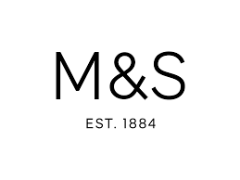

Student name: AKASHDEEP
Student Number: 2223250
Lecturer: DR HOSSEIN SHOKRI
Table of Contents
Introduction 2
Marks and Spencer’s Background 2
Marks and Spencer’s Mission and Objectives 4
Macro-Environment Analysis 4
PESTEL Analysis 4
Micro-Environment Analysis 7
Industry Life Cycle 7
Porter’s Industry Five Forces Analysis 8
Key Success Factors 10
Internal Analysis 10
Resource-Based View (RBV) 10
Marks and Spencer’s Strategic Resources and Capabilities 11
Value Chain Analysis 12
Primary Activities 12
Secondary Activities 12
VRIO Analysis of Distinctive Resources and Capabilities 13
SWOT Analysis 13
Turnaround Strategy Evaluation/Addressing the issues 14
Store Closures and Online Expansion 14
Supply Chain Reforms 15
Shift from discount culture 15
Enhancing Efficiency and Adaptability 16
Improving Customer Experience 16
Strategies to Sustain Competitive Advantage 16
Growth Strategies 19
Green Strategy and CSR 21
Conclusion 22
Recommendation 22
References 24

Introduction
An in-depth analysis of Marks & Spencer's (M&S), one of the well-known British retailers, strategic management choices has been presented in this report. The purpose of this report is to examine the major issues facing M&S as well as to evaluate how the company achieved a competitive advantage through management decisions that were made to achieve a competitive advantage. The purpose of this report is to demonstrate an understanding of strategic concepts as well as their application in the real world by using a variety of models, theories, and frameworks associated with strategic management. As a whole, this report provides a comprehensive analysis of M&S's strategic management decisions, their impact on its competitive advantage, as well as recommendations for the company to be able to sustain its growth in the dynamic retail industry in the future.

Marks and Spencer’s Background
Michael Marks and Thomas Spencer founded M&S in Leeds in 1884 as a company. With a total of 959 stores across the UK, M&S sells a variety of food and drink products, excluding 615 of which sell only food products, and through its television advertising, M&S asserts that their food and drinks are exclusive and of the highest quality. A unique feature of its business model lies in the fact that it combines clothing retail and food retail under one roof, which makes it stand out from other major high-street brands in Britain. However, including declining sales and increasing competition, M&S has had to deal with significant challenges over the last couple of years (Mark and Spencer, 2023). As a result of achieving a major milestone in 1998, M&S became the first British retailer to register a pre-tax profit exceeding $1 billion, which was a significant step forward in the company's history (Rose, 2007). In terms of the number of people working for the company by the end of the year 2021, the company will have around 78,000 employees working across all of the different businesses it operates across various parts of the globe. As a result of the increasing competition, it faces from both online and low-cost retailers in recent years, M&S has suffered a decline both in sales and profits as a consequence of both the growth in sales and the decline in profitability. In 2020, the company was able to generate £9.9 billion in revenue but suffered a loss of £87.6 million in terms of its net income (Mark and spencer, 2023).
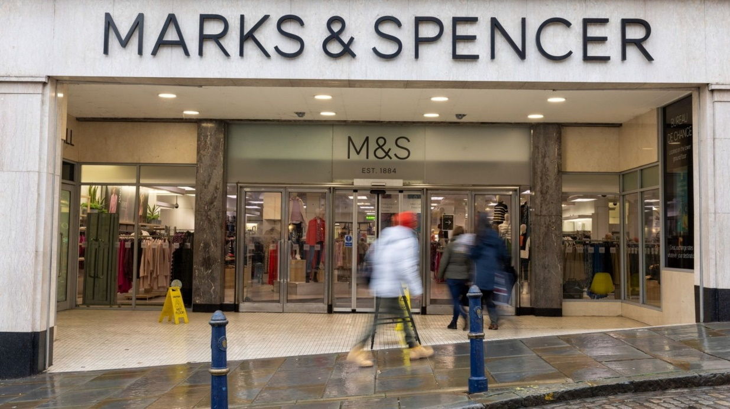
However, Over the years, there have been various turnaround plans implemented, but none have been successful in sustainably reversing the company's fortunes. Therefore, M&S has faced pressure to deal with the underlying issues that have been impacting the clothing retail segment of its business, which has been particularly vulnerable to current market pressures and competition as a result (Rose, 2007). The below provided statistic illustrated the total global revenue of Marks & Spencer from the year 2010 until the year 2023. The British retailer generated approximately 11.9 billion British pounds in revenue in the United Kingdom (UK) and internationally for the period ending April 1, 2023, making it one of the largest retailers in the world. The amount of money that was spent in this area has increased by approximately one billion pounds compared to last year.
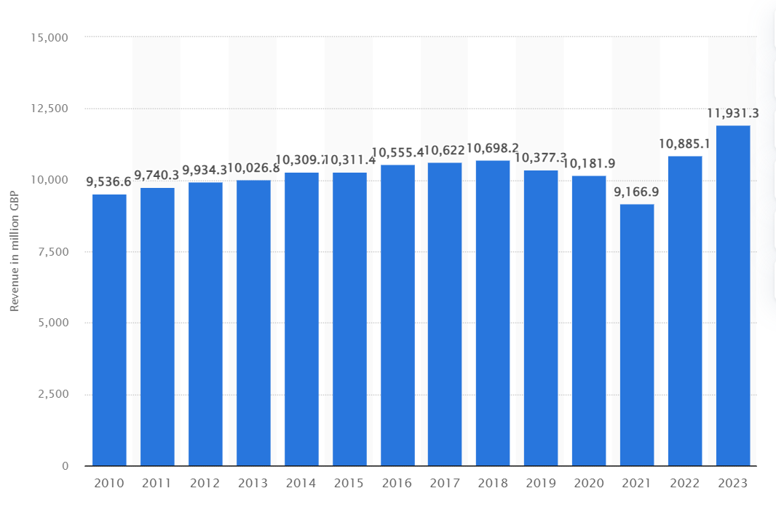

Marks and Spencer’s Mission and Objectives
The mission of Marks and Spencer is to provide everyone with access to aspirational quality. In addition to building a sustainable business, Mark and Spencer's objective is to ensure to remain accountable to shareholders and other stakeholders by providing consistent and profitable growth (Li, et al., 2023).

Macro-Environment Analysis
An organization's macro environment analysis enables it to analyze and identify potential opportunities and hazards that could impact its operations. By providing management with information before they make decisions about operations, the goal is to provide them with an advantage. The Pestle analysis is the part of macro-envrionment analysis which help Marks and Spencer’s to understand the external envrionmental factors that impact the company.

PESTEL Analysis
The PESTLE analysis provides a macro view of the industry environment. A PESTLE is an acronym that stands for Political, Economic, Social, Technological, Legal, and Environmental factors. A new business or industry can be assessed using it by a company to determine its potential impact. As part of the PESTEL analysis, Marks & Spencer examines the factors outside of its control that have an impact on the business environment in which it operates (Johnson, et al., 2020 pp(30)). Several dimensions are assessed in this study:

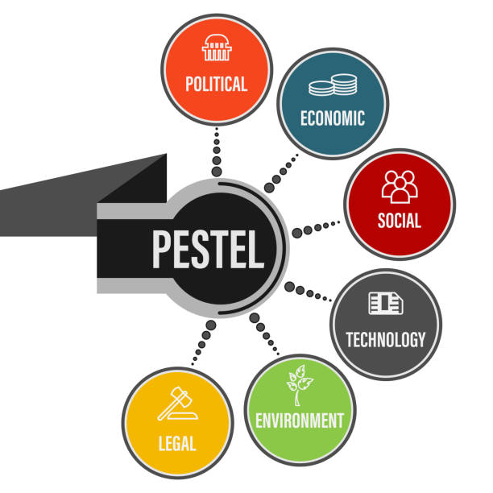
Political Factors: Government policies, regulations, and political stability can affect M&S's operations as a result of political factors. The retail industry is affected by several factors that can have a significant impact on it. For instance, M&S's supply chain, cost structure, and profitability can be affected by changes in trade policies, taxation, and labor laws, as well as changes in tax rates or labor laws. M&S can also benefit from political stability, as well as government support for the retail sector, to create a conducive business environment for them (Bush, 2019).
Economic Factors: M&S's performance is heavily influenced by economic factors, including the state of the economy. Many factors can influence consumer confidence and purchasing power, including fluctuations in the economy, GDP growth, inflation rates, exchange rates, and consumer spending patterns. In the case study, it is evident that M&S has experienced challenges with declining sales, indicating that economic factors have an influence on consumer behavior and the willingness of consumers to spend on products from M&S (Johnson, et al., 2020 pp(38)).
Social Factors: There are a number of social factors that affect the economy including demographic trends, cultural shifts, consumer preferences, and lifestyle changes. From the case study given it is also highlighted that the majority of M&S's core customers are often women over the age of 50. M&S needs to adapt its business model to keep up with the changing preferences and shopping habits of younger generations, so it can remain relevant. For M&S to remain competitive, it is essential that it understands societal changes and aligns products, marketing, and customer experiences with the changing preferences of consumers (Deloitte, 2019).
Technological Factors: The retail industry is experiencing a significant number of changes and advancements due to technological advancements and digital transformation (Wired, 2020). Many people have criticized M&S for not being able to leverage the opportunities arising from online shopping sufficiently. M&S must invest in technology if they are to meet changing customer expectations and to compete effectively in the digital era, and the case study emphasizes that M&S must improve its online platforms, enhance supply chain systems, and adopt digital innovations to meet these expectations and compete effectively (Johnson, et al., 2020 pp(39)).
Environmental Factors: There has been a significant increase in awareness and importance of environmental factors in recent years, including sustainability practices and environmental regulations. The company has been under pressure in recent months to improve its sustainability practices, such as reducing waste and carbon emissions. For M&S to maintain its reputation and meet consumer expectations, it is imperative that it adheres to environmental regulations, implements eco-friendly initiatives, and integrates sustainable practices throughout the supply chain, to meet its environmental targets.
Legal Factors: M&S's operations are impacted by several laws and regulations, such as employment laws, consumer protection regulations, intellectual property rights, and product safety requirements, which all have a direct impact on the business. To avoid legal issues, to protect consumer rights, and to maintain trust in the brand, M&S needs to ensure compliance with legal requirements (Johnson, et al., 2020 pp(45)).

Micro-Environment Analysis
An evaluation of the microenvironment is conducted using the microenvironment factors. The envirnment of Organization is made up of people and things that impact the direct operations of company. The microenvironment is the environment that directly affects a business's routine activities and affects them directly. It refers to a group of forces or factors that are close to a company and that can affect the company's performance.

Industry Life Cycle
The industry Life cycles describe how industries or businesses progress through four stages based on the characteristics. An industry's life cycle is divided into four phases: introduction, growth, maturity, and decline (Bjorkqvist, 2022).
Intrdocution Stage: In 1884, Marks & Spencer opened one stall in Leeds. At the start, the company was aiming to provide affordable high-quality products. A number of innovative practices were introduced as M&S grew, such as no-questions-asked returns and fixed prices. The reputation of the company was built on quality and customer service (Briedis, et al., 2020).
Growth Stage: The mid-20th century was a big growth period for M&S. As the company expanded its product line and invested in new store formats, it started selling food and clothing. M&S's biggest growth was in the 1950s and 1960s, after the post-war consumer boom. The company has grown because it's committed to quality, value, and customer satisfaction.
Maturity Stage: By the late 20th century, M&S had a huge market share in the UK. As well as competing with other retailers, the company also had to deal with changing consumer tastes. M&S faced challenges and underwent transformation during the 1990s. Over the years, the company had trouble adapting to changing fashion trends and was criticized for being old-fashioned (Briedis, et al., 2020).
Decline and Restructuring Stage: As sales and profitability declined during the 1990s and early 2000s, M&S underwent some restructuring. A more modern and dynamic approach to retailing challenged the company's traditional approach. M&S restructured its business as a consequence, resulting in changes in management and store closures, and revamping its product offerings (BBC, 2022).

Porter’s Industry Five Forces Analysis
Porter's Five Forces analysis identifies and analyzes five competitive forces in an industry, helping to identify its weaknesses and strengths (Barney & Hesterly, 2018). Corporate strategies are often determined by identifying an industry's structure using the Five Forces analysis.

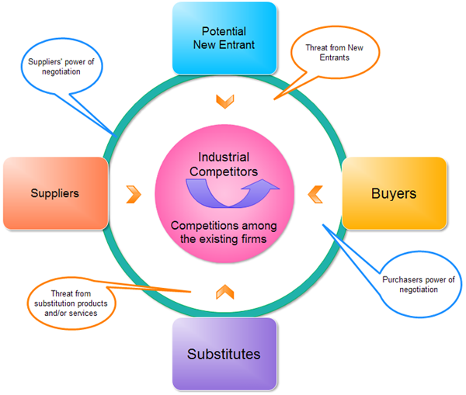
(Freeman, 2022)
Threat of New Entrants: There is a relatively low entry barrier to the retail industry, which makes it possible for new competitors to enter the industry. Brand recognition, customer loyalty, and economies of scale are some of the advantages that established brands like Marks & Spencer enjoy. For M&S to remain competitive, it must remain vigilant and continuously innovate.
Bargaining Power of Suppliers: Retail suppliers have limited bargaining power, such as clothing manufacturers and food producers. The advantages of bulk purchasing for large retailers like Marks & Spencer can be negotiated with suppliers (Johnson, et al., 2020 pp(69)). In contrast, suppliers may be able to exert some influence if there aren't enough high-quality suppliers. A good supplier relationship should be maintained by M&S, and its supplier base should be diversified to minimize any risks (Goyal, 2020).
Bargaining Power of Buyers: Since there are so many options available and it is so easy to switch brands, retail buyers have significant bargaining power. In addition to Marks & Spencer, customers have access to other high-street retailers and online retailers. To counter the bargaining power of buyers, the case study emphasizes the importance of improving customer experience and regaining customer trust. A seamless shopping experience, unique products, and exceptional service are essential to retaining and attracting customers for M&S (Johnson, et al., 2020 pp(68)).
The threat of Substitutes: It is moderately likely that substitutes will enter the retail industry. Competitor brands, budget retailers, and online marketplaces offer alternatives to Marks & Spencer's products. M&S can create unique products by keeping up with changing consumer preferences and trends (Meng, 2022). If the business is to set itself apart from rivals and provide goods and services that are hard to replicate by its competitors, then it must come up with strategies such as content marketing to set itself apart from its competitors.
Competitive Rivalry: With several established players competing for market share, the retail industry is highly competitive. Online platforms and traditional retailers compete against Marks & Spencer (Johnson, et al., 2020 pp(65)). Additionally, Primark and other fast fashion brands are mentioned as competitors in the case study. The brand needs to be differentiated, the value proposition enhanced, and the customer experience improved for M&S to remain competitive (Zhenxiang & Lijie, 2011).

Key Success Factors
One of the key success factors for Marks & Spencer is the company's strong brand reputation and heritage, which has helped build its reputation as a trustworthy and reliable retailer. Taking advantage of this brand equity is crucial for the company if it is going to attract and retain loyal customers (Hodgson, 2017). As well as that, it is of utmost importance to focus on delivering an exceptional customer experience as well as excellent customer service. For M&S to maintain the premium brand image that it portrays in its in-store experiences, it should invest in improving communications between staff members and customers, increasing staff numbers, and improving the in-store experiences.
Another important factor is the ability of the company to adapt to the market trends and consumer preferences that are constantly changing. M&S should keep up with fashion and retail trends to keep ahead of its competitors, as well as maintain high-quality standards to remain competitive. This will be achieved by constantly innovating its product offerings. Finally, M&S will have to be able to compete in the modern retail landscape by effectively managing its supply chain and by successfully seamlessly integrating online and offline channels to thrive. To achieve a competitive advantage and drive its business toward long-term success, Marks & Spencer needs to optimize these factors to achieve long-term success.

Internal Analysis
The purpose of an internal analysis is to identify failures and opportunities within an organization by evaluating all the components that interact within it. A company's strengths and weaknesses are analyzed using internal analysis (Twin, 2022).

Resource-Based View (RBV)
The resource-based view is a management framework that determines which strategic resources a company can utilize to achieve sustainable competitive advantage. The resource-based view (RBV) asserts that competitive advantages are the result of firms' valuable, rare, and inimitable resources. Competing firms are able to develop and acquire these resources based on their ability to create or acquire them.
One of Marks & Spencer's most pressing issues is the decline in clothing sales, the need to improve customer service and the in-store experience, and the challenge of transitioning to an online retail model. As a result of performing an RBV analysis, the company can identify the key resources and capabilities it has that can be utilized to resolve these issues ( Indian Retailer Bureau, 2022). M&S, for example, can leverage the strong brand reputation and heritage that it has built up over the years to attract customers back to the clothing section of the store. Furthermore, these organizations can optimize their physical assets, supply chain infrastructure, and technology to improve the efficiency of their operations and meet the changing demands of customers. M&S can develop a competitive advantage and drive growth by identifying the rarity and non-substitutability of these resources, thereby being able to identify opportunities to create a competitive advantage and drive growth (Murthy, et al., 2021).

Marks and Spencer’s Strategic Resources and Capabilities
M&S faces several important challenges that require the company to establish core competencies and distinguishing capabilities that will enable it to meet those challenges and differentiate itself from other companies in the market. To remain competitive, we will need to enhance our core competencies such as product design, supply chain management, and customer relationship management (Twin, 2022). With its expertise in these areas, M&S is in a position to enhance its product offering, deliver trendy and high-quality clothing, and increase customer satisfaction in a manner that is both profitable and environmentally responsible. It makes sense that M&S should focus on developing distinctive capabilities, such as customer service that is tailored to each customer, and online shopping that is effective so that the company can stand out from its competitors and address its core problems (Lynch, 2018).
Marks & Spencer can identify its strengths and weaknesses through a comprehensive internal analysis, which aligns its resources and capabilities to address the central issues. Ultimately, M&S can achieve sustainable growth and competitive advantage if it leverages its resources effectively, optimizes value chain activities, and focuses on its core competencies and distinctive capabilities, thereby addressing declining clothing sales, enhancing customer service, and successfully transitioning to online retail.

Value Chain Analysis
Value Chain Analysis provides competitive advantage for companies of all sizes by increasing profit margins and optimizing value chains. A particular production or sales activity is assessed to determine areas that can be improved to increase their value.

Primary Activities
The primary function of operations is to source, receive, and warehouse raw materials and components for use in manufacturing. Buying fresh ingredients for food products or coordinating the transportation and storage of textiles for clothing could be part of this task for M&S. The central issues that Marks & Spencer faces need to be addressed by analysing its value chain and identifying the areas in which the company can enhance its value and improve its performance to solve them (Treece, 2023). To achieve this, inbound logistics must be streamlined to be able to source and procure clothing products efficiently. To deliver high-quality and fashionable clothing, it is very important to optimize operations by focusing on how products are designed and how they are made

Secondary Activities
The secondary activities include production, raw materials, components, and other resources are necessary to be sourced and acquired. It is composed of technical systems, equipment, and physical infrastructure that make up a value chain. Among the responsibilities are managing e-commerce platforms, store POS systems, and logistics management systems at M&S. To provide our customers with a seamless experience, outbound logistics, such as distribution and delivery, need to be enhanced. Furthermore, the importance of improving customer service as well as investing in marketing and sales strategies will also play a key role in attracting and retaining customers. A value chain analysis is a method that can be used by M&S to identify areas that need to be improved and develop measures aimed at addressing the central issues (CHARLTON, 2023).

VRIO Analysis of Distinctive Resources and Capabilities
VRIO analysis determines whether a company has a sustainable competitive advantage based on its capabilities and resources (Doyle & Stern, 2006). In VRIO, value consists of rarity, imitable characteristics, and organisation.
Value: The strong reputation of M&S and high levels of customer loyalty allow the company to attract and retain loyal customers who value quality and reliability in the brand.
Rarity: Having a longstanding and respected brand reputation is a relatively rare attribute.
Imitability: Other companies may be able to develop their brands, but it will be difficult for them to compare to M&S's reputation and loyalty over the years.
Organization: M&S has successfully managed and leveraged its brand reputation through its corporate operations and marketing (Treece, 2023).

SWOT Analysis
SWOT analyses are commonly conducted for strategic planning or project management to analyze someone's strengths, weaknesses, opportunities, and threats.
Strenghts: The reputation of quality and reliability of M&S has given the company a longstanding legacy and strong brand recognition. It caters to a broad customer base by offering a wide range of products. An extensive store network makes it convenient for customers to shop. In response to growing consumer demand for ethical products, M&S launched "Plan A," one of its sustainability initiatives. In addition, the company's customers are loyal and the staff is dedicated (Wood, 2013).
Weakneses: Due to M&S's inability to adapt quickly to changing consumer preferences, sales have declined during some periods. There is a possibility that some consumers will perceive its traditional image as outdated (Rose, 2007).
Opportunities: To cater to environmentally-conscious consumers, M&S can leverage the growing focus on sustainability and align it with its existing initiatives. Having a bigger presence in e-commerce is possible because of the growth of online retail. M&S has a strong brand, so it can introduce new, stylish clothes (Twin, 2022). Opportunities exist for growth in emerging markets, particularly through further international expansion.
Threats: Market share at M&S is at risk due to intense competition in the retail sector. A global e-commerce giant as well as a fast fashion retailer are shaping consumer expectations. Consumer discretionary spending might be affected by economic downturns (Rose, 2007). The brand image of M&S could be negatively affected by traditional retail practices.

Turnaround Strategy Evaluation/Addressing the issues

Store Closures and Online Expansion
It was through the combination of a store closure plan and the expansion of the company's online presence that Marks & Spencer was able to turn around its business. Despite the decline in clothing sales, the rationale for store closures was to focus on more profitable locations and to try to slim down the business to focus on more profitable locations (BBC, 2022). It is intended that by reducing the number of stores, the company will be able to improve the value of each of them and invest more in the best-performing ones. It is also important to note that Marks & Spencer had been criticized for failing to capitalize on the growing trend of online shopping which is also aligned with this strategy. The closure of stores had several positive implications, including cost savings, increased operational efficiency, and the opportunity for resources to be redirected to online channels.

Supply Chain Reforms
For Marks & Spencer to meet the expectations of today's retail landscape, it identified the need to modernize its supply chain to prepare for the future (Dekhne, et al., 2020). According to the company, it was lagging behind competitors when it came to cost-effectiveness and adaptability. Through the implementation of supply chain reforms, M&S aimed at becoming more nimble, responsive, and flexible to the changing demands of the market. This included integrating with suppliers more closely, improving distribution and warehousing processes, as well as reducing lead times as a result. To accomplish this, it is necessary to enhance efficiency, increase inventory management, and reduce the costs associated with the supply chain. Marks & Spencer has announced that they are planning to build a new automated logistics center that will handle the delivery of clothing and homewares to 150 stores situated in the South East of the UK (Marks and Spencer, 2022). With this investment, the company has been able to update its infrastructure and improve its ability to meet the demands of the modern retail environment, which is why it invested. In addition to replacing outdated facilities, the new center will facilitate quicker replenishment of stores, allowing for more frequent changes to product lines and a more responsive response to customer demands (Lynch, 2018).

Shift from discount culture
By reducing its reliance on discounts and promotions, Marks & Spencer was able to restore its reputation as a high-quality retailer and restore its brand image as a high-end retailer. To attract customers who are seeking a premium shopping experience, the company focused on offering quality products at competitive prices, while offering value for money and maintaining a competitive pricing structure without excessive discounts. It was necessary to change the mindset of the organization and focus on delivering products that did not only meet customer expectations in terms of quality, style, and price but also exceeded them in terms of quality (Ritson, 2017).

Enhancing Efficiency and Adaptability
For Marks & Spencer to achieve a competitive advantage, its supply chain needed to be as efficient and adaptable as possible to achieve this objective. As part of this, the company had to integrate with suppliers more closely, take control of factories, and optimize the flow of goods from factory to customer. By reducing the company's reliance on third-party suppliers and improving its internal decision-making processes, it was able to respond sooner to market trends, reduce costs, and deliver products in an efficient and timely manner by reducing its reliance on third-party suppliers (Lynch, 2018).

Improving Customer Experience
Marks & Spencer has identified the need for improving the customer experience in-store and online as a priority. Several actions were taken to achieve this, such as increasing the number of staff to provide better customer service, providing handheld devices for better customer service, and making sure that customer service matched the premium brand image of the brand. Marks & Spencer's goal was to regain customer trust and loyalty by investing in customer service training, technology, and personalized service (Bjorkqvist, 2022). As a result of this strategy, the company was able to deliver a positive and satisfying shopping experience that would enable it to distinguish itself from its competitors in the online retail space.

Strategies to Sustain Competitive Advantage
The following strategies must be implemented by Mark and Spencer to achieve competitive advantage:
- Differentiation Strategy: To set itself apart from its competitors and gain a competitive advantage, Marks & Spencer pursued a differentiation strategy to set itself apart from its rivals. As a result, the company focused on differentiating itself as a brand and focused on developing its product portfolio (Marks and Spencer, 2022).
- High-Quality Products and Premium Brand Image: It was always the goal of Marks & Spencer to offer its customers high-quality products at competitive prices. Aiming to attract the type of consumers who value durability, style, and the quality of their clothing and homewares, the manufacturer sets high-quality standards and produces well-crafted clothing and homeware items. In this way, Marks & Spencer was able to establish a reputation within the market for itself as a brand that is reliable and trusted. As well as cultivating a premium brand image, the company has also worked on creating a positive image of the company. Achieving this perception of exclusivity and sophistication is what Marks & Spencer aimed to achieve through effective marketing and consistent messaging. In this branding strategy, the company sought to appeal to a clientele that was looking for a premium shopping experience as well as a clientele that was willing to pay a slightly higher price for quality products (Hodgson, 2022).
- Simplifying Product Offering: As a result, Marks & Spencer recognized that to improve its competitive advantage, it needed to simplify the products it offers. After analyzing the potential for confusion and diluting the brand identity of the company, the company realized it was risky to have a wide range of brands and products available. Therefore, Marks & Spencer made an effort to streamline its product range and reduce the number of brands it offered as a result of this. Marks & Spencer could focus on its brand image by simplifying its product offering, resulting in a more cohesive and distinctive image for its brand. By adopting this strategy, the company was able to better understand the needs of its target audience and tailor its products accordingly. As a result, decision-makers were able to make decisions more quickly and adapt more quickly to changing market trends as a result of this technology (Lynch, 2018).
- Omnichannel Approach: Marks & Spencer has taken a step to enhance the overall customer experience across both its online and physical stores as part of its omnichannel approach, aiming to create a competitive advantage by integrating both channels (Briedis, et al., 2020).
- Leveraging Online and Physical Stores: The company recognized the importance of e-commerce and invested in its online platforms and capabilities to take advantage of the growing market. By providing the convenience of online shopping, the company aimed to offer its customers the possibility of browsing and purchasing products from the comfort of their own homes, providing them with an opportunity to save time and money. To attract and retain its online customers, Marks & Spencer developed user-friendly websites as well as mobile applications to attract and maintain its online presence (Barney & Hesterly, 2018). As well as this, Marks & Spencer understood the significance of its physical stores as an important touchpoint for engagement with its customers and a means of conveying a sense of brand identity to them. As part of the company's strategic plan, the company focused on creating an in-store environment that was inviting and immersive as well as aligned with the company's premium image. Providing personalized assistance to the customer, optimizing customer service through the use of technology, and providing exclusive in-store promotional events and competitions, enhanced the physical shopping experience (Lynch, 2018).
- Enhancing In-Store Technology and Experience: With the advent of technology, Marks & Spencer has been able to enhance the in-store shopping experience by using it effectively. It invested in the latest technologies, including Wi-Fi networks in its stores, handheld devices for employees, and cloud-based software solutions for updating the company's systems. With these technological advancements, operational efficiency is being improved, seamless customer experiences are being facilitated, and recommendations and support are being provided in a more personalized manner (locatium, 2022).
Overall, as a result of leveraging the power of technology, Marks & Spencer set out to create an integrated experience between its online and offline channels. If a customer browses products online but chooses to purchase in the store, for example, or vice versa, that option could be available. Essentially, this omnichannel approach was designed to offer customers a consistent and convenient shopping experience across all touchpoints, thereby enhancing customer satisfaction and loyalty across all touchpoints, which was the goal.

Growth Strategies
As part of the implementation of a differentiation strategy, several factors need to be considered for the strategy to be successful.
- Clear Value Proposition: A differentiated product or service needs to be clearly defined and communicated in terms of the unique value proposition it offers. Identify the specific features, attributes, or benefits that set the product apart from the competition and elicit a positive response from target customers.
- Market Research: The organization needs to Identify the customer's preferences, needs, and desires by conducting thorough market research. The differentiated offering is most likely to be appreciated and valued by specific segments or niches of the market. Customize the strategy based on their specific needs to meet their goals (HEC, 2019).
- Product Innovation: Continually invest in R&D to keep up with the latest technological advancements to make the product or service more differentiated. To stay ahead of the competition, you should introduce new features, technologies, or designs that enhance the customer experience and meet customer needs as they change (HEC, 2019).
- Branding and Positioning: Mark and Spencer need to make sure that brand identity is aligned with the differentiated strategy to create a strong brand identity. Create a compelling brand story that captures the attention of customers and reinforces the value proposition that makes the brand unique. Communicate the differentiation to customers consistently through marketing and advertising efforts (Agarwal, 2023).
- Customer Experience: The organization needs to be focused on providing exceptional customer experiences aligned with its differentiating positioning to differentiate itself from its competitors. Enhance the distinctive value proposition of your business by personalizing interactions, offering outstanding customer service, and creating memorable touchpoints (Barney & Hesterly, 2018).
- Quality and Consistency: Marks & Spencer needs to make sure that high-quality standards are maintained, in addition to ensuring consistency in the delivery of differentiated offerings. The product or service must consistently meet or exceed the expectations of the customer, to build trust with them. As a result of consistency, a brand is perceived as unique and builds loyalty toward it.
- Supply Chain Management: The organization also needs to implement a supply chain management system that is efficient and effective so that the differentiation strategy can be supported. It is essential to establish close working relationships with suppliers to ensure that high-quality materials or components are used to provide unique product attributes. The goal is to maintain cost-effectiveness while maintaining differentiation by streamlining processes (Agarwal, 2023).
- Competitive Analysis: Marks & Spencer should also analyze and continuously monitor the competitive landscape to stay ahead of the competition. To protect and strengthen the unique positioning of the company, it is necessary to understand how competitors may attempt to imitate or duplicate the differentiation strategy (Barney & Hesterly, 2018).
- Employee Engagement: The differentiation strategy should be embraced by all employees by engaging them and empowering them. Marks & Spencer needs to make sure that they are trained and supported to ensure that they understand the unique value proposition of the organization and are prepared to deliver on it. Make sure that internal processes and culture are aligned with the differentiation focus within the organization (Agarwal, 2023).
- Continuous Improvement: It is important to periodically assess and refine the differentiation strategy in response to feedback from the customer, market changes, and emerging trends. To maintain competitive advantage, the differentiation offering needs to be enhanced and evolved continuously to maintain a competitive advantage (Barney & Hesterly, 2018).
Overall, if Marks & Spencer takes into consideration these factors, it will be able to effectively implement a differentiation strategy in a way that will create a sustainable competitive advantage for them.

Green Strategy and CSR
Corporate social responsibility (CSR) at M&S includes taking care of the environment and social challenges. A variety of initiatives have been taken to promote sustainability and responsible business practices.
Among Marks and Spencer's ambitious plans for Plan A is to tackle 100 social and environmental commitments by 2020. It aims to reduce its environmental footprint and promote ethics at the workplace as part of the plan. The Raw Materials department at M&S ensures sustainable sourcing of raw materials. It is essential for minimizing environmental and social impacts that products are produced so as to minimize their negative impact on the environment and society.
It has increased energy efficiency in distribution centers and stores to reduce waste generation and increase recycling. Renewable energy use has also gone up. M&S promotes recycling and sets targets to reduce waste going to landfills. Innovation and continuous improvement have been key components of M&S' sustainability efforts. In order to improve its environmental and social performance, the company explores new technologies, materials, and practices.

Conclusion
I would like to conclude the strategic analysis of Marks & Spencer (M&S) with a discussion of some of the challenges it faces as well as the opportunities it faces in the retail industry. In conclusion, M&S has taken steps to address the central issues and achieve competitive advantage through the evaluation of its external environment, internal resources, and strategic decisions based on an in-depth evaluation of its external environment, internal resources, and strategic choices. M&S has implemented several initiatives to adapt to changing market conditions including store closures and the expansion of their online business, supply chain reforms, changes to their sales strategy, development of differentiation strategies, as well as the acquisition of omnichannel strategies. Even though these strategic choices have both strengths and weaknesses, we would recommend investing even more money into online capabilities, continuously updating the supply chain, refining the product offering, and prioritizing the use of technology to enhance the in-store experience to maximize the company's future success. To achieve long-term success in the retail market, M&S will have to effectively implement these recommendations to position themselves for continued sustainable growth, enhanced customer satisfaction, and long-term success.

Recommendation
Taking into account the findings of the analysis conducted in this report, Marks & Spencer (M&S) is recommended to take the following steps to maximize its chances of success in the future. To begin with, M&S should continue to invest in online capabilities that will allow it to capitalize on the growing trend of e-commerce by strengthening its online capabilities. Several things need to be addressed as part of this process, such as improving the user experience, improving website functionality, and optimizing digital marketing strategies. Furthermore, the company should place a high priority on the modernization of its supply chain, leveraging technology to ensure a more efficient and adaptable supply chain. To succeed in this endeavor, the organization will need to integrate with suppliers, adopt agile manufacturing processes, and implement advanced inventory management systems. To reinforce the premium brand image of M&S, the retailer's product offering needs to be refined by simplifying and concentrating on quality to enhance its product offerings. As part of this process, brands will be carefully selected, fragmentation will be reduced, and product portfolios will be aligned with the preferences of customers. To achieve long-term success in the retail industry, M&S must implement these recommendations, and it will be positioned for sustained growth, improved customer satisfaction, and long-term success.

References
Indian Retailer Bureau, 2022. How is Marks & Spencer Reliance India Scaling its Omnichannel Capabilities? [Online]
Available at: https://www.indianretailer.com/article/technology/digital-trends/how-is-marks-spencer-reliance-india-scaling-its-omnichannel-capabilities.a7830
[Accessed 10 March 2022].
Agarwal, M., 2023. Creating a strong brand identity and messaging strategy for startups. [Online]
Available at: https://www.linkedin.com/pulse/creating-strong-brand-identity-messaging-strategy-startups-agarwal/
[Accessed 20 FEB 2023].
Barney, J. & Hesterly, W., 2018. Strategic Management and Competitive Advantage: Concepts and Cases, Global Edition. In: s.l.:Pearson.
BBC, 2022. Marks & Spencer speed up store closure plans. [Online]
Available at: https://www.bbc.com/news/business-63224269
Bjorkqvist, N., 2022. How Contentsquare is helping M&S put the customer at the heart of the site experience. [Online]
Available at: https://contentsquare.com/blog/marks-and-spencer-and-contentsquare/
[Accessed 17 AUG 2022].
Briedis, H., Kronschnabl, A. & Alex Rodriguez, 2020. Adapting to the next normal in retail: The customer experience imperative. [Online]
Available at: https://www.mckinsey.com/industries/retail/our-insights/adapting-to-the-next-normal-in-retail-the-customer-experience-imperative
[Accessed 14 MAY 2020].
Bush, T., 2019. Marks and Spencer PESTLE Analysis. [Online]
Available at: https://pestleanalysis.com/marks-and-spencer-pestle-analysis/
[Accessed 14 Oct 2019].
CHARLTON, G., 2023. The Importance of Customer Service for Loyalty and Retention. [Online]
Available at: https://www.salecycle.com/blog/strategies/the-importance-of-customer-service-for-loyalty-and-retention/
[Accessed 8 Feb 2023].
Dekhne, M. A., Fleischer, W. & Graf, C., 2020. The supply chain of the future: Key principles in building an omnichannel distribution network. [Online]
Available at: https://www.mckinsey.com/industries/retail/our-insights/supply-chain-of-the-future-key-principles-in-building-an-omnichannel-distribution-network
[Accessed 15 JAN 2020].
Deloitte, 2019. Shifting sands: How consumer behaviour is embracing sustainability. [Online]
Available at: https://www2.deloitte.com/ch/en/pages/consumer-business/articles/shifting-sands-sustainable-consumer.html
[Accessed 19 April 2023].
Freeman, J., 2022. Porter's Five Forces Model Templates. [Online]
Available at: https://www.edrawsoft.com/five-forces-model.html
Goyal, A., 2020. A Critical Analysis of Porter's 5 Forces Model of Competitive Advantage. Journal of Jetir, 7(7).
HEC, 2019. WHAT ARE THE KEY SUCCESS FACTORS FOR EFFECTIVE STRATEGY IMPLEMENTATION? [Online]
Available at: https://www.hec.edu/en/news-room/what-are-key-success-factors-effective-strategy-implementation
[Accessed 1 June 2010].
Hodgson, S., 2017. It’s not just branding, it’s Marks & Spencer branding. [Online]
Available at: https://medium.com/@Stewart_Fabrik/its-not-just-branding-it-s-marks-spencer-branding-bcd3df9988cc
[Accessed 18 Dec 2017].
Hodgson, S., 2022. Quintessentially British brands: It’s not just branding, it’s Marks & Spencer branding. [Online]
Available at: https://fabrikbrands.com/marks-and-spencer-branding/
Li, L., Zhang, Y. & Wang, Y., 2023. A critical examination of M&S's current strategic and marketing position, as well as potential sustainable competitive marketing strategies. Research gate, pp. 1-11.
location, 2022. HOW TO ENHANCE CUSTOMER EXPERIENCE WITH TECHNOLOGY IN RETAIL? [Online]
Available at: https://locatium.ai/customer-experience-retail/#:~:text=Optimizing%20retail%20client%20experience%20with%20technology&text=Simple%20foot%20fall%20analysis%20can,based%20on%20online%20purchasing%20history.
[Accessed 19 May 2022].
Lynch, R., 2018. Strategic Management ePub. In: s.l.:Pearson, pp. 1-704.
Mark and Spencer, 2023. Everything to celebrate. [Online]
Available at: https://www.marksandspencer.com
[Accessed 19 April 2023].
Marks and Spencer, 2022. GROWING M&S.COM: M&S TO PERMANENTLY INCREASE ONLINE CAPACITY BY BUILDING A NEW AUTOMATED ONLINE WAREHOUSE WITHIN ITS BRADFORD DISTRIBUTION CENTRE. [Online]
Available at: https://corporate.marksandspencer.com/media/press-releases/growing-mscom-ms-permanently-increase-online-capacity-building-new-automate
Marks and Spencer, 2022. Marks and Spencer (M&S) Marketing Mix (4Ps). [Online]
Available at: https://thestrategystory.com/blog/marks-and-spencer-ms-marketing-mix-4ps/#:~:text=Value-based%20pricing%3A%20Given%20Marks,durability%2C%20and%20innovation%20they%20offer
Meng, K., 2022. Rationales behind Marks & Spencer’s failure in the Chinese market, an important lesson to foreign firms. BCP Business & Management, Volume 31, pp. 1-6.
Murthy, S. R., Barry, M. & Ellis, J. E., 2021. 21 Marks & Spencer: Improving Supply-Chain Sustainability. [Online]
Available at: https://academic.oup.com/book/39548/chapter/339410663
[Accessed 2021].
Ritson, M., 2017. Mark Ritson: This is not just a decline, this is an M&S decline. [Online]
Available at: https://www.marketingweek.com/mark-ritson-ms-decline/
[Accessed 12 JULY 2017].
Rose, S., 2007. Back in Fashion: How We’re Reviving a British Icon. [Online]
Available at: https://hbr.org/2007/05/back-in-fashion-how-were-reviving-a-british-icon
Smith, P., 2023. Revenue of Marks & Spencer worldwide from the financial year 2010 to 2023. [Online]
Available at: https://www.statista.com/statistics/413349/group-revenue-marks-and-spencer-mands/
[Accessed 22 June 2023].
Treece, D., 2023. What Is Value Chain Analysis? [Online]
[Accessed 11 Feb 2023].
Twin, A., 2022. Core Competencies in Business: Finding a Competitive Advantage. [Online]
Available at: https://www.investopedia.com/terms/c/core_competencies.asp
[Accessed 9 Sep 2022].
Wired, 2020. The Evolution of the Internet and Its Impact on Retail Spaces. [Online]
Available at: https://www.wired.com/insights/2014/07/evolution-internet-impact-retail-spaces/
[Accessed 19 April 2023].
Zhenxiang, W. & Lijie, Z., 2011. Case Study of Online Retailing Fast Fashion Industry. International Journal of e-Education, e-Business, e-Management and e-Learning, 1(3), pp. 1-6.

