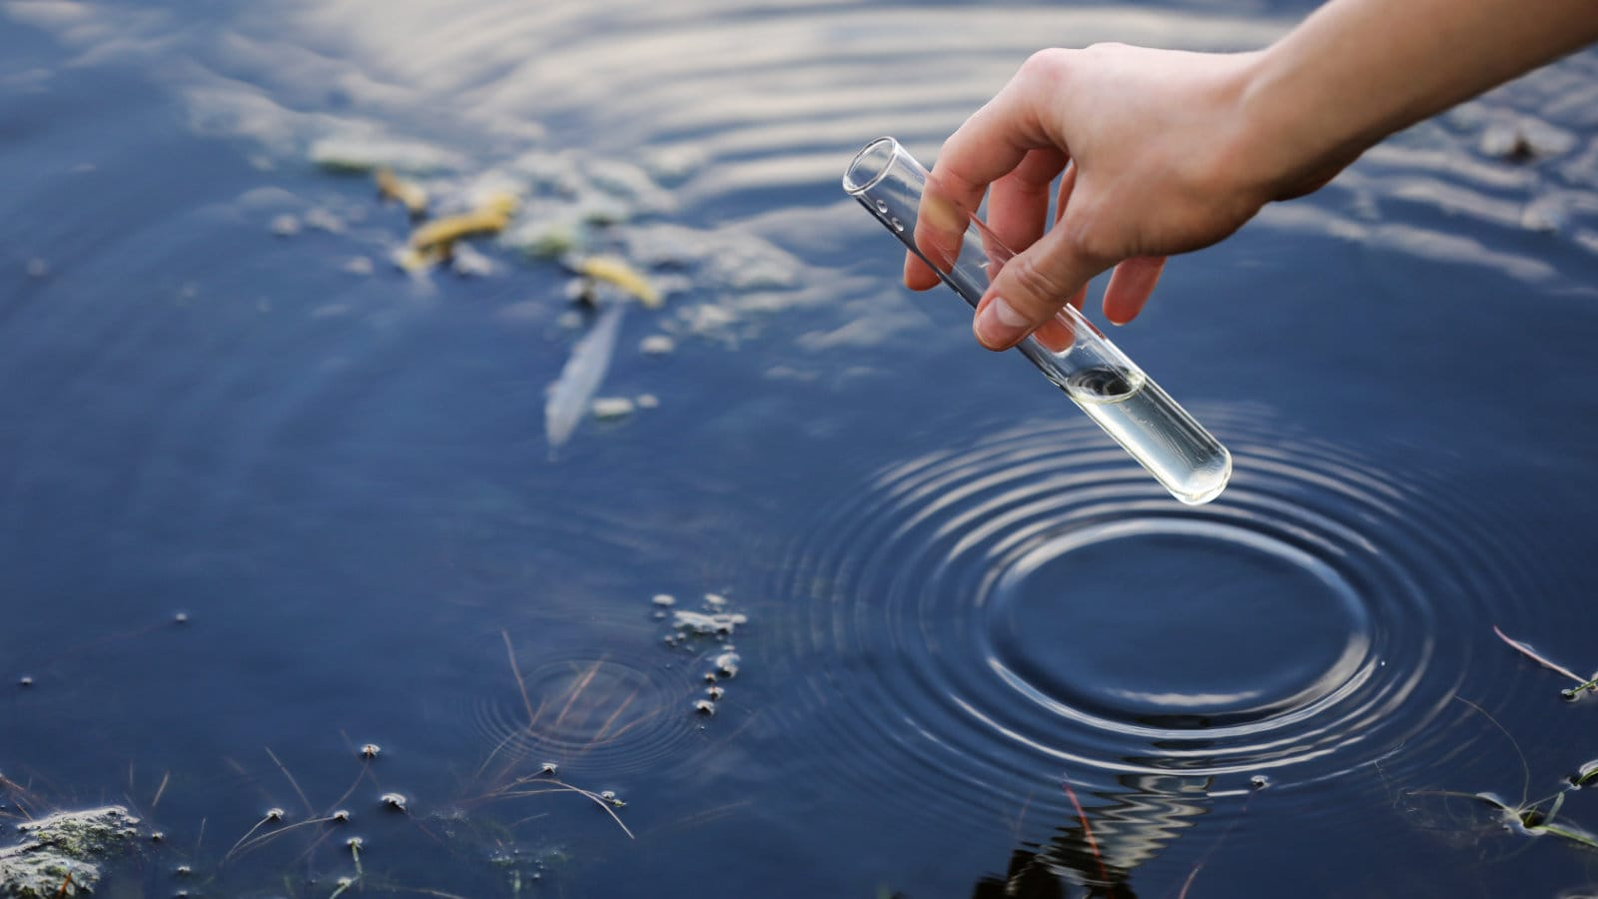  Water resource and quality monitoring  Water Resource and Environmental Monitoring (ACNB5004) | 13 May 2026  Francis Barcelo  2401983@student.uwtsd.ac.uk

Table of Contents
1 Question 1- Current Issue of Sewage Discharge in the United Kingdom 2
1.1 Introduction 2
1.2 Background and Causes 2
1.3 Environmental and Social Impacts 3
1.4 Possible Solutions 4
1.5 Conclusion 4
2 Question 2 5
2.1 Solution 6
3 Question 3 9
3.1 Introduction 9
3.2 Africa: Nile River Basin 10
3.3 Europe: Danube River 11
3.4 Asia: Mekong River 11
3.5 North America: Colorado River 12
3.6 South America: Parana River 13
3.7 Oceania: Murray-Darling Basin 13
3.8 Solution and Sustainable Water Use 14
3.9 Conclusion 14
4 Question 4 15
4.1 Solution 15
5 Reference 18

Question 1- Current Issue of Sewage Discharge in the United Kingdom

Introduction
Water is essential for all life on Earth. However, in recent years the discharge of untreated wastewater into bodies of water in the UK has increasingly been a significant issue. Wastewater is commonly discharge through storm overflow systems, which are designed to release excess wastewater during periods of heavy rainfall to prevent flooding and the backflow of raw sewage into residential areas. As the population continues to grow, the demand placed on wastewater companies and their systems combined with an increase in rainfall has made discharge occur more regularly. This has raised concerns about the effects it has on the environment and the potential risk it has to public health. In response there is more awareness from the public and the Government to find a viable solution to the problem.

Background and Causes
Most of the Uk’s Sewage system are outdated with most systems dating back to the Victorian era (over 100-150 years old) a time of rapid urbanisation and health concerns over diseases. Most systems are still being used in major cities in the UK today and most follows the principle of Joseph Bazalgette design for London’s sewage system that was designed for a population of 4 million. With an increase in the UK’s population there has been a drastic increase in pressure on these systems (ICE, 2026).
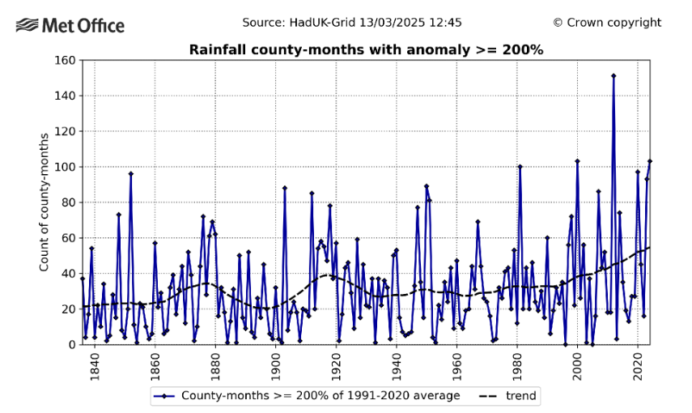
Figure 1: Graph showing trend of rainfall throughout the past years, (Met Office, (2025)
Figure 1 shows an increase in trend of rainfall from 2000’s to today. It is expected that the UK’s climate will continue to follow this trend (Met Office, 2025). With issues surrounding climate change it has made a significant impact on the amount of sewage being released during storm overflows in water bodies.

Environmental and Social Impacts
The discharge of untreated sewage to bodies of water can have a negative impact both on the environment and to the public’s health. Sewage can contain various range of pollutants ranging from faecal pathogens, industrial chemicals to microplastics and heavy metals. These pollutants stem from water treatment centres and rainfall runoff from buildings, pavements and roads. When they are released into bodies of water, they have a cause a serious risk to public health and damages the environments. Bacteria from sewage can consume the organic matter and dissolves the oxygen killing off organisms such as fish (The River Trust, 2026).
Excess Nutrients such as nitrogen and phosphorus in sewage can cause algae blooms which furthers reduces oxygen and sunlight exposures in the water. Solid waste such as non-biodegradable wet wipes can kill animals when digested (BBC, 2025). There has now been record broken where new data has shown that Welsh Water has recorded the highest number of sewage pollution incidents in 10 years (Buckland, C 2025). And it has been reported that Thames Water data reveals that discharge of raw sewage in rivers has increased by 50% in 2024 (Laville. S 2025).

Possible Solutions
Various independent organisations such as The Rivers Trust have committed by raising awareness and helped contribute on creating new legislations. New legislations such as the water act 2025 and the Environment Act 2021 has put more pressure on Water companies to comply and reduce the amount of raw sewage being discharged (The Rivers Trust, 2026).
Many of the legislation being published are still new, where there is yet to have an improvement on companies’ discharges. But with more awareness and a continuous pressure on both the government and water companies to respond, can help solve the problem.
Other solutions include the use of sewage sludge to produce gas and electricity, SuDS applications on roads can help improve water quality through infiltration. With continued steps being taken there would be an improvement in the quality of water around the country (Clisham. P 2025).

Conclusion
To conclude, the discharge of sewage on water bodies in the UK remains a significant and ongoing environmental issue. It’s impact on the environment and public health highlight the seriousness of the problem and the need for effective action. Factors such as an increase in rainfall, increasing population and an ageing infrastructure have contributed to the frequency of discharge events. Solution such as stronger regulation and long-term investments from water companies will have a positive impact on how sewage is being managed. Continued efforts from the Government, water companies, and various organisations are essential in helping improve water quality and ensure a sustainable management of wastewater in the future.

Question 2
Calculate the total solute concentration per Km² in a catchment 321 Km² large. And briefly explain the significance of this exercise for the management of water quality in a given catchment.
Table 1.- Nitrate-N concentration and discharge of a stream in a 24-hour period
Time (s) | Discharge m³ s⁻¹ | Nitrate – N mg L⁻¹
18:00 | 2.18 | 3.22
19:00 | 2.15 | 3.31
20:00 | 2.1 | 3.34
21:00 | 2.18 | 3.39
22:00 | 2.35 | 3.36
23:00 | 2.29 | 3.39
00:00 | 2.29 | 3.39
01:00 | 2.35 | 3.4
02:00 | 2.38 | 3.36
03:00 | 2.55 | 3.37
04:00 | 2.55 | 3.4
05:00 | 2.61 | 3.42
06:00 | 2.61 | 3.45
07:00 | 2.69 | 3.45
08:00 | 2.8 | 3.48
09:00 | 2.97 | 3.4
10:00 | 3.14 | 3.45
11:00 | 3.37 | 3.47
12:00 | 3.6 | 3.4
13:00 | 3.09 | 3.46
14:00 | 2.61 | 3.47
15:00 | 2.1 | 3.45
16:00 | 1.95 | 3.5
17:00 | 2.01 | 3.6

Solution
Load = Q x C
Q | Discharge in m³/s
C | Concentration (mg/L)

Conversion
Load = Q (m³/s) x C (mg/L) x 1000
To convert m³ into L
Load = Q (m³/s) x C (mg/L) x 3600
To convert remove seconds
Hence:
Load= Q (m³/s) x C (mg/L) x 1000 x 3600
Load= Q x C mg/s
Final Equation
Load per hour (mg) = Q x C x 3.6x10⁶

18:00 | 2.18 | 3.22 | 2.18 x 3.22 x 3.6x10⁶ =  25.27 x10⁶
19:00 | 2.15 | 3.31 | 2.15 x 3.31 x 3.6 x10⁶ =  25.62 x10⁶
20:00 | 2.1 | 3.34 | 2.1 x 3.34 x 3.6 x10⁶ =  25.25 x10⁶
21:00 | 2.18 | 3.39 | 2.18 x 3.39 x 3.6 x10⁶ =  26.60 x10⁶
22:00 | 2.35 | 3.36 | 2.35 x 3.36 x 3.6 x10⁶ =  30.46 x10⁶
23:00 | 2.29 | 3.39 | 2.29 x 3.39 x 3.6 x10⁶ =  27.95 x10⁶
00:00 | 2.29 | 3.39 | 2.29 x 3.39 x 3.6 x10⁶ =  27.95 x10⁶
01:00 | 2.35 | 3.4 | 2.35 x 3.4 x 3.6 x10⁶ =  28.76 x10⁶
02:00 | 2.38 | 3.36 | 2.38 x 3.36 x 3.6 x10⁶ =  28.79 x10⁶
03:00 | 2.55 | 3.37 | 2.55 x 3.37 x 3.6 x10⁶ =  30.94 x10⁶
04:00 | 2.55 | 3.4 | 2.55 x 3.4 x 3.6 x10⁶ =  31.21 x10⁶
05:00 | 2.61 | 3.42 | 2.61 x 3.42 x 3.6 x10⁶ =  32.13 x10⁶
06:00 | 2.61 | 3.45 | 2.61 x 3.45 x 3.6 x10⁶ =  32.42 x10⁶
07:00 | 2.69 | 3.45 | 2.69 x 3.45 x 3.6 x10⁶ =  33.41 x10⁶
08:00 | 2.8 | 3.48 | 2.8 x 3.48 x 3.6 x10⁶ =  35.08 x10⁶
09:00 | 2.97 | 3.4 | 2.97 x 3.4 x 3.6 x10⁶ =  36.35 x10⁶
10:00 | 3.14 | 3.45 | 3.14 x 3.45 x 3.6 x10⁶ =  40.00 x10⁶
11:00 | 3.37 | 3.47 | 3.37 x 3.47 x 3.6 x10⁶ =  42.10 x10⁶
12:00 | 3.6 | 3.4 | 3.6 x 3.4 x 3.6 x10⁶ =  44.06 x10⁶
13:00 | 3.09 | 3.46 | 3.09 x 3.46 x 3.6 x10⁶ =  38.49 x10⁶
14:00 | 2.61 | 3.47 | 2.61 x 3.47 x 3.6 x10⁶ =  32.60 x10⁶
15:00 | 2.1 | 3.45 | 2.1 x 3.45 x 3.6 x10⁶ =  26.08 x10⁶
16:00 | 1.95 | 3.5 | 1.95 x 3.5 x 3.6 x10⁶ =  24.57 x10⁶
17:00 | 2.01 | 3.6 | 2.01 x 3.6 x 3.6 x x10⁶ =  26.05 x10⁶
Total |  |  | 752.14 x10⁶ mg

Total: 752.14 x10⁶ mg
Convert mg into Kg = 752.14 x10⁶ $÷$ 1,000,000 = 752.14 Kg
Catchment area = 321km²
$\frac{752.14}{321}$ = 2.34 kg/ km²
Final Answer: 2.34 kg/ km² per day

Calculating the total solute concentration per km² of a catchment is important because it helps quantify the amount of pollutant being transported from a watershed over time. By expressing the pollutant load relative to the catchment areas it can help identify the intensity of pollution per unit area. This provides a clear understanding of how various land uses can contribute to water contamination and helps highlight areas where pollution sources may be concentrated. This analysis can be used to compare water quality conditions between different catchments where it can help prioritise environmental management actions and identify catchments that require stricter monitoring or remediation measures.

The calculation of pollutant loads also supports water quality management and environmental regulations by providing evidence for further policy development. This type of analysis can help keep in track of the impacts of various activities such as agriculture and wastewater discharge can have on river systems. Elevated nitrate loads can indicate various factors such as excessive fertiliser application and sewage contamination. Monitoring these trends over time allows authorities to assess whether management strategies are effective and to implement measures aimed at reducing nutrient pollution and protecting the environment.

Question 3
Write a brief account of all the main water “Hot Spots” in the world.
- Include at least one from each continent.
- Describe the nature of the conflict.
- Explain what in your view should be the solution.
- In your view, how can we use water more sustainably

Introduction
Water is an essential natural resource for all living things. But it is also important in various areas all over the world such as in agriculture, industry, and energy production. However, although the Earth is covered mostly by water, only a small proportion is accessible freshwater. The uneven distribution, combined with rising global demand, rising population, climate changed, and increased consumption has created more pressure on shared water resources around the world. In many regions rivers cross international borders, meaning that decisions made in one country can have a detrimental impact on another. This is known as a water hotspot, where competition and disagreement over water often lead to a conflict.
This report provides a brief account of major global water hotspots across different continents, outlining the nature of the conflicts and suggesting possible solutions for more sustainable water management.

Africa: Nile River Basin
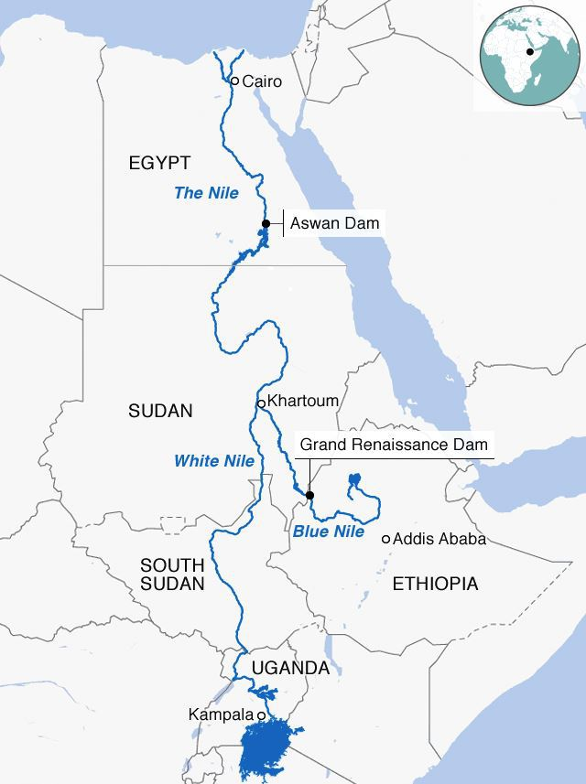
Figure 2: Map showing the countries the Nile River flows through (El-Said. M 2022)
One major water hotspot can be found in Africa where it involves The Nile River. The river flows through multiple countries such as Ethiopia, Sudan, and Egypt (See Figure 2). It is a vital resource for drinking water, agriculture, industry especially in Egypt where the country heavily relies on the majority of its freshwater supply. Also, due to the lack of rainfall in Egypt, irrigation heavily rely on the water from the river to be able to grow crops (NELSAP-CU, 2023).
One of the most recent and major conflict centres is on the construction of the Grand Ethiopian Renaissance DAM (GERD) in Ethiopia (See Figure 2), where it has shaped contemporary diplomatic relations within the Nile Basin. It is supposed to be the largest hydroelectric dam in Africa, where Ethiopia views the dam essential for generating power and supporting development (Rijntalder. T 2025). However, countries such as Egypt fears that the dam will reduce water flow downstream where it can influence agriculture and water security. The conflict is mainly caused by unequal control of water resources between upstream and downstream countries, in particular Egypt where they heavily rely on a river that originates outside its border (Mutahi. B 2020).

Europe: Danube River
The Danube River is one of Europe’s most transboundary rivers where it flows through countries such as Germany, Austria, Hungary, Romania, and Bulgaria. Compared to other hotspots, the Danube River is not defined by severe water scarcity or major conflicts but by management challenges. The river is one of Europe’s vital waterways but faces various problems that comes from severe nutrient pollution and hazardous substances. Pollution from industry, agriculture, and urban areas have affected the water quality downstream. The WWF listed the river among the top ten rivers in the world that are “fast dying” as a results of this problem in 2007, even with stronger policy the river is still identified to be heavily polluted to this day (WWF, 2007).
To help manage this problem, European countries need to cooperate through international agreements aimed in improving water quality and ensuring sustainable use.

Asia: Mekong River
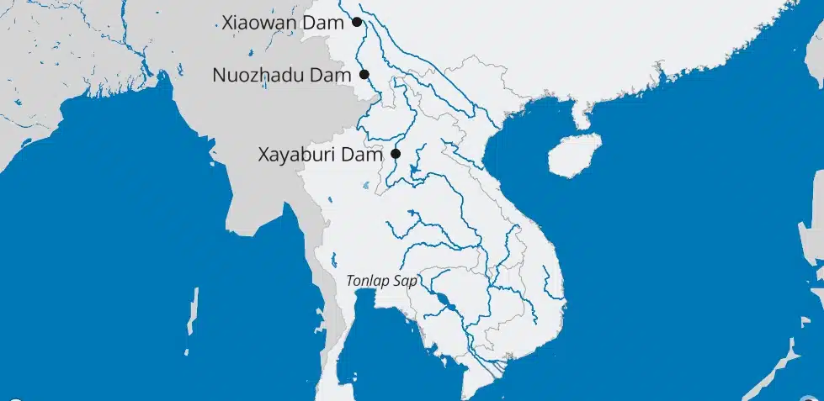
Figure 3: Map Showing the Mekong River, (Aguiar.P 2025)
In Asia there a many water hotspot, where the Mekong River is identified to be one. The river is an important water hotspot shared by countries such as China, Myanmar, Laos, Thailand, Cambodia, and Vietnam. The river is essential resource for various industries such as fishing, agriculture, transport, and hydroelectric power where it supports millions of people across Southeast Asia. The river is known for experiencing seasonal changes in discharge where it has led to extensive flooding and significant droughts (internet geography, n.d).
A major source of conflict is the construction of dams, particularly in China and Laos. These dams are used to generate electricity and support economic development but has led to a reduced water flow downstream which has affected natural flooding patterns (See Figure 3). Countries such as Cambodia and Vietnam heavily depend on the river for farming and fishing where the reduced water flow has damaged crop production, fish production, and local livelihoods. Additionally, the reduced water flow had led to sediment banks forming downstream and caused larger boats like ferries running aground (internet geography, n.d).

North America: Colorado River
In North America the Colorado River is known to be a vital water source for millions of people in both the United States and Mexico. It supplies major cities such as Los Angeles and Las Vegas, as well as large agricultural regions. The river is under severe pressure due to overuse, droughts, and climate change. Water demand has now exceeded supply for many years where it has led to the shrinking of reservoirs and reduced flow. In some cases, the river does not reach its natural delta in Mexico which has had an effect on the ecosystem and communities.
The conflict is driven by competition between urban areas, agriculture, and environmental needs. This had led to an increase in scarcity making long term management more difficult (Zhu. M 2024).

South America: Parana River
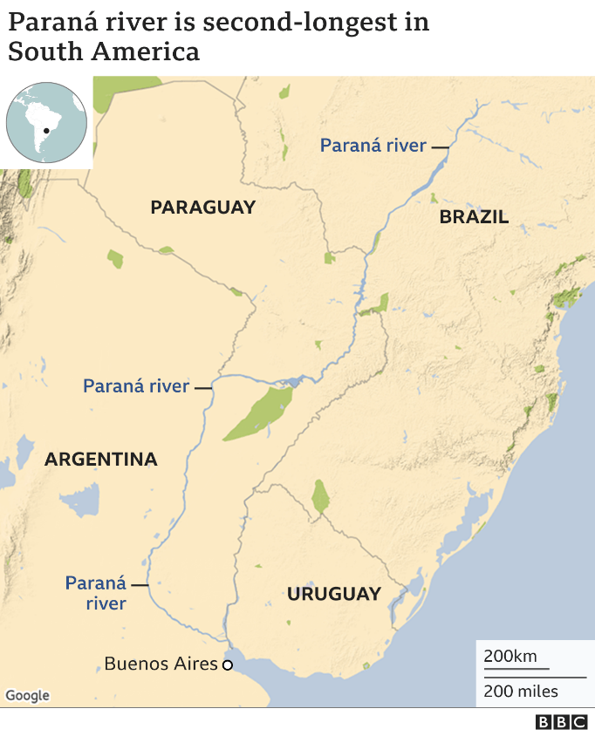
Figure 4: Map showing the Parana River (BBC 2021)
In South America the Parana River is a major shared water system between countries like Brazil and Argentina (See Figure 4). A key feature of this river is the Itaipu Dam one of the largest hydroelectric dams in the world. This has caused disputes between countries and low water levels, where it has been recorded that the Dam only runs at only 50% power. While the project supports economic development, it has raised concerns about fairness and environmental impact. Due to reduced water flow downstream it has caused major droughts in most regions where it has affected transportation, fishing, and agriculture (BBC 2021).

Oceania: Murray-Darling Basin
In Australia, the Murray Darlin Basin is the country’s most important agricultural water system where it supports farming, various ecosystems, and communities. The basin is currently facing serious pressure due to over extraction for irrigation prolonged droughts. This has reduced the river’s health and damaged the surrounding ecosystems. It has also created competition between farmers and government authorities. The main issue is balancing agricultural production with environmental sustainability, as overuse threatens the long-term future of the system (MDBA 2025).

Solution and Sustainable Water Use
There are many ways to reduce water conflicts and improve sustainability across the world. International cooperation is essential, with countries sharing rivers needing strong agreements to ensure a fair and transparent water distribution. Various organisations can also help manage shared resources more effectively. As technology continues to advance it can play a big role in helping to find a viable solution. Drip irrigation, wastewater recycling, desalination, and improved infrastructure can all reduce water waste and increase efficiency. These methods can help make better use of a resources that is already limited.
In addition, sustainable water use must be encouraged. This includes reducing pollution, protecting ecosystems, raising awareness, and managing demand in agriculture and urban areas. By raising awareness there is an increased chance for governments to take action by creating policy to help promote responsible water consumption.

Conclusion
In conclusion, global water hotspots demonstrate the increasing pressure being placed on water sources across the world. Rivers such as the Nile River, Mekong River, and Colorado River have shown how climate changes, agriculture, and population growth has created conflict between countries over water use. Many countries rely heavily on these water bodies making cooperation essential. Sustainable management, improved irrigation systems and reduced pollution can all help protect water supplies. Without better resource management, water scarcity and environmental damage are likely to continue to increase worldwide.

Question 4
Find the dissolved oxygen concentration of a stream B (DO_{B}), given the following:
Stream | Q (mg/L) [flow] | Temperature | D (Oxygen Deficit) | DO (dissolved oxygen)
A | 3.7 | 21 | 4.49
B
C | 6.2 | 19.4 | 3.58

Chloride Concentration = 0mg/L
Saturation is a function of Temperature and Chloride concentration. For this question, chloride concentration is ignored due to the value of 0 mg/L.

Solution
Step 1:
(DO_{A} x Q_{A}) + (DO_{B} x Q_{B}) = (DO_{C} x Q_{C})

Step 2:
DO_{B} = $\frac{\left(DOC x QC\right)-(DOA x QA) }{QB}$

Step 3:
Q_{B} = Q_{C} – Q_{A}
Q_{B} = 6.7 – 3.7 = 2.5 m³/s

Step 4:
DO = DO_{sat} - DO_{Deficit}
DO_{A} = DO_{A(sat)} - DO_{A(Deficit)} | DO_{A} = DO_{A(sat)} – 4.49
DO_{C} = DO_{C(sat)} – DO_{C(Deficit)} | DO_{C} = DO_{C(sat)} – 3.58

Step 5:
Use Formula’s or Table
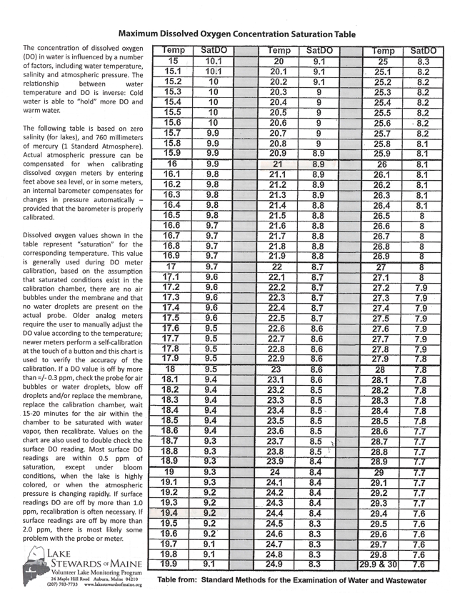
Figure 5: Maximum Dissolved Oxygen Concentration Saturation Table (Lake Stewards of Maine, n.d)
At 21°C SatDO = 8.9
At 19.4°C SatDO = 9.2
DO_{A} = 8.9 – 4.49 = 4.41
DO_{C} = 9.2 – 3.58 = 5.62

Step 6:
DO_{B} = $\frac{\left(DOC x QC\right)-(DOA x QA) }{QB}$

DO_{B} = $\frac{\left(5.62x 6.2\right)-(4.41 x 3.7) }{2.5}$
= 7.4108 mg/L
Stream | Q (mg/L) [flow] | Temperature | D (Oxygen Deficit) | DO (dissolved oxygen)
A | 3.7 | 21 | 4.49 | 4.41
B | 2.5 |  |  | 7.4108
C | 6.2 | 19.4 | 3.58 | 5.62

Reference
Aguiar. P (2025) Lower Mekong at Risk: Water Scarcity & Rising Geopolitical Tensions. [online] Available at: https://www.geopoliticalmonitor.com/lower-mekong-at-risk-water-scarcity-rising-geopolitical-tensions/ (Accessed on 9 May 2026)
BBC (2021) South America’s drought-hit Parana River at 77-year low. [online] Available at: https://www.bbc.co.uk/news/world-latin-america-58408791 (Accessed on 10 May 2026).
BBC (2025) Thames Water: Inside the Crisis. [online] Available at: https://www.bbc.co.uk/iplayer/episodes/m00284vn/thames-water-inside-the-crisis (Accessed on 1 February 2026)
Buckland. C (2025) Welsh Water sewage spills at highest in 10 years. [online] Available at: https://www.bbc.co.uk/news/articles/cy5wd2dnl0po (Accessed on 15 February 2026)
Clisham. P (2025) Why the sewage problem is likely to linger for years to come. [online] Available at: https://www.ice.org.uk/news-views-insights/inside-infrastructure/why-the-sewage-problem-is-likely-to-linger (Accessed on 15 February 2026)
El-Said. M (2022) Ethipia’s GERD: Damming water in unstable terrane. [online] Available at: https://www.dailynewsegypt.com/2022/06/08/ethiopias-gerd-damming-water-in-unstable-terrane/ (Accessed on 9 May 2026)
ICE (2018) Thames Tideway: Increase the ability for London to deal with its own sewage. [online] Available at: https://www.ice.org.uk/what-is-civil-engineering/infrastructure-projects/thames-tideway (Accessed on 14 February 2026).
Internet Geography (n.d) Managing the Mekong River- A transboundary water issue. [online] Available at: https://www.internetgeography.net/educas-gcse-geography/managing-the-mekong-river-a-transboundary-water-issue/ (Accessed on 9 May 2026)
Lake Stewards of Maine (n.d) Maximum Dissolved Oxygen Concentration Saturation. [online] Available at: https://www.lakestewardsofmaine.org/wp-content/uploads/2023/08/LSM-Max-DO-Concentration-Saturation-Table-compressed.pdf (Accessed on 10 May 2026).
Laville. S (2025) Thames Water data reveal raw sewage discharges in rivers rose 50% in 2024. [online] Available at: https://www.theguardian.com/business/2025/mar/18/thames-water-data-reveals-raw-sewage-discharges-rivers-2024 (Accessed on 15 February 2026)
Met Office (2025) Annual Climate stocktake shows weather records and extremes now the norm in UK Climate. [online] Available At: https://www.metoffice.gov.uk/about-us/news-and-media/media-centre/weather-and-climate-news/2025/annual-climate-stocktake-shows-weather-records-and-extremes-now-the-norm-in-uk-climate#:~:text=As%20the%20UK's%20climate%20warms,is%20clear%20from%20our%20observations.%E2%80%9D (Accessed on 14 February 2026).
Mutahi. B (2020) Egypt-Ethiopia row: The trouble over a giant Nile dam. [online] Available at: https://www.bbc.co.uk/news/world-africa-50328647 (Accessed on 9 May 2026).
Murray-Darling Basin Authority (MDBA) (2025) Water quality threats-A summary of potential threats to water quality in the Murray-Darling Basin’s waterways. [online] Available at: https://www.mdba.gov.au/news-and-events/newsroom/water-quality-threats-april-2025 (Accessed on 10 May 2026).
Nile Equatorial Lakes Subsidiary Actor Program (NELSAP-CU) (2023) Water Quality Multi-Criteria Analysis – To Prioritise Investments in identified Nile Basin Hotspots. [online] Available at: https://nilebasin.org/sites/default/files/2024-10/NCCR%20Water%20Quality%20Project%20Brief_Updated%20Jun%202024.pdf (Accessed on 9 May 2026)
Rijntalder. T (2025) The GERD Dispute: Lessons for Water Governance and the Fure of the Nile Basin. [online] Available at: https://www.fpri.org/article/2025/10/the-gerd-dispute-lessons-for-water-governance-and-the-future-of-the-nile-basin/ (Accessed on 9 May 2026).
The River Trust (2026) The issue – why is it relevant to the work of The Rivers Trust. [online] Available at: https://theriverstrust.org/about-us/our-position-statements/combined-sewer-overflow-position-statement#:~:text=The%20issue%20%E2%80%93%20why%20is%20it,acute%20effects%20upon%20aquatic%20wildlife (Accessed on 14 February 2026)
World Wildlife Fund (2007) Danube one of top ten world’s most threatened rivers. [online] Available at: https://wwf.panda.org/es/?97320/Danube-one-of-top-ten-worlds-most-threatened-rivers (Accessed on 9 May 2026)
Zhu. M (2024) Cailin Och documents the Colorado River’s water shortage crisis. [online] Available at: https://www.nationalgeographic.com/impact/article/caitlin-ochs-explorer-story (Accessed on 10 May 2026).

