

An Introduction to Microsoft Word 2007-2010: Tables

Jamie Tavender/Rhian Pole/John Apps

Adapted from notes from Steve Hole

Introduction:
Creating documents using Microsoft Word allows for the manipulation and display of text and other information. Tables, which are made up of rows and columns that form cells, can be utilised to organise information in your document. Formatting text, structuring your document, and adding a little bit of aesthetic appeal to your document are just a few ways in which you can use tables in Word. By using tables, you can turn an otherwise dull and unorganised document into a more well-designed and laid-out project. This guide will provide some basic information on the creation and manipulation of tables.
Open a Document:
Before you can begin working with tables, you must first open up a document in Word. You can either start a new blank document (Office button >> New, or Ctrl + N), or open up a previously saved document from your computer (Office button >> Open, or Ctrl + O). Once the file is opened in Word, you can insert a table.

Creating a Table:
There are different methods you can use to insert a table into your Word document. If you are less experienced with tables, then you might want to consider using the Insert Table option. Otherwise, you can use Draw Table, which lets you make a table by scratch by drawing it freehand using the Draw Table tool.

Insert Table:
In your document, place your cursor where you wish to insert a table. Then, go to the insert tab on the ribbon and select Table >> Insert Table.

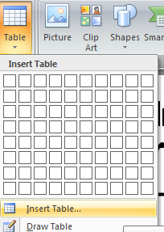

After you make this selection, the Insert Table window will pop up.

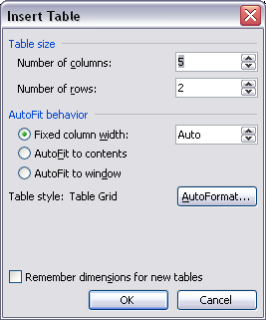

Input the necessary information needed to create your table. Decide on a number of rows and columns. AutoFit refers to the space that the table takes up in your document. For your initial table, you might want to set the Fixed column width to Auto. This sets the width to all of the columns in your table to an equal amount, and the table itself will take up the entire width of the document. When you have decided on all of your table options, click on the OK button. The table will then be automatically inserted into your document.

Draw Table:
If you'd like to draw your own table for scratch, go to the table button, and you will see a grid of boxes which you can increase and decrease the size of:

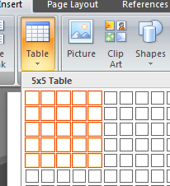

Simply drag the curser to the size of table you would like, but be aware the biggest you can do in this quick table option is a table of 10x8 size.
As you can see, the table above is the result of selected the size highlighted on the previous image, and Word will put that table where the cursor is to the dimensions selected.

The Tables design and layout tab:
When you select or highlight a table, the ribbon generates two new tabs at the end, called Design:

- The first box on the left hand side (Table style and Options) allows you to select what the purpose of the row or column you have selected is. For example selected header row tells Word that you want that row to bold and underline the words inside of it, as it is acting as a heading.
- In table styles, the user has a plethora of different styles, colours and look of the table they have created, so always choose which one works best for you in terms of look and academic standard.

And Layout:

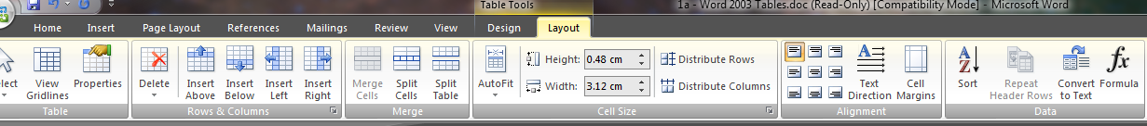

- View Gridlines: Allows you to choose whether the lines separating the table are visible or not
- Delete: Allows the user to delete a row or column when selected
- Insert above/below/left/right: Allows the user to insert a row or column wheever the curser is selected within the table
- Split Cells: Splitting a cell is the act of selecting a specific cell, and dividing it into one or more rows or columns. Select the cell that you want to split, and then click on the Split Cells icon. Once you do this, the Split Cells window will appear. From here, you can decide how many rows or columns you wish to create from the one cell.
- Merge Cells: Merging cells is the act of selecting more than one separate cell and merging them so that they become one. First, select the cells that you want to merge with your mouse (by clicking and holding within one cell and dragging the mouse across the cells you want to select), and then click on the Merge Cells icon. Word will automatically merge the two cells together.
- Cell Size options: In this section of the tab, the user can simply change the size of certain cells or columns depending on their need
- Alignment: Allows the user to align the text in a section wheever the user wishes (left, right, up, down)
- Sort Ascending: Sort a selection of text in cells in ascending order.
- Sort Descending: Sort a selection of text in cells in descending order.

Inserting Text and Content into a Table:
To begin adding text to a table, click your cursor in the cell where you want the text to be placed. Begin typing (or paste text from another source) into the cell. To move from one cell to another, hit the Tab button on your keyboard, and continue typing in the cell as needed. You can format the text within the cell using the home tab on the ribbon; just as you would edit any other text in Word (see Introduction to Word handout).

Inserting an Image into a Table:
Place your cursor into the cell where you wish to insert an image. Then, go to the insert tab, and select Picture, and then choose from Clip Art or From File. Locate a picture, and click on Insert to put the image into a cell.
Move a Table:
To move an entire table to a new location in your document, move your cursor over the table until you see the icon that appears in the upper left-hand corner of the table, shaped like a square with crosshair arrows inside.
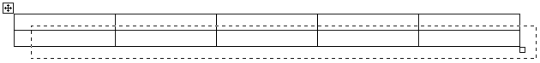
When you see this appear, click on it. You will see that it selects the entire table. With the table selected, you can drag it to any new place in your document.
Change Row / Column Heights / Widths:
If you need to increase or decrease the height or width of a row or column, you can do so by clicking and dragging the borders of rows or columns. Drag the borders until you create the desired amount of space between rows or columns.
Table Properties:
At any time, you are free to change the properties of your table. Right-click inside of any table and select Table Properties.
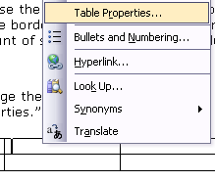
A new window with four tabs will appear. Within these tabs, you can adjust every minor detail about the table including alignment, spacing, text wrapping, etc.
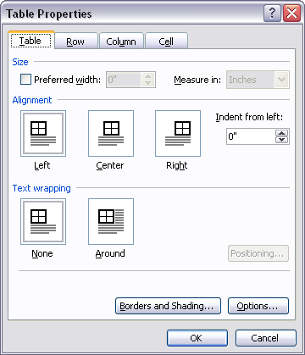

Activity:
Create a suitable table to indicate your current college class timetable. Make it as simple or as complicated as you feel is necessary. You could try inserting a picture into your table, shading portions of it, or altering the borders and line weights. It’s up to you!

