6/24/2020
Gareth Williams (1302811)
Microsoft
Manufacturing Design & Technology – Task 2
M5X02070

Contents

Contents 1
INTRODUCTION 3
APPRAISAL OF THE ORIGINAL SYSTEM 4
MANUFACTURING PROCESS PROPOSAL 6
DESIGN AND DEVELOPMENT WORK UNDERTAKEN 9
MANUFACTURING PROCESS DESIGN 19
CONCLUSION 21
References 22

Table of Figures

Figure 1 - Original 3 Jaw Gripper 4
Figure 2- Clash with joins 5
Figure 3 - Boothroyd Dewhurst method 7
Figure 4 - Lucas DFA Method (Scholar, 2007) 8
Figure 5- Poke-Yoke (RNA, 2019) 9
Figure 6- Benefits of Poke-Yoke (RNA, 2019) 9
Figure 7- QFD for Gripper 10
Figure 8- Exploded View of Gripper 11
Figure 9- FMEA Table 12
Figure 10- General Assembly View 13
Figure 11- Projected Views 13
Figure 12 - Gripper Body 14
Figure 13- Gripper Brace 14
Figure 14- Gripper Arm 15
Figure 15- Pin 01 16
Figure 16- Water cut Nest Layout for Gripper Arm 17
Figure 17- Water cut Nest Layout for Gripper Brace 17
Figure 18- Flow Diagram for gripper 19

INTRODUCTION

The purpose of this report is to undertake a design study to develop a three jaw gripper which will be used on a robot system to perform pick & place operations on an assembly line.
We have been approached by a company called Grippers ‘R’ Us to manufacture 40 complete end effectors which will be used on their robots.
There are many tools used in the design and process of new products including QFD, FMEA & DFA which will all help in meeting the customers’ requirements to produce a product that meets the specifications set out in the RFQ.
Grippers ‘R’ Us have set a budget of £300 per gripper. This report shows how I used several tools to design and manufacture the new gripper while trying to make it as cost effective to my company in order to make a profit.

APPRAISAL OF THE ORIGINAL SYSTEM
- Cylinder
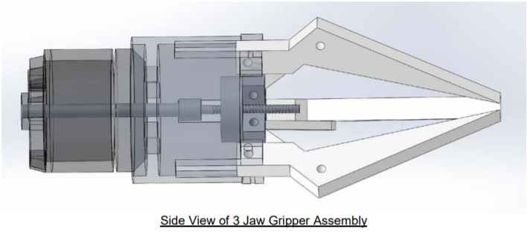
- Motor
- Join
- Gripper Arm
- Worm
- Drive Plate
Figure 1 - Original 3 Jaw Gripper
Appraisal
Name of component | What is the component doing? | How does it relate to other parts?
- Cylinder | Pushes drive plate along worm | Drives cylinder piston pushing or pulling drive plate.
- Motor | Drives the cylinder | Driving force for the cylinder to activate.
- Join | Attaches arm to drive plate | Acts as a bridge/hinge for arms to open/close. Could be a redundant part.
- Gripper Arm | Picks up part | Main contact point. Needs connection to driving parts to operate.
- Worm | Guides drive plate | Needs to be connected to cylinder piston and motor
- Drive Plate | Connection for join & arms | Central connection part holding everything together to operate correctly.
There are many issues with the current design of the gripper (fig 1). It is clear that there are holes in the gripper arms, joins and drive plate without any fasteners, pins or rivets to hold everything together.
There is also a clash between the joins shown below in (fig 2). This would prevent the gripper arm from opening because the join acts as a pivot point between the gripper arm and the drive plate.
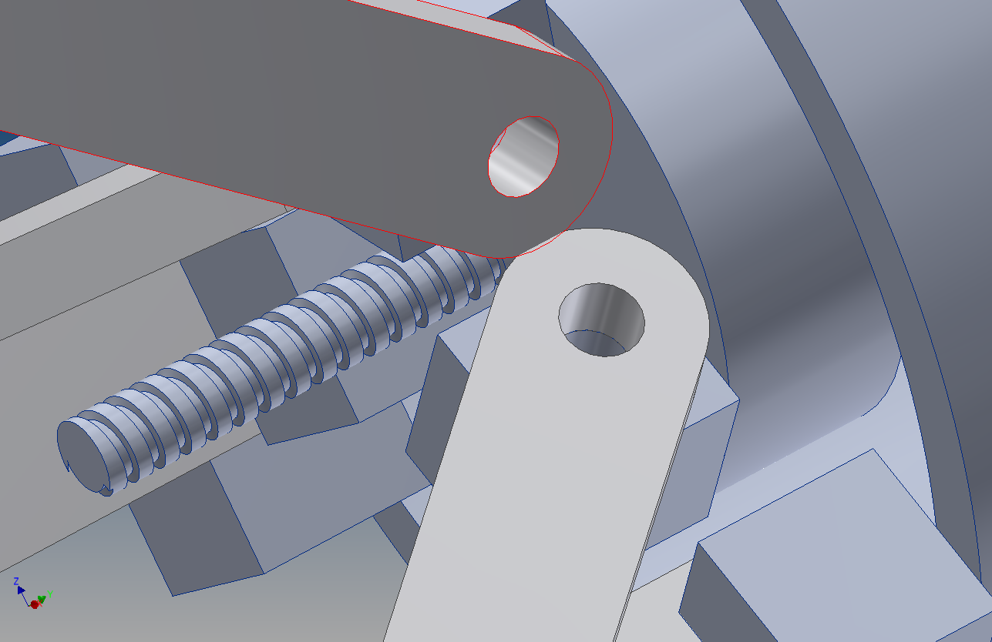
Clash between joins
Figure 2- Clash with joins
The gripper arms have not been designed very well. They are not very functional because they have been designed with a sharp angle so that when the gripper is in its closed position, the arms meet at a point. This would make it difficult to ‘pick and place’ items because the gripper arm would be making minimal contact with the part it was picking up which could result in the part slipping from the gripper which would in turn make the gripper useless.
The next part is the worm which is a threaded bar where the drive plate runs along. The fact that the worm has been threaded forces the drive plate to run along it in a rotational direction. This would then mean that all the parts attached to the drive plate such as the join plate and the gripper arms would also need to rotate. This is not suitable because the gripper arms would need to open/close around the axis of the pin holding the join to the drive plate, not the axis of the main body of the gripper. It would be better if this was changed to a bearing running along a linear shaft which tends to have tight tolerances to avoid any slack.
The final part of the design is the drive plate. Again, this had been poorly designed as a manufacturing point of view. It would be very difficult and time consuming to machine this component. This would also mean that it would not be cost effective to produce this part, especially as the expected volume is 40 parts per week.
After analysing the current gripper and the many flaws that it has, I have decided that I will redesign the gripper which will make it more cost effective to manufacture and will also be more functional to the main purpose of the gripper which is to pick & place.

MANUFACTURING PROCESS PROPOSAL
There are multiple manufacturing processes that can be used to make the individual parts for the gripper. Below is a list of some of the most common processes and the ‘pro’s and con’s’ associated with that process.
- Cylinder – The cylinder would be a bought out part from a pneumatic company.

- Motor – The motor would also be a bought out part from a specialist company.

- Join – The join is a simple part of the gripper. The holes in the join plate would need to be manufactured to with a degree of tolerance so that they mate with the fastener/pin that would be inserted. If the hole was too big then that would allow for slack between the contact points which could affect the pivot action.
There are 3 join plates on each gripper which would require 120 parts in total to meet the 40/week target. Therefore, taking into consideration the high volume required, I would choose to have these parts profile cut using a waterjet.
Waterjet Cutting Pros | Waterjet Cutting Cons
Cheap | Cannot cut blind, must be through part
Can produce high volumes | Needs a lead in/lead out
No chemicals or heat | Cutting head needs to be square at all times or it will cut draft angle
Versatility – Can cut through a range of materials. | Abrasives are not reusable
Can achieve high precision +/- 0.005mm | Limited Nozzle life

- Gripper Arm – The gripper arm could be manufacture in many different ways. Again it would come down to cost per part to determine which process to choose, while maintaining mechanical dynamic properties required for the application. Die casting would be a reasonable process to use given the high volume of parts required.
Die Casting Pros | Die Casting Cons
Close dimensional limits | High initial die investment
Reduced labour in set up | Limited number of casts
Smooth surface finish with less risk of stress risers | High temperature of casts can reduce life of dies
Low finishing costs | Minor casting modifications difficult and costly
Good solution for high volume applications | Relatively slow

- Worm – The worm is a simple part to manufacture as it is just a shaft with a thread along its length. I would choose to CNC turn this part as it would be the most cost effective and would be relatively quick to produce the 40 parts per week required.

- Drive plate – The drive plate has been designed in quite a complex way with there being 3 cubic features on a cylindrical part. This would make it very difficult to machine without using a 5 axis CNC milling machine. The easiest way to manufacture this part would be to use additive manufacturing such as 3D printing. As the part is relatively small, it would be easy to 3D print 40 parts in one go.
3D Printing Pros | 3D Printing Cons
Complex parts easy to produce | Slow build rate
Changes can be made easily | High production cost
No assembly required | Requires post processing
Very few skills needed to produce part | Reduced accuracy
Less Waste | Poor mechanical properties

Before manufacturing any parts, it is important to think about how all the individual parts are going to come together as an assembly. One tool that is used commonly is DFA (Design for Assembly). DFA looks at the most efficient way of assembling a system to save time and make it more cost effective. (Machine Design, 2002)The most efficient systems will only use the parts that they need for the assembly to work. To find out what parts were essential & non-essential to my design, I used the Boothroyd Dewhurst method shown in Fig 3.
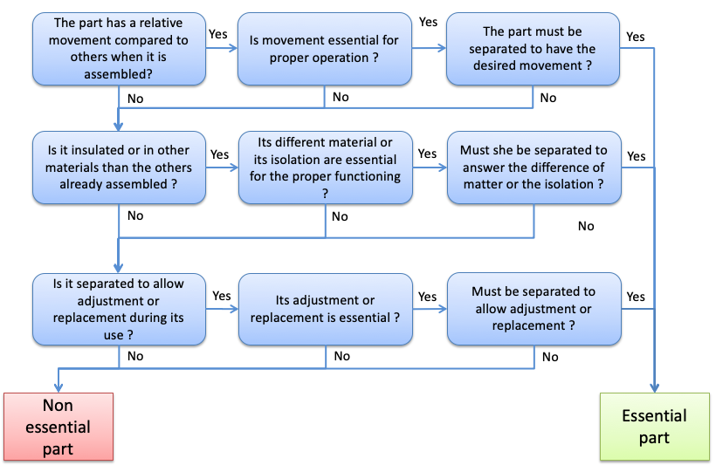
Figure 3 - Boothroyd Dewhurst method

From splitting my parts into ‘Essential’ & ‘Non-Essential’ parts, I could then calculate the design efficiency by using the following formula.

$$Design Effeciency=\frac{Essential Parts}{Essential Parts+Non Essential Parts} x 100$$

Once I had ended up with all my essential parts, I then had to look at the easiest way to assemble the essential parts. To do this I used the Lucas method. The Lucas method uses a point’s scale which measures the level of assembly difficulty. (Armstrong, 2012) Below is the table which shows the handling and fitting index used to calculate the parts assembly difficulty. If the number came out too high, then I would then have to go back to the drawing board to see if I could change the design to make the overall number come down.

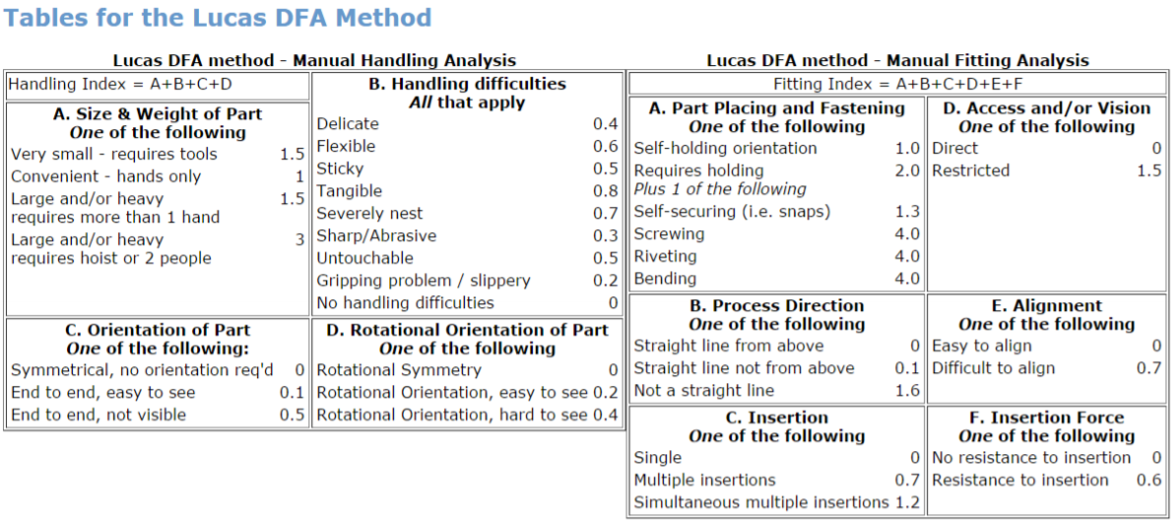
Figure 4 - Lucas DFA Method (Scholar, 2007)

Poke-Yoke
When the gripper is being assembled, it is important that the parts that make up the assembly are assembled in the correct orientation. If not then it could make the part useless. One method used while designing a part is Poke-Yoke. Poke-Yoke is a way of mistake-proofing a component to try and eliminate human error. Human error can be extremely costly because if a part has been assembled incorrectly then the customer could return the whole batch of parts even if that was the only part with the error. (RNA, 2019)
Below (fig 5) is a table showing the connection between human error and causes for defects, and also the benefits of using Poke-Yoke in the design (fig 6).

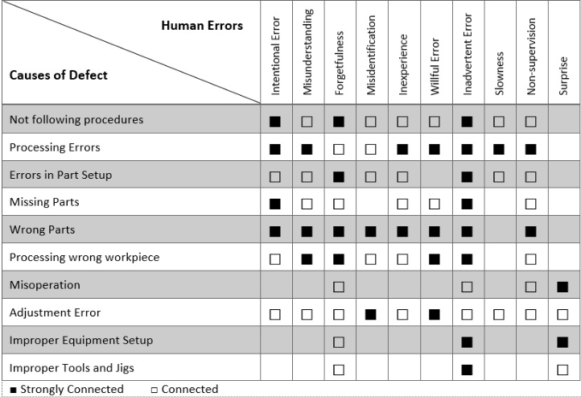
Figure 5- Poke-Yoke (RNA, 2019)
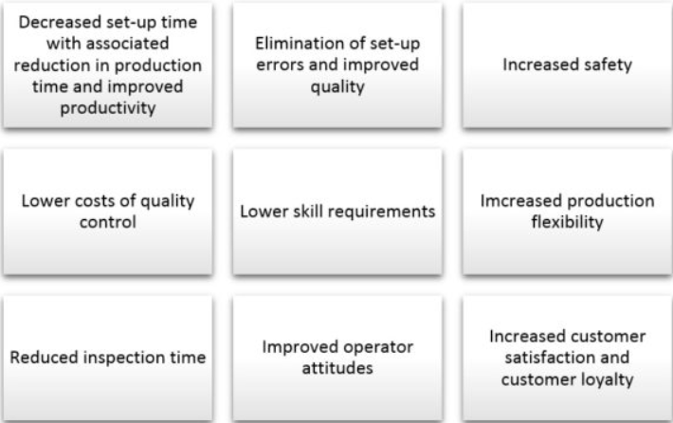
Figure 6- Benefits of Poke-Yoke (RNA, 2019)

DESIGN AND DEVELOPMENT WORK UNDERTAKEN
I decided to re-design the gripper while trying to keep the new design as simple and clean as possible. It was important to work closely with the customer in order to produce a product that they were happy with.
The first thing that was carried out was a QFD (Quality Function Deployment). A QFD is a tool used where the customers’ needs are translated into technical requirements. (Product Plan, 2019)
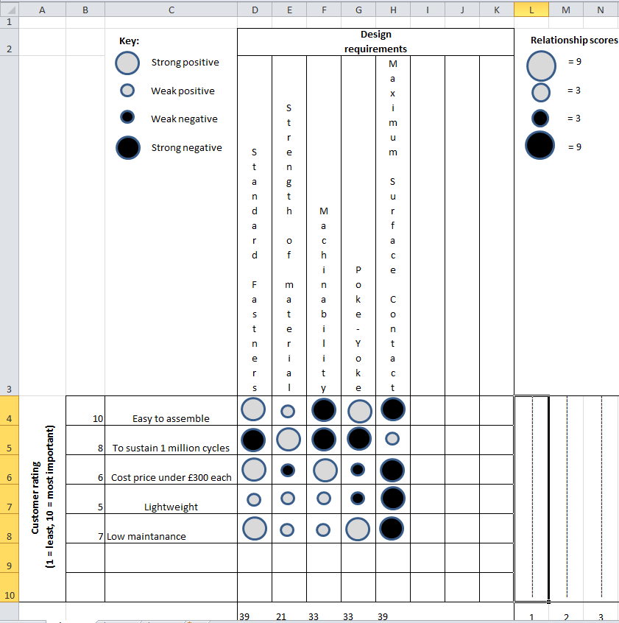
Figure 7- QFD for Gripper
Once the QFD had been completed and the customer needs had been met, it was time to move onto the next stage of the project which was to look at how the gripper could be manufactured based on the customer requirements. To do this I carried out a DFMA (Design for Manufacture & Assembly).
The purpose of a DFMA is to establish at the design stage how the parts are going to be manufactured in the easiest way. It is also a tool used to improve the process and design by reducing manufacturing costs by selecting raw materials that assures the best cost, quality, reliability, safety, time to market and customer satisfaction is achieved. (East West, 2020)
Below is an exploded view of the proposed new gripper that I designed.

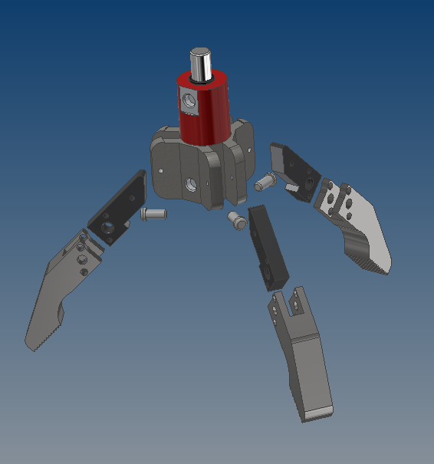
Figure 8- Exploded View of Gripper

Once the design has been finalised, it is important to think about what could go wrong both in terms of the assembly as a whole and also the individual parts that make up the assembly. To do this I carried out a Failure Mode and Effects Analysis (FMEA). Using a FMEA reviews the process and design to identify failure modes, what could go wrong? Failure causes, why would the failure happen? And failure effects, what would be the consequences of the failure? ( QI Essentials Toolkit, 2017)
Below in fig 9, I have carried out a FMEA exercise to identify any potential failures. It is much better to implement changes at the design stage to reduce the chances of failures occurring, than waiting until the part has failed and having to react when it is too late.

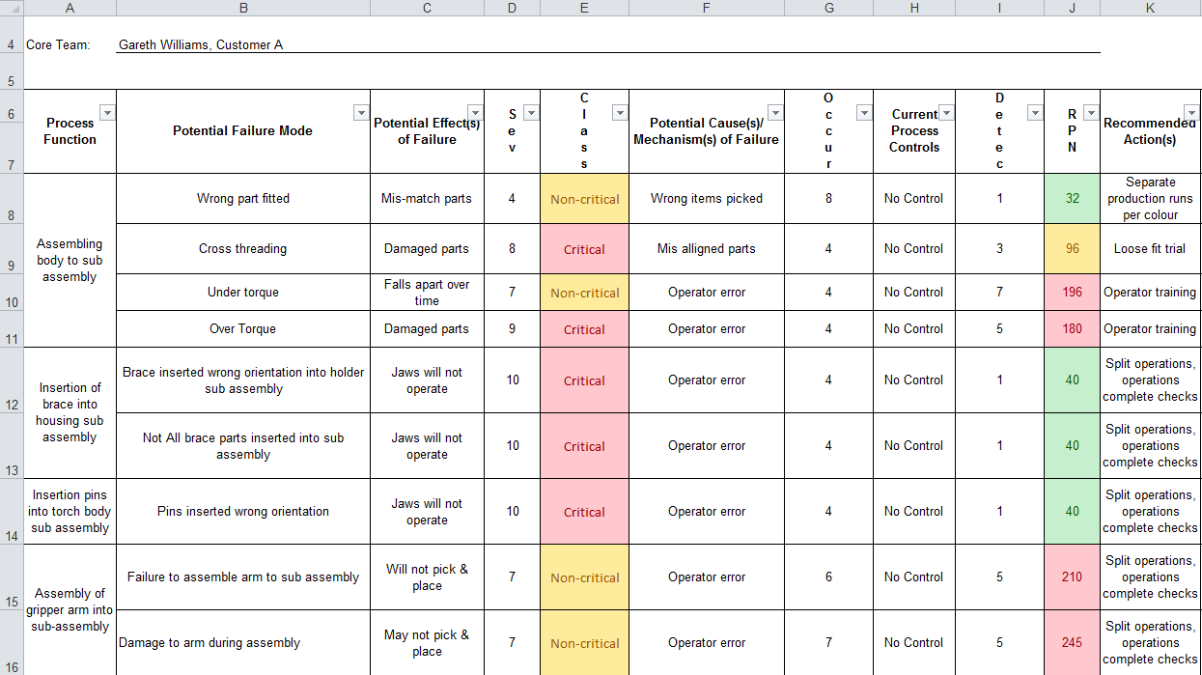
Figure 9- FMEA Table
Below I have laid out the 2D assembly and part drawings that would be used to manufacture & assemble the new gripper. The 2D drawings give detailed instructions including dimensions, geometrical tolerances and limits & fits. In the top left hand box on each drawing is the Item number, the quantity of parts required to make one complete assembly, the part number and also the material of the individual parts. As you can see from Fig 10, there are 4 main components that make up the gripper.
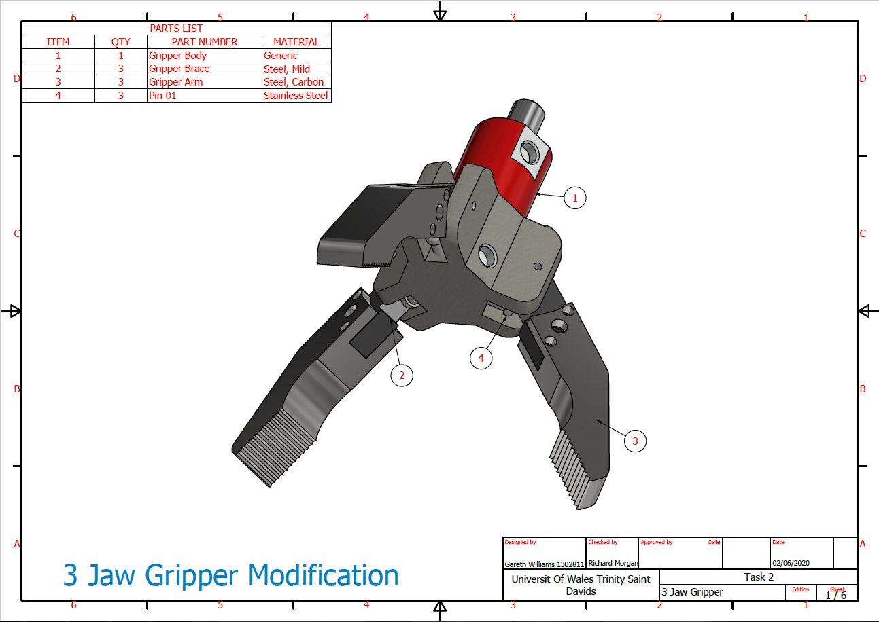
Figure 10- General Assembly View
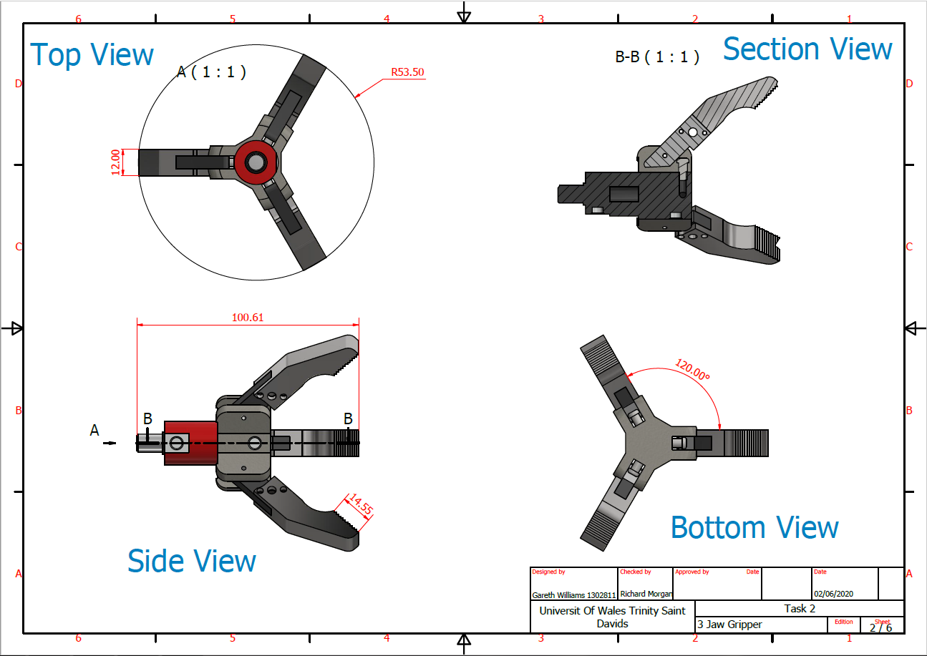
Figure 11- Projected Views

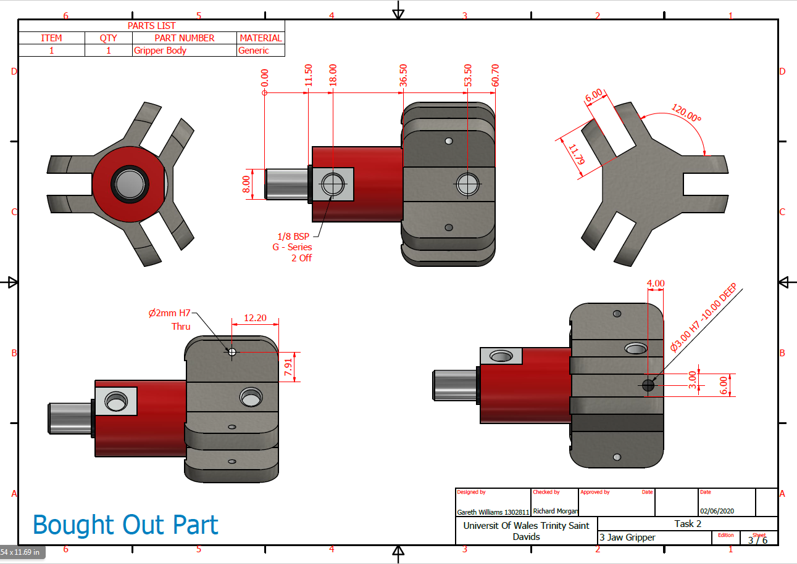
Figure 12 - Gripper Body
I decided to use a bought out part for the main body of the gripper. This would be the most cost effective way because the gripper body is a universal part for a robot/cobot system. The gripper body I chose shown in fig 12 above is from company called Gimatic UK and costs £200 + VAT per part. The body takes 2 x 1/8th BSP standard fittings to operate the piston inside.
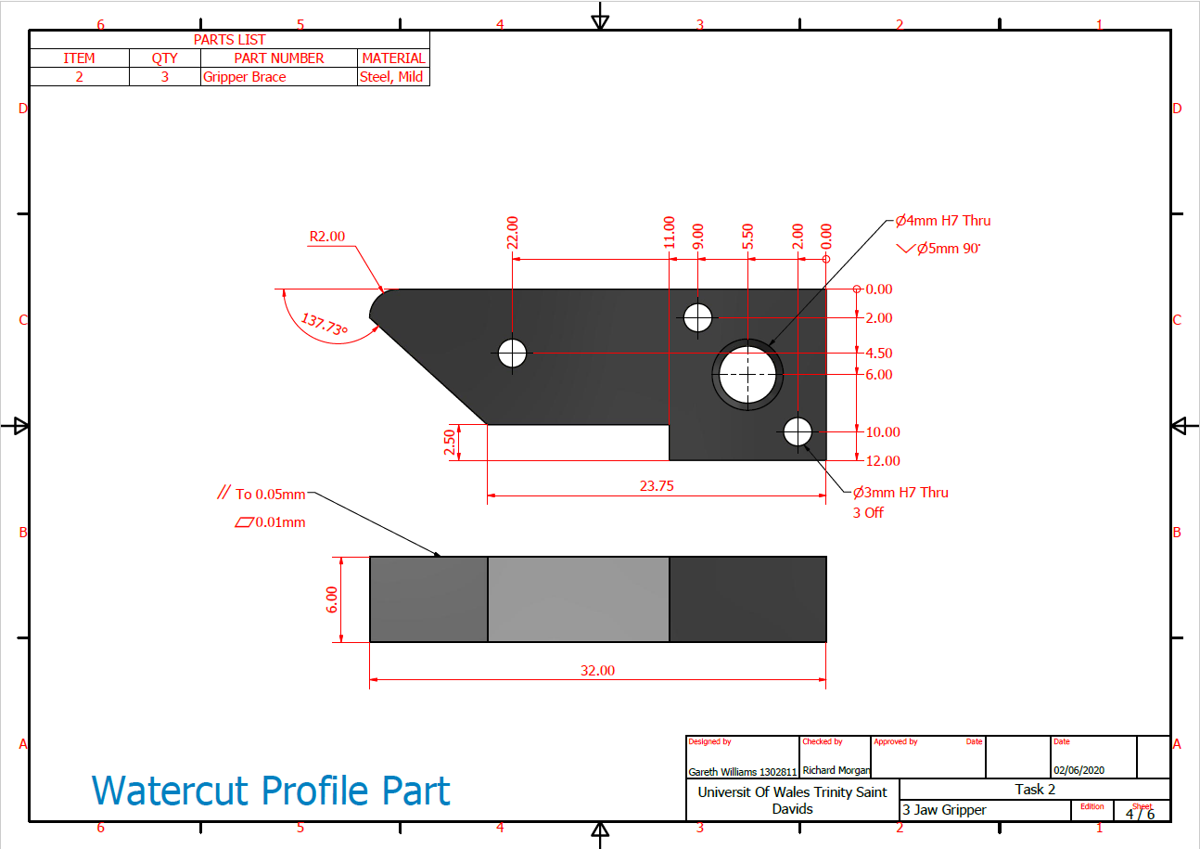
Figure 13- Gripper Brace
For the gripper brace shown above in fig 13, I decided that the quickest and most cost effective way of manufacturing this part would be to have it profile cut using a water-jet. The reason for this is because all the features such as holes and the profile are all on one plane. This means that there would not be any post production needed apart from opening out the holes to the correct diameter based on the specified tolerance noted on the drawing. Having this part water-cut would also be the most time efficient. This is because the material I have chosen for the gripper brace is mild steel. If I was to machine these parts individually then it would take much longer because I would have to take into account the speeds & feeds required for mild steel.
The reason for this choice is because the brace needs to be hard wearing because it is acting as a join part between the gripper body and the gripper arm. If I was to choose a softer material such as aluminium, then there is a chance that the hardness of the rivets holding them together could wear the hole size which would mean the limits & fits were lost and the hole would become slack.
I have laid out the nest shown below in fig. 17 which shows that I could fit 175 parts onto a 500mm x 200mm x 6mm plate. The total cost to manufacture this part is shown below.
Material cost = £95
Cost of water cutting = £150
Total Cost = £95 + £150 = £245/175 parts = £1.40 per part
3 parts required per gripper = £1.40 x 3 = £4.20 per gripper

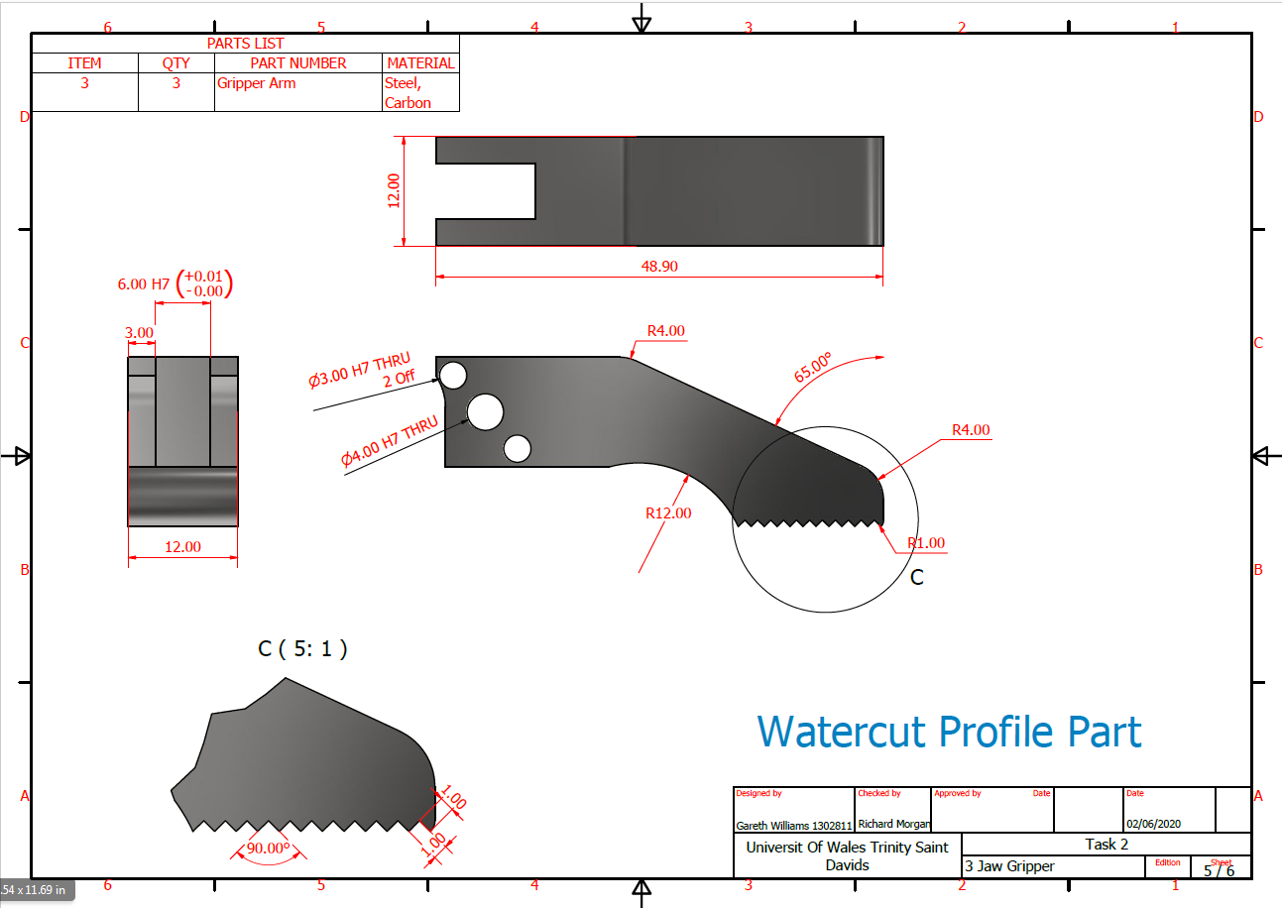
Figure 14- Gripper Arm
For the gripper arm shown above in fig.14, I also decided to manufacture these parts using a water-jet cutting machine. The reason for this is because it is quite a complex part and would take too long to manufacture these in the high volume that is needed to satisfy the customers’ requirements of 40 grippers per week. The material I have chosen for the gripper are is a carbon steel. This is because the gripper is the main contact point with the part it is picking & placing, therefore the material needs to be hard wearing so that it can last the 1 million cycles set out by the customer in the QFD.
The gripper arms would need some post production machining because they have a blind pocket which located the gripper brace. The water-jet cutting machine would not be able to do this operation because it is on a different place to the profile and holes. Again, the holes would need to be opened out to incorporate the tolerances set on the 2D drawing.
I have laid out the nest shown in fig.16 which shows that I could fit 120 parts onto a 500 x 300 x 12mm plate. The total cost to manufacture this part is shown below.
Material cost = £150
Cost of water cutting = £140
Machining Costs = £100/120 parts = £0.83 per part
Total Cost = £150 + £140 + £100 = £390/120 parts = £3.25 per part
3 parts required per gripper = £3.25 x 3 = £9.75 per gripper

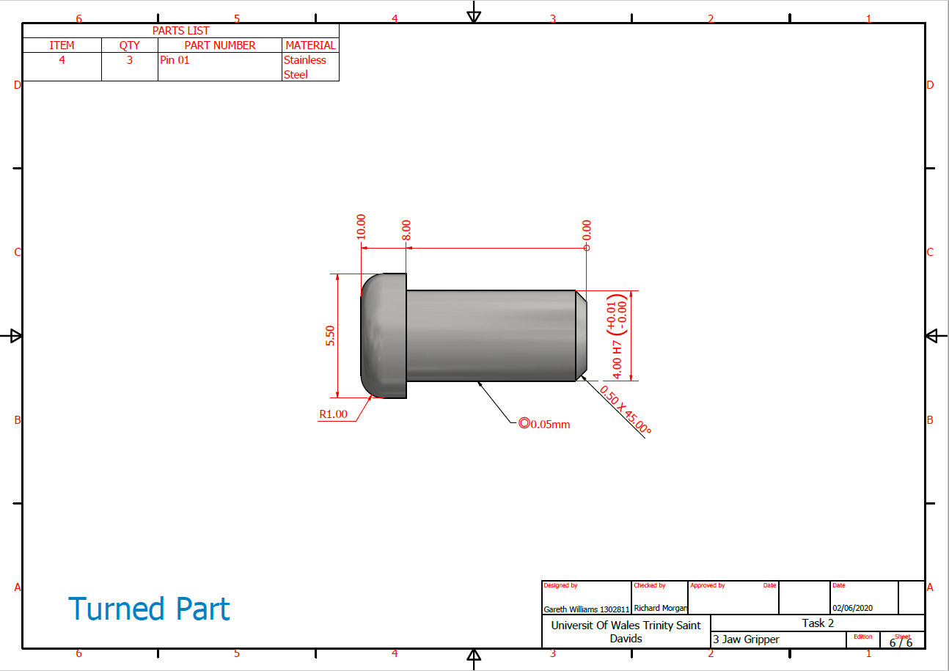
Figure 15- Pin 01
For the pins that are the mechanism between the gripper body and the gripper arms that force the gripper to open or close, I chose to machine these parts using a CNC lathe. The parts are very simple so it was the quickest and most cost effective way of producing them. The reason for the oversized head on one end of the pin is to act as a Poke-Yoke when assembling so that it would reduce the chance of human error. This way the pin can only go in one way. The cost to produce 120 pins to assemble 40 grippers a week is £240 = £2 per part.

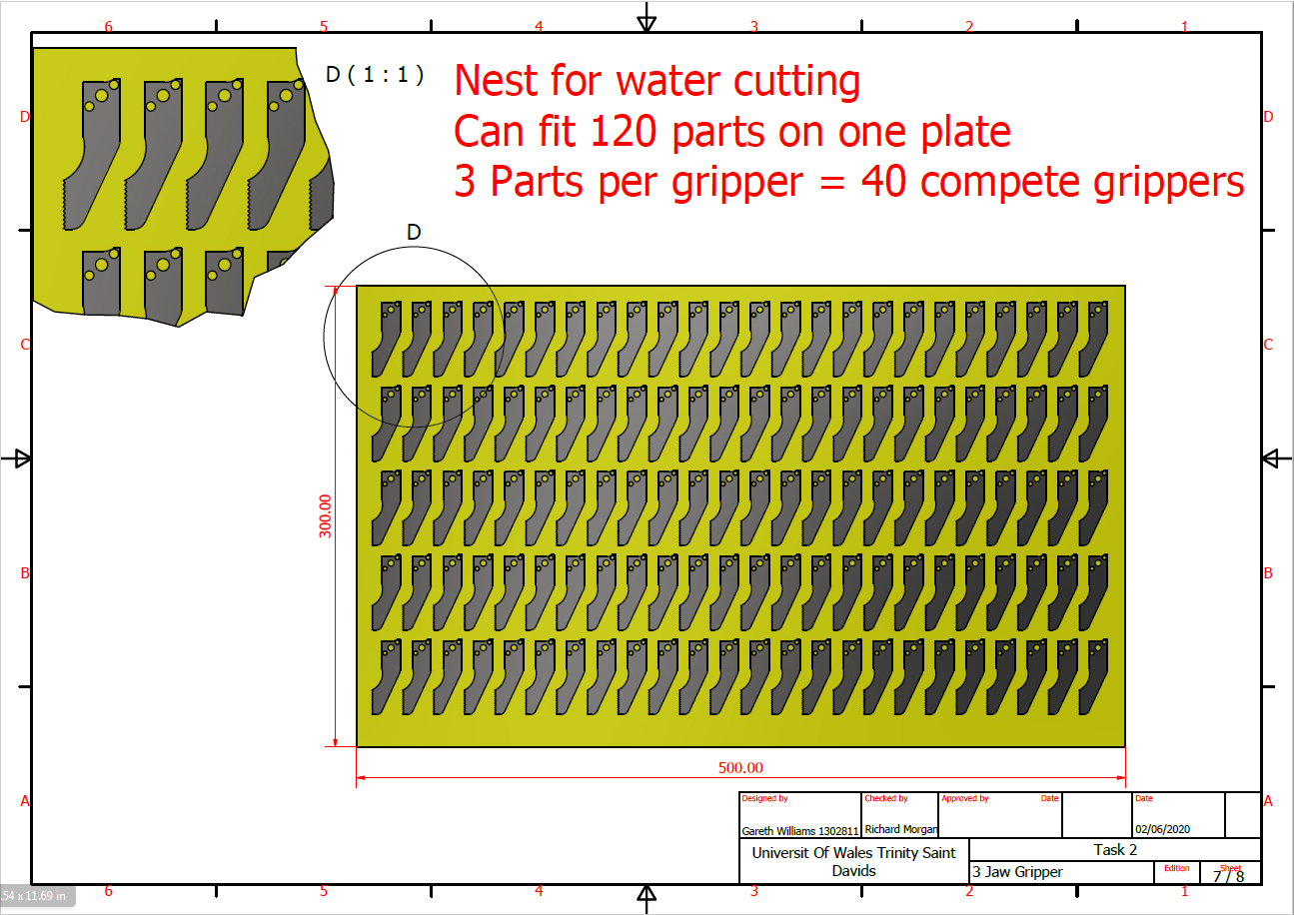
Figure 16- Water cut Nest Layout for Gripper Arm
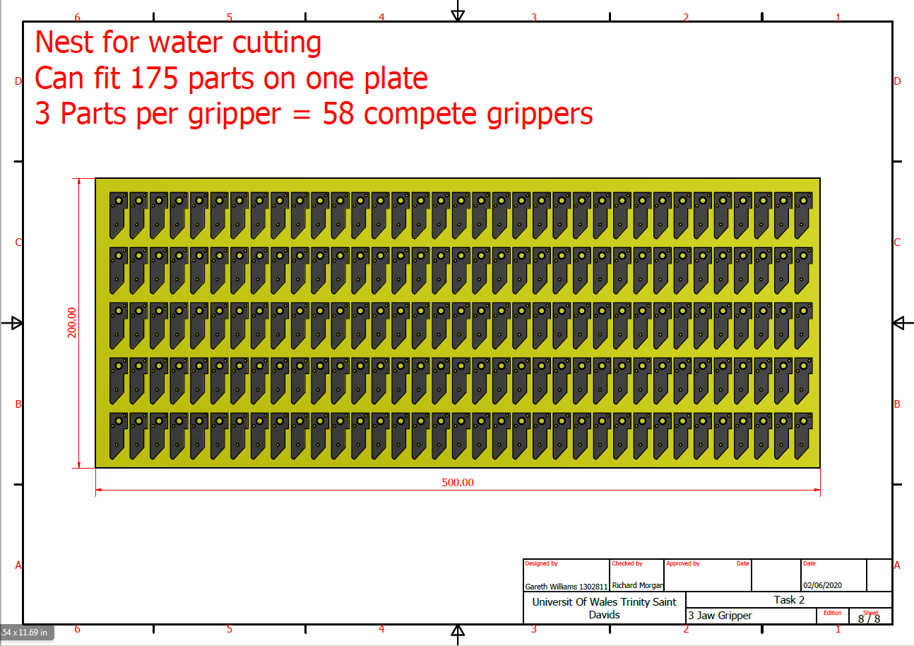
Figure 17- Water cut Nest Layout for Gripper Brace
Cost Breakdown
The total cost to produce 40 grippers that are required to fulfil the order from Grippers ‘R’ Us is shown below.

Gripper Body = £200 + VAT
3 x Gripper Brace = £4.20
3 x Gripper Arm = £9.75
3 x Pin = £6

Total cost per complete gripper = £219.95 each
Selling cost to customer = £300
Selling cost – Cost price = £300 - £219.95 = £80.05 profit OR 26.68%
Total Profit for 40 Grippers per week = 40 x £80.05 = £3202

MANUFACTURING PROCESS DESIGN

Figure 18- Flow Diagram for gripper

A manufacturing process flow chart is a step by step guide showing what tasks must be completed from the very start of a project when a customer requests a quotation, right until the very end of the project when the product is shipped to the customer. (An Introduction to Manufacturing Process Flow Charts and Workflows, 2018)
Fig.18 above is a high level flow diagram showing the steps that need to be taken in order to produce the 40 grippers requested by Grippers ‘R’ Us.

REQUEST FOR QUOTATION (RFQ)
At this stage, the customer has got in touch to request a quotation to produce 40 end grippers to be used on a pick & place robot/cobot system. During this stage I had to work with the customer to identify exactly what they expected and to try and work within their budget. I obtained quotes from various different suppliers in order to come to the final quotation of £300 per unit.
PURCHASE ORDER
This is when the customer was happy with the price I had quoted them to produce 40 complete grippers per week. A written contract was signed and the project could commence.
DELIVERY OF RAW MATERIAL
I then ordered all the raw material and bought out parts needed for the project. Once I had taken delivery of the raw materials, I then sent them to Cross Engineering who is going to water-jet cut the gripper brace and gripper arms.

MANUFACTING OF PARTS
This is the stage where the main bulk of the production of parts occurs. The post production machining for the gripper arms would occur during this stage. The pins that would be produced on the CNC lathe would also be manufactured.
ASSEMBLY OF PARTS
Once all the individual parts had been manufactured, this is the stage where they would be assembled to the gripper body. This process should be a streamlined as possible after carrying out the DFA (Design for Assembly) operation and also incorporating Poke-Yoke into the design of the parts, therefor making it easier and less prone to human error.
TEST GRIPPER
After the gripper had been fully assembled, it was important to test it to check that the main functions of the gripper work before the parts are shipped to the customer. If for whatever reason a problem is found, then it can be sorted before it reaches the customer. If there were problems with the gripper when the customer took delivery, this could have major repercussions which could end up with the customer going elsewhere for the work.
SIGN OFF
After the gripper has been tested and has passed the required checks, the gripper can then be signed off by the customer and the quality department.
PACKAGING AND SHIPMENT
Once the gripper has been signed off, it is important to package them properly to prevent any damage to the gripper during shipping. If the grippers arrived at the customer damaged then they could refuse to take delivery. This could either mean having to reproduce the order which would eat into the profits, or they could find another supplier and we could lose the contract all together.

CONCLUSION

After studying the original design model of the gripper, it was clear to see that there were several changes needed to improve its design in order for it to function properly.
I decided that I would re-design a new 3 jaw gripper intended to be used as an end effector on a robot carrying out pick & place operations. I worked closely with the customer ‘Grippers ‘R’ us’ to make sure that their needs were met with regards to the specification required.
After researching different manufacturing processes that could be used to produce the individual parts required for the gripper, I decided that having the gripper brace and gripper arms water-jet cut and the pins CNC turned would be the most cost effective and practical way.
During the design stage of the project, I used different tools such as QFD (Quality Function Deployment) which set out exactly what the customer wanted, DFA (Design for assembly) to try and eliminate any parts that were not needed using the Boothroyd Dewhurst method and also incorporated Poke-Poke into the design which would minimise the chances of human error when it came to assembling the gripper, FMEA (Failure Mode Effect Analysis) to try and eliminate anything that could go wrong with the product.
The project was successful and we were able to meet the customer demand of producing 40 grippers per week. Grippers ‘R’ Us set a budget of £300 per gripper. The total cost to produce the gripper came to £219.95 per unit which gave us a 26.68% profit margin of £80.05 per unit.

References
QI Essentials Toolkit. (2017, 10 15). Retrieved from http://www.ihi.org/resources/Pages/Tools/FailureModesandEffectsAnalysisTool.aspx
An Introduction to Manufacturing Process Flow Charts and Workflows. (2018, 08 23). Retrieved from https://opsdog.com/categories/workflows/production
Armstrong. (2012, 03 03). Engineering Armstrong. Retrieved from http://engineering.armstrong.edu/cameron/Design%20for%20Asssembly.pdf
East West. (2020, 03 24). Retrieved from East West Design: https://news.ewmfg.com/blog/manufacturing/dfm-design-for-manufacturing
Machine Design. (2002, 11 15). Retrieved from https://www.machinedesign.com/fastening-joining/article/21812784/design-for-assembly
Product Plan. (2019, 03 03). Retrieved from https://news.ewmfg.com/blog/manufacturing/dfm-design-for-manufacturing
RNA. (2019, 01 25). Retrieved from https://www.rnaautomation.com/blog/poka-yoke-in-manufacturing/
Scholar, S. (2007). Connection Design for Easy Assembly On-Site. Method to Design and Evaluate Structural Connections.

