

COMPUTER SYSTEM COMPONENT SPECIFICATION
Computer Systems Fundamentals
DIGITAL SKILLS
Supervisor: Redhwan Al-Amri

GABRIELA CIUBA
1806307

‘This project is submitted in partial fulfilment of the requirements for the Certificate of Higher Education:
Digital Skills, University of Wales Trinity Saint David’

11 January 2024

DECLARATION

‘I have read and understood the University Regulations concerning plagiarism and I undertake:
• That all material presented for examination is my own work and has not been written for me, in whole or in part by any other person(s).
• That any quotation or paraphrase from the published or unpublished work of another person has been duly acknowledged in the project.

FORM OF CONSENT
I Gabriela Ciuba hereby consent that my Project, submitted in candidature for the Certificate of Higher Education: Level 4 degree, if successful, may be made available for inter-library loan or photocopying (subject to the law of copyright), and that the title and abstract may be made available to outside organizations

Table of contents
TASK 1 3
Introduction 3
Hardware 3
Software 5
Conclusion 6
TASK 2 7
Introduction 7
Components Specification 7
CPU 7
RAM (Random access memory) 8
Storage capacities and types 8
The various I/O devices 9
Operating System 9
Installed Applications 10
Internet connectivity 11
Conclusion 11
References 11

TASK 1

Introduction
In today’s rapidly evolving technological landscape, the process of choosing components for an affordable desktop PC necessitates meticulous attention to the user’s requirements, inclinations, and the precise tasks they aim to execute. This plan is made to create a system that meets the needs of an old family member. It uses parts that balance cost, how well they work and ease in using them.

Hardware
Firstly, picking the brain part (CPU) and main board is very important. The AMD Ryzen 3 3200G, which is known for doing things well and being cheap at the same time, is by far the best option. As shown by Clements in “Computer Hardware Basics,” AMD Ryzen processors are known for being good value and doing well when compared to other options [1].
In this situation, the combined graphics of Radeon Vega 8 make it even better. This means there is no need to buy another separate card for pictures and videos. This not only makes things cheaper but also lets videos play smoothly and helps in the enjoyment of online contents, matching what the user needs for non-game stuff. Next, consider the computer system memory. A good pick for Random Access Memory (RAM) is 8GB DDR4 setup with two sticks of 4GB each. This choice matches what is needed for writing words, looking at websites online and watching videos on the internet. As suggested by Berger in “Hardware and Computer Organization,” the amount of RAM used should match with what user’s system is supposed to do [2]. Two 4GB memory modules in the dual-channel design not only fulfil what users need but also boosts how fast data can move, making the whole computer quicker.
For long-term storage, the chosen option is a 240GB SATA solid state drive (SSD). The Kingston A400 hard drive makes the current system work much faster. It is way better than old type drives for starting up, opening things and moving files to your computer quicker. This SSD is known for its quick start-up, loading and sending files. It’s also more reliable with good toughness when compared to normal hard drives used before. Englander and Wong in “The Architecture of Computer Hardware, Systems Software, and Networking” say that SSDs are faster than HDDs. They also think they’re more reliable [3].
The chosen 240GB storage capacity is a smart choice in costs and space needs, making it faster to start up the computer. This important part makes sure that users have better experiences while using their computers.
When it comes to input and output features or ports, a common standard-sized USB keyboard and mouse are picked because they’re easy to use. Murdocca and Heuring in “Principles of Computer Architecture” say that USB ports are very important for making the computer work better [4].
So, you need at least four USB ports (2 that are fast and 2 slower ones) to connect things like extra drives or printers. Also, having 3.5mm headphone and microphone connectors makes it easy to get sound in and out of your device. An integrated SD card reader simplifies file transfer from cameras and other devices commonly used by the elderly, enhancing the overall accessibility of the system.
The choice of a graphics card revolves around the integrated Radeon Vega 8 graphics on the Ryzen 3 3200G. Considering the user’s non-gaming requirements, this choice aligns with the goal of minimizing costs while meeting the necessary performance criteria. As noted by Martindale and Roach in “How to build a PC from scratch,” integrated graphics solutions are well-suited for tasks such as video playback and general computing [5].
Transitioning to the case and power supply components, the decision to adopt a Micro ATX case caters to the user’s preference for a compact and space-efficient desktop, emphasizing a small form factor design. The Thermaltake Versa H15 Micro ATX Mini Tower Computer Chassis, noted for its enhanced airflow features such as a perforated top panel and strategically designed cable routing gap, contributes to better ventilation. Along with the EVGA 600 W1, an 80+ white rated power supply of 600 watts is used. This choice ensures that energy reaches the system in a reliable and effective way. The power device has strong safeguards like Over Voltage Protection (OVP), Under Voltage Protection (UVP), Over Current Protection (OCP), too much energy protection, short circuit guarding and heat control system. This is combined with a quiet smart fan that keeps down noise when it works. Picking the right one goes well with what digitaltrends.com says about how important a strong power source is for making sure your whole system stays steady.
For the monitor/screen, a 24-inch Full HD (1920x1080) LED display is picked. This decision, which is based on assertion of Patterson and Hennessy in “Computer Organization and Design ARM Edition,” tries to balance screen size with how clear the picture is. It gives a clear and easy-to-see place for writing words, browsing the internet or watching videos. It matches the elderly user’s preference.
Concerning network connectivity, the computer has a built-in fast internet connection on its main board for a strong wired link. This makes sure the user always has reliable access to the web. To give flexibility, a USB Wi-Fi adaptor is included. This lets one connect wirelessly when needed. This two-way method follows what a person might need for both cable and wireless connections, as suggested by Englander and Wong [3].

Software
The chosen operating system is Windows 10 Home. This choice is made because Windows 10 Home has a friendly user interface and can work well with many different software programs. This matches with what the person wants to learn about Microsoft Windows. It helps them enjoy using computers even more [5].
Norton 360 Antivirus Software is used to protect the system from any danger it might face. This choice is made because users need protection against computer viruses and online dangers. Norton 360 offers full antivirus protection, real-time threat detection and a safe VPN. It also helps to prevent identity theft. This software provides elderly users with a secure way of computing at an average.

TABLE 1 Desktop PC components shopping list
Component | Model | Price (£) | Source
CPU | AMD Ryzen 3 3200G | 69.97 | https://www.amazon.co.uk/AMD-Ryzen-3200G-Processor-Graphics/dp/B07STGHZK8/ref
Motherboard | Micro ATX AM4 | 117.12 | https://www.amazon.co.uk/ASUS-PRIME-B550M-Micro-Wi-Fi/dp/B09LVQXHBG/ref
RAM | Corsair Vengeance LPX 8GB (2x4GB) | 34.99 | https://www.currys.co.uk/products/corsair-vengeance-lpx-ddr4-3600-mhz-pc-ram-8-gb-x-2-10221331.html
Storage | Kingston A400 240GB SSD | 20.60 | https://www.amazon.co.uk/Kingston-SA400S37-240G-Solid-State/dp/B01N5IB20Q/ref
Case | Thermaltake Versa H15 Micro ATX | 72.20 | https://www.amazon.co.uk/Thermaltake-Computer-Chassis-Pre-Installed-CA-1D4-00S1NN-A0/dp/B07THWNQ1D/ref
Power Supply | EVGA 600 W1, 80+ WHITE 600W | 45.83 | https://www.amazon.co.uk/EVGA-WHITE-Power-Supply-100-W1-0600-K3/dp/B01127D0MY/ref
Monitor | Dell S2421H 24 Inch Full HD (1920x1080) Monitor | 94.97 | https://www.amazon.co.uk/Dell-S2421H-1920x1080-FreeSync-Ultrathin/dp/B09XBPCKSG/ref
Keyboard and Mouse | Logitech MK270 Wireless Keyboard and Mouse Combo | 19.99 | https://www.amazon.co.uk/Logitech-Wireless-Keyboard-Windows-Connection/dp/B00CL6353A/ref
USB Wi-Fi Adapter | TP-Link AC1300 Nano | 13.49 | https://www.amazon.co.uk/TP-Link-Wireless-Dual-Band-Miniature-T3U/dp/B0BF5HR769/ref
Windows 10 Home | Microsoft Windows 10 Home | 120.00 | https://www.amazon.co.uk/Microsoft-GmbH-111003-Windows-Home/dp/B01189SGKM/ref
Security Software | Norton 360 Deluxe | 16.99 | https://www.amazon.co.uk/Antivirus-Software-Subscription-Automatic-Activation/dp/B09KM41731/ref
TOTAL |  | 626.15

Conclusion
With a total approximate cost of £ 626.15, this setup makes a cheap desktop computer designed just for older people. It works well on simple tasks like the web, watching videos and talking face-to-face online with others. It should be remarked that the justification for the selected items is based on how well they match with what the specified user wants or likes.

TASK 2

Introduction
Personal computers have become part of people’s life. With technology and computing systems advancement, personal computers emerged with sophisticated features and super speed. This report focuses on a detailed description of the specifications of HP ENVY x360 -15-cn1001nw and its primary use. The laptop is mainly used to access the internet owing to its good processing speed. It also has Microsoft Office applications to help users prepare their assignments and read their notes. Other applications, such as the Teams application, have enabled users to attend online classes. Owing to its large memory, this laptop is being used to store family and travel photos. Finally, the laptop can be used to listen to music using the Music Player application.

Components Specification

CPU
A central processing unit (CPU) is the primary processor or the computer’s brain that covers all the electrical systems required to process input, output results, and store data [3]. The CPU continually follows computer programs’ directives that tell it what data to work on and how to work on it [1]. HP ENVY x360 -15-cn1001nw has an Intel(R) Core(TM) i5-8265U processor, which has a performance ranging from normal to good, and this makes it sufficient for most contemporary AAA titles. The computer also has a base speed of 1.8 GHz, which suggests that the computer executes 1.8 billion computations every second. This implies the computer is effective for students who desire to browse, stream, and complete demanding tasks such as gaming. As a result, the computer is fit for studying and preparing for assignments.
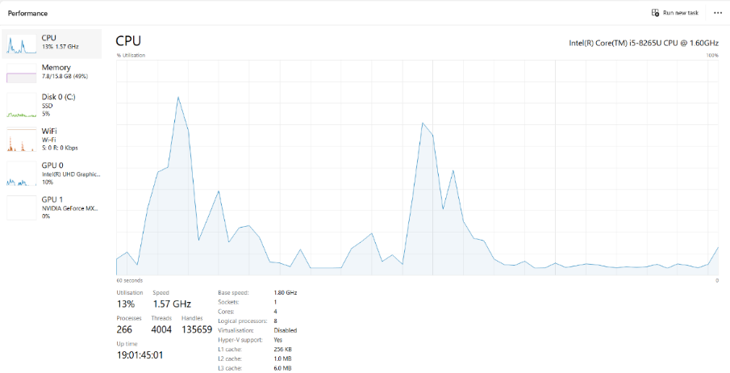

RAM (Random access memory)
RAM is the computer’s short-term memory [1]. RAM is where all data needed to run applications and open files are stored [2]. This computer has an installed RAM of 16.0 GB (15.8 GB usable). Generally, 8.0 GB of RAM is recommended for casual computer use and browsing; hence, 16 GB RAM is perfect for various demanding tasks such as gaming and running programs concurrently. This suggests that this computer is fast and good for class work and using Microsoft Office applications.
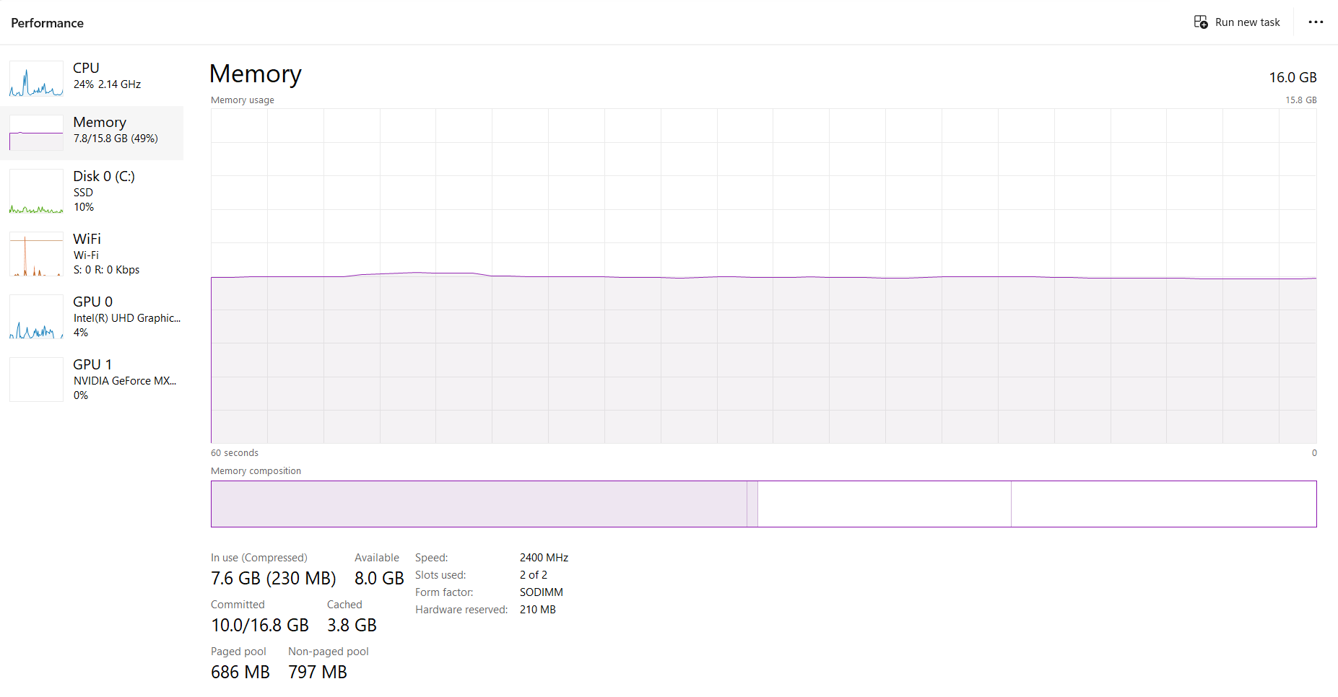

Storage capacities and types
HP ENVY x360 -15-cn1001nw has a 512 GB solid-state drive (SSD) [6]. SSD is a semiconductor-based storage gadget that generally utilises NAND flash memory to store/protect persistent data [3]. Given this computer has 512GB SSD and 16 GB RAM, it is fit for most computing tasks, such as streaming, web browsing, storage, and use of office software, as well as demanding tasks such as gaming, running various programs at the same time, and video editing. Accordingly, this computer’s storage capacities support tasks relating to school work and entertainment.

The various I/O devices
I/O devices designate any program, device, or operation which transfers data from and to the computer [4]. HP ENVY x360 - 15-cn1001nw has I/O devices, including printers, mice, hard disks, keyboards, scanners, microphones, monitors, touch pens, speakers, and cameras. These I/O devices make the computer fit for students who do a lot of printing, online classes and take pictures using a computer camera. Additionally, it provides a convenient way for students to interact with the computer, using a touch pen [6]. keyboards, and microphones to input data for processing. Accordingly, it is an appropriate laptop for students desiring to explore advanced I/O computer features to input data. Additionally, this laptop has USB 3.1, which allows the transfer of information at speeds up to 10Gbps, which suggests the hard disk has greater transfer speeds than hard disks with USB 3.0.

Operating System
OS is a scheme that recognises and configures logical and physical devices for service and typically records them in a standardised configuration such as Windows Registry [2]. HP ENVY x360 - 15-cn1001nw has Windows 11 Home. This OS has all Windows feature that any user can use, including system customisation, Windows Hello support, Windows Defender antivirus, and secure Boot. The various optimisations in this OS help this computer to run faster and maintain better performance compared to its predecessors [6]. Therefore, the OS makes it easy to manage its memory, software, hardware, and processes that empower the laptop to perform various tasks.
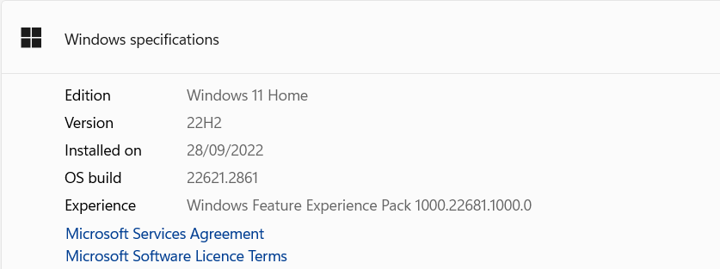

Installed Applications
This laptop has installed applications that include HP apps (HP 3D DriveGuard, HP Audio Switch, and HP JumpStart). Others include McAfee LiveSafe™, Netflix, and Microsoft Office 365. HP 3D DriveGuard is an application developed by HP to safeguard a customer’s laptop drive from vibrations and physical shock [7]. This application detects sudden reactions and movements using an accelerometer sensor that parks the hard drive heads to hinder possible damage. HP Audio Switch is an application developed by HP which enables users to manage their audio settings on their desktops and laptops [8]. HP JumpStart provides a multi-step welcome guidance to users that encompasses HP registration, HP Dropbox activation, McAfee registration, and an HP JumpStart Concierge screen with tips to help personalise one's computer apps [9]. Another application pre-installed app is Netflix. Netflix is a system that allows users to stream a wide range of movies, TV shows, and documentaries to meet their entertainment needs [10]. McAfee LiveSafe™ offers users protection against the latest ransomware, viruses, spyware, and malware.
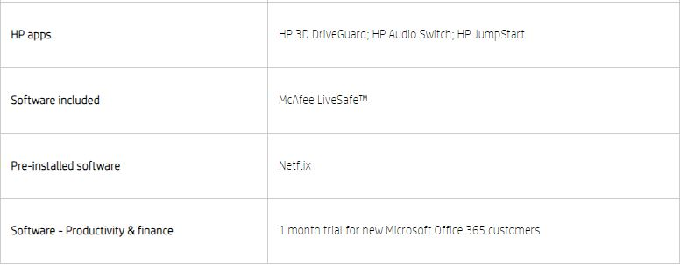

Internet connectivity
This laptop has Intel® Wireless-AC 9560 802.11b/g/n/ac (2x2) Wi-Fi® and Bluetooth® 5 Combo (Gigabit Wi-Fi® speed) with a maximum speed of 1.73 Gbps. According to Intel Corporation, Intel® wireless-AC 9560 has wave 2 features including 160MHz channels delivering up to 1.73 Gbps and downlink MU-MIMO [11]. These features provide a substantial increase in user speeds in condensed deployments, assisting in fast downloads, and long life of the battery. Intel® wireless-AC 9560 allows smooth streaming of high resolution videos and faster speed even when one moves away from the router. When utilising 160MHz channels, this connectivity can offer 5x faster Wi-Fi speeds up to 1.73Gbps. However, the downlink MU-MIMO enables an Access Point to concurrently convey data to various clients. This system can advance overall downlink network capacity potentially by over 3x [11].

Conclusion
Based on the analysis of these features, HP ENVY x360 -15-cn1001nw is a good laptop for student because the speed, CPU, the space, and RAM are fit for tasks involving learning and completing demanding tasks such as streaming, web browsing, and running applications concurrently.

References

[1] | A. Clements, Principles of computer hardware. Fourth edition., New York: Oxford University Press, 2006.
[2] | A. S. Berger, Hardware and computer organization: The software perspective., Elsevier Inc., 2005.
[3] | I. E. a. W. Wong, The architecture of computer hardware, systems software, and networking: An information technology approach. Sixth edition., Hoboken, NJ: John Wiley & Sons, Inc., 2021.
[4] | M. J. M. a. V. P. Heuring, Principles of computer architecture: Class test edition, Prentice Hall, 1999.
[5] | J. M. a. J. Roach, „Digital Trends,” 20 March 2023. [Online]. Available: https://www.digitaltrends.com/computing/how-to-build-a-pc/?fbclid. [Accessed: 29 December 2023].
[6] | „HP support. “HP Customer Support - Knowledge Base.”,” [Online]. Available: https://support.hp.com/us-en/document/c06194798. [Accessed: 7 January 2024].
[7] | „Reason. “HP 3D DriveGuard.”,” [Online]. Available: https://www.shouldiremoveit.com/hp-3d-driveguard-7302-program.aspx. [Accessed: 7 January 2024].
[8] | „HP Inc. “HP Audio Switch.”,” [Online]. Available: https://www.shouldiremoveit.com/hp-audio-switch-179834-program.aspx. [Accessed: 7 January 2024].
[9] | „HP support. “HP PCs - Using HP JumpStart (Windows 10).”,” [Online]. Available: https://support.hp.com/us-en/document/c05241398. [Accessed: 7 January 2024].
[10] | „ McAfee. “McAfee® LiveSafe™.”,” [Online]. Available: https://www.mcafee.com/en-us/antivirus/mcafee-livesafe.html. [Accessed: 7 January 2024].
[11] | „Intel Corporation. “Intel® Wireless-AC 9560.”,” [Online]. Available: https://gzhls.at/blob/ldb/d/6/6/c/832e60bd58d518d8145f3fa1787f209fec64.pdf. [Accessed: 7 January 2024].

