Lab - Accessing Network Devices with SSH
Topology
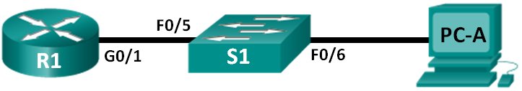
Addressing Table
Device | Interface | IP Address | Subnet Mask | Default Gateway
R1 | G0/1 | 192.168.1.1 | 255.255.255.0 | N/A
S1 | VLAN 1 | 192.168.1.11 | 255.255.255.0 | 192.168.1.1
PC-A | NIC | 192.168.1.3 | 255.255.255.0 | 192.168.1.1
Objectives
Part 1: Configure Basic Device Settings
Part 2: Configure Basic Security Measures on the Router and Switch
Part 3: Configure the Router for SSH Access
Part 4: Configure the Switch for SSH Access
Part 5: SSH from the CLI on the Switch
Background / Scenario
In the past, Telnet was the most common network protocol used to remotely configure network devices. Telnet does not encrypt the information between the client and server. This allows a network sniffer to intercept passwords and configuration information.
Secure Shell (SSH) is a network protocol that establishes a secure terminal emulation connection to a router or other networking device. SSH encrypts all information that passes over the network link and provides authentication of the remote computer. SSH is rapidly replacing Telnet as the remote login tool of choice for network professionals. SSH is most often used to log in to a remote device and execute commands; however, it can also transfer files using the associated Secure FTP (SFTP) or Secure Copy (SCP) protocols.
The network devices that are communicating must be configured to support SSH in order for SSH to function. In this lab, you will enable the SSH server on a router and then connect to that router using a PC with an SSH client installed. On a local network, the connection is normally made using Ethernet and IP.
Note: The routers used with CCNA hands-on labs are Cisco 1941 Integrated Services Routers (ISRs) with Cisco IOS Release 15.2(4)M3 (universalk9 image). The switches used are Cisco Catalyst 2960s with Cisco IOS Release 15.0(2) (lanbasek9 image). Other routers, switches, and Cisco IOS versions can be used. Depending on the model and Cisco IOS version, the commands available and the output produced might vary from what is shown in the labs. Refer to the Router Interface Summary Table at the end of this lab for the correct interface identifiers.
Note: Make sure that the routers and switches have been erased and have no startup configurations. If you are unsure, contact your instructor.
Required Resources
- 1 Router (Cisco 1941 with Cisco IOS Release 15.2(4)M3 universal image or comparable)
- 1 Switch (Cisco 2960 with Cisco IOS Release 15.0(2) lanbasek9 image or comparable)
- 1 PC (Windows 7 or 8 with terminal emulation program, such as Tera Term, and Wireshark installed)
- Console cables to configure the Cisco IOS devices via the console ports
- Ethernet cables as shown in the topology
- Configure Basic Device Settings
In Part 1, you will set up the network topology and configure basic settings, such as the interface IP addresses, device access, and passwords on the router.
  - Cable the network as shown in the topology.
  - Initialize and reload the router and switch.
  - Configure the router.
    - Console into the router and enable privileged EXEC mode.
    - Enter configuration mode.
    - Disable DNS lookup to prevent the router from attempting to translate incorrectly entered commands as though they were host names.
    - Assign class as the privileged EXEC encrypted password.
    - Assign cisco as the console password and enable login.
    - Assign cisco as the VTY password and enable login.
    - Encrypt the plaintext passwords.
    - Create a banner that will warn anyone accessing the device that unauthorized access is prohibited.
    - Configure and activate the G0/1 interface on the router using the information contained in the Addressing Table.
    - Save the running configuration to the startup configuration file.
  - Configure PC-A.
    - Configure PC-A with an IP address and subnet mask.
    - Configure a default gateway for PC-A.
  - Verify network connectivity.
Ping R1 from PC-A. If the ping fails, troubleshoot the connection.

- Configure Basic Security Measures on the Router
  - Encrypt the clear text passwords.
R1(config)# service password-encryption
  - Strengthen passwords.
An administrator should ensure that passwords meet the standard guidelines for strong passwords. These guidelines could include combining letters, numbers and special characters in the password and setting a minimum length.
Note: Best practice guidelines require the use of strong passwords, such as those shown here, in a production environment. However, the other labs in this course use the cisco and class passwords for ease in performing the labs.
    - Change the privileged EXEC encrypted password to meet guidelines.
R1(config)# enable secret Enablep@55
    - Require that a minimum of 10 characters be used for all passwords.
R1(config)# security passwords min-length 10
  - Secure the console and VTY lines.
    - You can set the router to log out of a connection that has been idle for a specified time. If a network administrator was logged into a networking device and was suddenly called away, this command automatically logs the user out after the specified time. The following commands cause the line to log out after five minutes of inactivity.
R1(config)# line console 0
R1(config-line)# exec-timeout 5 0
R1(config-line)# line vty 0 4
R1(config-line)# exec-timeout 5 0
R1(config-line)# exit
R1(config)#
    - The following command impedes brute force login attempts. The router blocks login attempts for 30 seconds if someone fails two attempts within 120 seconds. This timer is set especially low for the purpose of this lab.
R1(config)# login block-for 30 attempts 2 within 120
What does the 2 within 120 mean in the above command?
If two attempts are made within 120 seconds
What does the block-for 30 mean in the above command?
Block the user from attempting to login for 30 seconds.
  - Verify that all unused ports are disabled.
Router ports are disabled by default, but it is always prudent to verify that all unused ports are in an administratively down state. This can be quickly checked by issuing the show ip interface brief command. Any unused ports that are not in an administratively down state should be disabled using the shutdown command in interface configuration mode.

R1# show ip interface brief
Interface IP-Address OK? Method Status Protocol
Embedded-Service-Engine0/0 unassigned YES NVRAM administratively down down
GigabitEthernet0/0 unassigned YES NVRAM administratively down down
GigabitEthernet0/1 192.168.1.1 YES manual up up
Serial0/0/0 unassigned YES NVRAM administratively down down
Serial0/0/1 unassigned YES NVRAM administratively down down

- Configure the Router for SSH Access
Using Telnet to connect to a network device is a security risk because all information is transmitted in a clear text format. SSH encrypts the session data and provides device authentication, which is why SSH is recommended for remote connections. In Part 2, you will configure the router to accept SSH connections over the VTY lines.
  - Configure device authentication.
The device name and domain are used as part of the crypto key when it is generated. Therefore, these names must be entered prior to issuing the crypto key command.
    - Configure the domain for the device.
R1(config)# ip domain-name ccna-lab.com
  - Configure the encryption key method.
R1(config)# crypto key generate rsa modulus 1024
The name for the keys will be: R1.ccna-lab.com

% The key modulus size is 1024 bits
% Generating 1024 bit RSA keys, keys will be non-exportable...
[OK] (elapsed time was 1 seconds)

R1(config)#
*Jan 28 21:09:29.867: %SSH-5-ENABLED: SSH 1.99 has been enabled
  - Configure a local database username.
R1(config)# username admin privilege 15 secret adminpass
Note: A privilege level of 15 gives the user administrator rights.
  - Enable SSH on the VTY lines.
    - Enable Telnet and SSH on the inbound VTY lines using the transport input command.
R1(config)# line vty 0 4
R1(config-line)# transport input telnet ssh
    - Change the login method to use the local database for user verification.
R1(config-line)# login local
R1(config-line)# end
R1#
  - Save the running configuration to the startup configuration file.
R1# copy running-config startup-config
Destination filename [startup-config]?
Building configuration...
[OK]
R1#
  - Establish an SSH connection to the router.
    - Start Tera Term from PC-A.
    - Use Tera Term to telnet to R1.
Does R1 accept the Telnet connection? Explain.
No, as using SSH does not allow telnet to be used.

Use Tera Term, establish an SSH session to R1. Use the username admin and password adminpass. You should be able to establish an SSH session with R1.
Does R1 accept the SSH connection? Yes, the SSH connection is accepted
    - Intentionally mistype the user and password information to see if login access is blocked after two attempts.
What happened after you failed to login the second time?
The router refuses the connection after two incorrect attempts.
    - From your console session on the router, issue the show login command to view the login status. In the example below, the show login command was issued within the 30 second login blocking period and shows that the router is in Quiet-Mode. The router will not accept any login attempts for 14 more seconds.
R1# show login
A default login delay of 1 second is applied.
No Quiet-Mode access list has been configured.

Router enabled to watch for login Attacks.
If more than 2 login failures occur in 120 seconds or less,
logins will be disabled for 30 seconds.

Router presently in Quiet-Mode.
Will remain in Quiet-Mode for 14 seconds.
Denying logins from all sources.
R1#
    - After the 30 seconds has expired, SSH to R1 again and login using the SSHadmin username and Admin1p@55 for the password.
After you successfully logged in, what was displayed?
This user has not been set up, however I have set it up with privilege level 1. It shows the login banner, but it is not in privileged exec mode like the regular admin is due to the privilege level.
    - Enter privileged EXEC mode and use Enablep@55 for the password.
If you mistype this password, are you disconnected from your SSH session after two failed attempts within 120 seconds? Explain.
No, as the block for 30 2 attempts within 120 only applies to login to the router, not to go onto privileged exec mode.
    - Issue the show running-config command at the privileged EXEC prompt to view the security settings you have applied.
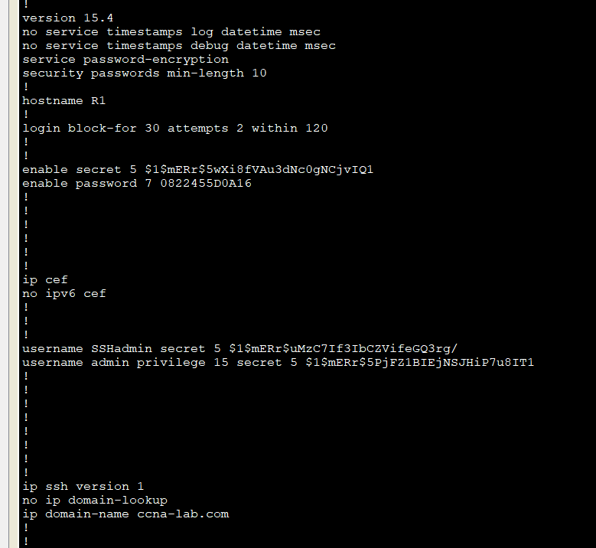

- Configure the Switch for SSH Access
In Part 3, you will configure the switch in the topology to accept SSH connections. After the switch has been configured, establish an SSH session using Tera Term.
  - Configure the basic settings on the switch.
    - Console into the switch and enable privileged EXEC mode.
    - Enter configuration mode.
    - Disable DNS lookup to prevent the router from attempting to translate incorrectly entered commands as though they were host names.
    - Assign class as the privileged EXEC encrypted password.
    - Assign cisco as the console password and enable login.
    - Assign cisco as the VTY password and enable login.
    - Encrypt the plain text passwords.
    - Create a banner that will warn anyone accessing the device that unauthorized access is prohibited.
    - Configure and activate the VLAN 1 interface on the switch according to the Addressing Table.
    - Save the running configuration to the startup configuration file.
  - Configure the switch for SSH connectivity.
Use the same commands that you used to configure SSH on the router in Part 2 to configure SSH for the switch.
    - Configure the device name as listed in the Addressing Table.
    - Configure the domain for the device.
S1(config)# ip domain-name ccna-lab.com
    - Configure the encryption key method.
S1(config)# crypto key generate rsa modulus 1024
    - Configure a local database username.
S1(config)# username admin privilege 15 secret adminpass
    - Enable Telnet and SSH on the VTY lines.
S1(config)# line vty 0 15
S1(config-line)# transport input telnet ssh
    - Change the login method to use the local database for user verification.
S1(config-line)# login local
S1(config-line)# end
  - Establish an SSH connection to the switch.
Start Tera Term from PC-A, and then SSH to the SVI interface on S1.
Are you able to establish an SSH session with the switch?
Yes, after creating the SVI interface an SSH connection was established.
- SSH From the CLI on the Switch
The SSH client is built into the Cisco IOS and can be run from the CLI. In Part 4, you will SSH to the router from the CLI on the switch.
  - View the parameters available for the Cisco IOS SSH client.
Use the question mark (?) to display the parameter options available with the ssh command.
S1# ssh ?
-c Select encryption algorithm
-l Log in using this user name
-m Select HMAC algorithm
-o Specify options
-p Connect to this port
-v Specify SSH Protocol Version
-vrf Specify vrf name
WORD IP address or hostname of a remote system
  - SSH to R1 from S1.
    - You must use the –l admin option when you SSH to R1. This allows you to log in as user admin. When prompted, enter adminpass for the password.
S1# ssh -l admin 192.168.1.1
Password:
***********************************************
Warning: Unauthorized Access is Prohibited!
***********************************************

R1#
    - You can return to S1 without closing the SSH session to R1 by pressing Ctrl+Shift+6. Release the Ctrl+Shift+6 keys and press x. The switch privileged EXEC prompt displays.
R1#
S1#
    - To return to the SSH session on R1, press Enter on a blank CLI line. You may need to press Enter a second time to see the router CLI prompt.
S1#
[Resuming connection 1 to 192.168.1.1 ... ]

R1#
    - To end the SSH session on R1, type exit at the router prompt.
R1# exit

[Connection to 192.168.1.1 closed by foreign host]
S1#

What versions of SSH are supported from the CLI?
SSH versions 1 and 2 are supported from the CLI.
s1(config)#ip ssh version ?
<1-2> Protocol version
s1(config)#ip ssh version
How would you provide multiple users, each with their own username, access to a network device?
To do this, the username command can be used (Just like when creating the admin account) to create usernames and passwords, which can be used to remotely connect to the router or switch, with their own privilege levels.

Reflection (max 800 words):
Write a research report comparing various Encryption standards, e.g AES, SHA, DES, RSA.

Introduction
In this report, I will be writing about the following encryption standards:
AES
SHA
DES
RSA
I will be comparing these standards against each other in terms of how secure they are, as well as the pros and cons of each one.

AES
AES stands for Advanced Encryption Standard, and is most known for its use on WhatsApp, as it encrypts messages to ensure that only the user that it is intended for sees it. It is also used to encrypt files on programs such as VeraCrypt and WinZip. AES is currently the standard method used to encrypt, as it is currently one of the most secure.
AES is done by dividing data into blocks. AES has a 128 bit block size, so data is split into a 4x4 column (8 bits in a byte, and 16x8=128). There are ten different rounds of encryption done with this method for a 128-bit key, 12 rounds of encryption for a 192-bit key and 14 rounds when encrypting using 256 bits. When using this process, an encryption key is created which is used to decrypt the message. The key must be known to encrypt or decrypt the message. Typically, 192 or 256 bits are only used for US government to encrypt top secret documents.

In the home, AES is used to encrypt things such as WhatsApp messages, file transfers and is also used in order to encrypt a WiFi router, along with the WPA2 protocol. (DeMuro, 2018)

SHA
SHA has two different forms – SHA-1 and SHA-2 is the successor of SHA1. Both SHA-1 and SHA-2 are very different in terms of construction (How the hash is created from the data) and the signature length for the hash is also different.

SHA-1 is a 160-bit hash and SHA2 can come in a variety of different lengths, the most common one being 256 bits. SHA-2 is the most widely supported variety of this algorithm in this day and age, due to research showing that SHA-1 was in fact weak and a more secure algorithm is needed. From 2016, SHA-2 has been used, and must be used if a website wants to get an SSL certificate.

256-bit and 384-bit SHA-2 algorithms are the most commonly used, where 224-bit and 512-bit algorithms are rarely seen.

There may not seem to be much difference in the two, however if the hash is larger, there are more possible combinations, and therefore it can ensure that there is a greater level of security on the website and can make it much less vulnerable. For SHA-2, there are 2 to the power of 256 different hash combinations. It is estimated that SHA-2 may last a few more years before needing another rethink. (Lynch & Nohe, 2018)

DES
DES has got a reputation of being one of the more vulnerable types of encryption that there is, due to it being compromised on a few occasions. It was first thought of back in 1977, and was withdrawn from use in 2005 due to it being found to be weak, in many studies.
The idea of DES was that of the US federal government, who developed it in order to encrypt all communications with the government. The idea was that all systems used the same standard to ensure that connection was maintained.
In order to prove that DES was no longer fit for use, a series of challenges were made by two organisations. In 1997, a brute force attack on the algorithm took 84 days to decrypt a message. In 1998, another challenge was created which took just over a month, and in 1999, a final challenge only took little under a day to crack, proving that it was no longer fit for purpose.
DES works similar to AES with multiple rounds of encryption, but the reason it failed was due to it having a much shorter key length (Less than half of an AES key), which, as mentioned earlier in this assignment, can play a huge part in how things are kept encrypted. (Townsend Security, 2018)

RSA
RSA encryption was developed in the 1970s, and is slower than other types of encryption hence why it is not used much. In this system, two keys are created – a private key and a public key. The private key is kept private, and the public key is a shared one (Hence the names). (Garcia, 2017)
In this type of encryption, a user can send out a public key which any user can use to send a message. Only the person who sent out the public key, and has the private key can decrypt and view this message. If one key is used, use of other keys is cancelled and other users cannot use them.

To put it simply:
User A must know user Bs private key to encrypt the message.
User B must know their private key to decrypt the message
For user A to send the encrypted message, user B must send their private key to user A
User B never distributes their private key.

References for this document:
Curran, B., 2018. What is RSA Cryptography? Complete Guide to this Encryption Algorithm. [Online]
Available at: https://blockonomi.com/rsa-cryptography/
[Accessed 8 12 2019].
DeMuro, J., 2018. What is AES?. [Online]
Available at: https://www.techradar.com/news/what-is-aes
Garcia, J., 2017. How does RSA work?. [Online]
Available at: https://hackernoon.com/how-does-rsa-work-f44918df914b
[Accessed 8 12 2019].
Lynch, V. & Nohe, P., 2018. The difference between SHA-1, SHA-2 and SHA-256 hash algorithms. [Online]
Available at: https://www.thesslstore.com/blog/difference-sha-1-sha-2-sha-256-hash-algorithms/
[Accessed 5 December 2019].
Townsend Security, 2018. AES vs. DES Encryption: Why Advanced Encryption Standard (AES) has replaced DES, 3DES and TDEA. [Online]
Available at: https://blog.syncsort.com/2018/08/data-security/aes-vs-des-encryption-standard-3des-tdea/
[Accessed 8 12 2019].

