
Title: Marketing Management – Assessment – 2

Course Name: Master of Business Administration
Course Code: LCMB7001
Student: Errol Malcolm
Student Number: 1709503
Lecturer: Tushara Balendran

Diagram sourced from: (jeetsingh568.blogspot.com)


Contents:
Executive Summary: 4
A. Background: 5
PESTEL: 6
Political: 6
Economic 6
Social: 6
Technological: 6
Ecological: 6
Legal: 7
Positives, 7
Negatives, 7
Porters five forces: 7
Threats to market for new entrants 7
Bargaining power of buyers: 7
Bargaining power of suppliers: 7
The threats to alternative products or services: 7
Rivalry amongst existing competition: 8
Positives: 8
Negatives 8
Weaknesses: 9
Opportunities: 9
Threats: 9
Positives 9
Negatives, 9
Market segmentation, targeting marketing and positioning and their use in developing marketing strategies and marketing plans: 9
Positives: 11
Negatives: 11
Marketing Mix Strategies: 12
Place: 13
Price: 13
Promotion: 13
People: 13
Physical Environment: 13
Process: 14
Product: 14
Positives: 14
Negatives 14
The Ansoff Matrix: 15
b.) Recommendations: 15
Conclusion: 16
References: 18
Appendix 1. 21
Information on Photos and some Diagrams Selected: 21

Diagram sourced from; The Astronomical Math Behind UPS' New Tool to Deliver Packages Faster | WIRED

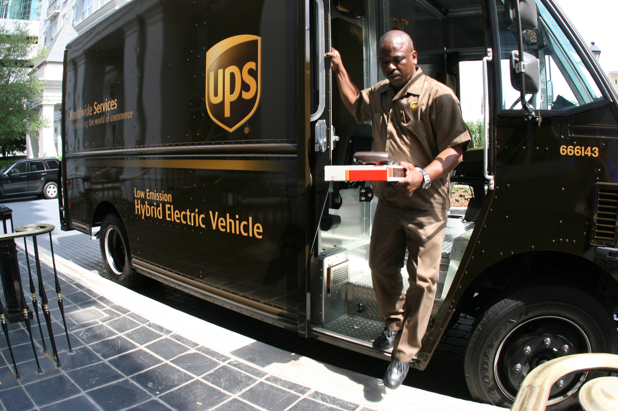

Executive Summary:
The purpose of this report is to conduct an environmental marketing analysis taking into consideration the key external influencing drivers together with an analysis of the internal environment and the role that marketing plays within the United Parcel Services (UPS) organisation.
Diagram below sourced from: UPS Boeing 777-200 Freighter for FSX (flyawaysimulation.com)
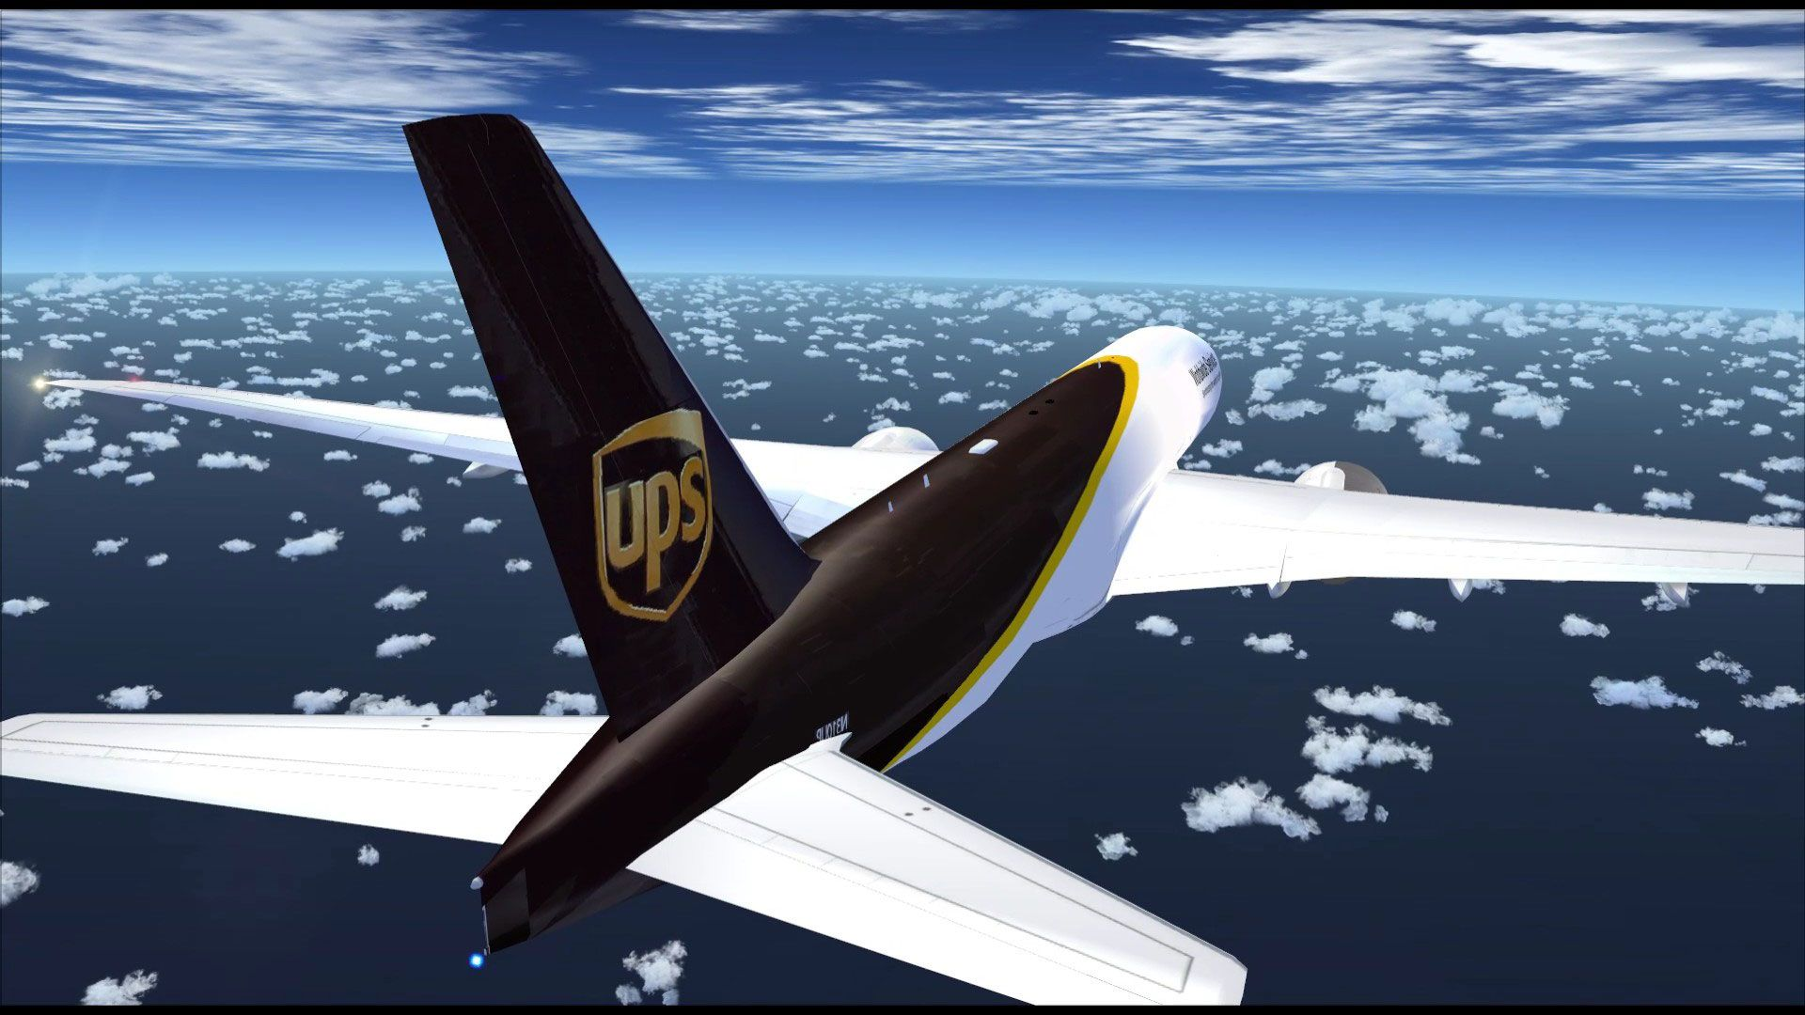

Diagram below sourced from: 'A day in the life' helps Armstrong Teasdale lawyer better understand client - Kansas City Business Journal (bizjournals.com)


Background:
Theoretical frameworks enable individuals, entrepreneurs, and marketing managers, to view an organization in a multitude of way’s, internally, externally, by applying a Swot analysis, which looks at strengths and weaknesses of an organisation. Furthermore, a Pestel, which allows you to look at the external macro environment, and Porters five forces, assist with analysing the competitive intensity, and the attractiveness of an industry.
Diagram below sorced from: Model T Ford Forum: Point me to a photo. (mtfca.com)
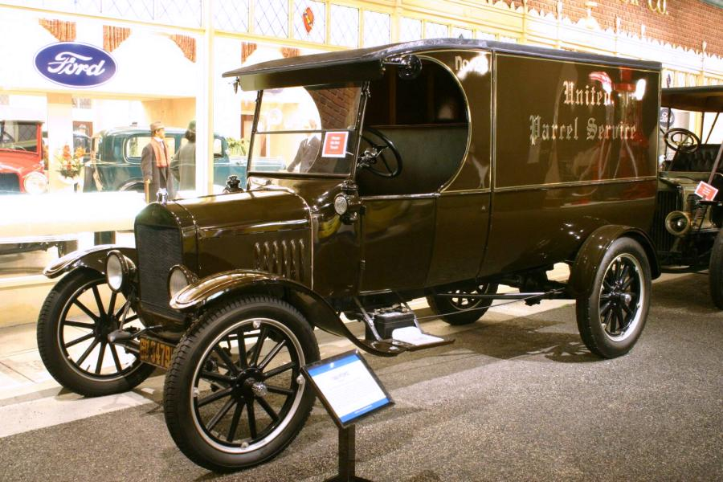

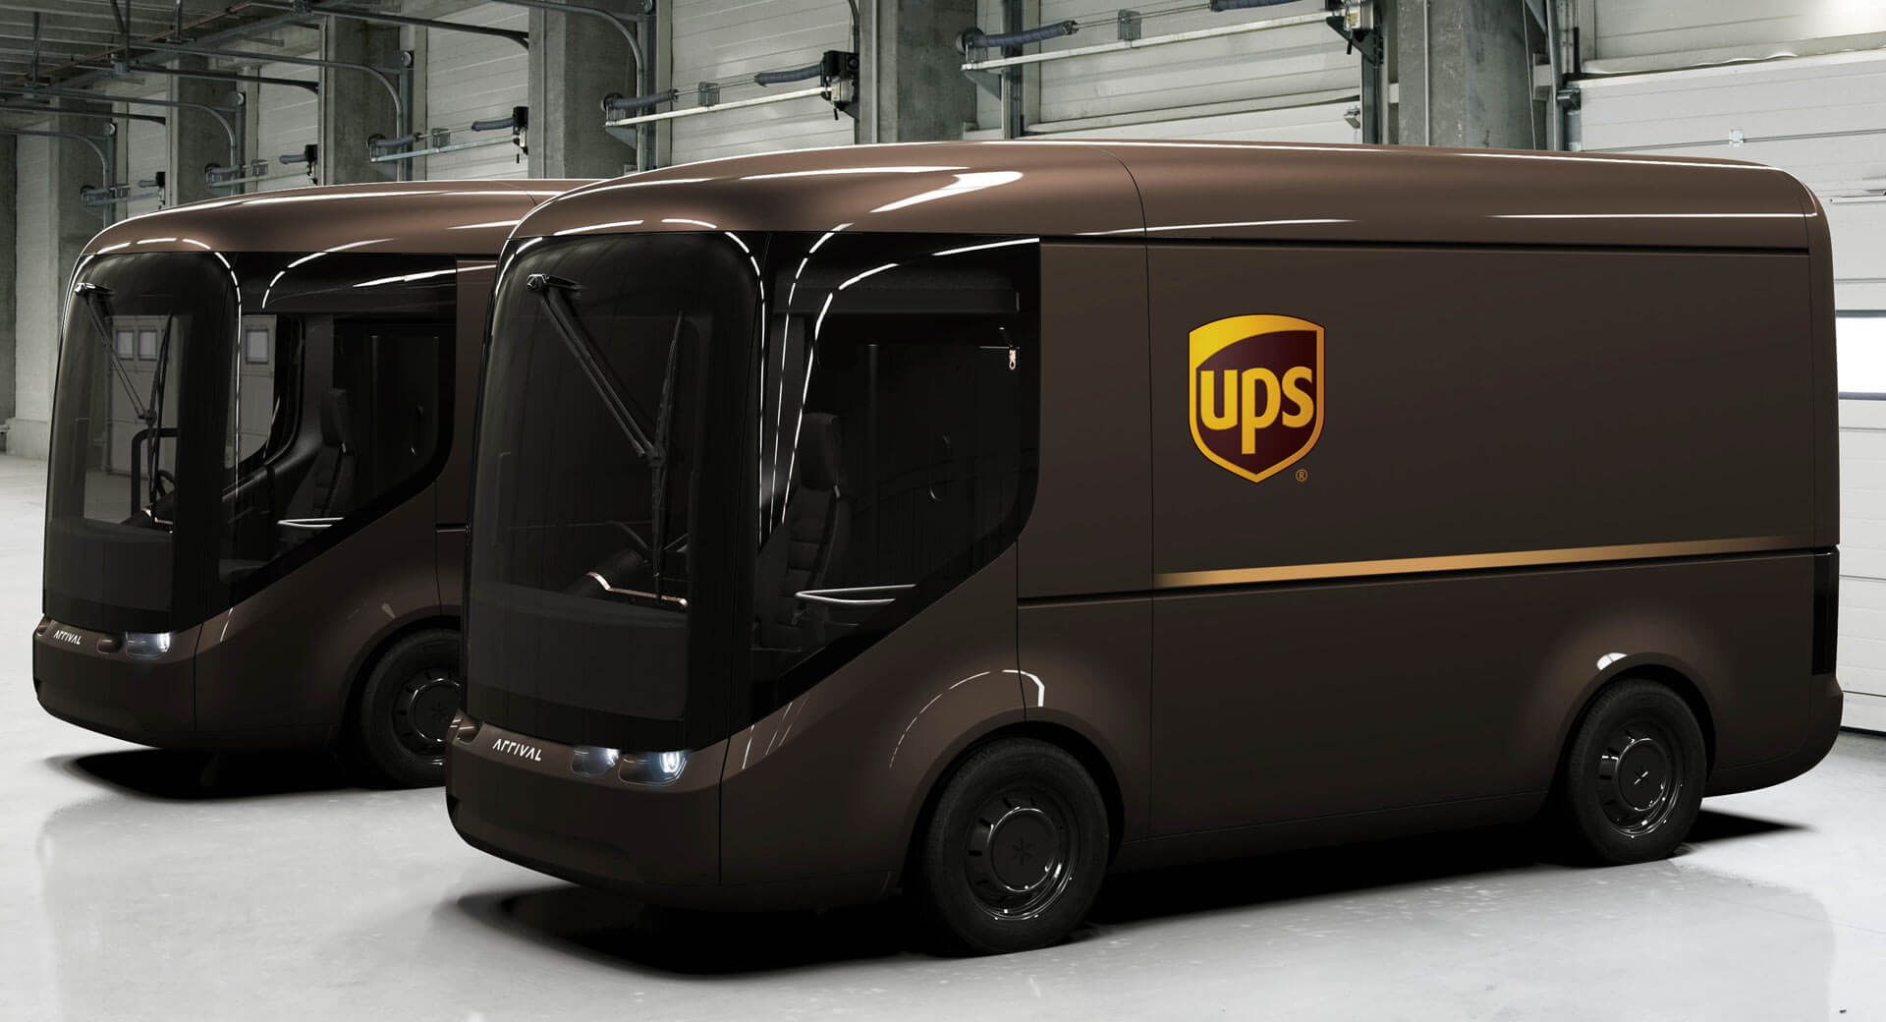
Diagram above sorced from: UPS Unveils New Electric Delivery Trucks With 150+ Mile Range | Carscoops

PESTEL:
The PESTEL structure has the ability to assist management with their decision-making abilities, in how you view (Political, Economic, Social, Technological, Ecological, and Legal) understandings of an organisation (Espinoza et al. 2019).
Diagram sourced from: PESTLE Analysis Diagrams Google Slides Presentation Template (slidesalad.com)
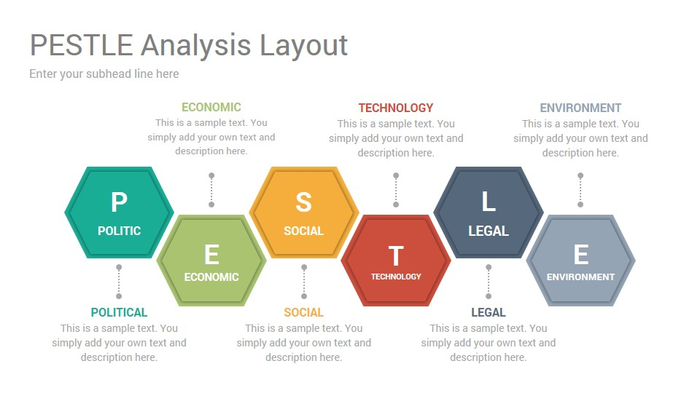
Political: UPS’s compliance with UK Law’s, VAT regulations, also the post-Brexit trade agreement, and alterations to the UK economy (Hatzigeorgiou and Lodefalk, 2016). Unfavourable, due to the importation of goods from Europe post-Brexit.
Economic: US companies top the list for trades with the UK, (Walker and Palumbo, 2018) exchange rates and stability of host countries. Unfavourable, due to the present conditions of global lockdowns.
Social: COVID-19 pandemic, consumers being more concerned with health issues. The organization are known for connecting and improving communities across the globe, donating 20 million hours, and the planting of 15 million trees (UPS Sustainability Progress Report, 2019). Favourable, due to the positive global inputs by the UPS organisation.
Technological: UPS impacting on their value chain to increase efficiency. Present advances in efficient technologies (UPS Sustainability Progress Report, 2019). Favourable, due to how technology advances progression for the human race.
Ecological: Preserving the world’s forests to reduce carbon emissions (UPS Sustainability Progress Report, 2020). Favourable, due to the positive global effects, produced for the benefits of humanity.
Legal: Health and safety laws, employment law, data protection, Income tax 501.00m, Rate, 27.17%, tax % revenue 0.59% (UPS Stock Analysis, 2021). Unfavourable due to employment laws, considering the new restrictions and points based-systems for European nationals.
Positives, ecological involvement to lower global carbon emissions, and for their input in social issues which improves communities around the globe, also the advancement with modern technologies.
Negatives, coping with COVID-19 globally, post Brexit trade agreement, alterations to UK VAT regulations.

Porters five forces:
According to Diane, et al. (2020) to gain an understanding of any industry and its appeal, the five forces model is what helps to attain this. (Which was published by Porter in the late seventies). The five forces model enables you to view the particular industry from five viewpoints, they are as follows: threats to market of new entrants, the bargaining power of buyers, the bargaining power of suppliers, the threats to alternative products or services, and the rivalry amongst the existing competition (Porter, 1979 ;Diane, et al. 2020).
Diagram sourced from: Thompson Crawford UF ENT6930: INDUSTRY: 5 Forces Model

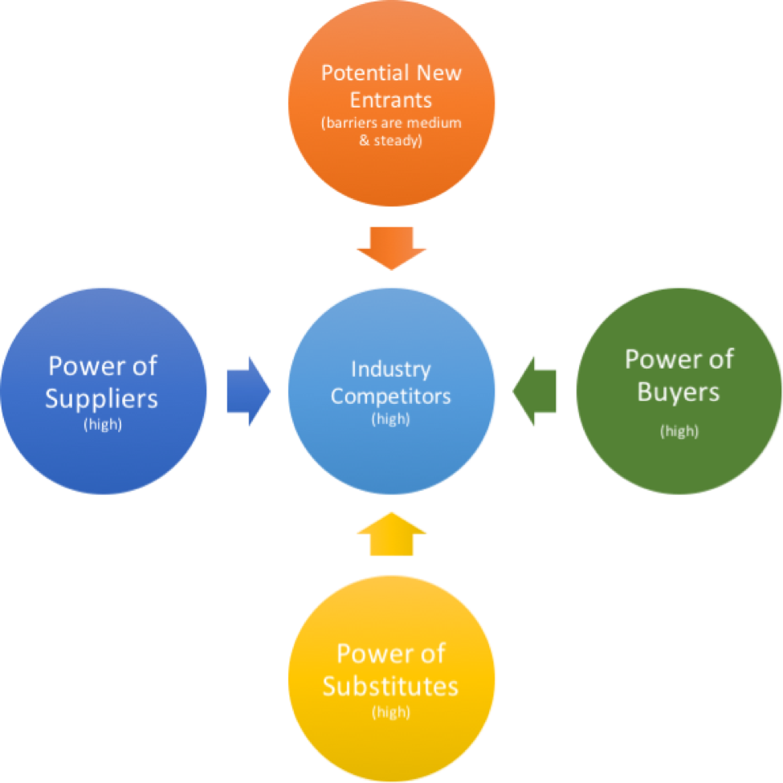
Threats to market for new entrants: This is considered low in the logistic and shipping freight industry, which is due to the substantial financial outlay for this type of business. Additionally, one new entrant could be Amazon who already deliver some parcels to their consumers (Stevens, 2018). The barriers to entry for new entrants are due to technology, blockchain (Hickius and Petersen, 2020).
Bargaining power of buyers: This is considered low, which is due to the substantial consumer numbers that use UPS.
Bargaining power of suppliers: This is considered medium, UPS have their own planes, however, during the months of November to December they lease planes from Wet Leased Aircrafts (UPS, 2019).
The threats to alternative products or services: This is considered low, for alternatives, the reason being UPS provide a logistical service, so if a consumer requires a package from a particular part of the world, it will be required to be shipped or delivered by, air freight. Alternatives are, maybe waiting for individuals to travel to that part of the world where intended package is destined.
Rivalry amongst existing competition: There are a number of rivals operating in this field, here are a few: Fed Ex, Royale Mail, Amazon, (Barton and MacArthur, 2019), also XPO, DHL, and others. All competing for market share, the closest rivals to UPS, are Fed Ex, others are not too far behind, which makes this industry very competitive.
Positives: threats from new entrants, bargaining power of buyers, threats to alternative products or services are all low, due to the huge financial outlay. Four additional positive forces could be applied suggested by (Diane, et al. 2020).
Negatives: bargaining power of suppliers is medium, competition for this market is high due to rival competitors. In addition, there are scholars from Carlton University who adopt the view that Porters model should have an additional four more forces, which are: “the competitors level of innovativeness, exposure to globalization, threat of digitalization, and industry exposure to de-regulation activities”, which would embrace all parts of the system that connect and rely on each other in tune with how business functions today. However, these four forces have not been applied (Diane, et al. 2020).
According to Nikolic and Stocic-Mihajlovic, (2020) in these current conditions businesses are shaped by unpredictability, and fast-paced changes, in the complexed shaky business environment. Furthermore, the environment also has its own influence too on business enterprise, but the effects here work either way, enterprise also has its effects on the environment. Additionally, this is why its significant to carry-out an analysis on the environment, looking at both internal, and external environments, Internally these are strengths and weaknesses, externally they are opportunities, and threats. In addition, looking at the strategic environment, is the foundation to business success and continuance (Nikolic and Stocic-Mihajlovic, 2020).

Diagram sourced from www.slideteam.net.
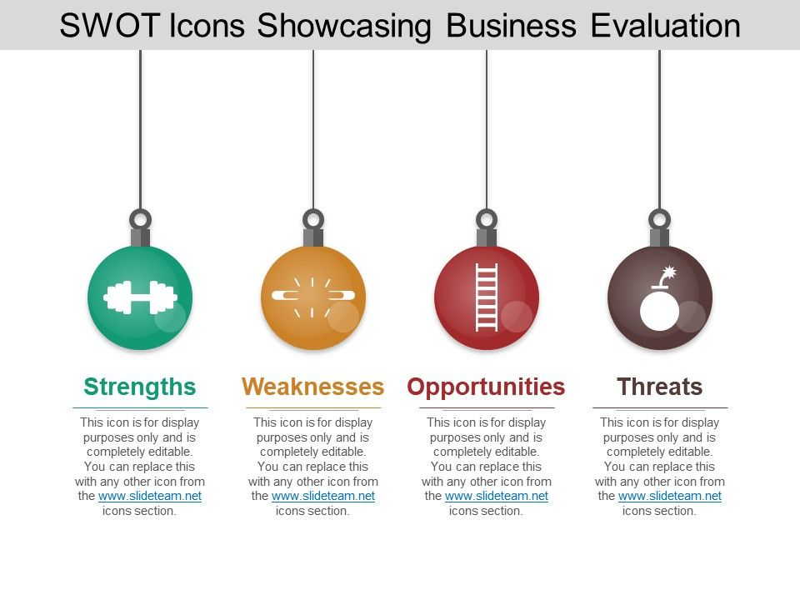Strengths: Global brand recognition which has allowed the organization to diversify their UPS Worldwide Express and Express Plus, to an additional 40 countries and the organisation are now able to deliver, as well as giving definite times for deliveries on shipments for their business consumers, this will now include an additional 140 countries and regions around the globe. In addition, developing their own renewable gas energy, and electric vehicles, vans, and bikes which will assist the organisations reduction on pollution. UPS are currently placed 48th on the Forbes listings for the world’s most valuable brands (Swant, 2019; UPS Sustainability Progress Report, 2019; UPS Business Strategy Hub, 2020; Llewellyn, 2020).
Weaknesses: Relying too heavily on their domestic market, with the US being the biggest market for UPS and the lion’s share of their profits. Therefore, placing the organisation too reliant on home grown profits. Additionally, for 2019, statistics on US logistics concerning package deliveries together with freight accumulated a sum of $58.6 billion, however, for the international market this accumulated a sum of $15.41 billion. Therefore, demonstrating that if the US suffers a down-turn such as a recession the organisation will suffer the effects (Business Strategy Hub, 2020).
Opportunities: UPS development into emerging markets will ensure that UPS reach out to a wider audience and will see the brand acquire increased growth, which can be accomplished by purchasing smaller logistical businesses in Europe. Additionally, there are also opportunities in Asia, Latin America, and Africa, to boost market share. Innovation, and technology has produced vast opportunity for the organisation globally, additionally, with E-commerce growing at such a rate and new businesses entering at such a pace. These businesses require the services of logistics which is an area for UPS to take advantage (Business Strategy Hub, 2020; UPS Staff writer,. 2016).
Threats: Competitors such as Fed Ex, Royale Mail, Amazon, who also utilise UPS’s logistical service. Also, others such as DHL Express, XPO, Uber, Gati. High competition has led to the organisation spending heavily on marketing. Furthermore, due to the spread of COVID-19 globally, UPS have predicted a drop in revenue of 7% for 2020, and if it is not curtailed they may incur more losses (Barton and MacArthur, 2019; Business Strategy Hub, 2020).
Positives, UPS are showing their commitment to renewable energies and sustainability around the globe, and huge possibilities in emerging markets if the organisation seek out the possibilities of European mergers, as well as other opportunities. Additionally, a boost of more business for UPS with the added 40 countries adopting the use of their Worldwide Express and Express Plus services, and the definite time slots for deliveries to 140 countries globally (Business Strategy Hub 2020).
Negatives, so many other organizations competing in the same worldwide market-place, in addition spending vast sums to keep ahead of their competition. Additionally, UPS have Amazon as customers who bring in 11.6% of sales, however, Amazon are also looking to seek more of a foothold in the logistical business themselves, which will incur the loss of business at some point further down the line for UPS (Strategy Hub Business 2020).

Market segmentation, targeting marketing and positioning and their use in developing marketing strategies and marketing plans:
Segmentation: Helps to ensure UPS, have an understanding about their consumers and their requirements, coupled with emerging possibilities to new markets. Yankelovich and Meer, (2006), have uncovered that, if carried-out correctly, a proper segmentation will highlight the groups that are more worthy of attention, by seeking out what their consumer requirements are, as well as the benefits, and specifics that are required for these groups, to establish the consumers that are likely to pay the higher premium, or those that require the lower premium. Once this information is obtained, marketing teams, are now able to drive profit margins upwards. UPS, also have a wide variety of consumers, from varied sectors, such as aerospace, retail, healthcare, professional services, industrial manufacturing, consumer services, and Governments, therefore, having a selection of target markets, and the reason why the organization adopts a mix of targeting strategies. The UPS approach to positioning strategy is to create a vision of logistics in the minds of likely consumers, which enables individuals to spend their money on such services (UPS, 2021; Gengler and Mulvey, 2017).
Sole Proprietorship Images, Stock Photos & Vectors | Shutterstock
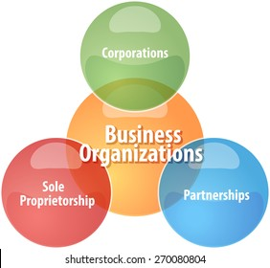
However, according to O’brian et al., (2020) macro segmentation is how a company can utilise segmentation variables, for instance an organisations size, where they are situated, and the type of industry they are. A larger organisation might purchase a similar item, or service to a smaller company, but in a dissimilar way. A larger organisation may purchase larger orders, and possibly have a standard procedure. There will also be individual departments for selective purchases that are linked to quality control and individual authority, which are likely to receive a discount on services. Furthermore, organisations will need to factor in larger order discounts, for their clients that spend that much more, organisations will also need to have professional sales advisors, additionally, organisations may, from time-to-time help with the marketing mix for certain companies, which would require a dedicated sales advisor, for each client.
In addition, for the smaller clients that do not need a larger service or discounted service, may adopt a model that serve a greater number of smaller businesses, that may not be far off attaining higher profits, just like the larger organisations in the same sector. And micro segmentation on the other-hand, is where all companies purchase in different ways from others in the same sector, organisations that sell their services are required to gain a thorough understanding of this process. In addition, sales advisors will need to gauge an understanding of the procedure to be able to function properly and grasp an understanding of the purchasing knowledge of standard pricing, jointly with looking to develop long-term business relations O’brian et al., (2020).
The way UPS apply segmentation to their consumers are by taking care of their changing requirements, which helps the organisation to gain a better understanding, of the various groups, from a demographical view-point, which consists of; age, gender, lifestyle, income, values, buying behaviours, geographics, as well as taking-into-account the type of business, for instance, their b2b, and b2c consumers by gaining an understanding about them they are listed by their behavioural segmentation types, which gives the organisation better marketing options whether that be for businesses, individuals, retail, or industries, this relates to UPS differentiated market strategies (UPS annual report, 2019).
Positives: are a wide consumer selection base, great possibilities in the emerging sectors, the potential for increased profits look promising ahead until 2025.
Negatives: are that global lockdown’s may have slowed down the emerging market sectors for the foreseeable future.
The diagram below represents UPS market share from 2017 – 2025.
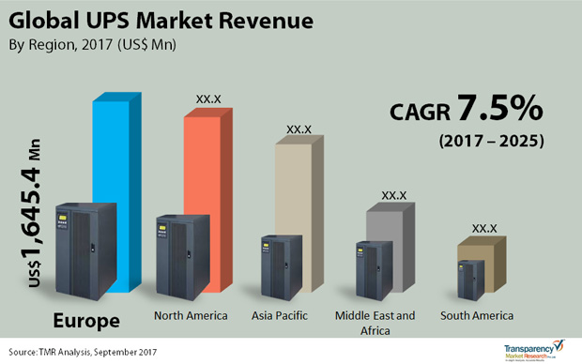
The diagram below displays domestic and international prices, sourced from: Shipping Policy (gymsupply.com)
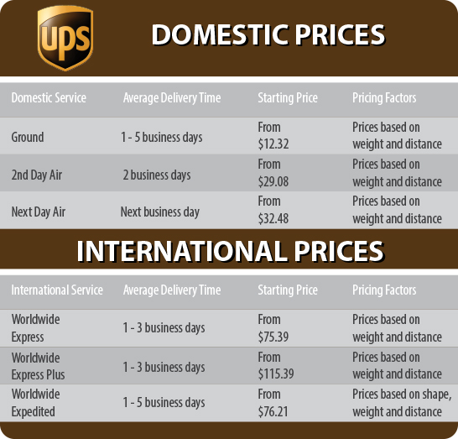

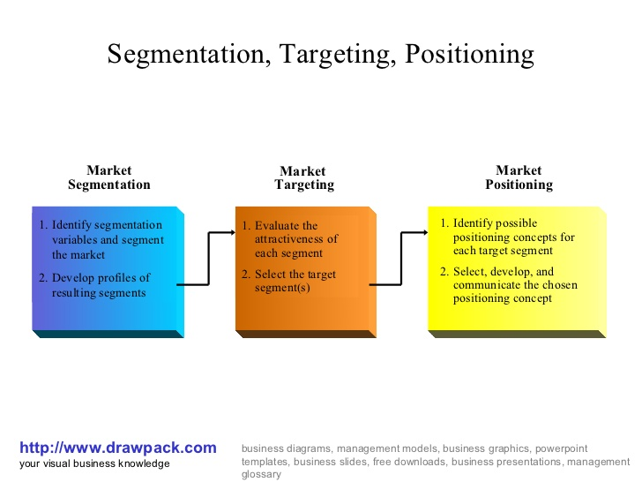

Marketing Mix Strategies:
For managers of marketing, it is to ensure that effectiveness is applied to projects of marketing planning, and the correct analysis about the consumer, or the competition, as well as taking-into-account the internal and external forces, present fashionable trends, assumptions are the frameworks implemented and applied to make decisions in marketing (Hollensen, 2010; Kotler, and Keller, 2009). In addition, according to Kotler, (2017, p. 235 / 236) once you have selected the course of your marketing mix, the task now is to get the message out to your target market, making certain to apply the work carried out upholds the strategic plan, the next phase requires positioning to set it all in stone, so for instance, if the task set out, is to create a high-quality service, this must be implemented (Kotler, 2017, p. 235 / 236; Joonwood et al. 2017).
Diagram sourced from: "Offline" Marketing Strategies | Red Matchstick Marketing
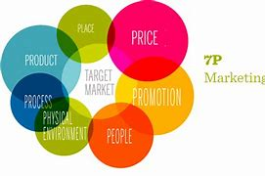

Place:
UPS are a worldwide organisation, there world headquarters are based in 55 Glenlake Parkway NE Atlanta, GA 30328 United States, however, there are other offices based around the globe, which are: Singapore, Belgium, and Miami, that cover Asia, Europe, and the Caribbean. The UPS organisation now operate in 220 countries across the globe, which takes care of distribution, additionally, UPS own hubs in Philadelphia, Illinoi, as well as Louisville USA, furthermore, Cologne Germany, and Hong Kong China (UPS Contact Us, 2021).

Price:
The organisation do have their fair amount of competition in the logistics field, which can be local, and international from a variety of similar organisations already mentioned in the swot analysis. UPS have embraced a competitive pricing structure that is similar to their competitors, however, to retain consumer loyalty, they do their utmost to give the best service available. Furthermore, the pricing strategy all depends on a few factors, for instance, the distance, the mode of transport, size of package, time of delivery, the weight of package, there are also domestic, or international prices to consider too, and the handling charges, freight charges with bulk packages, and custom duty fees (Mazarenu, 2020; UPS, 2021).

Promotion:
UPS are a world-renowned organisation and are involved in several marketing acts to promote the organisations brand and name to the consumer. UPS advertising has cost $100m, which consists of news-papers, bill-board hoardings, magazines, and celebrity endorsements, one of which has been with Eva Longoria hosting a web chat, talking about her businesses, which was hosted by Kevin Warren, the Chief Marketing Officer at UPS. UPS when considering consumer purchases, the organisation will offer discounts with the more sizeable orders, and other promotional offers. UPS also promote their services with all their vehicles, this creates brand awareness for consumers. UPS also understand the significance of social media, by means of their website, which promotes their services and branding. The organisation have acquired several partnerships, from Government agencies, healthcare, to non-profit organisations, and manufacturers (UPS Healthcare and The Foundation, 2021; Swani and Milne, 2017; Aaker, 2004; Berry, 2000; The Unstoppable Webinar Series, 2021; Media Radar, No date).

People:
The Chief executive officer at the UPS organisation is Carol Tome, who has replaced David Abney, who stepped down on 12th of March 2020. The UPS organisation have a workforce globally of 543,000, with some individuals working on a part-time basis, and some who work seasonally. Workers apply their work in various sections, some are drivers, some work in warehouses, some are mail delivery, or dedicated door delivery, or various workforce who travel to various parts of the globe. UPS also have air crews, and air cargo sections, and other workers who apply their work through the brokerage section of the organisation. All workforce members receive the correct training, for instance when working with hazardous materials, UPS managers have to ensure the correct training is appropriately carried out, as not to incur Government penalties (Mazarenu, 2021; UPS stories, 2021; Snider, 2021).

Physical Environment:
UPS ensure their consumers receive a unique service, parcels are collected from the door- steps of houses, by workers wearing the organisation’s brown logo branded uniform, also driving the brown UPS branded van, consumers receive a receipt for the goods, also there are various types of insurance to choose from, and a dedicated customs clearance service, the consumer also receives tracking service information from the organisation through website, by phone, or SMS (UPS tracking service, 2021).

Process:
The UPS organisation is an organisation that operates heavily on technology, which is linked to our shipping, tracking, pricing, mobile apps, b2c, these are deliverables, that provide a seamless function for the organisation. They also adopt cost effective solutions for sending small parcels. Workers are continuously trained and kept up to speed with the latest technologies, in doing so, this creates higher profits for the organisation, and adds to the consumer experience (UPS tracking service, 2021).

Product:
UPS is a worldwide organisation providing a unique service which is tailored to suit all, such as businesses, manufacturing, healthcare, retail, the air industry, and Governments. Furthermore, delivery times can be selected, to suit all consumers, i.e., same day, next day, two days, which covers the domestic market, however, for the international market, parcels can either be expressed critical, express plus, express, express saver, or express standard. The marketing mix, for the organisation consists of a worldwide package delivery service, also a supply chain and consignment service (Forbes, 2021). UPS have built a positive brand equity by delivering on the brand promise, the brand globally represents reliability, trust, quality service that incorporates innovation, which are the organisations core values. Additionally, all linked with their mission statement is called brand management (Swani and Milne, 2017; Aaker, 2004; Berry, 2000; Kotler, 2017 pp. 264).
Positives: are that this model aligns the marketing concept to ensure that marketing is less challenging.
Negatives: however, this model may be more challenging to others, due to the additional 3P’s,
Diagram below sourced from: UPS Deploys Delivery e-Bike In Downtown Pittsburgh (Pennsylvania) (cleantechnica.com)
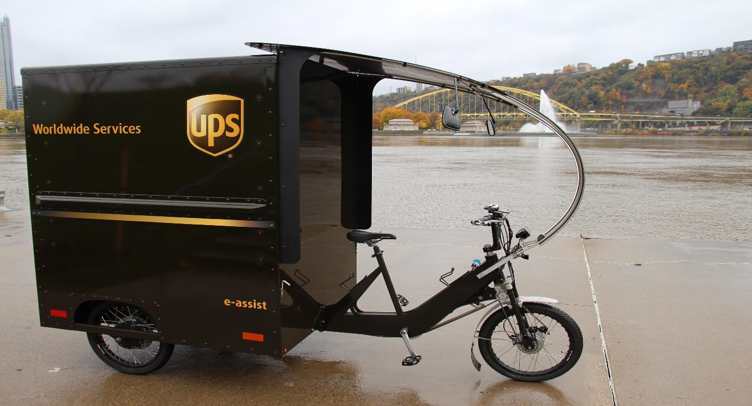

The Ansoff Matrix:
‘Here is a method for measuring profit potential of alternative product-markets strategies, starting with a forecast of trends and contingencies and then working towards company needs and long-term objectives (Harry Igor Ansoff, 1957).
Diagram sourced from B2U.com:
Internal and External Growth Strategies EXPLAINED with EXAMPLES | B2U (business-to-you.com)

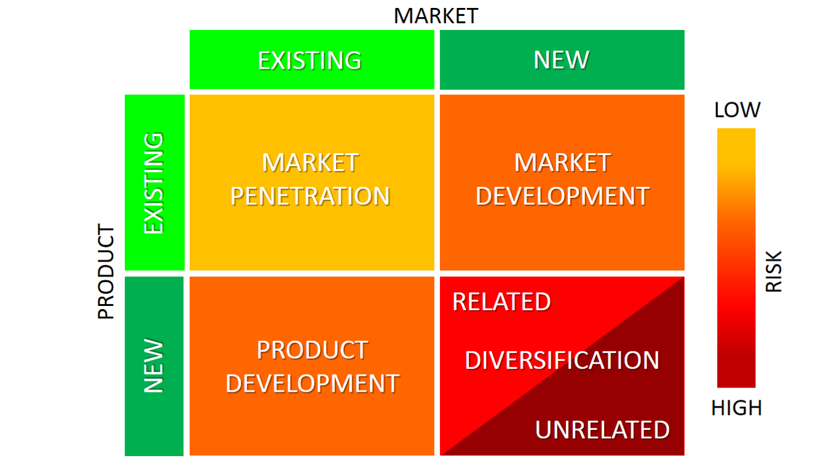

b.) Recommendations:
Market Development, or also known as Market Extension, this maybe the way forward for the UPS organisation, with this plan of action the organisation can sell existing services to new markets, which can be brought to fruition by applying further segmentation to assist with seeking out the newer consumer base. Additionally, with the increase of clinical trials in the last ten years, that has focussed on countries such as, Asia, Latin America, and Africa, these are areas UPS could seek out new possibilities for the organisation, or the organisation can focus on buying up smaller logistical firms in Europe, as highlighted in the swot analysis. Furthermore, clinical trials that have taken place by Mena, have shown an increase in revenue of 10- fold, for the next following ten years, which equates to $1 billion annually from these markets. However, the growth from these markets do have their challenges too, which are logistics, customs, and Governmental procedures. Therefore, seeking out these new market developments can be risky, however, it will assist the organisation, by planting firm roots in

these areas and building intelligence in these countries first (Ansoff matrix 2018; HI-Ansoff Harvard business review., 1957; UPS Staff writer,. 2016; Business Strategy Hub, 2020).

Conclusion:
Taking-into-account all the information gathered from the situation models above, UPS, is an organisation, that are a technically savvy organisation, and they seem to stand head and shoulders amongst others in this sector, which is not easy to enter, however, as mentioned above there are many competitors to compete with, but UPS do their utmost with their varied marketing mix to reach out to all who use or want to acquire their services, with the variety of pricing structures, and the varied times and collections of packages. UPS have also increased their foothold globally and as forecast have shown the organisation can continue doing so for the next decade, if they decide to seek out emerging market possibilities already mentioned above in the recommendation section.
The UPS organisation are extremely environmentally friendly which builds great relationships with their consumers, and prospective consumers, as well as the communities the organisation work with on humanitarian grounds. COVID-19, together with global lockdowns, has slowed down growth for the UPS organisation in 2020, already mentioned above, however, now with the introduction of several new vaccines, i.e., Pfizer, AstraZeneca, and Moderna (Wood, 2021) once these are administered to individuals globally, then we should witness countries globally coming out of lockdowns, and the UPS organisation will continue with their upward surge with their global operations. Already mentioned in the PESTEL, are factors the organisation will need to take into consideration which are the new policies on Brexit, and other UK business law’s. Furthermore, the information from the scholars at Carlton University, was significant about Porters model requiring an extra four more forces, “The Competitors level of Innovativeness, Exposure to Globalisation, Threat of Digitalisation, and Industry Exposure to De- Regulation Activities”. And if they had been applied, they would have given this report a very different outlook, which leaves further areas for research. This report has demonstrated an environmental market analysis taking-into-account significant external influence drivers, jointly with analysis of the internal environment also the significant role that marketing encompasses within the organisational setting.

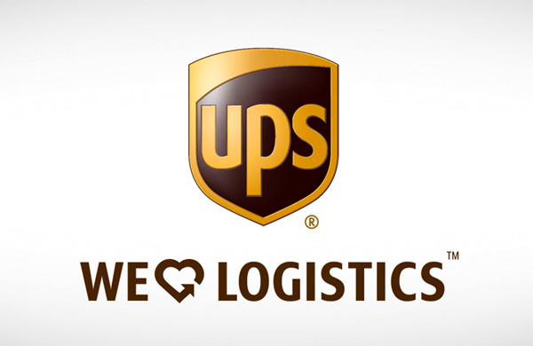

Diagram above sourced from: Logistics & Fulfillment | iappscommerce.com
Diagram below sourced from: UPS Tracking - Online UPS Worldwide Courier Track & Trace Status (onlinetrackingnumbers.com)

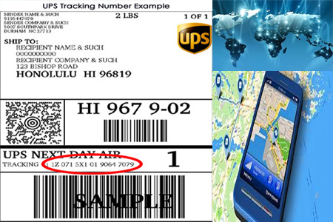

Diagram below sourced from: Louisville is headquarters haven (lanereport.com)


References:

Aaker, D.A., (2004) Leveraging the corporate brand. California management review, 46(3), pp.6-18. In Swani and Milne, (2017).
Air Cargo News., (2018) UPS Turns to Wet Leased Aircrafts to Bridge the Growth Gap. Available at :https://www.aircargonews.net/airlines/freighter-operator/ups-turns-to-wet-lease-aircraft-to-bridge-the-growth-gap/ (Accessed: 03. 05. 2018).
Ansoff, H,I., (1957) Strategies for diversification. Harvard business review, 35(5), pp.113-124.
Ansoff Matrix., (2018) A Guide to the Product Market Growth Matrix. Available at :Ansoff Matrix — A Guide to the Ansoff Product Market Growth Matrix (Accessed: 02. 05. 2021).
Barton and MacArthur., (2019) Does the United States Postal Service Charge Amazon Too Little? Journal of business and accounting, 12(1), pp.19–35.
Business Strategy Hub., (2021) UPS Swot Analysis 2021. Available at: UPS SWOT Analysis (2021) | Business Strategy Hub (bstrategyhub.com) (Accessed: 02. 05. 2021).
DHL., (2021) Quick Quote. Available at :https://send.dhlparcel.co.uk//parcel-services/uk-parcel-sizes-and-pricing?gclid=3522a74adcec164eaa81c708e6b26b23&gc (Accessed: 02. 05. 2021).
Fed Ex, (2021) Company Overview. Available at :http://investors.fedex.com/company-overview/overview-of-company/default.aspx#:~:text=FedEx%20has%20grow (Accessed: 02. 05. 2021).
Hackius, N. and Petersen, M., (2020) Translating High Hopes Into Tangible Benefits: How incumbents in supply chain and logistics approach blockchain. IEEE access, 8, pp.34993-35003.
Hatzigeorgiou A, & Lodefalk, M. (2016) The Brexit Trade Disruption Revisited. The Estey Centre journal of international law and trade policy, 17(1), pp.41–58.
I, Diane,. et al., (2020) Is Porter's Five Forces Framework Still Relevant? A Study of the Capital/Labour Intensity Continuum via Mining and IT industries. Technology innovation Management Review, 10(6), pp.28–41.
J. A. Montalván Espinoza et al., (2019) Extending PESTEL Technique to Neutrosophic Environment for Decisions Making in Business Management. Neutrosophic sets and systems, 27, pp.228–236.
Koter, P, T., (2017) Principles of Marketing 17th Edition United Kingdom: Pearson Ltd.
L.L. Berry., (2000) Cultivating service brand equity. Journal of the Academy of marketing Science, 28(1), pp.128-137. In Swani and Milne, (2017)
Llewellyn, R., (2020) Arrival Electric Vans, Arrivals first look- is this Britain’s Rivian? Fully Charged Electric Vehicles. Available at : A R I V A L 1st look - is this Britain's Rivian? | FULLY CHARGED for Electric Vehicles. - YouTube (Accessed: 03. 05. 2021).

Mazareanu, E., (2021) Number of United Service employees from FY 2013 to FY 2020 (in 1000). Available at: United Parcel Service - employees 2013-2020 | Statista (Accessed: 03. 05. 2021).
Mazareanu, E., (2020) United Parcel Service – statistics and facts. Available at :United Parcel Service - statistics & facts | Statista (Accessed: 03. 05. 2021).
M Marketing 91., (2020) Marketing Mix of UPS United Parcel Service. Available at :Marketing mix of UPS United Parcel Service - UPS Marketing mix (marketing91.com) (Accessed: 03. 05. 2021).
Media Radar., (No Date) UPS United Parcel Service Advertiser Profile. Available at :UPS United Parcel Service | Advertising Profile | See Their Ad Spend! | MediaRadar (Accessed: 02. 05. 2021).
Mulvey, M, S. & Gengler, C, E., (2017) Planning pre-launch positioning: Segmentation via willingness-to-pay and means-end brand differentiators. The journal of brand management, 24(3), pp.230–249.
Nikolić, M. & L, Stošić-Mihajlović, L., (2020) Strategic Analysis of the Business of the Enterprise. Trendovi u Poslovanju, 8(1), pp.28–36.
O'Brien, M., Liu, Y., Chen, H. and Lusch, R., (2020) Gaining insight to B2B relationships through new segmentation approaches: Not all relationships are equal. Expert Systems with Applications, 161, p.113767.
Park, J., et al., (2017) A New Bayesian Spatial Model for Brand Positioning. Journal of modelling in management, 12(3), pp.404–431.
Porter, M.E., (1979) How, Competitive Forces Shape Strategy. Harvard Business Review, 57(2): 137-145. In Diane et al. (2020).
Slide Team., (2021) Swot Icons Showcasing Business Evaluation Powerpoint Slide Designs. Available at :Swot Icons Showcasing Business Evaluation Powerpoint Slide Designs | Presentation PowerPoint Diagrams | PPT Sample Presentations | PPT Infographics (slideteam.net) (Accessed: 03. 05. 2021).
S SlideSalad., (2021) PESTLE Analysis Diagrams Googles Slide Presentation Template. Available at :PESTLE Analysis Diagrams Google Slides Presentation Template (slidesalad.com) (Accessed: 02. 05. 2021).
Snider, M., (2021) UPS CEO David Abney to retire, board member Carol Tome to take post at end of May. Available at :UPS CEO David Abney to step down, shipper names Carol Tome' as new CEO (usatoday.com) (Accessed: 02. 05. 2021).
Stevens, L., (2018) Amazon to Launch Delivery Service That Would Vie with FedEx, UPS. Available at :Amazon to Launch Delivery Service That Would Vie With FedEx, UPS - WSJ (Accessed: 02. 05. 2021).
Stock Analysis., (2021) United Parcel Services, Inc. (UPS). Available at :United Parcel Service (UPS) Stock Statistics & Valuation Metrics | Stock Analysis (Accessed: 02. 05. 2021).
Sustainability UPS Media., (2019) Gri Content index. Available at :2019-gri-index.pdf (ups.com) (Accessed: 02. 05. 2021).
Swani, K. & Milne, G, R., (2017) Evaluating Facebook brand content popularity for service versus goods offerings. Journal of business research, 79, pp.123–133.
Swant, M., (2019) The Worlds, Most Valuable Brands. Available at :The 2020 World's Most Valuable Brands (forbes.com) (Accessed: 02. 05. 2021).
UPS Webinar, (2021) The Unstoppable Webinar Series with Ava Longoria. Available at :UPS Webinar: Opening Doors: Eva Longoria Talks Inclusivity in Business and Beyond - Bing video (Accessed: 07. 05. 2021).
UPS Investors., (2021) Annual Reports and Proxy. Available at :Annual Reports & Proxy | UPS (Accessed: 02. 05. 2021).
UPS Staff Writer., (2016) How to minimise risk in emerging markets. Available at :How to minimize risk in emerging markets | UPS - United States (Accessed: 02. 05. 2021).
UPS Investors., (2021) Political Contributions. Available at :Political Contributions | UPS (Accessed: 02. 05. 2021).
UPS., (2020) What does Brexit deal mean for your shipments? Available at :Brexit guide | UPS (Accessed: 02. 05. 2021).
UPS Sustainability Progress Report., (2019) Accelerating Sustainable Solutions. Available at :2019-progress-report.pdf (ups.com) (Accessed: 03. 05. 2021).
UPS Green Logistics and Environment Environmental Responsibility., (2021) Efficiency to make a world of difference. Available at :Green Logistics and Environmental Responsibility | UPS - United Kingdom (Accessed: 03. 05. 2021).
UPS Stories., (2021) Get quick access to the right people. Available at :Contact Us | UPS Stories (Accessed: 03. 05. 2021).
UPS Packaging., (2021) Hazardous Materials Package Regulations. Available at :https://www.ups.com/us/en/help-center/packaging-and-supplies/special-care-shipments/hazardous-materials/responsibi (Accessed: 03. 05. 2021).
Yankelovich, D. and Meer, D., (2006) Rediscovering market segmentation. Harvard Business Review 84(2): 122--131.
Walker, A. Palumbo, D. BBC Business News., (2018) The US – UK trade relationship in five charts. Available at :The UK-US trade relationship in five charts - BBC News (Accessed: 03. 05. 2021).
Wood, P., (2021) Which COVID Vaccine have the Government Ordered. Available at :Which Covid vaccines has the UK government ordered? - CityAM : CityAM (Accessed: 05. 05. 2021).
XPO Logistics., (2021) We provide pivotal supply chain solutions to most successful companies in the world. Available at :https://www.bing.com/search?q=who+are+xpo+logistics&form=ANNTH1&refig=be2d23c0de8b43888ff6101cf9ca88b1&sp=1& (Accessed: 02. 05. 2021).

Appendix 1.

Information on Photos and some Diagrams Selected:

On page 1. Is the UPS company logo.
Diagram on page 5. Is of the first Model T Ford Motor Vehicle used by James Casey, Claud Ryan, and Charles Soderstrom, at UPS.
Also, on page 5. Is the new Arrival, electric vehicle used today.
On page 11. a UPS diagram of the global revenues forecasted from 2017-2025.
Also, on page 11. Is a UPS domestic, and international prices for packages.
Page 14. Photo of UPS electric bike, picture taken in Pittsburgh Pennsylvania USA.
Also, on page 16. Is a photo of UPS tracking on-line, world courier track and trace system with on-line tracking number.
On page 16. Is the UPS headquarters in Louisville.

Diagram below sourced from: Could UPS Have the Worst Tagline Ever? | UsefulArts.us



