D.Gwynn (1804288)

Leadership and management within the nhs
[Document subtitle]

Contents Page

Abstract | Pg. 2
Introduction | Pg. 2
Findings | Pg. 2
Conclusion | Pg. 7
Recommendations | Pg.7
Appendix | Pg. 8
References | Pg. 10

Abstract
The purpose for this report is to highlight how management and leadership and the theory that relates to management practices used. This report will focus on the Nation Health Service and its structure. It will also address what culture is presently within the NHS and way effect this has had. It will consider the relationship between service uses and staff and the effects this has had. Finally, it will consider how staffing levels impact staff and patient care.

Introduction
This report will highlight the impact of effective leadership and management in relation to the motivation of employers in the National Health Service (NHS). It will also highlight the impact of the organisational structure and culture in supporting or hindering leadership and management within that setting. This report will also focus on the impact this could have on service users if the NHS employees are lacking in motivation. This report may also make recommendations for change, if appropriate within the NHS.

Findings
When looking at leadership and management it is important to define what this means. The term leadership can be difficult to define but it generally involves a relationship where one person has influence over how others behave (Mullins, 2002.) This suggests that leadership focuses on moving people and the organisation forward, with an emphasis on dealing with people, increasing the competency of staff and the way in which teams work together. Mullins (2013) defines management as an active process that has an impact on how people behave and makes things happen. Therefore, it can be suggested that while leadership is about influencing behaviour, management is more about the process of getting things done through other people. Moreover, in contrast, leadership is the way management methods and processes are used. Harvey-Jones (2003) argues that leadership and management are linked. Adair (2009) further states that an understanding of how they are linked is crucial in providing positive leadership.

When looking at the NHS, it is evident that its structure is complex. The structure of the NHS is predominantly from outside of a hospital and from The Secretary of State for Health. They have overall responsibility (NHS. 2019. NHS England). From there Responsibility falls to The Department of Health and Social care (DHSC) who are in control of ‘strategic leadership and funding’. Responsibility then cascades down to NHS England, and then to local authorities and primary care services such as General Practitioners (GPs). Finally, there are health boards which all have responsibilities for areas of care. This complex structure is before you have reached a hospital, which itself will have its own management and leadership team. (See Appendix 1)

Swansburg (1996) states that the theory of modern management has developed from the work of Fayol, who outlined several principles that he found useful when running a large organisation. However, it was also suggested that these principles could be applied to other forms of society such as “political, religious and philanthropic” (Bagad. 2009. Pg25) settings. Fayol outlined that there were four main elements of management and these are further divided into fourteen principles, including division of work, authority, discipline, unity of direction, remuneration of personnel, centralisation, scalar chain, order, equity, stability, initiative and subordination. Fayol theory is widely used today. When looking at the structure of the NHS Division of work would be essential for a large organisation with a large proportion of managers and leaders.
Adair (2009) states that on developing the Action-Centered Leadership Model, he reflected on Maslow’s Hierarchy of Needs and Herzberg’s Motivation theory, both of which look at achieving potential through motivation. This illustrates that Adair’s Action- centered leadership model uses the insight of the works of Maslow, Herzberg and Fayol and the thinking around human needs and motivation. When looking at the theory of managing organisations, Adair (1997) outlined three areas of leadership responsibility, these areas are “task need, team maintenance need and individual need” (Adair.1997. Pg16) These elements will overlap when managing the needs of individuals and also the needs of the group.(see appendix 2) Adair also goes on to express that because of these overlapping areas, if the team member does not feel able to complete the task outlined, then the team will suffer as a result and the task will be more difficult to complete. Therefore, to be able to succeed as a manager there is a need to command all three areas.

It is important to understand how the structure and culture of the NHS can support or hinder leadership and management within it. West et al (2014) explains that the NHS needs a highly professional and skilled level of leadership in order to deal successfully with the demands of financial and service pressures. Therefore, it can be suggested that the leadership and management model would need to be highly effective to support this thinking. However, it could also be argued that due to the number of apparent issues currently in the NHS this is not the case.

Schein (1992) states that a culture be a shared set of assumptions that become embedded in an organisation and ‘taken for granted’. This then shapes how the employers in that organisation work and respond to things. For instance, it could be argued that the concept of working longer and not being paid for this time has become a culture in the NHS and therefore expected of its employees. This theme was highlighted in the Royal College of Nurses Employment survey. This survey shows that 50% of nurses were not paid for the extra hours they have worked. (See Appendix 3) The report also highlights that there is a link between work pressures and pay and that this is closely linked to the pay not being matched with the reasonability expected of them. The “Trusted to Care” report by Andrews highlights that “the culture of care can be defined both by what care is provided and how it is provided” (2014. Pg10). Therefore, a culture can be how care is provided both in the sense of good care and poor care. This culture is often shared between staff and be as a result of expectations on them being high and the number of staff being low. The Andrew’s (2014) report suggests that service users are being provided with poor experiences in hospital, an anonymous quote from service users and staff were used throughout. It was stated that this was because of staff shortages due to suspensions and illness.

Mullins (1999) explains that “The relationship between organisations and their workforces is governed by what motivates individuals to work at their best and the satisfaction they derive from their activities”. When looking at The Francis report, it illustrates that a shift in culture is needed to “end the climate of fear, bullying and harassment that can stop clinicians from speaking out against poor care” (2013.Pg1) It goes onto explain that it is important for staff and management to jointly promote a new culture of being able to raise concerns and that this behavior is acceptable and positive. Furthermore, the NHS is moving towards “Collective leadership” (West et al, 2014. Pg5) and this means creating a new culture of everyone taking responsibility for the success of the organisation and not just for their own job or work area. (West et al, 2014)
In accordance with Schin’s (2016) thinking, an organisation has three levels of culture. “Artifacts “are the surface or outer edges of the organisation. These are visual elements such as the organisation logo, the building structures and the clothing. “Espoused Values”, are elements of the organisation that surround its standards, values and the code of conduct, these values are not visible. Lastly “Basic Underlaying Assumptions” are often core values of culture that are deeply embedded in the organisation. Schein believed that discussions were needed with as many employees as possible to discover the underlying culture and the background. Schien also believed that a behavioural culture had to be unlearnt first before a new one could be learnt in its place. (Schein, 2010) When applying the thinking of Schein, it can be argued that many of the culture issues within the NHS are deep rooted and would fall into Schien thinking that they are Basic Underlaying Assumptions. Therefore, for this culture within the NHS to change, the current cultures need to be unlearnt.

When considering the relationships between employees and service users, West et al (2104. Pg5) argues that “every interaction in an organisation both reveals and shapes its culture” In the NHS today it seems that many of the interactions between service users and staff are presented the way they are due to a culture of ‘this is how it was always done before’ and therefore is normalised (Department of Health , 2015 )
This is evident from the findings of the Francis Report where a “weak board driven by national demands” meaning those managing those staff below them, therefore created a “toxic culture” where the focus was meeting targets and balancing finances. The primary aim was not to care for service users but to meet targets and financial issue in the hospital. (Department of Health, 2015) Furthermore, when considering Mintzberg’s theory of managerial Roles, there are 10 roles or behaviours that can be used when categorising the role of a manager. These include “a Figurehead, leader, liaison, monitor, disseminator, spokesperson, entrepreneur, disturbance handler, resource allocator and negotiator” (Christy. 2013. Pg436). These are then grouped together into three groups, these are interpersonal where the manager manages thorough people, Informational, when the manager manages through the information that is acquired and decisional, when the manager manages through action. (Christy. 2013) Therefore, when applying Mintzberg theory to the structure of the NHS, it could be argued that nurses are expected to be “leaders”. Mullins suggests that this is the “most significant of roles” (2013, Pg.436) and are expected to motivative, guide and be responsible for staffing levels, while also fulfilling the nursing role.

According to McGregor (1960) “a motivated and supported workforce will create challenges for themselves to achieve organisational objectives”. Therefore, in effective leadership and management, as outlined by McGregor, X Theory expresses that the manager believes that the workers do not want to work very hard and that the manager needs to impose strict rules, constant supervision and a threat of punishment (Weiss, 2014). However, McGregor also notes that this attitude can become self-fulfilling, in that staff then tend to become passive and reliant on being told what to (Schermerhorn. 2010) It could be argued that this theory is reflected within the NHS structure as the management has often focused on meeting targets such a waiting times and managing budget restrictions therefore, the consequences of these actions are overstretched staff, that feel undervalued and as a result become poorly motivated and perhaps too afraid to show initiative . The nursing profession has noted that the job role has changed. They are expected to do far more paper work including care plans and recording charts, as well as an increase in tasks that doctors are not willing to do such as taking blood. Therefore, these elements do not make the job rewarding. The NHS is fundamentally known for being under staffed, this is more evident with increased work load. The National Institute for Health and Care Excellence (NICE) developed safe staffing levels on wards. These guidelines suggest a safe level of staff are needed to be able to provide quality of care. Although the NICE guidance does not specifically say what the staff to patient ratio should be, they suggest that the risk of harm to patients increases if one nurse has more than eight patients. (NHS,2016). This is further supported by the Francis Report. It highlights “chronic under staffing” became a way to meet the financial pressure the hospital was subjected to by the health board. (Department of Health, 2014. Pg22) Moreover, Herzberg outlines (1968, Pg11) “motivation is a function of growth from getting intrinsic rewards out of interesting and challenging work”. Herzberg expressed that job satisfaction was more important and not increasing the workload. This was believed to be key to motivating employees to work. (Herzberg 1968). The NHS can only be effective and successful if they have the cooperation and willingness of motivated staff (Domey, 2016). It has been cited that there are a number of reasons for staff shortages in the NHS such as poor pay, stress in the work place, and low job status. (Madi and Mabel, 2002) This creates a feeling of dissatisfaction and in turn lowers staff morale and increases staff turnover, thus increasing costs. Moreover, McGregor’s Y Theory would argue that if staff are given more responsibility and freedom in carrying out the roles, they would then be more motivated and happier in their job and therefore less inclined to leave. (Schermerhorn. 2010)

The NHS in England and Wales has seen a number of high profile scandals centered around Quality and Safety of care. The “Francis Report” evolved, then the “Andrew’s Report” followed and from this came the “Trusted to Care” report (2014). These reports give an insight into institutional and cultural failures. Woods et Al (2017) state large scale failures of control and leadership at multiple levels, from what social scientists’ term as the ‘blunt end’ where decisions, policies, rules, regulations, resources and incentives are generated, through to the sharp end, often known as the front line, where care is provided to patients.

Conclusion
Therefore, to conclude, when looking at why leadership and management within the National Health Service is important it can be suggested that it is vital to the way the oranganisation functions.

Recommendations
- Improve the way targets and financial pressures are translated down to staff on the frontline.
- Reduce nursing work load to make it feel more manageable.
- Improve staff moral particularly amongst nursing staff.

Appendix
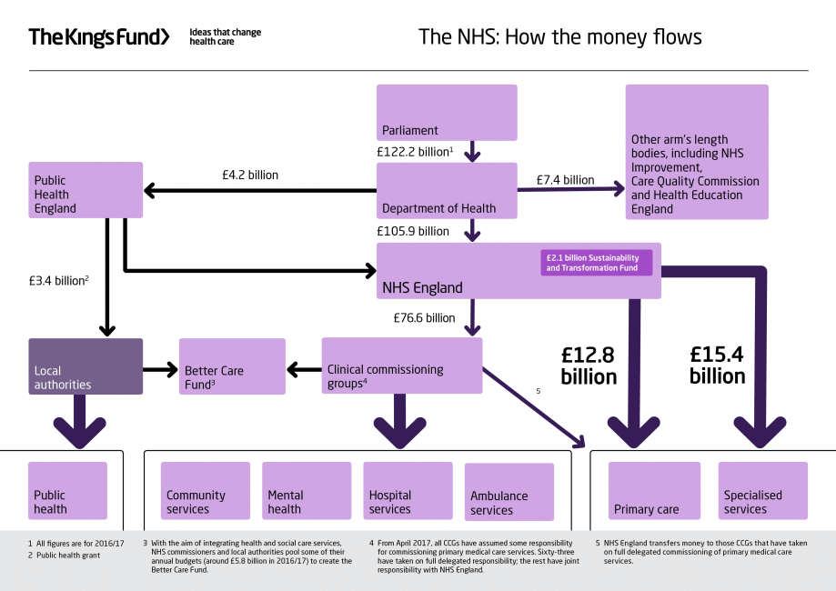

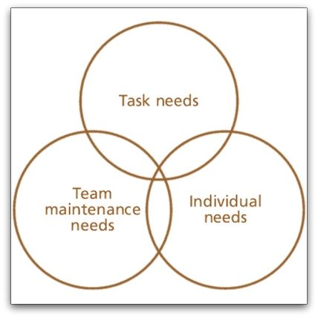
2.

- 6.1.1 Most nursing staff work additional hours, much of which is unpaid
The majority of nurses (71%) reported working additional hours at least once a week and this has increased substantially from 10 years ago, when only 58 per cent reported working additional hours. Fifteen per cent worked additional hours on every shift, 35 per cent did so several times a week, 22 per cent did this once a week, and 21 per cent reported working additional hours less than once a week. Just seven per cent of nurses did not work additional hours (Figure 6.1).

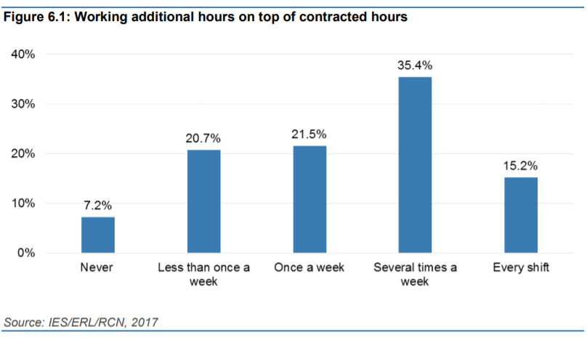

References

Adair, J. (2009) How to Grow Leaders. Kogan Page: Great Britain.

Adair, J. 2009. Leadership and Motivation: The Fifty-Fifty Rule and the Eight Key Principles of Motivating Others. Kogan Page: London

Andrew. J and Bulter. M (2014) Trusted to Care: An independent review of the Princess of Wales Hospital And Neath Port Talbot Hospital at Abertawe Bro Morgannwg University Health Board.

Bagad, V.S. (2009). Principles of Management. Technical Publication: India

British Medical Authority. (2013) Recommendations of the Francis Report into the Mid Staffordshire Hospitals NHS Foundation Trust. Available at https://www.bma.org.uk/-/media/B59F222D6AC24F04A07D9F676484BA2B.ashx [accessed on 15th March 2019]

Department of Health (2015) Culture Change in the NHS. Applying the lessons of the Francis Enquiry. Available at https://assets.publishing.services.gov.uk/government/uploads/attachment_data/file/403010/culture-change-nhs.pdf [Accessed on 22rd March 2019]

Domey, J. (2016) Meeting the Challenge: Successful Employee Engagement in the NHS. Available at https://www.nhsconfed.org/-/media/Confederation/Files/Publications/Documents/New-care-models-staff-engagement-FINAL.pdf [accessed on 24th February 2019]
Francis, R. (2013) Report of the Mid Staffordshire HNS Foundation Trust Public inquiry. Available at https://webarchive.nationalarchives.gov.uk/20150407084231/http://www.midstaffspublicinquiry.coc/report [ accessed on 24th February 2019]

Harvey-Jones, J. (2003) Making It Happen: Reflections on Leadership. London: Profile Books:

Herzberg IF (1968) One more time: how do you motivate employees? Harvard Business Review. 46,1, 53-62.

House of Commons Health Committee. 2010. The Nursing Workforce. Available at https://publications.parliament.uk/pa/cm201719/cmselect/cmhealth/353/353.pdf [Accessed on 17th March 2019]

Mabel. J. (2013) Recruitment and retention: A study in motivation Nursing Management (through 2013); London Vol. 9, Iss. 8, (Dec 2002): 17-21. Available at https://search-proquest-com.ezproxy.uwtsd.ac.uk/docview/220163916?accountid=130472 [accessed on 22rd March 2019]

Mullins, L. (2002). Management and Organisational Behaviour. Sixth edition. London. Pitman.

McGregor D (1960) The Human Side of Enterprise. London, McGraw-Hill.

Schermerhorn, R. (2010) Management. 11th ed. New York: Wiley & Sons

Schin, E. (2016) Organizational Culture and Leadership. 5th ed. Wiley and Sons: New Jersey

Swansburg, R. (1996). Management and Leadership in Nurse Managers. 2nd ed. Jones and Bartlett: Burlington.

The Kings Fund. (2016) How is the NHS Structure? Available at https://www.kingsfund.org.uk/audio-video/how-new-nhs-structured [accessed on 23rd March 2019]

Wood, M D et Al. 2017. Culture and behavior in the English National Health Service. Available at https://Qualitysafety.bmy.com [Accessed 18th March 2019]
West, M. et al, 2014. Leadership for Health Care. Available at https://www.kingsfund.org.uk/sites/default/files/field/field_publication_file/developing-collective-leadership-kingsfund-may14.pdf [accessed on 24th March 2019]

